Whole-cell biosensors for determination of bioavailable pollutants in soils and sediments: Theory and practice

Xiaokai Zhangª, Boling Li^{b,c}, Daniel N. Schillereff^{d}, Richard C. Chiverrell^{b}, Boris Tefsen^{e}, Mona Wells^{e*}
ª Institute of Environmental Processes and Pollution Control, and School of Environmental and Civil Engineering, Jiangnan University, Wuxi 214122, China
^{b} School of Environmental Science, University of Liverpool, Brownlow Hill, Liverpool, L69 7ZX, United Kingdom
^{c} Department of Biological Sciences, Xi'an Jiaotong-Liverpool University, Suzhou, Jiangsu, 215123, PR China
^{d} Department of Geography, King's College London, London WC2R 2LS, UK
^{e} Natural Sciences, Ronin Institute, Montclair, NJ 07043, United States
* Mona.Wells@RoninInstitute.org
Abstract: The bioavailability of pollutants is a key factor affecting environmental risk. Whole-cell bioreporters are a demonstratedly effective tool for the investigation of pollutant bioavailability in water and soil/sediment. Unlike aqueous samples, transmittance of bioreporter optical signal is reduced in direct-contact assays with soil/sediment, which affects the accuracy of bioreporter-detected pollutant bioavailability. No studies have measured the magnitude and variability of soil/sediment effects on signal in direct-contact assays or how associated uncertainties influence results. In this study, we investigate the optical effects of soil/sediment particles in suspensions on bioreporter signal transmittance and quantify how variable these optical effects are from sample-to-sample. We find that neglecting bioreporter signal diminution by soil/sediment, as many studies do, can lead to order-of-magnitude errors in results, underestimating risk. Correction based on methods in ad hoc use (e.g. comparison to signal from non-inducible reporter or use of reference soil/sediment) are also problematic for some types of experiment, and could lead to errors in excess of 30%. Our findings have a sound basis in theory, and we provide recommendations concerning the most suitable type of approach to use for different experimental settings. Generally, if best accuracy is not needed to quantify bioavailability, for samples that have been ground, sieved, and are of reasonably uniform color, it may be possible to use a single or average correction factor, particularly for experiments performed at a single slurry concentration. For investigations studying bioavailability under varying solid-phase:water ratios (e.g., sorption/desorption), detailed compensation measurements are needed for independent variables, including each specific soil/sediment sample, slurry concentration, and in some cases bioreporter signal intensity. Our measurements and calculations indicate that best results are obtained when working in the region of ballistic photon transmittance. Findings herein will be useful in areas that require information on bioavailability, such as ecotoxicology and environmental risk assessment.

Keywords: Bioreporter; Biotechnology; Pollutant and environmental risk assessment; Optical scattering and reflection; Bioaccessibility and speciation

1. Introduction
Increasing population and associated industrial activities have caused unprecedented levels of environmental pollution worldwide, such that humankind and ecosystems are facing greater pressure from toxic pollutants than ever before (Clemens and Ma, 2016; Pure Earth/Green Cross, 2015; RoyChowdhury et al., 2018). Soils and sediments are primary sinks for toxic metal pollutants in particular due to sorption on these solid matrices. Generally, toxic metal pollutants are monitored and analyzed using chemical methods of instrumental analysis such as atomic absorption spectroscopy, atomic fluorescence spectroscopy, inductively coupled plasma mass spectrometry (ICP-MS), and X-ray absorption spectroscopy (Carter et al., 2017; United States Environmental Protection Agency, US EPA, 1979, 2017). These conventional chemical methods of analysis measure chemical concentration, which often does not correlate well with measured biological effects of pollutants (Fairbrother et al., 2007; US EPA, 2003a, b, 2007a; Zeng et al., 2021). Biological effects from pollutants, most importantly toxic response, are a consequence of pollutant bioavailability, or, as many others have put it, by definition, “that which is not bioavailable is not toxic” (Sander et al., 2015; Semple et al., 2004). Hence environmental bioavailability has been an increasing focus of investigators and regulators in the areas of environmental monitoring, environmental quality, and environmental risk assessment (An et al., 2019; Sander et al., 2015; Wang and Song, 2019). In recent years, whole-cell bioreporters, i.e. genetically engineered bacteria that can give a “report” on analytes, have been used as an effective tool to determine the bioavailability of, and hence risk posed by, many pollutants, with a number of studies focusing on toxic metals in the environment (Al-Anizi et al., 2014; van der Meer and Belkin, 2010; Wells, 2012; see Preedy and Pattel, 2012 and/or Thouand and Marks., 2016 for comprehensive texts on bioreporters). So-called lights-on bioreporters produce a signal that is selective, or in some cases specific, to certain analytes and that positively correlates positively with analyte bioavailability. Thus, lights-on bioreporters measure bioavailability much as traditional methods of instrumental analysis measure concentration (Belkin, 2003; Kessler et al., 2012; van der Meer and Belkin, 2010).
Lights-on bioreporters are constructed by combining a promoter gene (a sensing element) and a reporter gene (signaling element) within a host cell. Fusing the promoter to the reporter ensures that when the promoter responds to the analyte, i.e. the promoter is “turned on”, this then causes a reporter gene to be expressed, the resultant signal from which is typically optical. Bioreporters occupy an important niche among biological methods as, compared to tests using, for instance, fathead minnow (Driessnack et al., 2017; US EPA, 2007b), or springtail (Ardestani and van Gestel, 2013, ISO, 2014) that measure pollutant bioavailability indirectly via measurement of toxic response, bioreporters measure bioavailability directly. Additionally, both conventional chemical methods of instrumental analysis and toxicity testing require significant preparation time for analysis and (e.g. using acid digestion for instrumental techniques or cultivating and maintaining test organisms for toxicity testing) are relatively labour-intensive and hence expensive. In comparison, bioreporters not only hold the advantage of direct measurement of bioavailability, but they are also faster and cheaper (Clifford and McGeer, 2010; van der Meer and Belkin, 2010; Wells, 2012), while still being very sensitive to target analytes at low concentrations (Dong et al., 2011; He et al., 2018; Kessler et al., 2012; Magrisso et al., 2009; Zhang et al., 2017). Despite the myriad advantages of using bioreporters to measure bioavailability, to date, much bioreporter work has involved the measurement of pollutants in aqueous environments (Al-Anizi et al., 2014; Zhang et al., 2017, 2020a).
Generally speaking, understanding bioavailability, and the attendant hazard represented by bioavailable toxic pollutants in soil/sediment, is more complicated than in the aqueous phase. Many non-biological methods have been developed to mimic the measurement of bioavailability, particularly in soil/sediment, however, these lack the inherent dynamic ability of organisms to interact with their environment (Cabaniss, 2009; Dudal and Gérard, 2004). Organisms are able to detect bioavailability of chemicals in their environment and have been shown in some cases to respond in a manner that itself affects bioavailability, for instance, in order to sequester a toxin or increase nutrient intake (Glatstein et al., 2018; Wells et al., 2005; Zhang et al., 2020b). Non-biological, i.e. chemical approaches to estimate bioavailability represent a measurement that has been referred to as chemoavailability (Wells, 2012), i.e. if bioavailability is the availability of an analyte to biota, chemoavailability is the availability of an analyte to a chemical proxy such as the membranes used in DGT (diffusive gradients in thin-films, Zhang et al., 2014), or chelate extractions (Cao et al., 2008), to name two well-known approaches. In these techniques that measure chemoavailability, the putative “chemoavailable” fraction of analyte is removed from the matrix, extracted, and then analyzed instrumentally. For whole-cell bioreporters, in contrast, direct-contact measurement may be performed in situ. Direct-contact assays reflect an actual biotic measurement, rather than relying on chemical proxy, and hence hold that advantage (Belkin et al., 2003; Magrisso et al., 2008). Optical bioreporter response results from a variety of reporter genes in common use for bioreporter construction (Belkin et al., 2003; Köhler et al., 2000), and detection of bioluminescence signal generated from either the luc or lux reporter gene is very common in consequence of the sensitivity afforded (Magrisso et al., 2008).
Assessing the bioavailability and toxicity of pollutants in soil/sediment and other environmental materials using whole-cell bioreporters in direct-contact assays is more difficult than for the aqueous phase since solid particles can strongly affect transmittance of the optical signal produced by bioreporters, which may cause diminution of measured signal (Brandt et al., 2006). Many bioreporter studies on soil/sediment have thus focused on measuring the pollutants in soil/sediment extracts rather than soil/sediment suspension (Peltola et al., 2005; Xu et al., 2013, and references therein). Measuring extracts alleviates the issue of transmittance diminution by particles, however, does not harness the ability of the bioreporter to measure bioavailability. Measuring extracts detects the pollutant content of soil/sediment that desorbs into aqueous solution, a type of measurement that could just as well be done using, for instance, ICP-MS in a chemoavailability framework. Several studies have shown that during soil/sediment suspension-bioreporter direct-contact measurements the concentration of pollutants detected by bioreporters is higher, sometimes much higher, than for extracts (Brandt et al., 2006; Dong et al., 2011; Ivask et al., 2011). In other words, bioreporters are able to sense more, sometimes much more, than free or loosely bound (readily desorbed) pollutant, i.e., for direct-contact assays bioreporters are able to sense bioaccessible pollutant. These findings again underscore the difference in chemoavailability and bioavailability of pollutants in soil/sediment. In recognition of the shortcomings of using bioreporters to measure extracts, recent studies begin to focus more on using bioreporters in direct-contact assays to study pollutants in soil/sediment-water suspensions (Everhart et al., 2006; Hakkila et al., 2004; Ivask et al., 2004, 2011).
We reviewed the literature and summarize the approaches to dealing with the effect of particulates on bioreporter optical signal in Table 1. We found a total of four approaches with differing conceptual underpinnings, as illustrated schematically in Figure 1. Of these four, one approach is to ignore (or treat as negligible) the effects, and the other three involve correction/compensation of some form. Obviously, omitting correction or compensation has the potential to produce inaccurate experimental results, leading to underestimation of signal/analyte bioavailability. In this sense, correcting for reduced signal transmittance by solid particles is preferable, however, there seems to be no generally agreed way to do so. For example, early work by Hakkila et al. (2004) reported the use of a non-inducible luminescent control bioreporter to infer the effects of particles (Approach 2 in Figure 1) on bioreporter signal transmittance. The non-inducible control bioreporter could take several forms, the general idea being that the control is “on” or producing signal, however the signal is not the result of induction by an analyte/pollutant, and therefore the response of the control is not conflated with bioreporter induction by an analyte/pollutant. Yoon et al. (2016a, b) took a different approach and added standard solutions of metal to direct-contact assays using a control soil to correct for effects from particles in direct-contact assay suspensions (Approach 3). Approach 4 involves pre-exposing a bioreporter to a pollutant and subsequently placing activated bioreporter into uncontaminated soil to estimate a correction (Toba and Hay, 2005).
In chemistry and theoretical physics, much has been written regarding the behaviour of light fields in dispersion and scattering media and regarding to solving problems of the reconstruction of the dispersion medium parameters from the characteristics of scattered radiation (Dick, 1998; Hecht, 2002). A fundamental issue around signal correction is the question of what the magnitude and variability of the effect of particulates on signal transmittance is for environmental matrices, namely soil/sediment. We have not been able to find that any study has thus far explicitly measured changes in signal transmittance with respect to soil/sediment direct-contact assays, and hence likewise the issues of magnitude and variability of effects, or how uncertainties associated with same influence results, have not been addressed. How soil/sediment particles in solution affect transmittance will be nonlinear (essentially from known deviations to the Beer–Lambert–Bouguer law, Dick, 1998), hence this information is also important to know as using different quantities of solid matrix in assays will result in nonlinear effects on transduced bioreporter signal. Of the three approaches to correction for the effect of solids on bioreporter signal that are illustrated in Figure 1, we regard Approach 3 as being most problematic as it tests not only the interaction of solids with light, but also entails that the standard could be actively sorbing to the solid matrix, thus changing bioavailability of the standard, during the course of a measurement. For Approach 2, using a control bioreporter may not be ideal if the optical intensity differs substantively from that of the bioreporter that senses the analyte of interest. Similar comments pertain to Approach 4 of using a reference sediment if the optical effects of the reference are not suitably similar to those of the sample. Such issues have not been systematically addressed in previous studies. The aim of this study was to address existing knowledge gaps, with specific objectives as follows: 1) to study the optical effects of soil/sediment particles in suspensions on bioluminescence signal, with an emphasis on environmental samples, 2) to see how variable these optical effects are, and 3) to assess the implications of our findings for bioreporter soil/sediment direct-contact assays. We found that optical effects of the soil/sediment on bioreporter signal varies as a function of soil/sediment slurry concentrations (SCs) in a manner consistent with optical theory. Higher SCs have more pronounced effects, and the optical effects are closely related to the nature of the soil/sediment itself. We offer recommendations concerning experimental design based on the degree of accuracy needed for results.
2. Materials and Methods
2.1. Bioreporter strain and growth media
In this study, genetically engineered Escherichia coli PHL268 strain zntA (Kessler et al., 2012) was used. We used this strain based on our and others’ past experience with it as providing reliable and reproducible results, both in terms of optical output and ability to measure bioavailability (Zhang et al., 2017, 2020a). In principle, any bioreporter producing reliably quantifiable optical signal would be suitable for the work we describe here. Bioluminescence signal is induced in zntA in response to activation with bioavailable Pb (Kessler et al., 2012), and since Pb pollution of soil/sediment is approaching crisis proportions globally (Antoniadis et al., 2019; Li et al., 2019), it is of interest to be able to obtain accurate bioreporter measurements for these materials. For routine use, the bioreporter strain was stored on Lysogeny Broth (LB) agar amended with 40 μg·mL⁻¹ ampicillin at 4 °C. To prepare for use in assays, the bacteria were grown for 16 h at 30 °C in LB supplemented with 40 μg·mL⁻¹ ampicillin. Cells were then diluted 100-fold in fresh LB without ampicillin and re-grown at 26 °C with shaking at 200 rpm. When the optical density of the diluted culture reached 0.2 at 600 nm (OD₆₀₀), cells were centrifuged (10,625 × g), the supernatant was discarded and the cell pellet was resuspended in optimized minimal medium (MM). The MM was composed of 2 g of sodium gluconate, 6.06 g of 3-[N-morpholino] propane sulfonic acid (MOPS), 4.68 g of NaCl, 1.49 g of KCl, 0.43 g of Na₂SO₄, 0.03 g of CaCl₂∙2H₂O, 1.07 g of NH₄Cl and 0.2 g of MgCl₂∙6H₂O in 1,000 mL of distilled water adjusted to pH 7.0 ± 0.1 (see Zhang et al., 2017, 2020).
2.2. Environmental samples and sampling sites
The aim in choosing materials to study was to select geomaterials with sufficient variability in the affect on bioreporter signal transmittance to obtain representative information, while also keeping the sample suit small enough to be tractable. Materials tested included kaolinite (almost white in color), biochar (black), and a selection of soils and sediments from different locales. Kaolinite (Kaol) was purchased from Alfa Aesar Co., Ltd (Shanghai, China). Pig biochar (PBC) was a gift from Foshan University, China (Qin et al., 2018). Two agricultural soil samples from Inner Mongolia (Soil-1, 43°30'54'' N, 118°39'3''E) and Henan (Soil-2, 35°16'48'' N, 113°43'03''E) provinces in China were tested, in addition to six sediment samples (Sed-1 to Sed-6) from Brothers Water, a lake in the eastern Lake District of north-west England (54°30'23.7''N, 2°55'29.6''E). The sediments from Brothers Water were taken from a dated core (Schillereff et al., 2015) with an age span of 600 years, over which the lake catchment gradually experienced increasingly intensive pastoral agriculture and industrial activity, such that the depositional environment changed substantially, as reflected in part by marked color changes in the core. PBC, soils and sediments were dried ground, then sieved through a 20-mesh screen. Kaol received no further treatment as it comes pre-treated from the supplier.
2.3. Measurements of bioreporter bioluminescence signal transmittance
To perform experiments to measure bioreporter signal transmittance, bioreporter response measured in solution phase was compared to the same exposure in slurries made with solid samples. For all experiments described here, bioreporters were induced prior to each experiment as described in Section 2.4 below. In consequence, changes in bioreporter signal for experiments described here result from optical effects of particles in solution on transmittance, not from changes in induction conditions. Slurries were prepared by weighing a conveniently quantifiable amount of material into a container, followed by dilution/serial dilution in water to achieve the desired SC (for instance, 5 grams diluted to a total volume of 100 mL to obtain a SC of 50 mg·mL⁻¹). Slurries had to be sampled by pipette immediately after vigorous mixing to obtain a representative sample and uniform results, as settling occurs immediately after the cessation of agitation. At the outset of our experiments, we knew that the direct-contact sediment assay would pose a number of challenges because of the complex interplay between SC, attenuation of signal transmittance, how these affect the analyte method detection limit (MDL), and the issue of high Pb concentrations potentially kill the bioreporter (Riether et al., 2001). We first performed a series of preliminary experiments with soil/sediment of moderate Pb concentrations over SC ranges from 0.04 to 500 mg solid material·mL⁻¹ water to determine the feasible range of SC (too much soil/sediment attenuates signal, too little soil/sediment reduces Pb available for the bioreporter to sense). Based on these preliminary experiments, we chose to do more detailed experiments using the slurry dilution series: 6.3, 3.1, 1.6, and 0.8 mg soil/sediment·mL⁻¹ water. Note, we distinguish MDL from limit of detection (LOD). LOD refers to the bioreporter’s ability to detect Pb in standard aqueous assays (see, for instance, Zhang et al., 2017, 2020). MDL is a function of LOD and other factors that influence the final measurement, according to the method used to measure signal in soil/sediment matrices.
In order to measure the physical effect of particles in solution and to avoid bioreporter activation during the majority of experiments performed here, we added pre-induced (Section 2.4) solution-phase bioreporter to a known quantity of soil/sediment and measured the diminution of signal immediately. This is similar to Approach 4 in Figure 1, however, for the experiment reported here, we do not assume that all soil/sediment exert an equal effect, and instead we test this assumption. We investigated two methods to perform signal-blocking experiments. 1) For the first method, bioreporter was induced with Pb standard. Upon reaching the maximum luminescence response, 50 µL of activated bioreporter solution was added using a multi-channel pipette and immediately mixed with 50 µLs portions of well-mixed slurry in a 96-well microtiter plate (Nunc, Denmark). After loading, the contents of the wells were mixed well by pipette and bioluminescence was measured using a microtiter plate luminometer (Varioskan LUX, Thermo Fisher Scientific, USA). Bioluminescence of samples with soil/sediment were compared to controls without. 2) The second method was optimized on the basis of the first method. For this, prior to each experiment, plates were prepared wherein doses of 50 µL well-mixed sediment slurry were added to wells in a microplate and carefully dried at low temperature (30 °C). For each experiment, a separate plate was prepared with aqueous-phase bioreporter activation as described in Section 2.1. At maximum luminescence response for the aqueous-phase plate, the 100 µL of activated reporter solution was immediately transferred to the microtiter plate pre-prepared with dried samples, with vigorously mixing to suspend the dried samples into solution. Immediately thereafter the sample bioluminescence was remeasured. We found that the results obtained by these two methods are the same to within statistical uncertainty, hence we adopted the second method for routine use because enabling pre-preparation of slurries leaves fewer variables to control during bioreporter experiments.
All experiments for the measurement of bioreporter signal transmittance were performed with four replicates unless otherwise stated. Bacterial luciferase, the reporter molecule expressed by zntA (Kessler et al., 2012), has a broad spectral range across ~400–600 nm (Nijvipakul et al., 2008), and no spectral filtration is employed in order to maximize signal. Comparing R_{C}, i.e. the “control” reporter bioluminescence signal in the absence of solid material, to R_{S}, the bioluminescence value after addition of slurry, transmittance (%T) was calculated as
$\%T= \frac{R_{S}}{R_{c}}*100\%$ (1)
Absorbance is a function of the log of transmittance, albeit in this case the nomenclature is optical density since the diminution in transmittance is a result of particles in solution; this expression is
$OD=2-\log_{10}(\%T)$. (2)
Non-linear curve fitting was used to describe the relationships between %T and OD versus SC using the fitting functions (using OriginLab data analysis software)
$\%T= \frac{(100+p1)}{1+{\left(\frac{SC}{p2}\right)}^{p3}} -p1$, and (3a)
$OD= p4-p5*ln⁡(SC+p6)$, (3b)
in order to enable parameterization (ps) of observations. To ensure goodness of fit while avoiding erratic parameter behavior from over-fitting, we used a standard approach built into the fitting software, namely to balance dependency, D, with non-linear R² (goodness of fit). We fitted to maximize R² values subject to the criterion D < 0.95. We report R² associated with results below. The maximum value of D for all work was 0.92, with an average value of 0.72.
For the relationship between %T and SC, the radius of curvature, R, was subsequently calculated from eq. 3a according to
$R = \frac{{\left(1+{\%T'}^{2}\right)}^{3/2}}{\%T''}$, (4)
where %T ´ and %T ´´ are the first and second derivatives of %T with respect to SC, respectively. The minimum of R corresponds to maximum curvature. Setting R´, the derivative of R, equal to zero and solving for SC, then %T, yields the ordinate and abscissa at maximum curvature. The calculation was performed with the Python SymPy module using the nonlinear numerical solver function Nsolve.
2.4. Induction of bioreporter, bioavailability calibration curves, and bioavailability experiments
The bioluminescence signal from luciferase in strain zntA is a result from expression of the lux genes under control of the zntA promoter induced by cytoplasmic Pb. Assays performed with Pb standards are used to construct bioavailability calibration curves, and which are employed to quantify bioavailability of Pb in samples (unknowns). To perform assays, 50 µL of bioreporter cell suspension was added using a multichannel pipette to each well in a 96-well opaque white microtiter plate followed by another 50 µL of Pb standard or sample. Pb standards were prepared in 0.002% HNO₃, which has been confirmed as low enough to be neutralized/buffered by MM (Zhang et al., 2017). After loading, the contents of the wells were mixed well by pipette. Subsequently, the microplate was incubated at 24 °C with shaking at 180 rpm, and bioluminescence was measured at 10-minute intervals for up to seven hours. Unattentuated bioreporter response is reported as the maximum response ratio (MRR), where MRR = RLU_{CPb, max} / RLU_{0, max}, RLU_{CPb, max} is the maximum response in relative luminescence units (RLU, i.e. as measured by the microplate reader) for Pb concentration C_{Pb}, and RLU_{0, max} is the maximum response of the blank (Zhang et al., 2017).
For all of the experiments testing the optical effects of soil/sediment on bioreporter signal, we use the pre-induced bioreporter for the investigation, achieved using Pb standards. In other words, the bioreporter does not “see” soil/sediment until it is fully induced. The luciferase responsible for bioluminescent signal requires time to be expressed subsequent to induction, and we find that full signal production does not occur until ~180 minutes after induction. For direct-contact assays of bioavailability, as the name implies, we induced the bioreporter in test samples via direct-contact between the bioreporter and the sample starting at t = 0. Response was measured in terms of MRR (as above) after first applying a compensation factor based on the change in signal effected by the presence of particles (as described in Section 2.3 above) to achieve a solution-phase equivalent signal. The resultant compensated signal was quantified using bioavailability calibration curves based on Pb standards, per Magrisso et al. (2009). Test samples for direct-contact assays were prepared in a manner to control for obfuscating variables, to wit, by preparing a dilution series of slurries with Pb-spiked Soil-2. For these experiments, two series of Soil-2 samples were prepared, one with “low Pb” and another with “high Pb” (respectively, 0.2 and 40 mg·L⁻¹ assay concentration). Soil-2 samples used to prepare these were spiked with Pb and allowed to equilibrate overnight prior to measurement according to the method of Sander et al. (2004)

3. Results and discussion
3.1. Response of bioreporter to Pb
Figure 2 shows the bioluminescence produced by induction of the zntA strain as a function of time (Figure 2A) and concentration (Figure 2B–C) using different concentrations of Pb, as described in Section 2.4. The response of zntA bioreporter to Pb has a significant dose-dependent effect, in agreement with the literature on the use of bioreporters for heavy metal detection (Magrisso et al., 2009; Xu et al., 2013). Bioluminescence initially increases linearly with increasing Pb concentration (Figure 2B), typically transitioning from linear to log-linear response, reaching the highest value at ~25 mg·L⁻¹ (Figure 2B), thereafter decreasing rapidly. The decreases at high Pb concentrations above 25 mg·L⁻¹ result from toxic effects (Riether et al., 2001; Xu et al., 2013). In practice we cannot control the range of Pb concentration in real samples, however, nonlinear calibration is possible across the entire range of concentration. For unknown samples, to differentiate signals with Pb concentrations below the maximum from those above it, two additional measurements are needed. First, a measurement to determine whether effectively zero signal results from Pb below the bioreporter’s ability to detect it or very high Pb. The LIVE/DEAD technique has been used for this (Buffi et al., 2011). Dilution series are also used for concentration ranging. To reduce response complexity of the problem and increase the accuracy of this study, all the assays focusing on optical effects were conducted in the linear response range of the bioreporter, and although the nature of a biological measurement is often inherently variable, we find that zntA response is highly reproducible (Figure 2C).
3.2. Effect of slurry concentration on bioluminescence signal transmittance and apparent solution optical density
Figure 3 shows %T and OD as a function of increasing SC for a weighted composite of results from soils and sediments tested during this study (see Section 2.3), as well as a schematic diagram illustrating mechanisms of the interactions of particles with bioreporter-generated optical signal in solution. As expected from theory, higher SCs result in lower light transmission and vice versa. The decrease of %T from low to high SC is highly non-linear (Figure 3A), even at very low SC, which is not unexpected given the polychromaticity of the signal. When plotted as OD (Figure 3B), a logarithmic trend is apparent, also consistent with expectation.
To aid discussion here, Figure 3C shows the major mechanisms describing the transmittance trajectories of bioreporter optical signal when travelling through a slurry. These include 1) ballistic photon and quasi-ballistic or snake photon transmittance, 2) absorption, 3) scattering (subject to glow-ball effect, discussed in the next section), and 4) reflectance (Hecht, 2002; Meretska et al., 2017; Myers et al., 2013). Photons that are absorbed are not measured by the detector, hence the observed response is a function of ballistic/quasi-ballistic photons, scattered light and reflectance. Ballistic photons are defined as all detected photons that do not experience scattering interactions when travelling through a medium (Vasefi, 2010), whereas those photons that are only a little affected are called quasi-ballistic or snake photons (Martelli and Binzoni, 2018). Ballistic and quasi-ballistic photons dominate under conditions of optical transparency/low SC, and under such conditions scattering and reflectance are low to negligible, comparatively. At higher SCs, scattering (which under our measurement conditions may be assumed to be isotropic) and/or reflectance predominates, and ballistic photons drop to zero. This trend is exactly what we see in Figure 3. At low SC, the sharp decrease in signal transmittance occurs as the optical transparency required to have ballistic and quasi-ballistic photons is rapidly reduced with increasing SC. Conversely, at high SC, the trend line tends to be scattering-dominated, with scattering being a phenomenon that is more resistant to attenuation, hence producing a relatively flat and low-slope portion of the plot of %T versus SC. These two optical regimes have different implications with respect to the effects on bioreporter signals when detecting pollutants in soil/sediment.
3.3. Light transmission in the context of different light intensities
The optical regime wherein ballistic photons dominate can be thought of in terms of what is not present: particles in solution, i.e. %T is about optical transparency. When scattering dominates, %T is about the number and nature of particles present, however, %T in this regime is also theoretically a function of photon density via the formation of what is referred to as an optical glow ball (Hecht, 2002). At greater optical depth where scattering is dominant (i.e. solution opacity with increasing SC), light injected into the particle field will form a glow ball or quasi-spherical area of scattered light. The greater the intensity of photons in the scattering solution, the larger the glow ball, and the higher the resultant signal from scattered light. Based on this, we expect that as the intensity of bioreporter signal increases, larger glow balls result at high SCs, and therefore a higher %T and lower OD as a function of signal intensity. To produce varying signal intensities, three different concentrations of Pb were used to activate the bioreporter to different intensities of luminous signal, as described in Section 2.4. Subsequently experiments involving mixing soil/sediment with activated reporter were performed, as described in Section 2.3, and results are shown in Figure 4A–D. One soil (Figure 4A and B) and one sediment (Figure 4C and D) were chosen for this more detailed analysis. Overall, the appearance of the curves in Figure 4 are consistent with observations from Figure 3. Since a more transparent solution should transmit light better, and %T is a relative representation of how many photons pass through a given medium compared to incident photons (here originating from the bioreporter), we were not anticipating that changes in the intensity of the bioreporter signal would change %T at low SCs. Per expectation, we do not find that %T is affected in any noticeable way as a function of increasing bioreporter signal at the lower SC range where ballistic photons dominate.
We do expect effects at higher SCs in the scattering regime. To quantitatively evaluate the shapes of the curves in Figure 4 with respect to the transition from relative optical transparency to opacity, we calculated parameters associated with each curve (eq.s 3–4). The parameters, given in Table 2, show some inter-related trends. Consistent with expectations based on the glow-ball effect, the strongest signal intensity results in larger %T (lower OD) at high SC. At the same time, stronger signal intensity is associated with a flatter slope in OD versus SC for the high SC portion of the curve. The circumstance of larger values of %T and lower/flatter slopes at high SC forces the curve to fold over earlier, and the transition point of maximum curvature therefore occurs at lower SC/higher %T. The trend is consistent for the soil data set, wherein more points (and at higher SC) were measured. For both soils and sediment, differences in response as a function of light intensity are indistinct between 0.05 and 0.1 mg·L⁻¹ Pb, and are more apparent in comparing 0.2 mg·L⁻¹ Pb, to 0.05 and 0.1. Given that we expect more signal throughput (lower apparent OD for a larger glow ball), it is also logical that the OD curves exhibit a flatter slope for higher signal intensity, as we observe.
A consequence of the curve shapes in Figure 3 (A–B) and Figure 4 (A–D) is that the errors in %T correction matter less at high SC because the correction is not effectively changing. In contrast, our results also indicate that, for the soils and sediments tested in this study, more than 88% of the light signal will be lost above 100 mg·mL⁻¹ SC, which will greatly increase the MDL of Pb irrespective of the bioreporter’s LOD (or the LOD for other analytes for which a bioreporter is sensitive) in soil/sediment. In other words, at higher SCs, due to loss of optical signal transmission, low concentrations of analyte may not be detectable in direct-contact assays. For lower SCs, a basic factor exacerbating errors in %T correction is difficult to achieve reproducible SCs at very low values such as the lowest value used in this study. Additionally, there is the detection limit quandary at low SC. A very high concentration of analyte would need to be present in soil/sediment in order to be detectable with such minuscule amounts of solid in slurries at low SCs. Results in Figure 4 suggest that at higher SC, different bioreporter signal intensities will call for different correction factors. Since the intensities tested here with respect to optical effects are effectively within the range of linear response for this reporter, the errors are not considerable, amounting to differences of less than 5%. If our observation is indeed generalizable, then Approach 2 to correction in Figure 1 would be viable. The error introduced in assuming a single correction to be applicable, irrespective of signal intensity, when working in log-linear calibration may be greater, however. Until more research is conducted in this area, it would be useful for investigators to perform tests on their specific bioreporters and sample suites prior to deciding the best route to handling signal correction, and without such it would be unsafe to assume that Approach 2 is sound.
3.4. Effect of different geomaterials on signal transmission
The transmission of light through a suspension as a function of geomaterial will be determined by many different physical properties such as particle size, shape, and color (Mishchenko et al., 2002; Stankevich and Shkuratov, 2004; Wind and Szymanski, 2002). Our focus here is so-called first order effects, i.e. particle size, shape (and other considerations) are likely second order effects, due to the manner in which samples are processed (delimiting particle size) and the active shaking of the microplate during experiments (ensuring isotropic presentation of particle field and lack of sedimentation during measurement). We chose three very different materials for testing as described in Section 2.3 to obtain an indication of what range of differences we might observe as a function of color. Most notably, the three materials we chose, Kaol, Soil-1, and PBC, have very different material characteristics and span a wide range of color from near white to black. Results from tests on these materials are given in Figure 5, panel A of which shows the great difference in the appearance of the materials. In Figure 5B and C (%T and OD, respectively, versus SC) we see that the type of material tested has a far greater effect than the effect of signal intensity discussed with respect to data in Figure 4, and that again the effect is strongly manifested in the high SC portion of the curve. There is an interplay between the optical effects of absorbance and reflectance that is notable in these results. Black-colored materials are well-known to absorb light, reducing the relative contribution of both scattering and reflectance. Stankevich and Shkuratov (2004), for instance, reported that multiple scattering is effectively suppressed by black particles. In result, for measurement of bioreporter signal in PBC, small increases in SC result in rapid diminution of %T. For Kaol the trend is quite different; as the SC increases, the bioluminescence signal transmittance decreases more gradually, again consistent with expectations based on observations that, for light injected into a field of white particles, multiple scattering is well developed (Stankevich and Shkuratov 2004). The interplay between absorption and reflectance entails that higher reflecting materials will produce more scattering, i.e. a larger glow ball, and in the case of Kaol compared to PBC, a much higher %T at high SC, with the results for Soil-1 lying in between. Table 3 shows parameters associated with plots in Figure 5. The results follow the same trends as remarked in Table 2 (a bigger glow ball produces higher %T at high SC, accompanied by earlier/lower SC change in curvature) according to the order, for %T, Kaol > Soil-1 > PBC.
3.5. Is signal correction generalizable for soils and sediments, and, is there an optimal slurry concentration?
Direct-contact assays are unquestionably of more interest for environmental studies, however, results here indicate that the nominally default approach of neglecting correction is not appropriate at any SC that is likely to provide enough sample for analyte detection. It is of practical interest to consider the question of whether correction is generalizable for all/most soils and sediments and how optimal SC for any given experiment should be determined. Figure 6 shows the results from experiments (Section 2.3) for all soils and sediments used in this study and additional information relating to SC selection. Panels A and B show variability in soil/sediment on light transmission for individual samples (black dots) and the 95% confidence interval for the average given by the nonlinear fitting software. From these plots it can be seen that there is a reasonable amount of variability in curve shape. From visual inspection of samples, we have the impression that even small changes in color, detectable by eye, are a factor that relates to differences in curve shape. This supposition is hardly exotic, for instance, Völz, (2001) has remarked that fine nuances in color have a particularly strong effect on optical dispersion properties. Using the data in Figure 6A, an average relative error (absolute) was calculated for each datum based on the error that would result if an average correction factor were used instead of optical correction based on careful measurements for the individual sample (Figure 6C). The greatest error, just over 30% relative, occurs at a SC of ~10–20 mg·mL⁻¹, i.e. just above the typical maximum curvature (Tables 2 and 3) after which ballistic photons are effectively absent. As this level of relative error would be unacceptable for most quantitative applications, the logical choices would be to work below this, in the spectral region dominated by ballistic photons, or above this in the glow-ball dominated spectral region. While the relative error from using a single correction factor is 16% in the latter region, this is also the region that will be sensitive to the light intensity of the signal. In contrast, working in the ballistic-photon dominated region, below 6 mg·L⁻¹ for this work, results in the lowest average relative error (8%), and represents a measurement domain wherein the correction factor is not theoretically anticipated to be a function of bioreporter signal intensity. These considerations argue for measurement at low SCs.
Primary problems with measurement at low SC relate to issues with precision and LOD. We find that we obtain precision of less than 10% relative standard deviation at the SCs below 6 mg·L⁻¹, given careful sample preparation and handling. With respect to LOD, Figure 6D shows the interplay between (as a function of SC) %T effects, analyte concentration of Pb in assay (assuming 100% bioavailable from soil/sediment sample, i.e. effectively equivalent to solution-phase conditions), signal actually measured after diminution of bioreporter signal by particles in solution, and the calculated amount of Pb required to be in a soil/sediment sample in order to provide a bioreporter response at the limit of quantitation (LOQ). The signal actually measured is quasi-linear in regions, with a higher slope up to the ballistic/glow ball transition and lower slope thereafter (Figure 6D, dash-dot line). As expected from theory, this entails higher analytical sensitivity in the ballistic photon domain. Less intuitively, the SC that is associated with an acceptable LOQ for Pb is much lower than we had anticipated. We find that the lowest SC measured for this study would nonetheless produce a signal at the LOQ for soil/sediment with as little as ~51 mg·kg⁻¹ Pb. According to the World Health Organization (WHO, 1996), the maximum levels of allowable Pb to be considered as “unpolluted” soils is 85 mg·kg⁻¹. The National Standards of the People’s Republic of China stipulate that the allowable concentration of Pb in agricultural soil is 50 to 80 mg·kg⁻¹ (MHPRC, 2008). A much higher acceptable risk concentration of 400 mg·kg⁻¹ for residential areas is assigned by the United States Environmental Protection Agency (US EPA, 2009). Therefore, the LOQ at the lowest SC in study is well within the useful range of Pb for contaminated soil/sediment work.
3.6. Example of correction for an environmentally relevant experiment
For many pollutants, when coming into contact with soil/sediment, a range of biogeochemical interactions occur that result in reduced pollutant bioavailability with time, a process variously referred to as equilibration (short-term) or aging (long-term). While most assays performed in this work were designed to eliminate such direct-contact effects in order to focus on optical effects from a soil/sediment particle field, we performed one direct-contact experiment to assess the efficacy of correction (as described in Section 2.4). Topics of interest in environmental settings include changing bioavailability of contaminants as a function of soil/sediment-to-water ratio (due to sorption/desorption and other surface reaction processes) and equilibration and “aging” (decrease of bioavailability over time). Figure 7 shows results from this low and high Pb experiment after correction using 1) the soil/sediment average correction factors (Figure 3A), and 2) correction factors obtained specifically for Soil-2. For the low-Pb spiked soil, the two corrections make almost no difference. As SC increases, the concentration of bioavailable Pb decreases in a manner consistent with what would be expected based on sorption as a function of SC. For the high-Pb spiked soil, the two results vary somewhat. When the average correction factor is applied, the bioavailable Pb concentration decreases in a manner akin to that of the low-Pb spiked soil, albeit, based on the rationale that sorption processes govern bioavailability, we expect the lowest SC datum in Figure 7A to be higher. One explanation might be that a higher concentration of bioavailable Pb at the lowest SC differentially depresses the activity of bioreporter at these Pb concentrations (Magrisso et al., 2009; Zhang et al., 2017). For the soil-specific correction factor, results indicate that the bioavailable Pb is effectively constant, which could also be logically explained—at this high concentration of Pb, the soil’s active sorption sites may be effectively saturated, i.e., the bioreporter results reflect the flat part of the sorption curve. If anything, the higher signal from high Pb would mean a larger glow ball at high SC, which might bias the high SC points upward, consistent with the observation that the highest SC concentration in Figure 7B is slightly higher than the other results. Based on our experience developed through the work reported here, we feel that Figure 7B is the more reliable result, however, the important point from this experiment is not which result is reliable. The important point from this experiment is that uncertainties in correction factor may propagate in a manner that warrant close scrutiny and careful measurement of correction factors, and some types of experiment are more vulnerable to misinterpretation than others. For experiments where only one SC is used, and working in the ballistic photon domain and with soil/sediment specific correction factors, it is much easier to manage uncertainty. For experiments such as that in Figure 7 where results from one SC are compared to results from other SCs and complex factors control bioavailability/signal, i.e. the kind of experiments that interest environmental scientists, much more measurement is in order to assess the effects of uncertainty in the interpretation of results.
In terms of bioavailability, in the low- and high-Pb experiments, we expect the 24-hour equilibration of Pb in soil-solution to result in some sorption, and further, that some of the sorbed Pb will not be bioavailable. On average, the results from both approaches to correction in Figure 7 confirm this. While the trends as a function of SC differ somewhat, the average percent bioavailability for soil-specific versus average correction is, respectively, 43 and 44% for low Pb and 92 and 82% for high Pb. From our experience working on projects that involve quantification of bioavailability of toxic metal contaminants in soil/sediment, the bioavailability of Pb in the low Pb experiment is higher than we expected. It appears that Soil-2 has low sorption capacity or the bioreporter is able to “see” an appreciable amount of sorbed Pb (per Magrisso et al., 2009; Tecon et al., 2010), or both. In keeping with the relatively high average bioavailability from the low-Pb experiment, the relative average bioavailability in the high-Pb experiment suggests even lower sorption, which is consistent with the higher Pb:soil ratio for that experiment.

4. Conclusions
This is the first work to quantitatively evaluate the implications of how soil/sediment particles in solution affect optical signals arising from bioreporter measurements of pollutant bioavailability. While this study has employed a Pb-sensitive bioreporter, our findings are applicable to any investigations that utilize whole-cell bioreporters producing an optical signal in response to toxic contaminants/analytes. Major findings are as follows:
- The potential error introduced by the effects of particles on signal in direct-contact assays is large. Neglecting effects (Approach 1/Figure 1) will certainly be unsuitable for quantitation of bioavailability (error potentially as high as an order of magnitude, i.e. with more than 85% diminution in %T, per Figures 3 to 7). This approach may be of value for screening of toxic pollutants if that is all that is required;
- Use of a non-inducible reporter (Approach 2/Figure 1) will not be suitable if highest accuracy is needed for bioavailability quantitation. Our data suggest errors of up to 5% over the small range of signal variability that we tested (Figure 4/Table 1). Error for large variation in signal intensity would be this much or more, and particularly given propagation of error, a substantial difference in inducible versus non-inducible signal output will decrease accuracy of bioavailability results.
- Use of a reference soil/sediment (Approach 3/Figure 1), particularly if the soil has any appreciable contact time with the analyte, is not suitable for bioavailability quantitation if reference soil/sediment properties are different than test samples and the contact is long enough to permit analyte sorption (Figures 5–6/Table 2). According to data here, this could result in error of > 30% for a reference soil (Figure 6) or much more for poorly matched matrices (Figure 5).
- For some types of experiment, if best accuracy is not needed to quantify bioavailability, it may be possible to use a single correction factor, particularly for experiments performed at a single slurry concentration and when different samples are similar, particularly in color (Figure 6);
- For experiments studying the effect of slurry concentration on bioavailability, more detailed measurements are needed to ensure high accuracy in correction factors, otherwise, potential artefacts in bioavailability results may eventuate (Figure 7).

Acknowledgments
We thank the National Natural Science Foundation of China for support of this project via a competitive award (Grant No. 42107245). We are very grateful to Shimshon Belkin and Sharon Yagur-Kroll of the Hebrew University of Jerusalem for provision of and technical assistance with the bioreporter strain and to Malcolm Horsburgh from the University of Liverpool for hosting and supporting some of the experimental work in his laboratory.

References
Al-Anizi, A.A., Hellyer, M.T., Zhang, D., 2014. Toxicity assessment and modelling of Moringa oleifera seeds in water purification by whole cell bioreporter. Water Res. 56, 77‒87.
An, J., Jeong, S., Moon, H.S., Jho, E.H., Nam, K., 2012. Prediction of Cd and Pb toxicity to Vibrio fischeri using biotic ligand-based models in soil. J. Hazard. Mater. 203, 69–76.
Antoniadis, V., Shaheen, S.M., Levizou, E., Shahid, M., Niazi, N.K., Vithanage, M., Ok, Y.S., Bolan, N., Rinklebe, J., 2019. A critical prospective analysis of the potential toxicity of trace element regulation limits in soils worldwide: Are they protective concerning health risk assessment? - A review. Environ. Int. 127, 819‒847.
Ardestani, M.M., van Gestel, C.A.M., 2013. Dynamic bioavailability of copper in soil estimated by uptake and elimination kinetics in the springtail Folsomia candida. Ecotoxicology 22, 308‒318.
Belkin, S., 2003. Microbial whole-cell sensing systems of environmental pollutants. Curr. Opin. Microbiol. 6, 206–212.
Brandt, K.K., Holm, P.E., Nybroe, O., 2006. Bioavailability and toxicity of soil particle-associated copper as determined by two bioluminescent Pseudomonas fluorescens biosensor strains. Environ. Toxicol. Chem. 25, 1738–1741.
Buffi, N., Merulla, D., Beutier, J., Barbaud, F., Beggah, S., van Lintel, H., Renaud, P., van der Meer, J.R., 2011. Development of a microfluidics biosensor for agarose-bead immobilized Escherichia coli bioreporter cells for arsenite detection in aqueous samples. Lab Chip. 11, 2369–2377.
Cabaniss, S.E., 2009. Forward modeling of metal complexation by NOM: I. A priori prediction of conditional constants and speciation. Environ. Sci. Technol. 43, 2838–2844.
Cao, A., Cappai, G., Carucci, A., Lai, T., 2008. Heavy metal bioavailability and chelate mobilization efficiency in an assisted phytoextraction process. Environ. Geochem. Hlth. 30, 115–119.
Carter, S., Fisher, A., Gibson, B., Marshall, J., Russell, B., Whiteside, I., 2017. Atomic spectrometry update: review of advances in the analysis of metals, chemicals and materials. J. Anal. Atom. Spectrom. 32, 2068–2117.
Clemens, S., Ma, J.F., 2016. Toxic heavy metal and metalloid accumulation in crop plants and foods. Annu. Rev. Plant Biol. 67, 489–512.
Clifford, M., McGeer, J.C., 2010. Development of a biotic ligand model to predict the acute toxicity of cadmium to Daphnia pulex. Aquat. Toxicol. 98, 1–7.
Dick, V.P., 1998. Applicability limits of Beer's Law for dispersion media with a high concentration of particles. Appl. Opt. 37, 4998–5004.
Dong, N.M., Risgaard-Petersen, N., Sørensen, J., Brandt, K.K., 2011. Rapid and sensitive Nitrosomonas europaea biosensor assay for quantification of bioavailable ammonium sensu strictu in soil. Environ. Sci. Technol. 45, 1048–1054.
Driessnack, M.K., Jamwal, A., Niyogi, S., 2017. Effects of chronic waterborne cadmium and zinc interactions on tissue-specific metal accumulation and reproduction in fathead minnow (Pimephales promelas). Ecotoxicol. Environ.Safe. 140, 65‒75.
Dudal, Y., Gérard, F., 2004. Accounting for natural organic matter in aqueous chemical equilibrium models: a review of the theories and applications. Earth-Sci. Rev. 66, 199‒216.
Everhart, J.L., McNear, D., Peltier, E., van der Lelie, D., Chaney, R.L., Sparks, D.L., 2006. Assessing nickel bioavailability in smelter-contaminated soils. Sci. Total Environ. 367, 732‒744.
Fairbrother, A., Wenstel, R., Sappington, K., Woo, W., 2007. Framework for metals risk assessment. Ecotoxicol. Environ. Safe. 68, 145‒227.
Glatstein, D.A., Bruna, N., Gallardo-Benavente, C., Bravo, D., Pérez, M.E.C., Francisca, F.M., Pérez-Donoso, J.M., 2018. Arsenic and cadmium bioremediation by antarctic bacteria capable of biosynthesizing CdS fluorescent nanoparticles. J. Environ. Eng. 144, 04017107.
Hakkila, K., Green, T., Leskinen, P., Ivask, A., Marks, R., Virta, M., 2004. Detection of bioavailable heavy metals in EILATox‒Oregon samples using whole–cell luminescent bacterial sensors in suspension or immobilized onto fibre-optic tips. J. Appl. Toxicol. 24, 333–342.
He, W., Hu, Z.H., Yuan, S., Zhong, W.H., Mei, Y.Z., Dai, C.C., 2018. Bacterial bioreporter–based mercury and phenanthrene assessment in Yangtze River Delta soils of China. J. Environ. Qual. 47, 562–570.
Hecht, E., 2002. Optics, Fourth Edition. Addison-Wesley, San Francisco, CA. pp. 421–425.
ISO, 2014. Soil Quality–Inhibition of Reproduction of Collembola (Folsomia candida) by Soil Pollutants, International Organization for Standardization, Geneva, Switzerland.
Ivask, A., Dubourguier, H.C., Põllumaa, L., Kahru, A., 2011. Bioavailability of Cd in 110 polluted top soils to recombinant bioluminescent sensor bacteria: Effect of soil particulate matter. J. Soil Sediment 11, 231–237.
Ivask, A., François, M., Kahru, A., Dubourguier, H.C., Virta, M., Douay, F., 2004. Recombinant luminescent bacterial sensors for the measurement of bioavailability of cadmium and lead in soils polluted by metal smelters. Chemosphere 55, 147‒156.
Ivask, A., Green, T., Polyak, B., Mor, A., Kahru, A., Virta, M., Marks, R., 2007. Fibre-optic bacterial biosensors and their application for the analysis of bioavailable Hg and As in soils and sediments from Aznalcollar mining area in Spain. Biosens. Bioelectron. 22, 1396‒1402.
Ivask, A., Virta, M., Kahru, A., 2002. Construction and use of specific luminescent recombinant bacterial sensors for the assessment of bioavailable fraction of cadmium, zinc, mercury and chromium in the soil. Soil Biol. Biochem. 34, 1439‒1447.
Jiang, B., Zhu, D., Song, Y., Zhang, D., Liu, Z., Zhang, X., Huang, W.E., Li, G., 2015. Use of a whole-cell bioreporter, Acinetobacter baylyi, to estimate the genotoxicity and bioavailability of chromium (VI)-contaminated soils. Biotechnol. Lett. 37, 343‒348.
Kessler, N., Schauer, J.J., Yagur-Kroll, S., Melamed, S., Tirosh, O., Belkin, S., Erel, Y., 2012. A bacterial bioreporter panel to assay the cytotoxicity of atmospheric particulate matter. Atmos. Environ. 63, 94‒101.
Köhler, S., Belkin, S., Schmid, R., 2000. Reporter gene bioassays in environmental analysis. Fresenius J. Anal. Chem. 366, 769–779.
Kumar, S., Verma, N., Singh, A.K., 2017. Development of cadmium specific recombinant biosensor and its application in milk samples. Sensor Act. B-Chem. 240, 248–254.
Lappalainen, J., Karp, M., Nurmi, J., Juvonen, R., Virta, M., 2000. Comparison of the total mercury content in sediment samples with a mercury sensor bacteria test and Vibrio Fischeri toxicity test. Environ. Toxicol. 15, 443–448.
Li, C., Zhou, K., Qin, W., Tian, C., Qi, M., Yan, X., Han, W., 2019. A review on heavy metals contamination in soil: Effects, sources, and remediation techniques. Soil Sediment Contam. 28, 380–394.
Martelli, F., Binzoni, T., 2018. Heuristic model for ballistic photon detection in collimated transmittance measurements. Opt. Express 26, 744–761.
Magrisso, S., Belkin, S., Erel, Y., 2009. Lead bioavailability in soil and soil components. Water Air Soil Poll. 202, 315–323.
Magrisso, S., Erel, Y., Belkin, S., 2008. Microbial reporters of metal bioavailability. Microb. Biotechnol. 1, 320–330.
Meretska, M.L., Uppu, R., Vissenberg, G., Lagendijk, A., Ijzerman, W.L., Vos, W.L., 2017. Analytical modeling of light transport in scattering materials with strong absorption. Opt. Express 25, A906–A921.
MHPRC, 2008. Environmental Quality Standards for Soils, GB-15618-2008. Ministry of Health of the People’s Republic of China, Beijing.
Muurinen, J., Pasupulate, A., Lappalainen, J., Virta, M., 2019. Field-compatible protocol for detecting tetracyclines with bioluminescent bioreporters without pipetting steps. Luminescence 34, 249–254.
Myers, J.A., Curtis, B.S., Curtis, W.R., 2013. Improving accuracy of cell and chromophore concentration measurements using optical density. BMC Biophys. 6, 4.
Nijvipakul, S., Wongratana, J., Suadee, C., Entsch, B., Ballou, D.P., Chaiyen, P., 2008. LuxG is a functioning flavin reductase for bacterial luminescence. J. Bacteriol. 190, 1531‒1538.
O’Connor, D., Hou, D., Ok, Y.S., Lanphear, B.P., 2020. The effects of iniquitous lead exposure on health. Nat. Sustain. 3, 77‒79.
OED, 1989. Definition of toxic. Oxford English Dictionary, second edition, Oxford University Press https://www.oed.com/oed2/00255483;jsessionid=8472DCC2FCE2686ACF8F6FD650C49EA4.
Peltola, P., Ivask, A., Åström, M., Virta, M., 2005. Lead and Cu in contaminated urban soils: Extraction with chemical reagents and bioluminescent bacteria and yeast. Sci. Total Environ. 350, 194–203.
Preedy, V.R., Pattel, V.B., 2012. Biosensors and Environmental Health, 1st ed, CRC Press, London, UK.
Pure Earth (Blacksmith Institute) and Green Cross, 2015. World’s Worst Pollution Problems: Top Six Toxic Threats. Pure Earth and Green Cross, New York, Zurich.
Qin, P., Wang, H., Yang, X., He, L., Müller, K., Shaheen, S.M., Xu, S., Rinklebe, J., Tsang, D.C.W., Ok, Y.S., Bolan, N., Song, Z., Che, L., Xu, X., 2018. Bamboo- and pig-derived biochars reduce leaching losses of dibutyl phthalate, cadmium, and lead from co-contaminated soils. Chemosphere 198, 450–459.
Riether, K.B., Dollard, M.A., Billard, P., 2001. Assessment of heavy metal bioavailability using Escherichia coli zntAp::lux and copAp::lux-based biosensors. Appl. Microbiol. Biotechnol. 57, 712–716.
Robinson, J.W., Skelly Frame, E.M., Frame II, G.M., 2021. Instrumental Analytical Chemistry: An Introduction. 1st Edition, CRC Press, New York.RoyChowdhury, A., Datta, R., Sarkar, D., 2018. Heavy metal pollution and remediation. In: Torok B, Dransfield, T. (eds) Green Chemistry. Elsevier, Amsterdam, pp 359–373.
Sander, S.G., Buck, K.N., Wells, M., 2015. The effect of natural organic ligands on trace metal speciation in San Francisco Bay: Implications for water quality criteria. Mar. Chem. 173, 269–281.
Sander, S., Mosley, L. M., Hunter, K. A., 2004. Investigation of interparticle forces in natural waters: Effects of adsorbed humic acids on iron oxide and alumina surface properties. Environ. Sci. Technol. 38, 4791−4796.
Semple, K.T., Doick, K.J., Jones, K.C., Burauel, P., Craven, A., Harms, H., 2004. Defining bioavailability and bioaccessibility of contaminated soil and sediment is complicated. Environ. Sci. Technol. 38, 228A–231A.
Schillereff, D.N., 2015. Lake sediment records of flood frequency and magnitude. PhD Thesis, University of Liverpool.
Stankevich, D., Shkuratov, Y., 2004. Monte Carlo ray-tracing simulation of light scattering in particulate media with optically contrast structure. J. Quant. Spectrosc. Ra. 87, 289‒296.
Tecon, R., Wells, M., van der Meer, J.R., 2010. A new green fluorescent protein-based bacterial biosensor for analysing phenanthrene fluxes. Environ. Microbiol. 8, 697–708.
Thouand, G., Marks, R.S., 2016. Bioluminescent Microbial Biosensors: Design, Construction, and Implementation, CRC Press, Florida.
Toba, F.A., Hay, A.G., 2005. A simple solid phase assay for the detection of 2, 4-D in soil. J. Microbiol. Meth. 62, 135–143.
Turpeinen, R., Virta, M., Häggblom, M.M., 2003. Analysis of arsenic bioavailability in contaminated soils. Environ. Toxicol. Chem. 22, 1‒6.
US CDC, 2021. Lead Poisoning Prevention. US Centers for Disease Control and Prevention. https://www.cdc.gov/nceh/lead/prevention/.
US EPA, 2017. Chemical Determinative Method Summary. EPA-600-R-17-356. US Environmental Protection Agency, Washington, DC.
US EPA, 2009. Regional Screening Level (RSL)‒Generic Tables. US Environmental Protection Agency, Washington, DC. https://www.epa.gov/risk/regional-screening-levels-rsls-generic-tables
US EPA, 2007a. Guidance for Evaluating the Oral Bioavailability of Metals in Soils for Use in Human Health Risk Assessment. OSWER 9285.7-80. US Environmental Protection Agency, Washington, DC.
US EPA, 2007b. Aquatic Life Ambient Freshwater Quality Criteria–Copper. EPA–822-R-07-001. US Environmental Protection Agency, Washington, DC.
US EPA, 2003a. Draft Update of Ambient Water Quality Criteria for Copper. EPA-822-R-03-026. US Environmental Protection Agency, Washington, DC.
US EPA, 2003b. The Biotic Ligand Model: Technical Support Document for its Application of the Evaluation of Water Quality Criteria for Copper. US Environmental Protection Agency, Washington, DC.
US EPA, 1979. Methods for Chemical Analysis of Water and Wastes. EPA-625-/6-74-003. US Environmental Protection Agency, Washington, DC.
Usman, K., Abu-Dieyeh, M.H., Zouari, N., Al-Ghouti, M.A. 2020. Lead (Pb) bioaccumulation and antioxidative responses in Tetraena qataranse. Sci. Rep. 10, 17070.
van der Meer, J.R., Belkin, S., 2010. Where microbiology meets microengineering: Design and applications of reporter bacteria. Nat. Rev. Microbiol. 8, 511‒522.
Vasefi, F., 2010. Advancements in angular domain optical imaging in biological tissues. PhD Thesis, Simon Fraser University.
Völz, H. G., 2001. How light scattering and absorption depend on the content of coloring material (Beer's Law, Scattering Interaction). In: Industrial Color Testing, 2nd Edition, Wiley-VCH Verlag GmbH, pp 131–206.
Wang, X., Song, N., 2019. An improved biotic ligand model (BLM) for predicting Co(II)-toxicity to wheat root elongation: The influences of toxic metal speciation and accompanying ions. Ecotox. Environ. Safe. 182, 109433.
Wells, M., 2012. Polycyclic aromatic hydrocarbon (PAH) sensitive bacterial biosensors in environmental health. In: Hunter, R.J., Preedy, V.R. (Eds), Biosensors and Environmental Health. CRC Environmental Health Series, Enfield, New Hampshire.
Wells, M., Wick, L.Y., Harms, H., 2005. Model polymer release system study of PAH bioaccessibility: The relationship between “Rapid” release and bioaccessibility. Environ. Sci. Technol. 39, 1055‒1063.
WHO, 1996. Permissible Limits of Heavy Metals in Soil and Plants. Geneva, Switzerland.
WHO, 2019. Lead poisoning and health. World Health Organization. http://www.who.int/news-room/fact-sheets/detail/lead-poisoning-and-health.
Wind, L., Szymanski, W.W., 2002. Quantification of scattering corrections to the Beer-Lambert law for transmittance measurements in turbid media. Meas. Sci. Technol. 13, 270‒275.
Xu, T., Close, D.M., Sayler, G.S., Ripp, S., 2013. Genetically modified whole-cell bioreporters for environmental assessment. Ecol. Indic. 28, 125‒141.
Yoon, Y., Kang, Y., Chae, Y., Kim, S., Lee, Y., Jeong, S.W., An, Y.J., 2016a. Arsenic bioavailability in soils before and after soil washing: the use of Escherichia coli whole-cell bioreporters. Environ. Sci. Pollut. R. 23, 2353‒2361.
Yoon, Y., Kim, S., Chae, Y., Kim, S.W., Kang, Y., An, G., Jeong, S.W., An, Y.J., 2016b. Simultaneous detection of bioavailable arsenic and cadmium in contaminated soils using dual-sensing bioreporters. Appl. Microbiol. Biot. 100, 3713‒3722.
Zeng, N., Wu, Y., Chen, W., Huang, Q., Cai, P., 2021. Whole-Cell microbial bioreporter for soil contaminants detection. Front. Bioeng. Biotech. 9, 622994
Zhang, C., Ding, S., Xu, D., Tang, Y., Wong, M.H., 2014. Bioavailability assessment of phosphorus and metals in soils and sediments: A review of diffusive gradients in thin films (DGT). Environ. Monit. Assess. 186, 7367‒7378.
Zhang, X., Li, B., Deng, J., Qin, B., Wells, M., Tefsen, B. 2020a. Advances in freshwater risk assessment: improved accuracy of dissolved organic matter-metal speciation prediction and rapid biological validation. Ecotox. Environ. Safe. 202, 110848.
Zhang, X., Li, B., Deng, J., Qin, B., Wells, M., Tefsen, B., 2020b. Quantitative high-throughput approach to chalkophore screening in freshwaters. Sci. Total Environ. 735, 139476.
Zhang, X., Qin, B., Deng, J., Wells, M., 2017. Whole-cell bioreporters and risk assessment of environmental pollution: A proof-of-concept study using lead. Environ. Pollut. 229, 902–910.

Figure captions
Figure 1. Schematic representing approaches for measuring pollutant bioavailability in soils and sediments using bioreporters that generate an optical signal. Approaches 2–4 result in a correction to compensate for diminution of bioreporter signal by solid particles suspended in the aqueous phase.
Figure 2. Response kinetics of bioreporter strain zntA as a function of (A) time (in RLU) and (B and C) Pb concentration (in MRR). Error bars represent standard deviation based on four parallel experiments. Panel C shows results for multiple repeated experiments over the course of all research reporter herein (see text).
Figure 3. The effect of slurry concentration on (A) %T and (B) OD for composite data of all soils/sediments used in this study; data were composited using a weighted average. Values for R² in panels A and B refer to fitting using eq.s 3a and b. Panel (C) is a schematic showing the primary optical effects governing detection of response; see text for discussion. Error bars represent standard deviation based on a weighted composite of multiple independent experiments performed over the course of this work (N ≥ 8).
Figure 4. Effect of different light intensities on signal transmission. Panels A and B are for experiments with Soil-2, and panels C and D are for experiments with Sed-1. Error bars represent standard deviation based on a weighted composite of multiple independent experiments performed over the course of this work (N ≥ 4).
Figure 5. Effect of different geomaterials on light transmission. (A) Photograph showing the difference in the appearance of the materials tested (unmagnified image of material as used). (B) and (C) are %T and OD, respectively, versus SC. Error bars in panels B and C represent standard deviation based on four parallel experiments.
Figure 6. Change, as a function of SC, of (A) %T and (B) OD for all soils/sediments used in this study (average of 4 parallel experiments, dots) and the 95% confidence interval around the average of all data (grey shading). (C) The average relative error (absolute) of bioavailable Pb measured if an average rather than soil/sediment-specific correction factor is used. (D) the interplay between %T, analyte concentration of Pb in assay (assuming 100% bioavailable from soil/sediment sample), the %T) Pb signal actually measured after diminution of bioreporter signal by particles in solution (i.e. without correction for reduction of %T by particles), and the calculated amount of Pb required to be in a soil/sediment sample in order to provide a bioreporter response at the Pb LOQ. A soil/sediment would need to have 500 mg·L⁻¹ Pb to produce the analyte concentration of Pb in assay shown, and greater or lesser amounts of soil/sediment Pb would increase, or decrease, respectively, response slope (linear response range assumed here for purposes of illustration).
Figure 7. The concentration of measured bioavailable Pb in Soil-2 after signal correction using (A) an average soil/sediment correction factor (Figure 3A), and (B) a soil-specific correction factor. Error bars represent standard deviation based on four parallel experiments.

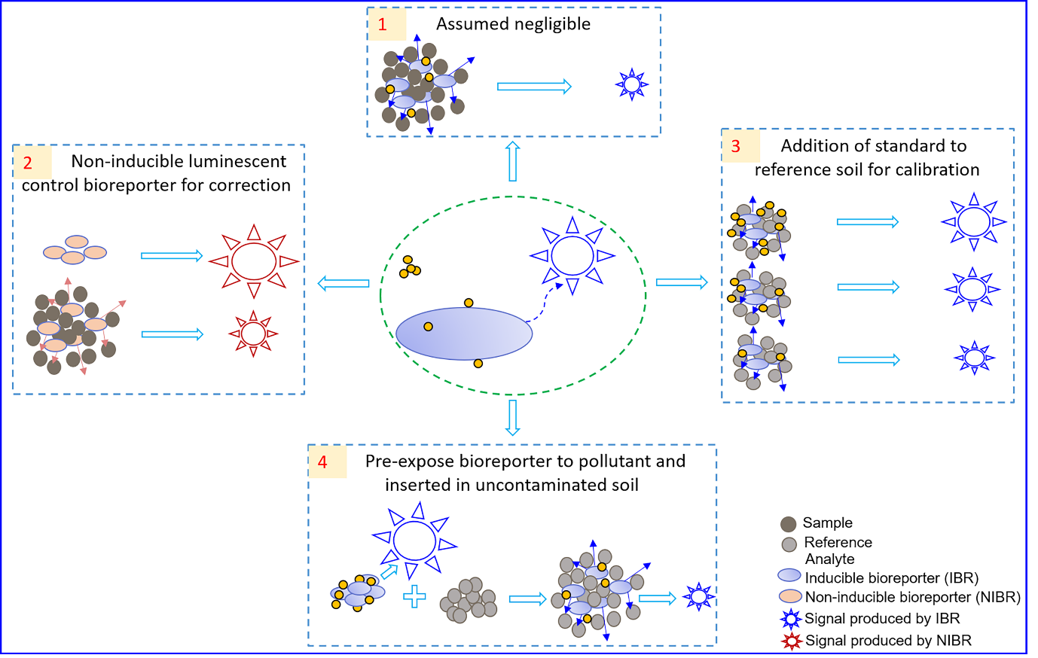
Figure 1. Schematic representing approaches for measuring pollutant bioavailability in soils and sediments using bioreporters that generate an optical signal. Approaches 2–4 result in a correction to compensate for diminution of bioreporter signal by solid particles suspended in the aqueous phase.
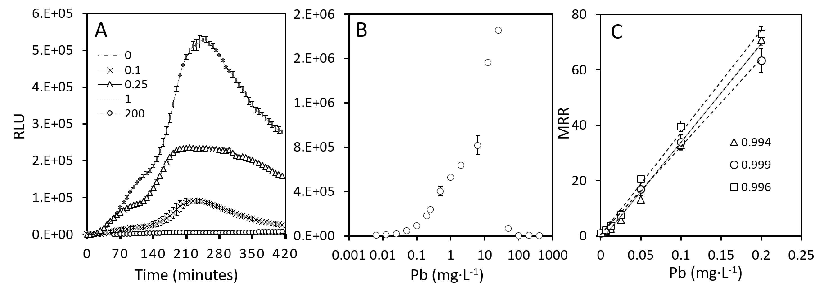Figure 2. Response kinetics of bioreporter strain zntA as a function of (A) time (in RLU) and (B and C) Pb concentration (in MRR). Error bars represent standard deviation based on four parallel experiments. Panel C shows results for multiple repeated experiments over the course of all research reporter herein (see text).
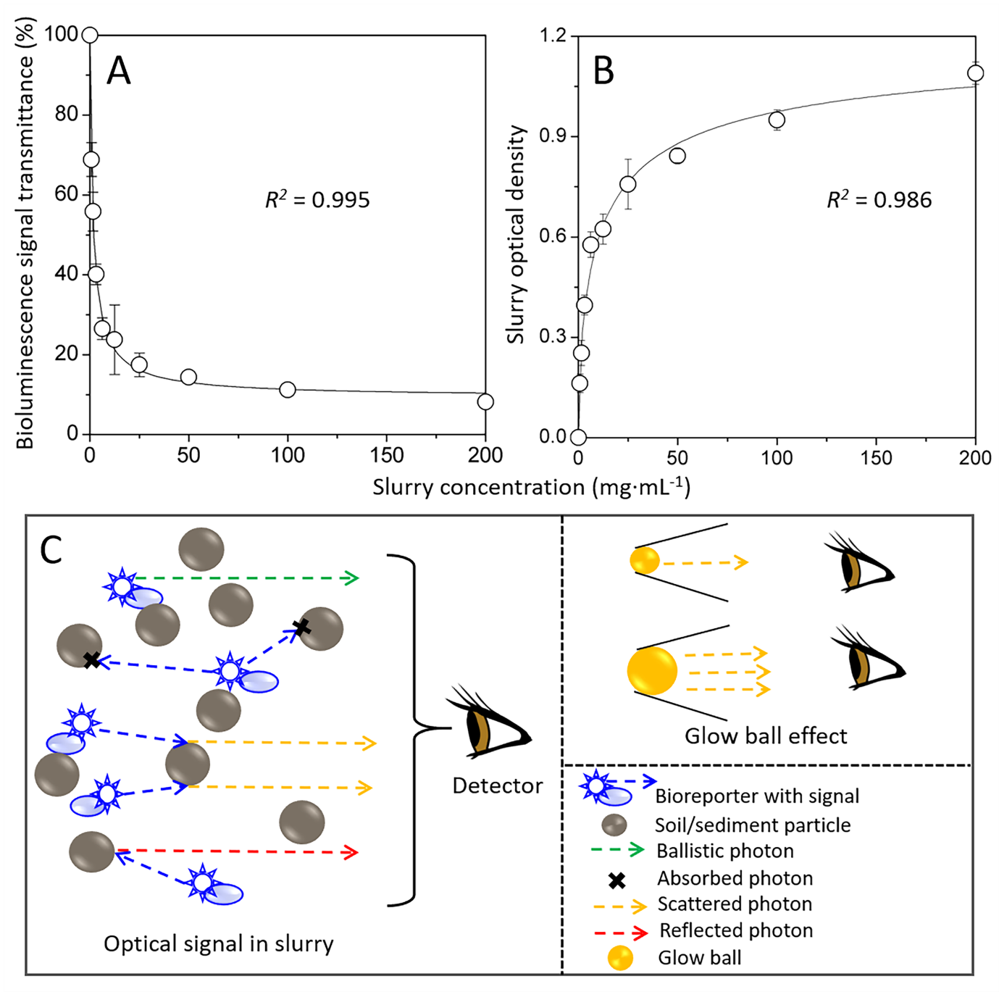
Figure 3. The effect of slurry concentration on (A) %T and (B) OD for composite data of all soils/sediments used in this study; data were composited using a weighted average. Values for R² in panels A and B refer to fitting using eq.s 3a and b. Panel (C) is a schematic showing the primary optical effects governing detection of response; see text for discussion. Error bars represent standard deviation based on a weighted composite of multiple independent experiments performed over the course of this work (N ≥ 8).
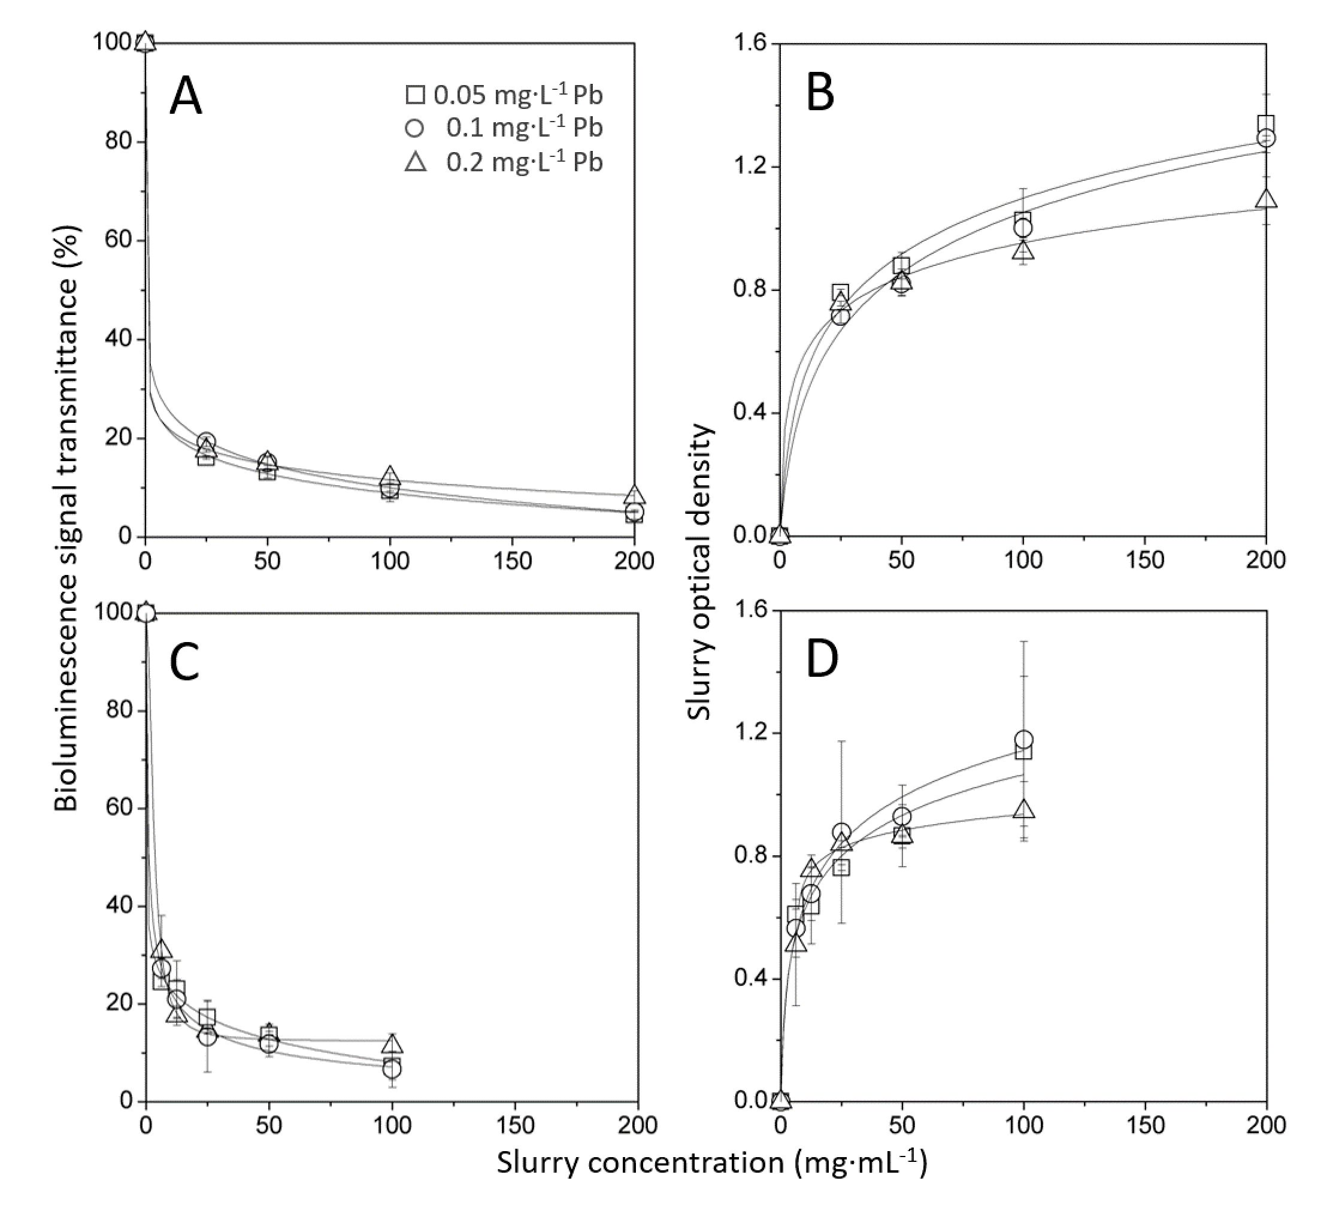
Figure 4. Effect of different light intensities on signal transmission. Panels A and B are for experiments with Soil-2, and panels C and D are for experiments with Sed-1. Error bars represent standard deviation based on a weighted composite of multiple independent experiments performed over the course of this work (N ≥ 4).

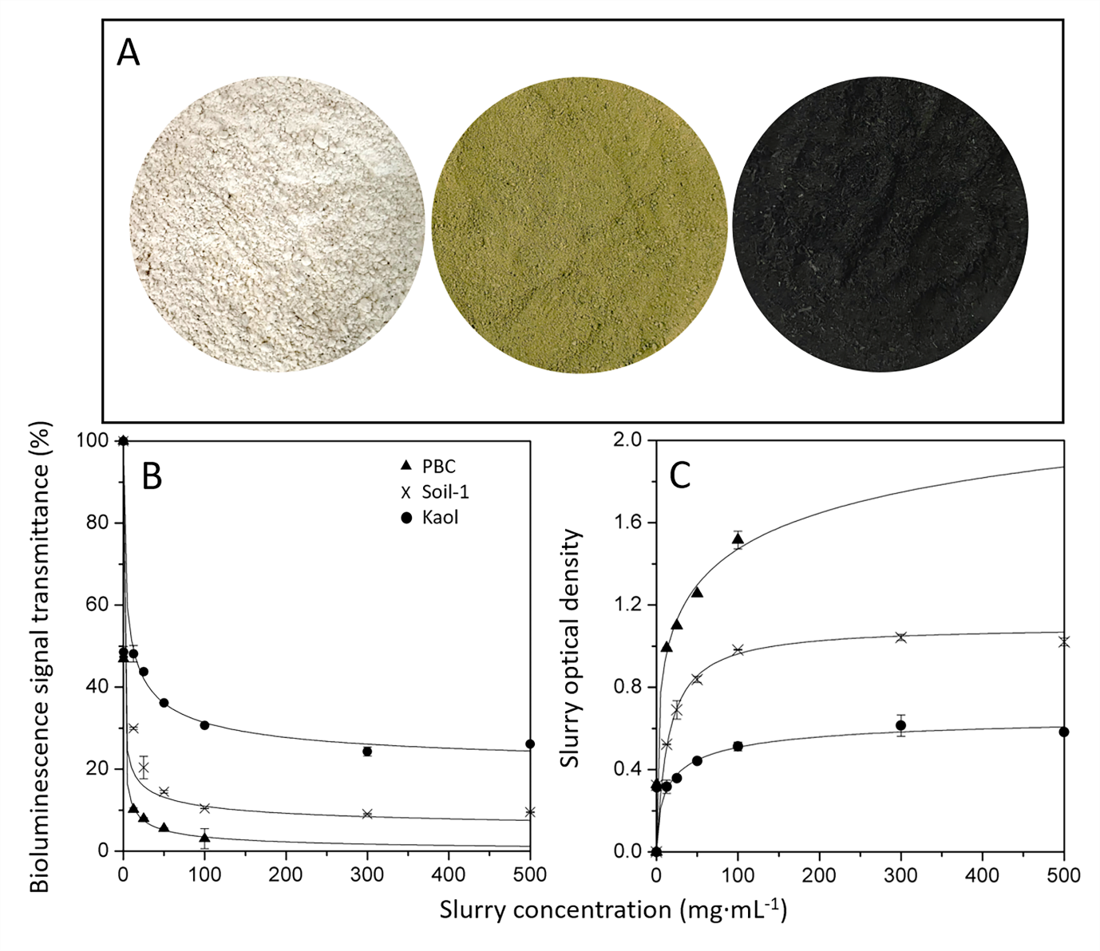
Figure 5. Effect of different geomaterials on light transmission. (A) Photograph showing the difference in the appearance of the materials tested (unmagnified image of material as used). (B) and (C) are %T and OD, respectively, versus SC. Error bars in panels B and C represent standard deviation based on four parallel experiments.

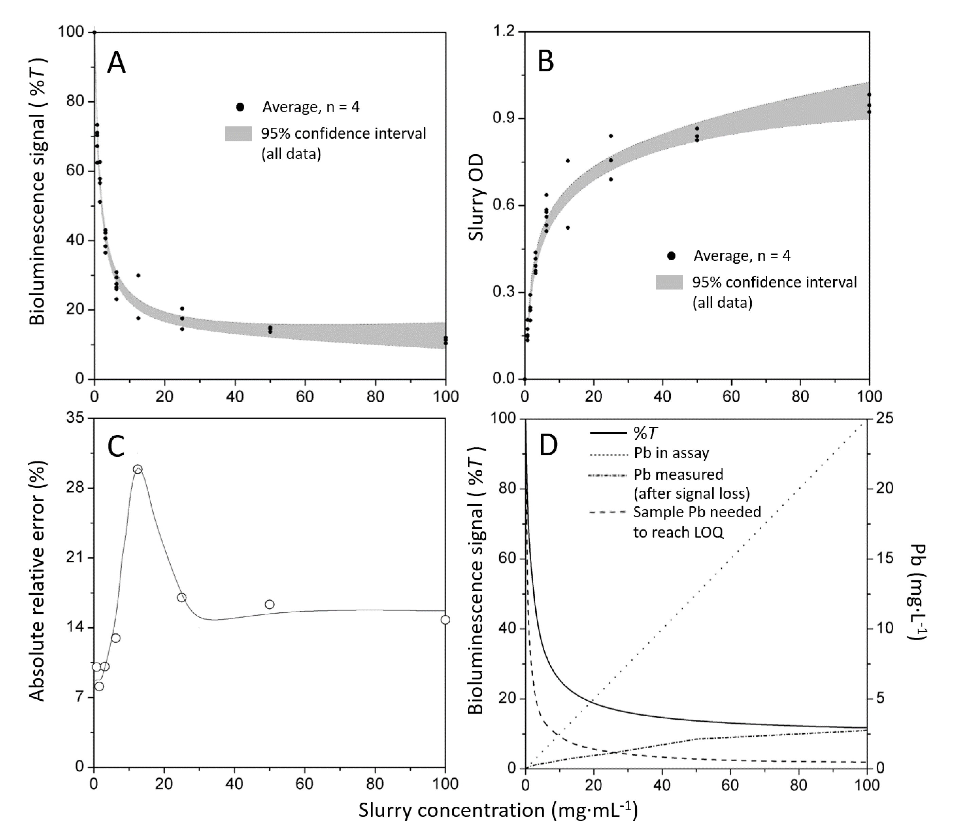
Figure 6. Change, as a function of SC, of (A) %T and (B) OD for all soils/sediments used in this study (average of 4 parallel experiments, dots) and the 95% confidence interval around the average of all data (grey shading). (C) The average relative error (absolute) of bioavailable Pb measured if an average rather than soil/sediment-specific correction factor is used. (D) the interplay between %T, analyte concentration of Pb in assay (assuming 100% bioavailable from soil/sediment sample), the %T) Pb signal actually measured after diminution of bioreporter signal by particles in solution (i.e. without correction for reduction of %T by particles), and the calculated amount of Pb required to be in a soil/sediment sample in order to provide a bioreporter response at the Pb LOQ. A soil/sediment would need to have 500 mg·L⁻¹ Pb to produce the analyte concentration of Pb in assay shown, and greater or lesser amounts of soil/sediment Pb would increase, or decrease, respectively, response slope (linear response range assumed here for purposes of illustration).

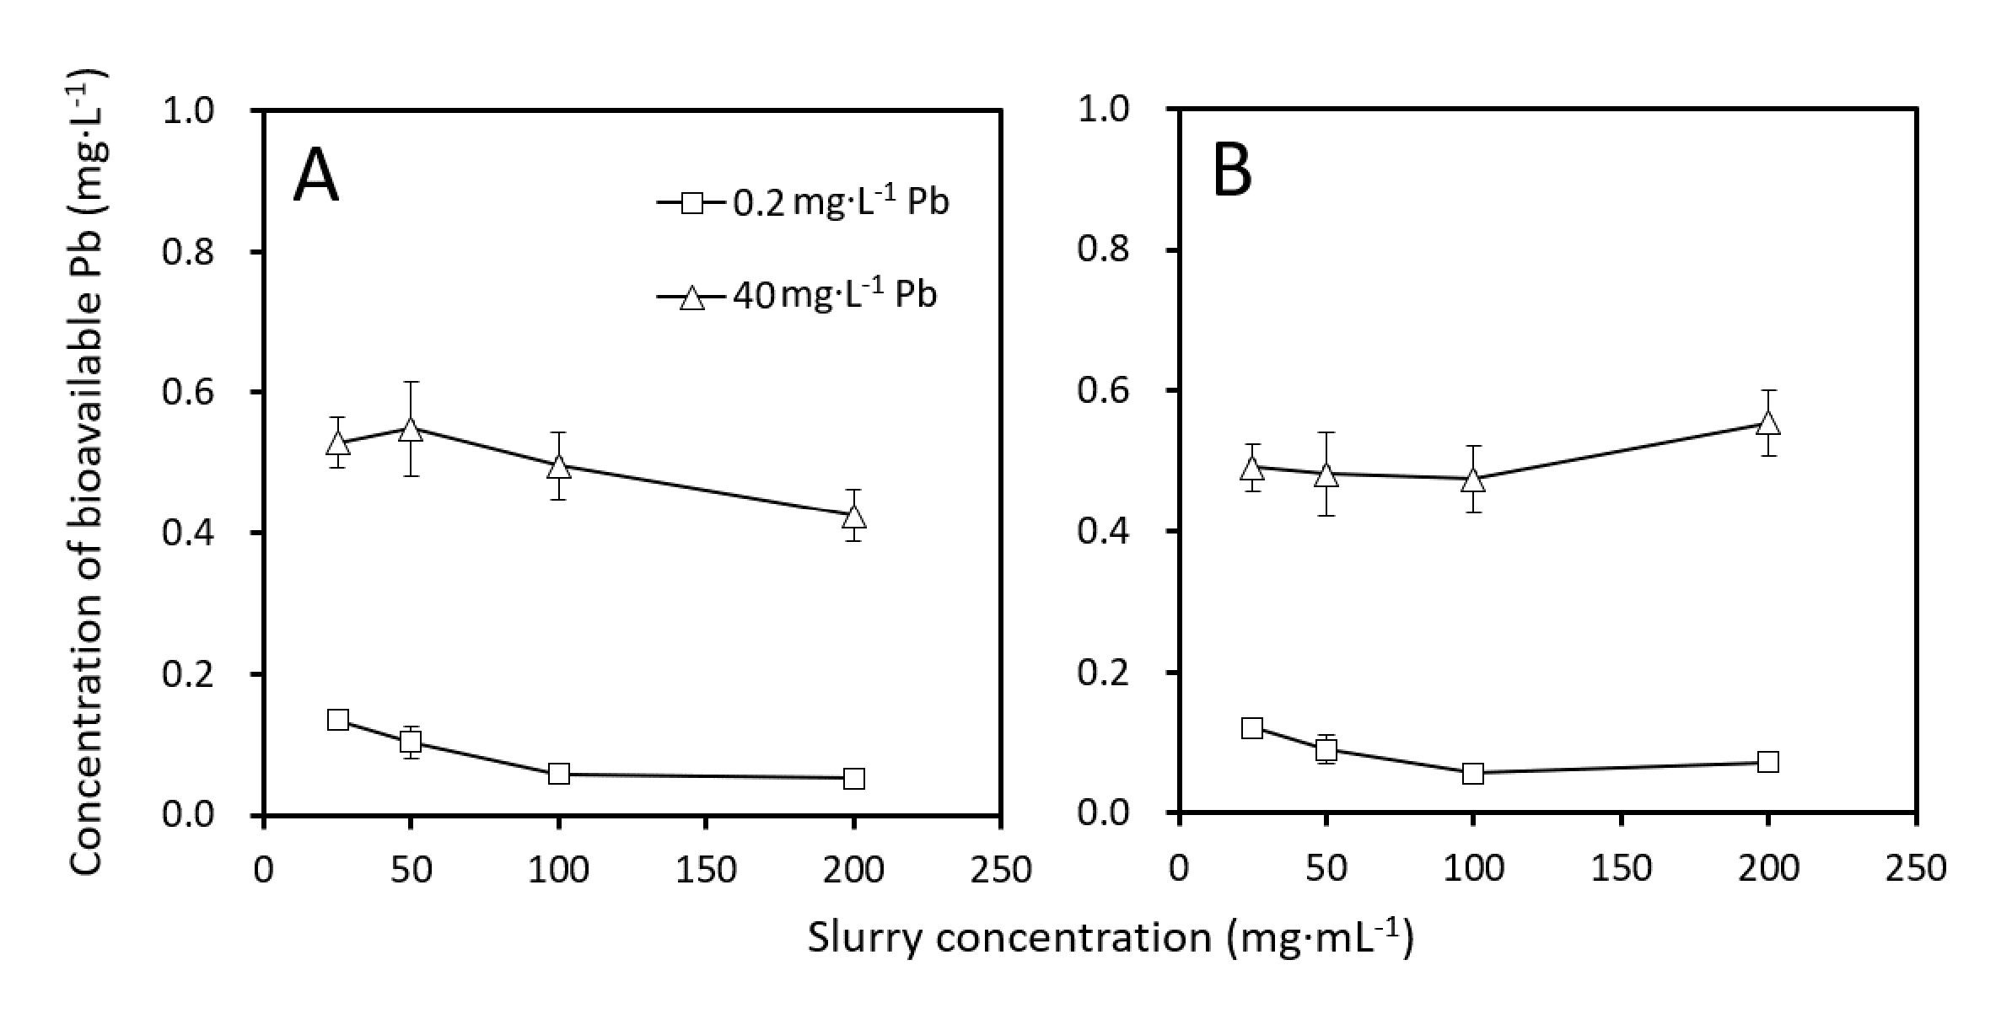
Figure 7. The concentration of measured bioavailable Pb in Soil-2 after signal correction using (A) an average soil/sediment correction factor (Figure 3A), and (B) a soil-specific correction factor. Error bars represent standard deviation based on four parallel experiments.

Table 1
Methods used in bioreporter studies on solid matrices for the correction of bioreporter optical signal transmittance diminution by the solid matrix in environmental samples during the measurement of pollutants bioavailability.
Bioreporter |  | Field application |  | Reference
Host strain | Analyte(s) | Matrix | Approach to optical effects in suspension
E. coli MC1061 | Hg | Sediment | Assumed negligible; no corrections for diminution in transmittance were applied | Lappalainen et al., 2000
E. coli MC1061  R. metallidurans CH34  R. eutropha AE104 | Hg, Cd, Zn,  Cr(VI) | Soil | Assumed negligible | Ivask et al., 2002
E. coli MC1061 | Hg | Soil | Assumed negligible. | Turpeinen et al., 2003
C. metallidurans AE1433 | Pb | Soil | Assumed negligible. | Magrisso et al., 2009
N. europaea ATCC19718 | Ammonium | Soil | Assumed negligible. | Dong et al., 2011
A. baylyi ADP1 | Cr(VI) | Soil | Assumed negligible. | Jiang et al., 2015
E. coli DH5α, S.aureus pI258, E. coli pAD123 | Cd | Milk | Assumed negligible. | Kumar et al., 2017
E. coli K-12 | Tetracyclines | Soil and milk | Assumed negligible. | Muurinen et al., 2019
E. coli DH5α  P. putida N1 | Hg and  PHE | Soil | Assumed negligible. | He et al., 2018
E. coli MC1061  S. aureus RN4220  B. subtilis BR151 | As, Hg, Cd, Pb, Cu | Soil | A non-inducible luminescent control strain (based on E. coli MC1061 host) was used to determine the diminution of bioreporter optical signal from particles in suspension on direct-contact assays. | Hakkila et al., 2004
R. metallidurans AE2515 | Ni | Soil | Genearl approach as per Hakkila et al., 2004. | Everhart et al., 2006
E. coli MC1061 | Hg, As | Soil and sediment | Genearl approach as per Hakkila et al., 2004. | Ivask et al., 2007
P. fluorescens DF57-Cu15 | Cu | Soil | Genearl approach as per Hakkila et al., 2004. | Brandt et al., 2009
B. subtilis BR151  S. aureus RN4220 | Cd, Pb | Soil | Genearl approach as per Hakkila et al., 2004. | Ivask et al., 2004, 2011
E. coli DH5α | As, Cd | Soil | Standards were added to direct-contact assays using control soil (basic calibration curve, this study) or to multiple soil/sediment sample replicates (i.e., via Method of Additions calibration curve) to correct for effects from particles in direct-contact assay suspensions. | Yoon et al., 2016a, b
R. eutropha JMP134-32 | 2,4-D | Soil | Diminution of optical signal from analyte pre-induced bioreporter added to uncontaminated reference soil was used to correct for effects from particles in direct-contact assay suspensions. | Toba and Hay, 2005

Table 2
Parameters associated with curves in Figure 4A–D.
Sample | Pb (mg · L⁻¹) | Maximum curvature |  | %T at highest SC, expt. | %T at highest SC, fit | OD vs, SC slope (at high SC) | R²
 |  | abscissa | ordinate |  |  |  | %T | OD
Soil-2 | 0.05 | 3.42 | 26.9 | 9.41 | 5.06 | 0.0031 | 1.000 | 0.974
 | 0.1 | 4.11 | 30.9 | 9.96 | 5.20 | 0.0033 | 1.000 | 0.983
 | 0.2 | 2.92 | 27.0 | 11.9 | 8.35 | 0.0019 | 1.000 | 0.993
Sed-1 | 0.05 | 3.90 | 28.7 | 7.23 | 8.15 | 0.0051 | 0.999 | 0.960
 | 0.1 | 9.59 | 22.7 | 6.62 | 8.36 | 0.0042 | 0.998 | 0.985
 | 0.2 | 12.2 | 18.3 | 11.3 | 12.4 | 0.0014 | 0.999 | 0.998

Table 3
Parameters associated with curves in Figure 5A
Sample | Pb (mg‧L⁻¹) | Maximum curvature |  | %T at 100 SC, expt. | R²
 |  | abscissa | ordinate
Kaol | 0.2 | 2.32 | 47.90 | 30.69 | 0.948
Soil-1 |  | 5.39 | 24.15 | 10.41 | 0.986
PBC |  | 6.09 | 15.02 | 3.05 | 1.000

One reviewer questioned the word toxicity as relates to this paper. Toxicity testing as we use it here entails exactly that—a measurement of toxic effect such as LD₅₀, the concentration at which 50% of test organisms die. With reference to pollutants we use the words toxic and toxicity as per the dictionary definition (OED, 1989), and specifically with respect to our work herein as used, for instance in O’Connor et al. (2020); US CDC, (2021); Usman et al. (2020) and WHO, (2019).
As taught in undergraduate chemistry curricula, see for example Robinson et al. (2021).
From the research group of Professor Hailong Wang, an internationally renowned expert and pioneer in the field of biochar research. The biochar was produced by pyrolyzing pig carcasses under oxygen-limited conditions for 4 h at a final temperature of 650 °C.
Scattering is a term used in physics, which, as applied to optical signal such as we discuss here, describes a wide range of physical processes wherein light is forced to deviate from a ballistic trajectory by particles in the aqueous medium through which it passes. Technically, scattering may also include deviation via reflection. Many texts treat so-called mirror-like or specular reflections differently than diffuse reflections from scattered light. Our results suggest that the effects of specular reflection within the particle field are more important in glow ball injection of light to the detector than are diffuse/scattered reflections.
We were unable to capture photos that adequately convey the differences in color for these soil and sediment samples, however, the differences are readily discernible by eye in bright natural light.

