Changes in Corneal Biomechanical Properties in Photorefractive Keratectomy Followed by two accelerated Collagen Cross-Linking Energy Doses in Rabbit Eyes

FangJun Bao ^{1,2}, Wen Chen ¹, XiaoBo Zheng ¹, YuanYuan Miao ^{1, 2}, ManMan Zhu ¹, Stephen Akiti ¹, YiXin Li ¹, ZiHan Weng ¹, JunJie Wang ^{1,2}, PeiPei Zhang ¹, ShiHao Chen ^{1,2}*, Ahmed Elsheikh ^{3,4,5}

FangJun Bao and Wen Chen and are co-first authors of the article

Affiliations
¹ Eye Hospital, WenZhou Medical University, Wenzhou 325027, China
² The institution of ocular biomechanics, Wenzhou Medical University, Wenzhou 325027, China
³ School of Engineering, University of Liverpool, Liverpool L69 3GH, UK
⁴ National Institute for Health Research (NIHR) Biomedical Research Centre for Ophthalmology, Moorfields Eye Hospital NHS Foundation Trust and UCL Institute of Ophthalmology, London, UK
⁵ Beijing Advanced Innovation Center for Biomedical Engineering, Beihang University, Beijing, 100083, China

Conflict of Interest
The authors indicate no financial conflict of interest.

Running Head
Changes in Corneal Biomechanical Properties in PRK Followed by two accelerated CXL

Financial Support

This study was supported by the National Natural Science Foundation of China (31771020, 82001924), Zhejiang Provincial Natural Science Foundation of China under Grant (LY18A020008, LY20H120001, LQ20A020008), XinMiao Talents Program of Zhejiang Province (2020R413086), the Projects of Medical and Health Technology Development Program in Zhejiang Province (2019RC056, 2018KY541, 2016ZHB012), Science and Technology Plan Project of Wenzhou Science and Technology Bureau (Y2020354, Y20180172, Y20170198, Y20170792) and the General Projects of Department of Education of Zhejiang Province (Y201839651).

Corresponding author
Professor ShiHao Chen
No. 270 Xueyuan West Road, WenZhou City, ZheJiang Prov, 325027, China
e-mail: chenle@rocketmail.com
Tel: 86-577-88068862
Fax: 86-577-88824115

Highlights:
The biomechanical losses caused by PRK can not be completely compensated by ACXL, the increase ratio in 1.8J Xtra group was lower than 2.7J Xtra group.
Abstract
Purpose: To evaluate whether photorefractive keratectomy (PRK), combined with the two commonly delivered energy doses in accelerated corneal crosslinking (ACXL), could help the cornea restore its preoperative stiffness level.
Methods: 72 corneas of 36 healthy white Japanese rabbits were randomly divided into four equal groups. The groups included a blank control group (Co group) and three that have undergone PRK. After tissue ablation, one of the latter three groups (PRK group) was left untreated while the other two were exposed to riboflavin (0.22% concentration by volume) and UVA (370nm) with the same irradiation (30mW/cm²) but different collagen crosslinking energy doses of 1.8 J/cm² (PXL group) and 2.7 J/cm² (PXH group). Dynamic Scheimpflug analyzer (Corvis ST) measurements of stiffness parameter at first applanation (SP-A1), Stress-Strain Index (SSI) and other dynamic corneal response (DCR) parameters were taken 3 days pre-op and one month post-op. Subsequently, ex-vivo inflation testing was performed and the tangent modulus of each specimen was estimated using an inverse analysis process.
Results: In comparison to the control group, the tangent modulus at a stress of 10kPa decreased by 8.9% after the PRK and increased by 10.6% and 22.4% in the PXL and PXH groups respectively. SP-A1 decreased postoperatively in the PRK group (p< 0.05) indicating an overall stiffness reduction of -7.4, -3.5 and -5.3 mmHg/mm in PRK, PXL and PXH groups, respectively. The material stiffness parameter SSI remained almost unchanged in the PRK group (p= 0.989), increased slightly in the PXL group (8.3%, p= 0.077), and increased significantly in the PXH group (11.1%, p< 0.05).
Conclusions: We showed that biomechanical deterioration following PRK was significant and could not be fully compensated by ACXL with either 1.8J/cm² and 2.7J/cm² doses. The increase value of corneal overall stiffness was higher in ACXL at 2.7J/cm² energy than in 1.8J/cm² group.

Keywords; corneal crosslinking; cornea; photorefractive keratectomy; biomechanics; Inverse Analysis: FE simulations
Introduction
Laser vision correction (LVC) procedures reduce the cornea’s overall stiffness due to the loss of ablated tissue and in some procedures, such as LASIK and SMILE, tissue separation. Several factors, such as high myopic corrections, thin corneas and residual corneal thickness below 250µm, which lead to high percentages of tissue loss, are considered major risk factors for corneal mechanical instability and progressive ectasia ¹⁻³ ^{4,5}.

It has been proposed to combine accelerated corneal cross-linking (ACXL) with the LVC procedures – in what is labelled as the Xtra surgeries – to counteract the stiffness loss ^{6,7}. ACXL involves photopolymerization of corneal collagen by the combined action of a photosensitizing substance (riboflavin) and ultraviolet-A (UVA) light ⁸. The stiffness increase caused by ACXL through photopolymerization is expected to reduce the likelihood of, or slow down, the progression of corneal ectasia. ACXL was first performed in combination with LASIK (LASIK Xtra, a term introduced by Avedro, Inc., Waltham, MA, USA) before subsequently being used in PRK (PRK Xtra) and SMILE (SMILE Xtra) ⁹⁻¹¹.

Currently, there is no scientifically backed consensus on the effectiveness of combining ACXL protocols with LVC procedures. The UVA irradiation protocols also vary much in both duration and power of irradiation – in LASIK-Xtra, for example, surgeries have adopted a range of irradiation energy between 1.35 and 5.4 J/cm² ¹²⁻¹⁴, while in PRK Xtra, 30 mW/cm² irradiation with a total energy dose of 2.7 J/cm² was most commonly used ^{7,10,15}. In theory, the higher the energy, the greater the strengthening effect produced by ACXL. However, this could also adversely increase corneal haze, which is especially undesirable in PRK where patients expect a fast visual recovery ¹⁶.

In PRK, it is believed that corneal biomechanics change significantly less than in LASIK and SMILE where the separation of the cap and flap cause additional stiffness losses. For this reason, it has been recommended to limit the ACXL energy to 2.7 J/ cm² in PRK Xtra ^{7,17}. However, the optimal energy required for PRK Xtra is still unknown, and there has been no comparison between the various protocols in terms of safety and efficacy. This paper seeks to address this need through an assessment of the changes in corneal stiffness caused by two PRK Xtra protocols with energy doses of 1.8 J/cm² and 2.7 J/cm². The study relied on mechanical inflation testing and stiffness estimates produced by the Corvis ST (CVS; OCULUS, Wetzlar, Germany). The tests were carried out on rabbit corneas due to their similar biomechanical behavior to human corneal tissue ^{18,19} and because of the lack of human donor corneas available for experimental research.

Materials and Methods
Specimens
Thirty-six white Japanese rabbits (3-4 kg, aged 4-5 months), obtained from the Animal Breeding Unit of Wenzhou Medical University, were housed in individual cages where the temperature and humidity were well controlled. The 72 right and left eyes of the rabbits were randomly divided into four groups (namely PRK group, PXL group, PXH group and Co group) of 18 eyes each. The former three groups underwent PRK, while the Co group was a blank control group as described in Table 1. A process was followed to ensure that no bilateral eyes from the same rabbit were included in the same group. Before the experiment, the rabbits were allowed to acclimatize for at least one week. All animals were treated in agreement with the ARVO Statement for the Use of Animals in Ophthalmic and Vision Research and with the approval of the Animal Care and Ethics Committee of the Eye Hospital, Wenzhou Medical University.

Surgical Techniques
Photorefractive Keratectomy (PRK)
General anaesthesia was administered by intramuscular injection of pentobarbital sodium (Merck, Darmstadt, Germany; 30mg/kg) and SU-MIAN-XIN (Veterinary Institute at University of Munitions, Changchun, China) with 0.2 ml/kg concentration to all eyes in the PRK, PXL and PXH groups. After placing a wire eyelid speculum, tissue ablation was performed with the MEL 90 excimer laser (Carl Zeiss Meditec, Jena, Germany). The epithelium was removed using the PTK mode of the excimer laser with a diameter of 8.2 mm and a depth of 45μm. This figure was compatible with a tPRK procedure with a similar setup, which would require an ablation zone diameter of 8.12 mm. The ametropic laser, in the PRK mode, was then used to ablate stromal tissue with a maximum ablation depth of 82μm, over an optical zone with 6.5mm diameter, in order to provide a refractive error correction of -6.0D. This error correction was selected as it altered corneal biomechanical properties, but not excessively. It was also similar to those adopted in earlier studies including those by Wu and Lee, in which mean refractive error corrections between -5.63D and -6.22D were considered in the xtra and non-xtra versions of LASIK, SMILE and tPRK ^{10,20,21}. Both PTK and PRK processes were performed with a 500-Hz infrared eye tracker centred on the pupil. After surgery, fluorometholone 0.1% (Flumetholon; Santen, Osaka, Japan) and topical levofloxacin 0.5% (Cravit; Santen, Osaka, Japan) were applied twice a day for one month in PRK group.

PRK with Accelerated Collagen Crosslinking
After completion of the excimer laser ablation, the Xtra groups were treated with 0.22% riboflavin drops (VibeX Xtra, Avedro, America) placed on the corneal surface and carefully spread with an irrigating cannula for 90 seconds. The corneal surface was then rinsed thoroughly with 30 cc of a chilled balanced salt solution (Guojing Pharmaceutical , Lishui , China ). A 365 nm wavelength and 9.0 mm diameter UVA beam was continuously applied to the cornea in a uniform circular pattern by a UVA irradiation system (CL-01, SiHaiTong Co, Suzhou, China). At a power of 30 mW/cm², the UVA exposure lasted 60 or 90 seconds, to deliver a total energy of 1.8 or 2.7 J/cm², in the PXL and PXH groups, respectively. After surgery, fluorometholone 0.1% (Flumetholon; Santen, Osaka, Japan) and topical levofloxacin 0.5% (Cravit; Santen, Osaka, Japan) were applied four times a day for one month.

Corvis ST biomechanical Testing
All rabbits were tested on Corvis ST 3 days before surgeries (all four groups) and 1 month after (PRK, PXL, PXH groups). The rabbits were anaesthetized (following the steps described above) and the head was placed on the lower jaw elevator of the Corvis ST. A wire eyelid speculum was positioned in the eye and the corneal plane was aligned with the measuring head of the instrument. After focusing adjustments, when the four reflection points on the cornea were smallest and sharpest, the airpuff was released and outputs including the central corneal thickness (CCT), biomechanically corrected intraocular pressure (bIOP), the stiffness parameter at first applanation (SP-A1), the integrated inverse radius (IIR), the deformation amplitude at apex (DA), the DA ratio between values measured at apex and 2mm away (DARatio2mm) and the stress-strain index (SSI) were recorded.

SP-A1 was calculated as the difference between the adjusted air puff pressure at first applanation (AdjAP1) and bIOP divided by the defection amplitude at the first applanation (A1DeflAmp) ²² as shown in Figure 1.
SP-A1 = (adjAP1 – bIOP) / (A1DeflAmp) Equation 1
IIR was the integration result of inverse radius values from first to second applanation events ⁷. Also DA and its ratio between values at the apex and 2mm from the apex (DARatio2mm) were obtained ²³, SSI was developed as a measure of the cornea’s material stiffness that was intended to be independent of tissue thickness and IOP ²⁴. Each eye was measured twice, and the mean value of each dynamic corneal response (DCR) parameter was used in statistical analysis.

Biomechanical Inflation Testing
A week after the Corvis ST testing, the rabbits were sacrificed by intravenous injection pentobarbital sodium overdose of 100mg/kg and the eyes were immediately enucleated. The corneas were separated along with a 3-mm wide ring of scleral tissue, mounted onto a custom-built pressure chamber (Figure 2A) and subjected, within 3 hours' postmortem, to inflation testing as described in a previous study ²⁵ (Figure 2B). Three cameras (EOS 60D, Canon, Inc. Tokyo, Japan) positioned at angles 75°, 195° and 316° relative to the right horizontal direction were used to capture side images (Figure 1A) of each specimen at different loading levels (0, 4, 8 mmHg, etc). The first set of side images were used to determine the initial shape of specimen, which was needed in constructing eye-specific numerical models. Before testing, the specimens were conditioned in three cycles of loading and unloading up to a pressure of 30 mmHg applied at a rate of 0.10 mmHg/s. A recovery time of 90 seconds was allowed between each two successive loading cycles to ensure the behavior was free of effect of the strain history of repeated loading cycles ^{26,27}. Finally, the specimens underwent a fourth loading cycle up to 30 mmHg at the same loading rate, the results of which were used in subsequent inverse analysis to determine the material properties of the tissue.

Inverse Analysis
The pressure-deformation results obtained from the inflation tests were used in an inverse analysis process to determine the cornea’s stress-strain behavior ^{25,27}. Seventy-two cornea-specific finite element (FE) models, each with 1728 fifteen-noded triangular prism elements (C3D15H), were constructed for analysis on the Abaqus FE software package (Dassault Systèmes Simulia Corp., Rhode Island, USA). The models adopted the thickness and limbal diameter measurements, and the topography derived from the cross-sectional images of the pecimens under initial load (2.0 mmHg) ²⁵ (Figure 1C). A first-order hyperelastic Ogden constitutive model was assumed to represent corneal material behavior as indicated in earlier studies ^{25,28,29} :
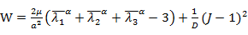 (1)
In Ogden model, W represents the strain energy per unit volume, the deviatoric principal stretches equal by (k=1, 2, 3) and λ₁, λ₂, λ₃ are the principal stretches, J = λ₁λ₂λ₃. Material parameters μ and α are the strain hardening exponent and the shear modulus, respectively, to be determined for each tested cornea from the inverse analysis exercise. D is the compressibility parameter expressed by 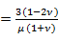 and calculated with the corneal tissue assumed to be nearly incompressible ³⁰,³¹ and a Poisson's ratio, ν, of 0.48 ²⁵.
The FE models were subjected to inverse analysis using both Abaqus and LS-OPT (Livermore Software Technology Corp, CA, USA), to determine the optimal values of the material parameters μ and α for each cornea. This was achieved by minimizing the root mean square (RMS) of mismatch between the experimentally measured and the numerically predicted apical displacements according to the following objective function (similar to processes adopted in previous studies ^{25,29}):
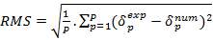 (2)
where P is the total number of pressure levels at which the RMS is calculated (i.e. at 2 mmHg intervals up to 30 mmHg), and and represent the experimental and numerical deformation of corneal apex at each pressure level. Within the inverse analysis process, parameters µ and α could have values between 0.001 and 0.1, and between 50 and 250, respectively. This range was found suitable for all corneas tested in this study.

Statistical analysis
Statistical analysis was performed using SPSS 20.0 (SPSS Inc., Chicago, USA). Kolmogorov–Smirnov (K–S) normality test was applied to test the normality of distribution of the rabbits' parameters in vivo. CVS parameters and tangent modulus obtained from the four specimen groups were compared by one-way ANOVA test. Differences were considered statistically significant when the P-value was less than 0.05. The results are expressed as the mean ± standard deviation (SD).

Results
Corvis parameters analysis
Table 2 showed the four groups (PRK, PXL, PXH and Co) were closely matched in CCT (F= 1.834, p= 0.150) and bIOP (F= 0.583, p= 0.628). CCT decreased significantly (p< 0.01) post-surgery, but there were no significant differences in post-surgery CCT among the three surgery groups (p= 0.684). The bIOP decreased in both PRK and PXL group (p< 0.05) and did not change in PXH group (p= 0.517).

The corneal biomechanical metrics measured by the CVS pre and post-operation are listed in Table 2. There were no significant differences (p> 0.05) in SP-A1, IIR, DA, DARatio2mm and SSI among the four groups before surgery. However, SP-A1 decreased postoperatively compared with pre-surgery values in the PRK group (p< 0.05), indicating overall stiffness reduction. The change in SP-A1 was large after PRK (-7.4±13.5 mmHg/mm), smaller in the PXH group (-5.3±18.9 mmHg/mm) and smallest in the PXL group (-3.5±16.2 mmHg/mm), Table 2. Both IIR and DA underwent small and non-statistical variations between pre- and post-surgery stages in all three surgery groups (all p> 0.05). Another evidence of overall stiffness reduction was observed in the significant increases in DARatio2mm post-surgery compared with pre-surgery in PRK, PXL and PXH groups (p< 0.05). The change in DARatio2mm from pre- to post-surgery was highest in PRK (0.5±0.8 mm), followed by PXL (0.1±0.7 mm) and PXH (0.0±0.7 mm). Further, the results in Table 2 showed that while SSI indicated significant material stiffness increases in the PXH group from pre- to post-surgery (p< 0.05), the changes remained insignificant in the PXL group (p= 0.077) and PRK group (p= 0.989).

Inverse analysis of inflation test results
The mean diameter of the rabbit corneas tested was 13.06±0.49 mm (range: 12.20-14.20 mm). A clear difference in pressure-displacement behavior at corneal apex was observed among the four groups, Figure 3. Inverse analysis was used in this study to derive a material constitutive model – in particular the material parameters μ and α– for each cornea that provided the best possible match (lowest RMS) with experimental behavior. With μ and α determined (Table 3), the stress-strain (σ-ε) relationship, and hence the tangent modulus (Et = dσ/dε) at any stress level, were obtained ²⁴. The mean and standard deviation of stress-strain behavior for each specimen group are presented in Figure 4, while Et at three stress levels of 6kPa, 8kPa and 10kPa is plotted in Figure 5. Significant differences were found in Et between the PRK group and the 2.7J Xtra group (PXH, p= 0.045) in the 10kPa stress level, while the differences were not significant (all p> 0.05) between other group pairs (Figure 5). All differences in Et between the PRK group and each of the PXL and PXH groups, or between the two Xtra groups, at other stress levels were not significant.

Discussion
Although rare, iatrogenic postoperative ectasia represents a major complication after laser vision correction (LVC) ¹⁴. Reports show a prevalence ranging from 0.02% to 0.6%, with a higher incidence post LASIK than post PRK.^{1,32} Accelerated crosslinking of corneal tissue (ACXL) after LVC surgeries has been introduced in order to restore some of the biomechanical losses caused by the surgeires and hence prevent the development of iatrogenic ectasia ³³. This study showed that the biomechanical deterioration caused by PRK could not be compensated by ACXL with either 1.8J/cm² and 2.7J/cm² doses.

The current study looked at the effectiveness of combining ACXL with PRK, in the PRK Xtra technique, in restoring corneal stiffness to the pre-surgery level. Attention was given to ACXL with two energy doses (1.8 J/cm² and 2.7 J/cm²), both of which were delivered with one irradiation intensity level (30 mW/cm²). Compared with the Co group, the study showed that the reduction in material stiffness (as measured by the tangent modulus, Et) following PRK was small (-8.8%, -8.9%, -8.9% in Et at stresses of 6, 8, 10 kPa, respectively). With ACXL, both Xtra groups demonstrated corresponding increased material stiffness, compared with the PRK group, by 25.5%, 22.9%, 21.4% with 1.8 J/cm² energy dose (PXL group), and 35.4%, 34.7%, 34.3% with 2.7 J/cm² energy dose (PXH group).

It is important to note that the overall stiffness reductions caused by PRK was mainly due to losses in “geometric” stiffness, which in turn resulted from the corneal thickness reductions – CCT reduced by 23.6±1.7%, 22.7±1.8% and 23.0±1.4%, in PRK, PXL and PXH groups, respectively. On the other hand, the stiffness increases due to ACXL was in the tissue’s “material” stiffness, which has been illustrated in Et increases. With both energy doses considered, the material stiffness increases due to ACXL exceeded and more than compensated for the geometric stiffness losses due to tissue ablation. This finding is consistent with Spiru et al., who demonstrated that the corneal biomechanical integrity is less affected with PRK ³⁴.

Earlier studies reported that corneal biomechanical integrity was less affected by PRK than by LASIK or SMILE ³⁵. This difference could be due to the additional tissue separation, introduced while producing the LASIK flap or the SMILE cap, which does not feature in PRK. Meanwhile, considering that the ACXL's affects the epithelium through the UVA absorption/filtering, from a biomechanical point of view, PRK Xtra may be safer than LASIK Xtra and SMILE Xtra ^{36,37}, and there are no reported cases of ectasia after PRK Xtra procedures yet. Besides, excessive ACXL might induce corneal flattening, possibly contributing to undesirable refractive outcome ^{38,39}.

Torres-Netto et al. reported that ACXL caused average stiffening of 44.5% in corneas that underwent PRK surface ablation to correct -10.00 D spherical and -0.75 D cylindrical errors ⁶. The difference between our results and Torres-Netto’s findings could be related to various factors. Torres-Netto used a higher refractive error correction (-10.0/-0.75D vs -6.0D), lower irradiance (9 mW/cm² vs 30 mW/cm²) and higher total energy (5.4 J/cm² vs 1.8 J/cm² or 2.7 J/cm²). These differences may have led to their PRK group demonstrating larger stiffness losses, while the PRK Xtra group exhibited a higher proportion of enhanced stiffness. In addition the experimental platforms employed in the studies were different – while in our study, inflation testing was used alongside the Corvis ST DCRs, their study relied on uniaxial strip tests that has a number of inherent deficiencies related to the straightening of the naturally curved tissue, the severance of the collagen fibrils that cross the strip edges and the unphysiologic uniaxial loading conditions ^{40,41}.

The changes in SP-A1 and DARatio2mm, obtained in vivo, were mostly compatible with the ex-vivo inflation test results. There were significant reductions in SP-A1 and increases in DARatio2mm post-surgery in the PRK group, both indicating overall stiffness losses. Meanwhile, the changes in these two parameters became less in both the PXL and PXH groups, indicating overall stiffness increases with combined PRK-ACXL procedures (still less then the Co group). However, this outcome indicated higher stiffening effect in this study compared to that of Lee et al., who found that SP-A1 decreased postoperatively in both PRK and PRK Xtra groups, indicating that ACXL was not sufficient to restore the cornea’s overall stiffness to the pre-surgery levels.⁷

There are several possible explanations for this result. Firstly, SP-A1 is calculated while considering corneal geometrical parameters, corneal deformation and intraocular pressure ²². Due to variations in the ratio of corneal thickness loss, corneal deformation under Corvis ST would be different and may result in this mismatch. ⁴². Secondly, significant stomal fibril remodelling occurrs between days 14 and 28 after PRK surgery, and subsequently an increased elastic modulus of the anterior stroma was observed during this period ^{43,44}. As Lee et al. used biomechanical parameters measured six months post surgery, while in our study, the measurmentrs were taken one month post surgery, this difference may explain some of the outcome incompatibility reported above. Thirdly, differences between the human corneas in Lee’s study and the rabbit corneas tested in our experiments may contribute to the difference in study outcomes.

The limitations of our study include the use of rabbit corneas instead of human eyes and the possible influence of this on the Corvis ST measurements. Rabbit eyes have been shown in the past to exhibit similar biomechanical behavior to human eyes studies ^{45,46}, and it has been necessary to use them in this research because of the difficulties in acquiring human eyes in sufficient numbers. Rabbit eyes have also been used extensively in crosslinking research ^{47,48}. By having a control group, we believe that our experiments present a comparatively equivalent effect of ACXL to that on human eyes. Another limitation was that the cross-linking effect would be different in thick and thin corneas, smaller in thick corneas and larger in thin corneas. Therefore, even if we maintained the same percentage of tissue altered (PTA) in these corneas (which would lead to different refractive error corrections), the cross-linking effect on biomechanics would still not be constant. For this reason, we have elected to maintain a constant refractive error correction in our study.

Overall, our tests showed that although the CXL-induced stiffness increases were significant, they were less than the stiffness losses caused by PRK even when 2.7 J/cm² energy was used. With the availability of in-vivo corneal biomechanical indeces – such as the Corvis ST DCRs – the amount of irradiation employed could be optimized depending on the type of surgery and the patient-specific corneal biomechanical behavior pre-operatively.

References
1. Sorkin N, Kaiserman I, Domniz Y, Sela T, Munzer G, Varssano D. Risk Assessment for Corneal Ectasia following Photorefractive Keratectomy. J Ophthalmol 2017; 2017: 2434830.
2. Chan C, Saad A, Randleman JB, Harissi-Dagher M, Chua D, Qazi M, Saragoussi JJ, Shetty R, Ancel JM, Ang R, Reinstein DZ, Gatinel D. Analysis of cases and accuracy of 3 risk scoring systems in predicting ectasia after laser in situ keratomileusis. J Cataract Refract Surg 2018; 44: 979-92.
3. Randleman JB, Woodward M, Lynn MJ, Stulting RD. Risk assessment for ectasia after corneal refractive surgery. Ophthalmology 2008; 115: 37-50.
4. Tervo TM. Iatrogenic keratectasia after laser in situ keratomileusis. J Cataract Refract Surg 2001; 27: 490-1.
5. Chan CC, Boxer Wachler BS. Corneal ectasia and refractive surgery. Int Ophthalmol Clin 2006; 46: 13-25.
6. Torres-Netto EA, Spiru B, Kling S, Gilardoni F, Lazaridis A, Sekundo W, Hafezi F. Similar Biomechanical Cross-linking Effect After SMILE and PRK in Human Corneas in an Ex Vivo Model for Postoperative Ectasia. J Refract Surg 2020; 36: 49-54.
7. Lee H, Roberts CJ, Ambrosio R, Jr., Elsheikh A, Kang DSY, Kim TI. Effect of accelerated corneal crosslinking combined with transepithelial photorefractive keratectomy on dynamic corneal response parameters and biomechanically corrected intraocular pressure measured with a dynamic Scheimpflug analyzer in healthy myopic patients. J Cataract Refract Surg 2017; 43: 937-45.
8. Wollensak G, Spoerl E, Seiler T. Riboflavin/ultraviolet-a-induced collagen crosslinking for the treatment of keratoconus. Am J Ophthalmol 2003; 135: 620-7.
9. Kanellopoulos AJ, Asimellis G. Combined laser in situ keratomileusis and prophylactic high-fluence corneal collagen crosslinking for high myopia: two-year safety and efficacy. J Cataract Refract Surg 2015; 41: 1426-33.
10. Lee H, Yong Kang DS, Ha BJ, Choi JY, Kim EK, Seo KY, Kim TI. Comparison of Outcomes Between Combined Transepithelial Photorefractive Keratectomy With and Without Accelerated Corneal Collagen Cross-Linking: A 1-Year Study. Cornea 2017; 36: 1213-20.
11. Ganesh S, Brar S. Clinical Outcomes of Small Incision Lenticule Extraction with Accelerated Cross-Linking (ReLEx SMILE Xtra) in Patients with Thin Corneas and Borderline Topography. J Ophthalmol 2015; 2015: 263412.
12. Ng AL, Kwok PS, Wu RT, Jhanji V, Woo VC, Chan TC. Comparison of the Demarcation Line on ASOCT After Simultaneous LASIK and Different Protocols of Accelerated Collagen Crosslinking: A Bilateral Eye Randomized Study. Cornea 2017; 36: 74-7.
13. Tomita M. Combined laser in-situ keratomileusis and accelerated corneal cross-linking: an update. Curr Opin Ophthalmol 2016; 27: 304-10.
14. Lim EWL, Lim L. Review of Laser Vision Correction (LASIK, PRK and SMILE) with Simultaneous Accelerated Corneal Crosslinking - Long-term Results. Curr Eye Res 2019; 44: 1171-80.
15. Sachdev GS, Ramamurthy S, Dandapani R. Comparative analysis of safety and efficacy of photorefractive keratectomy versus photorefractive keratectomy combined with crosslinking. Clin Ophthalmol 2018; 12: 783-90.
16. Ohana O, Kaiserman I, Domniz Y, Cohen E, Franco O, Sela T, Munzer G, Varssano D. Outcomes of simultaneous photorefractive keratectomy and collagen crosslinking. Can J Ophthalmol 2018; 53: 523-8.
17. Lee H, Roberts CJ, Kim TI, Ambrosio R, Jr., Elsheikh A, Yong Kang DS. Changes in biomechanically corrected intraocular pressure and dynamic corneal response parameters before and after transepithelial photorefractive keratectomy and femtosecond laser-assisted laser in situ keratomileusis. J Cataract Refract Surg 2017; 43: 1495-503.
18. Ni S, Yu J, Bao F, Li J, Elsheikh A, Wang Q. Effect of glucose on the stress-strain behavior of ex-vivo rabbit cornea. Exp Eye Res 2011; 92: 353-60.
19. Bao F, Deng M, Wang Q, Huang J, Yang J, Whitford C, Geraghty B, Yu A, Elsheikh A. Evaluation of the relationship of corneal biomechanical metrics with physical intraocular pressure and central corneal thickness in ex vivo rabbit eye globes. Exp Eye Res 2015; 137: 11-7.
20. Wu D, Wang Y, Zhang L, Wei S, Tang X. Corneal biomechanical effects: small-incision lenticule extraction versus femtosecond laser-assisted laser in situ keratomileusis. J Cataract Refract Surg 2014; 40: 954-62.
21. Liu J, Wang Y. Influence of Preoperative Keratometry on Refractive Outcomes for Myopia Correction With Small Incision Lenticule Extraction. J Refract Surg 2020; 36: 374-9.
22. Roberts CJ, Mahmoud AM, Bons JP, Hossain A, Elsheikh A, Vinciguerra R, Vinciguerra P, Ambrosio R, Jr. Introduction of Two Novel Stiffness Parameters and Interpretation of Air Puff-Induced Biomechanical Deformation Parameters With a Dynamic Scheimpflug Analyzer. J Refract Surg 2017; 33: 266-73.
23. Chan TC, Wang YM, Yu M, Jhanji V. Comparison of corneal dynamic parameters and tomographic measurements using Scheimpflug imaging in keratoconus. Br J Ophthalmol 2017: [Epub ahead of print].
24. Eliasy A, Chen KJ, Vinciguerra R, Lopes BT, Abass A, Vinciguerra P, Ambrosio R, Jr., Roberts CJ, Elsheikh A. Determination of Corneal Biomechanical Behavior in-vivo for Healthy Eyes Using CorVis ST Tonometry: Stress-Strain Index. Front Bioeng Biotechnol 2019; 7: 105.
25. Bao F, Deng M, Zheng X, Li L, Zhao Y, Cao S, Yu AY, Wang Q, Huang J, Elsheikh A. Effects of diabetes mellitus on biomechanical properties of the rabbit cornea. Exp Eye Res 2017; 161: 82-8.
26. Yu JG, Bao FJ, Joda A, Fu XA, Zhou S, Wang J, Hu XL, Wang QM, Elsheikh A. Influence of glucocorticosteroids on the biomechanical properties of in-vivo rabbit cornea. J Mech Behav Biomed Mater 2014; 29: 350-9.
27. Zheng X, Bao F, Geraghty B, Huang J, Yu A, Wang Q. High intercorneal symmetry in corneal biomechanical metrics. Eye and vision 2016; 3: 7.
28. Mulhern MG, Condon PI, O'Keefe M. Myopic and hyperopic laser in situ keratomileusis retreatments: indications, techniques, limitations, and results. J Cataract Refract Surg 2001; 27: 1278-87.
29. Bao F, Zheng Y, Liu C, Zheng X, Zhao Y, Wang Y, Li L, Wang Q, Chen S, Elsheikh A. Changes in Corneal Biomechanical Properties With Different Corneal Cross-linking Irradiances. J Refract Surg 2018; 34: 51-8.
30. Grupcheva CN, Malik TY, Craig JP, McGhee CN. In vivo confocal microscopy of corneal epithelial ingrowth through a laser in situ keratomileusis flap buttonhole. J Cataract Refract Surg 2001; 27: 1318-22.
31. Dhaliwal DK, Romanowski EG, Yates KA, Hu D, Mah FS, Fish DN, Gordon YJ. Valacyclovir inhibition of recovery of ocular herpes simplex virus type 1 after experimental reactivation by laser in situ keratomileusis. J Cataract Refract Surg 2001; 27: 1288-93.
32. Santhiago MR, Giacomin NT, Smadja D, Bechara SJ. Ectasia risk factors in refractive surgery. Clin Ophthalmol 2016; 10: 713-20.
33. Roberts CJ, Dupps WJ, Jr. Biomechanics of corneal ectasia and biomechanical treatments. J Cataract Refract Surg 2014; 40: 991-8.
34. Kling S, Spiru B, Hafezi F, Sekundo W. Biomechanical Weakening of Different Re-treatment Options After Small Incision Lenticule Extraction (SMILE). J Refract Surg 2017; 33: 193-8.
35. Spiru B, Torres-Netto EA, Kling S, Lazaridis A, Hafezi F, Sekundo W. Biomechanical Properties of Human Cornea Tested by Two-Dimensional Extensiometry Ex Vivo in Fellow Eyes: PRK Versus SMILE. J Refract Surg 2019; 35: 501-5.
36. Baiocchi S, Mazzotta C, Cerretani D, Caporossi T, Caporossi A. Corneal crosslinking: riboflavin concentration in corneal stroma exposed with and without epithelium. J Cataract Refract Surg 2009; 35: 893-9.
37. Podskochy A. Protective role of corneal epithelium against ultraviolet radiation damage. Acta Ophthalmol Scand 2004; 82: 714-7.
38. Lautert J, Doshi D, Price FW, Jr., Price MO. Corneal Epithelial Remodeling After Standard Epithelium-off Corneal Cross-linking in Keratoconic Eyes. J Refract Surg 2018; 34: 408-12.
39. Voulgari N, Mikropoulos D, Kontadakis GA, Safi A, Tabibian D, Kymionis GD. Corneal Scarring and Hyperopic Shift After Corneal Cross-linking for Corneal Ectasia After SMILE. J Refract Surg 2018; 34: 779-82.
40. Hoeltzel DA, Altman P, Buzard K, Choe K. Strip extensiometry for comparison of the mechanical response of bovine, rabbit, and human corneas. J Biomech Eng 1992; 114: 202-15.
41. Elsheikh A, Anderson K. Comparative study of corneal strip extensometry and inflation tests. J R Soc Interface 2005; 2: 177-85.
42. Qin X, Tian L, Zhang H, Chen X, Li L. Evaluation of corneal elastic modulus based on Corneal Visualization Scheimpflug Technology. Biomed Eng Online 2019; 18: 42.
43. Raghunathan VK, Thomasy SM, Strom P, Yanez-Soto B, Garland SP, Sermeno J, Reilly CM, Murphy CJ. Tissue and cellular biomechanics during corneal wound injury and repair. Acta biomaterialia 2017; 58: 291-301.
44. Thomasy SM, Raghunathan VK, Miyagi H, Evashenk AT, Sermeno JC, Tripp GK, Morgan JT, Murphy CJ. Latrunculin B and substratum stiffness regulate corneal fibroblast to myofibroblast transformation. Exp Eye Res 2018; 170: 101-7.
45. Sjoquist B, Basu S, Byding P, Bergh K, Stjernschantz J. The pharmacokinetics of a new antiglaucoma drug, latanoprost, in the rabbit. Drug Metab Dispos 1998; 26: 745-54.
46. Pellinen P, Huhtala A, Tolonen A, Lokkila J, Maenpaa J, Uusitalo H. The cytotoxic effects of preserved and preservative-free prostaglandin analogs on human corneal and conjunctival epithelium in vitro and the distribution of benzalkonium chloride homologs in ocular surface tissues in vivo. Curr Eye Res 2012; 37: 145-54.
47. Song W, Tang Y, Qiao J, Li H, Rong B, Yang S, Wu Y, Yan X. The comparative safety of genipin versus UVA-riboflavin crosslinking of rabbit corneas. Mol Vis 2017; 23: 504-13.
48. Bradford SM, Mikula ER, Juhasz T, Brown DJ, Jester JV. Collagen fiber crimping following in vivo UVA-induced corneal crosslinking. Exp Eye Res 2018; 177: 173-80.

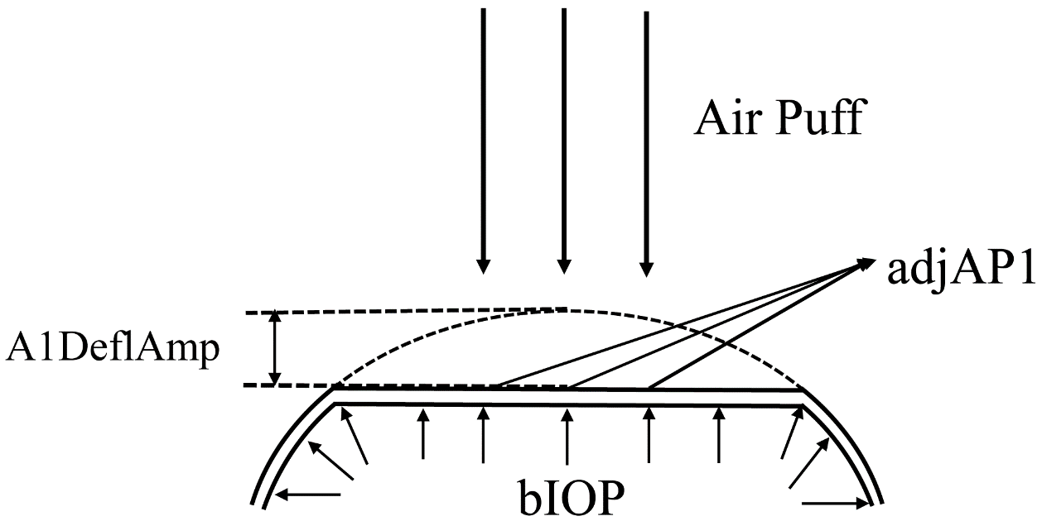
Figure 1 A diagram showing the Corvis measurements used in calculating the stiffness parameter at first applanation (SP-A1) including adjAP1 (adjusted air pressure value at the point of first applanation), A1DeflAmp (displacement between the apex in the undeformed state and the deflected state at first applanation, A1), and bIOP (biomechanically-corrected intraocular pressure). SP-A1 = (adjAP1 - bIOP)/ (A1DeflAmp)
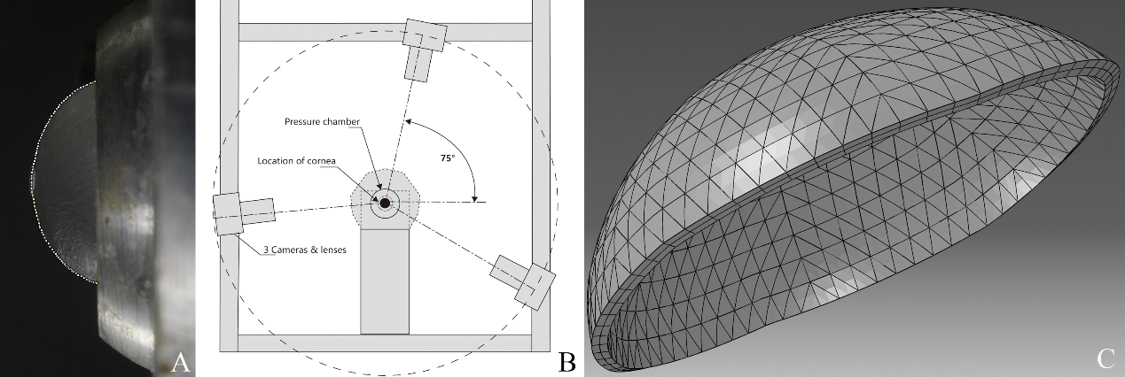
Figure 2 Corneal profile (A) captured before the start of the inflation test by one of the three cameras mounted on the inflation rig (B) and used to construct specimen-specific numerical models (C)
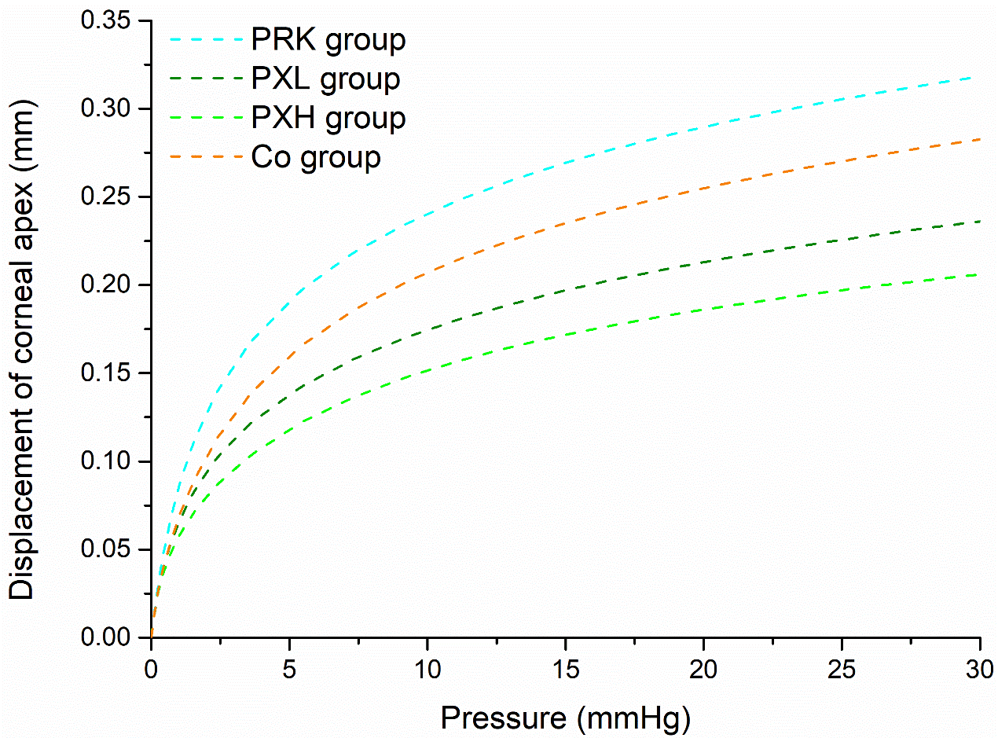
Figure 3 Fitted pressure-displacement behavior at the corneal apex in the 4 specimen groups
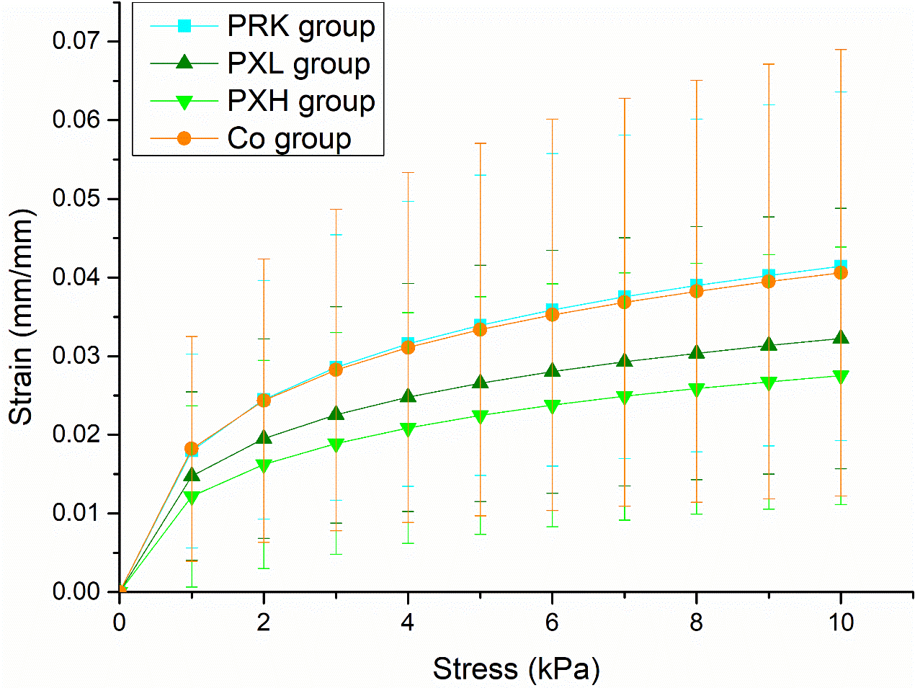
Figure 4 Mean and standard deviation of stress-strain behavior of specimens in each group
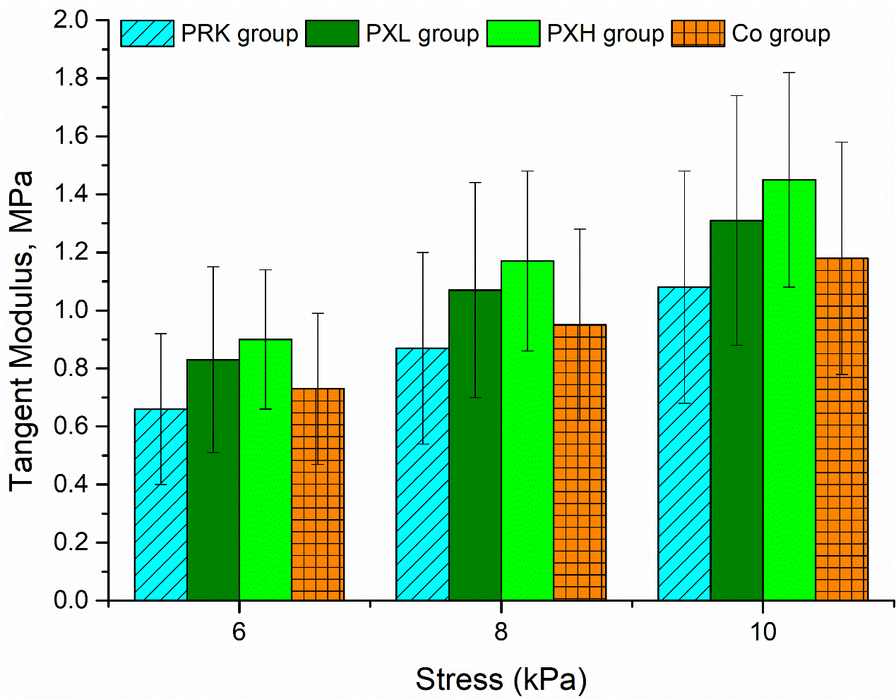
Figure 5 Mean and standard deviation of tangent modulus values for specimens included in each group obtained at three stress value of 6kPa, 8kPa and 10kPa
Table 1 ACXL settings adopted in different specimen groups
Group | n | Irradiation
PRK group | 18 | -6.0D ablation
PXL group | 18 | -6.0D ablation and 30 mW/cm² for 60 seconds
PXH group | 18 | -6.0D ablation and 30 mW/cm² for 90 seconds
Co group | 18 | untreated

Table 2 Mean and standard deviation of Corvis ST parameters in all specimen groups
Corvis ST parameters | Stages | PRK group | PXL group | PXH group | Co group
CCT, μm | Pre | 348.8±25.1 | 363.9±28.2 | 357.5±21.6 | 366.2±17.1
CCT, μm | Pos | 299.7±16.5 | 309.3±41.8 | 295.2±45.1 | -
bIOP, mmHg | Pre | 17±2.9 | 16.1±2.7 | 16±3.1 | 15.8±2.8
bIOP, mmHg | Pos | 15.1±2.3 | 14.4±1.5 | 15.4±4.4 | -
SP-A1, mmHg/mm | Pre | 62.4±15.0 | 60.2±14.9 | 58.2±14.5 | 57.2±18.4
SP-A1, mmHg/mm | Pos | 55.5±13.9 | 55.7±9.8 | 55.2±17.4 | -
IIR, mm | Pre | 14.9±2.4 | 15.1±1.1 | 15.4±1.3 | 14.6±1.7
IIR, mm | Pos | 15.1±1.3 | 15.0±1.3 | 15.4±1.0 | -
DA, mm | Pre | 1.19±0.29 | 1.20±0.18 | 1.23±0.18 | 1.22±0.32
DA, mm | Pos | 1.22±0.17 | 1.24±0.11 | 1.20±0.24 | -
DARatio2mm, mm | Pre | 5.31±0.71 | 5.27±0.44 | 5.45±0.60 | 5.33±0.54
DARatio2mm, mm | Pos | 5.83±0.72 | 5.35±0.47 | 5.46±0.44 | -
SSI | Pre | 0.63±0.11 | 0.63±0.07 | 0.62±0.07 | 0.63±0.17
SSI | Pos | 0.63±0.06 | 0.68±0.10 | 0.69±0.11 | -
CCT = Central Corneal Thickness, bIOP = biomechanically corrected intraocular pressure, SP-A1 = stiffness parameter at first applanation, IIR = integrated inverse radius, DA = deformation amplitude, DARatio2mm = ratio between DA values at the apex and 2mm from the apex, SSI = Stress Strain Index.
Table 3 Mean and standard deviation of constitutive parameters α and μ in all specimen groups
Group | α, MPa | μ | RMS, mm
PRK group | 0.0247±0.0365 | 110.1774±38.4378 | 0.0021±0.0019
PXL group | 0.0567±0.0899 | 127.8156±35.3452 | 0.0021±0.0031
PXH group | 0.0459±0.0400 | 145.0199±33.9295 | 0.0039±0.0040
Co group | 0.0275±0.0323 | 120.7560±38.6463 | 0.0025±0.0027

