An isogeometric approach to Biot-Cosserat continuum for simulating dynamic strain localization in saturated soils

Feng Zhuª, Hongxiang Tang^{a,} *, Xue Zhang^{b}, Yonghui Liª, George Papazafeiropoulos^{c}

ªState Key Laboratory of Coastal and Offshore Engineering, Dalian University of Technology, 116023 Dalian, China
^{b}Department of Civil Engineering and Industrial Design
University of Liverpool, Liverpool, L69 3BX, UK
^{c}Institute of Structural Analysis and Antiseismic Research, National Technical University of Athens // Zografou Campus, Athens 15780, Greece

* Corresponding author.
Tel.: +86-411-84708511-807
E-mail address: tanghx@dlut.edu.cn

Abstract: The Biot-Cosserat continuum theory (Cosserat model as a regularization mechanism) is combined with isogeometric analysis (Biot-CIGA) to simulate dynamic strain localization in saturated soils. The results demonstrate that Biot-CIGA can solve the ill-posed problem of saturated soils caused by strain-softening properties and non-associated flow rules, thereby obtaining a convergent, mesh-independent numerical solution. Compared with the finite element analysis of Biot-Cosserat continuum (Biot-CFEA), the high-order continuity of Biot-CIGA provides a smooth pore pressure gradient field and thus ensures the local mass balance of pore fluids. Additionally, the Biot-CIGA describes the inflow and outflow of pore fluids in the element, which means it is able to accurately simulate the volumetric strain of the element. Simulation results also show that the Biot-CIGA method can also effectively alleviate the mesh distortion in shear bands when materials experience large deformation. Last but not least, because Biot-CIGA adopts NURBS as its shape functions, it can conduct simulations directly on CAD models, which not only maintains the precise geometry, but also avoids an expensive intermediate meshing step.
Keywords: saturated porous media; isogeometric analysis; finite element analysis; elastoplastic; Cosserat continua; Biot consolidation theory; shear band

Introduction
Saturated soil is a two-phase porous medium composed of pore fluid and soil particles, in which pore fluid plays a significant role, even a leading role, on the mechanical properties of saturated soil. In geotechnical engineering, most of the progressive failures of geostructures are associated with the behavior of strain localization of saturated soil, such as submarine landslides. Therefore, it is valuable to numerically predict the initiation of a shear band, its location and orientation in saturated soil. However, when using finite element analysis (FEA) to simulate the strain localization of saturated soil under the framework of classical continuum, four issues are encountered:
Firstly, the shape functions describing the pore fluid are low-order and non-smooth, that is, its derivative is discontinuous. When using FEA to numerically simulate the strain localization of saturated soil, the equal-order shape functions cannot be used in the displacement field and pore pressure field, which is mainly due to the following two reasons: (1) FEA needs to fulfill the Ladyzhenskaya-Babuška-Brezzi (LBB) condition or the much simpler Zienkiewicz–Taylor patch test [1] to avoid numerical oscillations in the pore pressure field; (2) If the displacement field and the pore pressure field use equal-order shape functions, the total stress and effective stress will be one order lower than the pore pressure, which will cause numerical contradiction with the effective stress principle. Although the Q8p4 element of unequal order (e.g. an eight-node quadrilateral element for the displacement field and a four-node quadrilateral element for the pore pressure filed) can be used to simulate the strain localization problem of saturated soil. However, if the pore pressure field is interpolated using a bilinear element (i.e., a four-node quadrilateral element), the pore pressure gradient field is not only discontinuous between the elements, but also becomes a bi-constant within the elements. According to Darcy’s law, the flow of the pore fluid, and thus the mass flow, is proportional to the pore pressure gradient. Therefore, the discontinuity of the pore pressure gradient field between the elements makes FEA unable to satisfy the local mass balance of the pore fluid[2], and the bi-constant pore pressure gradient in the element makes FEA unable to simulate the pore fluid flow in the element, that is, it cannot correctly simulate the volume strain of the element. However, the correct simulation of pore fluid flow and transport is crucial to reveal the inherent failure mechanism of saturated soil. This means that FEA has certain limitations in dealing with the strain localization of saturated soil.
Secondly, high-order elements in the FEA (such as an eight-node quadrilateral element describing the deformation of the soil skeleton) are sensitive to mesh distortion. For the strain localization, the deformation is mainly concentrated in the shear band, which will leads to excessive mesh distortion in the band [3], which usually results in the FEA to diverge after a certain softening stage, or to produce a misleading result. A common technique for solving mesh distortion is remeshing. However, remeshing is usually time-consuming and cumbersome and often leads to inaccuracies in the solution fields that are projected onto a new mesh [4]. Although remeshing is inevitable in large deformation problems, it should be kept to a minimum in order to ensure the calculation accuracy.
Thirdly, the numerical solutions are mesh-dependent in the framework of classical continuum. For the strain localization problem of saturated soil, the numerical solutions obtained by the traditional rate-independent constitutive models are usually mesh-dependent, and the predicted shear band width will collapse to the used element size. The origin of this problem is that when the strain-softening properties and non-associated flow rule are considered, the governing partial differential equations become ill-posed. Ill-posed problems can be regularized by weakly discontinuous [5] or strongly discontinuous numerical methods [6], and can also be solved by some advanced constitutive models, such as integral-type non-local models [7,8], visco-plasticity models [9, 10], higher-order gradient models [11–13], and Cosserat or micro-polar models [14–19]. Therefore, in order to obtain a mesh-independent numerical solution, some regularization mechanisms need to be introduced.
Fourthly, the presence of a Laplacian in the continuum equation will introduce an internal length scale. Schrefler et al. [20,21] pointed out that their porous media model contains a Laplacian, which makes the model have some regularization properties. This regularization effect can also be intuitively understood as the rate-dependent behavior of the soil skeleton induced by Darcy’s law. However, this internal length scale only plays a regularizing role under certain conditions and depends on the material parameters. Hence, in order to obtain a mesh-independent numerical solution under normal conditions, some regularization mechanisms need to be introduced to ensure the well-posedness of partial differential equations, such as gradient-dependent models and Cosserat models. In the case of dynamic strain localization, Zhang et al. [22] deduced an expression for the internal length scale generated by the seepage process in the porous medium. After that, Schrefler et al. [23] analyzed in detail the interaction between the internal length scale of gradient plasticity and the one of the multiphase model based on the work of [24]. For more detailed information, please refer to these papers above.
However, this manuscript mainly focuses on the first three issues. In order to solve these three problems, this manuscript combines the Biot-Cosserat continuum [25] (Cosserat model as a regularization mechanism) with isogeometric analysis (IGA) [26] to simulate the dynamic strain localization in saturated soils. The advantages of this combination are: on one aspect, in addition to regularizing the ill-posed problems, the microelement (i.e. micropolar particles) of Cosserat continuum can reflect the microstructure of the material, and its rotational degrees of freedom can phenomenological characterize the rotation deformation between the particles in the rock and soil materials; on another aspect, IGA based on non-uniform rational B-splines (NURBS) can not only ensure that the shape function of the pore fluid has high-order continuity under the premise of satisfying the LBB condition and effective stress principle, but also effectively alleviate the mesh distortion problem in the shear zone.
It is worth mentioning that although scholars have proposed many methods for the local mass balance problem, such as the finite volume methods [27], the mixed finite element methods [28], the discontinuous Galerkin (DG) finite element methods [29], and the enriched Galerkin (EG) finite element methods [30]. Among them, Choo and Lee [30] pointed out that, on the one hand, the EG method requires fewer degrees of freedom than the DG method; on the other hand, for problems involving highly heterogeneous permeability fields, it can still provide non-oscillatory and locally conservative pressure fields. Nevertheless, the authors believe that IGA is still one of the better choices. One of the reasons is that the high-order continuity of IGA can naturally ensure the local mass conservation of pore fluid, and the numerical realization is relatively simple; another reason is that high-order IGA can effectively alleviate mesh distortion, which is important for strain localization where the deformation is mainly concentrated in the shear zone.
Unlike the classical continuum, the microelement of the Cosserat continuum is no longer assumed to be an infinitesimal mathematical point, but is assumed to be a representative element with a certain size, or called a micropolar particle, which can be used to reflect the microstructure of the material. For each microelement, the distributed force on each surface is also no longer assumed to be uniformly distributed. Therefore, when the distributed force is equivalent to acting on the center of the face, not only a concentrated force but also a micro-couple will be generated, and the corresponding deformations include normal strain, shear strain and micro-curvature. Namely, the Cosserat continuum can be regarded as a generalized classical continuum, while the classical continuum can be regarded as a special case of the Cosserat continuum. In terms of computational implementation of Cosserat continuum, the displacement-based finite element requires an additional rotation degree of freedom at each node, which can be used to phenomenological characterize the rotation deformation between particles in geomaterials. Correspondingly, micro-curvature (spatial derivative of rotational freedom) is introduced in the strain, and the coupled stress (energy conjugation with micro-curvature) is included in the stress. De Borst [31] first considered the effect of coupling stress on the yield criterion, and proposed a pressure-dependent J2 flow plasticity model under the framework of the Cosserat continuum. Subsequently, on the basis of De Borst's work, Li and Tang [14] derived the consistent algorithm of the pressure-dependent Drucker-Prager elastoplastic Cosserat model. The results show that the Cosserat continuum model can not only accurately reflect the mechanical response of geotechnical materials, but also overcome the mesh-dependent phenomena caused by strain-softening properties. In addition, Pane and Pietruszczak [32] pointed out that materials with non-associated flow rules can be equivalent to materials with strain softening behavior through a numerical scheme. The non-associated flow rule has also been introduced in the study of strain localization, such as de Borst [31], Tang et al. [14,33]. However, without considering material softening, the influence of the non-associated flow rule on the mesh-dependent has remained largely unnoticed. Recently, Sabet and de Borst [34,35] pointed out that the non-associated flow rules can also cause structural softening and mesh dependence (related to mesh density and mesh line direction), and further pointed out that the Cosserat model can not only ensure the well-posedness of partial differential equations, but also greatly improve the global convergence behavior of the nonlinear solver. Hageman et al. [36] analyzed in detail the combined problem of fracture propagation and non-associated, off-fault plasticity in the Cosserat continuum as well as the classical continuum, each with and without viscosity. However, the Cosserat continuum also faces some challenges. For example, Ristinmaa and Vecchi [37] pointed out that the element size should be less than 5 times the length scale to give full play to the regularization effect of Cosserat model, which will make the Cosserat model significantly increase the amount of calculation when solving practical engineering problems.
IGA is an emerging numerical method proposed by Hughe et al. [26] in 2005. The core concept of IGA is the application of the same basis functions for representing computational models and approximating the unknown fields. Therefore, IGA inherits the high-order continuity of NURBS on the one hand, making it an effective method for calculating high-order partial differential equations, such as poroelasticity [2], gradient-dependent plasticity [38]; on the other hand, IGA can conduct simulations directly on the computer-aided design (CAD) models, which not only maintains the precise geometry, but also avoids an expensive intermediate meshing step. In addition, high-order NURBS shape functions can also effectively alleviate the influence of mesh distortion on the calculation results. Lipton discussed this advantage of IGA in detail [4]. These advantages make it significantly superior to traditional FEA, and it has been successfully applied in various engineering fields, including fluid-structure interaction problems [39–41], contact problems [42–44], strain localization problems [11, 13], structural mechanics problems [45,46], optimization problems [47–49], and cohesive fracture problems [47,50] etc. However, NURBS-based IGA also faces some challenges, such as implementing local refinement [51–54] and constructing analysis-suitable models from B-rep geometries [55,56] or trimmed geometries [57,58], etc.
Recently, Guo and Zhao [59] enabled a hierarchical multiscale computational method to consider the coupled hydro-mechanical behavior in saturated soils based on the u–p formulation, and analyzed the influence of pore fluid on the strain localization. Ehsan Mikaeili and Bernhard Schrefler [60] combined strong discontinuities and XFEM to study strain localization in saturated porous media. Xiaoyu Song [61] et al. realized a true three-phase model implemented via stabilized low-order mixed finite elements, and then studied the effect of pore air pressure on strain localization triggered by initial heterogeneity either in porosity or suction. Fusao Oka [62] proposed a calculation model for nonlinear dynamic analysis of strain localization in multiphase geomaterials, and analyzed the influence of suction on strain localization. In addition, Irzal F. et al. [2] proposed a isogeometric formulation for studying poroelasticity materials and pointed out that its numerical results are not only better than FEA, but also can relax the minimum time step limit in the consolidation problem. For the Stokes problem, Tuong Hoang et al. [63] studied the numerical stability and convergence of some isogeometric mixed finite elements (i.e. Taylor–Hood, Sub-grid, and Raviart–Thomas elements, etc.) under the framework of the Isogeometric Finite Cell Method. B. Dortdivanlioglu et al. [64] proposed a mixed isogeometric analysis method based on subdivision stabilization to study strongly coupled diffusion in solids, and at the same time evaluated the numerical stability of different families of mixed isogeometric analysis techniques. For fractured porous media, Hageman and de Borst [65] proposed a non-Newtonian fluid model, then compared the effects of non-Newtonian and linear Newtonian fluids on the fluid velocity inside the fracture, and pointed out that IGA can accurately obtain the fluid velocity at the fracture tip.
For the sake of brevity, in the remainder of this paper, the FEA-based Biot-Cosserat continuum model is referred to Biot-CFEA, and the IGA-based Biot-Cosserat continuum model is referred to the Biot-CIGA method. The paper is organized as follows: Section 2 gives the basic governing equations of the Biot-Cosserat continuum. Section 3 presents the isogeometric discretization under the Biot-Cosserat continuum, including the B-spline/NURBS shape functions, the spatial discretization, the time discretization, and the corresponding numerical algorithms. In Section 4, three numerical examples are used to illustrate the advantages of the Biot-CIGA method. Conclusions are provided in Section 5.

Basic equations for Biot-Cosserat continuum
In the saturated Cosserat continuum, the balance equation of the soil skeleton can be expressed as
$L^{T}σ+ρb=ρ^{'}\ddot{u}$
where the body forces $b$, the differential operator $L^{T}$, the average density $ρ$, and the matrix $ρ^{'}$ can be expressed as follows:
$b=\left[\begin{aligned}b_{x} \\ b_{y} \\ 0\end{aligned}\right]$
$L^{T}=\left[\begin{matrix}∂/∂x & 0 & 0 & 0 & ∂/∂y & 0 & 0 \\ 0 & ∂/∂y & 0 & ∂/∂x & 0 & 0 & 0 \\ 0 & 0 & 0 & -1 & 1 & l_{c}∂/∂x & l_{c}∂/∂y\end{matrix}\right]$
$ρ=nρ_{f}+\left(1 - n\right)ρ_{s}$
$ρ^{'}=\left[\begin{matrix}ρ & 0 & 0 \\ 0 & ρ & 0 \\ 0 & 0 & Θ\end{matrix}\right]$
where $ρ_{f}$ indicates the fluid density, $ρ_{s}$ is the soil particle density, $n$ represents the porosity, and $Θ$ refers to the rotational inertia of microelement. When the microelement is assumed to be a cube, $Θ$ can be expressed as follows:
$Θ=\frac{2ρ}{\left(1 + υ\right)}l_{c}$
where $l_{c}$ is the characteristic length parameter.
According to the principle of effective stress, Eq. can be further expressed as
$L^{T}\left(σ^{″} - α M p\right)+ρb=ρ^{'}\ddot{u}$
where $σ^{″}$ refers to the corrected effective stress, and $p$ represents the excess pore fluid pressure. The matrix $M$ and Biot’s constant $α$ can be defined as follows:
$M={\left[\begin{matrix}1 & 1 & 1 & 0 & 0 & 0 & 0\end{matrix}\right]}^{T}$
$α=1-\frac{K_{t}}{K_{s}}$
where $K_{t}$ and $K_{s}$ are the bulk modulus of soil particles and soil skeleton, respectively.
The differential equations of fluid motion and mass conservation can be defined as follows:
$-∇p-R+ρ_{f}b=0$
$-∇^{T}\dot{w}=αM^{T}\dot{ε}+\dot{p}/Q^{*}$
where $R$ is the viscous force, $\dot{w}$ is the flow ratio of the pore fluid, and $\dot{ε}$ is the strain rate. $Q^{*}$ can be defined as follows:
$1/Q^{*}=n/K_{f}+\left(1 - n\right)K_{s}$
where $K_{f}$ is the bulk modulus of pore fluid.
Based on Eq. and Eq. , the governing equation of pore fluid can be defined as follows:
$∇^{T}k\left(- ∇ p + ρ_{f} b\right)+αM^{T}L\dot{u}+\left(1 / Q^{*}\right)\dot{p}=0$
where k is the permeability coefficient of Darcy’s law. Eqs. and above are the governing equations of saturated Cosserat continuum.

IGA formulation for Biot-Cosserat continuum

The B-spline/ NURBS shape functions
In this section, a brief introduction of the characteristics of B-spline/NURBS is given. A more detailed account can be found in [66]. A B-spline curve, $C_{B}$, of order $q$ can be defined as follows:
$C_{B}=\sum_{i=1}^{n}{B_{i,q}}\left(ξ\right)P_{i}$
where $n$ is the number of control points, $P_{i}$ is the control point coordinates, and $B_{i,q}$ is a univariate B-spline basis function.
With a set of non-negative weights $w_{i}$, a NURBS basis function can be defined as follows:
$N_{i,q}\left(ξ\right)=\frac{B_{i,q}\left(ξ\right)w_{i}}{\sum_{j=1}^{n}{B_{j,q}}\left(ξ\right)w_{j}}$
Similar to Eq., A NURBS curve can be defined
$C_{N}=\sum_{i=1}^{n}{N_{i,q}}\left(ξ\right)P_{i}$
According to the properties of tensor product[66], a NURBS surface, $S_{N}\left(ξ , η\right)$, of order $q$ in $ξ$-direction and order $p$ in $η$-direction can be defined as follows:
$S_{N}\left(ξ , η\right)=\sum_{i=1}^{n}{\sum_{j=1}^{m}{N_{i,j}^{q,p}}}\left(ξ , η\right)P_{i,j}$
where $N_{i,j}^{q,p}$ are the bivariate NURBS basis functions expressed as
$N_{i,j}^{q,p}\left(ξ , η\right)=\frac{B_{i,q}\left(ξ\right)G_{j,p}\left(η\right)w_{i,j}}{\sum_{k=1}^{m}{\sum_{l=1}^{n}{B_{k,q}\left(ξ\right)G_{l,p}\left(η\right)w_{k,l}}}}$
In addition, a NURBS surface and its basis functions, as well as the elements used for IGA, are depicted in Fig 1.

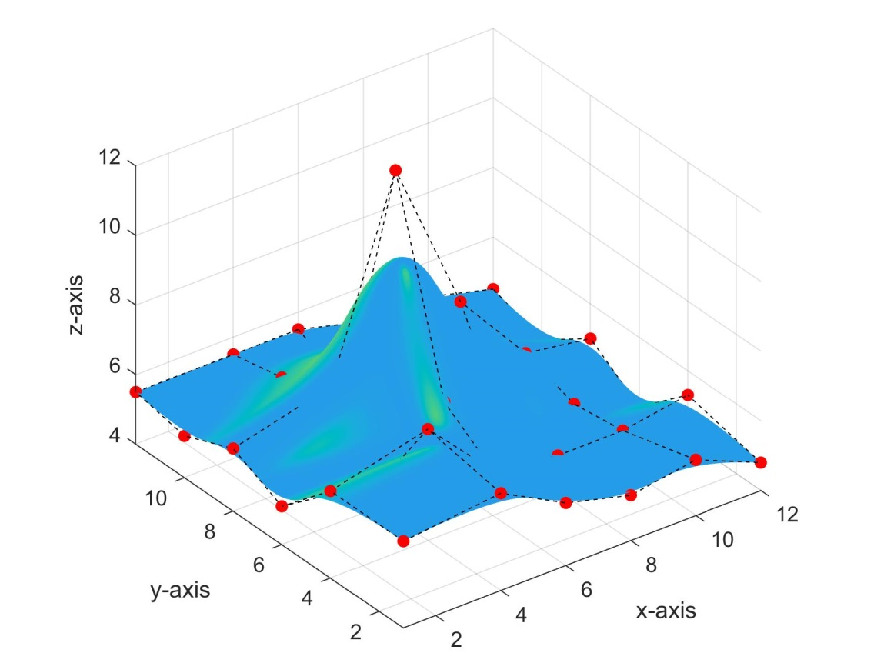
(a)
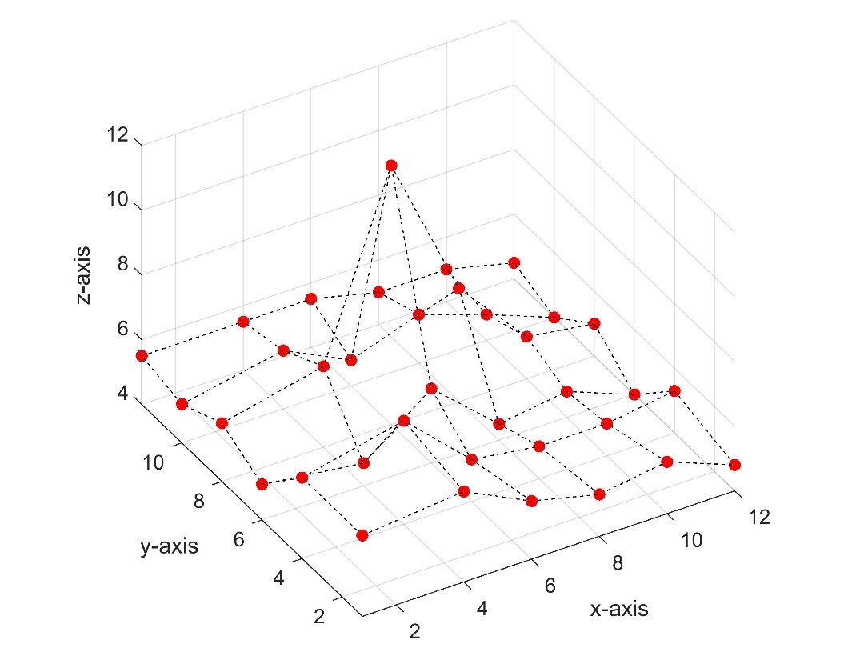
(b)
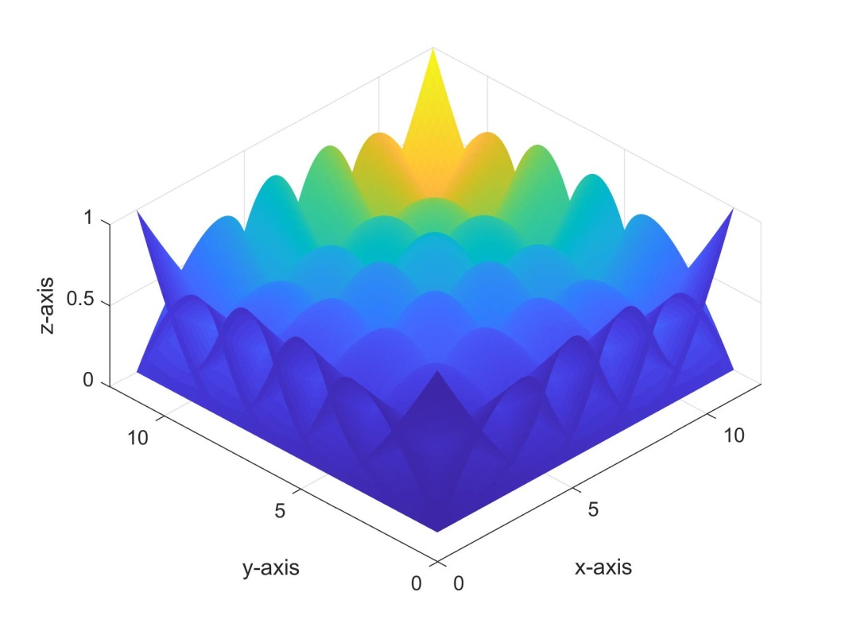
(c)
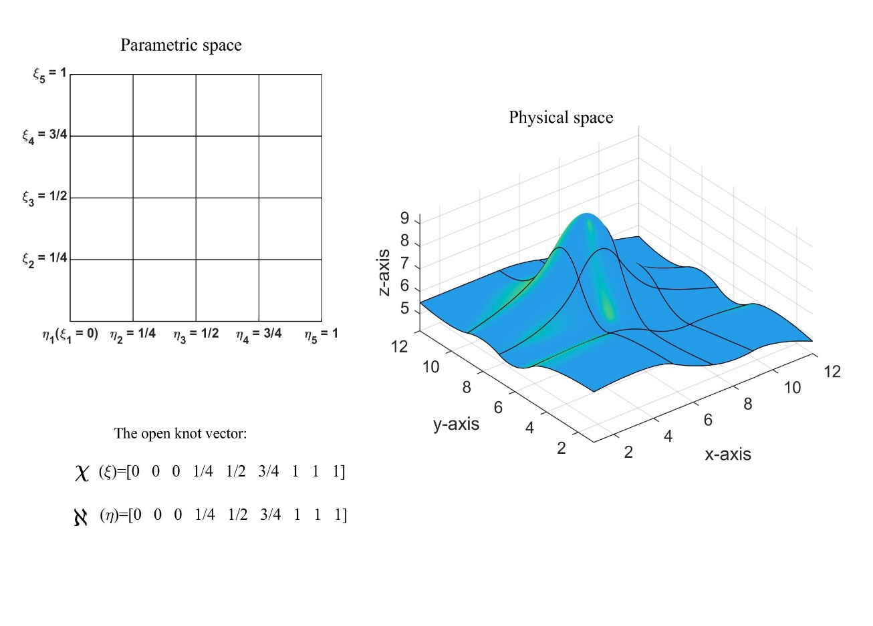
(d)
Fig. 1. A NURBS surface: (a) a NURBS surface and related control points; (b) control mesh constructed by control points; (c) associated NURBS basis functions of order 2; (d) parametric space, the matching open knot vectors, and the elements used for IGA. The control points are marked by red dots, and the corresponding elements are formed by mapping from parametric space to physical space.

Discretization in space and time
To solve partial differential equations and , firstly, the discretization in space and time are carried out using the IGA and NEWMARK methods, respectively. Then, the discrete equations are solved iteratively by Newton-Raphson scheme.
Similar to FEA, the discretization of geometry $x$, displacement field $u$ and excess pore pressure field $p$ in IGA can be expressed as follows:
$x=\sum_{i=1}^{l}{N_{i}}\left(ξ\right)x_{i}$
$u=\sum_{j=1}^{m}{N_{j}}\left(ξ\right)u_{j}$
$p=\sum_{k=1}^{n}{N_{k}}\left(ξ\right)p_{k}$
where $N$ refers to the NURBS shape functions; $x_{i}$, $u_{j}$ and $p_{k}$ are the coordinate value, displacement value, excess pore pressure value on the corresponding control points, respectively; while $ξ$ indicates the coordinate of the parametric space. In this paper, the authors use the $Q3_{p}/Q2$ mixed isogeometric formulation that satisfies the Zienkiewicz–Taylor patch test. A more detailed account can be found in [64]. In addition, the strain-softening properties in this paper are achieved by gradually reducing the cohesion coefficient $c$ as the equivalent plastic strain $\overline{ϵ_{p}}$ increases. Fig. 2 shows the change curve of cohesion coefficient $c$.
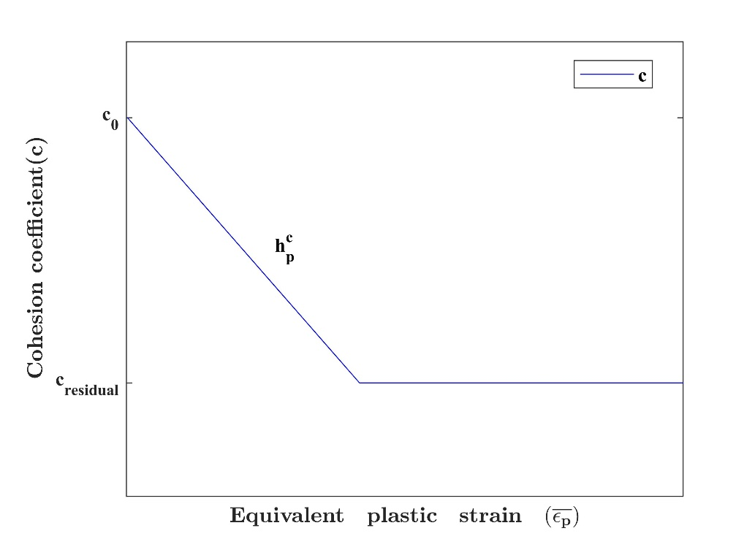
Fig. 2. Change curve of cohesion coefficient $c$
Applying Galerkin formulation, integration by parts, and Gauss theorem to Eqs. and , the discrete equation of saturated Cosserat continuum can be obtained
$\left\{\begin{aligned}M{\ddot{u}}^{t+∆t}+Ku^{t+∆t}-Qp^{t+∆t}{{ - f}_{s}}^{t+∆t}=0 \\ Q^{T}{\dot{u}}^{t+∆t}+S{\dot{p}}^{t+∆t}+{Hp}^{t+∆t}{{ - f}_{w}}^{t+∆t}=0\end{aligned}\right.$
where $K$ indicates the consistent elastoplastic tangent operator in Cosserat continuum. Addition information about $K$ is provided in [14].
After introducing Rayleigh damping $C=aM+bK$ in Eq. , its matrix form can be expressed as follows:
$\left[\begin{matrix}M & 0 \\ 0 & 0\end{matrix}\right]\left\{\begin{aligned}{\ddot{u}}^{t+∆t} \\ {\ddot{p}}^{t+∆t}\end{aligned}\right\}+\left[\begin{matrix}C & 0 \\ Q^{T} & S\end{matrix}\right]\left\{\begin{aligned}{\dot{u}}^{t+∆t} \\ {\dot{p}}^{t+∆t}\end{aligned}\right\}+\left[\begin{matrix}K & -Q \\ 0 & H\end{matrix}\right]\left\{\begin{aligned}u^{t+∆t} \\ p^{t+∆t}\end{aligned}\right\}=\left\{\begin{aligned}{f_{s}}^{t+∆t} \\ {f_{w}}^{t+∆t}\end{aligned}\right\}$
where
$M={\sum_{e}{\int_{Ω_{e}}{\left(N^{u}\right)}}}^{T}ρ'N^{u}dΩ_{e}$
$Q={\sum_{e}{\int_{Ω_{e}}{B}}}^{T}αMN^{p}dΩ_{e}$
$K={\sum_{e}{\int_{Ω_{e}}{B}}}^{T}σ″dΩ_{e}$
$f_{s}=\sum_{e}{\left({\int_{Ω_{e}}{\left(N^{u}\right)}}^{T} ρ b^{t+∆t} d Ω_{e} + \int_{Γ_{t}}{{\left(N^{u}\right)}^{T}} t^{t+∆t} d Γ_{t}\right)}$
$S={\sum_{e}{\int_{Ω_{e}}{\left(N^{p}\right)}}}^{T}{\left(Q^{*}\right)}^{-1}N^{u}dΩ_{e}$
$H={\sum_{e}{\int_{Ω_{e}}{\left(∇ N^{p}\right)}}}^{T}k∇N^{p}dΩ_{e}$
$f_{w}=\sum_{e}{\left({\int_{Ω_{e}}{\left(∇ N^{p}\right)}}^{T} k ρ_{f} b^{t+∆t} d Ω_{e} - {\int_{Γ_{w}}{\left(N^{p}\right)}}^{T} {\dot{w}}^{t+∆t} d Γ_{w}\right)}$
where $N^{u}$ is the shape functions of the displacement field, and $N^{p}$ is the shape functions of the pore pressure field.

Numerical examples

One-dimensional consolidation
We first benchmark the implementation of the proposed Biot-CIGA method by Terzaghi’s 1D consolidation problem where the closed-form solution is available. As shown in Fig. 3, the model is 10m high and discretized using $1×20$ elements. The boundary conditions are as follows: the bottom of the model is completely fixed, the horizontal displacements of the left and right boundaries are constrained to zero, and a load $p=110kPa$ is applied on the top surface; except for the upper surface, all other boundaries are taken as impermeable. The Young’s modulus $E=2.6×10^{7}Pa$, Poisson’s ratio $ν=0.3$, and the porosity $n=0.15$.
This problem is solved by the Biot-CIGA method and Biot-CFEA method respectively. The Biot-CFEA method adopts the Q8p4 element that satisfies the LBB conditions and effective stress principle. Fig. 4 presents the distribution of pore pressure along the y axis. Because the parameters such as porosity $n$ and average density $p$ will change continuously due to soil deformation in the coupled simulation, it can be considered that the results of Biot-CIGA are consistent with the theoretical solution. Fig. 5 shows the distribution of the pore pressure gradient along the y-axis, which is similar to the results of Irzal et al. [2]. According to Darcy’s law, the flow of the pore fluid, and thus the mass flow, is proportional to the pore pressure gradient. Therefore, according to the pore pressure gradient distribution, Irzal et al. [2] pointed out that high-order IGA can ensure local mass balance, while FEA cannot; However, what is different from Irzal F. et al.[2] is that they mainly focus on the change of the pore pressure gradient between the elements, and we are more concerned about the inside of the elements. It can be seen from Fig. 5 that Biot-CFEA cannot simulate the pore fluid flow in the element due to the constant pore pressure gradient (the red mark in Fig. 5), which makes it unable to accurately simulate the volume strain of the element. On the contrary, it can be seen from Fig.5 that the higher-order IGA can correctly reflect the volume strain of the element. The authors believe that a reasonable reflection of these factors is of great help in analyzing the dynamic strain localization of saturated soil. Although the Biot-CFEA method can improve the accuracy of simulating pore fluid flow by increasing the number of elements. However, on the one hand, the number of increasing elements can only be determined by the engineer based on personal experience; on the other hand, the amount of calculations generated by this will be huge. For example, on the premise that the length, width and height of a three-dimensional model are 100 elements, each additional element in the height direction will increase the model by 10,000 elements. Therefore, increasing the number of elements is not an effective method.
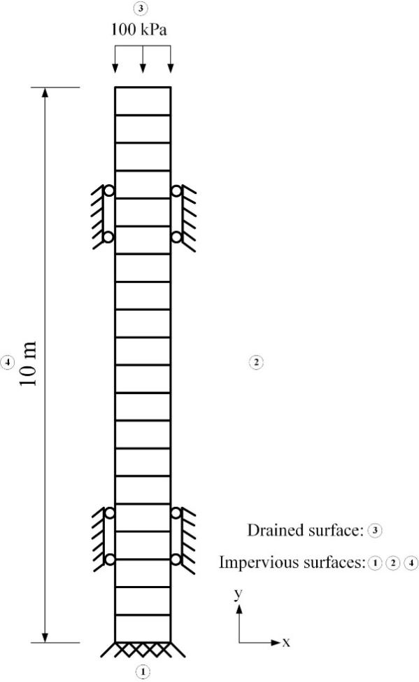
Fig. 3. One-dimensional consolidation model
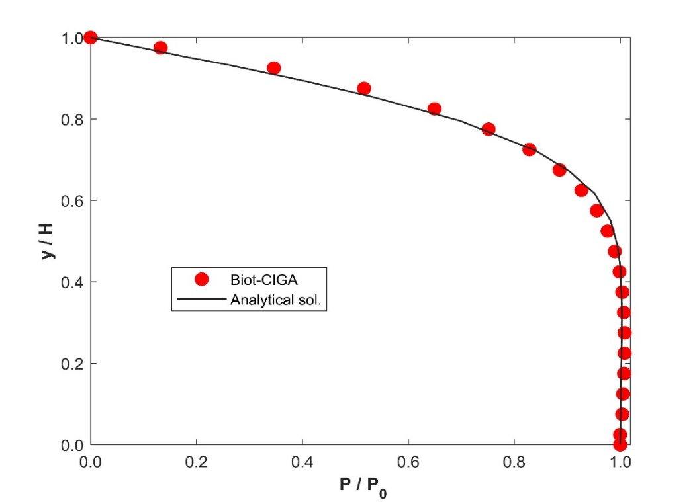
Fig. 4. Pore pressure distribution along the y-axis obtained by Biot-CIGA and theory, respectively
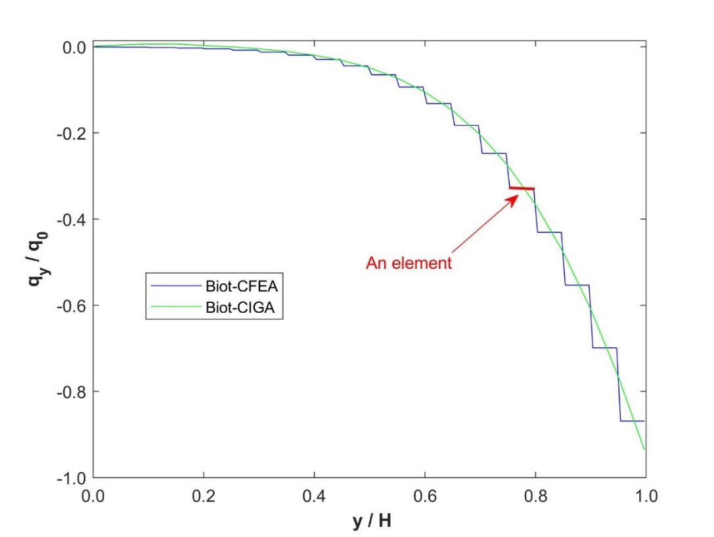
Fig. 5. Pore pressure gradient distribution along the y-axis obtained by Biot-CIGA and Biot-CFEA, respectively

Panel compression
The second example is a panel compression problem under the plane strain condition. A schematic of the panel is shown in Fig.6. The boundary conditions are as follows: the vertical displacements of the bottom and the horizontal displacements of the left boundary are constrained to zero, and a dynamic load $v=0.08m/s$ is applied on the top surface; except for the right boundary of the model, all other boundaries are taken as impermeable. The Young’s modulus $E=5.0×10^{7}Pa$, Poisson’s ratio $ν=0.3$, the internal friction angle $φ=35^{°}$, the porosity $n=0.322$, the soil density $ρ_{s}=2.647×10^{3}kg/m^{3}$, the bulk modulus of the soil $K_{s}=6.146×10^{9}Pa$, the permeability coefficient $k=1.0×10^{-5}m/s$, the length scale $l_{c}=0.1m$, and the Biot coefficient has been assumed that $α=1$.
First of all, this model is used to explore the mesh-dependent phenomenon of porous media in the classical continuum when considering the strain-softening properties and non-associated flow rule. Three regular mesh discretizations are used, and the ratio of their element size to length scale is $l_{e}/l_{c}=$2.8, 1.8, 1.5, respectively. Fig. 7 shows the deformed configuration of the model obtained from the classical continuum. It can be observed from Fig. 7 that: in Fig. 7(a), there is only one shear band extending from the upper right corner to the lower left corner, and its width is about 16.8$l_{c}$; however, there are two shear bands in Fig. 7(b), where the width of the main shear band is 7.5$l_{c}$ and the width of the secondary shear band is 6$l_{c}$, and the positions, shapes and directions of the two shear bands are different from those in Fig. 7(a). The equivalent plastic strain distribution in Fig. 8 shows this phenomenon more intuitively. Furthermore, the authors used the second-order work to verify the shear failure mode in Figure 7(b). For porous media, Kakogiannou et al. [67] pointed out: The second-order work has the ability to capture both localized and diffused failure modes; On the other hand, the second-order work can not only indicate the local instability, but also provide useful information about the global domain (integrating over the whole soil mass). Therefore, the second-order work provides a new perspective for the failure of saturated soil. Based on the work of Mikaeili and Schrefler [60], the manuscript calculates the second-order work in terms of the effective stress. The authors selected three moments of vertical displacement as $V=0.0550m$, $V=0.1100m$, and $V=0.2200m$for comparative analysis: (1) It can be seen from Fig. 11(a) that the second-order work at this time is all positive, indicating that the material is in a stable state at this time; (2) As the vertical displacement increases (as shown in Figure 11(b)), the second-order work begins to appear negative and is confined to a narrow band, indicating that there is a shear band at this time; (3) After the vertical displacement increases further (as shown in Fig. 11(c)), the negative value of the second-order work is mainly concentrated in two narrow bands, indicating that there are two shear bands at this time. This confirms what can be seen from Figs. 9 and 10. Tang [33] also had similar results when using multi-scale methods to study the strain localization of solid materials. In addition, Figs. 12 and 13 respectively show the force-displacement curves and pore pressure distributions corresponding to the three meshes. It can be observed from Figs 12 and 13 that both the force-displacement curves and the pore pressure distributions are closely related to the mesh density. The above analysis proves from multiple perspectives that in the classical continuum, the porous media considering strain-softening and non-associated flow rules has obvious mesh-dependent phenomena, so it is necessary to introduce a regularization mechanism (such as the Cosserat model).
Secondly, the Cosserat model is introduced into the IGA framework, namely the proposed Biot-CIGA method, to study the strain localization of porous media materials. Figs. 14 and 15 respectively show the deformed configuration and the equivalent plastic strain distribution obtained by the Biot-CIGA method. As can be seen from the figure, the shear band width of the three meshes is 14$l_{c}$, and the positions, shapes, directions of the shear bands are also the same. Fig. 16 presents the force-displacement curves of the three meshes. It can be seen from the figure that the force-displacement curves of different meshes coincide with each other in both the elastic stage and the softening stage. In addition, the pore pressure distributions of these meshes (as shown in Fig. 17) are basically the same. Therefore, it can be proved that the proposed Biot-CIGA method can solve the mesh-dependent problem of porous media.

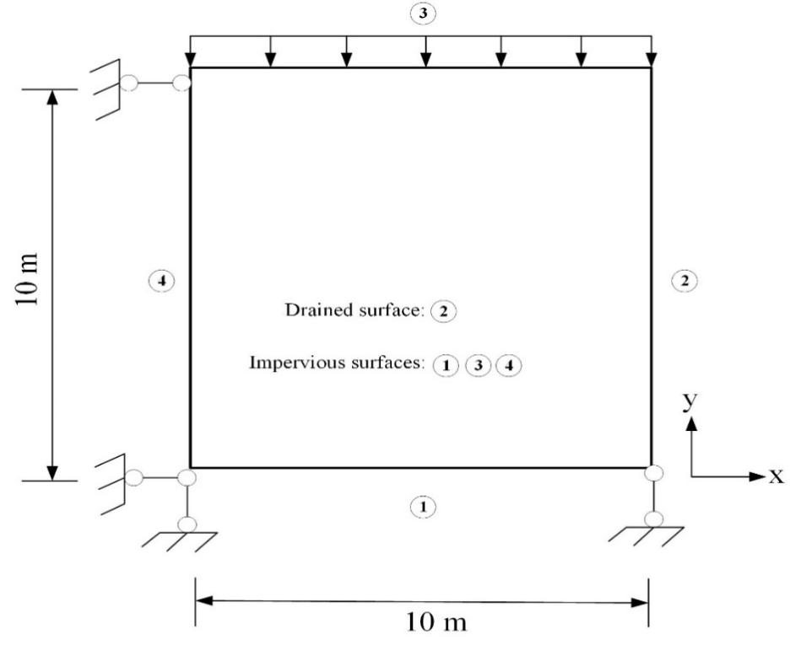
Fig. 6. The panel compression model
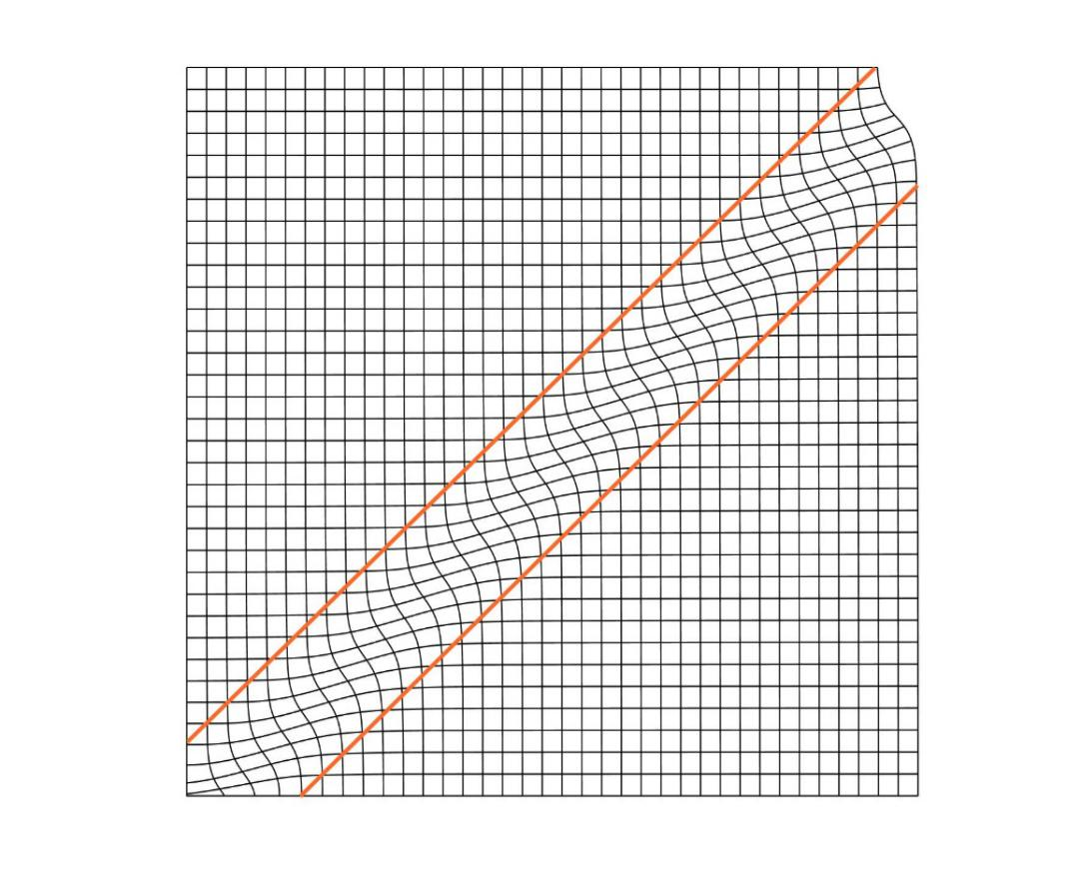
(a)
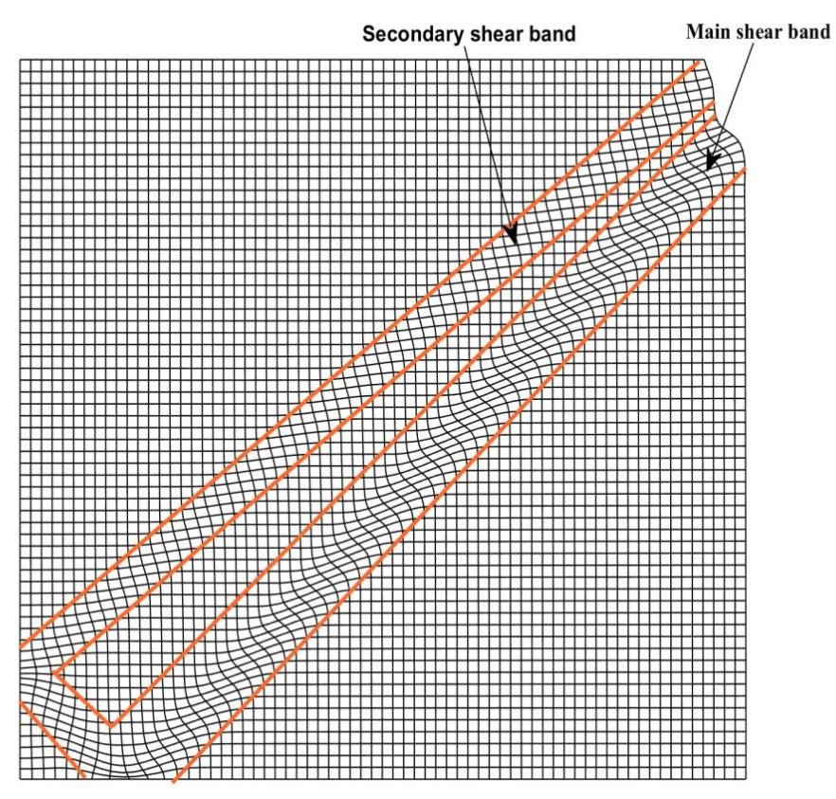
(b)
Fig. 7. Deformed configuration of the panel model obtained by classical continuum: (a) 1296 elements; (b) 4096 elements
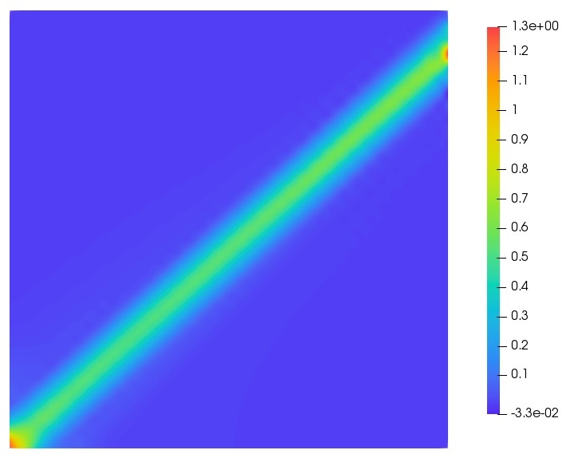
(a)
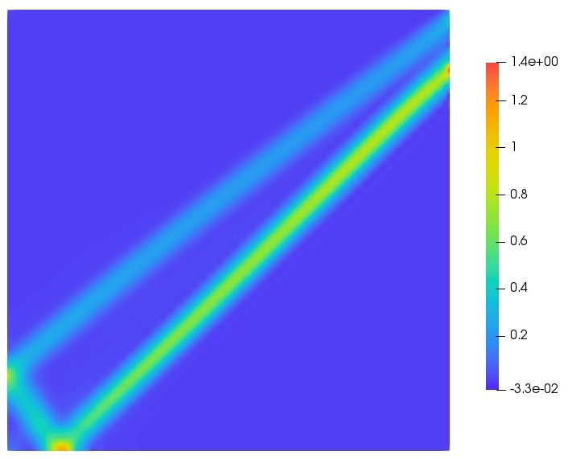
(b)
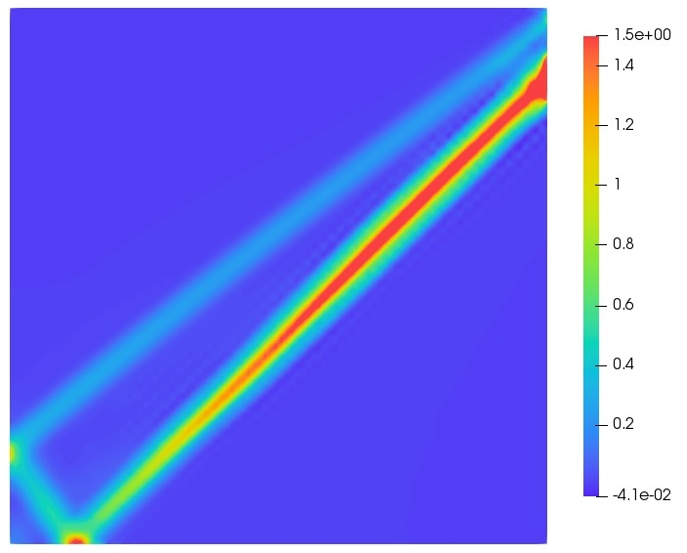
(c)
Fig. 8. Equivalent plastic strain distribution with different mesh densities obtained by classical continuum: (a) 1296 elements; (b) 3025 elements; (b) 4096 elements
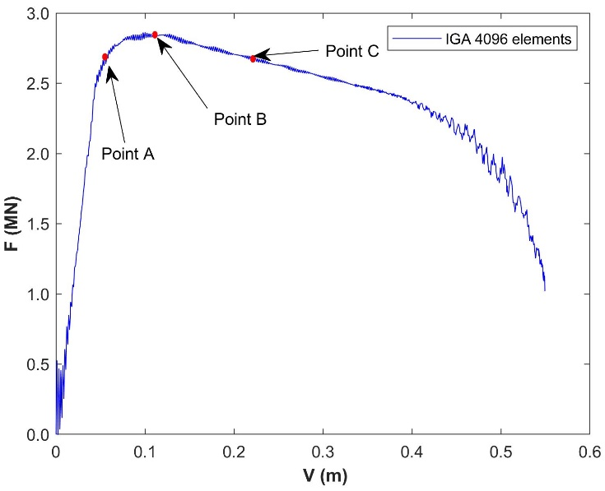
Fig. 9. Force-displacement curve of panel compression model (4096 elements)
(a) (b) (c)
Fig.10. Equivalent plastic strain distribution under different vertical displacements: (a ) $V=0.0550m$(Point A) (b) $V=0.1100m$(Point B) (c) $V=0.2200m$(Point C)
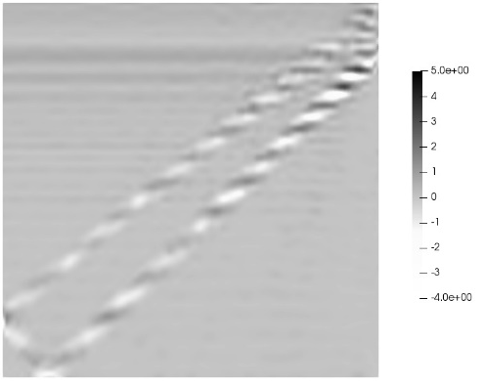
(a) (b) (c)
Fig. 11. Second-order work under different vertical displacements: (a )$V=0.0550m$(Point A) (b )$V=0.1100m$(Point B) (c)$V=0.2200m$ (Point C)

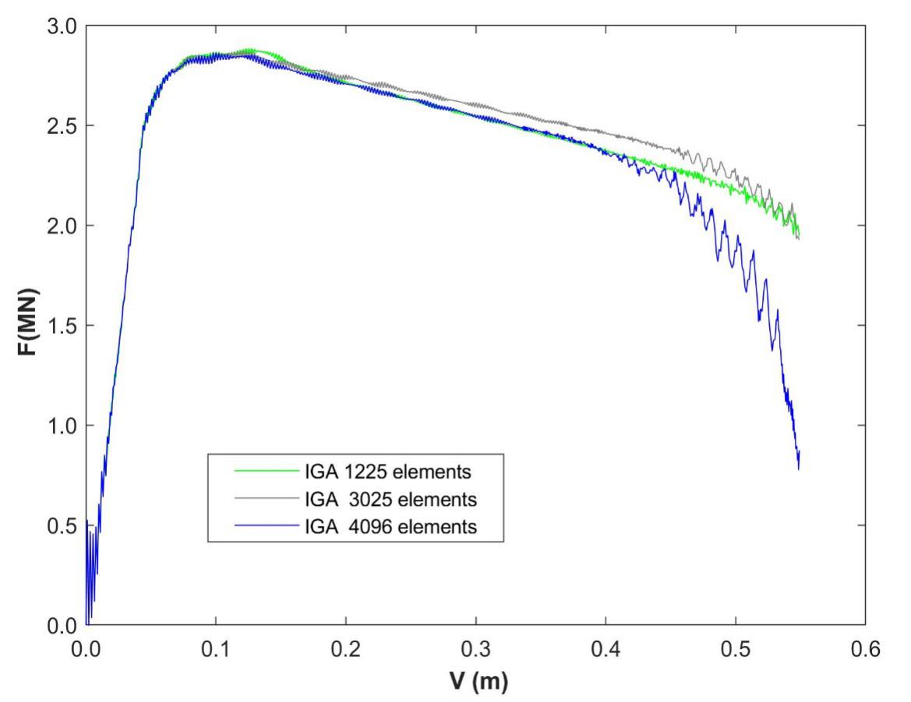
Fig. 12. Vertical force-displacement curves obtain by classical continuum under different meshes
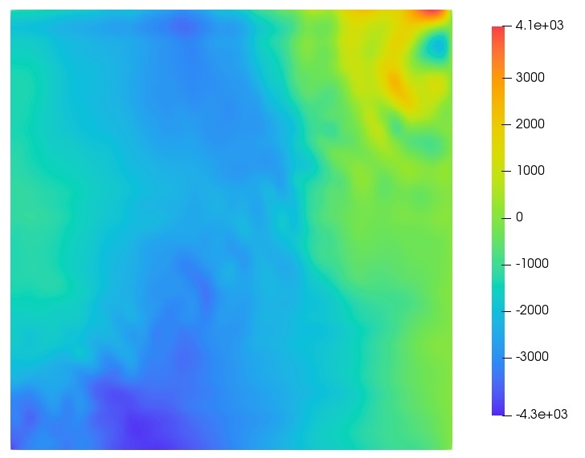
(a)
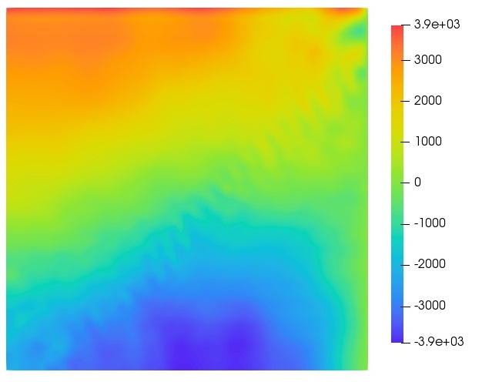
(b)
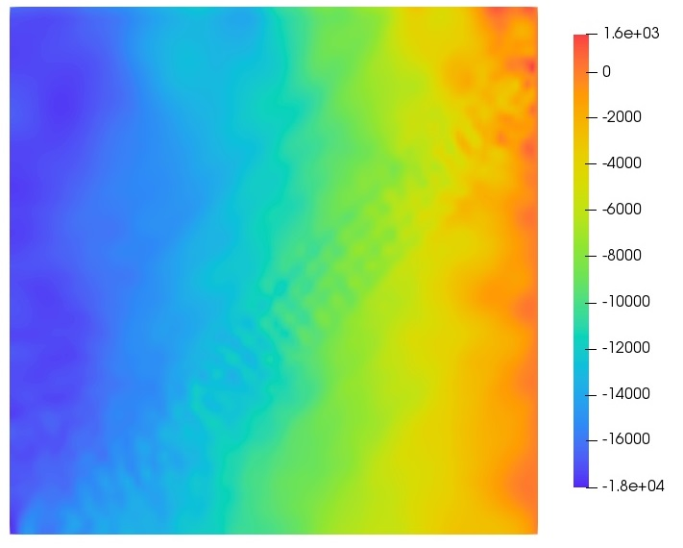
(c)
Fig. 13. Pore pressure distribution with different mesh densities obtained by classical continuum: (a) 1296 elements; (b) 3025 elements; (c) 4096 elements
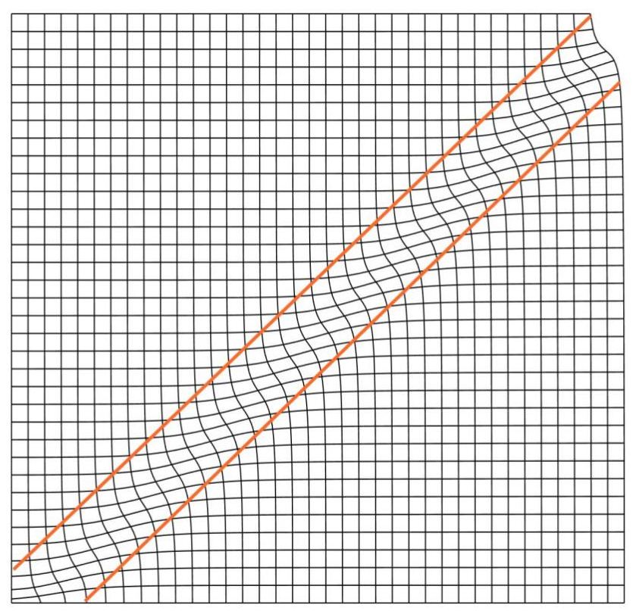
(a)
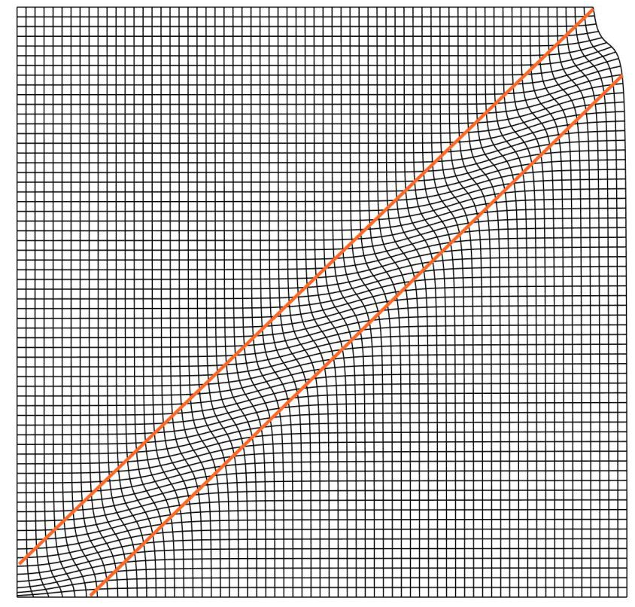
(b)
Fig. 14. Deformed configuration of the panel model obtained by Biot-CIGA: (a) 1296 elements; (b) 4096 elements
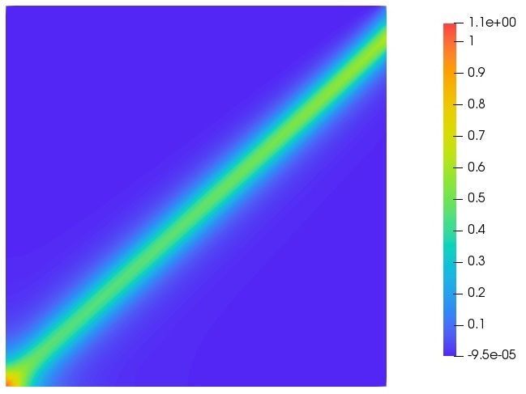
(a)
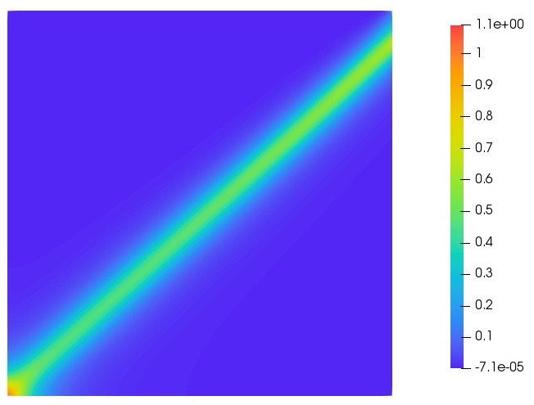
(b)
Fig. 15. Equivalent plastic strain distribution with different mesh densities obtained by Biot-CIGA: (a) 1296 elements; (b) 4096 elements
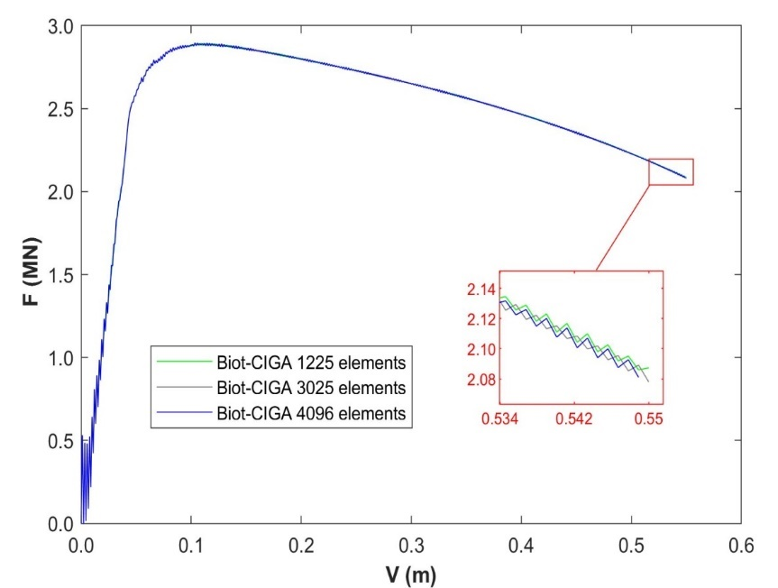
Fig. 16. Vertical force-displacement curves obtain by Biot-CIGA under different meshes
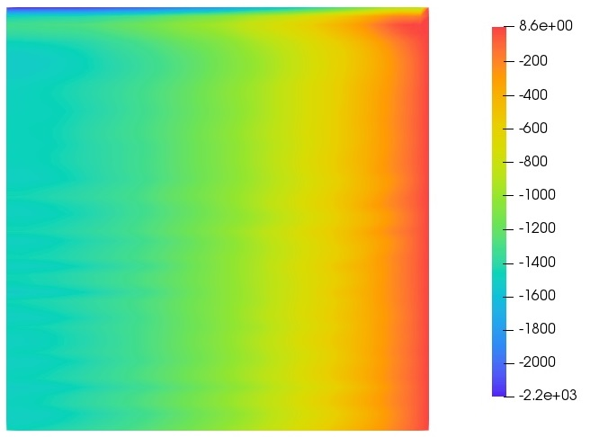
(a)
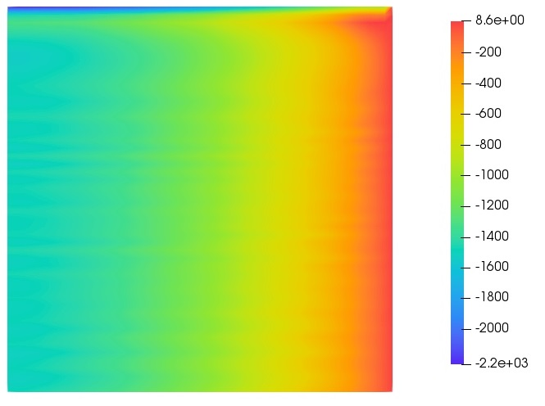
(b)
Fig. 17. Pore pressure distribution with different mesh densities obtained by Biot-CIGA: (a) 1296 elements; (b) 3025 elements

Biaxial compression test
The third example is a biaxial compression test with confining pressure $p=200kPa$ (as shown in Fig. 18). The height of the model is $H=0.08m$, and its width is $W=0.04m$. The boundary conditions are as follows: an axial dynamic load of $v=0.048m/s$ is applied to the top surface of the model, and the horizontal displacements of the upper surface are constrained to zero, and the bottom of the model is completely fixed; the upper and lower boundaries of the model are drainage boundaries, and the left and right boundaries are impermeable. Except for the length scale $l_{c}=0.001m$, the other parameters are basically the same as the panel compression model. Three regular mesh discretizations are used, and the ratio of their element size to length scale is $l_{e}/l_{c}=2.0,1.5,1.3$, respectively.
For the strain localization, the deformation is mainly concentrated in the shear band, which will lead to excessive mesh distortion in band. Therefore, an important problem that needs to be solved in the simulation of strain localization is to overcome or alleviate the influence of mesh distortion. Fig. 19 shows the force-displacement curves of different mesh densities obtained by Biot-CFEA and Biot-CIGA, respectively. It can be seen from Fig. 19(a) that when the vertical displacement $V=0.0150m$($V/W=0.375$) or so, the calculation of Biot-CFEA does not converge due to mesh distortion (as shown in Fig. 21(a)), and the force-displacement curves of different mesh densities within the range $0.012m-0.0150m$ shows obvious mesh-dependent phenomena. However, it can be seen from Fig. 19(b) that although the mesh has been extremely distorted (as shown in Fig. 21(b)) when the vertical displacement $V=0.03m$ ($V/W=0.75$), the force-displacement curves of different mesh densities obtained by Biot-CIGA are still mesh-independent. The equivalent plastic strain distributions shown in Fig. 22 further prove that the solution of the Biot-CIGA method at $V=0.03m$ is still mesh-independent. In conclusion, the calculation range of the Biot-CIGA method in the biaxial compression model is increased by $100\%$ compared with the Biot-CFEA method, indicating that Biot-CIGA can significantly alleviate the effects of mesh distortion. In order to explain the oscillation phenomenon in Fig. 19, the authors selected three loading rates, namely $v=48mm/s$, $v=4.8mm/s$ and $v=0.48mm/s$. Fig. 20 below shows the force-displacement curves at three loading rates, in which the small window on the upper right side is enlarged by 50 times. It can be seen from Fig. 20 that as the loading rate decreases, the oscillation amplitude of the corresponding force-displacement curve gradually decreases. Therefore, the authors believe that one of the main reasons for the oscillation in the Fig. 19 is caused by the higher loading rate. In addition, the reason why the tail ($V=0.022m-0.03m$) of the force-displacement curves in Fig. 19(b) tends to be horizontal is that most of the elements in the shear band are in the residual state at this time.
To study the effects of length scales on the Biot-CIGA method, a fix mesh discretization and four different length scales (i.e. $l_{c}=0.001m,0.002m,0.003m,0.004m$) are adopted. Fig. 23 shows the force-displacement curves of different length scales. Fig. 24 presents the change trend of peak load with length scales. From Figs. 23 and 24, it can be observed that as the length scales increases, the mechanical response of saturated porous media become more rigid. Fig. 25 shows the equivalent plastic strain distribution of different length scales. As shown in the figure, the larger the length scale, the wider the width of the shear band, which indicates that the width of the shear band is proportional to the length scale.

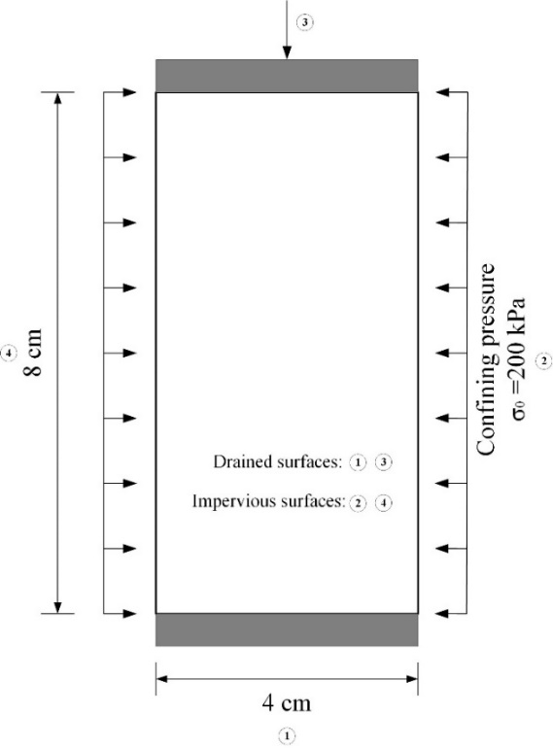
Fig. 18. The biaxial compression test
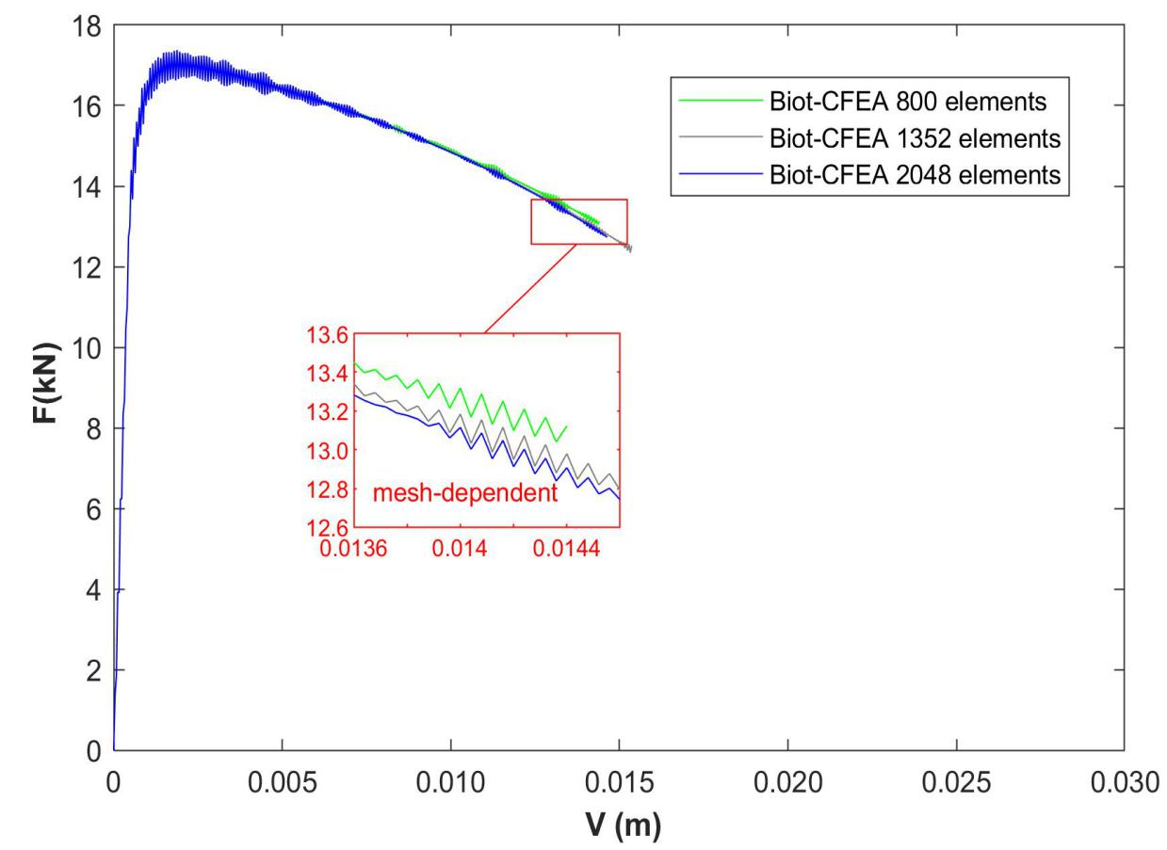
(a)
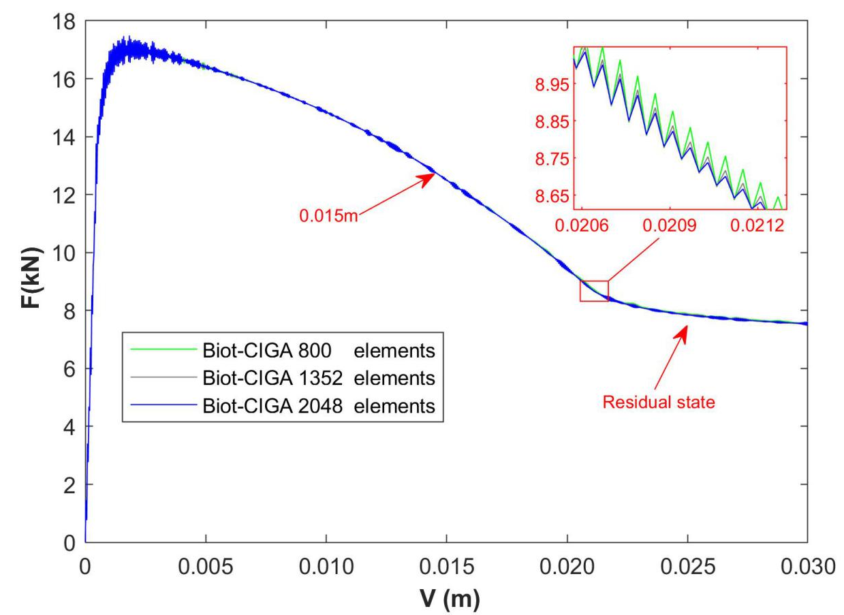
(b)
Fig. 19. Vertical force-displacement curves obtained by Biot-CFEA and Biot-CIGA under different meshes: (a) Biot-CFEA; (b) Biot-CIGA
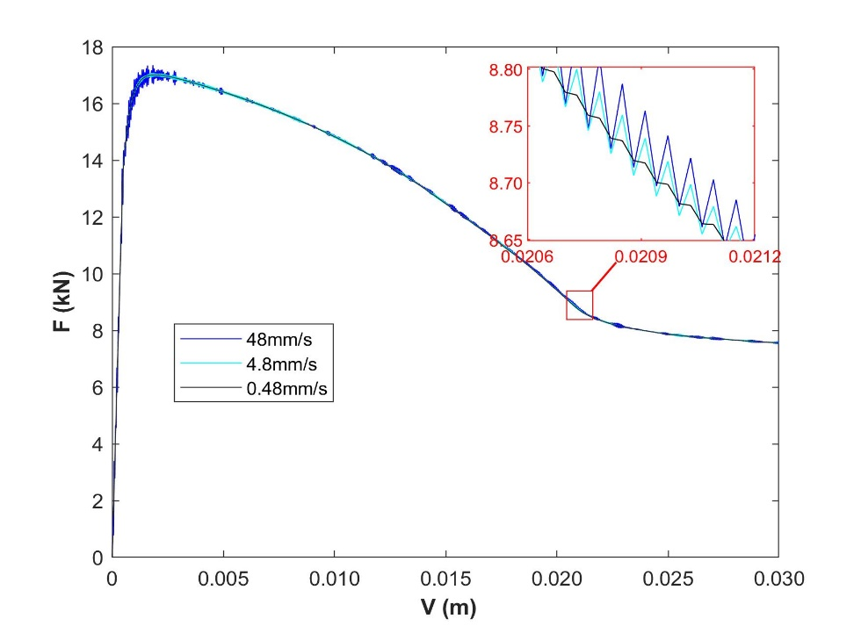
Fig. 20. Force-displacement curve under different loading rates

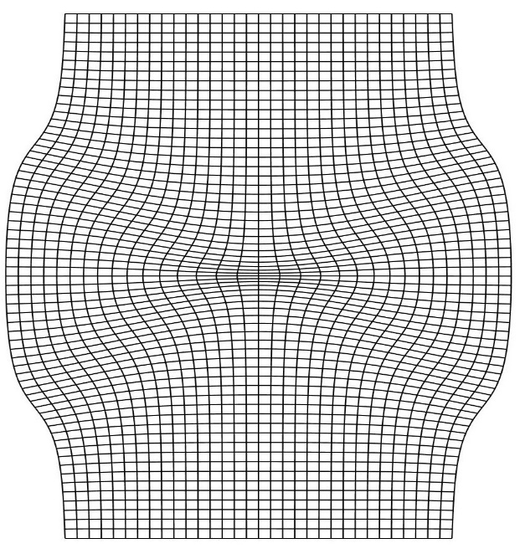
(a)
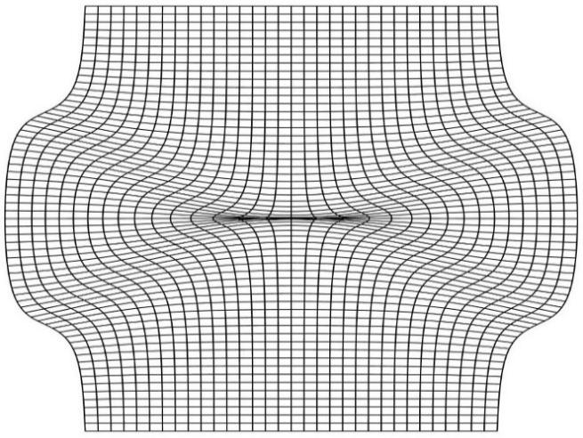
(b)
Fig. 21. Deformed configuration of the biaxial compression model obtained by Biot-CFEA and Biot-CIGA on the same mesh discretization: (a) Biot-CFEA ($V=0.015m$); (b) Biot-CIGA ($V=0.03m$).
(a) (b) (c)
Fig. 22. Equivalent plastic strain distribution with different mesh densities obtained by Biot-CIGA: (a) 800 elements; (b) 1352 elements; (c) 2048 elements
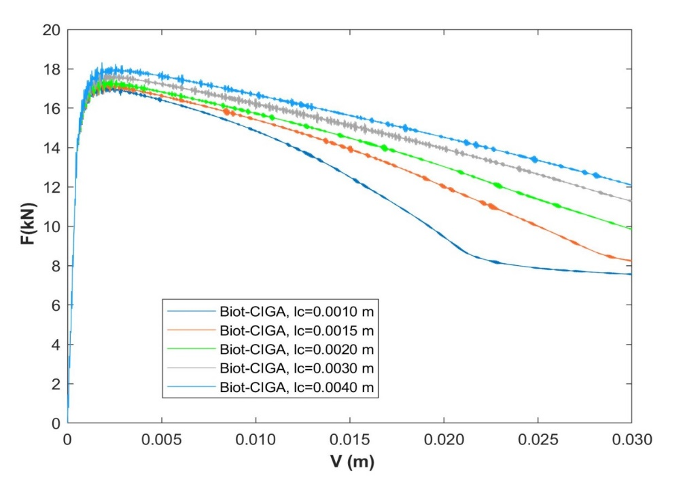
Fig. 23. Force-displacement curves of different length scales obtained by Biot-CIGA (800 elements)
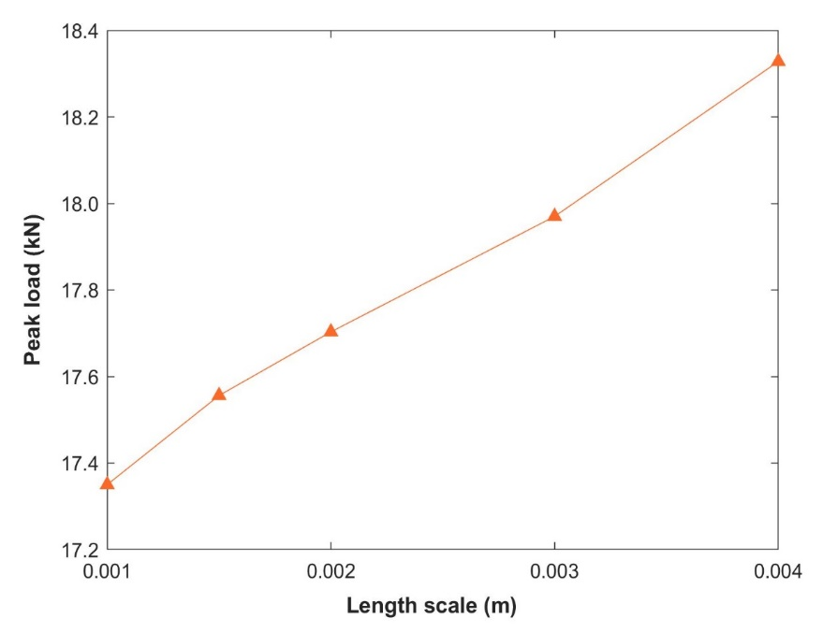
Fig. 24. Change trend of the peak load obtained by Biot-CIGA with the length scale (800elements) 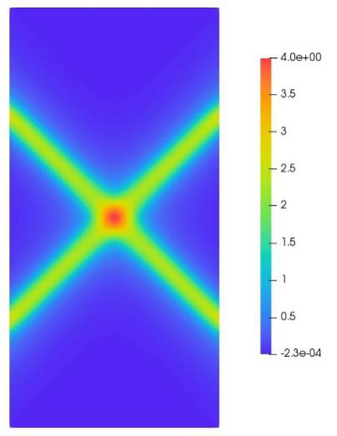 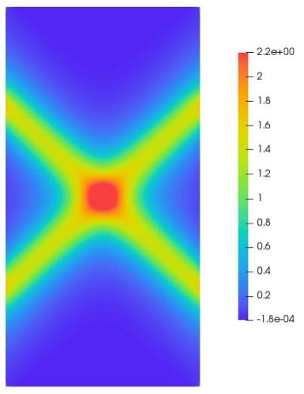 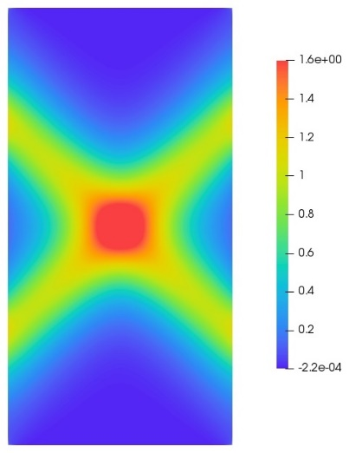
(a) (b) (c)
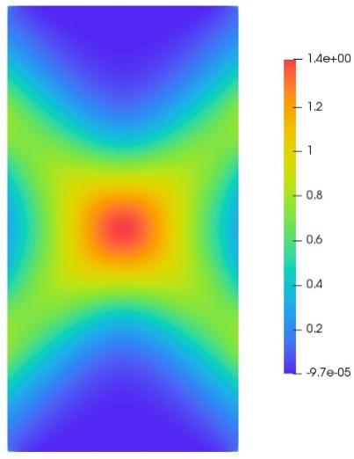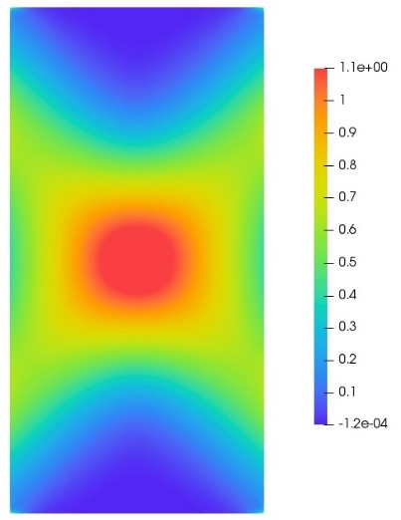
(d) (e)
Fig. 25. Equivalent plastic strain distribution corresponding to different length scales (800 elements): (a) $l_{c}=0.001m$; (b) $l_{c}=0.0015m$; (c) $l_{c}=0.002m$; (d) $l_{c}=0.003m$; (e) $l_{c}=0.004m$

Conclusions
To simulate the strain localization of saturated soil, the following three aspects need to be considered: a regularization mechanism (such as Cosserat model) is needed to solve the ill-posed problem of partial differential equations caused by strain-softening properties and non-associated flow rules; the adopted numerical method should be able to overcome or alleviate the mesh distortion in the shear zone; its shape functions should have high-order continuity in order to correctly describe the flow and transport of pore fluid, so as to accurately simulate the progressive failure mechanism of saturated soil. Contrary to FEA, IGA not only has the ability to overcome mesh distortion, but also has the property of high-order continuity. Therefore, the formulation for isogeometric analysis of (IGA) Biot-Cosserat continuum(Cosserat model as a regularization mechanism) is developed in this paper to simulate the dynamic strain localization in saturated soils.
Through three examples of one-dimensional consolidation, panel compression, and biaxial compression test, it is shown that in the classical continuum, the width, shape, and location of the shear band of saturated porous media are both closely related to the mesh density. It is also shown that when the mesh in the shear zone is excessively distorted, the Biot-CFEA method not only fails to converge, but its numerical solution also shows mesh-dependent after a certain softening stage. On the contrary, Biot-CIGA can effectively alleviate the mesh distortion problem in the band (even in the case of large deformation), thereby obtaining a convergent, mesh-independent numerical solution. Moreover, the high-order continuity of Biot-CIGA, on the one hand, can provide a smooth pore pressure gradient field, thereby ensuring the local mass balance of pore fluid. On the other hand, it can describe the inflow and outflow of pore fluid in the element, that is, it has the ability to correctly simulate the volumetric strain of the element.
In addition, because Biot-CIGA (IGA) adopts NURBS as its shape functions, it can conduct simulations directly on CAD models, which not only maintains the precise geometry, but also avoids an expensive intermediate meshing step.

Acknowledgement
The authors are pleased to acknowledge the support from the National Natural Science Foundation of China (Projects 51890912, 51979025 and 52011530189) and the Open Research Fund of State Key Laboratory of Coastal and Offshore Engineering, Dalian University of Technology (Project LP1926).

Reference
[1] DEIST FH, DIMITRIOU C. Finite Element Method. S Afr Mech Eng 1969;19:124–6.
[2] Irzal F, Remmers JJC, Verhoosel C V., Borst R de. Isogeometric finite element analysis of poroelasticity. Int J Numer Anal Methods Geomech 2013:1891–907. doi:10.1002/nag.
[3] Benson DJ, Bazilevs Y, Hsu MC, Hughes TJR. Isogeometric shell analysis: The Reissner-Mindlin shell. Comput Methods Appl Mech Eng 2010;199. doi:10.1016/j.cma.2009.05.011.
[4] Lipton S, Evans JA, Bazilevs Y, Elguedj T, Hughes TJR. Robustness of isogeometric structural discretizations under severe mesh distortion. Comput Methods Appl Mech Eng 2010. doi:10.1016/j.cma.2009.01.022.
[5] Belytschko T, Fish J, Engelmann BE. A finite element with embedded localization zones. Comput Methods Appl Mech Eng 1988;70. doi:10.1016/0045-7825(88)90180-6.
[6] Simo JC, Oliver J, Armero F. An analysis of strong discontinuities induced by strain-softening in rate-independent inelastic solids. Comput Mech 1993;12. doi:10.1007/BF00372173.
[7] Lu X, Bardet JP, Huang M. Numerical solutions of strain localization with nonlocal softening plasticity. Comput Methods Appl Mech Eng 2009;198:3702–11. doi:10.1016/j.cma.2009.08.002.
[8] Reis FJP, Rodrigues Lopes IA, Andrade Pires FM, Andrade FXC. Microscale analysis of heterogeneous ductile materials with nonlocal damage models of integral type. Comput Struct 2018;201. doi:10.1016/j.compstruc.2018.02.013.
[9] Needleman A. Material rate dependence and mesh sensitivity in localization problems. Comput Methods Appl Mech Eng 1988;67. doi:10.1016/0045-7825(88)90069-2.
[10] Niazi MS, Wisselink HH, Meinders T. Viscoplastic regularization of local damage models: Revisited. Comput Mech 2013;51. doi:10.1007/s00466-012-0717-7.
[11] Kolo I, de Borst R. Dispersion and isogeometric analyses of second-order and fourth-order implicit gradient-enhanced plasticity models. Int J Numer Methods Eng 2018;114. doi:10.1002/nme.5749.
[12] Liu N, Jeffers AE. Feature-preserving rational Bézier triangles for isogeometric analysis of higher-order gradient damage models. Comput Methods Appl Mech Eng 2019;357. doi:10.1016/j.cma.2019.112585.
[13] Kolo I, Chen L, de Borst R. Strain-gradient elasticity and gradient-dependent plasticity with hierarchical refinement of NURBS. Finite Elem Anal Des 2019;163. doi:10.1016/j.finel.2019.06.001.
[14] Li X, Tang H. A consistent return mapping algorithm for pressure-dependent elastoplastic Cosserat continua and modelling of strain localisation. Comput Struct 2005. doi:10.1016/j.compstruc.2004.08.009.
[15] Arslan H, Sture S. Finite element analysis of localization and micro-macro structure relation in granular materials. Part I: Formulation. Acta Mech 2008;197:135–52. doi:10.1007/s00707-007-0512-2.
[16] Arslan H, Sture S. Finite element analysis of localization and micro-macro structure relation in granular materials. Part II: Implementation and simulations. Acta Mech 2008;197:153–71. doi:10.1007/s00707-007-0514-0.
[17] Tang H, Hu Z, Li X. Three-dimensional pressure-dependent elastoplastic cosserat continuum model and finite element simulation of strain localization. Int J Appl Mech 2013;5. doi:10.1142/S1758825113500300.
[18] Tang H, Sun F, Zhang Y, Dong Y. Elastoplastic axisymmetric Cosserat continua and modelling of strain localization. Comput Geotech 2018;101:159–67. doi:10.1016/j.compgeo.2018.05.004.
[19] Tang H, Wei W, Liu F, Chen G. Computers and Geotechnics Elastoplastic Cosserat continuum model considering strength anisotropy and its application to the analysis of slope stability. Comput Geotech 2020;117:103235. doi:10.1016/j.compgeo.2019.103235.
[20] Schrefler BA, Majorana CE, Sanavia L. Shear band localization in saturated porous media. Arch Mech 1995;47:577–99.
[21] Schrefler BA, Sanavia L, Majorana CE. A mltiphase medium model for localisation and postlocalisation simulation in geomaterials. Mech Cohesive-Frictional Mater 1996;1:95–114. doi:10.1002/(SICI)1099-1484(199601)1:1<95::AID-CFM5>3.0.CO;2-D.
[22] Zhang HW. An internal length scale in dynamic strain localisation analysis of saturated porous media. Rock Soil Mech 2001;22:249–53.
[23] Schrefler BA, Zhang HW, Sanavia L. Interaction between different internal length scales in strain localization analysis of fully and partially saturated porous media - The 1-D case. Int J Numer Anal Methods Geomech 2006;30:45–70. doi:10.1002/nag.474.
[24] Zhang HW, Schrefler BA. Gradient-dependent plasticity model and dynamic strain localization analysis of saturated and partially saturated porous media: One dimensional model. Eur J Mech A/Solids 2000;19:503–24. doi:10.1016/S0997-7538(00)00177-7.
[25] Tang H, Li X. The Biot-Cosserat continuum model for coupled hydro-dynamic analysis in saturated porous media and finite element simulation of strain localization 2007;24.
[26] Hughes TJR, Cottrell JA, Bazilevs Y. Isogeometric analysis: CAD, finite elements, NURBS, exact geometry and mesh refinement. Comput Methods Appl Mech Eng 2005;194:4135–95. doi:10.1016/j.cma.2004.10.008.
[27] Remacle J, Lambrechts J, Seny B. Two-way coupling in reservoir–geomechanical models: vertex-centered Galerkin geomechanical model cell-centered and vertex-centered finite volume reservoir models. International 2012:1102–19. doi:10.1002/nme.
[28] Ferronato M, Castelletto N, Gambolati G. A fully coupled 3-D mixed finite element model of Biot consolidation. J Comput Phys 2010;229:4813–30. doi:10.1016/j.jcp.2010.03.018.
[29] Liu R, Wheeler MF, Dawson CN, Dean R. Modeling of convection-dominated thermoporomechanics problems using incomplete interior penalty Galerkin method. Comput Methods Appl Mech Eng 2009;198:912–9. doi:10.1016/j.cma.2008.11.012.
[30] Choo J, Lee S. Enriched Galerkin finite elements for coupled poromechanics with local mass conservation. Comput Methods Appl Mech Eng 2018;341:311–32. doi:10.1016/j.cma.2018.06.022.
[31] de Borst R. A generalisation of J2-flow theory for polar continua. Comput Methods Appl Mech Eng 1993;103:347–62. doi:10.1016/0045-7825(93)90127-J.
[32] G.N.Pane, S.Pietruszczak. Symmetric tangential stiffness formulation for non-associated plasticity. Comput Geotech 1986;2:89–99.
[33] Tang H, Dong Y, Wang T, Dong Y. Simulation of strain localization with discrete element-Cosserat continuum finite element two scale method for granular materials. J Mech Phys Solids 2019;122:450–71. doi:10.1016/j.jmps.2018.09.029.
[34] Sabet SA, de Borst R. Structural softening, mesh dependence, and regularisation in non-associated plastic flow. Int J Numer Anal Methods Geomech 2019;43:2170–83. doi:10.1002/nag.2973.
[35] Sabet SA, de Borst R. Mesh bias and shear band inclination in standard and non-standard continua. Arch Appl Mech 2019;89:2577–90. doi:10.1007/s00419-019-01593-2.
[36] Hageman T, Sabet SA, de Borst R. Convergence in non-associated plasticity and fracture propagation for standard, rate-dependent, and Cosserat continua. Int J Numer Methods Eng 2020:1–19. doi:10.1002/nme.6561.
[37] Ristinmaa M, Vecchi M. Use of couple-stress theory in elasto-plasticity. Comput Methods Appl Mech Eng 1996;136:205–24. doi:10.1016/0045-7825(96)00996-6.
[38] Kolo I, de Borst R. An isogeometric analysis approach to gradient-dependent plasticity. Int J Numer Methods Eng 2018;113:296–310. doi:10.1002/nme.5614.
[39] Bazilevs Y, Hsu MC, Scott MA. Isogeometric fluid-structure interaction analysis with emphasis on non-matching discretizations, and with application to wind turbines. Comput Methods Appl Mech Eng 2012;249–252. doi:10.1016/j.cma.2012.03.028.
[40] Dinachandra M, Raju S. Isogeometric analysis for acoustic fluid-structure interaction problems. Int J Mech Sci 2017;131–132. doi:10.1016/j.ijmecsci.2017.06.041.
[41] Apostolatos A, De Nayer G, Bletzinger KU, Breuer M, Wüchner R. Systematic evaluation of the interface description for fluid–structure interaction simulations using the isogeometric mortar-based mapping. J Fluids Struct 2019;86. doi:10.1016/j.jfluidstructs.2019.02.012.
[42] Dimitri R. Isogeometric treatment of large deformation contact and debonding problems with T-splines: A review. Curved Layer Struct 2015;2. doi:10.1515/cls-2015-0005.
[43] Greco F, Rosolen A, Coox L, Desmet W. Contact mechanics with maximum-entropy meshfree approximants blended with isogeometric analysis on the boundary. Comput Struct 2017;182. doi:10.1016/j.compstruc.2016.11.008.
[44] Dimitri R, Zavarise G. Isogeometric treatment of frictional contact and mixed mode debonding problems. Comput Mech 2017;60. doi:10.1007/s00466-017-1410-7.
[45] Stavroulakis G, Tsapetis D, Papadrakakis M. Non-overlapping domain decomposition solution schemes for structural mechanics isogeometric analysis. Comput Methods Appl Mech Eng 2018;341. doi:10.1016/j.cma.2018.07.011.
[46] Yin L, Zhang F, Deng X, Wu P, Zeng H, Liu M. Isogeometric Bi-Directional Evolutionary Structural Optimization. IEEE Access 2019;7. doi:10.1109/ACCESS.2019.2927820.
[47] Kang P, Youn SK. Isogeometric shape optimization of trimmed shell structures. Struct Multidiscip Optim 2016;53. doi:10.1007/s00158-015-1361-6.
[48] Wang ZP, Poh LH, Dirrenberger J, Zhu Y, Forest S. Isogeometric shape optimization of smoothed petal auxetic structures via computational periodic homogenization. Comput Methods Appl Mech Eng 2017;323. doi:10.1016/j.cma.2017.05.013.
[49] Wang C, Xia S, Wang X, Qian X. Isogeometric shape optimization on triangulations. Comput Methods Appl Mech Eng 2018;331. doi:10.1016/j.cma.2017.11.032.
[50] Verhoosel C V., Scott MA, De Borst R, Hughes TJR. An isogeometric approach to cohesive zone modeling. Int J Numer Methods Eng 2011;87. doi:10.1002/nme.3061.
[51] Vázquez R. A new design for the implementation of isogeometric analysis in Octave and Matlab: GeoPDEs 3.0. Comput Math with Appl 2016;72:523–54. doi:10.1016/j.camwa.2016.05.010.
[52] Garau EM, Vázquez R. Algorithms for the implementation of adaptive isogeometric methods using hierarchical B-splines. Appl Numer Math 2018;123:58–87. doi:10.1016/j.apnum.2017.08.006.
[53] Bracco C, Buffa A, Giannelli C, Vázquez R. Adaptive isogeometric methods with hierarchical splines: An overview. Discret Contin Dyn Syst Ser A 2019;39. doi:10.3934/dcds.2019010.
[54] Carraturo M, Giannelli C, Reali A, Vázquez R. Suitably graded THB-spline refinement and coarsening: Towards an adaptive isogeometric analysis of additive manufacturing processes. Comput Methods Appl Mech Eng 2019;348. doi:10.1016/j.cma.2019.01.044.
[55] Breitenberger M, Apostolatos A, Philipp B, Wüchner R, Bletzinger KU. Analysis in computer aided design: Nonlinear isogeometric B-Rep analysis of shell structures. Comput Methods Appl Mech Eng 2015;284. doi:10.1016/j.cma.2014.09.033.
[56] Al Akhras H, Elguedj T, Gravouil A, Rochette M. Towards an automatic isogeometric analysis suitable trivariate models generation—Application to geometric parametric analysis. Comput Methods Appl Mech Eng 2017;316. doi:10.1016/j.cma.2016.09.030.
[57] Marussig B, Zechner J, Beer G, Fries TP. Stable isogeometric analysis of trimmed geometries. Comput Methods Appl Mech Eng 2017;316. doi:10.1016/j.cma.2016.07.040.
[58] Marussig B, Hiemstra R, Hughes TJR. Improved conditioning of isogeometric analysis matrices for trimmed geometries. Comput Methods Appl Mech Eng 2018;334. doi:10.1016/j.cma.2018.01.052.
[59] Guo N, Zhao J. Hierarchical multiscale modeling of fluid-saturated soils. 15th Asian Reg Conf Soil Mech Geotech Eng ARC 2015 New Innov Sustain 2015:649–53. doi:10.3208/jgssp.TC105-08.
[60] Mikaeili E, Schrefler B. XFEM, strong discontinuities and second-order work in shear band modeling of saturated porous media. Acta Geotech 2018;13:1249–64. doi:10.1007/s11440-018-0734-6.
[61] Song X, Ye M, Wang K. Strain localization in a solid-water-air system with random heterogeneity via stabilized mixed finite elements. Int J Numer Methods Eng 2017;112:1926–50. doi:10.1002/nme.5590.
[62] Oka F, Shahbodagh B, Kimoto S. A computational model for dynamic strain localization in unsaturated elasto-viscoplastic soils. Int J Numer Anal Methods Geomech 2019;43:138–65. doi:10.1002/nag.2857.
[63] Hoang T, Verhoosel C V., Auricchio F, van Brummelen EH, Reali A. Mixed Isogeometric Finite Cell Methods for the Stokes problem. Comput Methods Appl Mech Eng 2017;316:400–23. doi:10.1016/j.cma.2016.07.027.
[64] Dortdivanlioglu B, Krischok A, Beirão da Veiga L, Linder C. Mixed isogeometric analysis of strongly coupled diffusion in porous materials. Int J Numer Methods Eng 2018;114:28–46. doi:10.1002/nme.5731.
[65] Hageman T, de Borst R. Flow of non-Newtonian fluids in fractured porous media: Isogeometric vs standard finite element discretisation. Int J Numer Anal Methods Geomech 2019:2020–37. doi:10.1002/nag.2948.
[66] Piegl L, Tiller W. The NURBS book, 2nd edition. Springer-Verlag 1997.
[67] Kakogiannou E, Sanavia L, Nicot F, Darve F, Schrefler BA. A porous media finite element approach for soil instability including the second-order work criterion. Acta Geotech 2016;11:805–25. doi:10.1007/s11440-016-0473-5.

