A clinical prediction model to support the diagnosis of asthma in children and young people in primary care
L Daines, LJ Bonnett, H Tibble, A Boyd, SW Turner, S Lewis, A Sheikh, H Pinnock

Abstract

Aim
Making an accurate diagnosis of asthma can be challenging. Approaches used to assess the probability of asthma vary between clinicians; a prediction model could help to standardise clinical assessment. We aimed to derive and internally validate a clinical prediction model to support health professionals in primary care to assess the probability of an asthma diagnosis in children and young people presenting with symptoms suggestive of asthma.

Methods
We created a dataset from the Avon Longitudinal Study of Parents and Children (ALSPAC) enhanced with data from linked primary care electronic health records. Individuals with at least three inhaled corticosteroid prescriptions in one year and a ‘specific’ asthma Read code were designated as having asthma. Potential candidate predictors were included if data were available in at least 60% of participants. Remaining missing data were handled using multiple imputation. The prediction model was derived using logistic regression. Bootstrap re-sampling was used to internally validate the model.

Results
11972 individuals aged <25 years (49% female) were included, of whom 994 (8%) had asthma. Model performance was good; after internal validation, the area under the receiver operating characteristic (AUROC) was 0.86 (figure 1; 95% CI 0.85 to 0.87). The calibration slope was 0.99. The items included in the final model were wheeze, cough, breathlessness, hay fever, eczema, food allergy, social class, maternal asthma, childhood exposure to cigarette smoke, previous prescription of a short acting beta agonist and the recording of lung function/reversibility testing in the past.
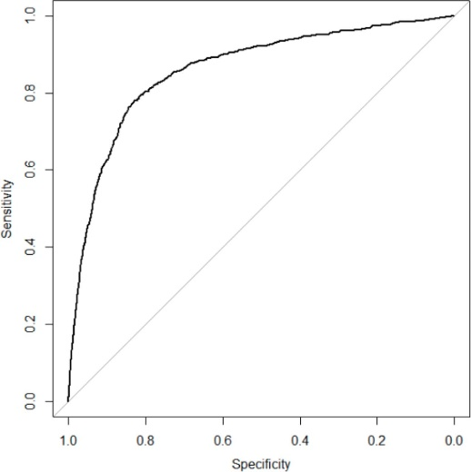
Figure 1: Receiver operating characteristic curve for the asthma diagnosis model

Conclusion
Information readily available from a patient’s electronic health records can support primary care clinicians weigh up the likelihood of a child/young person having asthma. We plan to externally validate the prediction model in a dataset created from primary care electronic health records. We will then develop the prediction model into a clinical decision support system (CDSS), co-produced with clinicians and patients, and test the feasibility of using the CDSS in clinical practice prior to prospective evaluation.

