Deciphering syn- and post-emplacement processes in shallow mafic dykes using magnetic anisotropy
Simon A. Martin*, Janine L. Kavanagh, Andrew J. Biggin
Department of Earth, Ocean and Ecological Sciences, University of Liverpool, Liverpool, L69 3GP
*simon.a.martin@outlook.com

Abstract
Dykes form key pathways for the transport and emplacement of magma within the crust. We have identified syn- and post emplacement processes recorded across a ~2m thick basaltic dyke on the Isle of Skye, Scotland. We measured the rock magnetic properties, anisotropy of magnetic susceptibility (AMS) and anisotropy of anhysteretic magnetisation (AARM) across two dyke-thickness profiles spaced 13m apart along the dyke strike (sites G5 and G6). At 20-25 cm intervals, our samples are very closely spaced compared to standard sampling protocols. Our results show that the dyke’s magnetic fabrics originate from two mineral groups: titanomagnetite, which is abundant in the central dyke region at site G5, and iron sulphides (pyrite and pyrrhotite) that dominates the margin regions at both sites. The titanomagnetite occurs in unaltered dyke rock; its magnetic fabrics are primary, having formed during magma solidification, and record lateral magma flow. The pyrrhotite occurs in jointed and hydrothermally altered dyke rock; its petrological and magnetic fabrics are secondary, having originated from a sulphide-rich fluid which infiltrated cooling joints oriented perpendicular to the dyke margins and locally modified the primary magnetic fabrics. At site G6, pyrrhotite also occurs in the dyke centre, suggesting that locally the post-emplacement sulphide-rich fluid permeated into this region; this site is located close to a branch in the dyke and has increased joint frequency, which could explain the enhanced alteration. The presence of syn- (primary) and post-emplacement (secondary) fabrics was only identified due to our high frequency sampling regime and use of both AMS and AARM techniques. We highlight that future magnetic anisotropy studies of dykes may benefit from high sample frequency combined with sampling along-strike and across-thickness. Using both AMS and AARM techniques to detect more variations in magnetic fabrics can reveal more complete syn- and post-emplacement dyke histories.
Keywords: anisotropy of magnetic susceptibility, anisotropy of anhysteretic remanent magnetisation, dyke emplacement, post-emplacement alteration, iron sulphides, British and Irish Palaeogene Igneous Province
- Introduction
Sheet (planar) intrusions are pathways through which magma can flow through the Earth’s crust. Dykes are one type of sheet intrusion that are generally subvertical (>80˚ dip) in orientation with lengths substantially greater than thickness. When dykes cluster together, this can lead to the formation of volcanic complex or dyke swarm (e.g. Townsend et al., 2017). Only a small volume of magma (<10%) propagates to the surface and erupts (Crisp, 1984), and unravelling the dynamic processes that occur during dyke propagation is necessary for understanding the formation of these structures and their tendency to erupt.
Dykes are generally associated with volcanoes and with multiple geodynamic environments, such as lithospheric regions above mantle plumes or where rifting is occurring (e.g. Ernst and Baragar, 1992). Dyke emplacement in these regions can be separated into two contrasting styles: active or passive (see Kavanagh, 2018 for a review). Active emplacement occurs when magma overpressure causes fracturing of the host rock into which the magma then flows. In volcanic settings, active intrusion may occur, for example, when there is increased magma flux to a reservoir which then ruptures, e.g. during the 2004-2005 activity at Piton de la Fournaise volcano, La Reunion (Peltier et al., 2008). Passive dyke emplacement occurs when the crust has already been fractured, and space for the magma to fill relates to mechanisms not not associated with magmatic processes. For example, this may occur in volcanic rift zones that are gravitationally unstable (e.g. the East Rift Zone, Kilauea, Hawai’i; Fiske and Jackson, 1972), or in areas of tectonic extension or crustal extension related to mantle plumes (e.g. MacKenzie Dyke Swarm, Canada; Ernst and Baragar, 1992).
Many studies focus on dyke emplacement mechanisms that include observations of field relationships of fossil intrusions in 2D (e.g. Delaney and Pollard, 1982; Smith, 1987) and rarely in 3D (Kavanagh and Sparks, 2011), and through geophysical surveys of dykes as they move (e.g. Chadwick et al., 2011; Hjartardóttir et al., 2015). As dyke emplacement occurs in the subsurface it is very difficult to monitor in real-time, as only indirect signals such as ground deformation and seismicity can be measured during intrusion, e.g. during the eruption of Bardarbunga, Iceland in 2014 (e.g. Hjartardóttir et al., 2015; Sigmundsson et al., 2015). Numerical (e.g. Gudmundsson et al., 1999; Yamato et al., 2012) and analogue modelling techniques (e.g. Tibaldi et al., 2014; Kavanagh et al., 2018) are based on conceptual dyke emplacement models that are grounded in field and geophysical observations. Most of these studies investigate the mechanics of dyke propagation and are focused on the role of the host-rock deformation, however, understanding the processes occurring within the flowing magma, and how this is recorded during magma solidification, is also vital.
Structures associated with magma flow in dykes include large and small scale features observed in field exposures; for example, en echelon segmentation (e.g. Schofield et al., 2012), ropey flow structures (e.g. Kavanagh et al., 2018), scour marks (e.g. Smith, 1987; Varga et al., 1998), stretched vesicles (e.g. Coward, 1980), and crystal preferred orientations (e.g. Archanjo and Launeau, 2004). Ropey flow structures and scour marks are only preserved in exceptional circumstances (e.g. Varga et al., 1998; Kavanagh et al., 2018), and as such there is the need to study the microscale crystal, vesicle, and magnetic fabrics. Dyke contact regions where chilled margins are present record the history of initial magma flow, whereas the central regions of intrusions may preserve records of later stage flow, which can be more complex and include flow reorientation or reactivation (e.g. Platten and Watterson, 1987). A common assumption is that the predominant magma flow is vertical but field evidence (e.g. Poland et al., 2004; Kavanagh et al., 2018) and recent analogue modelling (e.g. Kavanagh et al., 2018) suggests lateral flow is also prevalent. As such, understanding how magma flow fabrics vary across the thickness and length (along strike) of dykes is vital for unravelling more complete magma flow histories.
Rock magnetism and magnetic anisotropy are used across multiple fields of geology as records for understanding rock histories (Blundell, 1957; Raposo and Ernesto, 1995; Tauxe, 2010). Studying the properties and orientations of the magnetic minerals present provides insights into rock ages or identification of depositional, tectonic or syn- and post-emplacement processes. For the case of magmatic intrusions, rock magnetic techniques (both anisotropy of magnetic susceptibility, AMS, and anisotropy of anhysteretic remanent magnetisation, AARM) have identified micro-scale magnetic fabrics preserved in solidified magma (e.g. Knight and Walker, 1988; Tauxe et al., 1998; Callot et al., 2001; Chadima et al., 2009). These have been used to study models of emplacement and magma flow trajectories within a variety of intrusion types, such as plutons (e.g. Olazabal et al., 1999; Selkin et al., 2014), dykes (e.g. Knight and Walker, 1988; Staudigel et al., 1992; Varga et al., 1998; Clemente et al., 2007; Chadima et al., 2009) and sills (e.g. Hrouda et al., 2015; Závada et al., 2017; Martin et al., 2019), or to infer the intrusion source locations (e.g. Poland et al., 2004; O’Driscoll et al., 2006). A common problem with these types of studies, however, is the number of samples that are analysed relative to the size of the intrusion is typically very low, which leads to questions over how representative the inferred patterns or fabrics are to inform on the overall intrusion structure and its development. Cañón-Tapia and Herrero-Bervera (2009) drew attention to the importance of using a sampling strategy appropriate for the study, noting that this can influence interpretation quality.
This study investigates how magnetic fabrics vary across the thickness of basaltic dykes. A ~2m thick basaltic dyke from the Isle of Skye, Scotland was selected due to its excellent exposure and accessibility for sampling. Samples were collected at 20-25cm intervals across the dyke thickness from two profiles for AMS, AARM and rock magnetic analyses. The main goal was to obtain a detailed understanding of the spatial variability of magnetic fabrics in dykes and their origins. Observed fabrics were interpreted in combination with field-based structural data and simple petrological analyses to understand how syn- and post-emplacement histories can be unravelled in solidified mafic dykes.
- Geological Setting: Dykes of the Skye Dyke Swarm
In order to investigate how magnetic fabrics vary across the length and thickness of a dyke, a well-exposed <2 m thick dyke was required that had both host-rock wall contacts easily accessible. The chosen dyke would also benefit from having a well-constrained tectonic history with no known post-emplacement tectonic overprinting events. The Isle of Skye has been intruded by the ~60 Ma Skye Dyke Swarm (SDS; Figure 1A) and has been the focus of multiple studies for magnetic (Herrero-Bervera et al., 2001), petrological and geochemical studies (e.g. Platten and Watterson, 1987; Hughes et al., 2015). As such it provides the exposure, background knowledge and opportunity for a detailed study such as ours to be conducted. Through this case study we aim to enhance the current understanding of dyke emplacement in this region both during the Palaeogene and in general.
The Trotternish Peninsula is located in the north of the Isle of Skye (Figure 1A), and consists of a series of Jurassic (~168 Ma) layered sandstones and mudstones (Hudson and Trewin, 2002). These are overlain by the Skye Lava Group (~60 Ma) that is predominantly of basaltic composition (Hudson and Trewin, 2002; Emeleus and Bell, 2005). Postdating lava emplacement are a series of mafic sills of the Little Minch Sill Complex that intruded through the Jurassic sedimentary rocks (Gibb and Gibson, 1989; Gibson and Jones, 1991; Schofield, 2009). The North Britain Palaeogene Dyke Suite (Emeleus and Bell, 2005; Hughes et al., 2015) is a series of basaltic dykes from the SDS that cut through the sedimentary and igneous rocks and have a general strike of NW-SE. Both the Little Minch Sill Complex and the SDS form a part of the British and Irish Palaeogene Igneous Province.
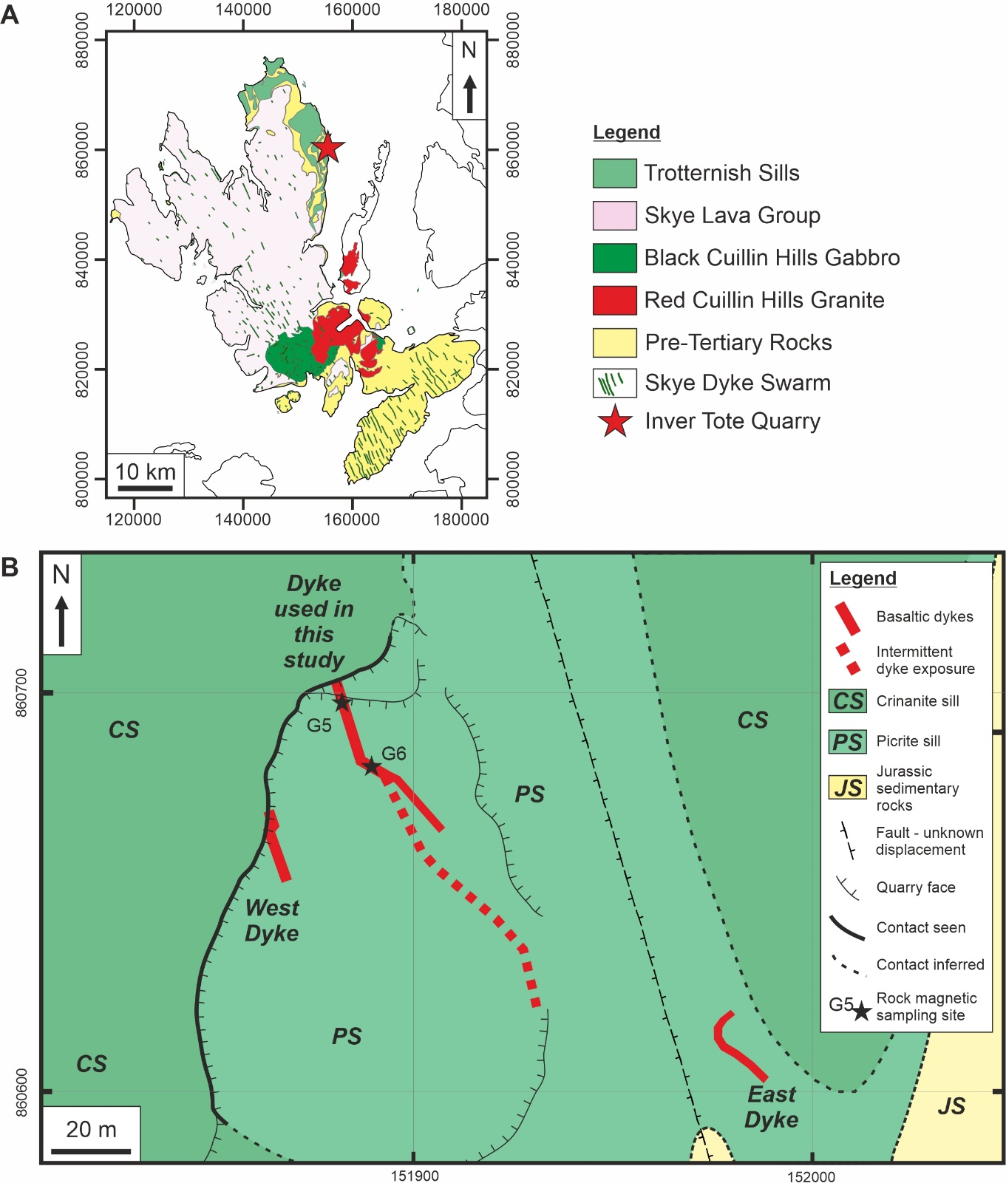
Figure 1: A) Simplified geological map of the Isle of Skye showing main groups of rocks (simplified from BGS, 2008; adapted from Martin et al., 2019). The main portion of the Skye Dyke Swarm and its general orientation is defined by the green lines, and Inver Tote quarry is identified by the red star. B) Geological map of the dykes at the quarry near Inver Tote, Isle of Skye, Scotland. Jurassic sedimentary rocks (JS, yellow) are intruded by Tertiary age crinanite (CS, dark green) and picrite (PS, light green) mafic sills. Cross-cutting the area are three basaltic dykes (red). The southern portion of the main dyke has infrequent exposure in the quarry floor as it is obscured by rubble (its approximate location is indicated by the red dashed line). Locations of magnetic sampling sites are marked by black stars (G5 and G6) in the north end of the quarry. Petrographic thin section transects were collected less than 1 metre from site G5 along the dyke strike.
Structural mapping and sampling for rock magnetism and petrological analyses were undertaken at Inver Tote quarry, Trotternish (NG 51863 60609), an abandoned quarry with easy access for sampling (Figure 1B). Here two stacked sills of picrite (lower sill) and crinanite (upper sill) from the Little Minch Sill Complex shallowly dip westwards (Figure 2A), with a pegmatitic gabbro vein cutting through the picrite (Martin et al., 2019). Cross-cutting the sills within the quarry are two NNW-SSE striking basaltic dykes from the SDS (studied dyke and west dyke) which follow a similar orientation to faults in the surrounding area (e.g. Figure 1B, and Figure 2A). In a gully to the east of the quarry, a third dyke crops out (Figure 1B).
The studied dyke ranges in thickness between 1.7 and 2 m with a strike that varies from 120° – 170° in different exposed sections across the quarry (Figure 1B). It is a fine-grained basalt with 1-2% plagioclase phenocrysts close to the margins. Centimetre-sized dykelets with calcite filled crack tips are present within fractures in the sill host rock on the eastern margin of where the dyke is exposed in the quarry wall (Figure 2B; also see Figure 4.2 in Martin, 2020). Fractures are present within the dyke, with increased density closer to the margins, as such these are believed to be cooling joints Figure 2B).
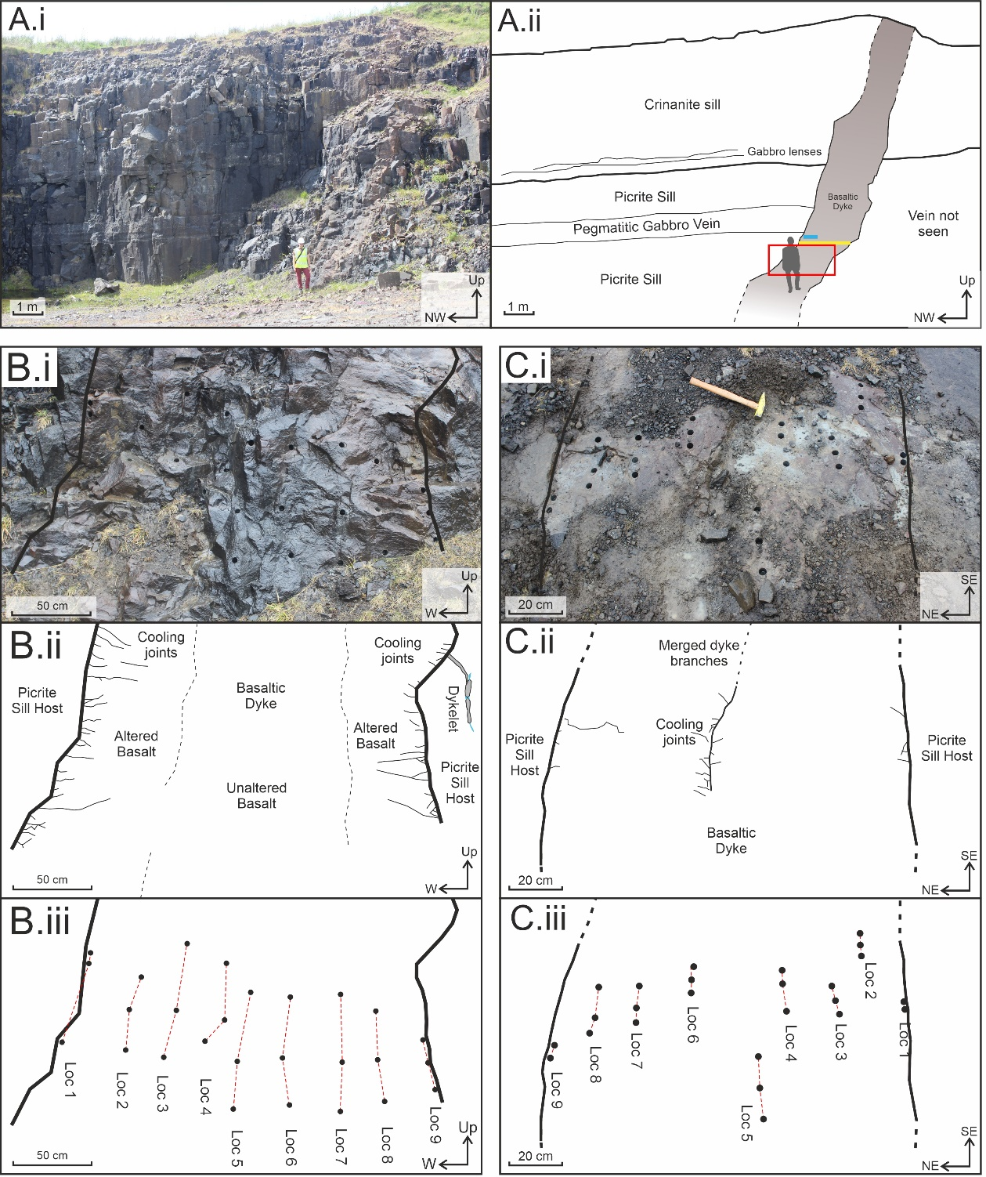
Figure 2: Field photographs (i) and diagrams (ii) of sills and the studied dyke that crop out in a quarry near Inver Tote, Isle of Skye. A) The intrusions that crop out in the quarry. These are a crinanite sill, picrite sill, a basaltic dyke and a pegmatitic gabbro vein. The red box (ii) indicates the location of panel B. The yellow line represents the location of petrographic Transect A, and the blue line above the sample for petrographic Transects B and C. Basaltic dyke at sites G5 (B) and G6 (C) Photograph (i) shows the core positions of the samples taken for rock magnetic studies, with accompanying sketches showing (ii) physical structures and (iii) the position of samples grouped by Location. A complex dykelet can be seen branching from the east side of the main dyke in Bi-ii. Note the difference in orientation between sites G5 and G6.
Our detailed magnetic study focusses on two profiles across the dyke, which provided the best opportunity for study and sampling due to its thickness and exposure. The profiles were located 13 m apart in the northern end of the quarry: one profile is in the quarry wall (G5), and the other is on the quarry floor (G6) (Figures 1B and 2). Alteration of the outer portions of the dyke is evident from the orange colouration of the face compared with the unaltered central dyke region (Figure 2B) and is associated with regions of more closely-spaced cooling joints (Figure 2Bii). Alteration of the dyke at site G6 is also evident as red discolouration (Figure 2C).
- Methodology
  - Sampling Regime
Fifty-two 2 cm diameter rock cores, up to 10 cm long, were collected at 20-25 cm intervals across the thickness of the dyke. These were collected from two dyke-thickness profiles separated by 13 m along the dyke strike (profiles G5 and G6 in Figure 1B). The cores were drilled using a Stihl BT45 motor driven core drill. Along each of the two profiles, three cores were collected from the internal parts of the dyke (locations 2-8) whilst 2-3 cores were collected from the margins (Locations 1 and 9, Figure 2Biii and Ciii, Table 1). Cores from site G5 were oriented in situ using both sun and magnetic compasses, but cores from site G6 were oriented using a magnetic compass only due to the weather being overcast during collection. A correction factor of +14˚, the mean difference between the magnetic and sun compass orientations of cores from site G5, was thus subsequently applied to the magnetic orientations of site G6. In the laboratory, cores were cut into 2.2 cm long specimens, with each core producing one to three specimens, yielding 96 specimens in total. Crushed masses from the offcuts of one core from each location were used for rock magnetic measurements to identify the magnetic minerals present.
Table 1: Table showing rock core samples and hand specimens collected for magnetic and petrographic analyses, sorted according to distance from the western dyke margin at sites G5 and G6. *The sample numbers for thin sections represent distances from the East margin for Transect A. **8 thin sections were studied in total from block LMS-4a collected close to site G5, and are split into 2 transects, h and v; h represents a horizontally oriented transect (Transect B), v represents a vertically oriented transect (Transect C) and p is a thin section parallel to the dyke plane.

Location number | G5 |  |  | G6 |  |  | Thin sections (collected at G5)
 | Distance from west margin (m) | Specimens for AMS | Specimens for AARM | Distance from west margin (m) | Specimens for AMS | Specimens for AARM
1 | 0.00 | 6 | 6 | 0.00 | 4 | 3 | LMS-4a-  (h1-4, v1-3, p)**
2 | 0.25 | 5 | 6 | 0.20 | 6 | 6 | -
3 | 0.50 | 5 | 4 | 0.43 | 6 | 5 | LMS-20-1.5m*
4 | 0.75 | 6 | 6 | 0.70 | 6 | 4 | -
5 | 1.00 | 6 | 6 | 0.97 | 6 | 5 | LMS-20-1m*
6 | 1.25 | 7 | 6 | 1.12 | 6 | 6 | -
7 | 1.50 | 6 | 6 | 1.36 | 6 | 6 | LMS-20-0.5m*
8 | 1.75 | 7 | 6 | 1.50 | 6 | 5 | -
9 | 2.00 | 7 | 7 | 1.70 | 3 | 2 | LMS-20-0m *

  - Petrographic Analyses
Petrographic analyses were undertaken to aid in the identification and characterisation of the petrological constituents and textures of the dyke and to support the findings of the rock magnetism and magnetic anisotropy studies. Five oriented hand-sized samples were collected at 50 cm distances across the dyke thickness (Transect A, yellow line in Figure 2A, Table 1). An individual large block was collected from the western margin and oriented using up arrows on several faces. This block was sub-sampled for a series of 15 cm long continuous thin section transects from the dyke margin into the dyke interior (Transects B and C, blue line in Figure 2Aii, Table 1). Transect B was taken in the horizontal plane and consisted of four thin sections, whereas transect C was taken in the vertical plane and consisted of three thin sections. One sample was also collected parallel to the dyke plane. The thin sections were first studied using a Meiji MT9000 polarizing microscope at 10x optical zoom. Micro-scale imaging was then undertaken using a Meiji TM3000 benchtop scanning electron microscope with a W-filament and a beam current of 15 kV.
  - Characterizing the Magnetic Carriers
Vital to magnetic studies is the characterization of the magnetic carriers that give rise to the observed AMS and AARM fabrics of the studied rock units. Identification of the magnetic carriers of the dyke was undertaken on samples collected at 25 cm intervals across the dyke thickness at site G5 (Table 1). Three sets of experiments were used to characterize the minerals controlling the magnetic fabrics: (1) isothermal remanent magnetisation (IRM) acquisition and backfield IRM demagnetisation, hysteresis loops, and thermomagnetic analysis using a variable field translation balance (VFTB), (2) high temperature susceptibility analysis using an MFK1-A Kappabridge, and (3) three component thermal demagnetization using a method similar to that of Lowrie (1990) and a combination of a furnace, a JR-6A spinner magnetometer, and a pulse magnetiser. High temperature susceptibility experiments were also performed on samples collected from site G6.
The VFTB is used to perform high-field analyses on specimens comprising 150 mg of ground rock powder, to measure the IRM and backfield curves, hysteresis loops, and high-temperature variation of spontaneous magnetisation. A rock chip is taken from the offcut section of the core, crushed using a pestle and mortar, and from this 150mg of the powder is then placed into the VFTB sample holder. The IRM was measured in zero field after applying a stepwise DC magnetic field, up to +800 mT. Backfield measurements were performed in the same fashion as the IRM in an opposing field of up to -800 mT. Hysteresis loops were measured during the application of an increasing positive field to 1000 mT, which was then removed and inverted before being returned to the original field. Finally, to determine the Curie temperature of the magnetic minerals present, the samples were placed in a 240 mT field and heated continuously from 50°C to 700°C cycling back to room temperature in 100°C steps, starting from 200°C. The data was analysed using RockMagAnalyzer 1.0 software (Leonhardt, 2006).
High temperature susceptibility measurements were made on a MFK1-A Kappabridge from AGICO (Advanced Geoscience Instruments Company). For these experiments, freshly crushed rock samples were heated in an Argon environment from 30°C to 700°C and then cooled back to room temperature while measuring the bulk magnetic susceptibility every 5-10 seconds. These data were analysed using AGICO’s Cureval8 software (Chadima and Hrouda, 2012).
Three-component IRM thermal demagnetization experiments (Lowrie, 1990) were performed on one G5 specimen from each position across the thickness of the dyke. These samples underwent a complete AF demagnetization before having three different decreasing strength bias fields applied to them in three orthogonal directions. The fields used were: x-axis of 1.2 T, y-axis of 0.4 T and z-axis of 0.02 T. These field strengths are different to those set out by Lowrie (1990) as those used in this study were the limits of the pulse magnetisers available, however, they also coincide with the coercivities of minerals being targeted, i.e. titanomagnetite (10’s mT; O’Reilly, 1984) and pyrrhotite (up to 100’s mT; O’Reilly, 1984). Each specimen was then heated and cooled to a maximum of 620°C in steps of 20°C to 50°C, measured in an AGICO JR-6A spinner magnetometer and the Rema6 software (Chadima et al., 2018a) after each heating step. This suite of experiments was performed after AMS and AARM analyses as heating of the specimens alters the magnetic properties.
  - Anisotropy of Magnetic Susceptibility and Anhysteretic Remanent Magnetism Studies
The rock samples were studied both for their anisotropy of magnetic susceptibility (AMS) and anisotropy of anhysteretic remanent magnetisation (AARM) to identify if there are predominant crystal orientations of the magnetic minerals present in the dyke.
Magnetic susceptibility is a measure of how easily a sample can produce an induced magnetisation and is affected by the properties of all the magnetic minerals present within a sample, i.e. domain state, grain size, intensity, and orientation (Khan, 1962). AMS is the directionally-dependent response of magnetic minerals to the applied field (Knight and Walker, 1988; Raposo and Ernesto, 1995). Magnetic susceptibility (K) is defined as K = M_{i}/H where M_{i} is the degree of induced magnetization and H is the strength of the magnetic field. It is characterised by a second order ellipsoid tensor with three principle eigenvectors: K₁, K₂ and K₃, where K₁ is the longest axis, K₂ is the intermediate axis and K₃ is the shortest axis of the ellipsoid tensor (Knight and Walker, 1988) (Figure 3A). Stronger AMS signals result from multi-domain sized crystals (> 50 μm), with certain ferromagnetic minerals (e.g. magnetite) tending to dominate the susceptibility measurements (e.g. Hargraves et al., 1991). The ratios between the tensor axis magnitudes result in a range of ellipsoid shapes: spheroidal, oblate, prolate and triaxial (Tauxe, 2010). The spheroidal ellipsoid has little to no variation in the tensor axis magnitudes, as such K₁ = K₂ = K₃. The oblate ellipsoid describes samples where the K₃ axis is smaller than the similar sized K₁ and K₂ axes (K₁ = K₂ > K₃) and is known as magnetic foliation. The prolate ellipsoid is where the K₁ axis is larger than the similar sized K₂ and K₃ axis (K₁ > K₂ = K₃), also known as magnetic lineation (Geoffroy et al., 2002). The triaxial ellipsoid is where each axis has a different magnitude (K₁ > K₂ > K₃).
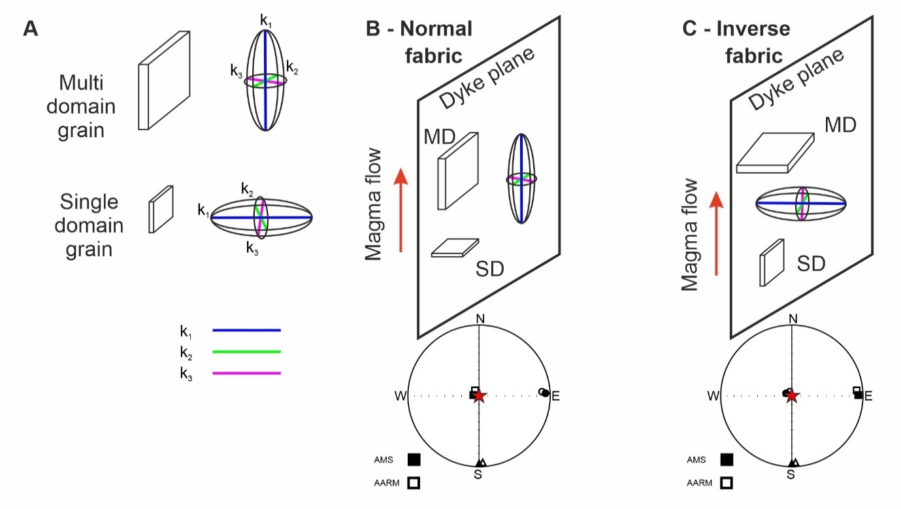
Figure 3: Magnetic anisotropy tensors and the relationship to crystal fabrics and dyke planes. A) the relationship of the orientation of AMS ellipsoid tensor to multi-domain and single-domain crystals, B) an example of a normal fabric where the AMS ellipsoid orientation is parallel to the long axis of tabular crystals and the dyke plane, C) an example of inverse fabrics where the AMS ellipsoid is perpendicular to the dyke plane. When MD crystals are dominant, AMS and AARM axes align, whereas when SD crystals are dominant, AMS and AARM axes are inverted.

AMS analyses were conducted on an AGICO Multifunction Kappabridge, MFK1-A, using an applied field of 200 A m⁻¹ and a frequency of 967 Hz, where each specimen was sequentially rotated around 3 axes while an induced magnetic field was applied to the specimen. Measurement and processing of the susceptibility during application of the field was performed by AGICO’s Safyre7 software (Chadima et al., 2018b). Processing of the AMS tensor data was automatically completed by AGICO’s Anisoft 4.2 software (Chadima and Jelinek, 2009). The software uses Jelinek statistics (Jelínek, 1977), with susceptibilities accurate to within 1% error. These statistics result in a set of parameters that characterize the magnetic anisotropy: mean susceptibility (K_{m} = (K₁+K₂+K₃)/3), lineation (L = K₁/K₂), foliation (F = K₂/K₃), shape parameter (T = (2η₂ – η₁ – η₃) / (η₁ / η₃)) and corrected degree of anisotropy (P_{j} = $exp\sqrt{2[{\left(η_{1}-η\right)}^{2}+{\left(η_{2}-η\right)}^{2}+{\left(η_{3}-η\right)}^{2}]}$) (Jelínek, 1981). K₁, K₂ and K₃ are principal axes of susceptibility ellipsoid, with η₁, η₂ and η₃ being the natural logarithms to the axes. η = (η₁ + η₂ + η₃)/3.
Some studies have used AARM in addition to AMS to study the magnetic fabrics of intrusions (e.g. Chadima et al., 2009; Soriano et al., 2016; Martin et al., 2019). AARM identifies the fabrics that originate from magnetic remanence carrying minerals that are more likely to be single domain (SD) to vortex-state (VS; a type of pseudo-single domain or PSD) in size (e.g. McCabe et al., 1985; Jackson, 1991; Roberts et al., 2017). It also utilizes a second-order ellipsoid tensor, with similar properties to AMS, however it is defined by K_{rem} instead of K_{m}, and is calculated by averaging the magnitudes of six AARM tensor axes.
Measurement of AARM was conducted using multiple pieces of equipment: a JR-6A dual speed spinner magnetometer, a LDA5 alternating field (AF) demagnetiser, and a PAM1 anhysteretic pulse magnetiser from AGICO. The natural remanent magnetization (NRM) of each specimen was initially measured in the JR-6A spinner magnetometer, before undergoing demagnetization and subsequent remagnetisation in 6 different orientations, using the LDA5 and PAM1 equipment respectively. The Rema6 software was used to control the JR-6A and measure the magnetisation of the specimens. The AARM ellipsoids were subsequently analysed using AGICO’s Anisoft 4.2 software.
When the magnitudes and orientations of the ellipsoids are identified and compared with macroscale and microscale structures, the syn- and post-emplacement processes can be determined (e.g. Varga et al., 1998; Liss et al., 2002; Clemente et al., 2007; Chadima et al., 2009; Hrouda et al., 2015). AMS is the most common of the magnetic fabric techniques utilized here to understand dyke emplacement processes (e.g. Knight and Walker, 1988; Staudigel et al., 1992; Poland et al., 2004; Roni et al., 2014) but AARM represents a powerful additional tool (e.g. Chadima et al., 2009; Silva et al., 2010; Soriano et al., 2016). When the AMS K₃ axis is perpendicular to the crystallographic long axes, this is known as a normal magnetic fabric (Figure 3B; Rochette et al., 1992; Chadima et al., 2009). When the K₃ axis is perpendicular to the dyke plane, AMS fabrics can be used in collaboration with indicators of magmatic lineation (from macro and micro-scale structures), to infer the magma flow axis (Figure 3B). Near to intrusion margins, AMS fabrics are often imbricated with respect to the intrusion plane (Knight and Walker, 1988; Rochette et al., 1992) which can enable the magma flow direction to be determined based on the direction of imbrication. Inverse fabrics occur when the K₃ axis is aligned with crystal long axes and K₁ is perpendicular to the intrusion plane (Figure 3C) (Rochette et al., 1992; Chadima et al., 2009), as is the case with single domain magnetite. Anomalous fabrics have been identified where the AMS and AARM ellipsoid axes are inclined to each other and have been attributed to a range of hybrid fabrics resulting from multiple mineral phases and domain states (Potter and Stephenson, 1988; Soriano et al., 2016). Other processes have also been attributed to the development of anomalous fabrics, including; syn- or post-emplacement shear along the crack (Dragoni et al., 1997; Clemente et al., 2007), alteration (Rochette et al., 1991; Just et al., 2004; Just and Kontny, 2012), cooling contraction (Hrouda et al., 2015), and different flow regimes occurring during magma emplacement and solidification (Martin et al., 2019).
- Results
  - Petrology
The dyke is a fine-grained basalt with a 1-2% population of plagioclase phenocrysts that are up to 1 mm in size near to the margins. Rare crystals of pyrite are also present. Vesicles increase in size from <0.1 mm close to the dyke margins to > 10 mm towards the centre (Figure 4A). Small round blebs of fine-grained mudstone xenoliths are present ~5 mm from the west margin of the dyke (see Figure 4B). Under SEM-EDS, iron sulphides were predominantly found along and within 0.5 mm fractures perpendicular to the dyke plane (Figure 4A and C) in thin sections closest to the margins. These sulphides were also present in some of the surrounding vesicles (Figure 4A and C), some of which show idiomorphic crystal shapes that suggest growth from the vesicle wall inwards. In some thin sections, cubic sulphide crystals were identified, but these did not appear to be related to vesicles and suggest general alteration of the basalt. Calcite was present within all other fractures in the host-rock surrounding the dyke (Figure 2C) and within vesicles (Figure 4).
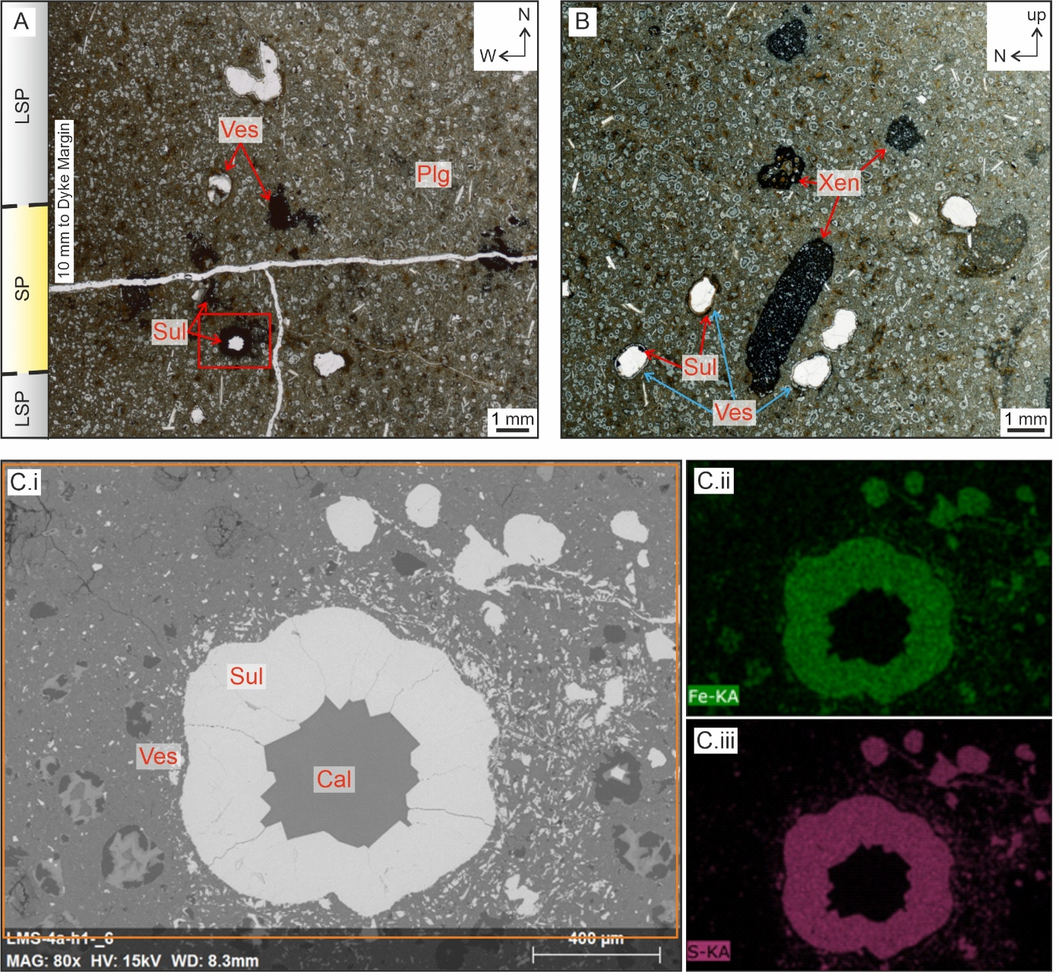
Figure 4: Photomicrographs of the dyke samples viewed using plane polarized light (A, B) and backscattered electron SEM-EDS (C.i) with element maps for Fe (C.ii) and S (C.iii) from thin sections collected from near the west margin of the dyke (Table 1). A) Photomicrograph of thin section LMS-4a-h1 from Transect B collected perpendicular to the dyke plane. Left side of the image is 10 mm from the dyke margin, and the dark spots within vesicles around the horizontal fracture are the location of iron sulphide minerals. The red box shows the location of panel C. Note the increased amount of sulphide precipitation (SP) surrounding the fracture, compared to increased distance away where the is little sulphide precipitation (LSP). B) Photomicrograph of thin section LMS-4a-par collected parallel to the dyke plane, approximately 5 mm from the west margin. Many vesicles are present within the image from <0.2 mm to >10 mm in size. The dark rounded blebs are xenoliths of mudstones. C) High-magnification image of a single vesicle and surrounding basalt (location indicated in panel A). Cii) and Ciii) are element maps for Fe (green) and S (purple), respectively. Iron sulphide has grown into the vesicle with the core later filled with calcite. The abbreviations Ves, Sul, Plg, Xen, and Cal, represent vesicles, sulphides, plagioclase, xenoliths, and calcite, respectively.

  - Rock Magnetic Properties
Here we describe the results from the thermoremanent magnetisation, high temperature susceptibility, and three-component thermal demagnetisation experiments performed to characterize the magnetic mineral carriers.
Thermoremanent magnetisation curves for site G5 of the dyke show very weak susceptibilities near to the margins (locations 1 and 9 in Figure 5Ai and iii). During heating, these locations underwent large amounts of alteration, producing 1 or 2 phases with Curie temperatures between 580 and 350 °C on cooling from above 500°C (Figure 5A). High temperature susceptibility graphs also show irreversibility between heating and cooling curves for the same near-margin locations. In these experiments, alteration also occurs from 450 °C, forming one main phase with a Curie temperature of ~510 °C (Figure 5B). Central dyke samples show reversibility to 300 °C, with irreversibility occurring in all subsequent temperature ramps suggesting mineral alteration, which gradually increases the overall magnetisation from 400 °C up to 700 °C (Figure 5Aii). Irreversibility is also seen in the high temperature susceptibility data for the centre of the dyke (Figure 5Bii). For site G6, thermomagnetic data (Figure 6) show a different trend, in contrast to what occurs at site G5, as the dyke core (location 5, Figure 6C) shows similar properties to the dyke margins (locations 1 and 9, Figure 6A, C and E). Intermediate locations (2 and 7, Figure 6B and D) show properties similar to the dyke core of site G5 (location 5, Figure 5Aii).
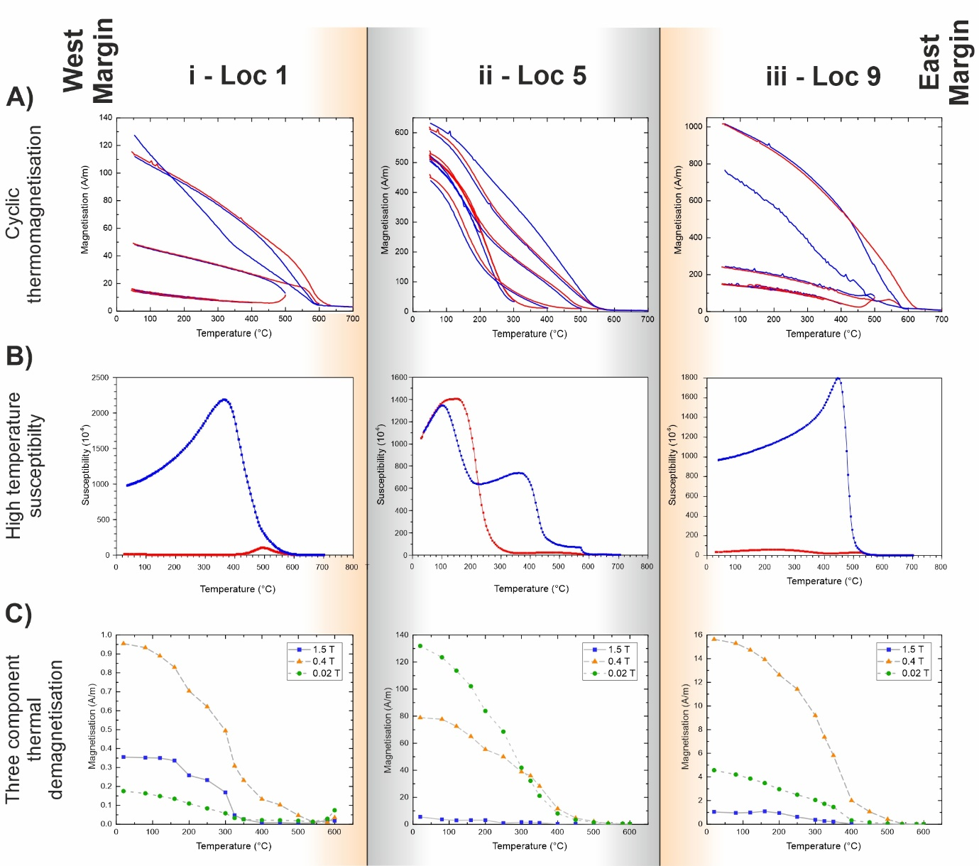
Figure 5: Graphs showing representative data from thermomagnetic experiments for identification of magnetic carriers at site G5. A) Cyclic thermomagnetisation from VFTB experiments with red lines showing stepwise heating curves and blue lines showing cooling curves. Alteration occurs when cooling curves differ from heating curves, for example, between 400 °C and 500 °C in i). B) High temperature susceptibility curves show the evolution of magnetic susceptibility during a heating (red) and cooling (blue) cycle to 700 °C, with irreversibility suggesting alteration of magnetic minerals. C) Three component thermal demagnetisation data showing phase removal with substantial drops in magnetization showing the unblocking temperatures of magnetic minerals present. The samples have been separated into 3 groupings: East and West Margin Altered Groups (orange background colour; i and iii) and the Fresh Central Group (grey background colour; ii). See Supplementary Figure 1 for all thermomagnetisation data.
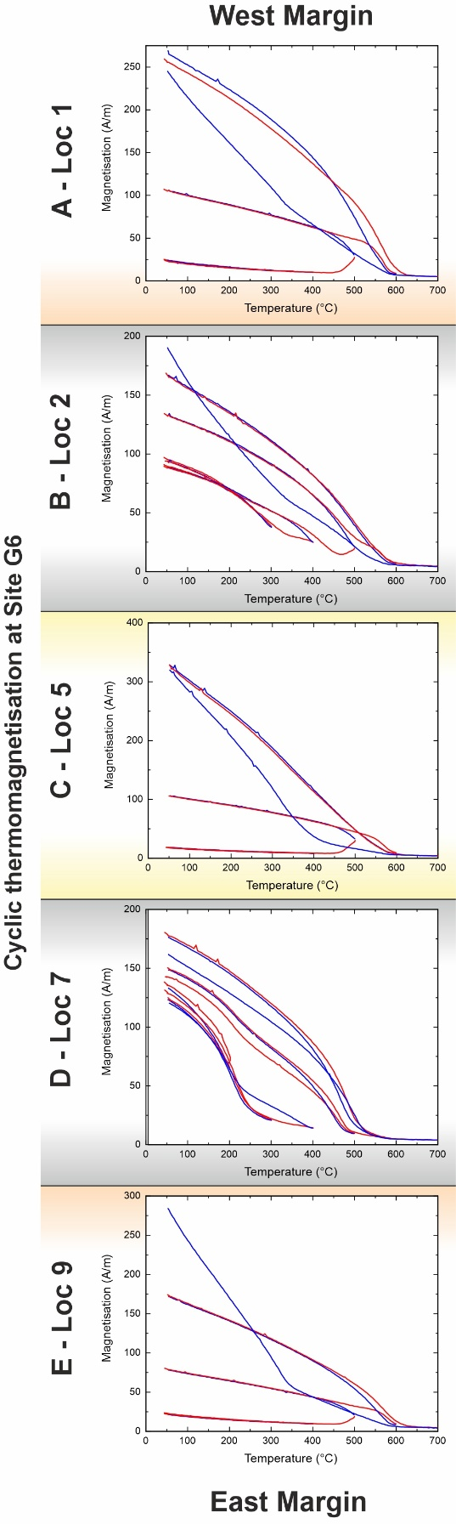
Figure 6: Graphs showing representative cyclic thermomagnetisation data from VFTB experiments for identification the magnetic minerals at site G6: A) Location 1 from the western margin, B) Location 2, C) Location 5 from the dyke core, D) Location 7 and E) Location 9 from the eastern margin. Red lines show stepwise heating curves and blue lines show cooling curves. Alteration occurs when cooling curves differ from heating curves, for example, between 400 °C and 500 °C in A, C, E. See Supplementary Figure 1 for all thermomagnetisation data.
Three-component thermal demagnetisation experiments show demagnetisation of different coercivity-components at different temperatures. These phases are identified predominantly as the intermediate and soft coercivity-components (0.4 and 0.02 T: Figure 5C). These contrasting coercivity-components represent the unblocking temperatures for multiple magnetic mineral phases. The intermediate phase is generally the most dominant phase (between 0.02 and 0.4 T) apart from at locations 2, 4 and 5, where the soft phase is the most common. For the intermediate phases, the greatest decrease in magnetization, and thus the unblocking temperature, occurs between 300 and 400 °C. This suggests a pyrrhotite origin and is most evident in margin samples. At locations where the soft phase is the most dominant (locations 2, 4, and 5), there are 2 observed unblocking temperatures. The first and largest decrease is between 160 and 200 °C with the second decrease in a similar location to the intermediate phase. The first signal is indicative of a Ti-rich titanomagnetite (c. TM60, Tauxe, 2010), with the second supporting the presence of pyrrhotite. The hard phase (blue) is generally very low to not present, except for locations 1 and 6 where it follows a similar trend to the intermediate phases. The presence of these is believed to be pyrrhotite with coercivities straddling the boundary between the intermediate and hard phase field strengths. It should also be noted that absolute magnetisations of specimens close to the margins were approximately one order of magnitude lower than those in the dyke core. Unblocking temperatures are summarised in Figure 7A.
Hysteresis measurements completed during VFTB analyses enable estimation of the domain states of the magnetic carriers giving rise to the fabrics which are then summarised by using the saturation remanence/saturation magnetisation vs bulk coercivity plot of Tauxe et al. (2002). Figure 7B shows that with increased distance from the margins, the magnetic carriers apparently increase in domain size from a mixture of vortex (or PSD) and uniaxial SD at locations 1 and 9, to multidomain in the dyke core (G5 locations 4 to 7). Experiments at G6 show contrasting behaviour of the magnetic carriers, with locations 4 to 6 also showing a mixture of vortex and SD behaviour compared with locations 2, 3 and 7 indicating MD behaviour (Figure 6 and 7B). In several samples, such as G6 Location 9, a paramagnetic mineral phase (likely pyrite) dominates as shown by the hysteresis loops. This will control the AMS response in margin regions but be absent from the AARM results. When the ferromagnetic components are isolated in these samples there is a lot of noise, and features such as wasp-waisting cannot be confidently determined. In other samples, where there is only a small paramagnetic fraction, such as G5 Location 4, hysteresis loops are thin suggesting that a low coercivity phase dominates, likely titanomagnetite. In another set of samples, a mixture of ferromagnetic and paramagnetic phases exist. In one such case (G5 Location 9), a wasp-waisted loop is clearly visible indicating that both high and low coercive phases are present. This demonstrates that pyrite (positive slope at high fields), pyrrhotite (not clear in other hysteresis loops), and titanomagnetites are all affecting the magnetic anisotropy results. The bulk hysteresis measurements for both sites G5 and G6 also appear to correlate with the relative magnitudes of the three coercivity components measured in thermal demagnetisation experiments (Figures 5 and 7).
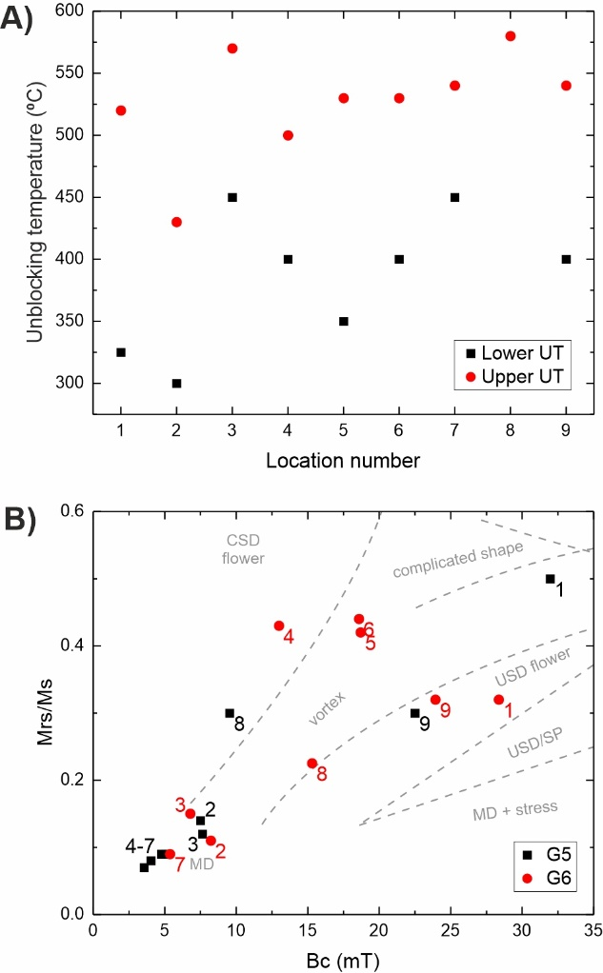
Figure 7: Graphs showing identification of magnetic carriers in the dyke across the thickness (Location number) and breadth (sampling sites G5 and G6). A) Unblocking temperatures against location across dyke thickness for site G5, obtained from three component demagnetization experiments (modified Lowrie method), black represents the lower unblocking temperature (Lower UT) and red the upper unblocking temperature (Upper UT). B) Squareness vs bulk coercivity plot (Tauxe et al., 2002) showing different shapes and sizes of magnetic carriers from flower or vortex state, to multi-domain (MD) state (calculated for magnetite), where Bc is bulk coercivity and Mrs/Ms is the remanent magnetic saturation relative to magnetic saturation, also known as squareness. Black squares show data for site G5 and red circles show data for site G6.

The patterns observed in rock magnetic experiments also indicate that different magnetic carriers provide the signals observed in the magnetic anisotropy studies. At site G5 (the quarry wall profile) there appears to be two regions, one near the dyke margins which is dominated by pyrrhotite (the East/West Margin Altered Group, EMAG/WMAG), and the other towards the dyke central region dominated by titanomagnetites (Fresh Central Group, FCG). Whereas at site G6 (the quarry floor profile) there are three regions of fabrics: the first two are similar to site G5 (AMAG/WMAG and FCG), however are smaller in thickness. The third region is in the dyke core with properties that also suggest pyrrhotite being the magnetic carrier (Central Altered Group, CAG).
  - Magnetic anisotropy
Here we describe how the observed magnetics vary across the thickness of the dyke at each site and then across the breadth of the intrusion by comparing the results from sites G5 and G6. At site G5 (a profile which crosses the wall of the quarry) the dyke is 2 m thick and the locations are separated by 25 cm intervals, whereas at site G6 (a profile across the floor of the quarry) the dyke is thinner and the samples are separated by intervals of 15-23 cm (see Table 1 for sample distances from margins). Magnetic anisotropy data for each specimen can be found in Supplementary Tables 1 and 2 for AMS and AARM, respectively.
    - Magnetic anisotropy at site G5 (quarry wall)
When all AMS specimen data for site G5 (a profile across the quarry wall) are combined (n = 55), the K₁ axis is oriented horizontally in a NW-SE orientation, approximately 20° anticlockwise of dyke plane (Figure 8A). The K₃ axis plunges 39° towards 237°. The magnetic foliation dips 51° to the NE, oblique to the dyke plane.
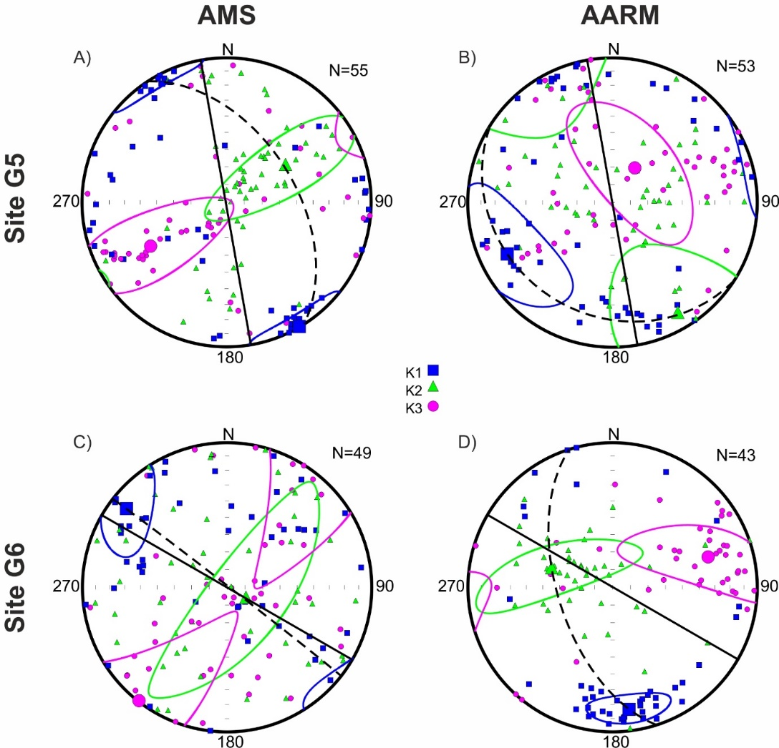
Figure 8: Equal area plots showing data from all specimens for AMS (A, C) and AARM (B, D) with the data separated by sample site: G5 (A, B) and G6 (C, D) in the dyke. K₁ axes are blue squares, K₂ axes are green triangles and K₃ axes are purple circles. Solid ellipses are the 95% confidence ellipses calculated by Anisoft 4.2. The solid black line represents the dyke plane, and the dashed line represents the magnetic foliation. See Supplementary Tables 1 and 2 for AMS and AARM data, respectively.
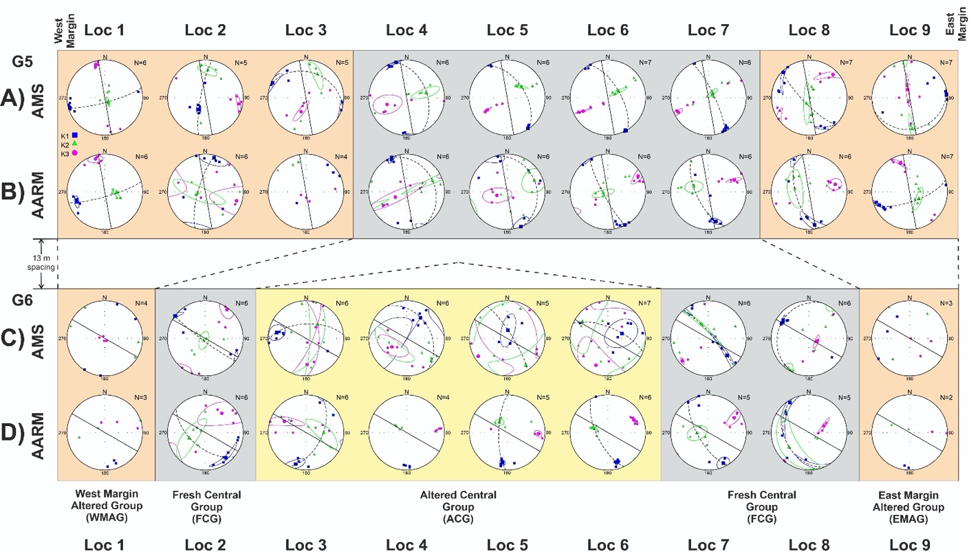
Figure 9: Equal area plots showing AMS (A) and AARM (B) fabrics of specimens collected from the dyke plotted against the location across the dyke thickness and by site (G5, quarry wall or G6, quarry floor). The number of specimens for each position is shown to the upper right of each plot. K₁ axes are blue squares, K₂ axes are green triangles and K₃ axes are purple circles. Solid ellipses are the 95% confidence ellipses. The solid black line represents the dyke strike direction, and the dashed line represents the magnetic foliation. The locations are separated into four groups based on observed fabrics and the magnetic carriers: East Margin Altered Group and West Margin Altered Group (WMAG and EMAG, pyrrhotite-bearing, orange), Fresh Central Group (FCG, titanomagnetite-bearing, grey), and Altered Central Group (ACG, pyrrhotite-bearing, yellow).
When the specimens are separated into the different locations across the dyke thickness at site G5 (quarry wall), a range of fabrics and fabric orientations are observed. In the margin regions, locations 1 and 9, the K₁ axes (blue squares) are sub-horizontal and perpendicular to the dyke plane oriented in the ENE-WSW orientation (Figure 9A). Also at these locations, the K₃ axes (pink circles) lie within the dyke plane, however, their orientations are perpendicular to each other, sub-horizontal to the N in the West margin (location 9) and sub-vertical in the East margin (location 1). The magnetic foliation planes are perpendicular to the dyke plane, being sub-vertical and sub-horizontal in the West and East margins, respectively. Away from the margins (locations 2-8), the K₁ axes rotate to being almost parallel with the dyke plane (< 30°). The magnetic foliation planes in these locations are also less oblique with the dyke plane and can be considered imbricated.
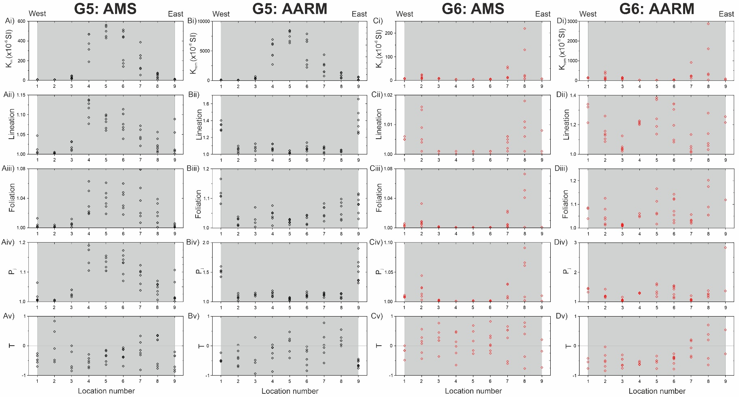
Figure 10: Graphs showing (i) mean susceptibility, (ii) lineation, (iii) foliation, (iv) degree of anisotropy and (v) shape parameter characteristics for (A) site G5 AMS, (B) site G5 AARM, (C) site G6 AMS and (D) site G6 AARM ellipsoids of the dyke, relative to the location across the dyke thickness. Data across the breadth of the dyke are shown by black diamonds for site G5 and red diamonds for site G6. See Supplementary Tables 1 and 2 for this data.
At site G5, the mean susceptibilities increase towards the centre of the dyke, with the largest values occurring at location 5 (K_{m} = 4-6 x 10⁴, Figure 7Ai). Magnetic lineation, foliation, and degree of anisotropy are higher in the Eastern side and core of the dyke compared with the western side. The western margin (location 1), however, yields more anisotropic ellipsoids than the adjacent location (location 2; Figures 10Aii-iv). It should be noted that for each of the K_{m}, L, F and P_{j} parameters, locations 2-3 are considerably smaller than the corresponding ellipsoid properties from the opposite side of the dyke (locations 7 and 8). The ellipsoid shapes are prolate at the margins (locations 1 and 9), changing to a mixture of oblate and prolate at locations 2-3 and 7-8 (25-50 cm and 150-175 cm respectively), and prolate again between locations 4 and 6 (Figure 10Av).
The mean AARM K₁ axis for all specimens (n=53) at site G5 plunges shallowly to the WSW (20/224°) (Figure 8B). The mean K₃ axis plunges more steeply to the NNE (33/069°), closer to and less oblique with the dyke plane than the K₁ axis. There is a large amount of scatter associated with all three ellipsoid axes. The magnetic foliation plane is almost horizontal and nearly perpendicular to the dyke plane. The orientation of the AARM ellipsoid is considerably different to the orientation of the AMS ellipsoid, as the AMS K₁ axis is aligned with the AARM K₂ axis, whereas the AARM K₁ axis is in a similar orientation to the AMS K₃ axis.
At the dyke margins, the K₁ AARM axes are sub-horizontal and perpendicular to the dyke plane (Figure 6B), while the magnetic foliation planes are close to vertical. Away from the margins, the K₁ orientations lie closer to the dyke plane and are sub-horizontal, with the magnetic foliation planes dipping between 70˚-85˚ to the West. In the dyke core (locations 4 and 5), the magnetic foliations are shallower, dipping ~30˚ to the NE. AARM ellipsoid properties show a similar trend to AMS ellipsoid properties with low K_{rem} at the margins, increasing towards the dyke core (Figure 10Bi). Magnetic lineation, foliation, and degree of anisotropy are highest in the margins, with smaller values in the dyke core (location 5) (Figures 7Bii-iv). Ellipsoid shapes are wholly prolate at the margins, however, they become mixed with more tri-axial fabrics present in the dyke interior (Figure 10v). This tendency is more prominent in the eastern side (location 7 and 8).
When the AMS and AARM fabrics are compared at site G5, similarities and differences can be identified. In the margins (locations 1 to 3, and 8 to 9), the AMS and AARM fabric orientations are generally oblique to each other, with at least two axes not oriented in the same direction. The exception to this is location 1 where there is only a slight difference in the orientation of the ellipsoid tensors. These fabrics can be classified as anomalous fabrics, where neither normal nor inverse fabrics are observed. In the dyke core (locations 4 to 7) the AMS and AARM orientations are more similar and can be considered normal fabrics.
    - Magnetic anisotropy at site G6 (quarry floor)
Site G6 lies 13 m to the south of site G5 in a section of the dyke striking 120˚ in the quarry floor. Fewer specimens were collected from this site (n = 49) resulting in some locations not having the minimum of 5 specimens required to perform Jelinek statistics.
The average AMS ellipsoid for all specimens at site G6 has a sub-horizontal K₁ axis oriented towards the NW (13/308°), a deviation of 8° from the dyke plane (Figure 8C). The K₂ axis dips steeply lying on the dyke plane, resulting in a dyke-parallel magnetic foliation. The K₃ axis is perpendicular to the dyke plane and is oriented towards the SW (01/218°).
At site G6 locations 1 and 9, there was insufficient data for Jelinek statistics to calculate 95% confidence ellipses. However, from the available data, the AMS K₁ axes are oriented perpendicular to the dyke plane at the western margin but are oblique at a range of angles at the Eastern margin (Figure 9). Location 2 has a magnetic foliation almost parallel to the dyke plane, however all other locations have magnetic foliations that are oblique by >20˚. In the case of location 8, it is almost perpendicular. Reliable calculation of the mean ellipsoid for location 4 is prevented by scatter. Mean susceptibility, lineation, foliation, and degree of anisotropy all show similar trends in the ellipsoid properties with the margins being relatively low values, then increasing at adjacent locations (2 and 8) before decreasing between locations 3 and 7 (Figure 10Ci-iv). Ellipsoid shapes are variable across each location, with specimens showing both oblate and prolate shapes (Figure 10Cv).
For the AARM analysis at site G6, 43 of the 49 specimens were used from the AMS with the remaining 6 specimens being too fragile for the spinner magnetometer. When the data for all specimens is combined (Figure 8D), the resulting K₁ axis plunges shallowly to the south with the K₃ axis to the East. The K₂ axis is almost parallel with the dyke plane, however the magnetic foliation is oblique with a dip of 59/211°, due to the orientation of K₁. In comparison with the AMS data, both ellipsoids show prolate shapes, however, their orientations are oblique to each other by ~35°.
The data for the AARM orientations at site G6 are similar across the dyke breadth with few exceptions (Figure 9D). This pattern is identified as sub-horizontal K₁ axes that dip to the S-SE (or NW for location 8) with the magnetic foliation planes dipping moderately to steeply towards the west. The main exception to this is location 3 where the K₁ axis is oriented to the SW and the foliation plane dips moderately towards the SE. K_{rem} and foliation for AARM has a similar fabric to the AMS K_{m}, with sites 2, 8 and the central portion of the dyke (locations 5 and 6) having considerably larger foliations compared to the other locations (Figure 10Di and Diii). Lineation and degree of anisotropy show slightly different trends in the ellipsoid properties compared with the K_{rem} and foliation, with the margins and core being relatively higher than locations 3 and 7 (Figure 10Dii and Div). The ellipsoid shapes are dominated by prolate fabrics in the Western portion of the dyke, from location 1 to 6, becoming more oblate towards the Eastern margin, across locations 7-9 (Figure 10Dv). It should be noted that the reduced number of useable specimens at locations 1 and 9 prevents the interpretation of the magnetic fabrics in these areas.
At site G6 across the entire thickness of the dyke, the AMS and AARM ellipsoid are not consistently aligned with each other being characterised by anomalous fabrics. However, there are two exceptions to this which are locations 3 and 8. At location 3, the AMS ellipsoid is prolate, with the K₁ axis slightly imbricated with respect to the dyke plane; the K₁ and K₃ axes of the AARM ellipsoid are switched however, a characteristic of an inverse fabric. At location 8 the ellipsoid axes for both AMS and AARM are aligned with each other and thereby characterised by a normal fabric. The fabric for location 2 could also be considered normal as there is only a small variation in the axes orientations when the AMS and AARM fabrics are compared.
    - Comparison of magnetic anisotropy and magnetic carriers at sites G5 and G6
In summary, at G5 the AMS and AARM fabrics at the margin locations (1 and 9) display anomalous fabrics with perpendicular magnetic foliations, compared to the normal fabric found in the central dyke region. At site G6, the AMS and AARM analyses also show contrasting fabrics at different locations across the dyke thickness, with most locations displaying anomalous fabrics. Location 2 almost shows a normal fabric, location 3 has inverse fabric, and location 8 has normal fabric. Across profile G6 the ellipsoid orientations are perpendicular then sub-parallel before becoming oblique to the dyke plane with increased distance away from the margins. The coloured backgrounds of Figure 9 are associated with the carriers of the magnetic fabrics (see section 4.2). Orange (G5 and G6) and yellow (only G6) zones represent pyrite and pyrrhotite dominated altered regions, whereas the grey zone (G5 and G6) represents titanomagnetite dominant unaltered regions. Overall, the results show that the presence of particular magnetic carriers is closely linked to the recorded magnetic fabric.
- Discussion
From the combined AMS fabrics, AARM fabrics, rock magnetic carrier data, and petrology, four groups of signals have been identified (Figure 9); the West Margin Altered Group (WMAG), the East Margin Altered Group (EMAG), the Fresh Central Group (FCG), and the Altered Central Group (ACG). These groupings provide insights of different times in the dyke’s history and distinguish syn- and post-emplacement processes that occurred.
  - Origin of the magnetic carriers
Results from the dyke show that multiple magnetic phases provide the magnetic fabrics, which impacts the ability to interpret some of the observed fabrics; especially for those fabrics closest to the margins (EMAG and WMAG: orange zones in Figures 5, 6, and 9). In these regions, rock magnetic experiments (Figure 5) indicate the dominant phases providing AMS fabrics to be paramagnetic pyrite small amounts of MD titanomagnetites, whereas AARM fabrics are dominated by ferromagnetic pyrrhotite with a Curie temperature of approximately 325 ˚C (Tauxe, 2010). There is also a small amount of Ti-rich titanomagnetite with a Curie temperature around 150 ˚C (Tauxe, 2010), which is identified by the larger decreases in magnetisation of the soft phase in the three-comonent demagnetisation experiments (e.g. location 2 at G5). During laboratory heating, these phases undergo extensive amounts of alteration causing growth of magnetite that dominates the signal of the cooling curves in both thermomagnetic and high temperature susceptibility experiments. Petrographic images show that the iron sulphides are most commonly found in and around fractures (Figure 4A). Geochemical analyses by Hughes et al. (2015) suggested that the sulphur at Inver Tote originated from primary assimilation and melting of Jurassic sedimentary rocks, through which the dykes and sills intruded. During magma propagation, the country rocks released allogenic sulphur into the magma. Hughes et al. (2015) reported a larger sulphur content in the proximity of mudstone xenoliths close to the dyke margins compared to the core of the dyke, which correlates with the strong pyrrhotite signal we observed in unblocking temperatures (Figure 9C). Whilst their interpretations suggest mudstone assimilation for the origin of sulphur, we suggest an alternate source where secondary processes are responsible for the transport and precipitation of sulphur in these rocks.
The combination of a larger proportion of iron sulphides in margin regions combined with calcite and other minerals (Figure 4) within vesicles and fractures around the dykes in the quarry, suggests that post-emplacement fluids flowed through the area and were locally concentrated within the WAMG and EAMG. Enhanced alteration in the margin regions of the dyke (Figure 3) suggest that these fluids were likely localised through permeable pathways that could be linked to cooling related tensile fracturing associated with margin regions in contact with host rocks (e.g. Spry, 1962). These fluids may also help to explain the lack of titanomagnetites within the margin regions. The sulphide overgrowth could alter the iron bearing phases during fluid flow, effectively erasing the magnetic minerals and their associated magnetic fabrics. Consequently, the post-emplacement fluid flow would reduce the magnetisation of samples in these areas, which is supported by the relatively low magnetisation intensities we observed (Figure 5A). The ACG is only present at site G6 and has similar properties to the EMAG and WMAG, being dominated by pyrrhotite signals. This indicates that the core of site G6 has been affected by a similar alteration as that observed in the margins, suggesting similar processes occurred there.
In the FCG, AMS fabrics are dominated by larger proportions of VS to MD sized titanomagnetites (Figure 7B), which have high susceptibilities. AARM in the FCG is also dominated by titanomagnetites, however there is also a small amount of pyrrhotite present as shown by intermediate phases present in three-component thermal demagnetization experiments (Fig. 5C). The titanomagnetites have a range of concentrations of Ti which have undergone small amounts of deuteric oxidation identified by Curie temperatures that increased incrementally during cyclic thermomagnetisation experiments (Figure 5A). This lack of deuteric oxidation was likely due to relatively rapid cooling and an absence of free oxygen during emplacement as separation of the Ti-rich and Ti-poor phases did not occur until reheating. Variations in deuteric oxidation have been observed across the thickness of both lava flows (e.g. Audunsson et al., 1992; Biggin et al., 2007) and ignimbrites (Çubukçu, 2015). Then these structures were in contact with the pre-eruption topography little to no deuteric oxidation occurred because of a shortage of post-emplacement available oxygen combined with rapid cooling due to contact with the ground. In contrast the upper regions of these deposits more vigorous deuteric oxidation occurred (Audunsson et al., 1992). This is due to dissociation of water rising through the deposits combined with oxygen and water available in the air. Although these examples were from extrusive deposits, we expect that a similar lack of free oxygen is responsible for the limited deuteric oxidation evident in the FCG region of the dyke.
The lower pyrrhotite content in the FCG, suggests that less or no alteration occurred within the dyke central region compared with the margin regions. A slower cooling rate in the core would enable both larger titanomagnetite crystals to grow and reduce the frequency and increase the spacing of cooling-related jointing within the dyke core. Subsequently, this would reduce the number of pathways for post-emplacement fluids to flow along and precipitate the sulphides and calcite that were observed closer to the margins. Our model also explains the lower sulphur proportions observed by Hughes et al. (2015), but does not require the xenolith assimilation and mixing that they suggest.
  - Emplacement model
5.2.1 Syn-emplacement dyke propagation
Initial magma flow directions are often interpreted from quenched dyke margin samples (e.g. Poland et al., 2004; Clemente et al., 2007). Alteration of the magnetic carriers at the margins of this dyke mean that it is not possible for these samples. Instead, the evidence of initial propagation direction of the dyke can be derived only from macro-scale field-based structures observed in the eastern edge of the dyke which all seem to suggest an initial magma propagation direction towards the north (Figure 11A). The dyke located west of the studied dyke (Figure 1B), reveals a direct view of ropey structures on the quenched dyke margin that would have been in direct contact with host rock. These ropes on the eastern margin of that dyke are curved and suggest an initial magma flow direction horizontally towards the north (see Figure 7a in Kavanagh et al., 2018). Small dykelets that have protruded from the studied dyke into the surrounding sill host rock and are parallel to the dyke plane also supports a northwards magma trajectory within the dyke (Figure 2B; see also Figure 4.2 in Martin, 2020). These have rounded dyke tips at the top and bottom with a similar morphology to lobate shaped magma bodies that have rounded margin regions related to localised flow; this supports northwards dyke propagation.
The suggestion of initially northward propagation of the dyke is contrary to that described by Hughes et al., (2015) who described magma rising from below in their explanation for the presence of mudstone xenoliths present within the margin regions of the dyke. We suggest that the magma initially ascended through the crust due to buoyancy with an approximately vertical flow, although vertical flow indicators are not preserved. However, due to the extensional tectonic stress field into which the dyke was emplaced (e.g. Walker, 1993), the propagation direction reoriented to propagate laterally and northwards into this area, thus causing the magma flow direction to transition from vertical to horizontal (Figure 11A). The study area being located towards the north-eastern edge of the regional dyke swarm (Figure 1A) may also support the lateral propagation of the magma away from a magma source located towards the south.
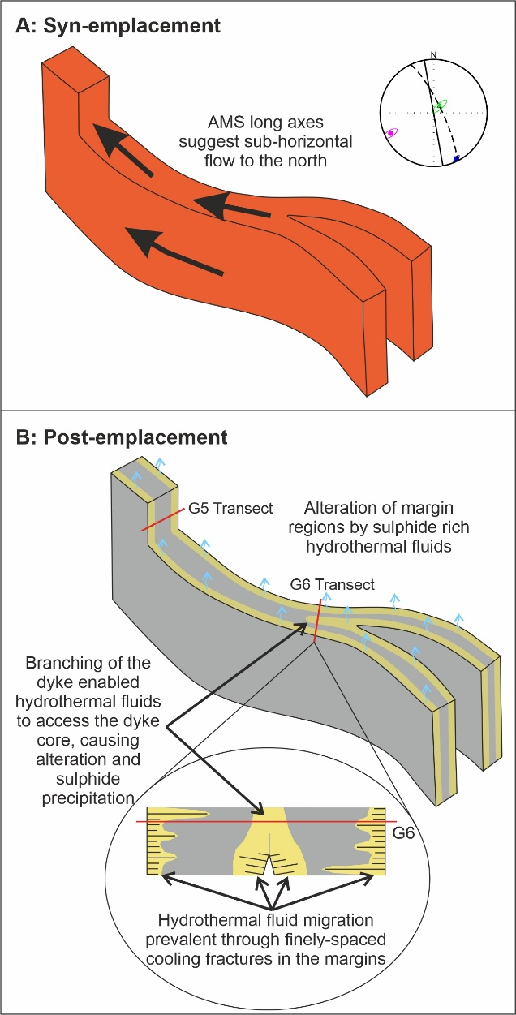
Figure 11: Schematic diagrams of dyke propagation and post-emplacement alteration. (A) Lateral magma flow towards the north during dyke propagation, inferred from AMS normal fabrics in the dyke core and supported by macro-scale field observations. Inset: A representative equal area plot showing AMS fabrics that indicate magma flow is included. (B) Post-emplacement hydrothermal fluids (blue) flowing through closely-spaced columnar jointing in the margin regions of the crystalline magma (yellow regions), resulting in growth of pyrrhotite crystals that dominate the magnetic fabrics. Alteration and precipitation of sulphides in the dyke core near site G6 occurred due to proximity of the site to the branched dyke section.

Magnetic fabric data away from the dyke margins, can potentially be used as indicators of magma flow direction that occurred during the later stages of magma transport. In the central region, AMS and AARM tensors for site G5 have similar axes, magnetic foliation orientations, and yield normal fabrics. The normal fabric is imbricated with respect to the dyke plane reflecting a flow direction towards the North (Figure 11A), supporting lateral magma propagation. Within the dyke core, the shallower dipping orientation of the magnetic foliation plane compared with the dyke plane may suggest a slight vertical component to the magma flow direction. However, the AMS and AARM ellipsoids have tri-axial to prolate shapes meaning that magnetic lineation rather than foliation is a reliable indicator for flow direction (Figures 10Av and 10Bv). Overall, our analysis suggests the magma flow direction in the dyke at this location was initially horizontal but then migrated to be shallowly inclined to the north. There are several possibilities for why a change in flow direction might occur. For example, perhaps eruption of the dyke towards the north provided a new upwards pathway for magma, or magma pressure reduction caused drain-back towards the magma source region towards the south.
5.2.2 Post-emplacement solidification and alteration
Other than the difference in oxidation of the margin regions compared with the dyke core, there is no obvious evidence for internal boundaries within the magma. This suggests emplacement occurred as a single injection. We infer that any compositional differences across the dyke thickness result from post-emplacement fluid flow through the weaker margin regions of the dyke (Figure 11B). This occurs through a permeable fracture network associated with magma quenching, contraction, and subsequent fracturing during cooling joint formation in the dyke margins (Figures 2B and C) (e.g. Spry, 1962). The fluids caused breakdown of the basalt and enabled the growth of pyrrhotite and subsequently calcite in the margin regions (yellow regions in Figure 11B). Along strike at site G6, the presence of pyrrhotite within the dyke core is attributed to the proximity of the site to the branched region. This would have increased jointing and have facilitated access of the hydrothermal fluid to locally alter the dyke core (Figure 11B).
The lack of internal compositional boundaries within the solidified magma also has implications for the solidification of the dyke. The method by which heat from the magma is lost into the surrounding host rock is important for preserving the flow fabrics in the intruding fluid. By inferring that the dyke solidified as a single unit we can calculate an approximate first-order timescale for solidification by conductive cooling (t), using the equation:
$t= \frac{L^{2}}{k}$ (1)
where L is the half thickness (1 m) and k is the thermal diffusivity (4.5 x 10-7 m²/s for basalt; Hartlieb et al., 2016). Here, we calculate the solidification time to be approximately 26 days. However, upon eruption the thickness of a dyke can reduce by half due to pressure release and an elastic response of the host-rock (Kavanagh et al., 2018). This means that the emplacement thickness of the studied fossil dyke may have initially been much greater than the dimensions seen today. If we instead assume the dyke half-thickness prior to eruption was two metres, this would extend the thermal life to approximately 100 days. It should be noted that this calculated thermal life is similar, within error, to recently emplaced dykes that have erupted at the surface. For example, the emplacement and eruption of a dyke at Kilauea, Hawai’i in 2018 (Neal et al., 2019), which was active for approximately 90 days and experienced sustained, localized lateral magma flow of magma. This similarity in emplacement times suggests that the dyke in this study may have fed an eruption comparable in size to recent events. Consequently, the magnetic fabrics and inferred emplacement processes identified here could be used to explain the processes occurring at currently active volcanoes.
  - Implications of the study
This study utilized a closely spaced sampling regime across the dyke thickness, and at different sites along its length, to understand the dynamics of intrusion through the emplacement history. Our high-density rock sample dataset, combined with detailed macro-scale field observations, has enabled us to identify multiple magnetic fabrics originating from distinct syn- and post-emplacement processes. This demonstrates the importance of rock sampling strategy for magnetic and petrographic studies of magma propagation dynamics, i.e. sampling multiple regions of an intrusion and at close spacing helps to improve our understanding of magma intrusion processes. Previous studies have focused only on the fabrics preserved in the margin regions of dykes (e.g. Knight and Walker, 1988; Poland et al., 2004; Clemente et al., 2007; Airoldi et al., 2012), which whilst useful for understanding initial propagation directions can ignore large amounts of the emplacement history that might be captured in the dyke core. This also means that in studies where anomalous or inverse fabrics are found close to intrusion margins, the fabrics preserved towards the core could be important for identifying magma flow. Studying multiple regions of the same intrusion also allows for the identification of more complete emplacement histories. This strategy aids in the development and re-evaluation of emplacement models, with differently distributed profiles offering a glimpse into three-dimensional complexities. The identification of post-emplacement fluid flow through the area is of great interest to both mining and geothermal industries. Therefore more detailed studies of dykes where evidence of post-emplacement fluid flow has been found could identify their emplacement orientations and as such have the potential to be trackers of economic minerals they carry.
- Conclusions
This study focussed on how magnetic anisotropy vary across both the thickness and length of a ~2 m thick basaltic dyke. The analysis presented here provides new insights into the syn- and post-emplacement processes that occur during magma transport and solidification. It also provides further insight into the effect that secondary alteration has on primary magmatic fabrics related to magma flow. This study uses a high-resolution sampling regime across the breadth of a single basalt dyke and at two sites separated along the dyke strike. The sites have undergone varying degrees of alteration and overprinting by syn-emplacement magnetic fabrics. The orientations and ellipsoid shaped of AMS and AARM fabrics vary dramatically, with the majority identified as anomalous magnetic fabrics both with respect to each other and with the dyke plane. These anomalous fabrics are associated with post-emplacement flow of a sulphide-rich fluid which enabled titanomagnetite breakdown and pyrrhotite growth. Where normal fabrics were observed, i.e. in the unaltered dyke core of site G5, horizontal flow towards the north was inferred. This correlates with the orientation of macroscale ropey flow structures on an adjacent dyke within the quarry. These magnetic fabrics were protected from post-emplacement alteration due to less cooling joints present in the dyke core. In one location at site G6, there was localized increased cooling related fracturing that enabled post-emplacement fluids to penetrate the central region and locally promote greater amounts of alteration across the entire dyke thickness. The complexities observed in the magnetic and petrological fabrics evident in this single, thin mafic dyke demonstrates the ability of intrusions to be passages for magma flow through the crust but also to be of economic importance for the mining and geothermal industries. This study also highlights the opportunities which come from understanding and interpreting both AMS and AARM fabrics, as multiple processes can give rise to the observed fabrics. Implementing sampling strategies that have higher frequency and are closely distributed will unlock more complete histories of dyke emplacement, enabling better insights into the processes occurring during active magma intrusion.

Acknowledgements

The authors would like to thank the University of Liverpool and The Royal Society (Grant no. RG130771). SM also thanks The Mineralogical Society (Postgraduate Bursary 2014) for support and Elliot Wood for field assistance. JLK acknowledges a UKRI Future Leaders Fellowship (MR/S035141/1): ‘Modelling Magma Movement: linking indirect observations with dynamic processes’. We thank Peter Kokelaar for suggesting the field location and Alan Boyle for useful discussions about sulphide growth.

References
Airoldi, G., Muirhead, J.D., Zanella, E., and White, J.D.L., 2012, Emplacement process of Ferrar Dolerite sheets at Allan Hills (South Victoria Land, Antarctica) inferred from magnetic fabric: Geophysical Journal International, v. 188, p. 1046–1060, doi:10.1111/j.1365-246X.2011.05334.x.
Archanjo, C.J., and Launeau, P., 2004, Magma flow inferred from preferred orientations of plagioclase of the Rio Ceara-Mirim dyke swarm (NE Brazil) and its AMS significance: Geological Society, London, Special Publications, v. 238, p. 285–298, doi:10.1144/GSL.SP.2004.238.01.17.
Audunsson, H., Levi, S., and Hodges, F., 1992, Magnetic property zonation in a thick lava flow: Journal of Geophysical Research, v. 97, p. 4349–4360, doi:10.1029/91JB01508.
BGS, 2008, 1:250000 British Geology, SHAPE geospatial data, scale 1:250000, Tile ng, BGS: EDINA Geology Digimap Service, http://digimap.edina.ac.uk (accessed March 2015).
Biggin, A.J., Perrin, M., and Dekkers, M.J., 2007, A reliable absolute palaeointensity determination obtained from a non-ideal recorder: Earth and Planetary Science Letters, v. 257, p. 545–563, doi:10.1016/j.epsl.2007.03.017.
Blundell, D., 1957, A palaeomagnetic investigation of the Lundy dyke swarm: Geological Magazine, v. 44, p. 187–193.
Callot, J., Geoffroy, L., Aubourg, C., Pozzi, J.P., and Mege, D., 2001, Magma flow directions of shallow dykes from the East Greenland volcanic margin inferred from magnetic fabric studies: Tectonophysics, v. 335, p. 313–329.
Cañón-Tapia, E., and Herrero-Bervera, E., 2009, Sampling strategies and the anisotropy of magnetic susceptibility of dykes: Tectonophysics, v. 466, p. 3–17, doi:10.1016/j.tecto.2008.11.012.
Chadima, M., Cajz, V., and Týcová, P., 2009, On the interpretation of normal and inverse magnetic fabric in dikes: Examples from the Eger Graben, NW Bohemian Massif: Tectonophysics, v. 466, p. 47–63, doi:10.1016/j.tecto.2008.09.005.
Chadima, M., and Hrouda, F., 2012, Cureval8:, http://www.agico.com/text/software/cureval/cureval.php.
Chadima, M., and Jelinek, V., 2009, Anisoft42:, http://www.agico.com/text/software/anisoft/anisoft.php.
Chadima, M., Pokorny, J., Dusek, M., and Vyslouzil, J., 2018a, Rema6:, http://www.agico.com/text/software/rema6/rema6.php.
Chadima, M., Pokorny, J., and Studynka, J., 2018b, Safyr7:, http://www.agico.com/text/software/safyr/safyr.php.
Chadwick, W.W., Jónsson, S., Geist, D.J., Poland, M., Johnson, D.J., Batt, S., Harpp, K.S., and Ruiz, A., 2011, The May 2005 eruption of Fernandina volcano, Galápagos: The first circumferential dike intrusion observed by GPS and InSAR: Bulletin of Volcanology, v. 73, p. 679–697, doi:10.1007/s00445-010-0433-0.
Clemente, C.S., Amorós, E.B., and Crespo, M.G., 2007, Dike intrusion under shear stress: Effects on magnetic and vesicle fabrics in dikes from rift zones of Tenerife (Canary Islands): Journal of Structural Geology, v. 29, p. 1931–1942, doi:10.1016/j.jsg.2007.08.005.
Coward, M.P., 1980, The analysis of flow profiles in a basaltic dyke using strained vesicles: Journal of the Geological Society, v. 137, p. 605–615, doi:10.1144/gsjgs.137.5.0605.
Crisp, J.A., 1984, Rates of magma emplacement and volcanic output: Journal of Volcanology and Geothermal Research, v. 20, p. 177–211, doi:10.1016/0377-0273(84)90039-8.
Çubukçu, H.E., 2015, Vertical variation in the deuteric oxidation of titanomagnetites in an ignimbrite deposit: Kizilkaya Ignimbrite (Cappadocia, Turkey): Journal of Volcanology and Geothermal Research, v. 308, p. 10–18, doi:10.1016/j.jvolgeores.2015.10.006.
Delaney, P.T., and Pollard, D.D., 1982, Solidification of basaltic magma during flow in a dike: American Journal of Science, v. 282, p. 856–885.
Dragoni, M., Lanza, R., and Tallarico, A., 1997, Magnetic anisotropy produced by magma flow: Theoretical model and experimental data from Ferrar dolerite sills (Antarctica): Geophysical Journal International, v. 128, p. 230–240, doi:10.1111/j.1365-246X.1997.tb04083.x.
Emeleus, C.H., and Bell, B.R., 2005, The Palaeogene volcanic districts of Scotland: British Geological Survey, Nottingham, 212 p.
Ernst, R., and Baragar, W., 1992, Evidence from magnetic fabric for the flow pattern of magma in the Mackenzie giant radiating dyke swarm: Nature, v. 356, p. 511–513, http://www.nature.com/nature/journal/v356/n6369/abs/356511a0.html (accessed December 2014).
Fiske, R.S., and Jackson, E.D., 1972, Orientation and Growth of Hawaiian Volcanic Rifts: The Effect of Regional Structure and Gravitational Stresses: Proceedings of the Royal Society A: Mathematical, Physical and Engineering Sciences, v. 329, p. 299–326, doi:10.1098/rspa.1972.0115.
Geoffroy, L., Callot, J.P., Aubourg, C., and Moreira, M., 2002, Magnetic and plagioclase linear fabric discrepancy in dykes: a new way to define the flow vector using magnetic foliation: Terra Nova, v. 14, p. 183–190, doi:10.1046/j.1365-3121.2002.00412.x.
Gibb, F.G.F., and Gibson, S.A., 1989, The Little Minch Sill Complex: Scottish Journal of Geology, v. 25, p. 367–370, doi:10.1144/sjg25030367.
Gibson, S.A., and Jones, A., 1991, Igneous stratigraphy and internal structure of the Little Minch Sill Complex, Trotternish Peninsula, northern Skye, Scotland: Geological Magazine, v. 128, p. 51–66.
Gudmundsson, A., Marinoni, L.B., and Marti, J., 1999, Injection and arrest of dykes: Implications for volcanic hazards: Journal of Volcanology and Geothermal Research, v. 88, p. 1–13, doi:10.1016/S0377-0273(98)00107-3.
Hargraves, R.B., Johnson, D., and Chan, C.Y., 1991, Distribution anisotropy: The cause of AMS in igneous rocks? Geophysical Research Letters, v. 18, p. 2193–2196, doi:10.1029/91GL01777.
Hartlieb, P., Toifl, M., Kuchar, F., Meisels, R., and Antretter, T., 2016, Thermo-physical properties of selected hard rocks and their relation to microwave-assisted comminution: Minerals Engineering, v. 91, p. 34–41, doi:10.1016/j.mineng.2015.11.008.
Herrero-Bervera, E., Walker, G.P.L., Cañon-Tapia, E., and Garcia, M.O., 2001, Magnetic fabric and inferred flow direction of dikes, conesheets and sill swarms, Isle of Skye, Scotland: Journal of Volcanology and Geothermal Research, v. 106, p. 195–210.
Hjartardóttir, Á.R., Einarsson, P., Gudmundsson, M.T., and Högnadóttir, T., 2015, Fracture movements and graben subsidence during the 2014 Bárðarbunga dike intrusion in Iceland: Journal of Volcanology and Geothermal Research, v. 310, p. 242–252, doi:10.1016/j.jvolgeores.2015.12.002.
Hrouda, F., Buriánek, D., Krejčí, O., and Chadima, M., 2015, Magnetic fabric and petrology of Miocene sub-volcanic sills and dykes emplaced into the SW Flysch Belt of the West Carpathians (S Moravia, Czech Republic) and their volcanological and tectonic implications: Journal of Volcanology and Geothermal Research, v. 290, p. 23–38, doi:10.1016/j.jvolgeores.2014.12.001.
Hudson, J.D., and Trewin, N.H., 2002, Jurassic, in Trewin, N.H. ed., The Geology of Scotland, London, The Geological Society, p. 323–350.
Hughes, H.S.R., Boyce, A.J., McDonald, I., Davidheiser-Kroll, B., Holwell, D.A., McDonald, A., and Oldroyd, A., 2015, Contrasting mechanisms for crustal sulphur contamination of mafic magma: evidence from dyke and sill complexes from the British Palaeogene Igneous Province: Journal of the Geological Society, v. 172, p. 443–458, doi:10.1144/jgs2014-112.
Jackson, M., 1991, Anisotropy of magnetic remanence: A brief review of mineralogical sources, physical origins, and geological applications, and comparison with susceptibility anisotropy: Pure and Applied Geophysics, v. 136, p. 1–28, doi:10.1007/BF00878885.
Jelínek, V., 1981, Characterization of the magnetic fabric of rocks: Tectonophysics, v. 79, p. T63–T67, doi:10.1016/0040-1951(81)90110-4.
Jelínek, V., 1977, The statistical theory of measuring anisotropy of magnetic susceptibility of rocks and its application.: Brno, Czech Republic, Geofysika, 4 p.
Just, J., and Kontny, A., 2012, Thermally induced alterations of minerals during measurements of the temperature dependence of magnetic susceptibility: A case study from the hydrothermally altered Soultz-sous-Forêts granite, France: International Journal of Earth Sciences, v. 101, p. 819–839, doi:10.1007/s00531-011-0668-9.
Just, J., Kontny, A., De Wall, H., Hirt, A.M., and Martín-Hernández, F., 2004, Development of magnetic fabrics during hydrothermal alteration in the Soultz-sous-Forêts granite from the EPS-1 borehole, Upper Rhine Graben: Geological Society Special Publication, v. 238, p. 509–526, doi:10.1144/GSL.SP.2004.238.01.26.
Kavanagh, J.L., 2018, Mechanisms of Magma Transport in the Upper Crust—Dyking, in Burchardt, S. ed., Volcanic and Igneous Plumbing Systems, Elsevier, p. 55–88, doi:10.1016/b978-0-12-809749-6.00003-0.
Kavanagh, J.L., Burns, A.J., Hazim, S.H., Wood, E., Martin, S.A., Hignett, S., and Dennis, D.J.C., 2018, Challenging dyke ascent models using novel laboratory experiments: Implications for reinterpreting evidence of magma ascent and volcanism: Journal of Volcanology and Geothermal Research, v. 354, p. 87–101, doi:10.1016/J.JVOLGEORES.2018.01.002.
Kavanagh, J.L., and Sparks, R.S.J., 2011, Insights of dyke emplacement mechanics from detailed 3D dyke thickness datasets: Journal of the Geological Society, v. 168, p. 965–978, doi:10.1144/0016-76492010-137.
Khan, A., 1962, The anisotropy of magnetic susceptibility of some igneous and metamorphic rocks: Journal of Geophysical Research, v. 67, p. 2873–2885.
Knight, M., and Walker, G., 1988, Magma flow directions in dikes of the Koolau Complex, Oahu, determined from magnetic fabric studies: Journal of Geophysical Research, v. 93, p. 4301–4319.
Leonhardt, R., 2006, Analyzing rock magnetic measurements: The RockMagAnalyzer 1.0 software: Computers and Geosciences, v. 32, p. 1420–1431, doi:10.1016/j.cageo.2006.01.006.
Liss, D., Hutton, D.H.W., and Owens, W.H., 2002, Ropy flow structures: A neglected indicator of magma-flow direction in sills and dikes: Geology, v. 30, p. 715–718, doi:10.1130/0091-7613(2002)030<0715:RFSANI>2.0.CO;2.
Lowrie, W., 1990, Identification of Ferromagnetic Minerals in a rock by coercivity and unblocking temperture properties: Geophysical Research Letters, v. 17, p. 159–162.
Martin, S.A., 2020, The Dynamics of Magma Intrusion: using magnetic anisotropy to understand magma emplacement in intrusions: 177 p.
Martin, S.A., Kavanagh, J.L., Biggin, A.J., and Utley, J.E.P., 2019, The Origin and Evolution of Magnetic Fabrics in Mafic Sills: Frontiers in Earth Science, v. 7, p. 1–23, doi:10.3389/feart.2019.00064.
McCabe, C., Jackson, M., and Ellwood, B.B., 1985, Magnetic anisotropy in the Trenton Limestone: Results of a new technique, anisotropy of anhysteretic susceptibility: Geophysical Research Letters, v. 12, p. 333–336, doi:10.1029/GL012i006p00333.
Neal, C.A., Brantley, S.R., Antolik, L., Babb, J.L., and Etc, 2019, The 2018 rift eruption and summit collapse of Kīlauea Volcano: Science, v. 363, p. 367–374.
O’Driscoll, B., Troll, V.R., Reavy, R.J., and Turner, P., 2006, The Great Eucrite intrusion of Ardnamurchan, Scotland: Reevaluating the ring-dike concept: Geology, v. 34, p. 189–192, doi:10.1130/G22294.1.
O’Reilly, W., 1984, Rock and Mineral Magnetism: Glasgow, Blackie and Son, 220 p.
Olazabal, A.A., Carracedo, M., and Aranguren, A., 1999, Petrology, magnetic fabric and emplacement in a strike-slip regime of a zoned peraluminous granite: the Campanario-La Haba pluton, Spain: Geological Society, London, Special Publications, v. 168, p. 177–190, doi:10.1144/GSL.SP.1999.168.01.12.
Peltier, A., Famin, V., Bachèlery, P., Cayol, V., Fukushima, Y., and Staudacher, T., 2008, Cyclic magma storages and transfers at Piton de La Fournaise volcano (La Réunion hotspot) inferred from deformation and geochemical data: Earth and Planetary Science Letters, doi:10.1016/j.epsl.2008.02.042.
Platten, I.M., and Watterson, J.S., 1987, Magma Flow and Crystallization in Dyke Fissures, in Halls, H.C. and Fahrig, W.F. eds., Mafic Dyke Swarms: Geological Association of Canada Special Paper 34, p. 65–73.
Poland, M.P., Fink, J.H., and Tauxe, L., 2004, Patterns of magma flow in segmented silicic dikes at Summer Coon volcano, Colorado: AMS and thin section analysis: Earth and Planetary Science Letters, v. 219, p. 155–169, doi:10.1016/S0012-821X(03)00706-4.
Potter, D.K., and Stephenson, A., 1988, Single-domain particles in rocks and magnetic fabric analysis: Geophysical Research Letters, v. 15, p. 1097, doi:10.1029/GL015i010p01097.
Raposo, M.I.B., and Ernesto, M., 1995, Anisotropy of magnetic susceptibility in the Ponta Grossa dyke swarm (Brazil) and its relationship with magma flow direction: Physics of the Earth and Planetary Interiors, v. 87, p. 183–196, doi:10.1016/0031-9201(94)02970-M.
Roberts, A.P., Almeida, T.P., Church, N.S., Harrison, R.J., Heslop, D., Li, Y., Li, J., Muxworthy, A.R., Williams, W., and Zhao, X., 2017, Resolving the Origin of Pseudo-Single Domain Magnetic Behavior: Journal of Geophysical Research: Solid Earth, v. 122, p. 9534–9558, doi:10.1002/2017JB014860.
Rochette, P., Jackson, M., and Aubourg, C., 1992, Rock Magnetism and the Interpretation of Anisotropy of Magnetic Susceptibility: Reviews of Geophysics, v. 30, p. 209–226.
Rochette, P., Jenatton, L., Dupuy, C., Boudier, F., and Reuber, I., 1991, Diabase dikes emplacement in the Oman Ophiolite: A magnetic fabric study with reference to geochemistry, in Peters, T., Nicolas, A., and Coleman, R.G. eds., Ophiolite genesis and evolution of the oceanic lithosphere, p. 55–82, doi:10.1007/978-94-011-3358-6.
Roni, E., Westerman, D.S., Dini, A., Stevenson, C., and Rocchi, S., 2014, Feeding and growth of a dyke-laccolith system (Elba Island, Italy) from AMS and mineral fabric data: Journal of the Geological Society, v. 171, p. 413–424, doi:10.1144/jgs2013-019.
Schofield, N., 2009, Linking sill morphology to emplacement mechanisms.
Schofield, N., Heaton, L., Holford, S.P., Archer, S.G., Jackson, C. a.-L., and Jolley, D.W., 2012, Seismic imaging of “broken bridges”: linking seismic to outcrop-scale investigations of intrusive magma lobes: Journal of the Geological Society, v. 169, p. 421–426, doi:10.1144/0016-76492011-150.
Selkin, P.A., Gee, J.S., and Meurer, W.P., 2014, Magnetic anisotropy as a tracer of crystal accumulation and transport, Middle Banded Series, Stillwater Complex, Montana: Tectonophysics, v. 629, p. 123–137, doi:10.1016/j.tecto.2014.03.028.
Sigmundsson, F. et al., 2015, Segmented lateral dyke growth in a rifting event at Bárðarbunga volcanic system, Iceland: Nature, v. 517, p. 191–195, doi:10.1038/nature14111.
Silva, P.F., Marques, F.O., Henry, B., Madureira, P., Hirt, A.M., Font, E., and Lourenço, N., 2010, Thick dyke emplacement and internal flow: A structural and magnetic fabric study of the deep-seated dolerite dyke of Foum Zguid (southern Morocco): Journal of Geophysical Research, v. 115, p. B12108, doi:10.1029/2010JB007638.
Smith, R.P., 1987, Dyke emplacement at Spanish Peaks, Colorado, in Halls, H.C. and Fahrig, W.F. eds., Mafic Dyke Swarms: Geological Association of Canada Special Paper 34, Geological Association of Canada, p. 47–54.
Soriano, C., Beamud, E., Garcés, M., and Ort, M.H., 2016, “Anomalous” magnetic fabrics of dikes in the stable single domain/superparamagnetic threshold: Geophysical Journal International, v. 204, p. 1040–1059, doi:10.1093/gji/ggv495.
Spry, A., 1962, The origin of columnar jointing, particularly in basalt flows: Journal of the Geological Society of Australia, v. 8, p. 191–216, doi:10.1080/14400956208527873.
Staudigel, H., Gee, J., Tauxe, L., and Varga, R., 1992, Shallow intrusive directions of sheeted dikes in the Troodos ophiolite: Anisotropy of magnetic susceptibility and structural data: Geology, v. 20, p. 841–844.
Tauxe, L., 2010, Essentials of Paleomagnetism: Los Angeles, University of California Press, 488 p.
Tauxe, L., Bertram, H.N., and Seberino, C., 2002, Physical interpretation of hysteresis loops: Micromagnetic modeling of fine particle magnetite: Geochemistry, Geophysics, Geosystems, v. 3, p. 1–22, doi:10.1029/2001GC000241.
Tauxe, L., Gee, J.S., and Staudigel, H., 1998, Flow directions in dikes from anisotropy of magnetic susceptibility data: The bootstrap way: Journal of Geophysical Research, v. 103, p. 17775, doi:10.1029/98JB01077.
Tibaldi, A., Bonali, F.L., and Corazzato, C., 2014, The diverging volcanic rift system: Tectonophysics, v. 611, p. 94–113, doi:10.1016/j.tecto.2013.11.023.
Townsend, M.R., Pollard, D.D., and Smith, R.P., 2017, Mechanical models for dikes: A third school of thought: Tectonophysics, v. 703–704, p. 98–118, doi:10.1016/j.tecto.2017.03.008.
Varga, R.J., Gee, J.S., Staudigel, H., and Tauxe, L., 1998, Dike surface lineations as magma flow indicators within the sheeted dike complex of the Troodos Ophiolite, Cyprus: Journal of Geophysical Research, v. 103, p. 5241, doi:10.1029/97JB02717.
Walker, G.P.L., 1993, Re-evaluation of inclined intrusive sheets and dykes in the Cuillins volcano, Isle of Skye: Geological Society, London, Special Publications, v. 76, p. 489–497.
Yamato, P., Tartèse, R., Duretz, T., and May, D. a., 2012, Numerical modelling of magma transport in dykes: Tectonophysics, v. 526–529, p. 97–109, doi:10.1016/j.tecto.2011.05.015.
Závada, P., Calassou, T., Schulmann, K., Hrouda, F., Štípská, P., Hasalová, P., Míková, J., Magna, T., and Mixa, P., 2017, Magnetic fabric transposition in folded granite sills in Variscan orogenic wedge: Journal of Structural Geology, v. 94, p. 166–183, doi:10.1016/j.jsg.2016.11.007.

Supplementary Material
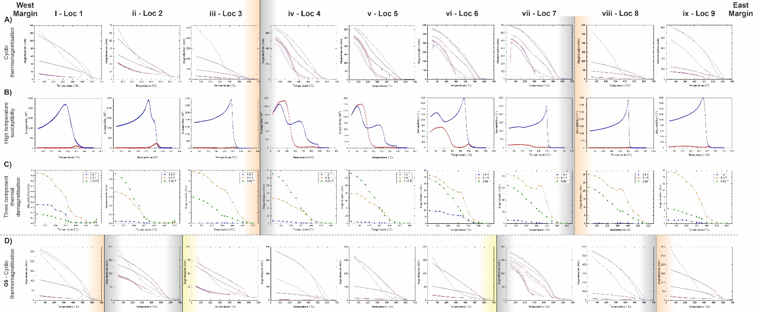
Supplementary Figure 1: Rock magnetic data for all locations at sites G5 and G6, with background colours signifying the different groupings. A) Cyclic thermomagnetisation, B) High temperature susceptibility, C) Three component thermal demagnetisaton for G5, and D) Cyclic thermomagnetisation for site G6.
Supplementary Table 1: Anisotropy of magnetic susceptibility ellipsoid data from Anisoft 4.2 for specimens from sites G5 and G6. Sample numbers refer to the Site-Location-Core at site, with A B C being specimen of the core, for example G5-L1-11A.
Supplementary Table 2: Anisotropy of anhysteretic remanent magnetisation ellipsoid data from Anisoft 4.2 for specimens from sites G5 and G6. Sample numbers refer to the Site-Location-Core at site, with A B C being specimen of the core, for example G5-L1-11A.

