In-Situ X-Ray Techniques for Electrochemical Interfaces
Bruna F. Baggio⁺, Yvonne Grunder*
Oliver Lodge Laboratory, Department of Physics, University of Liverpool, Liverpool, L69 7ZE, UK
* email: grunder@liverpool.ac.uk
⁺ email: B.F.Baggio@liverpool.ac.uk

Abstract
This article reviews progress in the study of materials by X-ray based techniques from an electrochemistry perspective. We are focusing on in-situ/operando Surface X-Ray Scattering and X-ray absorption spectroscopy and the combination of both. The background of those techniques together with the key concepts will be introduced. Key example of in-situ and in-operando investigation of liquid-solid and liquid-liquid interfaces are presented. X-ray scattering and spectroscopy have helped to develop an understanding of the underlying atomic and molecular processes associated with electrocatalysis, electrodeposition and battery materials. We will highlight recent developments including resonant surface diffraction and time resolved studies.
Keywords: Electrochemistry, Surface X-Ray Diffraction, X-ray Absorption, Spectroscopy
Contents
1. Introduction 2
X-Ray Scattering and Diffraction 4
a. Surface X-ray diffraction for electrochemical interfaces 5
b. Reflectivity/specular measurements 8
c. Small angle scattering/diffuse scattering 11
2. X-ray Absorption Spectroscopy (XAS) 13
3. Combination of Spectroscopy and Diffraction 18
4. References 19

Introduction
At the electrochemical interface the structure, morphology and composition of the electrode surface and adjacent electrolyte can change when electrochemical processes take place. Structural rearrangements of the electrode including relaxation and reconstruction phenomena depend on several factors such as adsorbates, either from the electrolyte or as intermediates in a reaction, as well as the electrode potential and can alter growth behaviour during electrodeposition and affect electrocatalytic processes.
First insights of changes in the atomic surface structure and chemical composition related to electrochemical processes have been obtained from ex-situ UHV analysis (1-3) though results can be misleading due to changes occurring during the transfer from one system to another.
In-situ/in operando analysis with surface-sensitive techniques such as scanning tunnelling microscopy (STM) and synchrotron-based surface X-ray methods have made it possible to characterise the interface during electrochemical processes. In particular, surface X-ray diffraction (SXRD) permits to obtain extremely accurate crystallographic parameters for both, the metal substrate and suitable adlayers. The main elements favouring in-situ applications of X-ray based techniques are the considerable penetration depth of hard X-rays into water (or other solvents) and sufficient beam intensity from synchrotron sources which allows measurable scattering intensity from the surface region (4, 5).
An unquestionable advantage of X-ray based experiments is being able to obtain in-situ structural and spectroscopic information under potential control without disturbing the system. In-situ surface X-ray diffraction and X-ray absorption (XAS) techniques can provide detailed structural and spectroscopic information during e.g. adsorbate formation, electrocatalytic reactions and electrochemical phase formation on both the electrode and electrolyte side of the interface. X-ray structural characterisation permits structure analysis, as lattice parameter and phases, atomic position and site occupancy, strain/relaxation whilst X-ray spectroscopy allows to study chemical composition as valence state, coordination environment and bond distances and can give insight on the chemical state of specific atoms. A combination of those can help to develop a full picture of working electrochemical interfaces, as has been applied for battery materials (6-9).
Due to inherent low intensity of the scattering signal from the interface and the requisite of tuneable energy of the incoming X-ray for spectroscopic, the experiments required to be performed at Synchrotron light facilities.
The continuing development of synchrotron light technologies, including more intense and focussed X-ray beams, and the development of faster X-ray detectors covering larger areas has allowed in-situ X-ray techniques to be commonly employed and to develop beyond providing static spectroscopic and structural measurements.
In this article we aim to give an overview of the different types of X-ray scattering and absorption spectroscopic techniques and the information they can provide.
This work highlights the possibilities X-ray based structural and spectroscopic techniques offer to study electrochemical systems in-situ and in-operando obtaining insights into electrochemical processes and structure-activity relationships not accessible with other techniques.
A full coverage of the literature of those techniques applied to electrochemistry is not the scope of this article, we highlight specific examples and developments to give the reader an idea about the possibilities these techniques offer. Even though X-ray imaging and photo emission (10-13) are powerful techniques to study the electrochemical interface, they are beyond the scope of this article and we refer the reader to existing literature for further details. Moreover, we highlight recent developments, allowing to follow in-situ structural and chemical changes at the electrochemical interface in order to obtain more detailed information about the underlying electrochemical processes on a faster timescale, now being able to follow structural and chemical changes with millisecond resolution.

X-Ray Scattering and Diffraction
In the following we are describing the basics of X-ray scattering and diffraction to be able to discuss specification and limitations arising from their nature. For a more thorough derivation and detailed description we refer the reader to existing literature (14-17). The intensity distribution resulting from the X-ray scattering might be thought of as a map in momentum (reciprocal) space, where the intensity is mapped as function of the reciprocal space coordinate I(Q). The scattering vector or momentum transfer Q is defined by the difference between the wave vectors of the incoming (Q_{in}) and scattered (Q_{out}) X-ray beam (Q=Q_{in}-Q_{out}) and is thus defined by the diffraction geometry (the sample and detector position with respect to the incoming x-ray beam) as depicted in Figure 1. The incoming X-ray beam scattered at each individual atom or ion results in a scattering amplitude described by an atom specific scattering factor f (Q, E).
The intensity distribution resulting from the scattering of all atoms is the square of the interference function obtained by summing the individual scattering contributions from each atom I(Q,E)= |$\sum{{f_{j}\left(Q,E\right)e^{2 π i Q r_{j}}|}^{2}}$, with r_{j} the position of the individual scatter j.
The interference function reflecting the periodic distribution of the atoms in the crystal, gives rise to the diffraction pattern with discrete intensity spots in reciprocal space, the Bragg reflections. Notice that we always refer to measurements in the space of the reciprocal lattice, not in the real space of the crystal itself, this is the formalism used in crystallography and diffraction physics. The positions of any point in reciprocal space defined by the scattering vector Q can be described with reciprocal space coordinates called Miller indices H, K and L (similar to assigning an x, y and z coordinate in real space) Q=(H,K,L) (15).
The information we can access in real space depends on the choice of the length and orientation of the Q vector in reciprocal space. The length scale or resolution in real space is inverse proportional to the length of the Q vector and the structure contributing to the scattering is perpendicular to the reciprocal space vector. Therefore, we will divide the techniques in the following by their sensitivity to different aspects of the interface defined by the geometry employed (Figure 1), namely Surface X-ray Diffraction (SXRD), Reflectivity or Specular measurements (XRR) and Grazing Incidence Small Angle X-ray Scattering (GISAXS).

Surface X-ray diffraction for electrochemical interfaces
The abrupt truncation of the electron density on the surface leads to the scattered intensity appearing in perpendicular direction to the surface (along the Q_{z} or L direction as depicted in Figure 1) with an in-plane spacing representing the real pace in-plane atomic distances through Bragg’s law, thus we find the diffraction pattern to be a lattice of rods (14). These rods, called crystal truncation rods (CTRs) since they arise from the crystal being truncated, are the key characteristic of diffraction from surfaces and the intensity distribution along these rods can provide detailed crystallographic structural information on the atomic scale with high accuracy on relaxation (18-21) and roughening parameters (20, 22).
The sensitivity of the CTR to surface coverage and composition is demonstrated for monolayer of underpotential deposited Ag onto Au(111) in Figure 2a. In addition, the calculated CTR profiles for an ideal clean Au(111) surface (green), a full Ag monolayer on Au(111) (red), and a Ag bilayer on Au(111) (blue) demonstrate the sensitivity of the data to structural surface changes. (23)
Additional scattering from a reconstructed surface or ordered adsorbate adlayers with different lattice parameters from the bulk crystal lead to additional rods(24-26). The additional intensity streaks in reciprocal space and modulation of the X-ray scattering intensity from the surface due to the perceived change in coverage of the first atomic layer, adsorbate layers (24, 25), underpotential deposition (27-31) and reconstructions (25, 26, 32) were the first systems to be studied by surface x-ray diffraction. The intensity distribution for a change in the surface periodicity is shown in Figure 2b as a schematic for the example of the Au(111) reconstruction around the (0, 1, 0.5) CTR position (solid symbol) indicating the peaks that arise due to the surface reconstruction (open symbols).(33) The corresponding contour map I(h,k) map of the measured X-ray intensity in the l = 0.5 plane at the same position is also shown.
Those studies have provided valuable insights into coverage, relaxation, adsorbate structures, bond lengths and their dependence on the applied potential.
Potentiodynamic measurements, when the scattered X-ray intensity is measured while the electrode potential is cycled over a potential window or stepped between two potentials can give valuable information about reversible and irreversible potential dependent structural changes, electrode stability and the dynamics of electrochemical processes. As an example the changes observed while scanning the potential are shown in Figure 2c for Ag underpotential deposition on Au(111) at different points in reciprocal space on the specular CTR at (0 0 1.5) and the two non-specular CTRs at (1 0 3.7) and (0 1 0.5) sensitive to relaxation effects and surface coverage, respectively.(23) Reversible processes studied include the lifting of the reconstructions on Au (26, 32-37) and Pt (38-40) surfaces, elucidating the role of the surface charge and adsorbed species. Potential step experiments, monitoring the intensity while stepping the potential permit to record intensity transients as shown in 3d for the copper underpotential deposition on gold allowing to deduct time constants for structural changes. (41, 42)
In addition, surface X-ray diffraction has played a key role in elucidating structural changes due to possible adsorption and/or absorption of species involved in electrocatalytic reactions (43), e.g. CO adsorption and oxidation on platinum could be followed on Pt(111) (44). More recently the subsurface adsorption of oxygenated species on Pt (45-49) and Cu (20) could be studied.
Studies of bulk alloys have helped to follow in-situ structural changes during corrosion (50-53) including the formation of a thin passivation layer followed by the formation of substrate islands at larger overpotentials, this behaviour is altered in the presence of halides (54).
Other potential induced processes which are well suited for the study by X-ray diffraction are the electro-dissolution and electrodeposition at single crystal electrodes (55-58). Due to the changes in roughness and morphology of the crystal surface upon deposition or dissolution measurable intensity changes can be observed. The scattered intensity is monitored at selected reciprocal space positions as a function of time while depositing on the electrode surface which allows to follow different growth modes and establish the influence of potential adsorbates and additives on those (56, 58, 59).
Data acquisition rates with time resolution of millisecond are achievable as has been shown for the electrochemical dissolution of Au(001) in Cl-containing electrolyte (60).
A drawback of the use of X-ray diffraction to study electrochemical processes is the limited reciprocal space that is accessible with the use of point detectors. Usually only one point in reciprocal space can be studied and changes of the interface which would be possible to observe at different places in reciprocal space remain uncovered, thus not allowing to obtain information of a larger region and to follow several processes simultaneously. When studying the influence of adsorbates onto the electrodeposition on copper for example the roughening of the surface giving insight into the growth mode and the signal coming from the adlayer, giving insight into the adsorbate structure and coverage, had to be recorded in two different sets (56).
Modification of the experimental conditions are required to overcome this limitation. The use of high energy (smaller wavelength) X-rays, thus compacting the reciprocal space and allowing to monitor a larger region with one 2D detector simultaneously has been employed over the recent years (45, 46, 61, 62).
Another approach to obtain information of more than one point in reciprocal space is the use of dispersive X-rays in combination with a 2D detector. In this case the incoming beam uses a multi-wavelength instead of using X-rays of single energy (63-65). With the absolute value of the scattering vector Q being proportional to the inverse of the wavelength λ of the X-ray beam |Q|~1/ λ a range of Q vectors is instantly accessible. Instead of having to adjust the scattering angle the intensity distribution observed corresponds to a range of Q and a CTR profile is observable with millisecond time resolution, allowing to study structural change of electrode surface layers (63).
Perhaps the main disadvantage that still remains is that SXRD is limited to well-ordered single crystal surfaces studies and cannot, up to the date, be applied to nanometre sized particles, although with the developments of the techniques such as GISAXS and EXAFS this problem has been overcame as exemplified in following sections.

Reflectivity/specular measurements
Reflectivity can be considered as a subset of surface X-ray diffraction with the limitation of the Q vector being normal to the surface plane (Q_{inplane}=0) thus monitoring structural changes perpendicular to the surface plane not requiring a specific in-plane symmetry. Quantitatively, XRR is sensitive to the surface normal electron density profile. When combined with surface X-ray diffraction the CTR with the limitation of Q_{inplane}=0 is called specular CTR and the information obtainable is similar to the one for reflectivity measurements. Reflectivity measurements can be achieved by varying the incident and exit angle with the restriction that the exit angle is the same as the incident angle at all times (Figure 1). The method thus investigates any structural changes normal to the interface and can be useful specifically to systems which do not have an in-plane symmetry e.g. are not sensitive to restructuring within a surface plane.
For electrochemical interfaces reflectivity and specular measurements have been employed to study the ordering of the ions close to the interface both for electrodes with in-plane symmetry and for electrodes without any crystalline structure, such as liquid-liquid interfaces. A detailed description of scattering from liquid interfaces can be found in reference (66). Characterisation of polarisable liquid/liquid interfaces via X-ray scattering have been conducted both for interfaces between an organic and aqueous electrolyte and between a liquid metal and aqueous electrolytes (67). For the mercury-aqueous interface a pseudo-Bragg peak was observed, indicating surface-adjacent layering within the mercury phase which shows potential and temperature dependence (68). The potential dependence of the additionally observed surface roughness could be explained by a response of the free electrons to the applied potential (69). A nucleation and growth process at the mercury–aqueous showed the formation of a precursor followed by quasi-epitaxial 3D crystal growth, which was assigned to a combined action of electrostatic and short-range chemical interactions (70).
X-ray reflectivity has been used to study the ion distribution at the organic-aqueous interface (71-74). The results have allowed to obtain ion concentration profiles for different cations at various interfacial potential. These works further permitted to extract excess charges for different potentials and determine experimentally potentials of mean force for different ions. More weakly hydrated ions were found closer to the interface showing that the contribution of ion pairing to the free energy of adsorption is very small for the investigated ions (71). Furthermore, to quantitatively describe the ion distribution at the interface requires to take into account the interplay between ion–solvent interactions and ion–ion correlations (73). Other applications of reflectivity to liquid-liquid interface monitored the assembly of water-soluble, heavily charged nanoparticles into an interfacial monolayer located on the organic side of the interface (75) and the molecular ordering and phase behaviour of surfactants at the water-oil interface with sub nanometre spatial resolution as a function of depth into the interface (76).
Similar to the characterisation of a liquid-liquid interface, specular X-ray scattering/reflectivity can be employed to obtain information about the liquid structure at the solid-liquid interface (77). Employing the reflectivity or specular rod in combination with SXRD allows to separate the contributions coming from the ordered crystal (Figure 3a) from the effect of the liquid layering onto the intensity distribution to interfacial water structures. Attention has to be however paid to the contrast of the electron densities and the structure of the electrolyte. Layering gives rise as already discussed for liquid-liquid surface to so-called quasi-Bragg peak (Figure 3b, green line), which will show up as an intensity modulation asymmetric with respect to the Bragg peaks of the CTR. Electrolyte structures without specific layering represented by an error function are less easy to distinguish as the intensity modification will be at low L values (Figure 3 b, blue line) which is also the region where effects of the beam or detector footprint being larger than the sample and misalignments such as the beam not hitting the centre of the sample might affect the results.
One of the first electrochemical systems investigating the electron density of the electrolyte normal to the surface Ag(111) in 0.1 M NaF showed a clear potential dependence of the ordering in the electrolyte. The presence of a dense ice-like layer of water adjacent to the interface and the flipping of the water molecule dependent on the applied potential was proposed (78). This was followed up by a more recent study of Ag(111) in 0.1 M KOH; the non-specular and specular CTR were measured. The changes with potential on the specular CTR are more pronounced (Figure 3c) and were assigned to electrolyte effects in addition to changes in the relaxation. A layer of hydrated K⁺ cations in the outer part of the double layer at the negative potential end was proposed (shown in Figure 3d, left). At the positive potential end adsorbed OH stabilising a hydrated K+ cation layer through non-covalent interaction thus forming a compact double layer structure in with a reduced Ag-K⁺ distance was found (Figure 3d, right). (79)
Timer resolved measurements of the specular CTR as shown in Error! Reference source not found. gave insight onto transitional structures during underpotential deposition of various metal cations on Au(111). (41) The intensity transient obtained for different copper concentration allowed to deduct the kinetics and time constants of adsorption (Error! Reference source not found.d). In general, the adsorption rate of the metal cations is related to the coordination energy of solvation.(41)
More recent studies investigated the atomic-scale interfacial structure of a non-aqueous liquid electrolyte solution with implication for Li-ion batteries. The roughness of the electrode was found to have minor effects on the interfacial structures. The solid interface gives rise to liquid layering near OCV and determines the orientation of the electrolyte molecules and ions near the surface electrolyte does not follow the structureless diffuse electric double layer predictions of the Gouy–Chapman model. The interfacial structural properties are mainly governed by specific intermolecular interactions, such as van der Waals, Coulomb and dipolar, rather than being governed by specific substrate–molecule interactions (80).
One of the disadvantages in scattering techniques is the phase loss of the complex structure future due to the intensity being proportional to the square of the scattering factor I(Q,E)= |$\sum{{f_{j}\left(Q,E\right)e^{2 π i Q r_{j}}|}^{2}}$. This means that a direct retrieval of the atomic positions is not possible and structural information relies on atomistic models to be refined through iterations. Analysis of the specular CTR through a non-iterative approach has recently been developed (81) this is possible for the specular CTR only as the data close to the origin of the reciprocal space (Q=0) is accessible and the intensity and electron density are continuous, thus related through causality. The approach has been applied to retrieve the electron density of the ion layering and monitor the Stern layer behaviour on Pt(111) (82) and RuO₂(110) and RuO₂(100) (83) as a function of potential.

Small angle scattering/diffuse scattering
Grazing incidence small angle X-ray scattering (GISAXS) (84, 85) can be employed, often in combination with atomic scale methods, to obtain in situ and operando information on the nanoscale in electrochemical environments for both solid-liquid and liquid-liquid interfaces. The wavevector is typically between 0 and 1 nm⁻¹ thus allowing large dimensions typically in the order of a few nm to a few hundreds of nm in real space to be probed. A representative GISAXS setup for electrochemical studies is shown in Figure 5a.
Thus, information about morphology and nanoscale objects perpendicular and parallel to the surface can be obtained.
The potential dependent study of nanoparticles at an aqueous organic is an example of using X-ray methods to follow the ordering of nanoscale objects. An arrangement of the particles into a hexagonal lattice over the investigated potential range was observed showing potential-dependent changes in lattice spacing and in-plane correlation length (75).
Due to the small range in reciprocal space to be covered, the diffuse scattering in the near forward direction, GISAXS employed with a 2D detector allows to follow changes at the interface on a fast time scale only limited by the signal-to-noise ratio and frame rate of the detector.
Examples include following growth processes during electrodeposition which lead to a change in the surface morphology and to monitor the kinetic roughening during the initial stages of electrodeposition. For Au(001) surface in chloride containing electrolyte, intensity maps at various times t of a growth experiment on the unreconstructed Au(001) surface are plotted as a function of the in-plane scattering vector components q_{x} and q_{y} (Figure 5 b) allowed to fit the line profiles (Figure 5c) in order to extract the peak position q_{r} as a function of deposition time. This gave insight into the lateral mound size as a function of deposition time for various deposition potentials during the 3D growth (86) .
Quantitative study of the structural evolution of Pt(111) in HClO₄ during oxidation/reduction cycles showed a coarsening of the formed nanoscale 3D islands with the number of cycles. The morphological evolution in the electrochemical system strongly resembles that found in homoepitaxial growth under UHV conditions (47).
GISAXS allows to follow morphology changes including roughening processes on a fast time scale. The structure of Pt(111) a place exchange of Pt and oxygen atoms was observed during surface oxidation . The resulting oxide consists of an oxygen rich outer and a Pt-rich inner atomic layer but approaches a more uniform stoichiometry with increasing potential the oxide (46).

X-ray Absorption Spectroscopy (XAS)
So far, we have focused on samples with long range order which can be probed by diffraction methods. In contrast, X-ray Absorption spectroscopy can be employed to obtain structural and chemical information from samples without requiring long-range order including amorphous materials and nanoparticles (87), but can also provide additional information for crystalline surfaces. The change in the X-ray absorbed by the sample while the X-ray photon energy is varied from below to above an absorption edge of a specific element is monitored and gives information about the near range structure and chemical environment of the probed atom (88, 89).
The XAS spectrum is divided into two regions with defined energy relative to the absorption edge and revealing different information about the local environment and the absorbing atom itself. X-ray absorption near edge structure (XANES) covers energy ranges up to several tens of electron volts (eV) above the edge and is directly linked to the electronic configuration and sensitive to the oxidation states of the atom probed (90). The extended X-ray absorption fine-structure (EXAFS), which extends from 50 eV above the edge to 1000 eV, approximately (91), arises from the backscattering of the photoelectron and thus contains information about the local environment of the absorbing atom including the chemical environment and nearest neighbour distances.
In electrochemical environment the range of absorbing atoms is restricted by the X-ray energy able to penetrate the sample and/or the electrolyte with absorption energies typically >5 keV thus in this specific environment not allowing to study elements with low atomic number. In-situ XAS can provide information about the chemical composition and oxidation state of individual elements in a multi element material, allowing to monitor chemical and structural changes during redox processes. This is of particular interest and has been employed to the study of materials and reactions for energy processes such as CO₂ reduction (10), oxygen and hydrogen evolution reactions (92), fuel cells (93, 94), heterogeneous electrocatalysts (95) and nanoscale catalysis (96).
X-ray absorption spectroscopy is not limited to short range ordered samples and can be employed to single crystals. In this case surface sensitivity and depth profiling can be achieved by using grazing incident X-rays and by varying the incident angle of the X-rays, respectively. (97) This is especially useful when studying deposition of foreign metals such as underpotential deposition, as the element specificity allows to distinguish between surface and deposit and to detect disordered deposits and possible surface alloying and/or the coadsorption of oxygenated species (98-103). X-ray absorption techniques have been extensively reviewed and are commonly employed to probe changes in chemical properties and the local environment of specific sites during electrochemical reactions. We therefore aim here to only highlight few examples and recent developments to demonstrate its use to develop a further understanding of fundamental electrochemical processes and applications.
X-ray absorption spectroscopy has helped to build an understanding of the activity, selectivty and stability relationship of electrode materials for CO₂ reduction by revealing oxidation states, coordianation number and atomic distances under reactive conditions.
Copper has been extensively studied (not only with XAS) as CO₂ reduction due to its ability to bind CO while hydrogen underpotential deposition does not occur (104), thus being able to catalyse the CO2 reduction to hydrocarbons. X-ray absorption spectroscopy has helped to gain insights into the chemical changes occurring during the reaction by analysing the XANES part of the spectra and into the stability and oxide formation by extracting coordination numbers and atomic distances from the EXAFS part of the spectra not only for copper but also for copper alloys as shown as an example for copper-complexes (105) and CuO_{x} nano-cubes(106) in Figure 6.
The activity and selectivity during electrochemical CO₂ reduction (107) reaction has been studied with in-situ/operando XAS for copper(II) phthalocyanine (CuPc), copper(II) benzene-1,3,5-tricarboxylate, and copper(II) 1,4,8,11-tetraazacyclotetradecane chloride ([Cu(cyclam)]Cl2). Among those complexes, CuPc shows the highest activity and selectivity for electrochemical CO₂ reduction to CH₄. The observed XAS spectra while stepping the potential from open circuit voltage to the potential for electrocatalytic reduction are shown in Figure 6a. The XANES analysis reveals a formation of Cu(I) followed by Cu(II) during this process. The Fourier transformed EXAFS shown in Figure 6b allowed to follow the change in bond distance and coordination numbers during the potential change. The formation of Cu-Cu bond with a length of 2.2 Å can be observed under operating conditions accompanied by a decrease in the Cu-N and Cu-C coordination number associated with CuPc and increase in the Cu-Cu coordination number (Figure 6 c). The change in oxidation state was found to be reversible only for the CuPCc complex.
XAS data obtained from CuO_{x} nano-cubes has been obtained approximately every 10 minutes (Figure 6d). The XANES data (inset in Figure 6d) reveals a change in the pre-edge feature indicating a change of the chemical state of copper towards metallic copper. The change in the local environment of the copper atoms could be extracted from the EXAFS. The Fourier transformed EXAFS (Figure 6e) shows a change from the Cu-O distance towards a Cu-Cu bonding length, which is accompanied by a change in coordination number for Cu -O from 2 to 0.3 and for Cu-Cu from 3.6 to 12. The expected coordinated number for Cu-Cu in a bulk distance is 12, thus the copper atom is during this reaction undercoordinated. For copper nano-cubes a coordination number of 10.8 was obtained for the Cu cubes indicating the formation and growth of pores on the Cu cubes under reaction conditions leading to an increased surface roughness.(108)
The relative concentration of the metallic copper and copper oxide as a function of time during CO₂ reduction are shown in Figure 6e. The reduced coordinate number under reactive conditions accompanied indicate an induced copper roughness during the reduction of the copper oxide electrode during the loss of oxygen. Under reactive conditions, the surface and the bulk of the electrode are dominated by the existence of reduced copper, which correlates with enhanced C–C bond formation at higher cathodic polarization due to the increased metallicity of the copper electrode (109)
Interestingly, in comparison in-situ XAS revealed that Zn (II) centre maintains its oxidation state under reaction conditions, which means that the Zn centre does not experience a redox reaction but CO2 reduction driven by the ligand.(105)
Oxygen evolution reaction (OER) has also been broadly studied by XAS (110-114). The atomic-level structure of Pt₃Ni nano-frame catalysts could be identified and linked to differences in their oxygen reduction reaction activity showing that nano-frame surfaces with different structure exhibit varying levels of binding strength to adsorbate molecules (111). The role of oxygen during the OER in an electrodeposited Ni-Fe(OxHy) electrocatalyst was investigate in the soft and hard X-ray regimes in alkaline pH (112). Multi-metallic oxide electrocatalysts exhibits impressive oxygen reduction activity in alkaline fuel cells. In-situ XAS resolved the synergistic catalytic mechanism of bimetallic oxide such as Co−Mn oxide catalyst (113) and to understand even more complex systems as trimetallic oxides (Mn-doped cobalt ferrite) under real-time fuel cell operating conditions (114).
Although only the local environment of the specific atom type is involved, XAS allows to probe the local geometric ligand environment and electronic metal states of oxygen-coordinated iridium centres in nickel-leached IrNi@IrOx metal oxide core–shell nanoparticles under catalytic oxygen evolution (115).
In situ EXAFS has been used to study the electrochemical formation and electrocatalytic activity of core shell nanoparticles, allowing to follow the potential dependent changes in coordination number and oxidation state by recording spectra of the elements of the core and shell separately. The formation of core shell nanoparticles was followed by EXAFS studies during the underpotential deposition of Cu onto a carbon-supported Au electrocatalyst investigating the initial stages of formation of the core-shell (116). Different methods of depositing Au@Pd core@shell nanoparticles (117) have been studied. The formation of a potential induced hydride phase could be followed for a series of Pd@Pt core-shell catalysts with varying Pt shell thickness monitoring lattice and inter-atomic distances of the metal neighbour pairs (118).
Time-resolved XAS technique was applied to investigate the key factors that limit the rate capability of Li-based batteries for a Li_{1.2}Ni_{0.15}Co_{0.1}Mn_{0.55}O₂ cathode following the contributions of the three different transition metals in the cathode to the electrochemical charge/discharge reactions. (119)
The investigation of kinetics and underlying mechanism of electrocatalytic systems in operando requires a high time resolution not achievable with standard XAS set-ups where one spectrum can take in the order of ten minutes. Quick EXAFS allowing to change the energy of the incoming X-ray beam much faster time-resolved compositional information for CO2 reduction on CuO_{x} catalysts (120). Similar to X-ray the use of dispersive X-rays allows the whole X-ray absorption spectrum to be collected simultaneously enabling time-resolved XAS experiments on a time scale of milliseconds. The local chemical environment and electronic structure of iridium during the oxidation of Ir(III) to Ir(IV) in the water splitting process on electrodeposited iridium oxide films under chronoamperometric conditions in both acidic and basic media was studied this way (121).

Combination of Spectroscopy and Diffraction
The combination of spectroscopic and structural X-ray techniques can be useful to get more concise information on the electrochemical interface. Diffraction techniques have the drawback that the only element specificity comes from the atomic scattering factor. Whereas EXAFS/XANES does have the disadvantage of being a bulk characterisation technique, the signal stems from the whole sample, thus not giving specific interfacial information. Specifically, for crystalline surfaces with elements that have atomic numbers which are close, (as the atomic scattering factors scales with the atomic number Z) those elements are indistinguishable by structural data. The application of anomalous or resonant scattering in which the energy of the incoming beam is scanned through an X-ray adsorption edge while the scattering vector Q is kept constant, can be useful to identify the specific phase and thus gain element sensitivity in the positional parameters. In the case of bi-metallic systems such as underpotential deposition (122-125) and alloy surfaces (50, 126, 127) the concentration profile at the surface in the electrochemical environment can be obtained.
In the same way resonant scattering allows to get element specific information reveal element-specific ion distributions to the electron density profile obtained from specular reflectivity (128, 129). The cation specific study revealed the distributions of mono-and divalent cations to be different which could be associated to a difference in their interfacial hydration structure. (130, 131) Studying the density profile as a function of ion concentration allows to develop a model for the concentration-dependent coverage and to deduct an effective surface charge.(132, 133)
Another advantage of resonant diffraction is that similar to XANES, the spectra contain information about the chemical state of the atomic contribution to the diffracted signal and thus allows to obtain sub-monolayer sensitive information of the oxidation states of the surface atoms. The electrochemical oxidation of Pt(111) single crystal surface was studies in this way (134, 135). It could be shown that the place exchange of surface platinum and oxygen is accompanied by second-layer platinum atoms losing their electrons to nearest neighbour oxygen atoms. Varying the polarisation of the X-rays between being normal and parallel to the surface plane of the electrode showed a strong dependence of the diffracted intensity on the polarisation angle (135, 136) which was attributed to anisotropic local environment of Pt surface atoms.
More recently attempts were made in quantifying the resonant surface X-ray diffraction signal and the polarisation dependence observed to probe the charge transfer between the metal electrode and the adsorbing species in the electrolyte solution.
Adsorption of halide anions Cl⁻ and Br⁻ onto Cu(001) (137, 138) and Au(001) (139-141) electrochemical systems were studied in order to directly probe the charge transfer and nature of the chemical bonding (142). Moreover, a theoretical tool based on an ab-initio approach to simulate surface resonant X-ray diffraction experiments is being developed (143) and allows to obtain details about the local electron density and bond formation from the resonant surface diffraction spectra.

References
1. Kolb D. 1996. Reconstruction phenomena at metal-electrolyte interfaces. Progress in Surface Science 51: 109-73
2. Wagner F-T, Ross Jr P. 1983. LEED analysis of electrode surfaces: Structural effects of potentiodynamic cycling on Pt single crystals. Journal of Electroanalytical Chemistry and Interfacial Electrochemistry 150: 141-64
3. Stuve EM, Krasnopoler A, Sauer DE. 1995. Relating the in-situ, ex-situ, and non-situ environments in surface electrochemistry. Surface Science 335: 177-85
4. Weaver MJ, Gao X. 1993. In-situ electrochemical surface science. Annual Review of Physical Chemistry 44: 459-94
5. Cristofolini L. 2014. Synchrotron X-ray techniques for the investigation of structures and dynamics in interfacial systems. Current Opinion in Colloid & Interface Science 19: 228-41
6. Bak S-M, Shadike Z, Lin R, Yu X, Yang X-Q. 2018. In situ/operando synchrotron-based X-ray techniques for lithium-ion battery research. NPG Asia Materials 10: 563-80
7. Lin F, Liu Y, Yu X, Cheng L, Singer A, et al. 2017. Synchrotron X-ray analytical techniques for studying materials electrochemistry in rechargeable batteries. Chemical reviews 117: 13123-86
8. Yan Y, Cheng C, Zhang L, Li Y, Lu J. 2019. Deciphering the Reaction Mechanism of Lithium–Sulfur Batteries by In Situ/Operando Synchrotron‐Based Characterization Techniques. Advanced Energy Materials 9: 1900148
9. Seok J, Yu S-H, Abruña HcD. 2020. Operando Synchrotron-Based X-ray Study of Prussian Blue and Its Analogue as Cathode Materials for Sodium-Ion Batteries. The Journal of Physical Chemistry C 124: 16332-37
10. Adarsh KS, Chandrasekaran N, Chakrapani V. 2020. In-situ Spectroscopic Techniques as Critical Evaluation Tools for Electrochemical Carbon dioxide Reduction: A Mini Review. Frontiers in Chemistry 8
11. Velasco-Vélez JJ, Pfeifer V, Hävecker M, Wang R, Centeno A, et al. 2016. Atmospheric pressure X-ray photoelectron spectroscopy apparatus: Bridging the pressure gap. Review of Scientific Instruments 87
12. Weiland C, Rumaiz AK, Pianetta P, Woicik JC. 2016. Recent applications of hard x-ray photoelectron spectroscopy. Journal of Vacuum Science and Technology A: Vacuum, Surfaces and Films 34
13. Liu Z, Bluhm H. 2016. Liquid/solid interfaces studied by ambient pressure HAXPES. In Springer Series in Surface Sciences, pp. 447-66: Springer Verlag
14. Robinson I, Tweet D. 1992. Surface X-ray diffraction. Reports on Progress in Physics 55: 599
15. Feidenhans R. 1989. Surface structure determination by X-ray diffraction. Surface Science Reports 10: 105-88
16. Als-Nielsen J, McMorrow D. 2011. Elements of modern X-ray physics: John Wiley & Sons
17. Robinson I. 1998. X-ray Crystallography of Surfaces and Interfaces. Acta Crystallographica Section A: Foundations of Crystallography 54: 772-78
18. Nichols RJ, Nouar T, Lucas CA, Haiss W, Hofer WA. 2002. Surface relaxation and surface stress of Au(1 1 1). Surface Science 513: 263-71
19. Gallagher ME, Lucas CA, Stamenković V, Marković NM, Ross PN. 2003. Surface structure and relaxation at the Pt3Sn(1 1 1)/ electrolyte interface. Surface Science 544: L729-L34
20. Grunder Y, Beane J, Kolodziej A, Lucas C, Rodriguez P. 2019. Potential Dependent Structure and Stability of Cu(111) in Neutral Phosphate Electrolyte. Surfaces 2: 145-58
21. Lucas CA. 2002. Surface relaxation at the metal/electrolyte interface. Electrochimica Acta 47: 3065-74
22. Robinson KM, Robinson IK, O'Grady WE. 1992. Electrochemically induced surface roughness on Au(100) studied by surface X-ray diffraction. Electrochimica Acta 37: 2169-72
23. Sisson N, Gründer Y, Lucas CA. 2016. Structure and Stability of Underpotentially Deposited Ag on Au(111) in Alkaline Electrolyte. The Journal of Physical Chemistry C 120: 16100-09
24. Magnussen OM. 2002. Ordered anion adlayers on metal electrode surfaces. Chemical Reviews 102: 679-725
25. Wang J, Ocko BM, Davenport AJ, Isaacs HS. 1992. In situ x-ray-diffraction and -reflectivity studies of the Au(111)/electrolyte interface: Reconstruction and anion adsorption. Physical Review B 46: 10321-38
26. Ocko BM, Wang J, Davenport A, Isaacs H. 1990. In situ x-ray reflectivity and diffraction studies of the Au(001) reconstruction in an electrochemical cell. Phys Rev Lett 65: 1466-69
27. Samant MG, Toney MF, Borges GL, Blum L, Melroy OR. 1988. Grazing incidence X-ray diffraction of lead monolayers at a silver (111) and gold (111) electrode/electrolyte interface. Journal of Physical Chemistry 92: 220-25
28. Samant MG, Toney MF, Borges GL, Blum L, Melroy OR. 1988. In-situ grazing incidence X-ray diffraction study of electrochemically deposited Pb monolayers on Ag(111). Surface Science 193: L29-L36
29. Melroy OR, Toney MF, Borges GL, Samant MG, Kortright JB, et al. 1988. Two-dimensional compressibility of electrochemically adsorbed lead on silver (111). Physical Review B 38: 10962-65
30. Melroy OR, Toney MF, Borges GL, Samant MG, Kortright JB, et al. 1989. An in-situ grazing incidence X-ray scattering study of the initial stages of electrochemical growth of lead on silver (111). Journal of Electroanalytical Chemistry 258: 403-14
31. Toney MF, Gordon JG, Melroy OR. 1991. In-situ surface x-ray scattering of metal monolayers adsorbed at solid-liquid interfaces. Presented at Proceedings of SPIE - The International Society for Optical Engineering
32. Tidswell IM, Marković NM, Lucas CA, Ross PN. 1993. In situ x-ray-scattering study of the Au(001) reconstruction in alkaline and acidic electrolytes. Physical Review B 47: 16542-53
33. Gründer Y, Harlow GS, Cocklin E, Fogg J, Beane JW, Lucas CA. 2019. Potential-dependent surface compression of gold and its link to electrocatalytic reactivity. Surface Science 680: 113-18
34. Ocko B, Magnussen O, Adžić R, Wang J, Shi Z, Lipkowski J. 1994. A critical comparison of electrochemical and surface X-ray scattering results at the Au (111) electrode in KBr solutions. Journal of Electroanalytical Chemistry 376: 35-39
35. Wang J, Davenport AJ, Isaacs HS, Ocko B. 1992. Surface Charge—Induced Ordering of the Au (111) Surface. Science 255: 1416-18
36. Ocko B, Helgesen G, Schardt B, Wang J, Hamelin A. 1992. Charge induced (1× 3) reconstruction of the Au (110) surface: An x-ray scattering study. Physical review letters 69: 3350
37. Markovic N, Tidswell I, Ross P. 1994. Oxygen and hydrogen peroxide reduction on the gold (100) surface in alkaline electrolyte: the roles of surface structure and hydroxide adsorption. Langmuir 10: 1-4
38. Marković N, Lucas C, Rodes A, Stamenković V, Ross P. 2002. Surface electrochemistry of CO on Pt (111): anion effects. Surface Science 499: L149-L58
39. Harlow GS, Aldous IM, Thompson P, Gründer Y, Hardwick LJ, Lucas CA. 2019. Adsorption, surface relaxation and electrolyte structure at Pt (111) electrodes in non-aqueous and aqueous acetonitrile electrolytes. Physical Chemistry Chemical Physics 21: 8654-62
40. Lucas C. 2002. Surface relaxation at the metal/electrolyte interface. Electrochimica acta 47: 3065-74
41. Nakamura M, Banzai T, Maehata Y, Endo O, Tajiri H, et al. 2017. Real–time observation of interfacial ions during electrocrystallization. Scientific Reports 7: 914
42. Tamam L, Ocko BM, Nakamura N, Ogawa Y, Deutsch M. 2013. The structure of Langmuir films of long diols on mercury. Soft Matter 9: 11204-13
43. Gründer Y, Lucas CA. 2016. Surface X-ray diffraction studies of single crystal electrocatalysts. Nano Energy 29: 378-93
44. Marković NM, Grgur BN, Lucas CA, Ross PN. 1999. Electrooxidation of CO and H2/CO mixtures on Pt(111) in acid solutions. Journal of Physical Chemistry B 103: 487-95
45. Drnec J, Ruge M, Reikowski F, Rahn B, Carlà F, et al. 2017. Initial stages of Pt(111) electrooxidation: dynamic and structural studies by surface X-ray diffraction. Electrochimica Acta 224: 220-27
46. Ruge M, Drnec J, Rahn B, Reikowski F, Harrington DA, et al. 2017. Electrochemical Oxidation of Smooth and Nanoscale Rough Pt(111): An In Situ Surface X-ray Scattering Study. Journal of The Electrochemical Society 164: H608-H14
47. Ruge M, Drnec J, Rahn Br, Reikowski F, Harrington DA, et al. 2017. Structural reorganization of Pt (111) electrodes by electrochemical oxidation and reduction. Journal of the American Chemical Society 139: 4532-39
48. Kondo T, Masuda T, Aoki N, Uosaki K. 2016. Potential-Dependent Structures and Potential-Induced Structure Changes at Pt(111) Single-Crystal Electrode/Sulfuric and Perchloric Acid Interfaces in the Potential Region between Hydrogen Underpotential Deposition and Surface Oxide Formation by in Situ Surface X-ray Scattering. Journal of Physical Chemistry C 120: 16118-31
49. Liu Y, Barbour A, Komanicky V, You H. 2016. X-ray Crystal Truncation Rod Studies of Surface Oxidation and Reduction on Pt(111). The Journal of Physical Chemistry C 120: 16174-78
50. Renner FU, Stierle A, Dosch H, Kolb DM, Lee TL, Zegenhagen J. 2006. Initial corrosion observed on the atomic scale. Nature 439: 707-10
51. Renner FU, Stierle A, Dosch H, Kolb DM, Zegenhagen J. 2007. The influence of chloride on the initial anodic dissolution of Cu<inf>3</inf>Au(1 1 1). Electrochemistry Communications 9: 1639-42
52. Renner FU, Gründer Y, Lyman PF, Zegenhagen J. 2007. In-situ X-ray diffraction study of the initial dealloying of Cu<inf>3</inf>Au(001) and Cu<inf>0.83</inf>Pd<inf>0.17</inf>(001). Thin Solid Films 515: 5574-80
53. Renner FU, Stierle A, Dosch H, Kolb DM, Lee TL, Zegenhagen J. 2008. In situ x-ray diffraction study of the initial dealloying and passivation of Cu3 Au (111) during anodic dissolution. Physical Review B - Condensed Matter and Materials Physics 77
54. Renner FU, Ankah GN, Pareek A. 2012. In-situ surface-sensitive X-ray diffraction study on the influence of iodide over the selective electrochemical etching of Cu3Au (111). Surface Science 606: L37-L40
55. Gründer Y, Stettner J, Magnussen OM. 2018. Review—In-Situ Surface X-ray Diffraction Studies of Copper Electrodes: Atomic-Scale Interface Structure and Growth Behavior. Journal of The Electrochemical Society 166: D3049-D57
56. Golks F, Stettner J, Gründer Y, Krug K, Zegenhagen J, Magnussen OM. 2011. Anomalous potential dependence in homoepitaxial Cu(001) electrodeposition: an in situ surface x-ray diffraction study. Phys. Rev. Lett. 108: 256101
57. Krug K, Kaminski D, Golks F, Stettner J, Magnussen OM. 2010. Real-time surface X-ray scattering study of Au(111) electrochemical dissolution. Journal of Physical Chemistry C 114: 18634-44
58. Krug K, Stettner J, Magnussen OM. 2006. In-situ surface x-ray diffraction studies of homoepitaxial electrochemical growth on Au(100). Phys.Rev.Lett. 96: 246101-1-01-4
59. Kaminski D, Krug K, Golks F, Stettner J, Magnussen OM. 2007. Time-Dependent Diffraction Studies of Au(100) Electrode Surface During Deposition. The Journal of Physical Chemistry C 111: 17067-71
60. Golks F, Krug K, Gründer Y, Zegenhagen J, Stettner J, Magnussen OM. 2011. High-Speed in situ Surface X-ray Diffraction Studies of the Electrochemical Dissolution of Au(001). Journal of the American Chemical Society 133: 3772-75
61. Martens I, Chattot R, Rasola M, Blanco MV, Honkimäki V, et al. 2019. Probing the Dynamics of Platinum Surface Oxides in Fuel Cell Catalyst Layers Using in Situ X-ray Diffraction. ACS Applied Energy Materials 2: 7772-80
62. Tim W, Jakub D, Finn R, Jochim S, Fouad M, Olaf M. 2020. In Situ Transmission X-ray Micro-Diffraction from Thin Metal Films Electrodeposited in Microfluidic Channels. Journal of the Electrochemical Society
63. Shirasawa T, Masuda T, Voegeli W, Arakawa E, Kamezawa C, et al. 2017. Fast Structure Determination of Electrode Surfaces for Investigating Electrochemical Dynamics Using Wavelength-Dispersive X-ray Crystal Truncation Rod Measurements. The Journal of Physical Chemistry C 121: 24726-32
64. Shirasawa T. 2019. Real-time Observation of Interface Atomic Structures by an Energy-Dispersive Surface X-ray Diffraction. e-Journal of Surface Science and Nanotechnology 17: 155-62
65. Matsushita T, Takahashi T, Shirasawa T, Arakawa E, Toyokawa H, Tajiri H. 2011. Quick measurement of crystal truncation rod profiles in simultaneous multi-wavelength dispersive mode. Journal of Applied Physics 110: 102209
66. P.S. Pershan MS. 2012. Liquid Surfaces and Interfaces: Synchrotron X-ray Methods: Cambridge University Press
67. Murphy BM, Festersen S, Magnussen OM. 2016. The Atomic scale structure of liquid metal–electrolyte interfaces. Nanoscale 8: 13859-66
68. Runge B, Festersen S, Koops CT, Elsen A, Deutsch M, et al. 2016. Temperature- and potential-dependent structure of the mercury-electrolyte interface. Physical Review B 93: 165408
69. Elsen A, Murphy BM, Ocko BM, Tamam L, Deutsch M, et al. 2010. Surface Layering at the Mercury-Electrolyte Interface. Physical Review Letters 104: 105501
70. Elsen A, Festersen S, Runge B, Koops CT, Ocko BM, et al. 2013. In situ X-ray studies of adlayer-induced crystal nucleation at the liquid–liquid interface. Proceedings of the National Academy of Sciences 110: 6663-68
71. Hou B, Laanait N, Yu H, Bu W, Yoon J, et al. 2013. Ion Distributions at the Water/1,2-Dichloroethane Interface: Potential of Mean Force Approach to Analyzing X-ray Reflectivity and Interfacial Tension Measurements. The Journal of Physical Chemistry B 117: 5365-78
72. Hou BY, Bu W, Luo GM, Vanysek P, Schlossman ML. 2015. Ion Distributions at Electrified Water-Organic Interfaces: PB-PMF Calculations and Impedance Spectroscopy Measurements. Journal of the Electrochemical Society 162: H890-H97
73. Laanait N, Mihaylov M, Hou B, Yu H, Vanýsek P, et al. 2012. Tuning ion correlations at an electrified soft interface. Proceedings of the National Academy of Sciences 109: 20326-31
74. Luo G, Malkova S, Yoon J, Schultz DG, Lin B, et al. 2006. Ion Distributions near a Liquid-Liquid Interface. Science 311: 216-18
75. Bera MK, Chan H, Moyano DF, Yu H, Tatur S, et al. 2014. Interfacial Localization and Voltage-Tunable Arrays of Charged Nanoparticles. Nano Letters 14: 6816-22
76. Schlossman ML, Tikhonov AM. 2008. Molecular ordering and phase behavior of surfactants at water-oil interfaces as probed by X-ray surface scattering. Annu. Rev. Phys. Chem. 59: 153-77
77. Fenter P, Sturchio NC. 2004. Mineral–water interfacial structures revealed by synchrotron X-ray scattering. Progress in Surface Science 77: 171-258
78. Toney MF, Howard JN, Richer J, Borges GL, Gordon JG, et al. 1995. Distribution of water molecules at Ag(111)/electrolyte interface as studied with surface X-ray scattering. Surface Science 335: 326-32
79. Lucas CA, Thompson P, Gründer Y, Markovic NM. 2011. The structure of the electrochemical double layer: Ag(111) in alkaline electrolyte. Electrochemistry Communications 13: 1205-08
80. Steinrück H-G, Cao C, Tsao Y, Takacs CJ, Konovalov O, et al. 2018. The nanoscale structure of the electrolyte–metal oxide interface. Energy & Environmental Science 11: 594-602
81. Kawaguchi T, Liu Y, Reiter A, Cammarot C, Pierce MS, You H. 2018. Direct determination of one-dimensional interphase structures using normalized crystal truncation rod analysis. Journal of Applied Crystallography 51: 679-84
82. Liu Y, Kawaguchi T, Pierce MS, Komanicky V, You H. 2018. Layering and Ordering in Electrochemical Double Layers. Journal of Physical Chemistry Letters 9: 1265-71
83. Kawaguchi T, Rao RR, Lunger JR, Liu Y, Walko D, et al. 2020. Stern layers on RuO2 (100) and (110) in electrolyte: Surface X-ray scattering studies. Journal of Electroanalytical Chemistry: 114228
84. Renaud G, Lazzari R, Leroy F. 2009. Probing surface and interface morphology with Grazing Incidence Small Angle X-Ray Scattering. Surface Science Reports 64: 255-380
85. Müller-Buschbaum P. 2009. A Basic Introduction to Grazing Incidence Small-Angle X-Ray Scattering. In Applications of Synchrotron Light to Scattering and Diffraction in Materials and Life Sciences, ed. M Gomez, A Nogales, MC Garcia-Gutierrez, TA Ezquerra, pp. 61-89. Berlin, Heidelberg: Springer Berlin Heidelberg
86. Ruge M, Golks F, Zegenhagen J, Magnussen OM, Stettner J. 2014. In operando GISAXS studies of mound coarsening in electrochemical homoepitaxy. Physical Review Letters 112
87. Wang Q, Frenkel AI. 2017. Chapter 5 - Characterization of Model Nanocatalysts by X-ray Absorption Spectroscopy. In Studies in Surface Science and Catalysis, ed. P Fornasiero, M Cargnello, pp. 149-83: Elsevier
88. Penner-Hahn JE. 2019. X-Ray Absorption Spectroscopy☆. In Encyclopedia of Analytical Science (Third Edition), ed. P Worsfold, C Poole, A Townshend, M Miró, pp. 404-19. Oxford: Academic Press
89. Sun Z, Wei S, Zhang X. 2018. The Application of X-ray Absorption Fine Structure Spectroscopy in Functional Materials. In Synchrotron Radiation Applications, pp. 149-224
90. Joly YG, S. 2016. Theory of X-Ray Absorption Near Edge Structure. In X‐Ray Absorption and X‐Ray Emission Spectroscopy, pp. 73-97
91. Vickerman JC, Gilmore IS. 2011. Surface analysis: the principal techniques: John Wiley & Sons
92. V VM, Nageswaran G. 2020. Operando X-Ray Spectroscopic Techniques: A Focus on Hydrogen and Oxygen Evolution Reactions. Frontiers in Chemistry 8
93. Russell AE, Rose A. 2004. X-ray absorption spectroscopy of low temperature fuel cell catalysts. Chemical Reviews 104: 4613-35
94. Amezawa K. 2020. X-ray absorption spectroscopic studies on solid oxide fuel cells and proton-conducting ceramic fuel cells. Current Opinion in Electrochemistry 21: 250-56
95. Zhang H, Li X, Jiang Z. 2019. Probe active sites of heterogeneous electrocatalysts by X-ray absorption spectroscopy: From single atom to complex multi-element composites. Current Opinion in Electrochemistry 14: 7-15
96. Wang M, Árnadóttir L, Xu ZJ, Feng Z. 2019. In situ X-ray absorption spectroscopy studies of nanoscale electrocatalysts. Nano-Micro Letters 11: 47
97. Firet NJ, Blommaert MA, Burdyny T, Venugopal A, Bohra D, et al. 2019. Operando EXAFS study reveals presence of oxygen in oxide-derived silver catalysts for electrochemical CO2 reduction. Journal of Materials Chemistry A 7: 2597-607
98. Albarelli MJ, White JH, Bommarito GM, McMillan M, Abruña HD. 1988. In-situ surface exafs at chemically modified electrodes. Journal of Electroanalytical Chemistry 248: 77-86
99. Melroy OR, Samant MG, Borges GL, Gordon JG, Blum L, et al. 1988. In-Plane Structure of Underpotentially Deposited Copper on Gold(111) Determined by Surface Exafs. Langmuir 4: 728-32
100. White JH, Abruña HD. 1988. Electrosorption of iodide on Pt(111) studied in situ by X-ray absorption spectroscopy. Journal of Physical Chemistry 92: 7131-34
101. White JH, Albarelli MJ, Abruña HD, Blum L, Melroy OR, et al. 1988. Surface extended X-ray absorption fine structure of underpotentially deposited silver on Au(111) electrodes. Journal of Physical Chemistry 92: 4432-36
102. White JH, Abruña HD. 1989. An in-situ surface EXAFS study of copper underpotential deposition on Pt (111). Part I. The observation of strong in-plane scattering at submonolayer coverage. Journal of Electroanalytical Chemistry 274: 185-99
103. Herrero E, Buller LJ, Abruña HD. 2001. Underpotential deposition at single crystal surfaces of Au, Pt, Ag and other materials. Chemical Reviews 101: 1897-930
104. Bagger A, Ju W, Varela AS, Strasser P, Rossmeisl J. 2017. Electrochemical CO2 Reduction: A Classification Problem. ChemPhysChem 18: 3266-73
105. Weng Z, Wu Y, Wang M, Jiang J, Yang K, et al. 2018. Active sites of copper-complex catalytic materials for electrochemical carbon dioxide reduction. Nature communications 9: 1-9
106. Möller T, Scholten F, Thanh TN, Sinev I, Timoshenko J, et al. 2020. Electrocatalytic CO2 Reduction on CuOx Nanocubes: Tracking the Evolution of Chemical State, Geometric Structure, and Catalytic Selectivity using Operando Spectroscopy. Angewandte Chemie International Edition n/a
107. Mistry H, Varela AS, Bonifacio CS, Zegkinoglou I, Sinev I, et al. 2016. Highly selective plasma-activated copper catalysts for carbon dioxide reduction to ethylene. Nature Communications 7: 12123
108. Grosse P, Gao D, Scholten F, Sinev I, Mistry H, Roldan Cuenya B. 2018. Dynamic Changes in the Structure, Chemical State and Catalytic Selectivity of Cu Nanocubes during CO2 Electroreduction: Size and Support Effects. Angewandte Chemie International Edition 57: 6192-97
109. Velasco-Velez J-J, Mom RV, Sandoval-Diaz L-E, Falling LJ, Chuang C-H, et al. 2020. Revealing the Active Phase of Copper during the Electroreduction of CO2 in Aqueous Electrolyte by Correlating In Situ X-ray Spectroscopy and In Situ Electron Microscopy. ACS Energy Letters 5: 2106-11
110. Calvillo L, Carraro F, Vozniuk O, Celorrio V, Nodari L, et al. 2018. Insights into the durability of Co–Fe spinel oxygen evolution electrocatalysts via operando studies of the catalyst structure. Journal of Materials Chemistry A 6: 7034-41
111. Becknell N, Kang Y, Chen C, Resasco J, Kornienko N, et al. 2015. Atomic structure of Pt3Ni nanoframe electrocatalysts by in situ X-ray absorption spectroscopy. Journal of the American Chemical Society 137: 15817-24
112. Drevon D, Görlin M, Chernev P, Xi L, Dau H, Lange KM. 2019. Uncovering the role of oxygen in Ni-Fe (O x H y) electrocatalysts using in situ soft x-ray absorption spectroscopy during the oxygen evolution reaction. Scientific reports 9: 1-11
113. Yang Y, Wang Y, Xiong Y, Huang X, Shen L, et al. 2019. In situ X-ray absorption spectroscopy of a synergistic Co–Mn oxide catalyst for the oxygen reduction reaction. Journal of the American Chemical Society 141: 1463-66
114. Xiong Y, Yang Y, Feng X, DiSalvo FJ, Abruña HD. 2019. A strategy for increasing the efficiency of the oxygen reduction reaction in Mn-doped cobalt ferrites. Journal of the American Chemical Society 141: 4412-21
115. Nong HN, Reier T, Oh H-S, Gliech M, Paciok P, et al. 2018. A unique oxygen ligand environment facilitates water oxidation in hole-doped IrNiO x core–shell electrocatalysts. Nature Catalysis 1: 841-51
116. Price SW, Speed JD, Kannan P, Russell AE. 2011. Exploring the first steps in core–shell electrocatalyst preparation: in situ characterization of the underpotential deposition of Cu on supported Au nanoparticles. Journal of the American Chemical Society 133: 19448-58
117. Price SW, Rhodes JM, Calvillo L, Russell AE. 2013. Revealing the details of the surface composition of electrochemically prepared Au@ Pd Core@ Shell nanoparticles with in situ EXAFS. The Journal of Physical Chemistry C 117: 24858-65
118. Wise AM, Richardson PW, Price SW, Chouchelamane G, Calvillo L, et al. 2018. Inhibitive effect of Pt on Pd-hydride formation of Pd@ Pt core-shell electrocatalysts: an in situ EXAFS and XRD study. Electrochimica Acta 262: 27-38
119. Yu X, Lyu Y, Gu L, Wu H, Bak SM, et al. 2014. Understanding the rate capability of high‐energy‐density Li‐rich layered Li1. 2Ni0. 15Co0. 1Mn0. 55O2 cathode materials. Advanced Energy Materials 4: 1300950
120. Lin S-C, Chang C-C, Chiu S-Y, Pai H-T, Liao T-Y, et al. 2020. Operando time-resolved X-ray absorption spectroscopy reveals the chemical nature enabling highly selective CO2 reduction. Nature Communications 11: 3525
121. Achilli E, Minguzzi A, Lugaresi O, Locatelli C, Rondinini S, et al. 2014. In Situ Dispersive EXAFS in Electrocatalysis: The Investigation of the Local Structure of IrO
122. Lucas CA, Marković NM, Ross PN. 1997. Electrochemical deposition of copper onto Pt(111) in the presence of (bi)sulfate anions. Physical Review B - Condensed Matter and Materials Physics 56: 3651-54
123. R. Ramadan A, D. Chabala E, Rayment T. 1999. An insitu surface differential diffraction and anomalous scattering investigation of surface relaxation during underpotential deposition of Ag on Au(111). Physical Chemistry Chemical Physics 1: 1591-96
124. Tidswell IM, Lucas CA, Marković NM, Ross PN. 1995. Surface-structure determination using anomalous x-ray scattering: Underpotential deposition of copper on Pt(111). Physical Review B 51: 10205-08
125. Shibata M, Hayashi N, Sakurai T, Kurokawa A, Fukumitsu H, et al. 2012. Electrochemical Layer-by-Layer Deposition of Pseudomorphic Pt Layers on Au(111) Electrode Surface Confirmed by Electrochemical and In Situ Resonance Surface X-ray Scattering Measurements. The Journal of Physical Chemistry C 116: 26464-74
126. Stamenkovic VR, Fowler B, Mun BS, Wang G, Ross PN, et al. 2007. Improved Oxygen Reduction Activity on Pt<sub>3</sub>Ni(111) via Increased Surface Site Availability. Science 315: 493-97
127. Fowler B, Lucas CA, Omer A, Wang G, Stamenković VR, Marković NM. 2008. Segregation and stability at Pt3Ni(111) surfaces and Pt75Ni25 nanoparticles. Electrochimica Acta 53: 6076-80
128. Park C, Fenter PA, Sturchio NC, Regalbuto JR. 2005. Probing Outer-Sphere Adsorption of Aqueous Metal Complexes at the Oxide-Water Interface with Resonant Anomalous X-Ray Reflectivity. Physical Review Letters 94: 076104
129. Lee SS, Park C, Fenter P, Sturchio NC, Nagy KL. 2010. Competitive adsorption of strontium and fulvic acid at the muscovite-solution interface observed with resonant anomalous X-ray reflectivity. Geochimica et Cosmochimica Acta 74: 1762-76
130. Fenter P, Park C, Nagy KL, Sturchio NC. 2007. Resonant anomalous X-ray reflectivity as a probe of ion adsorption at solid-liquid interfaces. Thin Solid Films 515: 5654-59
131. Kohli V, Zhang Z, Park C, Fenter P. 2010. Rb and Sr adsorption at the TiO<inf>2</inf> (110)-electrolyte interface observed with resonant anomalous X-ray reflectivity. Langmuir 26: 950-58
132. Lee SS, Heberling F, Sturchio NC, Eng PJ, Fenter P. 2016. Surface Charge of the Calcite (104) Terrace Measured by Rb+ Adsorption in Aqueous Solutions Using Resonant Anomalous X-ray Reflectivity. Journal of Physical Chemistry C 120: 15216-23
133. Bellucci F, Lee SS, Kubicki JD, Bandura A, Zhang Z, et al. 2015. Rb+ adsorption at the quartz(101) - Aqueous interface: Comparison of resonant anomalous X-ray reflectivity with ab initio calculations. Journal of Physical Chemistry C 119: 4778-88
134. Chu YS, You H, Tanzer JA, Lister TE, Nagy Z. 1999. Surface resonance X-ray scattering observation of core-electron binding-energy shifts of Pt(111)-surface atoms during electrochemical oxidation. Physical Review Letters 83: 552-55
135. Menzel A, Chang K-C, Komanicky V, You H, Chu YS, et al. 2006. Resonance anomalous surface X-ray scattering. Radiation Physics and Chemistry 75: 1651-60
136. Menzel A, Tolmachev YV, Chang KC, Komanicky V, Chu YS, et al. 2006. Polarization-dependent resonant anomalous surface X-ray scattering of CO/Pt(111). Europhysics Letters (EPL) 74: 1032-38
137. Gründer Y, Kaminski D, Golks F, Krug K, Stettner J, et al. 2010. Reversal of chloride-induced Cu(001) subsurface buckling in the electrochemical environment: An in situ surface x-ray diffraction and density functional theory study. Physical Review B 81: 174114
138. Saracino M, Broekmann P, Gentz K, Becker M, Keller H, et al. 2009. Surface relaxation phenomena at electrified interfaces: Revealing adsorbate, potential, and solvent effects by combined x-ray diffraction, STM and DFT studies. Physical Review B 79: 115448
139. Gründer Y, Thompson P, Brownrigg A, Darlington M, Lucas CA. 2012. Probing the Halide–Metal Interaction by Monolayer Metal Deposition at the Electrochemical Interface. The Journal of Physical Chemistry C 116: 6283-88
140. Wandlowski T, Wang JX, Magnussen OM, Ocko BM. 1996. Structural and kinetic aspects of bromide adsorption on Au(100). Journal of Physical Chemistry 100: 10277-87
141. Ocko B, Magnussen O, Wang J. 1996. One-dimensional commensurate-incommensurate transition: Bromide on the Au(100) electrode. Physical Review B - Condensed Matter and Materials Physics 53: R7654-R57
142. Grunder Y, Lucas CA. 2017. Probing the charge distribution at the electrochemical interface. Phys Chem Chem Phys 19: 8416-22
143. Joly Y, Abisset A, Bailly A, De Santis M, Fettar F, et al. 2018. Simulation of surface resonant x-ray diffraction. Journal of chemical theory and computation 14: 973-80

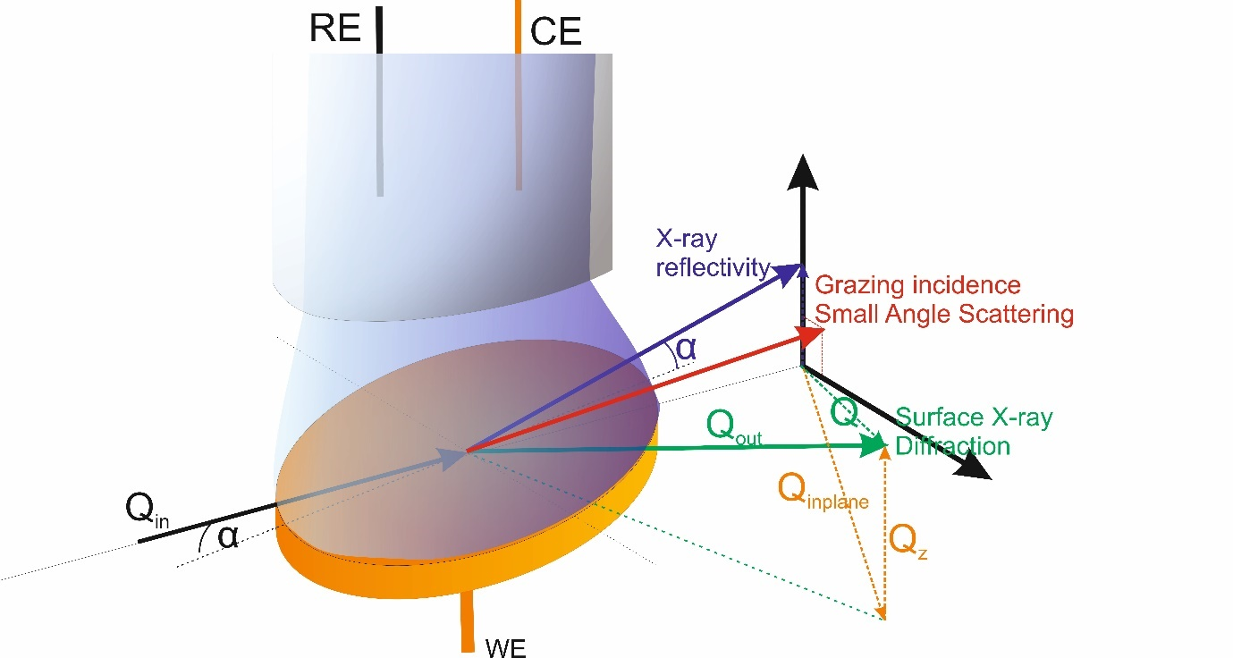
Figure 1 Scattering and diffraction geometries for X-rays measurements probing a surface in an electrochemical cell are shown. The x-rays penetrate the electrolyte and the scattering form the surface is observed. The scattering vector Q, with Q=Q_{in}-Q_{out}, defines the structural position (through it’d direction) and length scale (through its length) to be probed. In this paper we distinguish between Surface X-ray diffraction, which is sensitive to structural changes with the same in-plane symmetry of the crystalline substrate on the atomic scale, X-ray reflectivity, with the Q vector perpendicular to the surface probing structural information perpendicular to the surface And GISAXS with the Q vector length being smaller than for the other two techniques, allowing to access structural information on the scale of nanometres.

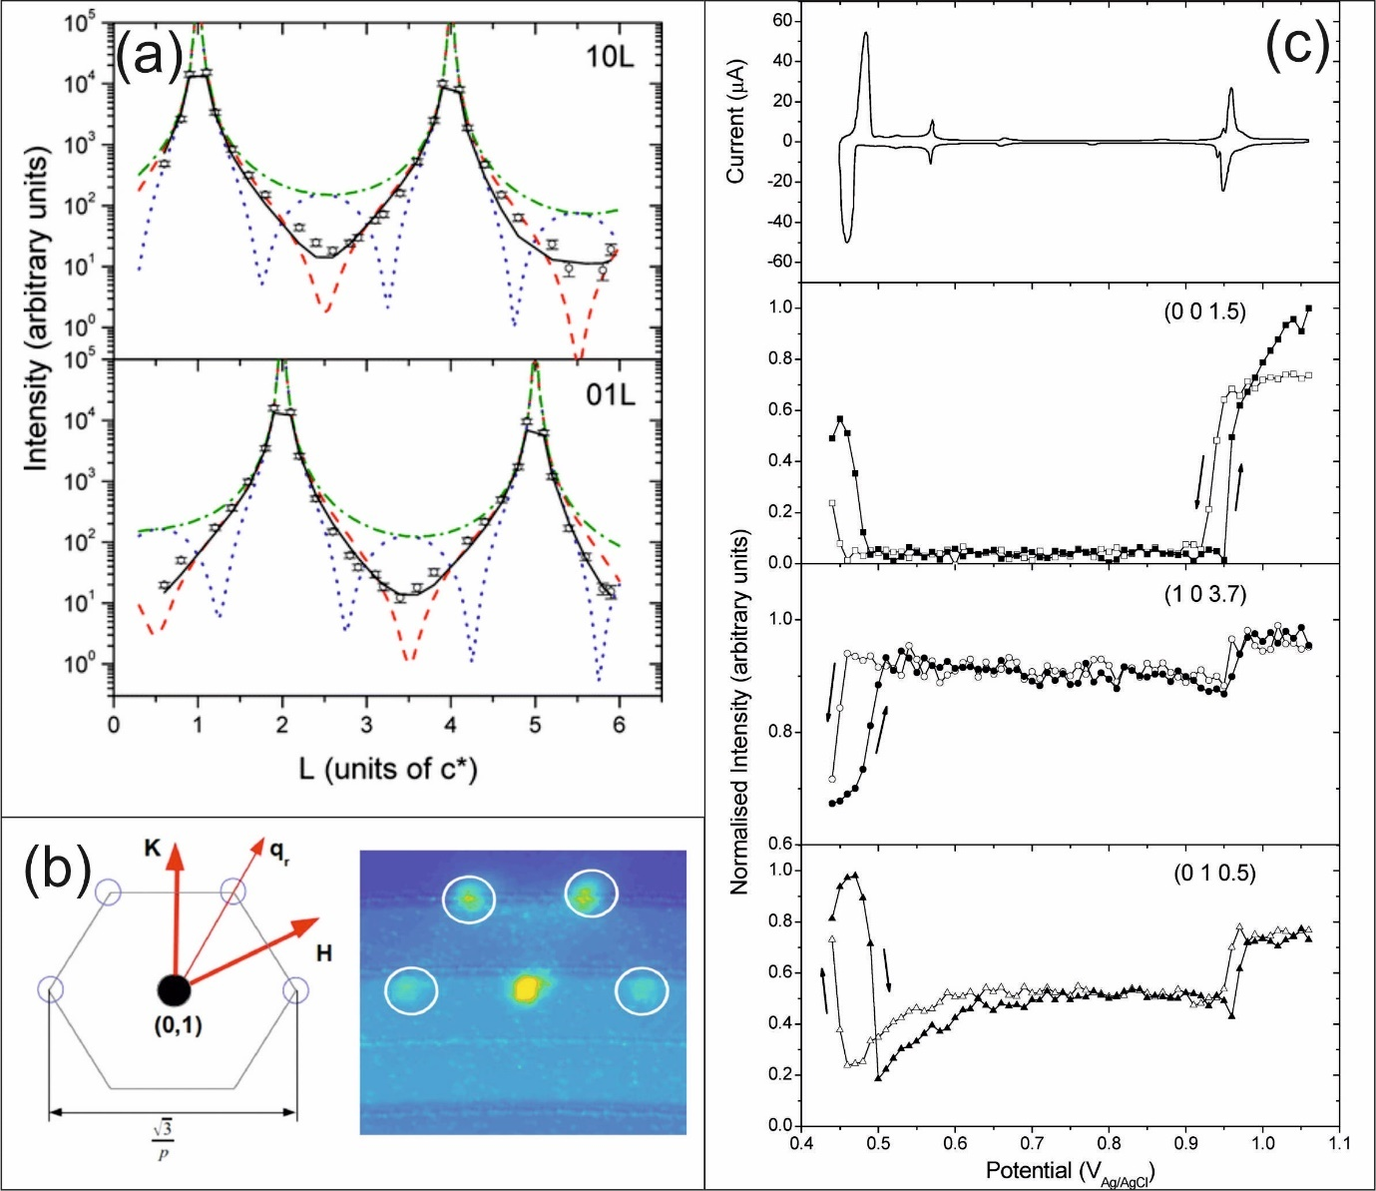
Figure 2 The influence of surface layers of densities and/or symmetry different than the substrate is demonstrated (a) Crystal truncation rod (CTR) data (black circles) of a Au(111) electrode with 1 monolayer of underpotential deposited silver is shown together with calculated CTR profiles for an ideal clean Au(111) surface (green), a full Ag monolayer on Au(111) (red), and a Ag bilayer on Au(111) (blue).(b) A schematic of the scattering in the surface plane of reciprocal space around the (0, 1, 0.5) CTR position of a reconstructed Au(111) surface is shown together with together of a contour map of the measured X-ray intensity in the l = 0.5 plane of the same position. (c) Cyclic voltammetry of silver underpotential deposition on Au(111) together with the X-ray voltammetry measured at different reciprocal space positions. The potential dependent changes in the intensity do match the current peaks in the cyclic voltammogram and can be assigned to electrochemical processes of Ag deposition and adlayer formation and lifting. Figures 2a and 2c adapted with permission from (J. Phys. Chem. C 2016, 120, 29, 16100–16109). Copyright (2016) American Chemical Society from (23) and Figure 2b adapted with permission from Reference (33)

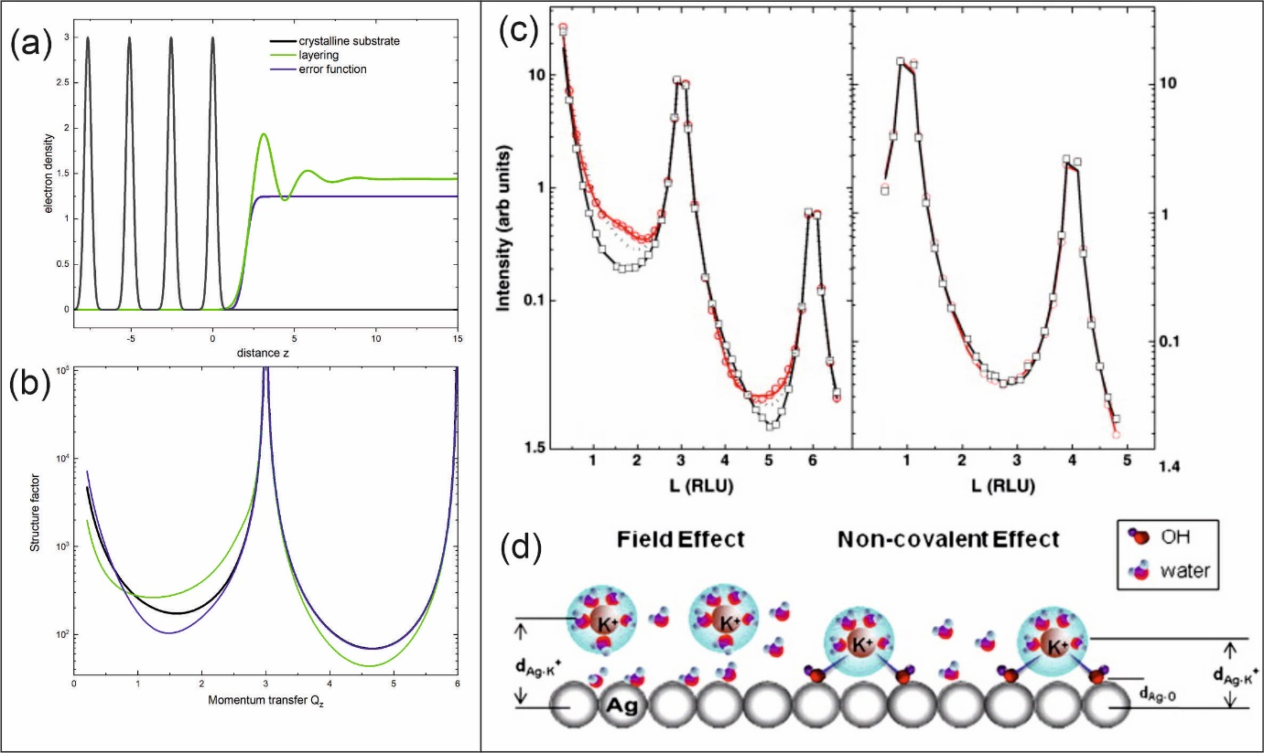
Figure 3 The sensitivity of X-Ray Reflectivity to structure normal to the surface, here specifically the electron density of the liquid side of the interface is demonstrated by showing (a) the different components contributing in real space and (b) the contribution of the structure of the liquid onto the specular CTR showing the contribution of the substrate only, the homogeneous liquid represented through an error function and through a layered model. (b) the non-specular CTR (right) and specular CTR (left) of the Ag(111)/0.1 M KOH interface measured at − 1.0 V (circles) and − 0.2 V (squares) versus SCE. (d) The interfacial structure at the negatively charged (left) and positively charged (right) surface obtained from modelling the data in (c). Adapted with permission from (79).

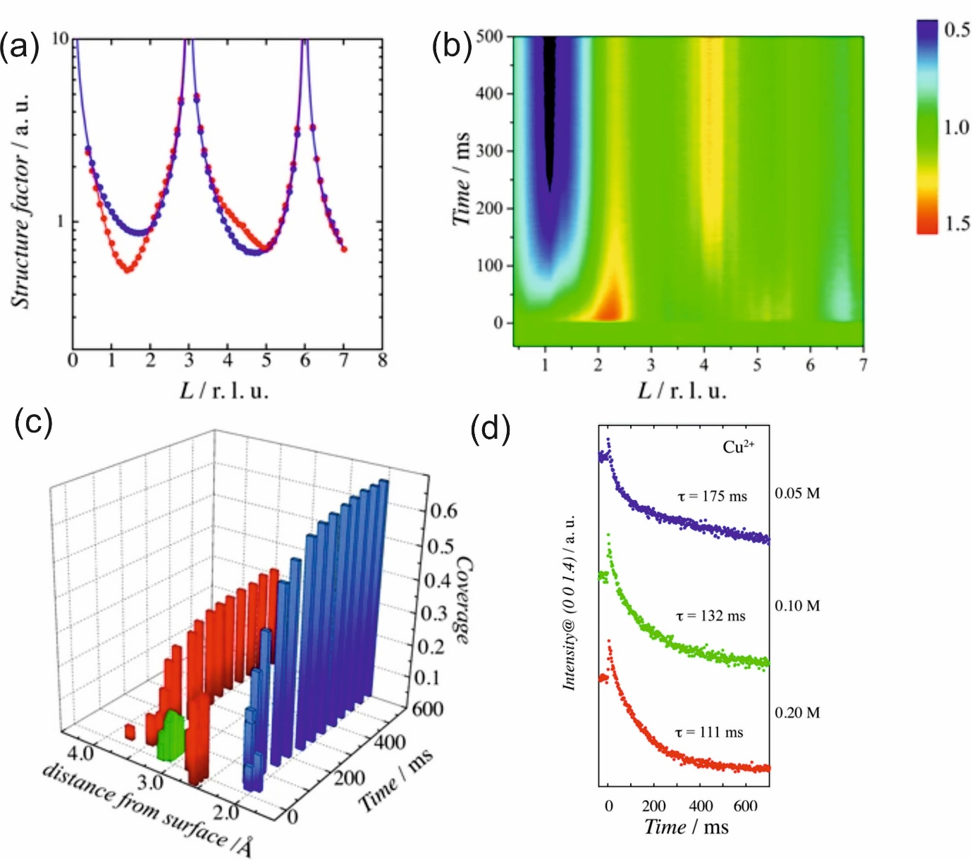
Figure 4 The study of copper underpotential deposition on Au(111) with the help of specular CTRs is presented (a) Specular CTR of Au(111) at the underpotential deposition potential of 0.45 V (red points) and at a potential of 1.05 V at which no underpotential deposition occurs vs SHE (blue points). The solid lines are the structure factors calculated from the optimized models. b) The time–resolved specular CTR after the potential step from 1.05 V to 0.45 V with time resolution of 0.5 ms is shown. Red and blue regions indicate the increase and decrease of intensity, respectively. c) Time dependence of the structural parameters extracted by optimising a model to fit the data from (b) The blue, red, and green bars represent the underpotential deposited Cu, adsorbed (bi)sulphate, and non–adsorbed Cu, respectively. d) Intensity transients at the (0 0 1.4) position for different sulphate concentration were recorded with time resolution of 1.0 ms to follow the deposition process. Figure adapted from Nakamura (2017) (CC BY)(41)

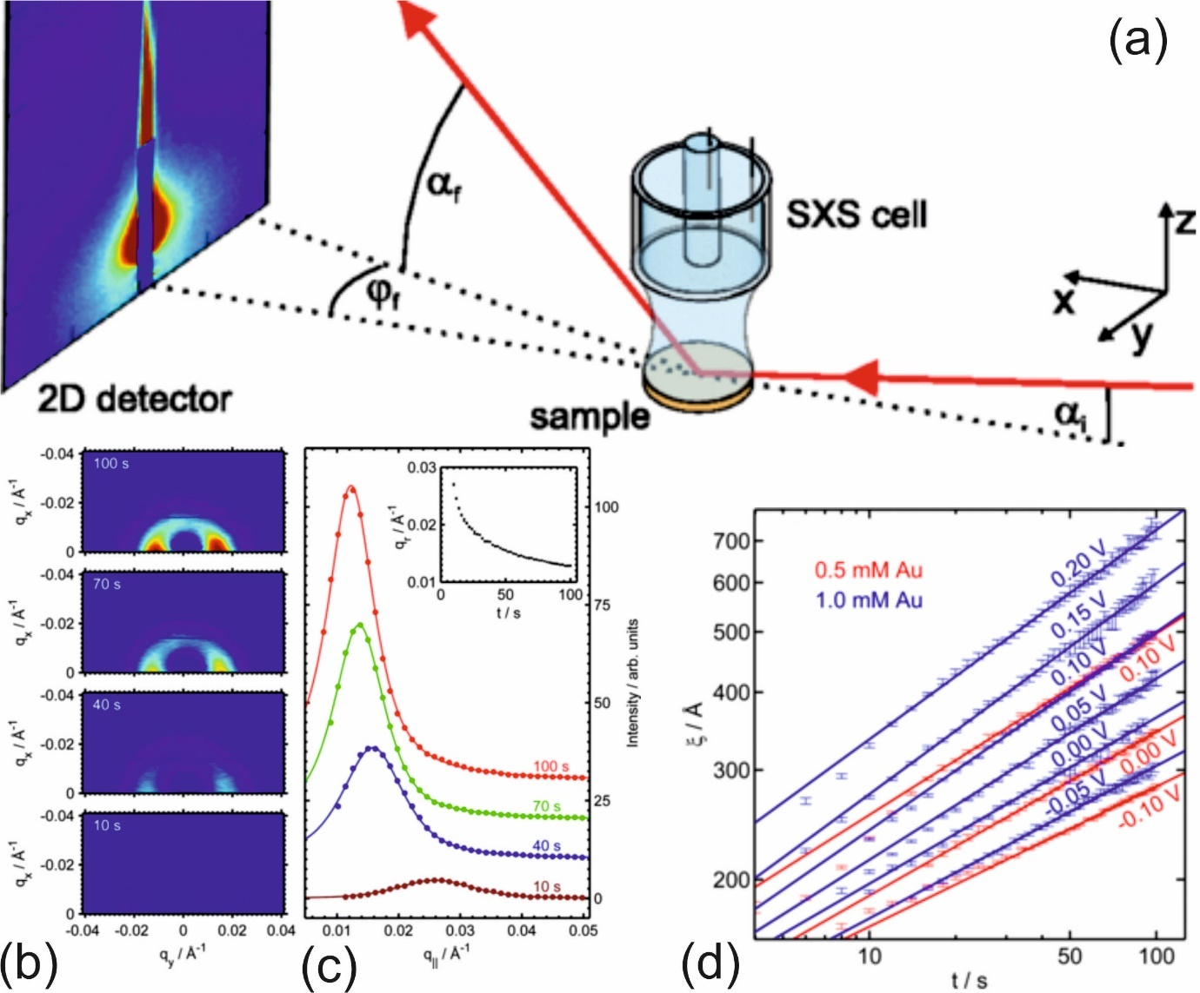

Figure 5 (a) A typical setup for GISAXS (b) The intensity distribution I(qx,qy) obtained after 10s, 40 s, 70 s and 100 s after initiating 3D growth on an unreconstructed Au(001) surface and (c) the Corresponding radial intensity distribution I(q∥) (symbols). Lorentzian line shape fits (lines) to the data allowed to extract the peak position q_{r} as a function of deposition time (inset) and (d) to extract the lateral mound size as a function of deposition time for various deposition potentials. Adapted with permission from (86)

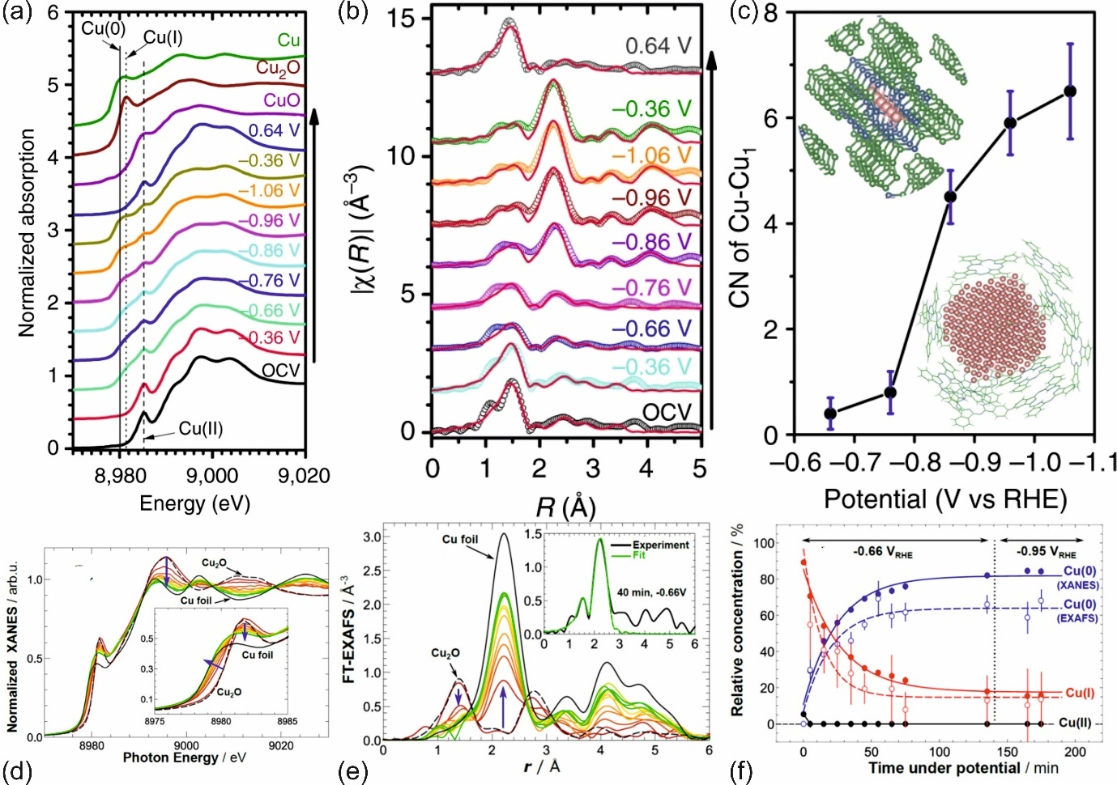
Figure 6 In situ XAS measurements under electrocatalytic reaction conditions. a) Cu K-edge XANES spectra, (b) Fourier-transformed Cu K-edge EXAFS spectra and (c) the extracted potential dependence of the coordination number for Cu-Cu for CuPc. (d) Cu K-edge XANES spectra, (b) Fourier-transformed Cu K-edge EXAFS spectra and (d) the extruded time dependence of the relative concentration of Cu(0) and Cu(I) under reactive conditions for CuOx nano-cubes. Figures 6(a-c) adapted from Weng (2018) (CC BY)(105) and Figure 6(d-f) adapted from Möller (2020) (CC BY) (106)

