Received 00th January 20xx,
- School of Advanced Technology, Xi’an Jiaotong-Liverpool University, Suzhou 215123, China.
- Department of Electrical Engineering and Electronics, University of Liverpool Liverpool, L69 3GJ, UK.
- Department of Chemistry, Xi’an Jiaotong-Liverpool University, Suzhou 215123, China.
- College of Materials Science and Engineering, Shenzhen University, Shenzhen 518060, China
- Department of Mathematical Sciences, Xi’an Jiaotong-Liverpool University, Suzhou 215123, China
* Corresponding authors. E-mail addresses: Chun.Zhao@xjtlu.edu.cn.
†. Deceased (April, 15th, 2021)
Electronic Supplementary Information (ESI) available: [details of any supplementary information available should be included here]. See DOI: 10.1039/x0xx00000x
Accepted 00th January 20xx
DOI: 10.1039/x0xx00000x

High-Performance Solution-Processed Ti₃C₂T_{x} MXenes Doped ZnSnO Thin-Film Transistors via the Formation of a Two-Dimensional Electron Gas
Tianshi Zhao^{a,b}, Chenguang Liu^{c}, Chun Zhao^{a,*}, Wangying Xu^{d}, Yina Liu^{e}, Ivona Z. Mitrovic^{b}, Eng Gee Limª, Li Yang^{c}, and Ce Zhou Zhao^{a,†}
MXenes are a large class of two-dimensional (2D) materials widely studied recently since they have good water solubility and be able to tune the work function (WF) of the materials without changing their electronic characteristics. Based on this, aqueous solution-processed indium-free zinc tin oxide (ZTO) thin-film transistors (TFT) have been fabricated under an annealing temperature of 300 ℃ and successfully optimized. This optimization is achieved by fabricating the channel layer into a homojunction structure (MXenes doped ZTO/ZTO) to form a two-dimensional electron gas (2DEG). Through doping the specific concentrations of Ti₃C₂T_{x} MXenes into the upper layer ZTO thin films, the TFTs exhibit the enhanced field-effect mobilities (μ_{FE}) of 10.77 cm²V⁻¹s⁻¹ and 13.06 cm²V⁻¹s⁻¹ as well as the large on/off current ratio of more than 10⁸. Moreover, compared with the undoped double-layer ZTO TFTs, the homojunction devices show better stability, mainly resulted from the transformation in leading conduction mode. Finally, through applying the homojunction channel on the solution-processed aluminum oxide (AlO_{x}) dielectric layer, the μ_{FE} exhibits a further enhanced value of 28.35 cm²V⁻¹s⁻¹. This is the first report to apply MXenes to the channel layer of TFTs and to fabricate the solution-processed ZTO thin films via aqueous solvent under 300 ℃.
Introduction

Recently, amorphous metal oxide (MO) semiconductors have attracted lots of attention in the research of thin-film transistors (TFT) as a result of their superior physical and device performance characteristics compared to traditional amorphous silicon and organic semiconductors ¹. Being classified as MO materials, In-based oxidizing compounds are a superior candidate for the n-type TFTs ²⁻⁴. Nevertheless, since the abundance of In in the earth is very low (0.25 ppm), the In-free materials with excellent n-type semiconductor characteristics are emerging as the replacement of In-based channel materials ⁵. Among all the In-free MO semiconductor materials, ZnSnO (ZTO) has been recognized as one of the most favorable substitutes for the In-based semiconductor since both Zn and Sn are nontoxic, abundant in reserves on earth, and similar ionic radii (0.074 nm for Zn²⁺ and 0.071 nm for Sn⁴⁺) ⁶⁻⁹. Moreover, the 4d¹⁰5s⁰ electronic configuration of Sn⁴⁺ is similar to the 5s orbital of In³⁺, which means that the conductive channel with Sn⁴⁺ could have high mobility ^{5, 10}. For the application of TFTs, Li and Zhang et al. fabricated high-performance ZTO TFTs via radio frequency magnetron sputtering, and the bias stability was optimized by nitrogen anion doping ¹¹. J.-S. Park et al. prepared ZTO TFTs via chemical vapor deposition (CVD) with high mobility of 24.7 cm²V⁻¹s⁻¹ through lithium doping ¹². It is well known that the fabrication process under the vacuum condition is quite mature and beneficial to deposit high-quality film due to the less contaminated environment ¹³⁻¹⁵.
However, the high costs, complicated processes, and unsuitability for large-area manufacturing limit the development of vacuum-based processes ^{16, 17}. In the past few years, to address these shortcomings, the solution process, including spin-coating ¹⁸, draw spinning ¹⁹, spray-pyrolysis ²⁰, and so on, have attracted much attention ²¹. Nevertheless, unlike the conventional indium-based materials, the full condensation of ZTO metal-oxide-metal (M-O-M) network requires a high annealing temperature above 500 ℃, and simply lowering the temperature leads to poor mobility less than 3 cm²V⁻¹s⁻¹, which might inhibit the low-cost production and future application on wearable devices ^{6, 22}. Recently, a TFT optimization method for solution-processed TFT has been proposed and implemented, that is, to fabricate the semiconductor layer of the devices in a heterojunction/homojunction structure ²³⁻²⁶. The variation in work function (WF) of different kind of semiconductor layers leads to band bending at the interface due to the Fermi level alignment when they are in contact, which would cause the formation of a quasi-two-dimensional electron gas (2DEG) system that led to remarkable improvement in the electron mobility as well as the bias stability ²³⁻²⁷. However, up till now, few reports of heterojunction/homojunction structured TFTs have been published upon solution processed indium-free devices.
Inspired by the utilization of two-dimensional transition metal carbides (MXenes, Ti₃C₂T_{x}) to exquisitely tune the WF of the perovskite layer and the electron transport layer in solar cells, here, we report a kind of ZTO TFTs using MXenes to adjust the WF and generate the 2DEG at the interface of the homojunction channel layers ²⁸. MXenes, a large category of two-dimensional materials, are identified with a general formula of M_{n+1}X_{n}T_{x} (M represents transition-metal such as Ti, V, Nb, and Mo, etc., X is carbon and/or nitrogen, T stands for surface termination like =O, -OH, and -F, etc., and n can be 1, 2, 3, and 4) ²⁹⁻³⁴. According to the previous report, MXenes can be produced under room temperature and has excellent hydrophilicity due to their rich functional groups, such as -OH, =O, and so on ^{29, 32, 34, 35}. Among all kinds of MXenes, Ti₃C₂T_{x} is the first reported and the most widely studied member with the most prominent performance in energy field ³⁶. Moreover, in addition to helping the formation of 2DEG, as an n-type dopant, the high-conductivity of MXenes may also enhance the electron mobility in the ZTO layer by providing an efficient pathway for electron transport as previously reported ^{37, 38}. Consequently, the application of MXenes into the low-temperature aqueous solution process has been extensively researched, and several outcomes have been reported in the fields of solar cells ^{28, 38}, resistive random access memories ³⁵, sensors ³⁹, potassium-ion batteries ⁴⁰, and so on. However, to the best of our knowledge, there are few reports on the application of MXenes to solution-processed TFT. By doping the Ti₃C₂T_{x} MXenes into ZTO precursor solution with designed concentrations and fabricated as homojunction structured (MXene-ZTO/ZTO) TFTs, the field-effect mobilities (μ_{FE}) reached 10. 77 and 13.06 cm²V⁻¹s⁻¹ with large on/off current ratio of 10⁷ and 10⁸, respectively. As shown in Fig. S1 and table S1, compared with recent studies on ZTO-based semiconductor/SiO₂ TFTs, the devices in this work show excellent electrical performance, considering the field-effect mobility, on/off ratio as well as the maximum annealing temperature (this work: ≤300 ℃) ^{20, 22, 41-49}. In addition, the results of positive gate bias test proved that the as-mentioned devices also had improvement on bias stability with respect to the control group without MXenes incorporation. Then, the fully solution-processed TFTs were successfully fabricated by combining the mentioned homojunction channel layer with the aqueous solution-processed aluminum oxide (AlO_{x}) insulator layer. The μ_{FE} of the TFTs has significantly increased to 28.35 cm²V⁻¹s⁻¹ with a more stable behavior under gate bias compared with the bilayer ZTO channel devices. Finally, through connecting the AlO_{x}-based solution-processed TFTs with a 2 MΩ resistor, a resistor-loaded inverter was successfully built, which further indicates the potential of applicating in logic circuits.

Experimental

MXenes preparation:

First, 2 g lithium fluoride (LiF, 99.99% metals basis, Aladdin) and 40 ml hydrochloric acid (HCl, AR 36.0~38.0%, Sinopharm Chemical Reagent Co., Ltd) was stirred in a polytetrafluoroethylene (PTFE) beaker for 30 min. Second, 2 g titanium aluminum carbide MAX (MAX-Ti₃AlC₂, 98%, 11 technology Co., Ltd) was slowly added to the beaker in the first step, the reaction temperature was adjusted to 35 ℃, and stirring was continued for 24 h in a fume hood. Subsequently, the obtained solution was centrifuged (3500 rpm, 10 min) and poured off the supernatant. Then 40 ml of deionized (DI) water was added to the sediment of the centrifuge tubes. After that, the tubes were shaken by hand to mix the sediment with DI water and ultrasonicated for 15 min in a high-power ultrasonic machine (750 W). Then, the above centrifugation and ultrasonication steps were repeated until the pH of the supernatant poured out after centrifugation is 5. After that, 40 ml of ethanol (CH₃CH₂OH, AR ≥99.7%, Sinopharm Chemical Reagent Co., Ltd) was added to the centrifuge tubes, followed by ultrasonication for 1.5 h (with the function of intercalator) and centrifugation for 10 min (10000 rpm). Next, 20ml of DI water was added to the centrifuged sediment and ultrasonicated for 20 minutes. Finally, the obtained mixture was centrifuged again at 3500 rpm for 3 min to obtain the black-brown few-layer dispersion of about 5 mg/mL. The dispersion is stored in an argon atmosphere, and the storage time does not exceed 14 days.

Device fabrication:

For the solution preparation, the hydrochloric acid (HCl, 36.0% ~ 38.0% AR, Sinopharm Chemical Reagent Co., Ltd) was first diluted 10 times with DI water. Then, 0.9 g tin chloride dihydrate (SnCl₂·2H₂O, 99.99% metals basis, Aladdin) and 1.78 g zinc nitrate hexahydrate (Zn(NO₃)₂·6H₂O, 99.99% metals basis, Aladdin) were added into the diluted HCl solution to obtain the pristine ZTO precursor solution. Finally, in order to obtain 0, 0.5, 1, 2, and 4 wt.% MXenes doped solution, 0, 0.9, 1.8, 3.6, and 7.2 mL MXenes dispersions were mixed with 20, 19.1, 18.2, 16.4, and 12.8 mL pristine ZTO precursor solution, respectively. The precursor solutions for the AlO_{x} were prepared by dissolving 3.75 g aluminum nitrate nonahydrate (Al(NO₃)₃•9H₂O, 99.99% metals basis, Aladdin) in 5 mL DI water. All the solutions were then stirred in the atmosphere for 12 h in a fume hood. The heavily doped n-type silicon substrates with 100 nm thermally grown silicon oxide (SiO₂) were performed as the gate electrodes and the dielectrics of the TFT, and a 30 min-air plasma process was applied on the SiO₂ surfaces to improve the hydrophilicity. The solutions were then spin-coated at 5000 rpm for 30 s on the surfaces of SiO₂. Substrates with solution film were then pre-annealed at 180 ℃ for 10 min and 300 ℃ for 2 h on a hotplate in air condition. Then, the repeated spin-coating and annealing processes were done to prepare the second semiconductor layers. For the TFTs using AlO_{x} as the dielectric layer, extra steps before depositing the channel layer were operated that the AlO_{x} precursor solution was spun coated onto the n⁺⁺ heavily doped silicon at 4000 rpm for the 40s and then annealed at 300 ℃ for 2 hours in air condition. Finally, aluminum (Al) source and drain electrodes were deposited onto the top semiconductor layer by thermal evaporation through a shadow mask with a width of 150 μm and a series of length value (10, 20, 30, 40, and 50 μm). The whole TFTs preparation process flow is shown in Fig. S2. The threshold voltage (V_{th}) is extracted by the intersection point of the I_{D}^{1/2}-V_{G} curve linear region extension line and x-axis. The μ_{FE} and subthreshold swing (S.S.) of the devices were calculated by the following equations:
$μ_{sat}=\left(\frac{2L}{WC_{i}}\right){\left(\frac{d\sqrt{I_{D}}}{dV_{G}}\right)}^{2}$ (1)
$S.S.={\left(\frac{d(\log_{10}{I_{DS}})}{dV_{G}}\right)}^{-1}$ (2)
Where C_{i} is the capacitance per unit area of the SiO₂ dielectric layer in the transistor, the value of which is 26 nF/cm². W and L are the channel width and length, I_{D} is the drain current, and V_{G} is the gate voltage.

Characterization:

The transmittance of the ZTO and MXene-ZTO layers were observed by ultraviolet-visible spectrophotometry (UV-Vis, SHIMADZU UV-2550). It is worth noting here that for the UV-Vis measurement, in order to prepare the transparent samples, the channel layers of each group were deposited on glass substrates instead of SiO₂ via the spin-coating process. The ultraviolet photoemission spectroscopy (UPS) measurement of the ZTO and MXene-ZTO thin films were characterized by an ultraviolet photoemission spectrometer (Kratos, AXIS SUPRA+). The X-ray photoelectron spectroscopy (XPS) measurement of the ZTO and MXene-ZTO thin films were measured by an X-ray photoelectron spectroscopy (Kratos, AXIS Supra). The morphology of the surfaces was observed by an atomic force microscope (AFM, AFM, BRUKER Nanoscope V). The crystallization and structural information of the thin-films were displayed using x-ray diffraction (XRD, BRUKER D8 ADVANCE) with Cu Kα radiation (𝜆=1.542 Å). The electrical characteristics of the TFTs were revealed utilizing a semiconductor analyzer (Keysight B1500 Å) in the dark at room temperature.

Results and Discussion

The structure of the Ti₃C₂T_{x} MXenes molecule is depicted in Fig. 1(a). It is worthy that the oxygen atom will not be lost until the temperature rises to 800 ℃ and the Ti-C network structure maintains a stable state at least 1000 ℃ ³¹. According to the different orders of semiconductor bilayers, we classify the TFT devices involved in this report into 4 types. As shown in Fig. 1(b) to (e), the structures of the control group named “Z”, “Z/Z”, “1MZ/1MZ”, and “Z/1MZ” for single ZTO, double ZTO channel TFTs, double 1 wt.% MXenes doped ZTO channel TFTs, and ZTO/1 wt.% MXenes doped ZTO channel TFTs, respectively. Especially for the “MZ/Z” devices, according to the mass ratio of MXenes to the sum of Sn and Zn elements (MXenes: Sn+Zn) in the solution, we divide them into 4 categories as well: 0.5, 1, 2, and 4MZ refers to the precursor solution with 0.5, 1, 2, 4 wt.% of MXenes, which has been described in Fig. 1(f).
Fig. S3(a) shows the optical transmittance spectra of ZTO and MXene-ZTO thin-film samples. At the range of visible light wavelength (380~780 nm), all the films exhibit good transparency (>80 %), indicating the suitability of fabricating transparent devices. With the increase in MXenes doping concentration, the transmittance of the films exhibits a slight decrease, which is accompanied by the increase of the absorption coefficient (α) ^{44, 50}. Based on this, as Fig. S3(c) depicted, the optical bandgap (E_{g}) can be expressed by ⁴⁴:
$α=\frac{\ln\left(1-R\right)}{d\ln{(T/T_{0})}}$ (3)
${(αhν)}^{2}=β(hν-E_{g})$ (4)
Where T is the transmittance of the film, T₀ is the original transmittance without the sample, R is the measurable reflectivity (as shown in Fig. S3(b)), h is Planck’s constant, ν is the frequency of the incident photon, and β is energy independent constant. The optical bandgap could be extracted from the horizontal intercept of the (αhν)² curve’s linear region extension line ⁴⁴. To acquire the accurate value of the CBM, VBM, and WF for each kind of sample, the ultraviolet photoemission spectroscopy (UPS) tests for ZTO, and MXene-ZTO thin films around the VB region and the secondary E_{cutoff} were operated, and the results are depicted in Fig. 1(g). The WF of the samples is determined by the secondary E_{cutoff}, which is shifted from 3.71 eV to 3.02 eV with the concentrations of MXenes in ZTO from 0 to 4 wt.% ^{28, 50}. This phenomenon might be attributed to the electron doping effect induced by MXenes, which has been reported by previous MXenes-doping or other electron-rich organic polymer doping investigation ^{25, 28}. The VBM and CBM could be calculated by the following equations ^{28, 50}:
$VBM=WF+E_{onset}$ (5)
$CBM=VBM-E_{g}$ (6)
Where E_{onset} represents the electron onset edge, and the complete energy band diagram of all groups of samples are plotted in Fig. 1(h). As the doping concentration of MXenes rises, WF is getting closer to CBM, which indicating that the doping of MXenes is considered as specified n-type doping ⁵¹.
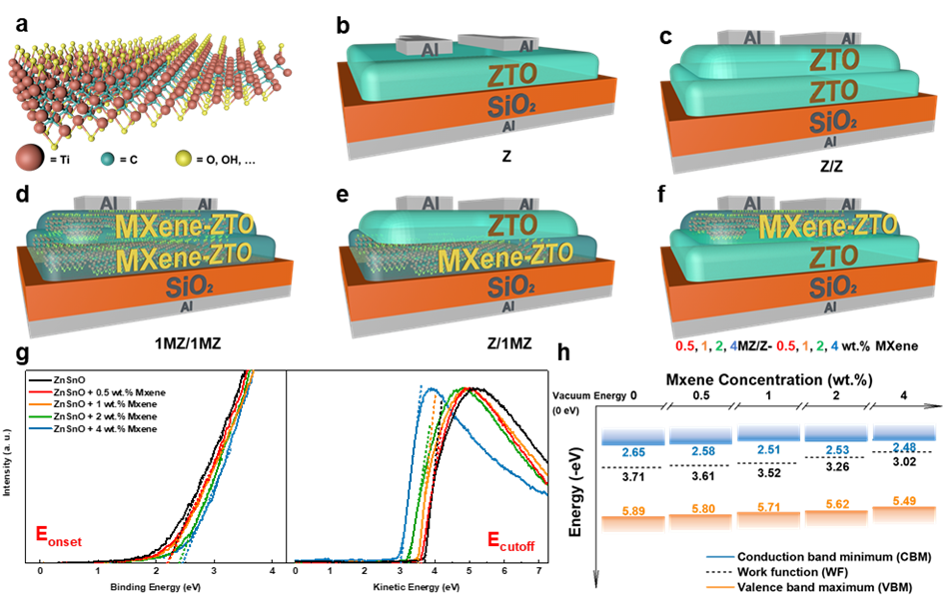
Further investigation upon the elemental composition and chemical state of thin films was carried out through X-ray photoelectron spectroscopy (XPS) measurement. The full spectrum scanning results of all kinds of samples are displayed in Fig. 2(a). According to the results, the absence of peaks related to aluminum (Al) (~73.3 eV) and Al-Ti (~72 eV) indicates that the Ti₃AlC₂ (MAX) had been completely etched and transformed to MXenes (the detailed steps will be introduced in the Experimental Section) ^{52, 53}. Compared with the pure ZTO samples, the MXene-ZTO films showed a higher peak of C and the peaks of Ti, which are results from the doping of MXenes. Fig. 2(b) to (e) displays the Ti 2p spectra of the films with different doping concentrations. As the doping concentration increases, the ratio of TiO₂ peak gradually increases and shows a mostly obvious increase at 4 wt.% doping condition. The over-formation of TiO₂ could explain this phenomenon. The TiO₂ in the films exhibits nanoparticle morphology and could inhibit the transportation of the carrier. This may lead to degradation of the device’s performance, which will be discussed later. The XRD results of the films to provide the information on crystallinity are depicted in Fig. S4. The pristine ZTO film exhibits an amorphous structure. For the MXenes doped samples, the peaks at 25° and 28° represent the (101) and (200) plane of TiO₂, suggesting the oxidation of MXenes ^{31, 54}. The (002) peak at 7° represents the unoxidized MXenes ^{31, 54}. The rising trend of TiO₂ peaks as the doping concentration increased is consistent with the XPS results.
Fig. 1 (a) Schematic structure of the Ti₃C₂T_{x} MXene molecule. Surface terminations (T_{x}) are a mixture of O, OH, etc. Five distinct structures of TFT devices involved in this work: (b) Structure named “Z” for single ZTO channel TFTs; (c) structure named “Z/Z” for double ZTO channel TFTs; (d) structure named “1MZ/1MZ” for double 1 wt.% MXenes doped ZTO channel TFTs; (e) structure named “Z/1MZ” for ZTO/1 wt.% MXenes doped ZTO channel TFTs; (f) structure named “0.5, 1, 2, and 4MZ/Z” for 0.5, 1, 2, and 4 wt.% MXenes doped ZTO channel TFTs, respectively. (g) UPS binding energy plots for ZTO and MXene-ZTO thin films around the valence band (VB) region and the secondary electron cut-off (E_{cutoff}). (h) Schematic energy band diagram illustrating the shifts of conduction band minimum (CBM), valence band maximum (VBM), and WF under different concentrations of MXenes doping.
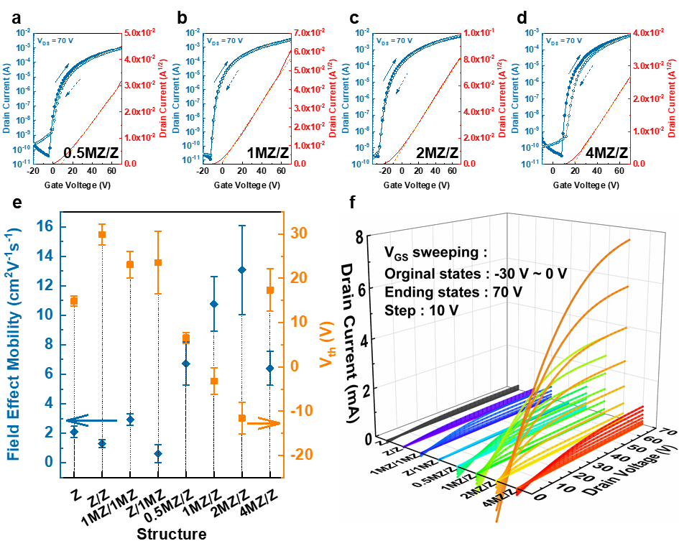
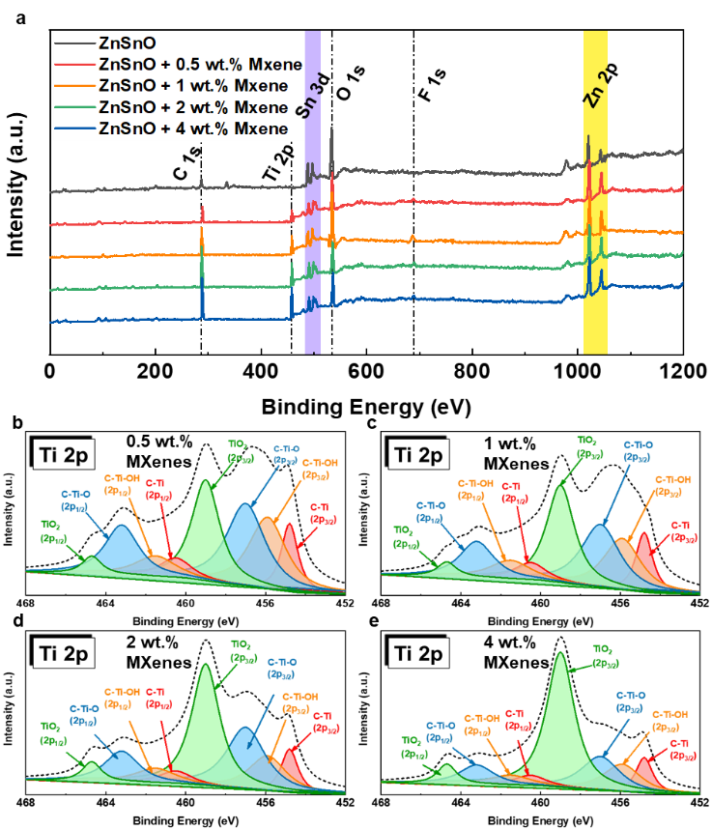
The typical transfer performances and the electrical characteristics of all types of TFTs are illustrated and summarized in Table 1, Fig. 3(a) to (e), and Fig. S5. The output curves are depicted in Fig. 3(f). The devices show a linear feature at low drain voltage (V_{D}), indicating excellent ohmic contact between the source/drain electrodes and the semiconductor layers. For the pristine single-layer ZTO devices (Z), the average μ_{FE} is 2.1 cm²V⁻¹s⁻¹, the average V_{th} is 14.88 V, the S.S. is 1.19 V/dec, and the on/off ratio is about 2.7 × 10⁶. For the group of double-layer ZTO without MXenes doping (Z/Z), the TFTs show a μ_{FE} of 1.3 cm²V⁻¹s⁻¹, an average V_{th} of 29.89 V, an S.S. of 1.78 V/dec, and an on/off ratio of about 5.4 × 10⁶. A slight performance degradation could be found for the Z/Z devices, which is mainly caused by the thicker channel layer of the double-layer device, introducing more defect states. A clockwise hysteresis could be observed due to the trapping effect of the accumulated electrons near the interface of the ZTO/SiO₂ layers ⁵⁵. The 1MZ/1MZ TFTs are with 1 wt.% MXenes doping in both top and bottom ZTO layers, the μ_{FE} boosts up to 2.76 cm²V⁻¹s⁻¹ with the S.S. increases to 2.04 V/dec. The total equivalent trap state (N_{t}), including interface and bulk trap states, could be calculated by the S.S. value:
Fig. 2 Transfer curves for (a) 0.5MZ/Z, (b) 1MZ/Z, (c) 2MZ/Z, and (d) 4MZ/Z TFTs. (e) Summary of μ_{FE} and V_{th} performances for all eight types of TFTs. (f) Output curves measured under V_{GS} sweeping from the original states to 70 V of all eight groups of TFTs.
Fig. 3 Full XPS spectrum scanning of (a) ZTO and MXene-ZTO thin films. Ti 2p XPS spectra scanning of MXene-ZTO thin films with (b) 0.5 wt.% MXenes doping, (c) 1 wt.% MXenes doping, (d) 2 wt.% MXenes doping, and (e) 4 wt.% MXenes doping.
$N_{t}=\left[\frac{S.S.\log{(e)}}{kT/q}-1\right]\frac{C_{i}}{q}$ (7)
Where k is the Boltzmann constant, q the electron charge, e the base of the natural logarithm. The N_{t} results of Z/Z and 1MZ/1MZ are 4.6 × 10¹² and 5.4 × 10¹², respectively. The enhancement of N_{t} via MXenes doping might result from the -OH termination brought by MXenes molecules. Moreover, the n-type doping effect leads to larger carrier density. Thereby the devices exhibit higher mobility. For both Z/1MZ and n-MZ/Z (n = 0.5, 1, 2, and 4) devices, the bilayer homojunction structured semiconductors were made of two layers of different materials that one was doped by MXenes while the other one wasn’t. However, the performances of the devices are largely different. For Z/1MZ, all the μ_{FE}, S.S., and the on/off ratio results are obviously degraded compared to the control group (Z/Z), while n-MZ/Z shows more optimized performance. This could be explained by the rougher interface of MXene-ZTO than pure ZTO films, as shown in Fig. S6. The undoped ZTO samples exhibit a root mean square (RMS) roughness value of 0.32 nm, while the MXenes doped ones exhibit a rougher surface with an RMS roughness value of 1.37 nm, which could be attributed to the nanosheet of MXenes and the nanoparticle structured TiO₂ generated by MXenes. Consequently, the conduction path of the carriers will be more obstructed when MXene-ZTO is in the lower layer and ZTO is in the upper layer since the conductive channel in the homojunction TFTs usually exists at the interface between the two layers of semiconductor ²⁴. For n-MZ/Z structured devices, we investigated the variation of devices’ performance with a different doping concentration in n-MZ/Z. As summarized, the electrical performance shows an optimized trend with the rise of MXenes concentration. However, for 4-MZ/Z, the μ_{FE} falls back, and the S.S. goes up. These might be resulted from the excessive introduction of TiO₂ nanoparticles due to MXenes over-doping. For n-MZ/Z, the drain currents at the saturation region are higher than other types, which could be explained by the formation of 2DEG at a good homojunction interface. Considering all the μ_{FE}, on/off ratio, and the hysteresis, we choose 1MZ/Z as the optimal group, and further detailed discussion will be continued between this group and Z/Z.
Fig. 2(f) and Fig. S7 depict output characteristics of the TFTs, which indicates typical n-type behavior for each kind of device. The contact resistance (R_{C}) behaviors for each group were calculated based on the output curves through a transmission line method (TLM) ^{51, 56}:
$R_{tot}=\frac{∂V_{D,lin}}{∂I_{D,lin}}=LR_{ch}+R_{C}$ (8)
Where R_{tot} is the total device resistance, R_{ch} is the channel resistance, and L is the channel length. In order to obtain the R_{C} via equation (2), the devices with L from 10 to 50 μm of each group were fabricated and measured. As depicted in Fig. S8, the R_{C} values according to the device structure are exhibited. In general, MXenes doping could effectively reduce the R_{C} due to the n-type doping effect ⁵¹. For the MXenes doped ZTO films, the Fermi level shifted toward the CBM and lead to a narrower Schottky barrier at the metal-semiconductor junction. Consequently, the electron’s injection process was more efficient, and the R_{C} value was reduced, which is also consistent with the UV-Vis and UPS results. The re-increased R_{C} value for 4MZ/Z could be attributed to the rough surface caused by TiO₂ nanoparticles.
Furthermore, to investigate the formation of 2DEG in 1MZ/Z TFTs (represents other homojunction TFTs), we prepared corresponding metal-insulator-semiconductor (MIS) devices with Al/1 wt.% MXenes doped ZTO/ZTO/SiO₂/n⁺⁺ Si/Al stacked structure (mapped to 1MZ/Z TFTs) and the MIS devices with ZTO/ZTO/SiO₂/ n⁺⁺ Si/Al structure (mapped to Z/Z TFTs) were set as the control group. The thickness of the ZTO bilayer and the homojunction layer films was measured through AFM and exhibits in Fig. 4(a) and (b), respectively. The two sets of samples have similar thicknesses of approximately 14 nm. The thickness of the thin-film samples refer to the TFTs belong to other 6 groups is displaced in Fig. S9 with consistent value and the thickness information of all the channel films are listed in table S3. Based on the capacitance-voltage (CV) curves in Fig. 4(c) and (d), the free carrier density as a function of depth was calculated and plotted in Fig. 4(e) and (f) through the following equations ⁵⁷⁻⁵⁹:
$N_{CV}=\frac{2}{ε_{0}εq\frac{d\left(1/{C^{2}}\right)}{dV}}$ (9)
$z\left(V\right)=ε_{0}ε\left(\frac{1}{C(V)}-\frac{1}{C_{i}}\right)$ (10)

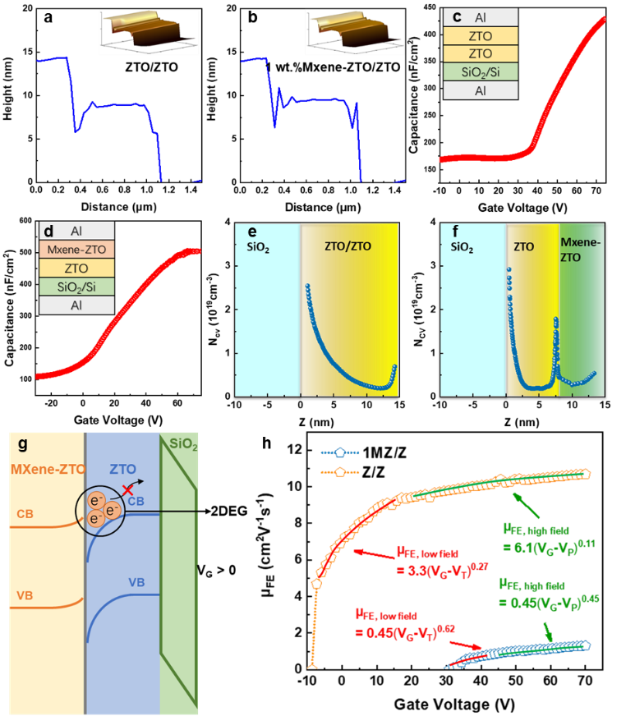
Table 1 Electrical characteristics of all TFTs with different type structures.
Fig. 4 The thickness of (a) ZTO/ZTO bilayer film and (b) 1 wt.% MXenes doped ZTO/ZTO bilayer measured by AFM (refers to Z/Z and 1MZ/Z TFTs, respectively.). The capacitance-voltage (C-V) curves obtained from the (c) Al/ZTO/ZTO/SiO₂/n⁺⁺ Si/Al and (d) Al/homojunction bilayer/SiO₂/n⁺⁺ Si/Al metal-insulator-semiconductor (MIS) structure devices. The free carrier density as a function of depth extracted from C-V results of (e) ZTO/ZTO and (f) MXenes doped ZTO/ZTO homojunction MIS devices. (g) Energy band diagram of the generated 2DEG in homojunction devices under positive V_{G} bias. (h) V_{G} dependence of the μ_{FE} of the Z/Z and 1MZ/Z TFT devices. The solid red line (low field) and green line (high field) are fitting to the power-law equation.
Types | μ_{FE}  (cm²V⁻¹s⁻¹) | V_{th}  (V) | S.S.  (V/dec) | On/off ratio
Z | 2.1 ± 0.37 | 14.88 ± 1.12 | 1.19 | ~2.7 × 10⁶
Z/Z | 1.3 ± 0.28 | 29.89 ± 2.32 | 1.78 | ~5.4 × 10⁶
1MZ/1MZ | 2.93 ± 0.41 | 23.12 ± 3.01 | 2.01 | ~2.8 × 10⁷
Z/1MZ | 0.64 ± 0.59 | 23.56 ± 7.04 | 3.62 | ~7.5 × 10⁵
0.5MZ/Z | 6.73 ± 1.44 | 6.56 ± 1.20 | 1.41 | ~6.5 × 10⁷
1MZ/Z | 10.77 ± 1.83 | -3.21± 3.06 | 1.02 | ~3.2 × 10⁸
2MZ/Z | 13.06 ± 3.01 | -11.55± 3.52 | 1.57 | ~2.0 × 10⁷
4MZ/Z | 6.4 ± 1.15 | 17.35 ± 4.78 | 1.80 | ~4.1 × 10⁷
Where N_{CV} is the free carrier density, C is the measured capacitance per unit area, C_{i} is the capacitance per unit area of the SiO₂ layer, q is the elementary charge, ɛ₀ is the vacuum permittivity, and ɛ is the relative permittivity of the homojunction or ZTO bilayer. As expected, the MIS devices that refer to 1MZ/Z TFTs show an obvious peak of N_{CV} at the interface of MXenes doped ZTO and ZTO layers while the group refers to Z/Z TFTs doesn’t, which indicates that the 2DEG has formed within the homojunction group. The energy band diagram for the corresponding mechanism is shown in Fig. 4(g) that the Fermi energy alignment between contact surfaces of two semiconductors with different WFs leads to band bending at the semiconductor homojunction, resulting in the formation of a 2DEG at this interface ^{24, 25}. The 2DEG was composed of electrons trapped in the potential well, on the side of ZTO ^{24, 25}. Since both the long-range Coulomb scattering induced by trapped charges and the short-range ionization impurity scattering was suppressed, the mobility of the 2DEG moving along the plane direction would be very high, which is consistent with the optimized performance of homojunction TFT groups with suitable MXenes doping ^{25, 60}. The negatively shifted V_{th} of these groups of TFTs could also be evidence of the increased carrier density since the conductive channel is easier to build under low gate voltage ^{23, 61}. To study the conduction mechanism of the device in more detail, we fitted the μ_{FE} – V_{G} curves of Z/Z and 1MZ/Z in Fig. 4(h) by the power-law equation with appropriate values of K and γ ^{24, 51, 62}:
$μ_{FE}=K{(V_{G}-V_{th,P})}^{γ}$ (11)
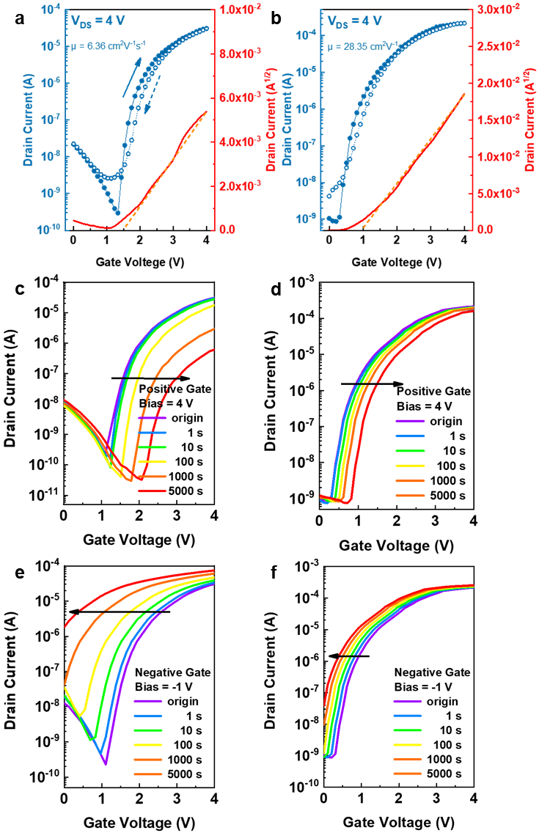
where μ_{FE}, V_{G}, V_{th}, and V_{P} are the field-effect mobility, gate, threshold voltages, and percolation voltage, respectively. The factor, K, and the exponent, γ, are correlated to the predominant conduction mechanism, where γ was fitted in two distinct bias regions, the low field (V_{G} – V_{th}) and the high field (V_{G} - V_{P}) one. A conventional increase in γ values from 0.1 up to 0.7 indicates the transition toward trap-limited conduction (TLC) and its reversal toward percolation conduction (PC), i.e., value for close to 0.7 is indicative of a TLC process, while a value of close to 0.11 a percolation dominated PC mechanism ^{24, 51, 62}. TLC is dominated by point defects and grain boundaries within the oxides, while the PC is commonly associated with s-orbital overlaps of the post-transition metal cations in multi-basic oxides, leading to bandlike transport, and depends on various metal oxides employed and the deposition techniques used ⁶². Especially for MO materials, the oxygen vacancy would be the main cause for the TLC ⁶³. Therefore, the trend that an enhancement of mobility accompanied by a deterioration of bias stability could always be found in previous studies ^{11, 63, 64}. Compared with TLC, the PC mechanism shows better stability under the bias of gate voltage, which will be discussed later. The γ of Z/Z is about 0.62 and 0.45 in low field bias and high field regimes, respectively, while the γ of 1MZ/Z is about 0.27 and 0.11 in low field bias and high field regimes, respectively. A conclusion that the homojunction structured TFTs in 1MZ/Z shows more PC-dominated characteristics than Z/Z TFTs could be obtained, and the 2DEG played an important role in preventing the formation of TLC ⁶². This statement can also be used to explain the disappearance of hysteresis from Z/Z to 1MZ/Z devices. Fig. S11 depicts the transfer curves of the 1MZ/Z and Z/Z devices before and after exposure to air for 5 days. Compared with the Z/Z group, the device belongs to 1MZ/Z group even showed a slight improvement in air stability. This also resulted from the formation of 2DEG in 1MZ/Z devices, which played an important role in the carrier conduction process and weakened the impact of defects introduced by air contact on device characteristics.
Fig. 6 Transfer curves of the (a) Z/Z and (b) 1MZ/Z TFTs replaced the SiO₂ dielectric layers with solution-processed AlO_{x} layers. Transfer curves of (c) AlO_{x}-Z/Z and (d) AlO_{x}-1MZ/Z devices under 4 V positive gate bias with a duration of 5000 s. Transfer curves of (e) AlO_{x}-Z/Z and (d) AlO_{x}-1MZ/Z devices under -1 V negative gate bias with a duration of 5000 s.
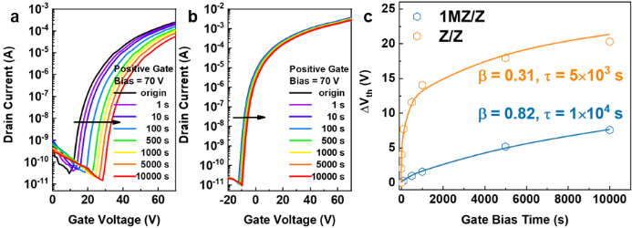
To further investigate the gate bias stability, we subjected the Z/Z and 1MZ/Z TFTs to a positive gate bias (PGB) measurement of V_{G} = 70 V and V_{D} = 0 V for a maximum duration of 10000 s and observed the V_{th} shift. The transfer curves are displayed in Fig. 5(a) and (b), demonstrating that a much better PGB stability could be found within 1MZ/Z (ΔV_{th} = +7.59 V under 10000 s PGB) than Z/Z (ΔV_{th} = +20.32 V under 10000 s PGB). The time dependence of ΔV_{th} behavior can be analyzed by the stretched-exponential equation ^{23, 65}:
Fig. 5 Transfer curves of (a) Z/Z and (b) 1MZ/Z devices under 70 V positive gate bias with a duration of 1000 s. (c) The V_{th} shifting data (symbols) and stretched-exponential fittings (solid lines) for Z/Z and 1MZ/Z TFTs.
${∆V}_{th}=(V_{th∞}-V_{th0})(1-e^{-{\left(\frac{t}{τ}\right)}^{β}})$ (12)
Where V_{th∞} represents the threshold voltage at an infinite time, V_{th0} is the initial value of V_{th} before the PGB test, τ is the characteristic time constant associated with the charge trapping time, and β is stretched-exponential exponent between 0 and 1 ^{23, 65}. It should be noted here that the τ and β are not dependent on the amplitude of the gate bias ⁶⁵. A β value close to 1 indicates a narrower trap distribution of the time constants, and a higher τ value demonstrates better stability ⁶⁵. As illustrated in Fig. 5(c), the TFTs in Z/Z shows a β of 0.31 and a τ of 5×10³s, while in 1MZ/Z shows higher values of β = 0.82 and τ = 1×10⁴s, therefore, further revealing a better PGB stability of 1MZ/Z TFTs of which a longer bias time is required to reach an equilibrium condition ²⁴. Moreover, the negative gate bias (NGB, 10000 s, -10 V) test results for the two groups are shown in Fig. S12(a) and (b), linking to Z/Z and 1MZ/Z groups, respectively. Also, the much less negative V_{th} shift of 1MZ/Z device indicates a more stable NGB behavior. The optimization on devices’ stability of 1MZ/Z is consistent with the mechanism changing from TLC to PC mode, as discussed above.
As concluded in previous studies, replacing the SiO₂ dielectric material with high-k MO materials like AlO_{x} ⁶⁶, zirconium oxide (ZrO_{x}) ¹⁷, hafnium oxide (HfO_{x}) ⁴⁵, and scandium oxide (ScO_{x}) ⁶⁷, etc. could effectively improve the μ_{FE} of the TFTs via faster filling
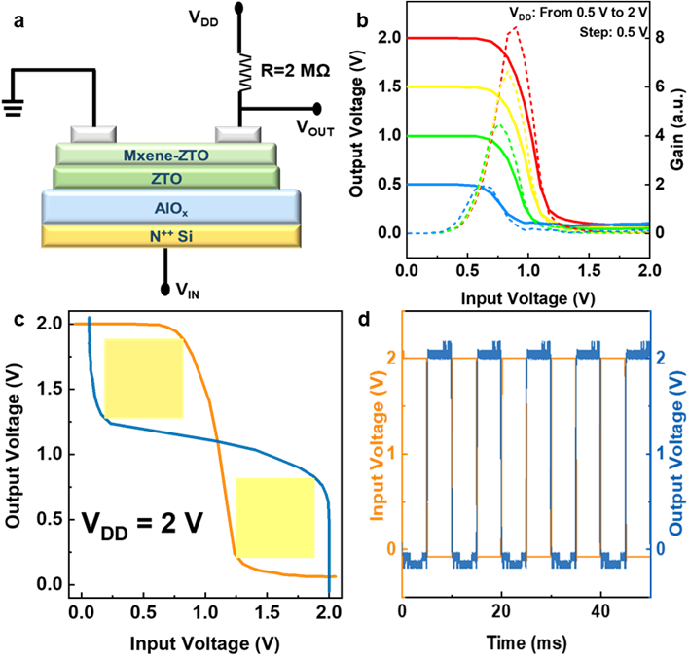
of the deep localized states in the bandgap induced by larger areal capacitance. In this work, through combining the channel layers of the Z/Z and 1MZ/Z TFTs mentioned above with an aqueous solution-processed AlO_{x} dielectric layer, the enhancement on mobility was realized, and the typical transfer curves could be found in Fig. 6(a) and (b). The thickness of the AlO_{x} layer has been measured through AFM, which is about 60 nm and depicted in Fig. S10(a). Based on this, the dielectric constant-frequency and leakage current behavior have been calculated and shown in Fig. S10(b) and (c). For convenience, we named these two kinds of TFTs of AlO_{x}-Z/Z and AlO_{x}-1MZ/Z. Compared with the bilayer AlO_{x}-Z/Z group, the μ_{FE} of the AlO_{x}-1MZ/Z TFTs has significantly increased from 6.36 cm²V⁻¹s⁻¹ to 28.35 cm²V⁻¹s⁻¹. It is worth noting that, as summarized in table S2, the TFTs in this work also show optimized behaviors when compared with recent ZTO-based semiconductor/high-k oxides TFT studies ^{20, 48, 65, 68-70}. Moreover, the 5000 s PGB (+4 V) and NGB (-1 V) tests were operated for the AlO_{x}-Z/Z and AlO_{x}-1MZ/Z devices. The PGB test results for the AlO_{x}-Z/Z and AlO_{x}-1MZ/Z devices are plotted in Fig. 6(c) and (d), respectively. The NGB test results for the AlO_{x}-Z/Z and AlO_{x}-1MZ/Z devices are depicted in Fig. 6(e) and (f), respectively. It is consistent with the comparison result of Z/Z, and 1MZ/Z discussed above, which indicates that the homojunction structured AlO_{x}-1MZ/Z shows stable characteristics as predicted.
Fig. 7 (a) An inverter by connecting a AlO_{x}-1MZ/Z TFT with a 2 MΩ external resistor. (b) The static VTC curves and the voltage gain of the resistor-loaded inverter at different V_{DD} values. (c) Noise margin with maximum equal criteria (yellow squares) at V_{DD} of 2 V. (d) Dynamic measurement of the inverter at 100 Hz V_{IN}.
To further demonstrate the potential of logic-circuits application of the devices, a resistor-loaded inverter was built through connecting the AlO_{x}-1MZ/Z TFTs with a 2 MΩ resistor, as plotted in Fig. 7(a). The voltage transfer characteristics (VTC) illustrating the output (V_{OUT}) – input (V_{IN}) voltage behavior is shown in Fig. 7(b). A gain value of more than 8 under a V_{DD} of 2.0 V could also be extracted from the VTC curves, which meets the demand of the logic circuit’s driving (2.5) ^{71, 72}. Moreover, the noise margin of 0.6 V under the V_{DD} of 2 V (83 % of the V_{DD}/2) was also obtained, as shown in Fig.7(c), indicating an excellent noise tolerance ability when one device switches the other. Finally, the dynamic behavior of the inverter was tested with a V_{IN} of a square waveform at 100 Hz, depicted in Fig. 7(d). The result demonstrates that the as mentioned circuit has the excellent inverter-like on/off states under at least 100 Hz, which indicates potential in the application of more complicated integrated circuits.
Conclusion
In summary, we utilize the 2D material MXenes as the dopant into ZTO semiconductors to fabricate the TFTs with bilayer semiconductors of MXene-ZTO and ZTO. The precursor solvent is DI water, and the whole process was operated under a low temperature of 300 ℃ in air condition. Through the physical and electrical measurements, we found that through the formation of the 2DEG between the two-channel layers, the devices showed a significant improvement in both mobility and bias stability. The optimization could be attributed to the main conduction mechanism changing from TLC to PC mode as the structure changing from prime double-layer ZTO to MXene-ZTO/ZTO homojunction layer. The fitting results of the μ_{FE} – V_{G} and the ΔV_{th} – PGB time curves could be clear evidence for this conclusion. Through combining the as mentioned MXene-ZTO/ZTO channel layer with solution-processed high-k AlO_{x} dielectric layer, the TFTs with μ_{FE} increased to 28.35 cm²V⁻¹s⁻¹ were fabricated, and the optimized stability was also proved accordingly. Finally resistor-loaded inverter circuit based on the AlO_{x}-1MZ/Z device was fabricated and tested. According to the typical inverter-like results for both the VTC and Dynamic tests, the TFTs reported in this work further showed potential of applicating in logic circuits.

Conflicts of interest
There are no conflicts to declare.
Acknowledgements
This research was funded in part by the Natural Science Foundation of the Jiangsu Higher Education Institutions of China Program (19KJB510059), Natural Science Foundation of Jiangsu Province of China (BK20180242), the Suzhou Science and Technology Development Planning Project: Key Industrial Technology Innovation (SYG201924), and the Key Program Special Fund in XJTLU (KSF-P-02, KSF-T-03, KSF-A-04, KSF-A-05, KSF-A-07, KSF-A-18). The author Ivona Z. Mitrovic acknowledges the British Council UKIERI project no. IND/CONT/G/17-18/18. Finally, this work is dedicated to Prof. Cezhou Zhao for his passing away.
References
1. W. Xu, H. Li, J.-B. Xu and L. Wang, ACS Appl. Mater. Interfaces, 2018, 10, 25878-25901.
2. M. Li, J. Zheng, H. Xu, Z. Wang, Q. Wu, B. Huang, H. Zhou and C. Liu, Adv. Mater. Interfaces, 2018, 5, 1700981.
3. J. Sheng, T. Hong, H.-M. Lee, K. Kim, M. Sasase, J. Kim, H. Hosono and J.-S. Park, ACS Appl. Mater. Interfaces, 2019, 11, 40300-40309.
4. Z. Lin, L. Lan, S. Sun, Y. Li, W. Song, P. Gao, E. Song, P. Zhang, M. Li and L. Wang, Appl. Phys. Lett., 2017, 110, 133502.
5. J. Ren, K. Li, J. Yang, D. Lin, H. Kang, J. Shao, R. Fu and Q. Zhang, Sci. China Mater., 2019, 62, 803-812.
6. S. Nam, J.-H. Yang, S. H. Cho, J. H. Choi, O.-S. Kwon, E.-S. Park, S.-J. Lee, K.-I. Cho, J. Jang and C.-S. Hwang, J. Mater. Chem. C, 2016, 4, 11298-11304.
7. C.-G. Lee and A. Dodabalapur, Appl. Phys. Lett., 2010, 96, 243501.
8. S.-J. Seo, C. G. Choi, Y. H. Hwang and B.-S. Bae, J. Phys. D: Appl. Phys., 2008, 42, 035106.
9. M. Tsaroucha, Y. Aksu, E. Irran and M. Driess, Chem. Mater., 2011, 23, 2428-2438.
10. H. Hosono, J. Non-Cryst. Solids, 2006, 352, 851-858.
11. J. Li, Y.-Z. Fu, C.-X. Huang, J.-H. Zhang, X.-Y. Jiang and Z.-L. Zhang, Appl. Phys. Lett., 2016, 108, 143505.
12. J. H. Lim, H.-J. Jeong, K.-T. Oh, D.-H. Kim, J. S. Park and J.-S. Park, J. Alloys Compd., 2018, 762, 881-886.
13. S. Lee, J. Shin and J. Jang, Adv. Funct. Mater., 2017, 27, 1604921.
14. K. Nomura, T. Kamiya and H. Hosono, Adv. Mater., 2011, 23, 3431-3434.
15. H. Y. Jung, Y. Kang, A. Y. Hwang, C. K. Lee, S. Han, D.-H. Kim, J.-U. Bae, W.-S. Shin and J. K. Jeong, Sci. Rep., 2014, 4, 3765.
16. A. Liu, H. Zhu, H. Sun, Y. Xu and Y. Y. Noh, Adv. Mater., 2018, 30, 1706364.
17. G. Adamopoulos, S. Thomas, P. H. Wöbkenberg, D. D. Bradley, M. A. McLachlan and T. D. Anthopoulos, Adv. Mater., 2011, 23, 1894-1898.
18. Y. S. Rim, H. Chen, Y. Liu, S.-H. Bae, H. J. Kim and Y. Yang, ACS Nano, 2014, 8, 9680-9686.
19. A. Liu, H. Zhu, G. Liu, Y. Y. Noh, E. Fortunato, R. Martins and F. Shan, Adv. Electron. Mater., 2018, 4, 1700644.
20. A. T. Oluwabi, A. Katerski, E. Carlos, R. Branquinho, A. Mere, M. Krunks, E. Fortunato, L. Pereira and I. O. Acik, J. Mater. Chem. C, 2020, 8, 3730-3739.
21. E. A. Cochran, K. N. Woods, D. W. Johnson, C. J. Page and S. W. Boettcher, Journal of Materials Chemistry A, 2019, 7, 24124-24149.
22. S. J. Kim, A. R. Song, S. S. Lee, S. Nahm, Y. Choi, K.-B. Chung and S. Jeong, J. Mater. Chem. C, 2015, 3, 1457-1462.
23. Y.-H. Lin, W. Li, H. Faber, A. Seitkhan, N. A. Hastas, D. Khim, Q. Zhang, X. Zhang, N. Pliatsikas and L. Tsetseris, Nat. Electron., 2019, 1-9.
24. D. Khim, Y. H. Lin and T. D. Anthopoulos, Adv. Funct. Mater., 2019, 29, 1902591.
25. Y. Chen, W. Huang, V. K. Sangwan, B. Wang, L. Zeng, G. Wang, Y. Huang, Z. Lu, M. J. Bedzyk and M. C. Hersam, Adv. Mater., 2019, 31, 1805082.
26. D. Khim, Y. H. Lin, S. Nam, H. Faber, K. Tetzner, R. Li, Q. Zhang, J. Li, X. Zhang and T. D. Anthopoulos, Adv. Mater., 2017, 29, 1605837.
27. C. Mizue, Y. Hori, M. Miczek and T. Hashizume, Japanese Journal of Applied Physics, 2011, 50, 021001.
28. A. Agresti, A. Pazniak, S. Pescetelli, A. Di Vito, D. Rossi, A. Pecchia, M. A. der Maur, A. Liedl, R. Larciprete and D. V. Kuznetsov, Nat. Mater., 2019, 18, 1228-1234.
29. J. Li, Y. Du, C. Huo, S. Wang and C. Cui, Ceram. Int., 2015, 41, 2631-2635.
30. R. Thakur, A. VahidMohammadi, J. Moncada, W. R. Adams, M. Chi, B. Tatarchuk, M. Beidaghi and C. A. Carrero, Nanoscale, 2019, 11, 10716-10726.
31. Z. Li, L. Wang, D. Sun, Y. Zhang, B. Liu, Q. Hu and A. Zhou, Materials Science and Engineering: B, 2015, 191, 33-40.
32. C. J. Zhang, S. Pinilla, N. McEvoy, C. P. Cullen, B. Anasori, E. Long, S.-H. Park, A. s. Seral-Ascaso, A. Shmeliov and D. Krishnan, Chem. Mater., 2017, 29, 4848-4856.
33. G. Deysher, C. E. Shuck, K. Hantanasirisakul, N. C. Frey, A. C. Foucher, K. Maleski, A. Sarycheva, V. B. Shenoy, E. A. Stach and B. Anasori, ACS Nano, 2019, 14, 204-217.
34. L. Yang, D. Kan, C. Dall'Agnese, Y. Dall'Agnese, B. Wang, A. K. Jena, Y. Wei, G. Chen, X.-F. Wang and Y. Gogotsi, Journal of Materials Chemistry A, 2021.
35. W.-J. Sun, Y.-Y. Zhao, X.-F. Cheng, J.-H. He and J.-M. Lu, ACS Appl. Mater. Interfaces, 2020, 12, 9865-9871.
36. C. Zhang, Y. Ma, X. Zhang, S. Abdolhosseinzadeh, H. Sheng, W. Lan, A. Pakdel, J. Heier and F. Nüesch, Energy & Environmental Materials, 2020, 3, 29-55.
37. J. Guo, B. Legum, B. Anasori, K. Wang, P. Lelyukh, Y. Gogotsi and C. A. Randall, Adv. Mater., 2018, 30, 1801846.
38. L. Yang, Y. Dall'Agnese, K. Hantanasirisakul, C. E. Shuck, K. Maleski, M. Alhabeb, G. Chen, Y. Gao, Y. Sanehira and A. K. Jena, J. Mater. Chem. A, 2019, 7, 5635-5642.
39. S. J. Kim, H.-J. Koh, C. E. Ren, O. Kwon, K. Maleski, S.-Y. Cho, B. Anasori, C.-K. Kim, Y.-K. Choi and J. Kim, ACS Nano, 2018, 12, 986-993.
40. H. Huang, J. Cui, G. Liu, R. Bi and L. Zhang, ACS Nano, 2019, 13, 3448-3456.
41. C.-C. Hsu, C.-H. Chou, Y.-T. Chen and W.-C. Jhang, IEEE Trans. Electron Devices, 2019, 66, 2631-2636.
42. T. S. Jung, H. Lee, H. J. Kim, J. H. Lee and H. J. Kim, ACS Appl. Mater. Interfaces, 2018, 10, 44554-44560.
43. S. H. Lee, S. Lee, K. Woo, Y.-J. Kim, S.-Y. Bak, Y.-J. Han, S. Kim, T.-H. Han and M. Yi, Solid-State Electron., 2020, 107765.
44. J. Li, C.-X. Huang, Y.-Z. Fu, J.-H. Zhang, X.-Y. Jiang and Z.-L. Zhang, Electron. Mater. Lett., 2016, 12, 76-81.
45. A. Liu, Z. Guo, G. Liu, C. Zhu, H. Zhu, B. Shin, E. Fortunato, R. Martins and F. Shan, Adv. Electron. Mater., 2017, 3, 1600513.
46. S. O. Ryu, C. H. Ha, H. Y. Jun and S. O. Ryu, J. Electron. Mater., 2020, 49, 2003-2007.
47. X. Yang, S. Jiang, J. Li, J.-H. Zhang and X.-F. Li, RSC Adv., 2018, 8, 20990-20995.
48. Q. Zhang, G. Xia, L. Li, W. Xia, H. Gong and S. Wang, Curr. Appl Phys., 2019, 19, 174-181.
49. B. Park, D. Ho, G. Kwon, D. Kim, S. Y. Seo, C. Kim and M. G. Kim, Adv. Funct. Mater., 2018, 28, 1802717.
50. A. Liu, H. Zhu and Y.-Y. Noh, ACS Appl. Mater. Interfaces, 2019, 11, 33157-33164.
51. N. Wijeyasinghe, F. Eisner, L. Tsetseris, Y. H. Lin, A. Seitkhan, J. Li, F. Yan, O. Solomeshch, N. Tessler and P. Patsalas, Adv. Funct. Mater., 2018, 28, 1802055.
52. C. Hinnen, D. Imbert, J. Siffre and P. Marcus, Appl. Surf. Sci., 1994, 78, 219-231.
53. D. Mencer Jr, T. Hess, T. Mebrahtu, D. Cocke and D. Naugle, Journal of Vacuum Science & Technology A: Vacuum, Surfaces, and Films, 1991, 9, 1610-1615.
54. L. Jiao, C. Zhang, C. Geng, S. Wu, H. Li, W. Lv, Y. Tao, Z. Chen, G. Zhou and J. Li, Adv. Energy Mater., 2019, 9, 1900219.
55. J. H. Park, Y. B. Yoo, K. H. Lee, W. S. Jang, J. Y. Oh, S. S. Chae and H. K. Baik, ACS Appl. Mater. Interfaces, 2013, 5, 410-417.
56. W.-S. Kim, Y.-K. Moon, K.-T. Kim, J.-H. Lee and J.-W. Park, Thin Solid Films, 2010, 518, 6357-6360.
57. E. Yarali, H. Faber, E. Yengel, A. Seitkhan, K. Loganathan, G. T. Harrison, B. Adilbekova, Y. Lin, C. Ma and Y. Firdaus, Adv. Electron. Mater., 2020, 2000028.
58. J. Kim, C. T. T. Huong, N. V. Long, M. Yoon, M. J. Kim, J. K. Jeong, S. Choi, D. H. Kim, C. H. Lee and S. U. Lee, Nano Lett., 2020, 20, 4864-4871.
59. S. Voinigescu, K. Iniewski, R. Lisak, C. Salama, J.-P. Noel and D. Houghton, Solid-State Electron., 1994, 37, 1491-1501.
60. T. J. Seok, Y. Liu, H. J. Jung, S. B. Kim, D. H. Kim, S. M. Kim, J. H. Jang, D.-Y. Cho, S. W. Lee and T. J. Park, ACS Nano, 2018, 12, 10403-10409.
61. T. Zhao, C. Zhao, J. Zhang, I. Z. Mitrovic, E. G. Lim, L. Yang, T. Song and C. Zhao, J. Alloys Compd., 2020, 154458.
62. J. Krausmann, S. Sanctis, J. r. Engstler, M. Luysberg, M. Bruns and J. r. J. Schneider, ACS Appl. Mater. Interfaces, 2018, 10, 20661-20671.
63. Z. Wang, Q. Wu, M. Li, J. Wu, L. Liang, G. Li, S. Li, Y. Wang and C. Liu, IEEE Trans. Electron Devices, 2019, 66, 3371-3375.
64. Y. Li, W. Xu, W. Liu, S. Han, P. Cao, M. Fang, D. Zhu and Y. Lu, ACS Applied Electronic Materials, 2019, 1, 1842-1851.
65. Y. Zhang, H. Zhang, B. Che, J. Yang, J. Zhang and X. Ding, IEEE Electron Device Lett., 2020, 41, 389-392.
66. W. J. Scheideler, R. Kumar, A. R. Zeumault and V. Subramanian, Adv. Funct. Mater., 2017, 27, 1606062.
67. A. Liu, G. Liu, H. Zhu, H. Song, B. Shin, E. Fortunato, R. Martins and F. Shan, Adv. Funct. Mater., 2015, 25, 7180-7188.
68. R. N. Bukke, N. N. Mude, J. K. Saha and J. Jang, Adv. Mater. Interfaces, 2019, 6, 1900277.
69. B. Yang, G. He, Y. Zhang, C. Zhang, Y. Xia, F. Alam and J. Cui, IEEE Trans. Electron Devices, 2019, 66, 3479-3484.
70. R. Branquinho, D. Salgueiro, A. Santa, A. Kiazadeh, P. Barquinha, L. Pereira, R. Martins and E. Fortunato, Semicond. Sci. Technol., 2015, 30, 024007.
71. L. Zhu, G. He, Y. Long, B. Yang and J. Lv, IEEE Trans. Electron Devices, 2018, 65, 2870-2876.
72. M. J. Seok, M. Mativenga, D. Geng and J. Jang, IEEE Trans. Electron Devices, 2013, 60, 3787-3793.

