DOI: 10.1002/ ((please add manuscript number))
Article type: Full Paper

Bio-inspired Photoelectric Artificial Synapse based on Two-Dimensional Ti₃C₂T_{x} MXenes Floating Gate

Tianshi Zhao, Chun Zhao*, Wangying Xu, Yina Liu, Hao Gao, Ivona Z. Mitrovic, Eng Gee Lim, Li Yang*, and Ce Zhou Zhao

T. Zhao, Dr. C. Zhao, Prof. E. G. Lim, Prof. C. Z. Zhao
School of Advanced Technology
Xi’an Jiaotong-Liverpool University
Suzhou 215123, China
E-mail: Chun.Zhao@xjtlu.edu.cn
T. Zhao, Dr. I. Z. Mitrovic
Department of Electrical Engineering and Electronics
University of Liverpool
Liverpool L69 3GJ, UK
Dr. W. Xu
College of Materials Science and Engineering
Shenzhen University
Shenzhen 518060, China
Dr. Y. Liu
Department of Mathematical Sciences
Xi’an Jiaotong-Liverpool University
Suzhou 215123, China
Dr. H.Gao
Department of Electrical Engineering
Eindhoven University of Technology
Eindhoven, Netherlands
Dr. L. Yang
Department of Chemistry
Xi’an Jiaotong-Liverpool University
Suzhou 215123, China
E-mail: Li.Yang@xjtlu.edu.cn

Keywords: synaptic transistor, MXenes, neuromorphic, image recognition, photoelectric plasticity

The highly parallel artificial neural systems based on transistor-like devices have recently attracted widespread attention due to the high-efficiency computing potential and the ability to mimic biological neurobehavior. For the past decades, plenty of breakthroughs related to synaptic transistors have been investigated and reported. In this work, a kind of photoelectronic transistors that successfully mimicked the behaviors of biological synapses has been proposed and systematically analyzed. For the individual device, MXenes and the self-assembled titanium dioxide on the nanosheet surface serve as floating gate and tunneling layer, respectively. As the unit electronics of the neural network, the typical synaptic behaviors and the reliable memory stability of the synaptic transistors have been demonstrated through the voltage test. Furthermore, for the first time, the UV- responsive synaptic properties of the MXenes floating gated transistor and the applications, including conditional reflex and supervised learning, have been measured and realized. These photoelectric synapse characteristics illustrate the great potential of the device in bio-imitation vision applications. Finally, through the simulation based on an artificial neural network algorithm, the device successfully realizes the recognition application of handwritten digital images. Thus, this article provides a highly feasible solution for applying artificial synaptic devices in hardware neuromorphic networks.

1. Introduction

For the past decades, with the explosive growth in demand for big data processing, the conventional computing technology based on complementary silicon metal-oxide-semiconductor (CMOS) circuits and the von Neumann architecture is facing a bottleneck due to the unsatisfactory computational efficiency and the physically separate information processing ^{[1-5]}. Therefore, to overcome the dilemma, researchers have been dedicating to find the computing system with higher efficiency. One of the leading directions is utilizing the brain-inspired parallel computing systems based on artificial synapses, i.e., artificial neural systems ^{[1, 6-11]}. Just like the information transmission between the two neurons in the biological neural network, the artificial synapse provides an effective approach for data-processing depends on biomimetic synaptic processes, which could realize a specific logic function through one individual component ^{[1, 12-14]}. Through transforming presynaptic stimuli into postsynaptic responses, an artificial synaptic device could mimic the perception, learning, and memory functions of synapses in the human brain ^{[15-16]}. Moreover, although the artificial neural system has a massively parallel structure that one neuron might link with thousands of other neurons, it has been proved to consume extremely low energy during the synaptic processes ^{[1, 12-13, 17]}. Since the concept “neuromorphic electronic system” was firstly proposed by Mead in 1990, many breakthroughs have been reported, and the subjects related to artificial synapse have been being widely investigated ^{[5, 18-20]}. Compared with the two-terminal synaptic memristors, the three-terminal structured synaptic transistors are believed to benefit the controlling of synaptic weight due to the avoidance of setting training and testing inputs in the same terminal ^{[21-23]}. Typically, for synaptic transistors, the applied electrical input on the gate electrode (V_{GS}) or the optical input on the channel is regarded as the training signals. The change of conductance (G) or postsynaptic current (PSC) refers to the response induced by the testing voltage on the drain electrode (V_{DS}) ^{[21, 24]}.
Up till now, plenty kinds of transistors such as organic field-effect transistors (OFETs) ^{[14, 20]}, electrolyte-gated transistors (EGTs) ^{[25-27]}, ferroelectric field-effect transistors (FeFETs) ^{[28]}, and floating-gate transistors (FGTs) ^{[29-34]} have been reported to realize the behavior of artificial synapse. Among them, it is believed that the FGTs are excellent candidates due to their nonvolatile memory characteristics, reliable stability, and low energy consumption ^{[8, 35]}. According to the previous study, the synaptic FGTs with a floating gate have been demonstrated to have excellent memory window, charge retention, and hysteresis modulation ^{[20, 30, 32, 36]}. Compared with other candidates, utilizing the two-dimensional (2D) materials to prepare the floating gate could effectively lower down the coupled capacitance due to the decrease on the thickness ^{[34-35]}. In 2020, as a kind of novel 2D materials, the MXene was proposed to serve as floating gate for FGTs with outstanding stability ^{[34]}. The attractive behaviors of MXenes, such as metallic conductivity, excellent hydrophilicity, and high optical transparency (>97% per nm), etc., have made it to be a kind of favorable candidate for the floating gate ^{[34, 37-39]}. More importantly, for Ti₃C₂T_{x} MXenes (T stands for surface termination like =O, -OH, and -F, etc.), when exposed to the oxygen (O₂), a composite of amorphous carbon and titanium dioxide (TiO₂) would be gradually generated at the edge of nanosheets, which could effectively form a high-k tunneling layer on the floating gate ^{[34, 40-41]}. Therefore, the FGT with Ti₃C₂T_{x} MXenes as the floating gate is very worthy of investigation. Furthermore, the oxidized MXenes thin film was proved to have excellent photo-response behavior in the ultraviolet (UV) region of the spectrum ^{[40]}. This means that the FGT with Ti₃C₂T_{x} MXenes as the floating gate also has the behavior of photoelectric synapses, and thus has bright application prospects in biological visual simulation.
To this end, a kind of aqueous solution-processed synaptic FGT has been proposed in this work. The solution-processed oxidized MXenes and zinc tin oxide (ZnSnO, ZTO) served as the floating gate-tunneling layer and the n-type channel layer, respectively. Under the electrical pulses applied on gate terminal, the devices successfully mimicked the typical behaviors of biological synapse based on Hebbian rules such as excitatory postsynaptic current (EPSC)/inhibitory postsynaptic current (IPSC), paired-pulse facilitation (PPF), short-term memory (STM), long-term memory (LTM), learning-forgetting-erasing behavior, and long-term potentiation/depression (LTP/D), etc. ^{[42]}. In addition, for the first time, we reported the UV- responsive synaptic properties of the MXenes floating gated transistor (MXFGT) with a metal oxide channel through the stimulus of UV light spikes. It is worth noting that the device in this work can operate under a low energy consumption condition (~100 fJ), which is very close to the energy consumption of biological synapses (~10 fJ) ^{[43]}. Subsequently, conditional learning and supervised learning functions were completed by combining the electrical and UV stimulus. Finally, to explore the performance of MXFGT in biological visual simulation, we utilized the simulator based on the artificial neural network (ANN) to simulate the image classification process. The successful training and recognition results of the 28*28 pixels digital images based on the Modified National Institute of Standards and Technology (MNIST) database further proved the great potential of this work in the field of machine learning, establishing a foundation of research significance in future neuromorphic computing electronics.

2. Results and Discussion

Among the major biological systems, the nervous system plays a leading role in regulating physiological function activities, containing astronomical neurons ^{[44]}. As schematically shown in Figure 1(a), the neurons have the function of converting the received stimulus signals into response signals and transmitting them to the brain ^{[45]}. As an intermediate structure connecting two neurons, synapses play an important role in information transmission. The signal from the pre-neuron would effectively transmit into the post-neuron through neurotransmitters. Based on this, a bioelectric-chemical-bioelectric signal conversion process could be realized, and the presynaptic information could be converted to a postsynaptic response signal. The strength of this transmission process is regarded as synaptic weight ^{[13, 46]}. To emulate the biological structure, a kind of synaptic MXFGT device has been studied, and the structure diagram is illustrated in Figure 1(b). The device includes aluminum (Al) electrodes, ZTO channel layer, SiO₂ dielectric, MXenes floating gate, and the self-assembled TiO₂ tunneling layer generated through the partial oxidation process of MXenes. The electrical spikes applied on the bottom gate electrode, and the triggered drain-source current (I_{DS}) were utilized to mimic the bioelectric signals of presynaptic voltage and PSC, respectively. Figure 1(c) displays the transfer characteristic of the MXFGT under V_{GS} sweeping from -5 V to 5 V. An obvious clockwise hysteresis could be observed, which could be attributed to the existence of MXenes-TiO₂ floating gate-tunneling layer structure. To prove this conclusion, the control groups of the thin-film transistors with pristine ZTO channel layer and MXenes doped ZTO channel layer were also tested, and the results are depicted in Figure S1. As expect, negligible hysteresis could be found in these two groups in comparison with the MXFGT devices. Figure 1(d) exhibits the transfer curves of the MXFGT under a variety of different ranges of V_{GS} scanning conditions. The threshold voltage that shifted negatively as the V_{GS} scanning range increased also could be explained by the floating-gate effect induced by MXenes layer ^{[47]}. The stored electrons in the floating gate would migrate to the channel layer under the negative V_{GS} and enhance the n-type characteristics of the channel.
To further understand the physical properties of the MXenes-TiO₂ layers and the working mechanism of the MXFGT, a series of physical characterizations were operated. Figure 1(e) shows the Ti 2p X-ray photoelectron spectroscopy (XPS) spectra of the MXenes films with and without oxidation. For the oxidized sample, the apparent peaks at 458.4 eV and 464.5 eV belong to TiO₂ (2p_{3/2}) and TiO₂ (2p_{1/2}) species, respectively, which could be evidence of the converting process from MXenes to TiO₂ ^{[41, 48]}. The crystallization of the oxidized MXenes and ZTO channel layers were measured through x-ray diffraction (XRD) measurement. For ZTO film, as exhibited in Figure S2, the absence of peaks in the result indicates the amorphous structure. For oxidized MXenes film, the peaks at 25° and 28° represent the (101) and (200) plane of TiO₂, suggesting the oxidation of MXenes, and the (002) peak at 7° represents the unoxidized MXenes ^{[41, 49]}. Moreover, both the ZTO single layer and the ZTO/oxidized MXenes bilayer films were tested through the ultraviolet-visible spectrophotometry (UV-Vis) measure, as plotted in Figure S3. The rising absorbance of the two samples in the ultraviolet wavelength region illustrates the application potential of the film in terms of optical perception, which will be discussed later. To reveal the working mechanism of the MXFGT device, the schematic energy band diagrams under negative and positive V_{pre} are shown in Figure 1(f) and (g), respectively. The G of the n-type ZTO channel could be modulated by the electron trapping and de-trapping effects in the stacks of MXenes/TiO₂/ZTO layers. When no bias is applied, a large number of electrons in the MXenes layer are trapped due to the barriers between the conduction bands (Ec) of the SiO₂ and TiO₂ layers on both sides. Under negative V_{pre}, electrons will tunnel through the TiO₂ into the ZTO channel layer due to the offset of Ec. After the bias voltage disappears, the electrons concentration in the ZTO channel will rise, resulting in a higher G value. On the contrary, the positive V_{pre} could lead to an opposite-direction drifting of the electrons. Consequently, the G of the ZTO channel would decrease due to the decrease of the carrier concentration. This bidirectional change of channel conductivity is similar to the excitation/inhibition regulation of biological synapse, which can realize the functions of “writing” and “erasing” in artificial synaptic devices ^{[19, 35]}.
Based on the floating-gate effect, the basic synaptic plasticity of MXFGT was initially emulated and tested under the electrical stimulus. As shown in Figure S4(a), the EPSC could be triggered by applying a negative V_{pre} pulse (-5 V, 0.2 s). After the disappearance of the V_{pre}, the EPSC had risen by approximately 3.5 nA, which is about 300% of its original value. This is similar to the excitatory modulation effect of the biological synapse: when the presynaptic neuron receives a stimulus signal, the excitatory neurotransmitters would be released from the presynaptic membrane and delivered to the postsynaptic neuron resulting in a rising intensity of the bioelectricity. In addition, the depression signal could also be conveyed via the inhibitory neurotransmitters and cause the decreased excitability of nerve cells. As depicted in Figure S4(b), this process could also be mimicked, resulting from the positive V_{pre} pulse (+5 V, 0.2 s), the IPSC exhibited a reduction.
To further investigate the device‘s neural facilitation behavior, the multi-pulses characterizations were carried out corresponding to the Hebbian theory that the repeated stimuli of presynaptic neurons to postsynaptic neurons can lead to an increase in efficiency of synaptic transmission ^{[50]}. Firstly, the PPF test was measured under dual voltage pulses with different time intervals (Δt), and the EPSC was monitored, as shown in Figure S5. Since it takes time for the regression process of the tunneling carriers in the channel, the amplitude of the second EPSC peak (P2) induced by voltage pulse would be larger than the first one (P1) at a small enough Δt value. Typically, the PPF index is utilized to describe the device’s behavior in the PPF test. As plotted in Figure 2(a), as Δt increased, the PPF index exhibits a declining trend, which could be fitted through the following double-exponential function ^{[25]}:

$PPF index=\frac{P2}{P1}=1+A_{1}e^{\left({-∆t}/{τ_{1}}\right)}+A_{2}e^{\left({-∆t}/{τ_{2}}\right)}$$PPF index=\frac{P2}{P1}=1+A_{1}e^{\left({-∆t}/{τ_{1}}\right)}+A_{2}e^{\left({-∆t}/{τ_{2}}\right)}$ (1)

where A₁ and A₂ are the initial facilitation magnitudes, and τ₁ and τ₂ represent the rapid and slow relaxation time constants, respectively. For the electrical pulse stimulated PPF test, the τ₁ and τ₂ for the MXFGT are 7 and 93 ms, respectively. This result is compatible with the biological synaptic facilitation property as reported previously ^{[24-25]}. The EPSC gain observed in the PPF test could be extended to multi-pulse stimuli tests and adjusted by the height, width, and frequency of the input voltage pulses. To manifest this, Figure 2(b), (c), and (d) exhibit the EPSC induced by 10 pulses with a variable height, width, and frequency, respectively. As expected, a stronger V_{pre} pulses stimulus induced a higher gain of EPSC due to the higher carrier concentration in the channel. This phenomenon corresponds to the individual biological property that the stronger stimulus always leads to a greater response. Interestingly, compared with the pulses height and width modulation, the EPSC showed a more discriminative increase under different frequency input conditions. Compared with the result measured under 1 Hz input voltage pulses (50ms, -1 V), the EPSC gain under 10 Hz testing condition was increased by nearly 10 times. This indicates that MXFGT has application potential in high-pass filters ^{[12, 31]}.
With the pulse number increased, the retention time of EPSC after the disappearance of V_{pre} also became longer, as displayed in Figure 2(e). The red region shows the G change curves under 50 to 400 negative V_{pre} pulses (-5 V, 0.2 s, 2 Hz), while the blue region refers to the G decaying curves of each condition. If we regard the V_{pre} pulses as the information input and the G is the memory state of a human brain. Therefore, the increase of G in the red region could be assumed as the learning process, and the decaying behavior in the blue region could represent the natural forgetting process. Repeated input will deepen the memory strength of the human brain for information, just as compared to 50 pulses, 400 pulses caused a higher G value (from 32 nS to 54 nS). Simultaneously, the increased decaying time from 40 s to more than 200 s indicates a longer forgetting period resulting from the increased pulse number, which emulates the typical conversion from STM to LTM of human beings and corresponds to the Ebbinghaus forgetting law. In addition to natural forgetting, MXFGT can also simulate the artificial erasure process by applying multiple positive V_{pre} pulses. As shown in Figure 2(f), the applying of positive pulses accelerated the decrease of the G. Figure 2(g) further describes human learning behavior. After 400 negative learning V_{pre} pulses (-5 V) and the following 400 positive erasing V_{pre} pulses with various heights (+1 to +5 V), series of negative pulses (-5 V) were applied to mimic the relearning process. As depicted in Figure S6(a), the higher amplitude of erasing process resulted in a lowerer remaining G value for the erasing process. Figure S6(b) illustrates the energy requirement of the MXFGT for the complete relearning process after different voltage erasing processes. The energy consumption of the synaptic device could be calculated through the equation below ^{[12]}:

$E_{C}= I_{peak}×V_{read}×t$ (2)

where I_{peak}, V_{read,} and t represent the highest value of EPSC under the V_{pre} pulses, reading voltage (V_{DS} = 0.5 V), and pulse width (0.2 s), respectively. In order to reach the 100% learning state before erasing, the relearning energy requirement for +1 V erasing was only 22.5% of the initial learning process. This is also similar to the sensitization behavior of the organism, which is a protective response for the organism to deal with the injury it has suffered ^{[42, 51-52]}. After the +5 V pulses erasing process, almost the same energy as the first learning process was required to relearn. This phenomenon demonstrates the symmetrical LTP/D characteristics of the device under the same amplitude of positive/negative pulses, which benefits the machine learning simulation and will be discussed later. In Figure S7, a 5 × 5 synapse array is exhibited to emulate the learning, forgetting, and erasing processes for detecting image number “8”. In comparison with the erasing group, the higher reserving rate of G states within the 100 s-forgetting groups revealed the application basis of device array in information storage. Figure S8 and Figure S9 depict the results of the LTP/D cycle test with one and multi-cycle of V_{pre} pulses, respectively. For each cycle, 200 negative pulses (-5 V, 0.2 s, 2 Hz) and 200 positive pulses (+5 V, 0.2 s, 2 Hz) were applied to generate the periodically changing G value. It could be observed that the G change value remained stable during the 121 cycles (48400 pulses) test. A similar result is illustrated in Figure 2(h) that the high cyclic stability of the device could be demonstrated through over 550 negatives (-5 V)/positive (+5 V) switching pair-pulse cycles.
In addition to the electrical stimulating properties, the optoelectronic behaviors of synaptic transistors also play an important role in the application related to artificial neuromorphic devices ^{[13, 21, 53]}. For the MXFGT in this work, the optical responses of the device were investigated through the irradiating UV spikes (365 nm) on the channel, as schematically depicted in Figure 3(a). As mentioned above, the PPF characteristic under UV stimuli also could be observed, and the PPF index result is plotted in Figure 3(b). Similar to the electrical stimulating measurement, the PPF index also showed a falling trend as the Δt increased. According to equation 1, the time constants of τ₁ and τ₂ were calculated as 6 ms and 578 ms, repectively. Compared with the voltage test, the increase in the time constant of the PPF curve in the UV test suggests a longer synaptic plastic relaxation time under UV stimulation. According to previous studies, the current response of MXFGT under UV-spike stimulation could be attributed to two reasons: (i) the electron-hole pairs generated by the oxygen vacancies (V_{O}) in the MO network under photon radiation (V_{O} + hν → VO²⁺ + 2e⁻) ^{[53]}; (ii) the photoelectric response of Ti₃C₂T_{x} MXene-TiO₂ thin film under the light with a wavelength below 450nm, which will cause a photocurrent with a long relaxation time ^{[40, 54-55]}. The comparison of the UV stimulated EPSC properties between the MXFGT and the synaptic transistor with ZTO single-layer channel is illustrated in Figure 3(c). As depicted, after 10-spike stimuli, the MXFGT showed a greater EPSC rise and longer recovery time. This could be attributed to the enhancement of the photocurrent by the MXenes-TiO₂ layer and illustrates optimized LTP characteristics. Figure 3(d) exhibits the pulse-width dependent gain characteristic of the EPSC under UV stimuli. With a longer stimulation duration, the EPSC showed stronger synaptic response current behavior. Figure 3(e) and (f) demonstrate the multi-level EPSC change behavior of MXFGT under UV spikes with various frequencies and widths, respectively. These phenomena also corresponding to the electrical pulse stimulated test results and the biological synapse behaviors.
For an artificial synaptic device, the lower E_{C} is more beneficial to the realization of large-scale computing ^{[12-13, 17, 43]}. As shown in Figure 4(a) and (b), the behavior of multi-level EPSC could be respectively triggered through testing conditions with low V_{DS} (V_{READ}, 0.005 V for electrical stimuli and 0.05 V for UV stimuli) and spike duration. According to equation 2, the E_{C} for MXFGT under electrical stimuli and UV stimuli could be calculated as 3.75 pJ and 100 fJ, respectively. Figure 4(c) summarizes the E_{C} of synaptic devices reported in the past 6 years, which indicates a lower E_{C} of this work ^{[13, 21, 43, 53, 56-75]}. For a biological synapse, due to the barrier-free property, the E_{C} is in the range as low as 1 to 10 fJ ^{[17, 43]}. Therefore, since the E_{C} value close to that of biological synapses, MXFGT has great potential for constructing the bionic neuromorphic system with low power consumption.
Furthermore, the applications based on both the electrical and UV stimuli were investigated. Pavlov’s conditioning experiment was mimicked and displayed in Figure 4(d). The electrical pulses (1 Hz, -1 V, 500 ms) and UV light were utilized to represent the bell and food signals, respectively. At first, without the UV light (food signal), pure electrical stimuli (only bell) couldn’t induce a large enough response, which indicated the unlearned state. Next, the electrical pulses were continued to be applied while the UV light was turned on. At this stage, the increased EPSC could be obviously observed, which suggested a learning process based on the mixed signals (bell and food). Then, right after the disappearance of UV light, the same voltage pulse stimuli as in the first stage stimulated a larger current response. This referred to the memory state that the bell signal had been remembered. Finally, after a long period of time, the memory formed by conditioned reflex would fade away and result in EPSC’s re-decline. Inspired by the results of Pavlov’s learning, the application of supervised learning was proposed, as depicted in Figure 4(d). Five samples were used as targets to be divided into two classes, and the labels of smile and sad were set to describe them. In the training process, 20 electrical pulses (-1 V, 0.5 Hz, 1 s) with or without UV light were utilized for encoding the two labels (Figure S10(a)). For the testing process, the same electrical pulses under dark conditions were applied to recognize the result (Figure S10(b)). Extracted from the EPSC curves, the smiling group exhibited a G above 2 nS. Under the case of setting 2 nS as the threshold, the result indicated a successful recognition process of the labels. This proves that MXFGT has the possibility of being applied in the field of machine learning based on neuromorphic hardware networks.
In order to further explore the potential of applying the MXFGT to the machine learning field, a recognition task of handwriting numbers based on MNIST database was simulated through the measured LTP/D behavior of the device (Figure 5(a)). With the help of a single-layer perceptron ANN, the simulator classified the input images (28 ⅹ 28 pixels) into 10 categories related to the number from 0 to 9. As the schematic diagram depicted in Figure 5(b), the input layer included 28 ⅹ 28 artificial neurons and one bias neuron. To classify the input information, a weight (W) matrix contained 7840 (28 ⅹ 28 ⅹ 10) synapse nodes was utilized to operate the computing process. The W value of each node was extracted from the difference between the G of two equivalent devices (W = G⁺ - G⁻). During the training process, the W was updated through the following equations ^{[21]}:

$w↑ = G^{+}↑-G^{-}↓$ (3)
$w↓ = G^{+}↓-G^{-}↑$ (4)
$if G^{+}↑ or G^{-}↑, G_{n+1}-G_{n}=∆G↑=α_{P}e^{-β_{P}\frac{G_{n}-G_{min}}{G_{max}-G_{min}}}$ (5)
${if G}^{+}↓or G^{-}↓, G_{n+1}-G_{n}=∆G↓=-α_{D}e^{-β_{D}\frac{G_{max}-G_{n}}{G_{max}-G_{min}}}$ (6)

Where G_{n} and G_{n+1} represent the present and updated conductance states, respectively. G_{max} and G_{min} are the measured maximum and minimum values of the G, respectively. The parameters α_{P/D} and β_{P/D} are related to the first step size and the nonlinearity (NL_{P/D}) values of the conductance LTP/D curves (Figure 5(d) and (e)), respectively ^{[21]}. Here, two kinds of stimuli were applied to obtain the LTP/D properties of the MXFGT: (i) pure electrical stimuli (Figure 5(d), 200 pulses, ±5 V, 2 Hz, 0.2 s); (ii) UV stimuli (Figure 5(e) and Figure S11, 200 spikes, 2 Hz, 0.2 s) for LTP and electrical stimuli (200 pulses, +5 V, 2 Hz, 0.2 s) for LTD. Under condition (i), the NL_{P} (β_{P}) and NL_{D} (β_{D}) were 0.73 and 2.05, respectively. Under condition (ii), the NL_{P} (β_{P}) and NL_{D} (β_{D}) were 0.51 and 1.73, respectively. For both of the conditions, the input images were successfully recognized after training. Figure 5(c) takes the number “8” as an example: a clear mapping image of the W matrix was observed after the 12000 states training process. It is worth noting that the NL_{P} and NL_{D} matter the learning rate in the algorithm. Generally, an NL value approaching zero (linear) is preferred for the enhancement of recognition accuracy. Therefore, as shown in Figure 5(f) and (g), the group under mixed stimuli exhibited a slightly higher accuracy due to the better NL properties. Both groups had closed recognition accuracy after 12000 state training compared with the control group under ideal conditions (NL = 0). This excellent result in simulation suggests that the MXFGT has great potential in applying neuromorphic computing and could be a favorable candidate in artificial intelligence hardware systems.

3. Conclusion

In summary, we have proposed a kind of solution-processed synaptic transistors with a floating gate and tunneling layer of MXenes and TiO₂, respectively. The synaptic behaviors and stability of MXFGT under electrical or UV stimuli were systematically investigated, which provided a foundation for applying the devices in a functional system. In addition, the energy consumption of the transistors was measured and calculated, resulting in a low energy requirement for synaptic response and a value close to the biological system. Furthermore, by combining the input conditions of electrical and UV spikes, conditional and surpervised learning applications were successfully realized. Finally, the results of single-layer perceptron ANN simulation on image recognition suggest the MXFGT could be a promising candidate in machine learning. All these discoveries indicate the great potential of MXFGT for application in future high efficient parallel hardware neural network systems.

4. Experimental Section

MXenes preparation: First, 2 g lithium fluoride (LiF, 99.99% metals basis, Aladdin) and 40 ml hydrochloric acid (HCl, AR 36.0~38.0%, Sinopharm Chemical Reagent Co., Ltd) was stirred in a polytetrafluoroethylene (PTFE) beaker for 30 min. Second, 2 g titanium aluminum carbide MAX (MAX-Ti₃AlC₂, 98%, 11 technology Co., Ltd) was slowly added to the beaker in the first step, the reaction temperature was adjusted to 35 ℃, and stirring was continued for 24 h in a fume hood. Subsequently, the obtained solution was centrifuged (3500 rpm, 10 min) and poured off the supernatant. Then 40 ml of deionized (DI) water was added to the sediment of the centrifuge tubes. After that, the tubes were shaken by hand to mix the sediment with DI water and ultrasonicated for 15 min in a high-power ultrasonic machine (750 W). Then, the above centrifugation and ultrasonication steps were repeated until the pH of the supernatant poured out after centrifugation is 5. After that, 40 ml of ethanol (CH₃CH₂OH, AR ≥99.7%, Sinopharm Chemical Reagent Co., Ltd) was added to the centrifuge tubes, followed by ultrasonication for 1.5 h (with the function of intercalator) and centrifugation for 10 min (10000 rpm). Next, 20ml of DI water was added to the centrifuged sediment and ultrasonicated for 20 minutes. Finally, the obtained mixture was centrifuged again at 3500 rpm for 3 min to obtain the black-brown few-layer dispersion of about 5 mg/mL. The dispersion is stored in an argon atmosphere, and the storage time does not exceed 14 days.
Device fabrication: For the solution preparation, the hydrochloric acid (HCl, 36.0% ~ 38.0% AR, Sinopharm Chemical Reagent Co., Ltd) was first diluted 10 times with DI water. Then, 0.9 g tin chloride dihydrate (SnCl₂·2H₂O, 99.99% metals basis, Aladdin) and 1.78 g zinc nitrate hexahydrate (Zn(NO₃)₂·6H₂O, 99.99% metals basis, Aladdin) were added into the diluted HCl solution to obtain the pristine ZTO precursor solution. The solution was then stirred in the atmosphere for 12 h in a fume hood. The heavily doped n-type silicon substrates with 100 nm thermally grown silicon oxide (SiO₂) were performed as the gate electrodes and the dielectrics of the TFT and a 30 min-air plasma process was applied on the SiO₂ surfaces to improve the hydrophilicity. For the MXFGT devices, the MXenes solution was then diluted to 1 mg/mL and spin-coated at 3000 rpm for 20 s on the surfaces of SiO₂. Substrates with solution film were then oxidized at 80 ℃ for 1 min on a hotplate in air condition. After that, the ZTO solution was spin-coated at 5000 rpm for 30 s on the surface of oxidized MXenes. Then, the films were pre-annealed at 180 ℃ for 2 min and 300 ℃ for 2 h on a hotplate in air condition. For the control groups, the ZTO/substrate and MXenes doped ZTO (volume ratio 1:10)/substrate structured films were also prepared through similar processes. Finally, aluminum (Al) source and drain electrodes were deposited onto the top semiconductor layer by thermal evaporation through a shadow mask with a width/length ratio (W/L) of 15.
Characterization: The transmittance of the layers was observed by ultraviolet-visible spectrophotometry (UV-Vis, SHIMADZU UV-2550). The X-ray photoelectron spectroscopy (XPS) measurement of the thin films was measured by an X-ray photoelectron spectroscopy (Kratos, AXIS Supra). The crystallization and structural information of the thin films were displayed using x-ray diffraction (XRD, BRUKER D8 ADVANCE) with Cu Kα radiation (𝜆=1.542 Å). The electrical characteristics of the TFTs were revealed utilizing a semiconductor analyzer (Keysight B1500 Å) at room temperature.
Supporting Information
Supporting information is available from the Wiley Online Library or from the author.

Acknowledgements
This research was funded in part by the Natural Science Foundation of China (61828401), Natural Science Foundation of the Jiangsu Higher Education Institutions of China Program (19KJB510059), Natural Science Foundation of Jiangsu Province of China (BK20180242), the Suzhou Science and Technology Development Planning Project: Key Industrial Technology Innovation (SYG201924), and the Key Program Special Fund in XJTLU (KSF-P-02, KSF-T-03, KSF-A-04, KSF-A-05, KSF-A-07, KSF-A-18). The author Ivona Z. Mitrovic acknowledges the British Council UKIERI project no. IND/CONT/G/17-18/18.)

Received: ((will be filled in by the editorial staff))
Revised: ((will be filled in by the editorial staff))
Published online: ((will be filled in by the editorial staff))

References
[1] S. Z. Bisri, S. Shimizu, M. Nakano, Y. Iwasa, Adv. Mater. 2017, 29, 1607054.
[2] F. Yu, L. Q. Zhu, W. T. Gao, Y. M. Fu, H. Xiao, J. Tao, J. M. Zhou, ACS Appl. Mater. Interfaces 2018, 10, 16881.
[3] S. Seo, B.-S. Kang, J.-J. Lee, H.-J. Ryu, S. Kim, H. Kim, S. Oh, J. Shim, K. Heo, S. Oh, Nature communications 2020, 11, 1.
[4] J. Tao, D. Sarkar, S. Kale, P. K. Singh, R. Kapadia, Nano Lett. 2020, 20, 7793.
[5] K. Lu, X. Li, Q. Sun, X. Pang, J. Chen, T. Minari, X. Liu, Y. Song, Mater. Horiz. 2021, 8, 447.
[6] Y. Zhai, Y. Zhou, X. Yang, F. Wang, W. Ye, X. Zhu, D. She, W. D. Lu, S.-T. Han, Nano Energy 2020, 67, 104262.
[7] S. Kim, K. Heo, S. Lee, S. Seo, H. Kim, J. Cho, H. Lee, K.-B. Lee, J.-H. Park, Nanoscale Horizons 2021.
[8] E. J. Fuller, S. T. Keene, A. Melianas, Z. Wang, S. Agarwal, Y. Li, Y. Tuchman, C. D. James, M. J. Marinella, J. J. Yang, Science 2019, 364, 570.
[9] C.-P. Chou, Y.-X. Lin, Y.-K. Huang, C.-Y. Chan, Y.-H. Wu, ACS Appl. Mater. Interfaces 2019, 12, 1014.
[10] S. Ham, M. Kang, S. Jang, J. Jang, S. Choi, T.-W. Kim, G. Wang, Science Advances 2020, 6, eaba1178.
[11] C. Pan, C.-Y. Wang, S.-J. Liang, Y. Wang, T. Cao, P. Wang, C. Wang, S. Wang, B. Cheng, A. Gao, Nat. Electron. 2020, 1.
[12] C. Zhang, S. Wang, X. Zhao, Y. Yang, Y. Tong, M. Zhang, Q. Tang, Y. Liu, Adv. Funct. Mater. 2021, 31, 2007894.
[13] L. Yin, W. Huang, R. Xiao, W. Peng, Y. Zhu, Y. Zhang, X. Pi, D. Yang, Nano Lett. 2020, 20, 3378.
[14] J. Li, Y.-H. Yang, Q. Chen, W.-Q. Zhu, J.-H. Zhang, J. Mater. Chem. C 2020, 8, 4065.
[15] S. Cohen-Cory, Science 2002, 298, 770.
[16] V. M. Ho, J.-A. Lee, K. C. Martin, Science 2011, 334, 623.
[17] J. Yu, G. Gao, J. Huang, X. Yang, J. Han, H. Zhang, Y. Chen, C. Zhao, Q. Sun, Z. L. Wang, Nat. Commun. 2021, 12, 1.
[18] C. Mead, Proc. IEEE 1990, 78, 1629.
[19] J. Q. Yang, R. Wang, Y. Ren, J. Y. Mao, Z. P. Wang, Y. Zhou, S. T. Han, Adv. Mater. 2020, 32, 2003610.
[20] Y. Yu, Q. Ma, H. Ling, W. Li, R. Ju, L. Bian, N. Shi, Y. Qian, M. Yi, L. Xie, Adv. Funct. Mater. 2019, 29, 1904602.
[21] J. Sun, S. Oh, Y. Choi, S. Seo, M. J. Oh, M. Lee, W. B. Lee, P. J. Yoo, J. H. Cho, J. H. Park, Adv. Funct. Mater. 2018, 28, 1804397.
[22] J. J. Yang, D. B. Strukov, D. R. Stewart, Nat. Nanotechnol. 2013, 8, 13.
[23] C. S. Yang, D. S. Shang, N. Liu, G. Shi, X. Shen, R. C. Yu, Y. Q. Li, Y. Sun, Adv. Mater. 2017, 29, 1700906.
[24] Y. Wang, Q. Liao, D. She, Z. Lv, Y. Gong, G. Ding, W. Ye, J. Chen, Z. Xiong, G. Wang, ACS Appl. Mater. Interfaces 2020, 12, 15370.
[25] S. M. Kwon, S. W. Cho, M. Kim, J. S. Heo, Y. H. Kim, S. K. Park, Adv. Mater. 2019, 31, 1906433.
[26] W. Alquraishi, Y. Fu, W. Qiu, J. Wang, Y. Chen, L.-A. Kong, J. Sun, Y. Gao, Org. Electron. 2019, 71, 72.
[27] H. Wei, Y. Ni, L. Sun, H. Yu, J. Gong, Y. Du, M. Ma, H. Han, W. Xu, Nano Energy 2021, 81, 105648.
[28] M. K. Kim, J. S. Lee, Adv. Mater. 2020, 32, 1907826.
[29] M. Zheng, F. Yang, J. Guo, L. Zhao, X. Jiang, G. Gu, B. Zhang, P. Cui, G. Cheng, Z. Du, Nano Energy 2020, 73, 104808.
[30] X. Yang, J. Yu, J. Zhao, Y. Chen, G. Gao, Y. Wang, Q. Sun, Z. L. Wang, Adv. Funct. Mater. 2020, 30, 2002506.
[31] L. Li, X.-L. Wang, J. Pei, W.-J. Liu, X. Wu, D. W. Zhang, S.-J. Ding, Sci. China Mater. 2020.
[32] L. Zhao, J. Guo, L. Liu, S. Zhang, Y. Gao, F. Yang, J. Gan, G. Gu, B. Zhang, P. Cui, Nano Energy 2020, 78, 105229.
[33] M. A. Rodder, S. Vasishta, A. Dodabalapur, ACS Appl. Mater. Interfaces 2020, 12, 33926.
[34] B. Lyu, Y. Choi, H. Jing, C. Qian, H. Kang, S. Lee, J. H. Cho, Adv. Mater. 2020, 32, 1907633.
[35] S. Dai, Y. Zhao, Y. Wang, J. Zhang, L. Fang, S. Jin, Y. Shao, J. Huang, Adv. Funct. Mater. 2019, 29, 1903700.
[36] Y. He, R. Liu, S. Jiang, C. Chen, L. Zhu, Y. Shi, Q. Wan, J. Phys. D: Appl. Phys. 2020, 53, 215106.
[37] J. Li, Y. Du, C. Huo, S. Wang, C. Cui, Ceram. Int. 2015, 41, 2631.
[38] K. Hantanasirisakul, M. Q. Zhao, P. Urbankowski, J. Halim, B. Anasori, S. Kota, C. E. Ren, M. W. Barsoum, Y. Gogotsi, Adv. Electron. Mater. 2016, 2, 1600050.
[39] B. Anasori, M. R. Lukatskaya, Y. Gogotsi, Nat. Rev. Mater. 2017, 2, 1.
[40] S. Chertopalov, V. N. Mochalin, ACS Nano 2018, 12, 6109.
[41] L. Jiao, C. Zhang, C. Geng, S. Wu, H. Li, W. Lv, Y. Tao, Z. Chen, G. Zhou, J. Li, Adv. Energy Mater. 2019, 9, 1900219.
[42] X. Deng, S. Q. Wang, Y. X. Liu, N. Zhong, Y. H. He, H. Peng, P. H. Xiang, C. G. Duan, Adv. Funct. Mater. 2021, 2101099.
[43] S. K. Lee, Y. W. Cho, J. S. Lee, Y. R. Jung, S. H. Oh, J. Y. Sun, S. Kim, Y. C. Joo, Adv. Sci. 2021, 2001544.
[44] C. Koch, G. Laurent, Science 1999, 284, 96.
[45] Y. Liu, E. Li, X. Wang, Q. Chen, Y. Zhou, Y. Hu, G. Chen, H. Chen, T. Guo, Nano Energy 2020, 78, 105403.
[46] G. Feng, J. Jiang, Y. Zhao, S. Wang, B. Liu, K. Yin, D. Niu, X. Li, Y. Chen, H. Duan, Adv. Mater. 2020, 32, 1906171.
[47] J. Kim, Y. Kim, O. Kwon, T. Kim, S. Oh, S. Jin, W. Park, J. D. Kwon, S. W. Hong, C. S. Lee, Adv. Electron. Mater. 2020, 6, 1901072.
[48] A. Agresti, A. Pazniak, S. Pescetelli, A. Di Vito, D. Rossi, A. Pecchia, M. A. der Maur, A. Liedl, R. Larciprete, D. V. Kuznetsov, Nat. Mater. 2019, 18, 1228.
[49] Z. Li, L. Wang, D. Sun, Y. Zhang, B. Liu, Q. Hu, A. Zhou, Materials Science and Engineering: B 2015, 191, 33.
[50] N. Caporale, Y. Dan, Annu. Rev. Neurosci. 2008, 31, 25.
[51] A. I. Basbaum, D. M. Bautista, G. Scherrer, D. Julius, Cell 2009, 139, 267.
[52] M. S. Gold, G. F. Gebhart, Nat. Med. 2010, 16, 1248.
[53] J. Yu, L. Liang, L. Hu, H. Duan, W. Wu, H. Zhang, J. Gao, F. Zhuge, T. Chang, H. Cao, Nano Energy 2019, 62, 772.
[54] Y. I. Jhon, J. Koo, B. Anasori, M. Seo, J. H. Lee, Y. Gogotsi, Y. M. Jhon, Adv. Mater. 2017, 29, 1702496.
[55] Y. Dong, S. Chertopalov, K. Maleski, B. Anasori, L. Hu, S. Bhattacharya, A. M. Rao, Y. Gogotsi, V. N. Mochalin, R. Podila, Adv. Mater. 2018, 30, 1705714.
[56] G. Gou, J. Sun, C. Qian, Y. He, L.-a. Kong, Y. Fu, G. Dai, J. Yang, Y. Gao, J. Mater. Chem. C 2016, 4, 11110.
[57] C. Qian, J. Sun, L.-a. Kong, G. Gou, J. Yang, J. He, Y. Gao, Q. Wan, ACS Appl. Mater. Interfaces 2016, 8, 26169.
[58] F. Sun, Q. Lu, L. Liu, L. Li, Y. Wang, M. Hao, Z. Cao, Z. Wang, S. Wang, T. Li, Advanced Materials Technologies 2020, 5, 1900888.
[59] M. Lee, W. Lee, S. Choi, J. W. Jo, J. Kim, S. K. Park, Y. H. Kim, Adv. Mater. 2017, 29, 1700951.
[60] T. Jin, Y. Zheng, J. Gao, Y. Wang, E. Li, H. Chen, X. Pan, M. Lin, W. Chen, ACS Appl. Mater. Interfaces 2021, 13, 10639.
[61] Y. Zang, H. Shen, D. Huang, C. A. Di, D. Zhu, Adv. Mater. 2017, 29, 1606088.
[62] N. Duan, Y. Li, H.-C. Chiang, J. Chen, W.-Q. Pan, Y.-X. Zhou, Y.-C. Chien, Y.-H. He, K.-H. Xue, G. Liu, Nanoscale 2019, 11, 17590.
[63] Z. Song, Y. Tong, X. Zhao, H. Ren, Q. Tang, Y. Liu, Mater. Horiz. 2019, 6, 717.
[64] Q.-B. Zhu, B. Li, D.-D. Yang, C. Liu, S. Feng, M.-L. Chen, Y. Sun, Y.-N. Tian, X. Su, X.-M. Wang, Nat. Commun. 2021, 12, 1.
[65] H. R. Lee, D. Lee, J. H. Oh, Adv. Mater. 2021, 2100119.
[66] S. Qin, F. Wang, Y. Liu, Q. Wan, X. Wang, Y. Xu, Y. Shi, X. Wang, R. Zhang, 2D Materials 2017, 4, 035022.
[67] S. Dai, X. Wu, D. Liu, Y. Chu, K. Wang, B. Yang, J. Huang, ACS Appl. Mater. Interfaces 2018, 10, 21472.
[68] H. K. Li, T. Chen, P. Liu, S. Hu, Y. Liu, Q. Zhang, P. S. Lee, J. Appl. Phys. 2016, 119, 244505.
[69] S. Wang, C. Chen, Z. Yu, Y. He, X. Chen, Q. Wan, Y. Shi, D. W. Zhang, H. Zhou, X. Wang, Adv. Mater. 2019, 31, 1806227.
[70] D. Hao, J. Zhang, S. Dai, J. Zhang, J. Huang, ACS Appl. Mater. Interfaces 2020, 12, 39487.
[71] Y. Wang, Z. Lv, J. Chen, Z. Wang, Y. Zhou, L. Zhou, X. Chen, S. T. Han, Adv. Mater. 2018, 30, 1802883.
[72] W. Cheng, R. Liang, H. Tian, C. Sun, C. Jiang, X. Wang, J. Wang, T.-L. Ren, J. Xu, IEEE J. Electron Devices Soc. 2018, 7, 38.
[73] Y. Chen, W. Qiu, X. Wang, W. Liu, J. Wang, G. Dai, Y. Yuan, Y. Gao, J. Sun, Nano Energy 2019, 62, 393.
[74] H. Shim, K. Sim, F. Ershad, P. Yang, A. Thukral, Z. Rao, H.-J. Kim, Y. Liu, X. Wang, G. Gu, Sci. Adv. 2019, 5, eaax4961.
[75] Y. N. Zhong, T. Wang, X. Gao, J. L. Xu, S. D. Wang, Adv. Funct. Mater. 2018, 28, 1800854.
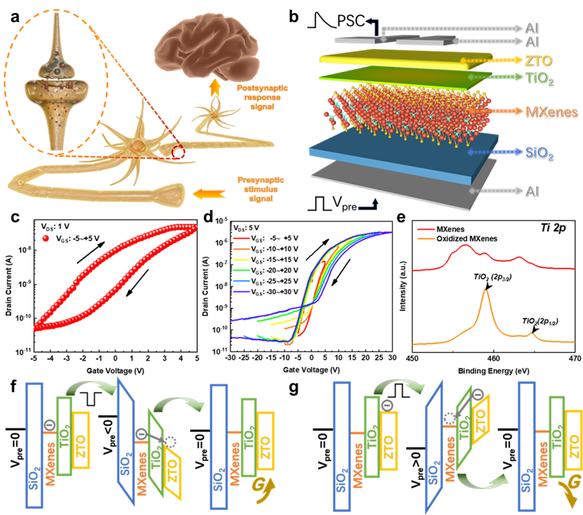
Figure 1. (a) Schematic illustration of the synaptic transmission under action potentials in the biological system. (b) The structure diagram of the MXFGT. (c) The transfer curves of MXFGT under V_{DS} of 1 V. (d) The transfer curves of MXFGT under various V_{DS} range from -5 ~ +5 V to -30 ~ +30 V. (e) The Ti 2p XPS spectra scanning on the surfaces of MXenes and oxidized MXenes thin films. Schematic energy band diagrams of MXFGT under V_{pre} of (f) negative gate bias and (g) positive gate bias.

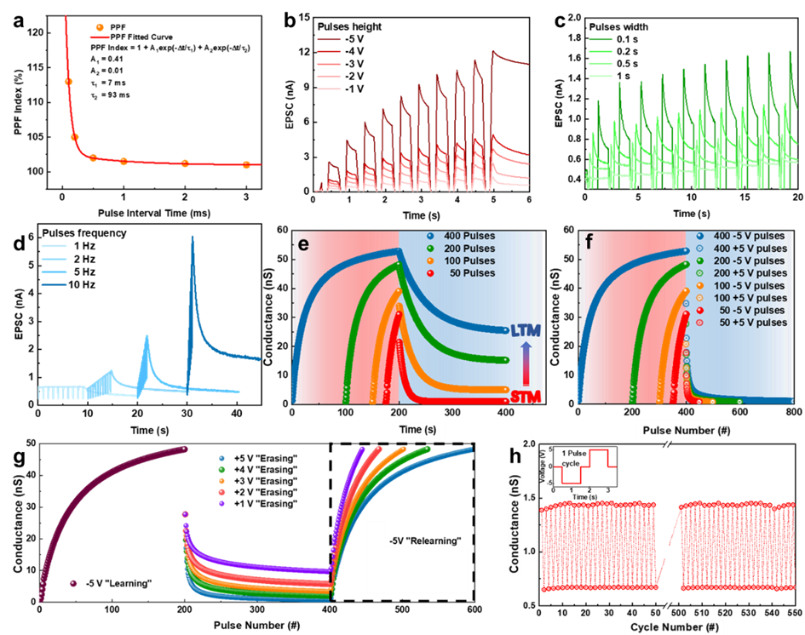
Figure 2. (a) The PPF index indicating short-term plasticity (STP) characteristics of MXFGT. The EPSC behavior of MXFGT adjusted by pre-synaptic stimuli of various (b) gate pulse height, (c) gate pulse width, and (d) gate pulse frequency. (e) The device behavior changes from STM to LTM as the number of gate pulses increases. (f) LTP/D characteristic curves as a function of number of pulses. (g) The “relearning” behaviors of the device under different “erasing” voltages. (h) Cyclic stability of device over 550 negative-positive gate pulse pairs.
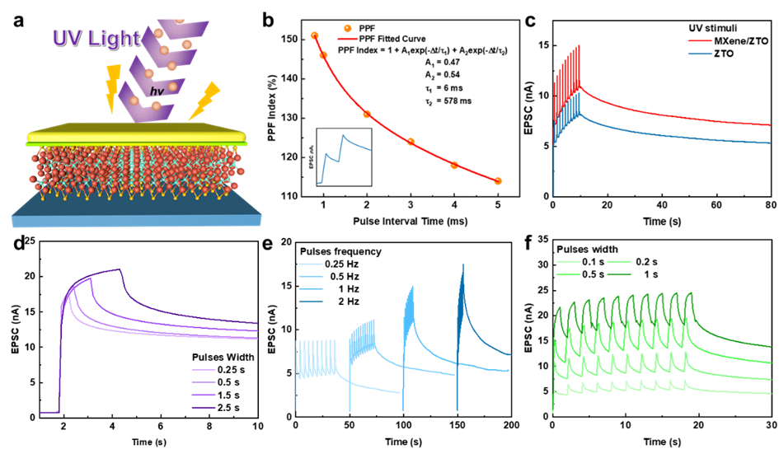
Figure 3. (a) Schematic device structure of the MXFGT under UV stimulus (365 nm, 3.2 mW∙cm⁻²). (b) The PPF index of the MXFGT under UV stimuli. (c) EPSC behavior comparison between the ZTO transistor (control group) and the MXFGT under UV stimuli. (d) The EPSC behavior of MXFGT under one-pulse UV stimulus with different width. The EPSC behavior of MXFGT adjusted by UV pulses stimuli with various (e) pulse frequency and (f) pulse width.
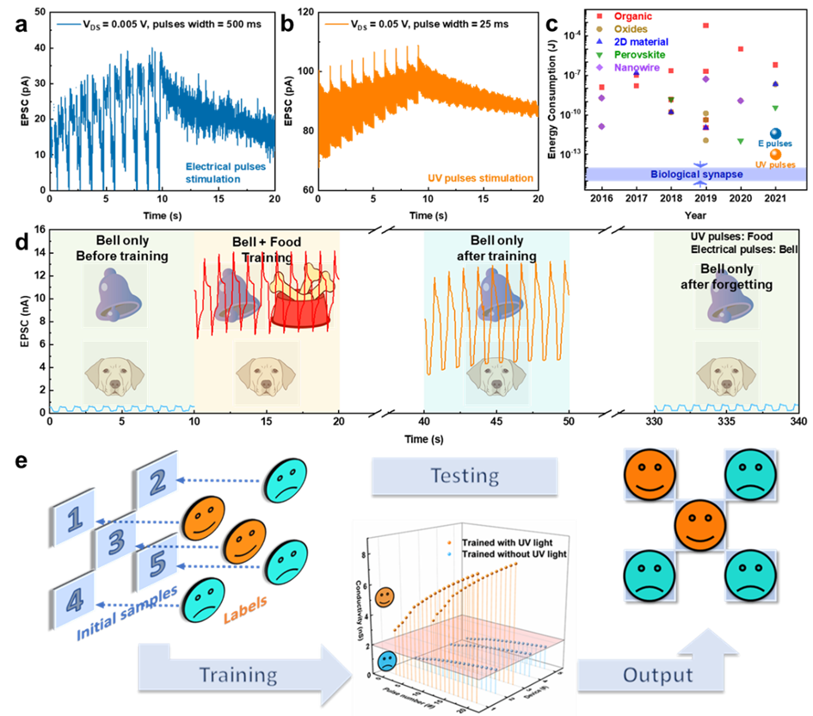
Figure 4. The EPSC results of the MXFGT under (a) electrical pulses stimulus and (b) UV pulses stimulus at low-energy-consumption working condition. (c) The minimum energy consumption of the synaptic devices reported by previous studies and this work for the past 6 years ^{[13, 21, 43, 53, 56-75]}. (d) Emulation of classical conditioning learning for MXFGT, for which the UV and the electrical pulses stimuli are used as food and bell signals for conditional learning, respectively. (e) The process of the supervised learning task completed through five MXFGT devices, which include training, forgetting and recognition periods. The conductance threshold for distinguishing the “smile” and “sad” labels was set at 2 nS.
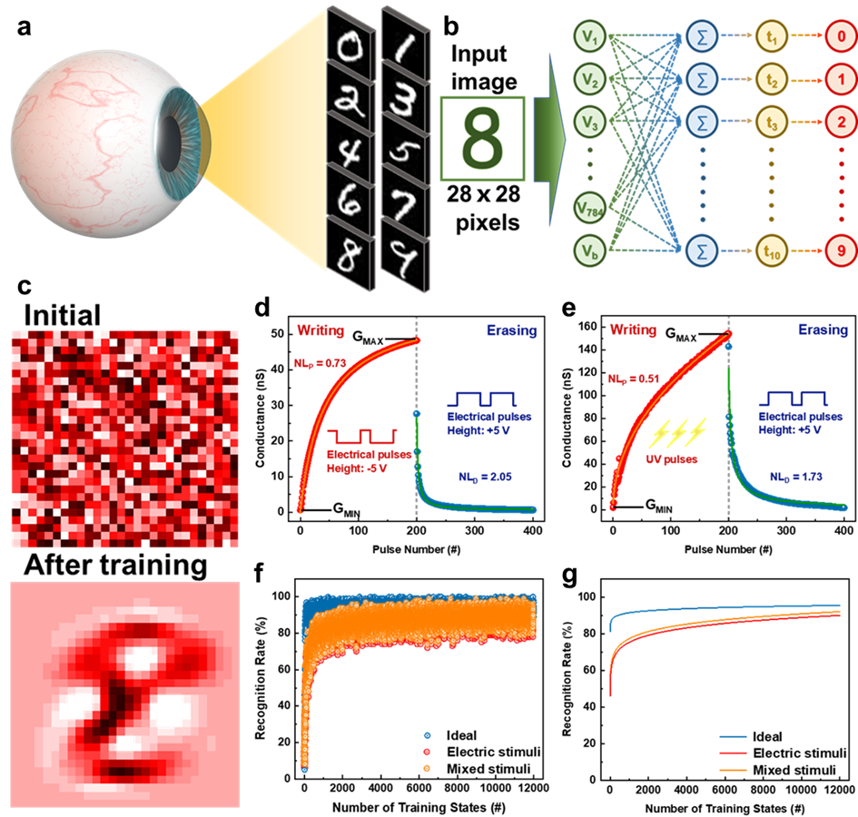
Figure 5. (a) Schematic diagram of the biological optic nervous system. (b) Schematic diagram of a single-layer perceptron ANN network. Synaptic weight updating states for the forward direction voltage bias characterized by the LTP/D curves. (c) Mapping images of number “8” before and after training process. The LTP/D curves of conductance state versus pulses state under (d) pure electrical stimuli and (e) UV-electrical mixed stimuli. (f) Recognition accuracy and (g) fitted recognition accuracy of the single-layer perceptron ANN simulator based on the devices under electrical or mixed stimuli compared to an ideal condition with near-linear updates.

A kind of solution-processed synaptic transistor is proposed with 2D material MXenes as the floating gate. The device shows biological synaptic behavior under the electrical or optical stimuli. Based on these, the applications related to conditional learning and image recognition are discussed, which suggest great potential in neuromorphic computing.

Keyword

synaptic transistor, MXenes, neuromorphic, image recognition, photoelectric plasticity

Tianshi Zhao, Chun Zhao*, Wangying Xu, Yina Liu, Hao Gao, Ivona Z. Mitrovic, Eng Gee Lim, Li Yang*, and Ce Zhou Zhao

Bio-inspired Photoelectric Artificial Synapse based on Two-Dimensional Ti₃C₂T_{x} MXenes Floating Gate

