High-performance and radiation-hardened solution-processed ZrLaO gate dielectrics for large area applications
Yuxiao Fang ^{1,2}, Chun Zhao ^{1,3,}*, Ivona Z. Mitrovic ¹, and Cezhou Zhao ^{1,3,}*
- Department of Electrical Engineering and Electronics, University of Liverpool, Liverpool L69 3GJ, UK;
- Printable Electronics Research Center, Suzhou Institute of Nano-Tech and Nano-Bionics, Chinese Academy of Sciences, Suzhou 215123, China;
- Department of Electrical and Electronic Engineering, Xi’an Jiaotong-Liverpool University, Suzhou 215123, China;
- Correspondence: E-mail: Chun.Zhao@xjtlu.edu.cn, Cezhou.Zhao@xjtlu.edu.cn

Abstract
Radiation hardness is important for electronics operating in harsh radiation environments such as outer space and nuclear energy industries. In this work, radiation-hardened solution-processed ZrLaO thin films are demonstrated. The radiation effects on solution-processed ZrLaO thin films and InO_{x}/ZrLaO TFTs were systemically investigated. The Zr_{0.9}La_{0.1}O_{y} thin films demonstrated excellent radiation hardness with negligible roughness, composition, electrical property, and bias-stress stability degradation after radiation exposure. The metal-oxide-semiconductor capacitors (MOSCAPs) based on Zr_{0.9}La_{0.1}O_{y} gate dielectrics exhibited an ultra-low flat band-voltage (V_{FB}) sensitivity of 0.11 mV/ krad and 0.19 mV/ krad under low dose and high dose gamma irradiation conditions, respectively. The low dose condition had a 103 krad (SiO₂) total dose and a 0.12 rad/s low dose rate, whereas the high dose condition had a 580 krad total dose and a 278 rad/s high dose rate. Furthermore, InO_{x}/Zr_{0.9}La_{0.1}O_{y} thin film transistors (TFTs) exhibited a large I_{on}/I_{off} of 2 × 10⁶, a small subthreshold swing (SS) of 0.11 V/ dec, a small interface trap density (D_{it}) of 1 × 10¹² cm⁻², and a 0.16 V threshold shift (ΔV_{TH}) under 3600 s positive bias-stress (PBS). InO_{x}/Zr_{0.9}La_{0.1}O_{y} TFTs based resistor loaded inverters demonstrated complete swing behavior, a static output gain of 13.3 under 4 V V_{DD}, and a ~ 9 % radiation induced degradation. Through separated investigation of the radiation-induced degradation on the semiconductor layer and dielectric layer of TFTs, it was found that radiation exposure mainly generated oxygen vacancies (V_{o}) and increased electron concentration among gate oxide. Nevertheless, the radiation-induced TFT instability was mainly related to the semiconductor layer degradation, which could be possibly suppressed by back-channel passivation. The demonstrated results indicate that solution-processed ZrLaO is a high-potential candidate for large-area electronics and circuits applied in harsh radiation environments. Besides, the detailed investigation of radiation-induced degradation on solution-processed high-k dielectrics in this work provided clear inspiration for developing novel flexible rad-hard dielectrics.
Keywords: Solution-processed; High-k gate oxide; Zirconium oxide; Lanthanum oxide; Radiation hardness; Inverter.

Introduction
Advanced electronic devices and integrated circuits (ICs) are crucial for applications working in nuclear energy industries and space, leading to the increased demand for transistors with excellent radiation hardness in recent years.¹⁻⁴ Solution-process is a promising thin film deposition method for large-area rad-hard applications such as wearable X-ray detectors,⁵ antenna arrays, and flexible materials⁶ for space suits or robots.⁷ Compared to traditional methods, the advantages of the solution-process are simple, low-cost, atmospheric processable, and high throughput.⁸⁻¹⁰ As a result, solution-process is appropriate for large area flexible thin film transistors (TFTs) fabrication. For portable and battery-powered electronics working in space environments, high-k dielectrics are preferred due to their energy-saving ability (low operation voltage, low power consumption) compared to traditional SiO₂.^{11, 12} ZrO₂ is a potential candidate with relatively low interface trap density, high dielectric constants (~ 22), and suitable band alignment.¹³⁻¹⁵ In recent years, La₂O₃ has attracted much attention due to its high k value (~ 27), large bandgap (5.8~6.0 eV), high breakdown field, and good thermodynamic stability.¹⁶⁻¹⁸ Through combining Zr and La, it is possible to suppress the water and carbon absorption, and the crystallization of thin films.^{19, 20}
Some applications working in harsh radiation environments suffered from space-like radiation with a 10⁻²-10⁻⁶ rad/s relatively low dose rate. Therefore, the detailed investigation of low-dose-rate radiation effects on solution-processed high-k dielectrics is critical to analyze the device degradation in harsh space environments and the improvement of rad-hard devices. Currently, laboratories employ gamma-ray radiation sources to evaluate and predict the radiation-induced degradation of devices operating under space-like environments.²¹ Radiation could damage the semiconductor layer, gate dielectrics, and surrounding insulators, including the isolation or substate oxide.²² For devices fabricated by vacuum methods, radiation-induced charge trapping/de-trapping behaviors among dielectrics of transistors dominate the device degradation.²³ Generally, oxygen vacancies could lead to increased electron concentration under radiation exposure and are responsible for the radiation-induced degradation in high-k oxides.²⁴ Investigation on Al₂O₃ deposited by ALD has shown that the gamma irradiation on thin-film caused significant oxygen vacancy formation and barrier height reduction.²⁵ Nevertheless, to the best of our knowledge, the radiation-induced degradation of solution-processed high-k dielectrics has been seldomly investigated and reported.²⁴ This study aims to explore the applications of radiation-hardened solution-processed ZrLaO dielectrics in TFTs and inverters working in harsh radiation environments. Solution-processed ZrLaO thin films and InO_{x}/ZrLaO TFTs with different La corporations were fabricated. The InO_{x}/Zr_{0.9}La_{0.1}O_{y} TFTs had an I_{on}/I_{off} up to ~ 210⁶, a small subthreshold swing (SS) of ~ 0.11 V/dec, and the resistor-loaded inverter based on InO_{x}/Zr_{0.9}La_{0.1}O_{y} TFTs exhibited a high output gain ~ 13.3 at 4 V working voltage. Notably, the radiation effects on the composition, surface roughness, and electrical properties of ZrLaO thin film were systemically investigated. The metal-oxide-semiconductor capacitors (MOSCAPs) based on Zr_{0.9}La_{0.1}O_{y} gate dielectrics exhibited an ultra-low flat band-voltage (V_{FB}) sensitivity of 0.11 mV/ krad and 0.19 mV/krad under low dose and high dose gamma irradiation conditions. The low dose condition had a 103 krad (SiO₂) total dose and a 0.12 rad/s low dose rate, whereas the high dose condition had a 580 krad total dose and 278 rad/s high dose rate. As shown in Figure 1, compared to previously reported devices,²⁶⁻³⁰ the V_{FB} sensitivities of Zr_{0.9}La_{0.1}O_{y} MOSCAPs are promising values for radiation-hardened applications. Whereas the radiation-induced degradation on the dielectric layer and semiconductor layer of InO_{x}/ZrLaO TFTs was investigated in separation. The demonstrated results indicate that solution-processed ZrLaO dielectrics have high potential for large-area electronics applied in harsh radiation environments. Besides, the detailed investigation of radiation-induced degradation on solution-processed high-k dielectrics could provide a clear inspiration for developing novel flexible rad-hard dielectrics.
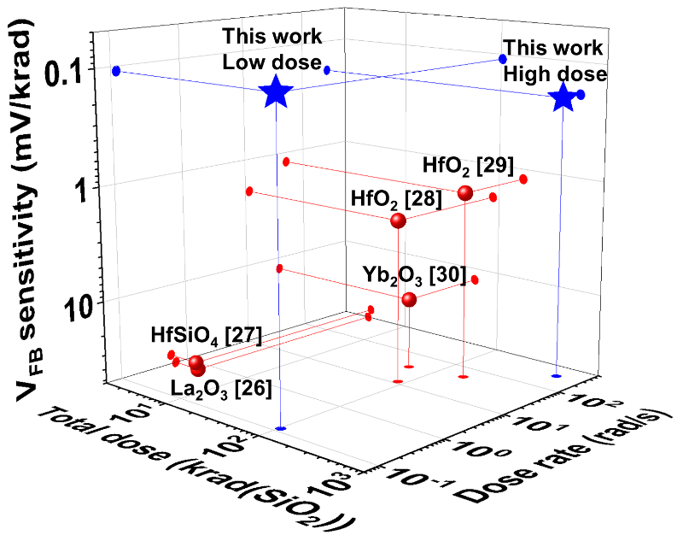
Figure 1. Summarized flat-band voltage (V_{FB}) sensitivity of high-k dielectrics under irradiation in recent years.²⁶⁻³⁰

Results and discussion

Precursor and thin film properties
The thin film fabrication and characterization details are introduced in the experimental methods section. Figure 2 (a) is a schematic diagram of gamma-irradiation on ZrLaO thin films and devices. Figure 2 (b)-(d) demonstrate the atomic force microscope (AFM) results of fresh ZrLaO thin films with different La incorporation. The calculated root-mean-square (RMS) values of Zr-only, Zr_{0.9}La_{0.1}O_{y}, and Zr_{0.8}La_{0.2}O_{y} thin films are 0.195, 0.133, and 0.141 nm, respectively. The small RMS values are related to the amorphous structure of ZrLaO thin films and the utilization of organic free de-ionized (DI) water as the precursor solvent.³¹ Figure 2 (e)-(g) display the AFM images of ZrLaO thin films after 144 krad γ-ray irradiation, and the RMS values of Zr-only, Zr_{0.9}La_{0.1}O_{y}, and Zr_{0.8}La_{0.2}O_{y} thin films are 0.282, 0.117, and 0.143 nm, respectively. Table S1 in supplementary documents summarized the RMS values of the thin films. The Zr-only thin films exhibited an increased surface roughness after irradiation compared to fresh thin films, corresponding to some small peaks generated by the high-energy photon colliding with the metal-oxide and the change of thin-film physical structures.⁷ On the other hand, the RMS values of thin films with La incorporation are almost the same before and after irradiation, which is probably related to the dense film and relatively high La-O bond dissociation energy. As the radiation exposure was carried out in ambient air. The ZrLaO thin films were also exposed to ambient air for 5 weeks to investigate the ambient air effect during radiation exposure, as shown in Figure S1. Compared to the fresh thin films, there is no significant variation of surface roughness of all thin films, demonstrating satisfied moisture resistance.⁹
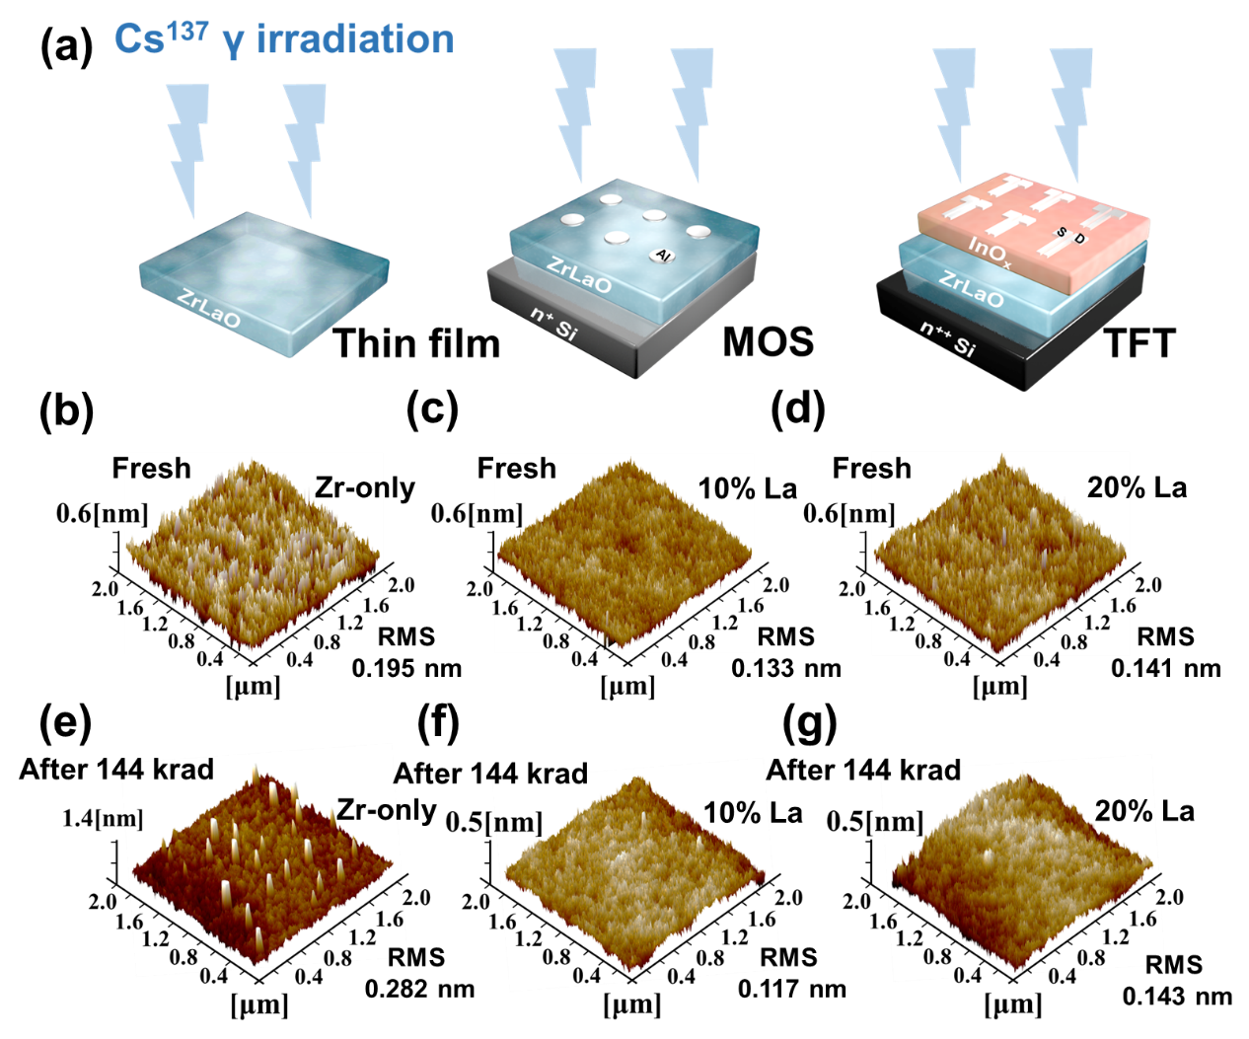
Figure 2. (a) Schematic diagram of gamma-irradiation on ZrLaO thin films and devices. 3D atomic force microscopy (AFM) results of ZrLaO thin films with different La concentrations (b)-(d) before and (e)-(g) after 144 krad (SiO₂) irradiation.

To analyze the composition variation induced by irradiation and ambient air exposure, X-ray photoelectron spectroscopy (XPS) characterization was carried out, as shown in Figure 3. 284.6 eV C 1s reference was utilized to calibrate all peaks, Gaussian–Lorenz fitting method was used to deconvolute the spectra based on Shirley type background. Figure 3 (a)-(c) display the divided O 1s peaks of ZrLaO thin films after 144 krad, including three peaks centered at 529.5 (O_{I}), 531.1(O_{II}), and 532.1 eV (O_{III}), respectively. The O 1s peak deconvolutions of ZrLaO thin films before and after 5 weeks ambient air exposure are displayed in Figure S2 for comparison. O_{I} peak represents O²⁻ ions combined with Zr and La ions, O_{II} peak is assigned to O²⁻ ions in the oxygen-deficient regions such as oxygen vacancy (V_{o}), and O_{III} peak is related to loosely bound oxygen, such as -CO³, absorbed O₂ or H₂O.³² ³³
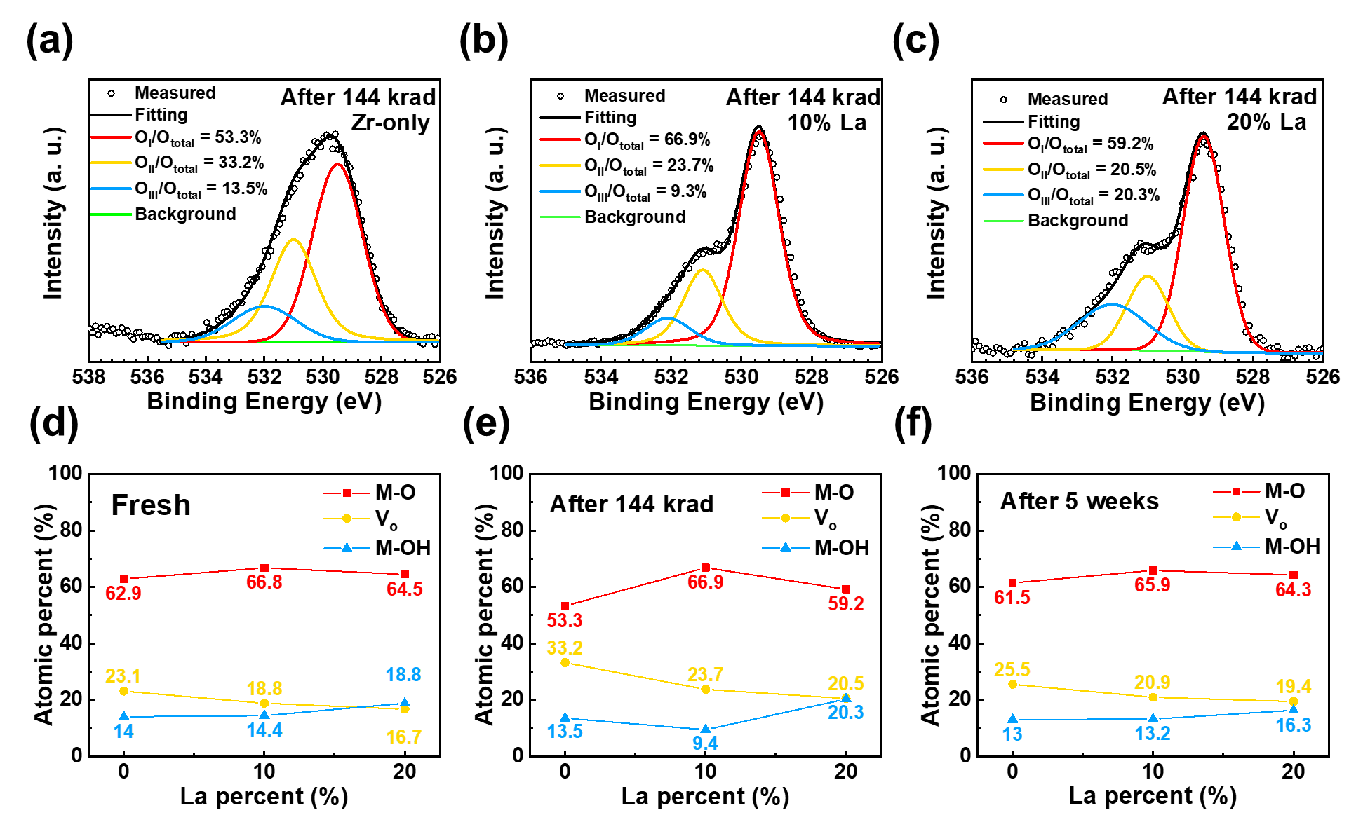
Figure 3. (a)-(c) X-ray photoelectron spectroscopy (XPS) spectra of O 1s narrow scans. Summarized atomic percentages of ZrLaO thin films with different La concentrations (d) before irradiation, (e) after 144 krad irradiation exposure, and (f) after 5 weeks ambient air exposure.

Figure 3 (d) summarizes the calculated atomic percentages based on O 1s peaks deconvolution, with La content increasing from 0 to 10 %, the O_{I} peak percentage (O_{I}/O_{total}) of the total oxygen region increased from 62.9 % to 66.7 % and the O_{II} peak percentage (O_{II}/O_{total}) decreased from 23.2 % to 18.8 %. Table S1 summarizes the atomic ratio of ZrLaO thin films under different conditions. The results suggest that appropriate La doping (10 %) could reduce bonded oxygen density, especially V_{o}, and maximize the metal-oxide framework formation. La has higher oxygen bond dissociation energy (798 kJ mol⁻¹) with O than Zr (766 kJ mol⁻¹), which may be helpful to lower down and control the total V_{o} amount. However, when the La content increased to 20 %, the O_{I}/O_{total} decreased from 66.7 % to 64.5 %, O_{III}/O_{total} increased from 14.4 % to 18.8 %, which was probably attributed to the poor densification and incomplete dehydration of the high-La samples at low temperature.³⁴ The thin film compositions after radiation exposure are summarized in Figure 3 (e); the Zr-only thin films exhibited a significant variation of composition and peak shape. After photon irradiation, M-O-M peak decreased notably, whereas the V_{o} and M-O-H peaks increased significantly.
As discussed before, when metal-oxide thin film suffered from high-energy photon collision, V_{o} could be generated and act as shallow donor states or deep traps. In addition, V_{o} could form hydroxides after adsorbing moisture. The Zr_{0.9}La_{0.1}O_{y} thin films exhibited a less increase of V_{o} concentration compared to Zr-only films after irradiation; the improved radiation hardness is due to the large V_{o} generation energy of the La₂O₃ suppressed the vacancy generation. It is reported that doping is an effective way to suppress radiation-induced damage.² However, when La incorporation continues to increase to 20 %, the thin film radiation hardness degraded. The M-OH concentration increased slightly after 144 krad radiation exposure, which is possibly ascribed to the irradiation enhanced moisture absorption of La₂O₃, the detailed mechanism requires further investigation. Notably, radiation hardness can be improved by optimizing the La₂O₃ content (~10 %) doped in ZrO₂. Figure 3 (f) summarizes the atomic percentages of ZrLaO thin films after 5-weeks ambient air exposure and the concentration of M-O and M-OH of all films exhibited no significant variation. As a result, the composition variations difference between Figure 3 (d) and (e) is mainly caused by radiation exposure. The XPS results indicate that doping appropriate amount of La₂O₃ (~ 10 %) into ZrO₂ is an appropriate solution to enhance the radiation hardness of ZrLaO thin films.

Electrical properties of ZrLaO thin films
To further determine the radiation-induced property degradation of ZrLaO thin films, ZrLaO metal-oxide-semiconductor capacitors (MOSCAPs) were fabricated and characterized. According to the high radiation tolerance of Zr_{0.9}La_{0.1}O_{y} thin films demonstrated by AFM and XPS results, Figure 4 (a) displays the capacitor-voltage (C-V) curves of Al/ Zr_{0.9}La_{0.1}O_{y} /n+ Si/Al MOSCAPs measured under total ionizing dose (TID) up to 103 krad. The inset shows the structure of a MOSCAP. The hysteresis and flat-band voltage (V_{FB}) of the C-V curves remained stable after irradiation. To investigate the radiation-induced trapping/de-trapping behaviors among the MOSCAPs, the flat-band voltage shift (ΔV_{FB}), oxide trap variation (ΔN_{ot}), and interface trap variation (ΔN_{it}) as a function of TID were calculated and summarized in Figure 4 (b). Besides, the radiation hardness of Zr_{0.9}La_{0.1}O_{y} MOSCAPs under high dose irradiation exposure was investigated and shown in Figure S3. The irradiation with a low dose rate of 0.12 rad/s and a high dose rate of 278 rad/s could barely affect the properties of MOSCAPs. Only small ΔV_{FB} (low dose: 0.01 V, high dose: 0.11 V) and ΔN_{ot} (low dose: -1.56 × 10¹⁰ cm⁻², high dose: -2.9 × 10¹¹) were observed, which is far below the maximum tolerance of radiation-induced threshold voltage shift (ΔV_{TH} < 0.3 V) of commercial Si-based ICs,³⁵ indicating the satisfied radiation hardness of solution-processed Zr_{0.9}La_{0.1}O_{y} thin films.
To investigate the electrical properties of ZrLaO thin films, metal-insulator-metal capacitors (MIMCAPs) were fabricated and the parameters were summarized in Table 1. Figure 4 (c) shows the frequency-dependent areal capacitance of fresh ZrLaO thin films, and the inset displays the structure of MIMCAPs. The leakage behaviors are displayed in Figure S4 (a), and the ambient air stability of MIMCAPs was investigated in Figure S4 (b) and (c). The k values at 1 kHz as a function of La content (0%, 10%, 20%) were calculated to be 11, 16.4, and 18.2, respectively. The increased k value is ascribed to the higher k value of La₂O₃ (~ 27) than ZrO₂ (~ 22). Besides, the Zr_{0.9}La_{0.1}O_{y} MIMCAPs exhibited the weakest frequency dispersion of capacitance in all frequency regions and the best ambient air stability, indicating the gradual decomposition of impurities and defects in Zr_{0.9}La_{0.1}O_{y} thin films, and the generation of a high-quality metal-oxide network.³⁶

Table 1. Dielectric properties of solution-processed ZrLaO thin films.
 | Thickness  (nm) | Leakage current (A/cm²) at 2.5 MV/cm | Areal capacitance (nF/cm²) at 1 kHz | Dielectric Constant at 1 kHz
Zr-only | 50.2 | Breakdown | 269 | 11.0
Zr_{0.9}La_{0.1}O_{y} | 61.3 | 2.2×10⁻⁷ | 241 | 16.4
Zr_{0.8}La_{0.2}O_{y} | 73.3 | 2.4 ×10⁻⁷ | 229 | 18.2

The properties of ZrLaO based TFTs and inverters

TFT parameters
To explore the applications of ZrLaO films in low power electronics, TFTs based on ZrLaO gate dielectrics were fabricated, and the fabrication process is demonstrated in Figure 4 (e). Figure 4 (d) displays the typical transfer characteristics (I_{DS}-V_{GS}) measured at drain voltage V_{DS} = 3.5 V, and the inset is the TFT structure. The main TFTs device parameters and their distributions are summarized in Table 2 and Figure S5; at least 5 devices were measured for each La concentration to ensure the data authenticity. The operation voltage of InO_{x}/ZrLaO TFTs is down to 4 V, which is ultra-low compared to those of TFTs based on SiO₂,^{9, 37} such a low operation voltage indicates the potential applications of ZrLaO based TFTs in low power consumption electronics. The large I_{on}/I_{off}, small SS, and small D_{it} values demonstrated the feasibility of Zr_{0.9}La_{0.1}O_{y} thin film as the gate oxide for InO_{x} TFTs. The small SS values for InO_{x}/Zr_{0.9}La_{0.1}O_{y} TFTs is possibly ascribed to the large areal capacitance of the Zr_{0.9}La_{0.1}O_{y} gate oxide and the high-quality InO_{x}/Zr_{0.9}La_{0.1}O_{y} interface. The D_{it} value of the InO_{x}/Zr_{0.9}La_{0.1}O_{y} TFT is comparable to those based on other solution-processed high-k dielectrics, e.g., AlO_{x} (2.6 × 10¹² cm⁻²),³⁸ YO_{x} (2.7 × 10¹² cm⁻²),³⁹ MgO_{x} (9 × 10¹² cm⁻²),⁴⁰ and ScO_{x} (3 × 10¹² cm⁻²).³¹ Besides, the calculations of activation energy (Ea) and density of states (DOS) are shown in Figure S6, indicate that the InO_{x} layers fabricated on different ZrLaO thin films have almost the same property and the improvement of TFTs performance is related to the La doping in the dielectric layer. On the other hand, excessive La concentration (20 %) could decrease I_{on} and poor InO_{x}/ZrLaO interface. It is reported that V_{o} among oxide could act as trap defects and degrade the properties of the device.⁴¹ According to the XPS results, the decrease in V_{o} is responsible for the reduced current of the device after 20 % La doping, while the increase of metal hydroxide related groups resulted in the increased InO_{x}/ZrLaO interface trap densities.
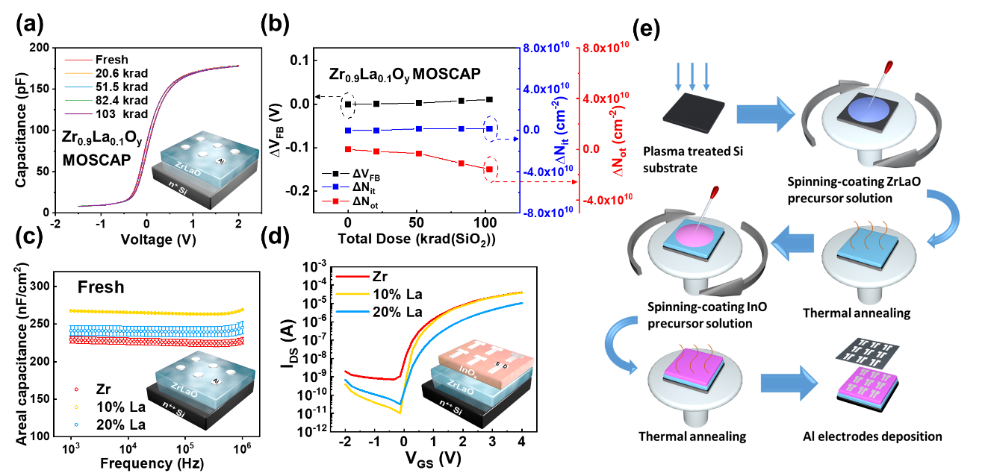
Figure 4. (a) Capacitance-voltage (C-V) curves and (b) summarized ΔV_{FB}, ΔN_{ot,} and ΔN_{it} of Zr_{0.9}La_{0.1}O_{y} metal-oxide-semiconductor capacitors (MOSCAPs) after 103 krad irradiation exposure. (c) Capacitance-frequency (C-f) curves of ZrLaO metal-insulator-metal (MIM) devices, the inset is the device structure. (d) Transfer characteristics (I_{DS}-V_{GS}) of InO_{x}/ZrLaO thin film transistors (TFT), inset is the device structure. (e) The fabrication process of InO_{x}/ZrLaO TFTs.

Table 2. Electrical parameters of InO_{x}/ZrLaO TFTs with different La concentrations.
La content | $$μ_{sat}$$  (cm² V⁻¹ s⁻¹) | I_{on}/I_{off} | V_{TH}  (V) | SS  (V/ dec) | D_{it}  (10¹² cm⁻²)
Zr-only | 1.7 ± 0.27 | ~ 110⁵ | 0.42 ± 0.17 | 0.27 ± 0.12 | 5.5 ± 3.0
10% La | 2.2 ± 0.06 | ~ 210⁶ | 0.59 ± 0.16 | 0.11 ± 0.01 | 1.0 ± 0.3
20% La | 0.9 ± 0.28 | ~ 310⁵ | 0.77 ± 0.18 | 0.26 ± 0.09 | 4.8 ± 2.1

TFT properties and bias stress (BS) stability degradation before and after irradiation
To investigate the radiation hardness of ZrLaO based TFTs, the transfer characteristics were measured under different TID, as shown in Figure 5 (a). The summarized I_{on}/I_{off} and V_{TH} as a function of TID are displayed in Figure 5 (b) and the detailed TFT parameters after 103 krad are shown in Table S2; there is a slight decrease of I_{on}/I_{off} value and an increase of V_{TH}, revealing the excellent radiation hardness of InO_{x}/Zr_{0.9}La_{0.1}O_{y} TFTs under a low dose rate environment. When considering display applications, the operational reliabilities TFTs are crucial electrical parameters. The InO_{x}/Zr_{0.9}La_{0.1}O_{y} TFTs have demonstrated the best devices properties, and their positive bias stress (PBS) stability with stress time up to 3600 s are investigated in Figure 5 (c). +2 V gate bias was applied to the gate of TFTs with their source and drain grounded during the bias. The inset shows the relationship between voltage shift (ΔV_{TH}) and stress time (t). A stretched exponential model with the following equation (1) can be utilized to fit the ΔV_{TH}:⁴²
$${∆V}_{TH}={∆V}_{TH0}(1-exp⁡(-{\left(\frac{t}{τ}\right)}^{β})$$ | (1)
where ΔV_{TH0} is the ΔV_{TH} at infinite time, $τ$ is the carrier characteristic de-trapping time, and $β$ is the stretched exponential exponent. The ΔV_{TH} as a function of stress time fitted the stretched exponential model, indicating that the dominant degradation mechanism is the charge trapping behavior at the TFT channel.⁴³ The 0.16 V small ΔV_{TH} corresponded to the enhanced InO_{x}/ZrLaO interface with a small D_{it} value. The relatively parallel V_{TH} shift and insignificant SS value variation suggested the semiconductor/dielectric interface had negligible bias-stress induced defects during the measurements.³¹
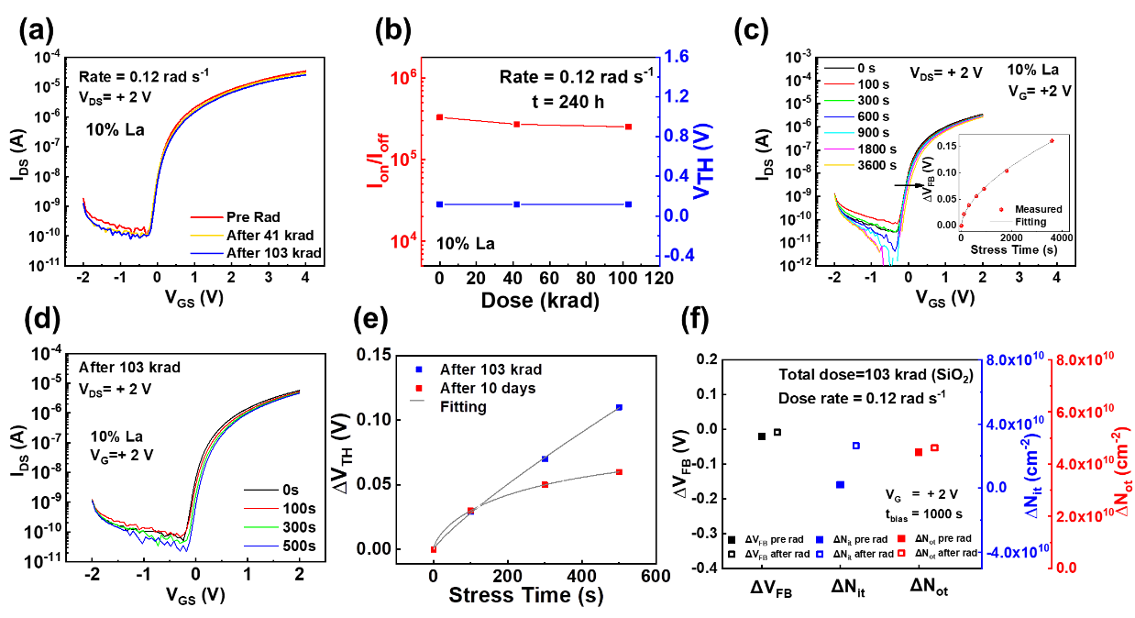
Figure 5. (a) I_{DS}-V_{GS} before and after 103 krad irradiation. (b) I_{on}/I_{off} and V_{TH} as a function of the total dose. (c) Positive bias-stress (PBS) stability of InO_{x}/Zr_{0.9}La_{0.1}O_{y} TFTs, inset is the exponential fitting of ΔV_{TH} under 3600 s PBS. (d) PBS stability of InO_{x}/Zr_{0.9}La_{0.1}O_{y} TFT after 103 krad irradiation. (e) Exponential fitting of ΔV_{TH} under 500 s PBS after 103 krad and 10 days. (f) Summarized ΔV_{FB}, ΔN_{ot,} and ΔN_{it} under 1000 s bias stress of Zr_{0.9}La_{0.1}O_{y} MOSCAPs before and after 103 krad irradiation.

To testify the effect of radiation on the PBS stability of InO_{x}/Zr_{0.9}La_{0.1}O_{y} TFTs, the PBS stability after irradiation was investigated in Figure 5 (d). The summarized V_{TH} after 103 krad irradiation exposure and 10 days ambient air exposure are shown in Figure 5 (e) for comparison. The radiation may have induced V_{o} to increase the electron concentration, which is reflected by the increased ΔV_{TH}, compared to the ΔV_{TH} of air-exposed devices in Figure 5 (e). The positive ΔV_{TH} after irradiation is mainly due to the enhanced oxygen adsorption of the InO_{x} layer. Generally, back-channel adsorbing gas molecules is one of the instability factors of oxide TFTs, which would be discussed later in detail. To separate the radiation-induced degradation of the dielectric layer and semiconductor layer, the BS stability of Zr_{0.9}La_{0.1}O_{y} MOSCAPs before and after irradiation was investigated. Figure 5 (f) displays the summarized ΔV_{FB}, ΔN_{ot,} and ΔN_{it} under 1000 s PBS before and after 103 krad irradiation. Without the radiation-induced degradation of the InO_{x} layer. The Zr_{0.9}La_{0.1}O_{y} thin films exhibited negligible BS stability degradation due to radiation exposure. After irradiation, PBS could induce insignificant positive ΔV_{FB} and ΔN_{ot} in Zr_{0.9}La_{0.1}O_{y} thin films compare to the pre-radiation results, which is probably caused by the radiation-induced net proton (H⁺) related positive charges.

InO_{x}/ZrLaO TFT based inverter
As InO_{x}/Zr_{0.9}La_{0.1}O_{y} TFTs have demonstrated excellent performance and radiation hardness, we further explored their application in inverter. By connecting InO_{x}/ZrLaO TFTs and a 13 MΩ resistor in series, a resistor-loaded inverter was achieved. Figure 6 (a) and Figure S7 exhibit the voltage transfer characteristic (VTC) curves and voltage gain (−∂V_{out}/∂V_{in}) of inverters under 1 to 4 V V_{DD}, the inset shows the connection circuit of the inverter. The inverters exhibited complete swing characteristics with output high voltage (V_{OH}) ≈V_{DD} and output low voltage (V_{OL}) ≈ 0 V. The voltage gain is around 13.3 when V_{DD} = 4 V, which is a promising value compared to the inverters reported in the literature, as shown in Table 3.^{10, 44-49} The high voltage gain was ascribed to the balanced mobility, the normally-off features, and the small SS of InO_{x}/Zr_{0.9}La_{0.1}O_{y} TFTs. The output characteristics and gain of the inverter before and after 103 krad low dose irradiation are shown in Figure 6 (b) and Figure 6 (c), respectively. The irradiation only led to a slight output degradation of the inverter; as summarized in Figure 6 (d), the voltage gain decreased around 9 % (13.3 to 12.1), the transition voltage positive shifted around 9 % (0.66 to 0.73 V). The decline of the voltage gain is affected by SS degradation caused by interface traps generation. Meanwhile, the shift of transition voltage is related to the TFTs threshold voltage shift induced by the net positive trapped charges among the gate dielectric and semiconductor layer. As analyzed in Figure 5 (f), the degradation of the inverter is mainly related to the instability of the InO_{x} semiconductor layer. The results suggested that InO_{x}/Zr_{0.9}La_{0.1}O_{y} TFTs have satisfied radiation hardness, and the 103 krad irradiation exposure could barely degrade the TFT properties.
Table 3. Voltage gain of different inverter circuits based on different TFTs.
Semiconductor/ Dielectric | V_{DD} (V) | Gain | Year | reference
IZO&GIZO/paper | 15 | 4.7 | 2011 | ⁴⁴
In₂O₃/SrO_{x} | 4 | 9.7 | 2017 | ⁴⁵
In₂O₃/Yb₂O₃ | 4 | 10.6 | 2017 | ⁴⁶
In₂O₃/Al₂O₃ | 3 | 5 | 2018 | ¹⁰
In₂O₃/ZrGdO_{x} | 2.5 | 7.4 | 2018 | ⁴⁷
LiInO/AlO | 3 | 6 | 2020 | ⁴⁸
IGZO/SiO₂ | 10 | 6.8 | 2020 | ⁴⁹
InO_{x}/ZrLaO | 4 | 13.3 | 2021 | This work

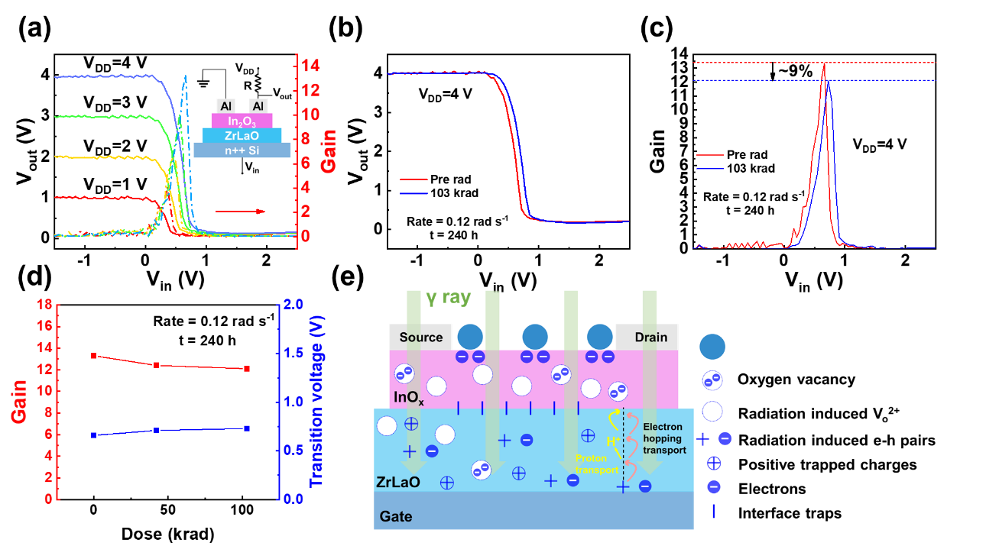
Figure 6. Characteristics of 13 MΩ resistor-loaded inverters based on InO_{x}/Zr_{0.9}La_{0.1}O_{y} TFTs. (a) Typical voltage transfer characteristic (VTC) and voltage gain, the inset is the circuit of the inverter. (b) VTC curves at V_{DD} = 4 V and (c) V_{in} dependent voltage gains before and after irradiation. (d) The voltage gain and transition voltage variation as a function of total dose up to 103 krad. (e) The schematic diagram of the radiation exposure and oxygen adsorption induced degradation of InO_{x}/ZrLaO TFTs.

Figure 6 (e) demonstrates the schematic diagram of radiation effects on InO_{x}/ ZrLaO TFT. As reported, radiation could lead to the formation of shallow donors in gate oxide, passivation of band tail state, a negative shift of V_{TH}, and an increase of mobility.⁷ However, a decreased mobility and positive V_{TH} shift were observed in ZrLaO TFTs, indicating that the ambient air effect dominated the device degradation. The oxygen molecules adsorption at the surface of back-channel follows chemical equilibrium equation:⁵⁰
$$K=\frac{O_{solid}^{-}}{P_{O_{2}}∙n}$$ | (2)
where K is the equilibrium constant, $O_{solid}^{-}$ is the adsorbed oxygen concentration at back-channel surface, $P_{O_{2}}$ is the oxygen partial pressure and n is the electron density in InO_{x} semiconductor thin film. K and $P_{O_{2}}$are constants at a fixed temperature, the radiation exposure could increase n according to the following equation:⁵¹
$$V_{o}→V_{o}^{2+}+{2e}^{-}$$ | (3)
where V_{o} is a non-conducting deep state and V_{o}²⁺ state provides two delocalized free electrons. Consequently, the $O_{solid}^{-}$ increased under radiation exposure and further resulted in the accelerated O₂ adsorption at the back-channel. The oxygen molecules have extremely high electronegativity (3.44), they could attract electrons in the InO_{x} film to form oxygen radicals, as described in the equation.⁵⁰
$$O_{2}(gas)+2e^{-}={2O}^{-}(solid)$$ | (4)
As a result of oxygen adsorption, a depletion layer was formed beneath the InO_{x} surface, leading to decreased carrier concentration. Therefore, a higher gate voltage was required to turn on the InO_{x}/ZrLaO TFTs, and V_{TH} was positively shifted. Radiation could also generate electron-hole pairs (EHPs) when passing through the gate oxide.⁵² With a positive applied electrical field, the electrons transported out of ZrLaO thin film in picoseconds, some fraction of the electrons recombined with holes in the oxide valence band even before they left the oxide. Those holes that escaped from the recombination transported through ZrLaO and be trapped at the InO_{x}/ZrLaO interface to form an interface trap, and the TFT mobility was decreased accordingly. The transportation was accompanied by hydrogen releasing, in the form of H⁺. The released H⁺ moved towards the InO_{x}/ZrLaO interface and were trapped by the defects among the ZrLaO thin films to form radiation-induced positive traps, which contributed to the positive V_{TH} shift.
For further investigation, the device mobility and SS degradation enhanced by irradiation exposure could be efficiently suppressed by passivating the backchannel.⁵³ [6,6]-phenyl-C61-butyric acid methyl ester (PCBM) has been reported to be a suitable candidate to stabilize the device, which could control the Fermi level of the films by acting as a remote dopant layer.⁷ Besides, an organic semiconductor above the oxide surface is helpful to suppress V_{o} generation and regenerate broken bonds, due to the formation of saturated unfilled coordination at the oxide surface.⁷

Conclusion
In summary, the effect of gamma irradiation on solution-processed ZrLaO thin films and InO_{x}/ZrLaO TFTs was investigated. The characterization results indicated that Zr_{0.9}La_{0.1}O_{y} films annealed at 350 °C had high M-O concentration, low V_{o} density, small frequency dispersion, and a large breakdown electrical field. The MOSCAPs based on Zr_{0.9}La_{0.1}O_{y} gate dielectrics exhibited an ultra-low V_{FB} sensitivity of 0.11 mV/ krad and 0.19 mV/krad under low dose and high dose gamma irradiation conditions, respectively. The low dose condition had a 103 krad (SiO₂) total dose and a 0.12 rad/s low dose rate, whereas the high dose condition had a 580 krad total dose and 278 rad/s high dose rate. InO_{x}/ZrLaO TFTs exhibited high performance of a large I_{on}/I_{off} of 2 × 10⁶, a small SS of 0.11 V dec⁻¹, a small D_{it} of 1 × 10¹² cm^{-2,} and a ΔV_{TH} of 0.16 V under 3600 s PBS. Besides, InO_{x}/Zr_{0.9}La_{0.1}O_{y} TFTs based resistor loaded inverters demonstrated complete swing characteristics and a high gain of 13.3 at V_{DD} = 4 V. Notably, the surface roughness, composition, electrical properties, bias-stress stability of Zr_{0.9}La_{0.1}O_{y} thin films had no significant variations after 103 krad low dose irradiation. It is found that radiation exposure mainly generated V_{o} among ZrLaO thin films and increased the mobility of the TFT devices. Doping La into ZrO₂ had demonstrated better thin film radiation hardness, due to the higher La-O bond dissociation energy than Zr-O bond, and the suppressed V_{o} generation among the bulk oxide. Compared to the irradiation effect, the oxygen adsorption at the back-channel caused by ambient air exposure dominated the degradation of the TFTs, which should be suppressed by back-channel passivation of the back-channel. Overall, the Zr_{0.9}La_{0.1}O_{y} thin films without passivation have demonstrated satisfied radiation hardness, which is crucial to the realization of large-area rad-hard applications such as wearable X-ray detectors,⁵ antenna arrays, and flexible materials⁶ for space suits or robots.⁷

Experimental Methods

Precursor Solution Preparation
To prepare 2.00 M (total metal, Zr: La=10:0, 9:1 and 8:2) ZrLaO precursor solution, zirconium oxynitrate hydrate (ZrO(NO₃)₂·xH₂O, 99.5 %) was dissolved in de-ionized (DI) H₂O. Followed by a vigorous stirring of the solution at ∼70 °C. After complete dissolution, lanthanum nitrate hexahydrate (LaN₃O₉·6H₂O, 99.9 %) was added to the solution with dissolved ZrO(NO₃)₂·xH₂O for further 8h heating and stirring. To prepare 0.1 M InO_{x} precursor solution, indium nitrate hydrate (In(NO₃)₃∙xH₂O, Aladdin) was dissolved in DI water and the solution was vigorously stirred at room temperature for 2 h. All precursor solution was then filtered by a 0.2 μm polytetrafluoroethylene (PTFE) syringe filter before spinning coating.

Thin Film Preparation and Characterization
To prepare the substrates, heavily doped and lightly doped (orientation:100, doping concentration: ~10¹⁵ cm⁻³, resistivity: 2-4 Ω·cm) n-type Si substrates were dipped in 2% HF aqueous solution for 60 s to remove the native oxide and then dried by N₂. ZrLaO precursor solution was dropped onto cleaned Si substrates and spun at 3000 rpm for 30 s. Then the substrates were placed on a 125 °C hot plate, the temperature was linearly increased to 350 ºC with a heating rate of 25 ºC min⁻¹ and held for 1 h. The surface morphologies of the ZrLaO thin films were investigated by AFM. The compositions of the ZrLaO thin films were determined by XPS. For radiation hardness investigation, a 662-keV Cs¹³⁷ γ-ray radiation source was used for low dose measurement, the stress time was up to 14 days and the total dose was up to 144 krad (SiO₂) at a dose rate of 0.12 rad s⁻¹. For high dose measurements, a Co⁶⁰ γ-ray radiation source was used, the total dose was up to 580 krad with a dose rate of 278 rad/s.

Device Fabrication and Characterization
InO_{x} precursor solution was dropped onto the deposited ZrLaO thin films and spun at 3000 rpm for 20 s. After that, the samples were heated at 250 ºC for 1h on a hot plate. Finally, shadow masks were used to deposit 300 nm thick Al source, drain, and bottom electrodes through e-beam evaporation. The ratio of channel width (W = 150 μm) and length (L = 10 μm) was defined as 15. To investigate the electrical properties of ZrLaO dielectrics, Al/ZrLaO/n⁺ Si metal-oxide-semiconductor capacitors (MOSCAPs) and Al/ZrLaO/n⁺⁺ Si metal-insulator-metal capacitors (MIMCAPs) were prepared with d = 0.3 mm diameter circular top Al electrode. The electrical characteristics of ZrLaO capacitors and InO_{x}/ZrLaO TFT were investigated by the semiconductor device analyzer (Agilent B1500A) in a dark shelter at room temperature.
The V_{TH} of TFT was determined by linear fitting to the dependence of I_{DS}^{1/2} on V_{GS}. The saturation carrier mobility ($μ_{sat}$) was extracted by the following formula²⁰:
$$μ_{sat}=\frac{2L}{WC_{i}}{(\frac{∂√I_{DS}}{∂V_{GS}})}^{2}$$ | (5)
where V_{GS} is the gate voltage, $I_{DS}$ is the saturation current and C_{i} is the areal capacitance of MIM capacitors. D_{it} was calculated using the following equation:⁴⁰
$$SS=\frac{kTIn(10)}{q}\left(1+\frac{q}{C_{i}}D_{it}\right)$$ | (6)
where SS is the subthreshold swing, q is the electron charge and k is the Boltzmann constant. To investigate the BS stability of the InO_{x}/ZrLaO TFTs, a constant gate bias was applied on the gate while the source and drain electrodes were grounded. The I_{DS}=V_{GS} curves of the InO_{x}/ZrLaO TFTs under PBS were measured in the dark environment and the stress time was up to 3600 s. To investigate the radiation hardness of InO_{x}/ZrLaO TFTs, transfer curves were characterized before and after γ-ray irradiation to analyze the radiation-induced degradation. Considering the irradiation exposure was carried out in ambient air, the devices' property degradation under ambient air exposure was investigated for comparison.

Associated content

Supporting information
AFM and XPS results of ZrLaO thin films before and after 5-weeks ambient air exposure, summarized RMS value and atomic ratio of ZrLaO thin films under different conditions, C-V curves and summarized ΔV_{FB}, ΔN_{ot} and ΔN_{it} of Zr_{0.9}La_{0.1}O_{y} MOSCAPs under high dose condition, C-V, J-E of ZrLaO MOSCAPs before and after 5-weeks ambient air exposure, the distribution of InO_{x}/ZrLaO TFT parameters, activation energy (E_{a}) as a function of V_{GS} for various TFT devices, VTC, voltage gain and linear fit of inverters based on InO_{x}/ZrLaO TFTs, electrical parameters of InO_{x}/Zr_{0.9}La_{0.1}O_{y} TFTs after 103 krad irradiation.

Acknowledgments
This research was funded in part by the National Natural Science Foundation of China (21503169, 2175011441, and 61704111), Natural Science Foundation of Guangdong Province (2017A030310524), Guangdong Research Center for Interfacial Engineering of Functional Materials (201701), Suzhou Science and Technology program (SYG201623), Suzhou Industrial Park Initiative Platform Development for Suzhou Municipal Key Lab for New Energy Technology (RR0140), Natural Science Foundation of SZU (2017001), Key Program Special Fund in XJTLU (KSF-A-04, KSF-A-05, KSF-A-07, KSF-P-02 and KSF-T-03) and the XJTLU Research Development Fund (RDF-14-02-42 and RDF-17-01-13). The author IZM acknowledges UKRI GIAA award as well as British Council UKIERI project no. IND/CONT/G/17-18/18

References
(1) Zhu, M., Xiao, H., Yan, G., Sun, P., Jiang, J., Cui, Z., Zhao, J., Zhang, Z., and Peng, L.-M., "Radiation-Hardened and Repairable Integrated Circuits Based on Carbon Nanotube Transistors with Ion Gel Gates," Nat. Electron. 2020, 10, 622-629.
(2) Ruan, D.-B., Liu, P.-T., Gan, K.-J., Chiu, Y.-C., Hsu, C.-C., and Sze, S. M., "Role of Tungsten Dopants in Indium Oxide Thin-Film Transistor on Radiation Hardness Technology," Appl. Phys. Lett. 2020, 18, 182104.
(3) Tai, Y.-H., Yeh, S., Huang, S.-H., and Chang, T.-C., "Total-Dose Effect of X-Ray Irradiation on Low-Temperature Polycrystalline Silicon Thin-Film Transistors," IEEE Electron Device Lett. 2020, 6, 864-867.
(4) Luo, M., Zhu, M., Wei, M., Shao, S., Robin, M., Wei, C., Cui, Z., Zhao, J., and Zhang, Z., "Radiation-Hard and Repairable Complementary Metal-Oxide-Semiconductor Circuits Integrating N-Type Indium Oxide and P-Type Carbon Nanotube Field-Effect Transistors," ACS Appl. Mater. Interfaces 2020, 44, 49963-49970.
(5) Cramer, T., Fratelli, I., Barquinha, P., Santa, A., Fernandes, C., D'Annunzio, F., Loussert, C., Martins, R., Fortunato, E., and Fraboni, B., "Passive Radiofrequency X-Ray Dosimeter Tag Based on Flexible Radiation-Sensitive Oxide Field-Effect Transistor," Sci Adv 2018, 6, eaat1825.
(6) Cramer, T., Sacchetti, A., Lobato, M. T., Barquinha, P., Fischer, V., Benwadih, M., Bablet, J., Fortunato, E., Martins, R., and Fraboni, B., "Radiation-Tolerant Flexible Large-Area Electronics Based on Oxide Semiconductors," Adv Electron Mater 2016, 7, 1500489.
(7) Park, B., Ho, D., Kwon, G., Kim, D., Seo, S. Y., Kim, C., and Kim, M.-G., "Solution-Processed Rad-Hard Amorphous Metal-Oxide Thin-Film Transistors," Adv. Funct. Mater. 2018, 47, 1802717.
(8) Li, Y., Lan, L., Hu, S., Gao, P., Dai, X., He, P., Li, X., and Peng, J., "Fully Printed Top-Gate Metal–Oxide Thin-Film Transistors Based on Scandium-Zirconium-Oxide Dielectric," IEEE Trans. Electron Devices 2019, 1, 445-450.
(9) Hong, L., Xu, W., Liu, W., Han, S., Cao, P., Fang, M., Zhu, D., and Lu, Y., "High Performance Indium Dysprosium Oxide Thin-Film Transistors Grown from Aqueous Solution," Appl. Surf. Sci. 2020, 144499.
(10) Zhu, L., He, G., Long, Y., Yang, B., and Lv, J., "Eco-Friendly, Water-Induced In₂o₃thin Films for High-Performance Thin-Film Transistors and Inverters," IEEE Trans. Electron Devices 2018, 7, 2870-2876.
(11) Lee, J. S., Chang, S., Koo, S.-M., and Lee, S. Y., "High-Performance a-Igzo Tft with Zrlao Gate Dielectric Fabricated at Room Temperature," IEEE Electron Device Lett. 2010, 3, 225-227.
(12) Münzenrieder, N., Zysset, C., Petti, L., Kinkeldei, T., Salvatore, G. A., and Tröster, G., "Flexible Double Gate a-Igzo Tft Fabricated on Free Standing Polyimide Foil," Solid-State Electron. 2013, 198-204.
(13) Liu, A., Liu, G. X., Zhu, H. H., Xu, F., Fortunato, E., Martins, R., and Shan, F. K., "Fully Solution-Processed Low-Voltage Aqueous In₂o₃ Thin-Film Transistors Using an Ultrathin Zro_{x} Dielectric," ACS Appl. Mater. Interfaces 2014, 20, 17364-17369.
(14) Byun, H.-R., You, E.-A., and Ha, Y.-G., "Room-Temperature Solution-Processed, Zro_{x}-Based Hybrid Gate Dielectrics for Low-Voltage Organic Thin-Film Transistors on Plastic Substrates," Appl. Phys. Lett. 2019, 1, 013301.
(15) Seon, J.-B., Cho, N.-K., Yoo, G., Kim, Y. S., and Char, K., "Solution-Processed Amorphous Zro₂ Gate Dielectric Films Synthesized by a Non-Hydrolytic Sol–Gel Route," RSC Advances 2018, 68, 39115-39119.
(16) Wu, Y., Yang, M., Chin, A., Chen, W., and Kwei, C., "Electrical Characteristics of High Quality La₂o₃ Gate Dielectric with Equivalent Oxide Thickness of 5 Å," IEEE Electron Device Lett. 2000, 7, 341-343.
(17) Zhuang, J., Sun, Q.-J., Zhou, Y., Han, S.-T., Zhou, L., Yan, Y., Peng, H., Venkatesh, S., Wu, W., and Li, R. K., "Solution-Processed Rare-Earth Oxide Thin Films for Alternative Gate Dielectric Application," ACS Appl. Mater. Interfaces 2016, 45, 31128-31135.
(18) Kukli, K., Ritala, M., Pore, V., Leskelä, M., Sajavaara, T., Hegde, R. I., Gilmer, D. C., Tobin, P. J., Jones, A. C., and Aspinall, H. C., "Atomic Layer Deposition and Properties of Lanthanum Oxide and Lanthanum‐Aluminum Oxide Films," Chem. Vap. Deposition 2006, 2‐3, 158-164.
(19) Kim, J., Choi, S., Jo, J.-W., Park, S. K., and Kim, Y.-H., "Solution-Processed Lanthanum-Doped Al₂o₃ Gate Dielectrics for High-Mobility Metal-Oxide Thin-Film Transistors," Thin Solid Films 2018, 814-818.
(20) Yang, B., He, G., Zhu, L., Zhang, C., Zhang, Y., Xia, Y., Alam, F., and Sun, Z., "Low-Voltage-Operating Transistors and Logic Circuits Based on a Water-Driven Zrgdo_{x} Dielectric with Low-Cost Znsno," ACS Appl. Electron. Mater. 2019, 4, 625-636.
(21) Fleetwood, D. M., "Total Ionizing Dose Effects in Mos and Low-Dose-Rate-Sensitive Linear-Bipolar Devices," IEEE Trans. Nucl. Sci. 2013, 3, 1706-1730.
(22) Kim, D.-G., Lee, T.-K., Park, K.-S., Chang, Y.-G., Han, K.-J., and Choi, D.-K., "Hydrogen Behavior under X-Ray Irradiation for a-Igzo Thin Film Transistors," Appl. Phys. Lett. 2020, 1, 013502.
(23) Schwank, J. R., Shaneyfelt, M. R., Fleetwood, D. M., Felix, J. A., Dodd, P. E., Paillet, P., and Ferlet-Cavrois, V., "Radiation Effects in Mos Oxides," IEEE Trans. Nucl. Sci. 2008, 4, 1833-1853.
(24) Manikanthababu, N., Basu, T., Vajandar, S., Nageswara Rao, S. V. S., Panigrahi, B. K., Osipowicz, T., and Pathak, A. P., "Radiation Tolerance, Charge Trapping, and Defect Dynamics Studies of Ald-Grown Al/Hfo₂/Si Nmoscaps," J. Mater. Sci.: Mater. Electron. 2020, 4, 3312-3322.
(25) Zhu, H. P., Zheng, Z. S., Li, B., Li, B. H., Zhang, G. P., Li, D. L., Gao, J. T., Yang, L., Cui, Y., Liang, C. P., Luo, J. J., and Han, Z. S., "Total Dose Effect of Al₂o₃-Based Metal–Oxide–Semiconductor Structures and Its Mechanism under Gamma-Ray Irradiation," Semicond Sci Tech 2018, 11, 115010.
(26) Yilmaz, E. and Kaya, S., "A Detailed Study on Zero-Bias Irradiation Responses of La₂o₃ Mos Capacitors," IEEE Trans. Nucl. Sci. 2016, 2, 1301-1305.
(27) Lok, R., Kaya, S., Karacali, H., and Yilmaz, E., "The Co-60 Gamma-Ray Irradiation Effects on the Al/Hfsio₄/P-Si/Al Mos Capacitors," Radiat. Phys. Chem. 2017, 155-159.
(28) Kaya, S., Yıldız, I., Lok, R., and Yılmaz, E., "Co-60 Gamma Irradiation Influences on Physical, Chemical and Electrical Characteristics of Hfo2/Si Thin Films," Radiat. Phys. Chem. 2018, 64-70.
(29) Ding, M., "The Radiation Response of Hafnium Oxide Based Metal-Oxide-Semiconductor Capacitors under ⁶⁰co Gamma Ray," IEEE Transactions on Electrical Insulation 2019, 1, 10-16.
(30) Kahraman, A., Gurer, U., and Yilmaz, E., "The Effect and Nature of the Radiation Induced Oxide-Interface Traps on the Performance of the Yb₂o₃ Mos Device," Radiat. Phys. Chem. 2020,
(31) Liu, A., Liu, G., Zhu, H., Song, H., Shin, B., Fortunato, E., Martins, R., and Shan, F., "Water‐Induced Scandium Oxide Dielectric for Low‐Operating Voltage N‐and P‐Type Metal‐Oxide Thin‐Film Transistors," Adv. Funct. Mater. 2015, 46, 7180-7188.
(32) Wang, Z., Wu, Q., Li, M., Wu, J., Liang, L., Li, G., Li, S., Wang, Y., and Liu, C., "Doping Effects of Various Carrier Suppressing Elements on Solution-Processed Snoₓ-Based Thin-Film Transistors," IEEE Trans. Electron Devices 2019, 1-5.
(33) Hennek, J. W., Smith, J., Yan, A., Kim, M.-G., Zhao, W., Dravid, V. P., Facchetti, A., and Marks, T. J., "Oxygen “Getter” Effects on Microstructure and Carrier Transport in Low Temperature Combustion-Processed a-In_{x}zno (X= Ga, Sc, Y, La) Transistors," J. Am. Chem. Soc. 2013, 29, 10729-10741.
(34) Woods, K. N., Chiang, T. H., Plassmeyer, P. N., Kast, M. G., Lygo, A. C., Grealish, A. K., Boettcher, S. W., and Page, C. J., "High-K Lanthanum Zirconium Oxide Thin Film Dielectrics from Aqueous Solution Precursors," ACS Appl. Mater. Interfaces 2017, 12, 10897-10903.
(35) Barnaby, H., "Total-Ionizing-Dose Effects in Modern Cmos Technologies," IEEE Trans. Nucl. Sci. 2006, 6, 3103-3121.
(36) Xu, W., Wang, H., Ye, L., and Xu, J., "The Role of Solution-Processed High-K Gate Dielectrics in Electrical Performance of Oxide Thin-Film Transistors," J. Mater. Chem. C 2014, 27, 5389-5396.
(37) Li, Y., Zhu, D., Xu, W., Han, S., Fang, M., Liu, W., Cao, P., and Lu, Y., "High-Mobility Nanometer-Thick Crystalline in–Sm–O Thin-Film Transistors Via Aqueous Solution Processing," J. Mater. Chem. C 2020, 1, 310-318.
(38) Tan, H., Liu, G., Liu, A., Shin, B., and Shan, F., "The Annealing Effects on the Properties of Solution-Processed Alumina Thin Film and Its Application in Tfts," Ceram. Int. 2015, S349-S355.
(39) Song, K., Yang, W., Jung, Y., Jeong, S., and Moon, J., "A Solution-Processed Yttrium Oxide Gate Insulator for High-Performance All-Solution-Processed Fully Transparent Thin Film Transistors," J. Mater. Chem. 2012, 39, 21265-21271.
(40) Jiang, G., Liu, A., Liu, G., Zhu, C., Meng, Y., Shin, B., Fortunato, E., Martins, R., and Shan, F., "Solution-Processed High-K Magnesium Oxide Dielectrics for Low-Voltage Oxide Thin-Film Transistors," Appl. Phys. Lett. 2016, 18, 183508.
(41) Zhong, D.-Y., Li, J., Zhao, C.-Y., Huang, C.-X., Zhang, J.-H., Li, X.-F., Jiang, X.-Y., and Zhang, Z.-L., "Enhanced Electrical Performance and Negative Bias Illumination Stability of Solution-Processed Inzno Thin-Film Transistor by Boron Addition," IEEE Trans. Electron Devices 2018, 2, 520-525.
(42) Zhang, D., Wang, M., Wang, H., and Yang, Y., "Enhanced Negative Bias Stress Degradation in Multigate Polycrystalline Silicon Thin-Film Transistors," IEEE Trans. Electron Devices 2017, 10, 4363-4367.
(43) Lee, J.-M., Cho, I.-T., Lee, J.-H., and Kwon, H.-I., "Bias-Stress-Induced Stretched-Exponential Time Dependence of Threshold Voltage Shift in Ingazno Thin Film Transistors," Appl. Phys. Lett. 2008, 9, 093504.
(44) Martins, R., Nathan, A., Barros, R., Pereira, L., Barquinha, P., Correia, N., Costa, R., Ahnood, A., Ferreira, I., and Fortunato, E., "Complementary Metal Oxide Semiconductor Technology with and on Paper," Adv Mater 2011, 39, 4491-6.
(45) Fan, C., Liu, A., Meng, Y., Guo, Z., Liu, G., and Shan, F., "Solution-Processed Sro_{x}-Gated Oxide Thin-Film Transistors and Inverters," IEEE Trans. Electron Devices 2017, 10, 4137-4143.
(46) Guo, Z., Liu, A., Meng, Y., Fan, C., Shin, B., Liu, G., and Shan, F., "Solution-Processed Ytterbium Oxide Dielectrics for Low-Voltage Thin-Film Transistors and Inverters," Ceram. Int. 2017, 17, 15194-15200.
(47) Zhu, L., He, G., Li, W., Yang, B., Fortunato, E., and Martins, R., "Nontoxic, Eco‐Friendly Fully Water‐Induced Ternary Zr–Gd–O Dielectric for High‐Performance Transistors and Unipolar Inverters," Adv Electron Mater 2018, 5, 1800100.
(48) Zhao, T., Zhao, C., Zhang, J., Mitrovic, I. Z., Lim, E. G., Yang, L., Song, T., and Zhao, C., "Enhancement on the Performance of Eco-Friendly Solution-Processed Ino/Alo Thin-Film Transistors Via Lithium Incorporation," J. Alloys Compd. 2020, 154458.
(49) Kang, M.-S. and Cho, W.-J., "Verification of Microwave Annealing Ambient Effect on Sol-Gel-Processed Amorphous in–Ga–Zn–O Thin-Film Transistors and Application to Inverter Circuit," Semicond Sci Tech 2020, 3, 035005.
(50) Yoo, H., Tak, Y. J., Kim, W.-G., Kim, Y.-g., and Kim, H. J., "A Selectively Processible Instant Glue Passivation Layer for Indium Gallium Zinc Oxide Thin-Film Transistors Fabricated at Low Temperature," J. Mater. Chem. C 2018, 23, 6187-6193.
(51) Kwon, J.-Y., Jung, J. S., Son, K. S., Lee, K.-H., Park, J. S., Kim, T. S., Park, J.-S., Choi, R., Jeong, J. K., Koo, B., and Lee, S. Y., "The Impact of Gate Dielectric Materials on the Light-Induced Bias Instability in Hf–in–Zn–O Thin Film Transistor," Appl. Phys. Lett. 2010, 18, 183503.
(52) Oldham, T. R. and McLean, F., "Total Ionizing Dose Effects in Mos Oxides and Devices," IEEE Trans. Nucl. Sci. 2003, 3, 483-499.
(53) Kwon, G., Kim, K., Choi, B. D., Roh, J., Lee, C., Noh, Y.-Y., Seo, S., Kim, M.-G., and Kim, C., "Multifunctional Organic-Semiconductor Interfacial Layers for Solution-Processed Oxide-Semiconductor Thin-Film Transistor," Adv. Mater. 2017, 21, 1607055.

Table of Contents Graphic
