A Promising Method to Improve the Bias-Stress and Biased-Radiation-Stress Stabilities of Solution-Processed AlO_{x} Thin Films
Yuxiao Fang, Wangying Xu, Tianshi Zhao, Ivona Z. Mitrovic, Li Yang, Chun Zhao and Cezhou Zhao
The effects of hydrogen peroxide (H₂O₂) on the device properties and stabilities of solution-processed AlO_{x} metal-oxide-semiconductor capacitors (MOSCAPs) were investigated. It is demonstrated that H₂O₂ is a strong oxidizer to decompose precursor residuals, reduce oxygen vacancy (V_{o}) and defects density of solution-processed AlO_{x} thin films. The interface quality and the bias-stress (BS) stability of AlO_{x} MOSCAPs were improved by employing H₂O₂. Furthermore, through carrying out on-site measurements, 7.5 M H₂O₂ AlO_{x} MOSCAPs exhibited ignorable radiation-induced oxide traps and interface traps under biased-radiation-stress (BRS) with a total dose up to 42 Gy (SiO₂). The 7.5 M H₂O₂ AlO_{x} MOSCAPs also demonstrate the ability to recover under radiation after the bias was interrupted. The reduced number of V_{o} and high AlO_{x} concentration of 7.5 M H₂O₂ AlO_{x} could suppress the radiation-induced trapping/de-trapping behavior among the AlO_{x} bulk and the breaking of Si-H bonds at the AlO_{x}/Si interface. Besides, through biased-illumination-stress (BIS) measurements, the breaking of Si-H bonds under negative biased-radiation-stress (NBRS) was further proved. The results demonstrate that employing H₂O₂ in the solution-process is simple and effective; it has significant potential to improve the stabilities of large-area electronics for nuclear and aerospace applications.
Keywords—Solution-process, H₂O₂, High-k gate dielectric, AlO_{x} capacitor, Gamma irradiation, On-site radiation measurements.

Introduction
O
ver the past decade, solution-processed thin film deposition techniques for oxide materials have been well developed, including dip-coating [1, 2], spin-coating [3-6], and inkjet-printing [7, 8]. Compared to traditional vacuum thin film deposition methods, solution-processes enable the fabrication of larger area flexible devices due to the advantages of simplicity, low cost, and high throughput. Furthermore, solution-processed high-k oxide dielectrics enable the low leakage current, low operation voltage, and ease process integration with solution-processed devices [9-11]. However, solution-processing brings poor film quality and stability. Improving the reliability of solution-processed dielectrics becomes challenging, especially those devices for nuclear and aerospace applications. It is reported that solution-processed AlO_{x} thin films suffer from inferior bias-stress (BS) and biased-radiation-stress (BRS) stabilities compared to those fabricated by traditional vacuum methods, which severely limits their practical applications [12-14]. Some literature has improved the BS stability of solution-processed devices through high-pressure annealing [15], doping with carrier suppressor [16, 17], UV treatment [18] and diffusion between different materials [19]. In these works, the BS stability of solution-processed devices has been examined and discussed together with the mechanism in detail. However, a few studies have been conducted on the stability of solution-processed devices under BRS [12, 14, 20, 21]. As solution-process is crucial to large-area electronics in harsh radiation environments, such as whole-body-scanning X-ray detectors and large-area antenna arrays [20]. Furthermore, the methods to improve the BRS stability of solution-processed devices have been seldomly reported and need to be explored [20].
Hydrogen peroxide (H₂O₂) is a suitable oxidizer for solution-processing to improve the thin film quality and stability; it is environmentally friendly since it decomposes to give only water and oxygen as the reaction products, which makes it one of the cleanest, most versatile chemical oxidants available [22]. Through strong oxidation, H₂O₂ could decompose the chemicals and impurities at low temperature and combine with oxygen-related defects within oxide layers, which helps to reduce the oxygen vacancy (V_{o}) density in AlO_{x} bulk and interface traps density at dielectric/semiconductor interface [23]. Comparing to other methods reported to improve the thin film quality and stability [15-19], utilizing H₂O₂ in the solution-process is simple, effective, and low-cost. Besides, the reduced number of V_{o} and high metal oxide concentration brought by H₂O₂ could suppress the radiation-induced trapping/de-trapping behaviors among the AlO_{x} bulk and the breaking of Si-H bonds at the dielectric/semiconductor interface, thus improve the radiation hardness of the thin film.
The applied voltage bias-stress on devices will enhance the motion, reaction, and trapping of charges at or near the oxide/semiconductor interface [24]. Therefore, the long-term reliability of solution-processed devices under BRS needs to be investigated. For the conventional off-site radiation response method, the electrical characteristics of devices were evaluated before and after irradiation. The interruption of irradiation can cause a rapid recovery of the flat band voltage (V_{FB}) shift, leading to underestimating the degradation caused by radiation-induced charge trapping/de-trapping. Consequently, on-site measurements have been introduced to fully characterize radiation-induced degradation. There has been limited research reported on the γ-ray radiation response of solution-processed high-k dielectrics by on-site techniques [25].
In this work, H₂O₂ was employed to improve the quality and stability of solution-processed AlO_{x} thin films. AlO_{x} thin films with high quality, low oxide trap, and semiconductor/oxide interface trap density were successfully fabricated at low temperature (~260 ºC). The BS and BRS stabilities of aqueous solution-processed AlO_{x} MOSCAPs with 7.5 M H₂O₂ were investigated with stress time up to 46000 s and total dose up to 42 Gy (SiO₂) by an on-site technique. In addition, the radiation-induced oxide trap variation, interface trap variation and the recovery behavior of AlO_{x} MOSCAPs were preciously analyzed.

Experimental Details
The fabrication process of H₂O₂ AlO_{x} is shown in Fig. S1 in the supporting information. 0.6 M (Al(NO₃)₃·xH₂O) was dissolved in de-ionized (DI) water with 0-10 M H₂O₂, and the solution was stirred for 6 h and filtered by a 0.22 µm Polytetrafluoroethylene (PTFE) syringe filter before spin coating. To prepare the substrates, single-crystal lightly doped N-type silicon wafers (orientation: 100, doping concentration: ~10¹⁵ cm⁻³, resistivity: 2-4 Ω·cm) were dipped in 2 % HF aqueous solution for 30 s to remove the native oxide and then dried by N₂. Subsequently, the Si substrates were exposed under air plasma for 30 mins to increase their hydrophilia. Then the precursor solution was spin-coated on the processed substrate at 4000 rpm for 40 s. Then the samples were directly transferred to a hot plate set to 125 °C and ramped to a final annealing temperature of 260 ºC at a rate of 25 ºC min⁻¹ and held for 1 h. Finally, 300 nm thick Al top and bottom electrodes were deposited through shadow masks by e-beam evaporation. The circular top electrode had a diameter of 0.3 mm.
The thickness of the solution-processed AlO_{x} thin films was measured by spectroscopic ellipsometry. To investigate the thermal behavior of the precursor powder, the precursor solution was dried at 100 ºC for 1 h and then monitored by thermogravimetric analysis-differential scanning calorimetry (TGA-DSC). The metal-oxide (M-O) lattice formation and impurity contents of AlO_{x} thin films were characterized by X-ray photoelectron spectroscopy (XPS). The capacitance-voltage (C-V) characteristics were measured using a HP 4284 precision LCR meter at a frequency of 1 MHz. To investigate the BS and BRS stability of AlO_{x} MOSCAPs, constant voltage bias stress was applied on the gate with and without radiation exposure. During the bias-stress, C-V curves were measured at regular points in time of 10^{1/3} s, 10^{2/3} s, 10^{3/3} s, 10^{4/3} s, 10^{5/3} s etc. to allow extraction of the V_{FB}. For BRS, a 662-keV Cs¹³⁷ γ-ray radiation source was used, the stress time was up to 46000 s and the total dose was up to 42 Gy (SiO₂). The dose rate is ~ 0.9 mGy/s. All electrical measurements were carried out in the dark at room temperature.

Results and discussion

Pre-radiation results
Table I
Summarized Thin Film and Device Properties of AlO_{x} Metal-Oxide-Semiconductor Capacitor (MOSCAP).
H₂O₂ concentration  (M) | Thickness  (nm) | Leakage Current at  4 V (10⁻⁵A/cm²) | Areal Capacitance (nF/cm²) at 1 kHz | Dielectric Constant at  1 kHz
0 | 25.3 | 3.00 | 207 | 6.29
2.5 | 24.7 | 1.24 | 215 | 6.42
5.0 | 23.2 | 1.11 | 234 | 6.56
7.5 | 22.5 | 0.32 | 248 | 6.72
10 | 21.5 | 0.61 | 237 | 6.23

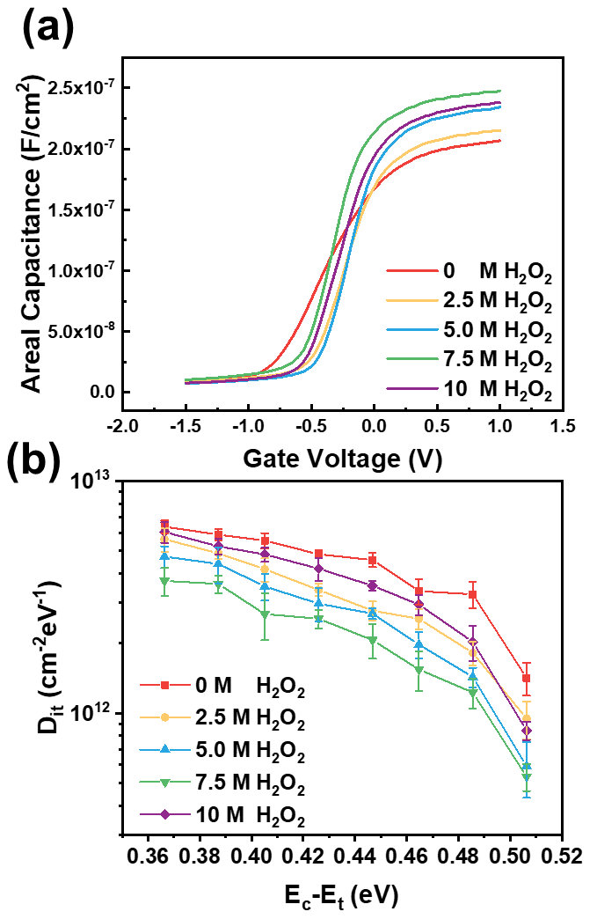
Fig. 1. (a) Capacitance-voltage (C-V), (b) the calculated interface trap density (D_{it}) in the E_{c}-E_{t} range of 0.37 eV to 0.51 eV of AlO_{x} MOSCAPs with different H₂O₂ concentration (0 M, 2.5 M, 5.0 M, 7.5 M, 10 M).
Table I summarizes the properties of H₂O₂ AlO_{x} thin films and MOSCAPs with different H₂O₂ concentration. The C-V curves measured at 1 MHz of AlO_{x} MOSCAPs are displayed in Fig. 1a; at least 5 devices of each H₂O₂ concentration were measured, as shown in Fig. S2. It is found that the C-V curves of 7.5 M H₂O₂ MOSCAPs had larger C_{max}, larger slope in the depletion region than other devices. The large C_{max} corresponding to higher AlO_{x} metal oxide framework concentration and the large slope of the C-V curves in the depletion region represents the enhanced interface quality with fewer interface traps.
To determine the effect of H₂O₂ in reducing interface trap density of AlO_{x} MOSCAPs, C-V curves were carried out under measurement frequency (f_{m}) from 1 kHz-1 MHz. Because higher f_{m} can only detect shallower interface states with higher characteristic interface trap frequency (f_{it}); thus, a higher gate voltage (V_{G}) is required to pull down the conduction band at the interface. It is reported that the capture cross-section of the interface traps varies from 1.4×10⁻¹⁵ cm² to 1.4×10⁻¹⁴ cm² when the traps energy level located from E_{c}-E_{t} = 0.24 eV to 0.73 eV. In order to avoid underestimating the interface trap density, it is assumed that the electron capture cross section at the interface $σ_{n}$was1×10⁻¹⁴ cm² in this work, which gives the value of D_{it} in the energy level range from 0.37 eV to 0.51 eV from the conduction band edge. Fig. 1b displays the comparison of D_{it} at
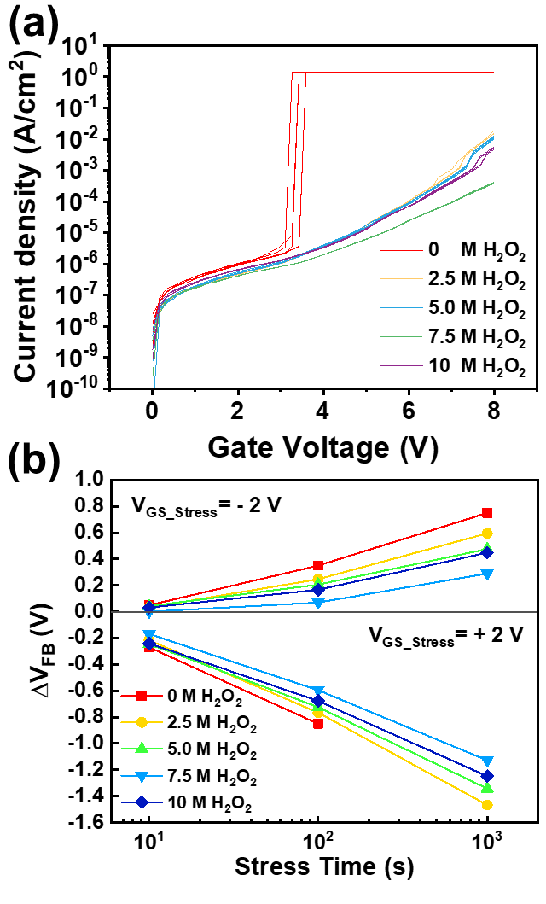
Fig. 2. (a) Leakage behavior (J_{leak}-V) and (b) positive & negative bias-stress (BS) stability of AlO_{x} MOSCAPs with different H₂O₂ concentration (0 M, 2.5 M, 5.0 M, 7.5 M, 10 M).
E_{c}-E_{t}=0.37 eV, with H₂O₂ concentration increasing from 0 M to 7.5 M, the D_{it} reduced from 6.35×10¹² cm⁻²eV⁻¹ to 3.72×10¹² cm⁻²eV⁻¹, the results are comparable to the value (2.2×10¹³ cm⁻²eV⁻¹) calculated from high-k oxide MOSCAPs reported in [26]. However, as the H₂O₂ concentration increased to around 10 M, there is an increase of D_{it} from 3.72×10¹² cm⁻²eV⁻¹(7.5 M) to 5.72×10¹² cm⁻²eV⁻¹ (10 M). This phenomenon could be probably ascribed to the quick condensation of precursor accompanied with O₂ releasing. The strong oxidation of H₂O₂ could lead to a rough semiconductor/oxide interface with increasing interface trap density [27].
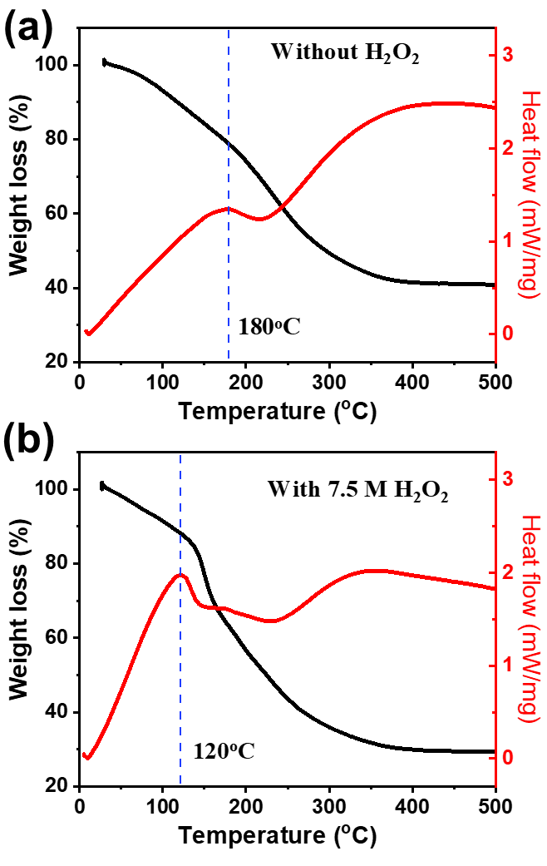
Fig. 3. TGA curves of Al(NO₃)₃ precursor powder (a) with 0 M H₂O₂ and (b) with 7.5 M H₂O₂ heated from 20 to 500 ºC with a heating rate of 10 ºC/min.
Leakage behavior (J_{leak}-V_{g}) of the AlO_{x} thin films was investigated and shown in Fig. 2a. It can be observed that adding H₂O₂ reduced J_{leak} effectively, which is attributed to the improved film quality with reduced structure defects, precursor impurities, and V_{o}. In this situation, the leakage paths were suppressed, and the leakage current was reduced accordingly. As shown in Fig. S3, the ln(J/E) versus E^{1/2} is linear, indicating the mechanism of the leakage current may be the Poole-Frenkel (PF) emission since it is usually assigned as the dominating leakage mechanism in metal-insulator-metal thin film stacks [28].
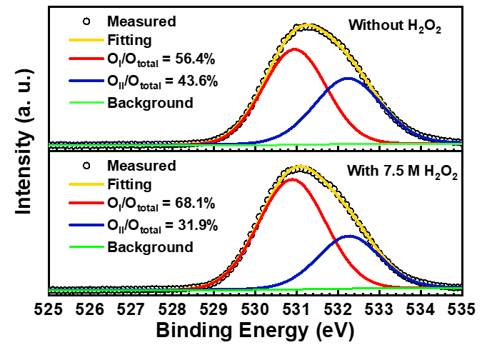
Fig. 4. X-ray photoelectron spectroscopy (XPS) spectra of O 1s narrow scans of solution-processed AlO_{x} films.
The BS stability of AlO_{x} MOSCAPs were investigated under gate voltage stress (V_{GS_Stress}) = + 2 V and V_{GS_Stress}= - 2 V with stress time up to 1000 s. The extracted flat-band voltage shift (ΔV_{FB}) is demonstrated in Fig. 2b. As the H₂O₂ concentration increased, the BS stability is gradually improved, and 7.5 M AlO_{x} MOSCAP have the best BS stability, corresponding to its best thin film quality with reduced V_{o} and defects.

Mechanism of employing H₂O₂
TGA-DSC curves of AlO_{x} precursor powder are shown in Fig. 3a and b. AlO_{x} thin films with 0 M and 7.5 M H₂O₂ concentration were selected for comparison, as AlO_{x} MOCAPs with 7.5 M H₂O₂ concentration have demonstrated the best device properties and BS stability. The formation of the thin film can be divided into three stages. The first stage was the decomposition of the precursor. At this stage, most of the chemicals were vaporized, precursors were decomposed, and then hydrolyzed metals (M-OH, M, metal; O, oxygen; and H, hydrogen) were formed. The second stage was called the formation of the film. This stage began with a large exothermic reaction peak, as seen in the red lines in Fig. 3. M-OH were converted to metal oxide (M-O) gradually to form film during this stage. The third stage followed the exothermic reaction peak and was called the densification of film. It can be found in Fig. 3b that the exothermic reaction peak of precursor powder with 7.5 M H₂O₂ occurs at 120 ºC, which was lower than the temperature (180 ºC) of precursor powder with 0 M H₂O₂ in Fig. 3a. This indicated the decomposition of impurities was accelerated, which could start at lower temperature: huge molecules broke down into tiny volatile molecules, such as oxygen and water, during the strong oxidizing reaction of H₂O₂ [29]. During this process, H₂O₂ was decomposed by pyrolysis, and hydroxyl radicals (OH•) were released through the stepwise reactions below.
 | $$H_{2}O_{2}→2OH$$ | (1)
 | $${OH+H}_{2}O_{2}→HO_{2}+H_{2}O$$ | (2)
 | $$OH+HO_{2}→H_{2}O+O_{2}$$ | (3)
All reaction equations are based on related papers [22, 27]. Although hydroxyl radicals lived a very short time during reactions, they acted as a powerful oxidizer and could accelerate the decomposition of solvent residues because of a higher oxidation potential than H₂O₂ [30]. Besides, the precursor powder 7.5 M H₂O₂ had around 30 % weight left at 300 ºC, which was less than that (40 %) of precursor powder with 0 M H₂O₂, indicating more impurities were vaporized and decomposed during the annealing process. Consequently, adding 7.5M H₂O₂ could form dense films with an increased percentage of AlO_{x} metal oxide and reduced defect sites at the specified annealing temperature.
In order to further explore the effects of employing H₂O₂ on the M-O lattice formation and impurity contents of AlO_{x} thin films, XPS spectra are performed in Fig. 4. By applying Gaussian-Lorenz fitting method, the O1s peaks were deconvoluted into two peaks represent low bind energy (O_{I}, 530.9 eV) and high binding energy (O_{II}, 532.3 eV). The peak of O_{I} is connected to O²⁻ ions combined with Al ions, and the peak of O_{II} is assigned to bonded oxygen, such as oxygen vacancy, hydroxyl groups, or absorbed H₂O on the film surface [22, 27]. The fraction of [O_{I}/ (O_{I} + O_{II})] increased from 56.4 % to 68.1 % after adding 7.5 M H₂O₂, whereas the ratio of [O_{II}/ (O_{I} + O_{II})] decreased from 43.6% to 31.9 %. The strong oxidizing reactions of H₂O₂ could form a metal oxide framework at a low temperature and suppress the number of oxygen vacancies as well as other defects. The increased AlO_{x} metal oxide concentration, reduced oxygen vacancies and M-OH content could diminish the trap state density, which improved the stability of integrated MOS devices accordingly.

Biased-radiation-stress (BRS) stability
To investigate the BRS stability of 7.5 M H₂O₂ AlO_{x} and 0 M H₂O₂ AlO_{x} capacitors, the device degradation caused by radiation-exposure-only needs to be determined first. Consequently, ΔV_{FB} under No-Bias and radiation-exposure-only was calculated and summarized in Fig. 5 (a)-(c). It is observed that the radiation could barely affect the ΔV_{FB} of 7.5 M H₂O₂ AlO_{x} capacitors, whereas the 0 M H₂O₂ AlO_{x} capacitors suffered from the radiation caused degradation under radiation-exposure-only. Radiation could generate electron-hole pairs (EHPs) when passing through oxide [31]. It is reported that the EHPs would have no significant effect on devices without an applied electric field [32]. Therefore, the device response under PBRS and NBRS should be the focus when investigating the radiation hardness of a device.
To investigate the improved BRS stability of 7.5M H₂O₂ AlO_{x} thin films compared to 0 M H₂O₂ AlO_{x} thin films, voltage bias was applied on the gate of devices during radiation exposure, and the radiation exposure was not interrupted when carrying out the C-V measurement during the BRS investigation. In order to separate the BRS effect and BS effect, the BS results are provided for comparison, as shown in Fig. 5 (d)–(i). Under NBRS, the stress time was 46000 s, and the total dose was up to 42 Gy (SiO₂). However, under PBRS, the stress time was only 100 s, and the total dose was up to 0.1 Gy. The reason is that the devices exhibited severe property degradation under PBS corresponded to a large ΔV_{FB,} and the stress time was shortened accordingly. It can be found in Fig. 5d and g that BRS could barely lead to an additional ΔV_{FB} in the 7.5 M H₂O₂ AlO_{x} device compared to BS. However, 0 M H₂O₂ AlO_{x} exhibited BRS induced device degradation corresponding to a more significant C-V shift.
The ΔV_{FB} of AlO_{x} MOSCAPs under PBS and PBRS are shown in Fig. 5d, and the distributions of ΔV_{FB} under PBRS are shown in Fig. S5a. The time dependence of ΔV_{FB} under BS and BRS is in agreement with the stretched exponential equation, which can be expressed as [33]:
 | $${∆V}_{FB}={∆V}_{FB0}(1-exp⁡(-{\left(\frac{t}{τ}\right)}^{β})$$ | (4)
where ΔV_{FB0} is the ΔV_{FB} at infinite time, $τ$ is the characteristic trapping time of carriers, and $β$ is the stretched exponential exponent. The stretched-exponential time dependence model hypothesized the emission of trapped charges toward deep states in the bulk dielectric for a long stress time (t >$τ$) and large stress field. It is plausible that the amorphous structure of the gate dielectric will lend itself to an appreciable number of band-tail states which can act as transport states for the emitted lower energy trapped state charge [34], but the extent can be different depending on the materials or deposition condition of
dielectric layers. The fitted values are listed in Table S1 and Table S2; the results are consistent with those from the literature [34, 35], where the value of ΔV_{FB0} is mainly determined by the bias stress amplitudes and interface qualities. 7.5 M H₂O₂ devices have larger $τ$ than 0 M H₂O₂ devices, indicating the slower degradation under BS and BRS measurements.
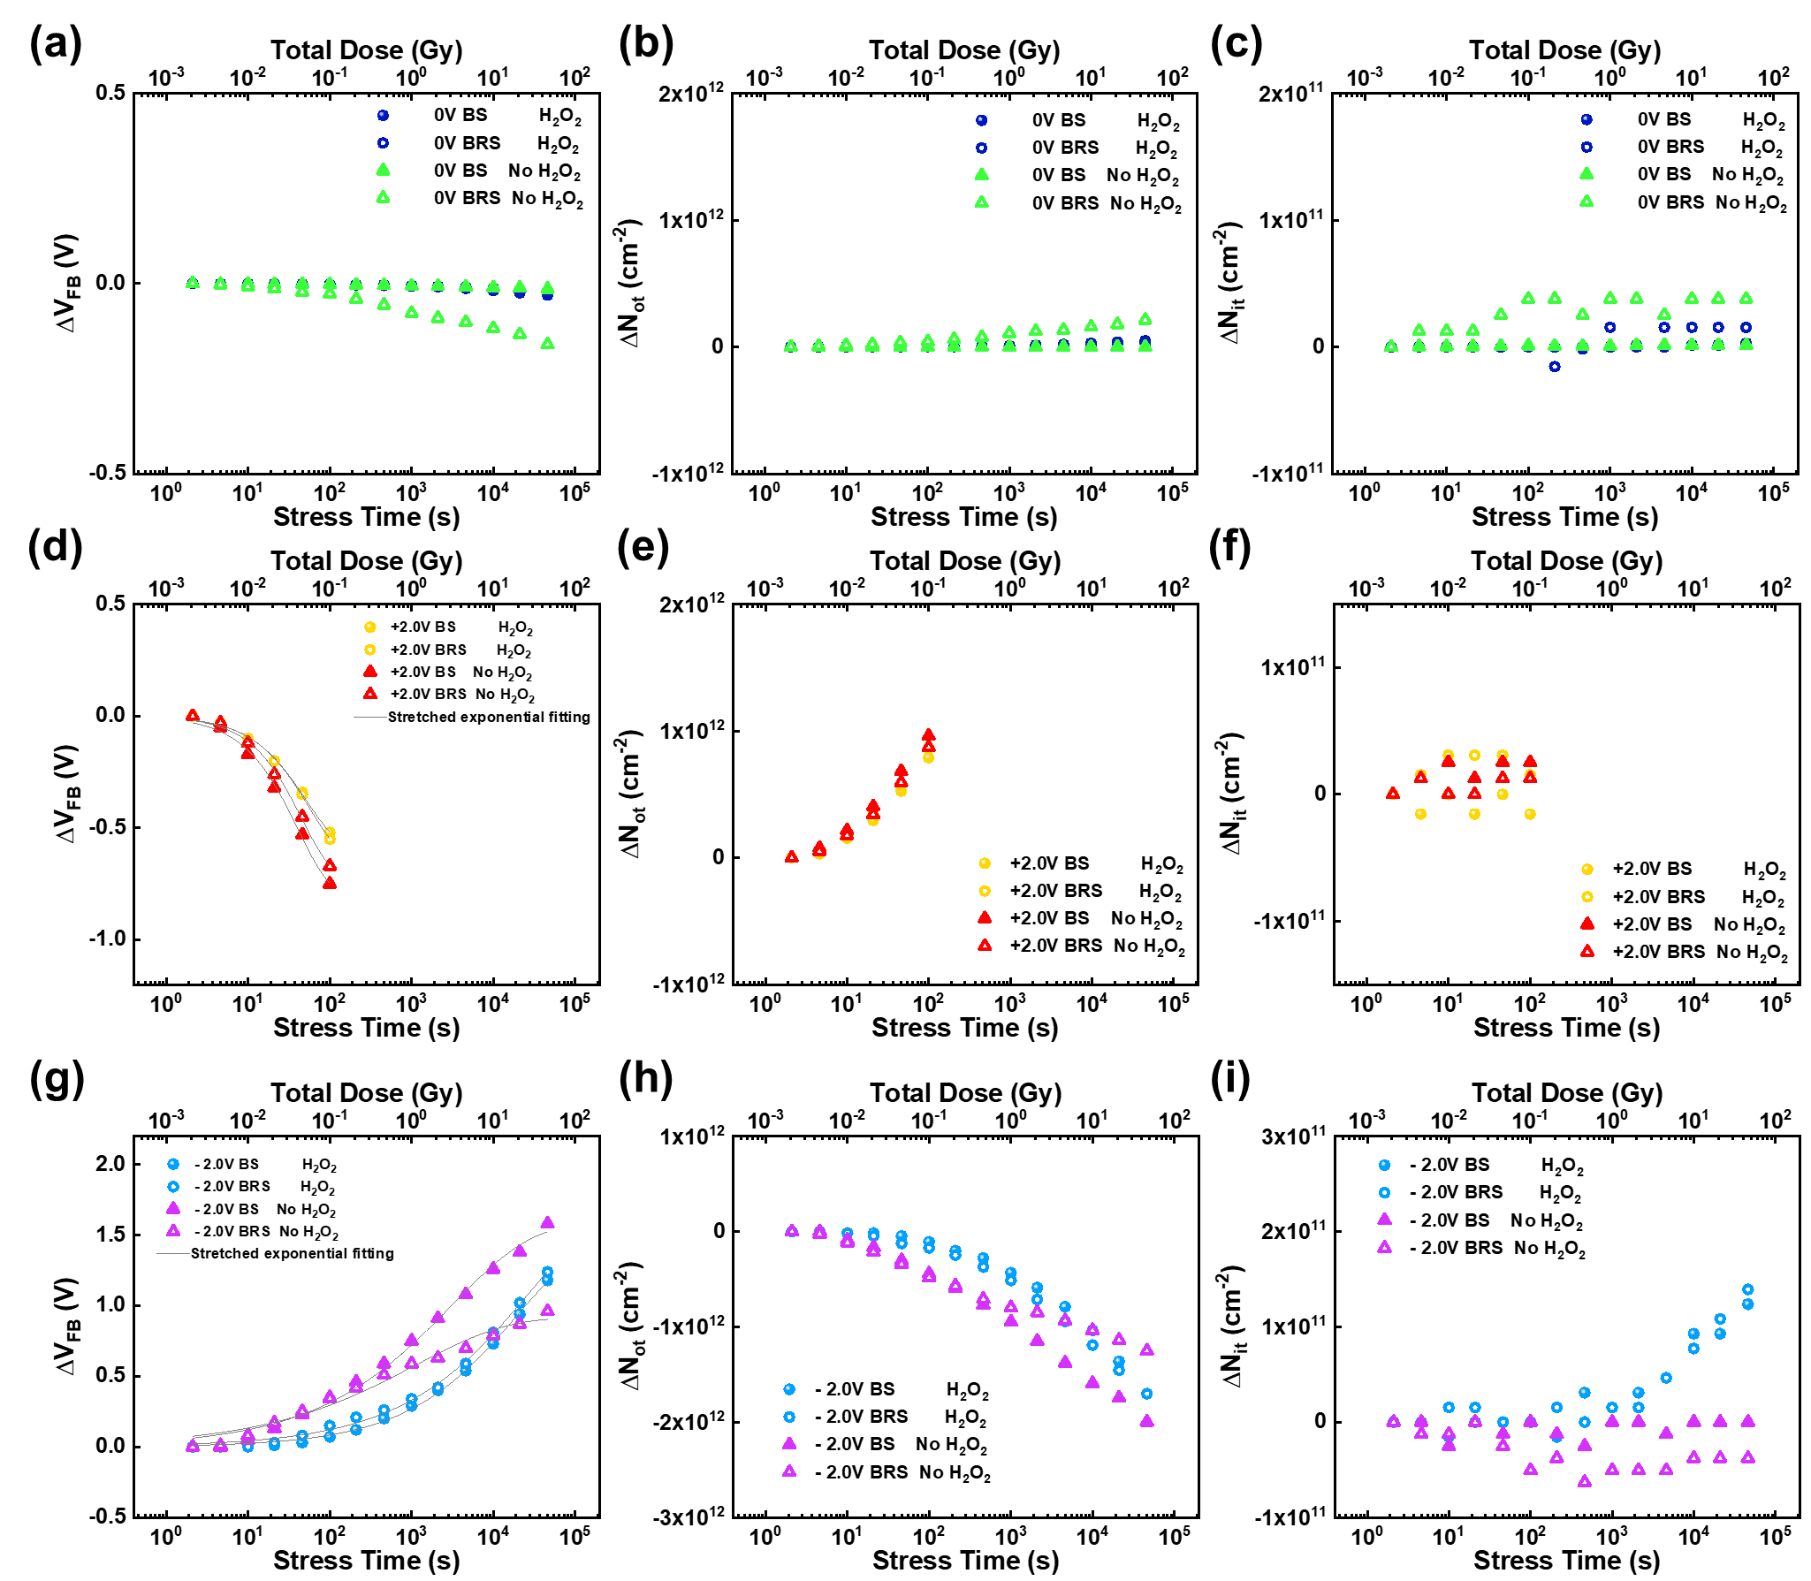
Fig. 5. (a) ΔV_{FB} and stretched exponential fitting results, (b) ΔN_{ot} and (c) ΔN_{it} of AlO_{x} MOSCAPs under positive bias-stress (PBS) and positive biased-radiation-stress (PBRS). (d) ΔV_{FB} and stretched exponential fitting results, (e) ΔN_{ot} and (f) ΔN_{it} of AlO_{x} MOSCAPs under negative bias-stress (NBS) and negative biased-radiation-stress (NBRS).
ΔV_{FB} is the combined effect of ΔN_{ot} in AlO_{x} bulk and ΔN_{it} at the AlO_{x}/Si interface. ΔN_{ot} causes the parallel shift of C-V curves, while ΔN_{it} influences the stretch-out of C-V curves. ΔN_{ot} can be estimated by equation (5) [36]:
 | $${ΔN}_{ot}=-\frac{C_{ox}{∆V}_{mg}}{qA}$$ | (5)
where ΔV_{mg} is the mid-gap voltage shift obtained from C-V curves, C_{ox} is the gate capacitance, q is the electronic charge and A is the electrode area. ΔN_{it} was estimated by equation(6) [36]:
 | $$∆N_{it}=\frac{C_{ox}({∆V}_{FB}-{∆V}_{mg})}{qA}$$ | (6)
Fig. 5e and f show ΔN_{ot} and ΔN_{it} of 7.5 M H₂O₂ AlO_{x}, respectively. No radiation-induced oxide traps or interface traps were observed under PBRS, whereas PBRS could cause a reduced positive ΔV_{FB} of 0 M H₂O₂ AlO_{x}, corresponding to radiation-induced electron trapping in AlO_{x} bulk. The generation of radiation-induced interface traps was negligible for all devices. The reason is that the generation of radiation-induced interface traps is related to the transport of radiation-induced holes and H⁺. Interface trap buildup occurs on time frames much slower than oxide-trap charge buildup; it takes place over many decades in time [37]. As a result, the PBRS time (100 s) was too short to affect interface trap density significantly.
As analyzed during the PBRS part, for 0 M H₂O₂ AlO_{x}, radiation could form negative oxide traps under PBRS, which was probably ascribed to the radiation-induced electron trapping in AlO_{x} bulk. This trapping behavior is highly sensitive to the electric field across the oxide during the radiation exposure, and switching the polarity of the bias-stress voltage should prevent the radiation-induced electron trapping. As a result, the device degradation under NBRS was then investigated. ΔV_{FB} under NBS and NBRS is demonstrated in Fig. 5g, the distribution of and ΔV_{FB} under NBRS is shown in Fig. S5b. For 7.5 M H₂O₂ AlO_{x}, NBRS could not cause additional positive ΔV_{FB} compared to NBS, indicating electron trapping in AlO_{x} bulk dominate the device property degradation under PBRS, and this trapping behavior was suppressed under NBRS in a short time. However, as the NBRS time increased, it resulted in a negative ΔV_{FB} of 0 M H₂O₂ AlO_{x}, indicating that switching bias suppressed the radiation-induced electron trapping and led to radiation-induced positive charges. ΔN_{ot} and ΔN_{it} of AlO_{x} MOSCAPs under NBRS were shown in Fig. 5h and i, respectively. No significant radiation-induced oxide traps or interface traps can be found in 7.5 M H₂O₂ AlO_{x}, whereas positive oxide traps and negative interface traps were generated under NBRS in 0 M H₂O₂ AlO_{x}. This could be ascribed to the breaking of Si-H bonds and AlO_{x}/Si interface, which contributes to an oxide trap (H⁺) and an interface trap (Si⁻) under NBRS; the detailed mechanism will be discussed with the assistance of energy band diagram later.
TGA and XPS results indicate that adding H₂O₂ in the solution-process could transfer M-OH into the M-O framework at low temperature and result in higher AlO_{x} metal oxide concentration in 7.5 M H₂O₂ AlO_{x} thin films than in 0 M H₂O₂ AlO_{x} thin films. In addition, H₂O₂ also suppressed the oxygen vacancy density, removed the precursor impurities, and enhanced the AlO_{x}/Si interface through its strong oxidation. The J-V and C-V results further prove the improvement of employing H₂O₂. As a result, the BS and BRS stabilities of the devices were improved by adding H₂O₂.

Mechanism of BRS induced degradation
According to the characterization results, the energy band diagrams of solution-processed AlO_{x} MOSCAPs under PBRS and NBRS can be displayed in Fig. 6a and b, respectively. For 0 M H₂O₂ AlO_{x} capacitors, reduced positive ΔN_{ot} was observed under PBRS compared to PBS. The decreased positive ΔN_{ot} was probably ascribed to radiation-induced electron trapping (process (3) in Fig. 6a). Radiation exposure and electric bias could form neutral traps among the AlO_{x} bulk near the AlO_{x}/Si interface [38]. Meanwhile, electrons in the Si substrate accumulated near the AlO_{x}/Si interface under a positive applied electric field. After that, those accumulated electrons could tunnel into the radiation generated traps and form negatively charged oxide traps, resulting in a reduced positive ΔN_{ot} [39, 40]. Besides, it is reported that V_{o} in oxide could significantly
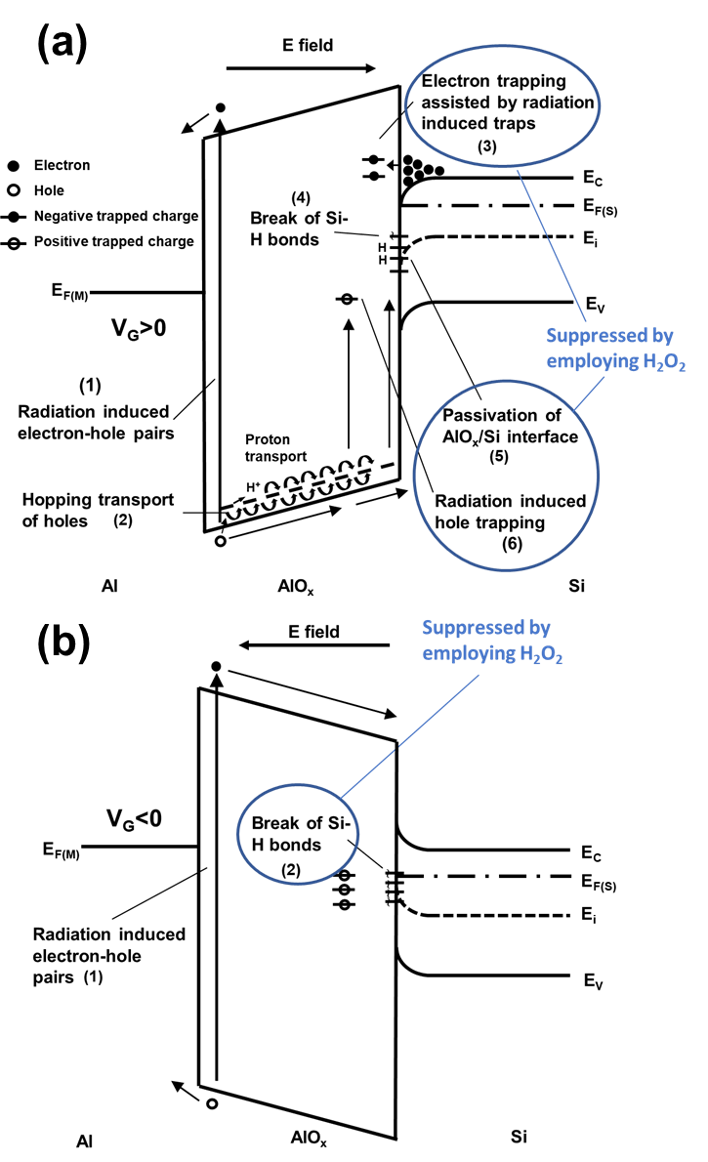
Fig. 6. Energy band diagrams of solution-processed AlO_{x} MOSCAPs under (a) PBRS and (b) NBRS.
degrade the device hardness by acting as trapping sites [41]. According to the XPS results and leakage behavior, 0 M H₂O₂ AlO_{x} capacitors exhibited higher defect density and larger leakage current than 7.5 M H₂O₂ AlO_{x} capacitors, which further verified that radiation-induced electron trapping dominated the generation of negative ΔN_{ot} observed in Fig. 5b.
Unlike oxide traps, radiation had a negligible effect on the interface trap density under PBRS. The interface-trap buildup is a two-stage process [37, 42]. During the first stage, EHPs are generated in AlO_{x} under radiation exposure (process (1) in Fig. 6a). With a positive applied electrical field, the electrons are sweep out of AlO_{x} thin film in picoseconds, whereas the holes are transported through AlO_{x} and trapped near the AlO_{x}/Si interface to form an oxide trap. The transportation is accompanied by the release of hydrogen, in the form of H⁺ (process (2) in Fig. 6b). In the second stage, the released H⁺ move towards the AlO_{x}/Si interface and passivate the Si⁻ (reaction (7)). Once a defect is passivated by hydrogen, it no longer functions as an interface trap.
 | $${Si}^{-}+H^{+}→Si-H$$ | (7)
The generation of radiation-induced interface traps is negligible for all devices. The PBRS time was too short (100 s) to generate significant radiation-induced interface traps.
7.5 M H₂O₂ AlO_{x} capacitors have demonstrated improved radiation hardness under PBRS with ignorable radiation-induced ΔN_{ot} and ΔN_{it} compared to 0 M H₂O₂ AlO_{x} capacitors, which is likely due to the dense film with low defect density (V_{o}) and leakage current. The reduced number of V_{o} and high AlO_{x} concentration could suppress the radiation-induced
electron trapping behavior. Thereby, the radiation hardness of AlO_{x} devices under PBRS was improved by employing H₂O₂.
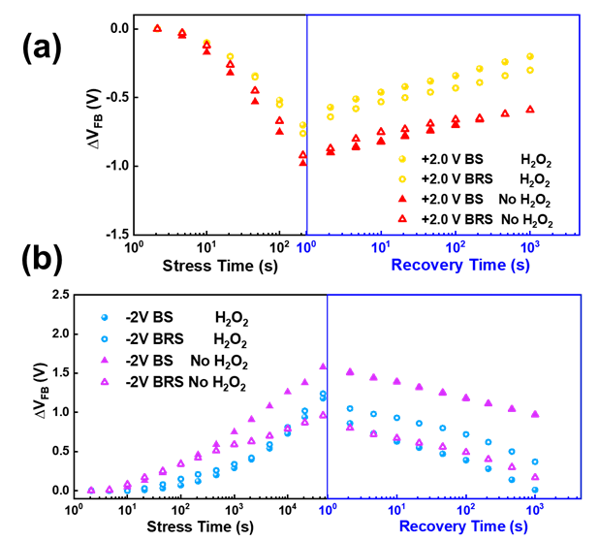
Fig. 7. ΔV_{FB} recovery characteristics of solution-processed AlO_{x} MOSCAPs after (a) PBS & PBRS and (b) NBS & NBRS.
Under NBRS, for 0 M H₂O₂ AlO_{x} devices, negative ΔN_{ot} was decreased in magnitude, whereas negative ΔN_{it} was produced. As shown in Fig. 6b, under negative applied gate voltage, the radiation-induced electron tunnelling from substrate and trapping among AlO_{x} bulk were suppressed. Instead, the breaking of Si-H bonds at the AlO_{x}/Si interface dominated the device radiation response, which could contribute to an interface trap (Si⁻) and an available H⁺ that can be trapped in AlO_{x} to serve as an oxide trap (reaction (8)) [24].
 | $$Si-H→{Si}^{-}+H^{+}$$ | (8)
Density-functional-theory calculations have demonstrated that the simple thermally assisted Si-H bond breaking is highly improbable for a passivated interface dangling bond under normal device operating conditions, such as simply voltage bias-stress at room temperature [43]. However, the applied electric field combined with radiation exposure can reduce the binding energy of a Si-H bond. Some candidates can facilitate breaking Si-H bonds, including the impurity Al atoms and suboxide bonds near the AlO_{x}/Si interface [44]. It has been proved that 0 M H₂O₂ AlO_{x} thin films contain a high concentration of metal hydroxide and a large density of oxygen vacancy. As a result, as the NBRS time increased, the breaking of Si-H bonds at the AlO_{x}/Si interface leads to the variations of ΔN_{ot} and ΔN_{it}.
On the other hand, 7.5 M H₂O₂ AlO_{x} capacitors had satisfied radiation hardness under NBRS; no additional radiation-induced ΔN_{ot} or ΔN_{it} could be found. The previous characterization results reveal that 7.5 M H₂O₂ AlO_{x} thin film contained enhanced metal-oxygen lattice, reduced V_{o,} and hydroxide species, indicating the amount of impurity Al atoms and suboxide bonds were reduced. The first-principle Hartree-Fock calculation [45] shows that the hydrogen bonding energy increases when the Si–O–Si angle reduces. With an improved oxide/semiconductor interface, the Si–O–Si bond can be less stretched, which leads to a stronger hydrogen bond. Similarly, for thinner and denser AlO_{x} thin films, the breaking of Si-H bonds could be suppressed. Besides, the improved film quality with reduced defect density limited the radiation-induced trapping/de-trapping behaviors in 7.5 M H₂O₂ AlO_{x} devices. Consequently, the radiation hardness of 7.5 M H₂O₂ AlO_{x} capacitors under NBRS was improved accordingly.
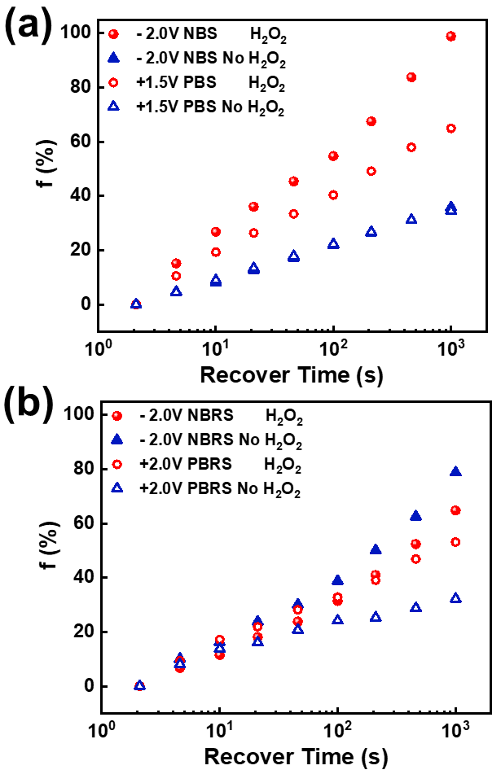
Fig. 8. Percent fading values of solution-processed AlO_{x} MOSCAPs after different (a) BS and (b) BRS conditions.
To further verify the radiation-induced damage under NBRS, the negative biased-illumination-stress (NBIS) was performed. The photon emitted by the LED has very low photon energy (~2.73 eV with λ ≈ 455 nm) compared to the energy (662 keV) of the photon emitted by the photon Cs¹³⁷ γ-ray radiation source used in this work. The Si-H bonds at the Si/AlO_{x} interface should not be broke by the incident light and lead to positive oxide traps. ΔV_{FB} and the distribution of ΔV_{FB} measured from at least 3 devices under NBS and NBIS are demonstrated in Fig. S6. As expected, both 7.5 M H₂O₂ AlO_{x} and 0 M H₂O₂ AlO_{x} exhibited NBIS induced positive V_{FB} shift.

Fading characteristics
As the voltage bias during the radiation exposure facilitated the motion of radiation-induced EHPs and thus degraded the device properties severely. The recovery behavior of the device under radiation exposure after the bias-stress was removed is a crucial issue to be investigated. Fig. 7 display the recovery behavior of the devices under BS and BRS, respectively. The BS and BRS induced degradation involved two components, a permanent (fixed) component, which was not decreased after stress removal, and a reversible component, which followed the applied stress bias dynamically. The devices recovered quickly when the bias-stress voltage was interrupted, demonstrating a self-healing ability. However, compared to the recovery behavior under BS, BRS still induced permanent damage to all devices. The device's recovery was related to the annealing of radiation-induced oxide traps, which was probably ascribed to that interface traps annealing requires high temperature [46]. The decreased fading values suggested that BRS induced oxide traps cannot be annealed and lead to permanent damage to AlO_{x} thin films. Generally, the neutralization of oxide trapped charge occurs primarily by one of two mechanisms: 1) the tunnelling of electrons from the silicon into either oxide traps [47] or electron traps associated with trapped holes [48], and/or 2) the thermal emission of electrons from the oxide valence band into oxide traps [49].
To better estimate the spontaneous recovery behavior of the MOSCAPs at room temperature, the fading characteristic is essential [50]. The percent fading value can be calculated from [51]:
 | $$f=\frac{V_{FB}(0)-V_{FB}(t)}{V_{FB}(0)-V_{FB}}×100\%$$ | (9)
where V_{FB} is the fresh flat band voltage, V_{FB}(0) is the flat band voltage immediately after bias stress experiment, and V_{FB}(t) is the flat band voltage after annealing time t. The fading values of 7.5 M H₂O₂ AlO_{x} and 0 M H₂O₂ AlO_{x} MOSCAPs after BS and BRS are shown in Fig. 8. It can be found that fading values were decreased under BRS compared to BS, except for the 0 M H₂O₂ AlO_{x} device under NBRS; it even increased after NBRS. Nevertheless, 7.5 M H₂O₂ devices exhibit higher fading values than 0 M H₂O₂ devices, indicating improved spontaneous recovery ability.

Conclusion
The method to improve the BS and BRS stabilities of solution-processed AlO_{x} was explored. H₂O₂ was employed in the precursor solution as a strong oxidizer. In addition, H₂O₂ suppressed the oxygen vacancy density, removed the precursor impurities, and enhanced the AlO_{x}/Si interface through its strong oxidation at low temperature. The J-V and C-V results further proved the enhancement of employing H₂O₂. In addition, the reliability of the devices was improved by adding H₂O₂. 7.5 M H₂O₂ AlO_{x} devices had demonstrated enhanced BS and BRS stabilities with stress time up to 46000 s and total dose up to 42 Gy (SiO₂). When the devices were under BRS, H₂O₂ could suppress the transportation and reaction of hydrogen (e.g., breaking of Si-H bond), the electron trapping into radiation generated neutral traps and the V_{o} among AlO_{x} bulk. ΔN_{it} was insignificant compared to ΔN_{ot}, which was ascribed to that interface trap buildup occurs on time frames much slower than the oxide-trap charge buildup. The degradation involved a permanent (fixed) component and a reversible component. It is found that BRS could result in permanent damage to all devices; 7.5 M H₂O₂AlO_{x} devices exhibited stronger recoverability than those with 0 M H₂O₂. The results in this work indicated that employing H₂O₂ in the solution-process had significant potential to improve the BS and BRS stabilities of large-area electronics applied for the nuclear environment and display area.

References
[1] S. Nam, Y. J. Jeong, J. Jung, S. H. Kim, J. Ahn, K. Shin, and J. Jang, "Direct printing of soluble acene crystal stripes by a programmed dip-coating process for organic field-effect transistor applications," Journal of Materials Chemistry C, vol. 6, No. 4, pp. 799-807, 2018,
[2] E. H. Kwon, Y. J. Jang, G. W. Kim, M. Kim, and Y. D. Park, "Highly crystalline and uniform conjugated polymer thin films by a water-based biphasic dip-coating technique minimizing the use of halogenated solvents for transistor applications," RSC Adv, vol. 9, No. 11, pp. 6356-6362, 2019,
[3] K. K. Banger, Y. Yamashita, K. Mori, R. L. Peterson, T. Leedham, J. Rickard, and H. Sirringhaus, "Low-temperature, high-performance solution-processed metal oxide thin-film transistors formed by a 'sol-gel on chip' process," Nat Mater, vol. 10, No. 1, pp. 45-50, Jan 2011, 10.1038/nmat2914.
[4] C. Avis, Y. G. Kim, and J. Jang, "Solution processed hafnium oxide as a gate insulator for low-voltage oxide thin-film transistors," J Mater Chem, vol. 22, No. 34, p. 17415, 2012, 10.1039/c2jm33054g.
[5] W. Y. Xu, H. T. Cao, L. Y. Liang, and J. B. Xu, "Aqueous solution-deposited gallium oxide dielectric for low-temperature, low-operating-voltage indium oxide thin-film transistors: a facile route to green oxide electronics," ACS Appl Mater Inter, vol. 7, No. 27, pp. 14720-5, Jul 15 2015, 10.1021/acsami.5b02451.
[6] G. H. Gelinck, H. E. Huitema, E. van Veenendaal, E. Cantatore, L. Schrijnemakers, J. B. van der Putten, T. C. Geuns, M. Beenhakkers, J. B. Giesbers, B. H. Huisman, E. J. Meijer, E. M. Benito, F. J. Touwslager, A. W. Marsman, B. J. van Rens, and D. M. de Leeuw, "Flexible active-matrix displays and shift registers based on solution-processed organic transistors," Nat Mater, vol. 3, No. 2, pp. 106-10, Feb 2004, 10.1038/nmat1061.
[7] F. Molina-Lopez, T. Z. Gao, U. Kraft, C. Zhu, T. Ohlund, R. Pfattner, V. R. Feig, Y. Kim, S. Wang, Y. Yun, and Z. Bao, "Inkjet-printed stretchable and low voltage synaptic transistor array," Nat Commun, vol. 10, No. 1, p. 2676, Jun 18 2019, 10.1038/s41467-019-10569-3.
[8] W. Cai, H. Ning, Z. Zhu, J. Wei, S. Zhou, R. Yao, Z. Fang, X. Huang, X. Lu, and J. Peng, "Investigation of direct inkjet-printed versus spin-coated ZrO₂ for sputter IGZO thin film transistor," Nanoscale Res Lett, vol. 14, No. 1, p. 80, Mar 5 2019, 10.1186/s11671-019-2905-2.
[9] W. Xu, M. Long, T. Zhang, L. Liang, H. Cao, D. Zhu, and J.-B. Xu, "Fully solution-processed metal oxide thin-film transistors via a low-temperature aqueous route," Ceram Int, vol. 43, No. 8, pp. 6130-6137, 2017, 10.1016/j.ceramint.2017.02.007.
[10] B. Yang, G. He, L. Zhu, C. Zhang, Y. Zhang, Y. Xia, F. Alam, and Z. Sun, "Low-voltage-operating transistors and logic circuits based on a water-driven ZrGdO_{x} dielectric with low-cost ZnSnO," ACS Applied Electronic Materials, vol. 1, No. 4, pp. 625-636, 2019, 10.1021/acsaelm.9b00110.
[11] H.-R. Byun, E.-A. You, and Y.-G. Ha, "Room-temperature solution-processed, ZrO_{x}-based hybrid gate dielectrics for low-voltage organic thin-film transistors on plastic substrates," Appl Phys Lett, vol. 114, No. 1, p. 013301, 2019,
[12] Y. X. Fang, C. Zhao, I. Z. Mitrovic, S. Hall, L. Yang, and C. Z. Zhao, "Bias-stress stability and radiation response of solution-processed AlO_{x} dielectrics investigated by on-site measurements," Microelectron Eng, No. p. 111113, 2019/08/22/ 2019, https://doi.org/10.1016/j.mee.2019.111113.
[13] L.-C. Liu, J.-S. Chen, and J.-S. Jeng, "Role of oxygen vacancies on the bias illumination stress stability of solution-processed zinc tin oxide thin film transistors," Appl Phys Lett, vol. 105, No. 2, p. 023509, 2014, 10.1063/1.4890579.
[14] D.-Y. Zhong, J. Li, C.-Y. Zhao, C.-X. Huang, J.-H. Zhang, X.-F. Li, X.-Y. Jiang, and Z.-L. Zhang, "Enhanced electrical performance and negative bias illumination stability of solution-processed InZnO thin-film transistor by boron addition," IEEE T Electron Dev, vol. 65, No. 2, pp. 520-525, 2018, 10.1109/ted.2017.2779743.
[15] Y. S. Rim, W. H. Jeong, D. L. Kim, H. S. Lim, K. M. Kim, and H. J. Kim, "Simultaneous modification of pyrolysis and densification for low-temperature solution-processed flexible oxide thin-film transistors," J Mater Chem, vol. 22, No. 25, pp. 12491-12497, 2012,
[16] J. Yang, Y. Zhang, C. Qin, X. Ding, and J. Zhang, "Enhanced stability in Zr-doped ZnO TFTs with minor influence on mobility by atomic layer deposition," IEEE T Electron Dev, vol. 66, No. 4, pp. 1760-1765, 2019, 10.1109/TED.2019.2896313.
[17] W. Yang, K. Song, Y. Jung, S. Jeong, and J. Moon, "Solution-deposited Zr-doped AlO_{x} gate dielectrics enabling high-performance flexible transparent thin film transistors," J Mater Chem C, vol. 1, No. 27, p. 4275, 2013, 10.1039/c3tc30550c.
[18] E. Carlos, R. Branquinho, A. Kiazadeh, J. Martins, P. Barquinha, R. Martins, and E. Fortunato, "Boosting electrical performance of high-k nanomultilayer dielectrics and electronic devices by combining solution combustion synthesis and UV irradiation," ACS Appl Mater Inter, vol. 9, No. 46, pp. 40428-40437, 2017/11/22 2017, 10.1021/acsami.7b11752.
[19] K. M. Kim, W. H. Jeong, D. L. Kim, Y. S. Rim, Y. Choi, M.-K. Ryu, K.-B. Park, and H. J. Kim, "Low-temperature solution processing of AlInZnO/InZnO dual-channel thin-film transistors," IEEE Electr Device L, vol. 32, No. 9, pp. 1242-1244, 2011,
[20] B. Park, D. Ho, G. Kwon, D. Kim, S. Y. Seo, C. Kim, and M.-G. Kim, "Solution-processed rad-hard amorphous metal-oxide thin-film transistors," Adv Funct Mater, vol. 28, No. 47, p. 1802717, 2018, 10.1002/adfm.201802717.
[21] Y. Fang, T. Zhao, C. Zhao, C. Zhao, I. Mitrovic, and L. Yang, "Enhanced biased radiation and illumination stress stability of solution-processed AlO_{x} dielectrics using hydrogen peroxide," in 2019 International Conference on IC Design and Technology (ICICDT), 2019, pp. 1-3.
[22] J. M. Kwon, J. Jung, Y. S. Rim, D. L. Kim, and H. J. Kim, "Improvement in negative bias stress stability of solution-processed amorphous In-Ga-Zn-O thin-film transistors using hydrogen peroxide," ACS Appl Mater Inter, vol. 6, No. 5, pp. 3371-7, Mar 12 2014, 10.1021/am4054139.
[23] J. M. Campos-Martin, G. Blanco-Brieva, and J. L. Fierro, "Hydrogen peroxide synthesis: an outlook beyond the anthraquinone process," Angew Chem Int Ed Engl, vol. 45, No. 42, pp. 6962-84, Oct 27 2006, 10.1002/anie.200503779.
[24] X. J. Zhou, D. M. Fleetwood, L. Tsetseris, R. D. Schrimpf, and S. T. Pantelides, "Effects of Switched-bias Annealing on Charge Trapping in HfO₂ Gate Dielectrics," IEEE T Nucl Sci, vol. 53, No. 6, pp. 3636-3643, 2006, 10.1109/TNS.2006.884249.
[25] Y. Fang, C. Zhao, S. Hall, I. Z. Mitrovic, W. Xu, L. Yang, T. Zhao, Q. Liu, and C. Zhao, "Aqueous solution-processed AlOx dielectrics and their biased radiation response investigated by an on-site technique," Radiat Phys Chem, vol. 170, No. p. 108644, 2020, 10.1016/j.radphyschem.2019.108644.
[26] Y. Mu, Y. Fang, C. Z. Zhao, C. Zhao, Q. Lu, Y. Qi, R. Yi, L. Yang, I. Z. Mitrovic, S. Taylor, and P. R. Chalker, "Total dose effects and bias instabilities of (NH₄)₂S passivated Ge MOS capacitors with Hf_{x}Zr_{1–x}O_{y}thin films," IEEE T Nucl Sci, vol. 64, No. 12, pp. 2913-2921, 2017, 10.1109/TNS.2017.2768566.
[27] A. Tessier and W. Forst, "Mechanism of hydrogen peroxide pyrolysis," Canadian Journal of Chemistry, vol. 52, No. 5, pp. 794-797, 1974/03/01 1974, 10.1139/v74-125.
[28] H. P. Zhu, Z. S. Zheng, B. Li, B. H. Li, G. P. Zhang, D. L. Li, J. T. Gao, L. Yang, Y. Cui, C. P. Liang, J. J. Luo, and Z. S. Han, "Total dose effect of Al₂O₃-based metal–oxide–semiconductor structures and its mechanism under gamma-ray irradiation," Semicond Sci Tech, vol. 33, No. 11, p. 115010, 2018, 10.1088/1361-6641/aada7a.
[29] S. Izyumov, E. Y. Shchekotov, D. Shchekotov, V. Tyapkov, S. Erpyleva, V. Bykova, and M. Zaitsev, "Studying the decomposition of monoethanolamine in water using efficient oxidation processes," Thermal Engineering, vol. 58, No. 7, pp. 535-539, 2011,
[30] S. V. Izyumov, E. Y. Shchekotov, D. E. Shchekotov, V. F. Tyapkov, S. F. Erpyleva, V. V. Bykova, and M. A. Zaitsev, "Studying the decomposition of monoethanolamine in water using efficient oxidation processes," Thermal Engineering, vol. 58, No. 7, pp. 535-539, 2011/07/01 2011, 10.1134/S0040601511070056.
[31] T. R. Oldham and F. McLean, "Total ionizing dose effects in MOS oxides and devices," IEEE T Nucl Sci, vol. 50, No. 3, pp. 483-499, 2003,
[32] Q. Q. Zhuo, H. X. Liu, Z. N. Yang, H. M. Cai, and Y. Hao, "The total dose irradiation effects of SOI NMOS devices under different bias conditions," Acta Phys Sin-Ch Ed, vol. 61, No. 22, p. 6, 2012, 10.7498/aps.61.220702.
[33] J.-M. Lee, I.-T. Cho, J.-H. Lee, and H.-I. Kwon, "Bias-stress-induced stretched-exponential time dependence of threshold voltage shift in InGaZnO thin film transistors," Appl Phys Lett, vol. 93, No. 9, p. 093504, 2008, 10.1063/1.2977865.
[34] F. Libsch and J. Kanicki, "Bias‐stress‐induced stretched‐exponential time dependence of charge injection and trapping in amorphous thin‐film transistors," Appl Phys Lett, vol. 62, No. 11, pp. 1286-1288, 1993,
[35] S. Zafar, A. Callegari, E. Gusev, and M. V. Fischetti, "Charge trapping related threshold voltage instabilities in high permittivity gate dielectric stacks," J Appl Phys, vol. 93, No. 11, pp. 9298-9303, 2003,
[36] J. Felix, D. Fleetwood, R. Schrimpf, J. Hong, G. Lucovsky, J. Schwank, and M. Shaneyfelt, "Total-dose radiation response of hafnium-silicate capacitors," IEEE T Nucl Sci, vol. 49, No. 6, pp. 3191-3196, 2002,
[37] M. Shaneyfelt, J. Schwank, D. Fleetwood, P. Winokur, K. Hughes, G. Hash, and M. Connors, "Interface-trap building rates in wet and dry oxides," IEEE T Nucl Sci, vol. 39, No. 6, pp. 2244-2251, 1992,
[38] M. Ceschia, A. Paccagnella, A. Cester, A. Scarpa, and G. Ghidini, "Radiation induced leakage current and stress induced leakage current in ultra-thin gate oxides," IEEE T Nucl Sci, vol. 45, No. 6, pp. 2375-2382, 1998,
[39] D. A. Neamen, "Modeling of MOS radiation and post irradiation effects," IEEE T Nucl Sci, vol. 31, No. 6, pp. 1439-1443, 1984, 10.1109/TNS.1984.4333526.
[40] T. Stanley, D. Neamen, P. Dressendorfer, J. Schwank, P. Winokur, M. Ackermann, K. Jungling, C. Hawkins, and W. Grannemann, "The effect of operating frequency in the radiation induced buildup of trapped holes and interface states in MOS devices," IEEE T Nucl Sci, vol. 32, No. 6, pp. 3982-3987, 1985, 10.1109/TNS.1985.4334054.
[41] J. R. Schwank, M. R. Shaneyfelt, D. M. Fleetwood, J. A. Felix, P. E. Dodd, P. Paillet, and V. Ferlet-Cavrois, "Radiation effects in MOS oxides," IEEE T Nucl Sci, vol. 55, No. 4, pp. 1833-1853, 2008, 10.1109/TNS.2008.2001040.
[42] F. McLean, "A framework for understanding radiation-induced interface states in SiO₂ MOS structures," IEEE T Nucl Sci, vol. 27, No. 6, pp. 1651-1657, 1980,
[43] L. Tsetseris, X. J. Zhou, D. M. Fleetwood, R. D. Schrimpf, and S. T. Pantelides, "Physical mechanisms of negative-bias temperature instability," Appl Phys Lett, vol. 86, No. 14, p. 142103, 2005, 10.1063/1.1897075.
[44] C. Zhao, J. Zhang, M. Zahid, G. Groeseneken, R. Degraeve, and S. De Gendt, "Impact of gate materials on positive charge formation in HfO₂∕ SiO₂ stacks," Appl Phys Lett, vol. 89, No. 2, p. 023507, 2006,
[45] K. Vanheusden, P. Korambath, H. Kurtz, S. Karna, D. Fleetwood, W. Shedd, and R. Pugh, "The effect of near-interface network strain on proton trapping in SiO₂," IEEE T Nucl Sci, vol. 46, No. 6, pp. 1562-1567, 1999,
[46] A. Lelis, T. Oldham, and W. DeLancey, "Response of interface traps during high-temperature anneals (MOSFETs)," IEEE T Nucl Sci, vol. 38, No. 6, pp. 1590-1597, 1991,
[47] T. Oldham, A. Lelis, and F. McLean, "Spatial dependence of trapped holes determined from tunneling analysis and measured annealing," IEEE T Nucl Sci, vol. 33, No. 6, pp. 1203-1209, 1986,
[48] A. Lelis, T. Oldham, H. Boesch, and F. McLean, "The nature of the trapped hole annealing process," IEEE T Nucl Sci, vol. 36, No. 6, pp. 1808-1815, 1989,
[49] P. McWhorter, S. Miller, and W. Miller, "Modeling the anneal of radiation-induced trapped holes in a varying thermal environment," IEEE T Nucl Sci, vol. 37, No. 6, pp. 1682-1689, 1990,
[50] G. Ristić, S. Golubović, and M. Pejović, "Sensitivity and fading of pMOS dosimeters with thick gate oxide," Sensors and Actuators A: Physical, vol. 51, No. 2-3, pp. 153-158, 1995,
[51] E. Yilmaz and S. Kaya, "A detailed study on zero-bias irradiation responses of La₂O₃ MOS capacitors," IEEE T Nucl Sci, vol. 63, No. 2, pp. 1301-1305, 2016,

This research was funded in part by Key Program Special Fund in XJTLU (KSF-A-07 and KSF-T- 03), Natural Science Foundation of SZU (2017001), Suzhou Science and Technology programme (SYG201623), XJTLU Research Development Fund (RDF-17-01-13) and Guangdong Research Center for Interfacial Engineering of Functional Materials (201701). The author IZM acknowledges UKRI GIAA award as well as British Council UKIERI project no. IND/CONT/G/17-18/18. Y. Fang, T. Zhao and I.Z. Mitrovic are with the Department of Electrical Engineering and Electronics, University of Liverpool, Liverpool L69 3GJ, UK; W. Xu are with the College of Materials Science and Engineering, Guangdong Research Center for Interfacial Engineering of Functional Materials, Shenzhen Key Laboratory of Special Functional Materials, Shenzhen University, Shenzhen 518060, China; L. Yang are with the Department of Chemistry, Xi’an Jiaotong-Liverpool University, Suzhou 215123, China; C. Zhao and C. Zhao are with the Department of Electrical and Electronic Engineering, Xi’an Jiaotong-Liverpool University, Suzhou 215123, China (E-mail: Chun.Zhao@xjtlu.edu.cn; Cezhou.zhao@xjtlu.edu.cn).

