The X-ray structure of juvenile hormone diol kinase from the silk worm Bombyx mori.

Jingxu Guo,^{a,b} Ronan M. Keegan,^{c} Daniel J. Rigden,^{d} Peter
T. Erskine,^{a,e} Steve P. Wood,^{a,f} Sheng Li^{g} and Jonathan Bartholomew Cooper ^{a,e}*

ªDivision of Medicine, UCL, Gower Street, London, WC1E 6BT, England, ^{b}The Department of Medicine, University of Cambridge School of Clinical Medicine, Cambridge, CB2 0QQ, England, ^{c}Scientific Computing Dept., Science and Technologies Facilities Council, UK Research and Innovation, Didcot, Oxfordshire, United Kingdom, ^{d}Institute of Systems, Molecular and Integrative Biology, Biosciences Building, Crown Street, Liverpool, L69 7BE, England, ^{e}Department of Biological Sciences, Birkbeck, University of London, Malet Street, Bloomsbury, London, WC1E 7HX, England, ^{f} Institute of Biomedical and Biomolecular Science, School of Biological Sciences, University of Portsmouth, King Henry Building, Portsmouth, PO1 2DY, England, and ^{g}Institute of Plant Physiology and Ecology, Shanghai Institutes for Biological Sciences, 320 Yue Yang Road Shanghai, 200031 P. R. China.
E-mail: jon.cooper@ucl.ac.uk

Abstract

Insect juvenile hormones (JH’s) are a family of sesquiterpenoid molecules that are secreted into the haemolymph. JH’s have multiple roles in insect develop- ment, metamorphosis and sexual maturation. A number of pesticides work by chemically mimicking JH, thus preventing insects from developing and repro- ducing normally. The haemolymph levels of JH are governed by the rates of its biosynthesis and degradation. One enzyme involved in JH catabolism is JH diol kinase (JHDK) which uses ATP (or GTP) to phosphorylate JH diol to JH diol phosphate which can be excreted. We have determined the X-ray structure of JHDK from silk worm Bombyx mori at a resolution of 2.0 ˚A with an R-factor of
  - % and an R-free of 24.8 %. The structure possesses three EF-hand motifs
which are occupied by calcium ions. This is in contrast to the recently reported structure of the JHDK-like-2 protein from B. mori (6kth) which possessed only one calcium ion. Since JHDK is known to be inhibited by calcium ions, it is likely that our structure represents the calcium-inhibited form of the enzyme. The electrostatic surface of the protein suggests a binding site for the triphos- phate of ATP close to the N-terminal end of the molecule in a cavity between the

N- and C-terminal domains. Superposition with a number of calcium-activated photoproteins suggests that there may be parallels between the binding of JH diol to JHDK and the binding of the luciferin to aequorin.

    - Introduction
JH’s are a family of sesquiterpenoid molecules that are produced in the cor- pora allata, two small glands behind the insect brain (Li et al., 2019; Zhang et al., 2019). JH’s are secreted into the haemolymph and have multiple roles in insect development, metamorphosis and sexual maturation (Hartfelder, 2000). During metamorphosis, the degree of juvenility at any stage is determined by the amount of JH in the haemolymph of the preceding stage; the lower the JH level, the more adult the next stage. Another function of JH, in many insects, is to regulate the production of eggs and in others it controls social behaviour
e.g. aggressiveness. A number of pesticides work by chemically mimicking the action of JH, thus keeping the insect in an immature state and/or preventing it from reproducing normally (Minakuchi & Riddiford, 2006).

The haemolymph levels of JH are governed by the rates of its biosynthesis and degradation. Biosynthesis, ultimately from acetyl-CoA, is in common with the early steps of cholesterol production. This proceeds via the mevalonate path- way as far as farnesyl pyrophosphate (FPP) (Noriega, 2014). Since insects do not produce cholesterol themselves, FPP is instead converted to JHIII in five steps. Two pathways have been implicated in JH degradation. One involves the action of JH esterase (JHE) while the other is initiated by JH epoxide hydrolase (JHEH) which converts its substrate to JH diol (Fig. 1). The second enzyme in the latter pathway is JH diol kinase (JHDK) which uses ATP (or GTP) to phosphorylate JH diol giving JH diol phosphate (JHDP) which is biologically inactive and is the endpoint of JH metabolism by this pathway. Whilst there are indications that the pathway initiated by JHEH is not the dominant one in the honey bee, Apis mellifera (Mackert et al., 2010), recent studies have shown that knockdown of the JHDK gene in Colorado beetle (Leptinotarsa decemlineata) increases the JH level in the haemolymph of the larvae and significantly impairs adult emergence (Fu et al., 2015).

The JHDK enzyme was first cloned from Manducta sexta (Maxwell et al., 2002a; b) and was found to have significant sequence identity with sarcoplasmic calcium binding proteins. It is around 180 amino acids in length, requires mag- nesium ions for activity and is inhibited by calcium ions. JHDK has also been cloned from silkworm Bombyx mori (Li et al., 2005) and the amino acid sequence was found to have 36 % identity with the invertebrate calcium signalling pro- tein calexcitin (Nelson et al., 1990; 1994; 1996; 2003). The similarity extends along the whole length of the two proteins and includes the three metal binding

EF-hand motifs found in the structure of Loligo pealei calexcitin (Beaven et al., 2005; Erskine et al., 2006), suggesting that structure analysis of JHDK using calexcitin as the search model is likely to be successful. Indeed, the Spodoptera litura enzyme has been modelled from the structure of calexcitin with three cal- cium ions bound to it (Zeng et al., 2016). These proteins are all distantly related to the amphioxus sarcoplasmic reticulum calcium binding protein, ASCP, the structure of which was reported by Cook et al., (1993). Indeed, amphioxus is of interest from an evolutionary point of view since it is the most primitive organ- ism to possess a chordate nervous system.

Calexcitin has been reported to have GTPase activity (Nelson et al., 1990; 1994; 1996; 2003) and the residues implicated in this activity are conserved in JHDK. These findings correlate with the fact that JHDK is a kinase that can use GTP as a substrate. Whilst it has been claimed that calexcitin possesses sequence motifs which are characteristic of GTP-binding proteins, it was pointed out by Gombos et al., (2001) that these are actually present in the wrong order. Hence it is of interest to determine whether and how proteins in this family are capable of binding nucleoside triphosphates.

A more recent analysis of B. mori genes involved in JH homeostasis and signalling showed that there are three JHDK genes located in a cluster on chro- mosome 3 (Cheng et al., 2014). These are referred to as JHDK, JHDK-like pro- tein 1 (JHDK-l1) and JHDK-l2; l1 and l2 have sequence identities of 58 % and 53 % with JHDK. The genes are expressed in the mid-gut and/or Malpighian tubules, the latter being an excretory system which drains into the insect hind- gut. Recently, the structure of JHDK-l2 has been determined at near-atomic resolution demonstrating that only one of the calcium-binding sites is occupied (Xu et al., 2021).

In this study, we have cloned and over-expressed the JHDK from B. mori and have determined the X-ray structure of the enzyme at 2.0 ˚A resolution.

    - Methods
  - Cloning, expression and purification
The gene for the 182 amino acid JHDK from B. mori (UniProt ID: Q6URH4) was amplified from a baculovirus expression construct (Li et al., 2005) by PCR using taq polymerase (Promega) with forward and reverse primers which were designed to introduce cleavage sites for the restriction enzymes NdeI and BamHI:

Forward: CCGGCGTAGCCTGGATCTAGACATATGGTGTCCGAAGTCAG Reverse: CGCGCGCAAGCTTGGATCCGCCCTATTAACAAGTCAATCTAC

Following digestion of the amplified DNA with NdeI and BamHI, the JHDK gene was ligated with the expression vectors pET-11a and pET16b (Novagen) using standard methods and transformed into E. coli strains DH5α (for confir- matory sequencing) and BL21(DE3) for overnight expression of the enzyme in shaking flasks at 310 K with expression induced by addition of 1 mM isopropyl- 1-thio-β-D-galactopyranoside (IPTG). Primer synthesis was conducted by York- shire Bioscience, UK and confirmatory DNA sequencing by MRC PPU, Dundee.

Purification work focused on the deca-His-tagged protein from the pET16b construct. Firstly, a 1 mL HisTrap HP column (GE Healthcare, Buckinghamshire, UK) was used (binding buffer: 20 mM imidazole, 50 mM NaH₂PO₄, 300 mM NaCl, pH 8.0, elution buffer: 500 mM imidazole in binding buffer) followed by a Superdex 75 16/600 (GE Healthcare, Buckinghamshire, UK) gel-filtration col- umn (buffer: 50 mM Tris, 100 mM NaCl, pH 7.5). Approximately 10 mg of purified protein was obtained per litre culture. No reducing agent was added at any stage of the purification and the protein was dialysed against 1 mM Ca²⁺ in phosphate-buffered saline before crystallisation.

  - Crystallisation
Screening for crystallisation conditions was accomplished using the sitting- drop method at 294 K with a Mosquito robot (STP Labtech) and 96-well plates (Molecular Dimensions) with a well volume of 100 µL. The robot was used to dispense 400 nL of protein, at 10 mg/mL and 20 mg/mL, plus 400 nL of the well solution into each drop. Only one crystal was obtained in the H3 condition of the JCSG-plus kit (0.1 M Bis-Tris pH 5.5, 25 % (v/v) PEG 3350) after a few months. Further optimisation using 24 well hanging drop plates (Molecular Dimensions) with 1 mL well volume and 2 µL drop size showed that crystals with better diffraction quality could be obtained reproducibly in exactly the same condition. However, it took approximately 5 months for the protein to crystallise.

  - X-ray data collection and structure analysis
Crystals were mounted using Molecular Dimensions cryoloops and were flash- cooled in liquid nitrogen without cryoprotection. Data were collected from the crystals at 100 K at Diamond Light Source (DLS) beamline I03 using a PILA- TUS 6M detector and a wavelength of 0.976 ˚A. A total of 360◦ of data were collected using a rotation range of 0.15 ◦ (2400 images) and an exposure time of 0.01 s per image. Automatic data processing using xia2 (Winter, 2010) and scaling using Aimless (Evans and Murshudov, 2013a) indicated that the crystals belonged to the space group P 2₁ (unit cell dimensions and processing statistics are shown in Table 1).

Molecular replacement using the structure of calexcitin from Loligo pealei, which has a sequence identity of 36 % with JHDK, consistently failed to give a solution, as did the recently published structure of JHDK-l2 (Xu et al., 2021) which has over 50 % identity with the target. However, a run of the MrBUMP molecular replacement pipeline (Keegan et al., 2018) which called upon ECOD (Cheng et al., 2014) to identify any possible domain-based search models, picked out two clear domains within the related homologues. These were used as search models for Phaser (McCoy et al., 2005) within MrBUMP which yielded a solu- tion based on domains from 5f6t and 4ndd, both of which are structures of L. pealei calexcitin. In spite of there being 6 copies of the protein molecule in the asymmetric unit (Kantardjieff & Rupp, 2003), Phaser was able to slowly accu- mulate the solution.

The structure was rebuilt using Coot (Emsley et al., 2010) and refined using REFMAC (Murshudov et al., 1997; 2011), both in the CCP4 suite (Winn et al., 2011). Refinement statistics are shown in Table 1. Figures of the struc- ture were prepared using the program CueMol (http://www.cuemol.org/en) which was also used for analysis of the domain movements. The structure and reflection data have been deposited with the RCSB with the accession code 7PJD and the original diffraction images are available at the following URL: https://doi.org/10.5281/zenodo.5237472.

    - Results
The structure of JHDK from B. mori has been determined at a resolution 2.0
˚A and refined to an R-factor of 19.0 % and an R-free of 24.8 % (Table 1). The tertiary structure is shown in Fig. 2 where it can be seen that the molecule is predominantly helical. According to DynaRama (Casan˜al et al., 2020) 98.4 % of the amino acids are in the most favoured region of the Ramachandran plot.

The enzyme consists of two domains of approximately 90 amino acids each of which are formed by the N-terminal and C-terminal halves of the molecule. Each domain consists of 4 main α-helices that from two EF-hands. The first 3 EF-hands of the protein are functional, i.e. they can bind calcium ions due to the presence of conserved negatively charged amino acids, whereas the 4th lacks these key metal-binding residues. The residues coordinating the calcium ions are shown in Table 2.

One curious feature of the structure is that the enzyme appears to have formed disulphide-linked dimers in the crystal. There are 6 molecules in the asymmet- ric unit and at least four of these form covalent dimers which are linked by SS bridges involving the C-terminal residue, Cys 183. The disulphide is well defined in the electron density map for monomers A and B (Fig. 3) and for

monomers C and D. In contrast, the C-terminal residues of chains E and F are not visible, probably due to disorder, but their general proximity suggests that a disulphide may have formed between them. These observations are consistent with the long crystallisation period of approximately 5 months and the lack of exogenous reducing agent. Apart from the disulphide, there are relatively few other interactions between the monomers at these interfaces. Use of the EBI PISA server (Krissinel & Henrick, 2007) reveals that the solvent accessible area buried by dimerisation is low and the associated non-covalent interactions are relatively limited and not conserved between the dimers in the asymmetric unit. The covalent dimers are therefore unlikely to be physiologically significant.

Use of the Superpose server (Maiti et al., 2004) shows that all 6 monomers of JHDK within the asymmetric unit superimpose with Cα- and main chain- RMSD’s of 0.4 ˚A. The all-atom RMSD is 0.8 ˚A, again suggesting that all monomers have very similar structure. The similarity breaks down only at the C-terminal end of the protein where the disulphide-forming residue, Cys 183, adopts very different conformations (up to 9 ˚A apart) in the 4 monomers (A, B, C and D) where this amino acid is visible in the electron density map.

A sequence alignment of B. mori JHDK with the two known isoenzymes from this organism (JHDK-l1 and l2) is shown in Fig. 4. The sequences of calexcitin and amphioxus sarcoplasmic reticulum binding protein (ASCP) are also shown. JHDK-l1 and l2 have sequence identities of 58 % and 53 %, respectively, with JHDK. The more distantly-related proteins calexcitin and ASCP have lower identities of 36 % and 24 %, respectively, with JHDK. All proteins demonstrate strong conservation of the metal-binding ligands in the first 3 EF-hand motifs.

The closest structural homologue of JHDK is the calcium-signalling protein calexcitin from the north Atlantic long-finned squid (Loligo or Dorytheus pealei ). This protein has a Cα RMSD of 1.99 ˚A for 179 overlaid residues (Fig. 5). Curi- ously, the JHDK isozyme, JHDK-l2, from B. mori, which has higher sequence identity with JHDK than calexcitin, has a higher Cα RMSD of 2.2 ˚A for 168 structurally equivalent residues (Fig. 6). This is likely to stem from differences in the relative orientation of the N- and C-terminal domains. For example, the N-terminal domains of JHDK and calexcitin superimpose with an RMSD of 0.92
˚A for 90 residues and the C-terminal domains superimpose with an RMSD of
1.23 ˚A for 85 structurally aligned residues. This improvement in RMSD is due to a difference of 11.8 ◦ in the relative orientation of the two domains in these proteins. The same comparison of JHDK with JHDK-l2 gave an RMSD of 1.49 ˚A for 83 residues of the N-terminal domain and an RMSD of 1.50 ˚A for 86 residues of the C-terminal domain. The domains of these two proteins differ in relative orientation by 13.8 ◦. As can be seen in Figs. 5 and 6, there are substantial dis- placements of the helices, particularly in the C-terminal domains. However, the differences are greatest for the domain-linker region and the adjacent helices, α₄

and α₅.

The solvent accessible surface of JHDK coloured according to electrostatic potential shows pronounced cavities in the inter-domain region of the molecule (Fig. 8). In the related protein, calmodulin, the two domains separate upon calcium binding allowing the protein to interact with hydrophobic elements of signalling partners. In JHDK, one of these cavities has a marked electropositive character which may form the binding site for ATP or GTP. This pocket was recognised by the CASTp server (Tian et al., 2018) with the top score and has a surface area of 155 ˚A². This pocket consists of Arg 6, Leu 10, Trp 86, Tyr 89, Ala 90, Pro 93, Ala 96, Lys 97, Trp 99, Gln 100, Asn 101, Cys 104, Trp 154, Gln 158, Trp 161, Lys 162, Phe 165 and Ser 166, most of which are reasonably well conserved in the alignment shown in Fig. 4. It is notable that this pocket involves a highly conserved stretch of basic residues (Arg 6 and Lys 7-9) which is close to the N-terminus of the protein and was implicated in ATP binding to JHDK-l2 by Xu et al., (2021). A selection of the residues forming this puta- tive substrate binding site are shown in Fig. 9. It is interesting that many of the residues forming this pocket are in the two helices connected by the flexible domain linker (α₄ and α₅).

    - Discussion
The X-ray structure of JHDK from the silkworm B. mori has been determined at 2.0 ˚A resolution. The enzyme took 5 months to crystallise and forms curi- ous disulphide-linked dimers involving the C-terminal cysteine, although these are unlikely to be physiologically relevant. The molecule consists of N-terminal and C-terminal domains, each with 2 EF-hand motifs, although only the first 3 EF-hands bind calcium since the fourth lacks key calcium-binding residues. The structure is similar to that of the recently solved JHDK-l2 which has 53
% sequence identity (Xu et al., 2021). Since JHDK-l2 possesses only one bound
calcium ion and it is known that calcium inhibits JHDK, it is likely that our structure represents the calcium-inhibited form of the enzyme. JHDK possesses a conserved region of basic residues which form an electropositive pocket close to the N-terminus of the protein and this may be involved binding the triphos- phate group of the ATP substrate. A similar ATP-binding pocket was predicted by Xu et al., (2021) based on docking studies, although their proposed site for the adenosine moiety is on the other side of the protein as viewed in Figs. 8 and 9.

Superposition of our structure with the neuronal calcium signalling protein calexcitin and JHDK-l2 shows substantial displacements of the helices, particu- larly in the C-terminal domain and the domain-linker region with its adjacent helices, α₄ and α₅. These effects, including the high RMSDs, probably con- tributed to the difficulties experienced in the molecular replacement in spite of

the high sequence identities with the available search models.

The four EF-hand protein calmodulin interacts with hydrophobic target pep- tides of partner proteins in various signalling cascades in a calcium-dependent manner. In addition, calmodulin is the target of a range of generally hydropho- bic drug molecules. Both classes of ligand bind in the inter-domain cleft of the molecule, with peptide targets generally binding in α-helical form (Harmat et al., 2000; Horva´th et al., 2005; Kovalevskaya et al., 2013; Vandonselaar et al., 1994; Yamauchi et al., 2003). In contrast, the docking studies of Xu et al., (2021) suggest that JH would bind to the enzyme in a more surface-exposed pocket

A number of three-EF hand proteins have been studied structurally, including the calcium-regulated photoproteins from bioluminescent coelenterates such as aequorin from jellyfish Aequorea. The 21 kDa apoaequorin binds the biolumines- cent molecule coelenterazine in its hydrophobic core almost centrally between the N- and C-terminal domains. Calcium binding triggers a conformational change in which the coelenterazine becomes oxidised to excited coelenteramide and this emits blue light on relaxation to the ground state (Deng et al., 2009). It is tempt- ing to speculate that JH could bind to the JHDK in a similar position to the hydrophobic luciferin coelenterazine of these photoproteins. Indeed superposi- tion of JHDK with coelenterazine binding protein from Renilla muelleri (RCSB ID: 2hps) (see Fig. 10 in Supplementary Material) yields an RMSD of 2.9 ˚A for 165 overlaid residues. A substantially improved RMSD of 2.0 ˚A for 161 overlaid residues is obtained with the calcium-loaded apo-form of this protein (RCSB ID 2hq8), suggesting that the coelenteramide-ejected state has greater structural similarity with the calcium-loaded form of JHDK reported here. Whether or not there are further parallels between JH metabolism and calcium-stimulated bioluminescence is an intriguing possibility that remains to be established.

Acknowledgements. We are indebted to Diamond Light Source (DLS, UK) for provision of synchrotron beam time and travel support.

References

Barton, G. J. (1993). Prot. Eng. 6, 37-40.
Battye, T. G. G., Kontogiannis, L., Johnson, O., Powell, H. R. and Leslie, A. G. W. (2011)
Acta Crystallogr. D 67, 271-281.
Beaven, G. D. E., Erskine, P. T., Wright, J. N., Mohammed, F., Gill, R., Wood, S. P., Vernon, J., Giese, K. P. & Cooper, J. B. (2005). Acta Crystallogr. F 61, 879-881.

Casan˜al, A., Lohkamp, B. & Emsley, P. (2020). Prot. Sci. 29, 1069-1078.

Cheng, D., Meng, M., Peng, J., Qian, W., Kang, L. & Xia, Q. (2014). Genet. Molec. Biol. 37, 444-459. https://doi.org/10.1590/s1415-47572014005000006
Cheng, H., Schaeffer, R. D., Liao, Y., Kinch, L. N., Pei, J., Shi, S., Kim, B. H. & Grishin, N. V. (2014) PLoS Comput. Biol. 10, e1003926.

Cook, W. J., Jeffrey, L. C., Cox, J. A. & Vijay-Kumar, S. (1993). J. Molec. Biol. 229, 461-471. Deng, L., Vysotski, E.S., Markova, S.V., Liu, Z.-J., Lee, J., Rose, J. & Wang, B.-C. (2005).
Prot. Sci. 14, 663-675. https://doi.org/10.1110/ps.041142905

Emsley, P., Lohkamp, B., Scott, W. G. & Cowtan, K. (2010). Acta Crystallogr. D 66, 486-501. Erskine, P. T., Beaven, G. D. E., Hagan, R., Findlow, I. S., Werner, J. M., Wood, S. P.,
Vernon, J., Giese, K. P., Fox, G. & Cooper, J. B. (2006). J. Molec. Biol. 357, 1536-1547.

Evans, P. R. & Murshudov, G. N. (2013). Acta Crystallogr. D 69, 1204-1214.
Fu, K. Y., Lu¨, F. G., Guo, W. C. & Li, G. Q. (2015). Arch. Insect Biochem. Physiol. 90, 154-167. https://doi.org/10.1002/arch.21251
Gombos, Z., Jeromin, A., Mal, T. K., Chakrabartty, A. & Ikura, M. (2001). J. Biol. Chem.
276, 22529-22536.
Harmat, V., B¨ocskei, Z., Na´ray-Szab´o, G., Bata, I., Csutor, A. S., Hermecz, I., Ar´anyi, P., Szabo´, B., Liliom, K., V´ertessy, B. G. & Ov´adi, J. (2000). J. Molec. Biol. 297, 747-755. https://doi.org/10.1006/jmbi.2000.3607

Hartfelder, K. (2000). Braz. J. Med. Biol. Res. 33, 157-177.
Horva´th, I., Harmat, V., Perczel, A., Pa´lfi, V., Nyitray, L., Nagy, A., Hla- vanda, E., Na´ray-Szab´o, G. & Ov´adi, J. (2005). J. Biol. Chem. 280, 8266–8274. https://doi.org/10.1074/jbc.M410353200
Kantardjieff, K. A. & Rupp, B. (2003). Prot. Sci. 12, 1865-1871. Karplus, P. A. & Diederichs, K. (2012). Science 336, 1030-1033.
Keegan, R. M., McNicholas, S. J., Thomas, J. M. H., Simpkin, A. J., Simkovic, F., Uski, V., Ballard, C. C., Winn, M. D., Wilson, K. S. & Rigden, D. J. (2018). Acta Crystallogr. D 74, 167-182.
Kovalevskaya, N. V., van de Waterbeemd, M., Bokhovchuk, F. M., Bate, N., Bindels, R. J., Hoenderop, J. G. & Vuister, G. W. (2013). Pflugers Arch. Eur. J. Physiol. 465, 1507-1519. https://doi.org/10.1007/s00424-013-1278-0

Krissinel, E. & Henrick, K. (2007). J. Molec. Biol. 372, 774-797. Li, K., Jia, Q. & Li, S. (2019). Insect Sci. 26, 600-606.

Li, S., Zhang, Q.-R., Xu, W.-H. & Schooley, D. A. (2005). Insect Biochem. Molec. Biol. 35, 1235-1248.
Maiti, R., Van Domselaar, G. H., Zhang, H., & Wishart, D. S. (2004). Nucleic Acids Res. 32, W590–W594. https://doi.org/10.1093/nar/gkh477

Maxwell, R. A., Welch, W. H. & Schooley, D. A. (2002a). J. Biol. Chem. 277, 21874-21881. Maxwell, R. A., Welch, W. H., Horodyski, F. M., Schegg, K. M. & Schooley, D. A. (2002b).
J. Biol. Chem. 277, 21882-21890.
McCoy, A.J., Grosse-Kunstleve, R.W., Storoni, L.C. & Read, R.J. (2005). Acta Crystallogr.
D 61, 458-464.

Minakuchi, C. & Riddiford, L. M. (2006). J. Pestic. Sci. 31, 77-84.

Murshudov, G. N., Vagin, A. A. & Dodson, E. J. (1997). Acta Crystallogr. D 53, 240-255. Murshudov, G. N., Skubak, P., Lebedev, A. A., Pannu, N. S., Steiner, R. A., Nicholls, R. A.,
Winn, M. D., Long, F. & Vagin, A. A. (2011). Acta Crystallogr. D 67, 355-367.

Nelson, T. J., Collin, C. & Alkon, D. L. (1990). Science 247, 1479-1483.
Nelson, T. J., Cavallaro, S., Yi, C.-L., McPhie, D., Schreurs, B. G., Gusev, P. A., Favit, A.,
Zohar, O., Kim, J., Beushausen, S., Ascoli, G., Olds, J., Neve, R. and Alkon, D. L. (1996).
PNAS 93, 13808-13813.
Nelson, T. J., Quattrone, A., Kim, J., Pacini, A., Cesati, V. & Alkon, D. L. (2003). Comp.
Biochem. Physiol. B135, 627-638.
Nelson, T. J., Yoshioka, T., Toyoshima, S., Fan, Y.-F. & Alkon, D. L. (1994). PNAS 91, 9287-9291.
Noriega, F. G. (2014). Int. Schol. Res. Not. article ID 967361, http://dx.doi.org/10.1155/2014/967361
Ritter, B., Denisov, A. Y., Philie, J., Deprez. C., Tung, E. C., Gehring, K. & McPherson, P. S. (2004). EMBO J. 23, 3701-3710.
Tian, W., Chen, C., Lei, X., Zhao, J., & Liang, J. (2018). Nucleic Acids Res. 46(W1), W363–W367. https://doi.org/10.1093/nar/gky473
Vagin, A., & Teplyakov, A. (2010). Acta crystallograph. D 66, 22-25 https://doi.org/10.1107/S0907444909042589.
Vandonselaar, M., Hickie, R. A., Quail, J. W. & Delbaere, L. T. (1994). Nat. Struct. Biol. 1, 795-801. https://doi.org/10.1038/nsb1194-795
Winn, M. D., Ballard, C. C., Cowtan, K. D., Dodson, E. J., Emsley, P., Evans, P. R., Keegan,
R. M., Krissinel, E. B., Leslie, A. G. W., McCoy, A., McNicholas, S. J., Murshudov, G. N., Pannu, N. S., Potterton, E. A., Powell, H. R., Read, R. J., Vagin, A. & Wilson, K. S. (2011). Acta Crystallogr. D 67, 235-242.

Xu, H., Zhang, Y., Zhang, L., Wang, Z., Guo, P. & Zhao, P. (2021). Int. J. Biol. Macromol.
167, 570–577. https://doi.org/10.1016/j.ijbiomac.2020.11.138
Yamauchi, E., Nakatsu, T., Matsubara, M., Kato, H. & Taniguchi, H. (2003). Nature Struct.
Biol. 10, 226-231. https://doi.org/10.1038/nsb900
Zeng, B. J., Lv, Y., Zhang, L. L., Huang, L. H. & Feng, Q. L. (2016). Insect Sci. 23, 819-828. https://doi.org/10.1111/1744-7917.12236
Zhang, T., Yuan, D., Xie, J., Lei, Y., Li, J., Fang, G., Tian, L., Liu, J., Cui, Y., Zhang, M.,
Xiao, Y., Xu, Y., Zhang, J., Zhan, S. & Li, S. (2019). Molec. Biol. Evol. 11, 2548-2556.

Table 1. X-ray data collection, processing and refinement statistics. The values in parentheses refer to the outer resolution shell.

RCSB ID | 7pjd
Beamline | DLS I03
Wavelength (˚A) | 0.976
Space group | P 2₁
a (˚A) | 65.64
b (˚A) | 79.43
c (˚A) | 100.93
β (◦) | 91.60
Solvent content (%) | 42.0
N º molecules per asymmetric unit | 6
Matthews coefficient (˚A³ Da⁻¹) | 2.12
Mosaic spread (◦) | 0.18
Resolution (˚A) | 50.59-1.99 (2.02-1.99)
∗Rmerge (%) | 10.7 (153.0)
#R_{meas} (%) | 11.6 (165.4)
$CC_{1/2} (%) | 99.9 (62.0)
Average I/σ(I) | 10.8 (1.2)
Completeness | 100.0 (100.0)
Multiplicity | 6.8 (6.9)
Wilson plot B -factor (˚A²) | 32.4
R-factor (%) | 19.0
Free R-factor (%) | 24.8
N º reflections in work/test sets | 67,669/3,471
RMSD bond lengths (˚A) | 0.0120
RMSD bond angles (◦) | 1.705
Mean all-atom B -factor (˚A²) | 44.3

∗R = Σ Σ |I (hkl)− < I(hkl) > |/Σ Σ I (hkl)
merge hkl i i hkl i i
#R_{meas} = Σ_{hkl}{N (hkl)/[N (hkl) − 1]}^{1/2}Σ_{i}|I_{i}(hkl)− < I(hkl) > |/Σ_{hkl}Σ_{i}I_{i}(hkl)
$ Half-set correlation coefficient (Karplus & Diederichs, 2012).

Table 2. The geometry of the calcium-binding sites. Each Ca²⁺-distance is the mean of the 6 monomers in the asymmetric unit. Note that the water ligands are indicated by W and that for site 1 in the sixth chain (F), the water ligand is replaced by the Oǫ1 of Glu 27.

Calcium site | Residues | Distance (˚A) | Standard deviation (˚A)
1 | Asp 19 Oδ1 | 2.27 | 0.07
 | Asp 21 Oδ1 | 2.33 | 0.08
 | Ser 23 Oγ | 2.50 | 0.15
 | Val 25 O | 2.31 | 0.04
 | Asp 30 Oδ1 | 2.58 | 0.07
 | Asp 30 Oδ2 | 2.46 | 0.09
 | W 301 | 2.40 | 0.11
2 | Asp 70 Oδ1 | 2.32 | 0.12
 | Asp 72 Oδ1 | 2.37 | 0.11
 | Asp 74 Oδ1 | 2.46 | 0.09
 | Lys 76 O | 2.28 | 0.08
 | Glu 81 Oǫ1 | 2.50 | 0.08
 | Glu 81 Oǫ2 | 2.48 | 0.12
 | W 302 | 2.45 | 0.30
3 | Asp 112 Oδ1 | 2.37 | 0.15
 | Ser 114 Oγ | 2.46 | 0.08
 | Asp 116 Oδ1 | 2.27 | 0.10
 | Ser 118 O | 2.33 | 0.07
 | Glu 123 Oǫ1 | 2.41 | 0.04
 | Glu 123 Oǫ2 | 2.57 | 0.11
 | W 303 | 2.31 | 0.09

O OH OH

O O

O O
OH
OPO₃H⁻
O O

JHEH JHDK

- (b) (c)

Fig. 1. The reactions catalysed by JH epoxide hydrolase (JHEH) and JHDK. JH, the substrate for JHEH, has several forms including JHI-III, which differ from JHI shown in (a), since the ethyl substituents on the top-left and mid-right of the molecule can be replaced by methyl groups. JHI diol (b) is a substrate for JHDK which converts it to JHI diol phosphate (c) and likewise for JHII and JHIII.

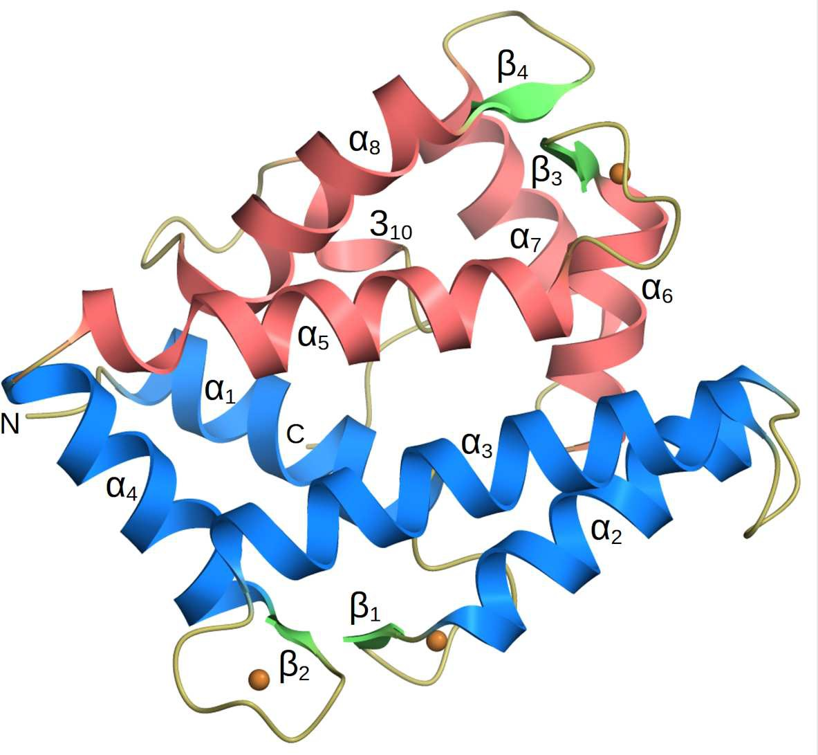

Fig. 2. The 3D structure of JHDK from B. mori at 2.0 ˚A resolution. Helices 1 to 4 (coloured pale blue) are within the N-terminal domain and the remaining heli- cal segments (pale red) form the C-terminal domain. The calcium-binding EF- hands of the enzyme form short β-strands labelled β1-3 whereas the fourth EF- hand (β4) is non-functional due to mutations of the calcium-binding residues. The calcium ion positions are shown as beige-coloured spheres and the N-and C-termini are labelled.

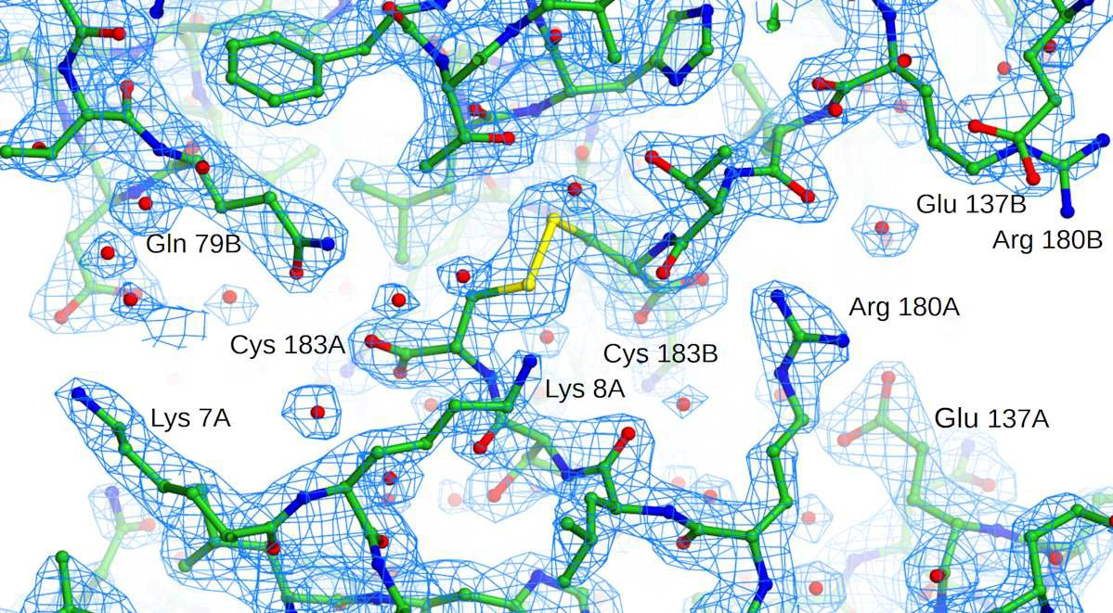

Fig. 3. The electron density of the disulphide bridge linking the C-terminal cys- teine (Cys 183) of chains A and B. The 2F _{o}-F _{C} map at 2.0 ˚A resolution is con- toured at 1.2 σ(ρ) and shown as cyan lines. Another disulphide links Cys183 of chains C and D. However, the residues at the C-termini of chains E and F are not visible, presumably due to disorder, although they are close enough for a disulphide to form. The intermolecular contacts at these disulphide-linked interfaces are not extensive suggesting that the covalent dimers in the crystal are not physiologically relevant.

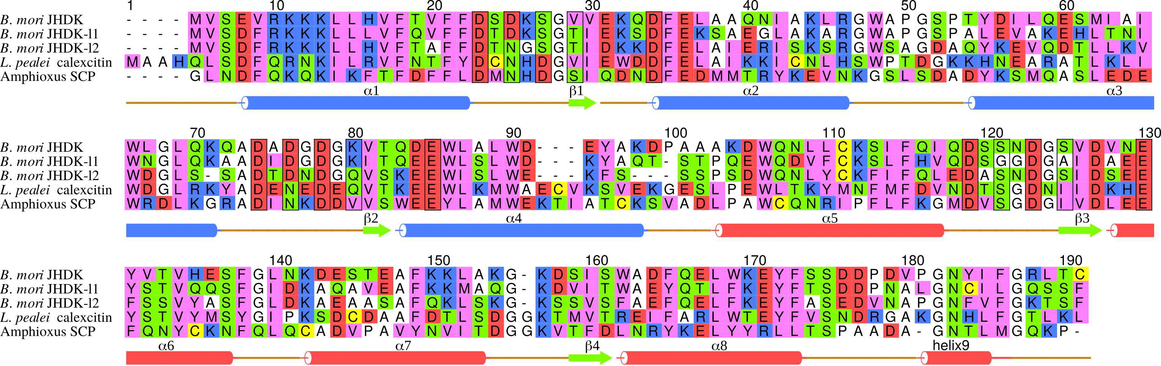

Fig. 4. A sequence alignment of B. mori JHDK with the isozymes JHDK-like- 1 (JHDK-l1) and JHDK-l2 from the same organism. The sequences of L. pealei calexcitin and amphioxus sarcoplasmic binding proteins (ASCP) are also shown. The amino acids are coloured according to the scheme: acidic: red, basic: pale-blue, neutral-polar: green, hydrophobic: purple, cysteine: yel- low and the structurally important residues Gly, Ala, Pro: white. The numbers shown correspond to the combined alignment and the residues with black boxes around them are involved in coordinating the calcium ions. The sec- ondary structure elements of the protein are labelled and displayed with the same colour scheme to Fig. 2. This figure was prepared using Alscript (Barton, 1993).

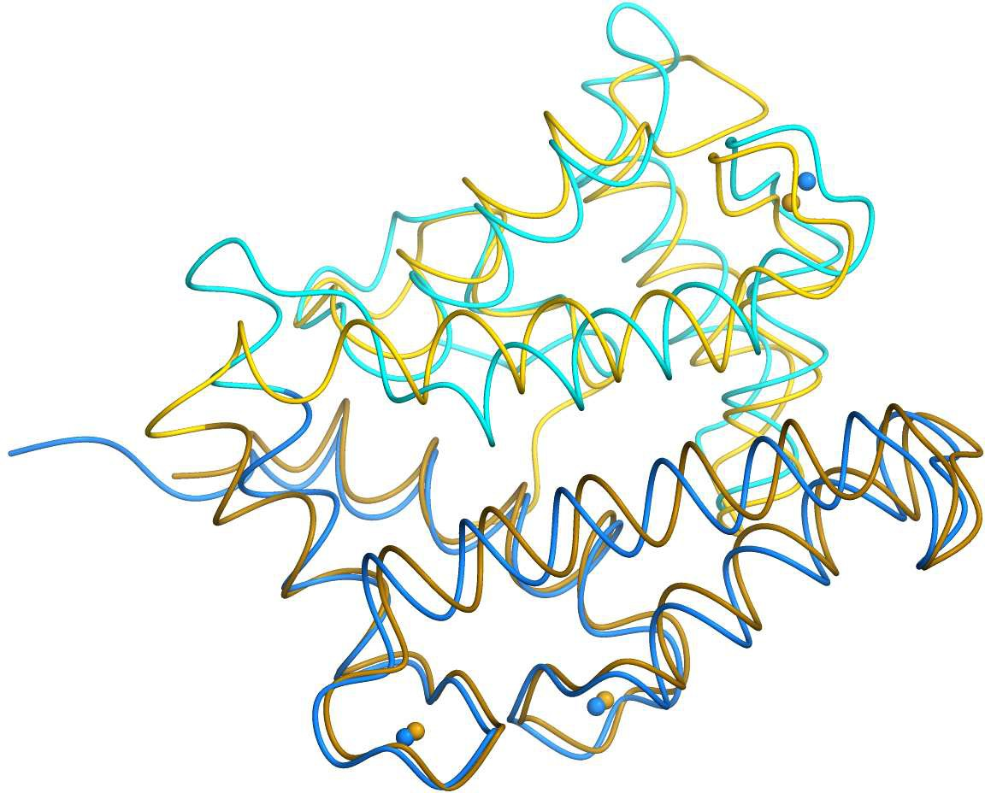

Fig. 5. A superposition with calexcitin. The structure of B. mori JHDK coloured beige superposed on L. pealei calexcitin in blue, shown in a similar orientation to Fig. 2. The N-terminal domains of both proteins which are in the bottom half of the picture are coloured darker. The calcium ions of both proteins are also shown.

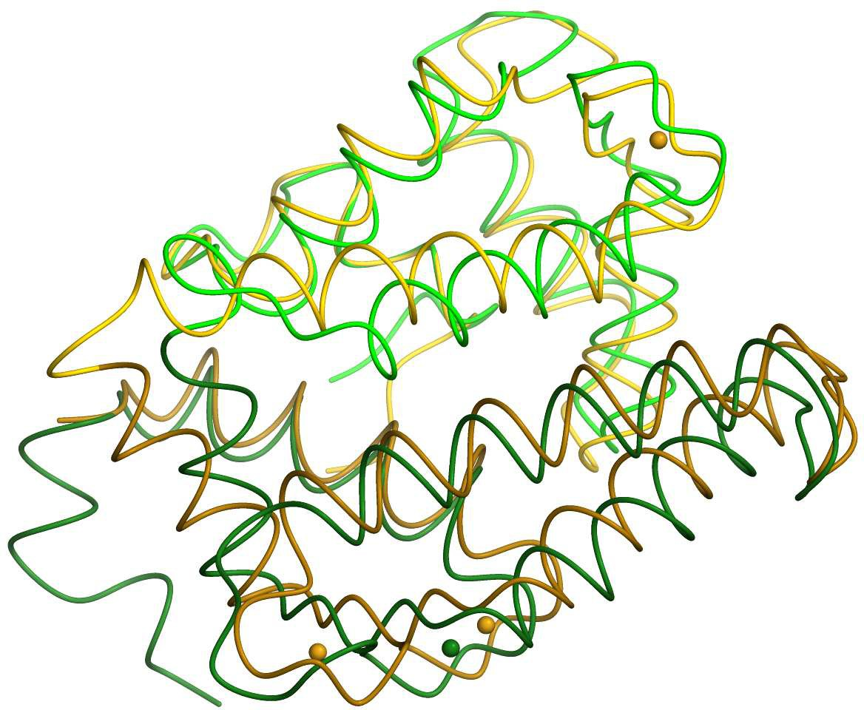

Fig. 6. A superposition with B. mori JHDK-l2. JHDK is shown beige with the JHDK-l2 isozyme coloured green. The N-terminal domains are in the lower half of the picture and are coloured darker. Note that in JHDK-l2 calcium is only bound to the first EF-hand.

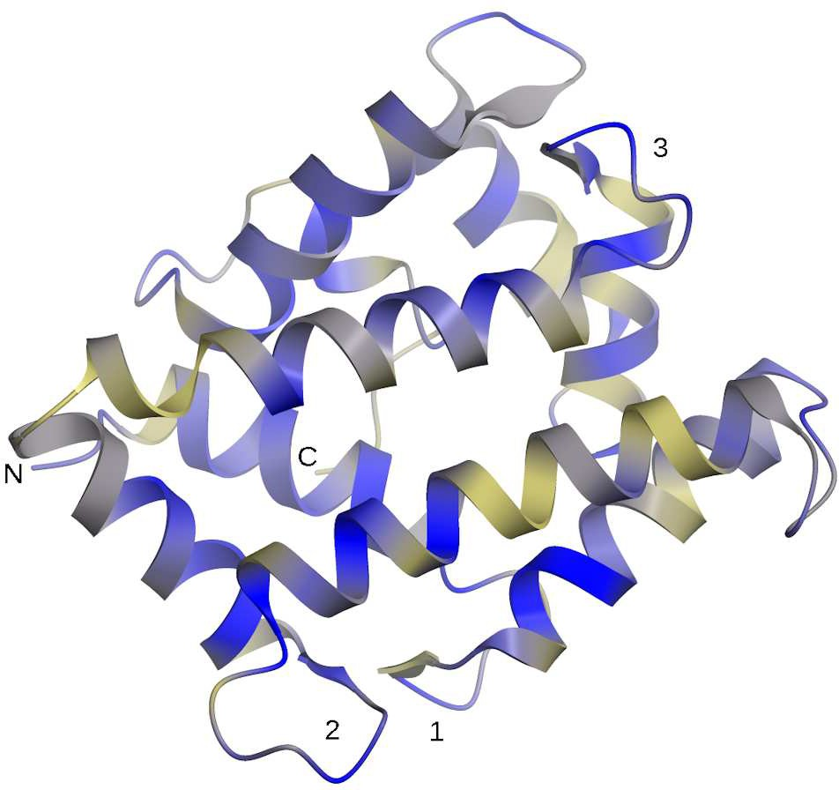

Fig. 7. The B. mori JHDK structure coloured according to the conservation of its amino acid sequence as shown in Fig. 3. The molecule is shown in the same orientation as Fig. 2 and blue indicates the strongly conserved regions while beige shows the most variable. The sequence conservation in the vicinity of helices which form the calcium binding sites (numbered) is apparent. The conservation analysis was done using ProtSkin (Ritter et al., 2004).

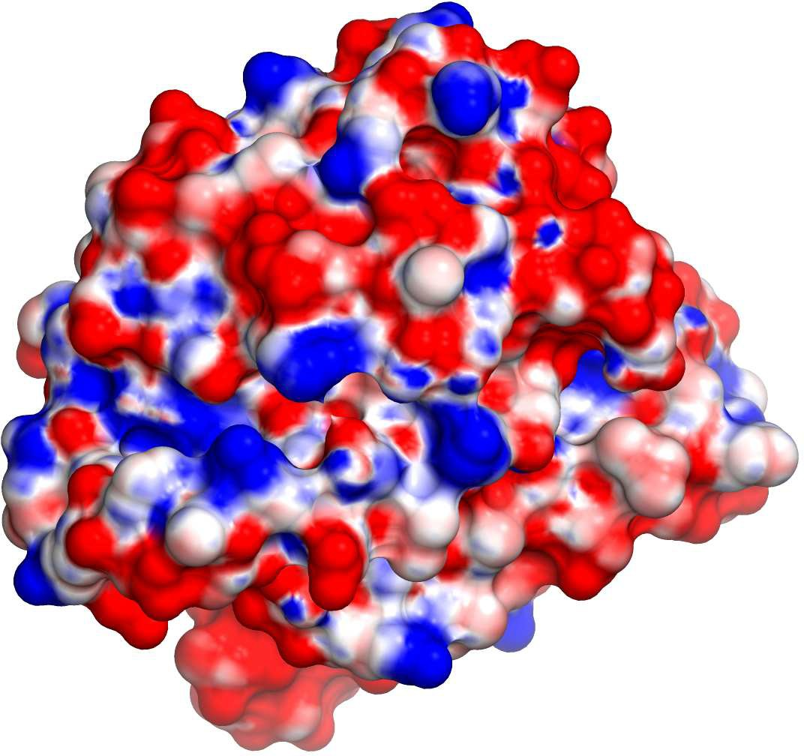

Fig. 8. The solvent accessible surface of B. mori JHDK coloured according to electrostatic potential. Pronounced cavities can be seen around the equatorial domain interface. In this view, the cavity with greatest electropositive char- acter is shown on the left. This may be the binding site for the triphosphate of ATP or GTP.

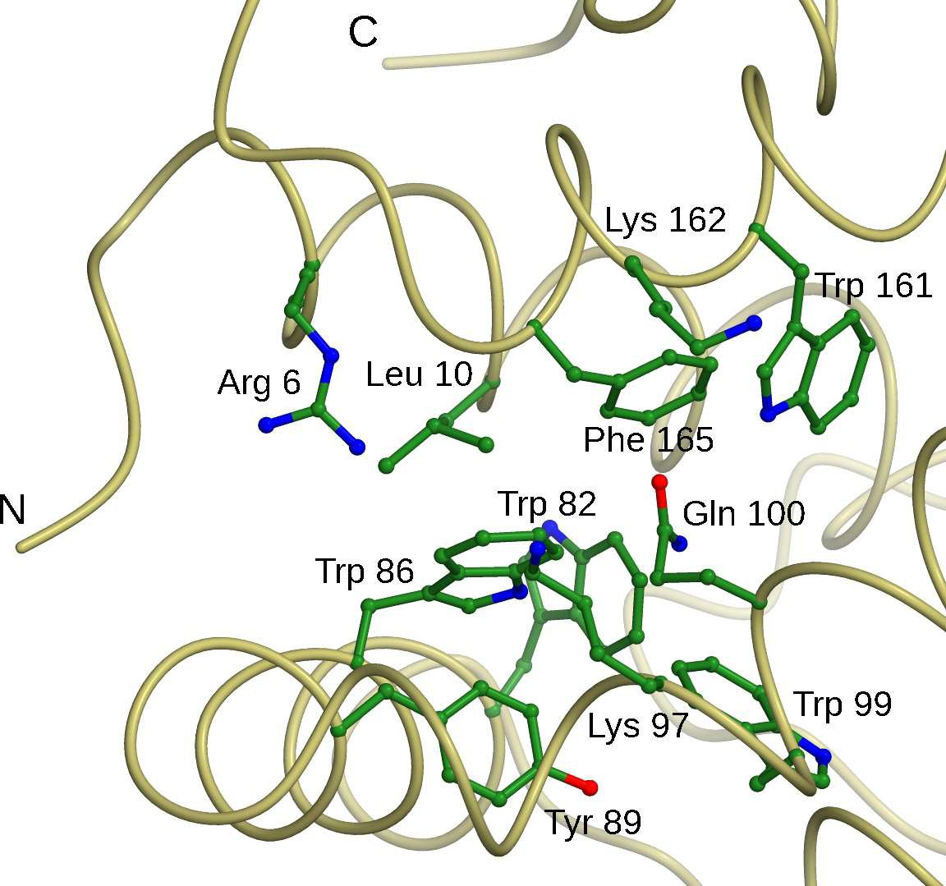

Fig. 9. The residues of the potential nucleotide binding site of JHDK. The sidechains forming the electropositive cavity are viewed from the same direc- tion as Fig. 8. Most are either basic or aromatic and are strongly conserved.

S1. Supplementary Material
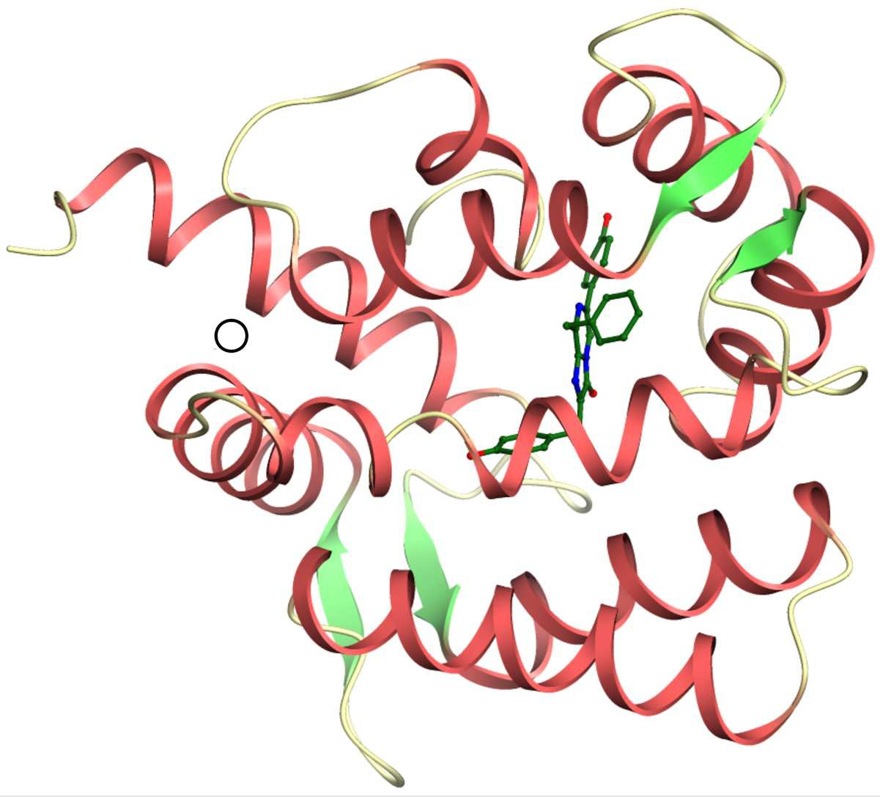

Fig. 10. The structure of the coelenterazine binding protein from Renilla muelleri (RCSB ID: 2hps) showing the location of the luciferin molecule in ball-and- stick representation. The putative ATP binding site of JHDK is indicated by the hollow black circle.

Synopsis

We have determined the X-ray structure of juvenile hormone diol kinase from silk worm Bombyx mori at a resolution of 2.0 ˚A with an R-factor of 19.0 % and an R-free of 24.8 %. It is likely that the structure represents the calcium-inhibited form of this triple EF-hand enzyme.

