Unravelling the charge distribution at the metal-electrolyte interface coupling in situ surface resonant X-Ray diffraction with ab initio calculations
Yvonne Soldo-Olivier*, Eric Sibert#, Maurizio De Santis, Yves Joly and Yvonne Gründer§
CNRS, Université Grenoble Alpes, Institut Néel, 38042 Grenoble, France

Keywords: charge at the electrochemical interface, in situ Surface Resonant XRD, ab initio calculations, DFT, platinum single crystal

ABSTRACT

The comprehension of the mechanisms underlying the charge distribution at the electrochemical interface is a fundamental step in sight of the performing of catalytic materials. Several techniques allow the atomic structure of the metal surface to be characterized, while no experimental method allows obtaining the charge distribution of the catalyst surface and in the electrolyte in the interfacial region. Combining experimental and ab initio calculations, we succeeded in quantitatively describing the charge distribution at the electrochemical interface of the archetypal system Pt(111) in acidic medium. In our approach, we couple in situ Surface Resonant X-Ray diffraction, a site sensitive experimental technique probing both the atomic and the electronic surface structure, with ab initio calculations, recently implemented to describe the Helmholtz double layer formed at the metal-solution interface. In the potential region in between the hydrogen desorption and the (bi)sulfate adsorption, we could determine the charge distribution on each of the metal surface layers and the distance separating the metal from the oppositely charged disordered ionic plane. We could reveal the presence of an electric dipole over the two outermost platinum layers. Our results demonstrate the potential of this original approach to unveil the electronic densities at the electrochemical interfaces, a challenging topic for the understanding of the electrochemical reactivity.

INTRODUCTION
In electrocatalysis, reactivities and performances are crucially affected by the atomic and electronic structure of the electrode surface and of the electrolyte forming the electrochemical interface, as well as by their stability and by the charge transfer mechanisms.
Due to the high complexity of industrial catalysts, the study of model systems has been proven to be of great help in the comprehension of such systems. In this context, single crystal surfaces have been extensively investigated, due to their ordered and well-defined structure, allowing major improvements in the comprehension of fundamental surface phenomena.
The atomic structure of the single crystal electrode surface and of adsorbed species has been widely explored in situ and operando with several techniques, such as Scanning Tunneling Microscopy, X-ray Absorption Spectroscopy and Surface X-Ray Diffraction, and enabled an atomic/molecular-level understanding of the interface.
Nevertheless, the knowledge of the charge spatial distribution at the interface as a function of the applied potential is mandatory for a complete description of the parameters influencing the electrochemical reactivity. Indeed, the sign and the extent of the interfacial charge largely impact the interactions of the molecules and ions with the electrode surface.
An experimental technique able to make this description was up to now lacking. Operando XAS and more recently X-ray Photoelectron Spectroscopy in ambient environment at the solid/liquid interface give access to the oxidation/reduction state of the surface atoms. Nevertheless, these methods do not allow a specific site selection: isolating the signal of the interface only can be difficult, all the more if the absorbing atoms are also present in the solution. Electrochemical voltammetry allows to access the total surface charge (which includes the charges due to adsorption processes). It is though the free charge, charge in excess on the metal surface balanced by ions in the electrolyte, which is related to the main properties of the electrochemical interface and in particular to the catalytic activity. Total and free charge coincide in absence of specific adsorption, otherwise the free charge value can only be estimated within models using extra-thermodynamic assumptions,. Resonant Surface X-Ray Diffraction (SRXRD) combines the desired properties of surface X-Ray diffraction on the site sensitivity and of X-Ray Absorption Near Edge Spectroscopy (XANES) on the atomic oxidation states. Indeed, experiments have shown a strong dependence of the recorded spectra on the potential value,. Nevertheless, up to now, the rare ab initio calculations, not considering the non-equivalent atoms, the non-zero momentum transfers and the effect of the applied electric field, resulted in a qualitative description of the surface properties.
We succeeded here in measuring for the first time the spatial charge distribution at the electrochemical interface of the archetypal system Pt(111) in acidic solution, for which the surface charge influence on common electrochemical reactions is well known⁹.
This result could be achieved analyzing in situ surface resonant x-ray diffraction experiments by comparison with first principle simulations of the recorded spectra. These ones, while going beyond the limitations evoked above, have been recently developed to take into account for the disordered ionic plane which forms close to the charged metallic surface, following the Helmholtz model.

EXPERIMENTAL METHODS

Experiments were made at the bending magnet D2AM French CRG beamline at the European Synchrotron Radiation Facility (ESRF, France). X-ray photon energy was selected by a two crystal Si(111) monochromator with an energy resolution of about 1.5 eV in the energy interval of the spectrum, between 11520 and 11560 eV across the Pt L_{III} edge.
SRXRD was collected using a five-circle diffractometer. This set-up allows for selecting a given (HKL) reflection of the crystal with additional constraints like e.g. a fixed incidence angle, and to switch between σ and π polarization.
The sample, a platinum (111) single crystal, was placed in a home-made electrochemical cell specifically dedicated to in situ diffraction experiments. The details of the surface preparation made before each experiment, allowing to get a clean and well-oriented platinum surface, and of the crystal transfer to the cell are given in S.I.1.
During the experiment the working electrode potential was maintained at 0.35 V_{RHE}, in the potential region in between the hydrogen desorption and the (bi)sulfate adsorption, where no adsorbed ions are expected on the Pt surface.
Spectra were recorded in situ at several positions in reciprocal space, indexed in the surface hexagonal unit cell. Diffraction from a truncated crystal shows a sharp scattering line-shaped for the momentum transfer parallel to the surface at integer (HK), and a continuous distribution as a function of L in-between Bragg peaks for momentum transfer in the out-of-plane direction. This intensity distribution is known as (HK) crystal truncation rod (CTR).
Data were registered in the reflectivity geometry at the (0 0 1.5) node, sensitive only to out-of-plane order, and along the (01) crystal truncation rod (L=0.5, 1.3 and 1.8) , sensitive to both in and out-of plane order. For Pt(111), the two reflections at (0 1 0.5) and (0 0 1.5) correspond to the so-called anti-Bragg positions and are the most sensitive to the surface contributions. Experiments were made in two different configurations, corresponding to the incident beam polarization parallel (σ) to the surface plane and nearly perpendicular to it (π), probing the atomic bonds in the corresponding directions. The schematic experimental setup is schematically described in figure 1.

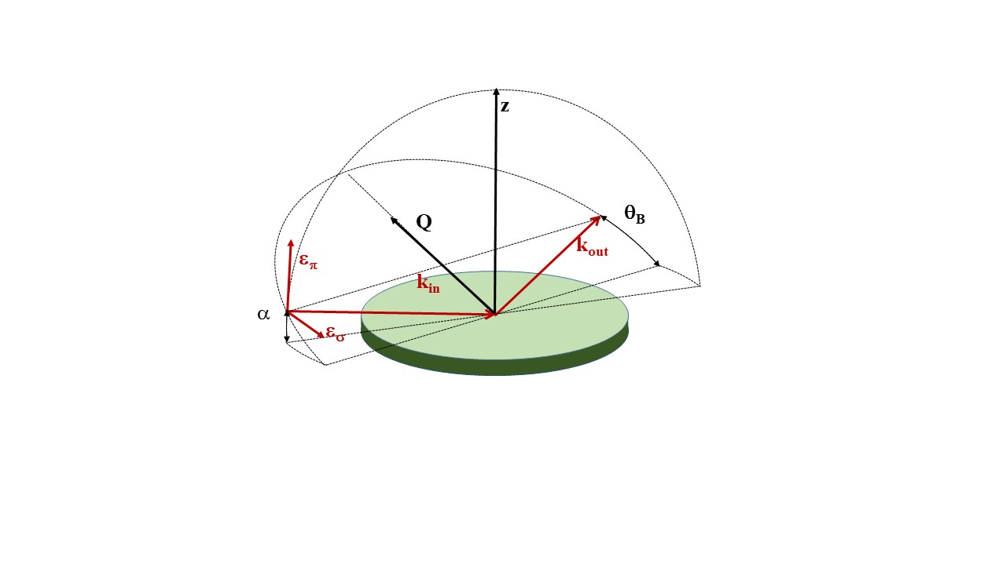
Figure 1. Scheme of the experimental geometry for the non-specular (0 1 L) reflections, collected in grazing incidence angle (α=1°). Two operating modes corresponds to incoming polarization parallel (ε_{σ}) or nearly perpendicular (ε_{π}) to the sample surface (incident beam electric field in the surface plane and forming an angle of 90°-α with it, respectively). z is the direction normal to the surface. The diffraction plane is also shown: it contains the diffraction vector Q, and the incoming (k_{in}) and outgoing (k_{out}) wave vectors. θ_{B} is the Bragg angle.

The fluorescent signal emitted by the sample was simultaneously recorded using a photomultiplier with NaI scintillator: absorption Pt_{LIII} edge position was used as energy calibration, allowing the comparison among the spectra.
Between the sample and the diffracted beam detection, we installed a Panasonic R90 graphite crystal analyzer, to reject the spurious diffused photons and the fluorescence signal and ensure that only elastically diffused photons are detected. Diffracted beam was recorded by a bidimensional pixel photon counting detector IMXPAD S70: measured intensity at each energy corresponds to the integrated signal recorded on a previously defined region of interest.
Details on the measurement operation mode and on the correction and normalization procedures applied to the experimental spectra are given in S.I.2.
Crystal truncation rod (0 1 L) was also measured at fixed energy for structural analysis. The surface structure obtained from the best fitting procedure, in excellent agreement with previous in situ SXRD measurements on Pt(111) in 0.05M H₂S0₄ in the same potential region, has been used in the simulation procedure. Details are given in S.I.3. Using the conventional hexagonal unit cell for the (111) surface, with the c axis perpendicular to the crystal surface, the Pt(111) surface is described by four atomic layers, positioned above the bulk substrate taken as the platinum semi-infinite crystal. The first three planes are fully occupied with an interplanar distance equal to the bulk one (2.265 Å), while the outermost layer is partially occupied (0.96) and the interlayer distance is expanded by 1.5% (2.30 Å).

Theoretical Calculations
Calculations were performed using the FDMNES, software, which uses the Density Functional Theory. The self-consistent approach is explained in the reference. Recently extended for the simulation of surface resonant diffraction experiments, it has now been developed for the electrochemical interface description, to take into account for the presence of the electrolyte facing the crystal and the effect of the applied external electric field.
When a (charged) metal is in contact with a liquid, a charge exchange happens between the two phases due to the initial gradient of the electrochemical potential. Following this mechanism, the simplest model to describe this phenomenon was proposed by Hermann von Helmholtz. It states that a double layer of opposite polarity forms at the electrochemical interface. In absence of specific adsorption, the interfacial double layer is described by the plane of the metal surface and by the plane containing the counter ions. At the potential of zero charge (pzc), the charge located at the interface vanishes..
In this context, FDMNES can model the electrochemical interface adding a potential V(z) (z coordinate perpendicular to the crystal surface) to the surface atomic structure potential. This additional potential simulates the presence of a non-ordered ionic layer (Helmholtz outer plane) at a distance z₀ from the top most surface atomic plane.
Given the position z₀, the FWHM Δ_{V}, and the amplitude $V_{0}$, the Helmholtz layer is modelled by the energy potential:
$$V\left(z\right)=\frac{\sqrt{π}}{2}V_{0}\frac{erf⁡(\frac{z-z_{0}}{α∆_{V}})}{\frac{z-z_{0}}{α∆_{V}}} Eq. 1$$
with α=0.285925223. A negative V₀ energy value corresponds to a positive ionic layer. This potential is simply added to the potential resulting from the surface atomic structure.
Figure 2 gives a schematic representation of the potential visualizing the different parameters used in the simulations.
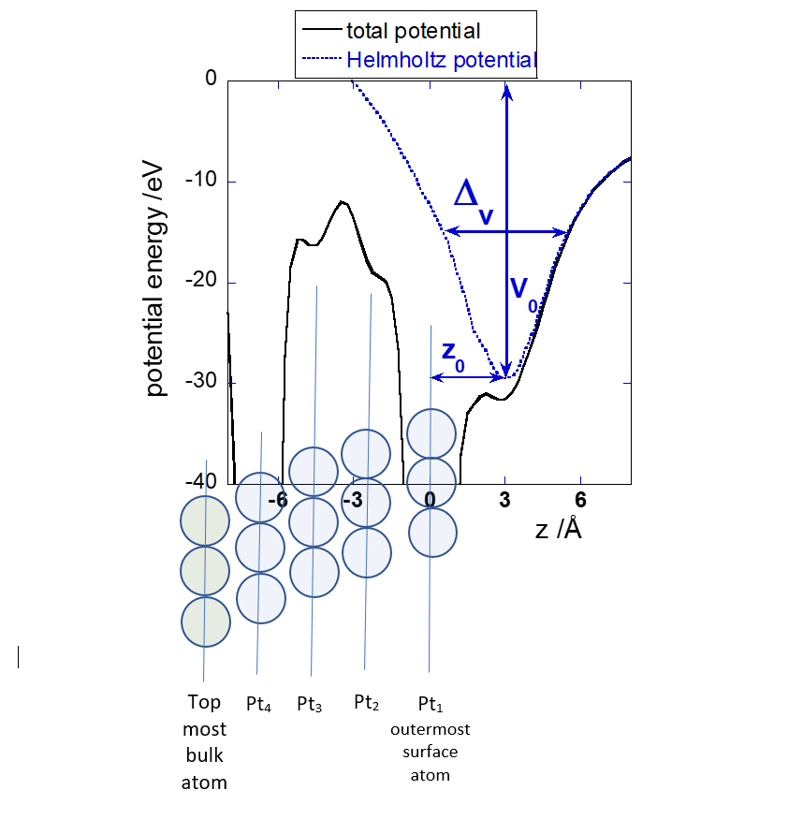
Figure 2. Total potential (continuous black line) as a function of the z coordinate perpendicular to the crystal surface through the outermost surface atom Pt₁ (z=0); Helmholtz contribution (V₀=-30 eV, z₀=3 Å, Δ_{V}=5 Å) is represented by the blue dotted line. Schematic representation of the Pt surface structure is overlapped.

The formula (Eq. 1) being partly empirical, the relationship between V₀ and the charge in the Helmholtz layer is not known. They must nevertheless be proportional between them and thus also proportional to the induced charge at the surface.
Calculations were performed as a function of the parameters V₀ and z₀, the distance between the Helmholtz layer and the surface. The Δ_{V} parameter, poorly sensitive, has been set equal to 5Å, this large value taking into account for the disordered nature of the Helmholtz ionic plane. One of the effects of the Helmholtz layer being to induce a total charge Ch per Pt atom in the top most surface layers, this last is also a parameter. The self-consistent procedure makes that it is shared between the different top most layers, Ch_{i} representing the charge per atom on each surface layer i. Further technical details are given in the S.I. 4.
In the present study we have neglected the non-resonant Thomson scattering of this ionic layer, eventually visible in any case only at the specular reflections . Indeed, its effect is expected to affect the experimental intensity by less than a few percent, due to the very high Pt scattering amplitude and to the structural disorder of the plane also in the perpendicular direction. This layer has nevertheless an influence on the electronic structure of the surface atoms, in particular inducing an expansion of the last inter-reticular distance.
The comparison between simulations and data is made using the total metric distance D, as detailed in S.I. 5.

RESULTS AND DISCUSSION
Experimental data
Resonant spectra are shown in figure 3. At (0 1 1.8) along the (0 1) CTR, close to the (0 1 2) Bragg peak, the experimental data presents a very similar behaviour in the two polarizations, both for the signal shape and the fine structures beyond the edge. Such observation agrees with the fact that at this (HKL) position the surface layers make only a small contribution to the total scattered intensity and the Pt bulk symmetry implies no sensitivity to the polarization.
The spectra evolve moving away from the Bragg peak. At L=1.3, measured only in π polarization, the signal is already largely modified. At the non-specular (0 1 0.5) and specular (0 0 1.5) anti-Bragg positions, fine structure of the spectra beyond the edge is very different in the two polarizations. We remark that the specular data in σ polarization seems to present an unexpected behavior below the edge energy.

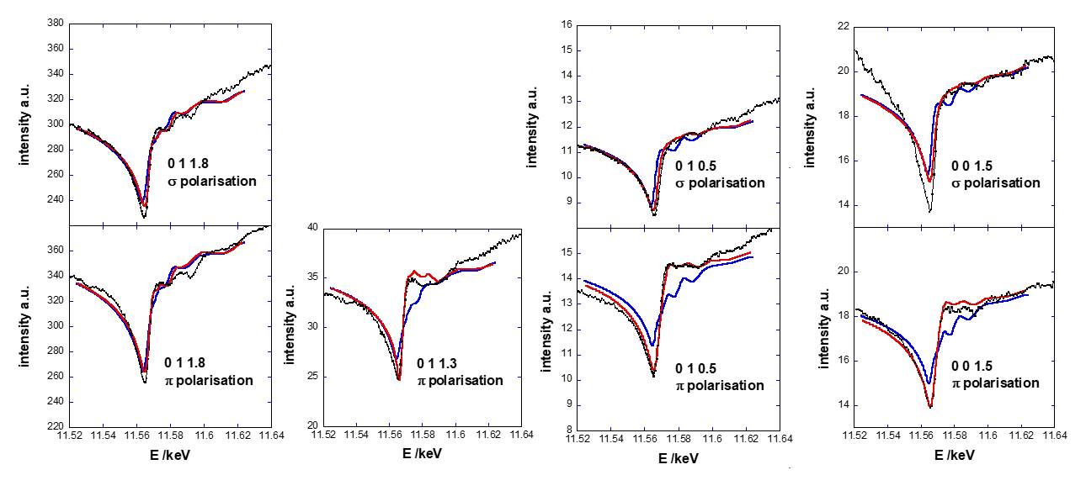

Figure 3. Normalized experimental spectra (black dots) recorded at (0 1 1.8), (0 1 1.3), (0 1 0.5) and (0 0 1.5) in σ and π polarizations and FDMNES ab initio calculations with (red continuous line) and without (blue continuous line) Helmholtz potential (V₀=-35 eV, z₀=3 Å, Δ_{V}=5 Å, surface atomic charge Ch=-0.2).

First principle simulation
As shown by the contour lines of the metric distance D, our confidence factor to compare simulation and data, D is large when V₀≥0 (figure 4). A well-defined minimum is found in the negative energy potential region for V₀=-35±5 eV and a total negative surface charge Ch=-0.20±0.05, which corresponds to about 50 μC/cm² (1.5⋅10¹⁵ platinum atoms/cm²).
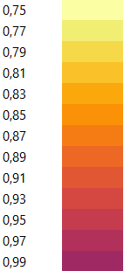
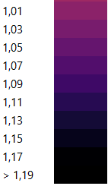
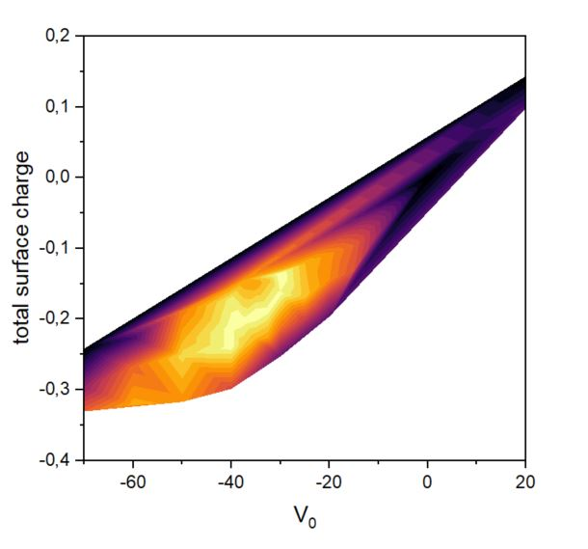

total surface atomic charge

Figure 4. contour lines of the total metric distance D (given as a percentage) as a function of the V₀ value describing the Helmholtz potential and the total surface atomic charge Ch.

The corresponding position of the positive ionic plane z₀ results to be 3.1±0.5 Å. Although limited to some tenths of Ångstrom, the sensitivity is remarkable, considering that it refers to average position of a highly disordered plane.
The agreement between experiments and simulation is here remarkably good, as shown in figure 3. Both intensity and fine structure are well reproduced for all the spectra, with the only exception of the intensity in the pathological spectrum recorded at (0 0 1.5) in σ polarization. The very good matching of best simulation with data confirms that the non-resonant Thomson diffusion by the Helmholtz ionic layer and the water absorption dependence from the photon energy are negligible, as assumed in our calculations.
The expected linear correspondence between V₀ and the induced charge is verified as the best agreement with experiment follows a linear combination of these parameters, as it can be seen in figure 4.
Our calculations allow the description of the atomic charge on each surface plane. We found that the charge is not limited to the outer topmost Pt plane, but to the two topmost ones, Ch₁=-0.47±0.1, Ch₂=0.27±0.05, while the charges on the underlaying Pt₃ and Pt₄ planes are negligible, Ch₃=+0.01 and Ch₄=-0.01. Figure 5 gives a schematic representation of the charge distribution at the electrochemical interface.

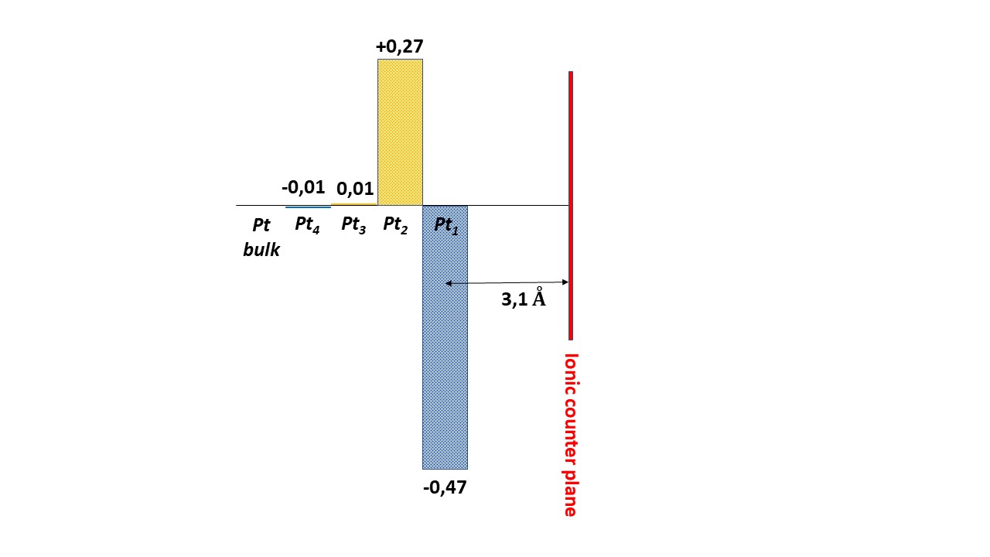Figure 5. Schematic representation of the charge distribution, charge per platinum atom, at the electrochemical interface.

This is the first experimental observation of the presence of an electric dipole in the metal surface in absence of adsorption effects. These results support the presence of a negative capacitance for some Pt surface layers, as suggested by theoretical works to explain the presence of a peak near the pzc for the differential capacitance curve of Pt(111)
The sensitivity of this technique to the surface atomic charge associated to the Helmholtz layer can be checked comparing our best result with calculations without the Helmholtz potential (Figure 3). The anti-Bragg reflections calculated with V₀=0 differ significantly from the experimental spectra. The effect is even stronger for the non-specular anti-Bragg reflection recorded with π polarization. It is indeed specifically sensitive to the electronic environment perpendicular to the surface, where the Helmholtz stands (see table 1).

 | No Helmholtz  D=1.19 (%) | Helmholtz  D=0.75 (%)
D₁ (0 1 0.5) σ pol. | 0.97 | 0.55
D₂ (0 1 0.5) π pol. | 2.22 | 0.75
D₃ (0 1 1.3) π pol. | 1.36 | 1.01
D₄ (0 1 1.8) σ pol. | 0.73 | 0.63
D₅ (0 1 1.8) π pol. | 0.74 | 0.67
D₆ (0 0 1.5) σ pol. | 1.35 | 1.14
D₇ (0 0 1.5) π pol. | 0.98 | 0.51

Table 1. Metric distances D_{i} with the FDMNES simulation calculated for each experimental spectrum without and with the Helmholtz potential (V₀=-35 eV, z₀=3 Å, Δ_{V}=5 Å, total atomic charge Ch=-0.20±0.05).)

Hence, even if measurements were recorded at 0.350 V_{RHE}, only some tens of mV lower than the Pt(111) pzc estimated equal to about 0.380 V_{RHE} ^{, 10}, our data clearly demonstrate that here the surface model free of charge is not the adequate description. Previous ab initio molecular dynamic calculations already suggested that at the pzc, a partial charge transfer occurs from the solvating water layer to the Pt electrode leading to a dipolar polarization distribution along the interface normal .
Analyzing the influence of the best matching Helmholtz potential on the individual metric distances D_{i} (Table 1), the highest influence is found for the anti-Bragg signals; they are the most sensitive to surface contribution and D_{i} diminishes by at least a factor two. The effect is even stronger for the non-specular anti-Bragg reflection recorded with π polarization. It is indeed specifically sensitive to the electronic environment perpendicular to the surface, where the Helmholtz layer stands. The only exception is the simulation of the specular spectrum in σ polarization, where a decrease by only 15% of the metric distance D₆ is found. The Helmholtz potential still improves the reproducibility of the (0 1 1.3) spectrum in π polarization (-26% of D₃), while it has a smaller influence on the simulation of the (0 1 1.8) data (D₄ and D₅ decrease by about 10%).
As expected, due to the limited energy interval of the spectrum SRXRD is more sensitive to the charge distribution of the interface than to interplanar distances (S.I.6), moreover accessible with the classical surface X-Ray Diffraction technique.

CONCLUSIONS
Charges at the electrochemical interfaces play a major role in the performances of the electrocatalysts. Their knowledge is mandatory to fully understand the reaction mechanisms, allowing the performing of more efficient electrode materials.
Our work has proven that in situ SRXRD coupled with ab initio calculations provides a new tool giving access to the surface electronic charge distribution of electrochemical interfaces.
We succeeded in quantitatively describing the interface charge distribution of the Pt(111) in 0.1M H₂SO₄ archetypal system. At 350 mV_{RHE}, close to the pzc potential value, a negative total surface atomic charge equal to -0.2±0.05 was found. This charge is actually distributed over the two last surface Pt layers, Ch₁=-0.47±0.1, Ch₂=0.27±0.05, corresponding to an electric dipole in the metal surface. We could determine the position of the positive counter ionic plane at 3.1±0.5 Å with a quite good sensitivity, despite its disordered structure.
Moreover, thanks to the site selection, this new approach will allow elucidating the partial charge transfer problem in presence of adsorbed species, identifying the individual element’s charge (crystal surface, adsorbed molecules, electrolyte).
This method will make a valuable contribution to the up to now lacking experimental evidence of surface charge distribution, which is mandatory to validate the theoretical predictions. We believe that, beyond the here studied system, this new technique will allow an original and deeper comprehension of electrochemical processes.

Corresponding Author
Yvonne Soldo-Olivier
CNRS, Université Grenoble Alpes, Institut Néel, 38042 Grenoble, France
yvonne.soldo@neel.cnrs.fr
Author information
# Eric Sibert
LEPMI, Univ. Grenoble Alpes, Univ. Savoie Mont Blanc, CNRS, Grenoble INP, St. Martin d’Hères, France
§ Yvonne Gründer
Oliver Lodge Laboratory, Department of Physics, University of Liverpool, United Kingdom

Author Contributions
Y.S.O., E.S., M.D. and Y.J. conceived the project, designed and performed experiments. Y.S.O., Y.J and Y.G. discussed the idea for modelling the data. Y.J. wrote and modified the FDMNES code for simulation of the data. Y.S.O. conducted FDMNES calculations. The manuscript was written through contributions of all authors.

Supporting Information. SI_SOLDO_SRXRD_Pt111_ACSCatalysis.docx
The electrochemical operation mode and the electrochemical cell for in situ SRXRD experiments are described in SI.1. The experimental procedure followed during SRXRD measurements is given in SI.2. Comparison of the fitting and the (0 1 L) CTR experimental signal is shown in figure S2 (section SI.3). The details of the ab initio calculations are given in SI.4. The description of the confidence factor used is detailed in SI.5. Figure S3 (section SI.6) displays the sensitivity of SRXRD spectra for the interplanar distance between the two outermost platinum surface layers.

ACKNOWLEDGMENT
Beam time at the French CRG BM2 beamline of the ESRF (Grenoble, France) is acknowledged. We thank the BM2 staff for support. Y.G. thanks the Royal Society for funding through a University Research Fellowship (URF\R\180005 ) and a research grant (RGF\EA\181030).

REFERENCES

. Ertl, G. Reactions at surfaces: from atoms to complexity (Noble Lecture). Angewandte Chem. Int. Ed. 2008, 47, 3524-3535.
. Kolb, D. and Simeone, F.C. ed. Michael Bowker, P.R. Davies, Scanning tunneling microscopy in surface science, chapter 5 : Characterization and Modification of electrode surfaces by in situ STM, (Wiley Online Library, 2009).
. Masuda, T.; Kondo, T. New sights into the electrochemical interface provided by in situ X-Ray absorption fine structure and surface X-Ray scattering. Curr. Opin. Electrochem. 2019, 14, 81-88.
. Gründer, Y.; Lucas, C.A. Surface X-ray diffraction studies of single crystal electrocatalysts. Nano Energy 2016, 29, 378-393.
. Nakamura, M. New insights on structural dynamics of electrochemical interface by time-resolved surface X-ray diffraction. Curr. Opin. Electrochem. 2019, 14,200–205.
. Schmickler, W. Electronic effects in the electric double layer. Chem. Rev. 1996, 96, 3177-3200.
. Savaleva, V.A.; Savinova, E. R. Insights into electrocatalysis from ambient pressure photoelectron spectroscopy. Curr. Opin. Electrochem. 2019, 17, 79-89.
. Martinez-Hincapié, R.; Climent, V.; Feliu, J.M. New probes to surface free charge at electrochemical interfaces with platinum electrodes. Curr. Opin. Electrochem. 2019, 14, 16-22.
. Briega-Martos, V.; Herrero, E.; Feliu, J. M., Pt(hkl) surface charge and reactivity. Curr. Opin. Electrochem. 2019, 17, 97–105.
. Rizo, R.; Sitta, E.; Herrero, E.; Climent, V.; Feliu, J. M. Towards the understanding of the interfacial pH scale at Pt(111) electrodes. Electrochim. Acta 2015, 162, 138–145.
. Grunder Y.; Lucas C.A. Probing the charge distribution at the electrochemical interface, PCCP 2017, 19, 8416-8422.
.Chu, Y. S.; You, H.;, Tanzer, J. A.; Lister, T. E.; Nagy Z. Surface Resonance X-Ray Scattering Observation of Core-Electron Binding-Energy Shifts of Pt(111)-Surface Atoms during Electrochemical Oxidation. PRL 1999, 83(3), 552-555.
. Menzel, A.; Changa, K.-C.; Komanickya, V.; Youa, H.; Chub, Y. S.; Tolmachevc, Y. V.; Rehr. J. J. Resonance anomalous surface X-ray scattering. Radiation Physics and Chemistry 2006, 75, 1651–1660.
. Lebouin; C.; Soldo-Olivier, Y.; Sibert, E.; De Santis, M.; Maillard, F.; Faure, R. Evidence of substrate effect in hydrogen electroinsertion into palladium atomic layers via in situ surface X-Ray diffraction., Langmuir 2009, 25(8), 4251–4255.
. Kondo, T.; Masuda, T.; Aoki, N.; Uosaki, K. Potential-Dependent Structures and Potential-Induced Structure Changes at Pt(111) Single-Crystal Electrode/Sulfuric and Perchloric Acid Interfaces in the Potential Region between Hydrogen Underpotential Deposition and Surface Oxide Formation by In Situ Surface X‑ray Scattering. J. Phys. Chem. C 2016, 120, 16118−16131.
. Robinson, I. K. Crystal truncation rods and surface roughness Phys. Rev. B 1986, 33, 3830-3836.
. Grübel, G.; Huang, K.G.; Gibbs, D.; Zehner, D.M.; Sandy, A.R.; Mochrie, S.G.J. Reconstruction of the Pt(111) surface: X-ray-scattering measurements. Phys. Rev. B, 1993, 48, 18119-18139.
. Bunău, O.; Joly, Y. Self-consistent aspects of x-ray absorption calculations. J. Phys. : Condens. Matter 2009, 21, 345501;
Bunău O.; Ramos A. Y.; Joly Y. The FDMNES code, International Tables for Crystallography, Volume I, X-ray Absorption Spectroscopy and Related Techniques, 2021
. Joly, Y.; Abisset, A.; Bailly, A.; De Santis, M.; Fettar, F.; Grenier, S.; Mannix, D.; Ramos, A. Y.; Saint-Lager, M.-C.; Soldo-Olivier, Y.; Tonnerre, J.-M.; Guda, S. A.; Gründer,Y. Journal of Chemical Theory and Computation 2018, 14( 2), 461.
. Boettcher S. W. ; Oener, S.Z.; Lonergan, M.C.; Surendranath, Y.; Ardo, S.; Brozek, C.; Kempleret , P. A. ACS Energy Letters 2021, 6, 261-266.
. Bard A. J. and Faulkner L. R. Electrochemical methods : Fundamentals and Applications (John Wiley & Sons, INC. 2nd Edition, 2001).
. Lewerenz H. J. On the Structure of the Helmholtz Layer and its Implications on Electrode Kinetics. ECS Trans. 2013, 50 (52), 3-20.
. Trasatti, S.; Lust, E.; The Potential of Zero Charge. Modern Aspects of Electrochemistry, Number 33, edited by Ralph E. White et al. Kluwer Academic / Plenum Publishers, New York, 1999.
. Warren B.E. X-Ray diffraction (Dover Publications, 1990)
. Templeton, D. H.; Templeton L. K. X-Ray dichroism an danomalous scattering of potessium tetrachloroplatinate(II). Acta Crist. A 1985, 41, 365-371.
. Le, J.-B.; Cheng, J. Modeling electrified metal/water interfaces from ab initio molecular dynamics: Structure and Helmholtz capacitance. Curr. Opin. Electrochem. 2021, 27, 100693-100699.
. Sebastián, P.; Martínez-Hincapié, R.; Climent, V.; Feliu, J.M. Electrochim. Acta 2017, 228, 667–676.
. Sakong, S.; Gross, A. The electric double layer at metal-water interfaces revisited based on a charge polarization scheme, J. Chem. Phys. 2018, 149, 084705.
. X-Ray Absorption, Principles, Applications, techniques of EXAFS, SEXAFS and XANES (ed. D.C. Koningsberger and R. Prins, Wiley, New York, 1988).
. Schmickler, W.; Guidelli, R. The partial charge transfer. Electrochim. Acta 2014, 127, 489–505. TABLE OF CONTENTS GRAPHIC

