Editorial for Special Issue on “Oldroyd at 100: celebrating the impact of J. G. Oldroyd on Non-Newtonian Fluid Mechanics

J.G. Oldroyd made seminal contributions to the constitutive modelling of nonlinear viscoelasticity, viscoplasticity, the flow of emulsions and also wall slip. To mark the centenary of his birth in 1921, the Journal of non-Newtonian Fluid Mechanics has produced a celebratory Special Issue that includes a series of papers which both review and reflect upon the impact and legacy of his work, whilst also looking forward. In this accompanying editorial we provide some biographical background, list a complete bibliography of Oldroyd’s published papers and book reviews as well as highlighting his key contributions to the field which continue to play a significant role in non-Newtonian fluid mechanics.

James Gardner Oldroyd¹ – known simply as “Jim” to friends – was born in Bradford, England, in April 1921. He attended the local Grammar School, where he matriculated in nine subjects at the early age of 14. Due to his young age, he was required to spend four years in the 6th form (instead of the usual two years), where he excelled in mathematics and also became proficient in the German and French languages. He was awarded a State Scholarship and went up to Trinity College, Cambridge, in October 1939. There followed a distinguished undergraduate career; he was awarded the Rouse Ball prize in 1941 and the Mayhew prize in 1942 (awarded to the top applied mathematics candidate) and graduated with a first class BA degree in mathematics in June 1942 (following the Cambridge tradition, an MA followed automatically 10 Terms later and was awarded in 1946).

He retained a close connection to Trinity College, as can be most readily seen in a reproduction of his meticulous entry in that college’s “freshmans’ book” shown in Figure 1, returning as a resident Research Scholar for three Terms in 1945-46, being elected a junior research fellow October 1947 following submission of a thesis entitled “A mathematical discussion of some rheological problems”. The preface and contents page of this dissertation are shown in Figure 2. Also elected that year were George Batchelor (founder of the influential Journal of Fluid Mechanics), Thomas Gold (noted astrophysicist), and Fritz Ursell (later Beyer chair at Manchester and famous for the Ursell number of nonlinear wave mechanics). Oldroyd acknowledges the helpful suggestions and criticisms of “Mr. W R Dean and Mr. A H Wilson”. Both Wilson and Dean (famous for his work on secondary flows in curved ducts which are now named “Dean flows” in his honour) were Fellows in Mathematics at Trinity during his undergraduate days and were his university examiners. Thus, it seems, they are probably the closest to being Oldroyd’s “Advisors” (or Supervisors) although it is also likely that Oldroyd’s studies were probably largely self-directed. There followed the award of a Ph.D in May 1949 and a Sc.D (a Doctor of Science or so-called “higher doctorate”) in February 1958.
¹What follows is based largely on Tanners and Walters biographical sketch [1]. Additional detective work from the Trinity College archives by Prof. E. John Hinch is also gratefully acknowledged

Jim Oldroyd's professional career began at the Ministry of Supply Facility at Aberporth (Wales) where he spent the period of 1942 to 1945 undertaking rocket research. After the Second World War, in 1945, Oldroyd then moved to Courtaulds Fundamental Research Laboratory in Maidenhead, England (at around the same time his University tutor Alan Herries Wilson had left academia to join Courtaulds to supervise their research and development of artificial fibres, most likely Oldroyd joining Courtaulds is not unconnected to this appointment). As the Trinity records show that he was resident as a Research Scholar for three Terms in 1945-46 this suggests that he was allowed/encouraged to take time away from Courtaulds to return to Cambridge to concentrate on research. Around this time his first archival publication appeared in “The London, Edinburgh, and Dublin Philosophical Magazine and Journal of Science” on some theoretical calculations concerned with (Newtonian) laminar boundary layers. All of Oldroyd’s published papers are listed in a bibliography at the end of this article.

It is noteworthy that his output was, from today’s viewpoint, rather modest in terms of volume, being less than 30 papers in total across a nearly 40-year period from 1945 to his final – posthumous - paper in JNNFM in 1984 (his h index being just 20 as of this writing in late 2021). However, there is no doubt of the lasting impact of his work in our field. He rarely published anything other than as a single author (publishing just three papers with other authors over his career). One of these papers arose from his time at Courtaulds where he had a fruitful interaction with D J Strawbridge and B A Toms (famous for research into turbulent drag reduction that was conducted around this time), two experimenters who were involved at the time in some innovative rheometry (see, for example, Bibliography entry [R] Oldroyd et al 1951). It is also clear that after a burst of intense activity spanning a roughly 10-year period from the late 40s to the late 50s, his output diminished.

Whilst at Courtaulds, Oldroyd published a series of remarkable papers (based on the contents of his PhD thesis which was conferred in 1949) culminating in his famous 1950 paper in the Proceedings of the Royal Society, “On the formulation of rheological equations of state” (Bibliography entry [U] Oldroyd 1950) which is where his famous “convected derivatives” first appeared and which is probably his single-most significant contribution to the field. This significance is reflected in the fact that this paper is the focus of a number of papers in this Special Issue by Thompson and Oishi [2], Renardy and Thomases [3], Harlen and Hinch [4], Shaqfeh and Khomami [5], Lennon, McKinley and Swan [6], Li et al. [7], Beris [8] and Castillo Sanchez et al. [9]. This paper is also where the famous Fluid B model (now referred to eponymously as the “Oldroyd-B” model) first appears. With the reproduction of the contents page of his Trinity Fellowship dissertation (Figure 2) we can see that he had been thinking about such issues for a number of years before this seminal paper. Part II of the dissertation contains a final small section where he uses his idea of convected time derivatives but for strain rather than stress (note in the preface to this dissertation he writes “the ideas put forward in this dissertation are necessarily in an initial stage of development”). Succinctly capturing the significance of this 1950 paper, Bob Bird, in a celebratory paper written for Oldroyd’s 60th birthday (or “LXth” as Bird referred to it) [10], stated that "the first twelve pages (of the 1950 paper) contains the central core of knowledge needed for understanding the kinematics of flow and deformation" capturing "an entire field of science with clarity, style and economy of words." Art Metzner described the 1950 paper “as probably the most important single paper in theoretical rheology” [11]. Although this statement was made in an article to celebrate Oldroyd being awarded the British Society of Rheology’s Gold Medal way back in 1980, it is as true today as it was then, as the papers in this Special Issue attest.

Amongst his Courtaulds' publications are also a series of papers in the Proceedings of the Cambridge Philosophical Society (which formed the basis of the first half of his Cambridge PhD thesis) on Bingham and non-Bingham plastic solids (what in modern terms we would call viscoplastic fluids or viscoplastic materials) which are discussed in the papers by Balmforth et al [12], Coussot & Rogers [13] and Moschopoulos et al [14]. These papers are also remarkable as being foundational as well as a demonstration of Oldroyd’s considerable mathematical skills. Firstly, at this time tensorial descriptions of the Bingham plastic were uncommon. Although Bingham’s original observations dated from 1911, it was only in the 1920s that 1D shear flows were described using constitutive laws recognizable today as Bingham fluids. A variational theory began to emerge in the 1930s, initiated by Prager’s contributions [15], very much linked to the development of plasticity theories. The variational principles were the genesis of the PDE theory of Bingham fluids that emerged in the 1960s with Mosolov & Miasnikov and in the 1970s with Duvaut and Lions, leading to the computational foundations of Fortin & Glowinski.

While Oldroyd was a contributor to variational principles, his main contributions were in the fields of mechanics and applied mathematics. In [DD] Oldroyd gives a clear tensorial constitutive model for the Bingham plastic. The elastic Bingham model is introduced with a linear elastic contribution below the yield stress. Although not pursued further and perhaps over-simplistic, elasto-visco-plastic (EVP) models are very much in vogue currently, used to explain both yielding phenomena and other departures from idealised Bingham behaviour. These ideas are reviewed in the modern context in the contribution by Coussot & Rogers [13], and computations using newer EVP approaches to describe bubble rise behaviour are captured in Moschopoulos et al [14].

Oldroyd’s Bingham papers are also the first to use advanced applied mathematical techniques (as is common in fluid mechanics). For example, in [BB] Oldroyd develops a viscoplastic boundary layer theory (using a knife and jet as examples). This area lay largely dormant until recently. There are also interesting conformal mapping methods, introduced for anti-plane shear flows, that lead to some of the few analytical solutions in non-trivial geometries. This approach was developed further by Entov in the 1970s. Unsteady flows and some of the first usages of perturbation methods for Bingham fluid flows are also found in Oldroyd’s early works. These are all reviewed in Balmforth et al. [12]. As the authors remark, with the exception of [BB, DD], the other papers are not well cited, considering their impact.

One of Oldroyd’s lesser-known contributions is to the theory of wall slip [W]. Here the first key contributions in the rheological context came in the 1930’s, from Reiner, Schofield, Scott Blair and Mooney. Oldroyd’s contribution was to view wall slip via a form of depletion layer, within which slip effects are related to a rapid change in the apparent fluidity, avoiding the notion of a slip velocity. This approach is reviewed in the contribution by Ghahramani et al [16].

His interest in the early development of microrheology is evidenced by his 1950s work on emulsions (see, for example, Oldroyd 1953 [P]). This work is discussed more by Harlen & Hinch [3] and begins to connect, in a more physical way, the deformation of the dispersed microstructure to the relative contributions of the continuum-level frame-invariant tensors that describe the general rate of straining and rotation of material elements. The paper by Castañeda [17] builds on Oldroyd’s early work, and uses more sophisticated homogenization methods, to generate new rheological models for suspensions of randomly oriented viscoelastic particles (of initially ellipsoidal shape) undergoing finite deformation.

In 1953, Oldroyd acted as Treasurer of the 2nd International Congress on Rheology held at Oxford, just as he was leaving Courtaulds to take up the Chair of Applied Mathematics at the University College of Swansea (a constituent college of the University of Wales) at the early age of 32, a post which he held until 1965. During this time he also assumed the Presidency of the British Society of Rheology (1955-57) and the Deanship of the Faculty of Science at Swansea (1957-59). He became an Editorial Board member of Rheologica Acta in 1963 (and “communicated many carefully reviewed manuscripts” according to its Editor, Hanswalter Giesekus [11]). Whilst at Swansea he also supervised three Ph.D students (one of us (KW) and also R.H. Thomas and J.R. Jones). A simplified academic genealogy is shown in Figure 3. As we have already noted, Oldroyd rarely published with others and only published one article with his Swansea students (with R H Thomas, Ref [M] in 1956). As Walters’ noted [18] “With very few exceptions it wasn’t Jim’s custom to add his name to papers written by his research students!”. Perhaps a way to best understand his supervisory style is to note that his 1951 paper “The motion of an elastico-viscous liquid contained between coaxial cylinders. Part I.” was never followed up directly by Oldroyd and Part II was only written by Walters (alone) a decade later [19].

In 1958 Oldroyd extended the general framework that he had illustrated with the simple “Fluid A” and “Fluid B” models [I]. The resulting model is now commonly known as the Oldroyd 8-constant model and the range of rheological responses captured by this model is the subject of Giacomin & Saengow [20] (the models investigated by Curtis and Davies [21] also fall within this framework, and the contribution by Lennon, McKinley & Swan [6] considers a further generalization). This (still idealized) model considered nonlinear interactions and products of the general frame-invariant tensors he had introduced earlier. This 8-constant model has proven useful over the years for aiding our understanding of how different nonlinear terms give rise to physical effects such as rate-dependence of the material properties in real non-Newtonian fluids (see for example Bird et al [22], Chapter 8; and Giacomin & Saengow [20]) but it is difficult to handle analytically or to robustly fit it to laboratory data. Furthermore, because it neglects nonlinear terms such as quadratic terms (or higher) in the stress tensor it is unable to describe the extent of shear-thinning in the viscosity that is observed experimentally.

In 1965, Oldroyd moved to a new academic position at the University of Liverpool, becoming Head of Department of Applied Mathematics and Theoretical Physics in 1973. During this period he supervised a number of PhD students (as shown in Figure 3). D C Evans would go on to do postdoctoral work with Bob Bird in Wisconsin (in Bob Bird’s fascinating oral history [23] he says “Hal Warner and I and a post-doc from Oldroyd’s group named D. C. Evans… – The C stood for Colin – the three of us wrote a very lengthy paper on the kinetic theory of dumbbells, but mainly rigid dumbbells”). Another from his Liverpool time – Brian Duffy – managed the rare honour of publishing with Oldroyd [B] (“Physical constants of a flowing continuum”) and has published widely in the field of Non-Newtonian Fluid Mechanics since. Oldroyd remained at Liverpool until his untimely death in November, 1982. As noted in the Times death notice, he died “very suddenly” and without warning on his way to his university office. He was evidently well liked and well respected by his colleagues, who contributed his obituary to The Times of London (writing in this piece “Oldroyd’s published papers… are now recognised as classics especially those published while he has at Courtaulds which were years ahead of their time”). One of his Liverpool colleagues from this time, N.D. Waters (whose PhD was supervised by one of us (KW) and externally examined by Oldroyd), remembers “Jim was a kind and generous colleague and was always on hand with help and advice” [24]. Bridgeman [25] provides further evidence of this generosity when he recalls a tale from his childhood “Jim Oldroyd and my father were colleagues at Liverpool and at some point in the early 70s, my parents hosted a departmental Christmas soirée… this very nice old man (“old” to my five-year-old eyes – he would have been early 50s) turned up with Christmas presents for me and my sister. I spent the first hour of that party building a small go kart with the man who I subsequently referred to as “Meccano Jim”.

In 1946, Oldroyd married Marged Katryn Evans, someone he had met during his Aberporth sojourn. They had three sons, Wynn, Hugh and Robert. During an illustrious career, Oldroyd won many honours. In 1964, he was awarded the Adams Prize by the University of Cambridge and as discussed above, in 1980, he received a Gold Medal from the British Society of Rheology. His influence on many post-war developments in rheology was considerable; evidence of this is provided by R B Bird's fitting tribute at the opening lecture of the 1988 International Congress in Sydney (Bird [26]); his lecture was entitled “The Two JG's”; a title with reference to both J G Oldroyd and J G Kirkwood, as well as an old high-school/boys novel of the same title by the British author A.M. Irvine.

Jim Oldroyd was, at first meeting, quiet and reserved (Petrie writes “one could say typically English” [11]) but this innate shyness did not prevent him from occasionally expressing his views in a forthright fashion. The treatise on the history of rheology by Tanner & Walters [1] elaborates on the extended discussions and disputes during the formal and contentious development of continuum mechanics and “rational mechanics” during the 1950s/60s, and we refer readers there for more detail (see Chapter 4 “Constitutive Equations” especially). He was an accomplished after-dinner speaker and possessed a keen, subtle, sense of humour as his many book reviews often highlight. It is perhaps fitting to end with a representative quote from one of these reviews:
“The reference on the first page to ‘theological’ equations of state proves, unfortunately, to be a misprint, for the equations the author has to offer in an early chapter on flow behaviour of thermoplastic melts are decidedly man-made and very far from perfect.”

Ian A. Frigaard,
University of British Columbia, Canada
Gareth H. McKinley
Massachusetts Institute of Technology, USA
Robert J. Poole,
University of Liverpool, UK
Kenneth Walters,
Aberystwyth University, UK

Bibliography of J G Oldroyd’s papers (reverse chronological order)
[A] Oldroyd, J.G., 1984. An approach to non-Newtonian fluid mechanics. Journal of non-Newtonian Fluid Mechanics, 14, pp.9-46.
[B] Oldroyd, J.G. and Duffy, B.R., 1979. Physical constants of a flowing continuum. Journal of Non-Newtonian Fluid Mechanics, 5, pp.141-145.
[C] Oldroyd, J.G., 1976. The Search for Rheological Equations of State Consistent with Thermodynamics. Proc. VIIth International Congress on Rheology," Gothenburg. Sweden (1976), pp. 102-103
[D] Oldroyd, J.G., 1970. Equations of state of continuous matter in general relativity. Proceedings of the Royal Society of London. A. Mathematical and Physical Sciences, 316 (1524), pp.1-28.
[E] Oldroyd, J.G., 1965. Some steady flows of the general elastico-viscous liquid. Proceedings of the Royal Society of London. Series A. Mathematical and Physical Sciences, 283 (1392), pp.115-133.
[F] Oldroyd, J.G., 1964. Non-linear Stress, Rate of Strain Relations at Finite Rates of Shear in So-Called 'Linear' Elastico-Viscous Liquids. Proc. International Symposium on “Second-Order Effects in Elasticity, Plasticity and Fluid Dynamics" (eds. M. Reiner and D. Abir) Pergamon, New York. pp. 520-529.
[G] Oldroyd, J.G., 1964. Survey of Second-Order Fluid Dynamics. Proc. International Symposium on “Second-Order Effects in Elasticity, Plasticity and Fluid Dynamics" (eds. M. Reiner and D. Abir), Pergamon. New York. pp. 699-711
[H] Oldroyd, J.G., 1961. The hydrodynamics of materials whose rheological properties are complicated. Rheologica Acta, 1(4), pp.337-344.
[I] Oldroyd, J.G., 1958. Non-Newtonian effects in steady motion of some idealized elastico-viscous liquids. Proceedings of the Royal Society of London. Series A. Mathematical and Physical Sciences, 245(1241), pp.278-297.
[J] Oldroyd, J.G., 1957, April. The rheology of some two-dimensional disperse systems. In Mathematical Proceedings of the Cambridge Philosophical Society (Vol. 53, No. 2, pp. 514-524). Cambridge University Press.
[K] Oldroyd, J.G., 1956. Non-Newtonian flow of liquids and solids. In Rheology; Theory and Applications, Volume 1 (pp. 653-682). Academic Press. Edited by F.R. Eirich (Chapter 16)
[L] Oldroyd, J.G., 1956. The effect of small viscous inclusions on the mechanical properties of an elastic solid. In Grammel R. (ed.) Internationale Union für Theoretische und Angewandte Mechanik/International Union of Theoretical and Applied Mechanics (pp. 304-313). Collected papers from IUTAM colloquium on “Deformation and flow of solids” held in Madrid, Spain 26-30, 1955. Springer, Berlin, Heidelberg.
[M] Oldroyd, J.G. and Thomas, R.H., 1956. The motion of a cylinder in rotating liquid with general elastic and viscous properties. The Quarterly Journal of Mechanics and Applied Mathematics, 9(2), pp.136-139.
[N] Oldroyd, J.G., 1955. The effect of interfacial stabilizing films on the elastic and viscous properties of emulsions. Proceedings of the Royal Society of London. Series A. Mathematical and Physical Sciences, 232(1191), pp.567-577.
[O] Oldroyd, J.G., 1954. Note on the hydrodynamic and thermodynamic pressures. Proceedings of the Royal Society of London. Series A. Mathematical and Physical Sciences, 226(1164), pp.57-58.
[P] Oldroyd, J.G., 1953. The elastic and viscous properties of emulsions and suspensions. Proceedings of the Royal Society of London. Series A. Mathematical and Physical Sciences, 218(1132), pp.122-132.
[Q] Oldroyd, J.G., 1951, April. Rectilinear flow of non-Bingham plastic solids and non-Newtonian viscous liquids. II. In Mathematical Proceedings of the Cambridge Philosophical Society (Vol. 47, No. 2, pp. 410-418). Cambridge University Press.
[R] Oldroyd, J.G., Strawbridge, D.J. and Toms, B.A., 1951. A coaxial-cylinder elastoviscometer. Proceedings of the Physical Society. Section B, 64(1), p.44.
[S] Oldroyd, J.G., 1951. The motion of an elastico-viscous liquid contained between coaxial cylinders. I. The Quarterly Journal of Mechanics and Applied Mathematics, 4(3), pp.271-282.
[T] Oldroyd, J.G., 1950. Finite strains in an anisotropic elastic continuum. Proceedings of the Royal Society of London. Series A. Mathematical and Physical Sciences, 202(1070), pp.345-358.
[U] Oldroyd, J.G., 1950. On the formulation of rheological equations of state. Proceedings of the Royal Society of London. Series A. Mathematical and Physical Sciences, 200(1063), pp.523-541.
[V] Oldroyd, J.G., 1949, October. Rectilinear flow of non-Bingham plastic solids and non-Newtonian viscous liquids. I. In Mathematical Proceedings of the Cambridge Philosophical Society (Vol. 45, No. 4, pp. 595-611). Cambridge University Press.
[W] Oldroyd, J.G., 1949. The interpretation of observed pressure gradients in laminar flow of non-Newtonian liquids through tubes. Journal of Colloid Science, 4(3), pp.333-342.
[X] Oldroyd, J.G., 1948, April. Rectilinear plastic flow of a Bingham solid: IV. Non-steady motion. In Mathematical Proceedings of the Cambridge Philosophical Society (Vol. 44, No. 2, pp. 214-228). Cambridge University Press.
[Y] Oldroyd, J.G., 1948, April. Rectilinear plastic flow of a Bingham solid: III. A more general discussion of steady flow. In Mathematical Proceedings of the Cambridge Philosophical Society (Vol. 44, No. 2, pp. 200-213). Cambridge University Press.
[Z] Oldroyd, J.G., 1948. A suggested method of detecting wall-effects in turbulent flow through tubes. Proc. First Int. Congr. Rheol. (Scheveningen, The Netherlands), Vol. II p.130-134. Edited by Organising Committee, published by Amsterdam North-Holland, 1949.
[AA] Oldroyd, J.G., 1947, October. Rectilinear plastic flow of a Bingham solid: II. Flow between confocal elliptic cylinders in relative motion. In Mathematical Proceedings of the Cambridge Philosophical Society (Vol. 43, No. 4, pp. 521-532). Cambridge University Press.
[BB] Oldroyd, J.G., 1947, July. Two-dimensional plastic flow of a Bingham solid: a plastic boundary-layer theory for slow motion. In Mathematical Proceedings of the Cambridge Philosophical Society (Vol. 43, No. 3, pp. 383-395). Cambridge University Press.
[CC] Oldroyd, J.G., 1947, July. Rectilinear plastic flow of a Bingham solid: I. Flow between eccentric circular cylinders in relative motion. In Mathematical Proceedings of the Cambridge Philosophical Society (Vol. 43, No. 3, pp. 396-405). Cambridge University Press.
[DD] Oldroyd, J.G., 1947, January. A rational formulation of the equations of plastic flow for a Bingham solid. In Mathematical Proceedings of the Cambridge Philosophical Society (Vol. 43, No. 1, pp. 100-105). Cambridge University Press.
[EE] Oldroyd, J. G. "LXXII. Calculations concerning theoretical values of boundary-layer thickness and coefficients of friction and of heat transfer for steady two-dimensional laminar flow in an incompressible boundary-layer with mainstream velocity U∝ xm or U∝ xm or U∝ e αm." The London, Edinburgh, and Dublin Philosophical Magazine and Journal of Science 36, no. 260 (1945): 587-600.

Book reviews (reverse chronological order)

“Body Tensor Fields in Continuum Mechanics” by A. S. Lodge (1974) Academic Press. Oldroyd, J.G., 1976. Journal of Fluid Mechanics, 73(4), pp.794-795.
“Nonlinear Viscoelastic Solids” by F. J. Lockett (1972) Academic: New York and London”. Oldroyd, J.G., 1973. Viscoelasticity. Nature Physical Science 242, pp.96.
“Advanced Rheology” by Markus Reiner (1971) H. K. Lewis: London, 1971. Oldroyd J.G., 1972. Nature 238 (5360), pp. 173-174
“Elasticity, Fracture and Flow with Engineering and Geological Applications” by J. C. Jaeger (1969). (Methuen's Monographs on Physical Subjects.) (Methuen: London, November). Oldroyd J.G., 1970. Nature 225 (5232), pp. 568-569
“Finite deformation of an elastic solid” by Francis D. Murnaghan (1967) (Dover reprint.). Oldroyd, J.G., 1970. The Mathematical Gazette, 54(387), pp.88-89.
“Elementary Rheology” by G. W. Scott Blair (1969) (Academic Press: London and New York, May 1969.). Oldroyd, J.G., 1969. Light Flow. Nature, 224(5214), pp.91-91.
“Mechanical Principles of Polymer Melt Processing” by J. R. A. Pearson (1966). Pergamon Press. Oldroyd, J.G., 1967. Journal of Fluid Mechanics, 29 (2), pp. 415-416
“Viscometric flows of non-Newtonian fluids -Theory and Experiment” By B. D. Coleman, H. Markovitz and W Noll (1966) Springer-Verlag. Oldroyd, J.G., 1967. Transactions of the Faraday Society 63 (537 P), pp. 2335
“Mechanics of Incremental Deformations. Theory of Elasticity and Viscoelasticity of Initially Stressed Solids and Fluids, Including Thermodynamic Foundations and Applications to Finite Strain” (1965) by M. A. Biot (John Wiley & Sons). Oldroyd J.G., 1966. British Journal of Applied Physics 17 (2), pp. 277
“The Molecular Theory of Fluids” by Prof. Herbert S. Green. (Deformation and Flow: Monographs on the Rheological Behaviour of Natural and Synthetic Products.) (1952). (Amsterdam: North-Holland Publishing Co.). Oldroyd, J.G., 1953. Nature, 172 (4372), pp. 265-266

Figures
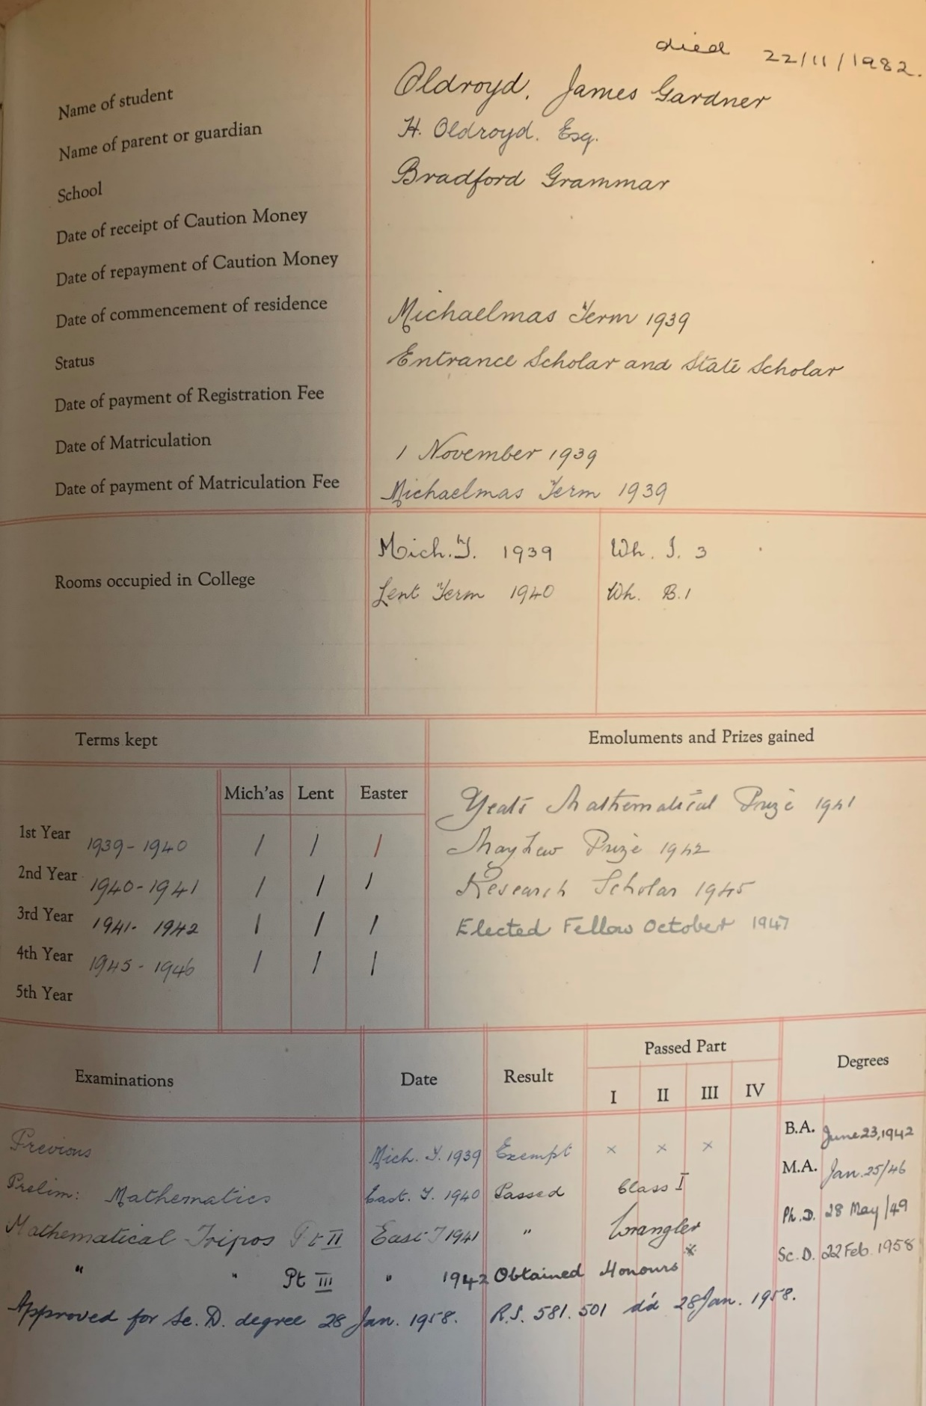
Figure 1: A reproduction of Oldroyd’s page in Trinity College’s Freshmans’ book (photo courtesy of E.J. Hinch and the Trinity Alumni Office)
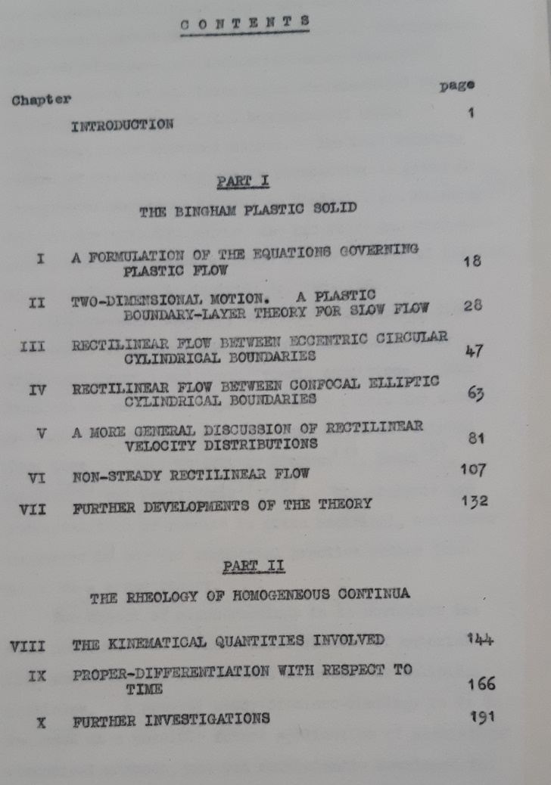
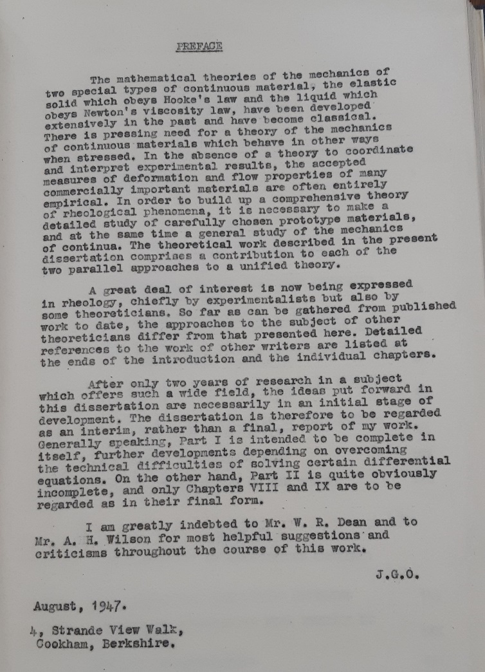
Figure 2: Preface and contents page of Oldroyd’s Trinity College Fellowship dissertation on “A mathematical discussion of some rheological problems”

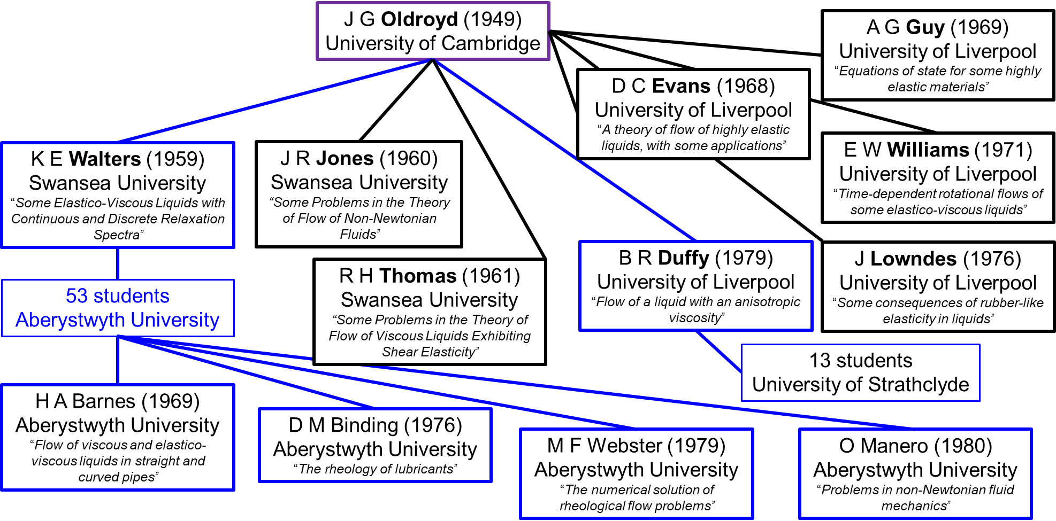
Figure 3: A partial academic genealogy for J G Oldroyd

References
[1] Tanner, R.I. and Walters, K., 1998. Rheology: an historical perspective. Elsevier.
[2] Thompson, R.L. and Oishi, C.M., 2021. Reynolds and Weissenberg numbers in viscoelastic flows. Journal of Non-Newtonian Fluid Mechanics, 292, p.104550.
[3] Renardy, M. and Thomases, B., 2021. A mathematician’s perspective on the Oldroyd B model: Progress and future challenges. Journal of Non-Newtonian Fluid Mechanics, 293, p.104573.
[4] Hinch, J. and Harlen, O., 2021. Oldroyd B, and not A?. Journal of Non-Newtonian Fluid Mechanics, 298, p.104668.
[5] Shaqfeh, E.S.G. and Khomami, B., 2021. The Oldroyd-B fluid in elastic instabilities, turbulence and particle suspensions. Journal of Non-Newtonian Fluid Mechanics, 298 p.104672.
[6] Lennon, K.R., McKinley, G.H. and Swan, J.W., 2021. The Medium Amplitude Response of Nonlinear Maxwell-Oldroyd Type Models in Simple Shear. Journal of Non-Newtonian Fluid Mechanics, 295, p.104601
[7] Li, G., Lauga, E. and Ardekani, A.M., 2021. Microswimming in viscoelastic fluids. Journal of Non-Newtonian Fluid Mechanics, 297, p.104655.
[8] Beris, A.N., 2021. Continuum Mechanics Modeling of Complex Fluid Systems Following Oldroyd's Seminal 1950 Work. Journal of Non-Newtonian Fluid Mechanics, 298, p.104677.
[9] Castillo Sanchez, H, A, Jovanovic M R, Kumar, S, Morozov, A, Shankar, V, Subramanian, G, Wilson, H., 2022. Understanding viscoelastic flow instabilities: Oldroyd-B and beyond. Journal of Non-Newtonian Fluid Mechanics. Accepted.
[10] Bird, R.B., 1981. To Professor James G. Oldroyd on the occasion of his LXth birthday. British Society of Rheology, Rheology Bulletin 24(2) pp24-27
[11] Petrie, C.J. and Giesekus, H., 1983. James Gardner Oldroyd (1921–1982). Rheologica Acta 22 pp1-3.
[12] Balmforth, N.J., Craster, R.V. and Hewitt, D.R., 2021. Building on Oldroyd’s viscoplastic legacy: Perspectives and new developments. Journal of Non-Newtonian Fluid Mechanics, 294, p.104580.
[13] Coussot, P. and Rogers, S.A., 2021. Oldroyd's model and the foundation of modern rheology of yield stress fluids. Journal of Non-Newtonian Fluid Mechanics, 295 p.104604.
[14] Moschopoulos, P., Spyridakis, A., Dimakopoulos, Y. and Tsamopoulos, J., 2021. The concept of elasto-visco-plasticity and its application to a bubble rising in yield stress fluids. Journal of Non-Newtonian Fluid Mechanics, 297, p.104670.
[15] Prager, W., 1954. On slow visco-plastic flow. Studies in mathematics and mechanics, pp.208-216.
[16] Ghahramani, N., Georgiou, G.C., Mitsoulis, E. and Hatzikiriakos, S.G., 2021. JG Oldroyd's early ideas leading to the modern understanding of wall slip. Journal of Non-Newtonian Fluid Mechanics, 293, p.104566.
[17] Castañeda, P.P., 2021. Anisotropic Oldroyd-type models for non-colloidal suspensions of viscoelastic particles in Newtonian and yield-stress fluids via homogenization. Journal of Non-Newtonian Fluid Mechanics, 295, p.104625.
[18] Walters, K., 2008. The Life and Work of J.G. Oldroyd. British Society of Rheology, Rheology Bulletin 49(2) pp 43-51.
[19] Walters, K., 1960. The motion of an elastico-viscous liquid contained between coaxial cylinders (II). The Quarterly Journal of Mechanics and Applied Mathematics, 13(4), pp.444-461.
[20] Giacomin, A.J. and Saengow, C., 2022. Ongoing Relevance of Oldroyd 8-Constant Fluids. Journal of Non-Newtonian Fluid Mechanics, 299, p.104653.
[21] Curtis, D.J. and Davies, A.R., 2021. Volterra kernels, Oldroyd models, and interconversion in superposition rheometry. Journal of Non-Newtonian Fluid Mechanics, 293, p.104554.
[22] Bird, R.B., Armstrong, R.C. and Hassager, O., 1987. Dynamics of Polymeric Liquids. Vol. 1: Fluid Mechanics. Wiley
[23] Interview of Robert Byron Bird by A. Jeffrey Giacomin on 2016 May 22, Niels Bohr Library & Archives, American Institute of Physics, College Park, MD USA, www.aip.org/history-programs/niels-bohr-library/oral-histories/42771-1
[24] Waters, N.D., 2021 Private communication
[25] Bridgeman, J., 2021 Private communication
[23] Bird, R.B., 1988. The Two JGs (J.G. Oldroyd and J. G. Kirkwood). Proceedings Xth International Congress on Rheology, Sydney. Edited by P. H. T. Uhlherr.

Wilson is another extremely interesting character in the British academic/industrial research environment of the mid Twentieth century. For his doctoral thesis he studied quantum mechanics with R.H. Fowler and subsequently worked with Heisenberg on energy band structures in conductors and semi-conductors. He was also a winner of the Adams Prize (1932), a Fellow of the Royal Society and heavily involved in the British “Tube Alloys” project to develop the atomic bomb. See https://en.wikipedia.org/wiki/Alan_Herries_Wilson for additional details.

