Ecosystem service delivery by urban agriculture and green infrastructure – a systematic review
D. L. Evans ^{1,2 a}, N. Falagán ¹, C. A. Hardman ³, S. Kourmpetli ¹, L. Liu ⁴, B. R. Mead ³ and J. A. C. Davies ²

¹ Soil and Agrifood Institute, Cranfield University, Cranfield, MK43 0AL
² Lancaster Environment Centre, Lancaster University, Lancaster, LA1 4YX
³ Department of Psychology, University of Liverpool, Liverpool, L69 3BX
⁴ The Pentland Centre for Sustainability in Business, Lancaster University, Lancaster, LA1 4YX

ª Corresponding author: Daniel.L.Evans@cranfield.ac.uk

Highlights:
- We systematically review ecosystem service delivery by urban agriculture and green infrastructure
- Green infrastructure and urban agriculture deliver a wide range of ecosystem services
- Community Gardens, Green Spaces, and Parks deliver the most diverse ecosystem services
- Natural, Indoor, and Religious Spaces are under-studied in urban ecosystem services research
- We highlight knowledge gaps and future potential of urban ecosystem services research
Abstract
The ability for urban ecosystems to deliver provisioning, regulating, cultural, and supporting services is vital for the health, sustainability, and resilience of urban environments. The increasing pressures being placed on urban environments by global climate change and the need to create sustainable food systems contributes to rising interest in green infrastructure and urban agriculture solutions. Yet, few studies have systematically assessed the ecosystem service provision of urban agriculture and green infrastructure in parallel. In this systematic review of 157 peer-reviewed journal articles, we synthesize the benefits and disbenefits of implementing various forms of urban agriculture and green infrastructure for the delivery of ecosystem services in urban areas. While both provide a diverse variety of ecosystem services, our review suggests that some services are provided more prevalently when green infrastructure is solely adopted (e.g., Local Climate and Air Quality Regulation), while other services are best delivered when green infrastructure is combined with urban agriculture (e.g., Biological Control and Maintenance of Genetic Diversity). Our data also show that ecosystem service delivery is partly modulated by the spaces in which urban growing takes place. Community Gardens, Green Spaces, Allotments, and Parks are found to be most conducive for diverse service provision, although it is also clear that some growing spaces have not been studied as frequently in urban ecosystem service research. We conclude by highlighting some key research gaps and priorities for urban ecosystem service research, including a stronger focus on under-represented services and growing spaces, the need for more systematic data collection, and the value of incorporating ecosystem service assessments into wider suitability and cost-benefit analyses.

Keywords
Urban Agriculture, Green Infrastructure, Ecosystem Services, Growing Space

- Introduction
Urban environments are increasingly important for delivering healthy, sustainable and resilient societies, economies and ecosystems. Over the last 40 years, the population residing in cities has more than doubled (OECD, 2020). By 2050, current projections forecast that two-thirds of the global population will live in cities (United Nations, 2018). This urbanization is expected to place increasing pressures on urban ecosystems to continue delivering key provisioning, regulating, cultural, and supporting services to rising populations (Eigenbrod et al. 2011). Moreover, disruptions to urban ecosystems, like flooding and drought, many of which are induced by larger-scale processes such as global climate change, heighten the threat to ecosystem service delivery and present multiple challenges to urban planners (da Silva et al., 2012). These challenges are further exacerbated in cases where urban densification or expansion is expected to encroach onto, or otherwise diminish the functioning of, urban ecosystems (Barthel et al., 2019). The importance of protecting these ecosystems and sustaining their services motivates the need to integrate nature-based solutions.
One of the trends in urban development and planning decisions over the past decade has been the adoption of green infrastructure (Mell, 2009). This refers to the provision and maintenance of natural and semi-natural green spaces within built ‘grey’ infrastructure. In some cases, space is set aside for these green spaces; examples include urban plazas, pocket parks, sports pitches, and cemeteries (Koe et al., 2017). However, acknowledging the limited acreage available in many urban environments, hybrid solutions that integrate greenery into, or on, grey infrastructure have been developed. For example, green walls and roofs, permeable pavements, and road-side swales. At a larger scale, green infrastructure may also comprise canals, shorelines, designated greenbelts, and walking trails (EEA, 2011).
An underpinning principle of green infrastructure is multifunctionality. The capacity for a single green space to perform several services confronts the current urban paradox, where growing demands for grey infrastructure, and diminishing acreage for greening, juxtapose with an increasing demand for ecosystem services (Landscape Institute, 2009; Pinho et al., 2016). However, the combination of services that each form of green infrastructure may provide is variable. The Millennium Ecosystem Service Assessment (2005) demonstrated that the delivery of some provisioning services (e.g., food production) can cause unintended declines in other regulating or supporting services (e.g., flood control and pollination). As a result, service trade-off decisions are necessary when considering which green infrastructures to deploy. Evaluating the ecosystem benefits and disbenefits of different green infrastructures has therefore become a key focus in urban ecosystem service assessments (Tallis et al., 2008; Bennett et al., 2009; Raudsepp-Hearne et al., 2010). In recent work, these assessments have accounted for not only the delivery of ecosystem services, but their resistance and resilience to perturbation, as well as their long-term sustainability (Ahern et al., 2006; Kato and Ahern, 2008; Angelstam et al., 2013; Costanza et al., 2017; Russo and Cirella, 2019).
Food production has often been overlooked within green infrastructure. For example, in a thorough review of the literature, Wang and Banzhaf (2018) synthesize numerous ecosystem service assessments, and report 28 different types of services delivered by green infrastructure. Of those, regulation of water flows, temperature control, accessibility for exercise, and recreation are the most cited services, but the provision of food is not mentioned. However, this overlooks a growing evidence base demonstrating the widespread benefits of urban agriculture, and the potential contribution urban food growing can make to the urgent and pervasive call for food sovereignty (Artmann and Sartison, 2018; Barthel et al., 2019; Edmondson et al., 2020; Langemeyer et al., 2021).
Many modes of urban food growing exist, akin to green infrastructure. These are often, though not exclusively, categorised in terms of the spaces used for cultivation: indoor farms, allotments, community gardens, etc. (Specht et al., 2014). Urban agriculture has become increasingly focused on integrating food production within, and on, existing grey infrastructure such as living walls, rooftop cultivation, and balcony farms. Where soils are unavailable or inaccessible, soil-less cultivation techniques have been deployed. These include hydroponic, aquaponic, and aeroponic systems (Sengupta and Banerjee, 2012; Samangooei et al., 2016), as well as the use of perlite, shells, and treated wastewater growing cultures (Nirit et al., 2006).
In addition to contributing to food production, it is widely agreed that urban agriculture can reduce greenhouse gas emissions (Kulak et al., 2013), control microclimates (Oberndorfer et al., 2007), boost pollination (Lin et al., 2015), increase biodiversity (Clucas et al., 2018), enhance societal relations (Park et al., 2019) and improve human health (Brown and Jameton, 2000) and wellbeing (Russo and Cirella, 2019). The precise suite of deliverable services can depend on what is cultivated and how, the nature of the growing space and location in the urban landscape, and how humans engage with it. Here, we use the term ‘growing space’ to refer to a site where the growing of edible and non-edible vegetation can take place (e.g., allotments, residential gardens, rooftops). By measuring and monitoring the services delivered by urban agriculture across urban space, the capacity for designing for and managing ecosystem service delivery is enhanced. Yet, without acknowledging the services delivered by other green infrastructure (i.e., non-edible), these efforts remain piecemeal at best.
To date, green infrastructure and urban agriculture have largely been discussed separately, despite the manifest parallels between them (although see Lin et al. (2017) and Adegun (2017) for recent examples where both have been reviewed together). As a result, only a few studies (e.g., Russo et al., 2017) have comprehensively assessed the service trade-offs between urban greening and urban food growing. This gap in our understanding currently constrains our ability to design for and manage ecosystem service provision in urban environments. Responding to this gap is critical to the formation of local, national, and global planning policies that aim to safeguard and strengthen the health, sustainability, and resilience of urban environments.
In this systematic review, we assess the benefits and disbenefits of implementing urban green infrastructure and urban agriculture for ecosystem service delivery. We aim to address three research questions: (1) Which edible and non-edible vegetation types, growing spaces, and ecosystem services have been the focus of research to date? (Sections 3.2 – 3.4); (2) To what extent does vegetation type affect the delivery of ecosystem services in urban areas? (Section 3.5); (3) To what extent does the growing space affect the delivery of ecosystem services in urban areas? (Section 3.6). In answering these questions, we hope to identify potential service win-wins for different combinations of edible and non-edible growing spaces to help underpin decisions on future urban agriculture and green infrastructure development. Furthermore, this review will identify the strengths and gaps in our understanding of urban agriculture and green infrastructure which will guide future research.

- Materials and methods
We undertook a systematic literature review to robustly synthesize the benefits and disbenefits of implementing urban green infrastructure and urban agriculture for the delivery of ecosystem services. For the purposes of this study, ‘urban agriculture’ does not include livestock, but does include fruit, vegetables, cereal crops, nuts, and beans. Hereafter, we use the term ‘non-edible growing’ and ‘edible growing’ to refer to urban green infrastructure and urban agriculture, respectively. Following widely applied protocols of ‘Preferred Reporting Items for Systematic Review Recommendations’ (PRISMA), steps were taken to minimize bias throughout the identification, selection, and synthesis of studies (Moher et al., 2009; Moher et al., 2015). Web of Science (all years) and Scopus (all years) were used to search the literature. Within the search string, synonyms for first-order ecosystem service categories (e.g., regulating, supporting, provisioning) were included, as well as those for ecosystem benefits (e.g., service, benefit, function). Urban environments at different scales (e.g., urban, city, community) were used to prefix broad synonyms for cultivation (e.g., farm, agriculture, plant growth). The full search term string is shown in Box 1. Search string terms needed to feature in the title, abstract, or keywords for the article to be included. In addition, only peer-reviewed articles written in English were searched.

(((“ecosystem” OR “environment*”) AND (“servic*” OR “benefit*” OR “function*” OR “good*”)) AND (“regulat*” OR “support*” OR “provision*” OR “deliver*” OR “valuati*” OR “evaluati*” OR “supply*” OR “manag*” ) AND ((“urban farm*” OR “urban agricultur*” OR “urban cultivat*” OR “urban food grow*” OR “urban plant grow*” OR “urban green space*” OR “urban garden*” OR “urban edible” OR “urban non-edible” OR “urban vegetati*”) OR (“city farm*” OR “city agricultur*” OR “city cultivat*” OR “city food grow*” OR “city plant grow*” OR “city green space*” OR “city garden*” OR “city edible” OR “city non-edible” OR “city vegetati*”) OR (“community farm*” OR “community agricultur*” OR “community cultivat*” OR “community food grow*” OR “community plant grow*” OR “community green space*” OR “community garden*” OR “community edible” OR “community non-edible” OR “community vegetati*”) OR (“indoor farm*” OR “indoor agricultur*” OR “indoor cultivat*” OR “indoor food grow*” OR “indoor plant grow*” OR “indoor green space*” OR “indoor garden*” OR “indoor edible” OR “indoor non-edible” OR “indoor vegetati*”)))

Box 1: Search string used in this study

The initial search, conducted in August 2020, yielded a sample of 2,159 articles, comprising 922 results from Web of Science and 1,237 from Scopus. Of these, 824 duplicate results were discarded, assigning 1,335 results to the first phase of screening. Two key criteria were used to screen the abstracts. First, the abstract needed to explicitly name an urban area, at spatial resolutions no lower than a city. Second, an explicit reference to an empirical and/or modelling-based assessment of one of more ecosystem services, within one or more growing spaces, was required. Following this first phase of screening, 1,082 articles were rejected. Of these, 526 failed to meet either criteria, 435 articles met criterion 1 but not 2, while 121 articles met criterion 2 but not 1. A total of 253 articles were then assigned to a second phase of full-text screening. During this second phase, a further 96 articles did not sufficiently meet the criteria above, and were rejected. This included 54 articles failing to report the results of an ecosystem service assessment, 15 articles where full texts were either unavailable or not written in English, 24 articles that were not based in one or more urban growing spaces, two articles that did not include plant growing in the experimental plan, and one article that did not report findings for a named urban area.
A total of 157 articles were subject to manual data extraction. By ‘manual’ we mean that relevant data were lifted from the article and inputted into a database. A complete list of data types extracted, including a short description, type of data, and an example can be found in Supplementary Information. These data are divided into four main categories of data were manually extracted from each article. The first of these included bibliographic information (see Columns A–I in Supplementary Table 1). Next, the geographical context of each study was manually extracted, including names of locations, their population and size, mean annual precipitation, and mean annual temperature (see Columns J–R in Supplementary Table 1). The third category comprised details of the non-edible and/or edible growing spaces studied. This included whether the growing regime was existing or had been specifically established for the study; whether the growing regime was edible, non-edible, or both; the name and area of the growing space; and details of the vegetation grown including name, mass, volume, and growing duration. Derivatives and variations of growing spaces were assigned into a standardised category. For example, “rooftop garden”, “green roofs”, “rooftop farms” and “urban rooftop” were consolidated into “Roof” (see Columns S–AD in Supplementary Table 1). The final category comprised details of the ecosystem service(s) investigated. In this study, we used ‘The Economics of Ecosystems and Biodiversity’ (TEEB) as the principal ecosystem service framework, and supplemented this with additions from the ‘Millennium Ecosystem Assessment’ (MEA) framework. The data types included within this final category of data included the ecosystem service (as it was written in the paper) and the associated TEEB/MEA ecosystem service category, and the duration over which the ecosystem service was assessed (see Columns AE–AU in Supplementary Table 1). For any category of data, if there were any ambiguous or vague data in the papers, these were independently assessed by a second member on the team, and subsequently discussed.
In each study, if a studied ecosystem service was observed to be delivered in a particular growing space, it was tagged as a provided service (see Columns AV–BE in Supplementary Table 1). Of those that were found to be provided, some studies also included a statement about whether the provision of the service had been enhanced or worsened relative to a baseline, or had remained the same (i.e., neutral). This baseline often comprised ecosystem service delivery in a non-growing space at a different location within the urban environment, or an assessment of ecosystem service delivery at the same location, prior to the establishment of edible and/or non-edible growing (see Columns BF–CI in Supplementary Table 1).

- Results and Discussion
Published assessments of ecosystem services for growing spaces in urban environments have increased since 2000. Between 2000 and 2013, our data show that <10 articles were published annually, and no assessment was reported for seven of these years. From 2013, there have been >10 articles published annually, with 2019 reporting the greatest number of assessments to date (n=37).
3.1 Distribution and geography
Figure 1 shows the global distribution of the urban environments included within our study. Europe and the Middle East represented the largest proportion of studies in our dataset (n=62) followed by Asia and Australia (n=48), North America (n=39), sub-Saharan Africa (n=5) and South America (n=1).
Of those studies that reported demographic information for their named urban areas, the total population was highly positively skewed, with the median population being 1,415,700 (see Table 1). For those studies that reported the acreage of their studied urban environments, which may have included boroughs or districts in some large cities, the median area was 396 km² and was highly positively skewed (Table 1).

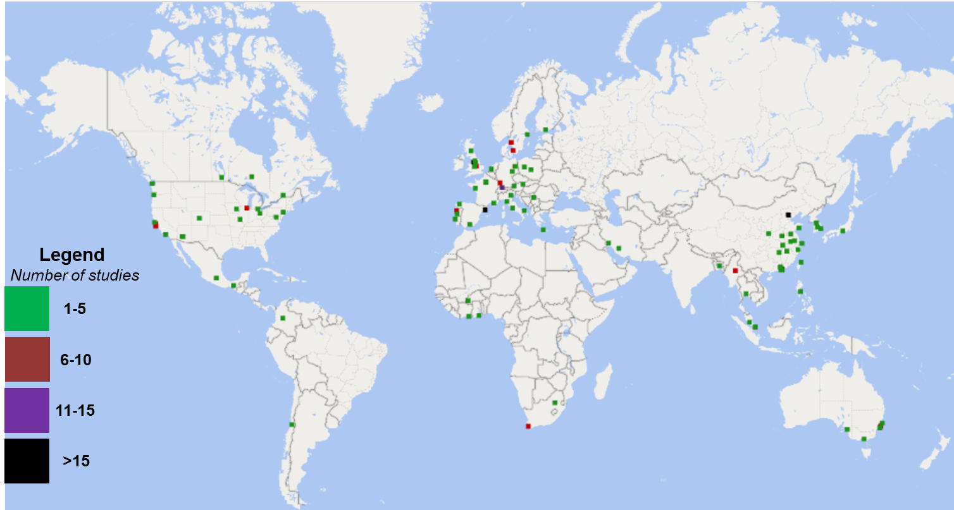
Figure 1: Global distribution of the urban environments included within our dataset.

Table 1: Geographical data of the urban environments included within our dataset for each region
 | Population |  |  | Area
Region | Range (millions) | Median (millions) | Skewness | Range (km²) | Median (km²) | Skewness
Asia and Australia | 48.84 | 4.40 | 2.31 | 99,920 | 895 | 4.09
Europe and the Middle East | 11.95 | 0.52 | 3.73 | 5,300 | 99 | 4.75
North America | 20.99 | 0.62 | 3.06 | 1,171 | 535 | 1.71
South America | * | 5.30 | * | 1,037 | 875 | 1.24
sub-Saharan Africa | 3.30 | 1.96 | * | * | 140 | *

3.2 Vegetation grown
Each study focused on either edible or non-edible vegetation (n=121), or described projects that combined both (n=37; Figure 2). Of those that solely assessed edible or non-edible vegetation, the majority (81%) of these were non-edible (n=98). Non-edible vegetation included trees (n=33), shrubs (n=20), flowers (n=1) and/or grass (n=20) although not every record specified these. In the 19% of studies that solely assessed edible vegetation (n=36), the principal vegetation grown included vegetables (n=18) and/or fruit (n=11).
3.3 Growing spaces
Figure 2 provides a breakdown of studies in the dataset that assessed ecosystem services across 17 different urban growing spaces. Parks were most commonly studied, with just over two-fifths of records focusing on these areas (n=64). The next most studied growing spaces were Community Gardens (n=44). While Allotments were examined by 9% of the dataset (n=14), only two studies presented analyses for Greenhouses. We also found that there were seven times more studies on the Roofs of buildings (n=14) than Indoor Spaces (n=2), yet no studies had been conducted in underground spaces. Vacant Spaces were assessed in 11 studies, with a similar proportion focusing on Roadside and Pathways (n=13), and just under a quarter of the dataset were attributed to generic Green Spaces (n=35). For the majority of cases, authors did not elaborate or further specify about the design and spatial characteristics of these Green Spaces.

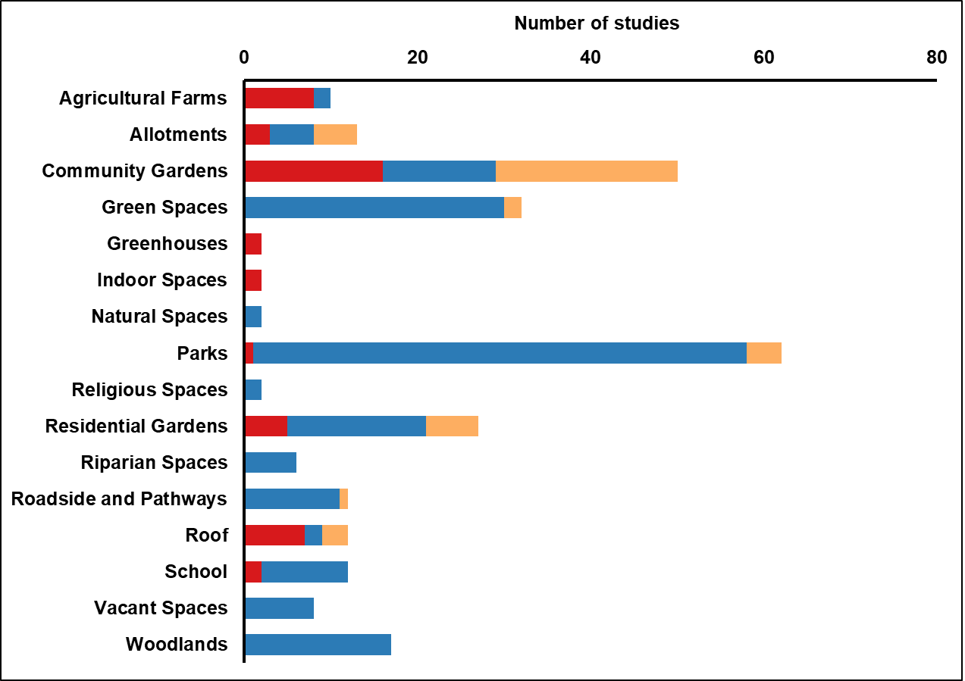
Figure 2: Breakdown of growing spaces studied in our dataset for edible (red), non-edible (blue), and both edible and non-edible (orange) vegetation.

3.4 Ecosystem services
In the papers analysed, 19 ecosystem services were assessed covering all four categories. The five most commonly studied included Maintenance of Genetic Diversity (n=48), Local Climate and Air Quality Regulation (n=44), Recreation and Mental and Physical Health (n=31), Food, Fibre and Fuel (n=27), and Aesthetic Appreciation and Inspiration for Culture, Art, and Design (n=24), while the five least studied comprised Biological Control (n=7), Spiritual Experience and Sense of Place (n=6), Moderation of Extreme Events (n=4), Noise Management (n=4), and Disease Regulation (n=2). A breakdown of the number of studies assessed for each ecosystem service can be found in Figure 3.
Twelve ecosystem services were found to be provided in 100% of the instances in which they were assessed. For Regulating, these included Pollination, Carbon Sequestration and Storage, Disease Regulation, Water Regulation, Noise Management, and Biological Control. For Cultural, these included Recreation and Mental and Physical Health, Aesthetic Appreciation and Inspiration for Culture, Art, and Design, and Spiritual Experience and Sense of Place. For Supporting, these comprised Habitats for Species, and Nutrient Cycling, whilst for Provisioning, this included Fresh Water. All ecosystem services were found to be provided in ≥50% of their respective assessments.
For 75% of the ecosystem service types studied here, there was at least one instance where an enhancement in the service had been identified. Enhancements were not recorded at all for Moderation of Extreme Events, Societal Relations, and Spiritual Experience and Sense of Place. By contrast, Disease Regulation, Local Climate and Air Quality Regulation, Water Regulation, and Carbon Sequestration and Storage were all found to have been enhanced in more than a third of cases in which they were assessed.
Meanwhile, just over a third of ecosystem service types reported at least one instance where the service had worsened. These included four Regulating services including Carbon Sequestration and Storage, Disease Regulation, Erosion Prevention and Maintenance of Soil Fertility, and Water Regulation. For Cultural, these included Aesthetic Appreciation and Inspiration for Culture, Art, and Design, and Recreation and Mental and Physical Health. For Supporting, Nutrient Cycling and Maintenance of Genetic Diversity were ecosystem services where there was at least one instance of worsening. Likewise, for Provisioning, this included Fresh Water. However, there were some instances in the dataset (i.e., in other locations) where these services were shown to have been enhanced.

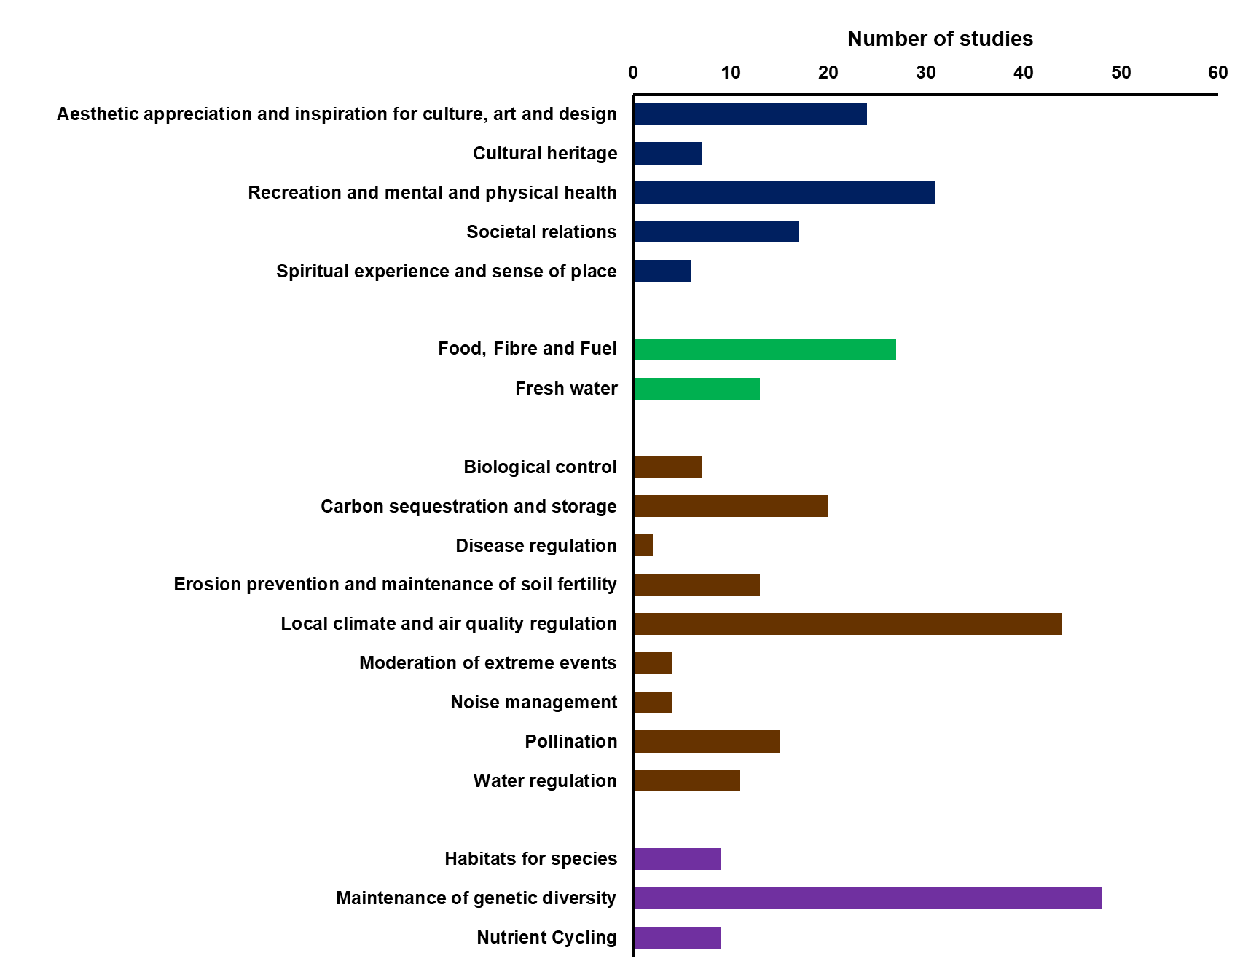
Figure 3: Breakdown of ecosystem services studied in our dataset, grouped into cultural (blue), provisioning (green), regulating (brown), and supporting (purple) categories.

3.5 Ecosystem services and vegetation grown
In this section, we present results addressing our second research question: to what extent does vegetation type affect the delivery of ecosystem services in urban areas. The studies of non-edible vegetation indicate that the full range of ecosystem services encountered could be provided, i.e., there are no services that are wholly exclusive to edible vegetation (Figure 4). Although the Food, Fibre and Fuel provisioning service was largely delivered by food growing, the dataset comprised some (< 10) instances where non-edible vegetation had been used to produce fibre and fuel. While the majority of services were found to be provided by edible vegetation, some cultural and regulating services were not observed in any of these studies. For instance, food growing was not found to provide Cultural Heritage, Moderation of Extreme Events, or Noise Management. This could be because food growing in urban environments tends to be localized in privately owned or privately managed spaces (e.g., rooftops, residential gardens, and allotments) where opportunities to foster Cultural Heritage are relatively constrained. Egerer and Fairbairn (2018) reported on the increasing number of locked gates around individual community garden plots in California, as a response to intra-garden theft. Similarly, in the UK, urban food production predominantly takes place in private gardens or allotment plots managed and assigned by local authorities to individuals (Grafius et al., 2020). These particular services were also some of the least studied – each accounting for less than 10% of the dataset – and as such it may be that the studies for edible vegetation had not addressed these services. We also note that the dataset includes more than double the number of studies for non-edible vegetation than that for edible. However, there have been studies which have found privately managed spaces (e.g., allotments) to provide cultural services such as recreation, learning and teaching about nature, and environmental behaviour (Breuste and Artmann, 2015).
Some ecosystem services were found to be provided more prevalently by non-edible growing practices than by edible vegetation. Among others, these included Local Climate and Air Quality Regulation. However, the provision of these services is likely to be species specific, and partly dependent on the context of the growing space. For instance, although grasses and trees have been found to be similarly effective in cooling urban areas, grasses may not be as resilient to droughts as deeper-rooted trees are in drought-prone locations (Armson et al., 2012). Moreover, Edmondson et al. (2016) found that trees in non-domestic greenspaces, which are generally taller than those found in residential areas, provided greater shading (and microclimate regulation) than those growing in domestic gardens. Our dataset also showed that non-edible plants can both enhance and worsen Local Climate and Air Quality Regulation services. This reflects the complexity of urban air quality and microclimate processes and the importance of careful project placement when considering these services. For instance, urban trees have been shown to worsen air quality by emitting biogenic volatile organic compounds and producing wind-dispersed pollen (Grote et al., 2016). Moreover, other research has shown that trees can also reduce local air circulation and concentrate air pollutants (Eisenman et al., 2019). On the contrary, urban tree canopies may also dilute air pollution by modifying air flow (Baldauf, 2017) and removing soluble particulate matter via stomatal uptake (Burkhardt, 2010).
Biological Control and Maintenance of Genetic Diversity were among the services more prevalently provided when both edible and non-edible vegetation were grown in tandem. Increasing plant diversity to suppress pests is an established practice within habitat management (Saldanha et al., 2019). Intercropping non-edible companion plants can avert generalist natural enemies from targeting fruit and vegetable crops by providing alternative food sources and shelter (Parker et al., 2013; Gontijo, 2019). Although Maintenance of Genetic Diversity was more commonly provided when edible and non-edible vegetation were combined, non-edible plants were more effective than edible varieties at enhancing this ecosystem service within our dataset. This may be because maximising edible crop yield in space-limited urban environments does not always provide opportunities for enhancing Maintenance of Genetic Diversity. While many strategies have recently been established to incentivise nature-friendly gardening (e.g., wildlife friendly gardens), some have called for more research to understand the efficacy of these certification schemes for supporting food production (Lin et al., 2015).

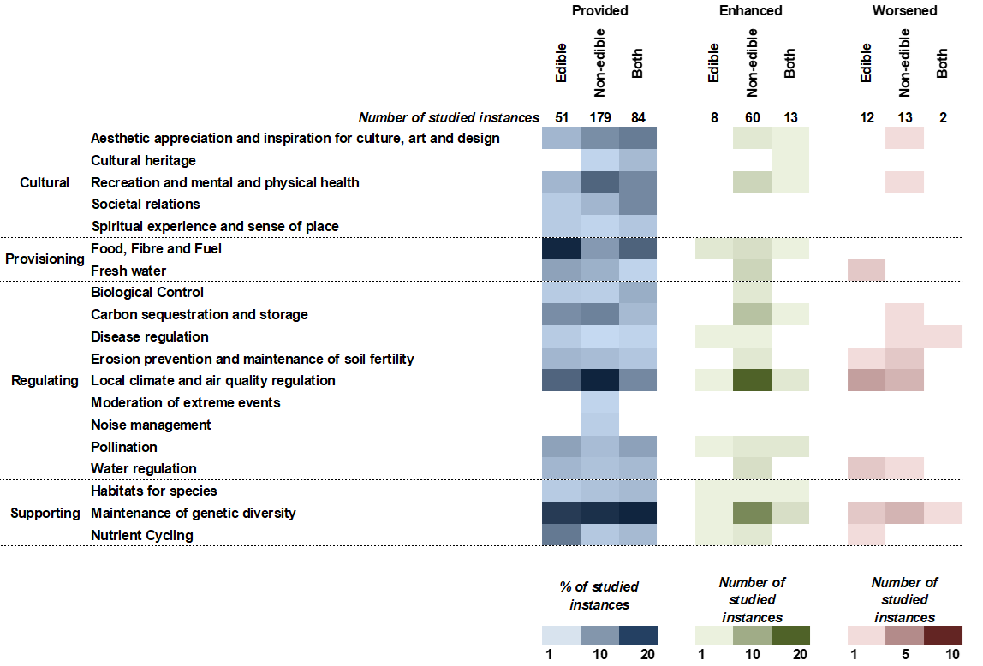
Figure 4: Heat map to show the provision (left), enhancement (centre), and worsening (right) of ecosystem services for edible, non-edible, and edible & non-edible vegetation (both). The number of studied instances for each column is shown at the top of the figure. For the ‘Provided’ column, coloured cells represent the percentage of studied instances. For ‘Enhanced’ and ‘Worsened’ columns, due to the relatively small nature of the samples, coloured cells represent the number of studied instances.

3.6 Ecosystem services and growing spaces
Here, we present results to address our third research question: to what extent does the growing space affect the delivery of ecosystem services in urban areas. Our analysis suggests that urban growing spaces differed in the variety of ecosystem services they provided (Figure 5). Parks, Green Spaces, Community Gardens, and Allotments were the most multifunctional, each delivering >16 different ecosystem services from across all four service categories, with Parks providing all of the studied services, and enhancing the greatest number of these services (Figure 6a).
The most prevalently provided services in both Parks and Green Spaces were Local Climate and Air Quality Regulation, and Recreation and Mental and Physical Health (Figure 5). In addition, these spaces were also the most effective at enhancing Local Climate and Air Quality Regulation (Figure 6a). The provision and enhancement of this regulating services in Parks and Green Spaces is consistent with other recent ecosystem service reviews (e.g., Giedych and Maksymiuk, 2017), but is nevertheless in spite of the biogenic pollutants, such as pollen and volatile organic compounds (VOCs), that can reduce air quality (Salmond et al., 2013). However, as Selmi et al. (2016) suggest, the ability for Green Spaces to improve air quality is likely to be context specific, and dependent, in part, on the species of tree being grown, and the number of different pollutant sources below the canopy. Although tree canopies have been found to minimize the dispersion of ground-level pollutants (Nowak et al., 2018), Parks tend not to be associated with high-polluting activities, and the Green Spaces within our dataset largely centred around pedestrian zones. Moreover, our dataset reported no instances of Local Climate and Air Quality Regulation worsening in Parks, and only two instances of worsening in Green Spaces.
Whilst Maintenance of Genetic Diversity was provided in both Green Spaces and Parks, it was found to be provided (and enhanced) more prevalently in the latter. Nielsen et al. (2013) found that Parks constitute important biodiversity hotspots in urban environments, with larger parks giving rise to greater species richness. This is principally because of a widely established species-area relationship where larger spaces tend to host a greater diversity of habitats. The mean area of Parks reported in our dataset was 787 ha., nearly three times the mean area of Green Spaces (287 ha.), which could explain why Maintenance of Genetic Diversity was provided and enhanced to a greater extent in urban Parks.
Maintenance of Genetic Diversity was also found to be notably provided in Community Gardens (Figure 5), which accords with previous work (Camps-Calvet et al., 2016; Schwarz et al., 2017; Li et al., 2020). In comparison with Green Spaces and Parks, Local Climate and Air Quality Regulation was provided less prevalently in Community Gardens. Nowak et al. (2002) suggested that maintenance activities in intensely managed spaces within urban environments may lead to greater emissions, although their study was specifically focused on urban tree management, rather than the activities typically observed in Community Gardens.
In contrast, some growing spaces within our dataset provided relatively few (<5) ecosystem services according to the literature. This group included Natural Spaces, which has only had two services examined – Maintenance of Genetic Diversity and Recreation and Mental and Physical Health – as well as Indoor Spaces and Religious Spaces, both of which have been observed to provide only two categories of ecosystem services, and Greenhouses, observed to provide only one service. Only two studies in our dataset assessed ecosystem services in Natural Spaces, which explains the relatively small number of reported services. However, this could also be due to the inconsistent and interchangeable use of the term ‘Natural Space’ in the literature (Nicol and Blake, 2000). Some researchers combine both wilderness greenspace and designed spaces (e.g., parks and gardens) into the ‘Natural Space’ category (Twedt et al., 2016), while others also include bluespace such as coastlines, rivers, and lakes (Rugel et al., 2019). For the purpose of the current study, parks, gardens and other designed urban greenspace were categorized separately, and Natural Spaces solely comprised non-designed areas, like open shrublands and nature reserves.
Indoor Spaces were only shown to serve Local Climate and Air Quality Regulation and Food, Fibre and Fuel, which could be similarly due to the relative dearth of ecosystem service assessments for indoor farming systems. This supports the findings of Goodman and Minner (2019), who suggested that there is currently a lack of knowledge about indoor agriculture, particularly information that can assist policy-makers to understand the social, economic, and environmental benefits. In addition to Local Climate and Air Quality Regulation and Food, Fibre and Fuel, there are likely to be other potential benefits provided by Indoor Spaces, such as Noise Management and Recreation and Mental and Physical Health, although further research is required to verify if this is the case.
While Religious Spaces were only evaluated twice in our dataset, it was surprising that neither study assessed the provision of cultural services, including Spiritual Experience and Sense of Place. Virtually all research on sacred sites has been conducted in non-urban areas (Jackson and Ormsby, 2017). A meta-analysis of urban ecosystem service valuation studies carried out by Haase et al. (2014) found that less than 2% of assessments focused on spiritual services. This has prompted calls for more research so that the importance and value of urban sacred sites can be communicated to urban planners (Ngulani and Shackleton, 2019).

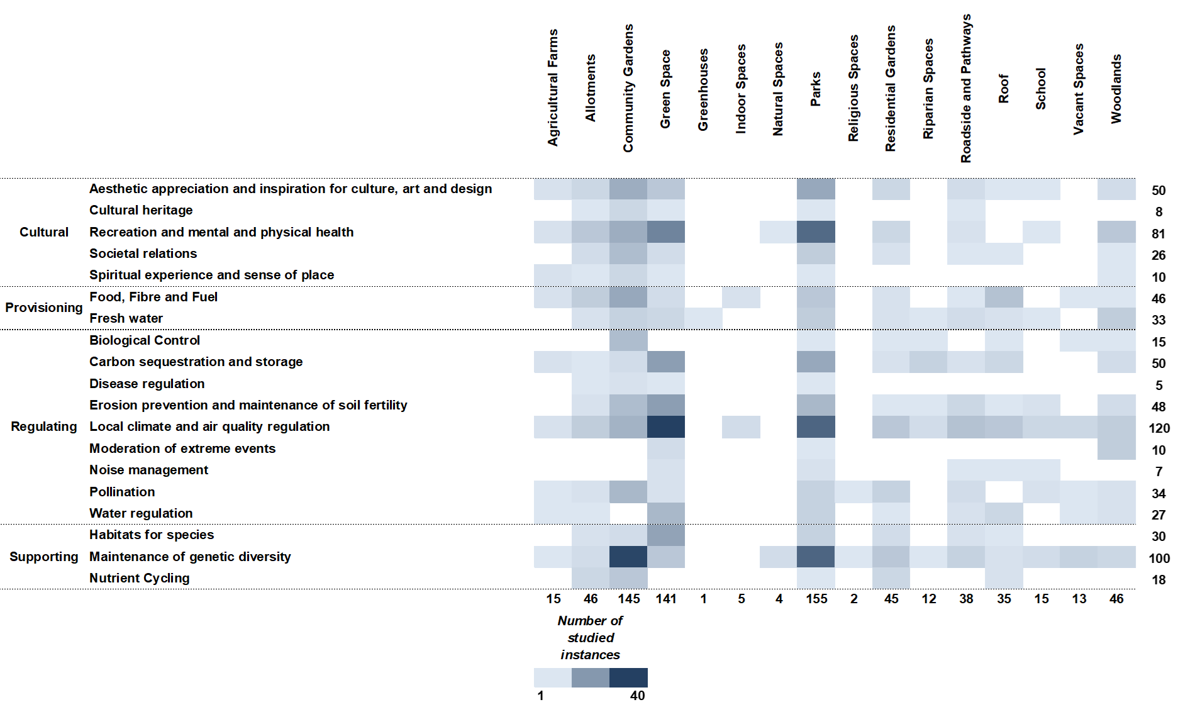
Figure 5: Heat map to show the number of studied instances where ecosystem services were provided in each of the growing spaces studied in this review. The number of studied instances for each growing space is shown under each column; the number of studied instances for each ecosystem service is shown at the end of each row.

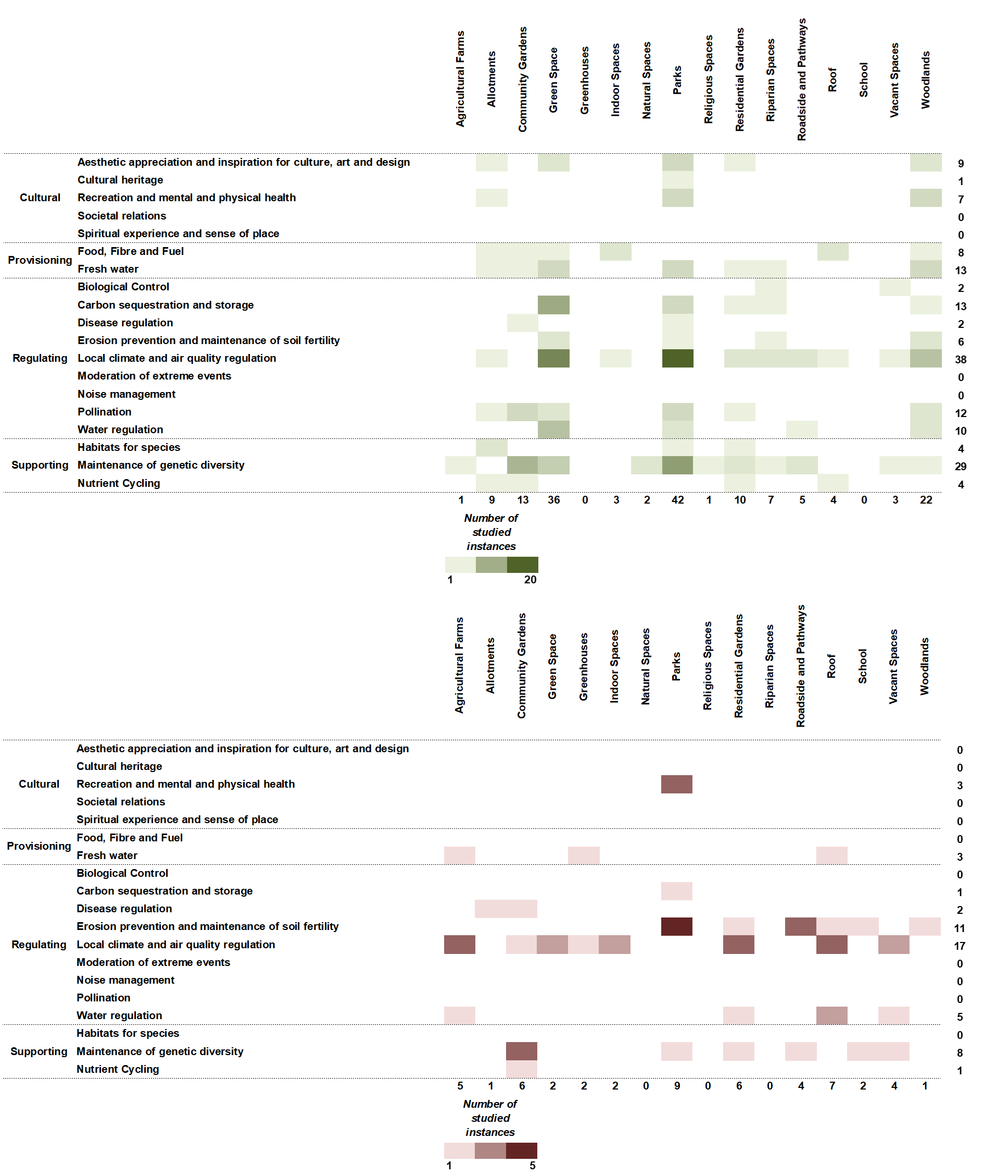
Figure 6: Heat map to show the number of studied instances where ecosystem services were enhanced (top panel) and worsened (bottom panel) in each of the growing spaces studied in this review. The number of studied instances for each growing space is shown under each column; the number of studied instances for each ecosystem service is shown at the end of each row.

3.7 Urban ecosystem services: win-win strategies
This study has presented edible and non-edible vegetation types, growing spaces, and ecosystem services that have been the focus of research to date. We have also investigated the extent to which vegetation type affects ecosystem service delivery, as well as the extent to which this delivery is governed by the growing space. Having answered these questions, here we turn to investigate the ecosystem services commonly provided (and enhanced) together in the same growing space. As stated by Lin et al. (2017), the development of urban agriculture and productive green infrastructure requires win-win strategies that maximise both environmental and social benefits.
Assessing pairwise combinations of ecosystem services in this study, eleven services from across the four service categories were frequently found to be provided together in the same growing space (Figure 7). Here, we refer only to pairwise combinations that were found more than ten times across our dataset. Regulation and Cultural were the only service categories to network with three other categories and Local Climate and Air Quality Regulation and Erosion Prevention and Maintenance of Soil Fertility enjoyed the greatest number of pairs. Both of these services were frequently provided with Habitat for Species, and Recreation and Mental and Physical Health. Local Climate and Air Quality Regulation was also commonly provided in combination with Fresh Water, Food, Fibre and Fuel, Carbon Sequestration and Storage, Water Regulation, and Pollination.
One of the mechanisms serving ecosystem service relationships, or ‘win-wins’, is the effect of common drivers (i.e., interventions that can drive change in one or more ecosystem services) (Bennett et al., 2009). In our dataset, it is likely that urban greening and/or food growing activities catalysed the provision of more than one service simultaneously. For example, the tree canopies from urban tree growing are likely to have regulated microclimate, through the provision of shading, whilst also protecting the ground surface from precipitation, thus preventing erosion.
Turner et al. (2014) found that cultural services were often vulnerable to trade-offs with agricultural provisioning services, but still able to form synergies with regulating services. Our findings here were similar in that we only observed one significant combination between Cultural and Provisioning services; instead, there were at least three separate synergies between Cultural and Regulating services.
As Harrison et al. (2014) stated in a similar network analysis, the relationships identified here were largely based on the number of times these services have been reported to be provided together, rather than their functional or hierarchical importance. In addition, this network analysis alone could not explain the associations between different ecosystem services, nor could it inform us as to whether a pair of services reinforce each other. Nonetheless, it highlighted a suite of ecosystem services that were most likely to be simultaneously provided in urban environments.
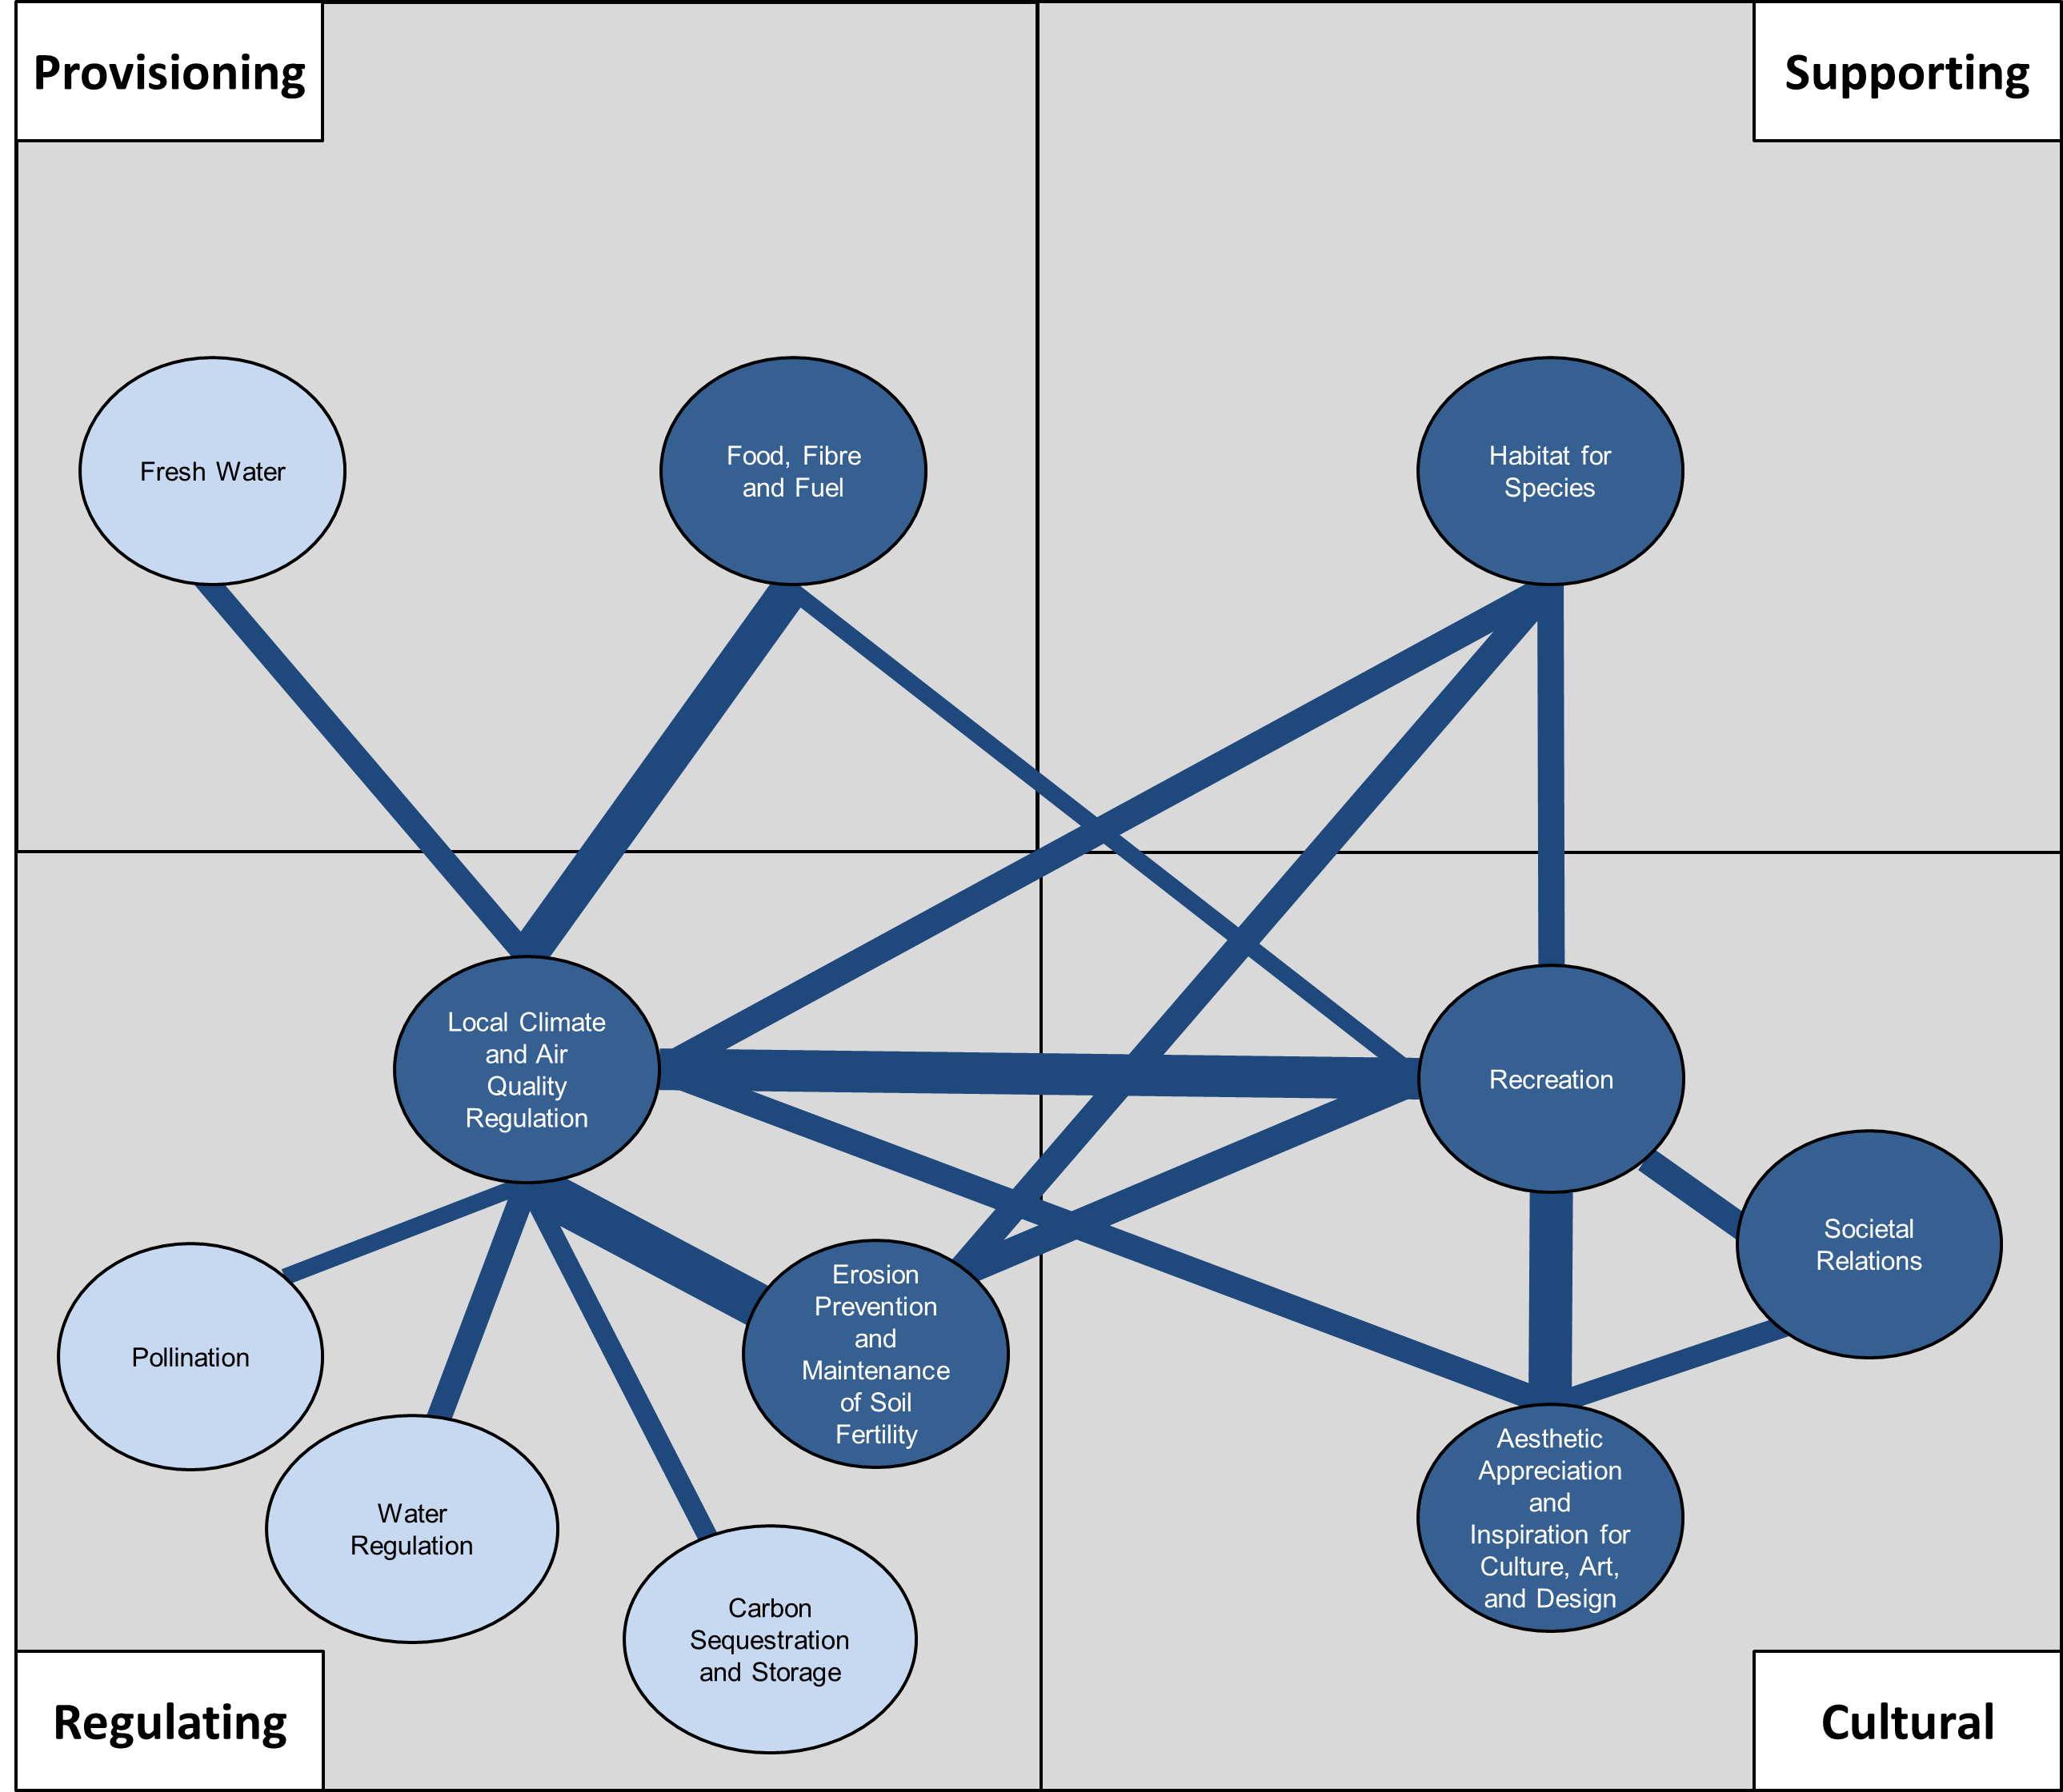
Figure 7: Map showing the extent to which ecosystem services provide other services from each of the four categories. Thickness of line indicates the number of studied instances where the two services in question were found to be provided together. Services filled in light blue were only associated with one other service; serviced filled in dark blue were associated with more than one service.

3.8 Gaps in Urban Ecosystem Service research
This review revealed key knowledge gaps and future research priorities, which can be grouped into: (1) growing spaces and ecosystem services requiring further study; (2) the need for more systematic data collection and study design; and (3) embedding ecosystem services in a wider suitability and cost-benefit analysis for green infrastructure choices.
Our dataset highlighted an under-representation of Greenhouses, Indoor Spaces, Natural Spaces, and Religious Spaces in urban ecosystem service assessments to date. Indoor spaces present an interesting frontier for green infrastructure and urban agriculture projects. Innovations in indoor growing environments, and the pressures experienced in conventional agricultural systems, are giving rise to increased interest in indoor urban farming (e.g., Beacham et al., 2019). Biophilic design – where nature is incorporated into the design of the built environment (Yin and Spengler, 2019) – is also raising interest in the value of integrating nature in indoor environments for human health and wellbeing (e.g., Gillis and Gatersleben, 2015), recognising the large amount of time spent indoors by urban populations. Potential increases in the prevalence of indoor growing spaces raises questions as to what ecosystem services these constructed ecosystems may provide, or how they may hinder the delivery of services. This may also stimulate research into the ecosystem service trade-offs and win-wins that may exist between outside and indoor spaces.

This review has shown that ecosystem services from all four service categories have been assessed in urban environments and did not appear to show that any one category in particular has been markedly under-researched. This contrasted somewhat with previous work reporting a systemic under-representation for one or more of the service categories. For example, a similar review by Haase et al. (2014) found that approximately 70% of the ecosystem services studied in urban environments were either Regulating or Supporting, with only 15% and 11% identifying Cultural and Provisioning services, respectively. Nevertheless, our dataset shows that some specific services have received less attention in urban growing spaces than others. These included Biological Control (n=7), Spiritual Experience and Sense of Place (n=6), Moderation of Extreme Events (n=4), Noise Management (n=4), and Disease Regulation (n=2). As Schröter et al. (2017) point out, the provision of some of these – particularly Cultural services – are subject to individual preferences and cannot be easily assessed or quantified with objective data collection. Moreover, some of these may have been indirectly assessed through measuring other ecosystem services. For instance, Noise Management may have been evaluated through Recreation and Mental and Physical Health, since many studies have found associations between urban soundscapes and a human’s psychological welfare (e.g., Francis et al., 2017).
Compiling and analysing the studies within our dataset demonstrates the multidisciplinary treatment that urban ecosystem service assessments have received to date. Given the complexity of urban environments and their ecosystems, this multidisciplinarity is to be expected and welcomed.
Our analysis indicated that ecosystem service research has largely taken place at the town- or city-level where experimental design and data collection is optimized to suit the characteristics of the study location. At this context-specific level, the lack of systematic and consistent research protocols is less apparent. However, synthesizing data to analyse urban ecosystem services at national and global scales commands a need for greater systematic data collection and study design (Costanza et al., 2017). While we acknowledge the heterogeneity of urban environments, there are some higher-order aspects that would benefit from greater methodological consistency. For example, establishing universally accepted and defined categories of urban ecosystem services (such as a classification outlined by Gómez-Baggethun and Barton, 2013) would be a useful contribution to the field, as would more widely agreed sampling and measurement protocols. This latter point is especially relevant for studies that aim to measure instances of enhancing and/or worsening ecosystem services, where a baseline control needs to be explicitly identified. This aligns with the six key challenges for future urban ecosystem services research identified by Luederitz et al. (2015), including the need for better clarification of definitions, more comprehensive spatial and contextual coverage, and greater data transferability.
Finally, an aspect rarely incorporated by researchers is embedding ecosystem service assessments into a wider suitability and cost-benefit analysis of urban growing spaces, although it is likely that this is conducted by local authorities prior to authorising green infrastructure (e.g., Dow Chemical, see Costanza et al., 2017). For the majority of studies reviewed here, only the provision of ecosystem services was measured, and only after the urban agriculture and/or green infrastructure had been established. Comparatively scarce research was undertaken to assess the suitability of the growing environment, nor was there sufficient accounting of the start-up costs necessary to prepare these environments for growing. Yet, identifying and quantifying these financial, resource, and labour costs is important for allowing the most cost-effective growing options to be selected. While cost-benefit analyses of different forms of urban greening have been explored (Johnson et al., 2020), there is still a need to embed these more systematically into urban ecosystem service research. Clinton et al. (2018) demonstrate a potential methodology for assessing ecosystem services using a quantitative value-based framework which estimates the global value of services provided by food growing could be worth as much as $80 to $160 billion annually.
4. Conclusions:
The principal aim of this systematic literature review was to assess the benefits and disbenefits of urban agriculture and green infrastructure for ecosystem service delivery.
- We found that both green infrastructure and urban agriculture are similar in their ability to deliver a wide range of ecosystem services.
- Some regulating services, such as Local Climate and Air Quality Regulation, are provided more prevalently when green infrastructure is solely adopted, while some, such as Biological Control and Maintenance of Genetic Diversity, appear more prevalent when these are combined with urban agricultural schemes.
- Our study also showed that the delivery of ecosystem services is partly modulated by the spaces in which they are assessed. Adopting either green infrastructure or urban agriculture within Community Gardens, Green Spaces, Allotments, and Parks is most conducive for diverse ecosystem service provision, each delivering >16 different ecosystem services from all four service categories. In contrast, some spaces are associated with the delivery of comparatively few services. These include Natural Spaces, Indoor Spaces, and Religious Spaces, although this is likely due to the fact that these areas have not been studied as frequently in urban ecosystem research.
- Across the four ecosystem service categories, we found eleven pairs of ecosystem service combinations that are most frequently provided together in the same growing space. Of these, Local Climate and Air Quality Regulation, and Erosion Prevention and Maintenance of Soil Fertility were most commonly studied together. This analysis highlights the need for individual studies to increase the range of ecosystem service categories studied if multi-functionality is to be understood and managed.
- Overall, our synthesis highlights some key research gaps and priorities, including a renewed focus on under-represented services and growing spaces, the need for more systematic data collection and study design, and the added value that would be achieved by incorporating ecosystem service assessments of green infrastructure and urban agriculture into suitability and cost-benefit analyses of decision-making in urban space.

Funding:
This work was undertaken as part of the UKRI Global Food Security Programme funded ‘Rurban Revolution: Can ruralising urban areas through greening and growing create a healthy, sustainable & resilient food system?’ project, (BB/S01425X/1).
Declaration of competing interests:
BRM has received funding to their institution from WW (formerly Weight Watchers International) for her PhD studentship. CAH has received research funding from the American Beverage Association and speaker fees from the International Sweeteners Association for work outside of the submitted manuscript.
Supplementary Information:
The Supplementary Information files for this manuscript can be accessed using: https://figshare.com/s/a08e5fef2556871d066e
References:
Ahern, J. (2006) Biodiversity Planning and Design: Sustainable Practices. Washington, DC: Island Press.
Angelstam, P., Andersson, K., Annerstedt, M., Axelsson, R., Elbakidze, M., Garrido, P., Grahn, P., Jönsson, K. I., Pedersen, S., Schlyter, P., Skärbäck, E., Smith, M. and Stjernquist, I. (2013) ‘Solving problems in social-ecological systems: definition, practice and barriers of transdisciplinary research’, AMBIO, 42, pp. 254-265.
Armson, D., Stringer, P. and Ennos, A. R. (2012) ‘The effect of tree shade and grass on surface and globe temperatures in an urban area’, Urban Forestry and Urban Greening, 11(3), pp. 245-255.
Artmann, M. and Sartison, K. (2018) ‘The Role of Urban Agriculture as a Nature-Based Solution: A Review for Developing a Systemic Assessment Framework’, Sustainability, 10(6), doi: 10.3390/su10061937
Baldauf, R. (2017) ‘Roadside vegetation design characteristics that can improve local, near-road air quality’, Transportation Research Part D: Transport and Environment, 52, pp. 354-361.
Barthel, S., Isendahl, C., Vis, B. N., Drescher, A., Evans, D. L. and van Timmeren, A. (2019) ‘Global Urbanization and Food Production in Direct Competition for Land: Leverage places to Mitigate Impacts on SDG2 and on the Earth System’, The Anthropocene Review, 6, pp. 71-97.
Beacham, A. M., Vickers, L. H. and Monaghan, J. M. (2019) ‘Vertical farming: a summary of approaches to growing skywards’, The Journal of Horticultural Science and Biotechnology, 94(3), pp. 277-283.
Bennett, E. M., Peterson, G. D. and Gordon, L. J. (2009) ‘Understanding relationships among multiple ecosystem services’, Ecology Letters, 12(12), doi: 10.1111/j.1461-0248.2009.01387.x
Bosch-Cano, F., Bernard, N., Sudre, B., Gillet, F., Thibaudon, M., Richard, H., Badot, P. and Ruffaldi, P. (2011) ‘Human exposure to allergenic pollens: a comparison between urban and rural areas’, Environmental Research, 111(5), pp. 619-625.
Breuste, J. H. and Artmann, M. (2015) ‘Allotment Gardens Contribute to Urban Ecosystem Service: Case Study Salzburg, Austria’, Journal of Urban Planning and Development, 141(3), doi: 10.1061/(ASCE)UP.1943-5444.0000264
Brown, K. H. and Jameton, A. L. (2000) ‘Public health implications of urban agriculture’, Journal of Public Health Policy, 21, pp. 20-39.
Burkhardt, J. (2010) ‘Hygroscopic particles on leaves: Nutrients or dessicants?’, Ecological Monographs, 80(3), pp. 369-399.
Camps-Calvet, M., Langemeyer, J., Calvet-Mir, L. and Gomez-Baggethun, E. (2016) ‘Ecosystem services provided by urban gardens in Barcelona, Spain: Insights for Policy and Planning’, Environmental Science and Policy, 62, pp. 14-23.
Clinton, N., Stuhlmacher, M., Miles, A., Aragon, N. U., Wagner, M., Georgescu, M., Herwig, C. and Gong, P. (2018) ‘A Global Geospatial Ecosystem Services Estimate of Urban Agriculture’, Earth’s Future, 6(1), pp. 40-60.
Clucas, B., Parker, I. R. and Feldpausch-Parker, A. M. (2018) ‘A systematic review of the relationship between urban agriculture and biodiversity’, Urban Ecosystems, 21, pp. 635-643.
Costanza, R., de Groot, R., Braat, L., Kubiszewski, I., Fioramonti, L., Sutton, P., Farber, S. and Grasso, M. (2017) ‘Twenty years of ecosystem services: How far have we come and how far do we still need to go?’, Ecosystem Services, 29, pp. 1-16.
Da Silva, J., Kernaghan, S. and Luque, A. (2012) ‘A systems approach to meeting the challenges of urban climate change’, International Journal of Urban Sustainable Development, 4(2), pp. 125-145.
D’Amato, G., Cecchi, L., Bonini, S., Nunes, C., Annesi-Maesano, I., Behrendt, H., Liccardi, G., Popov, T. and Van Cauwenberge, P. (2007) ‘Allergenic pollen and pollen allergy in Europe’, Allergy, 62(9), doi: 10.1111/j.1398-9995.2007.01393.x
Edmondson, J. L., Stott, I., Davies, Z. G., Gaston, K. J. and Leake, J. R. (2016) ‘Soil surface temperatures reveal moderation of the urban heat island effect by trees and shrubs’, Scientific Reports, 6(33708), doi: 10.1038/srep33708
Edmondson, J. L., Cunningham, H., Densley Tingley, D. O., Dobson, M. C., Grafius, D. R., Leake, J. R., McHugh, N., Nickles, J., Phoenix, G. K., Ryan, A. J., Stovin, V., Buck, N. T., Warren, P. H. and Cameron, D. D. (2020) ‘The hidden potential of urban horticulture’, Nature Food, 1, doi: 10.1038/s43016-020-0045-6
EEA (2011) Green Infrastructure and Territorial Cohesion: The concept of green infrastructure and its integration into policies using monitoring systems. Available at: https://doi.org/10.1787/b261814f-en (Accessed: 15 April 2021).
Egerer, M. and Fairbairn, M. (2018) ‘Gated gardens: Effects of urbanization on community formation and commons management in community gardens’, Geoforum, 96, pp. 61-69.
Eigenbrod, F., Bell, V. A., Davies, H. N., Heinemeyer, A., Armsworth, P. R. and Gaston, K. J. (2011) ‘The impact of projected increases in urbanization on ecosystem services’, Proceedings of The Royal Society B, 278, pp. 3201-3208.
Eisenman, T. S., Churkina, G., Jariwala, S. P., Kumar, P., Lovasi, G. S., Pataki, D. E., Weinberger, K. R. and Whitlow, T. H. (2019) ‘Urban trees, air quality, and asthma: an interdisciplinary review’, Landscape and Urban Planning, 187, pp. 47-59.
Francis, C. D., Newman, P., Taff, B. D., White, C., Monz, C. A., Levenhagen, M., Petrelli, A. R., Abbott, L. C., Newton, J., Burson, S., Cooper, C. B., Fristrup, K. M., McClure, C. J. W., Mennitt, D., Giamellaro, M. and Barber, J. R. (2017) ‘Acoustic environments matter: synergistic benefits to humans and ecological communities’, Journal of Environmental Management, 203(1), pp. 245-254.
Giedych, R. and Maksymiuk, G. (2017) ‘Specific Features of Parks and Their Impact on Regulation and Cultural Ecosystem Services Provision in Warsaw, Poland’, Sustainability, 9(5), doi: 10.3390/su9050792
Gillis, K. and Gatersleben, B. (2015) ‘A Review of Psychological Literature on the Health and Wellbeing Benefits of Biophilic Design’, Buildings, 5(3), pp. 948-963.
Gómez-Baggethun, E. and Barton, D. N. (2013) ‘Classifying and valuing ecosystem services for urban planning’, Ecological Economics, 86, pp. 235-245.
Gontijo, L. M. (2019) ‘Engineering natural enemy shelters to enhance conservation biological control in field crops’, Biological Control, 130, pp. 155-163.
Goodman, W. and Minner, J. (2019) ‘Will the urban agricultural revolution be vertical and soilless? A case study of controlled environment agriculture in New York City’, Land Use Policy, 83, pp. 160-173.
Grafius, D. R., Edmondson, J. L., Norton, B. A., Clark, R., Mears, M., Leake, J. R., Constanje, R., Harris, J. A. and Warren, P. H. (2020) ‘Estimating food production in an urban landscape’, Scientific Reports, 10(5141), doi: 10.1038/s41598-020-62126-4
Grote, R., Samson, R., Alonso, R., Amorim, J. H., Cariñanos, P., Churkina, G., Fares, S., Le Thiec, D., Niinemets, Ü., Mikkelsen, T. N., Paoletti, E., Tiwary, A. and Calfapietra, C. (2016) ‘Functional traits of urban trees: air pollution mitigation potential’, Frontiers in Ecology and the Environment, 14(10), pp. 543-550.
Haase, D., Larondelle, N ., Andersson, E., Artmann, M., Borgstrom, S., Breuste, J., Gomez-Baggethun, E., Gren, A., Hamstead, Z., Hansen, R., Kabisch, N., Kremer, P., Langemeyer, J., Rall, E. L., McPhearson, T., Pauleit, S., Qureshi, S., Schwarz, N., Voigt, A., Wurster, D. and Elmqvist, T. (2014) ‘A quantitative review of urban ecosystem service assessments: concepts, models, and implementation’, Ambio, 43, pp. 413-433.
Harrison, P. A., Berry, P. M., Simpson, G., Haslett, J. R., Blicharska, M., Bucur, M., Dunford, R., Egoh, B., Garcia-Llorente, M., Geamana, N., Geertsema, W., Lommelen, E., Meiresonne, L. and Turkelboom, F. (2014) ‘Linkages between biodiversity attributes and ecosystem services: a systematic review’, Ecosystem Services, 9, pp. 191-203.
Jackson, W. and Ormsby, A. (2017) ‘Urban sacred natural sites – a call for research’, Urban Ecosystems, 20, pp. 675-681.
Johnson, D., See, L., Oswald, S. M., Prokop, G. and Kristin, T. (2020) ‘A cost-benefit analysis of implementing urban heat island adaptation measures in small- and medium-sized cities in Austria’, Environment and Planning B: Urban Analytics and City Science, doi: 10.1177/2399808320974689.
Kato, S. and Ahern, J. (2008) ‘Learning by doing: adaptive planning as a strategy to address uncertainty in planning’, Journal of Environmental Planning and Management, 51(4), pp. 543-559.
Koe, C. B., Osmond, P. and Peters, A. (2017) ‘Towards a comprehensive green infrastructure typology: a systematic review of approaches, methods and typologies’, Urban Ecosystems, 20, pp. 15-35.
Knox, R. B., Suphioglu, C., Taylor, P., Desai, R., Watson, H.C., Peng, J. L. and Bursill, L. A. (2006) ‘Major grass pollen allergen Lol p 1 binds to diesel exhaust particles: implications for asthma and air pollution’, Clinical and Experimental Allergy, 27(3), doi: 10.1111/j.1365-2222.1997.tb00702.x
Kulak, M., Graves, A. and Chatterton, J. (2013) ‘Reducing greenhouse gas emissions with urban agriculture: A Life Cycle Assessment perspective’, Landscape and Urban Planning, 111, pp. 68-78.
Landscape Institute (2009) Green Infrastructure: Connected and Multifunctional Landscapes. Available at: https://landscapewpstorage01.blob.core.windows.net/www-landscapeinstitute-org/2016/03/GreenInfrastructurepositionstatement13May09.pdf (Accessed: 15 April 2021).
Langemeyer, J., Madrid-Lopez, C., Beltran, A. M. and Mendez, G. V. (2021) ‘Urban agriculture – A necessary pathway towards urban resilience and global sustainability?’, Landscape and Urban Planning, 210, doi: 10.1016/j.landurbplan.2021.104055
Li, J., Wang, Y., Ni, Z., Chen, S. and Xia, B. (2020) ‘An integrated strategy to improve the microclimate regulation of green-blue-grey infrastructures in specific urban forms’, Journal of Cleaner Production, 271, doi: 10.1016/j.jclepro.2020.122555
Lin, B. B., Philpott, S. M. and Jha, S. (2015) ‘The future of urban agriculture and biodiversity-ecosystem services: Challenges and next steps’, Basic and Applied Ecology, 16(3), pp. 189-201.
Lin, B. B., Philpott, S. M., Jha, S. and Liere, H. (2017) ‘Urban Agriculture as a Productive Green Infrastructure for Environmental and Social Well-Being’, in Tan, P. Y. and Jim, C. Y. (eds) Greening Cities. Singapore: Springer, pp. 155-179.
Luederitz, C., Brink, E., Gralla, F., Hermelingmeier, V., Meyer, M., Niven, L., Panzer, L., Partelow, S., Rau, A. L., Sasaki, R., Abson, D. J., Lang, D. J., Wamsler, C. and von Wehrden, H. (2015) ‘A review of urban ecosystem services: six key challenges for future research’, Ecosystem Services, 14, pp. 98-112.
Mell, I. C. (2009) ‘Can Green Infrastructure Promote Urban Sustainability’, Engineering Sustainability, 162(1), pp. 23-34.
Millennium Ecosystem Assessment (2005) Ecosystems and human well-being: synthesis. Washington, D.C.: Island Press.
Moher, D., Liberati, A., Tetzlaff, J., Altman, D. G. and PRISMA Group (2009) ‘Preferred Reporting Items for Systematic Reviews and Meta-Analyses: The PRISMA Statement’, PLoS Medicine, 6(7), doi: 10.1371/journal.pmed.1000097
Moher, D., Shamseer, L., Clarke, M., Ghersi, D., Liberati, A., Petticrew, M., Shekelle, P., Stewart, L. A. and PRISMA-P Group (2015) ‘Preferred reporting items for systematic review and meta-analysis protocols (PRISMA-P) 2015 statement’, Systematic Reviews, 4(1), doi: 10.1186/2046-4053-4-1
Ngulani, T. and Shackleton, C. M. (2019) ‘Use of public urban green spaces for spiritual services in Bulawayo, Zimbabwe’, Urban Forestry and Urban Greening, 39, pp. 97-104.
Nicol, C. and Blake, R. (2000) ‘Classification and Use of Open Space in the Context of Increasing Urban Capacity’, Planning Practice and Research, 15(3), pp. 193-210.
Nielsen, A. B., van den Bosch, M., Maruthaveeran, S. and van den Bosch, C. K. (2013) ‘Species richness in urban parks and its drivers: a review of empirical evidence’, Urban Ecosystems, 17, pp. 305-327.
Nirit, B., Asher, B. T., Haya, F., Pini, S., Ilona, R., Arnram, C. and Marina, I. (2006) ‘Application of treated wastewater for cultivation of roses (Rosa hybrida) in soil-less culture’, Scientia Horticulturae, 108(2), pp. 185-193.
Nowak, D. J., Stevens, J. C., Sisinni, S. M. and Luley, C. J. (2002) ‘Effects of urban tree management and species selection on atmospheric carbon dioxide’, Journal of Arboriculture, 28(3), pp. 113-122.
Nowak, D. J., Hirabayashi, S., Doyle, M., McGovern, M. and Pasher, J. (2018) ‘Air pollution removal by urban forests in Canada and its effect on air quality and human health’, Urban Forestry and Urban Greening, 29, pp. 40-48.
Oberndorfer, E., Lundholm, J. and Bass, B. (2007) ‘Green roofs as urban ecosystems: Ecological structures, functions, and services’, BioScience, 57, pp. 823-833.
OECD (02020) Cities in the World: A New Perspective on Urbanisation. Available at: https://doi.org/10.1787/b261814f-en (Accessed: 15 April 2021).
Park, H., Kramer, M., Rhemtulla, J. M. and Konijnendijk, C. C. (2019) ‘Urban food systems that involve trees in Northern America and Europe: A scoping review’, Urban Forestry and Urban Greening, 45, doi: 10.1016/j.ufug.2019.06.003
Parker, J. E., Snyder, W. E., Hamilton, G. C. and Rodriguez-Saona, C. (2013) ‘Companion planting and insect pest control’, in Soloneski, S. and Larramendy, M. (eds) Weed and Pest Control: Conventional and New Challenges. Croatia: InTech, pp. 1-31.
Pinho, P., Correia, O., Lecoq, M., Munzi, S., Vasconcelos, S., Gonçalves, P., Rebelo, R., Antunes, C., Silva, P., Freitas, C., Lopes, N., Santos-Reis, M. and Branquinho, C. (2016) ‘Evaluating green infrastructure in urban environments using a multi-taxa and functional diversity approach’, Environmental Research, 147, pp. 601-610.
Raudsepp-Hearne, C., Peterson, G. D. and Bennett, E. M. (2010) ‘Ecosystem service bundles for analysing tradeoffs in diverse landscapes’, Proceedings of the National Academy of Sciences, 107(11), pp. 5242-5247.
Rugel, E. J., Carpiano, R. M., Henderson, S. B. and Brauer, M. (2019) ‘Exposure to natural space, sense of community belonging, and adverse mental health outcomes across an urban region’, Environmental Research, 171, pp. 365-377.
Russo, A. and Cirella, G. T. (2019) ‘Edible urbanism 5.0’, Palgrave Communications, 5, doi: 10.1057/s41599-019-0377-8
Saldanha, A. V., Gontijo, L. M., Carvalho, R. M. R., Vasconcelos, C. J., Corrêa, A. S. and Gandra, R. L. R. (2019) ‘Companion planting enhances pest suppression despite reducing parasitoid emergence’, Basic and Applied Ecology, 41, pp. 45-55.
Salmond, J. A., Williams, D. E., Laing, G., Kingham, S., Dirks, K., Longley, I. and Henshaw, G. S. (2013) ‘The influence of vegetation on the horizontal and vertical distribution of pollutants in a street canyon’, Science of the Total Environment, 443, pp. 287-298.
Samangooei, M., Sassi, P. and Lack, A. (2016) ‘Soil-less systems vs. soil-based systems for cultivating edible plants on buildings in relation to the contribution towards sustainable cities’, Future of Food: Journal on Food, Agriculture and Society, 4(2), pp. 24-39.
Schroter, M., Kraemer, R, Mantel, M., Kabisch, N., Hecker, S., Richter, A., Neumeier, V. and Bonn, A. (2017) ‘Citizen science for assessing ecosystem services: status, challenges, and opportunities’, Ecosystem Services, 28, pp. 80-94.
Schwarz, N., Moretti, M., Bugalho, M. N., Davies, Z. G., Haase, D., Hack, J., Hof, A., Melero, Y., Pett, T. J. and Knapp, S. (2017) ‘Understanding biodiversity-ecosystem service relationships in urban areas: a comprehensive literature review’, Ecosystem Services, 27, pp. 161-171.
Selmi, W., Weber, C., Rivière, E., Blond, N., Mehdi, L. and Nowak, D. (2016) ‘Air pollution removal by trees in public green spaces in Strasbourg city, France’, Urban Forestry and Urban Greening, 17, pp. 192-201.
Sengupta, A. and Banerjee, H. (2012) ‘Soil-less culture in modern agriculture’, World Journal of Science and Technology, 2(7), pp. 103-108.
Specht, K., Siebert, R., Hartmann, I., Freisinger, U. B., Sawicka, M., Werner, A., Thomaier, S., Henckel, D., Walk, H. and Dierich, A. (2014) ‘Urban agriculture of the future: an overview of sustainability aspects of food production in and on buildings’, Agriculture and Human Values, 31, pp. 33-51.
Tallis, H., Kareiva, P., Marvier, M. and Chang, A. (2008) ‘An ecosystem services framework to support both practical conservation and economic development’, Proceedings of the National Academy of Sciences, 105, pp. 9457-9564.
Turner, K. G., Odgaard, M. V., Bocher, P. K., Dalgaard, T. and Svenning, J. C. (2014) ‘Bundling ecosystem services in Denmark: Tradei-offs and synergies in a cultural landscape’, Landscape and Urban Planning, 125, pp. 89-104.
Twedt, E., Rainey, R. M. and Proffitt, D. R. (2016) ‘Designed Natural Spaces: Informal Gardens are perceived to be more restorative than Formal Gardens’, Frontiers in Psychology, 7(88), doi: doi.org/10.3389/fpsyg.2016.00088
United Nations (2018) World Urbanization Prospects: The 2018 Revision. Available at: https://population.un.org/wup/Download/ (Accessed: 29 December 2020).
Wang, J. and Banzhaf, E. (2018) ‘Towards a better understanding of Green Infrastructure: A critical review’, Ecological Indicators, 85, pp. 758-772.
Wang, P., Xie, D., Zhou, Y., Youhao, E. and Zhu, Q. (2013) ‘Estimation of net primary productivity using a process-based model in Gansu Province, Northwest China’, Environmental Earth Sciences, 71, pp. 647-658.
Yin, J. and Spengler, J. D. (2019) ‘Going Biophilic: Living and Working in Biophilic Buildings’, in Galea, S., Ettman, C. K. and Vlahov, D. (eds) Urban Health. Oxford: Oxford Scholarship Online, doi: 10.1093/oso/9780190915858.003.0040

