Hospital Admission for symptomatic COVID-19 and impact of vaccination: analysis of linked data from the Coronavirus Clinical Information Network (CO-CIN) and the National Immunisation Management Service (NIMS)

Conor Egan, Lance Turtle, Mathew Thorpe, Andy Law, Gary Leeming, Ewen M Harrison, Malcolm G Semple, Annemarie B Docherty* and ISARIC4C investigators
*Correspondence to: Dr Annemarie B Docherty, The Usher Institute, University of Edinburgh, Edinburgh UK.

The SARS-CoV-2 vaccines administered in the UK are highly effective in preventing hospitalisation and death from COVID-19.¹ Patients with immunocompromise are less likely to be able to mount a satisfactory immunological response to the vaccine, and therefore may remain at higher risk of moderate to severe COVID-19.²
Understanding the reasons and risk factors for admission will provide insight into strategies for future vaccination. The aim of this study was to characterise the hospitalised vaccinated population and identify risk factors associated with hospital mortality using the prospective observational cohort recruited from the UK Coronavirus Clinical Information Network (CO-CIN).
ISARIC4C/CO-CIN has collected data on hospitalised patients with COVID-19 in the UK since February 2020.³ The National Immunisation Management Service (NIMS) contains vaccine type and date of first and/or second vaccination, since the COVID-19 vaccination programme started in the UK (08/12/2020). We have linked data in CO-CIN and NIMS and restricted our population to adults admitted to hospital with symptomatic PCR positive SARS-CoV-2 infection with at least 28 days follow-up. Patients with re-infection were removed from this analysis. We categorised patients into the following three groups: 1. “No virus immunity (NVI)” – unvaccinated patients and patients experiencing symptoms $≤$ 20 days after first vaccination dose;⁴ 2. “First dose failure (FDF)” – patients experiencing symptoms in 21 days or more after first vaccination dose or patients experiencing symptoms $≤13$ days after second vaccination dose; and 3. “Second dose failure (SDF)” – patients experiencing symptoms 14 days or more after second vaccination dose. Immunocompromise was defined as pre-existing immunological or metabolic disorder (for example, severe combined immunodeficiency or common variable immunodeficiency); solid organ transplant; HIV/AIDs; cancer on active treatment with chemotherapy or immune modifying drugs; receipt of immunosuppressing drugs. We looked at the association between immunocompromise, vaccine failure status and 28-day mortality, adjusting for age, sex, ethnicity, socioeconomic status, and comorbidity using logistic regression with an interaction between immunocompromise and vaccine failure status.

There were 40,870 patients recruited to ISARIC4C/CO-CIN between December 8th 2020 and August 15th 2021 with symptomatic PCR positive COVID-19. At the time of admission, 33,856 (82.8%) patients were unvaccinated, 5,332 (13.0%) had received their first vaccination and 1,682 (4.1%) had received their second vaccination. Of the patients who had received a vaccination, 51.4% (n=3,606) had no virus immunity, 27.7% (n=1,941) had first dose failure, and 20.9% (n=1,467) had second dose failure (figure 1A), proportions which persisted when restricting to patients with at least 60 days follow up (figure E1, online supplement). Despite lower absolute values, the relative proportion of immunocompromised patients increased from no virus immunity (12.4%) to first dose failure (17.5%) to second dose failure (20.6%) (table E1, online supplement).
After adjustment, vaccination reduced the odds of mortality in patients admitted to hospital (figure 1B, E2). Immunocompromised patients had consistently higher odds of mortality compared with immunocompetent patients (Ref level immunocompetent NVI; immunocompetent patients FDF 0.69 (95% CI 0.59, 0.81), SDF: 0.28 (95%CI 0.22, 0.35); immunocompromised patients - NVI: OR 1.40 (95%CI 1.28, 1.53), FDF OR 1.12 (95%CI 0.83, 1.50), SDF 0.78 (95%CI 0.55, 1.09)), there was a significant interaction between vaccination status and immunocompromise (p=0.0012).
Most patients admitted to hospital with symptomatic COVID-19 since the vaccination programme began in the UK have not been vaccinated, and for those who have received a vaccine, most admissions occurred within three weeks of the first dose before the vaccine would be expected to be effective. It is important to highlight to the general population that there is a lag between receiving a vaccination, and developing the immunity required to prevent hospitalisation or death. Vaccination generally reduced the odds of in-hospital mortality in both immunocompetent and immunocompromised patients, however this effect was reduced in immunocompromised patients. This is consistent with previous study findings that although patients with weakened immune systems mount a response to COVID-19 vaccines, the rates of seroconversion and antibody generation are lower [2].⁵⁻⁷ This vulnerable immunocompromised group should be prioritised for third booster vaccine doses and considered for alternative strategies such as prophylactic or therapeutic administration of high potency monoclonal antibodies.

Supporting statements
We would like to acknowledge the data linkages undertaken by Natalie Tarbatt and Nathan Abbotts (NHS England).
This work is supported by grants from: the National Institute for Health Research (NIHR) [award CO-CIN-01], the Medical Research Council [grant MC_PC_19059] and by the NIHR Health Protection Research Unit (HPRU) in Emerging and Zoonotic Infections at University of Liverpool in partnership with Public Health England (PHE), [award 200907], NIHR HPRU in Respiratory Infections at Imperial College London with PHE [award 200927], NIHR Biomedical Research Centre at Imperial College London [IS-BRC-1215-20013], EU Platform foR European Preparedness Against (Re-) emerging Epidemics (PREPARE) [FP7 project 602525] and NIHR Clinical Research Network for providing infrastructure support for this research. The views expressed are those of the authors and not necessarily those of the DHSC, DID, NIHR, MRC, Wellcome or PHE.

References
- Pritchard E, Matthews PC, Stoesser N, et al. Impact of vaccination on new SARS-CoV-2 infections in the UK. medRxiv 2021 June 09, doi: https://doi.org/10.1101/2021.04.22.21255913
- Boyarsky BJ, Werbel WA, Avery RK et al. Immunogenicity of a Single Dose of SARS-CoV-2 Messenger RNA Vaccine in Solid Organ Transplant Recipients. JAMA 2021 May 04;325(17):1784-1786
- Docherty, BB, Harrison EM, Green CA, et al. "Features of 20 133 UK patients in hospital with covid-19 using the ISARIC WHO Clinical Characterisation Protocol: prospective observational cohort study." bmj 369 (2020).
- Hall VJ, Foulkes S, Saei A, et al. COVID-19 vaccine coverage in health-care workers in England and effectiveness of BNT162b2 mRNA vaccine against infection (SIREN): a prospective, multicentre, cohort study. Lancet 2021 May 08; p1725-1735
- Kearns P, Siebert S, Willicombe M, et al. Examining the immunological effects of covid-19 vaccination in patients with conditions potentially leading to diminished immune response capacity. Preprints with the Lancet 2021 [preprint].
- Carr EJ, Harvey R, Wall EC. Neutralising antibodies after COVID-19 vaccination in UK haemodialysis patients. Lancet 2021 August 12, p1038-1041
- Thakkar A, Gonzalex-Lugo JD, Goradia N, et al. Seroconversion rates following COVID-19 vaccination among patients with cancer. Cancer Cell 2021 Aug 09; p1081-1090

Declaration of interests
CE, MT, AL, GL, EMH: nothing to disclose. L Turtle: reports grants from MRC, during the conduct of the study; grants from Wellcome Trust, grants from Innovate UK, grants from NIHR, grants from MRC, grants from EU Horizon 2020, outside the submitted work. MG Semple: reports grants from DHSC National Institute of Health Research UK, grants from Medical Research Council UK, grants from Health Protection Research Unit in Emerging & Zoonotic Infections, University of Liverpool, during the conduct of the study; other from Integrum Scientific LLC, Greensboro, NC, USA, outside the submitted work. AB Docherty: grant from Wellcome Trust, outside the submitted work.

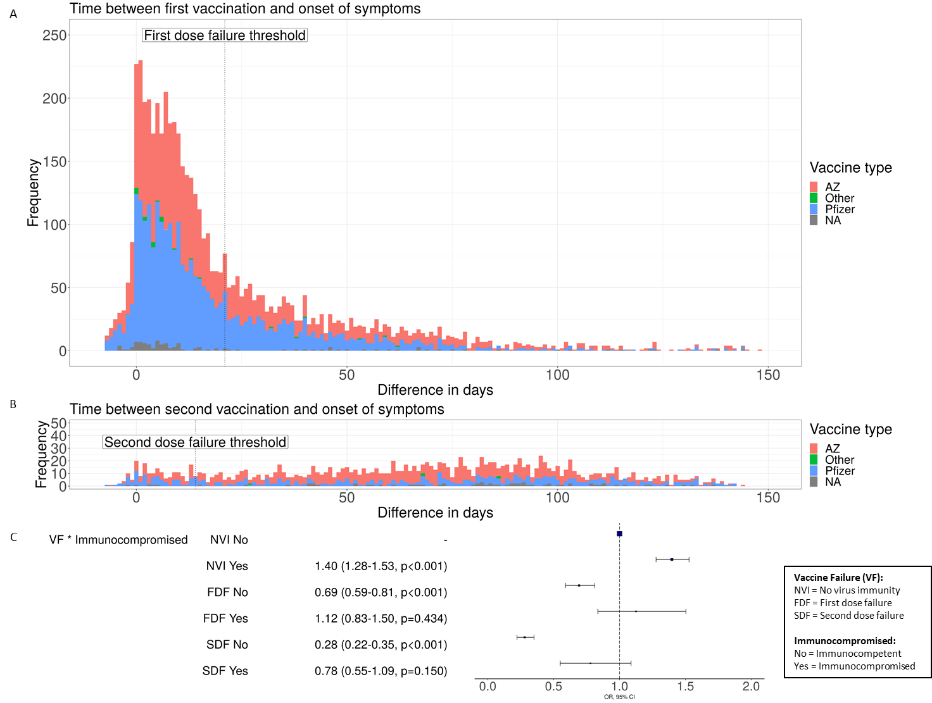

Figure 1: A: time between first vaccination and onset of symptoms for patients admitted with symptomatic PCR+ve COVID-19. Vertical dotted line represents transition from no virus immunity to first dose failure. Red – Astrazeneca vaccine, Blue – Pfizer, Green – other, grey – missing.
B: time between second vaccine and onset of symptoms for patients admitted with symptomatic PCR+ve COVID-19. Vertical dotted line represents transition from first dose failure to second dose failure.
C: Logistic Regression Odds of 28 day mortality for immunocompetent vs immunocompromised patients, stratified by vaccine group – no virus immunity, first dose failure, second dose failure. Odds adjusted for age, sex, ethnicity, socioeconomic status and comorbidity. Full model in the online supplement.

Online supplement

Table E1: patient demographics stratified by immunocompetency.
 | Immunocompetent  (N=35581) | Immunocompromised  (N=5289) | Overall  (N=40870)
Sex
Female | 15662 (86.4%) | 2456 (13.6%) | 18118
Male | 19885 (87.6%) | 2823 (12.4%) | 22708
Missing | 34 (77.3%) | 10 (22.7%) | 44
Ethnicity
White | 24414 (86.1%) | 3934 (13.9%) | 28348
South Asian | 2220 (88.6%) | 285 (11.4%) | 2505
Black | 909 (88.9%) | 114 (11.1%) | 1023
East Asian | 181 (91.9%) | 16 (8.1%) | 197
Other | 2380 (88%) | 324 (12%) | 2704
Missing | 5477 (89.9%) | 616 (10.1%) | 6093
Vaccination tier
Tier 2 | 9274 (88.5%) | 1209 (11.5%) | 10483
Tier 3 | 3454 (82.7%) | 725 (17.3%) | 4179
Tier 4 | 3655 (66.4%) | 1848 (33.6%) | 5503
Tier 5 | 2850 (90.7%) | 291 (9.3%) | 3141
Tier 6 | 6241 (83.7%) | 1216 (16.3%) | 7457
Tier 7 | 1632 (100%) | 0 (0%) | 1632
Tier 8 | 1850 (100%) | 0 (0%) | 1850
Tier 9 | 1711 (100%) | 0 (0%) | 1711
Tier 10 | 4914 (100%) | 0 (0%) | 4914
IMD quintile
1 | 9438 (88.5%) | 1231 (11.5%) | 10669
2 | 7353 (86.9%) | 1110 (13.1%) | 8463
3 | 6528 (87.2%) | 958 (12.8%) | 7486
4 | 6008 (86.3%) | 953 (13.7%) | 6961
5 | 5472 (85.6%) | 920 (14.4%) | 6392
Missing | 782 (87%) | 117 (13%) | 899
Comorbidities
Fever | 18325 (86.4%) | 2885 (13.6%) | 21210
Cough | 20465 (86%) | 3329 (14%) | 23794
Shortness of breath | 23562 (85.7%) | 3933 (14.3%) | 27495
Chronic kidney disease | 4176 (81.7%) | 937 (18.3%) | 5113
Solid organ transplant | 0 (0%) | 324 (100%) | 324
Chronic cardiac disease | 7905 (84.1%) | 1491 (15.9%) | 9396
Chronic pulmonary disease | 4187 (75.3%) | 1374 (24.7%) | 5561
Diabetes | 4692 (85.6%) | 789 (14.4%) | 5481
Obesity | 5101 (86.2%) | 820 (13.8%) | 5921
Chronic neurological disorder | 3106 (87.2%) | 457 (12.8%) | 3563
Dementia | 2922 (89.8%) | 331 (10.2%) | 3253
Vaccine failure
No information on date of symptom onset | 75 (92.6%) | 6 (7.4%) | 81
No virus immunity | 32740 (87.6%) | 4641 (12.4%) | 37381
First dose failure | 1601 (82.5%) | 340 (17.5%) | 1941
Second dose failure | 1165 (79.4%) | 302 (20.6%) | 1467

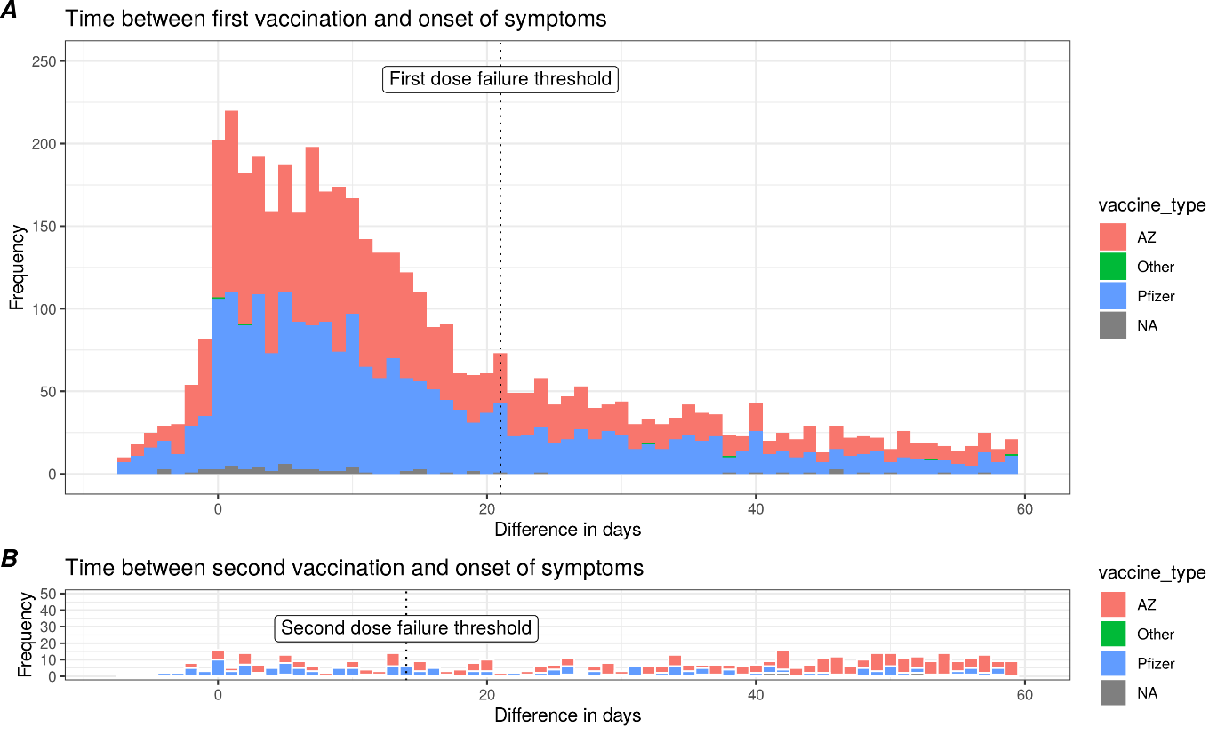

Figure E1:
A: Time from first vaccination to symptom onset. Green: -7-20 days, “no virus immunity. Blue: 21 days after first dose/ <14 days after second dose, “first dose failure”.
B: Time from second vaccination to symptom onset. Blue: 21 days after first dose/ <14 days after second dose, “first dose failure”. Purple: >=14 days after second dose, “second dose failure”. Note that the y axis scale is different between A and B. All patients included have at least 60 days follow up
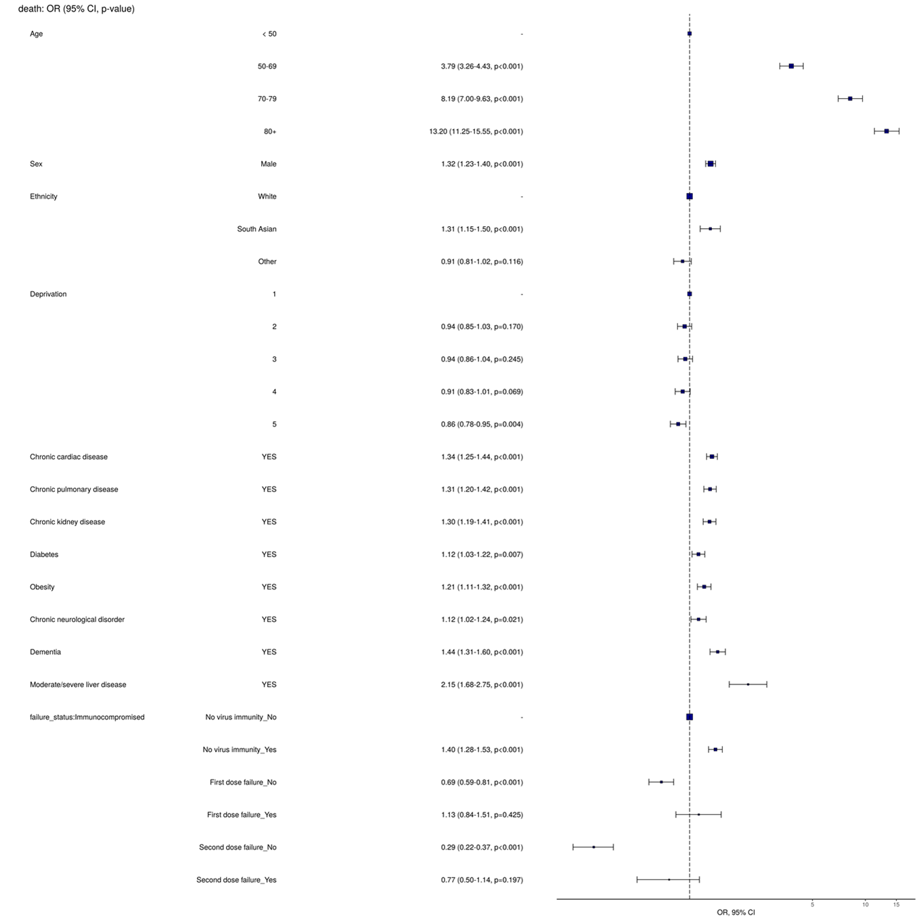
Figure E2: full model for 28 day in-hospital mortality

