**A Biomechanical Investigation of the Efficiency Hypothesis of Hafted Tool Technology**

Dominic Coe1, Larry Barham1, James Gardiner2, and Robin Crompton2

1School of Archaeology, Classics and Egyptology, University of Liverpool, Liverpool, L69 7WZ

2Institute of Life Course and Medical Sciences, University of Liverpool, Liverpool, L7 8TX

**Abstract**

The transition from hand-held to hafted tool technology marked a significant shift in conceptualising the construction and function of tools. Amongst other benefits, hafting is thought to have given users a significant biomechanical and physiological advantage in undertaking basic subsistence tasks compared with hand-held tools. It is assumed that addition of a handle improved the (bio)mechanical properties of a tool and upper limb by offering greater amounts of leverage, force, and precision.

This controlled laboratory study compares upper limb kinematics, electromyography and physiological performance during two subsistence tasks (chopping, scraping) using hafted and hand-held tools. Results show that hafted tool use elicits greater ranges of motion, greater muscle activity, and greater net energy expenditure compared with hand-held equivalents. Importantly, however, these strategies resulted in reduced relative energy expenditure compared with the hand-held condition in both tasks. More specifically, the hafted axe prompted use of two well-known biomechanical strategies that help produce larger velocities at the distal end of the limb without requiring heavy muscular effort, thus improving the tool’s functional efficiency and relative energy use.

The energetic and biomechanical benefits of hafting arguably contributed to both the invention and spread of this technology.

**Keywords | Energetics**

Hafting | Handle | Biomechanics | Palaeolithic | Chopping | Scraping | Energetics | Efficiency

**Introduction and Research Context**

Humans are distinctive among primates and the wider animal kingdom for dependency on technology to meet basic physiological needs and the close integration of technology in many aspects of their social and personal lives (Biro et al., 2013; Guindon, 2015:79-80). Since its appearance between 500,000 to 250,000 years ago (Wilkins et al., 2012; Barham, 2013), the invention of hafted (composite) tool technology represents a key technological transition that has shaped human social, cognitive, and biological capabilities. This new additive technology, with tools made of multiple parts combined into a working whole, has generated considerable interest in its cognitive implications, including the development of language and extended planning (Ambrose, 2001; 2010; Barham, 2010; 2013; Wynn, 2009; Wadley, 2010; Haidle, 2010; Hodgskiss, 2014; Sykes, 2015; Fairlie and Barham, 2016; Fairlie, 2017).

Of the advantages hafting is proposed to have conferred over non-hafted tools (killing power (Wilkins et al., 2014), raw material efficiency (Thieme, 1997; 2003) and reduced contact with biological hazards (Barham, 2013)), the underlying advantage lies in the greater leverage offered by placing working edges in a handle or shaft compared with hand-held tools that typified the Lower Palaeolithic (Oldowan and Acheulean). A hafted tool is generally assumed to increase the energetic efficiency, force and precision that can be applied to a task (Firth, 1925: 286; Odell, 1994; Morrow, 1996; Cowan, 1999; Churchill, 2001; Rots et al., 2011; Rots, 2015b). These largely untested assumptions have been consolidated into the ‘efficiency hypothesis’ of hafted tool technology (Barham, 2013) which argues that the increased biomechanical performance that can be applied to a task reduces energy expenditure and muscular force used. These reductions in physiological and biomechanical demands, as well as demands on energy and time budgets, would enhance both individual and group survival.

Despite speculation about the adaptive benefits of hafting and the proposed efficiency hypothesis, very little effort has been made to compare human-hafted and hand-held tool use performance. Morrow (1996) investigated the efficiency (in minutes) of three sizes (small, medium, large) of bifacially flaked knives to saw a hardwood dowel. Hafting a knife blade to a handle improved the functional efficiency of small and medium sized knives over their non-hafted counterparts (Morrow, 1996). Reece et al. (1997) recorded muscle recruitment patterns whilst using end-scrapers (hafted) and side-scrapers (hand-held), finding that some thenar muscles (flexor pollicis brevis and opponens pollicis) were recruited at higher levels during hand-held scraping compared with hafted scraping. Conversely, hypothenar musculature (e.g. abductor digiti minimi) was more active during the hafted end-scraper condition. They link the variation in recruitment patterns to morphological differences observed in Neanderthal hands, which provided a greater mechanical advantage to thumbs in precision gripping hand-held tools compared to hands of anatomically modern humans ( Niewoehner, 2007: 182). Claud et al. (2015) found late Middle Palaeolithic flake cleavers functioned more effectively than hand-held cleavers in both tree felling and carcass butchery tasks as measured by number of blows and time required. More recently, Key et al. (2021) compared the cutting performance of replicated hafted flint knives with effectiveness of non-hafted flint flakes and hand-held large flint bifacial tools across two standardised cutting tasks. They examined ergonomic differences between the tool types using electromyographic (EMG) analysis of nine upper limb muscles involved in gripping (first dorsal interosseous, flexor pollicis longus, abductor digiti minimi, flexor pollicis brevis), and movements of the wrist, elbow, and shoulder (flexor pollicis brevis, brachioradialis, flexor carpi radialis, biceps brachii, triceps brachii, anterior deltoid). The results show that addition of a handle reduces the activity of muscles involved in gripping compared with cutting tools held directly in the hand. Hafted knives also involved greater muscle activity in the upper body with the potential to generate extra force in cutting. The ergonomic and functional advantages of hafted knives support the predictions of the efficiency hypothesis.

This study establishes a controlled experimental methodology for comparing both proposed advantages of hafted technology using human dominant-side kinematics, tool velocity (chopping only), selected electromyography and whole body respirometry. The methodological approach combines the advantages of controlled experimentation that allows for repeated trials that minimise variation between variables, with a large sample of participants which enables us to record human interaction with the tools and materials giving the study archaeological relevance (Eren et al. 2016). We test the hypothesis that hafted tool use, and the mechanical lever advantage of a handle, will result in a kinematic pattern of reduced motion across the upper limb. In addition, we test the propositions that hafted tool-use will exhibit a pattern of reduced muscle activity in selected upper limb muscles and that energy use will be significantly reduced as a result.

**Materials and Methods**

The experiments compared differences in movement, muscle use and oxygen consumption in the context of two different activities that reflect basic subsistence and maintenance activities common in the past: chopping and scraping. Participants with a high level of physical fitness (see Shaw et al., (2012)) were recruited to undertake controlled experiments using hand-held and hafted axes and scrapers.

Participants

A total of 40 participants (24 male and 16 females) with no known upper limb musculoskeletal disorders were recruited for this study. The mean participant age was 26.0 (±4.0) years, mean height 173.60 (±27.36) cm and mean weight 75.26 (±15.15) kg. All experiments took place in the Evolutionary Morphology and Biomechanics Research Group Gait Laboratory, University of Liverpool over seven months. Each participant’s data was collected in a single data collection session. All participants received a verbal and written description of the protocol prior to participation. Following this, each participant provided written informed consent to the lead author (DC). No participants opted to withdraw. All participants were required to wear a glove on their dominant hand during both tasks and safety glasses during the chopping task. The study was approved by University of Liverpool Research Ethics Council (RETH1967).

Task Apparatus

The tools selected for the experiments were commercially manufactured, functionally effective and, importantly, allowed for the control of several variables important to the study’s primary focus of isolating the biomechanical effect of the handle (tool weight, edge length, edge sharpness, handle length). In both ergonomics (McGorry, 2001; McGorry et al., 2003; 2005) and experimental archaeology (Walker, 1978; Morrow, 1996; Key et al., 2018) the weight and sharpness of a tool has been shown to affect performance and productivity and these were prioritised here.

The chopping tool was a hatchet (referred to passim as axe) with a forged steel head and hickory handle (Screwfix, UK). In the hafted condition (Fig. 1a), no modifications were made. In the hand-held condition (Fig. 1b), the handle was removed at the base of the axe head. The scraping tool (‘Combination Shavehook’, Wickes, UK) was designed to be used uni-manually in an anteroposterior pulling motion. No modification was made to the tool used in the hafted condition (Fig. 1c). For the hand-held condition (Fig. 1d), the handle was removed to leave just the scraper head.

For the chopping task, commercial ash (*Fraxinus spp*.) dowels, 60mm in diameter and 350mm in length (G&S Specialist Timber, UK) were selected for their uniform size and material properties. The diameter selected reduced the risk of being chopped through completely in both hafted and hand-held conditions, whilst still providing a perceived achievable goal. They were also comparable in diameters to wooden implements from the Palaeolithic record (Thieme, 1997; Oakley, 1977; Allington-Jones, 2015) and other experimental studies of chopping tasks (Claud et al., 2015). For the scraping task, carpet (80% wool, 20% polyester, Carpet Options, UK) from a single roll was selected to provide a consistent, uniform surface. Carpet is considered a good substitute for large ungulate hide and has been used in previous studies investigating the biomechanical impact of scraping (Shaw et al., 2012).

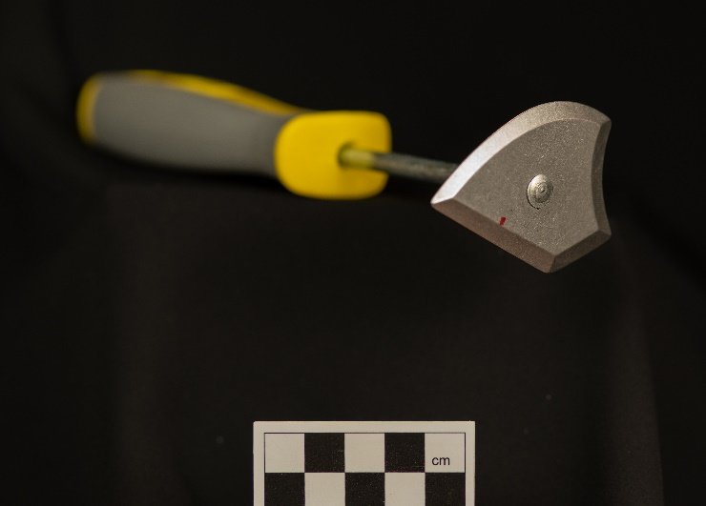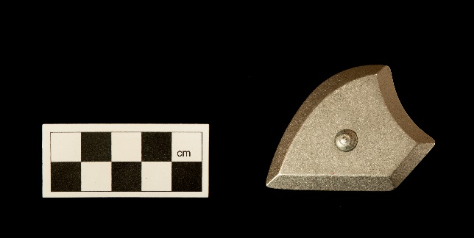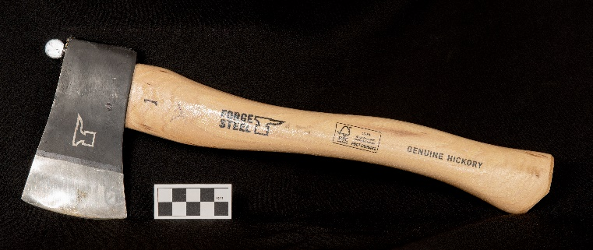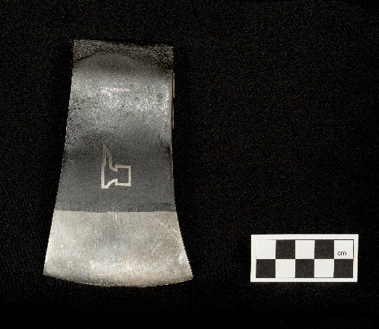

(a)

(b)

(c)

(d)

*Figure 1: Hafted (a) and hand-held (b) chopping tools and hafted (c) and hand-held (d) scraping tools used in experimental conditions.*

Kinematics

Twelve Oqus 7 (Qualisys, Gothenburg, Sweden) motion capture units (MCUs) recording at 200 Hz were used to collect three-dimensional motion of the thorax and dominant upper arm, forearm, and hand. A total of thirteen reflective markers were attached to anatomical landmarks of the torso and dominant upper limb, following ISB (International Society of Biomechanics) recommendations (Wu et al., 2005) (Table 1). In addition, two, four-marker cluster plates were placed in the upper arm and forearm to track upper and forearm movement. An additional marker (‘Axe’) was placed on the top of the axe head in the hafted condition to assess velocity of the tool. No ‘Axe’ marker was attached in the hand-held condition to avoid an obstacle in grasping the tool as well as concerns with accurate visibility of the marker throughout the task. Given the proximity of the MCP3 marker (~2cm) to the axe-head, we consider this a reasonable substitute to measure velocity.

Table : Kinematics Segment and Joint Coordinate System Definitions.

Electromyography

Eleven Trigno (Delsys, Boston, MA, USA) sensors were placed on the dominant side over the latissimus dorsi, upper trapezius, anterior deltoid, medial deltoid, posterior deltoid, pectoralis major (clavicular), biceps brachii, triceps brachii, brachioradialis, forearm extensor bundle (extensor digitorum, extensor carpi radialis, extensor carpi ulnaris), forearm flexor bundle (flexor digitorum, flexor carpi radialis, flexor carpi ulnaris). Placement of each sensor followed guidelines set out by Criswell (2010). Before electrode placement, the skin over each muscle was prepared by shaving hair and cleaning with alcohol. Before data collection, participants performed eight maximal tests developed by Boettcher et al. (2008) and Ginn et al. (2011) to produce maximum voluntary contractions (MVCs) for each muscle. Each MVC test was performed in a random order three times, each lasting five seconds. Between repetitions, participants were given a thirty second rest and between each test a minimum of one-minute. These data were used to normalise participant EMG data relative to their peak MVC activity (%MVC).

Respirometry

A Cosmed K5 (Cosmed, Rome, Italy) pulmonary gas exchange system that uses indirect calorimetry to estimate energy expenditure (EE) was used to measure participants’ energy use during hafted and hand-held tool use. The K5 system used oxygen consumption (VO2) and carbon dioxide production (VCO2), converted to EE using formulae developed by Weir (1949) (Levine, 2005). Before data collection, participants’ resting metabolic data was collected. Participants were required to lie prone for fifteen minutes after a period of at least two hours fasting. These data were used to normalise respirometry data by calculating net energy expenditure for each task and condition.

Experimental Protocol

The Cosmed K5 was fitted first and resting EE collected. EMG electrodes were applied, followed by MVC trials from the eight muscle tests. Next, kinematics markers were affixed to participants and a static trial performed. Last, the data collection protocol commenced in a random order. For each task and condition, participants completed the activity continuously for five minutes at a pace they deemed capable of maintaining. Participants were provided with at least ten minutes’ rest between task conditions to ensure fatigue was not a factor in task performance. The chopping task was to remove as much wood as possible from the wooden dowel within five minutes. The task was completed kneeling a comfortable distance from the wooden dowel, secured horizontally in front of them(Fig. 2a). Kneeling was selected for the chopping task as the safest posture to use, significantly reducing the risk of injury. In this position, miss-strikes would follow through into the ground rather than into participants’ feet, legs, or torso. For the scraping task, participants were instructed to remove as much carpet fibre as possible in five minutes without damaging the carpet base. This task required participants to be in a standing position, supported by their non-dominant arm if preferred. The carpet tile was attached to a board at an oblique angle (60°) (Fig. 2b).

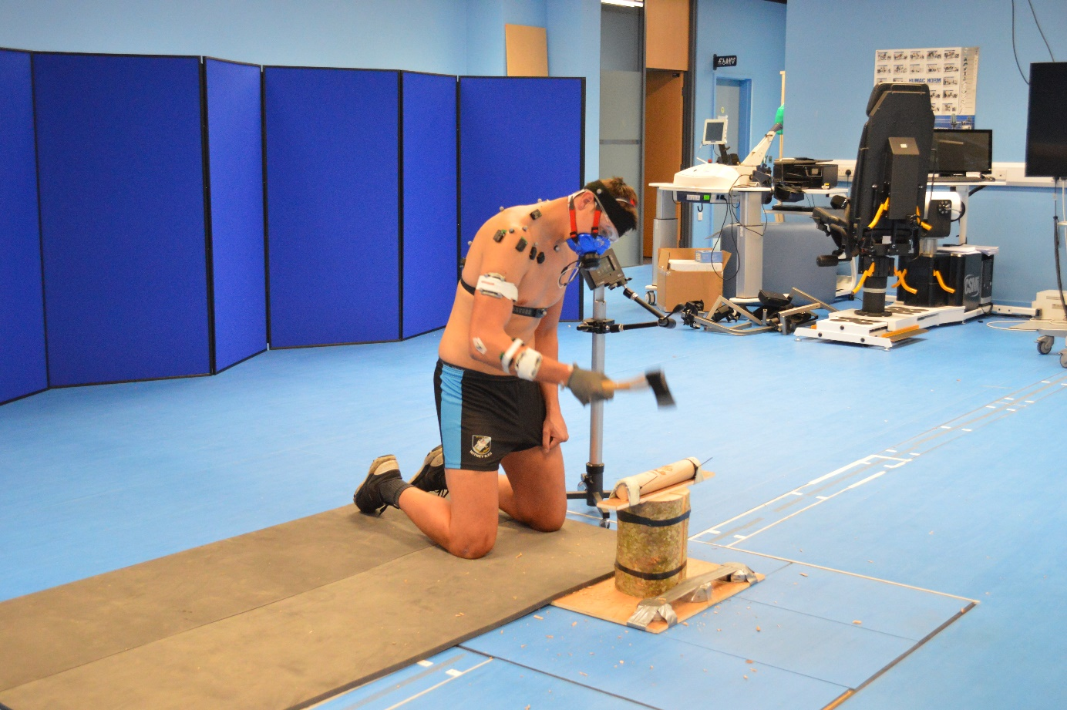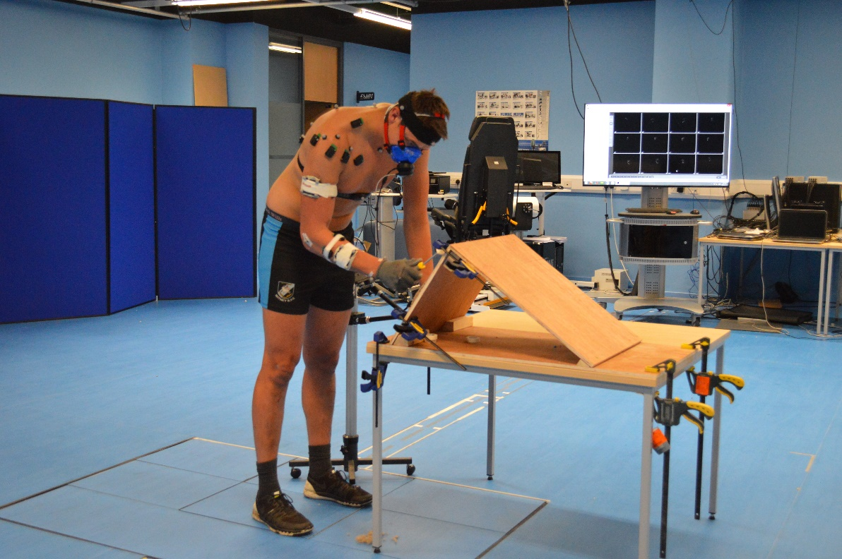

**(a)**

**(b)**

Figure 2: Study participant performing hafted conditions of chopping (a) and scraping (b) tasks.

Data Processing

Initial processing of kinematics data used Qualisys Track Manager 2.17 (QTM) software. Markers were identified, labelled, and 10 motion cycles were isolated in the 2nd, 3rd and 4th minute of activity. These motion cycles were then exported to Visual3D (C-Motion, Germantown, Maryland, USA) where motion data was filtered using a low pass, 4th order Butterworth filter and local coordinate systems were defined for each body segment (trunk, arm, forearm and hand). A kinematic model was created using a hybrid approach that included both Gates et al. (2016) and Rab et al. (2002) methods. Kinematic data was time-normalised from the highest point in the Z axis of the MCP3 marker (0%) to the subsequent highest point in the Z axis (100%). All normalised motion cycles were combined for each participant to create a mean representative cycle waveform for each intersegmental angle.

To assess velocity characteristics, 3D co-ordinates for the ‘Axe’ and ‘MCP3’ markers from the hafted trial and ‘MCP3’ from the hand-held trial were exported from QTM. In Matlab, the co-ordinate data were filtered using the same low pass 4th order Butterworth filter in line with the kinematics data. Marker co-ordinates were used to calculate marker displacement and marker velocity, expressed as meters per second (m/s). Participant data were averaged to produce mean participant velocity for each marker across the chop cycle and action cycles (0 – 100%) created using the same method as for kinematics data.

Raw MVC and trial EMG data was high pass filtered (40Hz, [zero lag], 4th order Butterworth), full wave rectified, then low pass filtered (5Hz, [zero lag], 4th order Butterworth) using Matlab 2019b (The Math Works, Natick, MA). The peak value for each muscle from the MVC trials was identified to determine maximum activation for each muscle. This value was used to normalise trial data to %MVC across the motion cycle. The EMG data were time normalised in the same manner as kinematics data.

Respirometry data were automatically converted and expressed as energetic expenditure per minute by the K5 device. All further processing was completed in Matlab 2019b. Data were low pass filtered (5Hz, [zero lag], 4th order Butterworth) following recommendations of Robergs et al. (2010). Mean resting energetic expenditure was calculated from the last twelve minutes of the 15-minute rest period. Mean trial energetic expenditure was calculated from the last four minutes of the task condition. Net energy expenditure (EE) was calculated by subtracting resting EE from mean trial EE. Last, ‘cost of activity’ EE (CoA EE) was calculated by dividing net EEmin with ‘measure of performance (MoP) for each participant. MoP was a quantifiable measure of a participant’s performance in each task and condition. For chopping, the volume of wood removed from the wooden dowel was calculated by subtracting post-chopping volume of the dowel from original volume of the dowel using models created using a DAVID SLS-2 scanner (Hewlett-Packard, Palo Alto, Cali., USA) (Fig. 3). To calculate original volume, custom Matlab code that applied convex hull methodology was used. To calculate post-chopping volume, each model was imported into Geomagic Studio 10 (3D Systems, N.C., USA) and volume was calculated using a built-in function. MoP for the scraping task was calculated as weight of fibre removed from the carpet tiles.

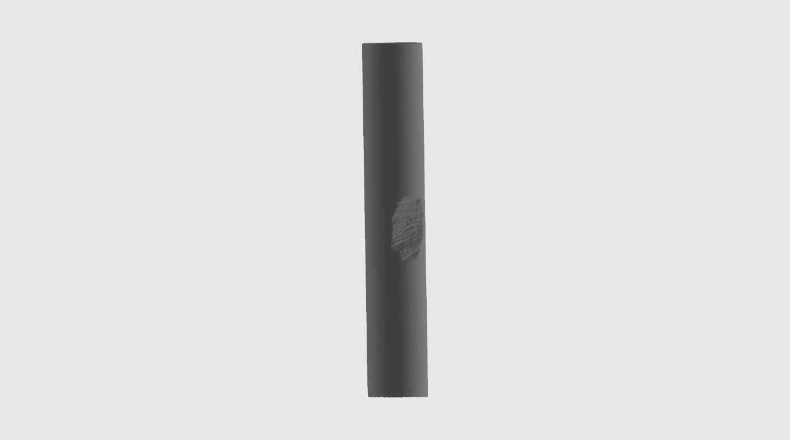

**(a)**

**(b)**

Figure 3: Example 3D models of wooden dowels chopped during the hafted (a) and hand-held (b) chopping conditions.

Data Analysis

One-dimensional statistical parametric mapping (SPM) was used to detect differences in intersegmental angles and muscle activity conditions (hafted vs. hand-held) across normalised action cycle curves (Pataky, 2010; 2012). SPM works by providing a topological analysis of smooth continuum associated with experimental intervention (Pataky, 2010; 2012). Using open-source Matlab code ([www.spm1d.org](http://www.spm1d.org)), a series of Bonferroni-corrected analyses of variance (ANOVA) variables were used to determine differences between conditions for each intersegmental angle, velocity marker, and muscle. The SPM method distinguished all specific time points in the motion cycle time-series where statistically significant differences between groups existed. ANOVA was used to compare energetic performance (Net EEmin and CoA) condition (α = 0.05) using SPSS V25 (SPSS Inc. Chicago, IL, USA).

**Results**

Chopping – Kinematics

Differences in motion were noted between experimental conditions (hafted vs hand-held) in trunk, glenohumeral, elbow, and wrist angles (Fig.4). Across the full chop cycle, the torso was positioned in a less flexed (p < 0.001) posture during hafted chopping (Fig. 4a). In both downswing and upswing phases, hafted chopping elicited greater flexion (p < 0.001) and external rotation (p = 0.002 & p = 0.003) at the glenohumeral joint (Fig. 4d & f). In hafted chopping, the elbow was flexed to a greater degree (p = 0.003) during termination of downswing and initiation of upswing (Fig. 4g). Participants also held their wrist in a less extended position at termination of downswing in hafted chopping (p = 0.005), this continued into the upswing phase (p = 0.001) (Fig. 4h). A similar motion pattern was noted in wrist deviation, although the degree of difference was greater: the wrist positioned in significantly more ulnar deviation at initiation and termination of downswing and during all of upswing (p = 0.004 & p < 0.001) (Fig. 4i). Although the time series graph shows a lack of overall forearm rotation across the chop cycle, during most of the downswing and initial phase of upswing, participants held their forearm in a less pronated position (p < 0.001) in hafted chopping (Fig. 4j).

Figure 4: Averaged participant group trunk, glenohumeral, elbow, and wrist intersegmental angles for hafted (blue) and hand-held (red) conditions, time normalized to a full chop cycle. Downswing and Upswing for each condition are separated by colour coordinated, vertical dashed lines. One standard deviation for each group is represented by shading in the corresponding colour. Associated SPM F-scores are reported below the average waveforms. Where F-scores exceed the critical value (black horizontal dashed line), significant differences between groups are recognised and labelled.

Chopping – Velocity

Velocity comparisons for both hafted axe marker vs hand-held MCP3 marker and hafted MCP3 marker vs hand-held MCP3 marker reveal significant differences. The hafted axe marker had a significantly higher velocity (p < 0.001) across the full chop cycle (Fig. 5a). Comparison of MCP3 marker velocity during both conditions, again showed the hafted condition produced significantly greater velocities in both downswing (p < 0.001) and upswing (p < 0.001) (Fig. 5b).

Figure 5: Averaged participant groups velocity of condition markers, time normalised to a full chop cycle. (a) velocity of the hafted axe head (blue) and hand-held MCP3 (red, dashed) condition markers. (b) velocity of the hafted MCP3 (blue) and hand-held MCP3 (red, dashed) condition markers. One standard deviation for each group is represented by shading in the corresponding colour. Associated SPM F-scores are reported below the average waveforms. Where F-scores exceed the critical value (black horizontal dashed line), significant differences between groups are recognised and labelled.

Chopping – Electromyography

As in the motion results, significant differences occur between experimental conditions (Fig. 6). During the downswing phase, triceps brachii (p < 0.001) amplitude was higher in the hafted condition (Fig. 6h), whereas forearm extensors (p < 0.001) amplitude was higher in the hand-held condition for the same phase (Fig. 6j). Forearm extensor (p < 0.001) amplitude was also higher in late upswing during hand-held chopping. During the early upswing phase, the hafted condition produced higher amplitudes for both the upper trapezius (p < 0.001) and brachioradialis (p = 0.001) (Fig. 6b & i). Moreover, muscles acting primarily on the glenohumeral joint appeared to be used only minimally in both conditions (Fig. 6c – f), with only the upper trapezius (Fig. 6b) approaching 20% MVC.

Figure 6: Averaged participant group normalized (% MVC) muscle amplitudes for hafted (blue) and hand-held (red), time normalized to a full chop cycle. Downswing and Upswing for each condition are separated by the colour coordinated, vertical dashed lines. One standard deviation for each group is represented by shading in the corresponding colour. Associated SPM F-scores are reported below the average waveforms. Where F-scores exceed the critical value (black horizontal dashed line), significant differences between groups are recognised and labelled.

Chopping – Respirometry

Significant differences were also revealed in absolute (hereafter ‘Net’) energy use between hafted and hand-held conditions (p < 0.001), with participants using more energy in the hafted condition compared with the hand-held condition (Fig. 7a). Importantly, this difference was reversed when energy use was assessed relative to the MoP. Participants used significantly (p < 0.001) fewer kilocalories to remove a cm3 of wood in the hafted condition than the hand-held (Fig. 7b).



Figure 7: Averaged participant group for (a) net energy expenditure (EE) and (b) cost of activity (CoA) EE for hafted (blue) and hand-held (red, crosshatch) conditions in the chopping task. Results show that hafted chopping had a statistically higher net energy demand compared with hand-held chopping. Only when energy use is assessed to a measure of performance, to create a cost of activity energy expenditure, is the energetic efficiency of a handle realised.

Scraping – Kinematics

For the scraping tasks, differences in intersegmental angle were noted between experimental conditions (hafted vs. hand-held) in glenohumeral and elbow joint angles (Fig. 8) representing subtle differences at specific regions of the upper limb. Although the motion pattern at the glenohumeral joint and elbow followed a similar pattern, participants in the hafted condition had a less flexed glenohumeral position (p < 0.001) across the full scrape cycle (Fig. 8d) and a less flexed elbow (p = 0.003) during the downstroke of the scrape cycle (Fig. 8g). Though not significant, the hafted condition also positioned the wrist in a less extended and ulnar deviated position throughout the scrape cycle (Fig. 8h & i).

Figure 8: Averaged participant group trunk, glenohumeral, elbow, and wrist intersegmental angles for hafted (blue) and hand-held (red) conditions, time normalized to a full scrape cycle. Downstroke and Upstroke for each condition are separated by the colour coordinated, vertical dashed lines. One standard deviation for each group is represented by shading in the corresponding colour. Associated SPM F-scores are reported below the average waveforms. Where F-scores exceed the critical value (black horizontal dashed line), significant differences between groups are recognised and labelled.

Scraping – Electromyography

Despite an overall similarity in muscle magnitude patterns across the upper limb, significant differences in muscle magnitude exist between experimental conditions (Fig. 9). During downswing, triceps brachii (p = 0.003) and brachioradialis (p = 0.001) amplitude was higher in the hafted condition (Fig. 9i & h). Further, muscles acting on the glenohumeral and elbow joints also seem to be minimally used in both conditions, with only forearm flexors (Fig. 9k) substantially exceeding 30% MVC.

Figure 9: Averaged participant group normalized (% MVC) muscle amplitudes for hafted (blue) and hand-held (red), time normalized to a full scrape cycle. Downstroke and Upstroke for each condition are separated by the colour coordinated, vertical dashed lines. One standard deviation for each group is represented by shading in the corresponding colour. Associated SPM F-scores are reported below the average waveforms. Where F-scores exceed the critical value (black horizontal dashed line), significant differences between groups are recognised and labelled.

Scraping – Respirometry

A similar pattern of results for scraping respirometry was noted as for chopping respirometry. Results for Net EE reveal that participants used more energy in the hafted condition (p = 0.006) compared with the hand-held condition (Fig. 10a).

Again, once a measure of performance for scraping is combined with Net EE (CoA EE), analysis shows participants used fewer kilocalories to remove a gm of fibre in the hafted condition (p < 0.001) than hand-held (Fig. 10b).



Figure 10: Averaged participant group for (a) net energy expenditure (EE) and (b) cost of activity (CoA) EE for hafted (blue) and hand-held (red, crosshatch) conditions in the scraping task. Results show that hafted scraping had a statistically higher net energy demand compared with hand-held scraping. Only when energy use is assessed to a measure of performance, to create a cost of activity energy expenditure, is the energetic efficiency of a handle realised.

**Discussion**

Chopping Task

Results of kinematics (Fig. 4) and EMG (Fig. 6) analyses highlight important differences, representing functionally different motion and muscle-activity strategies which affect the efficiency of each tool. Contrary to expectations, the hafted condition is characterised by an overall more open posture (less crouched) (Fig. 4a), significantly greater range of motion throughout the chop cycle and across each segment (Fig. 4), and greater muscle magnitudes in both upswing and downswing. Overall, motions and muscles acting in the sagittal plane (flexion/extension) showed the most noteworthy differences, corresponding to greater levels of extension in the hafted condition.

The large differences recognised between chopping conditions are best understood by comparing joint angular velocities (Fig. 11), identification of a proximal-to-distal joint sequence (PDJS) (Putnam, 1991) and Dart Thrower’s Motion (DTM) (Palmer et al., 1985). PDJS describes the coordinated movement of a multi-joint system in which motion follows a proximal-to-distal sequence whereby the most proximal joint (trunk) begins its motion first and reaches its peak angular velocity before more distal joints (glenohumeral, elbow, wrist) (Putnam, 1991; Williams et al., 2010; 2014; Feuerriegel, 2016). In this motion, the arm moves in a similar fashion to a whip resulting in greater angular velocities at the most distal joint than would be achieved without benefit of passive interactive torques (torque at the glenohumeral joint contributes to final hand velocity). This is known as a velocity summation effect.

Figure 11: Angular velocities of glenohumeral flexion/extension (blue), Elbow flexion extension (orange) and wrist flexion/extension (yellow), time normalised to full chop cycle during the hafted (a) and hand-held (b) chopping task. Coordinated coloured dots represent peak joint angular velocity for each joint motion in X-axis. Downswing and Upswing phases are separated by vertical dashed lines.

Table 2: Peak angular velocities for each joint and condition during the chopping task.

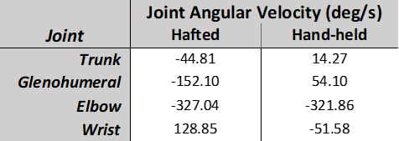

Studies of contemporary hammering activities identified a full PDJS (Côté et al. 2005), however, advantages of a summation effect were not recognised, with the elbow producing greater peak angular velocity (Côté et al., 2005: table 1). We also found hafted chopping peak angular velocities occur in a PDJS, also extending the PDJS to include the trunk (Fig. 11a). Furthermore, hafted chopping failed to utilise the full summation effect (Fig. 11a; Table 2), with elbow angular velocities peaking higher than at the wrist (Table 2). Why high impact activities employ a modified PDJS motion remains poorly understood but this may represent a strategy to avoid high joint reaction forces, ensuring joint stability at wrist and elbow (Williams et al., 2014). The complete absence of a PDJS during hand-held chopping (Fig. 11b) supports this hypothesis. It is possible that in high-impact, percussive activities such as hammering and chopping, traditional PDJS is not the best model to produce maximum linear velocity of the tool head, or that in these activities, elbow motion represents a more important joint motion compared with other activities (i.e. knapping) where reactive forces are substantially reduced.

During hafted chopping, the wrist moved from an extended, radially deviated position to a flexed, ulnar-deviated position known as the Dart Thrower’s Motion (DTM) (Palmer et al., 1985) (Fig. 4h and i). Motion during hafted chopping aligns well with that identified in studies of hammering which have shown whilst hammering follows a typical DTM path, there is an offset in extension (Fig. 3h; Palmer et al, 1985; Curran et al., 2008; Leventhal et al., 2010). The importance of this motion appears two-fold. First, it offers an improvement in radio-carpal joint stability relative to pure anatomical motions of extension-flexion and radial-ulnar deviation (Crisco et al., 2005). Secondly, the highly mobile wrist enables cocking of the wrist, which aids in dealing with the inertial resistance of the axe during upswing and early downswing. Furthermore (in conjunction with a PDJS), an uncoiling and rapid ulnar flexion of the wrist at the end of downswing maximises axe velocity just before the strike, without requiring heavy use of forearm musculature (Williams et al., 2014; Marzke et al., 1998; Pigeon et al., 1996). Lack of wrist mobility (Fig. 4h, i) and corresponding reduction in velocity (Fig. 5) of the axe head in hand-held relative to hafted chopping indicates the importance of such motions during behaviours which utilise power grips, including hafted chopping (Wolfe et al, 2006).

PDJS and DTM motion strategies employed during hafted chopping allow the upper limb to produce higher velocities (Côté et al, 2008) at the axe head (Fig. 5). This results in greater kinetic energy being transferred into the wood, and more effective removal of material. PDJS and DTM motion strategies also help provide stable joint motions capable of coping with reactive forces produced during striking of axe onto wood. In line with results expected from the utilisation of PDJS and DTM, velocity results (Fig. 5a) show hafted chopping produced significantly higher axe head velocity (a proxy for kinetic energy) for the entire chop cycle and most importantly during the period around axe strike. During hafted chopping participants were able to impart significantly greater kinetic energy into the wood to split fibres compared with hand-held chopping. The latter employs a fundamentally different motion sequence that ultimately cannot produce the same velocity (and therefore kinetic energy) as the hafted axe head. This resulted in hand-held chopping denting and mincing rather than splitting the wood fibres (Fig. 3b). That participants did not employ PDJS (Fig. 11b) and DTM motions (Fig. 3h and i) in hand-held chopping reflects a compromise between producing the levels of kinetic energy needed to split wood fibres whilst minimising reactive forces caused by striking to avoid injury. The proximity of hand to axe head in hand-held chopping and the direct transfer of forces into the upper limb probably inhibited wrist mobility and exploitation of the full range of motion at elbow and glenohumeral joints seen in hafted chopping.

The greater motion and muscle amplitude seen in hafted chopping translate to an overall increase in Net energy expenditure (EE) (Fig. 7), with hafted chopping using ~20% more total energy during the task (Fig. 7a). Only when Net EE is calculated relative to a measure of performance (MoP) is the handle efficiency realised, our analysis showing hand-held chopping uses three times more kilocalories to remove a cubic centimetre of wood than hafted chopping (Fig. 7b).

Scraping Task

Results of kinematics (Fig. 8) and EMG (Fig. 9) analyses represent subtle differences at specific regions of the upper limb which ultimately resulted in significant energetic efficiency during a scraping task (Fig. 10b). A similar motion pattern is observed in both scraping conditions across the upper limb, with differences often relating to different starting and ending positions in the cycle. In flexion/extension, the glenohumeral follows the same path in both conditions, although hand-held scraping is permanently held in ~12° greater flexion compared with hafted scraping (Fig. 8d). Whether this difference places alternative demands on flexion and extension musculature is not revealed but could result in differences in other, deep lying musculature, such as the coracobrachialis or teres major. Although similar in much of the scrape cycle, hand-held scraping deviates from continuous slow extension of the elbow, instead undergoing a period of stasis before continuing to extend briefly at the end of downstroke (Fig. 8g). This difference is potentially a strategy to limit motion at elbow and wrist to provide greater control of the force exerted during hand-held scraping. In hafted scraping, the mechanical leverage of the handle may enable continued pressure to be exerted through the scraper, allowing extension to continue unimpeded throughout downstroke. In line with continued extension of the elbow in hafted scraping, the triceps brachii is significantly more active during this period (Fig. 9h).

Reece et al. (1997) and Key et al. (2021) identify differences in muscle activity and recruitment in scraping and cutting tasks respectively when using hafted and hand-held tools. Similarly, the present study shows that hafted scraping elicits greater activity in muscles around the elbow (Fig. 9h, i) compared with hand-held scraping. As in the chopping task, the hafted scraper enables more use of the upper limb in terms of both motion and muscle use, ultimately providing it with greater functional capabilities. This is likely linked to the different grips used in the two conditions. Barham (2013:10) suggests, “the precision-grip used to hold a blade limits the amount of force that can be applied to the cutting motion when compared to a power-grip used to grasp a handle”. In this study and that of Key et al. (2021), use of a power grip affords a greater use of the upper arm compared with the precision grip, which appears to limit use of these muscles and motions, reducing forces placed through the tool.

As in the chopping task, increased motion and muscle activity in hafted scraping resulted in a greater absolute (Net) EE compared with hand-held scraping (Fig. 10a). This result was reversed once the MoP for scraping was applied, revealing an energetic efficiency to this task whilst using a hafted scraper (Fig. 10b). Unlike the chopping task, the mechanisms driving this greater efficiency are difficult to establish for scraping. We hypothesise that the amount of pressure that can be exerted through the scraper head is key to the greater effectiveness of a hafted scraper. As above, the difference in force production is likely based on the precision grip used in hand-held scraping compared with the power grip used in hafted scraping (Barham, 2013).

Hafting Biomechanics and the Efficiency Hypothesis

The results of this study support previous research highlighting functional efficiency advantages of hafting in a variety of tasks and experimental settings (Morrow et al., 1996; Reece et al., 1997; Claud et al., 2015; Key et al., 2021). The adaptive benefits and motivations behind the invention and proliferation of hafted tool technology are likely to be complex and multifaceted (Rots 2013). This study shows that two subsistence activities, ubiquitous in the prehistoric past, are significantly improved in both tool functionality and energetic efficiency when undertaken using a hafted tool compared with the hand-held equivalent.

This study has shown that to gain energetic advantage, a complex set of interactions occurs between motions and postures which ensure the tool remains functionally effective (e.g. axe-head velocity), while likely minimising reactive forces and risk of injury. The finding that a high-impact activity such as chopping, which is very difficult to complete hand-held, benefits greatly from hafting is unsurprising and has been predicted (Rots 2010; Barham 2013). However, that hafting also offers a biomechanical and physiological advantage to a scraping task, in which hafting is not functionally a requirement of acceptable performance, supports previous assumptions that hafting confers a universal advantage (Barham, 2013). This could increase the general fitness of the individual and groups reliant on basic subsistence activities (Rots, 2013; Mateos et al., 2018). Experimental evidence of adaptive advantages offered by hafting contributes to our understanding of the invention of this technology at a time of increased ecological resource variability during the Middle Pleistocene (Potts et al. 2020).

As noted earlier, this study employed an internal experimental model in its use of commercial tools, as a result, further validation work with more naturalistic arrangements would be a valuable direction for future research to help embed this research into other studies that employed an external model. Following this study and the work of Key et al. (2021), further experimental research is needed to assess the impact of hafting on other basic activities (drilling and piercing) as well as a variety of haft forms (cleft and juxtaposed etc.) to help model the spread and amplification of hafted technologies.

**Conclusion**

Hafted tool technology marked a significant shift in conceptualising the construction and function of stone tools. As well as representing an important shift in cognition of hominin groups that produced them (Ambrose, 2010; Barham, 2013; Wynn, 2009; Wadley, 2010; Hodgskiss, 2014; Sykes, 2015; Fairlie and Barham, 2016; Fairlie, 2017), hafting is often cited for the biomechanical and physiological benefits it offers the individual over hand-held equivalents (Firth, 1925; Odell, 1994; Morrow, 1996; Cowan, 1999; Churchill, 2001; Rots et al., 2011; Rots, 2015b; Barham, 2013). This study has shown that in two subsistence tasks, hafting results in significantly different biomechanical strategies, that ultimately works to offer an energetic benefit compared with hand-held equivalent tools. Most notably, during the chopping task it has shed light on the mechanism whereby the energetic benefit is achieved through increases in joint motions and muscle use which resulted in an increase in velocity and force that ultimately made the hafted tool used more effective per unit of energy applied to a task. Further research focussed on specific upper limb segments and muscle groups (e.g. the wrist joint and forearm musculature), as well as role of the grips employed would be of value to understanding the adaptive value of this key technological transition.

**Acknowledgments**

This study was funded by the Arts & Humanities Research Council, UK (no.1790551). The primary author wishes to thank all study participants, Todd Pataky for his support with data analysis and the three reviewers for their constructive comments. We take responsibility for any shortcomings.

**References**

Allington-Jones, L. 2015. The Clacton Spear: The Last One Hundred Years. *Archaeological Journal,* 172**,** 273-296.

Ambrose, S. H. 2001. Paleolithic Technology and Human Evolution. *Science,* 291**,** 1748-1753.

Ambrose, S. H. 2010. Coevolution of Composite-Tool Technology, Constructive Memory, and Language Implications for the Evolution of Modern Human Behavior. *Current Anthropology,* 51**,** S135-S147.

Barham, L. 2010. A Technological Fix For 'Dunbar's Dilemma'? *Proceedings of the British Academy*, 158, 89-367.

Barham, L. 2013. *From Hand to Handle: The First Industrial Revolution*, Oxford University Press.

Biro, D., Haslam, M. & Rutz, C. 2013. Tool Use as Adaptation. The Royal Society.

Boettcher, C. E., Ginn, K. A. & Cathers, I. 2008. Standard Maximum Isometric Voluntary Contraction Tests for Normalizing Shoulder Muscle Emg. *Journal of Orthopaedic Research,* 26**,** 1591-1597.

Churchill, S. E. 2001. Hand Morphology, Manipulation, and Tool Use in Neandertals and Early Modern Humans of the near East. *Proceedings of the National Academy of Sciences of the United States of America,* 98**,** 2953-2955.

Churchill, S. E., Berger, L. R., Hartstone-Rose, A. & Zondo, B. H. 2012. Body Size in African Middle Pleistocene Homo. *In:* Reynolds, S. C. & Gallagher, A. (eds.) *African Genesis: Perspectives on Hominin Evolution.* Cambridge University Press.

Claud, E., Deschamps, M., Colonge, D., Mourre, V. & Thiebaut, C. 2015. Experimental and Functional Analysis of Late Middle Paleolithic Flake Cleavers from Southwestern Europe (France and Spain). *Journal of Archaeological Science,* 62**,** 105-127.

Côté, J. N., Feldman, A. G., Mathieu, P. A. & Levin, M. F. 2008. Effects of Fatigue on Intermuscular Coordination During Repetitive Hammering. *Motor control,* 12**,** 79-92.

Côté, J. N., Raymond, D., Mathieu, P. A., Feldman, A. G. & Levin, M. F. 2005. Differences in Multi-Joint Kinematic Patterns of Repetitive Hammering in Healthy, Fatigued and Shoulder-Injured Individuals. *Clinical Biomechanics,* 20**,** 581-590.

Cowan, F. L. 1999. Making Sense of Flake Scatters: Lithic Technological Strategies and Mobility. *American Antiquity***,** 593-607.

Crisco, J. J., Coburn, J. C., Moore, D. C., Akelman, E., Weiss, A.-P. C. & Wolfe, S. W. 2005. In Vivo Radiocarpal Kinematics and the Dart Thrower's Motion. *JBJS,* 87**,** 2729-2740.

Criswell, E. 2010. *Cram's Introduction to Surface Electromyography*, Jones & Bartlett Publishers.

Eren, M. I., Lycett, S. J., Patten, R. J., Buchanan, B., Pargeter, J. & O'brien, M. J. 2016. Test, Model, and Method Validation: The Role of Experimental Stone Artifact Replication in Hypothesis-Driven Archaeology. Ethnoarchaeology, 8, 103-136.

Fairlie, J. E. 2017. *Getting a Handle on It: A First Step Towards Understanding the Cognitive Evolutionary Processes Underlying Changes in the Archaeological Record That Relate to Pliocene and Pleistocene Hand-Held Tool and Hafted Tool Technologies.* PhD, University of Liverpool.

Fairlie, J. E. & Barham, L. S. 2016. From Chaîne Opératoire to Observational Analysis: A Pilot Study of a New Methodology for Analysing Changes in Cognitive Task-Structuring Strategies across Different Hominin Tool-Making Events. *Cambridge Archaeological Journal,* 26**,** 643-664.

Feuerriegel, E. 2016. *Biomechanics of the Hominin Upper Limb: Entheseal Development and Stone Tool Manufacture.* PhD, The Australian National University.

Firth, R. W. 1925. The Maori Carver. *The Journal of the Polynesian Society,* 34**,** 277-291.

Gates, D. H., Walters, L. S., Cowley, J., Wilken, J. M. & Resnik, L. 2016. Range of Motion Requirements for Upper-Limb Activities of Daily Living. *American Journal of Occupational Therapy,* 70.

Ginn, K. A., Halaki, M. & Cathers, I. 2011. Revision of the Shoulder Normalization Tests Is Required to Include Rhomboid Major and Teres Major. *Journal of Orthopaedic Research,* 29**,** 1846-1849.

Guindon, F. 2015. Technology, Material Culture and the Well-Being of Aboriginal Peoples of Canada. *Journal of Material Culture,* 20**,** 77-97.

Hodgskiss, T. 2014. Cognitive Requirements for Ochre Use in the Middle Stone Age at Sibudu, South Africa. *Cambridge Archaeological Journal,* 24**,** 405.

Key, A., Fisch, M. R. & Eren, M. I. 2018. Early Stage Blunting Causes Rapid Reductions in Stone Tool Performance. *Journal of Archaeological Science,* 91**,** 1-11.

Key, A., Farr, I., Hunter, R., Mika, A., Eren, M. I. & Winter, S. L. 2021. Why Invent the Handle? Electromyography (Emg) and Efficiency of Use Data Investigating the Prehistoric Origin and Selection of Hafted Stone Knives. Archaeological and Anthropological Sciences, 13, 1-16.

Levine, J. A. 2005. Measurement of Energy Expenditure. *Public health nutrition,* 8**,** 1123-1132.

Marzke, M. W., Toth, N., Schick, K., Reece, S., Steinberg, B., Hunt, K., Linscheid, R. & An, K. N. 1998. Emg Study of Hand Muscle Recruitment During Hard Hammer Percussion Manufacture of Oldowan Tools. American Journal of Physical Anthropology: The Official Publication of the American Association of Physical Anthropologists, 105, 315-332.

Mateos, A., Terradillos-Bernal, M. & Rodriguez, J. 2019. Energy Cost of Stone Knapping. *Journal of Archaeological Method and Theory,* 26**,** 561-580.

Mcgorry, R. W. 2001. A System for the Measurement of Grip Forces and Applied Moments During Hand Tool Use. *Applied Ergonomics,* 32**,** 271-279.

Mcgorry, R. W., Dowd, P. C. & Dempsey, P. G. 2003. Cutting Moments and Grip Forces in Meat Cutting Operations and the Effect of Knife Sharpness. *Applied Ergonomics,* 34**,** 375-382.

Mcgorry, R. W., Dowd, P. C. & Dempsey, P. G. 2005. The Effect of Blade Finish and Blade Edge Angle on Forces Used in Meat Cutting Operations. *Applied Ergonomics,* 36**,** 71-77.

Morrow, T. A. 1996. Bigger Is Better: Comments on Kuhn's Formal Approach to Mobile Tool Kits. *American Antiquity,* 61**,** 581-590.

Niewoehner, W. A. 2007. Neanderthal Hands in Their Proper Perspective. *In:* Harvati, K. & Harrison, T. (eds.) *Neanderthals Revisited: New Approaches and Perspectives.* Springer.

Oakley, K. P., Andrews, P., Keeley, L. H. & Clark, J. D. A Reappraisal of the Clacton Spearpoint. Proceedings of the Prehistoric Society, 1977. Cambridge University Press, 13-30.

Odell, G. H. 1994. The Role of Stone Bladelets in Middle Woodland Society. *American Antiquity***,** 102-120.

Palmer, A. K., Werner, F. W., Murphy, D. & Glisson, R. 1985. Functional Wrist Motion: A Biomechanical Study. *Journal of Hand Surgery,* 10**,** 39-46.

Pataky, T. C. 2010. Generalized N-Dimensional Biomechanical Field Analysis Using Statistical Parametric Mapping. *Journal of Biomechanics,* 43**,** 1976-1982.

Pataky, T. C. 2012. One-Dimensional Statistical Parametric Mapping in Python. *Computer Methods in Biomechanics and Biomedical Engineering,* 15**,** 295-301.

Pigeon, P. & Feldman, A. G. 1996. Moment Arms and Lengths of Human Upper Limb Muscles as Functions of Joint Angles. Journal of biomechanics, 29, 1365-1370.

Putnam, C. A. 1991. A Segment Interaction Analysis of Proximal-to-Distal Sequential Segment Motion Patterns. *Medicine and science in sports and exercise,* 23**,** 130-144.

Potts, R., Dommain, R., Moerman, J.W., Behrensmeyer, A. K., Deino, A.L., Riedl, S., Beverly, E.J., Brown, E.T., Deocampo, D., Kinyanjui, R., Lupien, R., Owen, R.B., Rabideaux, R., Russell, J.M., Stockhecke, M., deMenocal, P., Faith, J.T., Garcin, Y., Noren, A., Scott, J.J., Western, D., Bright, J., Clark, J.B., Cohen, A.S., Keller, C.B., King, J., Levin, N.E., Brady Shannon, K., Muiruri, V., Renaut, R.W., Rucina, S.M., Uno, K., 2020. Increased ecological resource variability during a critical transition in hominin evolution, Science Advances, vol. 6, eabc8975.

Rab, G., Petuskey, K. & Bagley, A. 2002. A Method for Determination of Upper Extremity Kinematics. *Gait & Posture,* 15**,** 113-119.

Reece, S., Steinberg, B., Marzke, M. W., Toth, N., Schick, K., Hunt, K., Linscheid, R. L. & An, K. N. 1997. Sidescraping, Endscraping and the Hominid Hand. *Journal of Human Evolution,* 32**,** A17-A17.

Robergs, R. A., Dwyer, D. & Astorino, T. 2010. Recommendations for Improved Data Processing from Expired Gas Analysis Indirect Calorimetry. *Sports Medicine,* 40**,** 95-111.

Rots, V. 2013. Insights into Early Middle Palaeolithic Tool Use and Hafting in Western Europe. The Functional Analysis of Level Ha of the Early Middle Palaeolithic Site of Biache-Saint-Vaast (France). *Journal of Archaeological Science,* 40**,** 497-506.

Rots, V. 2015. Hafting and the Interpretation of Site Function in the European Middle Palaeolithic. *Settlement Dynamics of the Middle Paleolithic and Middle Stone Age*.

Rots, V., Van Peer, P. & Vermeersch, P. M. 2011. Aspects of Tool Production, Use, and Hafting in Palaeolithic Assemblages from Northeast Africa. *Journal of Human Evolution,* 60**,** 637-664.

Ruff, C. B., Trinkaus, E. & Holliday, T. W. 1997. Body Mass and Encephalization in Pleistocene Homo. *Nature,* 387**,** 173-176.

Shaw, C. N., Hofmann, C. L., Petraglia, M. D., Stock, J. T. & Gottschall, J. S. 2012. Neandertal Humeri May Reflect Adaptation to Scraping Tasks, but Not Spear Thrusting. *PloS one,* 7**,** e40349.

Sykes, R. W. 2015. To See a World in a Hafted Tool: Birch Pitch Composite Technology, Cognition and Memory in Neanderthals. *In:* Coward, F., Hosfield, R., Pope, M. & Wenban-Smith, F. (eds.) *Settlement, Society and Cognition in Human Evolution.* Cambridge University Press.

Thieme, H. 1997. Lower Palaeolithic Hunting Spears from Germany. *Nature,* 385**,** 807-810.

Thieme, H. 2003. Lower Palaeolithic Sites at Schoningen, Lower Saxony, Germany. *BAR International Series*.

Wadley, L. 2010. Compound-Adhesive Manufacture as a Behavioral Proxy for Complex Cognition in the Middle Stone Age. *Current Anthropology,* 51**,** S111-S119.

Walker, P. L. 1978. Butchering and Stone Tool Function. *American Antiquity,* 43**,** 710-715.

Weir, J. B. D. 1949. New Methods for Calculating Metabolic Rate with Special Reference to Protein Metabolism. *Journal of Physiology-London,* 109**,** 1-9.

Wilkins, J., Schoville, B. J., Brown, K. S. & Chazan, M. 2012. Evidence for Early Hafted Hunting Technology. *Science,* 338**,** 942-946.

Williams, E. M., Gordon, A. D. & Richmond, B. G. 2010. Upper Limb Kinematics and the Role of the Wrist During Stone Tool Production. *American Journal of Physical Anthropology,* 143**,** 134-145.

Williams, E. M., Gordon, A. D. & Richmond, B. G. 2014. Biomechanical Strategies for Accuracy and Force Generation During Stone Tool Production. *Journal of Human Evolution,* 72**,** 52-63.

Wu, G., Van Der Helm, F. C. T., Veeger, H. E. J., Makhsous, M., Van Roy, P., Anglin, C., Nagels, J., Karduna, A. R., Mcquade, K., Wang, X. G., Werner, F. W. & Buchholz, B. 2005. Isb Recommendation on Definitions of Joint Coordinate Systems of Various Joints for the Reporting of Human Joint Motion - Part Ii: Shoulder, Elbow, Wrist and Hand. *Journal of Biomechanics,* 38**,** 981-992.