ECOLOGICAL MONOGRAPHS

RUNNING HEAD: EVOLUTION OF THERMAL PERFORMANCE

Evaluating thermal performance of closely related taxa: support for *hotter is not better*, but for unexpected reasons

DAVID JS MONTAGNES,1,2,3 ZHAO LYU,4 QING WANG,1 AND CHEN SHAO2

*1Department of Ecology, Jinan University, Guangzhou, China*

*2Laboratory of Protozoological Biodiversity and Evolution in Wetland, College of Life Sciences, Shaanxi Normal University, Xi’an 710119, China*

*3Department of Evolution, Ecology and Behaviour, University of Liverpool, BioSciences Building, Crown Street, Liverpool, L69 7ZB, UK*

*4College of Life Sciences, Northwest University, Xi'an 710069, China*

Correspond authors: 2 E-mail: [shaochen@snnu.edu.cn](mailto:shaochen@snnu.edu.cn)

DJSM, QW, and ZL are all considered co-first authors of this work.

Data are already published and publicly available via the following link, with those items properly cited in this submission.

We use Genbank to store our material if the manuscript is accepted.

<https://www.ncbi.nlm.nih.gov/nuccore/MH051920>

<https://www.ncbi.nlm.nih.gov/nuccore/MH051921>

<https://www.ncbi.nlm.nih.gov/nuccore/MH051922>

<https://www.ncbi.nlm.nih.gov/nuccore/MH051923>

<https://www.ncbi.nlm.nih.gov/nuccore/MH051924>

<https://www.ncbi.nlm.nih.gov/nuccore/MH051925>

https://www.ncbi.nlm.nih.gov/nuccore/MH051926

*Abstract*. Temperature drives performance and hence adaptation; to interpret and understand these, thermal performance curves (TPC) are employed, often through meta-analyses, revealing trends across divergent taxa. Four discrete hypotheses – thermodynamic-constraint; biochemical-adaptation (hotter is not better); specialist-generalist; thermal-trade off – have arisen to explain cross-phyletic trends. In contrast, detailed comparisons of closely related taxa are rare, yet trends arising from these should reveal mechanisms of adaptation, as taxa diverge. Here, we combine experimental work with TPC-theory to assess if the current hypotheses apply equally to closely related taxa. We established TPC for 6 species (and 2 strains of one species) of the animal-model *Tetrahymena* (Ciliophora) – characterized by SSU rDNA/ COX1 sequences – by examining specific growth rate (*r*), size (*V*), production (*P* = *rV*), and metabolic rate (*rV*-0.25) across 15-20 temperatures. Using parameters derived from the mechanistic “Sharpe & DeMichele” function, we established a framework to test which hypothesis best represented the data. We conclude that superficially the “hotter is not better” hypothesis is best but argue that the mechanistic theory underlying it cannot apply at the genus level: trends likely arises from little rather than substantial adaptation. Our further analysis suggests: 1) upwards shift in the maximum-functioningtemperature(*T*max) is more constrained than the optimal temperature (*T*opt), leading to a decreased safety margin (*T*opt- *T*max) and suggesting species initially succeed in warmer environments through an increase in *T*opt, followed by increasing *T*max; and 2) thermal performance traits are correlated with phylogeny for closely related species, suggesting species gradually adapt to new thermal environments.

*Key words: adaptation; hotter is better; model organism; phylogeny; temperature; Tetrahymena; thermal response curve.*

INTRODUCTION

Environmental temperature is a principal driver of performance and hence adaptation. To interpret and understand these, thermal performance curves (TPC, Fig. 1) are often employed (Angiletta 2009). TPC have been applied, frequently through meta-analyses, to reveal trends across widely divergent taxa (Sinclair et al. 2016). In contrast, comparisons of closely related taxa are relatively rare (e.g., Krenek et al. 2012, Hoffmann et al. 2013), yet trends arising from these should offer insights into mechanisms of adaptation, as closely related taxa diverge. Here, we use experimental data to test if theory-based hypotheses associated with cross-phyletic thermal performance analyses apply equally to closely related taxa. To do so, we apply Krough’s principle, choosing a model organism that provides a useful tool to address our question (Montagnes et al. 2012). Specifically, to address thermal adaptation, we employ the established model organism *Tetrahymena* (Ciliophora; Elliot 1973, Cassidy-Hanley 2012), for which a wide range of species with distinct thermal optima (Nyberg 1981) have evolved over the last 1 to 70 million years (Wright and Lynn 1997) – a comparable age to other model organisms such as *Drosophila*, *Rattus*, and *Caenorhabditis* (http://www.timetree.org/).

Our primary aim is to examine the extent to which divergence in thermal performance curves reflects current evolutionary predictions, using three measures of performance: specific growth rate, production (the product of biomass and growth rate), and a derived estimate of metabolic rate. In doing so, we provide evidence that current logic associated with cross-phyletic analyses may not apply to closely related taxa; instead, we reveal trends, suggesting how adaptation may arise. We then apply our observations to explore the extent to which evolution of thermal performance reflects phylogenetic affinities and biogeography, and in doing so offer insights into the pressures leading to adaptation.

*Evolution of thermal performance curves (TPC)*

Four divergent predictions suggest how TPC have evolved (Fig. 2, top row; detailed below in *Thermal performance curve predictions: a framework*). These all rely on the assumption that thermal performance (Fig. 1) is driven by, or at least approximated by, biochemical reactions, generally regarded to be enzyme-mediated – although arguments are made for other temperature-sensitive structures and processes (Angiletta 2009). Underlying all four predictions is the assumption that enzyme-based thermal sensitivity is dictated by the Arrhenius model, for which performance (*P*) is an exponential function of temperature, *P* =*A*e*Ea*/*kT*, where *Ea* (eV K−1) is the activation energy, *A* is a pre-exponential scaler of *P*, *k* is the Boltzmann constant (8.61 × 10−5 eV K−1), and *T* is temperature (K). All four predictions also recognise that the Arrhenius model does not adequately represent rates over the temperature range which the organisms may function. For instance, enzymes alter their shape with temperature, impairing functionality: when cold they can become rigid, and when warm they can become too flexible (Angiletta 2009). At extreme temperatures proteins may denature, but before those limits are reached enzymes become inactive leading to minimum (*T*min)and maximum (*T*max) restrictions on the thermal breadth (Fig. 1, Angiletta 2009) – similarly, temperature may alter other structural and functional aspects of physiology, such as membranes and structural proteins. A common function that encompasses these attributes is that derived by Sharpe and DeMichele (Sharpe and DeMichele 1977), described in detail in the Methods and illustrated in Fig. 1. Here, we adopt this function as it best reflects our observed trends (see Methods).

Thermal performance curves will vary between taxa, driven by biochemical, physiological, and even behavioural processes – here we constrain ourselves to the first two of these, leaving behaviour to other studies. A common – admittedly narrow but instructive – view is that biochemical, and hence physiological, change occurs under selective pressure, or drift, during which a few mutations may code for enzymes that possess subtle differences in bonds (orthologous allozymes). These enzymes may then be more, or less, flexible at a given temperature, altering the temperature at which performance is maximal – or optimal (*T*opt), but without altering the temperatures at which performance is zero (i.e., *T*min, *T*max, Fig. 1b). Such changes could allow a species to adapt to a local average temperature, with its optimum near that temperature (Martin and Huey 2008). Further mutations may result in allozymes that confer greater stability at high and low temperatures, shifting *T*min or *T*max (Fig. 1c). There is good evidence that when environmental temperature extremes differ, there is a commensurate adaptation of species to these (Krenek et al. 2012, Hoffmann et al. 2013, Payne et al 2016). When both the above adaptions occur, this will shift the entire curve (Fig. 1d). Finally, genes may duplicate and then mutate, producing paralogous isozymes that provide low- or high-temperature adapted proteins within a genotype; combined, these adaptations may then confer wider breadth to a single taxon, but possibly with a reduction in maximum rate (Fig. 1e, Phillips et al. 2014). Through these, and related, processes – e.g., the inclusion of chaperone proteins that maintain enzyme stability (Maresca and Schwartz 2006, Hoffmann et al. 2013, Somero 2020) and adaptations in membrane fluidity (Losa and Murata 2004) – organisms adapt to different thermal niches, with associated constraints and trade-offs between optimal traits (Angiletta 2009, Phillips et al. 2014).

*Thermal performance curve predictions: a framework*

Two of the four predictions illustrate the extremes in potential adaptations in thermal performance. The “hotter is better” or “thermodynamic constraint” hypothesis argues that physiological rates are strictly driven by biochemical reactions, with taxa occupying wider-temperatures niches performing better at higher thermal optima (*T*opt, Fig. 2). In contrast, the “hotter is not better” or “biochemical adaptation” hypothesis predicts a taxon’s thermal niche is constrained by taxon-specific allozyme structure, and that taxa occupying low-temperature niches have evolved to compensate for their biochemical constraints; i.e., performance at *T*opt of species that have adapted to low- and high-temperatures will be similar. Two variations on these hypotheses suggest intermediate predictions (Fig. 2). The “thermal trade off” hypothesis predicts that higher temperatures will yield higher performance, but at the cost of reduced breadth. For instance, there might be a trade-off, where allozymes adapted to colder temperatures are structurally more flexible and confer a wider breadth but have a poorer affinity for substrates (Angiletta 2009) or the added effect of isozymes is greater when they occupy the same narrow thermal breadth (Phillips et al. 2014). The “specialist-generalist” hypothesis makes similar arguments to the “thermal trade off” hypothesis but assumes no reliance on the constraints dictated by the Arrhenius function, following logic of the “hotter is not better” hypothesis. To evaluate which of these four hypotheses is supported by experimentally obtained data, we have developed a graphical framework that compares expected correlations between performance-response parameters (Fig. 2, see Methods for details).

As outlined above, all four thermal-adaptation hypotheses have, historically, been based on biochemical reactions, and specifically enzymes. However, temperature affects other biological processes, such as membrane fluidity (Losa and Murata 2004), gas diffusivity (Pörtner 2002), organism size (Atkinson 1995, Atkinson et al. 2003), and behaviours (Abram et al. 2017). Combined, these processes will determine the thermal performance of the organism, and it follows that metrics that encompass the full range of potential adaptations should provide a better indication of adaptation. Given that environmental pressures will act on individuals, and reproductive potential is a key measure of success, *per capita* growth rate should then be a useful indicator of how thermal performance varies. However, specific growth rate may be insufficient on its own. Organism size decreases with increased temperature (Atkinson et al. 2003), and although smaller organisms may exhibit faster growth rates (Brown et al. 2004), they may also be less successful (Kingsolver and Huey 2008). Changes in growth rate alone may not then adequately reflect adaptation. Production, the elaboration of biomass (growth rate × biomass), may be a more holistic metric of success. Similarly, comparing thermal performance based on metabolic rate obtained by mass-scaling of growth rate (Brown et al. 2004), may offer further insights into adaptation. To provide a broad assessment of adaptation across species, we have, therefore, examined thermal performance curves for *per capita* (specific) growth rate, cell volume (as a proxy for biomass), production, and metabolic rate.

Finally, examining closely related taxa provides an opportunity to speculate on evolutionary trends associated with thermal adaptation and the scales over which adaptation might occur. For instance, related species may exhibit similar thermal responses, either because thermal traits are constrained evolutionarily or because closely related species co-occur and experience similar conditions (Hoffmann et al. 2013). In contrast, temperature driven allopatric speciation may occur, even on small scales for closely related taxa. In our final section we extend and apply our analysis of thermal performance by making some inroads into addressing the possible reasons for thermal adaptation. To do so, in the Discussion, in the context of our findings, we examine existing data on the distributional patterns of our model organism, with a focus on key aspects of its thermal performance and phylogeny.

METHODS

*Study organisms and culture maintenance*

Seven clonal cultures of *Tetrahymena* were examined: *T. borealis*, *T. canadensis*, *T. limacis*,two strains of *T. pyriformis, T. rostrata*, and *T. thermophila* (Appendix S1: Table S1). These were maintained axenically in SPP medium, consisting of: 2% proteose peptone, 0.1% yeast extract, 0.2% glucose, and 0.03% ferric citrate (Cassidy-Hanley 2012) – growth rates are similar on such media and bacteria, which *Tetrahymena* may grow on in nature (Curds and Cockburn 1968). All experiments used the above medium. Stock cultures were grown at 297 K, with regular serial dilutions to maintain cultures in exponential growth phase.

Unfortunately, details on the specific thermal environments from which taxa were originally isolated are mostly lacking, making biogeographical analysis difficult to impossible. Furthermore, although our chosen species have been maintained in culture for decades, our wider analysis suggests that they have retained their thermal performance characteristics. We reserve a more detailed consideration of these points for Discussion.

*Temperature-dependent growth rate, cell volume production, and metabolic rate*

Clonal cultures were maintained in the dark, across a range of constant temperatures between 281 and 315 ± 0.5 K. Cultures were first acclimated at target temperatures for 48 h. Specific (*per capita*) growth rate (*r*, d-1) was then obtained from samples collected over at least 2 days, during which cultures were in exponential phase; samples were taken every 3 to 17 h, depending on the treatment temperature. This process ensured that the organism was at its constant target temperature for between 3 to 6 generations, except possibly at some extreme temperatures where growth rate was virtually zero. Cell abundance and volume (*V*, µm3) were determined using an electronic cell counter, and specific growth rate was calculated as the slope of the response of *ln* abundance vs. time. Production (*Pr*) was determined as growth rate × size (*rV*), and metabolic rate (*M*) was estimated as *rV*-0.25 (Brown et al. 2004), although we note that protists may not exhibit mass-specific scaling of metabolic rate (DeLong et al. 2010).

*Testing thermal adaptation hypotheses*

Thermal performance curves were based on the model of Sharpe and DeMichele (Sharpe and DeMichele 1977), as it provided a fit that reflected trends in the data across taxa (Appendix S2). This model (Eq. 1, Fig. 1) includes terms that indicate an exponential increase in growth with temperature and inhibition of growth rate at high and low temperatures.

$P=\frac{Ae^{\frac{-E_{a}}{kT}}}{1+\frac{E_{a}}{{E_{H}-E}_{a}}e^{\frac{E_{H}}{k}(\frac{1}{T_{opt}}-\frac{1}{T})}+e^{\frac{E_{L}}{k}(\frac{1}{T_{L}}-\frac{1}{T})}}$ (1)

Here, performance (*P*) is either specific growth rate (*r,* d-1), production (*Pr*, µm3 d-1), or metabolic rate (*M*, µm-3 d-1); *Ea* (eV K−1) is the activation energy; *A* is a pre-exponential scaling factor (with units of *P*); *k* is the Boltzmann constant (8.61 × 10−5 eV K−1); *T* is temperature (K); *EH* (eV K−1) dictates the decrease in activity at high temperatures; *Topt* (K) is the temperature at which growth rate is at its maximum; *EL* (eV K−1) dictates the decrease in activity at low temperatures; and *TL* (K) is the temperature at which lower thermal inactivity becomes apparent. Eq. 1 was fit to the data by applying the Marquardt-Levenberg algorithm (SigmaPlot 14.0, Systat Software Inc., San Jose, CA, USA). Then by substituting parameter values into Eq. 1, *Pmax*, *Tmax*, *Tmin*, breadth (*Tmax*- *Tmin*), and the “safety margin” (*Tmax*- *Topt*) were obtained. Note that negative growth rates (mortalities) were not obtained in our experiments, and Eq. 1 – which was the appropriate function to use; see Appendix S2 – only asymptotically approaches zero, never providing a finite estimate of *Tmin* or *Tmax*. It would, therefore, be inappropriate to use our data or analysis to extrapolate (beyond our data) to where performance is zero. Consequently, proxies for *Tmin* and *Tmax* were obtained as interpolated values (i.e., from Eq. 1, but at a point within the range of collected data) at 20% of *Pmax* (see Fig. 1). These two estimates provided informative metrics that aid in revealing trends, which was our aim. The above parameters were then used to test which thermal adaptation hypothesis best reflected the trends exhibited across taxa, following our framework for analysis (Fig. 2). All tests applied α = 0.05. Note that given multiple correlations (Pearson moment) were performed to test the four hypotheses, some form of correction to account for multiple comparisons might be considered appropriate (e.g., decreasing α), but to fully support any one hypothesis would require all correlations to be supported; this could then lead to correcting the analysis by increasing α. Instead, we have been pragmatic and retained α to be 0.05, but with the recognition of the potential pitfalls of doing so.

*DNA extraction, PCR amplification, and sequencing*

Cells (10 to 20) isolated from each of the clonal stock cultures of species/strains (see *Study organisms and culture maintenance*) were used to extract genomic DNA using DNeasy Blood & Tissue Kit (Qiagen, Hilden, Germany), following the manufacturer’s instructions. SSU rDNA were amplified with the eukaryotic universal primers 18S-F and 18S-R (Medlin et al. 1988). High-fidelity Taq polymerase (Takara Ex Taq, Takara Biomedicals) was used to minimise the possibility of amplification errors. The amplification cycles followed those used by others (Lyu et al. 2018). Sequencing of the PCR products was performed bidirectionally on an ABI 3700 sequencer (Invitrogen sequencing facility, Shanghai, China) using primers 900 F (5'-CGA TCA GAT ACC GTC CTA GT-3'), 900R (5'-ACT AGG ACG GTA TCT GAT CG-3') and Pro B (5'-GGT TAA AAA GCT CGT AGT-3').

The SSU rDNA sequences from our taxa were compared with GenBank sequences. The results showed that six strains were almost identical to their corresponding species in GenBank (99.8% to 100%). However, one species (identified as *T. pigmentosa* by the CCAP) was more similar to *T. rostrata* (99.9%) than the other strains of *T. pigmentosa* (98.4%) in GenBank. Consequently, here we consider this species to be *T. rostrata*.

*Phylogenetic analyses and comparison with TPC traits*

SSU rDNA and COX1 gene sequences were used to build a phylogenetic tree for our seven taxa. SSU rDNA data, as obtained above, were used to obtain the most similar COX1 sequences in GenBank. *Glaucoma chattoni* (closely related to *Tetrahymena*, accession number: SSU rDNA X56533; COX1 EF070328) was used as an outgroup species (Liu et al. 2016). The SSU rDNA sequences were submitted to GenBank to obtain accession numbers (Appendix S1: Table S1). The above sequences were aligned using Clustal W implemented in BioEdit 7.0 with default parameters (Hall 1999). Regions that could not be aligned unambiguously were removed and ends were trimmed manually. The data of the two genes were concatenated in SeaView v4 (Galtier et al. 1996, Gouy et al. 2009). Maximum Likelihood (ML) analyses with 1000 bootstrap replicates to estimate the reliability of internal branches, were conducted using RAxML-HPC2 on XSEDE v 8.2.10 (Stamatakis et al. 2008) with the GTRGAMMA model, provided on the online server CIPRES Science Gateway (Miller et al. 2010). Tree topologies were visualized with MEGA 7.0 (Tamura et al. 2011).

Cluster analysis of thermal traits was applied to assess similarity in thermal responses between taxa. The four TPC parameters (*T*opt, *T*min, *T*max, *E*h) that were revealed to systematically vary between taxa (see Results) were used in this analysis. Data were analysed by hierarchical clustering, applying a squared Euclidean distance and between group averages (SPSS V22, IBM). Similarities between the resulting dendrogram and the SSU rDNA/COX 1 phylogeny were then compared by Mantel tests (Mantel.R script, R version 3.6.3).

A second, broader comparison, conducted on literature data, was based on thermal clustering associated with *T*max (a parameter that has been widely studied) and a phylogeny using SSU rDNA and COX 1 genes. Gene sequences were obtained from GenBank, based on data presented in Chantangsi et al. (2007) and Kher et al. (2011) and are presented in Appendix S1: Table S2. Values of *T*max were from the literature (Appendix S1: Table S2). This short but thorough meta-analysis covers works dating back to the 1950s (Appendix S1: Table S2); the specific methods for determining *T*max differ over the decades, but all methods assessed the temperature where divisions could not be sustained after one or a few generations. Given the rapid decline in growth rate at high temperatures (see Results), these estimates should be accurate, at least within one degree. When more than one estimate of *T*max was obtained for a single species, the mean of these was determined (differences between isolates within a species were no more than two degrees, Appendix S1: Table S2). Procedures for phylogenetic and clustering analysis and comparing similarities between the resulting trees followed those above.

RESULTS

*Thermal performance and volume responses*

For all of the *Tetrahymena* species, specific growth rate (*r*), production (*Pr*), and metabolic rate (*M*) exhibited typical thermal performance curves (TPC) when modelled by Eq. 1 (Figs 1, 3, Appendix S3: Table S1, S2). Most species exhibited a decrease in cell volume (*V*) with increasing temperature (i.e., the slope of the linear regression was negative, α = 0.05), although for *T. limacis* an increase in size at high temperatures led to no relationship, and *T. thermophila* size increased with temperature (Fig. 3). When scaled to the volume at 295 K, the change in volume can be represented as a percent decrease and compared to the expected average for protists of 2.5% K-1 (Atkinson et al. 2003). *Tetrahymena* values ranged from 0.69 to 3.3% K-1, with the exceptions of *T. limacis* and *T. thermophila*.

Change in cell volume led to difference between TPC for *r*, *Pr*, and *M*, with the most apparent aspect being variation in maximal rates (*P*max; see Fig. 1); i.e., for growth, production, and metabolic rate, respectively, these are *r*max, *Pr*max, and *M*max (Fig. 3). *r*max was relatively similar across taxa, while differences in volume led to a wider range of *Pr*max, and more subtle changes in *M*max. Of note is that although the two *T. pyriformis* strains exhibited distinctly different growth rate responses, their production responses were virtually identical (Fig. 3).

*Testing thermal performance hypotheses*

For all three variables (growth rate, production, and metabolic rate, respectively *r*, *Pr*, and *M*), the derived parameter “safety margin”, the minimum and maximum growth temperatures (*T*min, *T*max), and the parameter *E*H (see Fig. 1) correlated with the optimum temperature (*T*opt) (Fig. 4). For growth rate, *T*L (see Fig. 1) also correlated with *T*opt (Fig. 4). No other correlations were supported (α = 0.05), including those that assessed *P*max with breadth as tests for the “trade-off” and “specialist-generalist” hypotheses. These correlations were then compared to those predicted by the expected trends for each of the thermal performance hypotheses (see Introduction, Fig. 2).

To indicate which of the observed trends (i.e., from our experimental data, Fig. 4) agree with those predicted by a particular hypothesis, we have shaded (green) those panels in Fig. 2 that are supported. None of the current thermal performance hypotheses was fully supported by the trends revealed by the significant correlations; i.e., in no case are all panels in Fig. 4 shaded green. Furthermore, there was poor support for the “hotter is better” and the “specialist-generalist hypotheses (Fig. 4). Rather, aspects of both the “hotter is not better” and the “thermal trade-off” hypotheses were supported by significant correlations from our data (Figs 2, 4). Collectively, this analysis suggests that the underlying mechanisms driving the four current hypotheses may not apply to the closely related taxa that we examined.

*Cluster analyses and comparison to phylogeny*

Our phylogenetic analysis based on SSU rDNA and COX 1 data (Fig. 5a) generally reflects previous findings that evaluate many species of *Tetrahymena* (Chantangsi and Lynn 2008, Liu et al. 2016): *T. canadensis*, *T. borealis,* and *T. rostrata* cluster and then form a clade with *T. pyriformis*. This grouping then clusters with *T. limacis,* with *T. thermophila* being the most distant taxon. An important difference between our analysis and those of Chantangsi and Lynn (2008) and Liu et al. (2016) is the placement of *T. limacis*; they suggest a closer relation to the “*T. canadensis -* *T. borealis - T. rostrate”* cluster, further away from *T. pyriformis.*

Superficially, clustering based on the main thermal attributes that co-varied (*T*opt, *T*min, *T*max, *E*H) tended to reflect the SSU rDNA and COX 1 phylogeny (Fig. 5). This was more apparent for thermal clustering based on growth rate (*r*) and production (*Pr*) (Fig. 5a-c), where the main deviation from parallel clustering was the positioning of *T. limacis*, which is phylogenetically distinct from *T. canadensis*, *T. borealis*, and *T. rostrata* (Fig. 5a) but clusters with them based on thermal response parameters. Note that the bootstrap value for *T. limacis* is low, so less emphasis should be placed on this distinction. In fact, more extensive *Tetrahymena* phylogenies by Chantangsi and Lynn (2008), Liu et al. (2016), and here (Fig. 6) place *T. limacis* closer to the “*T. canadensis -* *T. borealis - T. rostrate”* cluster, reflecting the thermal clustering for *r* and *Pr* (Fig. 5a-c). Clustering based on metabolic rate (*M*) provided the poorest match with the phylogeny (Fig. 5a and d), with the two phylogenetically identical strains of *T. pyriformis* being separated based on thermal performance. Mantel tests indicated low support for correlation between all three evaluations of thermal performance and the phylogeny: *r* (p = 0.10, z = 123), *Pr* (p = 0.20, z = 249), and *M* (p = 0.29, z = 115). In contrast, when a larger data set (obtained from the literature) was examined, using the highest temperature at which growth can occur (*T*max), there was support for a correlation between phylogeny and thermal clustering (Fig. 6, Mantel test p = 0.022, z = 68.4). Notably there are exceptions: *T. thermophila* has a high *T*max but clusters with low-*T*max species (Fig. 6). There was also a near-linear, gradual increase in *T*max across species, when they were ranked from lowest to highest, possibly inferring gradual adaptation across species rather than step-wise, saltatory shifts (Fig. 7). Although, again, *T. thermophila* stood out as consistently (n = 4) sitting slightly above the apparent linear increase.

DISCUSSION

To understand how adaptations in thermal performance arise, we evaluated our experimental findings in the context of a novel theoretical framework (Fig. 2). To do so – following Krough’s principle (e.g., Montagnes et al. 2012) – we studied multiple species of the morphologically conserved yet genetically diverse model organism, *Tetrahymena* (Nanney 1982, Simon et al. 2007). Below, we first assess the relative merits of employing specific growth rate (*r*), production (*Pr*), and metabolic rate (*M*) as metrics of thermal performance (*P*). We then use these to evaluate the extent to which current thermal adaptation hypotheses (Fig. 2) can be supported by experimental data obtained from closely related taxa. In doing so, we find that the current arguments – raised in the Introduction – for the “hotter is better” and “hotter is not better” hypotheses do not seem to apply to closely related species; below we offer alternative explanations. In contrast, we support the view that thermal performance is correlated with phylogeny and adaptation at the species level is typically incremental, rather than saltatory. This detailed evaluation of a model species offers new approaches and in doing so provides both new insights and further support for how animals adapt to changing temporal and spatial thermal landscapes.

*Growth rate, volume, production, and metabolic rate*

For most organisms, fitness is dictated, at least in part, by reproductive success; it follows that specific growth rate (*r*) should be a useful metric to assess adaptation. Here we show that maximum growth rate (*r*max) is relatively constant across *Tetrahymena* species (Fig. 3); this similarity is considered in more detail in the following section, but we note that growth rates are similar when *Tetrahymena* is maintained on either bacteria or axenic medium (Curds and Cockburn 1968), suggesting that our observation may be applicable to more natural conditions. In contrast to *r*max, the optimum growth temperature (*T*opt), and the temperatures where growth rate reached zero (*T*min, *T*max) differed between species, suggesting adaptation to thermal niches. This reflects and supports trends in thermal adaptation observed within other genera, e.g., *Drosophila*, (Hoffmann et al. 2013), and has been noted for *Tetrahymena,* e.g., (Nyberg 1981). Furthermore, our review of variation in *T*max of *Tetrahymena* reveals a ~10 K range (Fig. 7), indicating substantial genus-level adaptation in this one parameter; note that our study organisms (Fig. 7, red symbols) exhibit similar estimates to those collected decades ago, suggesting that although some of our cultures have been maintained in the laboratory for extended periods, their thermal characteristics seemingly have not changed.

In contrast to growth rate (*r*), size generally decreases with increasing temperature (Atkinson 1995), potentially reducing fitness (Kingsolver and Huey 2008). *Tetrahymena* generally followed the temperature-size rule (Fig. 3), supporting the trend exhibited across protists to decrease in cell volume (*V*) at or near a rate of 2.5 % K-1 (Atkinson et al. 2003); exceptions were the obligate parasite *T. limacis* (Corliss 1972) and the thermophile *T. thermophila* (Fig. 3). Consequently, size alone may not be useful to assess thermal adaptation. Instead, evaluating production (*Pr =* *rV*) may be informative, as it is commonly used to assess trophodynamics, including the impacts of temperature on food web dynamics (Montagnes et al. 2008) and may also offer insights into adaptation. However, for production there were only subtle differences in *T*opt, *T*min, and *T*max, when compared to those associated with growth rate, although these did lead to one interesting result: the two strains of *T. pyriformis*, which differed substantially in their thermal performance curve for growth rate*,* exhibited almost identical thermal performance curves for production. Perhaps these two strains, which only reproduce asexually and hence likely undergo rapid evolution (see next section), are metabolically similar but have evolved distinct mechanisms for allocating biomass. That is, there may be an evolutionary trade-off to either increase in numbers or increase in size, reflecting *r*- vs *K*-strategies, as has been noted elsewhere, including for *Tetrahymena* (Fjerdingstad et al. 2007). Unlike *r*max, *Pr*max did vary between species (Fig. 3), but these changes revealed no clear cross-taxa trends, beyond those exhibited by the growth rate thermal performance curves (see next section). Metabolic rate (*M*) – which is closely if not directly related to biochemical processes – might be more appropriate to assess physiological adaptation. However, arising from the relatively small interspecific and phenotypic changes in volume of *Tetrahymena,* the derived estimate *M* = *rV*-.25 (Brown et al. 2004) led to similar metabolic rate and growth rate thermal performance curves, revealing no unique trends (Fig. 3). Furthermore, as this mass specific scaling may be spurious for protists (DeLong et al. 2010), we feel less emphasis should be placed on this one parameter, at least for morphologically similar congeners. In summary, recognising the above similarities, differences, and cautionary notes we proceeded to still examine all three metrics (*r*, *Pr*, *M*) to fully explore and evaluate adaptive patterns in thermal responses.

*Which thermal adaptation hypothesis might apply to closely related taxa?*

Based on all three metrics of performance (growth rate, production, and metabolic rate, respectively *r*, *Pr*, and *M*), none of the four current hypotheses associated with thermal performance adaptation (Fig. 2) are fully supported by our data. However, all three metrics provide similar conclusions (Fig. 4); below, we explore these and suggest that *Tetrahymena* is not an exception that breaks the rule. Rather, it is the rules that require reconsideration.

We begin by addressing a current and prominent debate: “hotter is better” vs. “hotter is not better” (Angilletta et al. 2010, Payne and Smith 2017, Sørensen et al. 2018). The latter argues that organisms adapt to their thermal environment, resulting in similar values of maximum performance (*P*max) across taxa, regardless of the optimum temperature (*T*opt); our data reflect this trend (Fig. 4). The former argues that *P*max increases with *T*opt, assuming performance is driven by thermal kinetics – over the range of *T*opt that we examined (~13 K), we might expect close to a doubling of *P*max, based on expected (Brown et al. 2005, Angiletta 2009) and our observed (Appendix S3: Table S1) estimates of activation energy (*E*a); our data do not reflect this trend (Fig. 3). “Hotter is better” is empirically supported in the context of laboratory-based biochemical reactions but seems implausible when applied to whole-organism behaviours on which adaptation acts (Clarke 2003, Phillips et al. 2014, Rezende and Bozinovic 2019). For instance, specific growth rate (*r*), an organism-based adaptive trait, is not exclusively driven by enzymes (see Introduction). Reproduction relies on multiple temperature-dependent processes, from membrane transport to food encounter. Assuming that organisms adhere, at least in part, to the principle of symmorphosis (Weibel 2000) – where organs (and by extension organelles and metabolic pathways) are matched structurally and functionally to optimize performance – then an adaptive increase in *r*max will require complementary changes, across systems and structures (Pörtner et al. 2006). Likewise, assuming that adaptive change associated with closely related taxa is primarily incremental rather than saltatory (Maresca and Schwartz 2006, Gingerich 2009), we might expect that species within a genus may only be adapted in some critical attributes to optimize their environmental temperatures, and hence may have similar values of maximum performance (*P*max). In other words, closely related taxa will adhere to the trends exhibited by – but not the logic underlying – those that currently support “hotter is not better”. Furthermore, following logic outlined in the Introduction, shifts in *T*opt, *T*max, and *T*min may require fewer complementary enzymatic changes and thus may be less restricted than *P*max; i.e., adaptive biochemical changes may be more readily expressed phenotypically in *T*opt, *T*max, and *T*min. Consequently, the initial divergence in thermal responses between closely related species should superficially follow the thermal performance pattern dictated by “hotter is not better”, and only through considerable cross-system physiological adaptation will trends dictated by the “hotter is better” hypothesis arise.

The above reasoning leads to a conclusion that is contrary to the current mechanistic-rationale associated with “hotter is better” and “hotter is not better”. This interpretation of our empirical data suggests that, at least for closely related species, arguments for the underlying mechanisms of these two hypotheses are the reverse of what has been proposed. In short, for closely related species “Hotter is not better” arises from little, rather than substantial adaptation. Clearly, the veracity of this prediction requires further support. One approach might be to examine more species of *Tetrahymena*, increasing the power of our analysis by increasing the sample size. However, now that we have revealed trends in this one model species, we suggest that a more appropriate approach will be to test our predictions on other taxa. In fact, our current work on 19 strains of the parasitic chytrid fungus *Batrachochytrium dendrobatidis* suggests similar patterns (unpublished data). Consequently, we encourage further work on other taxa, following our approach.

For our closely related species, the data show no evidence that adaptation supports either the “thermal trade-offs” or “specialist-generalists” trend (Figs 2-4), both of which lead to increases in maximum performance (*P*max), which we argue, above, is unlikely. We are then left with trends that mostly reflect those exhibited by the “hotter is not better” pattern (see green-shaded panels, Fig. 2), the mechanisms for which we outline above. The one notable exception to this tendency is that, as observed more generally (Hoffmann et al. 2013, Payne et al. 2016), increases in the optimum temperature (*T*opt) are less constrained than increases in *T*max. As argued above, it might be expected that fewer changes in enzyme structure (or other mechanisms/structures) are required to shift *T*opt, relative to changes in *T*max. If so, adaptation to environmental warming will lead to greater increases in *T*opt, relative to *T*max, and, as our data illustrate, a commensurate decrease in the “safety margin” with increased *T*opt (Fig. 4). Such behaviour has also been seen across fish species studied in the wild, where species that in nature were exposed to warmer maximum temperatures tended to have a narrower safety margin (Payne et al. 2016).

A change in the safety margin has consequences, as there will be an adaptive trade-off: as *T*opt increases, allowing taxa to grow more rapidly at higher ambient temperatures, their safety margin will decrease, and the organism will be more vulnerable to small shifts in temperature above *T*opt. Recognising such constraints may offer insights into organism success, and hence may reveal a driver of distributional patterns (Hoffmann et al. 2013, Payne et al. 2016).

*Phylogenetic lineages, biogeography, and speciation*

Closely related species might be expected to exhibit similar thermal performance curves due to the retention of evolutionarily conserved traits; alternatively, they may occupy similar niches and experience similar selective pressures (Hoffmann et al. 2013). Below, we explore the former by evaluating how key thermal attributes (Fig. 4) map on to phylogeny (Figs 5, 6). We then consider the latter, based on reproductive biology of sexual-asexual reproducing organisms and global biogeographical patterns – unfortunately, the locations for our isolates are unknown, but we are able to assess trends based on previous biogeographic studies, providing broader insights for future work.

In terms of terminal positioning of taxa, our data suggest a match between the phylogeny and thermal clustering (Fig. 5). Matrix distancing analysis on this small sample (n = 7) indicates poor support (p ≥ 0.1) for similarities between the two topologies, with specific growth rate (*r*) providing the most likely fit (Fig. 5). However, in our broader analysis (Fig. 6) and in two other extensive studies on *Tetrahymena* phylogeny (Chantangsi and Lynn 2008, Liu et al. 2016), *T. limacis* clusters closer to *T. canadensis,* *T. borealis,* and *T. rostrate*, with *T. pyriformis* branching earlier. This revised – more accurate – phylogeny better reflects the thermal clustering for *r* and *Pr* (Fig. 5a-c). Furthermore, the matrix distancing analysis on our review (n = 18) of the maximum temperature where growth occurs (*T*max) suggests significant correlation between this one aspect of thermal performance and phylogeny (Fig. 6). These analyses, therefore, seem to support the heritability of thermal responses, as has been seen for metazoa such as *Drosophila*; (Kellermann et al. 2012*a*, *b*) and other protists (Krenek et al. 2012). Coupled with this correlation, the intriguing steady increase in *T*max, across species (Fig. 7) – albeit with occasional poor replication within species – suggests that this adaptation may be polygenic and incremental rather than saltatory, although there is a slight step-wise increase at the higher end, suggesting a greater change for the thermophile *T. thermophila*. The mechanisms of these changes are clearly beyond the scope of this study but beg investigation to assess the genetic basis for this apparent gradual adaptation, peppered with at least one possible saltatory event – with the latter perhaps due to changes in chaperone proteins (Maresca and Schwartz 2006, Somero 2020).

Adaptation will, at least in part, arise through reproduction. Although protists differ from many metazoans in terms of their reproductive behaviours, *Tetrahymena* exhibits traits that make it a useful model for understanding wider speciation and biogeographical patterns of animals that exhibit both asexual and sexual reproduction (Lynn and Doerder 2012, Zufall et al. 2013). *Tetrahymena* reproduces asexually, through fission – akin to metazoan parthenogenesis. Ciliates also mirror multicellularity by possessing two nuclei: a polyploid, “somatic” macronucleus associated with cell growth and division and a diploid “gametic” micronucleus employed during sexual recombination. As the macronucleus drives clonal growth, mutations (beneficial or deleterious) are phenotypically expressed in the asexual progeny, with micronuclear changes remaining dormant. The micronucleus becomes active during conjugation (sex), ultimately producing a genetically new macronucleus post-conjugation. In some *Tetrahymena* (e.g., *T. pyriformis*), however, the micronucleus has been lost, sex is absent, and macronuclear-phenotypes persist; for *Tetrahymena* this is relatively common in nature (Lynn and Doerder 2012).

These aspects of reproduction and sex have wide-reaching implications for speciation. As with animals, sex is often stimulated by adverse conditions such as food depletion. For *Tetrahymena*, which lives in waters where food fluctuates daily to seasonally this stimulates conjugation (Doerder et al. 1995, Lynn and Doerder 2012, Zufall 2016). However, like animals, post-conjugation ciliates are initially incapable of mating; their “immature” period is ~100 generations (Lynn and Doerder 2012), equating to sex occurring after about 4 to 14 weeks, assuming 1 to 3 divisions per day. Accordingly, similar to many metazoa, for sexual species, selection will likely act at closer to a seasonal or annual level, while for asexual species adaptation likely occurs much more rapidly. Species within the genus *Tetrahymena* may, therefore, exhibit a range of potential rates of adaptation, offering a useful tool to assess how reproductive strategies affect speciation and biogeography (Brito et al. 2010, Fronhofer and Altermatt 2015, Tarkington 2019).

We might then ask if species of this animal-model are allopatrically isolated by their thermal environments? One school of thought suggests this is unlikely, as due to their small size and high likelihood of dispersal, eukaryotic microbes are widely distributed, and biogeography is then dictated by local conditions; i.e., protists act more like prokaryotes than metazoans (Caron 2009). However, *Tetrahymena* appears more metazoan in nature, exhibiting some endemism or at least regional dominance of species (Simon et al. 2007, Doerder 2019). For instance, these sexual species exhibit endemism: *T. pigmentosa,* *T. thermophila,* *T. hegewischi* (found only in North America), and *T. capricornis* (found only in Australia) (Simon et al. 2007). In contrast, other species that possess asexual and sexual strains, such as *T. borealis*, *T. canadensis*, and the strictly asexual *T. pyriformis* exhibit no endemism and may be globally distributed (Doerder 2019). Although far from conclusive, it seems that sexual species – that will adapt at a slower rate – may be functionally restricted and thus tend to exhibit endemism. Testing this hypothesis on a wider taxonomic scale seems worthy of pursuit.

Metazoan distributions suggest latitudinal patterns, presumably in part linked to thermal regimes (Sunday et al. 2012, Payne et al. 2016). Here, *Tetrahymena* differ from metazoa, exhibiting no clear latitudinal distribution (Elliott and Hayes 1955, Nyberg 1981, Doerder 2019), nor do species seem to exhibit thermal maxima that are associated with the average temperatures of their local habitat (Elliott and Hayes 1955). Finally, many *Tetrahymena* species, including some of our study species, co-occur (Doerder 2019), potentially experiencing similar thermal pressures. It, therefore, seems unlikely that *Tetrahymena* biogeography is driven primarily by temperature. Why then do distinct thermal performance curves exist, indicating overlapping but distinct thermal niches?

Phenotypically, *Tetrahymena* represents successful generalist (Nanney 1982), and virtually all *Tetrahymena* will grow at ~20 °C (Cassidy-Hanley 2012). However, the genus is genetically diverse (Simon et al. 2007), and, like metazoa, species may be separated by nutritional modes (e.g., prey preference; feeding method, free-living vs. facultative/obligate parasites) and to some extent habitat; e.g., ponds vs. streams (Corliss 1972, Lynn and Doerder 2012, Doerder 2019). Also, as with metazoa, dispersal rates and survival will influence *Tetrahymena*’s success (Fjerdingstad et al. 2007). Apparent sympatry may then occur due to small differences in niche dimensions (Simon et al. 2007), one of which is undoubtedly temperature, as we illustrate (Fig. 3). For instance, several species of *Tetrahymena* are associated with thermal hot springs, including strains of *T. thermophila* (Meyer and Nanney 1987), although it also occurs in a range of temperate waters. All *T. thermophila* exhibit high thermal tolerance (i.e., high *T*max and *T*opt), but as we have shown this may also lead to a small thermal safety margin. If we assume that *T. thermophila* is adapted to relatively high and stable thermal environments, such as hot springs, then a small safety margin would be inconsequential. However, in cooler, thermally variable ponds where *T. thermophila* also occurs at relatively low numbers (Zufall et al. 2013, Doerder 2019), this narrow safety margin would be detrimental, and in combination with other niche dimensions may contribute to its apparent endemism. We pose this as working hypothesis that requires wider exploration, across protists and metazoa.

There is also a growing body of literature that questions the use of thermal performance curves to define the thermal niche. Arising from a systematic review, Gvoždík (2018) suggests, with some caveats, that the thermal niche is the range of (body) temperatures where positive specific growth rate occurs. The “body” rather than ambient temperature seems sensible, as species, including *Tetrahymena*, may thermoregulate by movement to optimal conditions (Buckley et al. 2015, Jacob et al. 2018). Furthermore, critical thermal limits can depend on the length of exposure (Rezende et al. 2014), so experimental designs that acclimate animals – like ours – may not reflect the thermal niche under fluctuating temperature. Finally, the thermal niche may be affected by interactions such as competition and predation if competitors or predators differ from the focal species in their thermal niches (Salt et al. 2017). It may, therefore, not be surprising that our empirically derived thermal performance curves do not reflect *Tetrahymena* biogeography, although they inevitably are part of the larger puzzle.

*Beyond* Tetrahymena

Our widest reaching, and possibly most provocative, conclusion is that the current mechanistic-rationale underlying the “hotter is better” and “hotter is not better” hypotheses does not seem to apply to closely related species. In fact, we argue that the mechanisms leading to observed cross-taxa trends are the opposite of common dogma: i.e., “hotter is not better” arises from little, rather than substantial adaptation. Less contentious, but with equally far reaching implications is our support of the notion that upwards shifts in the maximum growth temperature (*T*max) are more restricted than those in optimal temperature (*T*opt), leading to a decrease in the safety margin (Hoffmann et al. 2013, Payne et al. 2016). Such shifts may increase fitness in warm, stable environments but will be detrimental in fluctuating environments where temperatures approach or exceed *T*max. One inference arising from this is that species may initially succeed in warmer environments through an increase in *T*opt, which is then followed by adaptations that increase *T*max.

We also support the prediction that thermal performance traits are correlated with phylogeny, even for closely related species, and that, generally, adaptation is incremental. This suggests that species gradually adapt to new thermal environments. However, there are instances where saltatory shifts occur, especially in *T*max. We suggest that such evolutionary jumps in thermal tolerance may arise from shifts in chaperone protein structure such as heat-shock proteins (Somero 2020) and encourage a focus in this direction, possibly using *Tetrahymena* as a model. Finally, at least within our model genus, species that exhibited distinct thermal performance did not necessarily exhibit clear biogeographic patterns. This may arise from several underlying experimental and real confounding factors, including considering rates of evolution and dispersal and inadequacies of the thermal performance curves to reveal the realised thermal niche. All of which require attention in future biogeographic studies.

ACKNOWLEDGEMENTS

We thank the following people for their constructive comments on earlier versions of this manuscript: Phil Bahan, Alfred Burian, John DeLong, Paul Doerder, Hazel Farthing, Alix Henwood, Dunja Lukic, Steve Parratt, Thomas Weisse, and Rebecca Zufall. We thank Stephen Cornell for his statistical advice. Finally, we thank four anonymous reviewers for offering constructive input that improved this manuscript.

FUNDING

Zhao Lyu was funded by the China Scholarship Council to spend 1.5 years in Montagnes’ laboratory and supported by National Natural Science Foundation of China (Project numbers: 32000302) to do further research for this work. Qing Wang was funded by the China Scholarship Council to spend 1 year in Montagnes’ laboratory and supported by National Natural Science Foundation of China (Project number: 41977268) and Natural Science Foundation of Guangdong Province (Project number: 2021A1515010814) to do further research for this work. Chen Shao was funded by National Natural Science Foundation of China (Project number: 32070428) to facilitate her collaboration in this work. Other than those funds above that enriched his laboratory, both culturally and intellectually, David Montagnes received no direct funds to support his efforts.

AUTHOR STATEMENTS

DJSM devised and designed the study, oversaw its development and data analysis, and wrote much of the manuscript; most of the work was conducted in his lab in Liverpool. ZL aided in the development of the study, conducted all laboratory experiments, and aided in the data analysis the writing. QW aided in the development of the study, the data analysis, and the writing. CS provided guidance throughout the study, with some work being conducted in her lab in Xi’, and she also contributed to writing the manuscript.

LITERATURE CITED

Abram, P. K., G. Boivin, J. Moiroux, and J. Brodeur. 2017. Behavioural effects of temperature on ectothermic animals: unifying thermal physiology and behavioural plasticity. Biological Reviews 92:1859–1876.

Angiletta, J. M. J. 2009. Thermal adaptation: a theoretical and empirical synthesis. Oxford University Press, Oxford, UK.

Angilletta, J. M. J., R. B. Huey, and M. R. Frazier. 2010. Thermodynamic effects on organismal performance: is hotter better? Physiological and Biochemical Zoology 83:197–206.

Atkinson, D. 1995. Effects of temperature on the size of aquatic ectotherms: exceptions to the general rule. Journal of Thermal Biology 20:61–74.

Atkinson, D., B. J. Ciotti, and D. J. S. Montagnes. 2003. Protists decrease in size linearly with temperature: *ca.* 2.5% ºC-1. Proceedings of the Royal Society of London. Series B: Biological Sciences 270:2605–2611.

Brito, P. H., E. Guilherme, H. Soares, and I. Gordo. 2010. Mutation accumulation in *Tetrahymena*. BMC Evolutionary Biology 10:354.

Brown, J. H., J. F. Gillooly, A. P. Allen, V. M. Savage, and G. B. West. 2004. Toward a metabolic theory of ecology. Ecology 85:1771–1789.

Buckley, L. B., J. C. Ehrenberger, and J. M. J. Angilletta. 2015. Thermoregulatory behaviour limits local adaptation of thermal niches and confers sensitivity to climate change. Functional Ecology 29:1038–1047.

Caron, D. A. 2009. Past president's address: Protistan biogeography: Why All The Fuss? Journal of Eukaryotic Microbiology 56:105–112.

Cassidy-Hanley, D. M. 2012. *Tetrahymena* in the laboratory: strain resources, methods for culture, maintenance, and storage. Methods in Cell Biology 109:237–276.

Chantangsi, C., and D. H. Lynn. 2008. Phylogenetic relationships within the genus *Tetrahymena* inferred from the cytochrome *c* oxidase subunit 1 and the small subunit ribosomal RNA genes. Molecular Phylogenetics and Evolution 49:979–987.

Chantangsi, C., D. H. Lynn, M. T. Brandl, J. C. Cole, N. Hetrick, and P. Ikonomi. 2007. Barcoding ciliates: a comprehensive study of 75 isolates of the genus *Tetrahymena*. International Journal of Systematic and Evolutionary Microbiology 57:2412–2423.

Clarke, A. 2003. Costs and consequences of evolutionary temperature adaptation. Trends in Ecology & Evolution 18:573–581.

Corliss, J. O. 1972. *Tetrahymena* and some thoughts on the evolutionary origin of endoparasitism. Transactions of the American Microscopical Society 91:566–573.

Curds, C. R., and A. Cockburn. 1968. Studies on the growth and feeding of *Tetrahymena pyriformis* in axenic and monoxenic culture. Microbiology 54:343–358.

DeLong, J. P., J. G. Okie, M. E. Moses, R. M. Sibly, and J. H. Brown. 2010. Shifts in metabolic scaling, production, and efficiency across major evolutionary transitions of life. Proceedings of the National Academy of Sciences 107:12941–12945.

Doerder, F. P. 2019. Barcodes reveal 48 new species of *Tetrahymena*, *Dexiostoma*, and *Glaucoma*: phylogeny, ecology, and biogeography of new and established species. Journal of Eukaryotic Microbiology 66:182–208.

Doerder, F. P., M. A. Gates, F. P. Eberhardt, and M. Arslanyolu. 1995. High frequency of sex and equal frequencies of mating types in natural populations of the ciliate *Tetrahymena thermophila*. Proceedings of the National Academy of Sciences 92:8715–8718.

Elliot, A. M. 1973. Biology of *Tetrahymena*. Dowden, Hutchinson, & Ross Press, Stroudsburg, PA.

Elliott, A. M., and R. E. Hayes. 1955. *Tetrahymena* from Mexico, Panama, and Colombia, with special reference to sexuality. The Journal of Protozoology 2:75–80.

Fjerdingstad, E. J., N. Schtickzelle, P. Manhes, A. Gutierrez, and J. Clobert. 2007. Evolution of dispersal and life history strategies – *Tetrahymena* ciliates. BMC Evolutionary Biology 7:133.

Fronhofer, E. A., and F. Altermatt. 2015. Eco-evolutionary feedbacks during experimental range expansions. Nature Communications 6:6844.

Galtier, N., M. Gouy, and C. Gautier. 1996. SEAVIEW and PHYLO_WIN: two graphic tools for sequence alignment and molecular phylogeny. Bioinformatics 12:543–548.

Gingerich, P. D. 2009. Rates of evolution. Annual Review of Ecology, Evolution, and Systematics 40:657–675.

Gouy, M., S. Guindon, and O. Gascuel. 2009. SeaView version 4: A Multiplatform graphical user interface for sequence alignment and phylogenetic tree building. Molecular Biology and Evolution 27:221–224.

Gvoždík, L. 2018. Just what is the thermal niche? Oikos 127:1701–1710.

Hall, T. A. 1999. BioEdit: a user-friendly biological sequence alignment editor and analysis program for Windows 95/98/NT. Nucleic Acids Symposium Series 41:95–98.

Hoffmann, A. A., S. L. Chown, and S. Clusella-Trullas. 2013. Upper thermal limits in terrestrial ectotherms: how constrained are they? Functional Ecology 27:934–949.

Jacob, S., et al. 2018. Habitat choice meets thermal specialization: Competition with specialists may drive suboptimal habitat preferences in generalists. Proceedings of the National Academy of Sciences 115:11988–11993.

Kellermann, V., V. Loeschcke, A. A. Hoffmann, T. N. Kristensen, C. Fløjgaard, J. R. David, J. Svenning, and J. Overgaard. 2012*a*. Phylogenetic constraints in key functional traits behind species’ climate niches: patterns of desiccation and cold resistance across 95 *Drosophila* species. Evolution 66:3377–3389.

Kellermann, V., J. Overgaard, A. A. Hoffmann, C. Fløjgaard, J. Svenning, and V. Loeschcke. 2012*b*. Upper thermal limits of *Drosophila* are linked to species distributions and strongly constrained phylogenetically. Proceedings of the National Academy of Sciences 109:16228–16233.

Kher, C. P., F. P. Doerder, J. Cooper, P. Ikonomi, U. Achilles-Day, F. C. Küpper, and D. H. Lynn. 2011. Barcoding *Tetrahymena*: Discriminating species and identifying unknowns using the cytochrome c oxidase subunit I (cox-1) barcode. Protist 162:2–13.

Kingsolver, J. G., and R. B. Huey. 2008. Size, temperature, and fitness: three rules. Evolutionary Ecology Research 10:251–268.

Krenek, S., T. Petzoldt, and T. U. Berendonk. 2012. Coping with temperature at the warm edge – patterns of thermal adaptation in the microbial eukaryote *Paramecium caudatum*. PLoS One 7:e30598.

Liu, M., X. Fan, F. Gao, S. Gao, Y. Yu, A. Warren, and J. Huang. 2016. *Tetrahymena australis* (Protozoa, Ciliophora): a well-known but “non-existing” taxon – consideration of its identification, definition and systematic position. Journal of Eukaryotic Microbiology 63:760–770.

Losa, D. A., and N. Murata. 2004. Membrane fluidity and its roles in the perception of environmental signals. Biochimica et Biophysica Acta (BBA) - Biomembranes 1666:142–157.

Lynn, D. H., and F. P. Doerder. 2012. The life and times of *Tetrahymena*. Methods in Cell Biology 109:9–27.

Lyu, Z., J. Wang, J. Huang, A. Warren, and C. Shao. 2018. Multigene-based phylogeny of Urostylida (Ciliophora, Hypotrichia), with establishment of a novel family. Zoologica Scripta 47:243–254.

Maresca, B., and J. H. Schwartz. 2006. Sudden origins: A general mechanism of evolution based on stress protein concentration and rapid environmental change. The Anatomical Record Part B: The New Anatomist 289B:38–46.

Martin, T. L., and R. B. Huey. 2008. Why “suboptimal” is optimal: Jensen’s inequality and ectotherm thermal preferences. The American Naturalist 171:E102–E118.

Medlin, L., H. J. Elwood, S. Stickel, and M. L. Sogin. 1988. The characterization of enzymatically amplified eukaryotic 16S-like rRNA-coding regions. Gene 71:491–499.

Meyer, E. B., and D. L. Nanney. 1987. Isozymes in the ciliated protozoan *Tetrahymena*. Isozymes 13:61–101.

Miller, M., W. Pfeiffer, and T. Schwartz. 2010. Creating the CIPRES science gateway for inference of large phylogenetic trees. Proceedings of the Gateway Computing Environments Workshop (GCE), San Diego Supercomputer Center, San Diego, USA.

Montagnes, D. J. S., E. Roberts, J. Lukeš, and C. Lowe. 2012. The rise of model protozoa. Trends in Microbiology 20:184–191.

Montagnes, D. J. S., G. Morgan, J. E. Bissinger, D. Atkinson, and T. Weisse. 2008. Short-term temperature change may impact freshwater carbon flux: a microbial perspective. Global Change Biology 14:2823–2838.

Nanney, D. L. 1982. Genes and phenes in *Tetrahymena*. BioScience 32:783–788.

Nyberg, D. 1981. Three new “biological” species of *Tetrahymena* (*T. hegewischi* n. sp., *T. sonneborni* n. sp., *T. nipissingi* n. sp.) and temperature tolerance of members of the “*pyriformis*” complex1. The Journal of Protozoology 28:65–69.

Payne, N. L., J. A. Smith, D. E. van der Meulen, M. D. Taylor, Y. Y. Watanabe, A. Takahashi, T. A. Marzullo, C. A. Gray, G. Cadiou, and I. M. Suthers. 2016. Temperature dependence of fish performance in the wild: links with species biogeography and physiological thermal tolerance. Functional Ecology 30:903–912.

Payne, N. L., and J. A. Smith. 2017. An alternative explanation for global trends in thermal tolerance. Ecology Letters 20:70–77.

Phillips, B. L., J. Llewelyn, A. Hatcher, S. Macdonald, and C. Moritz. 2014. Do evolutionary constraints on thermal performance manifest at different organizational scales? Journal of Evolutionary Biology 27:2687–2694.

Pörtner, H. O. 2002. Climate variations and the physiological basis of temperature dependent biogeography: systemic to molecular hierarchy of thermal tolerance in animals. Comparative Biochemistry and Physiology Part A: Molecular & Integrative Physiology 132:739–761.

Pörtner, H. O., A. F. Bennett, F. Bozinovic, A. Clarke, M. A. Lardies, M. Lucassen, B. Pelster, F. Schiemer, and J. H. Stillman. 2006. Trade‐offs in thermal adaptation: The need for a molecular to ecological integration. Physiological and Biochemical Zoology 79:295–313.

Rezende, E. L., and F. Bozinovic. 2019. Thermal performance across levels of biological organization. Philosophical Transactions of the Royal Society B: Biological Sciences 374:20180549.

Rezende, E. L., L. E. Castañeda, and M. Santos. 2014. Tolerance landscapes in thermal ecology. Functional Ecology 28:799–809.

Salt, J. L., C. Bulit, W. Zhang, H. Qi, and D. J. S. Montagnes. 2017. Spatial extinction or persistence: landscape-temperature interactions perturb predator–prey dynamics. Ecography 40:1177–1186.

Sharpe, P. J. H., and D. W. DeMichele. 1977. Reaction kinetics of poikilotherm development. Journal of Theoretical Biology 64:649–670.

Simon, E. M., D. L. Nanney, and F. P. Doerder. 2007. The “*Tetrahymena pyriformis*” complex of cryptic species. In: Protist Diversity and Geographical Distribution (eds. Foissner, W & Hawksworth, DL). Springer Netherlands Dordrecht pp. 131-146.

Sinclair, B. J., et al. 2016. Can we predict ectotherm responses to climate change using thermal performance curves and body temperatures? Ecology Letters 19:1372-1385.

Somero, G. N. 2020. The cellular stress response and temperature: Function, regulation, and evolution. Journal of Experimental Zoology Part A: Ecological and Integrative Physiology 333:379-397.

Sørensen, J. G., C. R. White, G. A. Duffy, and S. L. Chown. 2018. A widespread thermodynamic effect, but maintenance of biological rates through space across life's major domains. Proceedings of the Royal Society of London. Series B: Biological Sciences 285:20181775.

Stamatakis, A., P. Hoover, and J. Rougemont. 2008. A fast bootstrapping algorithm for the RAxML web-servers. Systematic Biology 57:758-771.

Sunday, J. M., A. E. Bates, and N. K. Dulvy. 2012. Thermal tolerance and the global redistribution of animals. Nature Climate Change 2:686-690.

Tamura, K., D. Peterson, N. Peterson, G. Stecher, M. Nei, and S. Kumar. 2011. MEGA5: Molecular evolutionary genetics analysis using maximum likelihood, evolutionary distance, and maximum parsimony methods. Molecular Biology and Evolution 28:2731-2739.

Tarkington, J. A. 2019. Long-term evolution of the complex eukaryote *Tetrahymena thermophila*. University of Houston, Houston, USA.

Weibel, E. R. 2000. Symmorphosis: on form and function in shaping life, Harvard University Press.

Wright, A. D. G., and D. H. Lynn. 1997. Maximum ages of ciliate lineages estimated using a small subunit rRNA molecular clock: Crown eukaryotes date back to the paleoproterozoic. Archiv für Protistenkunde 148:329-341.

Zufall, R. A. 2016. Mating systems and reproductive strategies in *Tetrahymena*. In: Biocommunication of Ciliates (eds. Witzany, G & Nowacki, M). Springer International Publishing Cham pp. 221-233.

Zufall, R. A., K. L. Dimond, and F. P. Doerder. 2013. Restricted distribution and limited gene flow in the model ciliate *Tetrahymena thermophila*. Molecular Ecology 22:1081-1091.

**Figure Legends**

FIG. 1.The thermal performance curve (TPC). (A) A typical curve indicating the maximum performance (*P*max) occurring at an optimum temperature (*T*opt). As defined in this study proxies for the minimum (*T*min) and maximum (*T*max) temperatures (i.e., where *P* is zero) are 20% of *P*max (see Methods for the logic of using these proxies). The Breadth and Safety margin are shown, as defined in the Methods. The parameters *E*L, *E*a, and *E*H are components of the TPC function (Eq. 1) and are explained, in detail, in the Methods (*Testing thermal adaptation hypotheses*). (B-E) Indications of how the TPC may shift due to adaptation, as indicated in the Introduction; here shaded areas are the change through adaptation, and dashed lines (E) indicate multiple, additive responses that lead to an apparent response (solid line), as argued by Phillips et al. (2014).

FIG. 2. A framework for analysis of four thermal performance hypotheses. Graphical representation of the four hypotheses (top, white panels), which are outlined in the Introduction. Panels below the hypotheses represent trends that will arise from hypotheses, based on how parameters of the thermal performance curve (Fig. 1) – as defined in Eq. 1 and text in the Methods – will vary. Dark-green panels represent trends exhibited by our data, while light-green panels indicate weakly supported trends; white panels were not supported (see Fig. 4). Note that horizontal lines represent no-trend (Fig. 4), as data present as a scatter rather than a clear linear correlation (see Fig. 4).

FIG. 3. Thermal performance curves. Top panels are a synthesis of trends for the seven taxa, presented for comparisons. Below these are the individual responses (taxa names on the right). Dots are measured or derived values. Lines through the data are the best fit of either Eq. 1 or for volume a linear regression; where no line is presented (volume for *T. limacis*) the regression was not significant. Adjusted *R*2 (non-linear fits) or *R*2 (linear fits) values indicate goodness of fit. See Appendix S3: Table S1, S2 for parameter estimates.

FIG. 4. A test of which of the four thermal performance hypotheses best reflects trends exhibited by the data (Fig. 3), using the framework outlined in Fig. 2. Data points represent parameters directly obtained or derived (see Methods) from fitting Eq. 1 to thermal response data (Fig. 3). Where there was a significant correlation this is indicated by a line and associated statistics.

FIG. 5.A comparison of molecular phylogeny and thermal clustering of the seven taxa in this study. (A) Maximum-likelihood analyses of *Tetrahymena,* with *Glaucoma chattoni* as an outgroup, based on SSU rDNA and COX1 sequences; numbers near nodes are bootstrap values for maximum likelihood. (B-D) Cluster analysis for three measures of performance (specific growth rate, production, metabolic rate), based on the thermal response parameters, *T*opt, *T*min, *T*max, and *E*H(see Methods). p-values are associated with Mantel tests for comparing molecular and thermal topologies.

FIG. 6. A comparison of molecular phylogeny and *T*max of 17 taxa. The tree is based on maximum-likelihood analyses of *Tetrahymena,* with *Glaucoma chattoni* as an outgroup, based on SSU rDNA and COX1 sequences; numbers near nodes are bootstrap values for maximum likelihood. Values in the colour-coded (red-warm to blue-cool) boxes are *T*max (K) for each taxon. See the Results for statistics of the Mantel test that reveals a significant correlation between phylogeny and *T*max temperature. See Appendix S1 for details on where data are from.

FIG. 7. The ranked maximum temperature at which growth occurs (*T*max) for 18 *Tetrahymena* strains, representing 17 species. Black dots are data obtained from the literature (Appendix S1: Table S2). Red dots are data obtained in this study (Appendix S3: Table S1, S2).

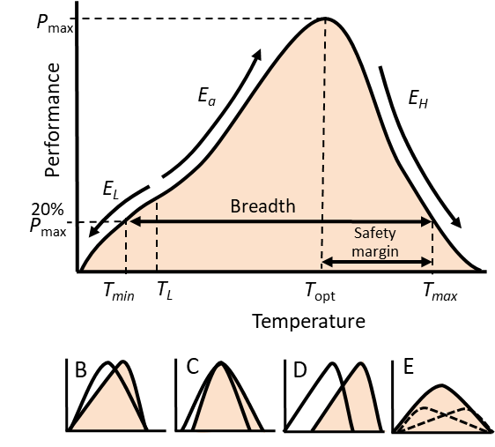

Figure 1

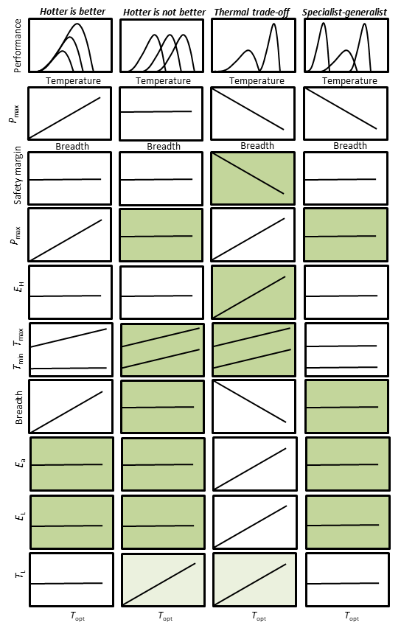

Figure 2

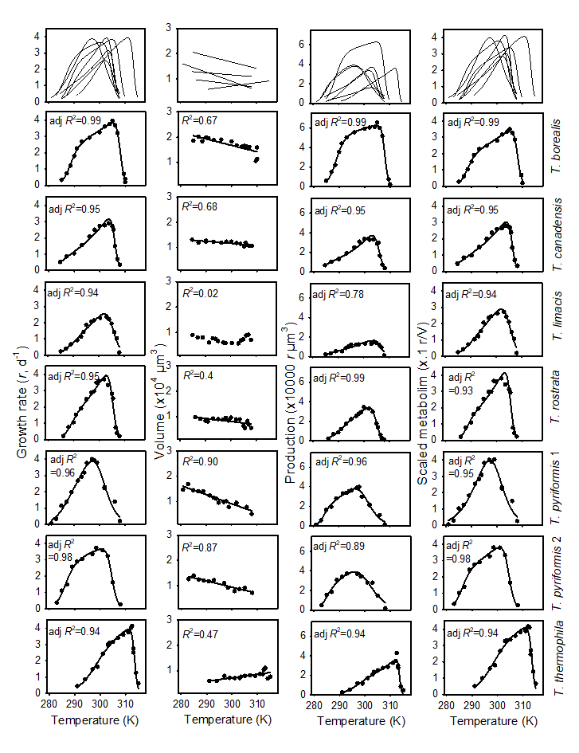

Figure 3



Figure 4

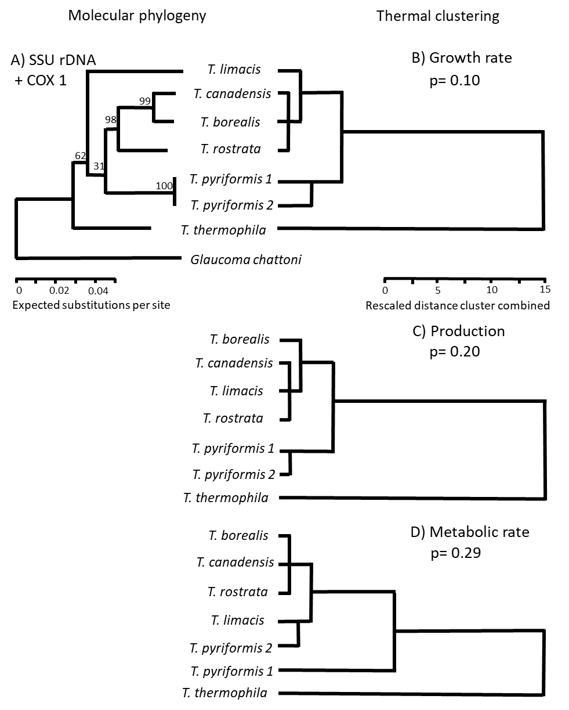

Figure 5

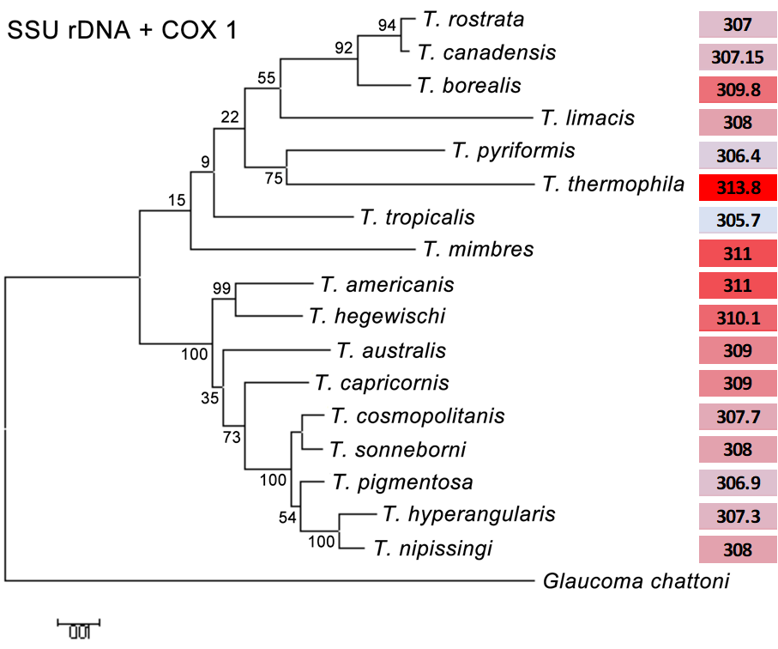

Figure 6



Figure 7