COPPER-CONTAINING NITRITE REDUCTASE

Samuel L. Rose¹, Michael A. Hough², Svetlana V. Antonyuk¹, Robert R. Eady^{1*} and
S. Samar Hasnain^{1*}
¹ Molecular Biophysics Group, Department of Biochemistry and System Biology, Institute of System, Molecular and Integrative Biology, Faculty of Health and Life Sciences, University of Liverpool, Liverpool, L69 7ZB, UK. ² Diamond Light Source, Harwell Science and Innovation Campus, Didcot OX11 0DE, England, UK. * To whom correspondence should be addressed. r.r.eady@liverpool.ac.uk and s.s.hasnain@liverpool.ac.uk

FUNCTIONAL CLASS

Enzyme (EC 1.7.2.1), copper-containing nitrite reductase containing type 1 and type 2 copper centers. Also named: nitrite reductase (NO forming) or NO₂⁺ oxidoreductase.

Copper-containing nitrite reductases (CuNiRs) are widespread in nature and are of major importance in the biogeochemical nitrogen cycle due to their involvement in several energy-generating pathways involving N-transformations where dioxygen (O₂) is not the terminal electron acceptor. CuNiR is encoded by the nirK gene which large-scale genome and transcriptome analysis show to be distributed across the three domains of life, with representative organisms among archaea, eubacteria, fungi and in unicellular eukaryotic foraminifera.^{1,2} The extensively characterized prototypic CuNiRs of eubacteria use soluble c-type cytochromes or cupredoxin as an electron source to catalyze the reaction:
NO₂⁻ + e- + 2H⁺  NO + H₂O E’_{o} _{(pH 7.0)} + 370mV Eqn. 1
This highly conserved family of enzymes contains two types of Cu center, an electron accepting type-1 Cu site (T1Cu) and a catalytic type-2 Cu (T2Cu) center. In Eubacteria, CuNiR is generally periplasmic, or occasionally membrane-bound, and in fungi and marine benthic foraminifera species their location is mitochondrial. The landscape of CuNiRs have expanded recently with the identification of variants, widely distributed in Eubacteria and ammonia-oxidizing Archaea. These enzymes have additional cupredoxin or cytochrome c domains tethered to the C- or N- terminal of prototypic CuNiRs containing a T1Cu-T2Cu catalytic unit.^{3,4} The CuNiRs from denitrifying organisms have been the subject of extensive study over many years and provide the foundation for our understanding of the chemistry involved in the biological reduction of nitrite (NO₂⁻) to nitric oxide (NO). The more recently identified variants with additional tethered domains present a challenge to understand their function and physiological/environmental relevance. This review will focus on the two-domain prototypic enzymes and the C-terminal extended three-domain enzymes.

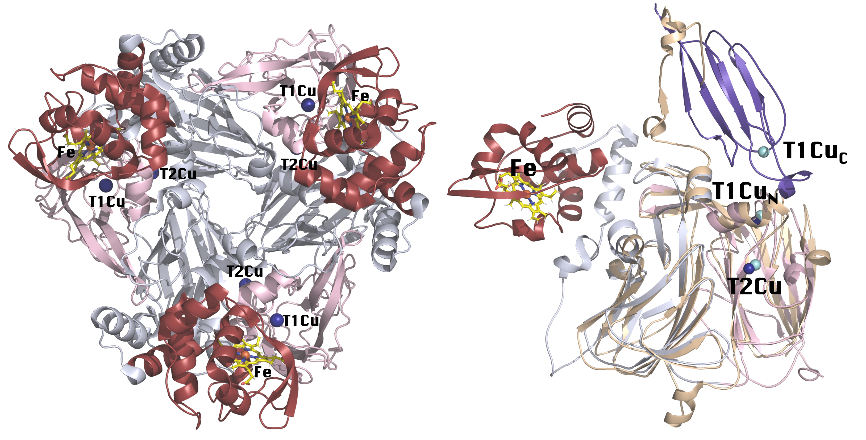
3D Structure Representation of the trimeric assembly of the C-terminal extended CuNiR RpNiR (PDB code: 3ZIY) showing the two types of copper centers and a heme c center. Panel on the right shows the monomer structures of RpNiR (cytochrome-fused) superimposed on cupredoxin-fused TsNiR (PDB code: 6HBE). C-terminal cytochrome domain for RpNiR is colored red and the two core cupredoxin domains are colored pink and silver. TsNiR is colored beige and its C-terminal cupredoxin domain is colored blue. Copper centers for RpNiR are colored dark blue and copper centers for TsNiR are colored cyan. This figure was made using the program PyMOL (Schrödinger, Inc.).

OCCURRENCE AND BIOLOGICAL FUNCTION

The core biogeochemical nitrogen cycle (N-cycle) is comprised of nitrogen fixation, the reduction of dinitrogen (N₂) to ammonia (NH₃), a process that provides a utilizable nitrogen source available to plants and higher organisms, and the effective reversal of this process by the denitrification, nitrification, and anammox steps is responsible for returning fixed N to the atmosphere. The N-flux between the different reservoirs is mainly controlled by microbial activity and organisms may, for example, simultaneously fix nitrogen and denitrify. During the last decade our understanding of these interconversions undergone by N-compounds of the N-cycle, and the range and metabolic capabilities of the organisms involved has been transformed.⁵ In the context of this review, roles of CuNiR have been extended beyond its long-established involvement in denitrification⁶ and are of particular importance in the aerobic NH₃-oxidising Eubacteria and Archaea in the nitrification pathway.⁷

CuNiR can also play a role in some microbial pathogenesis. In oxygen-limiting environments within the host, pathogens in the Neisseria genus such as N. gonorrhoea exploit denitrification and the outer membrane anaerobically induced protein AniA, a CuNiR of the nirK family, to promote growth and survival inside the host.^{8,9} In some bacterial species such as Brucella melitensis, denitrification is essential for their virulence with CuNiR playing an essential role.¹⁰ Similarly, CuNiR may also play a role in the pathogenesis of some denitrifying bacteria (such as ﻿Achromobacter xylosoxidans) that are considered opportunistic pathogens in immunocompromised patients.¹¹

Denitrification
Denitrification occurs under anoxic conditions when some microorganisms utilize nitrate as a terminal electron acceptor in place of O₂ to drive respiratory ATP synthesis. In this process nitrate (NO₃⁻) is reduced to N₂ by a series of intermediates, NO₂⁻, NO and nitrous oxide (N₂O), Scheme 1. The consecutive reactions of the denitrification pathway are catalyzed by distinct oxido-reductases that variously contain Mo, Fe, Cu or heme centers. The nitrate and NO reductases are integral membrane-bound enzymes while the nitrite and nitrous oxide reductases are soluble enzymes.⁶

NO₃⁻ → NO₂⁻ → NO → N₂O → N₂
Scheme 1 Canonical denitrification cascade

This is a widely dispersed metabolic pathway among aerobic prokaryotes but whole genome analysis has revealed that a significant number of organisms lack a complete set of enzymes as is the case in fungi. The truncation of the denitrification pathway results in the end product being the potent greenhouse gas N₂O. Two distinct types of nitrite reductase can participate in denitrification, a cytochrome cd₁ type, encoded by nirS and the more widely distributed copper-containing enzymes encoded by nirK, that form the subject of this review. Many of the structural and biophysical studies of CuNiRs described in detail here are based on data for enzymes from denitrifying Eubacteria,^{3,12,13} but representatives from denitrifying Archaea,¹⁴ nitrifying Eubacteria¹⁵ and anammox organisms¹⁶ have also been characterized.

Nitrification
Ammonia-oxidizing bacteria (AOB) and ammonia-oxidizing archaea (AOA) obtain energy from the aerobic oxidation of NH₃ to NO₂⁻, which is subsequently oxidized to NO₃⁻ by nitrite-oxidizing bacteria. There is mounting evidence that generation of NO by CuNiR plays a central role in the aerobic ammonia oxidation pathways in both bacteria and archaea.¹⁷ In both AOB and AOA of the phylum Thaumarchaeota, the product of NH₃ oxidation by ammonia monooxygenase is hydroxylamine (NH₂OH). In AOB NH₂OH has recently been shown to be reduced to NO by hydroxylamine oxidoreductase (HAO). The biochemistry of the conversion of NO to nitrite is unresolved but nirK catalyzing the reverse reaction of Eqn. 1 or ncyA encoding a nitrosocyanin have been proposed.¹⁸ Both are almost universally present in AOB genomes but the involvement of a yet to be identified enzyme is not excluded and further work is required to resolve this issue.^{19,20}

Under O₂-limiting conditions AOB employ nitrifier denitrification where NO₂⁻ formed from NH₃ oxidation is subsequently reduced to N₂O (Scheme 2).²⁰ The CuNiR involved in this pathway has been structurally characterized.
NH₃ → NO₂⁻ → NO → N₂O
Scheme 2

The situation in AOA is different since these organisms are unable to denitrify as they lack the genes for NO and N₂O reductase implying a different role for CuNiR. These organisms discovered just over a decade ago²¹ play a major role in the N-cycle since they are one of the most ubiquitous and abundant prokaryotes in the oceans. NH₃ oxidation by AOA involves NH₂OH as an intermediate but genome analysis indicates distinctly different biochemical pathways are utilized since genes encoding NH₂OH reductase are lacking⁷ and no motifs for c-type cytochrome proteins are present. All published AOA genomes lack nirS, but nirK is present and is highly expressed in metatranscriptomes during NH₃ oxidation. Current models for the oxidation of NH₂OH and its coupling to respiration involve a membrane-bound cupredoxin complex and CuNiR. One proposed role for CuNiR is in NO formation required for coupling with NH₂OH to form 2NO₂⁻ by the cupredoxin complex, or a direct interaction with NH₂OH in a cupredoxin complex to form NO₂⁻ via an NO intermediate.^{7,22} It is interesting to note that both bacterial²³ and archaeal CuNiRs from nitrifiers²⁴ have intrinsic NH₂OH oxidase activity suggestive of the direct interaction model operating.

Recently ¹⁵NO₂⁻ isotope distribution into N₂O and N₂ during O₂ formation by Nitroropumilus maritimus were found to be consistent with the dismutation of NO (produced by nirK) to form O₂ and N₂ with N₂O as an intermediate.²⁵ AOA are abundant in environments where O₂ is undetectable, such as in the marine oxygen-minimum zones. This demonstration of O₂ production coupled to N₂ formation under anaerobiosis enables AOA to populate oceanic oxygen minimum zones and shows a distinctly different role for CuNiR in these organisms.

Anammox
Anammox bacteria obtain their energy from the anaerobic oxidation of NH₃ to N₂ with NO₂⁻ as the terminal electron acceptor.

NH₄⁺ + NO₂- → N₂ + 2H₂O
Scheme 3

Discovered just before the turn of the century²⁶ these bacteria play a significant role in the release of N from the world’s oceans²⁷ and provide an attractive alternative in their application for the removal of N in waste-water treatment. Initially NO₂⁻ is reduced to NO that is then condensed with NH₃ to form hydrazine (N₂H₄), a reaction catalyzed by hydrazine synthase. Subsequently N₂H₄ is oxidized to N₂ by hydrazine oxidase. The reduction of NO₂-to NO during the anammox process was originally thought to be catalyzed by a cd₁ nitrite reductase encoded by nirS. However, sequencing of the Candidatus Jettenia caeni and Brocadia genomes revealed that these organisms only possess nirK.²⁸

Impact on the N-cycle
The increased application of nitrogen fertilizer to improve crop yields required to feed the growing global population has resulted in an imbalance of the N-cycle since some 60% of the applied fertilizer is not assimilated into biomass. It is either washed out of the root zone or lost to the atmosphere as a result of denitrification and nitrification and has a negative environmental impact.²⁹ Apart from the economic loss, these metabolic activities result in the considerable emission of N₂O from soils and ocean waters into the atmosphere. Although N₂O is a trace atmospheric gas, it has a global warming potential ~300-fold higher than CO₂ and its concentration is increasing.³⁰ CuNiRs are relevant to these broad issues since they produce NO, the substrate for nitric oxide reductase, which is the major biological source of N₂O.

SEQUENCE INFORMATION AND DISTRIBUTION

In all structurally characterized CuNiRs the organisation of the trimeric core and the electron donor/acceptor T1Cu and catalytic T2Cu centers is retained even when amino acid sequence identity is as low as ~30%.^{2,3} This includes the hexameric enymes of Hyphomicrobium^{31,32} and the anammox organism KSU-1,¹⁶ which are formed from a dimer of trimers. Some organisms have insertions in nirK of unknown significance and the structurally charicterized enzymes show some variability in the channels to the active site pocket, and in the sensor loop that links the T1Cu to the T2Cu of the active site. The residues that are ligands to the Cu atoms are conserved as are essential residues of the active site pocket Asp_{CAT} and His_{CAT} except in the trimeric C-terminal cupredoxin-tethered CuNiR from Thermus scotoductus SA-01 (TsNiR) where Asp_{CAT} is replaced by a Ser.³³ This enzyme also exhibits an altered T1Cu coordination where the axial ligand Met is replaced by a Gln. The overall organisation of the two-domain core enzyme and its relation to N- and C- terminal extended CuNiRs is shown in Figure 1a and b and the sequences of a selection of structurally-characterised enzymes are shown in Figure 1c.
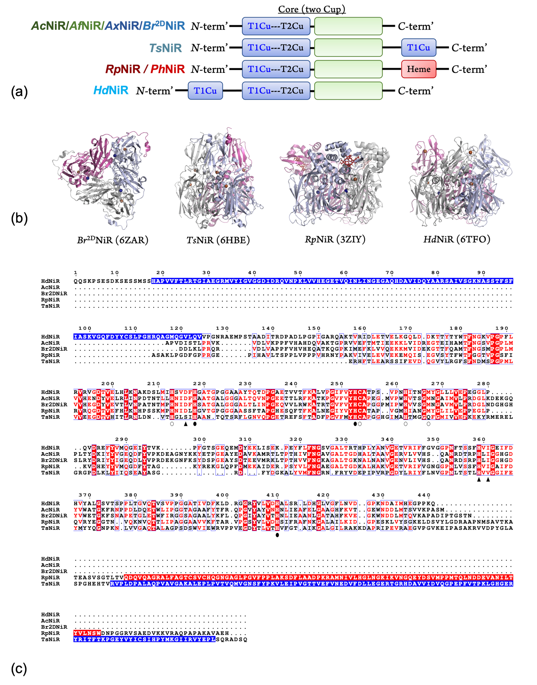
FIGURE 1. Overall domain, structure and sequence comparison of the two-domain core and N- and C- terminal extended CuNiRs. (a) Schematic of domain arrangement of structurally characterized CuNiRs. All contain a core of two cupredoxin (T1Cu-T2Cu) domains of the prototypic CuNiRs (Achromobacter cycloclastes (AcNiR), Alcaligenes faecalis (AfNiR), Achromobacter xylosoxidans (AxNiR) and Bradyrhizobium sp. ORS 375 (two-domain) (Br^{2D}NiR)). C-terminal extended CuNiRs such as those from Thermus scotoductus SA-01 (TsNiR), Ralstonia pickettii 12J (RpNiR)/Pseudoalteromonas haloplanktis (PhNiR) contain an additional cupredoxin domain or cytochrome c domain, respectively. The N-terminal extended CuNiR from Hyphomicrobium denitrificans (1NES1) (HdNiR) contains an additional cupredoxin domain; (b) Structural rearrangement of the trimeric form of the enzymes. The core two-domain trimer, as represented by Br^{2D}NiR (PDB: 6ZAR), is conserved in all but the N- or C- extended three-domain CuNiRs as represented by TsNiR (PDB: 6HBE), RpNiR (PDB: 3ZIY) and HdNiR (PDB: 6TFO) provide a distinct trimeric arrangement; (c) Sequence alignment of selected two-domain and three-domain CuNiRs. The two-domain enzymes: AcNiR (Uniprot: P25006) and Br^{2D}NiR (Uniprot: H0SLX7) are aligned with three-domain enzymes HdNiR (Uniprot: N0B9M5), RpNiR (Uniprot: B2UHR8) and TsNiR (Uniprot: E8PLV7). N-terminal signal peptide has been removed from all sequences. Numbering is from HdNiR. Additional cupredoxin domain is highlighted in blue and additional Cytochrome c domain is highlighted in red. T1Cu coordination residues are highlighted by a white circle and T2Cu coordination residues are highlighted by a black circle. Important T2Cu residues are highlighted by black triangles.
Distribution of Cu-nitrite reductases in denitrifying and nitrifying organisms
Genome analyses have revealed the extent of the phylogenetic distribution and diversity of nirK variants. The majority of available genome sequences are of denitrifiers, followed by the aerobic ammonium-oxidizing bacteria (AOB) and ammonium-oxidizing archaea (AOA), and a few anammox organisms. Truncated denitrification pathways due to the lack of a complete set of reductase genes are widespread.³⁴ In a significant number of organisms nirK is found in isolation, and the explanation for how these organisms cope with toxic NO is unexplained, suggesting a function other than the anaerobic respiration of nitrogen oxides.

Despite the conservation of residues in the catalytic core of CuNiRs there is a large divergence in nirK sequences among denitrifiers even among closely related organisms and two distinct phylogenetic clades have been identified³⁵ with Clade 1 containing mainly canonical CuNiRs from α-, β- and γ- proteobacteria (e.g., Achromobacter xylosoxidans (Ax), ﻿Achromobacter cycloclastes (Ac), Alcaligenes faecalis (Af)) and Clade 2 harboring a much greater taxonomical diversity containing multi-domain CuNiRs (e.g. Ralstonia pickettii (Rp), Hyphomicrobium denitrificans (Hd) and Thermus scotoductus (Ts)). There is a high incidence of N- and C terminus extensions (30% of 250 full-length sequences) with ~ 5% containing more than one copy of nirK. In addition, some CuNiRs also have an additional cytochrome and cupredoxin domain both tethered at the N-terminus. These 4-domain CuNiRs are often found together with classical two-domain CuNiRs, mainly amongst Rhizobiales species. An example is Bradyrhizobium ORS 375 (BrNiR) which also contains a two-domain CuNiR (Br^{2D}NiR).³⁶

In AOA nirK sequences form two highly divergent clusters that are as distant from each other as they are from bacterial nirK sequences. Amicyanin-domain fused proteins are a common theme in AOA genomes and nirK is no exception. Some soil AOA have an additional C-terminal amicyanin domain not seen in the marine organisms.³⁷ The ecotype-based sequence variation of nirK between these environments shows the core enzyme to have only 59% similarity, and that only the former group harbors C-terminal amicyanin extended variants. Homology-based structural predictions of the consensus sequences of the sensor loop linking the T1Cu to the catalytic T2Cu are longer compared with prototypic CuNiRs suggesting potential for niche differentiation and different reactivities compared with bacterial counterparts.¹⁷ The difference in distribution of cupredoxin-extended CuNiRs between soil and marine Archaea suggests they provide a niche advantage in specific environments.

PURIFICATION AND ASSAY
In recent years recombinant techniques using Escherichia coli host cells with the appropriate nirK gene inserted to overexpress the CuNiR of interest, has replaced isolation of the enzymes from their natural source. Purification uses combinations of standard techniques including ammonium sulfate precipitation, diethylaminoethyl (DEAE) or carboxymethyl (CM) ion-exchange and size exclusion chromatographies. CuSO₄ (100 μM - 2 mM) is usually added to buffers in early steps of the purification to re-metallate the T2Cu site to prevent the type-2 deficient enzyme from being formed.^{38,39} Alternatively, His-tagged CuNiR can be purified using a HisTrap affinity column and size exclusion chromatography with CuCl₂ [10-20 mM] added at a later stage⁴⁰ or CuSO₄ [1mM] in the initial stages.⁴¹ The blue and green prototypic CuNiRs have markedly different surface charge distributions, so for example, DEAE ion exchange is used for AxNiR³⁸ and CM ion exchange for AcNiR.⁴²

Routinely CuNiRs are usually assayed by their nitrite reduction activity using artificial electron donors, or less frequently protein-film voltammetry.⁴³ Commonly used electron donors are dithionite, dithionite/Methyl Viologen, NADH/phenazine methosulfate (PMS) or ascorbate/PMS. In single turnover experiments pulse radiolysis, laser-flash photolysis or X-ray generated photoelectrons provide reductant. Activity is measured from the rate of decrease in [nitrite] determined colorimetrically in stopped-time assays³⁸ or in continuous assays from the rate of formation of NO measured by sequestration with hemoglobin⁴⁴ or electrochemically using a NO-specific electrode in an anaerobic chamber. When NO is detected electrochemically, in order to avoid dioxygen contamination, a scavenging system (D-glucose, glucose oxidase and catalase) is included in the assay mixture.⁴⁵

MOLECULAR CHARACTERISATION
Structural and biophysical studies of two-domain prototypic CuNiRs are predominantly those originating from a number of denitrifying organisms^{3,4,46} but representatives from nitrifying³² and anammox organisms¹⁶ have also been characterized. All structurally characterized CuNiRs, including the domain-extended enzymes, have a duplicated cupredoxin domain monomer unit that forms the core of the trimeric/hexameric enzyme. Each monomer contains a T1 Cu site located close to the enzyme’s surface with Cu-Cys-Met-(His)₂ coordination. In a recently isolated C-terminally extended enzyme with an additional cupredoxin domain the T1 Cu site has a Cu-Cys-Gln-(His)₂ coordination.³² Depending on the geometry of the Cu-Cys-Met-(His)₂ site, the ligand-to-metal charge transfer (LMCT) bands of the oxidized center is affected, giving rise to the blue or green color to the enzyme with absorbance band for blue enzyme (AxNiR) appear at ~590 nm or green enzyme with bands at ~460 and 600 nm (AcNiR). The catalytic T2Cu sites are located at the interface between adjacent monomers some 12 Å from the surface and have Cu-(His)₃-H₂O, or occasionally Cu-(His)₃-(H₂O)₂ ligands in the enzymes as isolated (Figure 2). Access to the bulk solvent is provided by a ~ 6 Å wide channel between adjacent monomers. In the as isolated enzymes the difference between the reduction potentials of the T1Cu and T2Cu sites provides only a small, or in some cases an unfavorable, driving force for electron transfer (ET) from the T1Cu site. Consequently, in PcNiR for example, the addition of ascorbate or NADH/PMS (E_{m} -320 mV) results in the reduction of the T1Cu but inter-Cu ET only occurs in the presence of nitrite.⁴⁷

During catalysis electrons produced from denitrification/NH₃ oxidation are donated (from periplasmic c-type cytochrome or (pseudo) azurin depending on the species), to the T1Cu site. Subsequently the electron is transferred in a proton-gated reaction to the T2Cu site⁴⁴ via a 12.6Å His-Cys bridge between the two Cu ions. In single turnover experiments a protonation event precedes electron transfer.^{48,49} In addition to this ET bridge the Cu centers are connected by a longer sensor loop His-(X)₁₀₋₁₃-His that has a proposed role facilitating proton transfer through a network of ordered H₂O molecules so as to promote inter-Cu ET in the presence of nitrite (Figure 2).⁵⁰ The sensing loop contains the Asp_{CAT} residue which structural studies show forms an H-bond with the T2Cu H₂O ligand in the resting state and with nitrite in the enzyme-substrate complex. Spectroscopic and structural studies established that nitrite binds to the oxidized T2Cu by displacement of the H₂O ligand. During steady-state turnover the consensus view is that the order of nitrite binding and reduction of the T2Cu is dependent on [nitrite] and pH.^{43,3,4}

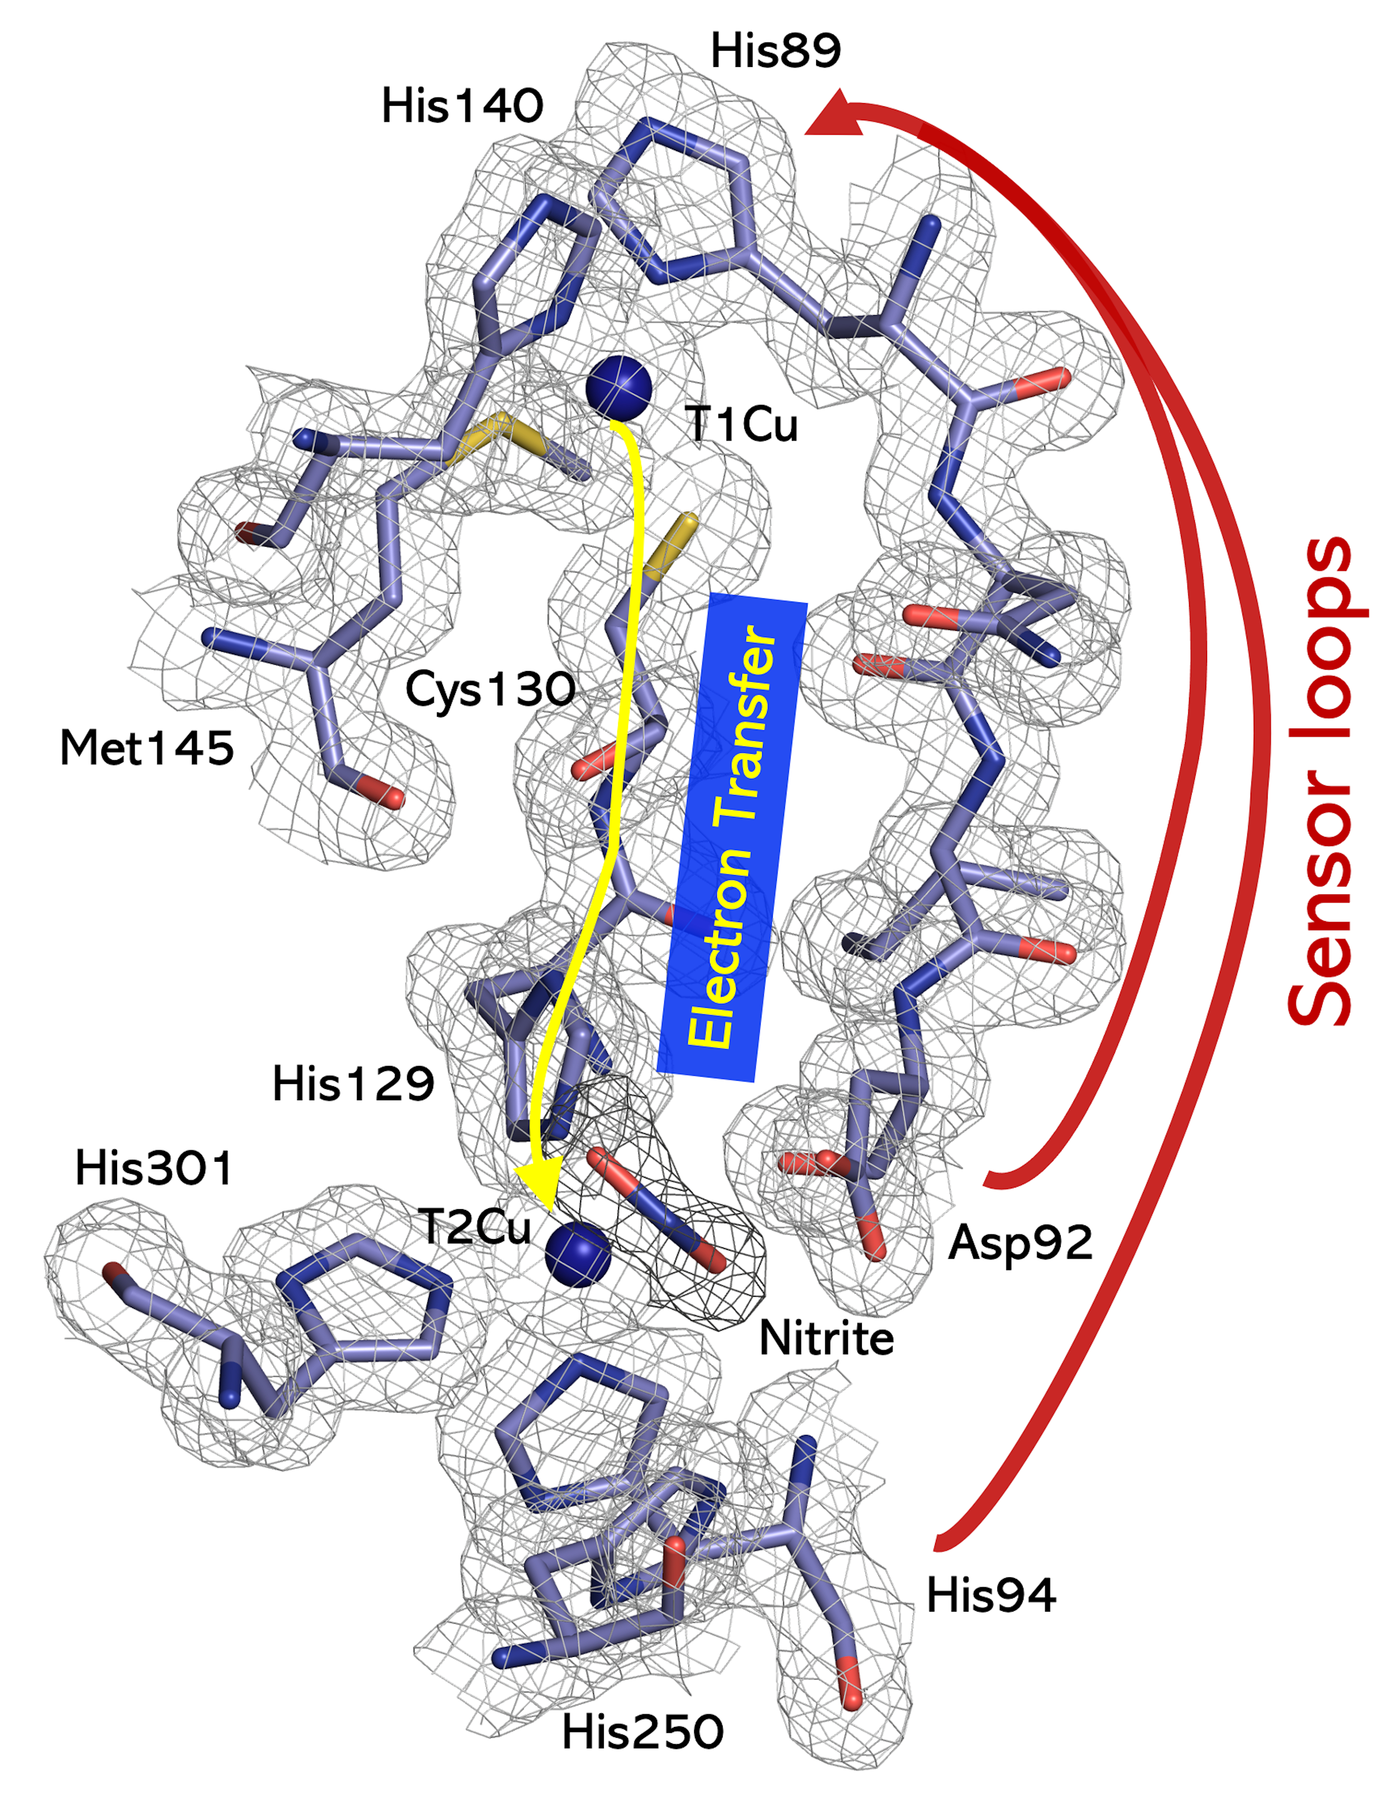
FIGURE 2. The T1Cu and T2Cu sites of nitrite-bound Br^{2D}NiR, free from radiation-induced chemistry, to 1.3 Å resolution using XFEL⁴⁰. The Cys130-His129 hard-wired bridge between the T1 and T2Cu sites of CuNiR is indicated by the yellow arrow and is universal in all CuNiRs. Sensor loops that relay information of the status of T2Cu site (resting versus substrate bound) to T1Cu are represented by red arrows. 2F_{o} − F_{c} electron density map obtained from SF-ROX structure is contoured at 1σ level. T1Cu and T2Cu are shown as blue spheres.

The structures of various CuNiRs with nitrite- and NO- bound to the T2Cu obtained by diffusion of these ligands into crystals revealed bidentate NO₂⁻ binding and unprecedented side-on NO binding modes that stimulated the interest of the chemical community. The ability to form the substrate adduct in crystallo, underpinned subsequent study of the structural changes at the catalytic center and the protonation state of Asp_{CAT} associated with the controlled delivery of electrons to the initially oxidized T2Cu-nitrite center described below.
X-RAY STRUCTURAL APPROACHES – FROM SYNCHROTRONS TO XFEL
It is 30 years since the first 3D structure of a CuNiR was reported at a resolution of 2.3 Å using a laboratory X-ray source, convincingly demonstrating the enzyme to be a trimer with the T1Cu-T2Cu centers at the catalytic heart.⁵¹ There are currently in excess of 200 structures in the PDB for CuNiRs helping to understand some of the fundamental processes of catalysis such as redox activation, proton-coupled electron transfer, gating of substrates etc. In parallel to the way structural biology has transformed the way we think of biology, our understanding of nitrite reduction processes at the molecular level has been clarified substantially. The tremendous success of structural biology during the last 30 years is largely owed to synchrotron X-ray facilities, advances in molecular biology techniques and computational power. Recently, the most advanced synchrotron MX facilities that harness micro-focus X-ray beams and advanced photon counting detectors have allowed multiple structures to be collected from a single crystal (MSOX) enabling the construction of a structural movie as the X-ray induced enzyme turnover takes place.^{50,52} More recently, the availability of femtosecond pulses from X-ray free-electron laser (XFEL) facilities have opened a new horizon of structural biology where time-frozen structures can be obtained that are free from radiation-induced chemistry (FRIC structures).^{53,54} The modern synchrotron beamlines have recently helped to provide atomic resolution (<1.2 Å) structures enabling non-restraint refinement using SHELX, a norm for small molecule crystallography.⁴¹ In this review, we focus on these three recent advances.

STRUCTURES OF PROTOTYPIC TWO-DOMAIN CuNIRs
Structures of AcNiR and Br^{2D}NiR have been determined at atomic resolution, the latter has been used to undertake unrestrained refinement,⁴¹ implemented in SHELX-97.⁵⁵ Such refinements are generally possible for crystallography of small molecules and can only be used when protein structures are determined to very high resolutions, ~1.2 Å as the number of observations are then sufficiently large so that stereochemical restraints are not required for a successful refinement. This allows the unambiguous assignments for multiple conformations of active site ligands and define standard deviations of individual bond distances and angles. It also helps to assign protonation state of the catalytically important residues by comparison of their geometry with the geometry in the chemical data base.⁵⁶ Atomic resolution structures from as isolated proteins have provided remarkable differences in T2Cu coordination, AcNiR shows single water in distorted trigonal geometry (Figure 3a), whilst the T2Cu in Br^{2D}NiR is penta-coordinated with 2 water ligands (Figure 3d). Both structures have Asp_{CAT} in two conformations. In AcNiR, Asp_{CAT} in the proximal position is neutral and protonated, while in the gatekeeper position it is negatively charged. In Br^{2D}NiR, Asp_{CAT} in proximal position is negatively charged whilst a proximal distorted position is neutral and protonated. His_{CAT} residues are non-protonated on Nε2 in both AcNiR and Br^{2D}NiR enzymes. This is consistent with the neutron structure of perdeuterated AcNIR which also showed Asp_{CAT} to be deprotonated (Figure 3c). In nitrite bound structures for AcNiR (Figure 3b) and Br^{2D}NiR (Figure 3e) both conformations of Asp_{CAT} are negatively charged, while protonation of His_{CAT} is different. In Br^{2D}NiR it is fully protonated, whilst in AcNiR His_{CAT} protonation on Nε2 is absent. In enzymatically produced NO bound Br^{2D}NiR structure (Figure 3f), Asp_{CAT} is protonated but His_{CAT} Nε2 is not.
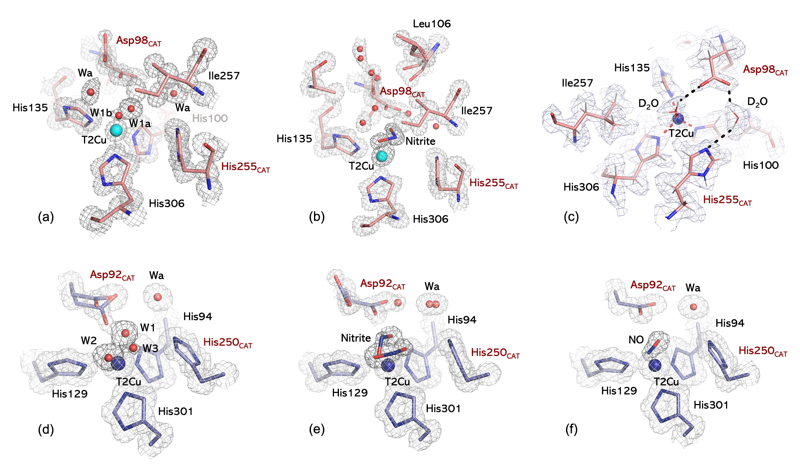
FIGURE 3. Differences in catalytic sites of two-domain CuNiRs, AcNiR and Br^{2D}NiR, determined by X-ray crystallography at atomic resolution. (a) As isolated AcNiR at 0.9 Å resolution (2BW4); (b) Nitrite bound AcNiR at 0.87 Å (5AKR); (c) neutron crystallographic structure of perdeuterated AcNiR at 1.8 Å (6GTJ); (d) As isolated Br^{2D}NiR at 1.1 Å (6ZAR); (e) Nitrite bound Br^{2D}NiR at 1 Å (6ZAT); (f) Enzymatically produced NO bound Br^{2D}NiR at 1.19 Å (6ZAV). 2F_{o}-F_{c} electron and neutron nuclear density maps are contoured at 1σ level as grey mesh. Ligands are highlighted by darker mesh. Waters are shown as red spheres. Asp_{CAT} and His_{CAT} residues are labelled in red.

MSOX STRUCTURAL MOVIES OF CuNiR DURING TURNOVER
As described previously herein, synchrotron or laboratory source X-ray crystal structures of redox active metalloproteins such as CuNiR are almost inevitably affected by radiation induced chemistry leading in many cases to the redox-coupled reaction proceeding in the presence of substrate.^{42,57,58} Higher doses of X-rays may result in wider damage beyond the redox centers.⁵⁹ Here, the primary mechanism of concern is radiolysis of water molecules within the crystal producing large numbers of solvated photoelectrons that rapidly reduce the metal centers, which act as electron sinks, within proteins. These redox state changes typically occur at doses far lower than those typically used to obtain single-crystal structures using synchrotron radiation.⁶⁰ Electron transfer centers such as the T1Cu center of CuNiR or the heme center in the extended three-domain cytochrome containing CuNiR are poised to accept electrons and so become reduced from the Cu (II) to Cu (I) state. For example, a combined crystallographic, optical and X-ray Absorption Near Edge Structure (XANES) study on AcNiR revealed that the T1Cu site became reduced more rapidly than the catalytic T2Cu site on irradiation.⁵⁷

A number of early studies used X-ray radiation to generate intermediate species within enzyme catalytic mechanisms of several different enzyme classes.⁵⁸ This involved either measurement of sequential datasets of increasing dose or the application of an X-ray ‘burn’ to generate the desired species followed by collection of the crystallographic data set used for structure determination. More recently, the availability of fast counting pixel detectors allowed the measurement of very large numbers of datasets obtained sequentially from the same X-ray exposed region of the crystal, thereby generating an X-ray driven structural movie of processes that could be initiated by the addition of electrons generated by the beam.^{49,52} This approach of obtaining multiple structures serially from the same crystal volume of a crystal (MSOX) during the chemical reaction, induced by the X-ray beam, has provided structural movies at several temperatures. MSOX may be combined with single crystal spectroscopies that can help to identify particular redox states associated with structures of the series. Applied to CuNiRs, MSOX movies have been obtained from nitrite-soaked crystals of AcNiR at temperatures of 100, 170 and 190 K as well as at room temperature with as many as 75 consecutive structures from the same crystal.^{49,52,61} This approach has allowed multiple states of the enzyme to be determined including the ‘initial’ nitrite complex, T1Cu(I)-T2Cu(II)-nitrite complex, NO complex and reformation of the original water bound form following catalysis. Notably, working at elevated temperatures has allowed more of the catalytic cycle to be observed than had been the case at 100 K. This is consistent with a number of studies indicating increased dynamic freedom and lower viscosity within crystals at elevated but still cryogenic temperatures.^{62,63} Importantly, the NO complex generated at the T2Cu center via MSOX has revealed a side-on NO binding at all temperatures examined against chemical expectations of an end-on Cu-N bonding of the NO-bound species.⁶¹

A considerable challenge in obtaining MSOX data from crystals at room temperature has been the much lower dose limits before loss of diffraction. Efforts are being made to remove dead-time between data sets so that greater number of datasets can be collected by eliminating the on-going radiolysis in between the collection of consecutive data sets. Progress towards this goal has been made in measurement of dose-dependent serial synchrotron crystallographic data for a CuNiR⁶⁷.

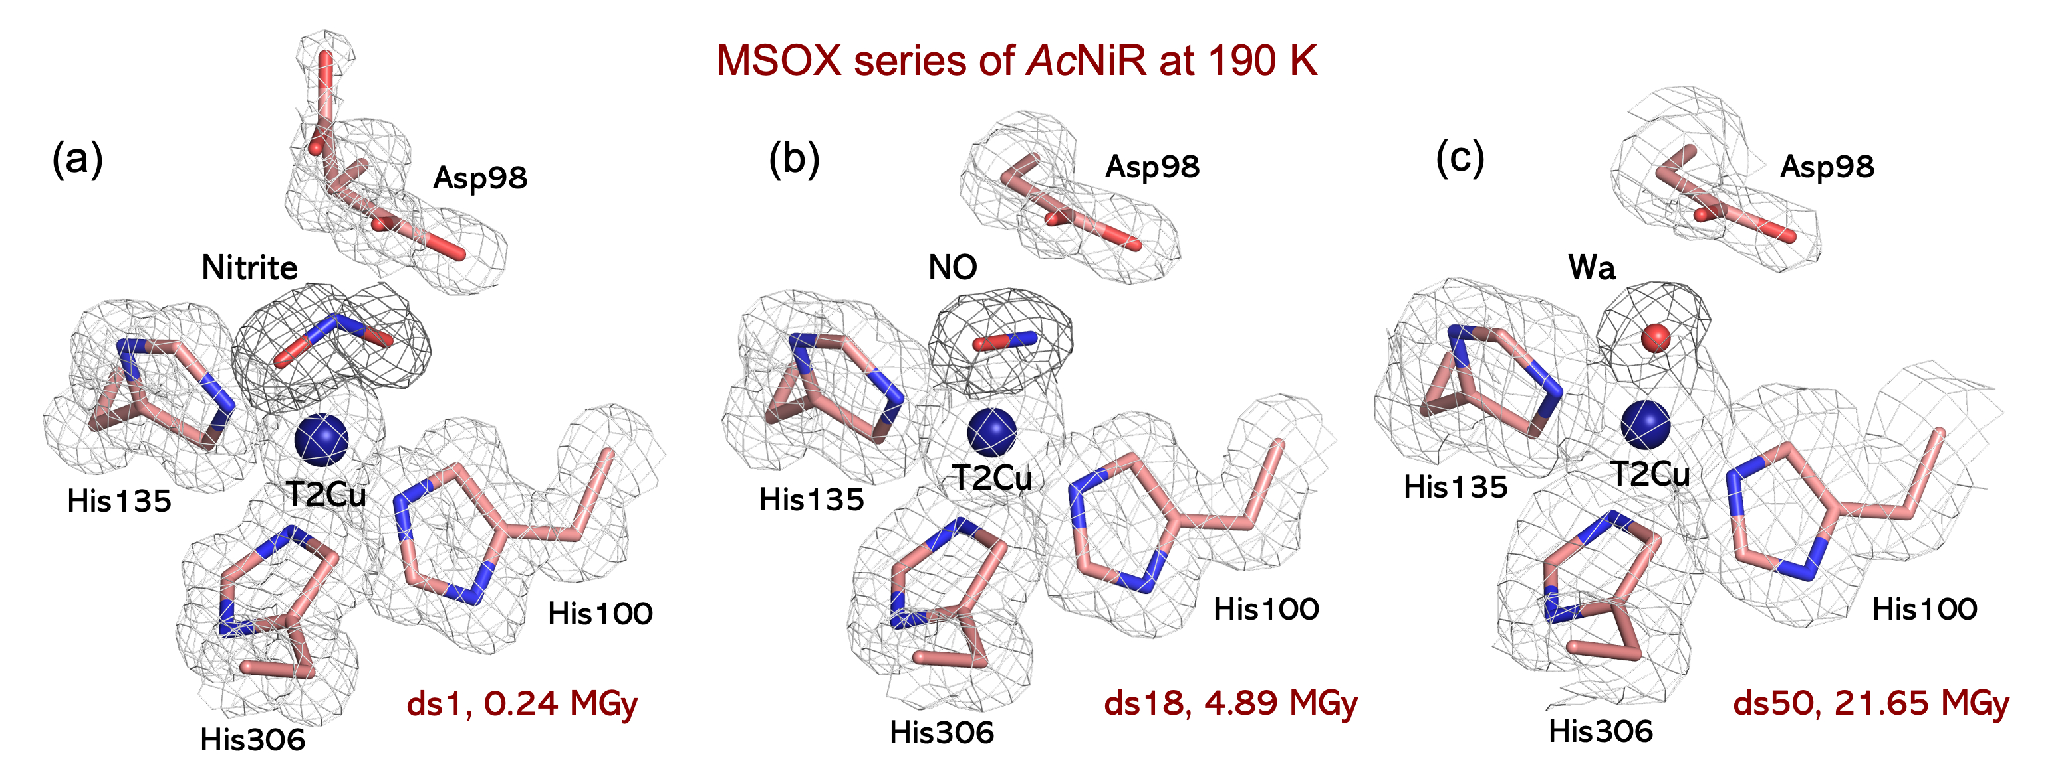

FIGURE 4. Three frames from a 75 frame MSOX movie of nitrite bound AcNiR at 190K. (a) The first frame (dataset1) shows a bidentate O-coordinated nitrite coordinated to the T2Cu atom; (b) By dataset 18 (ds18) the nitrite has been converted into the product NO coordinated in a side on the manner; (c) In dataset 50 (ds50), the NO product has dissociated from the enzyme and a water molecule is bound to the T2Cu atom, returning the enzyme to the resting state. The X-Ray dose associated with each structure is indicated in the figure. Maps shown are 2F_{o}-F_{c} electron density maps.

COMBINING SINGLE CRYSTAL SPECTROSCOPY WITH X-RAY CRYSTALLOGRAPHY OF CuNiR
A limitation of X-ray crystallography is that information about the redox state of the metal centers is not obtained and may be difficult to assign from the electron density on its own. This is a particularly important issue for x-ray crystallographic data collection on a synchrotron as X-ray induced redox changes occurs well before general radiation damage to the structure. An important advance has come from the ability to measure various spectroscopic data on-line during or before and after data collection or in between frames of an MSOX series. Several studies have shown the measurement of UV visible absorption spectra from the T1Cu site of copper nitrite reductases.^{57,52,41} The studies can be helpful because a signal is observed from the oxidized form of the enzyme but not from the reduced form. A limitation is that the spectroscopic signal from the T2Cu center is obscured by the much stronger absorption arising from the T1Cu center. In the case of proteins that contain cytochrome domains the signal of the copper centers are typically completely obscured by that of the heme. Other spectroscopic probes that have been used include XANES⁵⁷ and resonance Raman (unpublished data). A very promising approach recently developed is the measurement of X-ray emission spectroscopy (XES) data from microcrystals using the same X-ray pulse used for data collection although this has yet to be applied to CuNiRs.⁶⁴

STRUCTURES OF CuNiR USING X-RAY FREE ELECTRON LASERS (XFEL)
X-ray free-electron laser (XFEL) based crystallography allows data to be collected using femtosecond X-ray pulses, too short a timescale for any radiation-induced chemistry or ET to occur, allowing structures to be determined free from radiation-induced chemistry (FRIC). There are two XFEL crystallographic approaches that have been used, called serial femtosecond crystallography (SFX) and serial femtosecond rotational crystallography of a single crystal (SF-ROX) (Figure 5). SFX collects data from thousands of microcrystals exposed to pulses of X-rays of femtoseconds duration from the XFEL. This technique is generally used at ambient temperature and can be used for time-resolved studies, but the small crystal size limits the resolution obtainable as is the overall quality of data. The SF-ROX method uses the rotational crystallographic method where larger crystals are utilized, and the crystal is translated and rotated after each shot of femtoseconds XFEL pulses. In this case, the crystals are generally kept at cryogenic temperature but in principle data can be collected at elevated temperatures. In both cases, still diffraction images are obtained requiring merging a significant proportion of partial intensities with a further challenge of these images arising from a very large number of randomly oriented microcrystals in the case of SFX. With SF-ROX, high quality data can be obtained using 30 to 50 large crystals depending on the space group of the crystals. With recent availability of shorter wavelengths at SACLA XFEL, data have been collected to 1 Å resolution (Rose, Tosha & Hasnain unpublished data).

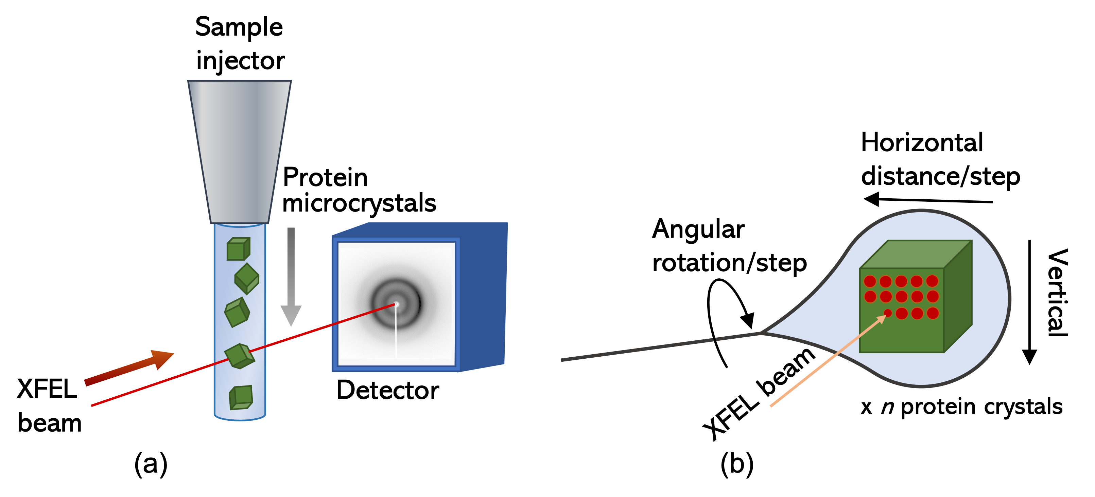
FIGURE 5. Schematic showing the two XFEL-based crystallographic approaches. (a) Serial Femtosecond Crystallography (SFX) and (b) Serial Femtosecond Rotational Crystallography (SF-ROX).

The SFX approach has been applied to A. faecalis (AfNiR)⁶⁵ and Geobacillus thermodenitrificans (GtNiR)⁶⁶ as well as for the nitrite bound form of AcNiR.⁶⁷ Unlike SR structures of the resting state, these two SFX structures of the resting state did not show a water ligand bound to the T2Cu site but a chloride ion in the case of AfNiR presumed to arise from purification/crystallization media and a Cu ion (20%) bound to His_{CAT} and a sodium ion in the case of GtNiR where Na⁺ and Cu²⁺ were present in the crystallization solution for SFX crystals. The first room temperature damage free nitrite complex structure, free from radiation-induced chemistry (FRIC), was obtained for AfNiR by collecting a total of 578,412 diffraction images (of which 155588 crystals were indexed and merged to form the dataset) from several hundred thousand nitrite-soaked microcrystals mixed with the grease matrix and packed in an injector syringe for SFX data collection. In an alternative approach of SFX where microcrystals are mounted in silicon fixed targets or `chips', mode of nitrite binding could be unambiguously identified from a 1.9 Å resolution structure obtained using 16,586 merged diffraction patterns obtained in 40 minutes of data collection. We note that nitrite binding could in fact be identified from a subset of only a thousand or so images.⁶⁷ The O-coordination has been observed in all the synchrotron-based and in-house X-ray structures clearly establishing that this coordination is governed by the enzyme and is required for catalysis.

The SF-ROX approach has been applied to a number of CuNiRs (AxNiR, AcNiR and Br^{2D}NiR) to provide damage-free FRIC structures of the as isolated resting state, chemically reduced state, nitrite (substrate) bound and turnover generated nitric oxide (product) bound states. The as isolated AxNiR structure revealed a dioxo-species proposed to be the one-electron reduced intermediate of the oxidase reaction leading to H₂O₂ as a product of dioxygen reduction by CuNiRs and is relevant to the oxidase and superoxide dismutase activity shown by CuNiRs. The SF-ROX FRIC structure of the as isolated AcNiR enzyme (1.5 Å resolution) showed a single highly ordered H₂O ligand at the T2Cu as seen in the SRX (0.9 Å) structure. AcNiR also provided the first XFEL structure of the chemically reduced state (SF-ROX^{RED}) to 1.6 Å resolution, obtained using 33 large colorless crystals. The H₂O ligand from the T2Cu is lost from the T2Cu site on reduction with T2Cu dropping 0.5 Å into the histidine plane that form a tricoordinate T2Cu site with three histidine residues ligating the copper (Figure 6b). T1Cu site also showed a marked difference from the as isolated FRIC structure of AcNiR, with two positions of the copper refined with occupancies of 0.7 and 0.3 with ligating Met150 at 2.26 Å and 2.47 Å, respectively. Met141 is positioned in a single distal conformation from His145, allowing a water molecule to fill the free space, making strong hydrogen bonds to both Met141 and T1Cu ligand His145. The surface loop (residues 187–206) adjacent to Met141 that is associated with the binding of the cognate partner protein cytochrome c₅₅₁ undergoes a significant movement compared to the oxidized FRIC structure. The nitrite bound SF-ROX structure of AcNiR was determined from 62 nitrite-soaked crystals at 1.5 Å resolution showing both ‘top-hat’ and ‘side-on’ nitrite conformations with Asp_{CAT} adopting equal proximal and gatekeeper conformations. The ‘top-hat’ conformation is similar to the SFX room temperature nitrite-soaked AfNiR structure (Figure 6a). A pH-dependent study of AcNiR has shown that these are inter-convertible conformations.⁵⁴
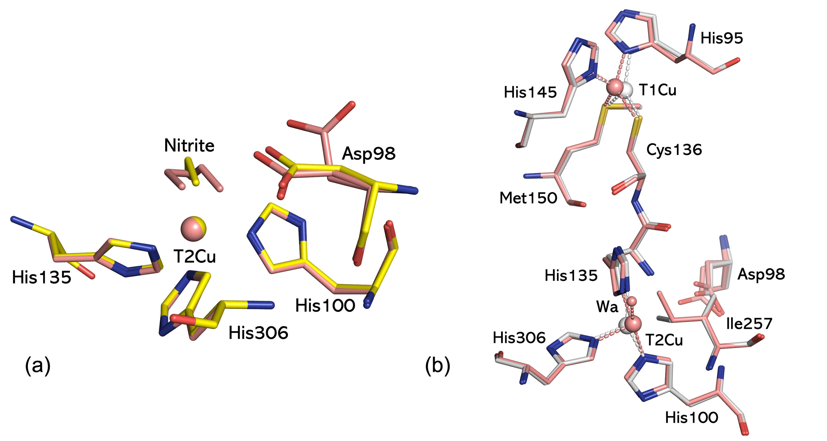
FIGURE 6. Comparison of Cu sites in XFEL structures of oxidized, reduced and nitrite bound states of CuNiR. (a) 'Top-hat' conformation of nitrite in SFX AfNiR (yellow) and SF-ROX AcNiR (salmon), AcNIR numbering is used; (b) Oxidized (salmon) versus reduced (white) T1 and T2Cu sites in SF-ROX AcNiR.

Recently, in several α-proteobacteria of the order Rhizobiales including Bradyrhizobium sp. ORS 375, two copies of nirK genes encoding a 4-domain heme-CuNiR and the usual two-domain CuNiR (Br^{2D}NiR) have been identified. Br^{2D}NiR, a blue CuNiR, shows a substantially lower catalytic efficiency despite a sequence identity of ~70% compared to the well characterized two-domain blue (AxNiR) and green (AfNiR and AcNiR) CuNiRs. SF-ROX has provided FRIC structures of this recently discovered enzyme in its oxidized, nitrite-bound and using dithionite as a reductant to obtain turnover-generated nitric oxide bound states. Each of these have provided the highest resolution (1.3 Å) FRIC structures to-date for CuNiRs. The as isolated structure obtained from data collected using 40 large crystals (0.4 – 0.7 mm) revealed the presence of two clear full occupancy waters (W1) and (W2) bound to T2Cu, at distances of 2.05 Å and 1.94 Å, respectively that are 2.51 Å apart. Asp_{CAT} is in main proximal conformation. The lower activity may thus arise from structural elements that regulate and orchestrate the binding of second water at the T2Cu site whose displacement by the substrate would require additional energy. The nitrite-bound FRIC structure of Br^{2D}NiR obtained using 28 large crystals to a resolution of 1.3 Å showed the nitrite molecule at the T2Cu²⁺ site in a single ‘side-on’ conformation with all 3 atoms O¹, N and O² binding by almost identical distances of 2.12 Å, 2.02 Å and 1.92 Å. Such a binding mode may be commensurate with lower catalytic activity. Crystals of Br^{2D}NiR with full nitrite occupancy were soaked with dithionite to effectively generate an anaerobic environment and initiate catalysis following T1Cu reduction, forming a true enzymatically produced NO-bound species. The FRIC structure of NO-bound Br^{2D}NiR species generated in this way was obtained by using 55 large crystals with the SF-ROX approach. The side-on coordination mode of NO is observed but with asymmetric coordination to Cu—N and Cu—O at 2.47 Å and 2.12 Å, respectively. Asp_{CAT} was in the proximal conformation. The side-on binding of NO has been a matter of debate but it is clear that such a binding mode is a catalytic property of the enzyme and is independent of the means by which it is generated.

STRUCTURE OF C-TERMINAL TETHERED CuNiR
During the last decade several extended CuNiRs have been identified with additional cupredoxin or cytochrome domains tethered to either C- or N- terminal of the prototypic CuNiRs containing T1Cu-T2Cu catalytic unit^{31-33,68-70}. The C-terminal tethered three-domain CuNiRs appear to be more widespread with both cupredoxin and cytochrome domains, each of which are known physiological electron donor partner to the prototypic CuNiR. The first tethered CuNiR was identified and structurally characterized in 2007. This was the N-terminal cupredoxin-fused CuNiR from Hyphomicrobium denitrificans (HdNiR),³¹ where structure and biochemical characterization showed it to be a hexamer rather than a trimeric structure known for all of the two domain CuNiRs. The additional cupredoxin T1Cu center in the fused domain was too far away from the electron-acceptor site of the catalytic T1Cu-T2Cu NiR core for an electron transfer between them to be feasible, questioning its functional relevance as an electron donor domain. The first C-terminal tethered CuNiR was the cytochrome-tethered NiRs from Ralstonia pickettii (RpNiR)⁶⁸ whose 1.01 Å resolution identified a water mediated electron transfer between the tethered cytochrome domain and Cu1-Cu2NiR core and an intriguing Tyr323 from the linker loop (315-330) in the catalytic pocket. Structure of another C-terminal tethered cytochrome-tethered CuNiR from Pseudoalteromonas haloplanktis (PhNiR) revealed similar arrangement for the trimer with somewhat different position of Tyr.⁶⁹ Recently, the first structure of a C-terminal cupredoxin-tethered nitrite reductase from Thermus scotoductus SA-01 (TsNiR) has been determined where the additional cupredoxin domain is co-located with theT1Cu-T2Cu NiR core from the same monomer placing the redox centers at optimal electron transfer distances,³² (Figure 7a). Despite this rich structural landscape of C-terminal tethered CuNiRs, only very limited insight has been gained on the catalytic mechanism particularly on the role and redox communication between the tethered domain and the core NiR. RpNiR has been the most extensively studied tethered system where several mutations and ligand binding studies have been attempted. Like other tethered CuNiRs, substrate binding has been made possible either by NO activation for some mutants or by mutation of Tyr323 itself or truncation of the linker loop without removing Tyr 323. In all these cases Tyr323, which is hydrogen bonded to Asp97 (Asp_{CAT}) and W2, connected to W1, coordinated by T2Cu (Figure 7c), is rotated out or removed (Figure 7d,e), opening the substrate channel access to T2Cu site seen for two-domain CuNiRs. In as isolated RpNiR, access is possible via the proton channel at the interface between two domains, while in PhNiR there is no clear route to the T2Cu site.
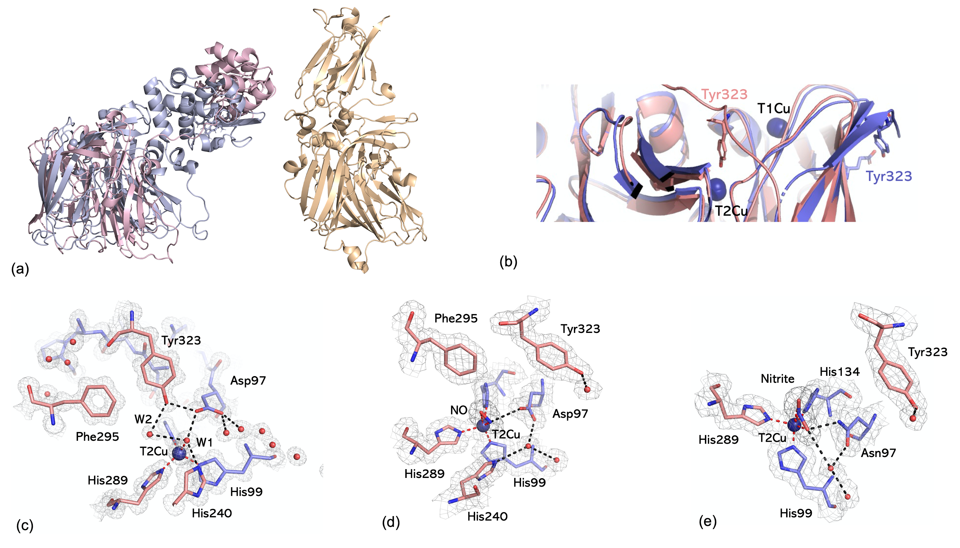

FIGURE 7. Structures of C-terminal tethered CuNiRs. (a) Structural arrangement of a monomer of C-terminal tethered CuNiRs where the left panel shows different arrangement of the cytochrome domain in RpNiR (lilac) and PhNiR (pink) and the right panel shows the tethered cupredoxin domain arrangement in TsNiR where T1Cu_{C} is at an ideal distance for ET from T1Cu of the core within the same monomer; (b) Different orientations of Ty323 from alignment of full length RpNiR (salmon) with RpNiR truncated core (lilac); (c) T2Cu site of as isolated RpNiR at 1.01 Å resolution showing hydrogen bonding Tyr323 with Asp97 and W2, and closed catalytic site; (d) NO binding to RpNiR changes conformation of Tyr323; (e) Nitrite binding to RpNiR mutant (Asp97Asn) also result in re-orientation of Tyr323. 2F_{o}-F_{c} electron density maps are contoured at 1σ level as grey mesh. Ligands are highlighted by darker mesh. Waters are shown as red spheres. Hydrogen bonds as black dotted lines, Cu coordinating bonds in red.

UNDERSTANDING OF MECHANISM AND WIDER IMPACT
During the last 30 years, the study of CuNiRs have provided a detailed understanding of the reversible reduction/oxidation reaction, coupling of the transfer of one electron to the uptake of two protons, visualization of intermediates and return of enzyme to the resting state on product release. CuNiRs from several organisms have been structurally characterized providing a rich landscape of naturally occurring variants which, combined with structurally-informed mutants have enabled researchers to test and validate hypotheses related to enzymatic function. These have established a number of key elements of the mechanism. It was clear from the very early studies that nitrite binds to the T2Cu by displacement of the H₂O /OH⁻ ligand. The damage free FRIC structure of AcNiR (1.5 Å) and the neutron structure of per-deuterated enzyme (1.8 Å) have shown unambiguously that T2Cu is ligated to a single neutral H(D)₂O ligand rather than the D₃O or OD⁻ ion. The binding of nitrite through the displacement mechanism is detected by the T1Cu site through the sensor loops connecting the two centers (Figure 2) so that an efficient proton-coupled electron transfer can take place initiating the bond-breakage and formation of nitrosyl intermediate. Structures of several CuNiR have established the bidentate mode of nitrite binding to the T2Cu with some differences in the asymmetry of the nitrite binding as well as ‘top hat’ and ‘side on’ conformations. The variety of bidentate conformations, and those of the Asp_{CAT} residue likely represent different stages of nitrite binding and anchoring in the catalytic pocket consistent with the view that substrate binding is ‘not a single step’ process.
CuNiRs have also contributed to the global effort to minimize radiation dose and subsequent radiation-induced chemistry during data collection while achieving the highest possible resolution of a structure through the use of efficient detectors and data collection strategy. These studies helped the development of MSOX technique on some of the most advanced SR beamlines. Structural changes that occur during turnover of CuNiRs has allowed visualization of the conversion of nitrite bound to the T2Cu to NO and return to the resting state following release of the product (Figure 4). These studies have clearly demonstrated a well-defined nitrosyl intermediate with side-on binding to Cu during in-crystal turnover using the electrons generated by X-rays. A FRIC structure of a nitrite soaked crystal exposed to dithionite to chemically-induce turnover, has confirmed the presence of a side-on Cu-NO species during nitrite reduction, eliminating the involvement of a proposed Cu-OH intermediate.
The recent expansion of the CuNiR landscape with the discovery of cupredoxin- and cytochrome domains tethered to the catalytic core opens up new opportunities for studying in-built complexes of the putative redox partners. Different C-terminal tethered CuNiRs have both types of putative redox partner, providing a strong platform to study the regulation of NiR activity and interdomain electron transfer. Application of the MSOX approach to the as isolated and substrate/product bound states with well-designed mutants are likely to help dissect many of the key principles of redox proteins interactions.
Acknowledgements.
We would like to thank BBSRC (e.g. BB/N013972/1, BB/L006960/1, BB/G005869/1, BB/D016290/1, 719/B06916, BB/R02105/1 and BB/M022714/1), Leverhulme Trust (grant No. RPG-2014-355) and STFC for their support over three decades of our research on nitrite reductases. We also acknowledge RIKEN for their support for several PhD students during their extended stay at Harima campus through Liverpool-RIKEN partnership. We thank Dr. Masaki Yamamoto and Prof. Yoshitsugu Shiro for hosting our joint students. We are grateful to current and past members of the Molecular Biophysics Group including several PhD students and postdoctoral fellows particularly Cong Han, Daisuke Sasaki, Jianshu Dong, Thomas Halsted, Sam Horrell, Mark Ellis and Fraser Dodd. We are also indebted to our colleagues, Dr. Richard Strange, Dr. Demet Kekilli, Dr. Zelda Abraham and Prof. Gary Sawers for their collaborations.

RELATED ARTICLES
Copper Nitrite Reductase (eibc0628); Three-domain heme-c-Cu nitrite reductases (eibc2316); Cytochrome c Fused Copper Nitrite Reductases (eibc2772); Nitrous Oxide Reductase (eibc0632).

REFERENCES

1 A Long B Song K Fridey A Silva FEMS Micro Ecol 91, 1-9 (2015).
2 C Woehle A-S Roy N Glook T Wein J Weissenbach P Rosenstiel C Hiebenthal J Michels J Schönfeld T Dagan Curr Biol 28, 2536-2543 (2018).
3 S Horrell D Kekilli R W Strange M A Hough Metallomics 9, 1470-1482 (2017).
4 RR Eady SS Hasnain Coord Chem Rev in the press
5 M M M Kuypers H M Marchant B Kartal Nature Rev microbiol, 16, 263-276 (2018).
6 W G Zumft Microbiol Mol Biol Rev 61, 533–616 (1997).
7 K M Lancaster, J D Caranto, SH Majer, M A Smith Joule, 2, 421–441 (2018).
8 P. Stefanelli, G. Colotti, A. Neri, M. L. Salucci, R. Miccoli, L. D. Leandro, R. Ippoliti, IUBMB Life, 60, 629-636 (2008).
9 J. Mellies á J. Jose á T. F. Meyer Mol Gen Genet, 256: 525-532 (1997)
10 S-H Baek, G. Rajashekara, G. A. Splitter, and J. P. Shapleigh, Journal of Bacteriology, 186, 6025–6031(2004).
11 M Yamamoto M Nagao G Hotta Y Matsumura A Matsushima Y Ito S Takaakura S Ichiyama J Antimicrob Chemo 67, 2110-2113 (2012).
12 E I Solomon D E Heppner E M Johnston JW Ginsbach J Cirera M Qayyum M T Kieber-Emmons C H Kjaergaard R G Hadt L Tian Chem. Rev 114, 3659-3853 (2014).
13 M Nojiri In: I Moura J J G Moura S F Pauleta L B Maia (Eds) The Royal Society of Chemistry pp.91-113 (2017).
14 H Ichiki Y Tanaka K Mochizuki K Yoshimatsu T Sakurai T Fujiwara J Bacteriol 183, 4149-4156 (2001).
15 T J Lawton K E Bowen L A Sayavedra-Soto D J Arp A C Rosenzweig J Biol Chem 288 , 25575-25583 (2013).
16 D Hira M Matsumura R Kitamura K Furukawa T Fujii Biochem Biophys Res Comm 526, 654-660 (2020).
17 B B Tolar, J Herrmann, JR. Bargar, H van den Bedem S Wakatsuki C A Francis, Environmental Microbiology Reports 9, 484–491 (2017).
18 A. Soler-Jofra, J. Pérez, M. C.M. van Loosdrecht, Water Research 190, 116723 (2021).
19 J D Caranto K M Lancaster Proc Natl Acad Sci USA 114, 8217-8222 (2017).
20 S V Arp L Y Stein Crit Rev Biochem Mol Biol 38, 471-495 (2003).
21 J C Ventner K Remington J F Heidelberg A L Halpern D Rusch J A Eisen et al Science 304, 66-74 (2004).
22 L Y Stein Curr Opin Chem Biol 49, 9-15 (2019).
23 G A F Ritchie D J D Nicholas Biochem J 138, 471-480 (1974).
24 S Kobayashi D Hira K Yoshida M Toyofuku Y Shida W Ogasawara T Yamaguchi M Oshiki Microbes Environ 44, 428-434 (2018).
25 B Kraft N Jehmlich M Larsen L Bristow M Könneke B Thamdrup D E Canfield https:ssoi.org/10.1101/2021.04.01.436977.
26 M Strous J A Fuerst E H M Kramer S Logemann G Muyzer K T van Pas-Schoonen R Webb J G Kuenen M S M Jetten Nature 400, 446-449 (1999).
27 A H Devol Ann Rev Mar Sci 7, 403-423 (2015).
28 S Bagchi R Lamendella S Strutt M C M van Loosdrecht P E Saikaly Nature Scientific Reports l6:28327lDOI:1038Lsrep28327.
29 D E Cranfield A N Glazer P G Falkowski, Science 330, 192-196 (2010).
30 A R Ravishankara J S Daniel R W Portmann Science 326, 123–125(2009).
31 M Nojiri Y Xie T Inoue T Yamamoto H Matsumura K Kataoka, Deligeer, K Yamaguchi Y Kai S Suzuki Proc Natl Acad Sci USA 104, 4315-4320 (2007).
32 D Sasaki T F Watanabe R R Eady R C Garratt S V Antonyuk S S Hasnain IUCrJ 7, (557-565 (2020).
33 D J Opperman D H Murgida S D Dalosto CD Brondino F M Ferroni IUCrJ 6, 248-258 (2019).
34 J P Shapleigh (2013) Denitrifying Prokaryotes In E Rosenburg E F DeLong S Lory E Stackbrandt F Thompson (eds) The prokaryotes. Springer Berlin Heidelburg DOI doi.org/10.1007/978-3-642-30141-4-71.
35 H Decleyre, K Heylen, B Tygat, A Willems BMC Genomics 17, 1-113 (2016).
36 D Sasaki T F Watanabe R R Eady R C Garratt S V Antonyuk S S Hasnain FEBS J 288, 262-280 (2020).
37 R Bartossek G W Nicol A Lanzen H-P Klenk C Schleper Env Microbiol 12, 1075-1088 (2010).
38 Z H L Abraham D J Lowe B E Smith Biochem J 295, 587-593 (1993).
39 J Dong D Sasaki R R Eady S S Hasnain IUCrJ 5, 510-518(2018),
40 T J Lawton K E Bowen L A Sayavedra-Soto D J Arp A C Rosenzweig J Biol Chem 288, 25575-25583 (2013).
41 S L Rose S V Antonyuk D Sasaki K Yamashita K Hirata G Ueno R R Eady T Tosha M Yamamoto S S Hasnain Science Advances 7, eadb8523 (2021).
42 S V Antonyuk R W Strange G Sawers R R Eady S S Hasnain Proc Natl Acad Sci USA 102, 12041-12046 (2005).
43 H J Wijma L J C Jeuken M P Verbeet F A Armstrong G W Canters J Biol Chem 281, 16340-16346 (2006).
44 S Brenner D J Heyes S Hay M A Hough R R Eady S S Hasnain N S Scrutton J Biol Chem 284, 25973-25983 (2009).
45 T. Monteiro, S. Gomes, E. Jubete, L. Añorga, C. M. Silveira & M. G. Almeida Scientific Reports 9:2622 (2019) https://doi.org/10.1038/s41598-019-39209-y
46 M Nojiri Structure and function of copper nitrite reductase, In I Moura J J G Moura S F Pauleta L B Maia (eds.) Metalloenzymes in Denitrification: Applications and environmental impacts, The Royal Society of Chemistry (2017) pp.91-113.
47 D Pinho S Besson C D Brondino B deCastro I Moura Eur J Biochem 271, 2361-2369 (2004).
48 S Ghosh A Dey Y Sun C P Scholes E I Solomon J Amer Chem Soc 131, 277-288 (2009).
49 N G H Leferinck R R Eady S S Hasnain N S Scrutton FEBS J 279, 2174-2181 (2012).
50 S Horrell S V Antonyuk R R Eady S S Hasnain M A Hough R W Strange IUCrJ 3, 271-281 (2016).
51 J W Godden S Turley D C Teller E T Adman M-Y Lui W J Payne J LeGall Science 253, 438-442 (1991).
52 S Horrell, D Kekilli, K Sen, R L Owen, F S N Dworkowski, S V Antonyuk, T W Keal, C W Yong, R R Eady, S S Hasnain, R W Strange, M A Hough IUCrJ 5, 283-292 (2018).
53 T P Halsted, K Yamashita, K Hirata, H Ago, G Ueno, T Tosha, R R Eady, S V Antonyuk, M Yamamoto, S S Hasnain IUCrJ 5, 22-31 (2018).
54 T P Halsted, K Yamashita, C C Gopalasingam, R T Shenoy, K Hirata, H Ago, G Ueno, M P Blakeley, R R Eady, S V Antonyuk, M Yamamoto, S S Hasnain IUCrJ 6, 761-772 (2019).
55. G Sheldrick, ACTA CRYST C: Structural Chemistry 71, 3-5 (2015)
56. www.ccdc.cam.ac.uk
57. MA Hough, SV Antonyuk, RW Strange, RR Eady, SS Hasnain, Journal of Molecular Biology 378 (2), 353-361 (2008)
58. I Schlichting Science 287, 1615-22 (2000)).
59. ED Mora, N Coquelle, C S Bury, M Rosenthal, J M Holton, I Carmichael, E F Garman, M Burghammer, J-P Colletier, M Weik, PNAS, 117, 4142-4151 (2020)
60. V. Pfanzagl, J. H. Beale, H. Michlits, D. Schmidt, T. Gabler, C. Obinger, K. Djinovic-Carugo, and S. Hofbauer, J. Biol. Chem. 295 13488–13501 (2020)
61. M A Hough, J Conradie, R W Strange, S V Antonyuk, R R Eady, A Ghosh, S S Hasnain, Chemical science, 11, 12485-12492 (2020)
62. G Bhabha, J T. Biel, and J S. Fraser, Acc. Chem. Res. 48, 2, 423–430 (2015).
63. M. Weik, R.B.G. Ravelli, I. Silman, J.L. sussman, P. Gros, and J. Kroon, Protein Science 10:1953–1961 (2001).
64. T Fransson, R Chatterjee, F D. Fuller, S Gul, C Weninger, D Sokaras, T Kroll, R Alonso-Mori, U Bergmann, J Kern, V K. Yachandra, and J Yano, Biochemistry 57, 4629–4637 (2018).
65. Y. Fukuda, K. M. Tse, T. Nakane, T. Nakatsu, M. Suzuki, M. Sugahara, S. Inoue, T. Masuda, F. Yumoto, N. Matsugaki, E. Nango, K. Tono, Y. Joti, T. Kameshima, C. Song, T. Hatsui, M. Yabashi, O. Nureki, M. E. P. Murphy, T. Inoue, S. Iwatae, E. Mizohata, Redox-coupled proton transfer mechanism in nitrite reductase revealed by femtosecond crystallography. Proc. Natl. Acad. Sci. U. S. A. 113, 2928–2933 (2016).
66. Y. Fukuda, K. M. Tse, M. Suzuki, K. Diederichs, K. Hirata, T. Nakane, M. Sugahara, E. Nango, K. Tono, Y. Joti, T. Kameshima, C. Song, T. Hatsui, M. Yabashi, O. Nureki, H. Matsumura, T. Inoue, S. Iwata, E. Mizohata. J. Biochem. 159, 527–538 (2016).
67. T. Moreno-Chicano, A. Ebrahim, D. Axford, M. V. Appleby, J. H. Beale, A. K. Chaplin, H. M. E. Duyvesteyn, R. A. Ghiladi, S. Owada, D. A. Sherrell, R. W. Strange, H. Sugimoto, K. Tono, J. A. R. Worrall, R. L. Owen and M. A. Hough IUCrJ 6, 1074-85 (2019).
68. SV Antonyuk, C Han, RR Eady, SS Hasnain Nature 496, 123-126 (2013).
69. Tsuda, A., Ishikawa, R., Koteishi, H., Tange, K., Fukuda, Y., Kobayashi, K., Inoue, T. & Nojiri, M. (2013). J. Biochem. 154, 51-60.
70. M. J. Ellis, J. G. Grossman, R. R. Eady, S. S. Hasnain, J. Biol. Inorg. Chem. 12 (2005) 1119-1127.

