Exposure of human immune cells, to the antiretrovirals efavirenz and lopinavir, leads to lower glucose and altered bioenergetic cell profiles through interactions with SLC2A1.

Bethany J. Heaton^{a,b}, Rebecca L. Jensen^{c}, James Line^{c}, Christopher A.W. David^{a,b}, Danielle E. Brain^{a,b}, Amy E. Chadwick^{c}, and Neill J. Liptrott^{a,b,c}

ªImmunocompatibility Group, Department of Pharmacology and Therapeutics, Institute of Systems, Molecular and Integrative Biology, The University of Liverpool, Liverpool, UK
^{b}Centre of Excellence for Long-Acting Therapeutics (CELT), Department of Pharmacology and Therapeutics, Institute of Systems, Molecular and Integrative Biology, The University of Liverpool,
^{c}Centre for Drug Safety Science, Department of Pharmacology and Therapeutics, Institute of Systems, Molecular and Integrative Biology, The University of Liverpool, Liverpool, UK

Corresponding author: Dr Neill Liptrott Neill.liptrott@liverpool.ac.uk

Data availability statement: The data that support the findings of this study are available from the corresponding author upon reasonable request.

Funding statement: The current work was, partially, supported by the European Commission [grant agreement No. 814607]

Author contribution statement:
B.J.H., R.L.J., J.L. and C.A.W.D. conducted experiments and analysed data. D.E.B., C.A.W.D. and A.E.C. reviewed and analysed data. N.J.L., as the senior author, designed and supervised the study, analysed data, and edited the manuscript. All authors discussed the progress of research, interpreted data, and wrote the manuscript.
Conflict of interest disclosure: No conflict of interest to disclose.
Ethics approval statement: Human cell lines were used throughout the study; no ethics were required.

Permission to reproduce material from other sources: The work in the manuscript is original, no reproduction from other sources was carried out.

Abstract
SLC2A1 mediates glucose cellular uptake; key to appropriate immune function. Our previous work has shown efavirenz and lopinavir exposure inhibits T cell and macrophage responses, to known agonists, likely via interactions with glucose transporters. Using human cell lines as a model, we assessed glucose uptake and subsequent bioenergetic profiles, linked to immunological responses.

Glucose uptake was measured using 2-deoxyglucose as a surrogate for endogenous glucose, using commercially available reagents. mRNA expression of SLC transporters was investigated using qPCR TaqMan™ gene expression assay. Bioenergetic assessment, on THP-1 cells, utilised the Agilent Seahorse XF Mito Stress test. In silico analysis of potential interactions between SLC2A1 and antiretrovirals was investigated using bioinformatic techniques.

Efavirenz and lopinavir exposure was associated with significantly lower glucose accumulation , most notably in THP-1 cells (up to 90% lower and 70% lower with efavirenz and lopinavir, respectively). Bioenergetic assessment showed differences in the rate of ATP production (J_{ATP}); efavirenz (4 μg/mL), was shown to reduce J_{ATP} by 87% whereas lopinavir (10 μg/mL), was shown to increase the overall J_{ATP} by 77%. Putative in silico analysis indicated the antiretrovirals, apart from efavirenz, associated with the binding site of highest binding affinity to SLC2A1, similar to that of glucose.

Our data suggest a role for efavirenz and lopinavir in the alteration of glucose accumulation with subsequent alteration of bioenergetic profiles, supporting our hypothesis for their inhibitory effect on immune cell activation. Clarification of the implications of this data, for in vivo immunological responses, is now warranted to define possible consequences for these, and similar, therapeutics.

Keywords
antiretroviral, immune response, HIV, membrane transporter, glucose, bioenergetics.

Chemical compounds
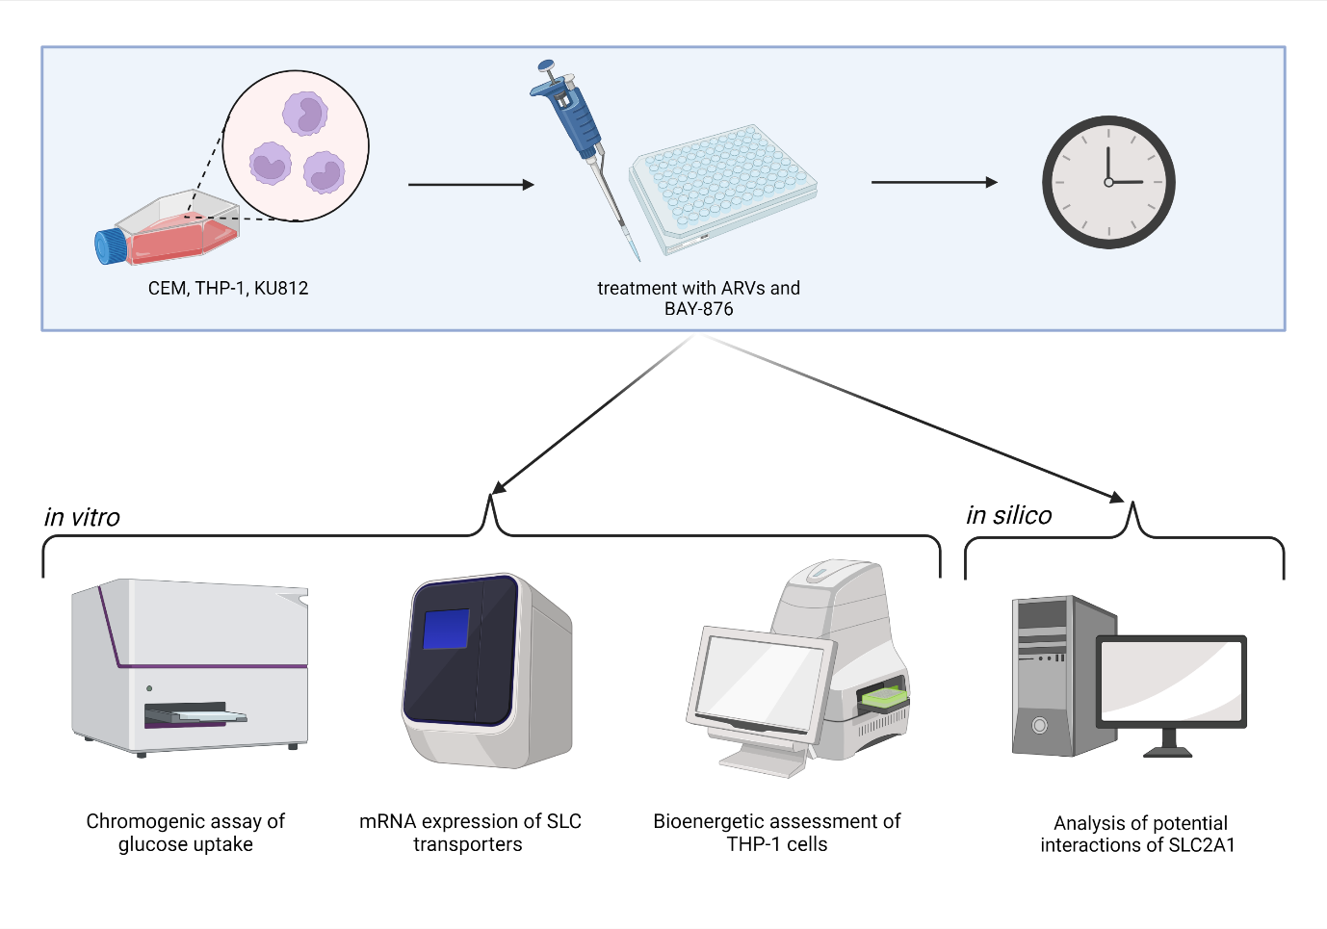
Chemical compounds studied in this article Efavirenz (PubChem CID: 64139); Lopinavir (PubChem CID: 92727); BAY-876 (PubChem CID: 118191391)
Graphical Abstract
Introduction
The human immune system has a number of mechanisms that allow for rapid activation following infection or damage [1, 2]. The rapid response requires a “metabolic boost” in the form of energy and biomass provision [3-6] particularly resulting in a high demand for rapid synthesis of ATP [5]. Activated immune cells support this bioenergetic demand by shifting from oxidative phosphorylation to glycolysis [7-10]. To support their increased need for glucose, immune cells rely on glucose uptake transporters (GLUTs) or solute carrier (SLC) transporters which are membrane-associated carrier proteins [11, 12]. These transporters facilitate the glucose transfer across the lipid bilayer in mammalian cells. Up to 14 human SLC2 transporters have, so far, been described with respect to functional involvement in immune responses [13].

The activity of GLUTs in immune cells has drawn considerable attention, due to their role in supporting immunological responses. Expression of SLC2A1, or GLUT1, provides cells with the basal levels of glucose required to function normally, however, when physiological and pathological conditions change, the need for glucose increases and GLUT1 is translocated to the surface [14-17]. When a T-cell receptor interacts with a cognate antigen, proteins responsible for the uptake of glucose, like SLC2A1, are upregulated via increased activation of the phosphoinositide 3-kinase (PI3K)/protein kinase B (AKT)/ mammalian target of rapamycin (mTOR) signalling axis [18, 19], inducing transcription factors such as hypoxia inducible factor 1-alpha (HIF1-α) [20], c-Myc [21] and NFκB [22]. It has been shown that GLUT1-deficient lymphocytes are impaired when it comes to the ability to undergo glycolysis, replication or differentiation [14]. Consequently, the availability of glucose is linked with the progression of immune disorders, such as human immunodeficiency virus (HIV). HIV infection is well characterised by an increase in glycolytic metabolism in CD4+ T cells [23], and is linked to a higher expression of GLUT1 transporters on monocytes and T cells [24-26]. During HIV infection, studies have shown the number of monocytes expressing SLC2A1 transporters increases, irrespective of treatment profiles [27] and T cells responding to viral infection often show dysregulated bioenergetic profiles [28].

In addition to their role in the uptake of endogenous substrates, SLC transporters are also implicated in the intracellular accumulation of a number of small-molecule drugs such as antiretrovirals (ARVs) [29-32] and selective serotonin reuptake inhibitors [33, 34] to name a few. In addition to their possible transport, there is also evidence that interactions between concomitantly administered drugs may result in lower intracellular accumulation within target immune cells; studies demonstrated that the ARVs tenofovir and nevirapine have intracellular drug interactions with the efflux transporter P-gp [35]. This could be suggested as a possible implication for the transport of endogenous molecules, in the presence of additional substrates, impacting on immune cell responses. We have previously observed a lower activation profile of primary human immune cells, in response to well-described mitogens, in the presence of the HIV non-nucleoside reverse transcriptase inhibitor (NNRTI), efavirenz (EFV) and protease inhibitor (PI), lopinavir (LPV) [36, 37]. The lower immune activation profiles, in the presence of ARVs, may be due to inhibition of glucose uptake transporters. We set out to examine the impact of ARVs on the uptake of glucose in several human immune cell lines.

The aim of the current study was to determine if glucose uptake was lower in the presence of efavirenz and lopinavir, in a number of human immune cell lines, as well as assess potentially altered expression profiles of GLUTs and alterations to the cells bioenergetic profiles following exposure to these antiretrovirals. The objective of this study was to attempt to elucidate the reasons for the lowered immune activation profiles observed previously. We decided to emphasise GLUT1 and GLUT4 (SLC2A4) due to their, previously reported, involvement in HIV infection and associated ARV treatments [17, 18, 24, 38]. Additionally, in silico analysis was undertaken to identify putative interactions of efavirenz and lopinavir with GLUTs, to support in vitro findings.

Materials and methods

Materials
CEM (T-cell line, ATCC number: CCL-119™), THP-1 (monocyte cell line, ATCC number: TIB-202™) and KU812 (basophilic cell line, ATCC number: CRL-2099) cells were purchased from ATCC (Manassas, Virginia, United States). Dimethyl sulfoxide (DMSO), Thiazolyl Blue Tetrazolium Bromide (3-[4,5-dimethylthiazol-2-yl]-2,5-diphenyltetrazolium bromide) (MTT), Hanks Balanced Salt solution (HBSS), Roswell Park Memorial Institute 1640 (RPMI-1640), nuclease-free water, BAY-876, oligomycin, carbonyl cyanide-4 (trifluoromethoxy) phenylhydrazone (FCCP), rotenone and antimycin A (Rot/AA) were obtained from Sigma-Aldrich (St. Louis, Missouri, United States). Phosphate-buffered saline (PBS), fetal bovine serum (FBS), TaqMan™ master mix, TaqMan™ primer FAM-MGB Probe for genes ACTB, SLC2A1, SLC2A4, live cell imaging solution (LCISol), Pierce™ BCA protein assay kit (BCA) and Corning® Cell-Tak™ cell and tissue adhesive were purchased from Thermo Fisher Scientific (Waltham, Massachusetts, United States). The ab136955 glucose uptake assay (colorimetric) kit was purchased from Abcam (Cambridge, UK) – version 16 of the protocol was followed for the ab136955 kit. The RNeasy® mini kit was purchased from Qiagen (Hilden Germany) and the GoScript™ reverse transcription system was obtained from Promega (Madison, WI, United States). The Seahorse XF base medium, without phenol red and the Seahorse XFe96 FluxPak plates were obtained from Agilent (Santa Clara, CA, United States). LPS-EK ultrapure (LPS) was purchased from Invivogen (Toulouse France). EFV and LPV, were obtained from LGM Pharma (Erlanger, Kentucky, United States). All drugs were in solution at a stock concentration of 10 mg/mL. EFV and LPV were dissolved originally in DMSO at 10 mg/mL then diluted into complete medium (RPMI-1640 supplemented with 10% FBS) to 1 μg/mL. For BAY-876, the IC₅₀ value of 2nM, taken from literature [39-41] was used in subsequent experiments.

Routine maintenance of cell lines
CEM, KU812 and THP-1 were maintained in complete growth medium (RPMI-1640 supplemented with 10% FBS) and maintained at 37°C, 5% CO₂. Cells were subcultured at cell densities of 8x10⁵ cells/mL. Briefly, cultures were transferred to 50 mL universal tubes and centrifuged in a Heraeus Multifuge 3SR+ (Thermo Fisher Scientific, Waltham, Massachusetts, United States) for 5 minutes at 2000 RPM. The supernatant was discarded in Virkon and cells were re-suspended in, fresh, complete medium. Culture volumes were adjusted to 2x10⁵ viable cells/mL following a cell count performed using NucleoCounter NC-200 (Chemometec, Allerod, Denmark). All experiments were carried out at passage 18 or lower.

Determining cytotoxicity of efavirenz and lopinavir in cell lines via MTT assay
CEM, KU812 and THP-1 were seeded at 5x10⁵ cells/mL in 96-well microplates. The cells were treated with EFV and LPV at 250 μg/mL and nine subsequent 1:2 dilutions and BAY-876 at 1.25 μM and nine subsequent 1:5 dilutions for 0- and 24-hours. Following incubation, the microplates were centrifuged, and the supernatant discarded. 50 μL of MTT (5 mg/mL in PBS) was added to each well and incubated for a further four hours before centrifugation and supernatant aspiration. 50 μL of DMSO was added to each well to lyse the cells and solubilise the formazan product. Absorbance values of each well were measured at 570nm using a CLARIOstar microplate reader (BMG Labtech, Offenburg, Germany). GraphPad Prism software (version 8) was used to calculate CC₂₀ values for drugs showing cytotoxicity.

Measurement of glucose uptake by chromogenic assay
CEM, THP-1 and KU812 cells were treated with EFV, LPV and BAY-876 for 0- and 24-hours. Cells were washed three times with HBSS. Cells were suspended at 5x10⁵ cells/mL in serum-free RPMI-1640 and plated at 100 μL per well. The glucose uptake assay was carried out following the protocol provided with the glucose uptake assay kit version 16: the plate was incubated for the appropriate set-up and washed 3× with PBS. 100 μL of PBS and 10 μL of 10 mM 2-deoxgyglucose (2-DG) was added to each well and incubated for 20 minutes. The plate was then again washed 3× with PBS and 80 μL of extraction buffer was added to each well to lyse samples. The plate was freeze/thawed and placed on a thermocycler (ElectraMed, Dublin, Ireland) at 85°C for 40 minutes. The standard curve was set up at 2-DG6P concentrations of 0, 20, 40, 60, 80 and 100 pmol/well. 10 μL of neutralising buffer was added, and the plate was spun at 500 rpm for 2 minutes. The supernatant was transferred to a new plate and 45 μL of assay buffer was added to each well. Reaction mix A was added at 10 μL and the plate was incubated for one hour at 37°C. 90 μL of extraction buffer was then added and placed on the thermocycler for 40 minutes at 90°C. 12 μL of neutralising buffer was added, along with 38 μL of reaction mix B before the absorbance values at 412 nm were recorded on the CLARIOstar microplate reader.

Measuring SLC transporter expression, in immune cell lines, using real-time PCR
1x10⁶ cells/well CEM, KU812 and THP-1 were seeded to a 48-well tissue culture plate and dosed with two concentrations of each drug in triplicate; the C_{max} and a uniform maximum concentration (informed by CC₂₀ data). Untreated and positive controls were included in parallel for each cell line. The positive controls consisted of known stimulants; C3a protein (50 ng/mL), LPS (20 ng/mL) and PHA (100 ng/mL) for KU812, THP-1 and CEM cell lines, respectively. All cells were incubated at 37°C and 5% CO₂ for 24 hours. After incubation, the cells were washed three times, in PBS, prior to RNA extraction.

RNA isolation was completed using spin columns supplied in the Qiagen RNeasy® mini kit, according to the manufacturer’s instructions. Briefly, cells were lysed, using kit reagents, and RNA eluted from the column into microcentrifuge tubes using nuclease-free water. The amount, and purity, of the eluent was determined using a NanoDrop 1000 spectrophotometer (Thermo Scientific) by measuring the 260:280 ratio. Each RNA sample was reverse transcribed using the GoScript™ RT system following the manufacturer’s protocol. Briefly, random primers, oligonucleotides, and reaction mix were added to each sample and incubated on a 42°C heat block for 60 minutes and stored at 4°C until analysis. 20 ng of cDNA was used per PCR run using the qPCR TaqMan™ gene expression assay. Each sample was combined with master mix, the specific gene primer-probe (either ACTB (Assay ID HS999999-3_m1), the housekeeping gene, or one of the genes of interest, SLC2A1 (Assay ID HS00197884_m1), or 2A4 (Assay ID HS00168966_m1)) and nuclease-free water to a total of 20μL. Each sample was then amplified on a DNAEngine® peltier thermal cycler (Bio-Rad) with the following programme settings: 50°C for 2 minutes, 95°C for 10 minutes and then 40 cycles of 95°C for 15 seconds followed by 60°C for 60 seconds. The fluorescence was recorded after each cycle by the Opticom Monitor 3 software and the cycle threshold (Ct) for each concentration was determined and exported into Prism 8 where it was normalised to the untreated housekeeping gene and transformed into average percentage difference using a comparative Ct calculation.

Measuring bioenergetic profiles in THP-1 cells using the Seahorse XFe96 analyser.
Before the assay, the sensor cartridge was hydrated and the XFe96 cell culture microplate was coated in Cell-Tak using the following method: Prepare Cell-Tak solution by adding 92.8 μL of Cell-Tak to 1.3 mL of 0.1 M NaHCO₃ (pH 8.0) (60 wells). 20 μL of the diluted Cell-Tak was added per well and incubated for 1 hour at 37°C without supplemental CO₂. The plate was then washed twice using 200 µL sterile 37°C distilled water, allowed to air dry, and stored at 4°C until needed.

THP-1 cells at 2x10⁶ cells/mL were treated with EFV, LPV and BAY-876 (± LPS) for 24-hours or used as an acute injection on the Seahorse (0 hour). Following incubation, the suspensions were transferred to the Cell-Tak prepared plate and centrifuged at 200×g for 1 minute to facilitate cell attachment. The plate was then incubated at 37°C for at least 1 hour to allow cell attachment. The plate was washed twice with 100 μL of Seahorse XF basal, phenol free medium and a final volume of 175 μL was added to each well and incubated for at least one hour. Concentrations of the Mito Stress Test compounds (oligomycin, FCCP, Rot/AA) were prepared in Seahorse XF medium at optimised concentrations for the THP-1 cells (data available on request): Oligomycin 1.5 μM, FCCP 0.5 µM, Rot/AA 1 µM. The cartridge and the utility plate was then loaded into the instrument and the calibration started. Once complete, the cell plate was added, and the results were collected once finished.

A BCA was performed to measure the total protein content from each well, which was then used to normalise the Seahorse data. Standards were prepared of the diluted albumin according to the Pierce™ BCA Protein Assay Kit protocol. A BCA working reagent was made by mixing fifty parts of BCA reagent A with one part of BCA reagent B. The microplate procedure was then followed to produce a standard curve to determine the protein concentration of each sample within the plate: 25 μL of each standard or sample was added into a microplate, in duplicate, and 200 μL of the BCA working reagent was added to each well. The plate was then mixed on a shaker for 30 seconds, then covered and incubated at 37°C for 30 minutes. The plate was then cooled to room temperature and the absorbance was read at 562nm.

Statistical analysis
Statistical analysis was performed using GraphPad Prism 8.3 software. Statistical significance was evaluated using a one-way ANOVA test. A P value <0.05 was considered statistically significant.

Molecular modelling of SLC2A1 with docking of ARVs and BAY-876
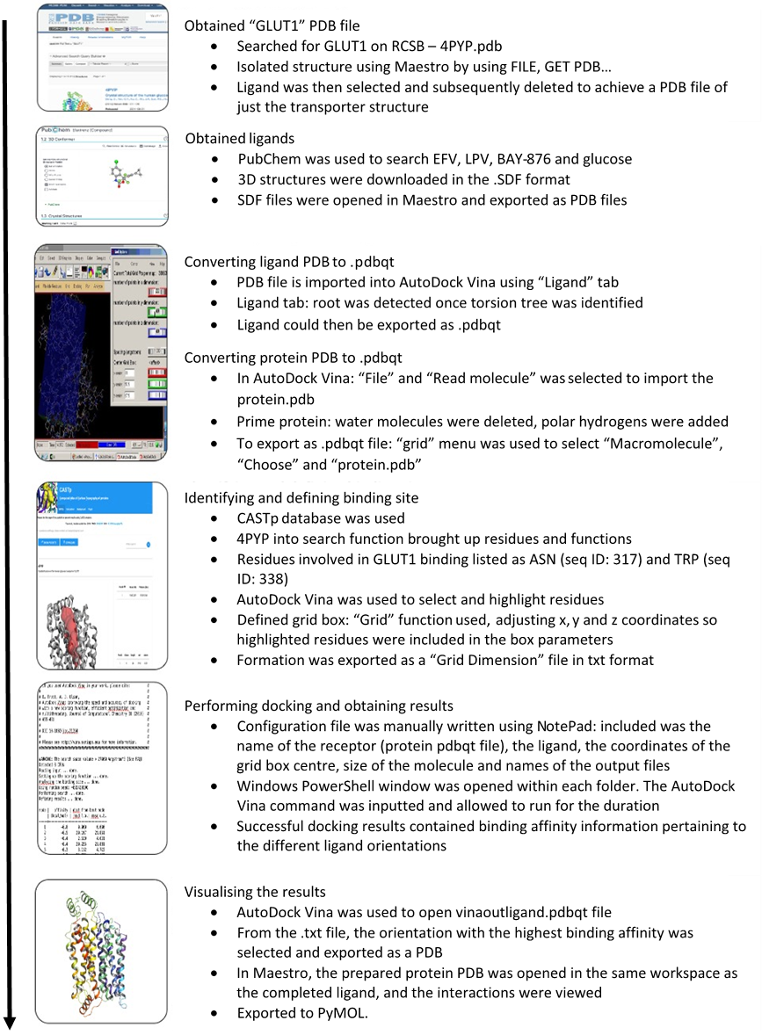

Results

Efavirenz and lopinavir exposure leads to cytotoxicity in CEM, THP-1 and KU812 cells.
The compounds used throughout the experiment could potentially cause cytotoxicity within the cell lines used. Therefore, prior to use in the functional assays, suitable concentrations were determined that did not result in marked cytotoxicity, in the cell lines being used. Using MTT assays, it was determined that EFV (Figure 1B) and LPV (Figure 1C) displayed toxicity with increasing concentration, generating the CC₂₀ concentrations displayed in Figure 1A. BAY-876 did not show any overt toxicity in the MTT assay for the three cell lines investigated. As such, valid CC₂₀ values could not be generated as there was no evident toxicity (Figure 1D).
Cell Line | ARV | CC₂₀ (μg/mL)
CEM | EFV | 11.73
 | LPV | 6.13
THP-1 | EFV | 14.04
 | LPV | 17.78
KU812 | EFV | 11.92
 | LPV | 6.22
Figure 1. Dose response curves of ARV drug effects on CEM, THP-1, KU812.
Cell-based and cell-free MTT assay concentration-response curves (absorbance at 570 nm) generated by CEM cell line treated with (A) efavirenz (EFV), (B) lopinavir (LPV), (C) emtricitabine (FTC), (D) lamivudine (3TC), THP1 cell line treated with (E) EFV, (F) LPV, (G) FTC, (H) 3TC, and KU812 cell line treated with (I) EFV, (J) LPV, (K) FTC, (L) 3TC. Data displayed as average of n=3 ± standard deviation.
Figure 1. Determination of CC₂₀ values, for EFV, LPV and BAY-876,in cell lines used within the study.
Table (A) of CC₂₀ concentrations generated from CC₅₀ values produced from the MTT assay concentration-response curves. The CC₂₀ concentrations were calculated using Prism EC_{Anything} calculator, based on CC₅₀ values and slope factor. These concentrations informed the exposures in subsequent experimentation. Cell-based and cell-free MTT assay concentration-response curves (absorbance at 570 nm) generated by CEM cell line treated with (B) efavirenz, (C) lopinavir and (D) BAY-876 for 24 hours. Data displayed as average of n=3 ± standard deviation.

Glucose uptake is lower in cells exposed to efavirenz and lopinavir, compared to untreated control cells
As the ARVs are known to affect the activation of immune cells, we speculated that these compounds may have an inhibitory effect on glucose uptake. We addressed this question by using, commercially available, assays employing 2-DG as a surrogate for endogenous glucose, thereby determined the impact of ARVs on 2-DG accumulation.

CEM cells treated with EFV at 11.73 μg/mL, over a period of 24 hours, had significantly lower 2-DG accumulation than that of untreated cells (26% lower) (Figure 2B).

Within the THP-1 cell line, at 0 hours, EFV resulted in lower glucose uptake at both 4 μg/mL (50% lower) and 14.04 μg/mL (90% lower) when compared with the untreated, control, cells (Figure 2C). LPV at 10 μg/mL resulted in 33% lower glucose accumulation when compared with the untreated cells. In addition, LPV at 17.78 μg/mL significantly lowered the 2-DG accumulation (40% lower) (Figure 2C). Similarly, at 24 hours, treatment with EFV at 14.04 μg/mL resulted in lower intracellular glucose accumulation than the untreated control cells at 24-hours (76% lower) (Figure 2D). LPV at 10 μg/mL resulted in a significant difference of glucose accumulation in 24 hours (30% lower) and LPV at 17.78 μg/mL resulted in 71% lower glucose uptake when compared to the untreated control cells (Figure 2D).

At 0 hours, KU812 cells when treated with 11.92 μg/mL EFV resulted in a decrease of glucose uptake when compared with the untreated control (35% lower) (Figure 2E). LPV at 10 μg/mL (27% lower) and 6.22 μg/mL (41% lower) showed lower cellular glucose uptake when compared with the untreated control (Figure 2F). At 24 hours, EFV at 4 μg/mL and at 11.92 μg/mL resulted in a 48% and 82% decrease of glucose uptake, respectively, compared to the untreated control cells (Figure 2F).

Cell Line | ARV | Concentration (μg/mL)
CEM | EFV Low | 4
 | EFV High | 11.73
 | LPV Low | 10
 | LPV High | 6.13
THP-1 | EFV Low | 4
 | EFV High | 14.04
 | LPV Low | 10
 | LPV High | 17.78
KU812 | EFV Low | 4
 | EFV High | 11.92
 | LPV Low | 10
 | LPV High | 6.22
The ARVs investigated were shown to result in lower 2-DG uptake in the three immune cell lines, suggesting possible inhibition of SLC2 transporters. EFV had an instant effect in all cell lines tested, although this was not marked in CEM cells, and LPV effect over 24 hours could suggest that EFV is a competitive inhibitor of the SLC2 transporters, with LPV altering the phenotype of the cells, which was explored below.

Table 1. Concentrations generated from CC₂₀ concentrations (high) and C_{max} (low) using Graphpad Compute EC_{anything} from EC₅₀.
Figure 2. Glucose uptake in CEM, THP-1 and KU812 treated with ARV drugs.
Glucose uptake displayed in the form of a bar chart plotted as a percentage of untreated control cells when cell lines were treated with EFV and LPV at varied concentrations displayed in µg/mL.
Chromogenic (ab136995) assay on (A) CEM cells for 0 hours, (B) CEM cells for 24 hours, (C) THP-1 cells for 0 hours, (D) THP-1 cells for 24 hours, (E) KU812 cells for 0 hours, (F) KU812 cells for 24 hours. Data displayed as average of n=4 ± standard deviation. Statistical significance when compared to untreated control displayed as * p<0.05.

A
Figure 2. Glucose uptake in CEM, THP-1 and KU812 treated with ARV drugs.
Glucose uptake displayed in the form of a bar chart plotted as a percentage of untreated control cells when cell lines were treated with EFV and LPV at varied concentrations displayed in µg/mL. Chromogenic (ab136995) assay on (A) CEM cells for 0 hours, (B) CEM cells for 24 hours, (C) THP-1 cells for 0 hours, (D) THP-1 cells for 24 hours, (E) KU812 cells for 0 hours, (F) KU812 cells for 24 hours. Data displayed as average of n=4 ± standard deviation. Statistical significance when compared to untreated control displayed as * p<0.05.

SLC2A1 inhibitor, BAY-876, displayed cell-type dependent effects on glucose uptake
As there was evidence of the ARVs affecting glucose transport, whether via interactions with a specific transporter or multiple, we introduced the known SLC2A1 inhibitor, BAY-876. We then tested the effect on cellular glucose uptake in the three immune cell lines when the SLC2A1 transporter was inhibited to determine the effects of glucose uptake within the immune cells.

The results displayed were unexpected as in both CEM (Figure 3B) and KU812 (Figure 3F) cells treated with 2 nM of BAY-876, the glucose accumulation within the cells was higher on average when compared with the untreated control cells at 24 hours. At 24 hours, glucose accumulation within CEM cells was higher by 29% and in KU812 cells by 16% when compared to the untreated cells.
Figure 3. Glucose uptake in CEM, THP-1 and KU812 treated with BAY-876 at 2nM.
Glucose uptake displayed in the form of a bar chart plotted as a percentage of untreated control cells over two incubation points. Chromogenic (ab136995) assay displayed when immune cells are treated with BAY-876 at 2nM on (A) CEM cells for 0 hours, (B) CEM cells for 24 hours, (C) THP-1 cells for 0 hours, (D) THP-1 cells for 24 hours, (E) KU812 cells for 0 hours, (F) KU812 cells for 24 hours. Data displayed as average of n=4 ± standard deviation. Statistical significance when compared to untreated control displayed as * p<0.05.

SLC2A1 and SLC2A4 expression was higher at the transcriptional level in the CEM and THP-1 cell lines
An additional line of investigation looked into whether ARVs had an effect on expression of SLC transporters. We addressed this by carrying out qPCR in all three cell lines to determine the influence of the ARVs on SLC2A1 and SLC2A4 mRNA expression.

In the CEM cell line, SLC2A1 expression was significantly higher (2728% greater) when treated with 10 μg/mL LPV (Figure 4A). No significant changes in SLC2A4 expression were observed in this cell line (Figure 4B). 4 μg/mL EFV and 20 μg/mL LPV all increase the expression of SLC2A4 by a non-significant margin. 10 μg/mL LPV and the PHA positive control caused suppressed expression by 50% and 70%, respectively.

EFV and LPV had no marked effects on the expression of SLC2A1 in THP-1 (Figure 4C). The 10 μg/mL dose of LPV had a significant increase effect on SLC2A4 (232% higher), an effect that was compounded by the higher 20 μg/mL dose which increased by 2725% compared to the untreated control (Figure 4D).

Treatments added to the KU812 cell line produced non-statistically significant changes in transporter gene expression (Figure 4E, F). These four antiretroviral treatments and C3a positive control all decreased the expression of SLC2A4 by as much as 99% (Figure 4F).

In THP-1 cells, LPV seemed to induce expression of SLC2A4. Therefore, in theory, this should lead to a higher level of 2-DG accumulation, rather than less at 24 hours like previously shown within the glucose uptake experiments. However, it is also possible that the ARV may be causing a concomitant increase in efflux transporters, to balance out the effect. Overall clarity on the phenotypic effects of LPV on GLUTs in these cells is required. For the most part, we can conclude that EFV and LPV caused no significant reduction in metabolite transporters expression, thus do not cause anergy through the modulation of SLC transporters at a transcriptional level.
Figure 4. SLC2A1 and SLC2A4 transporter expression, and changes in response to ARV exposure, in CEM, THP-1 and KU812 cells
SLC transporter expression displayed in the form of a bar chart as a percentage expression compared to untreated control in CEM cells showing (A) SLC2A1 expression, (B) SLC2A4 expression, in THP-1 cells showing (C) SLC2A1 expression, (D) SLC2A4 expression, in KU812 cells showing (E) SLC2A1 expression, (F) SLC2A4 expression, in response to C_{max} and CC₂₀ doses of antiretroviral aqueous drug formulations. Data displayed as average of n=3 + standard deviation, except where stated. Positive controls consisted of PHA (100 ng/mL) for CEM cells, LPS (20 ng/mL) for THP-1 cells and C3a protein (50 ng/mL) for KU812 cells. Significant results displayed as * p<0.05. Technical replicates missing (~), no amplification of cDNA during qPCR, data missing (#).

Efavirenz and lopinavir alter energy production within THP-1 cells
Due to the potential negative impact on normal cell function within the glucose uptake assays in the presence of the drugs, which may be attributed to restriction of SLC transporters or inactivation of the cells, we ran a series of Seahorse FX Mito Stress Tests on THP-1 cells. The test was to identify the differences, if any, within the energy profiles of the cells in the presence of the drugs. Calculation of glycolytic rates (J_{ATPglyc}) and oxidative reaction rates (J_{ATPox}) from extracellular acidification rate (ECAR) and oxygen consumption rate (OCR) were calculated following Mookerjee S, A. et al., this, in turn, was used to calculate the rates of ATP production (J_{ATP}) displayed in Figure 5 [42].

At 0 hours (acute injection), under basal conditions (Figure 5C), there were no significant differences in the rate of production of ATP with any of the treatments compared to the untreated.

After the oligomycin injection (Figure 5D), EFV at 4 μg/mL resulted in a 58% increase in the rate of ATP production from 125.5 pmol ATP/min/μg protein to 198.6 pmol ATP/min/μg protein. EFV at 4 μg/mL with LPS resulted in a 57% increase in the rate of ATP production from 125.5 pmol ATP/min/μg protein to 196.8 pmol ATP/min/μg protein. EFV at 14.04 μg/mL resulted in a 71% higher rate of ATP production from 125.5 pmol ATP/min/μg protein to 214.2 pmol ATP/min/μg protein, which increased to 79% after stimulation with LPS from 125.5 pmol ATP/min/μg protein to 225.3 pmol ATP/min/μg protein.

LPV at 10 µg/mL resulted in an increase in the rate of ATP production by 36% (170.9 pmol ATP/min/μg protein) when stimulated with LPS. BAY-876 plus LPS treatment also significantly increased the rate of ATP production by 54% (194 pmol ATP/min/μg protein).

At 24 hours, under basal conditions (Figure 5E), the primary source of ATP production was oxidative phosphorylation due to high OCR and low ECAR rates.

Overall, there was a significant reduction in J_{ATP} when treated with EFV at 4 μg/mL from 185.5 pmol ATP/min/μg protein to 23.5 pmol ATP/min/μg protein (87% lower) and 4 μg/mL with LPS down to 24 pmol ATP/min/μg protein (87% lower). In addition, when stimulated with LPS, 14.04 μg/mL of EFV significantly reduced the J_{ATP} by 88% (22.8 pmol ATP/min/μg protein). However, LPV at 10 μg/mL significantly increased J_{ATP} to 329 pmol ATP/min/μg protein (77% higher) the rate of ATP production when stimulated with LPS. After the addition of oligomycin (Figure 5F), the majority of the ATP produced was via glycolysis due to the increase in ECAR and decrease in OCR. EFV significantly reduced J_{ATP} at 4 μg/mL from 91.7 pmol ATP/min/μg protein to 11.2 pmol ATP/min/μg protein (88% lower), at 4 μg/mL after stimulation with LPS, to 25.7 pmol ATP/min/μg protein (72% lower) and at 14.04 μg/mL after stimulation with LPS (82% lower) from 91.7 pmol ATP/min/μg protein to 16.4 pmol ATP/min/μg protein.

We can conclude that the drugs have significant effects on the energy profiles of the THP-1 cells. EFV significantly reduces the rate of ATP production after 24 hours, despite the initial increase under stressed conditions. This is supported by the lower accumulation of 2-DG seen in the glucose uptake assays. In contrast, LPV over the 24 hours continues to increase the rate of ATP production. This, with the previous findings of increased expression of SLC2A4, could suggest the increase in energy production is to power ATP-powered efflux transporters.

Figure 5. ATP production (J_{ATP}) in THP-1 cells treated with ARVs and BAY-876
Displayed are rates of ATP production (J_{ATP}) converted from raw flux data provided by the Seahorse Mito Stress Test. Raw traces of oxygen consumption rate (OCR) and extracellular acidification rate (ECAR) produced by Seahorse Wave Desktop Software (v2.6) from Agilent Technologies by (A) THP-1 cells when treated with the ARVs and BAY-876 by acute injection, (B) THP-1 cells when treated with the ARVs and BAY-876 for 24 hours. J_{ATP} production when (C) THP-1 cells treated with ARVs and BAY-876 (± LPS) by acute injection, (D) THP-1 cells treated with ARVs and BAY-876 (± LPS) by acute injection and oligomycin, (E) THP-1 cells treated with ARVs and BAY-876 (± LPS) for 24 hours, (F) THP-1 cells treated with ARVs and BAY-876 (± LPS) for 24 hours and oligomycin. Data displayed as a mean of 3 + standard deviation, of n=2 experiments. Statistical significance when compared to untreated control displayed as * p<0.05.

Efavirenz bound to SLC2A1 at an alternate site to the binding site with the highest affinity
Due to there being changes to the accumulation of glucose within the cell lines but very few significant results in alterations of transporter expression, we concluded that the ARVs may have inhibitory effects of the SLC transporters rather than suppression of the transcription of the SLC transporters. From this we carried out a in silico analysis to determine where the ARVs may dock to SLC2A1.

The visual dockings of the ARVs, BAY-876 and glucose to SLC2A1 (Figure 6) show the binding position of the molecules to SLC2A1 with the highest affinity for binding (Supplementary Figure 1). Of the tested interactions, all apart from EFV, bound to SLC2A1 in a site with the highest binding affinity, similar to that of glucose (Figure 6I, J), in the centre of the SLC2A1 transporter. EFV bound in an alternative position on the outside of the transporter (Figure 6C, D). Each of the ARVs displayed interactions with SLC2A1, however, BAY-876 (Figure 6G, H) displayed no interactions with SLC2A1.

This further supported the suggestion of EFV being an inhibitor of the glucose transporters, theoretically now non-competitively.
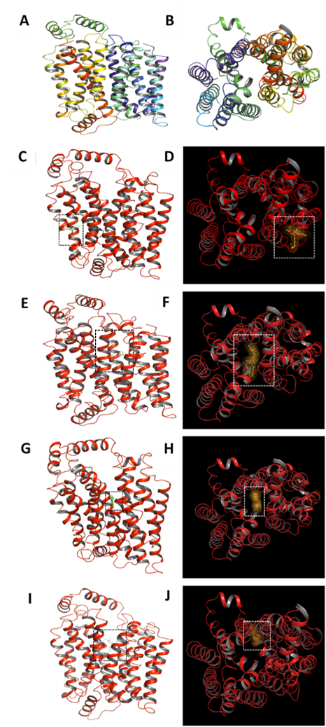
Figure 6. Putative interactions of EFV, LPV, and BAY-876 with SLC2A1.
Crystal structure for SLC2A1 obtained from Protein Data Bank (PDB) with the PDB ID 4PYP, representing the “exit state” (e1) of SLC2A1. (A) View of transmembrane α-helices are shown to be parallel to the membrane. (B) View of cytoplasmic orientation of the transmembrane α-helices. Backbone is hidden for ease of viewing. Visual images of the docking of ligand (green) (C) EFV, (E) LPV, (G) BAY-876 to SLC2A1 molecule (red) (PBD 4PYP) with labels displaying the distance in ångström. Glucose (green) (I) was used as a point of comparison. Cytoplasmic orientation visual of the docking between ligands (orange) (D) EFV, (F) LPV, (H) BAY-876 and (J) glucose to SLC2A1 is displayed with dots shown for ligands. Visualised using PyMoL. Dashed box used to mark point of binding of ligand to SLC2A1.

Discussion
Antiretrovirals have transformed the standard of care and saved countless lives in those living with HIV by reducing morbidity and mortality associated with ongoing viral replication. Previously, we have shown that exposing T cells and macrophages to efavirenz and lopinavir results in lowered activation profiles, in response to immune stimulation [36, 37]. In the current study, we set out to ascertain if inhibition of glucose uptake, via the interactions of ARVs with GLUTs, was a putative mechanism for this inhibition.

The chromogenic glucose uptake assay was performed on CEM, THP-1 and KU812 cells. At the chosen timepoints, EFV and LPV exposure resulted in significantly lower glucose uptake in all three cell lines, compared to untreated cells. EFV was effective at inhibiting glucose uptake only a few minutes after incubation whereas LPV altered glucose uptake after 24 hours. From this, EFV had the potential to be a direct competitive inhibitor to the glucose transporters, whereas LPV may be altering the phenotype of the immune cells. EFV has been shown to have damaging effects on mitochondrial function, with results displaying inhibition of complex I of the respiratory chain, affecting cellular glucose levels [43]. Previous studies [44, 45] have also demonstrated EFV treatment leading to lower ATP production like those demonstrated via the Seahorse stress test. This would indicate that the use of EFV and LPV at different concentrations could reduce the activation of immune cells, theoretically contributing to cellular pathogenesis.

Upon activation, immune cells favour glycolysis, causing an influx of glucose into the cells [7, 8, 46]. Activation of monocytes has been shown to increase membrane expression of SLC2 transporters, in particular increase SLC2A4 expression [47]. This potentially explains why the experimental results of the glucose uptake assay in the presence of the ARV drugs displayed a lower glucose uptake in the CEM cell line than the THP-1 cells as there are potentially a greater number of SLC2 transporters on the membranes of THP-1, resulting in a greater uptake of glucose. PIs have been proven to act as reversible non-competitive inhibitors of SLC2A4 transport activity [48, 49] which would also suggest a reduction of glucose uptake in immune cells in the presence of LPV. This supports the significant reductions in glucose uptake of THP-1 and KU812 cells at varying LPV concentrations. In addition, significantly lower cellular glucose levels in THP-1 and KU812 cells when treated with EFV was observed, suggesting possible inhibition of SLC2A1/SLC2A4 transporters. This would result in glucose metabolism in immune cells being reduced, suppressing immune cell activation.

Compounds, such as BAY-876, were designed to inhibit the binding/release of glucose to SLC2A1 for potential modulation of glucose uptake. BAY-876 is a novel inhibitor of the SLC2A1 transporter by more than 100-fold of the other SLC transporters (SLC2A2 by 4700-fold, SLC2A3 by 800-fold, SLC2A4 by 135-fold) [50]. Previous work on the binding/inhibition mechanism of BAY-876 suggests that it is a competitive substrate of the SLC2A1 transporter with glucose, binding at the intracellular site of the protein [50, 51]. The glucose uptake measured in the presence of BAY-876 across the three cell lines resulted in a greater accumulation of glucose across 24 hours. The result from the chromogenic glucose assay was unexpected. It was assumed that SLC2A1 inhibition with BAY-876 would decrease 2-DG uptake in all three cell lines. The observation was a greater accumulation of 2-DG, especially in CEM and KU812 cell lines.

A possible explanation for this observation could be that the inhibition of the SLC2A1 transporter by BAY-876 could lead to an increase in expression of the other GLUT transporters, thus the amount of 2-DG taken up by the cells is increased. Alternatively, there may be greater translocation of GLUTs to the surface of protein membranes when the existing SLC2A1 transporters on the surface become inhibited, so theoretically, BAY-876 at the half-maximal inhibitory concentration of 2nM causes an increase of SLC2A1 transporters leading to an increase in glucose uptake. These hypotheses are supported by work within the literature. Previous studies show the SLC2A1/3 inhibitors, Glupin and Glutor, shown to upregulate the SLC2A1 and SLC2A3 isoforms under hypoglycaemic conditions [52, 53]. Research into resting CD4+ T-cells shows expression of SLC2A1 and SLC2A3 at an equal level. Upon activation, expression of intracellular SLC2A1 was increased within two hours and surface expression was increased within four hours [14]. Activation of T-cells has been shown to stimulate the mTOR pathway, increasing glycolysis by promoting an increase in SLC2A1 activity [15]. In addition, the 2-DG molecule used in these experiments has also been shown to induce the AKT pathway through PI3K [54, 55].

The bioenergetics of the THP-1 cells was assessed using Agilent Seahorse XF Cell Mito Stress Test. The ATP production rates of the cells are able to be split between glycolytic and oxidative reaction rates which can then indicate the cells status of activation/proliferation potential. The basal response is linked to the background level of ATP production of the cells, with the oligomycin response being linked to stimulated ATP production within the cells, through various stress processes. Oligomycin results in a reduction of OCR, linked to cellular ATP production. Full background of the kit can be found in the Agilent Seahorse XF Cell Mito Stress Test Kit User Guide (Kit 103015-100, Second edition, May 2019). The bioenergetic profile of the THP-1 cells, in response to EFV over 24 hours, showed a decrease in the J_{ATP}. This has been shown in previous studies where incubation with efavirenz provoked a significant, concentration-dependent, decrease in ATP production-coupled O₂ consumption in multiple different cell lines [56-58]. Whereas in contrast, LPV over the 24 hours continued to increase the rate of ATP production. This could suggest the increase in energy production seen with LPV treatment is to power ATP-powered efflux transporters. Previous studies [59, 60] have identified a new class of glucose uniporters (SLC50) transporters, SWEETs, as a potential mediator of glucose transport. Human HEK293T cells were used to co-express candidate efflux proteins and the human homologue HsSWEET1 mediated weak efflux activity in oocytes [59]. One member of the group, SWEET1 (or SLC50A1), in the human genome [61] has been identified, however, most research on these efflux transporters is present in plants. It is suggested that these animal homologs of the SLC50s found in plants are probably involved in sugar efflux from gluconeogenic cells [59, 61], however, further investigation is needed to explain the clarity on the phenotypic effects of LPV on SLCs in these cells.

qPCR was used to investigate differences in mRNA expression of SLC metabolite transporters in immune cell lines when treated with the ARVs. Naïve immune cells generally express basal levels of both the transporters, such that they can adequately fuel their ordinary metabolic function. However, when activated, the expression levels rise to cope with increased metabolic demands and proliferative needs [62, 63]. All three cell lines exhibited basal levels of expression of each transporter in untreated conditions. CEM expression of SLC2A1 increased significantly in response to 10 μg/mL LPV, all other treatments only elicited minor, non-significant effects on expression. SLC2A4 transporter expression in THP-1 cells was markedly higher after treatment with 10 and 20 μg/mL doses of LPV, all other treatments had little impact. The lack of response to EFV suggests that the suppression in immune activation observed previously resulting from nanoformulations of these two drugs [36, 37] may not be due to modulation of GLUT transporters at a transcriptional level. LPV, however, was shown to impact gene expression, especially in the THP-1 cell line by increasing expression of SLC2A4.

Elicitation of higher expression of SLC2 transporters is expected in conjunction with an immune response. The ARVs, particularly LPV, alter SLC2 expression at the transcriptional level, however, overall there is still a reduction in glucose uptake such that EFV and LPV can possibly inhibit the SLC2 transporters at the cellular level rather than at a transcriptional level. The evidence seems to suggest that, due to the reduction of cellular glucose levels alongside the increase in SLC2 transporter expression at the transcriptional level, the ARVs impact a metabolic pathway, limiting immune response in some way. It must be noted that all studies were undertaken in immortalised cell lines and as such cannot precisely represent real-life conditions, adding a level of caution in dismissing the drugs’ transcriptional intervention.

The visual dockings of the substrates showed that all but EFV when bound to SLC2A1 displayed expected results, as they bound to the pre-determined binding site of SLC2A1. However, EFV seemed to bind to an allosteric site on the side of the SLC2A1 transporter. From the computerised model, it could be suggested that EFV acts as a non-competitive inhibitor of SLC2A1 or possibly has an inhibition mechanism effecting the other GLUT transporters. It is already known that EFV is a non-competitive inhibitor of the reverse transcriptase enzyme, binding to a site different from the active site [64], so for the computerised model to bind an allosteric site of the SLC transporter, it follows the trend. Each ligand, apart from BAY-876, displayed interactions with SLC2A1. This could potentially be an issue with the computerised ligand as only the 2D structure was available, making this a limitation of the research models. The AutoDock Vina output folder predicted high binding affinities for all tested substrates in relation to SLC2A1, demonstrated in the visual images which show low binding energies in kcal/mol. All ligands, apart from EFV, bound to a binding site with highest affinity to SLC2A1 and all but BAY-876 interacted with SLC2A1 directly in a theoretical computerised environment, however this should be backed up with in vitro experimentation.

Overall, our data demonstrates that the ARVs EFV and LPV can impact upon the glucose uptake and bioenergetic profiles of cells, which appears to influence the activation of immune cells exposed to them. Clarification of the implications of this data, for in vivo immunological responses, is now warranted, with investigations moving forward to primary cells potentially providing a clearer image. These results may provide insight into drug impact on immune cell function, beyond simple cytotoxicity.

References
1 Iwasaki, A. and Medzhitov, R. (2015) Control of adaptive immunity by the innate immune system. Nat Immunol. 16, 343-353
2 Mogensen, T. H. (2009) Pathogen recognition and inflammatory signaling in innate immune defenses. Clin Microbiol Rev. 22, 240-273
3 Finlay, D. and Cantrell, D. A. (2011) Metabolism, migration and memory in cytotoxic T cells. Nat Rev Immunol. 11, 109-117
4 Loftus, R. M. and Finlay, D. K. (2016) Immunometabolism: Cellular Metabolism Turns Immune Regulator. J Biol Chem. 291, 1-10
5 Vander Heiden, M. G., Cantley, L. C. and Thompson, C. B. (2009) Understanding the Warburg effect: the metabolic requirements of cell proliferation. Science. 324, 1029-1033
6 Brand, K., Leibold, W., Luppa, P., Schoerner, C. and Schulz, A. (1986) Metabolic alterations associated with proliferation of mitogen-activated lymphocytes and of lymphoblastoid cell lines: evaluation of glucose and glutamine metabolism. Immunobiology. 173, 23-34
7 Ganeshan, K. and Chawla, A. (2014) Metabolic regulation of immune responses. Annu Rev Immunol. 32, 609-634
8 Soto-Heredero, G., Gómez de Las Heras, M. M., Gabandé-Rodríguez, E., Oller, J. and Mittelbrunn, M. (2020) Glycolysis - a key player in the inflammatory response. FEBS J. 287, 3350-3369
9 Krawczyk, C. M., Holowka, T., Sun, J., Blagih, J., Amiel, E., DeBerardinis, R. J., Cross, J. R., Jung, E., Thompson, C. B., Jones, R. G. and Pearce, E. J. (2010) Toll-like receptor-induced changes in glycolytic metabolism regulate dendritic cell activation. Blood. 115, 4742-4749
10 Kelly, B. and O'Neill, L. A. J. (2015) Metabolic reprogramming in macrophages and dendritic cells in innate immunity. Cell Res. 25, 771-784
11 Bell, G. I., Kayano, T., Buse, J. B., Burant, C. F., Takeda, J., Lin, D., Fukumoto, H. and Seino, S. (1990) Molecular biology of mammalian glucose transporters. Diabetes Care. 13, 198-208
12 Song, W., Li, D., Tao, L., Luo, Q. and Chen, L. (2020) Solute carrier transporters: the metabolic gatekeepers of immune cells. Acta Pharmaceutica Sinica B. 10, 61-78
13 Mueckler, M. and Thorens, B. (2013) The SLC2 (GLUT) family of membrane transporters. Mol Aspects Med. 34, 121-138
14 Macintyre, A. N., Gerriets, V. A., Nichols, A. G., Michalek, R. D., Rudolph, M. C., Deoliveira, D., Anderson, S. M., Abel, E. D., Chen, B. J., Hale, L. P. and Rathmell, J. C. (2014) The glucose transporter Glut1 is selectively essential for CD4 T cell activation and effector function. Cell Metab. 20, 61-72
15 Wieman, H. L., Wofford, J. A. and Rathmell, J. C. (2007) Cytokine stimulation promotes glucose uptake via phosphatidylinositol-3 kinase/Akt regulation of Glut1 activity and trafficking. Mol Biol Cell. 18, 1437-1446
16 MacIver, N. J., Jacobs, S. R., Wieman, H. L., Wofford, J. A., Coloff, J. L. and Rathmell, J. C. (2008) Glucose metabolism in lymphocytes is a regulated process with significant effects on immune cell function and survival. Journal of Leukocyte Biology. 84, 949-957
17 Palmer, C. S., Anzinger, J. J., Zhou, J., Gouillou, M., Landay, A., Jaworowski, A., McCune, J. M. and Crowe, S. M. (2014) Glucose Transporter 1–Expressing Proinflammatory Monocytes Are Elevated in Combination Antiretroviral Therapy–Treated and Untreated HIV<sup>+</sup> Subjects. The Journal of Immunology. 193, 5595
18 Masson, J. J. R., Cherry, C. L., Murphy, N. M., Sada-Ovalle, I., Hussain, T., Palchaudhuri, R., Martinson, J., Landay, A. L., Billah, B., Crowe, S. M. and Palmer, C. S. (2018) Polymorphism rs1385129 Within Glut1 Gene SLC2A1 Is Linked to Poor CD4+ T Cell Recovery in Antiretroviral-Treated HIV+ Individuals. Frontiers in Immunology. 9
19 Wei, J., Raynor, J., Nguyen, T.-L. M. and Chi, H. (2017) Nutrient and Metabolic Sensing in T Cell Responses. Frontiers in Immunology. 8
20 Chen, C., Pore, N., Behrooz, A., Ismail-Beigi, F. and Maity, A. (2001) Regulation of glut1 mRNA by hypoxia-inducible factor-1. Interaction between H-ras and hypoxia. J Biol Chem. 276, 9519-9525
21 Palmer, C. S., Ostrowski, M., Balderson, B., Christian, N. and Crowe, S. M. (2015) Glucose Metabolism Regulates T Cell Activation, Differentiation, and Functions. Frontiers in Immunology. 6
22 Hsu, C.-L. and Dzhagalov, I. L. (2019) Metabolite Transporters—The Gatekeepers for T Cell Metabolism. Immunometabolism. 1, e190012
23 Taylor, H. E. and Palmer, C. S. (2020) CD4 T Cell Metabolism Is a Major Contributor of HIV Infectivity and Reservoir Persistence. Immunometabolism. 2
24 Palmer, C. S., Ostrowski, M., Gouillou, M., Tsai, L., Yu, D., Zhou, J., Henstridge, D. C., Maisa, A., Hearps, A. C., Lewin, S. R., Landay, A., Jaworowski, A., McCune, J. M. and Crowe, S. M. (2014) Increased glucose metabolic activity is associated with CD4+ T-cell activation and depletion during chronic HIV infection. AIDS. 28, 297-309
25 Palmer, C. S., Duette, G. A., Wagner, M. C. E., Henstridge, D. C., Saleh, S., Pereira, C., Zhou, J., Simar, D., Lewin, S. R., Ostrowski, M., McCune, J. M. and Crowe, S. M. (2017) Metabolically active CD4+ T cells expressing Glut1 and OX40 preferentially harbor HIV during in vitro infection. FEBS Lett. 591, 3319-3332
26 Hegedus, A., Williamson, M. K. and Huthoff, H. (2014) HIV-1 pathogenicity and virion production are dependent on the metabolic phenotype of activated CD4+ T cells. Retrovirology. 11, 1-18
27 Butterfield, T. R., Hanna, D. B., Kaplan, R. C., Kizer, J. R., Durkin, H. G., Young, M. A., Nowicki, M. J., Tien, P. C., Golub, E. T., Floris-Moore, M. A., Titanji, K., Fischl, M. A., Heath, S. L., Martinson, J., Crowe, S. M., Palmer, C. S., Landay, A. L. and Anzinger, J. J. (2017) Increased glucose transporter-1 expression on intermediate monocytes from HIV-infected women with subclinical cardiovascular disease. AIDS. 31
28 Pallett, L. J., Schmidt, N. and Schurich, A. (2019) T cell metabolism in chronic viral infection. Clinical & Experimental Immunology. 197, 143-152
29 Hartkoorn, R., Kwan, W., Shallcross, V., Chaikan, A., Liptrott, N., Egan, D., Sora, E., James, C., Gibbons, S., Bray, P., Back, D., Khoo, S. and Owen, A. (2010) HIV protease inhibitors are substrates for OATP1A2, OATP1B1 and OATP1B3 and lopinavir plasma concentrations are influenced by SLCO1B1 polymorphisms. Pharmacogenetics and genomics. 20, 112-120
30 Shallcross, V., Kwan, W. S., Hartkoorn, R., Mahungu, T., Khoo, S. H., Back, D. and Owen, A. (2008) Lopinavir is a substrate for SLCO1A2 but 516A>C and 38T>C polymorphisms do not influence lopinavir plasma concentrations. Journal of The International Aids Society - J Int AIDS Soc. 11
31 Moss, D., Liptrott, N., Siccardi, M. and Owen, A. (2015) Interactions of antiretroviral drugs with the SLC22A1 (OCT1) drug transporter. Frontiers in pharmacology. 6, 78
32 Moss, D., Liptrott, N., Curley, P., Siccardi, M., Back, D. and Owen, A. (2013) Rilpivirine inhibits drug transporters ABCB1, SLC22A1, and SLC22A2 in vitro. Antimicrobial agents and chemotherapy. 57
33 Sghendo, L. and Mifsud, J. (2012) Understanding the molecular pharmacology of the serotonergic system: using fluoxetine as a model. J Pharm Pharmacol. 64, 317-325
34 Rives, M. L., Javitch, J. A. and Wickenden, A. D. (2017) Potentiating SLC transporter activity: Emerging drug discovery opportunities. Biochem Pharmacol. 135, 1-11
35 Liptrott, N. J., Curley, P., Moss, D., Back, D. J., Khoo, S. H. and Owen, A. (2013) Interactions between tenofovir and nevirapine in CD4+ T cells and monocyte-derived macrophages restrict their intracellular accumulation. Journal of Antimicrobial Chemotherapy. 68, 2545-2549
36 Liptrott, N. J., Giardiello, M., McDonald, T. O., Rannard, S. P. and Owen, A. (2017) Lack of interaction of lopinavir solid drug nanoparticles with cells of the immune system. Nanomedicine. 12, 2043-2054
37 Liptrott, N. J., Giardiello, M., McDonald, T. O., Rannard, S. P. and Owen, A. (2018) Assessment of interactions of efavirenz solid drug nanoparticles with human immunological and haematological systems. Journal of Nanobiotechnology. 16, 22
38 Hresko, R. C. and Hruz, P. W. (2011) HIV Protease Inhibitors Act as Competitive Inhibitors of the Cytoplasmic Glucose Binding Site of GLUTs with Differing Affinities for GLUT1 and GLUT4. PLOS ONE. 6, e25237
39 Bowman, P. R., Smith, G. L. and Gould, G. W. (2019) GLUT4 expression and glucose transport in human induced pluripotent stem cell-derived cardiomyocytes. PloS one. 14
40 Di Dedda, C., Vignali, D., Piemonti, L. and Monti, P. (2019) Pharmacological Targeting of GLUT1 to Control Autoreactive T Cell Responses. Int J Mol Sci. 20, 4962
41 Reckzeh, E. S. and Waldmann, H. (2020) Development of Glucose Transporter (GLUT) Inhibitors. European J Org Chem. 2020, 2321-2329
42 Mookerjee, S. A., Gerencser, A. A., Nicholls, D. G. and Brand, M. D. (2017) Quantifying intracellular rates of glycolytic and oxidative ATP production and consumption using extracellular flux measurements. J Biol Chem. 292, 7189-7207
43 Blas-García, A., Apostolova, N., Ballesteros, D., Monleón, D., Morales, J. M., Rocha, M., Victor, V. M. and Esplugues, J. V. (2010) Inhibition of mitochondrial function by efavirenz increases lipid content in hepatic cells. Hepatology. 52, 115-125
44 Purnell, P. R. and Fox, H. S. (2014) Efavirenz induces neuronal autophagy and mitochondrial alterations. J Pharmacol Exp Ther. 351, 250-258
45 Vuda, M. and Kamath, A. (2016) Drug induced mitochondrial dysfunction: Mechanisms and adverse clinical consequences. Mitochondrion. 31, 63-74
46 Frauwirth, K. A. and Thompson, C. B. (2004) Regulation of T Lymphocyte Metabolism. The Journal of Immunology. 172, 4661
47 Maratou, E., Dimitriadis, G., Kollias, A., Boutati, E., Lambadiari, V., Mitrou, P. and Raptis, S. A. (2007) Glucose transporter expression on the plasma membrane of resting and activated white blood cells. European Journal of Clinical Investigation. 37, 282-290
48 Koster, J. C., Remedi, M. S., Qiu, H., Nichols, C. G. and Hruz, P. W. (2003) HIV Protease Inhibitors Acutely Impair Glucose-Stimulated Insulin Release. Diabetes. 52, 1695
49 Murata, H., Hruz, P. W. and Mueckler, M. (2002) Indinavir inhibits the glucose transporter isoform Glut4 at physiologic concentrations. Aids. 16, 859-863
50 Siebeneicher, H., Cleve, A., Rehwinkel, H., Neuhaus, R., Heisler, I., Muller, T., Bauser, M. and Buchmann, B. (2016) Identification and Optimization of the First Highly Selective GLUT1 Inhibitor BAY-876. ChemMedChem. 11, 2261-2271
51 Kopitz, C., Toschi, L., Algire, C., Héroult, M., Frisk, A.-L., Meyer, K., Schmitz, A., Lagkadinou, E., Petrul, H., Heisler, I., Neuhaus, R., Buchmann, B., Himmel, H., Bauser, M., Haegebarth, A. and Ziegelbauer, K. (2016) Abstract 4746: Pharmacological characterization of BAY-876, a novel highly selective inhibitor of glucose transporter (GLUT)-1 in vitro and in vivo. Cancer Research. 76, 4746
52 Reckzeh, E. S., Karageorgis, G., Schwalfenberg, M., Ceballos, J., Nowacki, J., Stroet, M. C. M., Binici, A., Knauer, L., Brand, S., Choidas, A., Strohmann, C., Ziegler, S. and Waldmann, H. (2019) Inhibition of Glucose Transporters and Glutaminase Synergistically Impairs Tumor Cell Growth. Cell Chemical Biology. 26, 1214-1228.e1225
53 Ceballos, J., Schwalfenberg, M., Karageorgis, G., Reckzeh, E. S., Sievers, S., Ostermann, C., Pahl, A., Sellstedt, M., Nowacki, J., Carnero Corrales, M. A., Wilke, J., Laraia, L., Tschapalda, K., Metz, M., Sehr, D. A., Brand, S., Winklhofer, K., Janning, P., Ziegler, S. and Waldmann, H. (2019) Synthesis of Indomorphan Pseudo-Natural Product Inhibitors of Glucose Transporters GLUT-1 and -3. Angewandte Chemie International Edition. 58, 17016-17025
54 Zhong, D., Liu, X., Schafer-Hales, K., Marcus, A. I., Khuri, F. R., Sun, S. Y. and Zhou, W. (2008) 2-Deoxyglucose induces Akt phosphorylation via a mechanism independent of LKB1/AMP-activated protein kinase signaling activation or glycolysis inhibition. Mol Cancer Ther. 7, 809-817
55 Zhong, D., Xiong, L., Liu, T., Liu, X., Liu, X., Chen, J., Sun, S. Y., Khuri, F. R., Zong, Y., Zhou, Q. and Zhou, W. (2009) The glycolytic inhibitor 2-deoxyglucose activates multiple prosurvival pathways through IGF1R. J Biol Chem. 284, 23225-23233
56 Funes, H. A., Apostolova, N., Alegre, F., Blas-Garcia, A., Alvarez, A., Marti-Cabrera, M. and Esplugues, J. V. (2014) Neuronal Bioenergetics and Acute Mitochondrial Dysfunction: A Clue to Understanding the Central Nervous System Side Effects of Efavirenz. The Journal of Infectious Diseases. 210, 1385-1395
57 Funes, H. A., Blas-Garcia, A., Esplugues, J. V. and Apostolova, N. (2015) Efavirenz alters mitochondrial respiratory function in cultured neuron and glial cell lines. Journal of Antimicrobial Chemotherapy. 70, 2249-2254
58 Wang, R., Novick, S. J., Mangum, J. B., Queen, K., Ferrick, D. A., Rogers, G. W. and Stimmel, J. B. (2015) The acute extracellular flux (XF) assay to assess compound effects on mitochondrial function. Journal of biomolecular screening. 20, 422-429
59 Chen, L.-Q., Hou, B.-H., Lalonde, S., Takanaga, H., Hartung, M. L., Qu, X.-Q., Guo, W.-J., Kim, J.-G., Underwood, W., Chaudhuri, B., Chermak, D., Antony, G., White, F. F., Somerville, S. C., Mudgett, M. B. and Frommer, W. B. (2010) Sugar transporters for intercellular exchange and nutrition of pathogens. Nature. 468, 527-532
60 Naftalin, R. J. (2018) A critique of the alternating access transporter model of uniport glucose transport. Biophysics Reports. 4, 287-299
61 Lizák, B., Szarka, A., Kim, Y., Choi, K.-s., Németh, C. E., Marcolongo, P., Benedetti, A., Bánhegyi, G. and Margittai, É. (2019) Glucose Transport and Transporters in the Endomembranes. Int J Mol Sci. 20
62 van der Windt, G. J. W. and Pearce, E. L. (2012) Metabolic switching and fuel choice during T-cell differentiation and memory development. Immunol Rev. 249, 27-42
63 Moro-García, M. A., Mayo, J. C., Sainz, R. M. and Alonso-Arias, R. (2018) Influence of Inflammation in the Process of T Lymphocyte Differentiation: Proliferative, Metabolic, and Oxidative Changes. Frontiers in Immunology. 9
64 Warnke, D., Barreto, J. and Temesgen, Z. (2007) Antiretroviral Drugs. The Journal of Clinical Pharmacology. 47, 1570-1579

Supplementary Files
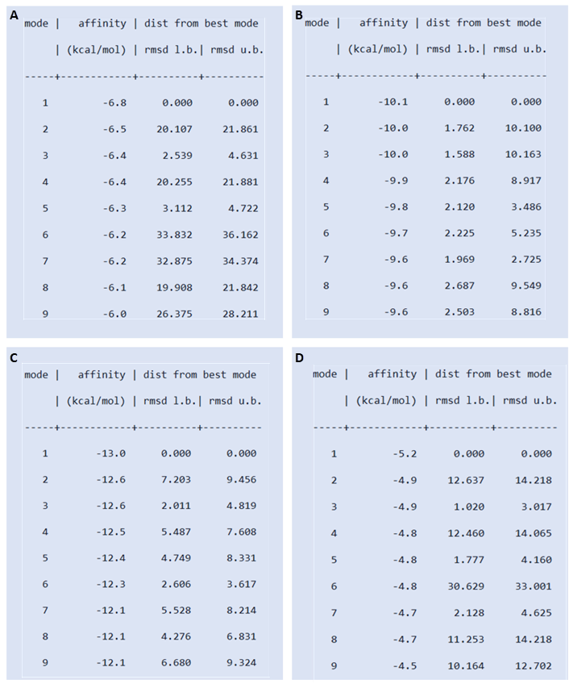

Sup Figure 1. Binding affinities of EFV, LPV, BAY-876 and glucose to SLC2A1.
Binding affinities in kcal/mol of (A) EFV, (B) LPV, (C) BAY-876 and (D) glucose to the SLC2A1 transporter. The mode refers to the formation of drug-transporter complex from the most probable (1) to least probable (9) outcome. The more probable the complex, the lower the energy required to form the complex, shown via the affinity column.

2-DG, 2-deoxyglucose; ARVs, antiretrovirals; BCA, Pierce™ BCA protein assay; Ct, cycle threshold; ECAR, extracellular acidification rate; EFV, efavirenz; FCCP, carbonyl cyanide-4 (trifluoromethoxy) phenylhydrazone; GLUT1, glucose uptake transporter 1; GLUTs, glucose uptake transporters; JATP, rate of ATP production; JATP, glyc glycolytic rate; JATPox, oxidative reaction rate; LCISol, live cell imaging solution; LPS, lipopolysaccharide; LPV, lopinavir; MTT, 3-[4,5-dimethylthiazol-2-yl]-2,5-diphenyltetrazolium bromide; NNRTI, non-nucleoside reverse transcriptase inhibitor; OCR, oxygen consumption rate; PDB, protein data bank; PI, protease inhibitor; Rot/AA, rotenone and Antimycin A; SLC, solute carrier

