Enron and the California energy crisis: the role of networks in enabling organizational corruption

Adam Nix
Stephanie Decker
Carola Wolf

ADAM NIX is a Lecturer in Responsible Business at the University of Birmingham. He holds a PhD in management from Aston Business School, and his thesis focused on the role social relationships have in facilitating corruption as an organizational activity. His research interests also include historical methods, digital history, and practice approaches to management and organizational research.
STEPHANIE DECKER is Professor in Strategy and History at the University of Bristol and visiting Professor of African Business History at the University of Gothenburg, Sweden. Her research focuses on the history of multinationals in West Africa as well as the use of historical methodology and archival research in business and management. She is joint editor-in-chief for Business History and has published her work in journals such as Business History Review, Business History, Human Relations, Enterprise & Society, Journal of Management Studies, and Academy of Management Review.
CAROLA WOLF is a Senior Lecturer in Strategy at the University of Liverpool. Her research applies a sociological perspective on strategy processes and practices, exploring issues of strategic change and the emergence of strategy in different organizational contexts. Additionally, she has an interest in managerial and professional work and career studies. Her work has been published in outlets including the Journal of Management, Journal of Management Studies, and Human Relations.

Abstract
We provide an analytically structured history of Enron’s involvement in the California energy crisis. In doing so, our analysis explores Enron’s emergence as a corrupt organization and its use of an inter-organizational network to manipulate California’s energy supply markets. We use this history to introduce the concept of network-enabled corruption, showing how corruption, even if primarily enacted by a single dominant organization, is often highly dependent on the support of other organizations. Specifically, we show how Enron combined resources from partner firms with their own capabilities, manipulating the energy market and capitalizing on the crisis. From a methodological point of view, our study emphasizes the growing importance of digital sources for historical research, drawing particularly on telephone and email records from the period to develop a rich, fly-on-the-wall understanding of an otherwise hard to observe phenomenon.

Keywords: Organizational corruption; Organizational misconduct; Analytically structured history; Digital sources; Energy supply industry

Introduction
On June 25, 2003, the Federal Energy Regulatory Commission (FERC) revoked Enron’s market-base rate authority – effectively its license to trade wholesale energy – ruling that its Oregon-based West Power division had manipulated neighbouring California’s wholesale electricity markets via various “gaming” practices. As a consequence, they were found to have severely disrupted energy markets through the western states, contributing towards a prolonged shortage of electricity supply that would ultimately become known as the California energy crisis. Five years previously, California had dramatically reconfigured its energy supply industry, splitting up the large monopoly utilities and creating markets for electricity to be traded between various participants. The move was the first of its kind within the US, following widespread liberalization of other regulated industries like natural gas, and the system initially performed well following its inception in 1998. However, by the spring of 2000, supply problems began to appear, leading to sharp rises in the cost of wholesale electricity. These problems would escalate dramatically over the following year, resulting in rolling blackouts across the state, multiple regulatory interventions, and ruinously high energy prices for both the state’s citizens and its utility companies.
While similar practices were found elsewhere, Enron’s manipulation of California’s markets was particularly extreme. Specifically, Enron’s traders used their knowledge of the newly designed markets to artificially increase or decrease wholesale prices in their favor, which often involved submitting false supply and demand information, withholding available electricity, or scheduling energy they did not have. They also made use of flaws in the market’s new computerised scheduling system, for instance, deliberately overloading parts of the grid to receive payments for then relieving it. Additionally, the FERC found that Enron had entered into undisclosed partnerships with numerous market participants, which allowed them to control energy scheduling and physical infrastructure. Not only did these actions exacerbate the state’s high energy prices and supply issues, they directly violated Enron’s market-base rate authority, and also contravened numerous rules set out in the protocols designed to govern the new system. Perhaps most significantly, they led to the criminal guilty pleas of three of West Power’s most senior traders: Timothy Belden, John Forney and Jeffery Richter, who were convicted of intention to commit wire fraud. Belden’s Plea Agreement acknowledged that, “[a]s a result of these false schedules, we were able to manipulate prices in certain markets, arbitrage price differences between the markets, obtain ‘congestion management’ payments in excess of what we would have received with accurate schedules, and receive prices for electricity above price caps . . . ”
Within this paper, we engage with the organizational corruption literature as a specific theoretical basis for better understanding Enron’s practices, and involvement in the California energy crisis. Corruption represents a misuse of one’s position for personal or collective gain, and within a corporate context, such behaviors tend to manifest as illicit transactions (e.g., bribery), agreements (e.g., price fixing), deception (e.g., misleading investors) or manipulative practices (e.g., market abuse). While the underlying social and economic causes of corruption have been extensively theorized, in depth empirical investigations are less common, in part due to the challenges surrounding its observation. Accordingly, we have a fairly good idea about what makes organizations commit corrupt acts (often as a persistent and routine organizational practice), but we know relatively little about how corruption is conceived, managed, and coordinated over time. By extension, the role that outside organizations play is particularly unclear. Clearly, acts like bribery or price fixing involve external parties, but it is also conceivable that other forms of corruption extend beyond single organization context. Given these gaps, and the regular calls for more empirical elaboration of corrupt phenomena, we provide a historical account of Enron’s manipulation that is analytically structured around the elaboration of corruption as an organizational phenomenon.
As a concept, corruption is distinct from criminality or illegality, which are dependent on factors like geographically specific laws, an appetite to prosecute or litigate, and a particular judicial interpretation. Moreover, while corruption often involves the breaking of laws, it can also extend beyond the technically illegal to include wrongful activities that are judged to transgress broader social norms. This is an important historical consideration, with legal proceedings subject to social, financial, and political conditions, as well as the evidence available at the time. Moreover, convictions for occupational crimes are comparatively rare, even when such behaviors were clearly widespread, because they often occupy an ambiguous space between ethically questionable and actively illegal. Nonetheless, it has been widely recognized that Enron’s actions in California deviated from acceptable social norms, both as a matter of ethical standard and as a point of law. Thus, ours is an established case of wrongdoing, which offers an entry point from which to explore how organizational corruption was enacted over time within an organizational division and through its relationship to other market participants.
Our analysis of these activities offers several contributions, the first of which is to add historical insight into Enron’s history. Because Enron is notorious for the extraordinary accountancy scandal that emerged in late 2001, its involvement in the 2000-2001 energy crisis has been somewhat overshadowed. Thus, focus has fallen primarily on its Houston-based executives and the firm’s wider political and cultural significance. For instance, Malcolm Salter shows how its leadership created conditions that embedded self-interested behaviors and compromised the judgments of those faced with ethically uncertain decisions. Similarly, Gavin Benke uses Enron as a lens to explore broader trends of neoliberalism and globalization, underscoring as he does that "[t]wo separate debacles in 2000 and 2001 - the California energy crisis and the revelation of accounting fraud - transformed the company into a symbol for all the ills of the deregulation..."
The history we present also contributes to the literature on organizational corruption, constituting a historically informed theoretical narrative with both historical veracity and conceptual rigor (what Mairi Maclean et al. call “dual integrity”). Empirically, we add insight into the workings of a corrupt organization and how corrupt practices evolve over time, something a historical approach is uniquely placed to provide. In particular, we show the extent to which normalized corruption can be embedded within inter-organizational processes, and the adaptation of these practices in the face of increased public and organizational scrutiny. Conceptually, we develop the particular nature of Enron’s corruption, which, while orchestrated by Enron as the primary actor, nevertheless was facilitated by a network of partner firms around Enron and could not have taken place without the active involvement of these network partners. We label this network-enabled corruption, a type of corruption in which a dominant organization (in this case, Enron) coordinates with a network of partner organizations to achieve illicit ends. This accounts for situations where corruption is primarily organized and enacted by a single organization, but sustained by other organizations who are a removed, but nonetheless vital, component. Inter-organizational corruption in this form is less likely to be seen horizontally among collusive competitors, and, as in our case, can exist within ostensibly legitimate market relations of service provider and client. Similarly, it differs from other notions of networked corruption, which revolve around illicit transactional activities like bribery or rent-seeking, generally between private and public actors. Thus, our narrative presents a materially different way of looking at corruption as an inter-organizational phenomenon.
In addition to its historical and theoretical contributions, this paper also holds methodological novelty. That is, we demonstrate how digital-era primary sources can be used to provide an unprecedented view into the workings of a historically important organization, and how they can elaborate usually hidden or under-represented historical events. For business historians in particular, the growing importance of digital sources is particularly clear, as great swaths of organizational records keeping and communication practice migrated to digital platforms from the mid-90s onwards. Indeed, it is quite conceivable that to fully understand historically important events like the emergence of the dotcom economy or the 2007 final crisis, historians will need to engage with these so called “born-digital” sources.

Organizational Corruption
While corruption often represents an abuse of publicly mandated authority – necessitating the involvement of a legislative or executive office - the concept holds relevance to a broad collection of social contexts. Indeed, the conceptualization of wrongful organizational activities as corrupt, has gained significant prominence, embodying what Blake Ashforth and Vikas Anand refer to as “the illicit use of one’s position of power for perceived personal or collective gain.” Thus, while lawfulness is often an important consideration in cases of corruption, it is not a defining criterion, as is the case with white-collar crime, corporate fraud or other related terms. Instead, corruption focuses on the underlying social phenomena behind such activities, in that they deviate from accepted social norms, involve the misappropriation of entrusted position, and are enacted with a view to some form of undue benefit. Within an organizational context, actors either leverage corruption for the benefit of their organization at the expense of stakeholders, or for themselves at the expense of their organization. We focus on corruption as the former, focusing on wrongdoing that is collectively practiced, and primarily enacted for organizational gain.
Such behaviors have been seen as endemic within the late twentieth century and early millennium, aided by the emergence of increasingly ambiguous (de)regulation and a push for entrepreneurial innovation more generally. However, there is plenty of pervious historical precedence. Within the early energy supply industry itself, the creation (and subsequent collapse) of the industry’s utility holding companies was a significant contributor to the Great Depression, disintegrating the corporate empires of energy tycoons like Samuel Insull. While not themselves illegal, their unregulated expansion became a context for widespread investor speculation, market manipulation and embezzlement. Insull himself famously convinced the criminal courts that, though flawed, his actions were ultimately honest; but others, like Howard Hopson of Associated Gas & Electric Co, were found to have committed numerous offences, including mail fraud, conspiracy, and unlawfully making profits. As Edwin Sutherland’s analysis of Associated Gas & Electric and fourteen other utilities shows, such cases were far from aberrations, with acts of collusion, financial misrepresentation, and misappropriation rife among the industry’s executive elite. Indeed, his work on “white-collar crime” broke new ground, challenging the assumption that pervasive criminality was the preserve of the lower-classes and their circumstances and showing that the well-to-do were more than capable of committing serious crimes, particularly through their organizational position. Though it was subsequently criticized for overfocusing on the offender (over the offence), his work here made forensically clear the prevalence, severity and social cost of wrongdoing within organizational and economic contexts.
While Sutherland’s work centered around relatively senior executives, corruption within organizations often transcends villainized individuals like Hopson, permeating throughout an organization’s structure and hierarchy. John Brook’s analysis of price fixing between General Electric and other post-war heavy electrical equipment manufacturers highlights that, even when wrongdoing is expressly prohibited, it can become a widespread and implicitly accepted practice. Organizational corruption research highlights the importance of organizational characteristics and conditions (e.g., competition, resource scarcity) that coerce or facilitate a decision to act wrongfully. While this is suggestive of a rational calculation of risk and return, such assessments – if consciously made at all – are invariably bounded by the incomplete information available to actors, along with their own cognitive limitations. Nonetheless, where structural conditions present the potential for reward (or forfeiture), they can create a criminogenic environment, which encourages or even compels misconduct. This was seen within the US saving and loans industry, when regulations governing thrift institutions were relaxed, precipitating widespread fraudulent behavior. Similarly, globalization and the neoliberal turn toward deregulation since the 1980s is often lamented for their catalytic effects on levels of corporate illegality and corruption. Here, as with the 1929 Crash, a focus on financial innovation and global competitiveness was seen to blur accepted business norms and heightened expectations for extraordinary performance.
Within organizations, systemic characteristics such as culture, leadership, and incentives can facilitate corruption, encouraging and ultimately embedding it as an acceptable means to goal attainment. The process by which these corrupt behaviors are normalized further shows how the mindful action of a limited few can become increasingly mindless and widespread, as they are incorporated within an organization’s structures and processes. Even in cases where wrongdoers are aware of the transgressive nature of their actions, they often use alternative interpretations to rationalize them, reframing dissonant information in line with a self-deceptive but morally tolerable explanation. Incumbent perpetrators also use rationalizations rhetorically to socialize newcomers into the group’s particularistic worldview. While these theories provide a valuable insight into corruption as an organizational phenomenon, they generally focus on what engenders and maintains a willingness to act corruptly. However, the practice of corruption remains largely hidden behind its clandestine nature, and we still need to empirically elaborate how it is actually incorporated and maintained within discrete organizational and industry contexts.
Furthermore, corruption as an inter-organizational phenomenon remains particularly underexplored. Beyond inherently inter-organizational collusion like price fixing, there is a wealth of evidence showing that criminal and unethical organizational practices often include actors from outside a single organization. For instance, analysis of the US automobile industry shows that manufacturers were complicit in the illegality of their franchise dealers, incentivizing illicit sales practices by exerting superior market power. Similarly, when Wall Street trader Dennis Levine embarked on an episode of sustained insider-trading, it was a carefully maintained network of external co-conspirators that provided the information material to his scheme. While inter-organizational, the level of active collaboration in these cases remains relatively low, with incidents of corruption still occurring largely within discrete organizational settings. However, some industries – particularly those involving network technologies like electricity – necessitate far greater levels of inter-dependence between market participants, which in turn affects how organizations navigate institutional arrangements. Where such settings are conducive to corrupt means, they present a highly relevant context from which to understand structural boundaries of corruption as a collective operational practice. This is the case for Enron, and we discuss the sources from which we reconstruct these activities in the next section.

Digital sources
As highlighted recently by Armando Castro and colleagues, corruption presents a serious methodological challenge to management scholars, as the contexts in which it occurs are invariably clandestine, and thus difficult to directly study. We believe that historical approaches can add significant value as an alternative to the social scientific methods that predominate this area. Indeed, business historians are well-positioned to contribute to wider debates in the study of wrongdoing, as has already been seen in related areas like fraud and white-collar crime. For such phenomena, the selection of a case or contextual setting is invariably in the past and events are often difficult to fully appreciate without sufficient hindsight. Moreover, information released during subsequent judicial proceedings are often valued by those seeking to piece together and illuminate otherwise hidden aspects of organizational events and actions. These traces of the past often take the form of retrospective inquiry reports and judgements, or submitted evidence like company records or social correspondence - materials highly suited to critical source analysis. Despite this, explicitly historical studies on organizational corruption are rare, and we suggest that a more historically cognizant treatment of organizational corruption has scope to add significant empirical and theoretical understanding.
In this regard, more recent historical periods offer particularly rich insight, as digital technologies like personal computers and the internet have changed the nature of those traces left behind. Within this research, we use a uniquely rich collection of digital historical sources to empirically elaborate historical events in ways that would not have been otherwise possible. This is because digital technologies preserve organizational life in ways that analogue equivalents do not. In particular, communication technologies are very good at capturing the ephemera of daily life from varied organizational contexts, rather than correspondence of high-level managers and executives that are more typically well represented in traditional archives. For us, this provided a view that included both junior and senior divisional employees, as well as their day-to-day interactions, many of which were too fleeting to have survived as traditional historical sources. Moreover, such insights are of particular value to understanding wrongful behaviors, which are usually pieced together from trial proceedings, rather than fly-on-the-wall views into its actual enactment. In this sense, our research is illustrative of both the “digital shift” emerging within historical research generally, and the specific affordances such sources offer to researching otherwise hidden organizational phenomena.
The sources we used were mostly accessed via the FERC’s e-library, which provides online access to its public collection of regulatory proceedings and related records. In particular, we made use of telephone transcriptions relating to 380 timestamped trading-floor calls. Obtained from digital audio tapes linked to each of Enron’s trading desks, these capture the traders’ daily interactions with various relevant parties, including colleagues, competitors, customers, and regulatory representatives. The original recordings were created and used internally by Enron, primarily as means of recording oral offer and acceptance, but they were seized under federal subpoena, where upon calls relevant to the case were transcribed and made public by the FERC. As a geographically dispersed and time sensitive task, the trading and scheduling of wholesale energy relied heavily on telephone conversations, even over alternative forms of digital communication like email. As such, these records provided the main insight into how managers at Enron organized corruption, both internally throughout the division and its hierarchy and with its partner organizations. Because only the most relevant tapes for the case were transcribed, the conversations made public are a relatively small sample of those originally obtained. Nonetheless, they give a highly relevant sample of corruption-related interaction, centering around Enron’s manipulation of California energy markets and the key events in the energy crisis.
We complement these sources with other company documents filed during FERC’s investigation, including memos, meeting minutes and other standalone items of correspondence. These were generally digitized reproductions of printed documents that were submitted individually for their specific relevance to a particular legal assertion. We also used legal documents such as expert witness’ testimonies and legal briefs, which provided additional insight into the case. Importantly, these also contextualize the various documents submitted, as they would generally cite and explain those they submitted. Additionally, we draw on a dataset of Enron’s emails, publicly released by the FERC in the fallout from the company’s failure. Unlike the other sources we use, the emails were published as a corpus for public and historical interest, rather individually based on specific legal arguments. As such they represent a large, un-curated dataset (over 500,000 emails from 150 accounts), and we limited our focus to accounts relevant to the Portland trading-office. Together, these company records provided important additional sources of insight, adding details about the case and allowing us to better contextualize the often technical and partial nature of the surviving telephone correspondence.
In addition to the above primary sources, we also make use of summary reports and decisions that together concluded the various legal proceedings into California's energy crisis. While these provide valuable insight, they carry limitations as a source of historical record. For one, legal decisions are relatively atemporal, being structured around specific legal issues and only considering temporality when relevant to the case. This makes past actions and events difficult to understand without reinterpreting and reordering their findings with a view to historical knowledge creation. Additionally, as there were various proceedings relevant to this case, the insight they provide is very dispersed. In this sense, reading a single report – even the FERC’s final report – provides a partial and relatively specific picture of the crisis and the action that contributed towards it. Moreover, these decisions themselves rely heavily on related briefs, exhibits and testimonials, to contextualize the summary discussion. Without synthesizing this body of supporting legal material, a full appreciation of the case would be extremely hard to achieve. Judicial process is also necessarily bound by a duty to determine legally relevant facts and apply the law. These circumstances mean that, while Enron's involvement in California's energy markets has been heavily investigated as a point of legal interest, the historical and conceptual importance of this case remains largely hidden.

Enron and California’s energy supply reforms
The energy company Enron was formed by the merger of Houston Natural Gas and Omaha-based InterNorth in 1985, under the leadership of the former’s CEO, Ken Lay. The new entity constituted a major player within the natural gas industry, controlling the largest system of transmission pipelines in North America. Lay was a vocal advocate of free markets, and this quickly became a core aspect of Enron’s public identity and their justification for liberalization within the energy industry. Thus, when natural gas was deregulated in the late 80s, Enron looked to capitalize, working with then McKinsey consultant, Jeffrey Skilling, to develop a new, commodity-based form of natural gas trading. Pitched as a “gas bank”, Skilling believed gas should be traded through a mediating partner rather than directly between buyer and seller, as was currently the case. Enron would continue to push the envelope of financial innovation, persuading the energy sector to embrace ever greater levels of commoditization and financial service provision.
In 1990, Skilling left McKinsey to head-up Enron’s financial services division. His experience in banking and finance influenced his commoditized vision of income generation, and he soon turned the gas bank into a success, solidifying his position within the firm. Over the next few years, Skilling continued to champion financialization, introducing a variety of energy-related financial services and placing Enron as an interface between buyers and sellers of commoditized energy products. Such activity was a stark contrast to the firm’s historic focus on heavy assets like pipelines and power plants. However, with Skilling’s success, the company increasingly resembled the organizations found on Wall Street rather than the gas company of its past. While the dynamic and innovative face of Enron sought to naturalize extraordinary growth, increasingly deceptive accounting practices, like the hiding of debt in complex subsidiary structures and the forward booking of unrealized profits, were concealing a troubling financial reality.
By 1997, Enron had gone from a significant, if globally obscure natural gas company, to an organizational phenomenon with substantial visibility and political sway. Young, aspirational, and bright graduates wanted to work for the company that promoted the importance of brains above age or experience. Furthermore, its political presence as an advocate of deregulation was substantial, helped in no small way by Lay’s connections to Washington. Despite significant diversification, much of Enron’s focus remained based in the energy sector; it was here that the firm directed its deregulation advocacy, seeing electricity markets as the greatest opportunity for new profit streams. As political appetite increasingly aligned with Enron, government and industry alike looked with ever increasing optimism to the role of competitive markets within electricity supply.
The distribution of electricity supply to consumers (or ratepayers) relies on two key physical components; generation, the ability to produce electricity, and transmission, the capacity to transfer large amounts of it to its point of distribution. As excessive quantities of surplus electricity cannot be stored, it has the potential to overload system infrastructure. Conversely, too little energy will necessitate the limiting of voltage (brownouts) or total absence of supply (blackouts). Thus, a precise balance between generated supply and electricity demand is needed, and achieved through so-called scheduling: the advance planning of a base-level of generation, anticipating availability and demand at a given point in time (twenty-four hours ahead). If necessary, schedules are adjusted closer to the time of transmission (day-of or hour-ahead) and in some cases reserves might be called on to negate any unexpected shortfall. Care must also be taken not to congest transmission lines by scheduling too much energy through particular paths. Using this combination of planning and redundancy, electricity can be reliably delivered to ratepayers, while avoiding the risks of over-generating.
[Insert Figure 1 here]
Energy supply, like other core public service industries, has long been at the heart of contestation about government’s role in the intervention and regulation of business. California’s pre-1998 grid (as with other US states) was made up of vertically integrated utility companies who supplied captive consumers in a geographic area, predominantly using their own generation and transmission infrastructure (see Figure 1). This arrangement – established in New Deal movements towards institutional economic policy – encouraged the naturally monopolistic tendencies of networked technologies, leaving utilities to internally coordinate the inter-dependent functions required for a reliable and safe electricity service. Nonetheless, no one utility exists in isolation. Rather they are connected directly to others as a regional system (or interconnection), which is itself then connected to other interconnections. Thus, California is a single, if substantial, area within the Western Interconnection, which is itself part of the North American grid. From their position within this macrogrid, California’s utilities could undertake limited import and export arrangements and mitigate potential reliability issues (see Figure 2).
[Insert Figure 2 here]
Though the integrated utility structure had endured, global events and the economic realities of capital-intensive infrastructure projects had blurred this framework over time. Specifically, legislation in the late seventies encouraged independent, private generation, which was then sold to utilities through generous long-term contracts. By the late 1980s, the cost of maintaining both these contracts and their own generation infrastructure was contributing to higher operating costs for utilities and Californians were paying more for their electricity than any other state. Moreover, as independent (non-integrated) generation was prevalent within the grid, many questioned whether vertical integration was still required. This added weight to the arguments of those who believed government’s presence in industries like energy was stifling innovation and impeding competitiveness. In line with broader political trends of the time (and encouragement by companies like Enron), regulators widely agreed that integrating competition would address many of their issues. Such initiatives had already been initiated elsewhere, for instance in the UK, where a mandatory wholesale “pool” market had been implemented in the early 1990s. Thus, on September 23rd, 1996, the state agreed to restructure its electricity system, setting in motion a radical departure from the predominating vertically integrated supply model.
[Insert Figure 3 here]
Though widely referred to as deregulation, this process did not represent the wholesale adoption of market forces. Instead, the regulatory framework governing energy was substantively reconfigured, introducing competitive elements to an otherwise regulated system. Specifically, the bill required utilities to sell and purchase power on a newly created spot market, the Power Exchange (PX), rather than generating for their own demand. Moreover, it curtailed their ability to enter bilateral contracts with independent generators, making the PX the main mechanism of domestic and inter-state market exchange. To manage the physical delivery of electricity, the California Independent Systems Operator (ISO) was created to manage state-wide transmission and held responsibility for contingency and adjustment administration. As such, the ISO would receive the PX’s market information, ensuring enough power was available. If transmission lines were congested, their automated computer system would set artificial price adjustments to incentivize the required change in scheduled flow. Finally, caps were introduced to reduce consumer rates by 10%, freezing them for a four-year transition period and ensuring the public saw an immediate positive outcome from the reforms.

An illicit path to profit
Throughout the ‘90s Enron had increasingly developed an aggressive performance focus and, with profits from natural gas waning, the firm looked to electricity to sustain its profitability. To this end, Enron acquired Portland General Electric (PGE) in July 1997, providing a route into the Western Interconnection and California’s new markets. The state’s reforms were the culmination of a sustained public relations campaign by Enron, and its executives were naturally eager to capitalize on these efforts, seeing an opportunity to leverage Enron’s knowledge of financial markets and trading in an untapped market. To this end, the goals for the acquisition were closely tied to their interest in energy deregulation and an ethical climate that valued profit maximization in an increasingly competitive business environment. This entry point would encourage the initial interrogation of California’s new regulations for weakness and provide the initial grounding for gaming as an acceptable trading practice.
Following the acquisition, Enron created the West Power division, locating it in the same building as PGE in Portland. This new division’s role was to buy and sell wholesale electricity and manage trading activities for other parties. As its senior traders worked to understand the complex new systems, it became clear that the rules and protocols California had devised contained flaws, offering potentially profitable opportunities to anyone with the knowledge and inclination to use them. While Enron was by no means the only company interested in leveraging the new regulations, its distinctive presence as a financial entity and an unambiguous prioritization of profit, encouraged a particularly unsympathetic pursuit of their variabilities. To this end, the division’s leaders would begin to analyze the rules, and by late 1997, start actively exploring the market’s exploitable weaknesses with a view to generating operational income in the process.
At this time, Enron was approached by others keen to exploit such “loop-holes.” Among them was George Backus, a consultant associated with Perot Systems, the information technology provider that had designed California’s new automated market protocols. In designing these protocols for both the ISO and PX computer systems, Perot Systems had amassed a substantial working knowledge of the new markets’ features, limitations and flaws. Using this knowledge, Backus promoted his consultancy services, offering market participants a privileged view into the new regulatory landscape within which they would operate. A fax sent by Backus to utility companies highlights the extent to which these opportunities for profit were morally uncomplicated, noting “[t]here may be ethical issues related to ‘the end justifying the means’ but there is a large region of opportunities between what is ethically viable (profitable) and ethically dangerous (illegal).” Though he also suggested they “destroy [the fax] or black out selected sections after you have read it,” his endeavors did not go unnoticed for long. In October, the head of the ISO chastised Perot Systems not only for its “violations of basic norms of business ethics” and “bad faith dealing,” but also risking “seriously eroding the integrity of the California market system.”
Despite this, Backus and his team continued to offer services based on this information to various market participants, including Enron’s West Power traders. A presentation, entitled “Profit Maximization Under UK and US Deregulation,” contained a section on “using California PX/ISO and FERC rules in the best advantage.” Here, the presenters were quick to naturalize such activity, arguing “market distortions are inevitable” and “distortions ‘force’ gaming to ‘clear’ the market.” In contradiction, however, “gaming” (i.e., taking unfair advantage of the rules and procedures) was explicitly prohibited by the new markets’ rules. Nonetheless, the presentation went on to identify how various automated protocols would behave in different market conditions and the best tactics for capitalizing on them. Among those in attendance was the then director of Enron’s California trading desk, Tim Belden. His handwritten notes on subsequent tutorial handouts allude to his particular interest in these vulnerabilities.
In the months that followed, the division’s senior traders remained in contact with the consultants, clarifying details and further developing their understanding of market vulnerabilities. Belden remained convinced of their value, and in a personal review email to his superior, he was explicit in seeing gaming as a core aspect of Enron’s trading strategy: “California gaming - we always say that we need to increase this activity but we never do. Need to work more closely with cash, scheduling, and real time [desks] to maximize opportunities.”
At this time, such activity was still largely exploratory, with occasional internal trading notes highlighting trades as “PHONY,” with the cited goal to “see if we could and take advantage of buying power at the Ex-Post price.” Additionally, they alluded to the involvement of its clients, with traders seeking case-by-case partnerships to trial particular games. Thus, Enron had entered a period of incremental testing, probing the regulations to find those practices its traders might successfully implement on a larger scale. In addition to providing technical insight, these efforts provided an initial precedence for the integration of gaming practices within the division’s operational processes, going as far as to formally document them for review by Enron superiors.
The most notable example of testing occurred in May 1999, when Belden conducted what he would later characterize as a market “experiment.” On the morning of May 24, Belden bid to supply 2,900 MWs of power for the next day to the California PX from a Nevada-based generation source. In order to provide this, he scheduled transmission through a small path called Silver Peak. Although theoretically within the ISO’s transmission network, Silver Peak was a small capacity line installed solely for the transfer of power from a generator in Nevada through to California. In what one expert witness called a “proof of concept scheme,” Belden had orchestrated a situation whereby only 15MWs of the 2,900MWs of power the ISO thought it was getting could actually be delivered. In effect, he had purposefully congested a path, allowing him to observe what happened when the ISO’s system intervened to decongest it.
Once submitted to the ISO, Belden’s schedule triggered operational procedures that Perot Systems had helped create, and the system automatically set about rebalancing the congested path. The schedule had also created significant variance between anticipated and actual supply, and this was remedied by increasing out-of-state imports, using reserve power, and reducing demand in the day-ahead market through increased prices. Importantly, Belden’s experiment demonstrated that it was possible to influence prices using California’s congestion protocols and to receive payments for relieving purposefully created congestion, in this case, costing Californian ratepayers an estimated $4.6M to $7.0M in the process. However, the episode did not go unnoticed and, following a lengthy investigation, the PX concluded Belden’s actions violated its scheduling and control protocols, and showed “disregard for [its] primary goal of maintaining efficient and fair markets.” Enron also conducted their own internal investigation, sending the Director of Regulatory Affairs to interview Belden. In addition to advocating his case, she encouraged him not to report a similar trade he made in January, lest the PX realize Silver Peak was not an isolated incident. Enron ultimately settled with the PX for a modest $25,000, which reflected the firm’s cooperative attitude during the investigation and the PX’s limited regulatory jurisdiction to apply further penalty.
Enron also agreed that such conduct would not be substantially repeated, however, its traders now had much of the information they needed and were already looking to operationalize it through more sustainable means. Belden had not actually tried to hide his actions. Moreover, he did not intend to repeat them, at least, not in their current form. Instead, Silver Peak constituted an isolated act, albeit one that would precipitate future normalization of related practices. As such, it was indicative of the relatively isolated, emergent nature of gaming activity within the division at that time. Enron’s defense of Belden during Silver Peak had also positively sanctioned such activity, presenting gaming as concordant with the company’s wider culture and ethical position. Even if the operational particularities of manipulative energy trading were largely bound within the division, Enron’s executives saw the leveraging of California’s new system as vital to the company’s financial prosperity.

Normalizing corruption
By late 1999, Belden was running the whole West Power division. Additionally, a trader responsible for a small-scale gaming scheme in Canada, John Lavorato, was now Belden’s superior. In Lavorato, Belden had a boss who understood the potential gaming offered and shared similar ethical views on its use. While experiments like Silver Peak had provided valuable insight, they were unsubtle, so traders began incorporating this knowledge into more covert “trading strategies” (see Table 1). These were pre-defined formulas that exploited vulnerabilities in California’s systems while disguising the traders’ true intent. Moreover, they could be used many times, allowing senior traders to embed and routinize gaming as a widespread, consistent practice within the division. In this way, the end of 1999 saw reports of preliminary success in exploiting the ISO’s flawed system. One of the division’s traders, even cited “gaming California’s congestion management system” among his accomplishments, “capturing significant value in the process.” During this time such gaming activities were, therefore, increasingly normalized, moving beyond the instigating actors and into the everyday activities of the wider division.
[Insert Table 1 here]
As part of this escalation, traders also began to further embed these manipulative routines into Enron’s external service relationships, providing the control of generation and transmission scheduling needed to actually execute their strategies. For instance, to utilize one particularly effective strategy (see Table 1, Fat Boy), traders used the control of partners’ generation output and scheduling to misrepresent demand for electricity in the day-ahead market, on the basis this would give them excess generation to sell in the higher real-time markets. As such, traders would make regular calls to partners, instructing them to turn units on or off, and on occasion, partners would even contact traders to let them know when they were in a good position to use the strategy. Thus, cooperative arrangements between Enron and other parties allowed the illusion of normal trading activity, when in reality it was implemented for ulterior reasons. Thus, by increasing the division’s integration into its partners’ operational activities and decision making, Enron’s existing business model provided traders with the means to enact their gaming strategies. Ultimately, these “consulting arrangements” allowed traders to convert their knowledge of the market’s flaws into something they could implement in a discrete and repeatable manner. In return, the partner firms generally received a pre-defined percentage share of the traders’ returns, benefiting from Enron’s superior trading expertise that they themselves lacked.
Despite the openness and regularity with which Enron pursued these relationships, the undisclosed nature of these collaborations breached market rules designed to limit the very market power that they were now providing Enron’s traders. One of the earliest and most prominent of these partnerships was Enron’s relationship with Texas-based utility, El Paso Electric. Enron had maintained a close relationship with El Paso for several years and, when the opportunity to profit from California materialized, the utility signed on to the traders’ plans. An example of the sort of arrangement agreed between the two firms can be seen in an email sent by the head of real-time trading, John Forney, to staff in early April, when he reports a new arrangement for the “Wheel Out” strategy:

We have struck a deal with El Paso where we buy from them PV [Palo Verde] and sell to them 4C [Four Corners] for a $10 spread. They don’t flow any power because they have the rights at both points, and they collect a check – no risk to them. […] Today, we have been paid in the mid-forties to relieve congestion. With approx. $4 of expenses, we make $31 no risk margin. […]

Accordingly, by working with companies like El Paso, traders could create an apparently legitimate schedule, the sole purpose of which was to trigger congestion relief payments. Enron also ran a large proportion of El Paso’s scheduling activity, providing control of generation and privileged information, which they used to affect levels of energy available to the Californian markets. It was the success of this early relationship with El Paso that would ultimately inform the development of a wider network of partners, serving “as a model for many of Enron’s other relationships.” Traders also leveraged Enron’s ownership of PGE, contravening the requirement to remain operationally distinct from the acquired utility, controlling large portions of its operations instead. Through these means, a network of facilitative organizations began to emerge, with each affiliated firm embedded in the actions of Enron as a dominant corrupt organization. Thus, as illustrated in Figure 4, by leveraging partners’ physical assets, information and assistance, West Power traders were able to pursue profit for Enron and its partners, via collectively enabled market manipulation.

[Insert Figure 4]

As traders developed more strategies, they created codenames to distinguish them, further embedding their usage in the collective memory and language of the division and its network of partners. While many of the names appear to stem from internal actors (some even naming them eponymously), it is clear external actors also used and understood them, even participating in their development. For instance, in April 2000, Forney was in the initial stages of coordinating a new congestion strategy with Californian utility, City of Redding, when he includes his counterpart in the naming of their new game, suggesting the now notorious, “Death Star”.
John: OK what do you want to call this project - we have to have a catchy name for that?
Trader: Project - ah - I was going to say project loop - but I don’t want that to go out in the world.
John: How about you know something friendly like Death Star?
Trader: (Laughter) How about reduce the debt - debt star- because we are trying to reduce our debt here. Whenever we make money it reduces our debt.
Consistent with other accounts of collective wrongdoing, such interactions also allude to the excitement that surrounded the new strategies, with codenames compounding their novelty. Others were simply illustrative of their process. In this way, a “Ricochet” involved the rebounding of a scheduled out-of-state energy back into California, simultaneously reducing apparent supply and avoiding the state’s price caps. Thus, codenames made complicated gaming processes easily identifiable and engaging, helping to embed them into accepted trading activity.
Once arrangements were established for a particular strategy, senior traders used the formal structures to disseminate instructions to traders within the division, who were responsible for much of the day-to-day implementation and coordination with partners. Indeed, trial evidence suggests at least 72 of the division’s 100 employees were involved in these strategies, along with as many as thirty generators, who supported Enron and shared in their profits. Expectations were openly communicated in meetings and reference materials, with the Real-Time division’s service handbook providing detailed instructions for market manipulation, specifying the generation units, transmission paths and participants to use in the process. Here, the level to which manipulation had become a routine part of trading is highlighted in the FERC’s comments on the use of such handbooks:

[I]f prices in the California market are high, the Enron employee would refer to the handbook section entitled “Who do you call and what action to take?” The Enron employee first decides if the price is high enough to be profitable to the “customer.” If it is profitable, the Enron employee would: “generate or import and fake, or increase, load.” In this situation, the Enron employee could call, for example, Glendale or Valley Electric and instruct them to increase imports into the California ISO control area; the Handbook lists the transmission paths to be used.
Furthermore, the ability to use trading strategies appropriately became an explicitly articulated performance criterion, with an agenda from a staff meeting even referencing formally monitored proficiency tests. The agenda goes on to update the group on current strategy options and even introduces three new employees (referred to as “players”), illustrating the overt nature of managerial expectation, and the speed at which new traders were socialized into the use of corrupt practices.
Once normalized, market manipulation was neither spontaneous nor occasional. A network of actors from multiple organizations had formed around Enron, with the collective aim of exploiting California’s regulations. While Enron was the linchpin, its traders’ corruption had clearly moved beyond this single organization, evolving to include a network of corruption enabling partner organizations.

Rationalizing in response to crisis
By spring 2000, senior traders had normalized corruption in the form of gaming throughout the division and its network of partner organizations; however, this normalization was still susceptible to disruption. Before the crisis, traders had deployed their strategies within a relatively uneventful market environment, where minimal price volatility and supply issues had kept electricity in the back of public consciousness. However, from May, the price utilities paid for electricity started to rise significantly, consistently reaching the ISO’s wholesale cap of 750$/MWh during that month and beyond, into the summer. While the causes were unclear, new regulations, unseasonable weather conditions, and suspicions of opportunistic behavior by companies such as Enron were variously singled out for blame. At this point, Enron’s traders and their network of partners increasingly used rationalizing techniques to account for the unfolding crisis, attempting to portray their acts as acceptable, based on certain ideological positions. For instance, when discussing the situation in California with Belden, his superior notes:

“[I]t’s just [expletive] unfortunate – we’re going to have repercussions of all this stuff, and not necessarily ‘cause we do anything wrong…” […] “You take this much money out of a market, I think that there’s um, you know, they just [expletive] like try to find somethin’[…]”

Such views followed the pre-crisis logic underpinning its initial exploration of vulnerabilities; that is, a belief that its actions were a legitimate part of participation within a flawed market. Accordingly, in the same way George Backus had argued that gaming was a natural stage in the process of deregulation, trading strategies were an uncomplicated route to profit maximization. Thus, the view prevailed that “if they’re going to put in place such a stupid system, it makes sense to try to game it.” Accordingly, when the system started to fail, this too was added to their interpretation of acceptability.
Arguably, the crisis was something of a perfect storm, with multiple factors together creating an exceptional situation. Firstly, there were several supply and demand issues. Low rainfall contributed to drought conditions in the Northwest, which limited the hydroelectric generation California could import. Coupled with the state’s low domestic output, this meant that available generation was lower than previous years. On the demand side, hot weather increased air-conditioning and refrigeration-based consumption, adding to demand. This compounded an existing trend of demand increase, caused by the state’s economic development (particularly Silicon Valley) and greater domestic consumption. These factors significantly contributed to the shortage and thus the price increases. The new regulations did not help this situation. The cap on consumer rates had essentially decoupled demand from the cost of supply, and with this, the economic situation became problematic for utilities. Forced to pay a heightened price for wholesale energy, they were unable to pass any of this increase on to ratepayers. In turn, the ratepayer had no financial incentive to use less energy. Thus, there was minimal opportunity to reduce the price through economically incentivized demand reductions.
As summer progressed, the economic and infrastructural situation in California deteriorated further. Supply shortages resulted in the first set of rolling blackouts on June 14, representing a significant escalation of the problem for California’s citizens. Although ratepayers had been largely protected by the consumer price caps, negotiating intersections without traffic lights, elevator trappings and forced industry downtime, brought the public dependence on reliable power into sharp focus. Additionally, San Diego had left the consumer-rate-cap arrangement early and, with utilities passing high energy prices on to ratepayers, public anger was swelling. Energy companies were increasingly being suspected of foul play by citizens and politicians alike. Moreover, Enron was singled out, partly for the company’s vocal advocacy for the reforms, but also because it was increasingly seen by many as a self-interested, out-of-state opportunist.
By late summer, the situation in California had deteriorated further, and with ever-increasing wholesale prices and suspicions of foul play, utilities pressed the FERC to investigate whether manipulation had occurred within the new market. Until now, Enron had been happy to support the West Power traders, content that their endeavors were bringing in record earnings. However, the FERC enquiry prompted Enron’s risk management team to launch their own investigation into the division’s practices, the details of which Houston was largely still unaware. Though their investigation revealed the trader’s strategies, codenames and all, Enron’s lawyers ultimately permitted its traders to continue, albeit with notice that their strategies remained a concern. In November, the FERC also reported back on their investigation, finding that a combination of supply and demand imbalance and flawed market design had caused the “unjust and unreasonable rates for short-term energy”. Claiming insufficient time and a lack of data, the report failed to substantiate any specific incidents of manipulation, but they acknowledged the opportunity was there and that market data suggested such abuses may have already occurred. Within California, the FERC’s decision was seen by many as a failure to act on blatant exploitation, and widely criticized.
Despite the report’s findings, the crisis continued to create complications for Enron’s traders, with some partners becoming increasingly reluctant to engage in the inflammatory gaming activities. This, in turn, frustrated their ability to maximize opportunities effectively, as the use of alliances was key to their trading strategies. As the political risk increased, some could not reconcile the risk of being found complicit in the worsening problems. Such reluctance was particularly strong among Enron’s public partners who, irrespective of their own views, feared others might see their actions as unacceptable. In one case, a partner explains the “nasty political situation” that would result for a public agency being found to have exported energy out of California, exacerbating the problem while others were trying to solve it. Thus, rather than failing to rationalize their actions, for some, the crisis appeared to tip the balance of political risk and financial reward, making participation more of a liability than an opportunity.
Despite traders’ efforts to encourage continued involvement, the reluctance by some to continue was clearly a frustration as, throughout Enron’s network, partners were split on whether to continue. From an internal perspective, the risks surrounding California came to a head on December 12, when Enron’s legal team returned to Portland, where ultimately, they instructed the cessation of the traders’ strategies. At least a partial suspension was subsequently apparent from communications, with some traders seeing the move as a prudent one and others eager for a resumption. However, this state of inactivity did not last long, and it is clear that manipulation activity resumed just a few weeks later. Indeed, the increased political and legal scrutiny had encouraged Enron’s traders and their network of partners to incorporate new, clandestine behaviors into their normalized practice. Again, Enron’s traders led the way, encouraging the use of cell phones and chat rooms to avoid monitored official telephone and email channels.
In January 2001, Forney moved to Houston, and his colleague Bill Williams was promoted as his successor. At this time, some of the original trading strategies remained suspended, with political risk and market illiquidity issues continuing to limit traders’ use of them. Despite the risks, Williams was keen to continue the work his predecessor had instigated, noting his desire to “take the shackles off and get after it again”. However, Forney cautioned Williams that they needed to limit their activity until the crisis had settled, also warning him that personal liability was an increasing issue for them. Accordingly, Enron’s focus on actual trading strategies such as the Death Star reduced somewhat, with them instead working with partners to physically withhold energy from California, increasing prices throughout the western markets in the process.
In California, the financial implications of the crisis were reaching a critical point. The creditworthiness of indebted utilities meant generators were unwilling to sell power to their de facto creditors, the PX and ISO. While such credit issues were a genuine liability for anyone selling into California, this was not the only reason why the state was struggling to acquire energy. By physically withholding energy, market participants were able to maintain high prices within the Western Interconnection, offering continued profit for companies like Enron. Indeed, such withholding was actively pursued within Enron West Power, with the FERC finding it “used its ability to control and withhold large amounts of generation to manipulate the market.” To do this, they also needed to mitigate the ISO’s new federal powers, which allowed them to compel generators to supply them during shortages. In this way, Enron’s traders encouraged its partners to find increasingly elaborate ways to avoid selling to California.
Such activity was illustrated most prominently when Williams asked a generator, Las Vegas Cogeneration, to “get a little creative [...] and come up with a reason to go down.” Here, his contact agreed to stop generation for maintenance, meaning a plausible excuse accompanied their withholding of electricity. This allowed them to avoid a schedule they had already committed to California, while the state again was forced to implement emergency procedures. Similarly, on January 19, the ISO used new powers to order Enron to notify them of all their available generation in the whole Western Interconnection. On receiving the order, the trader on duty immediately called numerous colleagues and between them constructed a way to minimize the amount of energy they would have to declare. In this way, market manipulation had escalated from trading strategies that unfairly exploited the rules, to actions that actively contravened the federal orders implemented to mitigate the crisis.
It was not until June that a fall in prices gave the first suggestion the crisis was abating, by which time it had already brought about the bankruptcy of both the PX and major Californian utility, Pacific Gas and Electric. The FERC had extended emergency regulation, requiring all generators in the Western Interconnection to bid available power into California, whether on or off-peak. This closed many of the remaining opportunities for inter-state manipulation and by the end of summer the prices had returned to pre-crisis levels. For Enron’s traders, the significance of the energy crisis was dramatically eclipsed by the bankruptcy and fraud scandal of the company just months later. As the various companies within its network entered a period of lean post-crisis market conditions, Enron was making ever more dramatic headlines. The impact this had on the Portland-based traders was naturally significant, and, after months of forced inactivity due to its poor credit rating, the group was largely disbanded before being sold off in the fallout from Enron’s bankruptcy.

Conclusion
When California deregulated its energy industry, it materially changed the environment of electricity generation and supply throughout the western states. Not only did it separate the previously integrated processes of generation, transmission and distribution, but the experimental market structure encouraged the entry of new market participants, who offered their financial expertise to incumbents unused to operating within competitive markets. Among these, Enron’s West Power division was found by the FERC to have conceived and exploited various illicit strategies, manipulating the new markets, and contributing to the ensuing crisis. This article develops an analytically structured history and argues that Enron normalized corruption in the form of market manipulation, developing and maintaining a facilitative network of complicit organizations that enabled their illicit strategies. Enron’s manipulation of the California energy markets thus highlights that some cases of corruption are difficult to understand without considering routine inter-organizational involvement as a fundamental component, even when ostensibly concentrated around a single corrupt organization.
While it has been assumed that corrupt organizations often require a level of external involvement to enable corrupt behavior, the dynamics of such arrangements have largely been omitted in favor of organization-level analysis. Our analysis shows how the strategies employed by Enron would not have been feasible without its network of partners, who held structurally different positions from Enron and controlled the generation assets traders needed to execute their strategies. In this way, Enron’s use of network-enabled corruption was embedded within the division’s core business model, providing financial services to market participants, evolving partnerships over time to increase control of resources beyond the scope of their legitimate market relationship. Far from discrete and unambiguous rule breaking, this alternative conceptualization of inter-organizational corruption shows how such abuses often mutate from the normal pursuit of competitiveness and profitability, and as our analysis shows, this can extend to include an organization’s network of ostensibly legitimate market relations.
While illicit cartels represent an alternative form of inter-organizational corruption, these are notably different to the concept we introduce here. Within such networks, scope for collaboration is narrowly focused (on price fixing) and generally disconnected from legitimate market structures. As such, price fixing is generally intermittent and covert practice - Brooks talks of G.E. managers periodically going to surreptitious lunches and holding euphemistic discussions with colleagues – which, even when widely practiced and accepted, are generally forbidden officially by the organization(s) involved. Bribery or rent-seeking relations are similarly unambiguous in their wrongfulness, and also like cartels, involve corruption committed across a network, rather than through one dominant organization. In contrast, our case elaborates a form of corruption that closely aligned with normal operational activities, representing illicit means by which multiple organizational commercial interests were directly or indirectly realized. Thus, traders communicated their practices in an uncomplicated and explicit way, even highlighting their gaming achievements and discussing their strategies and partnerships openly. It was only with the worsening energy crisis and the FERC’s investigation, that their corruption took on a more clandestine form.
In this regard, our analysis of Enron also shows the normalization of corrupt “gaming,”, whereby market manipulation became a core component of day-to-day operations and the deliberate pursuit of organizational profit. While the process of normalization has been described empirically – most notably in Diane Vaughan’s ethnographic history of deviance within NASA – detailed analysis concerning corruption remains largely theoretical. Normalization within Enron and its network emerged from intricate patterns of network interactions that, while not necessarily of individual significance, collectively showed the embedding and routinization of deviant behaviors over time. Sustained enquiry into the psychology of wrongdoing also shows that actors often frame their decisions around self-deceptive rationalizations, which can themselves contribute to the process of normalization. While this is primarily seen as a cognitive process, the everyday organization of corruption shows how these rationalizations are also developed through the interactions and collectively constructed beliefs and responses of participating individuals. In this way, the collective interpretation of, and response to, the crisis was mediated through regular informal interaction, and the clandestine norms later instigated by Enron traders provides a key example of the socially organized responses to changing market and regulatory circumstances.
California’s reforms clearly provided a facilitative context for corruption, constituting a form of criminogenic environment. Within Enron, exploitable loopholes directly influenced the strategic direction of the division, with traders working to expose and operationalize these lucrative flaws. For its partners, the reforms markedly changed the nature of energy supply, adding new risks, opportunities, and uncertainty that they addressed through their relationships with Enron. These responses were bound within a fledgling commercial landscape, where ambiguity and emergent norms further compromised ethical decision making. Though the regulations were breaking new ground within the energy industry, they were also symptomatic of wider trends of the period, and Enron’s network of partners illustrates how some chose to navigate these conditions within this particular industry context. Here, understanding the manipulation of California’s energy markets, requires an appreciation of the integrated nature of both physical and market-based elements of the energy supply industry. Indeed, the network characteristics of energy supply highlights that, while individual organizations are often singled out as culprits, the complexity and inter-connectedness of some industries can precipitate more cooperative, market-based responses to criminogenic conditions.
Within this paper, we combine a conceptual elaboration of organizational corruption with a rich empirical account of what is usually a hidden and difficult to observe setting. This historically situated view extends our temporal appreciation of corruption beyond existing theorizing and elaborates how it actually occurs as an organizational and market phenomenon over time. This is significant as corruption is often highly complex in nature, blurring legitimate business practices with abuses of authority and the privileges conferred through participation within a given commercial context. This makes it an important area for business historians to explore further, and extensions such as network-enabled corruption highlight the affordances historical approaches present to understanding how organizational actors actually go about exploiting such behaviors over time. In providing our history of Enron and California energy crisis, we elaborate the day-to-day practices and networks of relationships that enabled a corrupt organization to function and in doing so, demonstrate how corruption became a normalized and highly integrated part of organizational life.

Figure 1 Representation of pre-reform energy supply
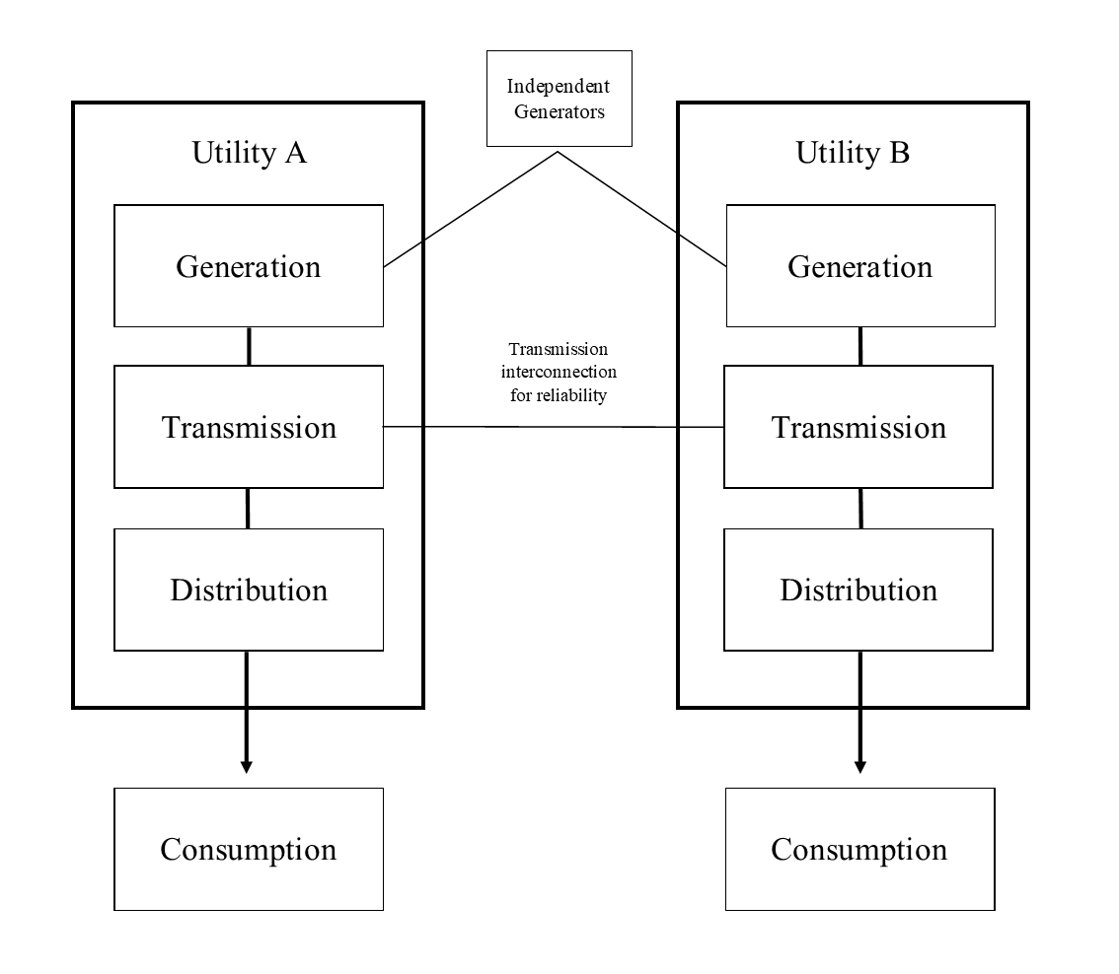

Figure 2 Map of North American Energy Interconnections
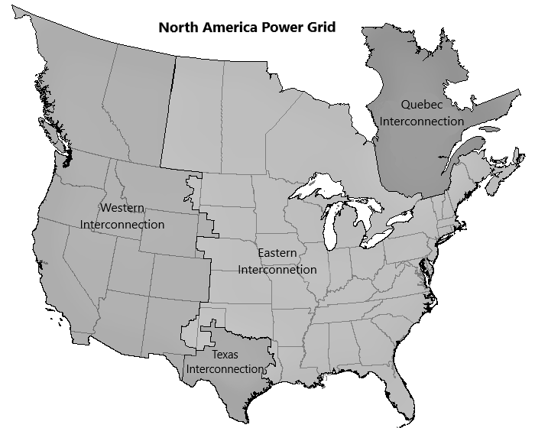

Figure 3 Representation of post-reform energy supply
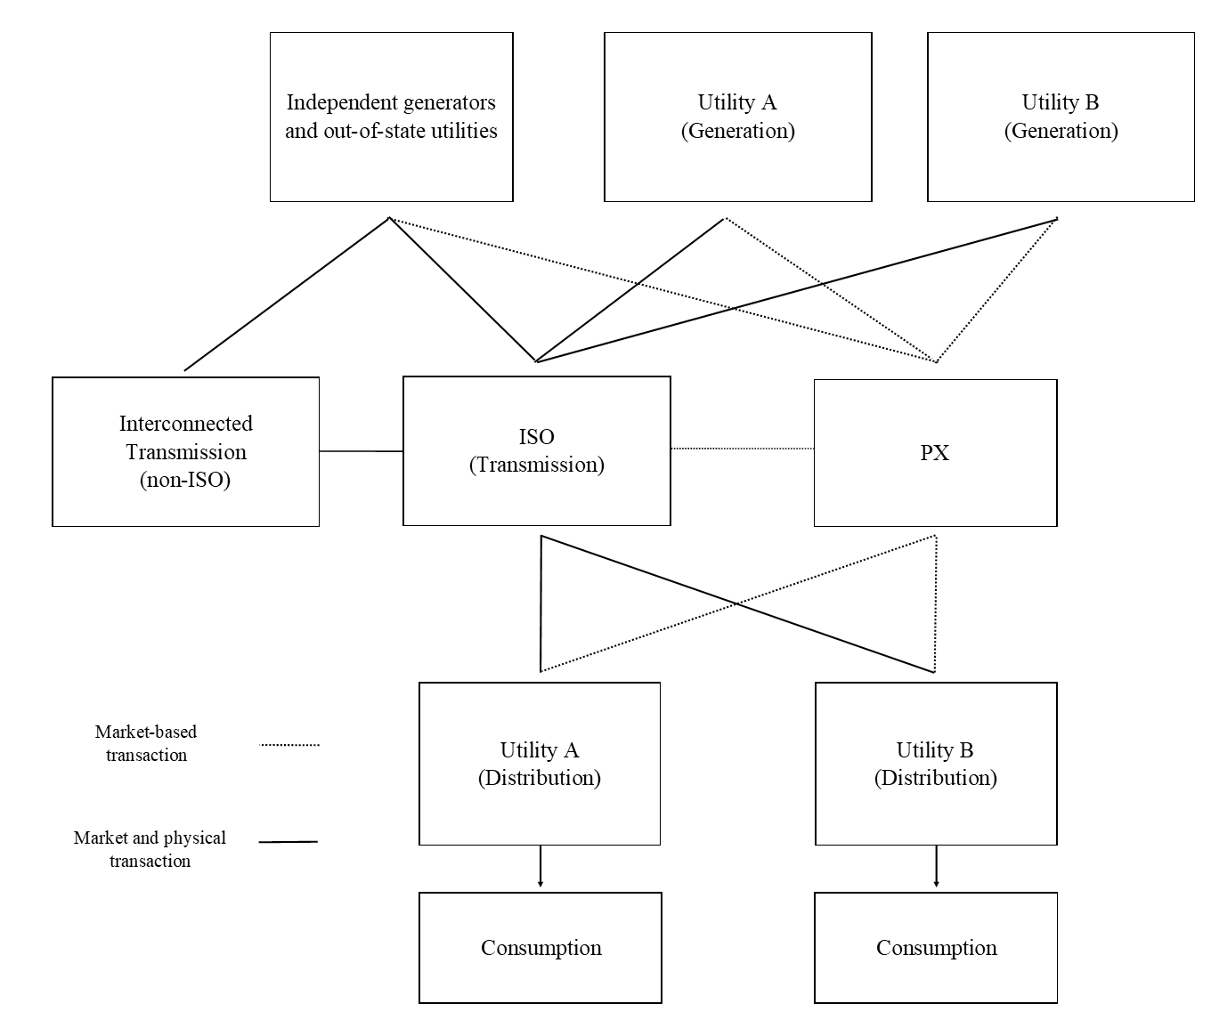

Table 1 Summary of key trading strategies
Codename | Description | Result
Ricochet | Exporting energy out of California’s ISO’s system, thus simultaneously avoiding price caps, and decreasing supply, then re-imported it, selling it in the next day’s (uncapped) real-time markets. | Artificially increased prices
Fat Boy | Deliberately overscheduling demand in the hour or day-ahead markets, generating a surplus which could then be sold in the uncapped real-time markets. | Artificially increased prices
Death Star | Scheduling a fictitious energy transmission in a loop that flows in the opposite direction to a congested transmission path. This entitled them to collect congestion relief revenues. Known variants on this strategy included Forney’s Perpetual Loop and Driscoll’s Death Star | Activated congestion relief payments
Load Shift | Created phantom demand for energy in order to change market price and then buy or sell in that market at an advantageous rate. | Activated congestion relief payment, and artificially increased prices
Wheel-Out | Purposefully scheduling transmission on a path that was out of service, thus entitling them to congestion revenues. | Activated congestion relief payments
Get Shorty | Selling reserves in the day-ahead markets and then buying them in the cheaper real-time market. | Provided a (prohibited) arbitrage opportunity between markets.

Figure 4 Structure of Enron’s network of market participants
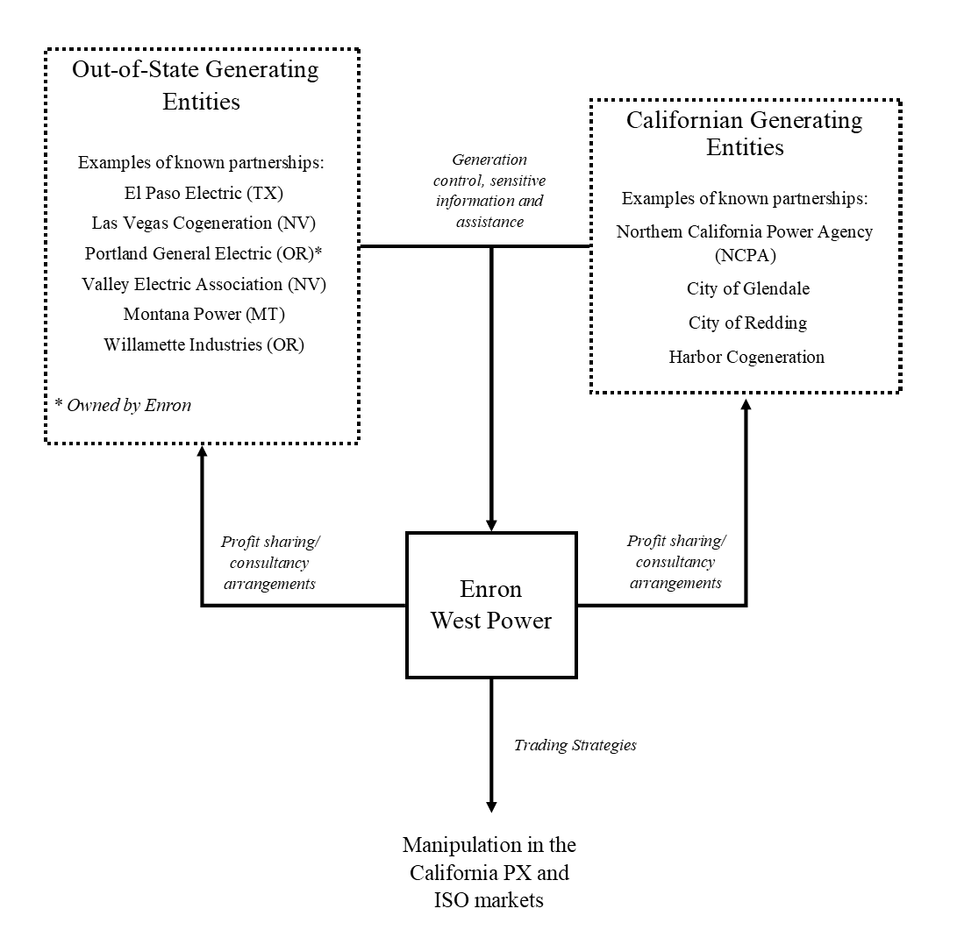

FERC, Commission revokes Enron's market-based rate authority, blanket gas certificates terminated, 2003. FERC, “Order revoking market-based rate authorities and terminating blanket marketing certificates” 103 FERC ¶ 61,343, 2003. Gaming here represents the taking of an unfair advantage from market rules and procedures, or any market conditions that could affect the availability of transmission and generation capacity or behavior of other market participants, to the detriment of efficiency and consumers. See CAISO, “ISO Market Monitoring and Information Protocol,” 2000, EL03-180, SNO-127, FERC.
Carl Blumstein, Lee Friedman, and Richard Green, “The History of Electricity Restructuring in California,” Journal of Industry, Competition and Trade 2, no. 1 (2002): 9–38.
FERC, “Initial Decision,” 119 FERC ¶ 63,013, 2007; FERC, “Final Report on Price Manipulation In Western Markets,” 2003.
FERC, “Initial Decision,” 12.
Plea agreement, United States v. Timothy Belden, (U.S. Dist. Ct., N.D. Cal. (2002), 3; Plea agreement, United States v. Jeffery Richter, (U.S. Dist. Ct., N.D. Cal. (2003); Plea agreement, United States v. John Forney, (U.S. Dist. Ct., N.D. Cal. (2005).
Blake Ashforth et al., “Re-Viewing Organizational Corruption,” Academy of Management Review 33, no. 3 (2008): 670–84; Stelios Zyglidopoulos et al., “Expanding Research on Corporate Corruption, Management, and Organizations,” Journal of Management Inquiry 26, no. 3 (2017): 247–53; Jonathan Pinto, Carrie Leana, and Frits Pil, “Corrupt Organizations or Organizations of Corrupt Individuals? Two Types of Organization-Level Corruption,” Academy of Management Review 33, no. 3 (2008): 685–709; Donald Palmer, “Extending the Process Model of Collective Corruption,” Research in Organizational Behavior 28 (2008): 107–35; Armando Castro, Nelson Phillips, and Shaz Ansari, “Corporate Corruption: A Review and an Agenda for Future Research,” Academy of Management Annals 14, no. 2 (July 2020): 935–68.
See for instance, Hartmut Berghoff, “‘Organised Irresponsibility’? The Siemens Corruption Scandal of the 1990s and 2000s,” Business History 60, no. 3 (2018): 423–45; Lynne Andersson, “Of Great Vampire Squids and Jamming Blood Funnels: A Socially Constructed and Historically Situated Perspective on Organizational Corruption,” Journal of Management Inquiry 26, no. 4 (2017): 406–17; Stelios Zyglidopoulos, “Toward a Theory of Second-Order Corruption,” Journal of Management Inquiry 25, no. 1 (2016): 3–10; J. S. Nelson, “The Corruption Norm,” Journal of Management Inquiry 26, no. 3 (2017): 280–86, https://doi.org/10.1177/1056492616675415.
Olivier Bertrand and Fabrice Lumineau, “Partners in Crime: The Effects of Diversity on the Longevity of Cartels,” Academy of Management Journal 59, no. 3 (2016): 983–1008.
Blake Ashforth and Vikas Anand, “The Normalization of Corruption in Organizations,” Research in Organizational Behavior 25 (2003): 1–52; Castro, Phillips, and Ansari, “Corporate Corruption: A Review and an Agenda for Future Research”; Zyglidopoulos et al., “Expanding Research on Corporate Corruption, Management, and Organizations.”
Henrich Greve, Donald Palmer, and Jo‐Ellen Pozner, “Organizations Gone Wild: The Causes, Processes, and Consequences of Organizational Misconduct,” The Academy of Management Annals 4, no. 1 (2010): 53–107; Castro, Phillips, and Ansari, “Corporate Corruption: A Review and an Agenda for Future Research.”
Hugo van Driel, “Financial Fraud, Scandals, and Regulation: A Conceptual Framework and Literature Review,” Business History 8, no. 61 (2019): 1259–99.
Peter Fleming and Stelios Zyglidopoulos, Charting Corporate Corruption: Agency, Structure and Escalation (Cheltenham 2009), 23–24; Edward Balleisen, Fraud: An American History from Barnum to Madoff (Princeton, 2018), 357; Robert Tillman, “Making the Rules and Breaking the Rules: The Political Origins of Corporate Corruption in the New Economy,” Crime, Law and Social Change 51, no. 1 (2009): 73–86; Donald Palmer, Normal Organizational Wrongdoing: A Critical Analysis of Theories of Misconduct in and by Organizations (Oxford, 2012), 52.
Malcolm Salter, Innovation Corrupted: The Origins and Legacy of Enron’s Collapse (Cambridge, MA, 2008).
Gavin Benke, Risk and Ruin: Enron and the Culture of American Capitalism (Philadelphia, 2018): 10. Also compare Robert Bradley’s work, which explores Enron as an agent of political capitalism Robert Bradley, Edison to Enron: Energy Markets and Political Strategies (Hoboken, 2011); Robert Bradley, Capitalism at Work: Business, Government, and Energy (Salem, 2014); Robert Bradley, Enron Ascending: The Forgotten Years, 1984-1996 (Hoboken, 2018).
Mairi Maclean, Charles Harvey, and Stewart Clegg, “Conceptualizing Historical Organization Studies,” Academy of Management Review 41, no. 4 (2016): 609–32; Mairi Maclean, Charles Harvey, and Stewart Clegg, “Organization Theory in Business and Management History: Present Status and Future Prospects,” Business History Review 91, no. 3 (2017): 457–81.
Following the FERC’s “Final Report”, various market participants, including identified partners of Enron, were ordered by the FERC to ‘show cause’ why their behavior during the crisis period should not be considered to constitute gaming and/or anomalous market behavior. See FERC, “Order to Show Cause Concerning Gaming and/or Anomalous Market Behavior,” 103 FERC ¶ 61,345, 2003.FERC, “Order To Show Cause Concerning Gaming And/or Anomalous Market Behavior Through The Use Of Partnerships, Alliances Or Other Arrangements And Directing Submission Of Information,” 103 FERC ¶ 61,346, 2003. The FERC individually agreed settlements or filed motions to dismiss relating to all entities. See FERC, “Initial Decision,” 4.
FERC, “Final Report,” VI-37-38. While such market relationships were an explicit part of Enron’s business and were not fundamentally illicit (as with a price fixing agreement), the failure to declare the extent of them contravened the terms of their market-base rate authority.
Kyoung-Hee Yu, Su-Dol Kang, and Carl Rhodes, “The Partial Organization of Networked Corruption,” Business & Society 59, no. 7 (2020): 1377–1409; David Jancsics and István Jávor, “Corrupt Governmental Networks,” International Public Management Journal 15, no. 1 (2012): 62–99.
Castro, Phillips, and Ansari, “Corporate Corruption: A Review and an Agenda for Future Research.”
Adam Nix and Stephanie Decker, “Using Digital Sources: The Future of Business History?,” Business History, no. Ahead of print (2021): 1–23; David Kirsch, “The Record of Business and the Future of Business History: Establishing a Public Interest in Private Business Records,” Library Trends 57, no. 3 (2009): 352–70; Michael Moss, “Where Have All the Files Gone? Lost in Action Points Every One?,” Journal of Contemporary History 47, no. 4 (2012): 860–75.
Nix and Decker, “Using Digital Sources: The Future of Business History?” Born-digital sources have only ever existed digitally, unlike the digitized versions of analogue records.
Over-focusing on corruption within public office “leaves out much of what has historically been deemed corrupt; and it relies upon the superficial clarity of public/private distinction and an unexamined view of what counts as improper use [of authority].” William Heffernan and John Kleinig, Private and Public Corruption (Lanham, 2004), 3.
Ashforth et al., “Re-Viewing Organizational Corruption.”
See van Driel, “Financial Fraud, Scandals, and Regulation: A Conceptual Framework and Literature Review.” Balleisen, Fraud, 11-12. Even within these fields, there is a reticence to make hard distinctions between fraud and related (but not necessarily criminal) wrongdoing, particularly as such terms have both colloquial and technical significance.
Pinto, Leana, and Pil, “Corrupt Organizations or Organizations of Corrupt Individuals? Two Types of Organization-Level Corruption.” This is not to say that individuals were not benefiting indirectly, for instance, via performance related bonuses.
Balleisen, Fraud: An American History from Barnum to Madoff, 362–66; Jackson Lears, Something for Nothing: Luck in America (Viking, 2003), 5, 321–22; Jonathan Levy, Freaks of Fortune: The Emerging World of Capitalism and Risk in America (Cambridge, MA, 2012), 309–10.
See van Driel, “Financial Fraud, Scandals, and Regulation: A Conceptual Framework and Literature Review.”
Forrest McDonald, Insull: The Rise and Fall of a Billionaire Utility Tycoon (Beard Books, 2004). Initially set up to finance utilities’ asset-heavy operations, these entities and the securities markets that supported them became the basis for complex and opaque ownership structures, often involving multiple layers of holding equity that controlled hundreds of operational utilities.
William J Hausman, “Howard Hopson’s Billion Dollar Fraud: The Rise and Fall of Associated Gas & Electric Company, 1921–1940,” Business History 60, no. 3 (2018): 381–98.
Edwin Sutherland, White Collar Crime, Uncut (New Haven, 1983).
Hartmut Berghoff and Uwe Spiekermann, “Shady Business: On the History of White-Collar Crime,” Business History 60, no. 3 (2018): 289–304; James William Coleman, “Toward an Integrated Theory of White-Collar Crime,” American Journal of Sociology 93, no. 2 (1987): 406–39.
Susan Shapiro, “Collaring the Crime, Not the Criminal: Reconsidering the Concept of White-Collar Crime,” American Sociological Review, 1990, 346–65.
John Brooks, “The Impacted Philosphers,” in Business Adventurs (London, 2019), 227–55; Wayne Baker and Robert Faulkner, “The Social Organization of Conspiracy: Illegal Networks in the Heavy Electrical Equipment Industry,” American Sociological Review 58, no. 6 (1993): 837–60; Kurt Eichenwald, The Informant: A True Story (New York, 2000). In addition to General Electric, notable historical examples of price fixing networks include ADM and competitors’ price fixing of the cattle feed additives.
For instance, organizational corruption builds on works such as Martin Needleman and Carolyn Needleman, “Organizational Crime: Two Models of Criminogenesis,” The Sociological Quarterly 20, no. 4 (1979): 517–28; Diane Vaughan, “The Dark Side of Organizations: Mistake, Misconduct, and Disaster,” Annual Review of Sociology 25 (1999): 271–305; Gresham Sykes and David Matza, “Techniques of Neutralization: A Theory of Delinquency,” American Sociological Review 22, no. 6 (1957): 664–70.; Elizabeth Umphress and John Bingham, “When Employees Do Bad Things for Good Reasons: Examining Unethical pro-Organizational Behaviors,” Organization Science 22, no. 3 (2011): 621–40.
William Black, Kitty Calavita, and Henry Pontell, “The Savings and Loan Debacle of the 1980s: White‐Collar Crime or Risky Business?,” Law & Policy 17, no. 1 (1995): 23–55.
Tillman, “Making the Rules and Breaking the Rules: The Political Origins of Corporate Corruption in the New Economy”; Ashforth et al., “Re-Viewing Organizational Corruption.”
Brent Goldfarb and David Kirsch, Bubbles and Crashes: The Boom and Bust of Technological Innovation (Stanford, 2019), 64-67; Balleisen, Fraud, 247-249 John Kenneth Galbraith, The Great Crash 1929 (Boston, 1955), 194-200.
Palmer, “Extending the Process Model of Collective Corruption.”
Dan Ariely, The (Honest) Truth about Dishonesty: How We Lie to Everyone, Especially Ourselves (London, 2012), 165-172; Amos Tversky and Daniel Kahneman, “The Framing of Decisions and the Psychology of Choice,” Science 211, no. 4481 (1981): 453–58; Tammy MacLean, “Framing and Organizational Misconduct: A Symbolic Interactionist Study,” Journal of Business Ethics 78, no. 1–2 (2008): 3–16; Nina Mazar, On Amir, and Dan Ariely, “The Dishonesty of Honest People: A Theory of Self-Concept Maintenance,” Journal of Marketing Research 45, no. 6 (2008): 633–44.
For the involvement of third parties in corrupt networks, see Olivier Bertrand and Fabrice Lumineau, “Partners in Crime: The Effects of Diversity on the Longevity of Cartels,” Academy of Management Journal 59, no. 3 (2016): 983–1008; Pinto, Leana, and Pil, “Corrupt Organizations”; David Jancsics, “Corruption as Resource Transfer: An Interdisciplinary Synthesis,” Public Administration Review 79, no. 4 (2019): 523–37.
William Leonard and Marvin Weber, “Automakers and Dealers: A Study of Criminogenic Market Forces,” Law and Society Review, 1970, 407–24; Harvey Farberman, “A Criminogenic Market Structure: The Automobile Industry,” Sociological Quarterly 16, no. 4 (1975): 438–57.
James Stewart, Den of Thieves (New York, 1992).
Jonathan Coopersmith, The Electrification of Russia, 1880–1926 (Ithaca, 2016); Harry M Trebing, “Assessing Deregulation: The Clash between Promise and Reality,” Journal of Economic Issues 38, no. 1 (2004): 1–27; Ernst ten Heuvelhof et al., Strategic Behaviour in Network Industries A Multidisciplinary Approach (Cheltenham, 2009).
Castro, Phillips, and Ansari, “Corporate Corruption: A Review and an Agenda for Future Research.”
van Driel, “Financial Fraud, Scandals, and Regulation: A Conceptual Framework and Literature Review”; Balleisen, Fraud: An American History from Barnum to Madoff; James Taylor, “White-Collar Crime and the Law in Nineteenth-Century Britain,” Business History 60, no. 3 (2018): 343–60.
Richard Evans, In Defense of History (New York, 1999); John Lewis Gaddis, The Landscape of History: How Historians Map the Past (Oxford, 2002); Albert Mills, Terrance Weatherbee, and Gabrielle Durepos, “Reassembling Weber to Reveal The-Past-as-History in Management and Organization Studies,” Organization 21, no. 2 (2014): 225–43.
JoAnne Yates, “Understanding Historical Methods in Organization Studies,” in Organizations in Time: History, Theory, Methods, ed. Marcelo Bucheli and Daniel Wadhwani (Oxford, 2014), 268–70; Kirsch, “The Record of Business and the Future of Business History: Establishing a Public Interest in Private Business Records.” While it is common for legal processes to create accessible historical source material, the amount of information collected and released in relation to Enron is exceptional for both its scale and richness of detail.
Samuel Buell, “‘White Collar’ Crimes,” in The Oxford Handbook of Criminal Law, ed. Markus Dubber and Tatjana Hörnle, First edit (Oxford, 2014), 844.
Lise Jaillant, “After the Digital Revolution: Working with Emails and Born-Digital Records in Literary and Publishers’ Archives,” Archives and Manuscripts 47, no. 3 (2019): 285–304.
https://www.ferc.gov/ferc-online/elibrary.
Carl Pechman, “Supplemental Testimony of Carl Pechman, Ph.D. On Behalf of Public Utility District No. 1 of Snohomish County, Washington,” EL03-180, SNO-160, 2007. The transcription process was overseen by an economist specializing in the energy industry, screening over 1000 hours of recordings and identifying calls relevant the inquiry. Due to its irrelevance as case evidence, some personal dialogue (e.g., family members and home telephone numbers) was redacted before publication.
Many more were appraised as audio files, but the cost of transcription (payable by the claimant) was such that they only transcribe those essential in making their case.
On archival sampling, see Stephanie Decker, “The Silence of the Archives: Business History, Post-Colonialism and Archival Ethnography,” Management & Organizational History 8, no. 2 (2013): 155–73.
FERC, “Order directing the release of information” 102 FERC ¶ 61,311 (2003). This data has previously been used within various fields, including history (e.g., Benke), management research (e.g., Brandy Aven, “The Paradox of Corrupt Networks: An Analysis of Organizational Crime at Enron,” Organization Science 26, no. 4 (2015): 980–96.), and linguistics (e.g., David Wright, “Stylistic Variation within Genre Conventions in the Enron Email Corpus: Developing a Textsensitive Methodology for Authorship Research.,” International Journal of Speech, Language & the Law 20, no. 1 (2013). While originally available via the FERC, this data is now publicly hosted by Carnegie Mellon University as part of the CALO Project: https://www.cs.cmu.edu/~enron/.
To isolate a manageable and relevant set of sources, we only included West Power Trading employees, reducing the accounts from 150 to 18. The emails from these accounts were then limited to just those of the ‘sent email’ folders. With sent mail, the communication was significant enough to warrant the original actor’s attention, as opposed to the passive holding of emails in an inbox folder. This process reduced the corpus to 4,091 individual items, which were then manually analyzed.
FERC, “Final Report.” In fact, it was later, lesser-known legal challenges that proved the most valuable. For instance, Washington-based, Snohomish Public Utility District, sought to remove themselves from costly forward energy contracts made with Enron at the height of the crisis, and it was through these proceedings (rather that the official investigation) that the most illuminating details were found. Like many, Snohomish’s case ultimately ended in settlement; however, the FERC’s 2007 “Initial Decision” on the case found extensively in their favor, upholding, and extending the judgements made against Enron in the earlier 2003 report.
Enron, “HNG/InterNorth, at the Corporation’s Annual Meeting Today, Approved Changing the Corporation’s Name to Enron Corp.” (PR Newswire, 1986), https://www.nexis.com; HNG/InterNorth, “HNG/InterNorth Announced Today That It Will Propose to Its Stockholders That the Name of the Corporation Be Changed to Enron Corp., Rather than Enteron Corp., Which Was Previously Announced.” (PR Newswire, 1986), https://www.nexis.com.
Enron’s particular interpretation and rhetorical use of free market capitalism suited the company’s aggressively profit-driven focus. Indeed, as a public relations tool, the free-market justification was strategically advantageous to the business and formed a core element of its political and a public identity throughout its existence. See Benke, Risk and Ruin, 90–91.
Jeffery Skilling, “Promoting Price Stability Through Supply Portfolios,” Public Utiliies Fortnightly, 1991, https://www.nexis.com.
Salter, Innovation Corrupted, 23-25.
Enron, “Enron Finance Corp. Names Jeffrey Skilling Chairman & CEO” (Southwest Newswire, 1990), https://www.nexis.com.
Sayan Chatterjee, “Enron’s Incremental Descent into Bankruptcy: A Strategic and Organisational Analysis,” Long Range Planning 36, no. 2 (2003): 133–49.
Benke, Risk and Ruin, 61.
Brian Cruver, Anatomy of Greed: The Unshredded Truth from an Enron Insider (London, 2002), 4.
Bradley, Edison to Enron, 20.
Tillman, “Making the Rules and Breaking the Rules: The Political Origins of Corporate Corruption in the New Economy.”
Blumstein, Friedman, and Green, “The History of Electricity Restructuring in California.”
In addition to energy produced internally, a limited number of bilateral transactions were also made for generation. See Ashutosh Bhagwat, “Institutions and Long Term Planning: Lessons from the California Electricity Crisis,” Administrative Law Review, 2003, 95–125.
Phillip Schewe, The grid: A journey through the heart of our electrified world (Washington D.C., 2007), 173.
The Public Utility Regulatory Policies Act required utilities to buy energy from registered independent generators (known as “Qualify Facilities”), a policy that California’s Public Utilities Commission were particularly stringent in applying.
Blumstein, Friedman, and Green, “The History of Electricity Restructuring in California.”
The UK pool system itself encountered problems, with market power abuse contributing to higher prices, and steps were taken to introduce bilateral markets. See Richard Green, “Draining the Pool: The Reform of Electricity Trading in England and Wales,” Energy Policy 27, no. 9 (1999): 515–25.
The Electric Utility Industry Restructuring Act, AB 1890, (1996); Dan Richard and Melissa Lavinson, “Something for Everyone: The Politics of California’s New Law on Electric Restructuring,” Public Utilities Fortnightly, 1996, https://www.nexis.com.
Marc Allen Eisner, Jeffrey Worsham, and Evan Ringquist, Contemporary Regulatory Policy, 2nd ed. (Boulder, 2006), 15-16. As Eisner note, deregulation need not be a complete removal of regulation, rather, it normally represents the replacement of one regulatory tool with a less intrusive alternative.
Even so, it was assumed that rates would remain above wholesale prices, thus allow utilities to recover any economical disadvantages of the reforms (i.e., stranded costs) through the difference.
Jeremiah Lambert, The Power Brokers: The Struggle to Shape and Control the Electric Power Industry (Cambridge, MA, 2015), 181–82.
Benjamin Holden, “Enron to Acquire Portland General,” The Wall Street Journal, 1996, https://www.wsj.com/articles/SB837990920552923500; Portland-General/Enron, “Enron Closes Merger with Portland General” (Business Wire, 1997), https://www.nexis.com.
Benke, Risk and Ruin, 82. Lambert, The Power Brokers, 186.
Patrick Crowley, “Initial Audio Tape Testimony of Patrick R. Crowley,” EL03-180, S-84, 2005; Carl Pechman, “Supplemental Testimony of Carl Pechman, Ph.D. On Behalf of Public Utility District No. 1 of Snohomish County, Washington,” ed. FERC, 2005, https://elibrary.ferc.gov.
Mark de Bruijne, “Enron,” in Strategic Behaviour in Network Industries: A Multidisciplinary Approach, ed. Ernst ten Heuvelhof et al. (Cheltenham, 2009), 100–101; Gary McWilliams, “The Quiet Man Who’s Jolting Utilities,” Business Week, 1997, https://www.bloomberg.com/news/articles/1997-06-08/the-quiet-man-whos-jolting-utilities; Bethany McLean and Peter Elkind, “Gaming California,” in The Smartest Guys in the Room: The Amazing Rise and Scandalous Fall of Enron (New York: Portfolio, 2003), 267–68.
Robert McCullough, “Summary of Supplemental Testimony of Robert F. McCullough on Behalf of Public Utility District No 1 of Snohomish County, Washington.,” EL03-180, SNO-710, 2007, 14-5; Belden "Plea Agreement".
George Backus, Email to Hannon, Rice and Kean re “ISO Found on of the $1B loop-holes”, 7th November 1997, EL03-180, SNO-713, FERC.
Jon Kamp, “Perot Systems’ Denials Fall Flat In Probe of California Energy Crisis,” Wall Street Journal, 2002, https://www.wsj.com/articles/SB102347466174656760.
George Backus, Letter to Jonathan Jacobs, Manager of Market Evalution at Pacific Gas and Electric, 21st July 1997, EL03-180, SNO-80, FERC.
Jeffrey Tranen, Letter to Ronald Nash re “ISO Alliance and Perot Systems Corporation Conflicts of Interest”, 22nd October 1997, EL03-180, SNO-81, FERC.
George Backus et al., Presentation re “Profit Maximization Under UK and US Deregulation”, 13th Janurary 1998, EL03-180, SNO-84, FERC.
CAISO, “ISO Market Monitoring and Information Protocol.”
Tim Belden, “Handwriten notes on document ‘Zonal Market Clearing Prices: A Tutorial’,” 1998, EL03-180, SNO-87, FERC.
Ed Smith, Letter to Rich Davis re “Real-Time Market Modeling Optimization”, 4th August 1998, EL03-180, SNO-86, FERC.
Tim Belden, Email to Phillip Allan, 30th June 1998, EL03-180, SNO-795, FERC.
Enron West Power Trading, “California PX/ ISO Schedule,” 6th May 1998, EL03-180, SNO-717, 3, FERC.
A more general precedents for gaming within Enron had already been established through small scale initiatives such as Project Stanley, a manipulation strategy that involved Enron and other parties within the Canadian energy market. See FERC, “Initial Decision,” 119 FERC ¶ 63,013, 2007, 34.
Quoted in Market Compliance Unit, “Report on Compliance Unit Investigation of Market Events for [Redacted],” California Power Exchange, EL03-180, SNO-89, 1999, 13.
Robert McCullough, “Prepared Direct Testimony of Robert F. McCullough on Behalf of Public Utility District No 1 of Snohomish County, Washington.,” EL03-180, SNO-58, 2007, 56.
McCullough, “Direct Testimony” 52-4.
McCullough, “Summary of Supplemental Testimony of Robert F. McCullough on Behalf of Public Utility District No 1 of Snohomish County, Washington.” 22. McCullough, “Direct Testimony” 56-7.
Market Compliance Unit, “Report on Compliance Unit Investigation of Market Events for [Redacted]” EL03-180, SNO-89, 1999. 6.
See Mary Hain, “Draft Fact Summary,” n.d., EL03-180, SNO-715, FERC. In fact, the PX were ultimately made aware of the previous event but noted the lack of effect on prices and Enron’s explanation that it was done to correct an earlier bedding error.
Market Compliance Unit, “Report" 6.; Patrick O’Neill and Stan Cocke, “Manipulation?,” Energy Market Report 5 (1999).
Steven Coffin, Crimical Complaint report to US District Court (Northern District of California) re United States of America v John Forney, 30th May, 2003, Federal Bureau of Investigation.
Tim Belden, Transcript of Telephone Conversation with John Lavorato, 4th August 2000, EL03-180, SNO-221, FERC; McCullough, “Supplemental Testimony” 196–97.
Christian Yoder and Stephen Hall, Memorandum to Richard Sanders re "Trading Strategies in the California Wholesale Power Markets/ISO Sanctions", 6th December 2000, EL03-180, SNO-20, FERC; de Bruijne, “Enron”
Scott McKinney, Personal review document "Accomplishments 1999" and "Goals for Y2K", 1999, EL03-180, SNO-797, FERC.
FERC, “Order to Show Cause Concerning Gaming and/or Anomalous Market Behavior.”
Pechman, “Supplemental Testimony of Carl Pechman, Ph.D. On Behalf of Public Utility District No. 1 of Snohomish County, Washington,” EL03-180, SNO-247, 2007, 111. While nonetheless still a breach of market rules, there is an argument that this particular game was used in part because utilities were under-scheduling their demand on the other side of the market, in the hope of buying cheaper real-time electricity. See de Bruijne, “Enron,” 88–89.
Brian (Enron), Transcript of telephone conversation with "Steve", 4th August 200, EL03-180, SNO-165, FERC. Snohomish, “Initial Brief of Public Utility District No. 1 of Snohomish County, Washington,” EL03-180, 2007, 35.
FERC, “Order to Show Cause”
FERC, “Initial Decision,” 19.
See FERC, “Commission Revokes Enron’s Market-Based Rate Authority, Blanket Gas Certificates Terminated,” ed. B Connors, 2003. In order to avoid issues of market power, Enron were required to disclose any relationships with other participants. This they did not do, violating their market-based rather authority as a result.
Stewart Rosman, Transcript of telephone conversation with “Theresa”, 19th December 2000, EL03-180, SNO-218, FERC.
John Forney, Email to Miller, Rosman, Wolfe and Foster re “Here’s some service for you!”, 4th February 2000, EL03-180, SNO-98, FERC.
In 2002, the FERC initiated proceedings against El Paso Electric for their part in Enron’s strategies. A settlement was subsequently agreed in July 2003. See FERC, “Certification Of Contested Settlement,” 104 FERC ¶ 61,115, 2003.
Snohomish, “Initial Brief”
As a legal matter, the involvement of Enron’s partners was addressed in the ‘show cause’ orders issued by the FERC following the findings of its “Final Report” in 2003 (See ft 16). While subsequent trial evidence significantly extended insight into its partnership arrangements, the legal scope of these proceedings was limited to Enron. See FERC, “Initial Decision,” 4.
Quoted in Barry Sullivan, “Prepared Initial Tape Testimony of Barry E. Sullivan Witness for the the Staff of the FERC,” EL03-180, S-129, 2005, 12. Though settling for the subtler ‘Debt Reduction’, Forney retained his preference for the Death Star, and it was this moniker that was ultimately adopted.
Levine instigated codified terms for use among his contacts, providing both security and a level of excitement. Stewart, Den of Thieves, 68.
Snohomish, “Initial Brief” 2; McCullough, “Direct Testimony” 35.
Enron West Power Trading, "Service Handbook (Real Time)," n.d., EL03-180, SNO-46, FERC.
FERC, “Order to Show Cause” 21.
Enron West Power Trading, "Agenda for Real Time Staff Meeting," 7th March 2000, EL03-180, SNO-75, FERC.
FERC, “Chronology - The Western Energy Crisis, the Enron Bankruptcy” (FERC, 2005).
Sykes and Matza, “Techniques of Neutralization”; Ariely, The (Honest) Truth about Dishonesty, 207-210.; MacLean, “Framing and Organizational Misconduct.”
Belden, with Lavorato, 2. Expletives in original.
McLean and Elkind, The Smartest Guys in the Room, 267.
Blumstein, Friedman, and Green, “The History of Electricity Restructuring in California.”
FERC, “Chronology.”
Michael McMahon, “San Diego Rate Freeze Request Rejected, Customers Irate,” The Energy Report, 2000, https://www.nexis.com.
Hil Anderson, “Governor Seeks Probe of California Electricity Market” (United Press International, 2000), https://www.nexis.com.
Gavin Benke, “Where Is Enron? Changing Perceptions of Geographic Relationships in the Deregulation of California’s Energy Market,” Business and Economic History On-Line 6 (2008). Similar animosity was felt by Enron, particularly in relation to the states politicians: Bob Badeer, Email to Tim Belden re Stave Peace, 17th July 2000, Enron Email Dataset.
McLean and Elkind, The Smartest Guys in the Room, 274–76. FERC, “Chronology”; McCullough, “Direct Testimony” When details of Enron’s wrongdoing did come to light, it was the discovery of a memo sent during this investigation, which summarized their various trading strategies and the purpose. See Yoder and Hall.
San Diego Gas & Electric Company v. Sellers of Energy and Ancillary Services into Markets Operated by the California Independent System Operator and the California Power Exchange, et al., 95 FERC ¶ 61,173 (2001)
At this point, organizational records had not been subpoenaed, and key documents like the Yoder Hall memo were yet to be discovered. As such, the investigation was based primarily of market data, and gave limited scope to provide specific incidents of wrongdoing.
Doug Heller, “Federal Energy Commission Finds Excessive Rates, But Fails to Take Action; FERC Report Magnifies Need for Re-Regulation of Electricity in California,” 2000, https://www.nexis.com.B Janson, “FERC Finds ‘unreasonable’ Power Costs in San Diego,” BC Cycle, 2000, internal-pdf://232.232.206.123/Ferc 2.pdf.
Stewart Rosman, Transcript of telephone conversation with Dick Jones, 5th December 2000, EL03-180, SNO-380, FERC.
Mike McDonald, Transcript of telephone conversation with Stewart Rosman, 11th December 2000, EL03-180, SNO-386, FERC.
“Examining Enron: Developments Regarding Electricity Price Manipulation in California,” Committe on Commerce, Science, and Transportation, U.S. Senate (U.S. Government Printing Office, 2002).
Jesse Bryson, Transcript of telephone conversation with Ryan Slinger, 14th December 2000, EL03-180, SNO-293, FERC. Holden Salisbury, Transcript of telephone conversation with Jesse Bryson, 2000, EL03-180, SNO-201, FERC.
Sean Crandell, Reply email to Tim Belden re "Morning Gas Call", 9th April 2001, Enron Email Dataset; Carl Pechman, “Supplemental Testimony of Carl Pechman, Ph.D. On Behalf of Public Utility District No. 1 of Snohomish County, Washington,” EL03-180, SNO-160, 2007, 5.
Monika Cousholi, Transcript of telephone conversation with Geir Solberg, 19th January 2001, EL03-180, SNO-477, FERC.
Bill Williams, Transcript of telephone conversation with John Forney, 29th December 2000, EL03-180, SNO-192, FERC.
FERC, “Initial Decision,” 16.
Once utilities like PG&E defaulted on their debts, the credit risk was transferred to their creditors (the PX), who then defaulted on their debts to the ISO. See Blumstein, Friedman, and Green, “The History of Electricity Restructuring in California.”
Bhagwat, “Institutions and Long Term Planning: Lessons from the California Electricity Crisis.”
FERC, “Initial Decision,” 16.
FERC, “Order Directing Remedies for California Wholesale Electric Markets,” 2000.
Bill Williams, Transcript of telephone conversation with "Rich", 16th January 2001, EL03-180, SNO-525, FERC.
Geir Solberg, Transcript of coversations with Greg Wolfe and Bill Williams, 19th Janurary 2001, EL03-180, SNO-479, FERC; Cousholi.
Blumstein, Friedman, and Green, “The History of Electricity Restructuring in California.”
Before this point, traders had continued to use and establish strategies, albeit at a significantly reduced scale. See Geir Solberg, Email to 'Real-time desk' re "New deal! Export at silverpeak!!!!", 17th April 2001, Enron Email Dataset.
Stewart Rosman, Telephone conversation with "Tom", 11th December 2001, EL03-180, SNO-499, FERC.
FERC, “Final Report”; FERC, “Initial Decision,”.
Pinto, Leana, and Pil, “Corrupt Organizations”; Bertrand and Lumineau, “Partners in Crime”
FERC, “Final Report,” VI-40.
Bertrand and Lumineau, “Partners in Crime: The Effects of Diversity on the Longevity of Cartels.” Additionally, the use of cartels within business has distinct historical and theoretical significance, which is not exclusively illicit in nature. Jeffrey Fear, “Cartels,” in The Oxford Handbook of Business History, ed. G Jones and J Zeitlin (Oxford, 2008).
Brooks, “The Impacted Philosphers,” 234–36. G.E. managers knowingly acted in breach of company’s regularly communicated “Policy Directive 20.5” on competitor price agreements.
Thus, providing in-depth, historical perspective on the process underlying organizational corruption. See Ashforth and Anand, “The Normalization of Corruption in Organizations.” Palmer, “Extending the Process Model of Collective Corruption.”
Diane Vaughan, The Challenger Launch Decision: Risky Technology, Culture, and Deviance at NASA (Chicago, 1996).
Jeremias De Klerk, “‘The Devil Made Me Do It!’ An Inquiry into the Unconscious ‘Devils within’ of Rationalized Corruption,” Journal of Management Inquiry 26, no. 3 (2017): 254–69; Sykes and Matza, “Techniques of Neutralization: A Theory of Delinquency”; Mazar, Amir, and Ariely, “The Dishonesty of Honest People: A Theory of Self-Concept Maintenance.”
This aligns with Vaughan’s analysis of the Challenger disaster, whereby an inter-organizational ‘work group culture’ influenced the interpretation of information and decision making in a manner particular (if concordant with) wider organizational norms. Vaughan, The Challenger Launch Decision, 394-396.
William Black, “Neo-Classical Economic Theories, Methodology, and Praxis Optimize Criminogenic Environments and Produce Recurrent, Intensifying Crises,” Creighton L. Rev. 44 (2010): 597.
Balleisen, Fraud, 148-155.
Figures 1 and 3 are adapted from Christopher Weare, “The California Electricity Crisis: Causes and Policy Options” (Public Policy Instit. of CA, 2003), 11.
Image adapted, with permission, from The Western Electricity Coordinating Council (WECC) (https://www.wecc.org/epubs/StateOfTheInterconnection/Pages/The-Bulk-Power-System.aspx)
FERC, “Initial Decision,” 18–20, 36.

