**Supplemental Information**

**Experimental evolution under varying sex ratio and nutrient availability modulates male mating success in *Drosophila melanogaster***

Irem Sepil, Jennifer C. Perry, Alice Dore, Tracey Chapman, Stuart Wigby

1. 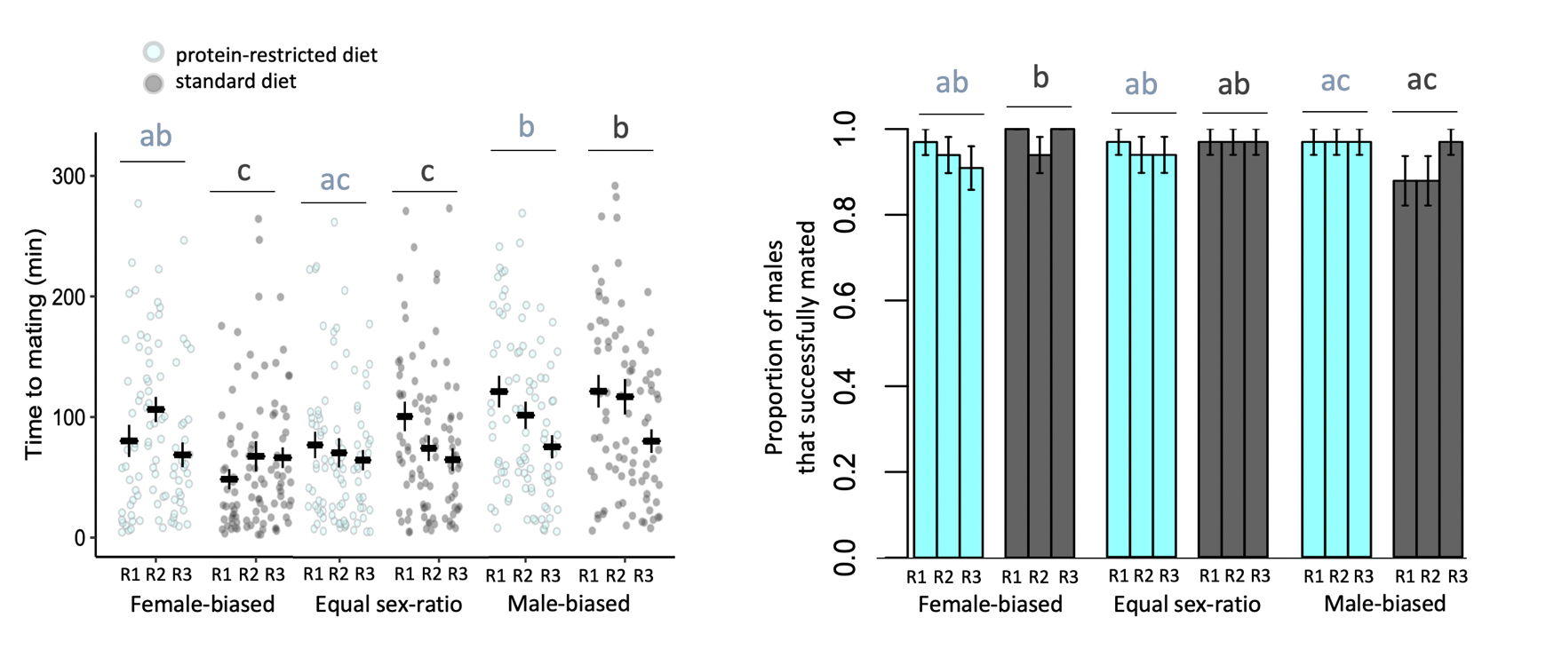 **(b)**

**Figure S1.** **(a)** Mating latencies and **(b)** mating success of experimentally evolved focal males from 18 populations differing in sex-ratios and adult dietary regimes (mean+se). Males evolved under female-biased, equal or male-biased sex ratios, and protein-restricted (20% yeast; light blue) or standard (100% yeast; dark grey) diet regimes. Each sex ratio and dietary combination had three replicates (R1-3). For both traits an interaction between sex-ratio and diet was detected. Letters indicate significant differences in post hoc tests.

1. **(b)**

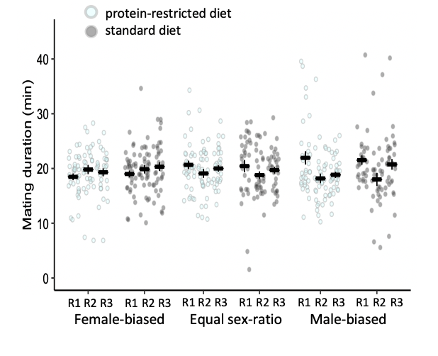

**Figure S2.** **(a)** Mating duration of experimentally evolved focal males (mean+se) **(b)** split by replicate populations. Males evolved under female-biased (FB), equal (EQ) or male-biased (MB) sex ratios, and protein-restricted (20% yeast; light blue) or standard (100% yeast; dark grey) diet regimes. Each sex ratio and dietary combination had three replicates (R1-3). Sex-ratio and diet had no impact on mating duration.

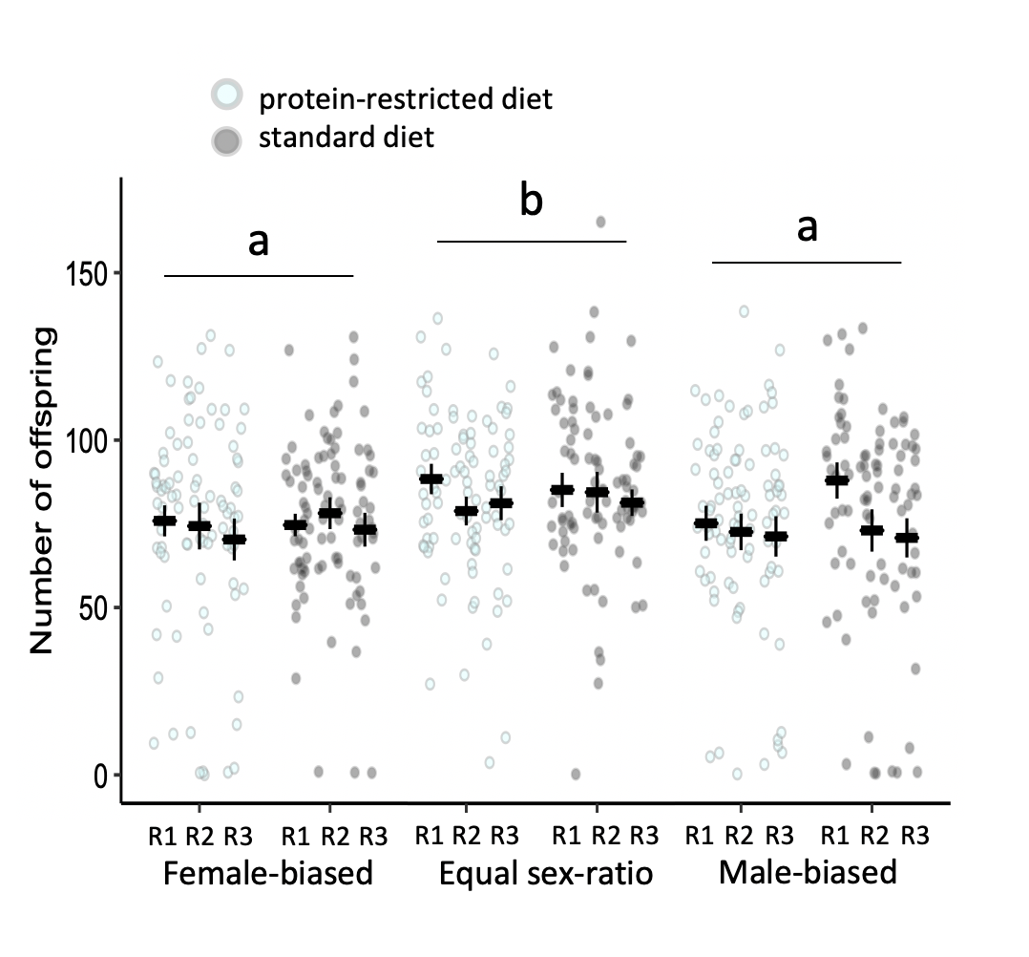

**Figure S3.** Number of offspring produced in 48 hours by experimentally evolved focal males from 18 populations differing in sex-ratios and adult dietary regimes (mean+se). Males evolved under female-biased, equal or male-biased sex ratios, and protein-restricted (20% yeast; light blue) or standard (100% yeast; dark grey) diet regimes. Each sex ratio and dietary combination had three replicates (R1-3). Number of offspring varied as a response to sex ratio. Letters indicate significant differences among sex ratio treatment in post hoc tests.

1. 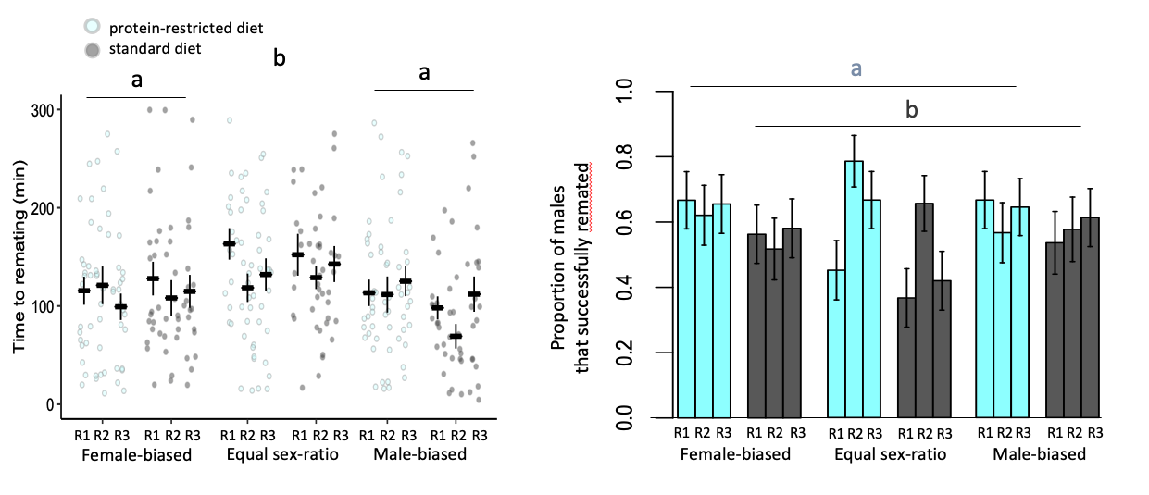 **(b)**

**Figure S4.** **(a)** Remating latencies and **(b)** remating success of experimentally evolved focal males from 18 populations differing in sex-ratios and adult dietary regimes (mean+se). Males evolved under female-biased, equal or male-biased sex ratios, and protein-restricted (20% yeast; light blue) or standard (100% yeast; dark grey) diet regimes. Each sex ratio and dietary combination had three replicates (R1-3). Remating latencies varied as a response to sex ratio. Proportion of rematings varied as a response to adult diet. Letters indicate significant differences among sex ratio (a) and diet treatments (b) in post hoc tests.

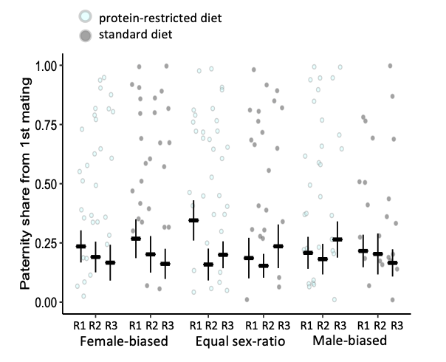

**Figure S5.** Paternity share of the experimentally evolved focal males (mean+se) from 18 populations differing in sex-ratios and adult dietary regimes (mean+se). Males evolved under female-biased, equal or male-biased sex ratios, and protein-restricted (20% yeast; light blue) or standard (100% yeast; dark grey) diet regimes. Each sex ratio and dietary combination had three replicates (R1-3). Sex-ratio and diet had no impact on paternity share when the focal males were the first to mate.

1. 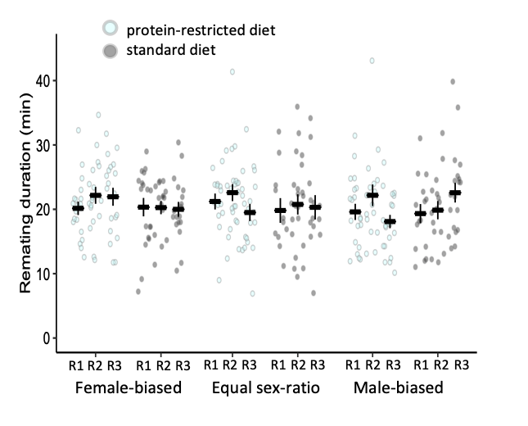 **(b)**

**Figure S6.** **(a)** Remating duration of experimentally evolved focal males (mean+se) **(b)** split by replicate populations. Males evolved under female-biased (FB), equal (EQ) or male-biased (MB) sex ratios, and protein-restricted (20% yeast; light blue) or standard (100% yeast; dark grey) diet regimes. Each sex ratio and dietary combination had three replicates (R1-3). Sex-ratio and diet had no impact on remating duration.

|  |  |  |  |  |  |  |  |  |  |  |  |  |  |  |  |  |  |  |
| --- | --- | --- | --- | --- | --- | --- | --- | --- | --- | --- | --- | --- | --- | --- | --- | --- | --- | --- |
|  | **FB-L1** | **FB-L2** | **FB-L3** | **FB-H1** | **FB-H2** | **FB-H3** | **EQ-L1** | **EQ-L2** | **EQ-L3** | **EQ-H1** | **EQ-H2** | **EQ-H3** | **MB-L1** | **MB-L2** | **MB-L3** | **MB-H1** | **MB-H2** | **MB-H3** |
| **mating proportion** | 33 | 33 | 33 | 33 | 33 | 33 | 33 | 33 | 33 | 33 | 33 | 33 | 33 | 33 | 33 | 33 | 33 | 33 |
| **mating latency** | 32 | 31 | 30 | 33 | 31 | 33 | 32 | 31 | 31 | 32 | 32 | 32 | 32 | 32 | 32 | 29 | 29 | 32 |
| **mating duration** | 32 | 31 | 30 | 33 | 31 | 33 | 32 | 31 | 31 | 32 | 32 | 32 | 32 | 32 | 32 | 29 | 29 | 32 |
| **offspring number** | 32 | 31 | 29 | 33 | 31 | 33 | 30 | 31 | 31 | 32 | 31 | 31 | 31 | 32 | 32 | 29 | 29 | 31 |
| **remating prop** | 30 | 29 | 29 | 32 | 29 | 31 | 31 | 28 | 30 | 30 | 32 | 31 | 30 | 30 | 31 | 28 | 26 | 31 |
| **remating latency** | 20 | 18 | 19 | 18 | 15 | 18 | 14 | 22 | 20 | 11 | 21 | 13 | 20 | 17 | 20 | 15 | 15 | 19 |
| **remating duration** | 20 | 18 | 19 | 18 | 15 | 18 | 14 | 22 | 20 | 11 | 21 | 13 | 20 | 17 | 20 | 15 | 15 | 19 |
| **paternity share** | 20 | 18 | 17 | 17 | 14 | 17 | 14 | 20 | 20 | 11 | 21 | 13 | 20 | 16 | 20 | 15 | 15 | 18 |

**Table S1.** Sample sizes used for each reproductive trait split by replicate populations.

|  |  |
| --- | --- |
| **Column name** | **Description** |
| *treatment* | The specific sex ratio and adult diet combination including replicate number |
| *group* | The specific sex ratio and adult diet combination |
| *vial* | The mating vial ID within treatment |
| *bias* | Sex ratio |
| *replicate_r* | Replicate number |
| *food* | Adult diet |
| *male_added* | The time at which the male was added to the mating vial |
| *mating_start* | The time at which mating started |
| *latency* | The time it took for mating to start after the male was added to the vial |
| *mating_finish* | The time at which mating finished |
| *mating_duration* | Total mating duration |
| *mating* | Whether a mating has happened in the vial |
| *day* | The day of the mating experiment |
| *No_offspring* | The number of offspring produced by the female in the 48 hours after the mating |
| *pos_offspring* | The positive number of offspring produced by the female in the 48 hours after the mating (excluding zeros) |
| *fertile_mating* | Whether any offspring was produced by the female in the 48 hours after the mating |
| *spa_added* | The time at which the spa male was added to the remating vial |
| *remating_start* | The time at which remating started |
| *remating_latency* | The time it took for remating to start after the male was added to the vial |
| *remating* | Whether a remating has happened in the vial |
| *remating_finish* | The time at which remating finished |
| *remating_duration* | Total remating duration |
| *wt_offspring* | The number of offspring with wildtype eyes produced by the female in the 48 hours after the remating |
| *spa_offspring* | The number of offspring with sparkling eyes produced by the female in the 48 hours after the remating |
| *total* | The total number of offspring produced by the female in the 48 hours after the remating |
| *prop* | The proportion of offspring with wildtype eyes to offspring with sparkling eyes produced in the 48 hours after the remating |

**Table S2.** **A description of the raw dataset columns.**