Making decisions about radiological imaging in pregnancy

Authors

Dr Rebecca Wiles
Consultant Radiologist
Department of Radiology
Liverpool University Hospitals NHS Foundation Trust

Dr Beth Hankinson
Consultant Radiologist
Department of Radiology
Liverpool University Hospitals NHS Foundation Trust

Ms Emily Benbow
Patient representative
Liverpool Babies Patient and Public Involvement and Engagement Group
Department of Women’s and Children’s Health, University of Liverpool

Dr Andrew Sharp
Consultant Obstetrician
Department of Women’s and Children’s Health, University of Liverpool

Globally ultrasound has been used in pregnancy for decades. The use of other imaging modalities such as plain radiography, Computed Tomography (CT), and Magnetic Resonance Imaging (MRI)—is increasing¹. Imaging plays an important role in the investigation of many conditions in pregnancy, but there is also the potential to cause harm. Concerns about fetal and maternal harm can make decisions to image difficult for patients and clinicians. However, risk is often lower than expected and, especially in many acute situations, is outweighed by the benefit.

How will this paper help clinicians and their patients make these decisions?

This paper will discuss the risk different commonly used imaging modalities pose to the fetus. Commonly encountered emergency clinical scenarios will be explored, along with what imaging could be used in these situations, with the aim of enabling the reader to understand the benefits and risks of imaging so that they can make informed decisions with their patients. We also describe how to approach discussion of risk with patients.
We will not cover elective scenarios which could potentially wait until post pregnancy; however, the principles we discuss behind choosing imaging modality can be applied to all pregnant patients.

As this paper is aimed at clinicians referring patients for imaging we will not discuss issues that are primarily the role of the radiology department e.g. dose modification techniques and prevention/management of inadvertent fetal imaging (e.g. when patients are unaware they are pregnant).
We will also not cover imaging in the post-partum period and in women who are breastfeeding.

What imaging modalities will be covered?

- Ultrasound—uses high frequency sound to produce images
- Ionising radiation— uses high energy electromagnetic radiation to produce images. X-rays and gamma rays are the most commonly used forms of ionising radiation in medical imaging
- MRI (magnetic resonance imaging) – uses strong magnetic fields and radio waves to produce images

What is the evidence like?

The evidence base for the risks of imaging in pregnancy that will be discussed in this paper includes experimental animal studies, observational epidemiological studies on human subjects and, in the case of ionising radiation, studies from Japanese atomic bomb survivors²⁻⁶. The majority of human studies are retrospective.

What potential risk does imaging in pregnancy pose to the fetus?

Different imaging modalities have different effects on human tissues and as such pose different risks (and levels of risk) to the fetus. See table 1. High dose ionising radiation such as CT (computed tomography) is generally of more concern than ultrasound, MRI and low dose ionising radiation such as plain radiography.

Table 1: fetal risks associated with, and guidelines for the use of, specific imaging modalities in pregnancy

Modality | Consideration
Ultrasound | Common indications in the pregnant patient | Obstetric imaging  Suspected acute abdominal/pelvic pathology  Heart imaging (echocardiography)
 | Evidence based summary of risk | No evidence of adverse maternal, fetal, perinatal, or childhood outcome ²*  There are theoretical risk from heating and movement effects⁷ ⁸ but adverse outcomes as a result of this have not been found in human studies.
 | IV contrast use | Microbubbles  Only used rarely in clinical practice (echocardiography, characterisation of liver and renal lesions) and as such will rarely be considered in pregnancy.  Microbubbles bursting can cause cavitation in tissues. Microbubbles enter the placenta and the risk of damage to the placenta has not been well investigated⁹.
 | Recommendations | Whilst ultrasound is generally safe, the principles of As Low As Reasonably Achievable (ALARA) principle should be followed:⁷ ⁸  - only use ultrasound if clinically indicated  - limit scanning time,  - limit Doppler imaging (uses higher energy than 2D imaging)  - use machine configured for obstetric use  IV contrast  Ultrasound contrast should be generally avoided (only used where benefits clearly outweigh the risks)¹⁰.
Ionising Radiation | Common indications in the pregnant patient | X-rays:  Plain radiographs e.g. chest and extremities  CT e.g. head imaging in suspected intracranial haemorrhage, CT pulmonary angiography in suspected pulmonary embolism and abdominal imaging in trauma  Gamma-rays:  ventilation/perfusion (VQ) scans  bone scans (rarely considered in pregnancy)  PET-CT uses both gamma rays and X-ray (rarely considered in pregnancy).
 | Evidence based summary of risk | Fetal malformation, growth restriction, intellectual disability and death, should not occur as a result of the levels of radiation used in diagnostic imaging. UK guidelines suggest this threshold is 100mGy¹¹ whilst USA guidelines suggest 50mGy⁷.  Cancer induction can theoretically occur with any dose of ionising radiation and as such there is no threshold below which this cannot occur. Risk is dependent on dose and body part imaged. See table 2 for childhood cancer risk with ionising radiation.
 | IV contrast use | Iodinate contrast  Used in most body imaging including CTPA and CT abdomen studies.  Not routinely used in brain imaging unless vascular assessment required – such as in CT venogram and angiogram studies.  Contrast does cross the blood-placental barrier but there is no evidence that IV CT contrast administered at any time in pregnancy causes harm to the fetus¹⁰.  There is a theoretical risk of neonatal hypothyroidism¹²
 | Recommendations | See table 2 for information about fetal dose  Low fetal dose procedures (e.g. X-ray and CT above the diaphragm or below the knees)  - risk to the fetus is extremely small (< 1 in 10,000-100,000 risk of childhood cancer induction (compared to a background risk of 1 in 500).  - If the procedure is clinically indicated they pose minimal risk to the fetus and can be justified.  Higher fetal dose procedures (e.g. CT which covers the pelvis and PETCT)  - risk to the fetus higher, though still low in absolute terms e.g. up to 1 in 200  - should only be considered if there is no way this information could be obtained without ionising radiation and not performing the procedure could be at serious detriment to the woman’s health  - if performed, fetal dose should not exceed 50-100mGy.  In all cases involving ionising radiation the dose should be kept as low as low as reasonable achievable.  IV contrast-  can be used if clinically indicated  due to theoretical risk of neonatal hypothyroidism, screen baby in first week of life¹⁰ ¹³ **
MRI | Common indications in the pregnant patient | Brain imaging (apart from suspected intracranial haemorrhage)  Fetal imaging  Acute abdominal pain
 | Evidence based summary of risk | No conclusive evidence that MRI use in pregnancy causes harm to the human fetus⁷ ¹⁴ ¹⁵.  Theoretical risks of fetal hyperthermia⁵ and inner ear damage⁶ can be mitigated by scanner modifications¹⁵
 | IV contrast use | Gadolinium based contrast  Contrast crosses the blood-placental barrier. There is limited evidence that MRI contrast use in pregnancy is associated with “a broad set of [neonatal] rheumatological, inflammatory, or infiltrative skin conditions” and of stillbirth or neonatal death¹⁶.
 | Recommendations | MRI can be considered safe in pregnancy.  Some bodies, such as the UK Government’s Medicines and Healthcare Products Regulatory Agency, advise caution in scanning in the first trimester (though it is advised this can be done when the benefits outweigh the risks)¹⁵. Others, such as the American College of Radiologists, suggest that patients in the first trimester of pregnancy should not be treated differently to those in later stages of pregnancy¹⁴.  Scan modification techniques should also be performed by the radiology team performing the study  IV contrast  - Avoid IV gadolinium unless it will change management during pregnancy or there is no other way to get the information¹⁰ ¹⁷.

* The metanalysis cited found a weak association between ultrasound exposure and non‐right handedness in boys, though not when boys and girls were analysed together.
** Already offered to all newborns in Europe, Australia, New Zealand and North America to assess for congenital hypothyroidism

Table 2: Typical fetal doses and risks of childhood cancer for some common diagnostic ionising radiation modalities used in early pregnancy when the fetus is small. Based on data summarised by the UK’s Health Protection Agency, The Royal College of Radiologists and The Royal College of Radiographers¹¹
Risk of childhood cancer has been rounded up to 1 in 10,000 per mGy.
For comparison, the natural childhood cancer risk is ~1 in 500.

Examination | Typical fetal dose (mGy) from a single scan* | Risk of childhood cancer per examination
Radiography  Teeth  Neck  Chest  Extremity  Mammography  CT  Head  Neck | 0.001-0.01 | <1 in 1,000,000
CT  Chest  Pulmonary angiogram | 0.01-0.1 | 1 in 1,000,000  to  1 in 100,000
Radiography  Abdomen  Pelvis  Hip  CT  Chest and liver  Nuclear medicine  Ventilation/perfusion scan (VQ scan)* | 0.1-1.0 | 1 in 100,000  to  1 in 10,000
Radiography  Lumbar spine  CT  Lumbar spine  Abdomen (not pelvis) | 1.0-10.0 | 1 in 10,000  to  1 in 1,000
CT  Abdomen and pelvis  PETCT  Whole body | 10.0-50.0 | 1 in 1,000  to  - in 200

*Dose can be reduced by performing perfusion scan first and, if normal, ventilation part of the scan need not be performed

Is there a role for abdominal shielding?

Abdominal lead shielding was historically used for ionising radiation that does not directly expose the fetus (examples include chest X-ray and CTPA). However, as the majority of the dose to the fetus in these studies is from internal (rather than external) scatter there is not likely to be any benefit to abdominal shielding. Additionally, if the shield is inadvertently partially in the field of view during the scan, automatic exposure control can inadvertently lead to increased dose¹⁸.

Guidelines from the American Association of Physicists in Medicine¹² and the British Institute of Radiology¹³ suggest avoiding the routine use of shielding for the above reasons. Both do suggest, however, to consider shielding on a case by case basis if patients would feel calmer and more reassured with lead shielding in place, providing the patient is adequately counselled about the potential risk of increased dose to the fetus and all care is taken that the shielding does not interfere with the image.

Does imaging pose a risk to the pregnant woman?

Ultrasound –
A meta-analysis performed on behalf of the World Health Organization found no evidence of adverse maternal outcome following ultrasound used in pregnancy². Ultrasound can be considered safe to the pregnant patient.

Ionising radiation -
Breast tissue is particularly susceptible to the effects of ionising radiation. A meta-analysis of studies of women exposed to different types of ionising radiation, including imaging, therapeutic radiation and atomic bomb survivors, showed that women whose breasts have been exposed are at increased risk of breast cancer¹⁹. Theoretically a 20 year old non-pregnant woman undergoing a CTPA study, giving a dose of 10mGy, has an excess breast cancer risk of 429 in 100,000²⁰. Pregnant and breastfeeding women are theoretically at increased risk of radiation effects because the breast are larger and are actively undergoing glandular proliferation²⁰

Despite these theoretical risks, a recent study²¹ did not show an increased risk of breast cancer in patients exposed to CT chest or VQ scanning in pregnancy or the early post-partum period for a short follow up time period (<12 years).

Overall, the exact risk of breast cancer induction in pregnant women exposed to ionising radiation is not known, but, as with all imaging, the theoretical risks needs to be weighed against the benefit that the imaging will provide and doses kept as low as reasonably achievable.

MRI –
As well as usual MRI safety considerations for all patients (the discussion of which are beyond the scope of this article), pregnant patients may find the relatively long scan times (most studies take at least 20 minutes to perform, some up to 1 hour) and claustrophobia difficult, particularly in late pregnancy. Scan technique may need to be adjusted to account for this which may include reducing scan times and considering alternative positioning within the scanner, for example anterior oblique positioning.

Are there any other risks of imaging pregnant patients?

The risk of detecting incidental findings (“incidentalomas”), which may lead to further investigations and increase unnecessary patient anxiety, needs to be considered along with other risks of imaging²².

Additionally, the possibility of false negative and false positive findings is of particular concern in pregnancy because anatomy and physiology is altered compared to the non-pregnant patient. Examples of this include haemodynamic circulation causing difficulties in pulmonary artery opacification on CTPA²³ and in suspected acute abdominal pathology when the gravid uterus can displace or compress structures, making them difficult to visualise on ultrasound²⁴.

How can I involve pregnant patients in decision making for techniques involving higher risk?

For ultrasound, MRI and low dose ionising radiation (see tables 1 and 2) discussions with the patient may be relatively straightforward. For techniques which involve higher fetal or breast doses (e.g. some X-ray and CT examinations) the discussion may be more challenging.

Discussion of risk in pregnancy can be particularly difficult as patients have to consider not only the risk to themselves but also need to make decisions on behalf of their unborn child.
The Royal College of Obstetricians and Gynaecologists offer advice to healthcare professionals and to patients about the discussion of risk in healthcare²⁵ ²⁶. Some of the points from these sources that apply to imaging in pregnancy include:

- Explain why the imaging is being suggested and how it will change management for the patient (and, if appropriate, the fetus). Explain what may happen if no imaging is done e.g. the risk of missing serious pathology, acknowledging that this may be difficult to quantify
- Give information in different ways.
  - Give estimated numerical risk of harm (table 2)
  - Give this in relative terms e.g. compared to background risk of childhood cancer of approximately 1 in 500 so an additional risk of 1 in 500 doubles the risk the baby will later develop childhood cancer
  - Provide context e.g. exposure to the fetus from background radiation is approximately 1 mGy whilst the radiation exposure from a transatlantic flight is 0.01 mGy²⁷
- Offer patient information leaflets if available (see “Information resources for patients” box below).

Should I obtain written consent?

The process for obtaining consent for imaging is variable. The ACR suggest that consent can be obtained in both verbal and written forms but in either case should be documented. They offer a sample patient consent form in their guidelines²⁸.

What are some common clinical scenarios?

Trauma

A 27-year-old woman is brought to the Emergency Department by ambulance following a high speed road traffic collision. She is 30 weeks pregnant.
GCS: 15. Heart rate: 125bpm. Blood pressure: 120/70. Respiratory rate: 25bpm.
She has left lower chest wall and left flank pain, guarding, and left flank bruising. She states her baby is moving normally and the obstetric team do not believe there is immediate fetal concern. The surgical team is called and imaging is considered. The patient wants to know about risks to her baby from CT scanning.

Trauma is the leading non-obstetric cause of maternal mortality and can also cause fetal loss so early identification of injury is important²⁹. Consider radiology when the risk from trauma is likely to be higher than the risk from imaging.

Chest radiography and Focussed Assessment with Sonography in Trauma (FAST) may help to rule in some injuries (for example pneumothorax and large volume haemoperitoneum respectively) and expose the fetus to minimal or no radiation. However, these modalities may not rule out potentially life threatening injury which could put the patient and fetus at risk, such as active bleeding, organ injury or fractures.

When potentially life threatening thoracic or abdominal injury is suspected, CT scan is the imaging modality of choice.

To communicate the risk of CT, explain to the patient
- The risk of missing life threatening pathology vs
- The risk to the fetus from radiation. For example, using an estimated fetal dose of 20mGy for a single CT abdomen and pelvis (table 2) the risk of childhood cancer induction is approximately 1 in 500. Using baseline risk of childhood cancer of 1 in 500, the risk would approximately double the baseline risk of childhood cancer. This could be communicated by saying, for every 500 times this scan is done in pregnancy, theoretically, one child would develop a cancer that they would not have developed otherwise.

Note, doses and risk in table 2 are for single scans but trauma protocols can involve dual phase scanning³⁰.

CT in trauma usually requires the use if IV contrast. Explain to the patient that there is no definite risk to the fetus from IV contrast administration. Due to the theoretical risk of hypothyroidism, neonatal heel prick is advised (this is already offered to all newborns in many countries). See table 1.

Once life threatening injury to the patient is excluded, consider obstetric ultrasound to look for fetal, placental, and uterine injury²⁹.

Figure 1a-d Imaging of a pregnant patient following major trauma
1a-c CT scan of the abdomen and pelvis with IV contrast in a pregnant patient involved in a high speed road traffic accident. Figure 1a (axial image, soft tissue windowing) demonstrates the gravid uterus and anterior placenta. Figures 1b (axial image, bone windowing) and 1c (coronal image, bone windowing) demonstrate a right sacral fracture (arrows).
1d ultrasound scan of the placenta and fetus performed the following day demonstrated no evidence of fetal or placental injury.

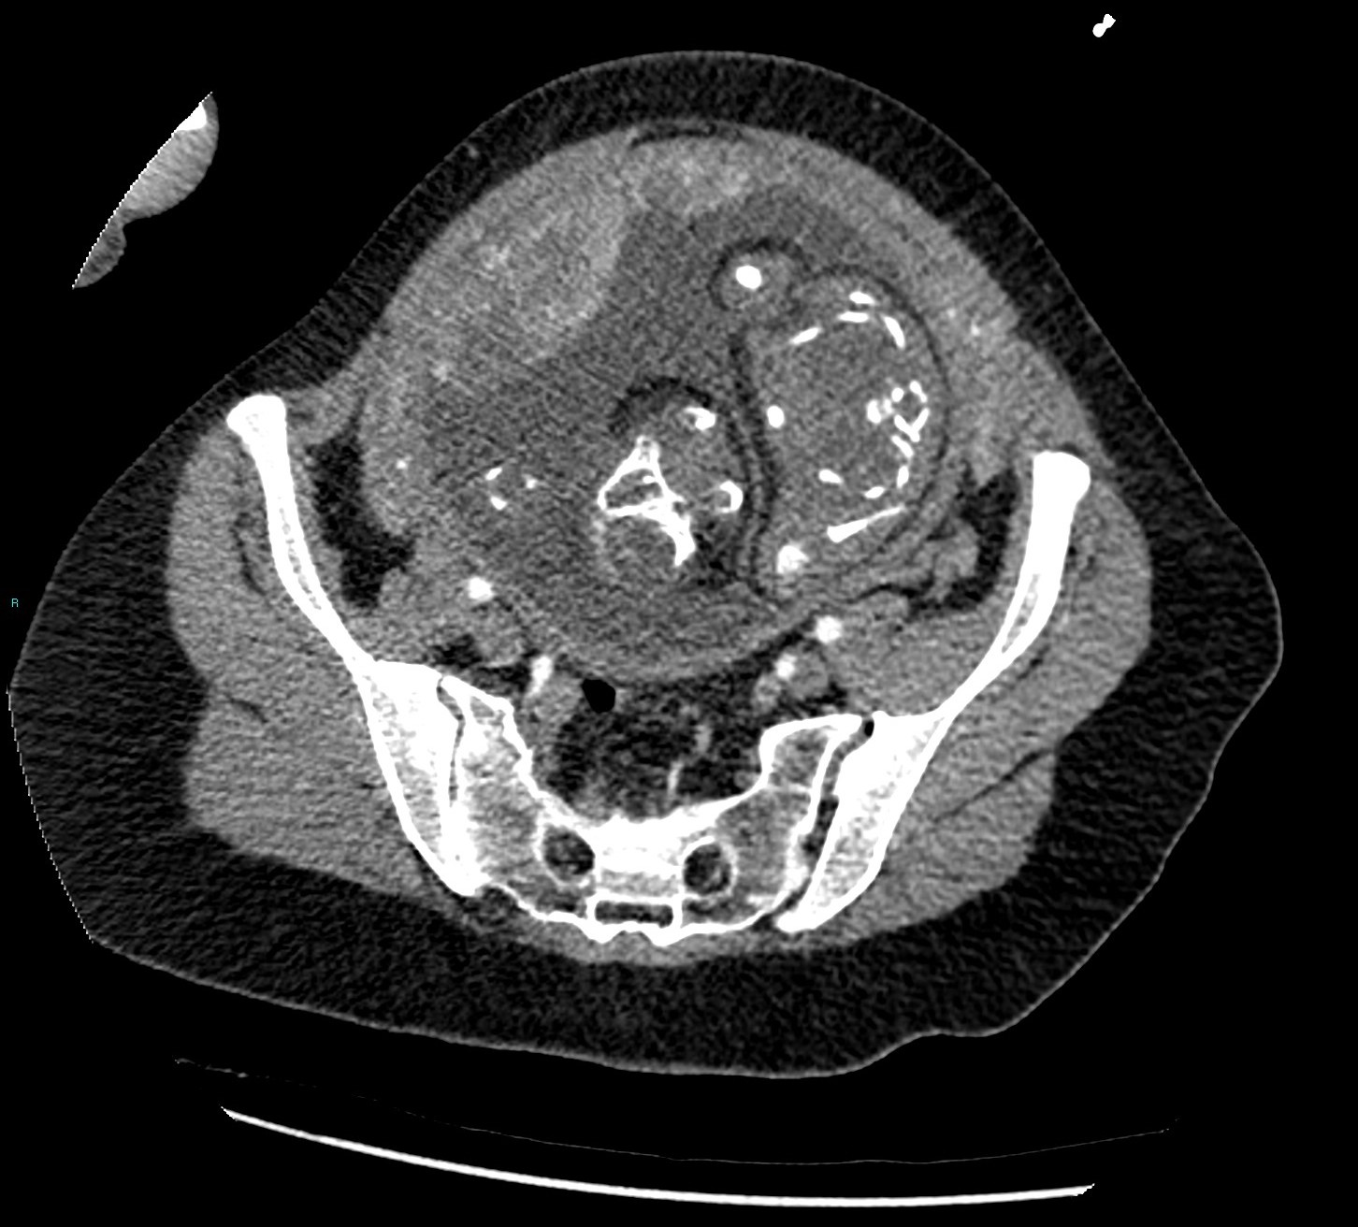

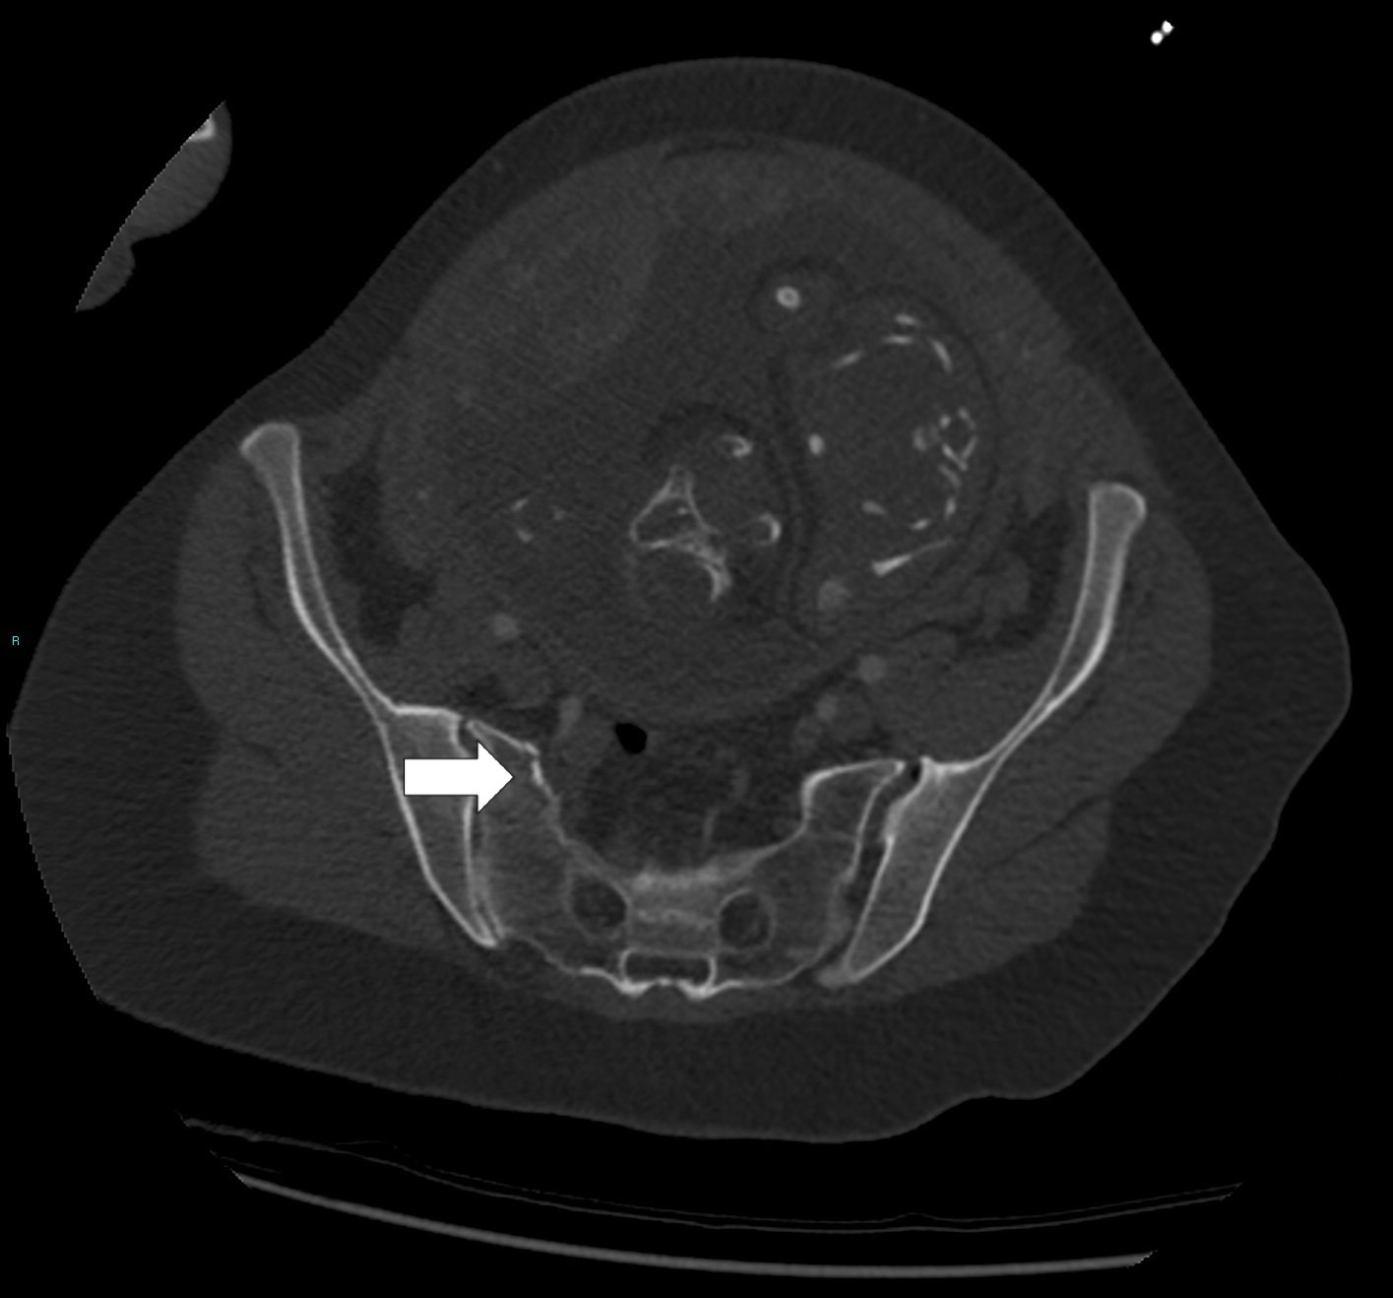

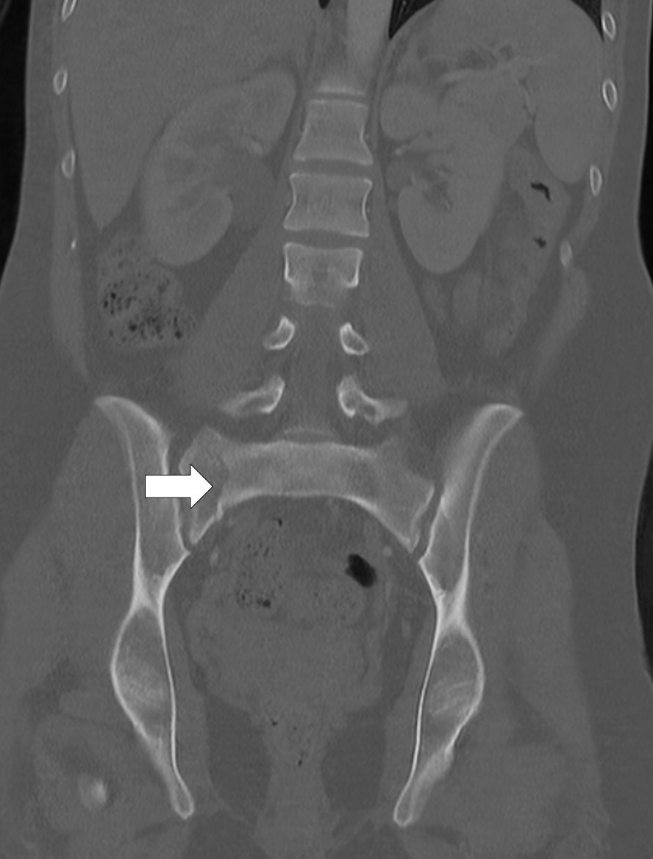
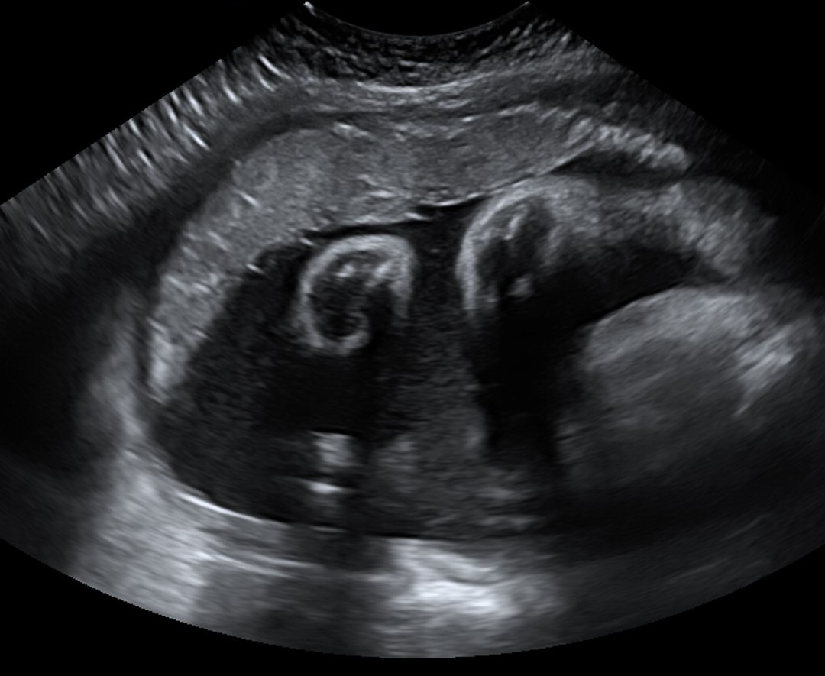

Headache

A 35-year-old woman attends an out of hours GP service with headache and vomiting that started suddenly, 24 hours earlier. She is 17 weeks pregnant and has no headache history. She has diplopia but no fever or meningism. All vital observations and urine dipstick are unremarkable. The GP recommends urgent assessment in the Emergency Department and advises the patient this will likely include imaging. The patient wishes to discuss imaging options.

Headache in pregnancy is common and usually due to primary headache disorders such as tension headache or migraine.
Preeclampsia is also a common cause of headache after 20 weeks of gestation and associated with hypertension with or without proteinuria³¹.

Features which warrant further urgent evaluation to exclude underlying pathology include acute onset, new headache, diplopia and vomiting. Potential diagnoses in pregnancy include subarachnoid haemorrhage and venous sinus thrombosis.

CT is quick, readily available, can readily detect acute haemorrhage and post contrast iodinated imaging is possible. MRI is more sensitive than CT for detecting most intracranial pathology; however, it is slower, less readily available, more prone to artefact, and post contrast gadolinium imaging generally not recommended in pregnancy¹⁰ ¹⁷ (table 1).

Advise the patient that the radiation dose to the fetus from CT scanning of the head is negligible (Table 2)¹¹. CT head should not be delayed if clinically indicated and MRI should not be considered first line purely on the basis of risk to the fetus if CT would be the usual first choice in the non-pregnant patient. If CT is negative further investigation with MRI, post contrast CT or lumbar puncture may be required depending on the suspected diagnosis.

Dyspnoea and chest pain

A 32-year-old woman attends the Emergency Department following sudden onset chest pain and dyspnoea 6 hours ago. She is 25 weeks pregnant. She has no relevant past medical history. She has had no fever, cough, or alteration in her sense of taste or smell.
Heart rate: 105bpm. Respiratory rate: 18bpm. Other observations, examination, ECG, routine blood, and chest radiograph are normal. Wells score is calculated as 7.5 (high risk of pulmonary embolism). The need for imaging is discussed. The patient is concerned about implications for her baby. She asks, “What difference will a scan make if I have a blood clot in my lungs?”

Venous thromboembolism (VTE) includes deep vein thrombosis (DVT) and pulmonary embolism (PE). The risk of missing VTE or of anticoagulating a patient without VTE puts the patient, and therefore also her fetus, at risk of illness or even death.

Wells score indicates high risk for pulmonary embolism and imaging investigations are recommended³². D dimer is not recommended in pregnancy or if Well’s score indicates high risk (>4) ³³ ³⁴.

Lower limb vein ultrasound should be performed if there are clinical signs of DVT³⁵ ³⁶ . Because the management of DVT and PE are the same, the diagnosis can therefore be made without the need for ionising radiation and there is no known risk to the fetus with ultrasound (Table 1).

In the absence of signs of DVT, guidelines for imaging of suspected PE are conflicting³⁷. Some suggest pregnant patients with suspected PE should undergo lower limb vein ultrasound to avoid ionising radiation. Others advise this is only done if the patient has clinical signs of DVT.
Direct imaging of PE is most commonly performed with CT pulmonary angiography (CTPA) or lung scintigraphy (ventilation/perfusion or VQ scanning). The choice between these studies is controversial because there are relative risks and benefits for each modality (table 3).

Modality | Fetal dose¹¹* | Maternal breast dose³⁸* | Availability | Use in presence of other lung pathology³⁸ | Likelihood of non-diagnostic result³⁹ | Other considerations
CTPA | Low. May be lower than VQ.  0.01-0.1 mGy (1 in 1,000,000 to 1 in 100,000 risk of childhood cancer) | May be higher than VQ  10-60 mGy | Good – common test performed widely | Advised | 12% (95% CI 8- 17) | IV contrast used (see table 1)
VQ | Low. May be higher than CTPA  0.1-1mGy (1 in 100,000 to 1 in 10,000 risk of childhood cancer) | May be lower than CTPA  0.98-1.07 mGy | May be limited, especially out of hours | Not advised | 14% (95% CI 10-18) | Perfusion scan can be performed first. If normal, ventilation scan is not needed

* recent Cochrane review⁴⁰ and further recent meta-analysis³⁹ pooled data regarding maternal and fetal doses for CTPA and VQ and advised caution in interpreting results of studies due to lack of high quality data.

Choice of CTPA and VQ scan in practice depends on a combination the factors in table 3 as well as local practices. The patient should be reassured that whichever modality is chosen the risk of missing PE is likely to be more than the risk to the fetus or the pregnant patient.
References to example patient information leaflets can be seen in the Information resources for patients section below.

Figure 2a CTPA in a patient in third trimester of pregnancy demonstrates dense glandular breast tissue, at increased risk from ionising radiation. Also demonstrating suboptimal opacification of the pulmonary trunk (arrow) measured at 191 Hounsefield units (optimal >210) which may be seen due to haemodynamic effects of pregnancy. 12% of CTPA studies may be non-diagnostic in pregnancy³⁹.
Figure 2b CTPA in a non-pregnant patient of the same age demonstrates less dense breast tissue and better opacification of the pulmonary trunk measured at 350 Hounsefield units (arrow)

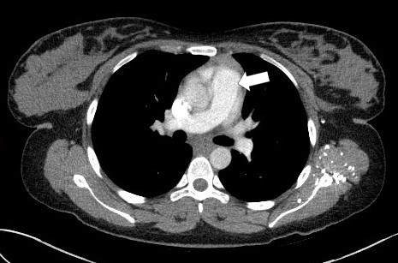

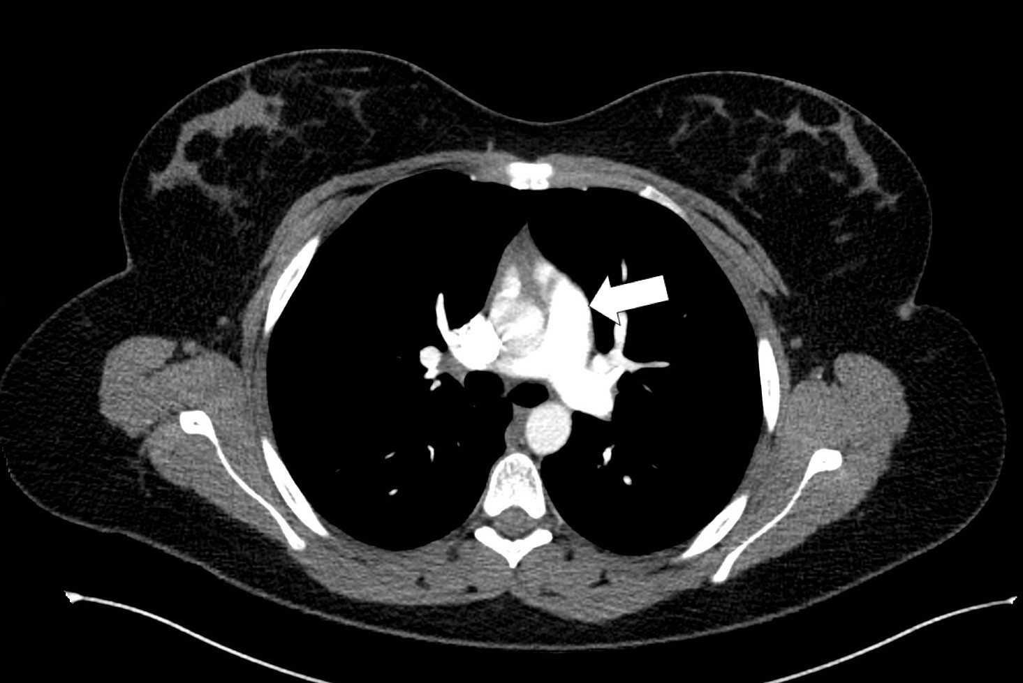

Acute abdominal pain

A 30-year-old woman attends the Emergency Department with right iliac fossa pain which started in the mid abdomen. She is 30 weeks pregnant. On examination she has tenderness and is guarding in the right iliac fossa. Blood tests reveal elevated white cell count and CRP. Urine dipstick is normal. Acute appendicitis and adnexal torsion considered the most likely differential diagnoses. The patient asks, “Do I need an MRI? Isn’t ultrasound good enough?”

Early diagnosis of acute abdominal or pelvic pathology can prevent maternal and fetal harm. The risk of not treating some conditions, for example acute appendicitis or adnexal torsion, whilst difficult to exactly quantify, is likely to be higher than the risk of imaging.

Ultrasound is safe in pregnancy and is often the first imaging modality used for abdominal and pelvic pain in a non-emergency situation. However, it is operator dependent and views of deep structures can be poor in pregnancy when anatomy becomes displaced. Ultrasound for acute appendicitis has 50-100 % sensitivity and 33- 92 % specificity⁴¹.

MRI is more accurate in the diagnosis of other suspected acute abdominal or adnexal pathology in pregnancy⁴¹. For example sensitivity and specificity for diagnosing appendicitis was 92% and 98% in a recent meta analysis⁴². MRI is, however, more time consuming and not as readily available at ultrasound, particularly out of hours.

If MRI is being considered, advise patients that MRI is not known to cause harm to the fetus (Table 1) but that scan times are at least 20 minutes (potentially longer) and that the scanner is small which may be uncomfortable. Also avoid IV contrast (Table 1).

If MRI is not available, CT is potentially an alternative but, as pelvic irradiation will be required, should only be considered if there is no other alternative. The risks will be similar to those discussed in the “Trauma” section above.

Figure 3a and b. MRI in a pregnant patient demonstrates right adnexal torsion. Coronal balanced fast field echo images show a right adnexal mass (large arrow in 3a) and intrauterine pregnancy (small arrow in 3a) which had been detected on ultrasound. Additional finding on MRI, not detected on ultrasound, was the twisted adnexal pedicle (arrow in 3b) confirmed the diagnosis of adnexal torsion for which surgery in pregnancy was required.

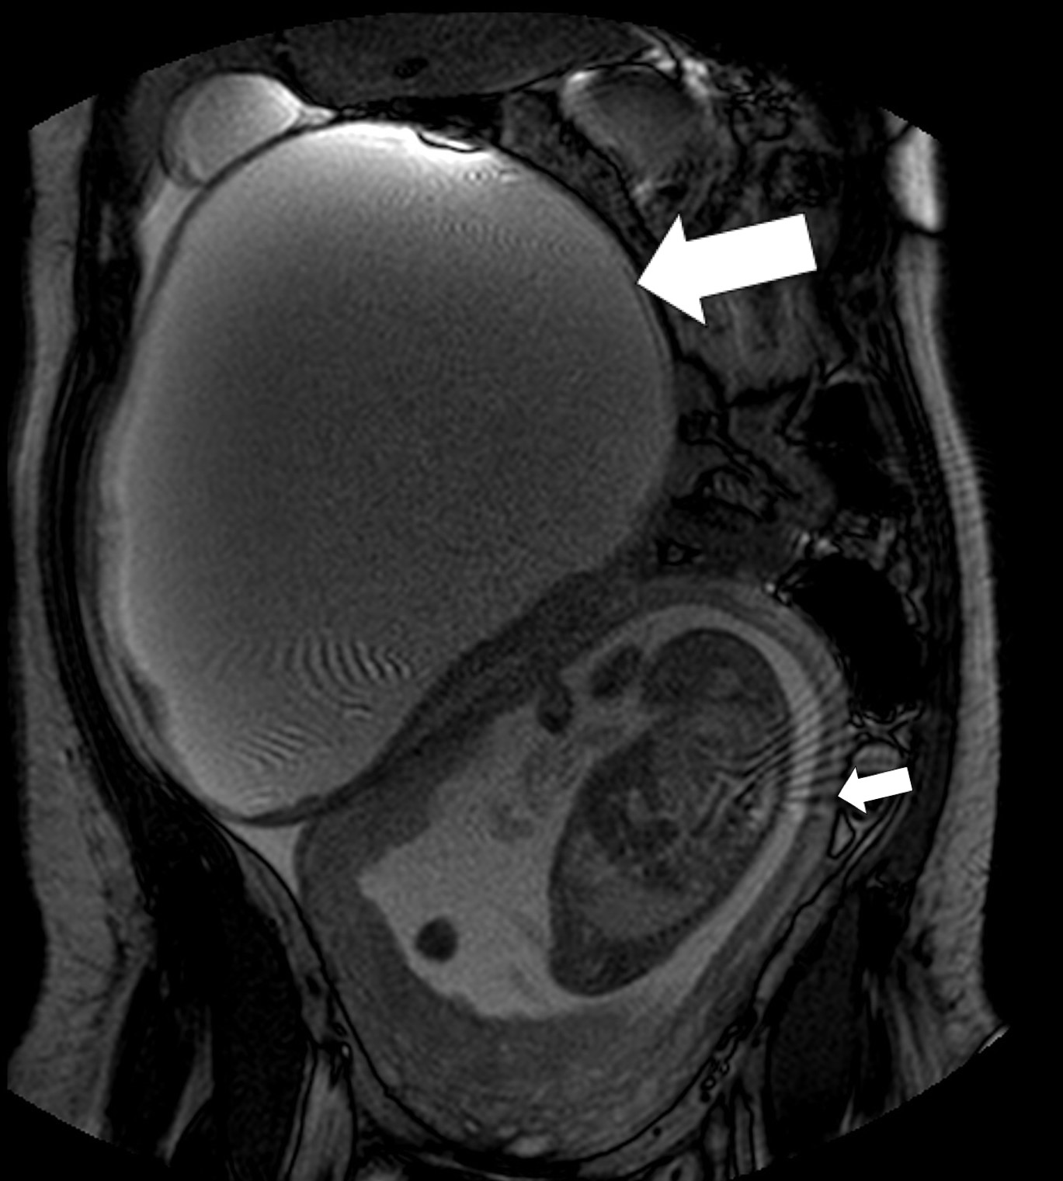

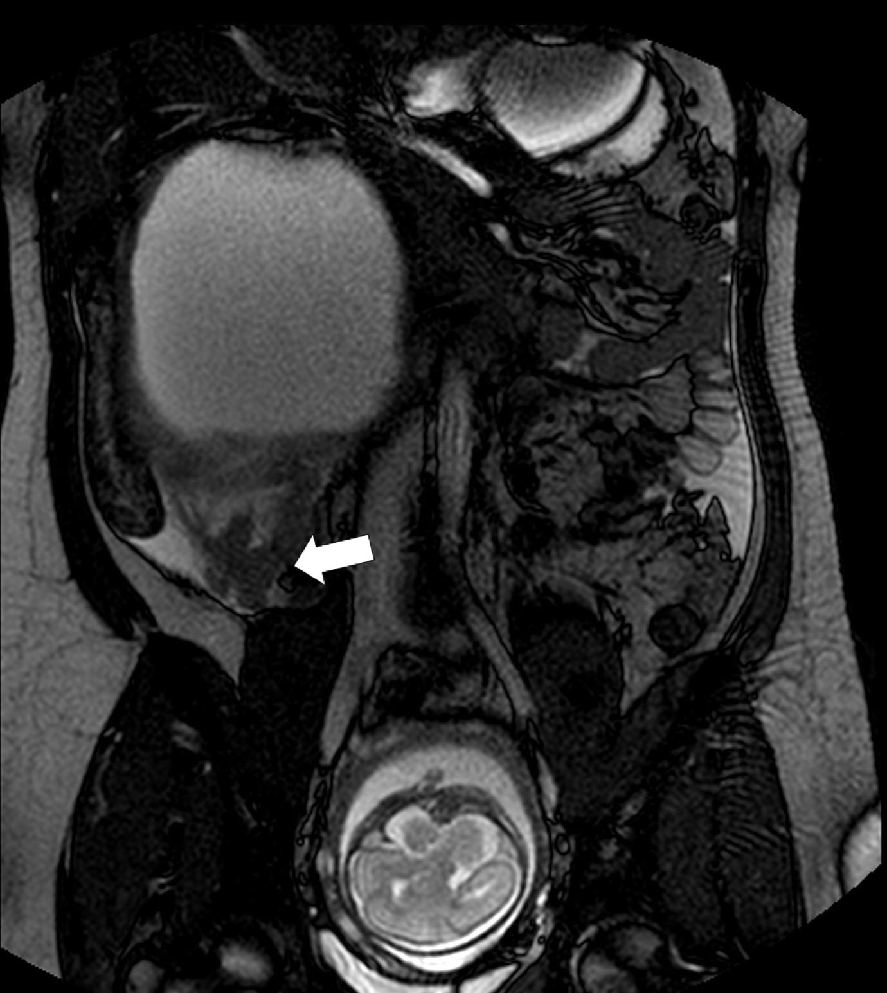

What you need to know

Ultrasound and MRI pose no known risk to the fetus in pregnancy. Nevertheless there are theoretical risks and as such patients should only undergo these studies if clinically indicated.

In radiography and CT, the fetal dose is dependent on whether the fetus is directly irradiated. Radiography and CT that does not cover the pelvis poses very low risk to the fetus.

IV contrast used in CT is not known to cause harm to the fetus (though due to theoretical risk of hypothyroidism, it is advised that thyroid function is tested in the child after birth via heel prick). IV contrast used in MRI and ultrasound should generally be avoided in pregnancy.

Education into practice
Questions about practice:

Do you always ask premenopausal women whether they could be pregnant before requesting imaging investigations?

Are you aware of any specific protocols or pathways in your institution for imaging pregnant patients? For example, is there a pathway for imaging suspected pulmonary embolism in pregnancy based on local availability of radiological services? If not, would this be helpful to your practice?

Reflective question:

Think about a time you have requested imaging for a pregnant or possibly pregnant patient. How did you communicate the risk to the patient? What alternatives to imaging did you offer?

How patients were involved in the creation of this article

EB is a patient representative in the Liverpool Babies Patient and Public Involvement and Engagement Group. She provided a patient perspective on imaging in pregnancy. This included the discussion surrounding how to discuss risk with patients and the use of straightforward, terminology without being patronising. She produced the “Information for Patients” section of the article.
The paper was also reviewed by an external patient representative. As a result of this the language was worded to ensure clear information to the reader, acknowledging that the reader (be they medical professional or patient) may not be familiar with some radiological and other technical terms.

How this article was created
The authors searched for UK and International guidelines (from both Radiological and Obstetric and Gynaecological societies and faculties) regarding imaging the pregnant patient with ultrasound, ionising radiation and MRI. Guidelines for imaging in specific conditions were also reviewed.
A literature search was also performed of patient information leaflets discussing the subjects relevant to the study – imaging in pregnancy and the investigation of specific conditions in pregnancy.

Information resources for patients

To be supplied separately

Contributorship and the guarantor

RW conceived the article.
RW and AS are guarantors
EB and RW wrote the Information resources for patients section
RW, AS and BH wrote the rest of the article

Conflicts of Interest

AC has received payment from Roche for giving an invited talk about the role of blood biomarkers sFlt-1/PlGF in predicting fetal growth restriction at a lunchtime symposium at an international conference in 2019. He received travel and accommodation expenses and an honorarium for his lecture.

RW, BH and EB - Competing Interest: None declared

Licence
“The Corresponding Author has the right to grant on behalf of all authors and does grant on behalf of all authors, an exclusive licence (or non exclusive for government employees) on a worldwide basis to the BMJ Publishing Group Ltd to permit this article (if accepted) to be published in BMJ and any other BMJPGL products and sublicences such use and exploit all subsidiary rights, as set out in our licence (https://authors.bmj.com/policies/#copyright).”

References

1. Kwan ML, Miglioretti DL, Marlow EC, et al. Trends in Medical Imaging During Pregnancy in the United States and Ontario, Canada, 1996 to 2016. JAMA Netw Open 2019;2(7):e197249. doi: 10.1001/jamanetworkopen.2019.7249
2. Torloni MR, Vedmedovska N, Merialdi M, et al. Safety of ultrasonography in pregnancy: WHO systematic review of the literature and meta-analysis. Ultrasound in Obstetrics & Gynecology 2009;33(5):599-608. doi: https://doi.org/10.1002/uog.6328
3. Streffer C, Shore R, Konermann G, et al. Biological effects after prenatal irradiation (embryo and fetus). A report of the International Commission on Radiological Protection. Ann ICRP 2003;33(1-2):5-206. [published Online First: 2003/09/10]
4. The 2007 Recommendations of the International Commission on Radiological Protection. ICRP publication 103. Ann ICRP 2007;37(2-4):1-332. doi: 10.1016/j.icrp.2007.10.003 [published Online First: 2007/12/18]
5. Yip YP, Capriotti C, Talagala SL, et al. Effects of MR exposure at 1.5 T on early embryonic development of the chick. J Magn Reson Imaging 1994;4(5):742-8. doi: 10.1002/jmri.1880040518 [published Online First: 1994/09/01]
6. Strizek B, Jani JC, Mucyo E, et al. Safety of MR Imaging at 1.5 T in Fetuses: A Retrospective Case-Control Study of Birth Weights and the Effects of Acoustic Noise. Radiology 2015;275(2):530-7. doi: 10.1148/radiol.14141382 [published Online First: 2015/01/13]
7. Committee Opinion No. 723: Guidelines for Diagnostic Imaging During Pregnancy and Lactation: Correction. Obstet Gynecol 2018;132(3):786. doi: 10.1097/AOG.0000000000002858
8. British Medical Ultrasound Society Guidelines for the safe use of diagnostic ultrasound equipment. Ultrasound 2010;18(2):52-59. doi: 10.1258/ult.2010.100003
9. Roberts VH, Frias AE. Contrast-enhanced ultrasound for the assessment of placental development and function. Biotechniques 2020;69(5):392-99. doi: 10.2144/btn-2020-0069 [published Online First: 2020/09/05]
10. American College of Radiology Committee on Drugs and Contrast Media. ACR Manual on Contrast
Media

, 2021.
11. Protection of Pregnant Patients during Diagnostic Medical Exposures to Ionising Radiation. United Kingdom: Health Protection Agency, The Royal College of Radiologists and The Royal College of Radiographers, 2009.
12. Satoh M, Aso K, Katagiri Y. Thyroid Dysfunction in Neonates Born to Mothers Who Have Undergone Hysterosalpingography Involving an Oil-Soluble Iodinated Contrast Medium. Horm Res Paediatr 2015;84(6):370-5. doi: 10.1159/000439381 [published Online First: 2015/09/25]
13. RANZCR. The Royal Australian and New Zealand College of Radiologists. Iodinated
Contrast Media Guideline. Sydney, 2018.
14. Expert Panel on MRS, Kanal E, Barkovich AJ, et al. ACR guidance document on MR safe practices: 2013. J Magn Reson Imaging 2013;37(3):501-30. doi: 10.1002/jmri.24011 [published Online First: 2013/01/25]
15. Medicines and Healthcare products Regulatory Agency. Safety Guidelines for Magnetic Resonance Imaging Equipment in Clinical Use, 2021.
16. Ray JG, Vermeulen MJ, Bharatha A, et al. Association Between MRI Exposure During Pregnancy and Fetal and Childhood Outcomes. JAMA 2016;316(9):952-61. doi: 10.1001/jama.2016.12126
17. The Royal College of Radiologists. Guidance on gadolinium-based contrast agent administration to adult patients London, 2019.
18. Tirada N, Dreizin D, Khati NJ, et al. Imaging Pregnant and Lactating Patients. Radiographics 2015;35(6):1751-65. doi: 10.1148/rg.2015150031 [published Online First: 2015/10/16]
19. Preston DL, Mattsson A, Holmberg E, et al. Radiation effects on breast cancer risk: a pooled analysis of eight cohorts. Radiat Res 2002;158(2):220-35. doi: 10.1667/0033-7587(2002)158[0220:reobcr]2.0.co;2 [published Online First: 2002/07/11]
20. Tirada N, Dreizin D, Khati NJ, et al. Imaging Pregnant and Lactating Patients. RadioGraphics 2015;35(6):1751-65. doi: 10.1148/rg.2015150031
21. Burton KR, Park AL, Fralick M, et al. Risk of early-onset breast cancer among women exposed to thoracic computed tomography in pregnancy or early postpartum. J Thromb Haemost 2018;16(5):876-85. doi: 10.1111/jth.13980 [published Online First: 2018/02/17]
22. O'Sullivan JW, Muntinga T, Grigg S, et al. Prevalence and outcomes of incidental imaging findings: umbrella review. BMJ 2018;361:k2387. doi: 10.1136/bmj.k2387 [published Online First: 2018/06/20]
23. Ridge CA, Mhuircheartaigh JN, Dodd JD, et al. Pulmonary CT angiography protocol adapted to the hemodynamic effects of pregnancy. AJR Am J Roentgenol 2011;197(5):1058-63. doi: 10.2214/AJR.10.5385 [published Online First: 2011/10/25]
24. Masselli G, Brunelli R, Monti R, et al. Imaging for acute pelvic pain in pregnancy. Insights Imaging 2014;5(2):165-81. doi: 10.1007/s13244-014-0314-8 [published Online First: 2014/02/19]
25. Presenting Information on Risk (Clinical Governance Advice No. 7). Royal College of Obstetricians and Gynaecologists. , 2008.
26. Understanding how risk is discussed in healthcare. Royal College of Obstetricians and Gynaecologists., 2015.
27. Murji A, Crosier R, Rasuli P. Non-obstetric diagnostic imaging in pregnancy. CMAJ 2015;187(17):1309. doi: 10.1503/cmaj.140901 [published Online First: 2015/07/29]
28. ACR practice guideline for imaging pregnant or potentially pregnant adolescents and women with ionizing radiation. American College of Radiology. , 2008. .
29. Sadro C, Bernstein MP, Kanal KM. Imaging of trauma: Part 2, Abdominal trauma and pregnancy--a radiologist's guide to doing what is best for the mother and baby. AJR Am J Roentgenol 2012;199(6):1207-19. doi: 10.2214/AJR.12.9091 [published Online First: 2012/11/22]
30. Carter NJ, Kirkwood GW, Miles R, et al. The inception of the Bastion Protocol for trauma CT scanning. Journal of The Royal Naval Medical Service 2018;104(3):183-86. doi: 10.1136/jrnms-104-183
31. . Hypertension in pregnancy: diagnosis and management. London2019.
32. . Venous thromboembolic diseases: diagnosis, management and thrombophilia testing. London2020.
33. Royal College of Obstetricians and Gynaecologists. Thromboembolic Disease in Pregnancy and the Puerperium:
Acute Management. RCOG Green-top Guideline No. 37b, 2015.
34. American College of O, Gynecologists' Committee on Practice B-O. ACOG Practice Bulletin No. 196: Thromboembolism in Pregnancy. Obstet Gynecol 2018;132(1):e1-e17. doi: 10.1097/AOG.0000000000002706 [published Online First: 2018/06/26]
35. Americal College of Radiology. ACR Appropriateness Criteria. Suspected Pulmonary embolism. Variant 3: Suspected pulmonary embolism. Pregnant patient. , 2016.
36. Royal College of Radiologists. iRefer Guidelines: Making the best use of clinical radiology
Version 8.0.1. CC31 Suspected pulmonary embolism (PE) in pregnancy.
37. Cohen SL, Feizullayeva C, McCandlish JA, et al. Comparison of international societal guidelines for the diagnosis of suspected pulmonary embolism during pregnancy. Lancet Haematol 2020;7(3):e247-e58. doi: 10.1016/S2352-3026(19)30250-9 [published Online First: 2020/02/29]
38. Leung AN, Bull TM, Jaeschke R, et al. American Thoracic Society documents: an official American Thoracic Society/Society of Thoracic Radiology Clinical Practice Guideline--Evaluation of Suspected Pulmonary Embolism in Pregnancy. Radiology 2012;262(2):635-46. doi: 10.1148/radiol.11114045 [published Online First: 2012/01/28]
39. Tromeur C, van der Pol LM, Le Roux PY, et al. Computed tomography pulmonary angiography versus ventilation-perfusion lung scanning for diagnosing pulmonary embolism during pregnancy: a systematic review and meta-analysis. Haematologica 2019;104(1):176-88. doi: 10.3324/haematol.2018.196121 [published Online First: 2018/08/18]
40. van Mens TE, Scheres LJ, de Jong PG, et al. Imaging for the exclusion of pulmonary embolism in pregnancy. Cochrane Database Syst Rev 2017;1:CD011053. doi: 10.1002/14651858.CD011053.pub2 [published Online First: 2017/01/27]
41. Masselli G, Derchi L, McHugo J, et al. Acute abdominal and pelvic pain in pregnancy: ESUR recommendations. Eur Radiol 2013;23(12):3485-500. doi: 10.1007/s00330-013-2987-7 [published Online First: 2013/08/31]
42. Kave M, Parooie F, Salarzaei M. Pregnancy and appendicitis: a systematic review and meta-analysis on the clinical use of MRI in diagnosis of appendicitis in pregnant women. World J Emerg Surg 2019;14:37. doi: 10.1186/s13017-019-0254-1 [published Online First: 2019/08/02]

