Effect of thermal shock on the permeability and seismic wave velocity of the caprock and reservoir during CO2 injection

Blake, O.O.^{1, 2}

Email: oshaine.blake@sta.uwi.edu
Telephone: 1(868) 662 2002 ext. 84431

Faulkner, D.R. ²

Email: faulkner@liverpool.ac.uk

Worden, R.H. ²

Email: r.worden@liverpool.ac.uk

Armitage, P. J. ^{2,} ³

Email: Peter.Armitage@uk.bp.com

Espie, A. A. ³

Email: tony.espie@uk.bp.com

¹Petroleum Geoscience, Department of Chemical Engineering, University of the West Indies, St. Augustine, Trinidad and Tobago.
²Department of Earth, Ocean and Ecological Sciences, University of Liverpool, United Kingdom.
³BP, Sunbury-on-Thames, Middlesex, United Kingdom.
Abstract
The injection of relatively cold CO₂ into warmer reservoirs causes rapid cooling of the host reservoir and the overlying caprock in the near wellbore region. This rapid cooling may cause thermal fracturing, which potentially may lead to escape of the CO₂. We have here investigated the effect of thermal fracturing, due to rapid quenching, on the permeability and P-and S-wave velocities of caprock and reservoir samples from the In Salah CO₂ storage site in Algeria. Injection of CO₂ may have cooled the caprock and reservoir by up to 65 °C. Laboratory experiments were conducted where caprock and reservoir samples were heated to various temperatures (50, 150, 250, 350 and 500 °C) and rapidly quenched to room temperature (20 °C). Permeability and P- and S-wave velocities were measured pre- and post-thermal treatment at effective pressures up to 60 MPa. Backscattered scanning electron microscopy analysis revealed that most of the fracturing is mainly within siderite (Fe carbonate). X-ray diffraction analysis showed that the minerals chlorite (Fe-clay) and siderite were destroyed in specimens heated to 500 °C. Specimens that were rapidly quenched by 230 °C experienced less than half an order of magnitude increase in permeability and very small to negligible changes in the P- and S-wave velocities. We conclude that the effect of thermal shock fracturing in the Krechba field due to CO₂ injection is negligible because the change in the permeability and velocities are insignificant for the predicted maximum degree of cooling (approximately 65 °C) of the formation due to CO₂ injection. The conclusion of the lack of thermal quenching effects due to CO2 injection at In Salah may be applicable to all global Carbon Capture and Storage prospects.
Keywords
Carbon capture and storage; Thermal fracturing; Permeability change; P- and S-wave velocities changes; Mineral alteration; Krechba field, In Salah CCS project, Algeria
Highlights
- Krechba core samples were heated to various temperatures and quenched to 20 °C.
- Permeability and seismic velocity were measured pre- and post-thermal treatment.
- Extreme thermal treatment caused fracturing mainly within siderite minerals.
- Changes in the measured parameters were negligibly influenced by effective pressure.
- The effects of thermal fracturing on the permeability and seismic velocity are minor.

1. Introduction
CO₂ injection into depleted and mature oil fields is an important practice to both reduce the carbon footprint (Ringrose, 2020) and enhance the recovery of petroleum (Worden and Smith, 2004). Supercritical CO₂ is also used to stimulate geothermal reservoirs (Avanthi Isaka and Ranjith, 2020; Liao et al., 2020). The heat transmission performance of CO₂ in geothermal reservoirs is better than water mainly due to its good mobility and heat capacity (Brown, 2000; Pruess, 2006). The long-term secure storage of the injected CO₂ is a key element of CCS (Harding et al., 2018). It is vital that the caprock, or impermeable layer, remains intact for the successful storage of CO₂ (Vilarrasa and Rutqvist, 2017; Alcalde et al., 2019; Rutqvist et al., 2019; Worden et al., 2020a). The temperature of the injected CO₂ is typically considerably lower than the formation temperature. This will cause the rocks surrounding the wellbore to cool rapidly, especially if injection rates are high. Consequently, the induced thermal stress will reduce the critical pressures required for shear and tensile failure around the near wellbore region in the caprock, which could, in turn, compromise the caprock sealing capacity (Luo and Bryant, 2010; Gor and Prévost, 2013; Vilarrasa and Rutqvist, 2017). The rapid cooling may also cause microfracturing due to thermal shock. Microfractures are known to improve connectivity between pores and thus enhance the permeability, which is excellent for the storage reservoir but detrimental to caprock properties (Kashif et al., 2019; Blake and Faulkner, 2020). Furthermore, any induced microfractures may also weaken the rocks (Graves et al., 2002; Hamdi et al., 2015). The induced change in the stress field due to the injection of cold CO₂ might cause pre-existing faults/fractures to fail resulting in monitorable microseismic events (Cornet et al., 1997; Baria et al., 2005; Häring et al., 2008; De Simone et al., 2013).
A number of studies involving numerical modeling of the thermal effects of CO₂ injection have been reported. Preisig and Prévost (2011) used a coupled multi-phase model to study the thermo-poromechanical effects of CO₂ injection at 30, 50, 70 and 90 °C into an aquifer reservoir (Krechba field, In Salah, Algeria) that has a temperature of 90 °C. They simulated CO₂ injection for a period of 3 years and found that the temperature difference between the injected CO₂ and the reservoir can reduce the compressive stresses, and even create tensile stresses, due to the inability of the rock to contract freely, which may lead to creation or re-opening of fractures. Gor and Prévost (2013) used a coupled multi-phase model to simulate 10 years of injection of CO₂ at 40, 50, and 90 °C into the Krechba field. The authors’ model showed that CO₂ injected at 40 and 50 °C resulted in tensile stresses around the injection well and ultimately fractured the caprock. Vilarrasa et al. (2014) and Vilarrasa et al. (2015) performed numerical simulations of non-isothermal two-phase flow in deformable porous media for CO₂ injected at 50 °C into the Krechba field. They considered 30 years of injection and found that shear slip along pre-existing fractures is more likely to occur in the cooled region, whereas tensile failure is less likely. Goodarzi et al. (2012) utilised a coupled reservoir flow and geomechanical model to simulate 100 years (50 years injection, followed by 50 years shut-in) of CO₂ injected at 30 °C into a storage reservoir (Nisku aquifer, Wabumun Lake area, Canada) with an original temperature of 60 °C. Goodarzi et al. (2012) reported that the thermal effects reduces the fracture (injection) pressure and enhance the horizontal fracture propagation through the caprock. In contrast to these studies, Vilarrasa et al. (2017) performed coupled thermo-hydro-mechanical simulations of cold CO₂ injection in the Krechba field and found that the rapid cooling will be beneficial to CO₂ storage operations due to the injectivity and permeability enhancement of the reservoir. Roy et al. (2018) coupled a linear elastic stress model with heat conduction to investigate the role of CO₂ injection temperature, effective in-situ horizontal stress, and the thermo-mechanical properties. They explored injection temperatures between -10 and 70 °C, and temperature differences between the injection and formation temperature up to 85 °C. Roy et al. (2018) reported that the thermal effects of CO₂ injection are negligible when the effective in-situ horizontal stresses are greater than 10 MPa. The results of these numerical studies are not in full agreement and therefore the mechanisms that govern caprock stability due to cold CO₂ injection are still not well-known and further investigation is required.
Many authors have experimentally quantified the evolution of permeability, velocities, attenuation, static and dynamic elastic properties, and strength of rocks due to thermal stressing (David et al., 1999; Menéndez et al., 1999; Reuschlé et al., 2006; Nasseri et al., 2009; Keshavarz et al., 2010; Heap et al., 2013; Wang et al., 2013; Siddiqi and Evans, 2015; Blake and Faulkner, 2016; Li et al., 2019; Blake and Faulkner, 2020; Blake et al., 2020; Srinivasan et al., 2020). In these experiments, thermal stresses were produced by slow heating (on the order of a few degrees per minute) of polymineralic samples that resulted in anisotropic thermal expansion of the constituent minerals. The resultant internal stresses were demonstrated to be sufficient to induce inter- and intra-granular cracking. The results of these studies showed that thermal stressing caused an increase in permeability and attenuation, and a decrease in velocities, static and dynamic elastic properties, and strength.
Despite the insights gained from the published slow thermal stressing experiments, the influence of thermal stressing and subsequent rapid cooling is less clear. There have been few laboratory experimental studies conducted to understand the effect of quenching on the microstructure of reservoir rocks and caprocks. Zhou et al. (2019) studied the effects of temperature on supercritical CO₂-induced fracturing through laboratory experiments using artificial cubic samples. The artificial samples were heated to temperatures from 25 to 100 °C and supercritical CO₂ was injected at 5 °C during a two-cycle injection scheme at 27 mL/min and 40 mL/min, respectively. Zhou et al. (2019) found that the breakdown pressure of supercritical CO₂ fracturing decreases linearly with increasing temperature. They concluded that thermal tensile stress and pore pressure are the main mechanisms for the reduced breakdown pressure and fracture network in supercritical CO₂ fracturing. Siratovich et al. (2015) conducted laboratory experiments on basalt, rhyolite, and granodiorite to quantify the effect of cold water quenching on porosity, velocities, and permeability under confining pressure of 35 MPa. Siratovich et al. (2015) heated the igneous rock specimens to a temperature of 375 °C and cooled at an average rate 14 °C/min to 25 °C. They found an increase in porosity, a decrease in density, an attenuation of elastic moduli, and an increase in the permeability of the rocks. The studies by Zhou et al. (2019) and Siratovich et al. (2015) produced potentially significant findings for CCS projects that now need to be advanced by employing rapid quenching while varying the initial temperature before cooling of actual rock samples from a CCS site.
In this study, we aim to determine whether the rapid change in temperature, which occurs during the injection of cold CO₂ into the reservoir formation, will be significant to induced thermal-shock fractures that could cause a breach in the caprock and thus potential leakage of CO₂. We used cored caprock and reservoir samples from the Krechba field, In Salah, Algeria (Figs. 1a and b). Specimens were heated to a range of temperatures (50, 150, 250, 350, and 500 °C) and then rapidly quenched to 20 °C. Permeability and P- and S-wave velocities were subsequently measured at effective pressures up to 60 MPa. The results of this work on samples from the Krechba CCS project will have implications for the burgeoning number of CCS projects worldwide.
We first provide descriptions of the samples, details of sample preparation, and details of experimental procedures. Then we present the results of the evolution of permeability and P- and S-wave velocities due to rapid thermal quenching, possible microfracture development and possible mineral alteration that might be responsible for any changes observed in the permeability and velocities. Finally, we discuss and interpret the trends observed in the data and establish the significance of the experiments for the security of CCS projects.

2. Material and Experimental methods

2.1 Sample preparation
Core samples from the Krechba field were used in this study. The Krechba field was the host for a major CCS project (the In Salah CCS project) between 2004 and 2011 where CO₂ was injected at a rate of ~ one million tonnes per year (545 million cubic metres per year) (Armitage et al., 2010; Ringrose et al., 2013). The CO₂ was injected at ~ 40 °C into a 20 m thick Carboniferous interval at a depth of about 2000 m in a saline aquifer that had an initial temperature of ~95 °C (Bissell et al., 2011). The structure of the Krechba field is a northwest-southeast oriented four-way dip closure anticline and producing units include Devonian to Lower Carboniferous sandstones at present-day depths of about 1,800 m TVD (Hirst et al., 2001; Armitage et al., 2010). Krechba typically produces 9 billion cubic metres of gas per year. The gas produced has a high CO₂ concentration (approximately 10% of reservoir gas is CO₂) and instead of venting this CO₂ to the atmosphere, at least until 2011, it was compressed and re-injected into the margins of the reservoirs for storage (Armitage et al., 2010).
A caprock (top-seal) sample (siltstone – C2D) and a reservoir sample (sandstone – C2L) were taken from the Lower Carboniferous unit of the Krechba field, collected from one well, KB9Z (Armitage et al., 2010). An additional low permeability sample (C2Y) was taken from the Upper Devonian unit, from the same well. A schematic log of this well is presented in Figure 1b. The Krechba samples have been classified as chlorite- and illite-bearing clastic rocks that are dominated by quartz and variable amount of siderite (Armitage et al., 2010). The grain size of the sandstone is 120 to 150 μm. The low permeability units are dominated by silt grains ranging from 40 to 60 μm and mica flakes that can be up to 200 μm in length. The porosity of the Krechba samples ranges from 17.9 % (reservoir) to 1.8 % (seal) (Armitage et al., 2010). The Krechba samples were plugged to a diameter of approximately 20 mm. The length of Krechba specimens ranged from 18 mm to 25 mm and the ends were squared to a tolerance of ± 0.02 mm.

2.2 Experimental procedures

2.2.1. Thermal treatment (heating and quenching of specimens)
To test the petrophysical response of rocks due to rapid quenching from various temperatures (50, 150, 250, 350 and 500°C), a furnace (Carbolite CSF 1200) was used to heat unconfined specimens at a rate of 3 °C/min up to the required temperature, which was then kept constant for ~15 hrs. The specimens were then quenched to room temperature (20 °C) rapidly (less than 5 s) in a deionized water bath when they were removed from the furnace. It is well established that significant fracturing occurs when rocks are heated at ~573°C, due to the α-β phase transition in quartz. We therefore chose a maximum temperature of 500 °C to avoid this predicted phase change. The temperature range used in this study, which is significantly higher than the Krechba reservoir, will aid in the understanding of thermal shocking of reservoirs that have higher temperature. However, quenching of reservoir greater than 150 °C may not be directly relevant to CO₂-injection-related cooling since reservoirs for CO₂ storage are unlikely to be at those high temperatures.
The Krechba core samples are very limited. As a proof of experimental concept, we used Westerly granite as analogue samples to demonstrate that a single specimen may be used for heating and quenching testing while being heated to increasingly higher temperatures. Westerly granite is a well-studied and much-reported rock type that can provide a high level of repeatability under carefully controlled test conditions (e.g. Brace, 1965; Spencer Jr. and Nur, 1976; Yong and Wang, 1980; Lockner, 1998; Nasseri et al., 2009; Blake and Faulkner, 2016). Westerly granite has a volumetric modal mineralogy of 27% quartz, 36% K-feldspar, 30% plagioclase, 6% phyllosilicates, and 1% accessory phases (Atkinson, 1984; Meredith and Atkinson, 1985). Two sets of experiments were performed on the westerly granite samples. (i) A single specimen (WGTFIC) was heated to 50, 150, 250, 350 and 500°C, and then rapidly quenched at each temperature to room temperature (20°C); and (ii) A suite of specimens (WGTF1 (heated to 50°C), WGTF2 (heated to 150°C), WFTF3 (heated to 250°C), WGTF4 (heated to 350°C) and WGTF5 (heated to 500°C) were heated and then rapidly quenched to room temperature.
An important concern of this study is that fractures may be thermally induced in two ways: (i) during heating, due to mismatched mineral thermal expansion coefficients or anisotropic thermal expansion of minerals (Cooper and Simmons, 1977; Fredrich and Wong, 1986) and (ii) during quenching, due to thermal shock. To address this concern, we performed additional experiments where we heated two Westerly granite specimens at a rate of 0.25°C/min, one to 250 °C (specimen WGTFA) and the other to 500 °C (specimen WGTFB). These specimens were then cooled at a rate of 0.25°C/min. The low rate of heating and cooling was used to ensure that any microfracturing events resulted only from the heating of the specimens and not due to thermal gradients across the specimen during cooling or heating.

2.2.2. Petrographical analysis
Back-scattered scanning electron microscopy (BSEM) and X-ray diffraction (XRD) analyses were undertaken of untreated Krechba specimens and specimens that have been thermally treated at 500 °C. We were not able to conduct petrographical analysis on specimens thermally treated to 50, 150, 250, and 350 °C because of the lack of Krechba samples. A Philips XL30 tungsten filament SEM was used to take BSEM images of polished specimen sections. For XRD analyses, samples were crushed in distilled water, to a powder < 10um, using an agate McCrone micronizing mill, and dried at 60 °C. The dried samples were then crushed into a light and loose powder in an agate mortar and pestle. The powdered samples were then back-loaded into cavity holders as random powders. A Panalytical X'Pert PRO MPD X-Ray Diffractometer equipped with Copper X-ray tube, with Ni filter to select for Cu k-α radiation, was used for XRD measurements. XRD scans covered a range of 4 –70° 2θ.

2.2.3. Permeability and velocity measurements
A servo-controlled triaxial apparatus installed at the Rock Deformation Laboratory, University of Liverpool, was used to measure permeability and P- and S-wave velocities of the specimens before and after each thermal treatment. The plugged specimens were placed in a PVC jacket to separate them from the confining viscous fluid (Fig. 2). 2 mm thick sintered stainless-steel spacers with a permeability of 1.3 × 10⁻¹³ m² were placed at both ends of the plug specimen, to ensure uniform pore-fluid pressure distribution over the faces of the specimen. The specimens were fully saturated with deionized water at 10 MPa effective pressure (confining pressure of 30 MPa and pore pressure of 20 MPa) by applying the pore fluid at the top and bottom of the specimen until constant pore pressure was attained. The specimens took several hours for the pore pressure at the top and bottom of the specimen to be equilibrated to 20 MPa.
Permeability and velocity measurements were carried out at 10, 20, 30, 40 50 and 60 MPa effective pressure using a constant pore pressure of 20 MPa. These measurements were made across one stress-cycle as subsequent cycles would follow the unloading trend of the first cycle (Bernabe, 1987; Faulkner and Rutter, 1998, 2000; Armitage et al., 2011). Experiments were carried out at room temperature (20 °C), where the temperature varied by no more than 3 °C. The small variation in temperature has negligible effect on the viscosity of the pore fluid and therefore the error in the permeability measurements is insignificant.
Permeability measurements were conducted using the transient pulse decay (TPD) technique along the axis of the cylindrical plug specimens (Brace et al., 1968; Trimmer, 1981; Armitage et al., 2011). In this method, a small pressure difference of approximately 1 MPa is rapidly introduced across the specimen and the decay of this pressure transient is recorded. The natural logarithm of the difference between the decaying pressure and the equilibrium pressure plotted against time is a linear function, the gradient of which yields permeability (see Fig. 3a for example of transient pulse decay measurement).
The pulse transmission technique was used to measure P- and S-wave velocities along the axis of the cylindrical specimens, where a piezoelectric ceramic was used to generate a P- or S-wave signal and another piezoelectric ceramic was used to receive the signal. Pairs of P- and S-wave piezoelectric ceramics, with frequency of 1.5 MHz, were housed just above and below the specimen. A pulser/receiver (JSR DPR300 Pulser/Receiver) was used for excitation of the piezoelectric ceramics and detection of the P- and S-waves. The propagated P and S-waves were recorded using a 300MHz bandwidth digital oscilloscope with 20 ppm time-based accuracy (Tektronix TDS 3032B). We adhered to ASTM-D2845 (2008) standards for laboratory determination of pulse velocities for accurate and reliable measurements of P- and S-wave velocities (see Fig 3b and c for example of P- and S-waveforms). The time it takes the wave to propagate through the steel housings and porous discs was subtracted from the total travel time, which yields the time propagated through the specimen. The P-and S-wave velocities were calculated using the specimen length and the propagation time through the specimen. The P- and S-wave velocities have less than 1% error.

3. Results

3.1 Thermal treatment of Westerly granite analogue samples - proof of experimental concept
The Krechba cored samples were very limited and therefore, we needed to prove that we can use one specimen for heating and quenching, taken to progressively higher temperatures. Therefore, Westerly granite samples were used as proof of experimental concept, where a single specimen was thermally treated at progressively higher temperature and compared to individual specimens that were thermally treated at various temperatures. The changes in permeability and velocity for Westerly granite are shown in Figure 4. The results of increasing temperature cyclic experiments using one specimen are similar to the results of using multiple specimens. This confirms that one specimen can be used to quantify the change in the physical properties as the rock is rapidly quenched from varying temperatures. A systematic increase in the permeability and decrease in the P- and S-wave velocities were observed as the Westerly granite specimens were thermally treated to higher temperatures. A significant increase in permeability and decrease in the P- and S wave velocities were observed when the Westerly granite specimen was thermally treated at 500 °C. The changes in the permeability and P- and S-wave velocities are greatest at the lowest effective pressure and slightly reduce as the effective pressure increases. This may be due to relatively high fracture density, which comprises of hairline fractures that are stress sensitive (Blake and Faulkner 2016)
Thermally induced fractures can occur during heating and when rocks are quenched. We carried out additional experiments where we heated and cooled westerly granite specimens at a slow rate, 0.25 °C/min. We compared these results to the heating and quenching experiments to investigate the degree of thermal fracturing due to quenching. Figure 5 shows a comparison between the change in permeability and P- and S-wave velocities of the westerly granite specimens that were heated and cooled at a slow rate (specimens WGTFA that was heated to 500 °C and WGTFB that was heated to 250 °C) and Westerly granite specimen that was heated and rapidly quenched (specimen WGTFIC). The permeability change in WGTFIC is about 0.25 and 0.50 orders of magnitude greater than WGTFA and WGTFB, respectively (Fig. 5a). There are no significant differences in the change P- and S-wave velocities for specimens thermally treated at 250 °C (Fig. 5b and c). However, when heated to 500°C, the change in P- and S-wave velocities for WGTFIC is about 200 m/s greater than WGTFA at 10 MPa effective pressure and reduce to about 100 m/s at higher effective pressures. These results suggest that thermal fracturing due only to quenching plays a significant role in the changes of the petrophysical properties, especially at higher temperatures.

3.2 The properties of untreated Krechba specimen before thermal shock experiments
Permeability and P- and S-wave velocities of the untreated Krechba specimens are presented in Figure 6. Permeability decreased with increasing effective pressures due to closure of microfractures within the specimens. These fractures are the result of removing approximately 1,800 m of overburden during acquisition of the core. We see hysteresis on unloading, but this hysteresis is significantly reduced with subsequent up and down pressure cycles (Faulkner and Rutter, 1998). We will here only focus on the depressurizing curve as subsequent cycles will follow this trend.
Krechba seal specimen C2Y has the lowest permeability, with values ranging from 5.85 x 10⁻²¹ to 1.86 x 10⁻²¹ m² (5.93 to 1.88 nD) as the effective pressure increased from 10 MPa to 60 MPa (Fig. 6a). The permeability of the Krechba reservoir specimen (C2L) was not measured because it is higher than the capability of the equipment (the triaxial apparatus can measure permeability in the range 10⁻¹⁵ to 10⁻²³ m², equal to 1 mD and 0.01 nD). The P- and S-wave velocities increased as the effective pressure increased from 10 to 60 MPa. The Krechba seal C2Y specimen has the highest P- and S-wave velocities with values of about 5000 m/s and 3200 m/s, respectively, at 10 MPa effective pressure; these values increased to approximately 5300 m/s and 3300 m/s, respectively, at 60 MPa effective pressure (Figs. 6b and c). Krechba reservoir specimen (C2L) has the lowest P- and S-wave velocities ranging from 3994 to 4159 m/s and 2363 to 2494 m/s, respectively, as the effective pressure increased from 10 to 60 MPa (Figs. 6b and c). The lowest velocity in C2L may be due to the high porosity.

3.3 Thermal treatment of Krechba specimens
The changes in the permeability and P- and S-wave velocities of Krechba specimens due to heating and quenching to room temperature are shown in Figure 7. A systematic increase in permeability and decrease in velocity occurred as the specimens were heated to higher temperature and then rapidly quenched to room temperature. Significant changes occurred in both seal and reservoir specimens at thermal treatments greater than 250 °C, but there was negligible change for the lower temperature quenching experiments. The seal specimens, C2D and C2Y, experienced 3.5 and 2.0 order of magnitude changes in permeability, respectively, when cooled after heating to 500 °C. There was also a decrease in P- and S-wave velocities for top-seal specimen, C2D, and reservoir specimen, C2L. The magnitude of the velocity change in lower-seal specimen, C2Y, is smaller than the velocity changes recorded for the other Krechba specimens. The permeability and velocity before and after thermal treatment followed similar trends, where the permeability decreases and velocity increases with increasing effective pressure. Figure 7 shows that the changes in the permeability due to thermal treatment are broadly insensitive to increasing effective pressure. The changes in the P- and S-wave velocity reduced with increasing effective pressure for specimens thermally treated at 350 °C and above.

3.4 Petrographic observations and mineralogical data
The experimental slow heating and rapid quenching of the rocks may have created microfractures that caused the P- and S-wave velocities to reduce and permeability to increase. BSEM images were taken on polished sections of untreated specimens and specimens that have been thermally treated at 500 °C to visualize the distribution of microfractures.
Krechba untreated specimens varied from moderately porous sandstones with pore-filling and grain-coating Fe-rich chlorite clay (Worden et al., 2020b) and siderite (specimen C2L, Figs. 8a and b) to chlorite-rich and siderite-bearing siltstone with low porosity (C2D and C2Y, Fig. 8c and d). Following heating to 500 °C, specimen C2L still had moderate porosity (Figs. 9a and b) and displayed some noteworthy changes due to the presence of new fractures, especially in the mineral identified as siderite in the untreated specimens (Figs. 9c and d). The grain coating Fe-rich clay still retained the appearance of chlorite (Fig. 9c). Following heating to 500 °C, specimen C2D still had relatively low porosity (Figs. 10a and b), but the grain-coating Fe-rich clay appeared to have shrunk back leaving the central parts of pores more open than in the untreated specimen (Fig. 10b).

3.4.1 Krechba mineralogy
XRD analyses were performed on the untreated specimens and specimens that were thermally treated to 500 °C to investigate if mineral alteration could be an additional reason for the observed large changes in the permeability and velocities. The mineralogy of the original Krechba specimens is dominated by quartz with siderite, chlorite and illite mica (Fig. 11a). The three Krechba specimens heated to 500 °C display significant mineralogical differences to the original specimens (Figs 11b, c and d). The peaks that represent chlorite and siderite in the original diffraction traces have been reduced in size in the Krechba specimens heated to 500 °C (Fig. 11). This suggests that the thermal treatment resulted in destruction of siderite and chlorite (Figs. 11b, c and d). Examination of the XRD traces of the 500 °C specimens reveal no new crystalline phases have developed in place of the two Fe-rich diagenetic minerals (siderite and chlorite), suggesting that there was insufficient time for new crystalline material, such as hematite or actinolite (McKinley et al., 2001), to develop. Chlorite and siderite in the Krechba specimens are located within pores and pore throats and hence are the dominant controls on permeability within Krechba field (Armitage et al., 2013). We conclude that the destruction of these pore-filling minerals during thermal treatment to 500 °C (Figs. 11b, c and d) might have opened pores and pore throats (Figs. 9c and 10b) which consequently led to the significant increases in permeability and decrease in P- and S- wave velocities (Fig. 7).

3.4.2 Characteristics of fractures in specimens heated to 500 °C
Ougier-Simonin et al. (2011) studied the effects of thermal stress due to the quenching of glass and revealed that the edges of quenched specimens cool faster than the center, producing edge-to-center thermal stresses. Therefore, we analyzed fracture length, aperture width and fracture density at the center and edges of the studied rocks heated to 500 °C to understand the heterogeneity of fracturing due to quenching. SEM images were collected to facilitate fracture analysis and the fracture density was determined by counting the number of microfractures that intersected a straight line of length 1.5 times the average grain diameter (e.g. Wilson et al., 2003; Mitchell and Faulkner, 2009).
The fracture length and aperture of the untreated Krechba specimens ranged from 18 to 31 μm and 0.5 to 0.6 μm, respectively (Figs. 12a and b). The fracture density of the untreated Krechba specimens is very low (less than 0.002 number of fractures per μm) (Fig. 12c). After being heated to 500°C and rapidly quenched to room temperature, the top-seal specimen, C2D, experienced the most fracture damage (increase in fracture length, aperture, and density) (Fig 12), which corresponds to the highest increase in the permeability and decrease in the P- and S-wave velocities of the Krechba specimens (Fig. 7). The edges of the thermally quenched specimens have longer fracture lengths (Fig 12a), wider fracture apertures (Fig 12b), and slightly higher fracture density (Fig. 12c) compared to the specimen’s central region.

4. Discussion
The injection of cold CO₂ into warmer formations may have a negative impact, which may be due to coupled effects of the injected pressure, phase and temperature of the CO₂, temperature difference between the CO₂ and formation, the rate at which the formation cools, principal in-situ stresses, and the mechanical, physical, and petrographical properties of the reservoir and caprock (Preisig and Prévost, 2011; Gor and Prévost, 2013; Vilarrasa et al., 2014; Vilarrasa et al., 2015; Vilarrasa and Rutqvist, 2017; Roy et al., 2018; Zareidarmiyan et al., 2018; Zhou et al., 2019). In this section we will discuss the changes in the physical (permeability and velocity) and elastic properties of the Krechba reservoir and caprock specimens due to only rapid change in temperature (quenching to 20°C) from varying temperatures (50, 150, 250, 350, and 500 °C).

4.1. Synthesis of changes that occurred in the Krechba specimens

4.1.1 Krechba specimens thermally treated at 50, 150, and 250 °C
The Krechba top-seal (C2D) and intra-reservoir baffle (C2Y) specimens that were heated to 50, 150, 250 °C and rapidly quenched, experienced less than 0.5 order of magnitude increase in the permeability (Figs. 7a and d). These specimens also experienced very small to negligible changes in the P- and S-wave velocities (Fig. 7b, c, e and f). The reservoir specimen (C2L) also experienced negligible changes in the P- and S-wave velocities (Figs. 7g and h). The apparent lack of changes can be interpreted to be a consequence of the lack of mineral alteration, the creation of very few fractures and minimal fracture growth. The fracture density increases with increasing temperature difference between heating and quenching of the specimens. The small change in velocity is comparable to results reported by Ougier-Simonin et al. (2011), where the authors heated glass samples to similar temperatures and quenched to 20°C. The small increase in the permeability and decrease in the P- and S-wave velocities are also similar to the changes observed in the Westerly granite samples (Fig 4).

4.1.2 Krechba specimens thermally treated at 350 °C
The Krechba top-seal (C2D) specimen that was heated to 350 °C and rapidly quenched, experienced a two orders of magnitude increase in the permeability (Fig. 7a). Whereas the intra-reservoir baffle (C2Y) specimen that was heated to 350 °C and rapidly quenched, experienced an one and half orders of magnitude increase in the permeability (Fig. 7d). These specimens also underwent substantial decreases in the P- and S-wave velocities, with the P- wave velocity being more affected (Fig. 7b, c, e, and f). Although the permeability of the reservoir specimen (C2L) was too high to be measured using the transient pulse decay method employed here, this specimen underwent a substantial decrease in the P-wave velocity and a smaller decrease in the S-wave velocity (Figs. 7g and h). We expect specimen C2L to have experienced a substantial permeability increase. The increase in the permeability and decrease in the P- and S-wave velocities in all three specimens can be directly related to the creation of fractures and growth of existing fractures resulting from the sudden decrease in temperature. The order of magnitude increase in the permeability and decrease in the P- and S-wave velocities are greater than the changes observed in the Westerly granite samples (Fig 4).

4.1.3 Krechba specimens thermally treated at 500 °C
The Krechba top-seal (C2Y) and intra-reservoir baffle (C2D) specimens that were heated to 500 °C and rapidly quenched, experienced three and two orders of magnitude increase in the permeability, respectively (Figs. 7a and d). These two specimens, and the reservoir specimen (C2L) heated to 500 °C and rapidly quenched, also experienced substantial decreases in the P- and S-wave velocities. The near near-instantaneous cooling by 480 °C caused significant fracturing (new fractures and fracture growth). The large increases in permeability and decreases in P- and S-wave velocities are not simply the result of thermal shock. The specimens have also undergone significant mineralogical alteration due to the high temperature. The XRD traces revealed that both Fe-rich chlorite and the Fe-carbonate siderite have undergone alteration and are effectively absent in the specimens heated to 500 °C (Figs. 11). This is not entirely unexpected since both of these iron-rich minerals have been demonstrated experimentally to be thermally sensitive. Pan et al. (2000) showed that siderite (FeCO₃) can be altered to magnetite (Fe₃O₄) at 490 °C. Luo et al. (2016) showed that siderite breaks down to a series of oxide phase at temperatures of 500 °C and higher. Lempart et al. (2018) and Sanz et al. (1983) showed that chlorite breaks down by a combination of dehydroxylation and dehydrogenation at temperature greater than about 400 °C and higher.
Chlorite occurs as a pore-filling and grain coating cement. Siderite occurs as a patchy, pore-filling and poikilotopic cement. Interestingly, BSEM images (e.g., Fig. 10b) reveal that the external morphology of original chlorite has seemingly remained intact despite the breakdown in the crystal structure, since it has kept its entirely typical grain-fringing, perpendicular needle-like form (Worden et al., 2020b). The loss of discernible chlorite as a specific mineral has not hugely changed the appearance of the rock and may not have led to big changes in the permeability or P- and S-wave velocities. The XRD data showed that siderite is no longer present in the Krechba specimens heated to 500 °C (Figs. 11b, c, and d) but the BSEM images reveal that the Krechba specimens still contain a Fe-dominated cement (Figs. 9 and 10). We found no Fe-oxide phases, such as magnetite, in the XRD data. Therefore, the “siderite-like” phase in Figures 11b, c and d, could either be non-crystalline FeCO₃, which is in the process of breaking down (devolatilising), or some non-crystalline form of Fe-oxide. What is apparent is that this non-crystalline, Fe-rich, high temperature product of siderite decomposition, has abundant cracks and pores within it (Figs. 9c and d).

4.1.4 Effect of heating and quenching on elastic properties of Krechba specimens
We have used the P- and S-wave velocities and density data to derive dynamic elastic properties including Young’s modulus (E_{d}), bulk modulus (K_{d}), shear modulus (µ_{d}) and Poisson’s ratio (v_{d}) (e.g. Blake and Faulkner, 2016; Blake et al., 2019), for each specimen, at each temperature and under varying effective pressure values (Figs. 13 and 14). The dynamic elastic properties were estimated from the following relationships for isotropic materials (Wolfenden, 1990):
$E_{d}=\frac{ρ{V_{s}}^{2}\left(3{V_{p}}^{2}-4{V_{s}}^{2}\right)}{{V_{p}}^{2}-{V_{s}}^{2}}$ (1)
$K_{d}=ρ\left({V_{p}}^{2}-\frac{4}{3}{V_{s}}^{2}\right)$ (2)
$µ_{d}=ρ{V_{s}}^{2}$ (3)
$ν_{d}= \frac{{V_{p}}^{2}-2{V_{s}}^{2}}{2{{(V}_{p}}^{2}-{V_{s}}^{2})}$ (4)
where Vp is the P-wave velocity, Vs is the S-wave velocity, and ρ is the density of the rock. For the calculation of the dynamic elastic properties, we have assumed that the specimens are isotropic. Some degree of intrinsic anisotropy exists in most rocks due to foliation, bedding, and preferred aligned fractures and minerals. To evaluate the intrinsic anisotropy of the Krechba samples requires velocity measurements in several directions to the bedding, foliation, or oriented fractures and minerals, which would require additional core samples to be plugged (Lo et al., 1986; Homand et al., 1993; Hornby, 1998). The anisotropy could possibly be assessed with an apparatus that can measure P- and S-wave velocities in several directions while the specimen is under confining conditions. The evaluation of such anisotropy was not within the scope of this study due to the limited quantity of core samples and the limitations of our apparatus, as the apparatus used can only measure P-and S-wave velocities along the axis of specimen (Fig. 2). Although there is some degree of uncertainty in the determination of the dynamic elastic properties due to anisotropy in the specimens, the results give an insight into how the elastic properties change due to thermal treatment (Fig. 14).
We have shown that fracturing due to rapid quenching is more intense at the edge of the cylindrical specimens (Fig. 12), which will impart a degree of heterogeneity into the specimen. Consequently our measurements will represent averages of the heterogeneous specimen, and constrain the minimum of the changes that are possible. Ougier-Simonin et al (2011) performed thermal stress modeling on cylindrical samples of thermally shocked glass and found that thermal shock produces tensile stresses in an annular region around the surface, with compressive stresses within the core. The boundary between these regions will migrate towards the sample core with time as heat conducts and the magnitude of the stresses will decrease. They determine the thermal shock will likely produce an slightly anisotropic stress field that would favour the formation of crack growth parallel to the axis of the cylinder and introduce a small degree of anisotropy.
Figure 13 shows that the Young’s modulus, bulk modulus and shear modulus of the untreated Krechba specimens increase with increasing effective pressure, which is due to fracture closure and compaction of the rock (Prasad, 2003; Fortin et al., 2005; Blake and Faulkner, 2016). The Poisson’s ratio shows little variation with effective pressure, similar to work reported by Wang and Ji (2009) and Blake et al. (2019). Thermal treatment caused significant changes of the Young’s modulus, bulk modulus, shear modulus and Poisson’s ratio (Fig. 14). The 10 to 20 GPa decrease in Young’s modulus is especially noteworthy (Figs. 14a, e, i). The general lack of change of any of the elastic parameters for specimens that were thermally treated at ≤ 250 °C confirms the negligible impact of thermal quenching by 230 °C. The higher degree of change of the elastic parameters for the Krechba specimens heated to 500 °C and cooled by 480 °C, evident in Figure 14, is likely to be the result of fracturing and mineral alteration.

4.2. Possible effect of confinement on thermal fracturing
Changes in the physical properties of the Krechba specimens due to rapid quenching are likely to be less, if the heating and quenching experiments are done under confinement. The heating and rapid quenching of the specimens were both conducted at room pressure (i.e., without confining pressure). Experiments carried out under triaxial stress state (replicating the reservoir stress state) may show different degrees of change in permeability and P- and S-wave velocities, as the porosity and dilation of the specimen would be reduced. Thermal fracturing experiments by Siddiqi and Evans (2015) showed that increasing confining pressures suppressed thermal fracturing. Siddiqi and Evans (2015) performed experiments on Sioux Quartzite at temperatures up 557 °C at a heating and cooling rate of 5 °/min under atmospheric pressure to 200 MPa confining pressure. At atmospheric pressure, the authors found that permeability increased by a factor of 3 to 4. The enhancement of permeability reduced when the specimens were heated under increasing confining pressures. When heated at 200 MPa confining pressure, the increase in permeability was insignificant, being closer to those of the untreated specimens. The results reported by Siddiqi and Evans (2015) suggest that the increase in the permeability and decrease in the P- and S-wave velocities due to thermal fracturing in the Krechba specimens would have been even lower if the thermal treatment of the specimens were conducted under confining conditions.
The increase in permeability and decrease in P- and S-wave velocities, due to only rapid quenching of the Krechba specimens, are likely to be the same under confining conditions. Siratovich et al. (2015) undertook heating and quenching experiments on basalt, rhyolite, and granodiorite (granite) under confinement. The authors conducted two sets of experiments at 35 MPa confining pressure for slow cooling (at an average cooling rate 1.2 °C) and rapid quenching (at an average quenching rate of 14 °C/min) to 25 °C, after heating the specimens to 375 °C. We will only highlight their results from the granite samples for comparison with our work. Siratovich et al. (2015) showed that slow cooling caused the granite permeability to increase by approximately 2.5 orders of magnitude, P-wave velocity to decrease by ∼250 m/s, and S-wave velocity to decrease by ∼200 m/s. Rapid quenching of the granite caused a further increase in the permeability of 0.5 to 1.5 orders of magnitude, and decrease in the P-wave velocity of 250 to 500 m/s. There was little difference in the reduction of the S-wave velocity between the slow cooling and rapid quenching experiments. The quenching results reported by Siratovich et al. (2015) are in agreement with the results of this study, where quenching plays an important role in the changes of the petrophysical properties, especially at higher temperatures (Fig 5).

4.3. Limitation of core samples.
Beside the small quantity of core available, there are other factors that add to the limitations of this study. Firstly, the retrieval of core samples from the Krechba borehole involved the use of lubricating and cooling drilling fluid which was at a temperature lower than the formation temperature. Therefore, the core samples will have undergone some degree of thermal shock, albeit over longer timescales (minutes to hours) than the thermal shock performed in the experiments described here. The reservoir temperature of the Krechba field is approximately 95 °C (Bissell et al., 2011). If the temperature of the drilling fluid was 20 °C, then the absolute maximum change in temperature that the cores experienced during drilling was 75 °C. This may explain the negligible change in the P- and S-wave velocities and permeability when the Krechba specimens were thermally treated at 50 and 150 °C. Secondly, fractures may also be induced due to stress relief when the cores were brought to the surface. However, the damage due to the thermal shock and stress relief on the Krechba specimens is low as the fracture density is less than 0.002 fractures per μm, fracture length is less than 50 μm, and fracture aperture is less than 0.6 μm (Fig. 12).

5. Conclusions
Laboratory experiments were conducted to investigate the effect of thermal fracturing, due to quenching, on the petrophysical properties (permeability and P- and S-wave velocities) of caprock and reservoir samples from the In Salah CO₂ storage site at the Krechba gas field in Algeria. Samples were heated to various temperatures to simulate reservoir temperatures and then rapidly quenched to room temperature. The quenching of the rock simulates the rapid change in temperature around the near wellbore region during injection of cold CO₂. The main conclusions that can be drawn from this study are:
(1) The caprock or seal specimens experienced negligible changes in permeability when quenched by 30 and 130°C. Thermal fracturing due to quenching by 230, 330, and 480 °C enhanced the permeability of: (i) the seal specimen from the Lower Carboniferous unit of the Krechba field by approximately 0.5, 2.0, and 3.5 orders of magnitude, respectively; and (ii) the seal specimen from the Upper Devonian unit of the Krechba field by approximately 0.5, 1.5, and 2.0 orders of magnitude, respectively.
(2) The seal specimens experienced negligible changes in the P- and S-wave velocities when quenched by 30,130, 230 °C. Thermal fracturing due to quenching by 330 and 480 °C caused: (i) a reduction of the P-wave velocity of ~400 and 800 m/s, respectively, and S-wave reduction of ~300 and 600 for the Lower Carboniferous seal specimen at 10 MPa effective pressure; (ii) a reduction of the P-wave velocity of ~500 and 700 m/s, respectively, and S-wave reduction of ~300 and 400 for the Lower Carboniferous reservoir specimen at 10 MPa effective pressure.
(3) The influence of effective pressures up to 60 MPa is negligible on the enhancement of the permeability and reduction of the S-wave velocity. The reduction in the P-wave velocity for seal and reservoir specimens, quenched by 330 and 480 °C, is moderately dependent on the effective pressure. As the effective pressure rises, the reduction in the P-wave velocity decreases.
(4) Most of the fracturing due to thermal quenching occurred within siderite or its replacement mineral. The seal specimen from the Lower Carboniferous unit experienced the greatest fracture damage (i.e., longest fracture length, widest fracture aperture, and highest fracture density), followed by the reservoir specimen.
(5) In our experiments, we have demonstrated that thermal fracturing due to quenching by 230 °C has negligible effect on both permeability and seismic wave velocity. Therefore, thermal fracturing will not have a negative influence during the injection of CO₂ (at a temperature of ~30 °C) into the depleted reservoir (at a temperature of ~95 °C) at the Krechba field, and in other fields at similar temperatures.

Acknowledgement
This study was funded by the In Salah Gas JIP. We thank James Utley from the Liverpool Diagenesis Research Group for support with XRD analysis. We thank Elisabetta Mariani and Carmel Pinnington from the Liverpool Electron Optics Laboratory for support with SEM analysis. We also thank Tariq Karamath from the Petroleum Geoscience Programme, University of West Indies, St. Augustine Campus, for contributions toward fracture damage analysis.

References
Alcalde, J., Heinemann, N., Mabon, L., Worden, R.H., Maver, M., Robertson, H., Ghanbari, S., Swennenhuis, F., Mann, I., Walker, T., Gomersal, S., Allen, M.J., Bond, C.E., Haszeldine, R.S., James, A., Mackay, E.J., de Coninck, H., Faulkner, D.R., Murphy, S., 2019. Developing full-chain industrial carbon capture and storage in a resource- and infrastructure-rich hydrocarbon province. Journal of Cleaner Production 233, 963-971.
Armitage, P.J., Faulkner, D.R., Worden, R.H., 2013. Caprock corrosion. Nature Geoscience 6, 79-80.
Armitage, P.J., Faulkner, D.R., Worden, R.H., Aplin, A.C., Butcher, A.R., Iliffe, J., 2011. Experimental measurement of, and controls on, permeability and permeability anisotropy of caprocks from the CO2 storage project at the Krechba Field, Algeria. J. Geophys. Res. 116, B12208.
Armitage, P.J., Worden, R.H., Faulkner, D.R., Aplin, A.C., Butcher, A.R., Iliffe, J., 2010. Diagenetic and sedimentary controls on porosity in Lower Carboniferous fine-grained lithologies, Krechba field, Algeria: A petrological study of a caprock to a carbon capture site. Marine and Petroleum Geology 27, 1395-1410.
ASTM-D2845, 2008. Standard test method for laboratory determination of pulse velocities and ultrasonic elastic constants of rock Vol. 4.08. ASTM International, West Conshohocken, PA.
Atkinson, B.K., 1984. Subcritical crack growth in geological materials. Journal of Geophysical Research: Solid Earth 89, 4077-4114.
Avanthi Isaka, B.L., Ranjith, P.G., 2020. Investigation of temperature- and pressure-dependent flow characteristics of supercritical carbon dioxide- induced fractures in Harcourt granite: Application to CO2-based enhanced geothermal systems. International Journal of Heat and Mass Transfer 158, 119931.
Baria, R., Michelet, S., Baumgärtner, J., Dyer, B., Nicholls, J.C., Hettkamp, T., Teza, D., Soma, N., Asanuma, H., Garnish, J.F., Megel, T., 2005. Creation and Mapping of 5000 m deep HDR/HFR Reservoir to Produce Electricity, Proceedings World Geothermal Congress 2005, Antalya, Turkey, Paper 1627, 8pp.
Bernabe, Y., 1987. The effective pressure law for permeability during pore pressure and confining pressure cycling of several crystalline rocks. J Geophys Res 92, 649.
Bissell, R.C., Vasco, D.W., Atbi, M., Hamdani, M., Okwelegbe, M., Goldwater, M.H., 2011. A full field simulation of the in Salah gas production and CO2 storage project using a coupled geo-mechanical and thermal fluid flow simulator. Energy Procedia 4, 3290-3297.
Blake, O.O., Faulkner, D.R., 2016. The effect of fracture density and stress state on the static and dynamic bulk moduli of Westerly granite. Journal of Geophysical Research: Solid Earth 121, 2382-2399.
Blake, O.O., Faulkner, D.R., 2020. Using Velocities, Density, and Bulk Modulus to Predict the Permeability Evolution of Microfractured Rocks. Rock Mechanics and Rock Engineering.
Blake, O.O., Faulkner, D.R., Bascombe, R., 2020. Using Q factor to detect closed microfractures. GEOPHYSICS 0, 1-43.
Blake, O.O., Faulkner, D.R., Tatham, D.J., 2019. The role of fractures, effective pressure and loading on the difference between the static and dynamic Poisson's ratio and Young's modulus of Westerly granite. Int J Rock Mech Min 116, 87-98.
Brace, W.F., 1965. Some new measurements of linear compressibility of rocks. J Geophys Res 70, 391-398.
Brace, W.F., Walsh, J., Frangos, W., 1968. Permeability of granite under high pressure. J Geophys Res 73, 2225-2236.
Brown, D.W., 2000. A hot dry rock geothermal energy concept utilizing supercritical CO2 instead of water, Proceedings of the twenty-fifth workshop on geothermal reservoir engineering, Stanford University. Citeseer, pp. 233-238.
Cooper, H.W., Simmons, G., 1977. The effect of cracks on the thermal expansion of rocks. Earth and Planetary Science Letters 36, 404-412.
Cornet, F.H., Helm, J., Poitrenaud, H., Etchecopar, A., 1997. Seismic and Aseismic Slips Induced by Large-scale Fluid Injections, in: Talebi, S. (Ed.), Seismicity Associated with Mines, Reservoirs and Fluid Injections. Birkhäuser Basel, Basel, pp. 563-583.
David, C., Menéndez, B., Darot, M., 1999. Influence of stress-induced and thermal cracking on physical properties and microstructure of La Peyratte granite. Int J Rock Mech Min 36, 433-448.
De Simone, S., Vilarrasa, V., Carrera, J., Alcolea, A., Meier, P., 2013. Thermal coupling may control mechanical stability of geothermal reservoirs during cold water injection. Physics and Chemistry of the Earth, Parts A/B/C 64, 117-126.
Faulkner, D.R., Rutter, E., 1998. The gas permeability of clay-bearing fault gouge at 20 C. Geological Society, London, Special Publications 147, 147-156.
Faulkner, D.R., Rutter, E., 2000. Comparisons of water and argon permeability in natural clay‐bearing fault gouge under high pressure at 20° C. Journal of Geophysical Research: Solid Earth 105, 16415-16426.
Fortin, J., Schubnel, A., Guéguen, Y., 2005. Elastic wave velocities and permeability evolution during compaction of Bleurswiller sandstone. Int J Rock Mech Min 42, 873-889.
Fredrich, J.T., Wong, T.-f., 1986. Micromechanics of thermally induced cracking in three crustal rocks. Journal of Geophysical Research: Solid Earth 91, 12743-12764.
Goodarzi, S., Settari, A., Keith, D., 2012. Geomechanical modeling for CO2 storage in Nisku aquifer in Wabamun Lake area in Canada. International Journal of Greenhouse Gas Control 10, 113-122.
Gor, G.Y., Prévost, J.H., 2013. Effect of CO2 Injection Temperature on Caprock Stability. Energy Procedia 37, 3727-3732.
Graves, R.M., Batarseh, S., Parker, R.A., Gahan, B.C., 2002. Temperatures Induced by High Power Lasers: Effects on Reservoir Rock Strength and Mechanical Properties, SPE/ISRM Rock Mechanics Conference. Society of Petroleum Engineers, Irving, Texas, p. 7.
Hamdi, P., Stead, D., Elmo, D., 2015. Characterizing the influence of stress-induced microcracks on the laboratory strength and fracture development in brittle rocks using a finite-discrete element method-micro discrete fracture network FDEM-μDFN approach. Journal of Rock Mechanics and Geotechnical Engineering 7, 609-625.
Harding, F.C., James, A.T., Robertson, H.E., 2018. The engineering challenges of CO2 storage. Proceedings of the Institution of Mechanical Engineers Part a-Journal of Power and Energy 232, 17-26.
Häring, M.O., Schanz, U., Ladner, F., Dyer, B.C., 2008. Characterisation of the Basel 1 enhanced geothermal system. Geothermics 37, 469-495.
Heap, M.J., Mollo, S., Vinciguerra, S., Lavallée, Y., Hess, K.U., Dingwell, D.B., Baud, P., Iezzi, G., 2013. Thermal weakening of the carbonate basement under Mt. Etna volcano (Italy): Implications for volcano instability. Journal of Volcanology and Geothermal Research 250, 42-60.
Hirst, J.P.P., Davis, N., Palmer, A.F., Achache, D., Riddiford, F.A., 2001. The ‘tight gas’ challenge: appraisal results from the Devonian of Algeria. Petroleum Geoscience 7, 13-21.
Homand, F., Morel, E., Henry, J.-P., Cuxac, P., Hammade, E., 1993. Characterization of the moduli of elasticity of an anisotropic rock using dynamic and static methods, International journal of rock mechanics and mining sciences & geomechanics abstracts. Elsevier, pp. 527-535.
Hornby, B.E., 1998. Experimental laboratory determination of the dynamic elastic properties of wet, drained shales. Journal of Geophysical Research: Solid Earth 103, 29945-29964.
Kashif, M., Cao, Y., Yuan, G., Asif, M., Javed, K., Mendez, J.N., Khan, D., Miruo, L., 2019. Pore size distribution, their geometry and connectivity in deeply buried Paleogene Es1 sandstone reservoir, Nanpu Sag, East China. Petroleum Science 16, 981-1000.
Keshavarz, M., Pellet, F.L., Loret, B., 2010. Damage and Changes in Mechanical Properties of a Gabbro Thermally Loaded up to 1,000°C. Pure Appl Geophys 167, 1511-1523.
Lempart, M., Derkowski, A., Luberda-Durnas, K., Skiba, M., Blachowski, A., 2018. Dehydrogenation and dehydroxylation as drivers of the thermal decomposition of Fe-chlorites. American Mineralogist 103, 1837-1850.
Li, Z., Fortin, J., Nicolas, A., Deldicque, D., Guéguen, Y., 2019. Physical and Mechanical Properties of Thermally Cracked Andesite Under Pressure. Rock Mechanics and Rock Engineering 52, 3509-3529.
Liao, J., Cao, C., Hou, Z., Mehmood, F., Feng, W., Yue, Y., Liu, H., 2020. Field scale numerical modeling of heat extraction in geothermal reservoir based on fracture network creation with supercritical CO2 as working fluid. Environmental Earth Sciences 79, 291.
Lo, T.-w., Coyner, K.B., Toksöz, M.N., 1986. Experimental determination of elastic anisotropy of Berea sandstone, Chicopee shale, and Chelmsford granite. Geophysics 51, 164-171.
Lockner, D.A., 1998. A generalized law for brittle deformation of Westerly granite. J Geophys Res 103, 5107-5123.
Luo, Y.H., Zhu, D.Q., Pan, J., Zhou, X.L., 2016. Thermal decomposition behaviour and kinetics of Xinjiang siderite ore. Transactions of the Institutions of Mining and Metallurgy: Section C. Mineral Processing and Extractive Metallurgy 125, 17-25.
Luo, Z., Bryant, S.L., 2010. Influence of Thermo-Elastic Stress on CO2 Injection Induced Fractures During Storage, SPE International Conference on CO2 Capture, Storage, and Utilization. Society of Petroleum Engineers, New Orleans, Louisiana, USA, p. 11.
McKinley, J.M., Worden, R.H., Ruffell, A.H., 2001. Contact diagenesis: The effect of an intrusion on reservoir quality in the Triassic Sherwood Sandstone Group, Northern Ireland. Journal of Sedimentary Research 71, 484-495.
Menéndez, B., David, C., Darot, M., 1999. A study of the crack network in thermally and mechanically cracked granite samples using confocal scanning laser microscopy. Physics and Chemistry of the Earth, Part A: Solid Earth and Geodesy 24, 627-632.
Meredith, P.G., Atkinson, B.K., 1985. Fracture toughness and subcritical crack growth during high-temperature tensile deformation of Westerly granite and Black gabbro. Physics of The Earth and Planetary Interiors 39, 33-51.
Mitchell, T.M., Faulkner, D.R., 2009. The nature and origin of off-fault damage surrounding strike-slip fault zones with a wide range of displacements: A field study from the Atacama fault system, northern Chile. J Struct Geol 31, 802-816.
Nasseri, M.H.B., Schubnel, A., Benson, P., Young, R., 2009. Common Evolution of Mechanical and Transport Properties in Thermally Cracked Westerly Granite at Elevated Hydrostatic Pressure. Pure Appl Geophys 166, 927-948.
Ougier-Simonin, A., Fortin, J., Guéguen, Y., Schubnel, A., Bouyer, F., 2011. Permeability and elastic properties of cracked glass under pressure. J Geophys Res 116, B07203.
Pan, Y., Zhu, R., Banerjee, S.K., Gill, J., Williams, Q., 2000. Rock magnetic properties related to thermal treatment of siderite: Behavior and interpretation. Journal of Geophysical Research: Solid Earth 105, 783-794.
Prasad, M., 2003. Velocity‐permeability relations within hydraulic units. GEOPHYSICS 68, 108-117.
Preisig, M., Prévost, J.H., 2011. Coupled multi-phase thermo-poromechanical effects. Case study: CO2 injection at In Salah, Algeria. International Journal of Greenhouse Gas Control 5, 1055-1064.
Pruess, K., 2006. Enhanced geothermal systems (EGS) using CO2 as working fluid—A novel approach for generating renewable energy with simultaneous sequestration of carbon. Geothermics 35, 351-367.
Reuschlé, T., Gbaguidi Haore, S., Darot, M., 2006. The effect of heating on the microstructural evolution of La Peyratte granite deduced from acoustic velocity measurements. Earth and Planetary Science Letters 243, 692-700.
Ringrose, P., 2020. How to store CO2 undergound: Insights from early-mover CCS projects. Springer, Switzerland.
Ringrose, P.S., Mathieson, A.S., Wright, I.W., Selama, F., Hansen, O., Bissell, R., Saoula, N., Midgley, J., 2013. The In Salah CO2 Storage Project: Lessons Learned and Knowledge Transfer. Energy Procedia 37, 6226-6236.
Roy, P., Morris, J.P., Walsh, S.D.C., Iyer, J., Carroll, S., 2018. Effect of thermal stress on wellbore integrity during CO2 injection. International Journal of Greenhouse Gas Control 77, 14-26.
Rutqvist, J., Pio-Rinaldi, A., Vilarrasa, V., Cappa, F., 2019. Numerical geomechanics studies of geological carbon storage (GCS), in: Newell, P., Ilgen, A.G. (Eds.), Science of Carbon Storage in Deep Saline Formations. Elsevier, Chennai, pp. 179-190.
Sanz, J., González-Carreño, T., Gancedo, R., 1983. On dehydroxylation mechanisms of a biotite in vacuo and in oxygen. Phys Chem Minerals 9, 14-18.
Siddiqi, G., Evans, B., 2015. Permeability and thermal cracking at pressure in Sioux Quartzite. Geological Society, London, Special Publications 409, 49-66.
Siratovich, P.A., Villeneuve, M.C., Cole, J.W., Kennedy, B.M., Bégué, F., 2015. Saturated heating and quenching of three crustal rocks and implications for thermal stimulation of permeability in geothermal reservoirs. Int J Rock Mech Min 80, 265-280.
Spencer Jr., J.W., Nur, A.M., 1976. The effects of pressure, temperature, and pore water on velocities in westerly granite. Journal of Geophysical Research (1896-1977) 81, 899-904.
Srinivasan, V., Tripathy, A., Gupta, T., Singh, T.N., 2020. An Investigation on the Influence of Thermal Damage on the Physical, Mechanical and Acoustic Behavior of Indian Gondwana Shale. Rock Mechanics and Rock Engineering 53, 2865-2885.
Trimmer, D., 1981. Design criteria for laboratory measurements of low permeability rocks. Geophysical Research Letters 8, 973-975.
Vilarrasa, V., Olivella, S., Carrera, J., Rutqvist, J., 2014. Long term impacts of cold CO2 injection on the caprock integrity. International Journal of Greenhouse Gas Control 24, 1-13.
Vilarrasa, V., Rinaldi, A.P., Rutqvist, J., 2017. Long-term thermal effects on injectivity evolution during CO2 storage. International Journal of Greenhouse Gas Control 64, 314-322.
Vilarrasa, V., Rutqvist, J., 2017. Thermal effects on geologic carbon storage. Earth-Science Reviews 165, 245-256.
Vilarrasa, V., Rutqvist, J., Rinaldi, A.P., 2015. Thermal and capillary effects on the caprock mechanical stability at In Salah, Algeria. Greenhouse Gases: Science and Technology 5, 449-461.
Wang, Q., Ji, S., 2009. Poisson's ratios of crystalline rocks as a function of hydrostatic confining pressure. Journal of Geophysical Research: Solid Earth 114.
Wang, X.-Q., Schubnel, A., Fortin, J., Guéguen, Y., Ge, H.-K., 2013. Physical properties and brittle strength of thermally cracked granite under confinement. Journal of Geophysical Research: Solid Earth 118, 6099-6112.
Wilson, J.E., Chester, J.S., Chester, F.M., 2003. Microfracture analysis of fault growth and wear processes, Punchbowl Fault, San Andreas System, California. J Struct Geol 25, 1855-1873.
Wolfenden, A., 1990. Dynamic elastic modulus measurements in materials. ASTM International.
Worden, R.H., Allen, M.J., Faulkner, D.R., Utley, J.E.P., Bond, C.E., Alcalde, J., Heinemann, N., Haszeldine, R.S., Mackay, E., Ghanbari, S., 2020a. Lower Cretaceous Rodby and Palaeocene Lista Shales: Characterisation and Comparison of Top-Seal Mudstones at Two Planned CCS Sites, Offshore UK. Minerals 10, 691.
Worden, R.H., Griffiths, J., Wooldridge, L.J., Utley, J.E.P., Lawan, A.Y., Muhammed, D.D., Simon, N., Armitage, P.J., 2020b. Chlorite in sandstones. Earth Science-Reviews 204, 103105.
Worden, R.H., Smith, L.K., 2004. Geological sequestration of CO₂ in the subsurface: lessons from CO₂ injection enhanced oil recovery projects in oilfields, in: Baines, S.J., Worden, R.H. (Eds.), Geological storage of carbon dioxide. Special Publication. Geological Society, London, pp. 211-224.
Yong, C., Wang, C.-y., 1980. Thermally induced acoustic emission in westerly granite. Geophysical Research Letters 7, 1089-1092.
Zareidarmiyan, A., Salarirad, H., Vilarrasa, V., De Simone, S., Olivella, S., 2018. Geomechanical Response of Fractured Reservoirs. Fluids 3, 70.
Zhou, D., Zhang, G., Prasad, M., Wang, P., 2019. The effects of temperature on supercritical CO2 induced fracture: An experimental study. Fuel 247, 126-134.

List of tables
 |  |  | Center |  |  | Edge
Specimen # | Untreated / Treated | Parameter | Fracture length (μm) | Fracture aperture (μm) | Fracture density (number per μm) | Fracture length (μm) | Fracture aperture (μm) | Fracture density (number per μm)
C2D-A | Untreated | Average | 21.44 | 0.58 | 0.0005 | N/A | N/A | N/A
 |  | Standard deviation | 7.06 | 0.27 | 0.0013 | N/A | N/A | N/A
 |  | Standard error | 4.08 | 0.10 | 0.0003 | N/A | N/A | N/A
C2D | Treated at 500 °C | Average | 132.21 | 1.32 | 0.0029 | 156.85 | 1.26 | 0.0031
 |  | Standard deviation | 80.76 | 0.55 | 0.0035 | 84.26 | 0.63 | 0.0049
 |  | Standard error | 17.62 | 0.12 | 0.0004 | 18.39 | 0.14 | 0.0006
C2L-A | Untreated | Average | 32.94 | 0.58 | 0.0017 | N/A | N/A | N/A
 |  | Standard deviation | 11.94 | 0.18 | 0.0033 | N/A | N/A | N/A
 |  | Standard error | 4.88 | 0.05 | 0.0006 | N/A | N/A | N/A
C2L | Treated at 500 °C | Average | 71.91 | 0.97 | 0.0026 | 113.22 | 1.13 | 0.0033
 |  | Standard deviation | 40.96 | 0.32 | 0.0030 | 47.35 | 0.55 | 0.0036
 |  | Standard error | 8.94 | 0.07 | 0.0004 | 10.33 | 0.12 | 0.0004
C2Y-A | Untreated | Average | 18.36 | 0.47 | 0.0018 | N/A | N/A | N/A
 |  | Standard deviation | 6.76 | 0.16 | 0.0026 | N/A | N/A | N/A
 |  | Standard error | 2.04 | 0.05 | 0.0007 | N/A | N/A | N/A
C2Y-A | Treated at 500 °C | Average | 41.66 | 0.66 | 0.0019 | 92.60 | 0.85 | 0.0026
 |  | Standard deviation | 18.96 | 0.35 | 0.0021 | 37.44 | 0.38 | 0.0032
 |  | Standard error | 4.14 | 0.08 | 0.0004 | 8.17 | 0.08 | 0.0006

Table 1. Fracture analysis (length, aperture, and density) of specimens before thermal treatment and after they were heated to various temperatures and then quenched to room temperature (20 °C). Fracturing was assessed at the center and edge of the cylindrical specimens.

List of Figure
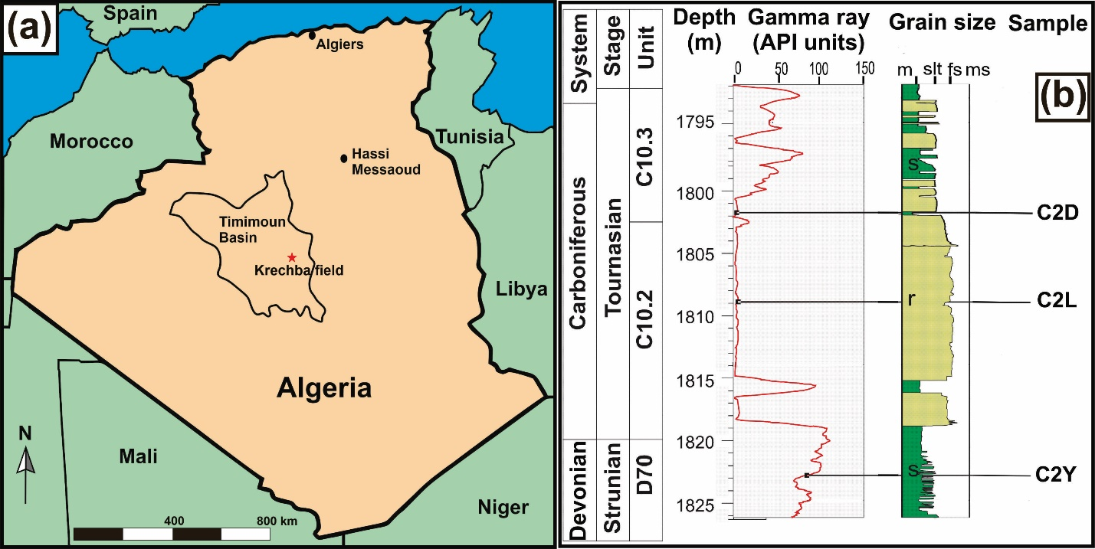
Figure 1. (a) Map of the Krechba field within the Timimoun Basin in Algeria, North Africa. (b) Stratigraphy , gamma ray log and grain size log of the reservoir of the Krechba field. Green units (s) on the log represent low porosity fluid flow barriers (seal or caprock) within the storage domain. Dark yellow units (r) represent reservoir units. The location of samples (C2D, C2Y, and C2L) used in this study is shown.
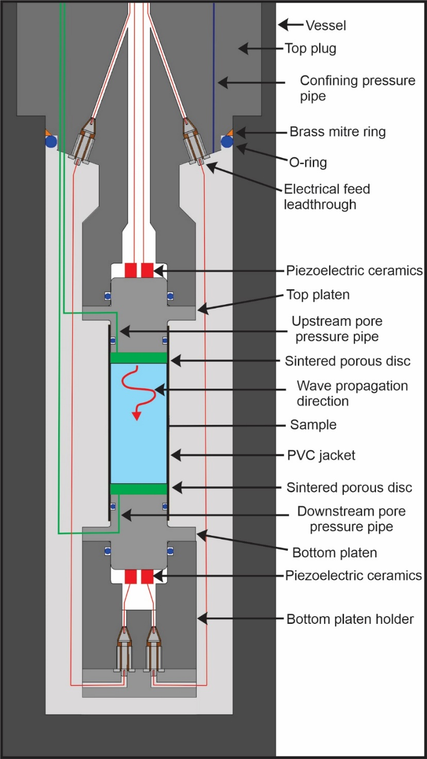
Figure 2. Schematic diagram of apparatus. The specimen was seated between the top and bottom platens, which housed the P- and S-wave piezoelectric ceramics. Sintered porous discs that have high permeability (1.3 x 10⁻¹³ m²) were placed at the ends of the specimen to ensure uniform pore pressure fluid distribution via the upstream and downstream pore pressure pipes. Permeability, and P- and S-wave velocities are measured along the axis of the specimen.

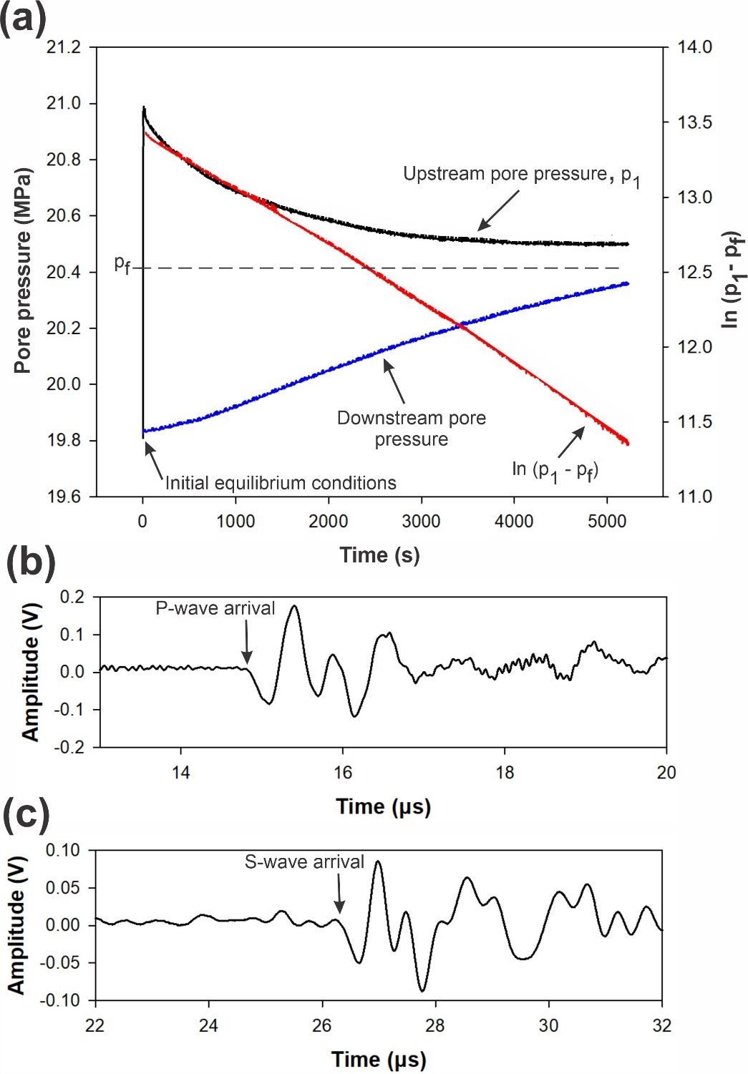
Figure 3. Typical permeability and P-and S-wave velocities measurements of specimen C2Y before thermal treatment at 10 MPa effective pressure during the pressurization stage. (a) Transient pulse decay measurement where the upstream and downstream pore pressures are initially at equilibrium. A small pressure difference is rapidly introduced across the specimen by instantaneously raising the upstream pore pressure. The gradient of the natural logarithm of the decay of the pressure transient (ln (p₁-p_{f} )) is used in the calculation of permeability. (b) P-wave form showing the P-wave arrival at 14.79 μs. (c) S-wave form showing the S-wave arrival at 26.26 μs.
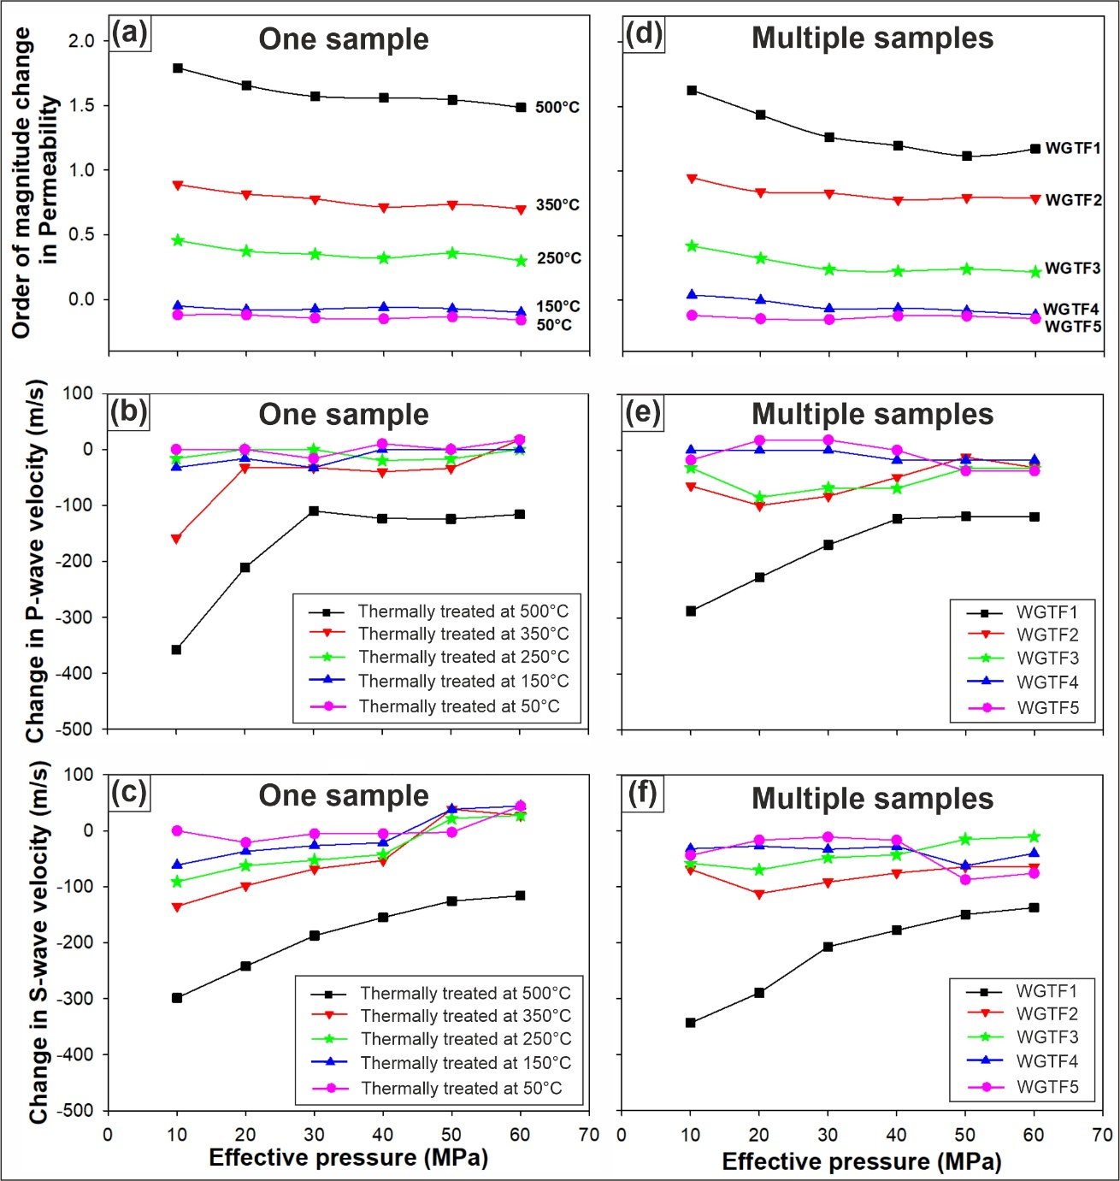
Figure 4. Comparison of changes in permeability and P- and S-wave velocities due to thermal treatment between using a single Westerly granite specimen (WGTFIC) (a, b, and c) and multiple Westerly granite specimens (WGTF1, WGTF2, WGTF3, WGTF4, and WGTF5) (d, e, and f). WGTFIC was subjected to increasing heating and rapidly quenching to room temperature (20 °C). WGTF1, WGTF2, WGTF3, WGTF4, WGTF5 were heated to 500, 350, 250, 150 and 50°C, respectively and then quenched to room temperature.
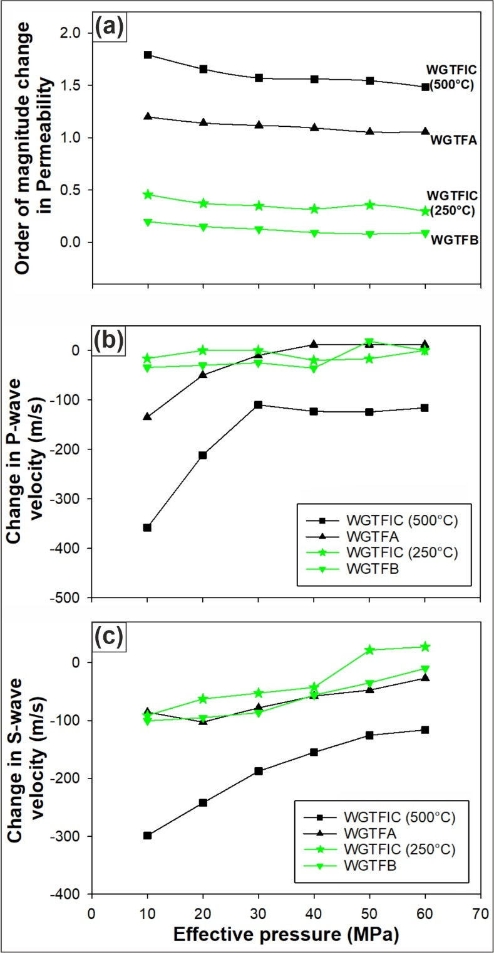
Figure 5. Comparison between change in permeability (a), P-wave velocity (b), and S-wave velocity (c) of Westerly granite specimens (WGTFA and WGTFB) that were heated and cooled at a slow rate (0.25 °C/min) and specimen that was heated and rapidly quenched (WGTFIC). WGTFA and WGTFB were thermally treated at 250 and 500 °C. WGTFIC was subjected to increasing heating and quenching to room temperature (20 °C).
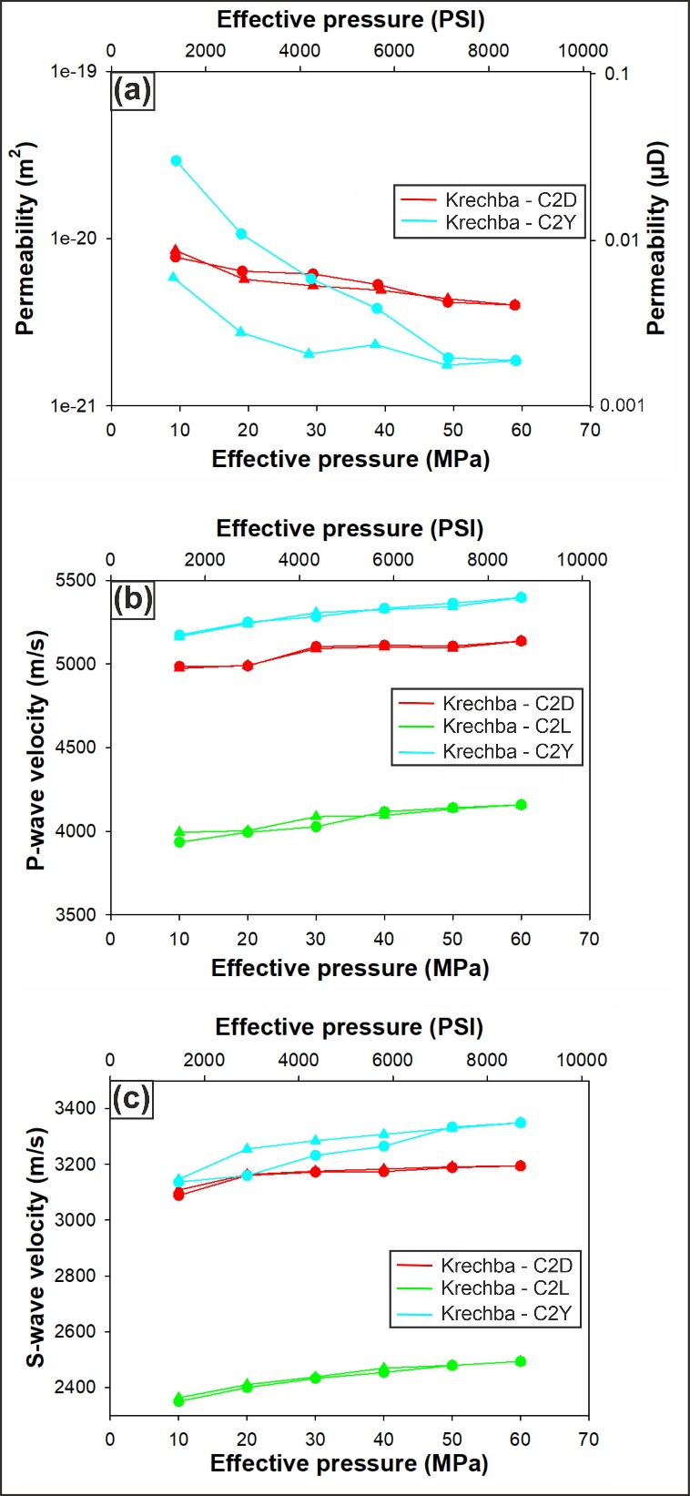
Figure 6. Permeability (a), P-wave velocity (b), and S-wave velocity (c) of Krechba specimens (C2D, C2L, and C2Y) before thermal treatment.
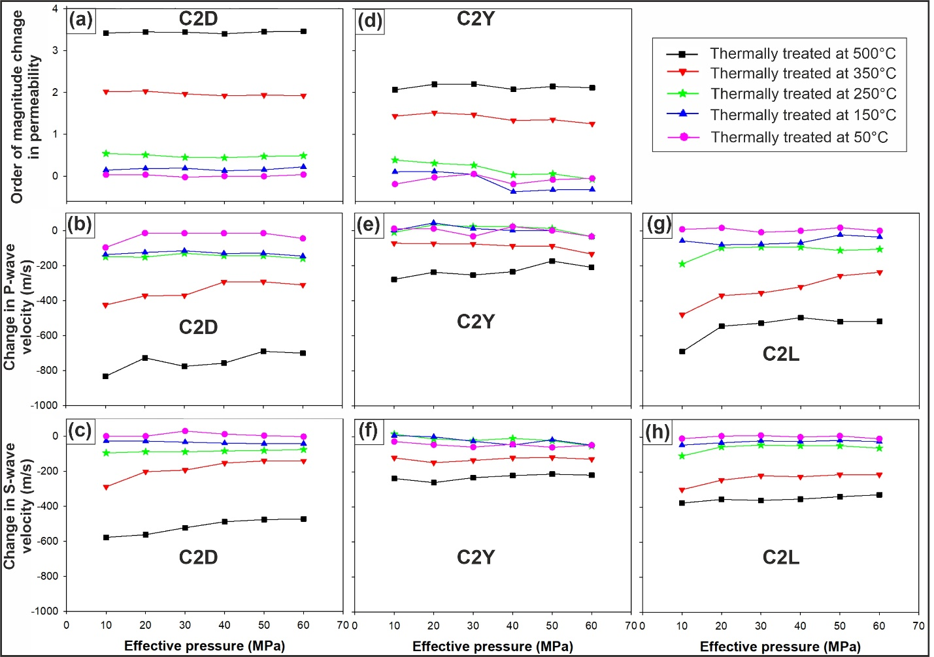
Figure 7. Change in permeability (a, d), P-wave velocity (b, e, and g) and S-wave velocity (c, f, and h) of Krechba specimens that were heated to 50, 150, 250, 350, and 500 °C and rapidly quenched to room temperature (20 °C) after each heating level.
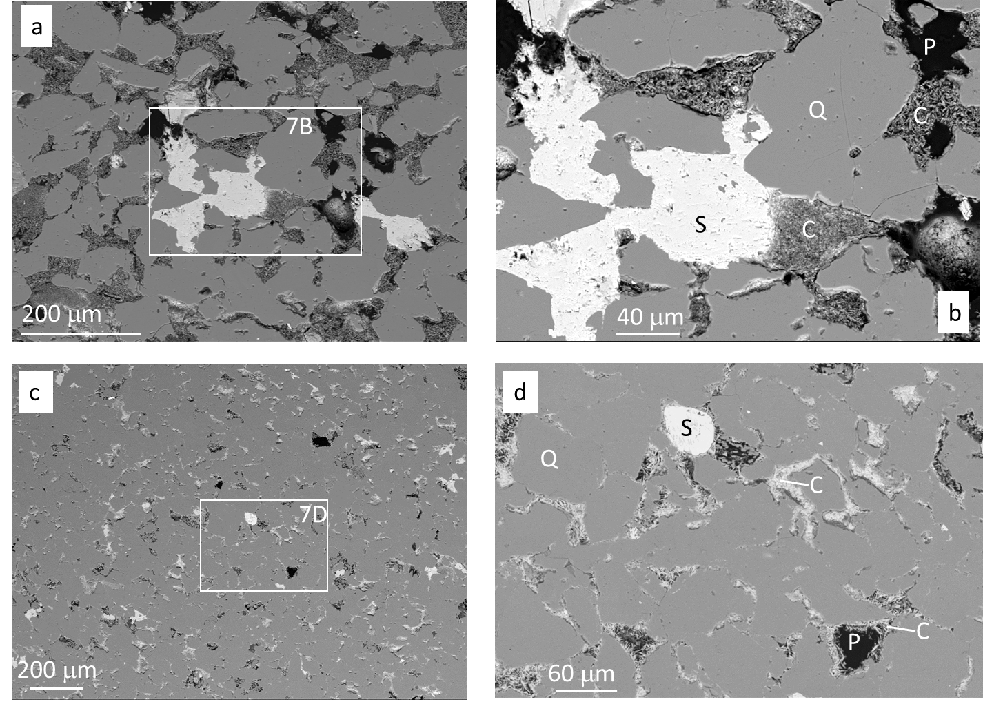
Figure 8. Backscattered electron microscope images of Krechba specimens before thermal treatment at different scales. (a) Specimen C2L low magnification. (b) Specimen C2L high magnification (inset in A). (c) Specimen C2D low magnification. (d) Specimen C2D high magnification (inset in C). C – Chlorite; P – Pore; Q – Quartz (detrital); S – Siderite.
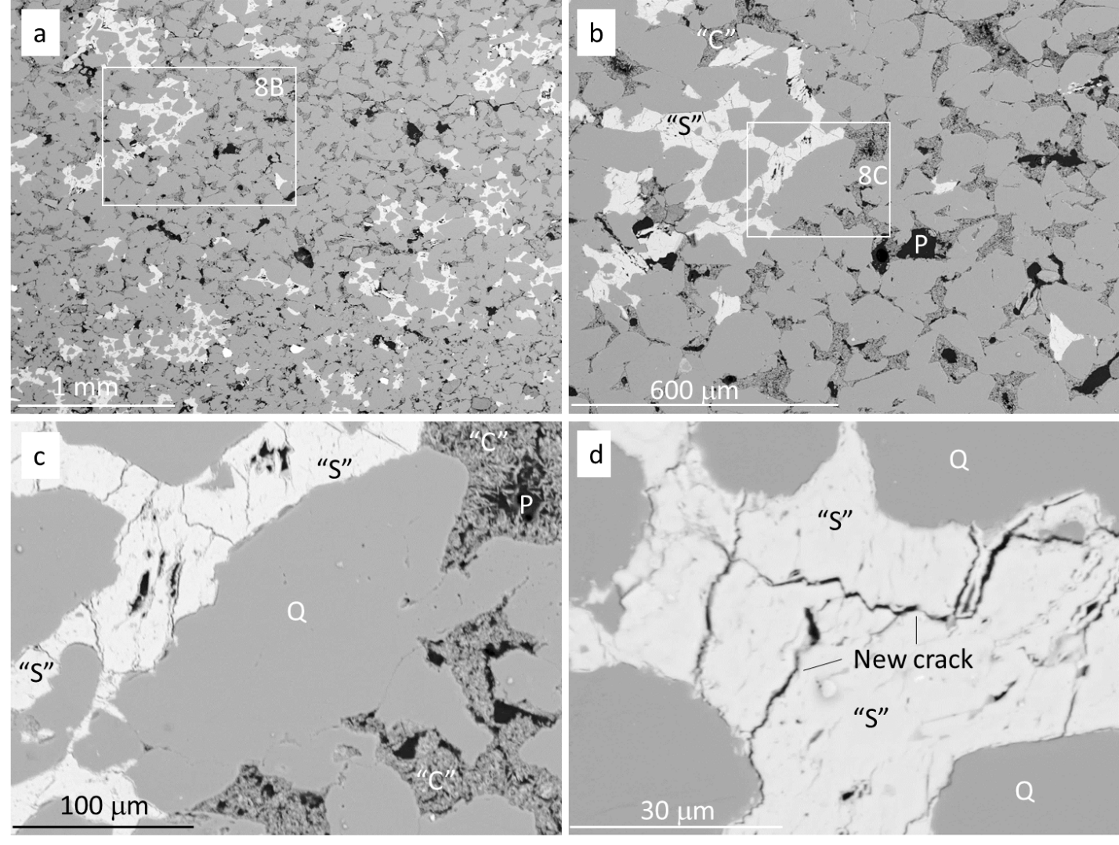Figure 9. Backscattered electron images of Krechba specimen C2L after heating to 500 °C and rapid quenching. (a) Low magnification image revealing the ubiquitous presence of two different types of Fe-rich pore-filling phases (altered Chorite (“C”) and Siderite (“S”)). (b) Higher magnification of Fig. 8a confirming the exclusive locations of the two Fe-rich pore-filling phases (“C” and “S”). (c) Higher magnification of Fig. 8b showing what appear to be new cracks in the high-density phase that has replaced siderite. Although the phase that sits between quartz grains, and in pores, resembles chlorite with its spiky-microporous character, XRD analysis (Fig. 10) shows that chlorite has been largely replaced in the specimens heated to 500 °C. (d) High magnification image showing new cracks in the high-density phase that has replaced siderite. Although the phase resembles siderite (Figs. 7a, b), XRD analysis (Fig. 10) shows that siderite has been largely replaced in the specimens heated to 500 °C. “C” – chlorite-replacement phase; “S” – siderite-replacement phase; P – pore; Q – quartz (detrital).

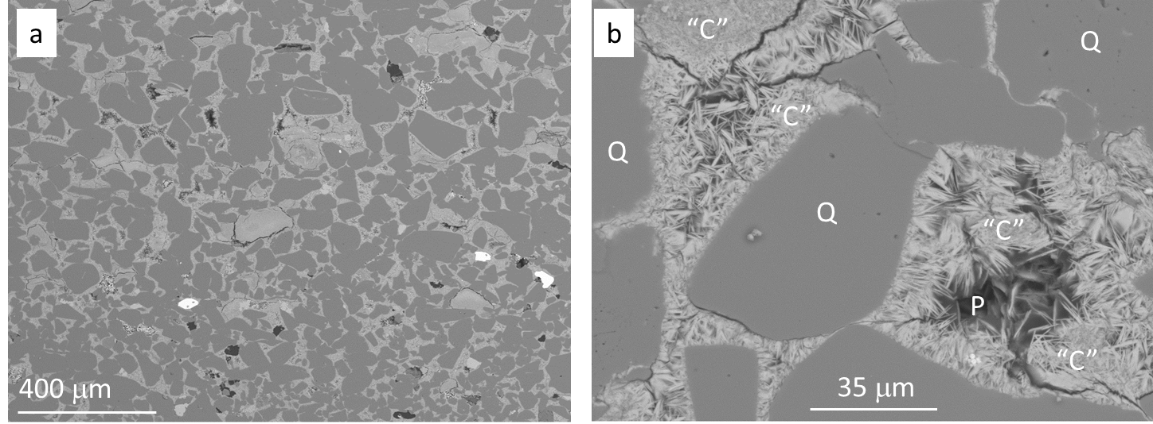Figure 10. Back scattered electron images of Krechba specimen C2D after heating to 500 °C and rapid quenching. (a) Low magnification image revealing the ubiquitous presence of a pore-filling, Fe-rich phase. (b) Higher magnification of quartz grains and Fe-rich pore filling phase. Although the phase that sits between quartz grains and in pores resembles chlorite, XRD analysis (Fig. 10) shows that chlorite has been largely replaced in the specimens heated to 500 °C. “C” – chlorite-replacement phase; P – pore; Q – quartz (detrital)
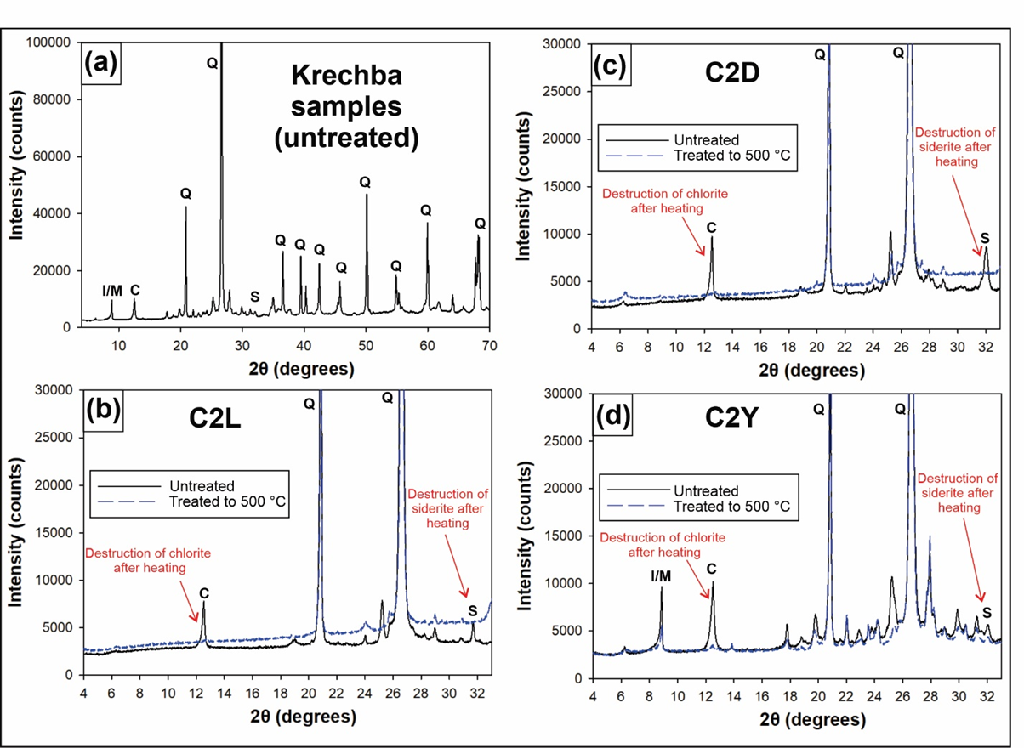Figure 11. X-ray diffraction traces of Krechba specimens before and after thermal treatment to 500 °C. The specimens heated to 500C have lost most of the initial chlorite and siderite. No new minerals have yet developed so that the lost of the original chlorite and siderite must have been accompanied by the development of amorphous (pre-crystalline) minerals that would eventually lead to the growth of an amphibole such as actinolite (McKinley et al., 2001) and hematite. C – Chlorite; I – Illite; M – Muscovite; S – Siderite; Q – Quartz.
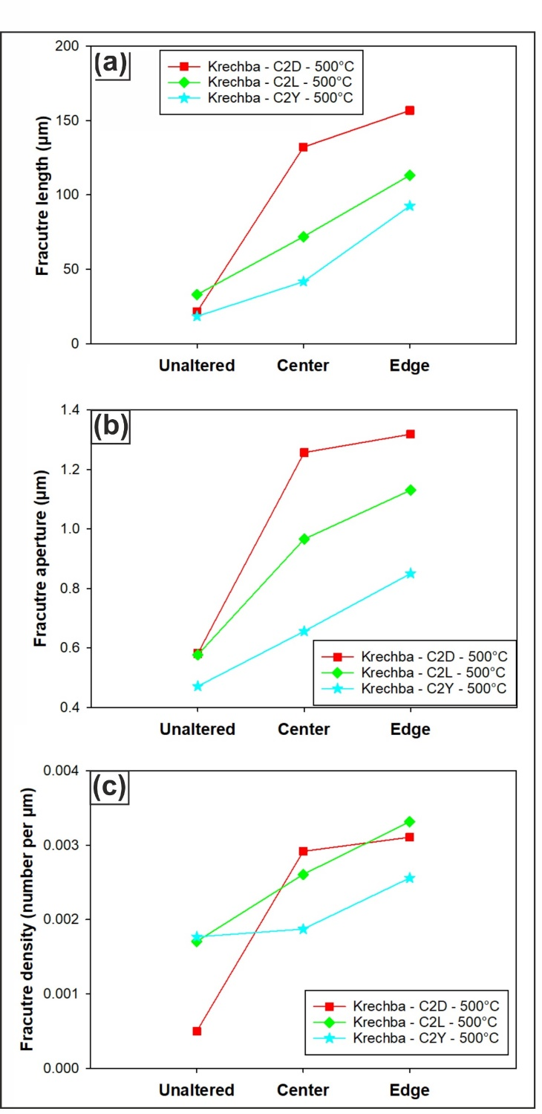
Figure 12. Fracture length (a), aperture (b) and density (c) of specimens before thermal treatment and after they were heated to various temperatures and then quenched to room temperature (20 °C).
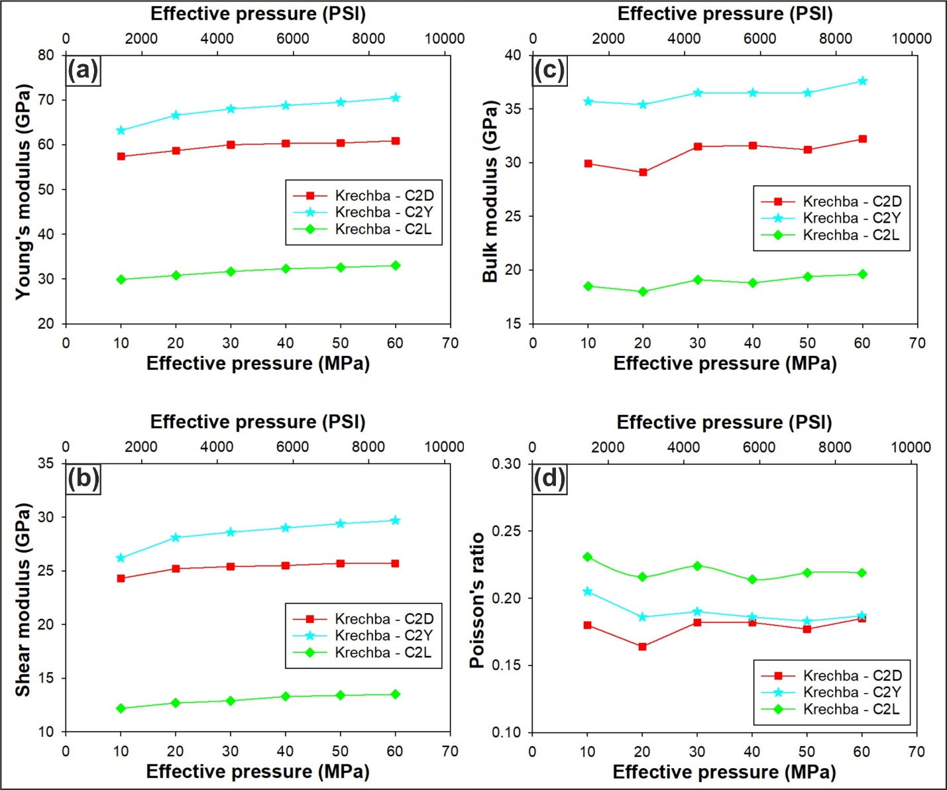Figure 13. Young’s modulus (a), shear modulus (b), bulk modulus (c), and (d) Poisson’s ratio of Krechba specimens (C2D, C2L, and C2Y) before thermal treatment.
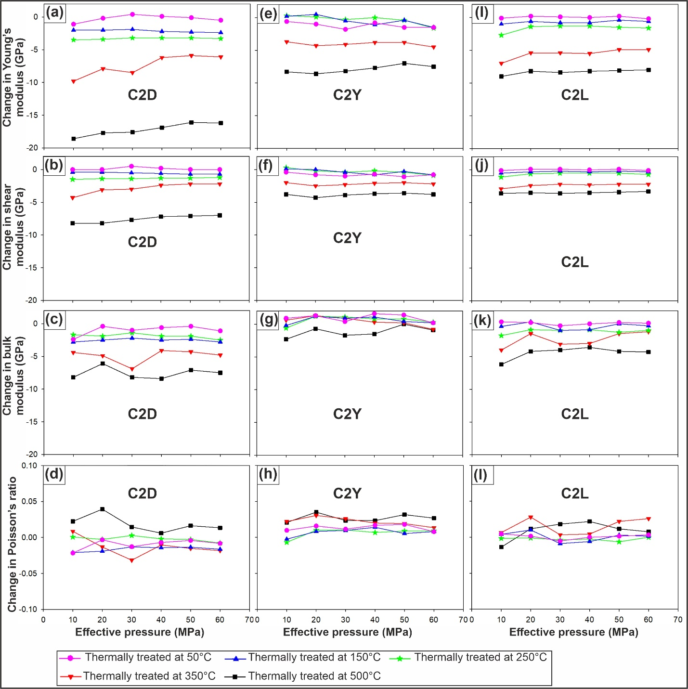Figure 14. Change in Young’s modulus (a, e, and i), shear modulus (b, f, and j), bulk modulus (c, g, and k), and Poisson’s (d, h, and l) of Krechba specimens that were heated to 50, 150, 250, 350, and 500 °C and rapidly quenched to room temperature (20 °C) after each heating level.

