Living with Ghosts: The Dead, Demonic and Divine
Heng, T. (2022, May 10). Living with ghosts: The dead, divine and demonic [Online]. The Sociological Review Magazine. https://doi.org/10.51428/tsr.iksg9021
Terence Heng

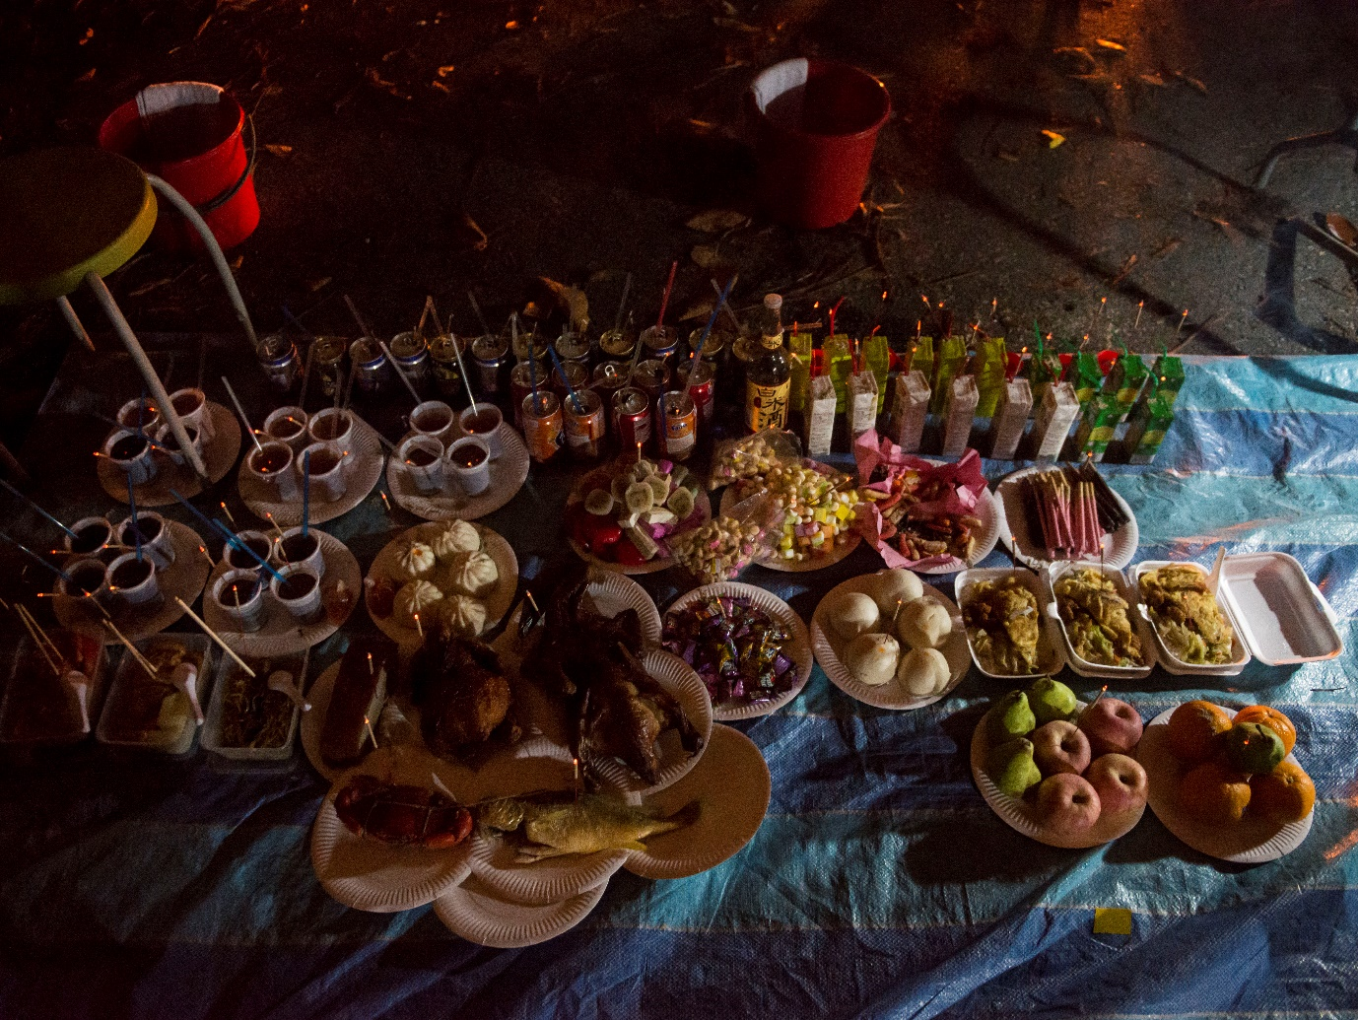
Figure 1: Food offerings for Unknown Spirits laid on tarpualin. In the background, buckets of water and a towel for spirits to refresh themselves. Bukit Brown Cemetery, 2012
Years ago, I found myself standing in the middle of a cemetery at midnight, camera in hand, anthropologist friend at my side. We had accompanied a small group of people, dressed all in white, who had come to the paupers’ section to lay out food offerings and chant prayers for the dead. Their spiritual leader later came to talk to us, and asked, “Do you feel them? They’re here, they’re all around – the spirits”.
I can’t say that I felt them, but I was sure he was being sincere. Just like my long-time Chinese spirit medium collaborator Nick, who explained to me his role as arbiter between living and the dead, and how many rituals involved recruiting, pleasing or regulating present, coherent and agentic spirits.
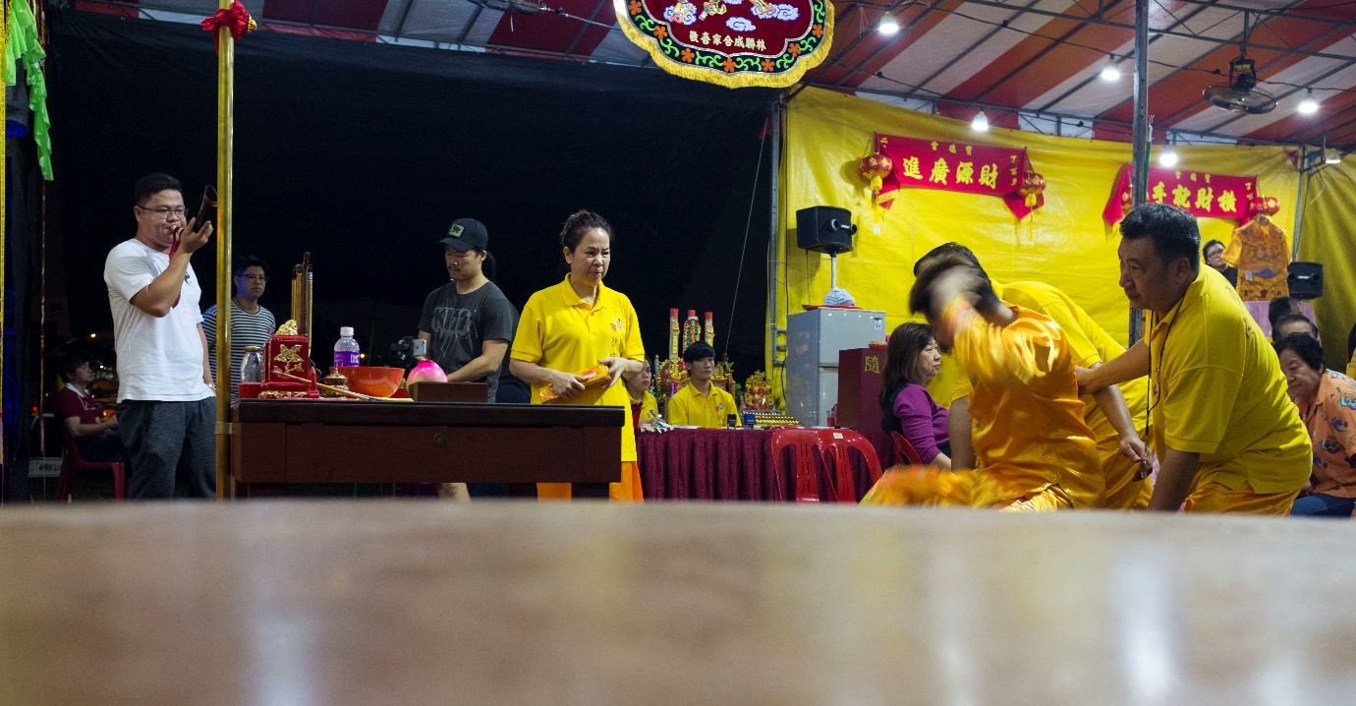
Figure 2: Nick (second from right), a Singaporean Chinese Tang-ki, or spirit medium, enters a trance to be possessed by the Monkey God, Qi Tian Da Sheng, during his spirit altar’s annual celebration in the neighbourhood
In the same way, I do not doubt how many of my informants, friends and family in Singapore see the living, material world as both tangible and intangible. To them, everyday life is not just about the living, but how the living co-habit with the dead, the divine and (sometimes) the demonic.
Such interaction with the spiritual realm is, of course, nothing new. Anthropologists and Sociologists have long documented the relationships that we have with spirits and deities (e.g. see Dahl, 2020; Sinha, 2016; Wilby 2005). That said, outside of institutionalised and organised forms of religion and spirituality, less is known about individualised relationships with spirits (and space).
At certain times of the year, these individual belief systems are supercharged into material practices of worship and worry. Rituals are enacted and offerings are made to appease wandering ghosts. Various mundane superstitions of risk management are performed to avoid trouble with spirits. For example, do not turn around if you hear your name called at night during the Hungry Ghost Festival. At the same time, many practices become opportunities for individuals and groups to engage in an outward show of collective identities.
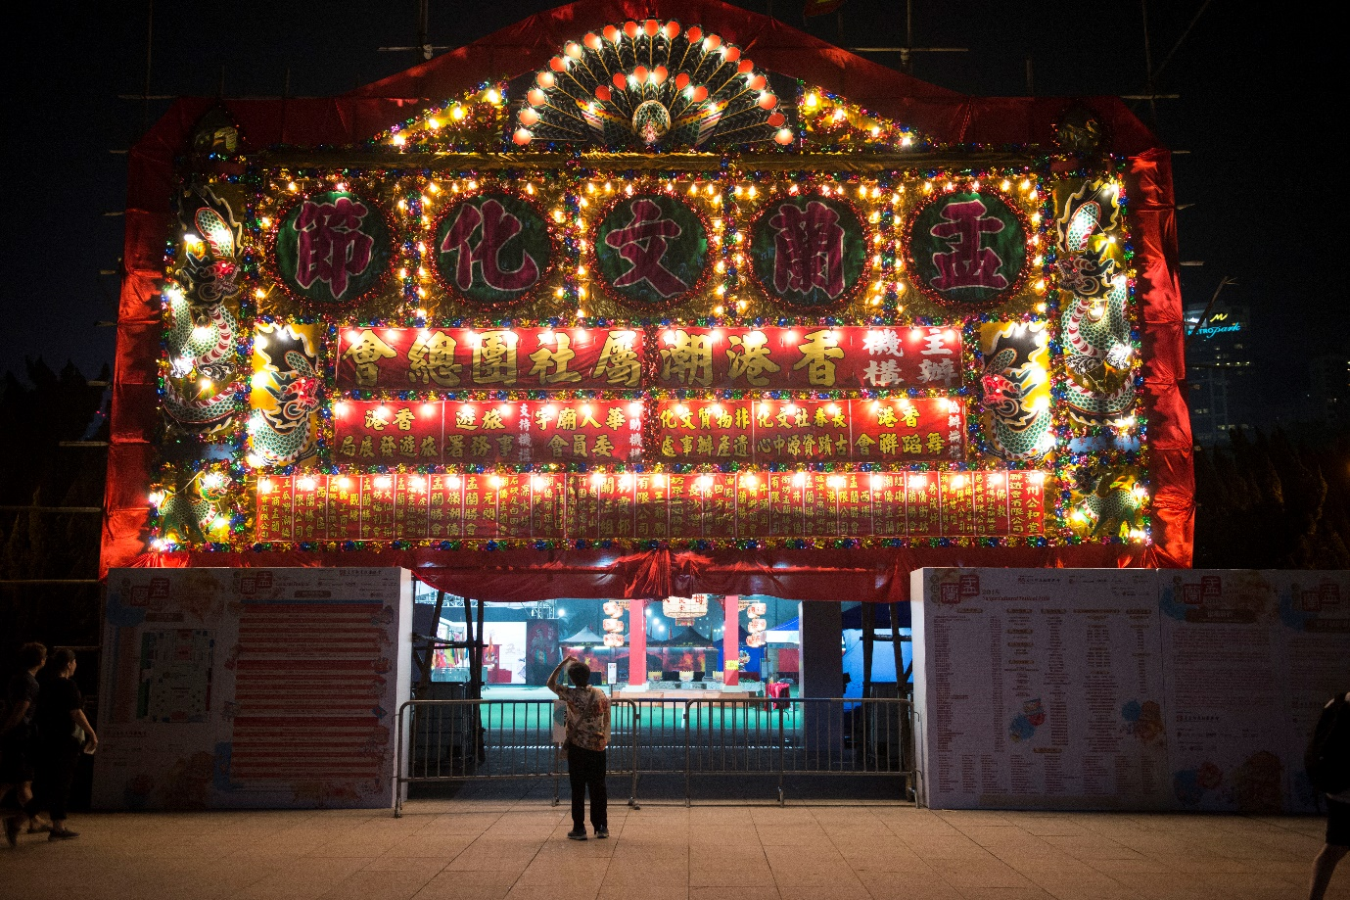
Figure 3: In Hong Kong, the Hungry Ghost Festival is also a chance to demonstrate region-specific Chinese identities (see Chan, 2018)
Almost 10 years of visual ethnographic fieldwork has led to my recent visual monograph, Of Gods, Gifts and Ghosts: Spiritual Places in Urban Spaces (Heng, 2020). In this book, I think about how Chinese religion practitioners make sense of the city through actions and artefacts. I offered a concept of a “spiritual imagination” – a way of seeing the world as physical and spiritual.
The spiritual imagination does not discount the restrictions of physical infrastructure or legal/political regulations of practice. Instead, it conceives of a world where spirits co-exist with individuals, institutions and physical and political structures. Just like Sociologists see the world through a sociological imagination, individuals exercising their spiritual imagination see the world as a place of, and for, spirits.
Figure 4: Adherents converse with Doreen, a Tang-ki, as she assumes the mantle of Tua Ya Pek, an underworld deity. The group is at the ground floor of a block of flats to ritually cleanse a recent suicide.
The sociological implications for a spiritual imagination twofold. For one, the spiritual imagination moves us towards an unspoken de-sequestration of death, even if modernity has sequestered it through institutions and professionalisation (Wilmott, 2000). Even if individuals are reluctant to talk about death, they certainly do death in their everyday lives through observance of rituals of fillial piety, especially during the annual tomb-sweeping festival Qing Ming Jie in March/April and the Hungry Ghost Festival in August (Heng, 2015).
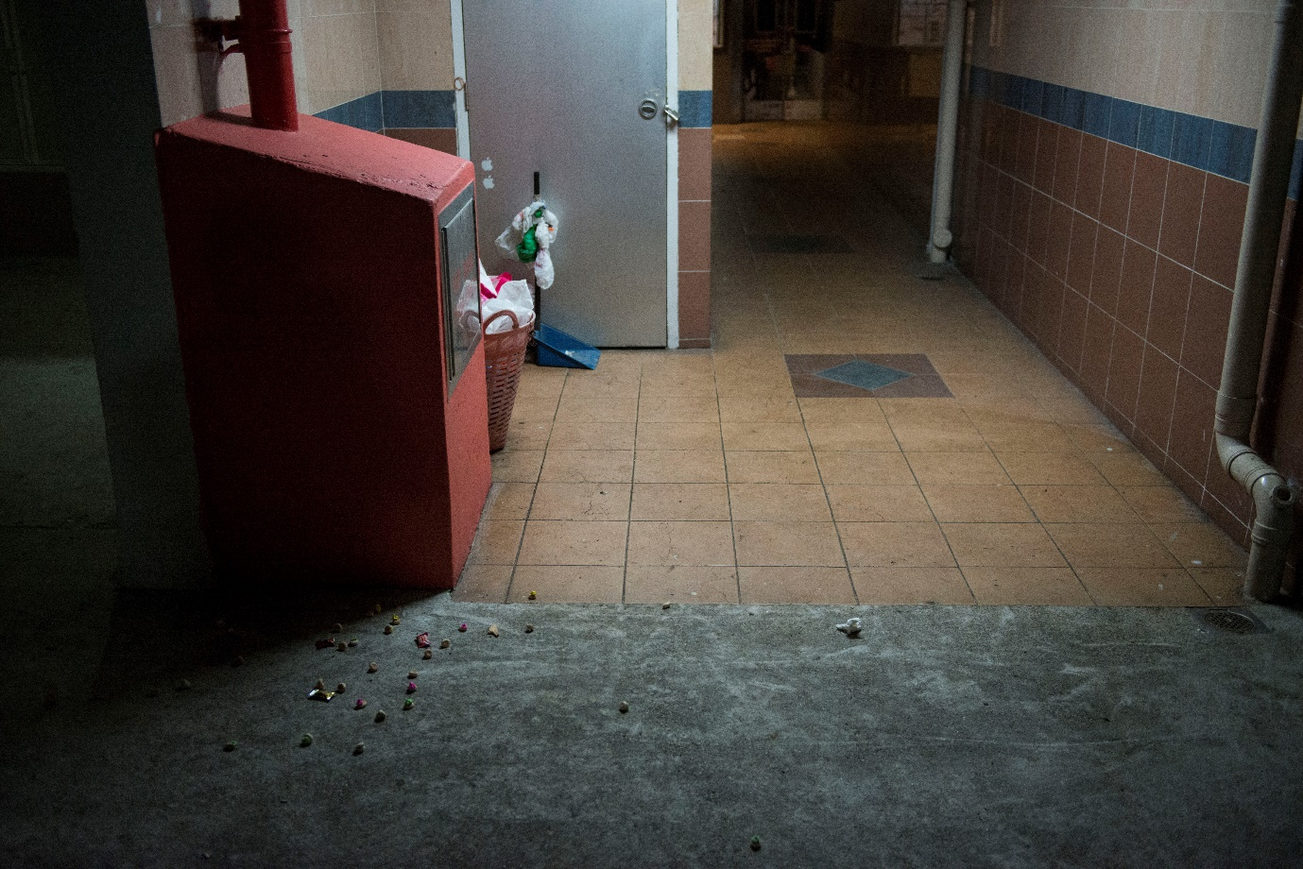
Figure 5: Roadside offerings remind us the dead are there. Iced Gem biscuits, an import of British global flows, becomes a snack for child ghosts in Singapore.
Two, the spiritual imagination opens up new ways of thinking how minority ethnic (and often diasporic) communities around the world re-imagine their practices in the face of state policies that limit, punish or monitor their activities. Although we know that funerals, festivals and other practices celebrating or remembering the dead are often powerful ways to perform and express identity (Garratini, 2007; Marchim 2013), the spiritual imagination is powerful resource for individuals, groups and communities to find ways around how their identities are spatially regulated.
Such ‘workarounds’ are apparent in the ways narratives around space are constructed (Woods, 2013) or how sacredness can be embodied (Heng, 2016; Holloway, 2003), but the fluidity of imagination allows for individuals to construct sacredness as they go. In other words, there is a flow of spirituality and sacredness, apparent where they choose to find it – over, above and through regulation and infrastructure.
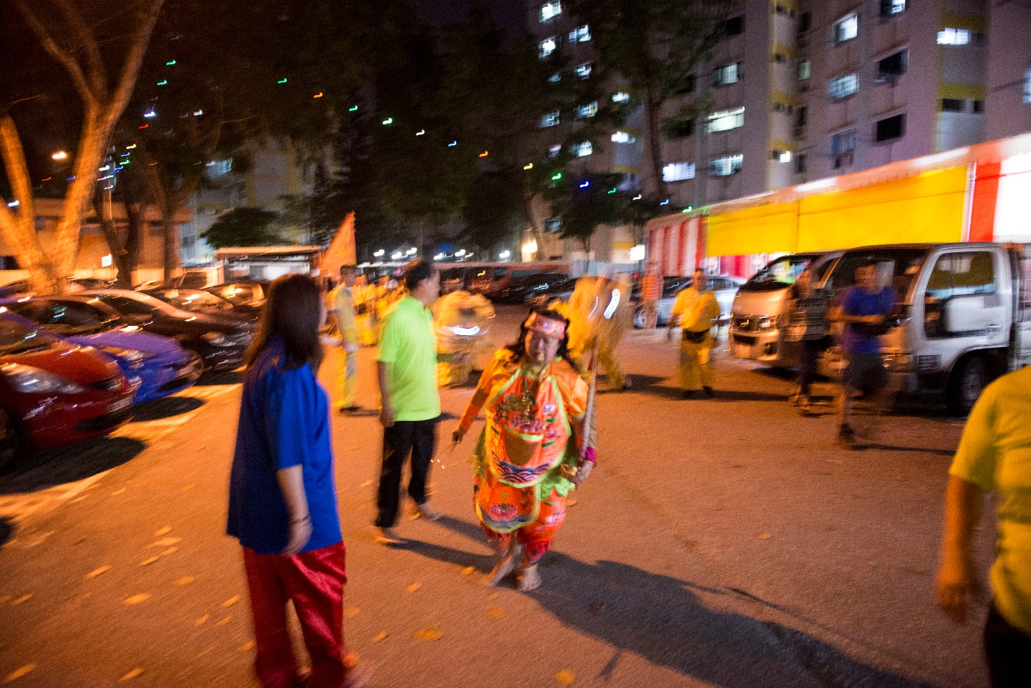
Figure 6: Embodied sacredness ebbs and flows into a carpark as a Tang-ki and her spirit altar celebrate the Hungry Ghost Festival.
References
Chan, S. C. (2018). Heritagizing the Chaozhou Hungry Ghosts Festival in Hong Kong. In C. Maags & M. Svensson (Eds.), Chinese Heritage in the Making (pp. 146–167). Amsterdam: Amsterdam University Press.
Dahl, S. A. P. (2020). Buddhist Mummy or ‘Living Buddha’? The Politics of Immortality in Japanese Buddhism. Https://Doi.Org/10.1080/00664677.2020.1786804, 30(3), 292–312. https://doi.org/10.1080/00664677.2020.1786804
Garattini, C. (2007). Creating memories: material culture and infantile death in contemporary Ireland. Mortality, 12(2), 193–206. https://doi.org/10.1080/13576270701255172
Heng, T. (2016). Making “Unofficial” Sacred Space: Spirit Mediums and House Temples in Singapore. Geographical Review, 106(2), 215–234. https://doi.org/10.1111/j.1931-0846.2015.12156.x
Heng, T. (2015). An appropriation of ashes: transient aesthetic markers and spiritual place-making as performances of alternative ethnic identities. The Sociological Review, 63(1), 57–78. https://doi.org/10.1111/1467-954X.12235
Heng, T. (2020). Of Gods, Gifts and Ghosts: Spiritual Places in Urban Spaces. London: Routledge.
Holloway, J. (2003). Make-believe: spiritual practice, embodiment, and sacred space. Environment and Planning A, 35(11), 1961–1974. https://doi.org/10.1068/a3586
Marchi. (2013). Hybridity and Authenticity in US Day of the Dead Celebrations. The Journal of American Folklore, 126(501), 272. https://doi.org/10.5406/jamerfolk.126.501.0272
Sinha, V. (2016). Marking spaces as ‘sacred’: Infusing Singapore’s urban landscape with sacrality. International Sociology, 31(4), 467–488. https://doi.org/10.1177/0268580916643259
Wilby, E. (2005). Cunning Folk and Familiar Spirits. Sussex: Sussex Academic Press. Retrieved from http://www.sussex-academic.com/sa/titles/history/Wilby.htm
Willmott, H. (2000). Death. So what? Sociology, sequestration and emancipation. Sociological Review, 48(4), 649–665. https://doi.org/10.1111/1467-954X.00237
Woods, O. (2013). Converting houses into churches: the mobility, fission, and sacred networks of evangelical house churches in Sri Lanka. Environment and Planning D: Society and Space, 31(6), 1062–1075. https://doi.org/10.1068/d7912

