Title: Synaptic transistors based on transparent oxide for neural image recognition
Author:

Q N Wang¹⁻³, C Zhao^{1-3,*}, W Liu^{1,2,*}, I Z Mitrovic², H van Zalinge², Y N Liu ^{4,5}, C Z Zhao¹⁻³
¹ School of Advanced Technology, Xi’an Jiaotong-Liverpool University, Suzhou, China.
²Department of Electrical Engineering and Electronics, University of Liverpool, Liverpool, UK.
³AI University Research Centre (AI-URC), Xi’an Jiaotong-Liverpool University, Suzhou, China
⁴ Department of Applied Mathematics, Xi'an Jiaotong-Liverpool University, Suzhou 215123, China
⁵ Department of Applied Mathematics, University of Liverpool, Liverpool L69 7ZD, UK.
*E-mail: Chun.Zhao@xjtlu.edu.cn, Wen.Liu@xjtlu.edu.cn

Keywords: image recognition, solution-processed transistor, synaptic device, MNIST, neural computing.
Abstract
Artificial synaptic devices are the critical component for large-scale neuromorphic computing, which surpasses the limitations of von Neumann's structure. Recently the emerging electrolyte gated transistor (EGT) has proven to be a promising neuromorphic application due to the conductance can be updated by the gate voltage stimulation. This paper presents a new low-temperature solution-based oxide thin film transistor with lithium (Li) ion dope dinto dielectric layer. We have proposed the indium oxide (InO_{x})/ zirconia (ZrO_{x}) transistor with large hysteresis. The synaptic plasticity of EGTs demonstrate the potential to simulate the biological neuron and calculation function. Moreover, the inhibitory/excitatory postsynaptic current (IPSC/EPSC), long-term potentiation/depression (LTP/LTD), short-term potentiation (STP), and paired-pulse facilitation (PPF) are confirmed through the electrical stimulation. The suitable ion doping concentration is obtained by the synaptic electrical characteristic. The synaptic transistor also has a low-noise linear conductance update and a relatively high G_{max}/G_{min} ratio. According to the G_{max}/G_{min} ratio and nonlinearity, the weight update process can be simulated for neuromorphic computing.

Introduction
In recent years, computing systems with bionic brain structures have attracted extensive attention [1-3]. Massively parallel computing and edge computing based on the synaptic devices can reduce the energy and improve the operation speed. The device of simulating biological synaptic behavior and function with artificial synapse as the core unit has been widely studied and has been proposed for multi-level storage and parallel computing [4]. According to the different mechanisms, synaptic transistors can be roughly divided into electrolyte gate transistor, floating-gate synaptic transistor, ferroelectric-gate synaptic transistor, electrolyte-gate synaptic transistor, and optoelectronic synaptic transistor. These different types of transistors can simulate abundant synaptic plasticity. Moreover, compared with two terminal devices, three terminal devices have great advantages in terms of stability and repeatability. The synaptic transistors of three terminal devices have the potential to accept both light stimulation and electrical stimulation by applying voltage to the gate electrode and applying the light to the channel.
The electrolyte-gate synaptic transistor is similar to the biological synapses in working principle. Neurons transmit the chemical information between the pre-synaptic and post-synaptic through the synaptic vesicle. Synaptic vesicles release neurotransmitters to receptors in post-synaptic terminal to produce the action potentials. The same working mechanism can be realized in EGTs based on the ion migration. By applying positive voltage to the gate electrode, ions migrate to the channel under the electric field to form the electric double layer. The ions pass further through the dielectric layer under the stronger electric field to increase the conductance in the channel. This phenomenon makes the conductance of EGTs as synaptic weight under the voltage stimulation.
In this paper, the solution-processed metal-oxide synaptic transistors have been proposed with Li⁺ ion-doped ZrO_{x} layers. Several typical synaptic behaviors, including inhibitory/excitatory postsynaptic current (IPSC/EPSC), long-term depression/potentiation (LTD/LTP) The long-term potentiation, and short-term potentiation of biological synapses are successfully simulated by applying the electrical pulse sequence on the gate electrode [3]. The simulated SLP-based ANN consists of 785 presynaptic electrical signals. Then 785 x 10 = 7850 crossbar array simulate biological synaptic weights [4,5]. The recognition accuracy rate reaches the 81% with the 100 epochs.

Experimental Methods:
Fabrication of artificial synaptic TFT:The ZrO_{x}-Li precursor solution (1.5M) was prepared by dissolving aluminum nitrate hydrate (ZrO (NO₃)₂·xH₂O) and 0.55M indium nitrate hydrate into deionized water. The InO_{x} precursor solution (1M) was prepared by dissolving indium nitrate hydrate (In (NO₃)₃·xH₂O) into deionized. First, the heavily doped Si (n++) substrate was cleaned by deionized water and dried under N2 flow. Afterward, the processed substrate was further treated by Plasma for 20 minutes to allow the film surface hydrophilic treatment. The ZrOx-Li film was spin-cast with precursor solution at 4000 rpm for 30 s and then annealed for 90 mins at 250°C in the air atmosphere. The InOx films was spin-cast with precursor solution at 3000 rpm for 40 s and then annealed for 1h at 230°C for the in the air atmosphere. The 40 nm thick Al source/drain(S/D) electrodes were fabricated by thermal evaporation through the shadow mask.
Device Characterization: A semiconductor parameter analyzer (Agilent B1500) with transistor characterization software under atmospheric conditions was operated to test the electrical properties of the Li doing InO_{x}/ZrO_{x} synaptic TFTs. To measure the EPSC/ IPSC current flowing between the S/D electrodes, the 0.1 V steady voltage bias was applied to the postsynaptic terminal.
ANNs simulation: The calculated conductance of synaptic TFT in the crossbar array was applied with the positive synaptic weight value. The measurement of the neurocomputing in ANNs Includes negative values. Subsequently, the synaptic weight (w = G⁺– G⁻) was expressed as the difference between the state of two synaptic devices (expressed as G⁺ and G⁻) between each conductance value [6, 7]

Results and discussion:
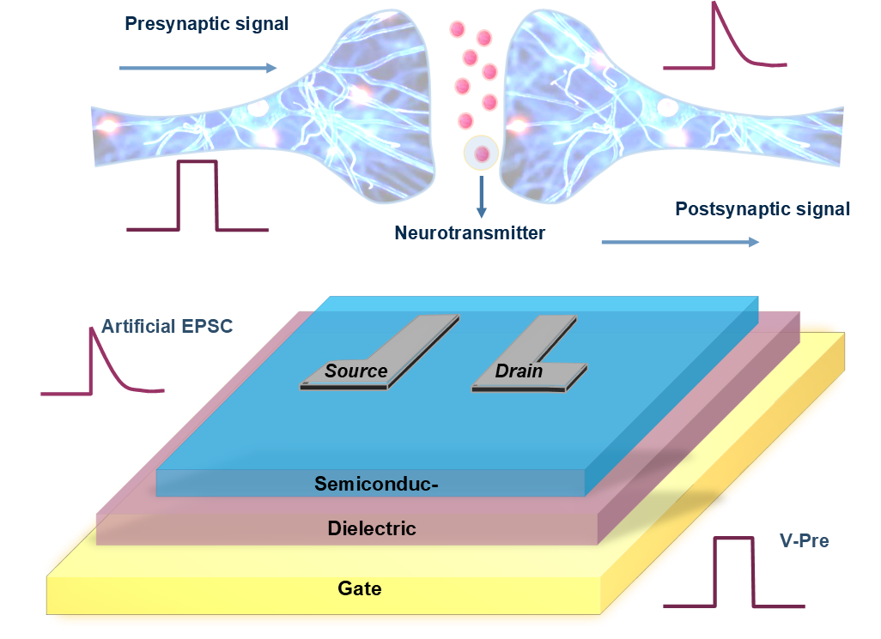
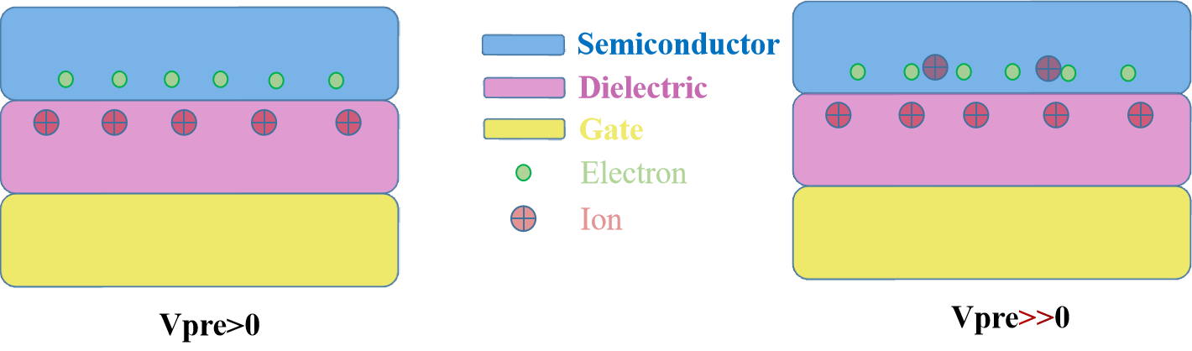
FIG.1. Schematics illustration of the transparent oxide synaptic transistor and the mechanism of synaptic device
Biological chemical synapses are the fundamental components of recollection, understanding, and computation that connect the neurons in the human brain [8]. Figure 1a shows the relationship between biological synapses and synaptic devices. Synaptic transmission is a complex transmission process. The presynaptic can be regarded as gate electrode and the postsynaptic can be regarded as drain electrode. The information in neurotransmitter can be regarded as the ion migration from the dielectric layer to the channel. The mechanism of electrolyte gate transistors based on the ion migration under voltage stimulation. When gate electrode are applied to the weak voltage, the ion in the dielectric layer migrate the the interface. Meanwhile, the formed ionic film will attract electrons to form an electric double layer. When gate electrode applied to the strong voltage, the ions will pass through the interface into the semiconductor layer and increase the conductance of synaptic device.

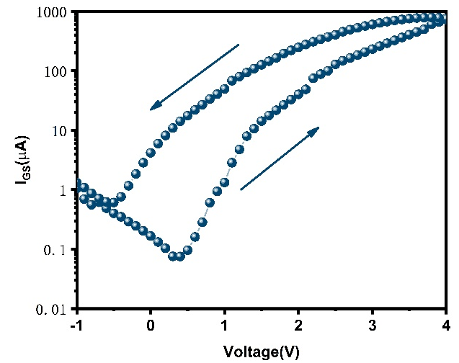
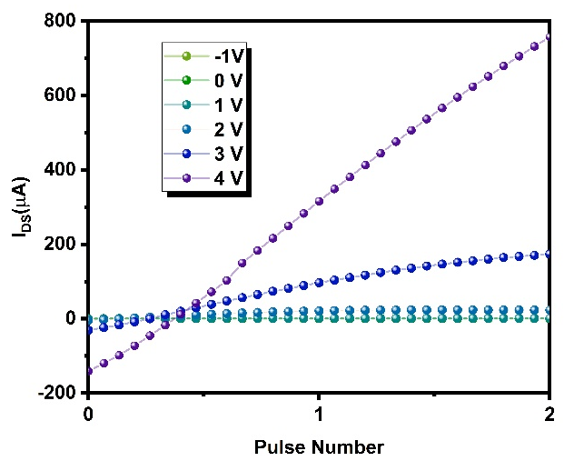
FIG.2. (a) Output characteristic curve of doped synaptic EGT (b) Transfer characteristic curve of doped synaptic EGT.
(b)
(a)
The output characteristic curve of Li ion doped synaptic EGTs shows in the Figure 2a. Typical n-type characteristics are shown in the figure. The V_{GS} gradually increases from -1 V to 4 V with 1 V step. In order to demonstrate the n-type transistor characteristic parameters of the synaptic EGTs with Lithium ion doping, the transfer curves of the system with VGS (gate voltage) sweeping at a rate of 20 mV s-1 and VDS=2 V were evaluated and plotted (Figure 2b). According to the trend of transfer curve, the synaptic TFTs have high I_{on}/I_{off} ratio (8200) and high mobility which are the important characteristic of TFTs. Through in-depth analysis of synaptic performance, it can be found that there is obvious current hysteresis. The reason for the large hysteresis can be attributed to the electrochemical doping, and the larger hysteresis also means that the device has a larger storage window.
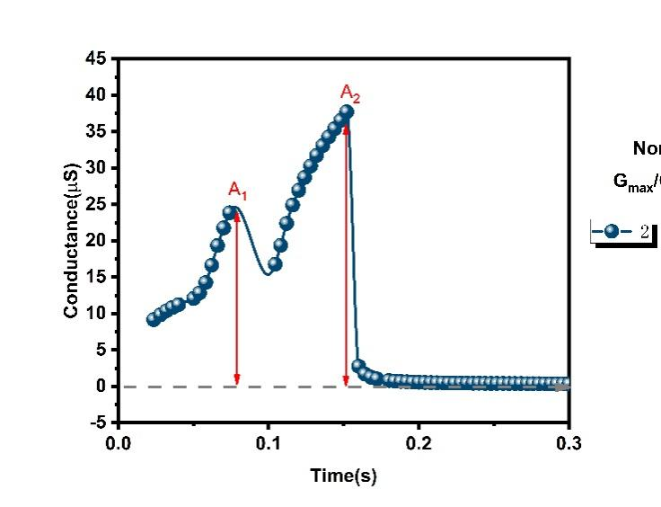
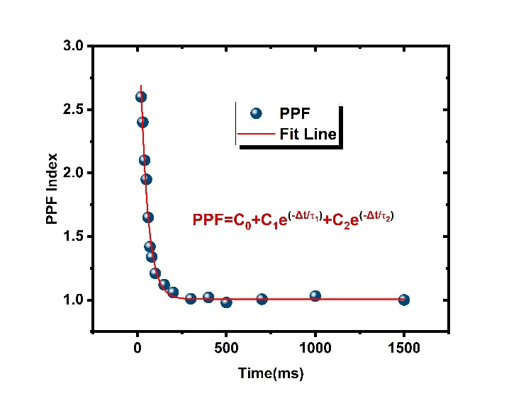
FIG.3. (a) PPF index, defined as A₂/A₁. (b) The EPSC stimulated by the two positive voltage (2 V).
(b)
(a)
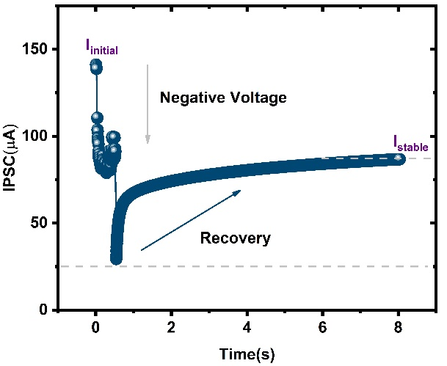
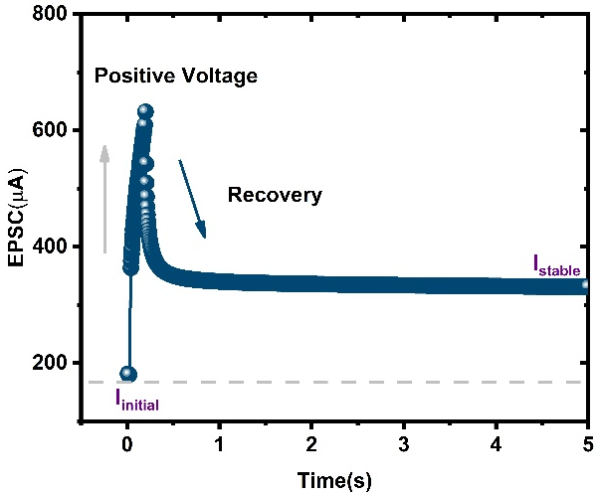
FIG.4. (a) The EPSC stimulated by positive presynaptic spike in 5 s. (b) The IPSC stimulated by negative presynaptic in 8 s.
(b)
(a)
Paired pulse facilitation (PPF) is another universal form of short-range synaptic plasticity, which is the fundamental type of STP, also the linchpin to processing sound and temporal image information in the neuron (Figure 3a, b). The following expression can be described and evaluated as the PPF index.
$PPF=\frac{A_{2}}{A^{1}}∗100\%$ (1)
Under the minimum time interval, the double-pulse facilitation coefficient((A₂/A₁) is the maximum. The following function expresses the relation between PPF and Δt.
$PPF=C_{0}+C_{1} e^{\left(−\frac{Δt}{τ1}\right)}+C_{2} e^{\left(−\frac{Δt}{τ2}\right)}$ (2)
Initial constants of rapid and slow phases C₀, C₁, and C₂ are 1, 15%, and 36%. The relaxation times are $τ1$(15 ms) and $τ2$(52 ms).
The action potential produced by the axon end of the presynaptic neuron opens the calcium channel, and calcium diffuses in neurons [9]. The presynaptic corresponds to the gate electrode of the thin film transistor and the postsynaptic corresponds to the drain electrode. EPSC and IPSC are the most basic information flow and processing processes in complex computing [10]. Figure 4a and Figure 4b demonstrates the inhibitory/excitatory postsynaptic current behavior. This process achieved by applying a positive voltage (2V 40ms) and a negative voltage (-2V 50ms). The conductance in the channel rises rapidly to 682μA and then falls back to 356μA. The reason for this nonvolatile phenomenon is the increase and decrease of Li ions in the channel. Ions migrate in dielectric and semiconductor layers under the stimulation of voltage. The connection strength of synaptic weight can not only increase, but also decrease. EPSC / IPSC and the memory form in our brain are inseparable.

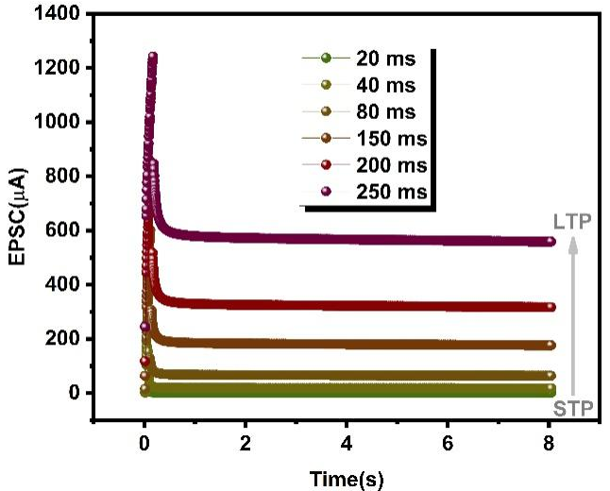
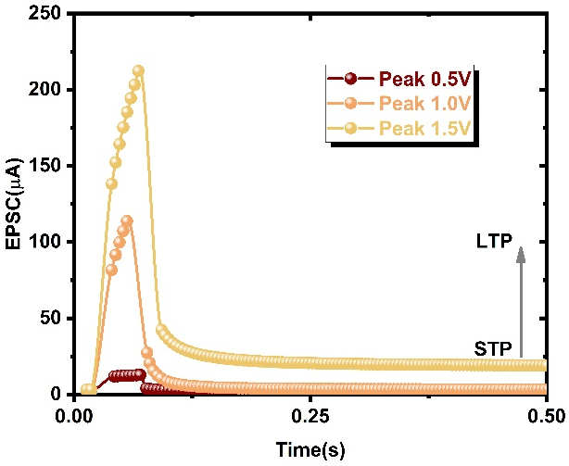
FIG.5. (a) The EPSC triggered by 3 positive pulses with 30 ms width as V_{DS} = 0.5 V. (b) The EPSC triggered by positive pulses with 6 pulse durations as V_{DS} = 0.5 V.
(a)
(b)
Figure 5a mainly illustrates the effect of electrical pulse amplitude on channel conductance. With increase of electrical pulse amplitude (from 0.5 V to 1.5 V), the conductance increase from initial value (5 μA) to the 23 μA. The conductance value as synaptic weight for neural network changes from STP to LTP and remains stable state for a certain period time (0.5 s). This phenomenon demonstrates the conductance have the potential to be orderly controlled for parallel computing. The transmission of information also depends on the width of the data. Moreover, with the increase of electrical pulse width, the conductance increase from initial value (10 μA) to the 598 μA after stimulation. There is a linear relationship between the electric pulse width and the corresponding conductance. It also shows that synaptic weight can be quantified by electrical stimulation. The gate of thin film transistor can be regarded as the pre-synaptic. At the same time, the change of synaptic weight is sensitive to pulse width compared with pulse intensity. This is attributed to the small ion radius and large diffusion coefficient of lithium. It is worth that each test shall be conducted at an interval of 3 minutes to ensure the accuracy.

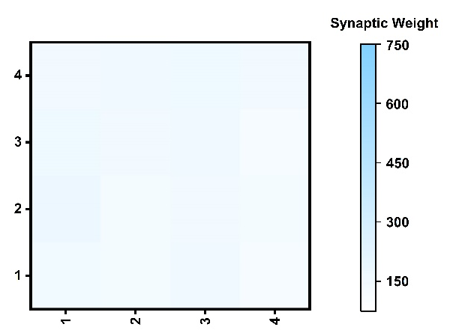
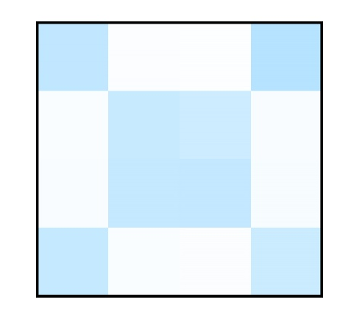
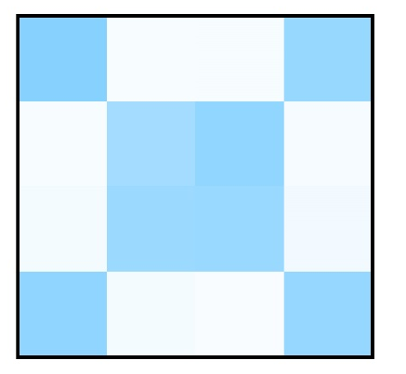
FIG.6. 4×4 array synaptic device before the voltage stimulation and after voltage stimulation.
Figure 6 mainly reflects the synaptic device in matrix form. The conductance before electrical stimulation is the original value. In order to reflect the stability and controllability of synaptic weight change. Uniform electrical stimulation is applied to gate of thin film transistors at different positions. After five minutes of electrical stimulation, the synaptic weight will eventually decrease slowly and stabilize in a small range. This phenomenon proves the synaptic weight update in the device array. The specific application involves the updating rules. Because there will be crosstalk between adjacent devices. The main reason for the increase of synaptic weight is the migration of lithium ions from the dielectric layer to the semiconductor layer. The X character composed of eight synaptic thin film transistors of 16 can be clearly distinguished.

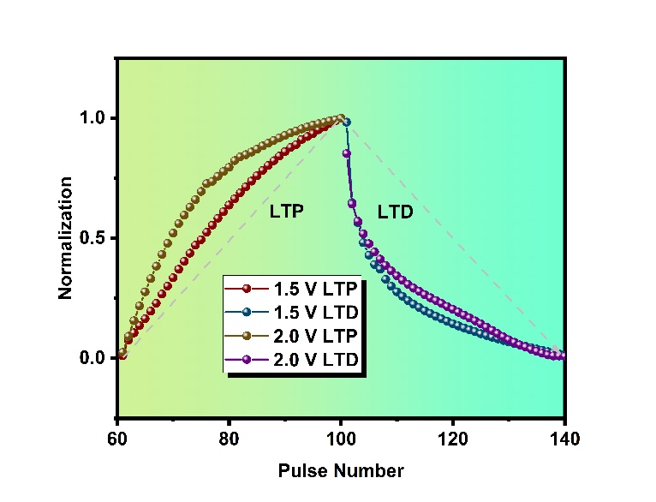
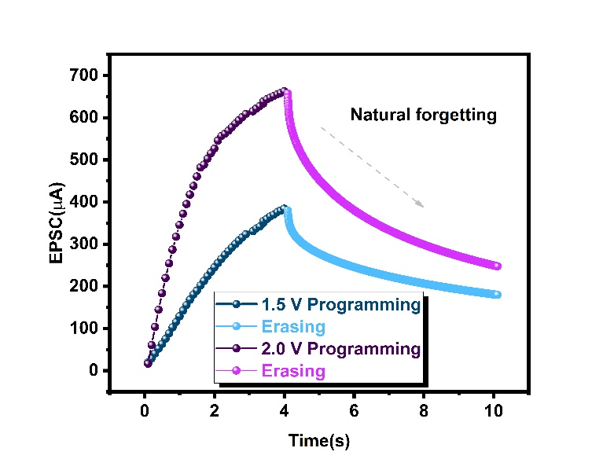
FIG.7. The increasing and decreasing of channel conductance illustrating the long-term potentiation (LTP) and long-term depression (LTD).
(b)
(a)
Figure 7a shows the effect of the 80 pulses on LTP / LTD characteristics under different voltage stimulations in the case of normalization [11]. The learning step size and weight change in artificial neural network are related to the nonlinearity and the maximum and minimum conductance value. The 40 positive consecutive pulses are applied to the presynaptic terminal that simulate the programming process of synaptic device. Then the 40 negative consecutive pulses applied to the presynaptic terminal that simulate the erase process of forgetting. Figure 7b demonstrate the natural forgetting to prove that the synaptic EGT has typical synaptic plasticity. Compared with programmable erasure, natural forgetting has a longer relaxation time. This phenomenon is similar to the working mechanism of synapses in our body. Therefore, bionics with synaptic transistors can be used to simulate more synaptic plasticity.

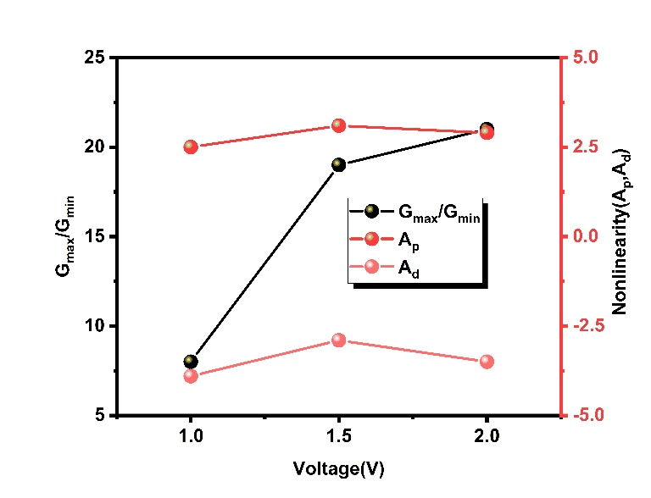
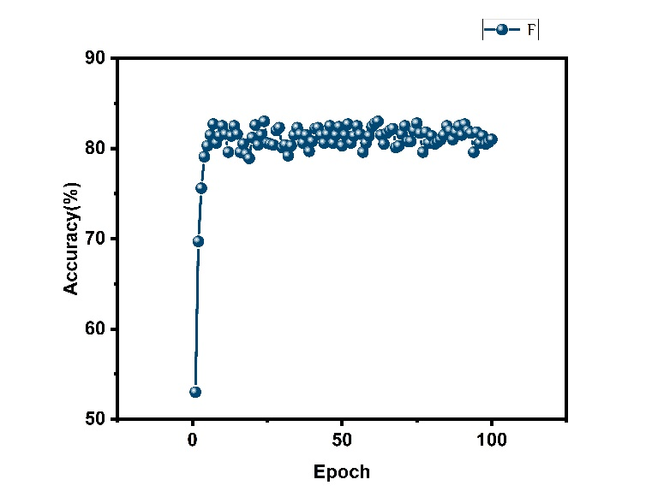
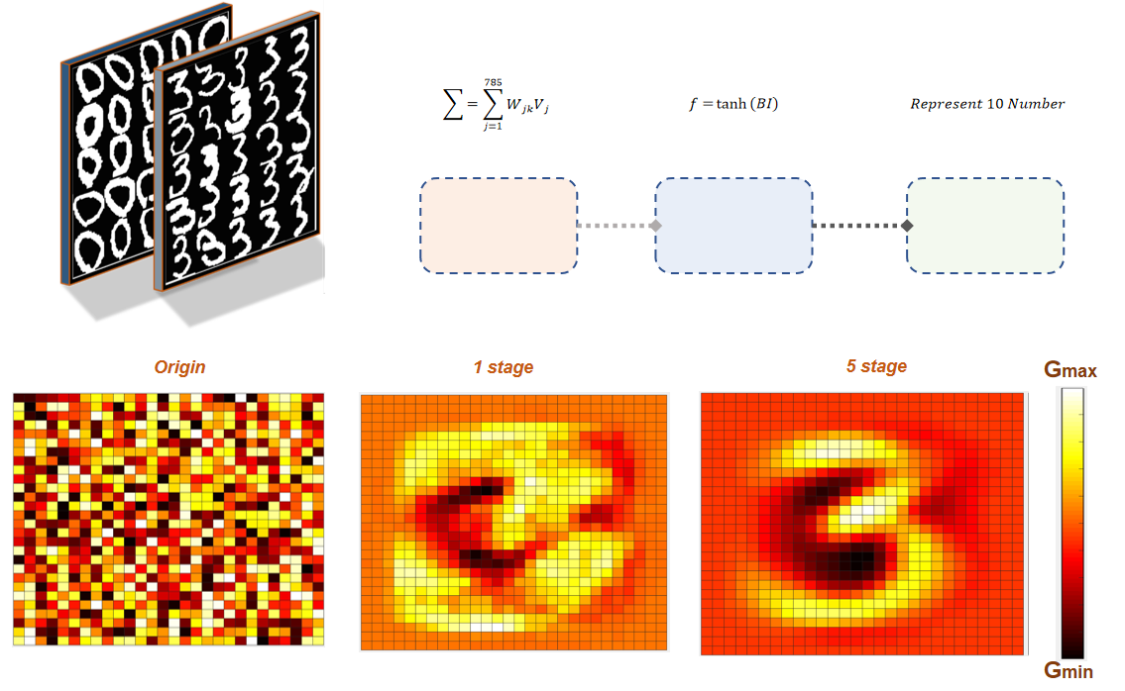FIG.8. (a) G_{max}/G_{min} and nonlinearity of LTP/LTD curve. (b) Recognition accuracy within 100 epochs. (c) Artificial Neural Network for the image recognition rate.
(c)
(b)
(a)
The 4 LTP/LTD curves can be analyzed that the nonlinearity increases first and then decreases with the increase of voltage in Figure 8a. The parameter of nonlinearity and G_{max}/G_{min} can be obtained from the curve. The maximum value of G_{max} / G_{min} is 22 when the 2 V voltage applied to the presynaptic. The continuous combination under different conductance states (G) is defined as assessing the nonlinearity of potentiation and depression.
${\text{ G}}_{\text{p}}=B\left(1− e^{\left(−\frac{p}{{\text{A}}_{\text{p}}}\right)}\right)+{\text{G}}_{\text{min}}$ (3)
${\text{G}}_{\text{d}}=−B\left(1− e^{\left(\frac{p−{\text{ P}}_{\text{max}}}{{\text{A}}_{\text{p}}}\right)}\right)+{\text{G}}_{\text{min}}$ (4)
$\text{B}=({\text{G}}_{\text{max}}−{\text{G}}_{\text{min}})/\left(1− e^{\left(\frac{{\text{-P}}_{\text{max}}}{{\text{A}}_{\text{p,d}}}\right)}\right)$ (5)
G_{p} is the potentiation conductance, G_{d} is the depression conductance, P_{max} is the maximum number of pulses, and A is the parameter describing the potential and depression nonlinearity. The long term potentiation and long term depression curve is to verify the synaptic have the potential to achieve the synaptic plasticity. Moreover, the Gmax/Gmin is related to the range of synaptic weight. And the nonlinearity of LTP/LTD curve is related to the learning step size. To verify the potential viability of EGTs as the synaptic device for neuromorphic computing, we simulate a single-layer-perception (SLP)-based ANN with the back-propagation algorithm and Manhattan update rules in MATLAB (Figure 8b). The recognition accuracy rate reaches the 81% with the 100 epochs. All neural algorithms are related to synaptic weight also shows that EGT has great potential for neuromorphic computing. The 784 synaptic weights map with high-resolution and low-noise acquisition demonstrates the original and different training states（1-5 stages）related to the output numbers "3"( Figure 8). A simple proportional timing relationship with the visualized pixel strength can be observed by the training maps. The adjustments of the learning size and weight variation range transform from the LTP/LTD curves impacted the outcomes of the training.

Conclusion
In conclusion, this work demonstrates the synaptic properties of the solution-processed Li-doped thin-film transistors. The weight update process combine with the synaptic plasticity of the electrolyte gate transistor to improve the recognition rate for the MNIST data. EPSC and IPSC are basic information flow and processing processes behind complex calculations. In this work, we analyze the conductance and nonlinearity that significantly impact learning accuracy based on the LTP/LTD characteristic.

Acknowledgements
This research was funded in part by the Natural Science Foundation of the Jiangsu Higher Education Institutions of China Program (19KJB510059), Natural Science Foundation of Jiangsu Province of China (BK20180242), the Suzhou Science and Technology Development Planning Project: Key Industrial Technology Innovation (SYG201924), University Research Development Fund (RDF-17-01-13), and the Key Program Special Fund in XJTLU (KSF-P-02, KSF-T-03, KSF-A-04, KSF-A-05, KSF-A-07, KSF-A-18).
References
[1] Dai S, Zhao Y, Wang Y, Zhang J, Fang L, Jin S, et al. Recent Advances in Transistor‐Based Artificial Synapses. Advanced Functional Materials. 2019;29;1903700.
[2] Ding G, Yang B, Zhou K, Zhang C, Wang Y, Yang JQ, et al. Synaptic Plasticity and Filtering Emulated in Metal–Organic Frameworks Nanosheets Based Transistors. Advanced Electronic Materials. 2019;6;1900978.
[3] Doan TH, Sato Y, Matsumoto M, Koganezawa T. Lateral Habenula Regulates Cardiovascular Autonomic Responses via the Serotonergic System in Rats. Front Neurosci. 2021;15:655617.
[4] Guo LQ, Han H, Zhu LQ, Guo YB, Yu F, Ren ZY, et al. Oxide Neuromorphic Transistors Gated by Polyvinyl Alcohol Solid Electrolytes with Ultralow Power Consumption. ACS Appl Mater Interfaces. 2019;11:28352-8.
[5] He W, Fang Y, Yang H, Wu X, He L, Chen H, et al. A multi-input light-stimulated synaptic transistor for complex neuromorphic computing. Journal of Materials Chemistry C. 2019;7:12523-31.
[6] Jang EK, Park Y, Lee JS. Reversible uptake and release of sodium ions in layered SnS2-reduced graphene oxide composites for neuromorphic devices. Nanoscale. 2019;11:15382-8.
[7] Kim MK, Lee JS. Ferroelectric Analog Synaptic Transistors. Nano Lett. 2019;19:2044-50.
[8] Kim S, Choi B, Lim M, Yoon J, Lee J, Kim HD, et al. Pattern Recognition Using Carbon Nanotube Synaptic Transistors with an Adjustable Weight Update Protocol. ACS Nano. 2017;11:2814-22.
[9] Kim S, Choi B, Yoon J, Lee Y, Kim HD, Kang MH, et al. Binarized Neural Network with Silicon Nanosheet Synaptic Transistors for Supervised Pattern Classification. Sci Rep. 2019;9:11705.
[10] Liu Y, Guan P, Zhang B, Falk ML, Katz HE. Ion Dependence of Gate Dielectric Behavior of Alkali Metal Ion-Incorporated Aluminas in Oxide Field-Effect Transistors. Chemistry of Materials. 2013;25:3788-96.
[11] Lv Y, Ma D, Meng H, Li C, Lin W. Habenula regulates cardiovascular activities in the insula cortex in a rat model of epilepsy. Int J Neurosci. 2012;122:314-23.

