Received 00th January 20xx,
ª St Petersburg University, 7/9 Universitetskaya Nab., Saint Petersburg
199034, Russian Federation. E-mail: m.kinzhalov@spbu.ru
^{b} Department of Chemistry, University of Liverpool, Crown Street, Liverpool L69
7ZD, UK, E-mail: konstantin.luzyanin@liverpool.ac.uk
† Electronic Supplementary Information (ESI) available. CCDC 2133432, 2133433, 2134335. For ESI and crystallographic data in CIF or another electronic format see DOI: 10.1039/x0xx00000x
Accepted 00th January 20xx
DOI: 10.1039/x0xx00000x

Experimental and Computational Tuning of Metalla-N-Heterocyclic Carbenes at Palladium(II) and Platinum(II) Centers
Maria V. Kashina,ª Konstantin V. Luzyanin,^{b}* Eugene A. Katlenok,ª Alexander S. Novikov, ª and
Mikhail A. Kinzhalov ª*
Palladium(II) and platinum(II) complexes featuring metalla-N-heterocyclic carbenes (7–12) were synthesised via metal-mediated coupling between equimolar cis-[MCl₂(CNR)₂] (R = 2,6-Me₂C₆H₃ (Xyl), 2,4,6-Me₃C₆H₃ (Mes)] and 2-aminopyridine or 2-aminopyrazine. Thiocyanate complexes 13–18 with two thiocyanate ligands were obtained through the ligand exchange in the parent 7–12 with NH₄CNS in acetone/CH₂Cl₂. Complexes 13–18 were isolated and characterised by HRESI⁺-MS, IR, ¹H and ¹³C{¹H} NMR spectroscopy, single-crystal X-ray diffraction (in the case of 11, 16, and 18). The UV-vis properties (for 7–18) and the electrochemical properties (for 7–12) were also evaluated. To study the electronic structure and bonding nature in the new compounds the quantum theory of atoms in molecules (QTAIM), and Mayer bond order analysis together with extended transition state with the natural orbitals for chemical valence method (ETS-NOCV), were used. X-ray diffraction studies and theoretical considerations indicate that the thiocyanate derivatives 16 and 18 form supramolecular dimer by two symmetrical pairs M¹···C⁵ and S¹···C² short intermolecular contacts between electron reach M^{II}-center and thiocyanate ligand in one side, and electron poor π system of azaheterocycle ring in another side.
Introduction
Transition metal complexes with heteroatom-stabilised carbenes, i.e. N-heterocyclic (NHCs)¹ and acyclic diaminocarbenes (ADCs)² underpin a broad range of applications in catalysis of organic processes;^{1c, 2b, 3} they are studied as emissive materials in optoelectronics,⁴ and potential anticancer drugs.^{2b, 5} Ligand properties of diaminocarbenes are manifested through the formation of the М–С_{carbene} σ-bond by transferring a pair of nonbonding electrons from the nucleophilic σ-orbital of the carbene carbon atom to the metal atom M. At the same time, the formation of a π-bond is also possible as a result of the interaction of a metal suitable in symmetry orbital with a vacant electron-deficient p_{π}-orbital of a carbene carbon atom. The diaminocarbene ligand is usually an effective σ-donor and a weak π-acceptor, which is reflected in the catalytic and photophysical properties of respective metal complexes. Tuning of the electron-donor capacity of diaminocarbenes, which is crucial for the success of their target applications, has been mainly accomplished by varying the substituents on the nitrogen atoms or the modification of the heterocyclic skeleton (Figure 1, A). It was shown that NHC complexes containing a metal atom within the NHC skeleton, named metalla-N-heterocyclic carbenes (MNHCs),⁶ exhibit stronger electron-donor character by comparison with classical imidazole-2-ylidenes.⁷
In pursuit of our ongoing project on the chemistry of diaminocarbenes,^{3c, 8} we have reported that platinum(II)-MNHC species (Figure 1, B) work as self-photosensitising transition-metal photocatalysts of the hydrosilylation of alkynes under visible light.⁹ In this catalytic reaction the platinum(II)-MNHC catalyst has a dual function: it serves as a light-absorbing species and transition metal catalyst enabling catalytic process.
Figure 1. A. Examples of cyclic, N-heterocyclic and metalla-N-heterocyclic diaminocarbenes. B. The platinum(II)-MNHC catalyst exhibiting photocatalytic properties under visible light irradiation.
Additional strategies for fine-tuning of the properties of complexes of this type are linked to (i) the modification of the structure of azaheterocyclic ring (highlighted with a yellow rectangle), (ii) the substitution in the aryl rings (highlighted with a cyan rectangle), and (iii) the replacement of the anionic ligands at both metal centers (highlighted with a magenta rectangle). An interplay of those will define the application of the complex thus designed towards a specific goal.
The scenario of this work was as follows. We started by preparation of a series of palladium(II)- and platinum(II)-MNHC complexes via the metal-mediated coupling of isocyanides with various 2-aminoazaheterocycles. Displacement of chlorides with thiocyanates led to the generation of previously unknown diaminocarbene-thiocyanate derivatives. Electronic structure and bonding nature in the new compounds were assessed by using the quantum theory of atoms in molecules (QTAIM), the natural bond orbital (NBO) analysis, and Mayer bond order analysis together with extended transition state with the natural orbitals for chemical valence method (ETS-NOCV). Analysis of frontier molecular orbital character, energy gaps, and UV/vis spectra by density functional theory (DFT) and time-dependent DFT (TD-DFT) approaches provided insights on the excited states involved in the light absorption and electrochemical processes, in turn related to the potential photocatalytic properties.
Results and discussion
Preparation and characterisation of metalla-N-heterocyclic diaminocarbenes. For this study, a series of Pd^{II} and Pt^{II} MNHC species 7–12 were prepared via the nucleophilic addition of 2-aminoazaheterocycles 5, 6 to metal-bound isocyanides in cis-[MCl₂(CNR)₂] (1–4, M = Pd, Pt). The reaction between any one of 1–4 proceeds in CH₂Cl₂ at RT for ca. 1 d and the subsequent workup provided the binuclear diaminocarbene species 7–12 in good (84–95%) isolated yields (Scheme 1, Route A). This process occurs via the intermediate generation of corresponding mononuclear M-ADC species and its nucleophilic addition to unreacted isocyanide material facilitated by deprotonation of M-ADC intermediate by an excess of aminoazaheterocycle used.⁹⁻¹⁰
Scheme 1. Preparation of 7–18.
MNHC complexes 7–12 are yellow solids stable in the solid state in the 20–80 °C temperature range. New complexes 9–12 were characterised by elemental analyses (C, H, N), accurate-mass ESI⁺-MS, and IR and ¹H, ¹³C{¹H}, and ¹⁹⁵Pt{¹H} NMR spectroscopies (see Experimental section for more details), while the authenticity of known species 7, 8 was confirmed by ¹H NMR spectroscopy.⁹⁻¹⁰ The intense absorption bands at 1619–1667 cm^{–1} in FTIR spectra of 7–12 was assigned to ν(C_{carbene}–N) of the NCN moiety. For 7–12, the important ¹³C resonances of the C atoms in two carbene ligands are different and detected at δ_{C} 168 and 182 ppm. This evidences that two NCN groups in 7–12 are substantially structurally different; one of them (having the downfield resonance at δ_{C} 168 ppm and assigned to C⁷ carbon) being of the amidine type, whereas another one (having the downfield resonance at δ_{C} 182 ppm and assigned to C¹ carbon) being of the diaminocarbene type. These δ_{C} values for diaminocarbene carbon C¹ are downfield relatively to those (δ_{C} 157–159) reported for the series of palladium complexes featuring chelated NHC, such as bis(imidazolylidene) palladium dichloride complexes,⁷ chelating but are some upfield of the δ_{C} 197–201 range observed for the series of palladium complexes featuring chelating acyclic aminocarbene ligands, i.e. [PdCl{C(N=C(C₆R²R³R⁴R⁵CON))=N(H)R¹}(C=NR¹)].¹¹
The thiocyanate anion NCS⁻ enables several pathways to alter the properties of the metal centres due to its ambidentate nature, allowing the coordination via either S- or N-ends. To the best of our knowledge, only two examples thiocyanate diaminocarbene complexes, viz. nickel(II)-NHC with N-coordinated thiocyanate¹² and gold(I)-NHC with S-coordinated thiocyanate¹³ have been reported. Thiocyanate species demonstrate the better donor abilities and increase dipole moment of complex molecules relative to halide analogues which may lead to the better catalytic activity of thiocyanate species in i. e. Kumada-Corriu coupling reaction.¹² In addition, the more donor character of thiocyanate appears to be related to stabilisation of the HOMOs of the complexes and their red-shifted absorption in UV-vis spectrum.¹⁴
The common method for the preparation of thiocyanate complexes from chloride substrates is metathetic reaction with NaNCS or KSCN in an aqueous or alcohol solution, occasionally aided by AgNO₃ to facilitate the chloride subtraction.¹⁵ Metathetic reactions of 7–12 with three-fold excess of NH₄CNS in acetone/CH₂Cl₂ at RT for 24 h afforded orange or yellow bis(N-coordinated thiocyanate) complexes 13–18 in good yields (Scheme 1, Route B). Owing to the poor solubility of complexes 13–18 in the most common solvents, all complexes were characterized in solution by means of HR-MS (ESI⁺) and in the solid state by FTIR, and solid-state ¹³C CP/MAS NMR. The structures of 16 and 18 were also elucidated by single-crystal XRD.
Complexes 13–18 gave satisfactory CHN data, which are consistent with the proposed formulae confirming the replacement of both chloride ligands with thiocyanate. The HRESI⁺-MS of 13–18 exhibit sets of peaks with the characteristic isotopic distribution due to [M + H]⁺, [M + Na]⁺ and/or [M – NCS]⁺ ions. IR spectroscopy was used to identify the coordination modes of thiocyanate in metal thiocyanate complexes.¹⁶ As a general rule, the value of ν(CN) stretch for the thiocyanate of N-bonded complexes lies near 2050 cm^{–1} (strong band) and that of S-bonded complexes is close to 2100 cm^{–1} (weaker band).^{16c} The IR spectra of 13–18 measured in KBr revealed two intense absorption bands in the range 2030–2090 cm^{–1} attributed to the ν(CN) stretch of the N-bonded thiocyanate. Additionally, FTIR spectra of 13–18 displayed a strong absorption overlapping bands at ca. 2200 cm^{–1} which are also present in spectra of starting 7–12 and are attributed to the ν(C≡N) of the isocyanide ligands.
UV-Vis absorption properties. All prepared complexes are yellow (10–18) or yellowish (7–9) solids, which makes them capable of absorbing light in the visible range. UV-vis absorption spectra of 7–12 were measured at ambient temperature in CH₂Cl₂ solution, while spectra of insoluble compounds 13–18 were measured in solid state. UV-vis data for 7–18 are summarised in Table 1 and overlay of spectra are given in Figures 2 and 3.
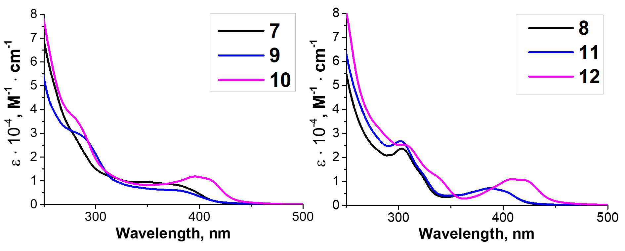
Figure 2. UV-vis absorption spectra for 7–12 in СH₂Cl₂ at RT.
Similar to other palladium¹⁷ and platinum^{17a, 17d, 18} cyclometallated complexes, the UV-vis spectra of 7–12 contain strong absorption bands below 320 nm [ɛ = (1.15–3.59)×10⁴ M^{–1}cm^{–1}] assigned to π–π* ligand centred transitions in the xylyl and mesityl moieties (Figure 2).¹⁹ The wide intense absorption bands in the 320–450 nm range with characteristic molar extinction coefficients [ɛ = (0.60–1.13)×10⁴ M^{–1}cm^{–1}] can be assigned to a mixed ¹L'LCT (ligand-to-ligand charge transfer) and ¹ILCT (intraligand charge transfer) transitions based on TD-DFT calculations (see section TD-DFT calculations). The energy of the ¹L'LCT/¹ILCT absorption band are affected by the change of the azaheterocyclic fragment.²⁰ Complexes with pyridine ring 7–9, 11 show blue-shifted ¹L'LCT/¹ILCT bands relative to their pyrazine counterparts 10 and 12 (e.g. 364–398 nm [ɛ = (0.60–0.83)×10³ M^{–1}cm^{–1}] in 7–9, 11 vs 402–414 nm [ɛ = (1.06–1.13)×10³ M^{–1}cm^{–1}] in 10 and 12).
Table 1. UV-Vis absorption data for 7–18.
 | Chloride complexes |  | Thiocyanate complexes
Complex | Absorption: λ_{max}, nm (ε · 10⁻⁴, M⁻¹cm⁻¹) |  | Complex | Absorption: λ_{max}, nm (ε · 10⁻⁴, M⁻¹cm⁻¹)
 | in CH₂Cl₂ | solid state |  | solid state
7 | 277sh (3.20), 364 (0.83) | 281sh, 417 | 13 | 285sh, 324, 389
8 | 303 (2.36), 318sh (1.35) 393 (0.64) | 310, 404 | 14 | 304, 339, 403
9 | 283sh (2.89), 378sh (0.60) | 293, 375 | 15 | 308, 394
10 | 281 (3.59), 402 (1.13) | 291sh, 407 | 16 | 310sh, 400
11 | 303 (2.53), 321sh (1.62), 398 (0.66) | 311, 427 | 17 | 305sh, 338sh, 395
12 | 311 (2.49), 338sh (1.15), 414 (1.06) | 308, 428 | 18 | 307sh, 379, 431

This could be explained by decrease of the LUMO energy in case of complexes 10 and 12 with pyrazine species due to the additional intercalation electron negative nitrogen atom in the azaheterocyclic fragment. Variation of the aryl fragment of the CNR or the corresponding daiminocarbene ligands induces no significant change in the positions of the ¹L'LCT/¹ILCT bands and only exerts minimal influence on the extinction coefficients (e.g. 364–393 nm [ɛ = (0.64–0.83)×10³ M^{–1}cm^{–1}] in 7, 8 vs 378–414 nm [ɛ = (0.60–1.13)×10³ M^{–1}cm^{–1}] in 9–12).
The UV-vis spectra of the 13–18 (KBr pellets) demonstrate similar absorption profiles to spectra of the 7–12 (Figure 3). Replacing the both chloride ligands with thiocyanate ligands leads to a significant increase in the HOMO energy and, consequently, the red shift of the long-wavelength bands (ca. 30 nm) in absorption spectra. These differences in optical absorption underline the significantly stronger electron donation from thiocyanate ligands compared to that of the chloride ligands.^{14, 21}
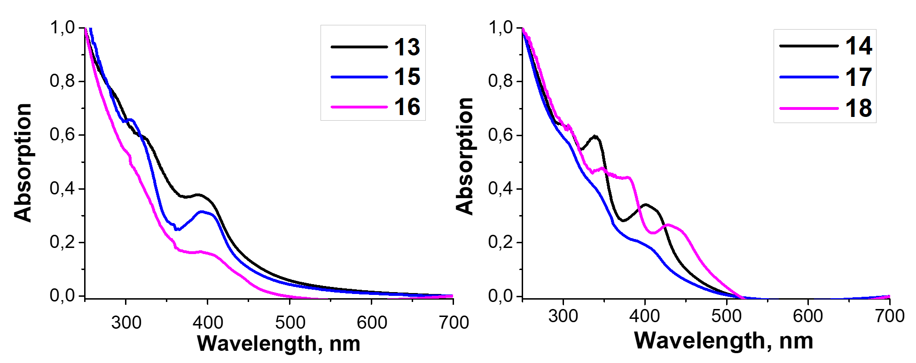
Figure 3. Normalized UV-Vis absorption spectra for 13–18 in solid state (KBr) at RT.
Frontier molecular orbitals analysis. To gain insight into the electronic structures and the optical properties of the obtained complexes time-dependent DFT calculations on 7, 8, 11, and 12 were undertaken. The theoretically predicted structures are in good agreement with experimental X-ray structures (Table S4 in SI). In general the computed bond lengths are close to the experimental ones which indicating a sufficient accuracy of the selected computational protocol.²² The main difference concludes in slightly elongation of coordination bonds (by 0.01–0.03 Å) and CN triple bonds (0.03–0.04 Å) in the optimized structures compared to experimental, due to relaxation of cyclic metal including systems.
Figure 4 shows the shape and energy of the frontier molecular orbitals for 7, 8, 11 and 12, while the FMO compositions are given in the Table S6. In all cases, high occupied molecular orbitals (HOMOs) are delocalized by the π molecular orbitals on the aryl ring connected with the exocyclic nitrogen atom of diaminocarbene species (contribution of aryls > 80%), while the contribution of the metal d orbitals is insignificant (<5%). The energy of the HOMO orbitals of 7, 8, 11 and 12 are similar, while the lowest unoccupied molecular orbitals (LUMOs) is localized over the entire diaminocarbene (22–34%) and azaheterocycle (38–54%) species. The large contribution (12–16%) from the metal d orbitals in LUMO may be related with the absence of luminescence for 7–12 at RT due to population of a metal-centred state.²³
The HOMO–LUMO energy difference varies considerably between 3.94 eV (7) and 3.31 eV (12). The small HOMO–LUMO gap of 12 with pyrazine species comes from the low lying LUMO which is affected by the additional intercalation electron negative nitrogen atom in the azaheterocyclic fragment. There is clearly a correlation between the HOMO–LUMO energy difference and the red-shifted absorption bands determined experimentaly for 10 and 12 with pyrazine ring relative to their pyridine counterparts 7–9, 11.

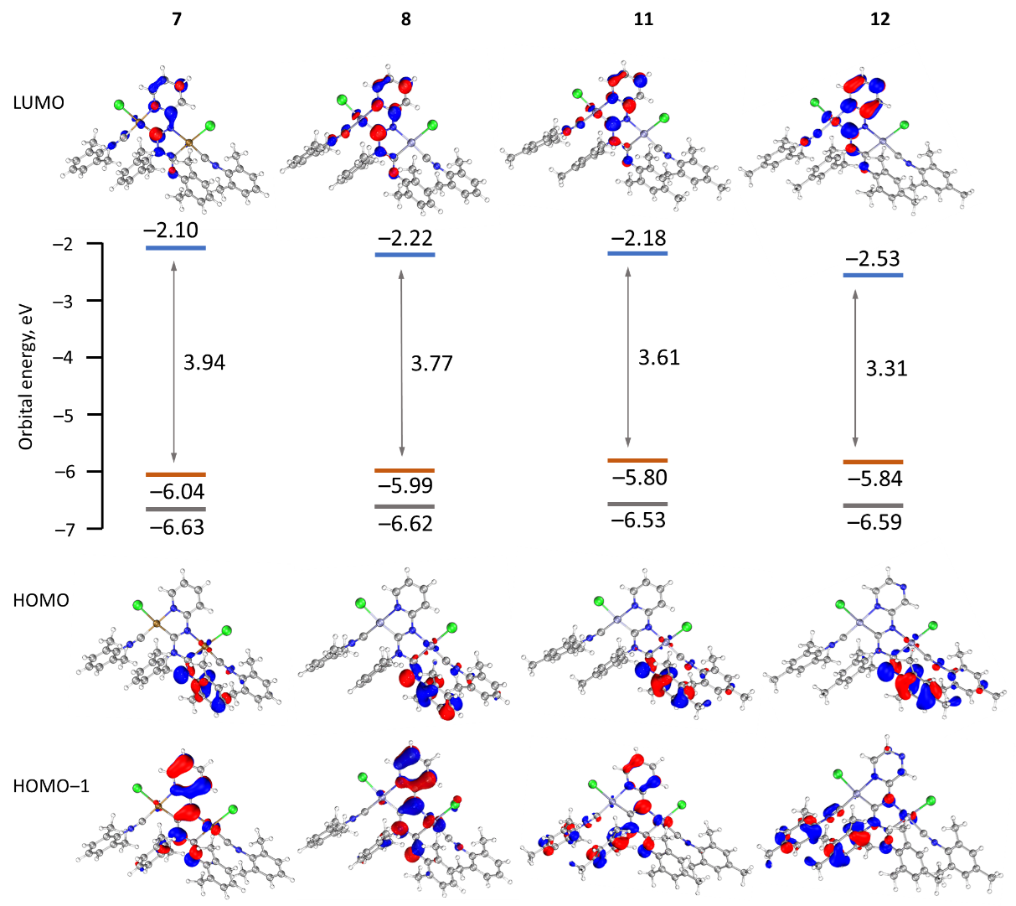
Figure 4. Calculated molecular orbital energy HOMO–LUMO gaps and surface plots of the HOMO–1, HOMO and LUMO for 7, 8, 11 and 12.

TD-DFT calculations. TD-DFT calculations were carried out to elucidate the nature of the transitions in the absorbance profile. The simulated based on TD-DFT calculations and the experimental UV-vis spectra of all complexes have a good agreement. Calculated absorption spectra for 7, 8, 11 and 12 reasonably reproduce the experimental spectral profiles (Figure S7). The absorption band in 320–450 nm range are resulted by combination of the most intense transfers appearing at ca. 340–360 nm (f ca. 0.123–0.156) and at ca. 393–410 nm (f ca. 0.031–0.038) associated correspondently with HOMO→LUMO (91–92 %) and HOMO-1→LUMO (91–94 %) transitions (Table S5 in SI).
Electrochemical studies. The electrochemical properties of 7–12 were examined using cyclic voltammetry (CV) in dichloromethane solution (Figure 5). Palladium complexes 7, 9 and 10 exhibit two irreversible oxidation waves in the ranges of 0.48–0.58 and 0.83–0.85 V, which corresponds multistep oxidation processes (Subsequent oxidation processes is probably assigned to the next step of the oxidation of the mono oxidized species²⁴). Platinum complexes 8, 11 and 12 are oxidized at more positive potentials than their corresponding palladium counterparts and first intense irreversible oxidation peak was observed in the range of 0.72–0.77 V.
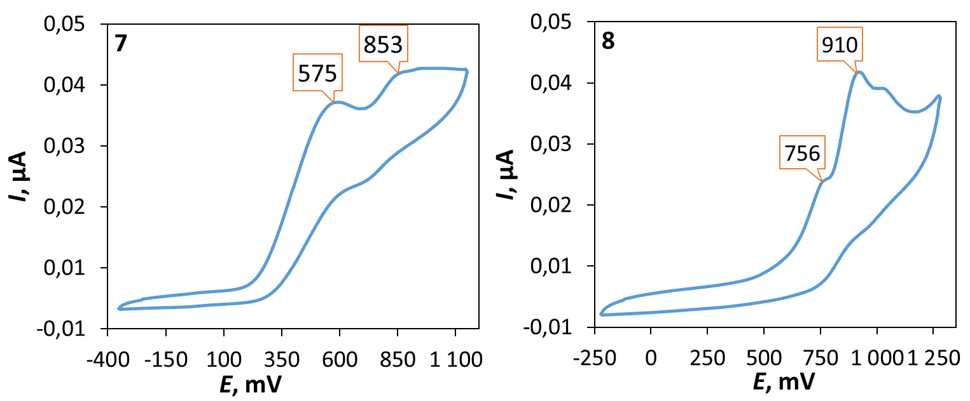
Figure 5. Cyclic voltammograms of 7 and 8 in СH₂Cl₂ at RT (potentials gives in mV vs. Fc⁺/Fc). Oxidation potentials (mV) of 9 483, 833; 10 718, 968; 11 566, 850; 12 740, 1028.
It is worth noting that, complexes with mesityl substituent 9–12 xylyl substituents are oxidized easier than their corresponding analogues 7 and 8 with xylyl substituent. To interpret the electrochemical behaviour of the complexes, quantum-chemical calculations were performed for 7, 8, 11 and 12 and their mono oxidized forms at the level of the DFT theory. The plot of the spin density calculated for oxidized forms 7, 8, 11 and 12 (Figure 6 and S8) demonstrate that the first oxidation process can be associated with the oxidation of the aryl fragment connecting to exocyclic nitrogen atom.
Figure 6. A plot of the spin density calculated for [8]⁺.
X-Ray diffraction studies of chloride species. Single crystals of 11 were obtained by the slow evaporation of CH₂Cl₂ solution. Crystals of 11 are yellow and possess low symmetry P1 space group (Figure 7). In 11, both metal centers acquire the distorted square-planar coordination environment. The CNR ligands are in cis-position to the C atoms of {C(NR)N(R)CN(NC₄H₃X)} (X = CH, N); the latter forms the dinuclear bicyclic framework.
The bond lengths of the two coordinated CN groups are in the interval of 1.136(8)–1.146(8) Å, typical for the CN triple bonds in isocyanide Pd^{II} and Pt^{II} complexes.^{3d, 25} The Pt–C_{carbene} distances are slightly smaller than typical Pt–C bonds (1.995–2.023 Å)^{5c, 26} reported for the relevant Pt^{II}–ADC complexes and are close to Pt–C distances in Pt-NHC complexes (1.970–1.991 Å).²⁷ On the other side, the Pt–C bond lengths are sufficiently larger than those in Pt-NHCs, where NHC is included into an extended rigid π-system (1.906–1.970 Å)²⁸ and in Pt-CAAC complexes (1.942–1.967 Å).²⁹ The bond lengths in the first carbene moiety C¹–N¹ (1.350(7) Å) and C¹–N³ (1.341(7) Å) are similar and are between single CN bond (e.g., 1.469(10) Å) in amines³⁰ and double CN bond (e.g., 1.279(8) Å) in imines³⁰ distances indicating a substantial delocalization of the electron density. In the second carbene the endocyclic C⁷–N³ bond of the metallacycle is typical single (1.450(7) Å), while the exocyclic C⁷–N⁴ is typical double (1.268(7) Å) indicating low degree of delocalization in these NCN carbene fragment. Structure of this carbene moiety is therefore closer to the amino(imino)carbene or diamonocarbene-like structures reported previously.³¹ All other bond lengths in 11 are normal, and their values agree with those reported for previously reported 7,^{10b} 8⁹ and other related diaminocarbene and isocyanide species.^{8c, 10a, 32}
Figure 7. View of 11 with the atomic numbering schemes. Solvent molecule and hydrogen labels were omitted for simplicity. The crystal data, and selected bond lengths and angles are given in the SI, section S1.
DFT analysis of ligand properties in chloride species 7–12. To shed the light on the nature of the bonding in these compounds, the quantum theory of atoms in molecules (QTAIM),³³ and Mayer bond order analysis,³⁴ as well as the extended transition state method and the natural orbitals for chemical valence scheme (ETS-NOCV),³⁵ were used.
Bader’s theory of atoms in molecules provides a unique way to analyse the electron density, ρ_{и}.³³ The most important property to assign a bond is the presence of a bond critical point (BCP) which is a point of electron and energy densities along the bond path. It is quite interesting to compare the M¹–C¹ bonds, which involves the metalla-N-heterocyclic carbene C¹ atoms, with the almost equivalent M²–C⁷ bonds, which engage the only formal acyclic diaminocarbene C⁷ atom. BCP for both pairs M–C_{carbene} bonds show a moderate value of electron density (ρ_{b} 0.070–0.091 e) and a positive value of the laplacian. Since a covalent bond in transition metal complexes is characterized by small value of ρ_{b} and small and positive values of ∇²ρ(r) due to the diffuse character of the electron distribution,³⁶ the best descriptor to ascertain the type of interaction is the local energy electronic density H(r).³⁷ All of these M–C_{carbene} have negative values of H(r) at the BCPs. The listed parameters indicate a significant degree of covalency. Another similar criterion was proposed by Espinosa³⁸ on the basis of the ratio |V(r)|/G(r) for closed shell interaction, |V(r)|/G(r) < 1 and for shared shell interaction, |V(r)|/G(r) > 2. The interaction is taken as an intermediate type if the ratio falls between these two limits.³⁹ The BCPs of M–C_{carbene} bonds have a |V(r)|/G(r) value 1.47–1.70 and it is taken as evidence for partial covalent nature. At the same time, the values for the ρ_{b} bond and |V(r)|/G(r) for all M–C_{carbene} bonds are higher than for the M–Cl, M–C_{CNR} and M–N bonds, all this indicates that the M–C_{carbene} is more covalent. Values for the local topological properties at the BCP of these two type bonds M–C_{carbene} are close enough (Table S7), and are comparable to those obtained from theoretical electronic energy density for the M–C_{carbene} bonds of the other diaminocarbene complexes.^{37, 40} The calculated Mayer bond orders (MBOs) of the M–C_{carbene} bonds are similar for both M–C_{carbene} bonds of each complex (0.5512 and 0.5491 for 7 and 0.9907 and 1.0678 for 8) and are larger than the MBOs of the M–C_{CNR} bonds (0.2675 and 0.2753 for 7 and 0.9029 and 0.9058 for 8). The values of the topological parameters at BCPs of the C_{carbene}–N bonds are all typical for covalent bonds between nonmetal atoms with some degree of delocalization.⁴¹ The MBOs for C_{carbene}–N bonds in the N¹–C¹–N³ moiety are higher than 1 and very similar 1.2570–1.3101), which support the previous proposal that the unsaturation of the C atom of a diaminocarbene is alleviated by π-donation of electron density from the filled p_{π} orbitals of the N atoms to the empty p_{π} orbital of the carbene carbon.⁴² The MBOs for C_{carbene}–N bonds in the second N³–C⁷–N⁴ moiety are different (C⁷–N⁴ 0.9715–0.9989 for C⁷–N³ and 1.6346–1.6752 for C⁷–N⁴) as evidenced by XRD data.
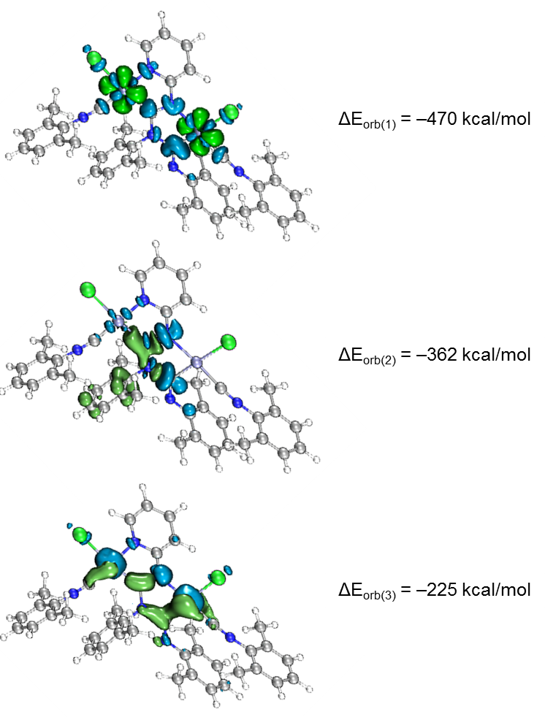
Figure 8. Shape of the deformation densities Δρ_{(1)–(3)} that correspond to ΔE_{orb(1)–(3)}. The direction of the charge flow of the deformation densities is blue (loss of electron density) → green (gain of electron density).
The coordination bonding in binuclear diaminocarbene complexes was understood by employing an extended transition state (ETS)⁴³ together with the natural orbitals for chemical valence (NOCV)^{35, 44} method. This method can be employed to quantify the bonding interactions in the complexes between the metal center and the surrounding ligands in a chemically intuitive manner. The ETS-NOCV scheme in this manner, gives quantitative (ΔE_{orb}) data about the strength of orbital interactions in chemical bonds.⁴⁵
The ETS-NOCV calculations for 7 and 8 were carried out using PBE0/ZORA-def2-TZVP geometries with the ADF program package.⁴⁶ The fragmentation pattern shown in the Figure S9, where the C¹–N¹, C⁷–N³ and all M–L bonds were fragmented homolytically in the frozen geometry of the complex molecule for this purpose. The major contribution to the total orbital interaction comes from the three orbital term ΔE_{orb(1)}−ΔE_{orb(3)} (90%), indicating a strong covalent bonding (Figure 8). The strongest pairwise orbital interaction (ΔE_{orb(1)}, –470 kcal/mol) comes from the ligand to metal σ dative interactions, which is provided by 41% of a total ΔE_{Orb}. Then, the second term (ΔE_{orb(2)}, –362 kcal/mol) is associated with the coupling of p orbitals in diaminocarbene moieties. The last ΔE_{orb(3)} (–225 kcal/mol) is due to the π-back-donation from metal centers to carbene ligands and comprises only 20% of the total ΔE_{Orb} energy.
X-Ray diffraction studies of thiocyanate derivatives. Single crystals for 16 and 18 were formed in situ in reaction mixture (Figure 9 and S1). The 16 and 18 form pale orange isomorphous through the Pd/Pt atom exchanges in the molecular crystals.^{5c, 25d, 25e} Both thiocyanate ligands in 16 and 18 are bound to the metal centers by the N atom, which is in full agreement with the data of IR spectroscopy. The M¹−N⁸ and M²−N⁹ distances were within the range of typical values for Pd−N^{16b, 47} and Pt−N^{16a, 47} coordination bonds reported for relevant N-ligated thiocyanates. Both M¹–N⁸–C⁴⁵ and M²–N⁹–C⁴⁶ angles due to the thiocyanate binding are considerably different: one thiocyanate in 16 and 18 is coordinated to the metal atom in a somewhat linear fashion (M¹–N⁸–C⁴⁵ 169.1(12)–178.5(3)°), while the other adopts a bent configuration with the corresponding angle (M²–N⁹–C⁴⁶) in the range of 147.0(4)–159.1(4)°. Subsequent theoretical studies (section S3.1) and analysis of the CCDC (section S4) showed that the differences are associated with the effect of crystal packing.
Figure 9. View of 18 with the atomic numbering schemes. Solvent molecule and hydrogen labels were omitted for simplicity. Crystal structure of 16 is given in the Section S1 in SI alongside selected bond lengths and angles.
Figure 10. Views of dimers of 18. Dotted lines indicate the Pt¹···C⁵ and S¹···C² contacts. Thermal ellipsoids are shown with 50% probability.
The polycyclic organometallic skeletons of thiocyanate complexes 16 and 18 are almost identical to chloride species (Figures S2 and S3). Thiocyanate is a type of ligand that can be explored as a potential crystal-driving supramolecular synthon generator in biochemistry⁴⁸ and material⁴⁹ chemistry. The versatile of interacting centers in NCS mainly associated with sulfur and the nitrogen atoms allows it to be involved in hydrogen⁵⁰, halogen⁵¹ bonding and π⁵² interactions. The Hirshfeld surface analysis for the XRD structures of 16 and 18 indicates the domination of the contacts that involve hydrogen atoms, specifically, H-H, C-H, S-H, and N-H (section S5 in SI). The H-H contacts provide the largest contributions to the molecular Hirshfeld surfaces, because the fraction of these atoms is maximal and the Hirshfeld surfaces analysis does not disclose the attractive or repulsive nature of these contacts. Apart from the contacts involving H atoms, 16 and 18 exhibit two pairs M¹···C⁵ and S¹···C² short intermolecular contacts forming supramolecular dimer (Figure 10).
The distances between the M¹···C⁵ and S¹···C² interacting atoms are slightly larger than the sum of Bondi’s vdW radii (102–109%),⁵³ but are comparable with the sum of Alvarez's (86–89% for M¹···C⁵ and 99% for S¹···C²)⁵⁴ vdW radii. The latter suggests that the observed noncovalent interactions can exist. To confirm or disprove the hypothesis on the existence of noncovalent interactions between M^{II}-center and C⁵ atom and between S-center of thiocyanato and C² atom, a further computational study was carried out.
QTAIM analysis³³ for model supramolecular associates (16)₂ and (18)₂ shows appropriate bond critical points (3, –1) (BCPs) for discussed contacts (Figures 11, 12, S11 and S12, Table S11). In the case of (18)₂, the formally bifurcated μ₂-S···[Pt^{II},C] contact (Figure 12), while in the case of (16)₂ a S¹···Pd² contact (Figure S12), are formed. The low magnitudes of electron density (0.005–0.008 a.u.), the positive values of the Laplacian of electron density (0.015–0.021 a.u.), and the positive energy density close to zero (0.001 a.u.) in the BCPs, as well as the balance between the Lagrangian kinetic energy G(r) and potential energy density V(r) at the BCPs (ratio |G(r)|/V(r) > 1) reveal that these contacts are purely noncovalent.³⁸
The Electron Localization Function⁵⁵ (ELF) projections for the M¹···C⁵ contacts were plotted along with CPs and bond paths (Figures 11 and S11). ELF projections show increased ELF areas around Pd^{II} and Pt^{II} atoms near the bond paths connecting metal centers and azaheterocycle species that can be interpreted as filled d_{z}² orbitals. The M···C bond paths that connect metal centers and C⁵ atom from azaheterocycle species go through these d_{z}² and π* orbitals. On the ELF projections plotted for the S¹···C² contacts sulfur lone pair is clearly visible near the bond paths; also, the electron density depletion regions associated with the π-holes are easily identified in the ELF basins. Reduced density gradient (RDG) analyses confirm the fact that all discussed contacts are clearly attractive.
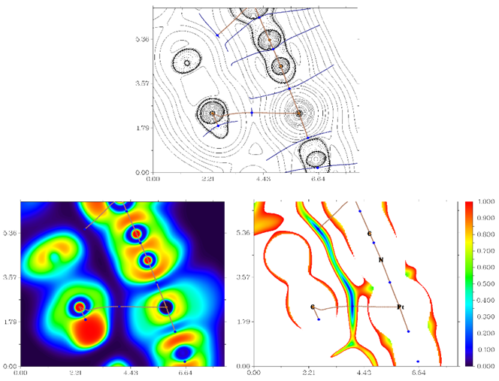
Figure 11. Contour line diagram of the Laplacian of electron density distribution ∇²ρ(r), bond paths, and selected zero-flux surfaces (left panel), visualization of electron localization function (ELF, center panel) and reduced density gradient (RDG, right panel) analyses for Pt¹···C⁵ intermolecular contacts in (18)₂. Bond critical points (3, –1) are shown in blue, nuclear critical points (3, –3) – in pale brown, bond paths are shown as pale brown lines, length units – Å, and the color scale for the ELF and RDG maps are presented in a.u.
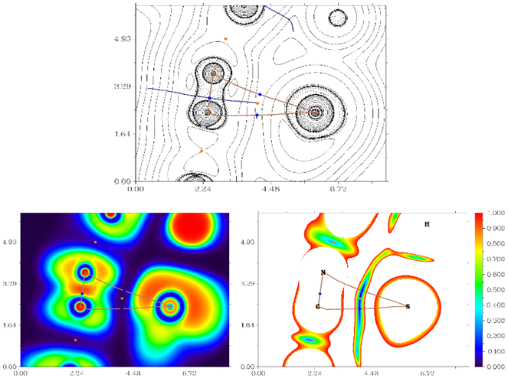
Figure 12. Contour line diagram of the Laplacian of electron density distribution ∇²ρ(r), bond paths, and selected zero-flux surfaces (left panel), visualization of electron localization function (ELF, center panel) and reduced density gradient (RDG, right panel) analyses for μ₂-S···[Pt^{II},C] intermolecular contact in (18)₂. Bond critical points (3, –1) are shown in blue, nuclear critical points (3, –3) – in pale brown, ring critical points (3, +1) – in orange, bond paths are shown as pale brown lines, length units – Å, and the color scale for the ELF and RDG maps are presented in a.u.
The comparison of the crystal structures of the thiocyanate derivatives with those of the chloride species (Figures S4, S5) revealed significant changes occurred on the anion exchange. If the crystal structure of chloride species is predominantly held by C-H···X (X = Cl, N) hydrogen bonds with no involvement of the M^{II}-center, the change from Cl to NCS as the anionic ligand favors the formation of M···C interactions.
Conclusions
In the course of this study, a series of new binuclear palladium(II) and platinum(II) metalla-N-heterocyclic carbene (MNHC) type complexes were prepared via metal-mediated coupling between cis-[MCl₂(CNR)₂] (R = Xyl, Mes) and 2-aminopyridine or 2-aminopyrazine nucleophiles. Characterization of 7–12 thus obtained by HRESI⁺-MS, IR, 1D ¹H, ¹³C{¹H}, ¹⁹⁵Pt{¹H} NMR and 2D HSQC(¹H, ¹³C), HMBC(¹H, ¹³C) spectroscopy as well as by single-crystal XRD revealed the difference in diaminocarbene ligands where the both C_{carbene}–N bonds in MNHC moiety are in agreement with data for classical diaminocarbenes, while the second NCN fragment is ADC-like carbene due to the rather double and single C–N bonds character. QTAIM reveals that the M–C_{carbene} bonds are characterized by low to moderate values of electron density ρ_{b}, positive values of the laplacian ∇²ρ and negative values of local electronic energy densities, H(r)-signifying that these M–C_{carbene} bonds have significant degree of covalency. The UV-vis absorption spectrum of MNHC species characterized by the wide intense absorption in the 320–414 nm range assigned to ¹L'LCT/¹ILCT transactions which is important in visible light photocatalysis. The absorption characteristics are governed by the nature of the azaheterocycle fragment and complexes with pyrazine pyridine ring (10 and 12) show 20–40 nm red-shifted bands relative to their pyrazine counterparts (7–9 and 11). In contrary, the parent CNR fragments have more effect on the electrochemical properties of the MNHC compounds and species with mesityl substituents (9–12) are oxidized at lower potential than their corresponding xylyl analogues (7 and 8).
The first palladium(II) and platinum(II) diaminocarbene thiocyanate derivatives 13–18 were synthesized from corresponding starting chlorides 7–12 by metathetic reaction with NH₄NCS. In these complexes, the both thiocyanate ligands are N-bound as confirmed by IR spectroscopy and single-crystal XRD. Replacing the both chloride ligands with thiocyanate ligands leads to a significant increase in the HOMO energy and, consequently, the red shift of the long-wavelength bands (ca. 30 nm) in absorption spectra. Isomorphous crystal structures of the thiocyanate derivatives 16 and 18 exhibit two symmetrical pairs M¹···C⁵ and S¹···C² short intermolecular contacts between electron reach M^{II}-center and thiocyanate ligand in one side, and electron poor π system of azaheterocycle ring in another side; observed noncovalent interactions provide supramolecular dimer.
Together, the experimental and computational data provide an insight into the flexible character of MNHC species. Our future studies are focused on exploring the photocatalytic properties of the [M]-MNHCs derived from reactions of metal-activated RNCs and various 2-aminoazaheterocycles to develop useful catalytic systems and to establish catalyst structure−activity relationships in various visible light activated systems.
Experimental
Materials and Instrumentation. Solvents, organic reagents and NH₄SCN were obtained from commercial sources and used as received. Isocyanide complexes cis-[MCl₂(CNR)₂] (M = Pd, R = Xyl 1,^{31a} Mes 2;^{10b} M = Pt, R = Xyl 3,⁵⁶ Mes 4⁵⁷) were prepared as reported earlier. C, H, and N elemental analyses were carried out on a Euro EA 3028 HT CHNSO analyzer. Mass-spectra were acquired on Bruker micrOTOF spectrometer equipped with ESI source; a CH₂Cl₂/MeOH mixture was used as the solvent. The instrument was operated at positive ion mode using m/z range of 50–3000. The capillary voltage of the ion source was set at –4500 V (ESI⁺) and the capillary exit at +(70–150) V. The nebulizer gas pressure was 0.4 bar and drying gas flow was 4.0 L/min. The most intensive peak in the isotopic pattern is reported. Infrared spectra were recorded on Bruker Tensor 27 FTIR instrument (4000–2400 cm^{–1}, resolution 2 cm^{–1}) in KBr pellets. The UV/vis absorption spectra in CH₂Cl₂ solution were recorded on a Shimadzu UV-2500 spectrophotometer in a quartz cuvette with l = 1.0 mm with the complex’s concentration 0.03 mM. A Shimadzu UV-1800 spectrophotometer was used to measure the UV/vis absorbance of solid-state complexes. The ¹³C CP/MAS NMR spectra were acquired using a double-resonance 4 mm MAS Bruker probe at a resonance frequency of 101 MHz under 14 kHz MAS. The CP contact time in all experiments was 3.5 μs with a delay between acquisitions of 1 sec and number of scans was collected 20000. Suitable single crystals were selected and mounted on a MiTeGen tip via crystallographic oil. Data were collected using a Rigaku XtaLAB Synergy, Single source at home/near, HyPix diffractometer equipped (monochromated CuKα radiation, λ = 1.54184 Å) at 100(0) K. In each case, the structure was solved with a ShelXT⁵⁸ structure solution program using Intrinsic Phasing and refined with a ShelXL⁵⁸ refinement package incorporated in the OLEX² program package⁵⁹ using Least Squares minimization. Empirical absorption correction was applied in CrysAlisPro⁶⁰ program complex using spherical harmonics, implemented in SCALE3 ABSPACK scaling algorithm. The CVs were measured using an Autolab PGSTAT302N voltammetric analyzer at a scan rate of 100 mV s^{–1}. A glassy carbon and a platinum wire were used as the working and counter electrodes, respectively. The sample solutions (ca. 5 mM) in 0.1 M [nBu₄N](BF₄)–CH₂Cl₂. Ag/AgNO₃ (0.01 M AgNO₃ in MeCN) was used for the reference electrode and the potential values were corrected against Fc⁺/Fc couple (E_{1/2} = 0.52 V vs. Ag/AgNO₃ in CH₂Cl₂).
Synthetic work. General procedure for the synthesis of 7–12. A mixture of solid [MCl₂(CNR)₂] (1–4, 0.10 mmol) and aminoazaheterocycles 5, 6 (0.20 mmol) was dissolved in CH₂Cl₂ (5 mL) and left to stand at RT for 24 h. During the reaction time, the mixture of turned from pale yellow to lemon yellow. After 24 h, the reaction mixture was filtered to remove a precipitated 5·HCl or 6·HCl and then was slow evaporated in air at RT to give yellow crystals of 7–12. The solids of 7–12 were separated by decantation and washed with three 2 mL portions of Et₂O and then dried in air at RT.
9. Yellow solid (37 mg, yield 78%). Anal. Calcd. For C₄₅H₄₈N₆Cl₂Pd₂: C, 56.5; H, 5.1; N, 8.8; found: C, 56.7; H, 5.4; N, 9.0. [М – Cl]⁺ calcd for C₄₅H₄₈N₆ClPd₂⁺ 921.1703, found 921.1706. IR (KBr, selected bands, cm^{–1}): ν(C–H) 2920 (s), 2854 (s); ν(C≡N) 2189 (s); ν(C_{carbene}–N) 1629 (s); δ(C–H from Мes) 855 (s). ¹H NMR (CDCl₃, 400.13 MHz, δ): 9.10 (d, ³J_{H,H} = 8.5 Hz, 1H, H³), 9.06 – 8.99 (m, 1H, H⁵), 7.84 (ddd, ³J_{H,H} = 8.8 Hz, ³J_{H,H} = 7.4, ⁴J_{H,H} = 1.7 Hz, 1H, H⁴), 7.03 – 6.94 (m, 1H, H⁶), 6.91 (s, 2H, m-H from Мes), 6.82 (s, 2H, m-H from Мes), 6.68 (s, 2H, m-H from Мes), 6.46 (s, 2H, m-H from Мes), 2.41 (s, 6H, 2Мe), 2.31 (s, 3H, Мe), 2.26 (s, 15H, 3Мe), 2.23 (s, 6H, 2Мe), 2.02 (s, 6H, 2Мe), 1.47 (s, 3H, Мe), 1.46 (s, 3H, Мe). ¹³C{¹H} NMR (101 MHz, CDCl₃, δ): 195.0 (C_{carbene}–N), 167.0 (C_{carbene}–N), 162.8 (C=N), 147.7 (p-C from Мes), 146.7, 141.5 (C³, C⁴), 140.7 (ipso-C from Мes), 140.0, 139.8, 138.9 (p-C from Мes), 136.2, 133.9, 133.9 (o-C from Мes), 133.7 (p-C from Мes), 128.5, 128.3, 128.1, 127.2 (m-C from Мes), 124.9, 124.2 (ipso-C from Мes), 118.3, 117.2 (C⁵, C⁶), 21.2, 21.1, 20.1, 20.0 (Мe’s), 19.5, 19.3 (2Мe’s), 18.4 (4Мe).
10. Yellow solid (42 mg, yield 88%). Anal. Calcd. For C₄₄H₄₇N₇Cl₂Pd₂: C, 55.2; H, 5.0; N, 10.2; found: C, 54.8; H, 5.0; N, 10.6. [M + H]⁺ calcd for C₄₄H₄₈N₇Cl₂Pd₂⁺ 958.1417, found 958.1412. IR (KBr, selected bands, cm^{–1}): ν(C–H) 2916 (s), 2853 (s); ν(C≡N) 2199 (s), 2189 (s); ν(C_{carbene}–N) 1632 (s); δ(C–H из Мes) 854 (s). ¹H NMR (CDCl₃, 400.13 MHz, δ): 10.37 (d, ⁴J_{H,H} = 0.7 Hz, 1H, H³), 8.89 (dd, ³J_{H,H} = 3.1 Hz, ⁴J_{H,H} = 1.0 Hz, 1H, H⁵), 8.32 (d, ³J_{H,H} = 3.3 Гц, 1H, H⁶), 6.93 (s, 2H, m-H from Mes), 6.83 (s, 2H, m-H from Mes), 6.69 (s, 2H, m-H from Mes), 6.48 (s, 2H, m-H from Mes), 2.40 (s, 6H, 2Me), 2.32 (s, 3H, Me), 2.26 (s, 3H, Me), 2.02 (с, 6H, 2Me), 2.26 (с, 3H, Me), 2.02 (s, 6H, 2Me), 1.47 (s, 6H, 2Me). ¹³C{¹H} NMR (101 MHz, CDCl₃, δ): 196.8 (C_{carbene}–N), 163.2 (ipso-C from Mes), 161.8 (C_{carbene}–N), 147.6 (p-C from Mes), 142.2 (C³), 140.6 (p-C from Mes), 140.2 (p-C from Mes), 139.1 (ipso-C from Mes), 137.9 (C⁵), 137.6 (C⁶), 135.9 (o-C from Mes), 134.0 (o-C from Mes), 133.9 (ipso-C from Mes), 133.9 (o-C from Mes), 128.6, 128.3, 128.2 (m-C from Mes), 127.0 (o-C from Mes), 124.7 and 123.9 (C≡N), 21.2, 21.1, 20.1, 20.0, 19.5 (Me’s), 19.2 (2Me’s), 18.4 (4Me’s).
11. Yellow solid (47 mg, yield 83%). Anal. Calcd. For C₄₅H₄₈N₆Cl₂Pt₂: C, 47.7; H, 4.3; N, 7.4; found: C, 47.2; H, 4.3; N, 7.6. [M + H]⁺ calcd for C₄₅H₄₉Cl₂N₆Pt₂⁺ 1134.2688, found 1134.2654. IR (KBr, selected bands, cm^{–1}): ν(C–H) 2915 (s); ν(C≡N) 2194 (s); ν(C_{carbene}–N) 1667 (s), 1619 (s); δ(C–H from Mes) 771 (s). ¹H NMR (CDCl₃, 400.13 MHz, δ): 9.36 – 9.07 (m, 2H, H⁵ + H³), 8.02 – 7.73 (m, 1H, H⁴), 7.05 (t, ³J_{H,H} = 6.6 Hz, 1H, H⁶), 6.92 (s, 2H, m-H from Mes), 6.82 (s, 2H, m-H from Mes), 6.68 (s, 2H, m-H from Mes), 6.42 (s, 2H, m-H from Mes), 2.40 (s, 6H, 2Me), 2.32 (s, 3H, Me), 2.27 (s, 15H, 3Me), 2.25 (s, 6H, 2Me), 2.04 (s, 6H, 2Me), 1.45 (s, 3H, Me), 1.40 (s, 3H, Me). ¹³C{¹H} NMR (101 MHz, CDCl₃, δ): 183.6 (C_{carbene}–N), 168.3 (C_{carbene}–N), 153.0 (C=N), 148.3 (p-C from Mes), 145.1, 141.7 (C³, C⁴), 140.1, (ipso-C from Mes), 139.9, 139.6, 138.6 (p-C from Mes), 136.2, 134.0, 133.9 (o-C from Mes), 133.1 (p-C from Mes), 128.5, 128.2, 128.1, 126.7 (m-C from Mes), 125.2, 124.6 (ipso-C from Mes), 117.7, 116.9 (C⁵, C⁶), 21.2, 21.1, 20.1, 19.9 (Me’s), 19.5, 19.0 (2Me’s), 18.4 (4Me’s). ¹⁹⁵Pt{¹H} NMR (CDCl₃, 86.02 MHz, δ): -3756, -3796.
12. Yellow solid (53 mg, yield 94%). Anal. Calcd. For C₄₄H₄₇N₇Cl₂Pt₂: C, 46.6; H, 4.2; N, 8.6; found: C, 44.8; H, 4.4; N, 8.4. [M + H]⁺ calcd for C₄₄H₄₈N₇Cl₂Pt₂⁺ 1135.2640, found 1135.2664. IR (KBr, selected bands, cm^{–1}): ν(C–H) 2915 (s); ν(C≡N) 2208 (s), 2190 (s); ν(C_{carbene}–N) 1634 (s); δ(C–H from aryls) 835 (s). ¹H NMR (CDCl₃, 400.13 MHz, δ): 10.50 (s, 1H, H³), 9.10 (d, ³J_{H,H} = 3.0 Hz, 1H, H⁶), 8.38 (d, ³J_{H,H} = 3.4 Hz, 1H, H⁵), 6.94 (s, 2H, m-H from Mes), 6.83 (s, 2H, m-H from Mes), 6.70 (s, 2H, m-H from Mes), 6.44 (s, 2H, m-H from Mes), 2.39 (s, 6H, 2Me), 2.33 (s, 3H, Me), 2.28 (s, 3H, Me), 2.27 (s, 6H, 2Me), 2.25 (s, 6H, 2Me), 2.04 (s, 6H, 2Me), 1.47 (s, 3H, Me), 1.41 (s, 3H, Me). ¹³C{¹H} NMR (101 MHz, CDCl₃, δ): 185.05 (C_{carbene}–N), 162.89 (ipso-C from Mes), 153.62 (C²), 148.11 (p-C from Mes), 141.98 (C³), 141.80 (p-C from Mes), 140.20 (p-C from Mes), 139.93 (ipso-C from Mes), 139.88 (C³), 138.73 (p-C from Mes), 137.06 (C⁵), 135.97 (o-C from Mes), 135.84 (o-C from Mes), 134.34 (C⁶), 134.00 (o-C from Mes), 133.30 (ipso-C from Mes), 132.64 (ipso-C from Mes), 129.08 (o-C from Mes), 128.58, 128.57, 128.26, 128.09 (m-C from Mes), 126.55 (o-C from Mes), 125.05 and 124.30 (C≡N), 21.19 (Me’s), 21.07 (Me’s), 20.06 (Me’s), 19.90 (Me’s), 19.42 (2Me’s), 18.97 (2Me’s), 18.32 (4Me’s). ¹⁹⁵Pt{¹H} NMR (CDCl₃, 86.02 MHz, δ): ‒3718, ‒3803.
General procedure for the synthesis of 13–18. The mixture of 7–12 (0.05 mmol) with three-fold excess of NH₄CNS (0.15 mmol) was suspended in acetone/CH₂Cl₂ mixture (v/v 3:1, 2 mL) at RT. The reaction mixture was stirred overnights to give yellow solution over the yellow or orange precipitate. These precipitate of 13–18 was separated by centrifugation, washed with two 2 mL portions of H₂O and dried in air at RT.
13. Yellow solid (35 mg, yield 74%). Anal. Calcd. For C₄₃H₄₀N₈S₂Pd₂: C, 54.6; H, 4.3; N, 11.9; S, 6.8, found C, 54.3; H, 4.8; N, 11.5; S, 6,6. [M + Na]⁺ calcd for C₄₃H₄₀N₈S₂Pd₂Na⁺ 969.0784, found 969.0796. IR (KBr, selected bands, cm^{–1}): ν(C≡N) 2204 (s), ν(NC_{thiocyanate}) 2064, 2087 (s); ν(C_{carbene}–N) 1605, 1634 (s); δ(C–H from aryls) 778 (s). ¹³C CP MAS NMR: 136.75, 136.42, 134.39, 133.46, 132.51, 131.36, 130.76, 129.55, 128.80, 127.96, 127.16, 125.82 (C and CH from aryls), 118.49 and 117.77 (C≡N), 21.42, 20.78, 19.03, 18.30 (Me’s).
14. Yellow solid (42 mg, yield 75%). Anal. Calcd. For C₄₃H₄₀N₈S₂Pt₂: C, 46.0; H, 3.6; N, 10.0; S, 5.7, found C, 45.7; H, 3.3; N, 9.8; S, 5,6. [M – NCS]⁺ calcd for C₄₂H₄₀N₇SPt₂⁺ 1063.2363, found 1064.2355. IR (KBr, selected bands, cm^{–1}): ν(C≡N) 2202 (s), ν(NC_{thiocyanate}) 2072, 2094 (s); ν(C_{carbene}–N) 1611, 1627 (s); δ(C–H from aryls) 777 (s). ¹³C CP MAS NMR: 166.7, 151.0, 145.1, 144.5, 136.7, 133.7, 130.7, 128.7, 127.9, 126.8, 126.2 (C and CH from aryls), 118.4 and 117.0 (C≡N), 21.5, 20.9, 20.5, 19.0, 18.6, 18.4, 17.8 (Me’s).
15. Yellow solid (34 mg, yield 68%). Anal. Calcd. For C₄₇H₄₈N₈S₂Pd₂: C, 56.3; H, 4.8; N, 11.2; S, 6.4, found C, 55.8; H, 4.3; N, 10.8; S, 6,6. [M – NCS]⁺ calcd for C₄₆H₄₈N₇SPd₂⁺ 944.1766, found 944.1744. IR (KBr, selected bands, cm^{–1}): ν(C≡N) 2187 (s), ν(NC_{thiocyanate}) 2071, 2100 (s); ν(C_{carbene}–N) 1619 (s); δ(C–H from aryls) 763 (s). ¹³C CP MAS NMR: 166.2, 140.3, 136.1, 134.8, 129.3, 127.0 (C and CH from aryls), 118.5 and 115.6 (C≡N), 20.0, 19.0 (Me’s).
16. Yellow solid (36 mg, yield 71%). Anal. Calcd. For C₄₆H₄₇N₉S₂Pd₂: C, 55.1; H, 4.7; N, 12.6; S, 6.4, found C, 54.8; H, 4.6; N, 12.8; S, 6,4. [M – NCS]⁺ calcd for C₄₆H₄₈N₇SPd₂⁺ 945.1718, found 945.1716. IR (KBr, selected bands, cm^{–1}): ν(C≡N) 2193 (s); ν(NC_{thiocyanate}) 2057; ν(C_{carbene}–N) 1625 (s); δ(C–H from aryls) 855 (s). ¹³C CP MAS NMR: 140.1, 137.9, 135.5, 135.1, 134.2, 133.7, 132.7, 131.5, 128.8 (C and CH from aryls), 19.8, 19.3, 19.1 (Me’s).
17. Yellow solid (54 mg, yield 77%). Anal. Calcd. For C₄₇H₄₈N₈S₂Pt₂: C, 48.0; H, 4.0; N, 9.5; S, 5.4, found C, 47.6; H, 3.7; N, 9.5; S, 5,6. [M + H]⁺ calcd for C₄₇H₄₉N₈S₂Pt₂⁺ 1180.2814, found 1180.2850. IR (KBr, selected bands, cm^{–1}): ν(C≡N) 2205 (s), ν(NC_{thiocyanate}) 2030, 2062 (s); ν(C_{carbene}–N) 1608 (s); δ(C–H from aryls) 854 (s). ¹³C CP MAS NMR: 196.81 and 190.60 (C_{carbene}–N), 160.66, 154.03, 150.48, 141.46, 138.79, 135.41, 133.29, 130.58, 129.43, 127.34, 126.07, 124.60 (C and CH from aryls), 116.12 and 114.59 (C≡N), 20.81, 20.04, 18.11, 16.06 (Me’s).
18. Yellow solid (47 mg, yield 80%). Anal. Calcd. For C₄₆H₄₈N₉S₂Pt₂: C, 46.8; H, 4.0; N, 10.7; S, 5.4, found C, 46.3; H, 3.6; N, 10.6; S, 5,5. [M + H]⁺ calcd for C₄₆H₄₈N₉S₂Pt₂⁺ 1180.2750, found 1180.2754. IR (KBr, selected bands, cm^{–1}): ν(C≡N) 2202 (s), ν(NC_{thiocyanate}) 2055, 2097 (s); ν(C_{carbene}–N) 1604, 1629 (s); δ(C–H from aryls) 845, 860 (s). ¹³C CP MAS NMR: 185.6 (C_{carbene}–N), 161.9, 153.5, 147.5, 145.3, 142.2, 140.8, 140.2, 139.7, 138.0, 136.2, 135.7, 135.1, 134.9, 133.8, 131.2, 130.1, 128.9, 128.4, 128.0, 125.5, 122.7 (C and CH from aryls), 119.0 and 118.4 (C≡N), 24.1, 21.9, 21.4, 19.7, 19.1, 18.4, 17.1 (Me’s).
Computational details. DFT/TD-DFT studies for complexes 7, 8, 11 and 12. The full geometry optimization of all complexes was carried out at the DFT level of theory using the PBE0⁶¹ functional with the atom-pairwise dispersion correction with the Becke–Johnson damping scheme (D3BJ)⁶² with the help of the ORCA package (version 5.0.2).⁶³ Zero-order regular approximation (ZORA)⁶⁴ was employed to account for relativistic effects. The ZORA-def2-TZVP(-f)⁶⁴ basis sets were used for the H, C, N, F, O and S atoms while the SARC-ZORA-TZVP basis sets were used for the Pd and Pt atoms.⁶⁵ The Hessian matrix was calculated analytically for the optimized structures to prove the location of correct minima (no imaginary frequencies). Combination of the “resolution of identity” and the “chain of spheres exchange” algorithms (RIJCOSX)⁶⁶ in conjunction with the auxiliary basis sets SARC/J were used.⁶⁷ The SCF calculations were tightly converged (TightSCF). Numerical integrations during all DFT calculations were done on a dense grid (DEFGRID3). TD-DFT calculations were performed by means of the conductor polarizable continuum model (CPCM)⁶⁸ solvation model. 60 vertical transition energies to the lowest singlet excited states with significant oscillator strengths, and their characters calculated allowed to simulate a large portion of the absorption spectra and are listed in Tables S5. Calculations of the lowest 10 singlet–singlet excitation energies at the optimized geometries are satisfied to gain the nature of the long wavelength light absorption of the complexes. QTAIM, MOs and spin density were calculated using the Multiwfn 3.8 software⁶⁹ and visualized with VMD program.⁷⁰
DFT studies for complexes 16 and 18. The single point calculations based on the experimental X-ray geometries of 16 and 18 and full geometry optimization procedure for isolated model structures have been carried out at the DFT level of theory using the dispersion-corrected hybrid functional ωB97XD⁷¹ with also the help of Gaussian-09⁷² program package. For palladium and platinum atoms the quasi-relativistic pseudopotentials MWB28 and MWB60 and the appropriate contracted basis sets⁷³ were used, the 6-31G* basis sets were used for other atoms. The topological analysis of the electron density distribution with the help of the atoms in molecules (QTAIM) method developed by Bader³³ has been performed by using the Multiwfn program (version 3.7).⁷⁴ The Cartesian atomic coordinates for all model structures are presented in Table S12, Supporting Information.
Hirshfeld analysis. The Hirshfeld molecular surfaces were generated by CrystalExplorer17 program.⁷⁵ The normalized contact distances, d_{norm},⁷⁶ based on Bondi’s van der Waals radii,⁵³ were mapped into the Hirshfeld surface (Table S13 and Figures S15, S16). In the color scale, negative values of d_{norm} are visualized by the red color indicating contacts shorter than the sum of van der Waals radii. The white color denotes intermolecular distances that are close to van der Waals contacts with d_{norm} equal to zero. In turn, contacts longer than the sum of van der Waals radii with positive d_{norm} values are colored with blue.

Author Contributions
M.V.K. − conceptualization, investigation (synthesis and physicochemical study), writing; K.V.L. − conceptualization, writing; E.A.K. – investigation (UV-vis spectroscopy and electrochemical study, computational study for 7, 8, 11 and 12), writing; A.S.N. – investigation (computational study for 16 and 18), writing; M.A.K.− conceptualization, writing, project administration.
Conflicts of interest
There are no conflicts to declare.
Acknowledgements
This work was supported by the Russian Science Foundation (project 21-73-10083). The electrochemical studies were performed by E.A.K. in the framework of the Russian Foundation for Basic Research project 19-29-08026. Measurements were performed at Center for Magnetic Resonance, Center for X-ray Diffraction Studies, Center for Chemical Analysis and Materials Research, and Computing Centre (all belong to St Petersburg University).
Keywords
diaminocarbene • NHC • organometallics • platinum complexes • palladium complexes
References
1. (a) S. A. Katkova, M. A. Kinzhalov, P. M. Tolstoy, A. S. Novikov, V. P. Boyarskiy, A. Y. Ananyan, P. V. Gushchin, M. Haukka, A. A. Zolotarev, A. Y. Ivanov, S. S. Zlotsky and V. Y. Kukushkin, Diversity of Isomerization Patterns and Protolytic Forms in Aminocarbene PdII and PtII Complexes Formed upon Addition of N,N′-Diphenylguanidine to Metal-Activated Isocyanides, Organometallics, 2017, 36, 4145; (b) H. V. Huynh, Electronic Properties of N-Heterocyclic Carbenes and Their Experimental Determination, Chem. Rev., 2018, 118, 9457; (c) M. N. Hopkinson, C. Richter, M. Schedler and F. Glorius, An overview of N-heterocyclic carbenes, Nature, 2014, 510, 485.
2. (a) M. A. Kinzhalov and K. V. Luzyanin, Reactivity of acyclic diaminocarbene ligands, Coord. Chem. Rev., 2019, 399, 213014; (b) M. A. Kinzhalov and K. V. Luzyanin, Synthesis and Contemporary Applications of Platinum Group Metals Complexes with Acyclic Diaminocarbene Ligands, Russ. J. Inorg. Chem., 2022, 67, 48.
3. (a) V. P. Boyarskiy, K. V. Luzyanin and V. Y. Kukushkin, Acyclic diaminocarbenes (ADCs) as a promising alternative to N-heterocyclic carbenes (NHCs) in transition metal catalyzed organic transformations, Coord. Chem. Rev., 2012, 256, 2029; (b) E. Peris, Smart N-Heterocyclic Carbene Ligands in Catalysis, Chem. Rev., 2018, 118, 9988; (c) S. A. Timofeeva, M. A. Kinzhalov, E. A. Valishina, K. V. Luzyanin, V. P. Boyarskiy, T. M. Buslaeva, M. Haukka and V. Y. Kukushkin, Application of palladium complexes bearing acyclic amino(hydrazido)carbene ligands as catalysts for copper-free Sonogashira cross-coupling, J. Catal., 2015, 329, 449−456; (d) M. A. Kinzhalov, K. V. Luzyanin, V. P. Boyarskiy, M. Haukka and V. Y. Kukushkin, ADC-Based Palladium Catalysts for Aqueous Suzuki−Miyaura Cross-Coupling Exhibit Greater Activity than the Most Advantageous Catalytic Systems, Organometallics, 2013, 32, 5212.
4. (a) M. A. Kinzhalov, E. V. Grachova and K. V. Luzyanin, Tuning the luminescence of transition metal complexes with acyclic diaminocarbene ligands, Inorg. Chem. Front., 2022, Advance Article; (b) M. Elie, J. L. Renaud and S. Gaillard, N-Heterocyclic carbene transition metal complexes in light emitting devices, Polyhedron, 2018, 140, 158; (c) R. Visbal and M. C. Gimeno, N-heterocyclic carbene metal complexes: photoluminescence and applications, Chem. Soc. Rev., 2014, 43, 3551.
5. (a) I. Ott, in Advances in Inorganic Chemistry, eds. P. J. Sadler and R. van Eldik, Academic Press, 2020, 121; (b) W. Liu and R. Gust, Update on metal N-heterocyclic carbene complexes as potential anti-tumor metallodrugs, Coord. Chem. Rev., 2016, 329, 191; (c) T. V. Serebryanskaya, M. A. Kinzhalov, V. Bakulev, G. Alekseev, A. Andreeva, P. V. Gushchin, A. Protas, A. Smirnov, T. L. Panikorovskii, P. Lippmann, I. Ott, C. M. Verbilo, A. Zuraev, A. S. Bunev, V. Boyarskiy and N. A. Kasyanenko, Water Soluble Palladium(II) and Platinum(II) Acyclic Diaminocarbene Complexes: Solution Behavior, DNA Binding, and Antiproliferative Activity, New J. Chem., 2020, 44, 5762.
6. J. Ruiz, L. García, B. F. Perandones and M. Vivanco, A Fischer Carbene within an Arduengo Carbene, Angew. Chem. Int. Ed., 2011, 50, 3010.
7. J. Ruiz, L. Garcia, C. Mejuto, M. Vivanco, M. R. Diaz and S. Garcia-Granda, Strong electron-donating metalla-N-heterocyclic carbenes, Chem. Commun., 2014, 50, 2129.
8. (a) A. A. Eremina, M. A. Kinzhalov, E. A. Katlenok, A. S. Smirnov, E. V. Andrusenko, E. A. Pidko, V. V. Suslonov and K. V. Luzyanin, Phosphorescent Iridium(III) Complexes with Acyclic Diaminocarbene Ligands as Chemosensors for Mercury, Inorg. Chem., 2020, 59, 2209; (b) A. S. Mikherdov, A. S. Novikov, M. A. Kinzhalov, V. P. Boyarskiy, G. L. Starova, A. Y. Ivanov and V. Y. Kukushkin, Halides Held by Bifurcated Chalcogen–Hydrogen Bonds. Effect of μ(S,N–H)Cl Contacts on Dimerization of Cl(carbene)PdII Species, Inorg. Chem., 2018, 57, 3420; (c) A. S. Mikherdov, M. A. Kinzhalov, A. S. Novikov, V. P. Boyarskiy, I. A. Boyarskaya, M. S. Avdontceva and V. Y. Kukushkin, Ligation-Enhanced π-Hole···π Interactions Involving Isocyanides: Effect of π-Hole···π Noncovalent Bonding on Conformational Stabilization of Acyclic Diaminocarbene Ligands, Inorg. Chem., 2018, 57, 6722; (d) A. S. Mikherdov, M. A. Kinzhalov, A. S. Novikov, V. P. Boyarskiy, I. A. Boyarskaya, D. V. Dar’in, G. L. Starova and V. Y. Kukushkin, Difference in Energy between Two Distinct Types of Chalcogen Bonds Drives Regioisomerization of Binuclear (Diaminocarbene)PdII Complexes, J. Am. Chem. Soc., 2016, 138, 14129; (e) M. A. Kinzhalov, A. S. Legkodukh, T. B. Anisimova, A. S. Novikov, V. V. Suslonov, K. V. Luzyanin and V. Y. Kukushkin, Tetrazol-5-ylidene Gold(III) Complexes from Sequential [2 + 3] Cycloaddition of Azide to Metal-Bound Isocyanides and N4 Alkylation, Organometallics, 2017, 36, 3974; (f) B. G. M. Rocha, E. A. Valishina, R. S. Chay, M. F. C. Guedes da Silva, T. M. Buslaeva, A. J. L. Pombeiro, V. Y. Kukushkin and K. V. Luzyanin, ADC-metal complexes as effective catalysts for hydrosilylation of alkynes, J. Catal., 2014, 309, 79.
9. J. C. Gee, B. A. Fuller, H.-M. Lockett, G. Sedghi, C. M. Robertson and K. V. Luzyanin, Visible light accelerated hydrosilylation of alkynes using platinum–[acyclic diaminocarbene] photocatalysts, Chem. Commun., 2018, 54, 9450.
10. (a) M. A. Kinzhalov, K. V. Luzyanin, V. P. Boyarskiy, M. Haukka and V. Y. Kukushkin, Coupling of C-amino aza-substituted heterocycles with an isocyanide ligand in palladium(ii) complex, Russ. Chem. Bull., 2013, 62, 758; (b) A. G. Tskhovrebov, K. V. Luzyanin, F. M. Dolgushin, M. F. C. Guedes da Silva, A. J. L. Pombeiro and V. Y. Kukushkin, Novel Reactivity Mode of Metal Diaminocarbenes: Palladium(II)-Mediated Coupling between Acyclic Diaminocarbenes and Isonitriles Leading to Dinuclear Species, Organometallics, 2011, 30, 3362.
11. K. V. Luzyanin, A. J. L. Pombeiro, M. Haukka and V. Y. Kukushkin, Coupling between 3-Iminoisoindolin-1-ones and Complexed Isonitriles as a Metal-mediated Route to a Novel Type of Palladium and Platinum Iminocarbene Species, Organometallics, 2008, 27, 5379.
12. R. Jothibasu, K.-W. Huang and H. V. Huynh, Synthesis of cis- and trans-Diisothiocyanato−Bis(NHC) Complexes of Nickel(II) and Applications in the Kumada−Corriu Reaction, Organometallics, 2010, 29, 3746.
13. M. V. Baker, P. J. Barnard, S. K. Brayshaw, J. L. Hickey, B. W. Skelton and A. H. White, Synthetic, structural and spectroscopic studies of (pseudo)halo(1,3-di-tert-butylimidazol-2-ylidine) gold complexes, Dalton Trans., 2005, 37.
14. (a) F. De Angelis, S. Fantacci, A. Selloni and M. K. Nazeeruddin, Time dependent density functional theory study of the absorption spectrum of the [Ru(4,4′-COO−-2,2′-bpy)₂(X)₂]4−(X=NCS, Cl) dyes in water solution, Chem. Phys. Lett., 2005, 415, 115; (b) M. K. Nazeeruddin, S. M. Zakeeruddin, R. Humphry-Baker, S. I. Gorelsky, A. B. P. Lever and M. Grätzel, Synthesis, spectroscopic and a ZINDO study of cis- and trans-(X2)bis(4,4′-dicarboxylic acid-2,2′-bipyridine)ruthenium(II) complexes (X=Cl⁻, H₂O, NCS⁻), Coord. Chem. Rev., 2000, 208, 213.
15. (a) K.-H. Chen, T.-H. Lin, T.-E. Hsu, Y.-J. Li, G.-H. Chen, W.-J. Leu, J.-H. Guh, C.-H. Lin and J.-H. Huang, Ruthenium (II) complexes containing dehydroacetic acid and its imine derivative ligands. Synthesis, characterization and cancer cell growth anti-proliferation activity (GI50) study, J. Org. Chem., 2018, 871, 150; (b) F. Nasouti and A. Eslami, Thermoanalytical Study of Linkage Isomerism in Coordination Compounds. Part 7. A DSC and DFT Investigation of Solid-state Linkage Isomerization in Bis(thiocyanato)-bipyridineplatinum(II) Complex, Z. Anorg. Allg. Chem., 2017, 643, 1131; (c) M. A. Fernandes, G. Z. Mashabane, R. Weber and L. Carlton, Structural study of analogues of Wilkinson’s compound [Rh(X)(PPh₃)₃] (X = NCO, NCS, N₃, N(CN)₂) and derivatives [Rh(NCO)(O₂)(PPh₃)₃] and [Rh(η⁶-C₆H₅B(NCO)Ph₂)(PPh₃)₂], Polyhedron, 2020, 181, 114468.
16. (a) S. Kishi and M. Kato, Thermal and Photo Control of the Linkage Isomerism of Bis(thiocyanato)(2,2‘-bipyridine) platinum(II), Inorg. Chem., 2003, 42, 8728; (b) A. J. Paviglianiti, D. J. Minn, W. C. Fultz and J. L. Burmeister, The conjunctive response to steric hindrance in dithiocyanato[bis(diphenylphosphino)alkyl or aryl] palladium(II) complexes: a new look at a classic series, Inorganica Chim. Acta, 1989, 159, 65; (c) K. Nakamoto, Infrared and Raman Spectra of Inorganic and Coordination Compounds: Part A: Theory and Applications in Inorganic Chemistry, 6th Edition, John Wiley & Sons, Inc., 2008.
17. (a) J. Yasuda, K. Inoue, K. Mizuno, S. Arai, K. Uehara, A. Kikuchi, Y.-N. Yan, K. Yamanishi, Y. Kataoka, M. Kato, A. Kawai and T. Kawamoto, Photooxidation Reactions of Cyclometalated Palladium(II) and Platinum(II) Complexes, Inorg. Chem., 2019, 58, 15720; (b) K. Karami, A. Ramezanpour, M. Zakariazadeh and C. Silvestru, Catalytic activity and facile recovery of a cyclometalated N-heterocyclic carbene palladium(II) complex immobilized by non-covalent interactions on reduced graphene oxide, Appl. Organomet. Chem., 2019, 33, e4907; (c) M. Iliş, M. Micutz and V. Cîrcu, Luminescent palladium(II) metallomesogens based on cyclometalated Schiff bases and N-benzoyl thiourea derivatives as co-ligands, J. Org. Chem., 2017, 836-837, 81; (d) K. Peng, D. Moreth and U. Schatzschneider, C^N^N Coordination Accelerates the iClick Reaction of Square-Planar Palladium(II) and Platinum(II) Azido Complexes with Electron-Poor Alkynes and Enables Cycloaddition with Terminal Alkynes, Organometallics, 2021, 40, 2584.
18. (a) V. Sivchik, R. K. Sarker, Z.-Y. Liu, K.-Y. Chung, E. V. Grachova, A. J. Karttunen, P.-T. Chou and I. O. Koshevoy, Improvement of the Photophysical Performance of Platinum-Cyclometalated Complexes in Halogen-Bonded Adducts, Chem. Eur. J., 2018, 24, 11475; (b) A. K.-W. Chan, M. Ng, Y.-C. Wong, M.-Y. Chan, W.-T. Wong and V. W.-W. Yam, Synthesis and Characterization of Luminescent Cyclometalated Platinum(II) Complexes with Tunable Emissive Colors and Studies of Their Application in Organic Memories and Organic Light-Emitting Devices, J. Am. Chem. Soc., 2017, 139, 10750.
19. D. A. Skoog, S. R. Crouch and F. J. Holler, Principles of instrumental analysis, Thomson Brooks/Cole, Belmont, CA, 6th edn., 2007.
20. N. Deibel, S. Hohloch, M. G. Sommer, D. Schweinfurth, F. Ehret, P. Braunstein and B. Sarkar, Electrochromic Platinum(II) Complexes Derived from Azobenzene and Zwitterionic Quinonoid Ligands: Electronic and Geometric Structures, Organometallics, 2013, 32, 7366.
21. (a) H. Zabri, I. Gillaizeau, C. A. Bignozzi, S. Caramori, M.-F. Charlot, J. Cano-Boquera and F. Odobel, Synthesis and Comprehensive Characterizations of New cis-RuL2X2 (X = Cl, CN, and NCS) Sensitizers for Nanocrystalline TiO2 Solar Cell Using Bis-Phosphonated Bipyridine Ligands (L), Inorg. Chem., 2003, 42, 6655; (b) S. Lentijo, J. A. Miguel and P. Espinet, Highly Fluorescent Platinum(II) Organometallic Complexes of Perylene and Perylene Monoimide, with Pt σ-Bonded Directly to the Perylene Core, Inorg. Chem., 2010, 49, 9169.
22. (a) Y. Zhao and D. G. Truhlar, Benchmark Energetic Data in a Model System for Grubbs II Metathesis Catalysis and Their Use for the Development, Assessment, and Validation of Electronic Structure Methods, J. Chem. Theory Comp. , 2009, 5, 324; (b) R. Valero, R. Costa, I. d. P. R. Moreira, D. G. Truhlar and F. Illas, Performance of the M06 family of exchange-correlation functionals for predicting magnetic coupling in organic and inorganic molecules, J. Chem. Phys., 2008, 128, 114103; (c) R. Srivastava and L. R. Joshi, The effect of substituted 1,2,4-triazole moiety on the emission, phosphorescent properties of the blue emitting heteroleptic iridium(iii) complexes and the OLED performance: a theoretical study, Phys. Chem. Chem. Phys., 2014, 16, 17284; (d) C. Adamo and D. Jacquemin, The calculations of excited-state properties with Time-Dependent Density Functional Theory, Chem. Soc. Rev. , 2013, 42, 845.
23. P. S. Wagenknecht and P. C. Ford, Metal centered ligand field excited states: Their roles in the design and performance of transition metal based photochemical molecular devices, Coord. Chem. Rev., 2011, 255, 591.
24. Y. B. Dudkina, D. Y. Mikhaylov, T. V. Gryaznova, A. I. Tufatullin, O. N. Kataeva, D. A. Vicic and Y. H. Budnikova, Electrochemical Ortho Functionalization of 2-Phenylpyridine with Perfluorocarboxylic Acids Catalyzed by Palladium in Higher Oxidation States, Organometallics, 2013, 32, 4785.
25. (a) M. V. Kashina, D. M. Ivanov and M. A. Kinzhalov, The Isocyanide Complexes cis-[MCl₂(CNC₆H₄-4-X)₂] (M = Pd, Pt; X = Cl, Br) as Tectons in Crystal Engineering Involving Halogen Bonds, Crystals, 2021, 11, 799; (b) M. Bulatova, D. M. Ivanov, J. M. Rautiainen, M. A. Kinzhalov, K.-N. Truong, M. Lahtinen and M. Haukka, Studies of Nature of Uncommon Bifurcated I–I···(I–M) Metal-Involving Noncovalent Interaction in Palladium(II) and Platinum(II) Isocyanide Cocrystals, Inorg. Chem., 2021, 60, 13200; (c) A. V. Buldakov, M. A. Kinzhalov, M. A. Kryukova, D. M. Ivanov, A. S. Novikov, A. S. Smirnov, G. L. Starova, N. A. Bokach and V. Y. Kukushkin, Isomorphous Series of PdII-Containing Halogen Bond Donors Exhibiting Cl/Br/I Triple Halogen Isostructural Exchange, Cryst. Growth Des., 2020, 3, 1975; (d) M. A. Kryukova, D. M. Ivanov, M. A. Kinzhalov, A. S. Novikov, A. S. Smirnov, N. A. Bokach and V. Y. Kukushkin, Four-Center Nodes: Supramolecular Synthons Based on Cyclic Halogen Bonding, Chem. Eur. J., 2019, 25, 13671; (e) M. V. Kashina, M. A. Kinzhalov, A. S. Smirnov, D. M. Ivanov, A. S. Novikov and V. Y. Kukushkin, Dihalomethanes as Bent Bifunctional XB/XB-Donating Building Blocks for Construction of Metal-involving Halogen Bonded Hexagons, Chem. Asian J., 2019, 14, 3915; (f) M. A. Kinzhalov, M. V. Kashina, A. S. Mikherdov, E. A. Mozheeva, A. S. Novikov, A. S. Smirnov, D. M. Ivanov, M. A. Kryukova, A. Y. Ivanov, S. N. Smirnov, V. Y. Kukushkin and K. V. Luzyanin, Dramatically Enhanced Solubility of Halide-Containing Organometallic Species in Diiodomethane: The Role of Solvent⋅⋅⋅Complex Halogen Bonding, Angew. Chem. Int. Ed., 2018, 57, 12785.
26. (a) B. G. M. Rocha, E. A. Valishina, R. S. Chay, M. F. C. Guedes da Silva, T. M. Buslaeva, A. J. L. Pombeiro, V. Y. Kukushkin and K. V. Luzyanin, ADC-metal complexes as effective catalysts for hydrosilylation of alkynes, J. Catal., 2014, 309, 79; (b) R. S. Chay, B. G. M. Rocha, A. J. L. Pombeiro, V. Y. Kukushkin and K. V. Luzyanin, Platinum Complexes with Chelating Acyclic Aminocarbene Ligands Work as Catalysts for Hydrosilylation of Alkynes, ACS Omega, 2018, 3, 863.
27. (a) S. Díez-González, N. Marion and S. P. Nolan, N-Heterocyclic Carbenes in Late Transition Metal Catalysis, Chem. Rev., 2009, 109, 3612; (b) C. P. Newman, R. J. Deeth, G. J. Clarkson and J. P. Rourke, Synthesis of Mixed NHC/L Platinum(II) Complexes: Restricted Rotation of the NHC Group, Organometallics, 2007, 26, 6225; (c) J. W. K. Seah, J. X. T. Lee, Y. Li, S. A. Pullarkat, N. S. Tan and P.-H. Leung, Chelating Phosphine–N-Heterocyclic Carbene Platinum Complexes via Catalytic Asymmetric Hydrophosphination and Their Cytotoxicity Toward MKN74 and MCF7 Cancer Cell Lines, Inorg. Chem., 2021, 60, 17276.
28. A. Tronnier, U. Heinemeyer, S. Metz, G. Wagenblast, I. Muenster and T. Strassner, Heteroleptic platinum(ii) NHC complexes with a C^C* cyclometalated ligand – synthesis, structure and photophysics, J. Mater. Chem. C, 2015, 3, 1680.
29. (a) S. Roy, K. C. Mondal, J. Meyer, B. Niepötter, C. Köhler, R. Herbst-Irmer, D. Stalke, B. Dittrich, D. M. Andrada, G. Frenking and H. W. Roesky, Inside Cover: Synthesis, Characterization, and Theoretical Investigation of Two-Coordinate Palladium(0) and Platinum(0) Complexes Utilizing π-Accepting Carbenes (Chem. Eur. J. 26/2015), Chem. Eur. J., 2015, 21, 9266; (b) S. Roy, K. C. Mondal and H. W. Roesky, Cyclic Alkyl(amino) Carbene Stabilized Complexes with Low Coordinate Metals of Enduring Nature, Acc. Chem. Res., 2016, 49, 357.
30. F. H. Allen, O. Kennard, D. G. Watson, L. Brammer, A. G. Orpen and R. Taylor, Tables of bond lengths determined by X-ray and neutron diffraction. Part 1. Bond lengths in organic compounds, J. Chem. Soc., Perkin Trans. 2, 1987, 0, S1.
31. (a) K. V. Luzyanin, A. J. L. Pombeiro, M. Haukka and V. Y. Kukushkin, Coupling between 3-Iminoisoindolin-1-ones and Complexed Isonitriles as a Metal-Mediated Route to a Novel Type of Palladium and Platinum Iminocarbene Species, Organometallics, 2008, 27, 5379; (b) R. S. Chay, K. V. Luzyanin, V. Y. Kukushkin, M. F. C. Guedes da Silva and A. J. L. Pombeiro, Novel Palladium–Aminocarbene Species Derived from Metal-Mediated Coupling of Isonitriles and 1,3-Diiminoisoindoline: Synthesis and Catalytic Application in Suzuki–Miyaura Cross-Coupling, Organometallics, 2012, 31, 2379.
32. (a) S. A. Katkova, M. A. Kinzhalov, P. M. Tolstoy, A. S. Novikov, V. P. Boyarskiy, A. Y. Ananyan, P. V. Gushchin, M. Haukka, A. A. Zolotarev, A. Y. Ivanov, S. S. Zlotsky and V. Y. Kukushkin, Diversity of Isomerization Patterns and Protolytic Forms in Aminocarbene PdII and PtII Complexes Formed upon Addition of N,N′-Diphenylguanidine to Metal-Activated Isocyanides, Organometallics, 2017, 36, 4145; (b) M. A. Kinzhalov, S. A. Timofeeva, K. V. Luzyanin, V. P. Boyarskiy, A. A. Yakimanskiy, M. Haukka and V. Y. Kukushkin, Palladium(II)-Mediated Addition of Benzenediamines to Isocyanides: Generation of Three Types of Diaminocarbene Ligands Depending on the Isomeric Structure of the Nucleophile, Organometallics, 2016, 35, 218; (c) E. A. Valishina, M. F. C. Guedes da Silva, M. A. Kinzhalov, S. A. Timofeeva, T. M. Buslaeva, M. Haukka, A. J. L. Pombeiro, V. P. Boyarskiy, V. Y. Kukushkin and K. V. Luzyanin, Palladium-ADC complexes as efficient catalysts in copper-free and room temperature Sonogashira coupling, J. Mol. Catal. A: Chem., 2014, 395, 162−171; (d) M. A. Kinzhalov, V. P. Boyarskiy, K. V. Luzyanin, F. M. Dolgushin and V. Y. Kukushkin, Metal-mediated coupling of a coordinated isocyanide and indazoles, Dalton Trans., 2013, 42, 10394.
33. R. F. W. Bader, A quantum theory of molecular structure and its applications, Chem. Rev., 1991, 91, 893.
34. A. J. Bridgeman, G. Cavigliasso, L. R. Ireland and J. Rothery, The Mayer bond order as a tool in inorganic chemistry J. Chem. Soc., Dalton Trans., 2001, 2095.
35. M. P. Mitoraj, A. Michalak and T. Ziegler, A Combined Charge and Energy Decomposition Scheme for Bond Analysis, J. Chem. Theory Comp., 2009, 5, 962.
36. L. J. Farrugia, C. Evans and M. Tegel, Chemical Bonds without “Chemical Bonding”? A Combined Experimental and Theoretical Charge Density Study on an Iron Trimethylenemethane Complex, J. Phys. Chem. A, 2006, 110, 7952.
37. A. K. Guha, C. Das and A. K. Phukan, Heterocyclic carbenes of diverse flexibility: A theoretical insight, J. Org. Chem., 2011, 696, 586.
38. E. Espinosa, I. Alkorta, J. Elguero and E. Molins, From weak to strong interactions: A comprehensive analysis of the topological and energetic properties of the electron density distribution involving X–H⋯F–Y systems, J. Chem. Phys., 2002, 117, 5529.
39. A. Shahi and E. Arunan, Hydrogen bonding, halogen bonding and lithium bonding: an atoms in molecules and natural bond orbital perspective towards conservation of total bond order, inter- and intra-molecular bonding, Phys. Chem. Chem. Phys., 2014, 16, 22935.
40. (a) K. R. Geethalakshmi, X. Yang, Q. Sun, T. Y. Ng and D. Wang, The nature of interfacial binding of imidazole and carbene ligands with M20 nanoclusters (M = Au, Ag and Cu) – a theoretical study, RSC Adv., 2015, 5, 88625; (b) G. F. Caramori, L. C. Garcia, D. M. Andrada and G. Frenking, Ruthenium(ii) complexes of N-heterocyclic carbenes derived from imidazolium-linked cyclophanes, Dalton Trans., 2014, 43, 14710.
41. R. F. W. Bader, A Bond Path: A Universal Indicator of Bonded Interactions, J. Phys. Chem. A, 1998, 102, 7314.
42. L. E. Johnson and D. B. DuPré, QTAIM Analysis of Ligand Properties and Mechanisms of Tuning of 6-Membered Ring N-Heterocyclic Carbenes in Transition Metal Complexes through Ring-Substituent Variation, J. Phys. Chem. A, 2009, 113, 8647.
43. T. Ziegler and A. Rauk, On the calculation of bonding energies by the Hartree Fock Slater method, Theor. Chim. Acta, 1977, 46, 1.
44. M. Mitoraj and A. Michalak, Donor–Acceptor Properties of Ligands from the Natural Orbitals for Chemical Valence, Organometallics, 2007, 26, 6576.
45. (a) G. Frenking and S. Shaik, The Chemical Bond: Fundamental Aspects of Chemical Bonding, Wiley, 2014; (b) L. Zhao, M. von Hopffgarten, D. M. Andrada and G. Frenking, Energy decomposition analysis, Wiley Interdiscip. Rev. Comput. Mol. Sci., 2018, 8, e1345; (c) L. Zhao, S. Pan, N. Holzmann, P. Schwerdtfeger and G. Frenking, Chemical Bonding and Bonding Models of Main-Group Compounds, Chem. Rev., 2019, 119, 8781.
46. ADF2017; SCM, Theoretical Chemistry, Vrije Universiteit: Amsterdam, The Netherlands, 2017.
47. X. Chang, K.-E. Lee, S. Il Jeon, Y.-J. Kim, H. K. Lee and S. W. Lee, Bis(isothiocyanato)bis(phosphine) complexes of group 10 metals: reactivity toward organic isocyanides, Dalton Trans., 2005, 3722.
48. L. Tchertanov, Understanding the Peculiarities of Azide and Thiocyanate Binding in Proteins: Use of the Small Molecule Structural Data, Supramol. Chem., 2000, 12, 67.
49. (a) C. Wechwithayakhlung, D. M. Packwood, J. Chaopaknam, P. Worakajit, S. Ittisanronnachai, N. Chanlek, V. Promarak, K. Kongpatpanich, D. J. Harding and P. Pattanasattayavong, Tin(ii) thiocyanate Sn(NCS)₂ – a wide band gap coordination polymer semiconductor with a 2D structure, J. Mater. Chem. C, 2019, 7, 3452; (b) P. Ghorai, P. Brandão, A. Bauzá, A. Frontera and A. Saha, Anion-reliant structural versatility of novel cadmium(II) complexes: Synthesis, crystal structures, photoluminescence properties and exploration of unusual O···S chalcogen bonding involving thiocyanate coligand, Inorganica Chim. Acta, 2018, 469, 189.
50. L. Tchertanov and C. Pascard, Statistical Analysis of Noncovalent Interactions of Anion Groups in Crystal Structures. III. Metal Complexes of Thiocyanate and their Hydrogen-Donor Accepting Function, Acta Crystallogr. B, 1997, 53, 904.
51. P. Cauliez, V. Polo, T. Roisnel, R. Llusar and M. Fourmigué, The thiocyanate anion as a polydentate halogen bond acceptor, CrystEngComm, 2010, 12, 558.
52. (a) J. Wilson, T. Maxson, I. Wright, M. Zeller and S. V. Rosokha, Diversity and uniformity in anion–π complexes of thiocyanate with aromatic, olefinic and quinoidal π-acceptors, Dalton Trans., 2020, 49, 8734; (b) J. Echeverría, Intermolecular Interactions between Thiocyanato Ligands in Metal Complexes, Cryst. Growth Des., 2021, 21, 1636.
53. A. Bondi, van der Waals Volumes and Radii, J. Phys. Chem., 1964, 68, 441.
54. S. Alvarez, A cartography of the van der Waals territories, Dalton Trans., 2013, 42, 8617.
55. (a) A. D. Becke and K. E. Edgecombe, A simple measure of electron localization in atomic and molecular systems, J. Phys. Chem., 1990, 92, 5397; (b) B. Silvi and A. Savin, Classification of chemical bonds based on topological analysis of electron localization functions, Nature, 1994, 371, 683; (c) A. Savin, R. Nesper, S. Wengert and T. F. Fässler, ELF: The Electron Localization Function, Angew. Chem. Int. Ed., 1997, 36, 1808.
56. F. Bonati and G. Minghetti, New isocyanide complexes of platinum(II), J. Org. Chem., 1970, 24, 251.
57. M. A. Kinzhalov, M. V. Kashina, A. S. Mikherdov, S. A. Katkova and V. V. Suslonov, Synthesis of Platinum(II) Phoshine Isocyanide Complexes and Study of Their Stability in Isomerization and Ligand Disproportionation Reactions, Russ. J. Gen. Chem., 2018, 88, 1180.
58. G. M. Sheldrick, A short history of SHELX, Acta Crystallogr. A, 2008, 64, 112.
59. O. V. Dolomanov, L. J. Bourhis, R. J. Gildea, J. A. K. Howard and H. Puschmann, OLEX2: a complete structure solution, refinement and analysis program, J. Appl. Crystallogr., 2008, 42, 339.
60. Agilent, C. CrysAlis PRO.; Agilent Technologies Ltd.: Yarnton, UK, 2014.
61. (a) J. P. Perdew, K. Burke and M. Ernzerhof, Generalized gradient approximation made simple, Phys. Rev. Lett., 1996, 77, 3865; (b) C. Adamo and V. Barone, Toward reliable density functional methods without adjustable parameters: The PBE0 model, J. Chem. Phys., 1999, 110, 6158.
62. (a) S. Grimme, S. Ehrlich and L. Goerigk, Effect of the damping function in dispersion corrected density functional theory, J. Comput. Chem., 2011, 32, 1456; (b) S. Grimme, A. Jens, S. Ehrlich and H. Krieg, A consistent and accurate ab initio parametrization of density functional dispersion correction (DFT-D) for the 94 elements H-Pu, J. Chem. Phys., 2010, 132, 154104.
63. (a) F. Neese, The ORCA program system, Wiley Interdiscip. Rev. Comput. Mol. Sci., 2012, 2, 73; (b) F. Neese, Software update: the ORCA program system, version 4.0, Wiley Interdiscip. Rev. Comput. Mol. Sci., 2018, 8, e1327.
64. F. Weigend and R. Ahlrichs, Balanced basis sets of split valence, triple zeta valence and quadruple zeta valence quality for H to Rn: Design and assessment of accuracy, Phys. Chem. Chem. Phys., 2005, 7, 3297.
65. J. D. Rolfes, F. Neese and D. A. Pantazis, All-electron scalar relativistic basis sets for the elements Rb–Xe, J. Comput. Chem., 2020, 41, 1842.
66. F. Neese, An improvement of the resolution of the identity approximation for the formation of the Coulomb matrix, J. Comput. Chem., 2003, 24, 1740.
67. D. A. Pantazis and F. Neese, All-Electron Scalar Relativistic Basis Sets for the Actinides, J. Chem. Theory Comp., 2011, 7, 677.
68. V. Barone and M. Cossi, Quantum Calculation of Molecular Energies and Energy Gradients in Solution by a Conductor Solvent Model, J. Phys. Chem. A, 1998, 102, 1995.
69. (a) T. A. Keith, AIMAll (Version 19.02.13); TK Gristmill Software: Overland Park KS, 2019; (b) T. Lu and F. Chen, Multiwfn: A multifunctional wavefunction analyzer, J. Comput. Chem., 2012, 33, 580; (c) T. Lu and F. Chen, Quantitative analysis of molecular surface based on improved Marching Tetrahedra algorithm, J. Mol. Graph. Model., 2012, 38, 314.
70. W. Humphrey, A. Dalke and K. Schulten, VMD: Visual molecular dynamics, J. Mol. Graph. Model., 1996, 14, 33.
71. J.-D. Chai and M. Head-Gordon, Long-range corrected hybrid density functionals with damped atom–atom dispersion corrections, Phys. Chem. Chem. Phys., 2008, 10, 6615.
72. Frisch, M.J.; Trucks, G.W.; Schlegel, H.B.; Scuseria, G.E.; Robb, M.A.; Cheeseman, J.R.; Scalmani, G.; Barone, V.; Mennucci, B.; Petersson, G.A.; et al. Gaussian 09, Revision B.01; Gaussian, Inc.: Wallingford, CT, USA, 2010.
73. D. Andrae, U. Häußermann, M. Dolg, H. Stoll and H. Preuß, Energy-adjustedab initio pseudopotentials for the second and third row transition elements, Theor. Chim. Acta, 1990, 77, 123.
74. T. Lu and F. Chen, Multiwfn: A multifunctional wavefunction analyzer, J. Comput. Chem., 2012, 33, 580.
75. (a) Turner, M.J., et al., CrystalExplorer17, 2017, University of Western Australia: Perth: Australia; (b) P. R. Spackman, M. J. Turner, J. J. McKinnon, S. K. Wolff, D. J. Grimwood, D. Jayatilaka and M. A. Spackman, CrystalExplorer: a program for Hirshfeld surface analysis, visualization and quantitative analysis of molecular crystals, J. Appl. Crystallogr., 2021, 54, 1006.
76. J. J. McKinnon, D. Jayatilaka and M. A. Spackman, Towards quantitative analysis of intermolecular interactions with Hirshfeld surfaces, Chem. Commun., 2007, 3814.

