Professor Kenneth Walters, 1934-2022
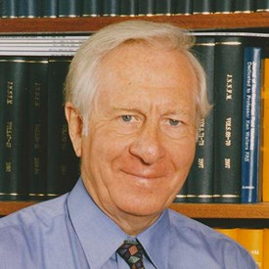
It is with great sadness that we mark the passing of Professor Kenneth Walters FRS on March 28th 2022. Ken was the founding Editor of the Journal of Non-Newtonian Fluid Mechanics in 1976 and served as Executive Editor up until Volume 100 published in 2001.
Ken was a skilled mathematician and rheologist, educated at the University of Wales, Swansea and receiving his PhD in 1959 under the guidance of James G. Oldroyd. He spent most of his career at Aberystwyth University, most recently as Distinguished Research Professor in the Institute of Mathematics, Physics and Computer Science.
Ken served his academic communities in many roles. Between 1974-76, he was President of the British Society of Rheology (BSR). From 1996-2000, he was first President of the European Society of Rheology (ESR), and, between 2000-2004, he was Chairman of the International Committee on Rheology (ICR). Ken received the Gold Medal of the BSR in 1984, the Weissenberg Award from the ESR in 2002, and honorary doctorates from three universities. He was elected a Fellow of the Royal Society in 1991, and become a Founding Fellow of the Learned Society of Wales in 2009. He was a prolific author, of both research papers and influential books.
However, beyond the many distinctions of a distinguished career listed above, perhaps his greatest impact was on the people and scientific community around him. Over 50 graduate students studied under Ken at Aberystwyth, many of whom have continued to very successful academic careers. Apart from JNNFM, Ken was a driving force behind foundation of the European Society of Rheology and the Institute on non-Newtonian Fluid Mechanics in Wales. Ken was unfailingly supportive of young emerging scientists, with a long-term view for the health of the field. The annual meetings of the INNFM had both scientific quality and a familial feel – a joy to attend!
As commented by his INNFM colleagues, Peter Townsend & Dan Curtis, “Ken’s kindness, enthusiasm and genuine interest in people meant that all regarded him as a friend rather than a colleague or collaborator. All will agree that Ken will be missed dearly by generations of rheologists across the world and that the lack of his gentlemanly presence at our meetings will be to their detriment.” We cannot agree more.

I. Frigaard
R. Poole

