System dynamics-life cycle assessment causal loop model for evaluating the carbon emissions of building refurbishment construction and demolition waste
Wenting Ma¹, Jian Li Hao², Cheng Zhang³, Fangyu Guo⁴, Luigi Di Sarno⁵
^{1,2,3.4} Department of Civil Engineering, Xi’an Jiaotong-Liverpool University, Suzhou, China
⁵ Department of Civil Engineering, University of Liverpool, Liverpool, Liverpool L69 3BX, UK
* Corresponding author: Jian Li Hao
Email address: Jianli.Hao@xjtlu.edu.cn

Abstract
Purpose
Building refurbishment (BR) is promoted as a green alternative to demolition and new build for urban renewal. The construction and demolition (C&D) waste of BR is increasing and recognized as more complex to manage. To address the limitations of the current static and linear life cycle assessment (LCA) method for evaluating the environmental impact of C&D waste, this study decodes the complex process and provides a causal loop model for evaluating the carbon emissions (Greenhouse Gases emissions) of BR C&D waste.
Methods
The study integrates system dynamics (SD) and a LCA approach to produce an integrated and holistic model for evaluating the carbon emissions of BR C&D waste. The environmental assessment system boundary and main factors of evaluating the carbon emissions of BR C&D waste are identified based on a LCA approach. Stakeholders in the life cycle of BR C&D waste are involved in development of the causal loop model. Semi-structured interviews are conducted with key stakeholders to validate the factors and identify the key processes of BR C&D waste management through a case study of Suzhou, China.
Results
Five causal loops are developed in this study: a general model for evaluating the carbon emissions of the life cycle of BR C&D waste, a sub-model for evaluating carbon emissions of BR C&D waste at the dismantlement stage, a sub-model for evaluating carbon emissions of BR C&D waste at the refurbishment material stage, a sub-model for evaluating carbon emissions of BR C&D waste at the refurbishment construction stage, and a sub-model for evaluating carbon emissions of BR C&D waste at the refurbishment material end of life stage.
Conclusion
The integrated SD-LCA causal loop model developed in this study will help decision makers to more clearly visualize and understand the current problems associated with BR C&D waste management and thereby strategically intervene to reduce the carbon emissions in the life cycle of BR C&D waste.
Graphical abstract
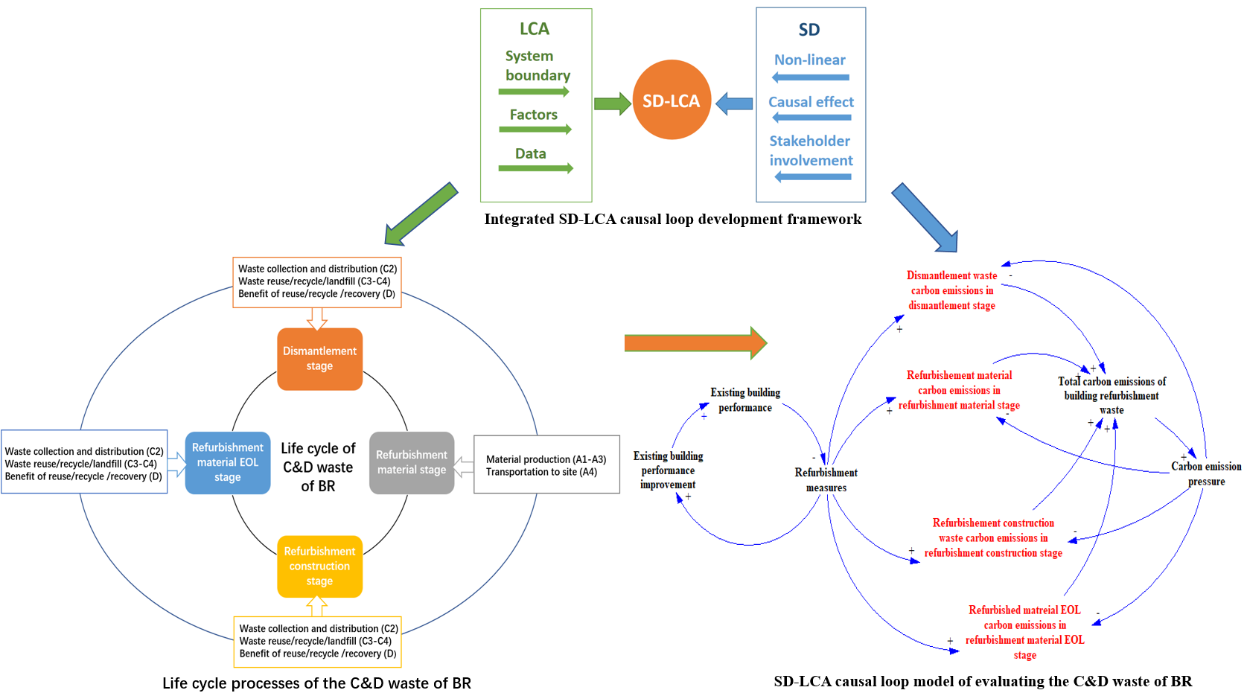
Statement of Novelty
BR C&D waste is increasing along with the recognition that managing it effectively is a complex problem. To address the limitations of the current static and linear method for evaluating the environmental impact of C&D waste, this study evaluates the carbon emissions of BR C&D waste using a novel integrated SD-LCA approach. This study not only develops a unique non-linear and causal loop evaluation model, but also engages stakeholders in its development.
Keywords
Construction and demolition (C&D) waste management, Greenhouse Gases (GHGs) emissions, building refurbishment, circular economy, System dynamics, Life cycle assessment (LCA)

- Introduction
1.1 Background
The building industry contributes more than one third of the world’s greenhouse gases (GHGs) emissions [1]. Accordingly, the mitigation of carbon emissions has become a critical mission for the building sector as the world seeks to reach the carbon neutral goal set in the Paris Agreement [2]. Building refurbishment (BR) has become an effective way to improve the operational energy efficiency of existing buildings and prevent embodied carbon emissions from large-scale demolition and rebuild [3, 4]. The European Commission intends to refurbish at least 80% of existing building stock by 2050 to mitigate Europe’s carbon emissions [5]. BR has been promoted by the Chinese government to achieve its sustainable development goal in building sector. As part of China’s “13th Five-year-plan”, 600 million $m^{2}$ of existing buildings were energy refurbished by the end of 2020 [6]. BR activities are expected to continually increase along with urban renewal.
Most of the current BR projects have been conducted without apparent concern for the embodied environmental impact [7]. Significant efforts have been made to reduce the energy consumption in building operations through using passive measures and active techniques, such as improving envelope insolation and using high efficiency HVAC systems [8] but the embodied carbon emissions produced by BR are often neglected [9]. The large amounts of C&D waste generated by the excessive dismantling of existing building envelopes [10] is adding significantly to embodied carbon emissions in the life cycle of BR, which needs to be quantified and assessed to help reduce overall emissions.
1.2 Environmental impact evaluation of C&D waste management
The C&D waste generated in construction, refurbishment and demolition accounts for 10 billion tons each year worldwide [11], which has become a critical global problem due to its negative environmental impact [12]. China alone generates around 2 billion tons of C&D waste each year [13], mainly due to its large scale urbanization and urban revitalization programs [14]. Extensive research has been devoted to evaluate the environmental impact of C&D waste using different methods [15-24]. Life cycle assessment (LCA) and system dynamics (SD) are two methods frequently used for evaluating the environmental performance of C&D waste management [25].
The LCA approach is based on life cycle thinking, which quantifies all relevant environmental impacts associated with a product, with its whole life cycle taken into account from resource extraction, production, and transportation, to use and end of life waste disposal [26]. The LCA approach has been extensively adopted for evaluating the environmental impact of C&D waste based on the structured international standard provided by ISO 14040 and 14044 with different system boundaries [27, 28]. From a life cycle perspective, many studies adopted LCA to evaluate the environmental impact of using different recycled waste materials in construction material production. For example, Cuenca-Moyano et al. (2017) evaluated the environmental performance of masonry mortar made of natural vs recycled aggregates [29]; Seco et al. (2018) evaluated blocks manufactured from C&D waste [30]; and Li et al. (2021) evaluated the environmental impact of self-compacting concrete made with demolition concrete waste [31]. Bianco et al. (2021) compared the environmental impact of concrete produced using a waste glass-based silicate activator compared with using commercial chemicals [32], and Sandanayake et al. (2022) performed LCA for shredded coffee cup waste to replace sand in concrete and replace wood chip in particleboard production [33]. Other studies considered the impact of different C&D waste disposal scenarios on landfill and recycling. For example, Penteado et al. (2016) investigated six integrated waste disposal methods including landfill, recycling and using C&D waste for road pavement material through a case study in Brazil [34]; Lockrey et al. (2018) evaluated the environmental performance of a C&D waste recycling system in Vietnam [35]; Jain et al. (2020) evaluated the environmental impact of two C&D waste management alternatives through a case study in urban India [36]; and Liu et al. (2021) analyzed the carbon emissions of three various waste disposal alternatives in Guangzhou, China [37]. Some studies evaluated the environmental impact of C&D waste using a whole LCA approach by considering both the upstream construction material, transportation, and downstream waste disposals. For example, Wang et al. (2019) revealed the importance of considering the environmental impact of C&D waste before and after the waste generation using an LCA approach [21]; and Llatas et al. (2021) analyzed waste management prevention scenarios including the upstream processes of material manufactory and transportation, and the downstream processes of waste disposal [38]. One limitation of LCA is that the analysis is linear and static [39], when in fact the factors influencing the carbon emissions of waste are not always static. The factors are affected by the interventions of many different waste management strategies as well as sophisticated dynamic interactions and multiple feedbacks among each other [40].
SD approach is based on the system thinking theory which holistically views a problem with understanding interrelationships between elements [41]. It has been approved as a powerful problem-solving tool to find optimal solutions to deal with complexity [42]. The dynamic interrelationships of the factors affecting the environmental performance of C&D waste have also been analyzed utilizing a SD approach [43]. Ye et al. (2012) identified major factors and assessed the environmental performance based on various C&D waste management alternatives [44]. Marzouk and Azab (2014) evaluated the environmental and economic impact of C&D waste recycling compared with landfills in Egypt through SD modeling [18]. Ding et al. (2016) assessed the environmental performance of C&D waste reduction management at the construction stage using SD, and one study measured the impact of C&D waste management on environmental factors from a water, air, and land perspective [20]. Ding et al. (2018) developed an environmental evaluation model for C&D waste reduction in the phase of design and construction [45]. By adopting a SD approach, Liu et al. (2020) analyzed the environmental impact of various C&D waste management scenarios, including illegal dumping, landfilling, and waste recycling in Guangzhou, China [46]. One of the limitations of SD is that the system boundary and factors for evaluating environmental performance are subjectively selected without using any standard method [25].
To cope with the limitations of these two methods and to explore an integrated method for evaluating C&D waste, this study integrates SD and LCA as a hybrid SD-LCA approach. This approach integrates life cycle thinking and system dynamics modeling to solve complex environmental problems [47, 48]. The integrated SD-LCA approach has been adopted and demonstrated its effectiveness in other research fields to deepen and broaden the life cycle assessment model. For example, Yao et al. (2018) analyzed mobile phone recycling in China using integrated SD-LCA method [49]; Bixler et al. (2019) integrated SD and LCA to simulate different green infrastructures for stormwater systems [40]; and Ren et al. (2020) integrated SD and LCA to evaluate the carbon footprint, energy, and cost of residential solar photovoltaic systems through a case study in Boston, USA [50].
1.3 Carbon emissions evaluation of BR
As mentioned above, the studies on C&D waste management are mainly focused on the new building construction and demolition projects. However, BR waste management is recognized as more complicated compared with new construction and demolition projects, as refurbishment involves partial dismantle and new construction in an integrated process [51]. According to Sustainability of Construction Works BS EN 15978 (2011), the calculation method for the assessment of environmental performance of buildings, the system boundary for calculating the carbon emissions of BR is in the following life cycle processes: the end of life of dismantled building components; new refurbishment material production and transportation; refurbishment construction; and waste management related to refurbishment [52].
Greenhouse gases (GHGs) are emitted throughout the whole life cycle of BR. The term carbon emissions is commonly used in studies quantifying climate change impacts, where GHGs emissions are weighted in terms of carbon dioxide (${CO}_{2}$) equivalents for aggregating impacts [53, 54]. Extensive studies have investigated the life cycle carbon emissions of BR in recent years. Several studies have investigated the carbon emissions of BR versus demolition and rebuild. For example: Ferreira et al. (2015) compared the environmental impact of the refurbishment and reconstruction for a heritage building in Lisbon, Portugal [55]; Weiler et al. (2017) studied the carbon emissions and energy consumption of building refurbishment compared with demolition and rebuild through an integrated LCA and energy simulation approach [56]; and Hasik et al. (2019) conducted a whole life cycle assessment for BR and new construction [57]. These studies have found that refurbishment produces lower carbon emissions than demolition and rebuild. Other studies focused on the tradeoffs of life cycle carbon emissions and energy consumption of BR through different refurbishment strategies. For example: Beccali et al., (2013) evaluated the environmental impacts on a building’s life cycle based on various refurbishment measures [58]; and Shadram et al. (2020) studied the multi-objective optimization to explore the various refurbishment measures on the trade-off for a building in Sweden through using a LCA approach [59]. These studies reveal that embodied environmental emissions are higher when operational energy performance is improved by energy refurbishment. Increasing attention is being paid to reducing life cycle embodied carbon for BR. For example: Ghose et al. (2017) conducted an environmental assessment of resource and waste management of a BR project in New Zealand that focused on the material and construction stage [60]; Opher et al. (2021) studied embodied carbon emissions from cradle to grave by LCA for a net zero carbon emission refurbishment project in Toronto, Canada [61]; and Ma et al. (2022) evaluated the whole life cycle of carbon emissions of C&D waste of BR from cradle to cradle though a case study in Suzhou, China [62]. These studies reveal that the whole life cycle assessment from cradle to cradle is necessary for evaluating carbon emissions of BR to achieve a circular economy for C&D waste management. According to the above studies, LCA is the most frequently used method for evaluating carbon emissions of building refurbishment.
However, little attempt has been made to evaluate carbon emissions of the whole life cycle of BR C&D waste through an integrated approach. This study therefore aims to develop an integrated SD-LCA causal loop model for evaluating the carbon emissions of BR C&D waste. The main steps in development of the model were as follows: the key factors for evaluating the carbon emissions of BR C&D waste were first identified based on the LCA method; semi-structured interviews with main stakeholders in the life cycle of BR C&D waste management were then conducted to validate the identified factors and find the causal effects between those factors; and finally, the causal-loop model for evaluating the carbon emissions of the life cycle of BR C&D waste was developed. The integrated SD-LCA causal loop model developed in this study could help decision makers to clearly visualize and understand current BR C&D waste management problems, and thereby make more strategic interventions to reduce carbon emissions during the life cycle of BR C&D waste.

- Methodology
The LCA methodology is increasingly being adopted for assessing the environmental performance of waste management systems [63]. It has been adopted in C&D waste management since the end of the 1990s to evaluate potential environmental impact of alternative C&D waste management scenarios [64]. Current LCA studies follows four phases based on ISO14040 (2006) and ISO14044 (2006): “goal and scope definition”, “life cycle inventory (LCI)”, “life cycle impact assessment (LCIA)”, and “life cycle interpretation” [27, 28].
System dynamics (SD) is an approach of analyzing the dynamic non-linear behavior and pattern of changes over time of complex problems [65]. SD was initially developed in the field of management by Jay Forrester with his colleagues at Massachusetts Institute of Technology in the 1960s [66, 67]. The first step of SD modeling is to identify key factors of a complex problem. Then, the key factors and their interconnections are drawn in a qualitative causal loop model which aids in visualizing and better understanding the complex system [68]. The next step is to convert the causal loop model to a quantified stock and flow model. The key factors are identified as stocks and flows which interconnected with each other by feedback loops. The stock and flow model is numerical simulated in a computer software [69].
This study integrates the system dynamics and LCA approach toward a dynamic and holistic evaluation model for evaluating the carbon emissions of BR C&D waste. The integrated SD-LCA framework is illustrated in Figure 1. The system boundary, factors, and the inventory data of the factors for evaluating the carbon emissions of refurbishment waste are identified within the processes of the system boundary based on the LCA methodology. SD provides a modeling platform for demonstrating non-linear and causal effect characteristics between factors, which also involves stakeholder engagement in model development.
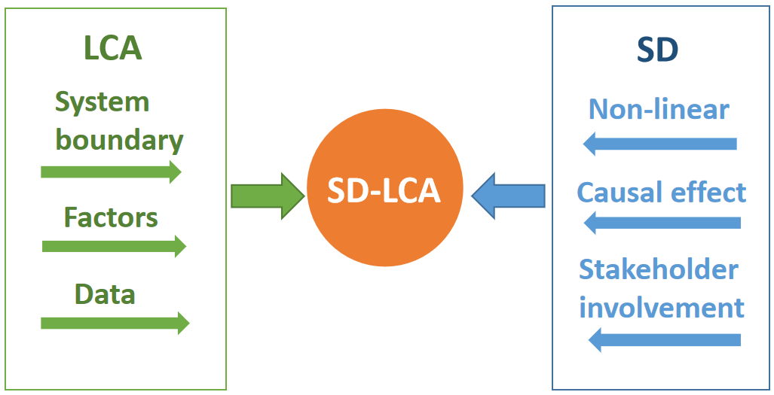
Figure 1. Integrated SD-LCA causal loop framework
Based on the integrated SD-LCA framework, the causal loop model is developed as shown in Figure 2. The goal and system boundary are first identified based on the standard LCA method and EN15978:2011-Sustainability of construction works [52]. The preliminary factors for evaluating the carbon emissions of BR C&D waste are identified based on the processes within the system boundary. Semi-structured interviews were then conducted to validate the preliminary factors and provide evidence to develop the causal loop model. The causal loop model was developed using the SD development tool: Vensim PLE [70].

Figure 2. SD-LCA causal loop model development steps

- Integrated SD-LCA causal loop model development
3.1 Goal and system boundary
The goal of this study is to develop a SD-LCA causal loop model to evaluate the carbon emissions of the life cycle of BR C&D waste. LCA methodology is used for identifying the system boundary and main factors. The system boundary and main factors for evaluating the carbon emissions of C&D waste in the life cycle of BR is based on the standard BS EN15978:2011-Sustainability of construction works [52]. The upstream and downstream impact of the waste generation should be taken into account for evaluating carbon emissions of the whole life cycle of BR waste [62]. This study extends the system boundary to include the benefit of using secondary materials in substitute of raw materials in the material stage, as well as the benefit of reuse, recycle, and recovery of the waste. Therefore, the system boundary of the life cycle of BR C&D waste as illustrated in Figure 3, includes the dismantlement stage, refurbishment material stage, refurbishment construction stage, and refurbishment material at end of life (EOL) stage.
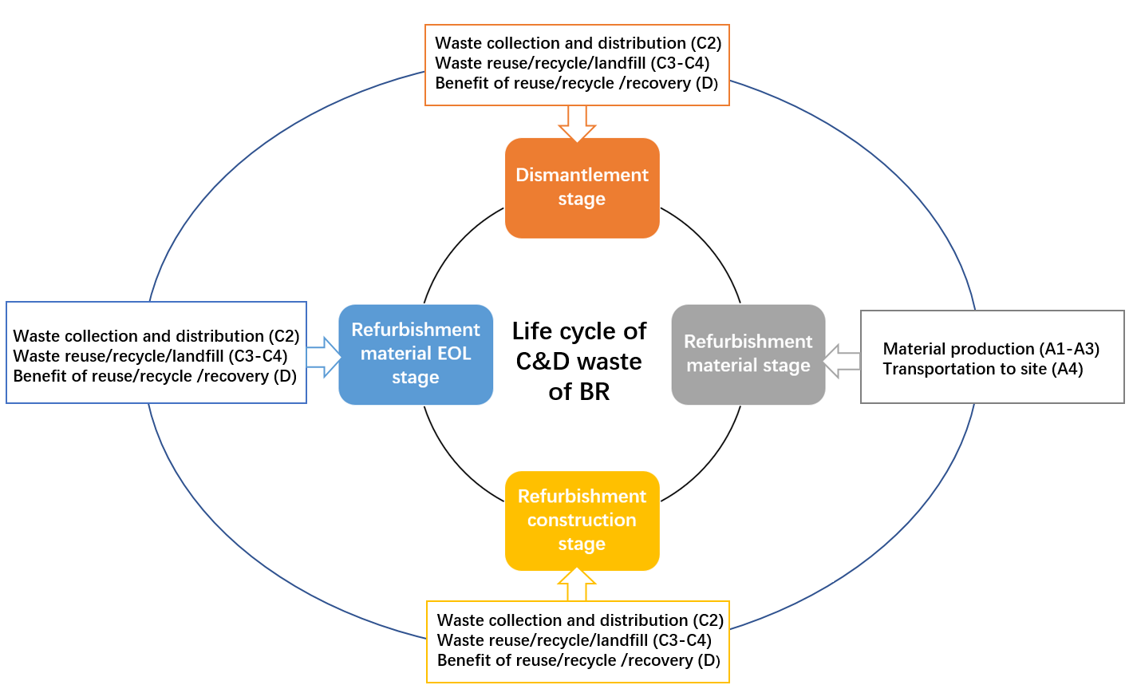
Figure 3. Life cycle of BR C&D waste (Adapted from BSEN15978:2011)
Dismantlement stage assesses the impact of the waste generated from the old components’ dismantlement and removal from the BR site. The waste management process covers the waste collection (C2), waste reuse/recycle/landfill (C3-C4), and the benefit of reuse/recycle/recovery (D). The dismantlement waste collection includes the impact due to the transportation from site to the waste disposal destination. C3 assesses the impact of waste processing for reuse, recycle, or recovery, while C4 is the impact of waste for landfill. This study includes the environmental benefits of the material being reused or recycled, as well as the recovered energy resulting from C3 that has the potential to be used as resources.
Refurbishment material stage covers the impact of material production (A1-A3) and transportation (A4). A1-A3 covers the process from “cradle to gate” for the refurbishment material used in the BR. Transportation A4 includes the transportation of the refurbishment material from the manufactory gate to the BR site. The reason for including the refurbishment material stage in this study is to assess the impact of BR C&D waste from cradle to cradle, and to assess the impact of the secondary material produced from C&D waste back to the system.
Refurbishment construction stage assesses the impact of the waste generated from the refurbishment construction. The refurbishment construction waste management process covers the waste collection (C2), waste reuse/recycle/landfill (C3-C4), and the benefit of reuse/recycle/recovery (D). The refurbishment construction waste collection includes the impact due to the transportation from site to the waste disposal destination. C3 assesses the impact of waste processing for reuse, recycle, or recovery. C4 is the impact of waste for landfill. This study includes the environmental benefits of the material being reused or recycled, as well as the recovered energy resulting from C3 that has the potential to be used as resources.
Refurbishment material EOL stage assesses the impact of the refurbishment material when is not intended to be used and starts to be treated as waste, thus, this refurbishment material EOL waste must be managed. The waste management process covers the waste collection (C2), waste reuse/recycle/landfill (C3-C4) and the benefit of reuse/recycle/recovery (D). The waste collection includes the impact due to the transportation from site to the waste disposal destination. C3 is to assess the impact of waste processing for reuse, recycle, or recovery. C4 is the impact of waste for landfill. This study includes the environmental benefits of the material being reused or recycled, as well as the recovered energy resulting from C3 that has the potential to be used as resources.

3.2 Identify factors
The main factors for evaluating the carbon emissions of BR C&D waste are identified according to the system boundary outlined in section 3.1. The key factors for evaluating carbon emissions in four life cycle stages of BR C&D waste are identified based on BSEN15978:2011 as shown in Table 1.
Table 1. Main factors for evaluating carbon emissions of BR C&D waste
LCA stages | Factors
Dismantlement stage | Amount of dismantlement waste
 | Carbon emissions of dismantlement waste transportation
 | Carbon emissions of dismantlement waste disposal (landfill/incineration/recycle)
 | Carbon emission savings of dismantlement waste incineration/recycle
Refurbishment material stage | Amount of raw/secondary material
 | Carbon emissions of material production
 | Carbon emissions of material transportation to site
Refurbishment construction stage | Amount of construction waste
 | Carbon emissions of construction waste transportation
 | Carbon emissions of construction waste disposal (landfill/incineration/recycle)
 | Carbon emission savings of construction waste incineration/recycle
Refurbishment material EOL stage | Amount of refurbishment material EOL waste
 | Carbon emissions of refurbishment material EOL waste transportation
 | Carbon emissions of refurbishment material EOL waste disposal (landfill/incineration/recycle)
 | Carbon emission savings of refurbishment material EOL waste incineration/recycle

  - Causal loop model development
A SD causal loop model is a qualitative tool serving as a fundamental step in solving problems in complex systems. The causal loop develops a model with factors, and causal loops between factors, to understand how individual factors work holistically in a non-linear system [71]. Many recent studies have developed causal loop models to analyze diverse complex systems [72-74]. Local stakeholders are engaged in the causal loop model development in order to confirm the factors and develop a model which better represents the system in as a real phenomenon [74]. Semi-structured interviews have proved effective for stakeholders’ engagement in causal loop development [75, 76]. In this study, the method of stakeholders’ engagement in development of the causal loop model was adapted from Agnew et al. (2018) [75]. Firstly, the stakeholders were selected according to the four life cycle stages of BR C&D waste management. The preliminary factors and pre-set questions were prepared before the interview. The semi-structured interviews with stakeholders related to the life cycle of BR C&D waste management and were conducted either individually or in small groups. There were four categories of stakeholders: four designers from a design company, three construction managers of refurbishment contractors, two managers in a C&D waste treatment company, and a head of the C&D waste management office in Suzhou.
Table 2. Stakeholders engaged in this study
Interviewee | Position | Working experience | Institution
1 | Designer | 5-10 | ARTS Group Co., Ltd.
2 | Designer | 11-15 | ARTS Group Co., Ltd.
3 | Designer | 5-10 | ARTS Group Co., Ltd.
4 | Designer | 5-10 | ARTS Group Co., Ltd.
5 | Project manager | 5-10 | Suzhou SIP Urban Renewal Development CO., LTD
6 | Project manager | 5-10 | Jiangsu Yian Construction Co., LTD
7 | Project manager | 11-15 | Jiangsu Yian Construction Co., LTD
8 | Technical director | 5-10 | Suzhou Construction Material Recycling application Co., LTD
9 | General manger | 5-10 | Suzhou Construction Material Recycling Application Co., LTD
10 | Head of office | 5-10 | Suzhou C&D Waste Management Office

During each of the semi-structured interviews, which lasted between one and two hours, the factors at the four stages of the BR C&D waste life cycle were confirmed with the stakeholders. The following questions were asked to understand the process of BR C&D waste management in Suzhou and to help identify feedback loops and causal relationships.
- What is your role and responsibility in building refurbishment projects?
- Is building refurbishment waste management considered from a life cycle perspective (including planning and design stage, construction stage, dismantlement and waste disposal stage, and waste recycling/recovery stage)?
- Which life cycle stage are you involved with in building refurbishment waste management?
- What is your role in the building refurbishment waste management process?
- Can you describe the building refurbishment waste management process?
- What are the key factors in the process for evaluating the carbon emissions?

- Results and discussion
The casual loop model for evaluating the carbon emissions of BR C&D waste is formulated using the Vensim PLE 8.2.1 system dynamics simulation software [70]. In a causal loop model, factors are connected to feedback loops with an arrow and polarity. The positive (+) polarity indicates reinforcing (“R”) loop, which means “when a cause factor increases, the effect factor increases” and vice versa. A negative (-) polarity indicates a balancing (“B”) loop, which means “when a cause factor increases, the effect factor decreases” and vice versa. There are five causal loop models developed: the general model for evaluating the carbon emissions of the life cycle of BR C&D waste, a sub-model for evaluating the carbon emissions of the BR waste at the dismantlement stage, a sub-model for evaluating the carbon emissions of the BR waste at the refurbishment material stage, a sub-model for evaluating the carbon emissions of BR waste at the construction stage, and a sub-model for evaluating the carbon emissions of the BR waste at the refurbishment material EOL stage.
4.1 General model for evaluating the carbon emissions of the BR C&D waste life cycle

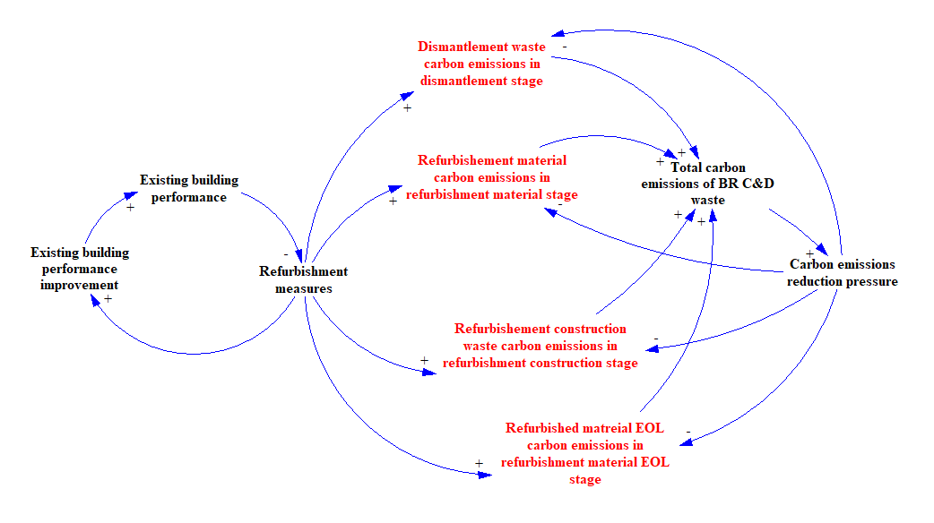
Figure 4. Causal loop model for evaluating the BR C&D waste life cycle

The general model for evaluating the BR C&D waste life cycle is illustrated in Figure 4. As illustrated, when the building owner is not satisfied with the performance of the building, it is likely to be refurbished to improve the performance. The worse the performance, the more refurbishment measures are used to improve the performance. The more refurbishment measures required, the greater the carbon emissions from refurbishment material consumption and C&D waste generation. According to the system boundary of this study, the carbon emissions of BR C&D waste are generated in four life cycle stages: dismantlement waste carbon emissions at the dismantlement stage, refurbishment material carbon emissions at the refurbishment material stage, refurbishment construction waste carbon emissions at the refurbishment construction stage, and refurbished material EOL carbon emissions at the refurbishment EOL stage. The carbon emissions produced in these four stages account for the total carbon emissions of BR C&D waste. When the total carbon emissions are high, it causes carbon emissions reduction pressure to control the increase of the total carbon emissions.

4.2 Sub-model for evaluating carbon emissions of dismantlement waste
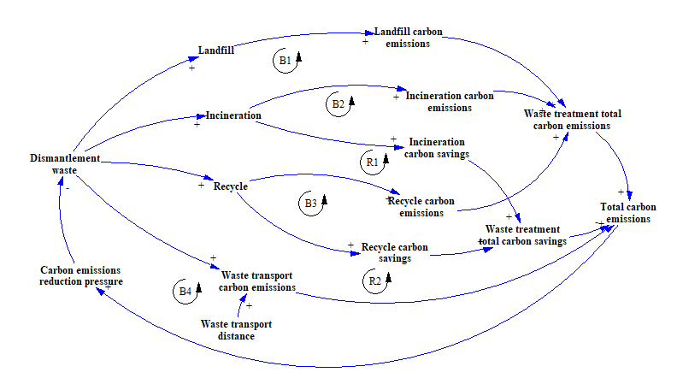
Figure 5. Causal loop model for evaluating carbon emissions during dismantlement
The sub-model for evaluating the carbon emissions of dismantlement waste is illustrated in Figure 5. As can be seen, there are 6 feedback loops for evaluating carbon emissions of BR C&D waste at the dismantlement stage. Four loops are balancing (B) loops and two loops are reinforcing (R) loops.
Loop B1: Dismantlement waste → Landfill → Landfill carbon emissions → Waste treatment total carbon emissions → Total carbon emissions → Carbon emissions reduction pressure → Dismantlement waste
Loop B2: Dismantlement waste → Incineration → Incineration carbon emissions → Waste treatment total carbon emissions → Total carbon emissions → Carbon emissions reduction pressure → Dismantlement waste
Loop B3: Dismantlement waste → Recycle → Recycle carbon emissions → Waste treatment total carbon emissions → Total carbon emissions → Carbon emissions reduction pressure → Dismantlement waste
Loop B4: Dismantlement waste → Waste transport carbon emissions → Total carbon emissions → Carbon emissions reduction pressure → Dismantlement waste
Loop R1: Dismantlement waste → Incineration → Incineration carbon savings → Waste treatment total carbon savings → Total carbon emissions → Carbon emissions reduction pressure → Dismantlement waste
Loop R2: Dismantlement waste → Recycle → Recycle carbon savings → Waste treatment total carbon savings → Total carbon emissions → Carbon emissions reduction pressure → Dismantlement waste
For B1, B2, B3 an increase in the dismantlement waste increases the amount of waste in landfilling, incinerating, recycling, therefore the carbon emissions of the process of the landfilling, incinerating, and recycling increase, eventually, the total carbon emissions increase. The same with the B4, the increase amount of waste will increase the amount of transportation. Thus, an increase in the transportation carbon emissions will eventually increase the total carbon emissions. An increase in the total carbon emissions has a negative impact, which will lead to carbon emissions reduction pressure. When the pressure is increased, a negative effect is eventually provided to control the total carbon emissions. For R1 and R2, the benefit of waste incineration and recycling will reduce the total carbon emissions of the dismantlement waste.

4.3 Sub-model for evaluating the carbon emissions of refurbishment materials
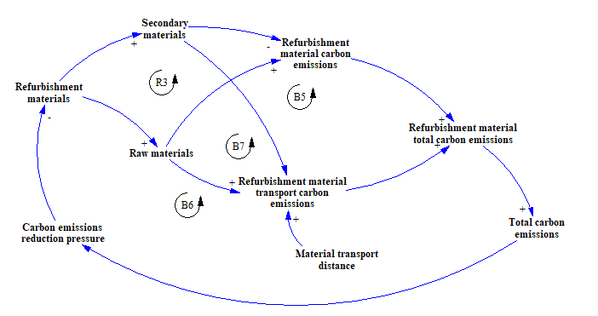
Figure 6. Causal loop model for evaluating carbon emissions of refurbishment materials
As can be seen from Figure 6, there are 4 feedback loops for evaluating carbon emissions of refurbishment materials. Three loops are balancing loops and one loop is a reinforcing loop.
Loop B5: Refurbishment materials → Raw materials → Refurbishment material carbon emissions → Refurbishment material total carbon emissions → Total carbon emissions → Carbon emissions reduction pressure → Refurbishment materials
Loop B6: Refurbishment materials → Raw materials → Refurbishment material transport carbon emissions → Refurbishment material total carbon emissions → Total carbon emissions → Carbon emissions reduction pressure → Refurbishment materials
Loop B7: Refurbishment materials → Secondary materials → Refurbishment material transport carbon emissions → Refurbishment material total carbon emissions → Total carbon emissions → Carbon emissions reduction pressure → Refurbishment materials
Loop R3: Refurbishment materials → Secondary materials → Refurbishment material carbon emissions → Refurbishment material total carbon emissions → Total carbon emissions → Carbon emissions reduction pressure → Refurbishment materials
For B5 and B6, an increase in the amount of raw material will increase the carbon emissions of the refurbishment material production and transportation. This in turn increases the total carbon emissions and then the increased carbon emission reduction pressure will control the carbon emissions of the refurbishment materials. For loop R3, an increase in the use of secondary materials will reduce the carbon emissions of refurbishment materials, thus reducing the total carbon emissions.

4.4 Sub-model for evaluating the carbon emissions of refurbishment construction waste
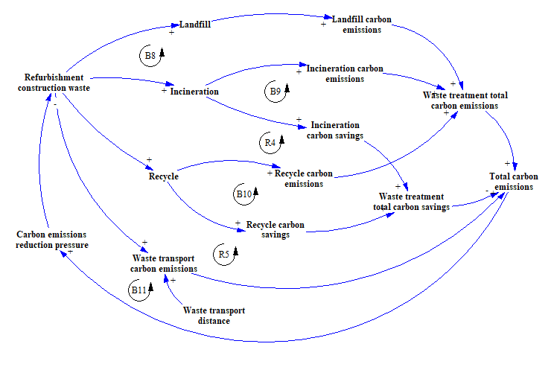
Figure 7. Causal loop model for evaluating carbon emissions of refurbishment construction waste
The sub-model for evaluating the carbon emissions of refurbishment construction waste is illustrated in Figure 7. As can be seen, there are 6 feedback loops for evaluating dismantlement waste carbon emissions. Four loops are balancing loops and two loops are reinforcing loops.
Loop B8: Refurbishment construction waste → Landfill → Landfill carbon emissions → Waste treatment total carbon emissions → Total carbon emissions → Carbon emissions reduction pressure → Refurbishment construction waste
Loop B9: Refurbishment construction waste → Incineration → Incineration carbon emissions → Waste treatment total carbon emissions → Total carbon emissions → Carbon emissions reduction pressure → Refurbishment construction waste
Loop B10: Refurbishment construction waste → Recycle → Recycle carbon emissions → Waste treatment total carbon emissions → Total carbon emissions → Carbon emissions reduction pressure → Refurbishment construction waste
Loop B11: Refurbishment construction waste → Waste transport carbon emissions → Total carbon emissions → Carbon emissions reduction pressure → Refurbishment construction waste
Loop R4: Refurbishment construction waste → Incineration → Incineration carbon savings → Waste treatment total carbon savings → Total carbon emissions → Carbon emissions reduction pressure → Refurbishment construction waste
Loop R5: Refurbishment construction waste → Recycle → Recycle carbon savings → Waste treatment total carbon savings → Total carbon emissions → Carbon emissions reduction pressure → Refurbishment construction waste
For B8, B9, B10, an increase in refurbishment construction waste increases the amount of waste in landfill, incineration, and recycle, and increases the carbon emissions of those processes and ultimately increasing the waste treatment carbon emissions and the total carbon emissions. The same with B11, an increasing amount of waste will increase the amount of transportation, which will increase the transport carbon emissions and ultimately increase the total carbon emissions. An increase in the total carbon emissions has a negative impact, which will lead to carbon emissions reduction pressure and eventually provide a negative effect to control the total carbon emissions. The loop R4 and R5 will reduce total carbon emissions due to the benefit of carbon savings from the incineration and recycle.

4.5 Sub-model for evaluating the carbon emissions of refurbishment material EOL waste
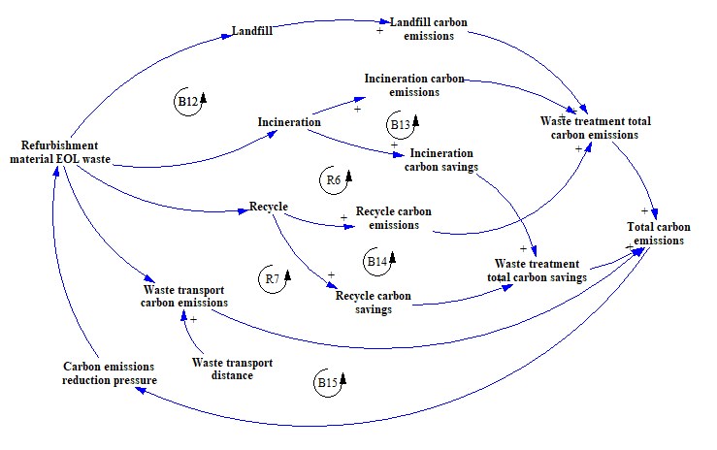
Figure 8. Causal loop model for evaluating carbon emissions of refurbishment material EOL waste
There are 6 feedback loops for evaluating refurbishment material EOL waste carbon emissions. Four loops are balancing loops and two loops are reinforcing loops.
Loop B12: Refurbishment material EOL waste → Landfill → Landfill carbon emissions → Waste treatment total carbon emissions → Total carbon emissions → Carbon emissions reduction pressure → Refurbishment material EOL waste
Loop B13: Refurbishment material EOL waste → Incineration → Incineration carbon emissions → Waste treatment total carbon emissions → Total carbon emissions → Carbon emissions reduction pressure → Refurbishment material EOL waste
Loop B14: Refurbishment material EOL waste → Recycle → Recycle carbon emissions → Waste treatment total carbon emissions → Total carbon emissions → Carbon emissions reduction pressure → Refurbishment material EOL waste
Loop B15: Refurbishment material EOL waste → Waste transport carbon emissions → Total carbon emissions → Carbon emissions reduction pressure → Refurbishment material EOL waste
Loop R6: Refurbishment material EOL waste → Incineration → Incineration carbon savings → Waste treatment total carbon savings → Total carbon emissions → Carbon emissions reduction pressure → Refurbishment material EOL waste
Loop R7: Refurbishment material EOL waste → Recycle → Recycle carbon savings → Waste treatment total carbon savings → Total carbon emissions → Carbon emissions reduction pressure → Refurbishment material EOL waste
For B12, B13, B14, an increase in refurbishment material EOL waste increases the amount of waste in landfill, incineration, and recycle, thereby increasing the carbon emissions of those processes and eventually increasing the waste treatment total carbon emissions and total carbon emissions. The same with the B15, the increased amount of the refurbishment material EOL waste will increase the amount of transportation. This will increase the transport carbon emissions and eventually increase the total carbon emissions. The increased total carbon emissions has a negative impact, which will lead to carbon emissions reduction pressure that provides a negative effect to eventually control total carbon emissions. For R6 and R7, the benefit of carbon savings from the waste incineration and recycle will reduce the total carbon emissions of refurbishment material EOL waste.
The above five causal loop models (the general model for evaluating carbon emissions of the life cycle of BR C&D waste, the sub-model for evaluating carbon emissions of the dismantlement waste, the sub-model for evaluating carbon emissions of the refurbishment material, the sub-model for evaluating carbon emissions of the refurbishment construction waste, and the sub-model for evaluating carbon emissions of the refurbishment material EOL waste) have provided findings that are useful for decision makers to clearly visualize and understand the current problems associated with BR C&D waste management and thereby strategically intervene to reduce the carbon emissions in the life cycle of BR C&D waste

- Conclusion and future work
This paper introduced a novel integrated SD-LCA methodology for reducing the carbon emissions of BR C&D waste. The qualitative integrated SD-LCA causal loop model was developed for visualizing the complexity of the life cycle carbon emissions of BR C&D waste with stakeholders’ involvement through a case study of Suzhou, China. The study has demonstrated the potential of the integrated SD-LCA modeling for evaluating the carbon emissions of the BR C&D waste from cradle to cradle by focusing on the causal loop feedback system and visually presenting four life cycle stages of BR C&D waste management. The main contributions of this research are as follows.
The integrated SD and LCA creates an innovative methodology for evaluating and mitigating carbon emission of BR C&D waste. The LCA provides a clear system boundary and factors which relates to the carbon emissions of BR C&D waste. SD provides a platform for modeling and visualizing complexity of inter-connections between factors in a non-linear BR C&D waste system. The integrated SD-LCA causal loop model developed in this study is useful for decision makers to more clearly visualize and understand the current problems associated with BR C&D waste management and thereby strategically intervene to reduce the carbon emissions in the life cycle of BR C&D waste. The SD-LCA causal loop models developed in this study provides useful findings and insights for the government and practitioner when considering carbon emissions related to urban revitalization, building refurbishment, and C&D waste management.
The limitation of this study is that the causal-loop model is a qualitative model for visualizing the complexity of the life cycle carbon emissions of the C&D waste in BR. There remains a need to further convert the causal-loop model to a stock and flow simulation model to quantify carbon emissions. In addition, the stakeholders engaged in this study are mainly from Suzhou city, which is a typical developed urban city of China. The life cycle of BR C&D waste management situation may be different in under developed areas in China and other countries.
Suggestions for future research resulting from this study are as follows. Firstly, the next step in this research is to convert the qualitative SD-LCA causal loop model to a quantitative SD-LCA stock and flow simulation model for evaluating various scenarios for mitigating carbon emissions of BR C&D waste. Secondly, the system boundary could be expanded to include evaluation of social and economic factors in addition to environmental factors. Thirdly, exogenous factors such as stakeholders’ attitudes, behaviors, and policies affecting carbon emissions of BR C&D waste could be investigated.

References
- Zuo, J., Pullen, S., Rameezdeen, R., Bennetts, H., Wang, Y., Mao, G., Zhou, Z., Du, H., Duan, H.: Green building evaluation from a life-cycle perspective in Australia: A critical review. Renewable and Sustainable Energy Reviews. 70, 358-368 (2017)
- UNFCCC: Paris Agreement. United Nations Framework Convention on Climate Change. (2015).
- Tam, V.W.Y., Hao, J.L.: Adaptive reuse in sustainable development. International Journal of Construction Management. 19, 509-521 (2019)
- Seki, Y., Sutrisna, M., Olanipekun, A.O.: Integrating a rich picture diagram and causal loop diagram to model stakeholder engagement in building refurbishment projects. Engineering, Construction and Architectural Management. 28, 1929-1951 (2021)
- Barbiero, T., Grillenzoni, C.: A statistical analysis of the energy effectiveness of building refurbishment. Renewable and Sustainable Energy Reviews. 114, 109297 (2019)
- Chen, Y., Yang, J., Berardi, U., Cui, G., Li, R., Li, N.: Assessments of multiple operation strategies in a passive office Building in Cold Region of China. Energy and Buildings. 254, 111561 (2022)
- Mourão, J., Gomes, R., Matias, L., Niza, S.: Combining embodied and operational energy in buildings refurbishment assessment. Energy and Buildings. 197, 34-46 (2019)
- Ma, W., Kim, M.K., Hao, J.L.: Numerical Simulation Modeling of a GSHP and WSHP System for an Office Building in the Hot Summer and Cold Winter Region of China: A Case Study in Suzhou. Sustainability. 11 (12), 3282 (2019)
- Giesekam, J., Barrett, J., Taylor, P., Owen, A.J.E., Buildings: The greenhouse gas emissions and mitigation options for materials used in UK construction. 78, 202-214 (2014)
- Passer, A., Ouellet-Plamondon, C., Kenneally, P., John, V., Habert, G.: The impact of future scenarios on building refurbishment strategies towards plus energy buildings. Energy and Buildings. 124, 153-163 (2016)
- Chen, K., Wang, J., Yu, B., Wu, H., Zhang, J.: Critical evaluation of construction and demolition waste and associated environmental impacts: A scientometric analysis. Journal of Cleaner Production. 287, 125071 (2021)
- Ouda, O.K.M., Peterson, H.P., Rehan, M., Sadef, Y., Alghazo, J.M., Nizami, A.S.: A Case Study of Sustainable Construction Waste Management in Saudi Arabia. Waste and Biomass Valorization. 9, 2541-2555 (2018)
- Zheng, L., Wu, H., Zhang, H., Duan, H., Wang, J., Jiang, W., Dong, B., Liu, G., Zuo, J., Song, Q.: Characterizing the generation and flows of construction and demolition waste in China. Construction and Building Materials. 136, 405-413 (2017)
- Hao, J.L., Di Maria, F., Chen, Z., Yu, S., Ma, W., Di Sarno, L.: Comparative study of on-site sorting for C&D in China and Europe. Detritus. 13, 114-121 (2020)
- Yuan, H.: A dynamic model for assessing the effectiveness of construction and demolition waste management. Department of Building and Real Estate (2011). the Hong Kong Polythchnic University. PhD Thesis.
- Coelho, A., De Brito, J.: Influence of construction and demolition waste management on the environmental impact of buildings. Waste Management. 32, 532-541 (2012)
- Marzouk, M., Azab, S.: Environmental and economic impact assessment of construction and demolition waste disposal using system dynamics. Resources, Conservation and Recycling. 82, 41-49 (2014)
- Butera, S., Christensen, T.H., Astrup, T.F.: Life cycle assessment of construction and demolition waste management. Waste Management. 44, 196-205 (2015)
- Ding, Z., Yi, G., Tam, V.W.Y., Huang, T.: A system dynamics-based environmental performance simulation of construction waste reduction management in China. Waste Management. 51, 130-141 (2016)
- Yu, S., Awasthi, A.K., Ma, W., Wen, M., Di Sarno, L., Wen, C., Hao, J.L.: In support of circular economy to evaluate the effects of policies of construction and demolition waste management in three key cities in Yangtze River Delta. Sustaibnale Chemistry and Pharmacy. 26, 100625 (2022)
- Wang, J., Wu, H., Tam, V.W.Y., Zuo, J.: Considering life-cycle environmental impacts and society's willingness for optimizing construction and demolition waste management fee: An empirical study of China. Journal of Cleaner Production. 206, 1004-1014 (2019)
- Ding, X., Hao, J., Chen, Z., Qi, J., Maro, M.: New Mix Design Method for Recycled Concrete Using Mixed Source Concrete Coarse Aggregate. Waste and Biomass Valorization. 11, 5431–5443 (2020)
- Hao, J.L., Cheng, B., Lu, W., Xu, J., Wang, J., Bu, W., Guo, Z.: Carbon emission reduction in prefabrication construction during materialization stage: A BIM-based life-cycle assessment approach. Science of The Total Environment. 723, 137870 (2020)
- Wu, H., Zuo, J., Zillante, G., Wang, J., Duan, H.: Environmental impacts of cross-regional mobility of construction and demolition waste: An Australia Study. Resources, Conservation and Recycling. 174, 105805 (2021)
- Wu, H., Zuo, J., Yuan, H., Zillante, G., Wang, J.: A review of performance assessment methods for construction and demolition waste management. Resources, Conservation and Recycling. 150,104407 (2019)
- European Commision-Joint Research Center-Institute for Environment and Sustainability: International reference life cycle data system (ILCD) Handbook-General guid for life cycle assessment-detailed guidance. Publications Office of the Europea Union, Luxembourg (2010).
- ISO14040: Environmental management-life cycle assessment-principles and framework. International Standard Organisation. Geneva (2006).
- ISO14044: Environmental management-life cycle assessment-requirements and guidelines. International Standard Organisation. Geneva (2006)
- Cuenca-Moyano, G.M., Zanni, S., Bonoli, A., Valverde-Palacios, I.: Development of the life cycle inventory of masonry mortar made of natural and recycled aggregates. Journal of Cleaner Production. 140, 1272-1286 (2017)
- Seco, A., Omer, J., Marcelino, S., Espuelas, S., Prieto, E.: Sustainable unfired bricks manufacturing from construction and demolition wastes. Construction and Building Materials. 167, 154-165 (2018)
- Li, J., Zhang, J., Ni, S., Liu, L., Walubita, L.F.: Mechanical performance and environmental impacts of self-compacting concrete with recycled demolished concrete blocks. Journal of Cleaner Production. 293, 126129 (2021)
- Bianco, I., Tomos, B.A.D., Vinai, R.: Analysis of the environmental impacts of alkali-activated concrete produced with waste glass-derived silicate activator – A LCA study. Journal of Cleaner Production. 316, 128383 (2021)
- Sandanayake, M., Bouras, Y., Vrcelj, Z.: A feasibility study of using coffee cup waste as a building material - Life cycle assessment and multi-objective optimisation. Journal of Cleaner Production. 339, 130498 (2022)
- Penteado, C.S.G., Rosado, L.P.J.W.m., research: Comparison of scenarios for the integrated management of construction and demolition waste by life cycle assessment: A case study in Brazil. 34, 1026-1035 (2016)
- Lockrey, S., Verghese, K., Crossin, E., Nguyen, H.: Concrete recycling life cycle flows and performance from construction and demolition waste in Hanoi. Journal of Cleaner Production. 179, 593-604 (2018)
- Jain, S., Singhal, S., Pandey, S.: Environmental life cycle assessment of construction and demolition waste recycling: A case of urban India. Resources, Conservation and Recycling. 155, 104642 (2020)
- Liu, J., Gong, E., Wang, X.: Economic benefits of construction waste recycling enterprises under tax incentive policies. Environmental Science and Pollution Research. 29(9), 12574-12588 (2021)
- Llatas, C., Bizcocho, N., Soust-Verdaguer, B., Montes, M.V., Quiñones, R.: An LCA-based model for assessing prevention versus non-prevention of construction waste in buildings. Waste Management. 126, 608-622 (2021)
- Collinge, W.O., Landis, A.E., Jones, A.K., Schaefer, L.A., Bilec, M.M.: Dynamic life cycle assessment: framework and application to an institutional building. The International Journal of Life Cycle Assessment. 18, 538-552 (2013)
- Bixler, T.S., Houle, J., Ballestero, T., Mo, W.: A dynamic life cycle assessment of green infrastructures. Science of The Total Environment. 692, 1146-1154 (2019)
- Senge, P.M.: The Fifth Discipline: the Art and Practice of the Learning Organization. Doubleday, New York (1990)
- Arnold, R.D., Wade, J.P.: A definition of systems thinking: A systems approach. Procedia computer science. 44, 669-678 (2015).
- Ma, W., Yuan, H., Hao, J.L.: A bibliometric visual analysis of the system dynamics approach for construction and demolition waste management. Cleaner Waste Systems. 100004 (2022)
- Ye, G., Yuan, H., Shen, L., Wang, H.: Simulating effects of management measures on the improvement of the environmental performance of construction waste management. Resources, Conservation and Recycling. 62, 56-63 (2012)
- Ding, Z., Zhu, M., Tam, V.W.Y., Yi, G., Tran, C.N.N.: A system dynamics-based environmental benefit assessment model of construction waste reduction management at the design and construction stages. Journal of Cleaner Production. 176, 676-692 (2018)
- Liu, J., Liu, Y., Wang, X.: An environmental assessment model of construction and demolition waste based on system dynamics: a case study in Guangzhou. Environmental Science and Pollution Research. 27, 37237-37259 (2020)
- Laurenti, R., Lazarevic, D., Poulikidou, S., Montrucchio, V., Bistagnino, L., Frostell, B.: Group Model-Building to identify potential sources of environmental impacts outside the scope of LCA studies. Journal of Cleaner Production. 72, 96-109 (2014)
- Onat, N.C., Kucukvar, M., Halog, A., Cloutier, S.: Systems thinking for life cycle sustainability assessment: A review of recent developments, applications, and future perspectives. Sustainability. 9 (5), 706 (2017)
- Yao, L., Liu, T., Chen, X., Mahdi, M., Ni, J.: An integrated method of life-cycle assessment and system dynamics for waste mobile phone management and recycling in China. Journal of Cleaner Production. 187, 852-862 (2018)
- Ren, M., Mitchell, C.R., Mo, W.: Dynamic life cycle economic and environmental assessment of residential solar photovoltaic systems. Science of The Total Environment. 722, 137932 (2020)
- Sezer, A.A., Bosch-Sijtsema, P.: Actor-to-actor tensions influencing waste management in building refurbishment projects: a service ecosystem perspective. International Journal of Construction Management. 1-10 (2020)
- CEN: UNE-EN 15978:2011 Sustainability of construction works - Assessment of environmental performance of buildings - Calculation method. International Standard. (2011)
- Manfredi, S., Allacker, K., Chomkhamsri, K., Pelletier, N., Maia de Souza, D.: Product Environmental Footprint (PEF) Guide. European Commission-Joint Research Center. Ispra. Italy. (2012).
- Tabrizikahou, A., Nowotarski, P.: Mitigating the Energy Consumption and the Carbon Emission in the Building Structures by Optimization of the Construction Processes. 14, 3287 (2021)
- Ferreira, J., Duarte Pinheiro, M., De Brito, J.: Economic and environmental savings of structural buildings refurbishment with demolition and reconstruction - A Portuguese benchmarking. Journal of Building Engineering. 3, 114-126 (2015)
- Weiler, V., Harter, H., Eicker, U.: Life cycle assessment of buildings and city quarters comparing demolition and reconstruction with refurbishment. Energy and Buildings. 134, 319-328 (2017)
- Hasik, V., Escott, E., Bates, R., Carlisle, S., Faircloth, B., Bilec, M.M.: Comparative whole-building life cycle assessment of renovation and new construction. Building and Environment. 161, 106218 (2019)
- Beccali, M., Cellura, M., Fontana, M., Longo, S., Mistretta, M.: Energy retrofit of a single-family house: Life cycle net energy saving and environmental benefits. Renewable and Sustainable Energy Reviews. 27, 283-293 (2013)
- Shadram, F., Bhattacharjee, S., Lidelöw, S., Mukkavaara, J., Olofsson, T.: Exploring the trade-off in life cycle energy of building retrofit through optimization. Applied Energy. 269, 115083 (2020)
- Ghose, A., Pizzol, M., McLaren, S.J.: Consequential LCA modelling of building refurbishment in New Zealand- an evaluation of resource and waste management scenarios. Journal of Cleaner Production. 165, 119-133 (2017)
- Opher, T., Duhamel, M., Posen, I.D., Panesar, D.K., Brugmann, R., Roy, A., Zizzo, R., Sequeira, L., Anvari, A., MacLean, H.L.: Life cycle GHG assessment of a building restoration: Case study of a heritage industrial building in Toronto, Canada. Journal of Cleaner Production. 279, 123819 (2021)
- Ma, W., Hao, J.L., Zhang, C., Di Sarno, L., Mannis, A.: Evaluating carbon emissions of China’s waste management strategies for building refurbishment projects: contributing to a circular economy. Environmental Science and Pollution Research. 1-15 (2022)
- Bovea, M.D., Powell, J.C.: Developments in life cycle assessment applied to evaluate the environmental performance of construction and demolition wastes. Waste Management. 50, 151-172 (2016)
- Craighill, A., Powell, J.C.: Lifecycle assessment and economic evaluation of recycling: a case study. Resources, Conservation and Recycling. 17(2), 75-96 (1996)
- Sweeney, L., Sterman, J.: Bathtub dynamics: initial results of a systems thinking inventory. System Dynamics Review. 16, 249-286 (2000)
- Forrester, J.W.: Industrial Dynamics. MIT Press, Cambridge, Mass (1961)
- Forrester, J.W.: Urban Dynamics. MIT Press, Cambridge, Mass (1969)
- Khan, S., Yufeng, L., Ahmad, A.: Analysing complex behaviour of hydrological systems through a system dynamics approach. Environmental Modelling & Software. 24, 1363-1372 (2009)
- Kelly, R.A., Jakeman, A.J., Barreteau, O., Borsuk, M.E., ElSawah, S., Hamilton, S.H., Henriksen, H.J., Kuikka, S., Maier, H.R., Rizzoli, A.E., van Delden, H., Voinov, A.A.: Selecting among five common modelling approaches for integrated environmental assessment and management. Environmental Modelling & Software. 47, 159-181 (2013)
- Ventana Systems: Vensim Personal Learning Edition. Harvard (2021).
- Liebovitch, L.S., Coleman, P.T., Fisher, J.J.A.b.s.: Approaches to understanding sustainable peace: qualitative causal loop diagrams and quantitative mathematical models. 64, 123-144 (2020)
- Inam, A., Adamowski, J., Halbe, J., Prasher, S.: Using causal loop diagrams for the initialization of stakeholder engagement in soil salinity management in agricultural watersheds in developing countries: A case study in the Rechna Doab watershed, Pakistan. Journal of Environmental Management. 152, 251-267 (2015)
- Kotir, J.H., Brown, G., Marshall, N., Johnstone, R.: Systemic feedback modelling for sustainable water resources management and agricultural development: An application of participatory modelling approach in the Volta River Basin. Environmental Modelling & Software. 88, 106-118 (2017)
- Purwanto, A., Sušnik, J., Suryadi, F.X., de Fraiture, C.: Using group model building to develop a causal loop mapping of the water-energy-food security nexus in Karawang Regency, Indonesia. Journal of Cleaner Production. 240, 118170 (2019)
- Agnew, S., Smith, C., Dargusch, P.: Causal loop modelling of residential solar and battery adoption dynamics: A case study of Queensland, Australia. Journal of Cleaner Production. 172, 2363-2373 (2018)
- Sterman, J.: Business dynamics. McGraw-Hill, Inc. (2000)

Statements & Declarations
Funding
This work was supported by the Research Development Fund (RDF/PGRS: 2018-01-13) and Key Special Fund Exploring Program (KSF-E-29) from Xi’an Jiaotong-Liverpool University, Suzhou, China
Declaration of competing interests
The authors declare that they have no known competing financial interests or personal relationships that could have appeared to influence the work reported in this paper.
Author Contributions
Wenting Ma: conceptualization, methodology, data curation, model development and writing; Jian Li Hao: conceptualization, supervision, review, and editing; Cheng Zhang: Supervision; Fangyu Guo: Supervision; Luigi Di Sarno: Supervision. All the authors contributed to the paper and approved the final version.
Data Availability
The datasets generated during the current study are not publicly available but are available from the corresponding author on reasonable request.
Compliance with Ethical Standards
The semi-structured interviews with stakeholders are approved by the Ethics Committee of Xi’an Jiaotong-Liverpool University with the following documents:
Participant information Sheet
Consent Form

