Neural correlates of texture perception during active touch
Jessica Henderson¹, Tyler Mari¹, Andrew Hopkinson^{1,2}, Adam Byrne^{1,3}, Danielle Hewitt¹, Alice Newton-Fenner^{1,3}, Timo Giesbrecht⁴, Alan Marshall⁵, Andrej Stancák^{1,3}, Nicholas Fallon¹.
1 School of Psychology, University of Liverpool, Liverpool, UK.
2 Hopkinson Research, Wirral, UK
3 Institute of Risk and Uncertainty, University of Liverpool, Liverpool, UK.
4 Unilever, Research and Development, Port Sunlight, UK.
5 Department of Electrical Engineering and Electronics, University of Liverpool, UK.

Corresponding author:
Jessica Henderson
Department of Psychological Sciences
University of Liverpool
Liverpool, L69 7ZA
United Kingdom
Email: Jessica.henderson@liverpool.ac.uk
ORCID ID: https://orcid.org/0000-0002-3816-5084

Financial Support:
This work was supported by the EPSRC [Grant Number: EP/S513830/1], and Unilever Ltd.
Declaration of Interest:
None

Abstract
Previous studies have shown attenuation of cortical oscillations over bilateral sensorimotor cortex areas during passive perception of smooth textures applied to the skin. However, humans typically explore surfaces using dynamic hand movements. As movements may both modulate texture-related cortical activity and induce movement-related cortical activation, data from passive texture perception cannot be extrapolated to active texture perception. In the present study, we used electroencephalography to investigate cortical oscillatory changes during texture perception throughout active touch exploration. Three natural textured stimuli were selected: smooth silk, soft brushed cotton, and rough hessian. Texture samples were mounted on a purpose-built touch sensor which measured the load and position of the index finger, whilst electroencephalography from 129 channels recorded oscillatory brain activity. The data were fused to investigate oscillatory changes relating to active touch. Changes in oscillatory band power, event-related desynchronisation/synchronisation (ERD/ERS), were investigated in alpha (8-12 Hz) and beta (16-24 Hz) frequency bands. Active texture exploration revealed bilateral activation patterns over sensorimotor cortical areas. Beta-band ERD increased over contralateral sensorimotor regions for soft and smooth textures, and over ipsilateral sensorimotor areas for the smoothest texture. Analysis of covariance revealed that individual differences in perception of softness and smoothness were related to variations in cortical oscillatory activity. Differences may be due to increased high frequency vibrations for smooth and soft textures compared to rough. For the first time, active touch was quantified and fused with electroencephalography data streams, contributing to the understanding of the neural correlates of texture perception during active touch.
Keywords: Electroencephalography; Texture perception; Active touch; Time-frequency analysis

Introduction
Haptic perception enables humans to explore their environment [1]. There are two types of stimulation used in haptic perception research: passive and active touch [2,3]. Passive touch involves the application of stimuli to the skin, typically using robotic presentation devices such as a tactile spinning wheel [4–7], which control the timing and properties of the stimulation. Conversely, active touch requires voluntary movement to optimise contact pressure, speed, and velocity during haptic exploration, thus being more representative of how humans interact with surfaces during real-world exploration [8,9]. Current literature investigating neural correlates of texture perception predominantly relies on passive stimulation devices [10–14], therefore, the neural correlates of active touch have yet to be elucidated.
Low-threshold mechanoreceptors (LTMR) of the glabrous skin contribute to texture perception [15,16]. Merkel cells respond to pressure, Meissner corpuscles process low-frequency vibrations, and Pacinian corpuscles respond to high-frequency vibrations [17–19]. The duplex theory of tactile texture perception [20] proposes that high-frequency vibrational cues encode tactile stimulation from fine textures, whereas spatial cues encode tactile stimulation from coarse textures via pressure [21–25]. The cerebral cortex appears to process low (5-50 Hz) and high-frequency stimuli (50-400 Hz) differently [26]. Low-frequency stimuli increase activation in the contralateral SI and bilateral SII, while high-frequency stimuli increase activation in the bilateral SII [27–29]. Therefore, the perception of coarse and fine textures likely involve different neural mechanisms.
Roughness perception has been investigated in previous studies examining neural correlates of touch [1]. Coarse artificial stimuli such as gratings, [10,14], three-dimensional (3D) printed textures [11] and Braille dot patterns [30] are often used to investigate the perception of roughness. Natural textures, such as silk and cotton, differ from coarse artificial textures as they are often finer grained and therefore more likely to rely on vibrational cues generated through movement [7,13]. Although natural textures typically lack large and pronounced spatial patterns, one can still perceive them as rough and unpleasant [13,31].
Event-related amplitude decreases and increases of band power, known as event-related desynchronisation (ERD) and event-related synchronisation (ERS) respectively, are known to vary with task-related changes [32,33]. Voluntary movement and somatosensory stimulation are associated with ERD in alpha and beta frequency bands over primary motor and somatosensory cortices [34–42], followed by beta-band ERS in the motor cortex after termination of stimulation [35,36,43]. Alpha- and beta-band ERD are interpreted as increased cortical activation [33,44]; in contrast, ERS indicates cortical inhibition or idling [45–47]. Increased alpha-band ERS over occipito-parietal areas is found during self-paced voluntary hand movement and is thought to be the result of diverting attention from the visual system to the motor system, increasing ERD in motor areas which supports hand/finger movement [48]. Investigation of texture perception has revealed bilateral alpha- and beta-band ERD during passive stimulation, with greater alpha-band ERD and increased magnitude of steady-state evoked potentials (SS-EP) with decreased stimulus roughness [12,13]. Further, ERD/ERS during voluntary movements are related to movement parameters such as force [49] and speed [50,51]. Therefore, the ERD/S method proposed by Pfurtscheller [52] is likely to show differences during active touch exploration of different textures which may be due to textural and active movement differences.
Voluntary movement is associated with a reduction in tactile perception, known as tactile suppression or movement-related gating [53,54], as evidenced by reductions of short-latency somatosensory evoked potentials (SEPs) [55–58]. However, movements made to gain information about surface properties enhance tactile perception [59], with greater amplitudes of long-latency SEPs [55,56,60–62]. This suggests that tactile suppression is context dependent, with active tactile exploration playing a significant role in providing information about textural properties. Thus, while the evidence suggests that active touch is likely to enhance, rather than supress, tactile perception, this remains to be fully elucidated.
The current study investigated cortical oscillatory changes associated with texture perception during active exploration of natural textures. Active touch was quantified using novel touch sensor technology, enabling precise measurement of load and position of the index finger, thus allowing for computation of behavioural active touch timings. Fusion of computed active touch timings and EEG data streams allowed accurate investigation of electrophysiological changes during active touch. Cortical oscillatory changes were investigated in alpha- and beta-bands during active touch exploration of three textures which varied in textural properties: smooth silk, soft brushed cotton, and rough hessian. We hypothesised that active touch exploration would elicit bilateral alpha- and beta-band ERD over the sensorimotor cortex. Based on evidence from passive touch studies [12], we predicted greater alpha-band ERD for smooth compared to rough textures. Furthermore, we hypothesised differences in cortical oscillatory activity for each texture would relate to individual differences in subjective perceptions of textural properties.

Method

Participants
Thirty-five participants were recruited (12 males) with no history of any neurological condition, or aversion or allergies to any textures. Nine participants were excluded due to excessive muscle artefacts or incomplete data recording from the touch sensor. The final sample for EEG analysis included 26 participants (7 males, 4 left-handed), aged 28.03 ± 11.06. Participants were reimbursed at a rate of £10 per hour for their time. The study was approved by the Research Ethics Committee of the University of Liverpool and all participants gave fully informed written consent at the start of the experiment in accordance with the Declaration of Helsinki.

Procedure
Participants were seated in a Faraday cage in front of a 19-inch LCD monitor. The study was carried out in a single 2-hour session. Participants were required to complete four tasks: initial subjective ratings of texture samples, pace training, an active touch task, and final subjective ratings. All tasks were presented using PsychoPy [63]. EEG and touch sensor data were recorded during the active touch task (see section 2.2.4). Elbow and wrist rests were used to stabilise and support the arm and wrist whilst maintaining position over the touch sensor. The height and position of the support were adjusted for each participant. This minimised non-essential motor movements whilst allowing for active touch exploration using lateral finger movements. Texture exploration was performed using the glabrous skin of the distal phalanx of the index finger.

Stimuli
The stimuli included three textures selected from a preliminary pilot study: silk, brushed cotton, and hessian, Figure 1. The stimuli selected were natural textures that encompassed three tactile properties: pleasant/unpleasant, smooth/rough, and soft/hard. Texture samples were cut into 100mm by 40mm strips and mounted with double-sided tape to plastic stages lined with easily removable PVC electrical insulation tape. Plastic stages were slotted into the sample chassis of the touch sensor (Figure 2). The texture samples were replaced for each participant. The stages were removably attached to the touch sensor instrument for presentation to the participants.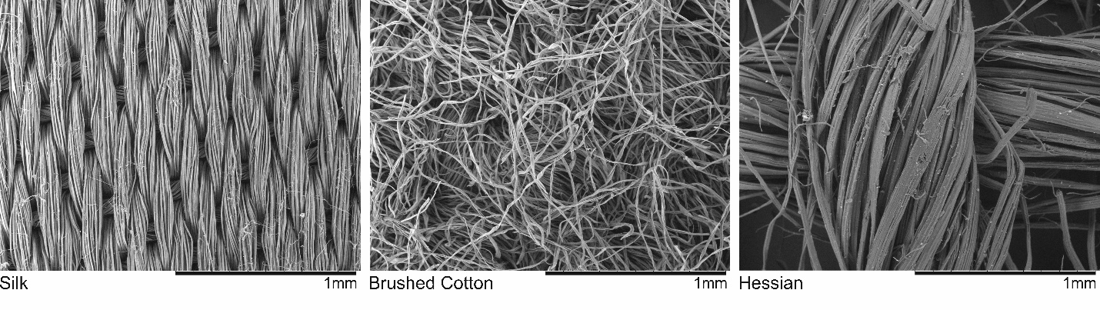
Figure 1. Hitachi TM-1000 scanning electron microscope images of the texture stimuli at 100x magnification.

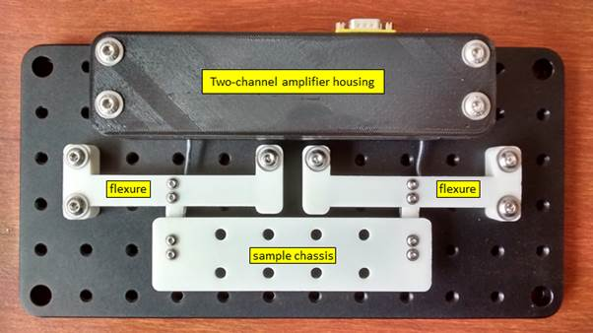
Figure 2. Top view of the touch sensor system showing the amplifier housing, the flexures from which the strain-gauge sensors are mounted, and the sample chassis attached to the sensors.

Subjective ratings
Initial and final subjective ratings were collected in response to the texture samples presented on stages attached to the touch sensor. Ratings were recorded using three 100-point VAS (visual analogue scale) to collect scores of pleasant/unpleasant, soft/hard, smooth/rough for each texture, using a slide bar manipulated on-screen with a computer mouse. During subjective ratings, a partition to occlude vision of the sample stage was placed over the hand and touch sensor. Participants rated all three textures on all VAS in their own time. No touch sensor or EEG data were recorded at this time.

Pace training
The pacer task trained participants to explore the texture samples at approximately 5.5 cm/s to avoid large variations in finger movement speeds between participants. Participants were instructed to complete four sweeps of a plastic stage lined with a 100mm by 40mm strip of PVC electrical insulation tape, beginning and ending on the left side of the stage. A white dot was presented on a black screen, the dot moved horizontally across the screen in 1.5 s denoting one sweep. Participants followed the pacer dot with their index finger for as many repetitions as they wanted to train movement speed. The pacer dot was not shown during experimental trials of the active touch task. When participants felt confident with the pace, they completed five practice trials while the researcher visually assessed their pace and ability to perform the finger abduction movement. If their pace was inadequate (deemed to differ from 5.5 cm/s), they completed the pace training and practice trials again. During the active touch task, the researcher visually inspected participants’ pace via the touch sensor recording app. The pacer dot was used to retrain participants between blocks if pace started to visually differ from 5.5 cm/s.

Active touch task
The active touch task consisted of three blocks which each encompassed three sub-blocks representing one texture. Participants experienced all three textures during each block. Blocks were repeated three times in a pseudo-randomised order which was counter-balanced between participants. Each sub-block contained 18 consecutive trials, totalling 54 trials for each texture over the course of the experiment.
Each trial consisted of a baseline period (4 s), touch experience (6 s) and recovery period (4 s). The baseline period was indicated by a white fixation cross on the screen, during which participants did not touch the texture. The touch experience began when the fixation cross turned from white to green, during which participants completed four sweeps of the texture: placing their index finger down on the left side of the texture sample, sweeping to the right then sweeping back to the left, and repeating before removing their index finger from the texture. The recovery period was indicated by the fixation cross turning from green to white, during which the participant did not touch the texture. At the end of each sub-block, participants were asked to rate how pleasant/unpleasant the texture was on a 100-point VAS. At the end of each sub-block, the researcher checked that participants were comfortable and changed the stage to present the next texture sample.

Recordings
EEG data were recorded continuously using a 129-channel Geodesics EGI System (Electrical Geodesics, Inc., Eugene, Oregon, USA) and a sponge-based HydroCel Sensor Net. The net positioning was aligned to three anatomical landmarks, two preauricular points and the nasion. Electrode impedances were kept below 50 kΩ. A recording band-pass filter was set at 0.001 – 200 Hz with a sampling rate of 1000 Hz. Electrode Cz was used as a reference electrode for recording.
Finger load, representing downward pressure on the texture, finger position along a unidimensional axis across the texture sample, and time relative to the trial-onset marker (fixation cross) were recorded using a Hopkinson Research Touch sensor (Hopkinson Research, Wirral, UK), with a sampling rate of 1000 Hz.

Pre-processing
EEG pre-processing was conducted using BESA v 6.1 (MEGIS GmbH, Germany). Eye blinks and electrocardiographic artefacts were removed using principal component analysis [64]. Data were filtered with a notch filter (50 Hz ± 2 Hz) and a visual inspection of data for the presence of any movement or muscle artefacts was performed. Trials affected by artefacts were excluded from subsequent analyses. EEG signals were down-sampled to 256 Hz and were re-referenced using the common average method [65].
Touch sensor data were cleaned and visually inspected using in-house software developed in Python 3 [66]. Position data were smoothed across time points using a Gaussian kernel (σ = 20), with 20 samples representing a window of 20 ms. Active touch timings (touch down; end of sweeps one, two and three; and lift off) were calculated relative to the trial-onset cue displayed on the LCD monitor. Trials were rejected when index finger touch down occurred one second or more after the trial-onset marker or less than 200 ms after the trial-onset marker. The latter step was implemented to remove trials where participants kept their finger on the touch sensor between trials. Furthermore, trials were rejected when index finger lift off occurred greater than one second after the trial-offset marker, or greater than two seconds before the trial-offset marker. Touch data were segmented into overlapping time windows to capture and extract active touch timings, with each time window individualised to the trial. The first time window captured touch down and the end of sweep one, the second captured end of sweep two, and the third captured the end of sweep three and lift off. Trials were removed if participants missed a sweep. Subsequently, data were filtered by texture and Z-scored were calculated for sweep duration and total load. Trials were removed when the Z score was ± 2 deviations from the normal distribution.
After EEG and touch sensor pre-processing was complete, the average number of trials and standard deviation per subject for ERD analysis in each condition was: silk, 27.57 ± 8.56; brushed cotton, 28.88 ± 8.86; hessian, 27.65 ± 7.90, the average number of rejected trials per condition was 25.96 ± 8.36. The number of accepted trials did not differ across conditions $(p>.05)$.

Analysis
Time-locked ERD analysis was conducted using synchronised EEG and touch sensor data. Active touch timings, computed relative to the trial-onset visual cue on a trial-by-trial basis, were synchronised to EEG data. These individualised active touch timings included touch-onset, end of sweep one, two and three, and touch-offset. EEG data epochs were calculated using the touch sensor triggers and average sweep length to give four time-locked touch epochs per trial.
The power spectra were computed in MATLAB (The MathWorks, Inc., USA) using Welch’s power spectral estimate method. The power spectra were calculated from EEG data
-4 s to 7.5 s relative to the trial onset visual cue and were then split into touch epochs. The power spectra were computed in 1 s windows shifted in overlapping 0.01 s steps. Data were smoothed using a Hanning window. The power spectral densities were estimated in the range of 1-80 Hz with a frequency resolution of 1 Hz. The baseline period utilized for analysis was 0.5 s to 3.5 s of the four second rest period prior to each trial. Relative band power (RBP) changes in alpha- (8-12 Hz) and beta-band (16-24 Hz) were evaluated in each of the three texture conditions using the ERD transformation [42,52].
$$ERD\%= \left(\frac{A-R}{R}*100 \right)$$
In the above equation, $ERD\%$ is a measure of RBP during active touch epochs ($A)$ relative to rest during the baseline period ($R$). Negative values of $ERD\%$ refer to the amplitude decreases of band power which signify the presence of cortical activation (ERD). In contrast, positive $ERD\%$ values refer to the amplitude increases of band power (ERS).
Mean total load (g) and sweep duration (s) were computed for each sweep exploration and analysed using a 3×4 repeated measures analysis of variance (ANOVA), with three levels of texture (silk, brushed cotton, and hessian) and four levels representing sweeps one to four across the texture. The Greenhouse-Geisser epsilon correction was used for all ANOVA analyses to account for any violation of the sphericity assumption.
Mean pleasantness, smoothness, and softness ratings for each texture were calculated for all 35 participants (± 2 SD). Ratings were evaluated using 2×3 repeated measures ANOVAs with two levels of time (initial and final) and three levels of texture (silk, brushed cotton, and hessian). Significant interaction effects were further examined using post hoc t-tests or Wilcoxon signed-rank tests for data that violated the Shapiro-Wilk test of normality, the Bonferroni correction was used to account for multiple comparisons.
Changes in ERD/S were investigated separately for alpha- and beta-band across 128 electrodes using 1×3 repeated measures ANOVAs. Permutation analyses with 5000 repetitions, implemented using statcond.m in the EEGLab library [67,68], identified electrodes showing significant differences between textures ($p<.05$). Secondly, we removed electrodes which demonstrated minimal changes in power from baseline, as these are unlikely to be involved in event-related sensory changes between texture conditions. Implementation of this second step was performed by calculating grand average ERD/S changes for all textures in each electrode identified from the permutation analyses. One sample t-tests with significance thresholds of $p<.01$ (uncorrected) were conducted on each grand average value to confirm that electrode ERD differed significantly from zero, i.e., that they demonstrated a significant change from baseline during sensory processing for all conditions. Electrodes that did not exhibit genuine changes during sensation were excluded from analysis of between-texture differences.
Repeated measures analysis of covariance (ANCOVA), performed with BMDP2V program [69], were utilised to investigate whether subjective ratings for each texture were related to differences in ERD/S. ANCOVAs were performed separately for electrodes identified as demonstrating significant differences between textures from the ANOVA analysis, with subjective ratings of pleasantness, smoothness and softness implemented as covariates.

Results

Subjective ratings
Mean subjective ratings for each texture are shown in Figure 3. 2×3 ANOVAs indicated statistically significant interactions between the effects of texture (silk, brushed cotton, and hessian) and time (initial and final). Interactions were identified in ANOVAs investigating pleasantness,$F\left(2, 2.62\right)=4.57, p=.015, η_{p^{2}}=0.15$; softness,$F\left(2, 7.27\right)=7.56, p=.001, η_{p^{2}}=0.24$; and smoothness,$F\left(2, 7.46\right)=9.80, p<.001, η_{p^{2}}=0.26$. Significant main effects of texture were identified for pleasantness, $F\left(2, 371.89\right)=153.63, p<.001, η_{p^{2}}=0.86$; softness, $F\left(2, 449.57\right)=152.54, p<.001, η_{p^{2}}=0.86$; and smoothness, $F\left(2, 795.45\right)=445.43, p<.001, η_{p^{2}}=0.95$. Pairwise comparisons revealed a reduction in pleasantness, softness and smoothness for hessian compared to brushed cotton and silk $(all p<.001)$. Additionally, brushed cotton was revealed to be less smooth $(p<.001)$ and less pleasant $(p=.009)$ than silk. Post-hoc tests revealed that, over time, hessian was perceived as progressively rougher, $t(33)=4.14, p<.001$ and harder $t(31)=5.90, p<.001$.

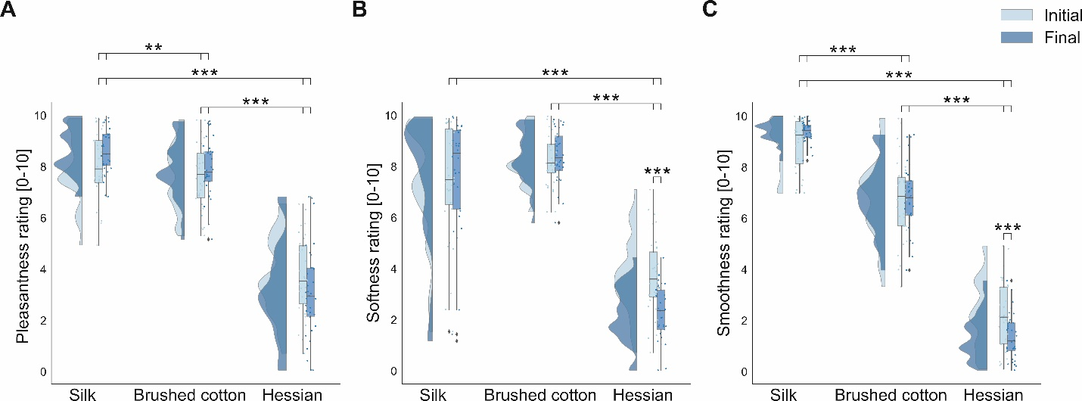
Figure 3. Raincloud plots [67] showing the distribution of mean subjective ratings, (A) pleasantness rating, (B) softness rating, and (C) smoothness rating, for textured stimuli for both initial and final hedonic ratings. The half violin plots depict the probability distributions of the data. The individual dots show data points from each participant. The boxplots indicate the median, upper and lower quartiles, as well as the interquartile range (IQR) between the 25th and 75th percentile, whilst the whiskers represent scores outside of the IQR. Statistically significant differences are denoted as * for <.05, ** for <.01 and *** for <.001.

Touch behaviour
Mean values of total load were 44.01 ± 4.13 g (mean ± standard error) in sweep one, 50.44 ± 5.05 g in sweep two, 49.5 ± 4.13 g in sweep three and 56.76 ± 5.96 g in sweep four. Figure 4 depicts a case example of load and duration over one trial. A 3×4 repeated measures ANOVA, with three levels of texture and four levels of sweep, revealed a significant main effect of sweeps, $F\left(1.32, 6349.97\right)=21.18, p<.001, η_{p^{2}}=0.39$. Pairwise comparisons revealed a significant reduction in total load (g) for sweep one compared to sweeps two, three, and four $(all p<.001)$. Additionally, sweep four demonstrated significant increased total load (g) relative to sweep two and three $(all p<.001)$. 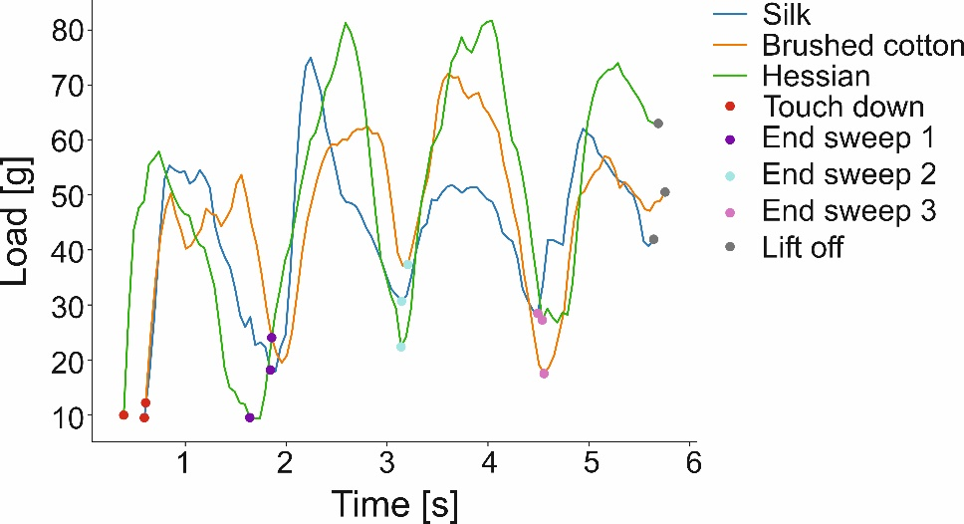
Figure 4. Line plot depicting load (g) for one complete trial for all three textures, with markers denoting the sweep time.

Mean duration (s) for each sweep were 1.17 ± 0.02 s (mean ± standard error) in sweep one, 1.30 ± 0.02 s in sweep two, 1.37 ± 0.02 s in sweep three and 1.50 ± 0.03 s in sweep four. A 3×4 ANOVA was performed on sweep duration (3 textures x 4 sweeps). Results indicated a significant main effect of sweep $\left(F \left(1.686, 2.652\right)=48.043, p<.001, n _{p}^{2}=0.658\right)$. Pairwise comparisons revealed a significant increase in sweep duration (s) over the duration of the trial for all sweeps $(all p<.001)$, with sweep 1 and 4 showing the largest difference (0.332) and sweep 2 and 3 showing the least difference (0.068).
Differences in load and duration are possibly due to touch down and lift off, which have the potential to confound EEG interpretation. Therefore, sweep one and sweep four were excluded from the subsequent ERD analysis and EEG data were averaged over sweeps two and three.

ERD/S
During active touch exploration, alpha-band ERD was evident bilaterally over central electrodes representing sensorimotor regions (Figure 5A). Alpha-band ERS were prominent over the midline and ipsilateral occipito-parietal electrodes. Beta-band ERD was distributed bilaterally over central electrodes (Figure 5D). Electrodes manifesting statistically significant effects of texture, were identified for alpha- (Figure 5A) and beta-bands (Figure 5D). The analysis, comprising permutation analyses with 5000 repetitions ($p<.05$) and one sample
t-tests (uncorrected $p<.01$), identified three electrodes which demonstrated a significant effect of texture on alpha- and beta-band oscillations.
A statistically significant effect for texture was found for alpha-band overlying left central parietal regions (electrode 42, CP3 according to the 10-10 system [70]) which corresponds to contralateral sensorimotor areas. The effect of texture, $F\left(2, 390.05\right)=4.40, p=.017, η_{p^{2}}=0.15$, was revealed to be due to hessian eliciting a stronger ERD than silk, as shown in Figure 5C.
In beta-band, statistically significant effects of texture were found overlying left parietal regions (electrode 52, P3 according to the 10-10 system [70]) and right central parietal regions (electrode 87, CP2 according to the 10-10 system [70]), both of which correspond to contralateral and ipsilateral sensorimotor areas, respectively. The effect of texture over contralateral sensorimotor region, $F\left(2, 299.85\right)=5.09, p=.010, η_{p^{2}}=0.17$, was revealed to be due to silk eliciting a significantly greater degree of ERD relative to hessian $(p=.008)$and brushed cotton $(p=.005)$. Over ipsilateral sensorimotor regions the effect of texture, $F\left(2, 265.52\right)=4.05, p=.023, η_{p^{2}}=0.14$, was revealed to be due to hessian eliciting a significant reduced degree of ERD compared to silk $(p=.019)$ and brushed cotton $(p=.041)$. ERD values for electrodes 52 and 87 are displayed in Figure 5C, Figure 5F, and Figure 5H, respectively.

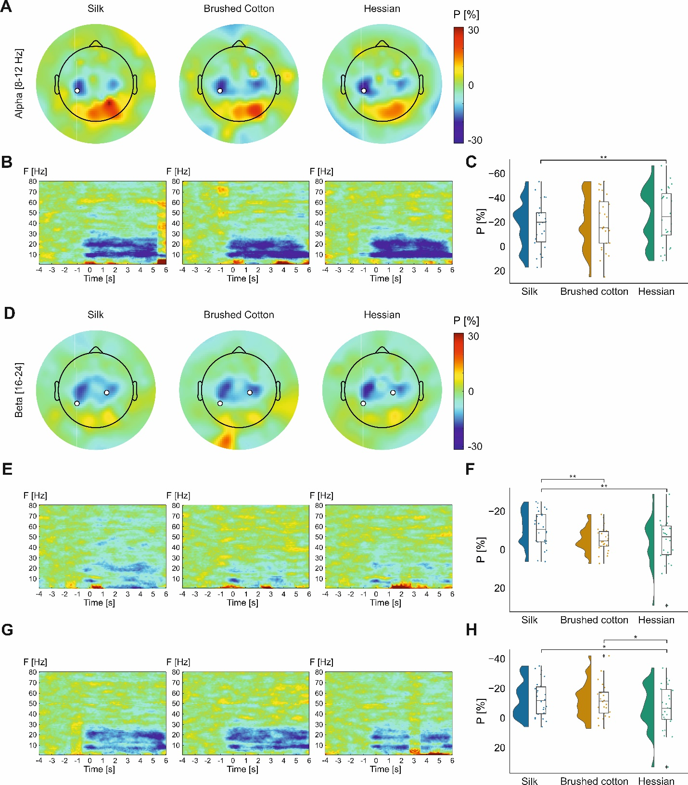
Figure 5. Band power changes for each texture condition (silk, brushed cotton, and hessian). Grand average topographic maps of each frequency band of interest, alpha- (A) and beta-band (D), are shown alongside an overhead view of electrodes showing statistically significant changes (p< .05). Time–frequency spectrograms for electrode 42 (B), 52 (E) and 87 (G), are pictured below the corresponding frequency band and condition. Raincloud plots [67] showing grand average alpha-band ERD/S values for textures conditions for electrode 42 (C), 52 (F) and 87 (H), are presented under the corresponding frequency band. The half violin plots depict the probability distributions of the data. The individual dots show data points from each participant. The boxplots indicate the median, upper and lower quartiles, as well as the IQR between the 25th and 75th percentile, whilst the whiskers represent scores outside of the IQR. Statistically significant differences are denoted as * for <.05, ** for <.01 and *** for <.001.

Covariate analysis
Repeated measures ANCOVAs were computed in electrodes demonstrating significant differences in ERD/S between textures, with subjective ratings of pleasantness, smoothness and softness as covariates. Results indicated that smoothness ratings significantly covaried with differences in alpha-band ERD observed in electrode 42 overlying contralateral sensorimotor areas $(F\left(1, 862.43\right)=11.47, p=.0016)$. After controlling for the smoothness ratings, the main effect of texture on alpha-band ERD was not significant $(F\left(2, 237.53\right)=3.16, p=.058)$. Softness ratings were identified as a significant covariant for changes in beta-band ERD recorded in electrode 52 over contralateral sensorimotor areas, $F\left(1, 384.63\right)=7.35, p=.01)$, and controlling$)$. Controlling for softness ratings led to an increased in significance for the main effect of texture $F\left(2, 468.79\right)=8.95, p<.001)$. No significant covariates were found for electrode 87 in beta-band.

Discussion
Previous literature has provided insights into the cortical processing of texture during passive touch [10,13,30], however cortical processing during active touch is poorly understood. The present study aimed to establish how texture perception is processed during active touch by assessing oscillatory changes in alpha- and beta-bands. Active touch stimulation of the index finger produced expected bilateral alpha- and beta- ERD over sensorimotor regions for all textures (Figure 5), with differences across stimuli observed. Furthermore, texture-related differences in alpha- and beta-band ERD covaried with subjective ratings of smoothness and softness. For the first time, we quantified parameters of active touch exploration using a novel fusion of touch sensor and EEG data streams which facilitated the investigation of ERD/S during each time-locked active touch experience.
Ipsi- and contralateral increases in beta-band ERD over sensorimotor regions were observed for silk and brushed cotton, relative to hessian. Differences in the modulation of beta-band activity may be attributed to variations in textural properties, with silk and brushed cotton rated as more smooth, soft, and pleasant when compared to hessian. Covariate analysis found ratings of perceived softness exerted a confounding effect for ERD differences in beta-band activity over the contralateral sensorimotor region. Controlling for the influence of individual differences in softness ratings between stimuli improved the sensitivity of analyses for changes in electrophysiological processing between textures. Suggesting beta-band ERD, in part, is likely modulated by differences in the micro-geometric properties of the texture such as softness. According to the duplex theory [20], vibrational cues mediate tactile perception of fine textures [25]. Therefore, the stronger beta-ERD in both contra- and ipsilateral central-parietal electrodes for the smoothest texture (silk) compared to a coarse texture (hessian) may be related to increased high-frequency vibrations from tactile elements. Brushed cotton likely generated less high-frequency vibrations compared to silk which explains the finding of an increased beta-ERD for bushed cotton compared to hessian only in the contralateral central-parietal electrode. As described, covariate analysis suggests that modulation of beta-band ERD is likely related to the processing of vibrotactile cures rather than hedonic perception. Thus, our findings on texture modulation during active touch accord with previous studies reporting an increased neural activation for physical properties of smooth compared to rough textures [12,13].
Interestingly, alpha-band ERD was greater in electrode 52 located over contralateral sensorimotor region during exploration of hessian, the roughest texture, compared to silk. This contradicts our hypothesis of increased ERD for fine compared to rough textures, although at present there is little research investigating active touch using EEG methods. Covariate analysis identified that subjective smoothness ratings accounted for the variation in alpha-band ERD, indicating that individual differences in perceived smoothness account for the differences seen in alpha-band ERD during texture processing. Rough textures increase activation of Merkel cells through pressure and skin deformation, whereas Meissner corpuscles and Pacinian corpuscles modulate finer textures through high-frequency vibrations [21–24]. Hessian is more likely to activate Merkel cells than brushed cotton and silk due to the increased spatial period of tactile elements [23,71–73]. Alpha-band activity may be modulated by roughness due to activation of Merkel cells and Meissner corpuscles, similar to the modulation of low- and high-frequency vibrotactile stimuli by SI and SII respectively [27–29]. Although greater alpha-band ERD has recently been observed when decreasing the stimulus roughness during passive stimulation of the fingertip [12]. Further research investigating texture perception during active touch is necessary to fully delineate how varying textural properties modulate oscillatory activity.
ERD analysis uncovered novel differences in oscillatory processing between conditions. This suggests that accurate data fusion is essential for time-locking ERD/S to the onset/offset of touch, as well as to remove noisy or incomplete trials and confounding elements of the touch experience. Investigation of active touch in relation to oscillatory changes likely requires rich touch data at the trial level to support the high temporal resolution of EEG methods [74]. In future, recording of touch data will facilitate the investigation of different physical properties of touch and their effect on neural processing, such as the effect of friction [75].
Although the current study has greater ecologically validity than previous paradigms [8], it does not fully represent natural touch experiences due to EEG laboratory settings and the use of hand and wrist supports and pace training for tactile exploration. Further, participants were exposed to the texture stimuli repeatedly over the testing period, which may reduce task engagement [76] or lead to sensory desensitisation [77,78]. However, repeated trials are necessitated by the ERD method [79]. Future use of continuous trials may be a more naturalistic and stimulating way to circumvent these problems. Furthermore, data were subjected to two stages of trial rejection (25.96 ± 8.36 trials rejected per texture). As a result, there were insufficient trials to compute grand average ERD/S per experimental block. Consequently, investigating the impact of time on ERD/S was beyond the scope of this study.
Additionally, this study is limited by the age of the population. Movement-related beta-band ERD increases with age in healthy populations [80–84] and has been linked with the inhibitory neurotransmitter GABA, which has been found to decline with age [85–87]. The present study included participants ages 20-65, although the mean age was 28.03 ± 11.06, therefore findings may not be generalisable to the aging population. Further, the final sample included four left-handed participants. The researcher ensured participants could comfortably perform the finger abduction movement with their right hand. Therefore, handedness did not impact task performance.
Total load during the first and final sweep of the index finger differed significantly. Muscle contractions increase during flexions and extensions of the wrist [88,89]; this additional wrist movement, present at touch onset and offset, may contribute to differences in total load observed during the first and last sweep. Further, voluntary movement is preceded by motor preparation which manifests as beta-band ERD, with the last sweep also likely to contain wrist movement preparation [40,51,90,91]. Therefore, motor preparation and additional wrist movements have the potential to confound ERD/S interpretation [92]; consequently, the first and final sweeps were excluded from the ERD analysis, allowing one to assess the periods most likely to display texture processing.
The novel fusion of EEG and touch data, allowing for the computation of accurate active touch timings and time-locking, was found to be crucial when analysing EEG data during active touch. Touch sensor technology should be implemented where feasible in subsequent investigations of neural correlates of active touch. The use of targeted active touch exploration highlighted differences in brain oscillatory activity due to texture perception. Beta-band differences in sensorimotor areas expand on previously observed ERD changes during passive touch, whereas alpha-band ERD showed a divergence from previous passive touch research. Further research to consider physical parameters of active touch can aid our understanding of brain processing of tactile perception and texture, which, may ultimately aid our understanding of debilitating conditions such as complex regional pain syndrome or other neuropathic pain syndromes which are accompanied by sensorimotor abnormalities [93,94]. Although, one must first understand the neural underpinning of active touch in healthy individuals so we can make comparisons to clinical conditions.

References
[1] S.J. Lederman, R.L. Klatzky, Haptic perception: A tutorial, Attention, Perception, and Psychophysics. 71 (2009) 1439–1459. https://doi.org/10.3758/APP.71.7.1439.
[2] C.E. Chapman, Active versus passive touch: factors influencing the transmission of somatosensory signals to primary somatosensory cortex, Canadian Journal of Physiology and Pharmacology. 72 (1994) 558–570. https://doi.org/10.1139/y94-080.
[3] S.J. Lederman, The perception of surface roughness by active and passive touch, Bull Psychon Soc. 18 (1981) 253–255. https://doi.org/10.3758/BF03333619.
[4] J.M.R. Aviles, F.M. Muñoz, D. Kleinböhl, M. Sebastián, S.B. Jiménez, A new device to present textured stimuli to touch with simultaneous EEG recording, Behavior Research Methods. 42 (2010) 547–555. https://doi.org/10.3758/BRM.42.2.547.
[5] G.K. Essick, F. Mcglone, C. Dancer, D. Fabricant, Y. Ragin, N. Phillips, T. Jones, S. Guest, Quantitative assessment of pleasant touch, Neuroscience and Biobehavioral Reviews. (2010) 192–203. https://doi.org/10.1016/j.neubiorev.2009.02.003.
[6] F. McGlone, H. Olausson, J.A. Boyle, M. Jones-Gotman, C. Dancer, S. Guest, G. Essick, Touching and feeling: Differences in pleasant touch processing between glabrous and hairy skin in humans, European Journal of Neuroscience. 35 (2012) 1782–1788. https://doi.org/10.1111/j.1460-9568.2012.08092.x.
[7] A.I. Weber, H.P. Saal, J.D. Lieber, J.W.J.-W. Cheng, L.R. Manfredi, J.F. Dammann, S.J. Bensmaia, Spatial and temporal codes mediate the tactile perception of natural textures, Proceedings of the National Academy of Sciences. 110 (2013) 17107–17112. https://doi.org/10.1073/pnas.1305509110.
[8] J.J. Gibson, Psychological Review Observations on Active Touch, Psychological Review. 69 (1962) 477–491.
[9] A. Wagner, J.J. Gibson, Pre-Gibsonian Observations on Active Touch, Hist Psychol. 19 (2016) 93–104. https://doi.org/10.1037/hop0000028.
[10] S. Ballesteros, F. Muñoz, M. Sebastián, B. García, J.M. Reales, ERP evidence of tactile texture processing: Effects of roughness and movement, in: Proceedings - 3rd Joint EuroHaptics Conference and Symposium on Haptic Interfaces for Virtual Environment and Teleoperator Systems, World Haptics 2009, 2009: pp. 166–171. https://doi.org/10.1109/WHC.2009.4810901.
[11] S. Eldeeb, J. Ting, D. Erdogmus, D. Weber, M. Akcakaya, EEG-Based Texture Classification during Active Touch, in: IEEE International Workshop on Machine Learning for Signal Processing, MLSP, IEEE Computer Society, 2019. https://doi.org/10.1109/MLSP.2019.8918777.
[12] C. Genna, C. Oddo, C. Fanciullacci, S. Micera, F. Artoni, C. Chisari, S. Micera, F. Artoni, Bilateral cortical representation of tactile roughness, Brain Research. 1699 (2018) 79–88. https://doi.org/10.1016/j.brainres.2018.06.014.
[13] A. Moungou, J.L. Thonnard, A. Mouraux, EEG frequency tagging to explore the cortical activity related to the tactile exploration of natural textures, Scientific Reports. 6 (2016) 1–10. https://doi.org/10.1038/srep20738.
[14] W. Tang, R. Liu, Y. Shi, C. Hu, S. Bai, H. Zhu, From finger friction to brain activation: Tactile perception of the roughness of gratings, Journal of Advanced Research. 21 (2020) 129–139. https://doi.org/10.1016/j.jare.2019.11.001.
[15] S.J. Lederman, J.M. Loomis, D.A. Williams, The role of vibration in the tactual perception of roughness, Perception & Psychophysics. 32 (1982) 109–116. https://doi.org/10.3758/BF03204270.
[16] F. McGlone, D. Reilly, The cutaneous sensory system, Neuroscience and Biobehavioral Reviews. 34 (2010) 148–159. https://doi.org/10.1016/j.neubiorev.2009.08.004.
[17] K.O. Johnson, T. Yoshioka, F. Vega Bermudez, Tactile functions of mechanoreceptive afferents innervating the hand, Journal of Clinical Neurophysiology. 17 (2000) 539–558. https://doi.org/10.1097/00004691-200011000-00002.
[18] M. Gomez-Ramirez, K. Hysaj, E. Niebur, Neural mechanisms of selective attention in the somatosensory system, Https://Doi.Org/10.1152/Jn.00637.2015. 116 (2016) 1218–1231. https://doi.org/10.1152/JN.00637.2015.
[19] M.A. Harvey, H.P. Saal, J.F. Dammann, S.J. Bensmaia, Multiplexing Stimulus Information through Rate and Temporal Codes in Primate Somatosensory Cortex, PLoS Biology. 11 (2013) e1001558. https://doi.org/10.1371/journal.pbio.1001558.
[20] D. Katz, Der Aufbau der Tastwelt., Zeitschrift Für Psychologie, Leipzig: Barth. (1925).
[21] M. Hollins, S.J. Bensmaïa, S. Washburn, Vibrotactile adaptation impairs discrimination of fine, but not coarse, textures, Somatosensory and Motor Research. 18 (2001) 253–262. https://doi.org/10.1080/01421590120089640.
[22] D.T. Blake, S.S. Hsiao, K.O. Johnson, Neural coding mechanisms in tactile pattern recognition: The relative contributions of slowly and rapidly adapting mechanoreceptors to perceived roughness, Journal of Neuroscience. 17 (1997) 7480–7489. https://doi.org/10.1523/jneurosci.17-19-07480.1997.
[23] K.O. Johnson, S.S. Hsiao, Neural mechanisms of tactual form and texture perception, Annual Reviews 4139 El Camino Way, P.O. Box 10139, Palo Alto, CA 94303-0139, USA, 1992. https://doi.org/10.1146/annurev.ne.15.030192.001303.
[24] T. Yoshioka, B. Gibb, A.K. Dorsch, S.S. Hsiao, K.O. Johnson, Neural coding mechanisms underlying perceived roughness of finely textured surfaces, Journal of Neuroscience. 21 (2001) 6905–6916. https://doi.org/10.1523/jneurosci.21-17-06905.2001.
[25] M. Hollins, S.R. Risner, Evidence for the duplex theory of tactile texture perception, Perception & Psychophysics. 62 (2000) 695–705. https://doi.org/10.3758/BF03206916.
[26] S.W. Han, Y.G. Chung, H.S. Kim, S.C. Chung, J.Y. Park, S.P. Kim, Evaluation of somatosensory cortical differences between flutter and vibration tactile stimuli, Proceedings of the Annual International Conference of the IEEE Engineering in Medicine and Biology Society, EMBS. (2013) 4402–4405. https://doi.org/10.1109/EMBC.2013.6610522.
[27] S.T. Francis, E.F. Kelly, R. Bowtell, W.J.R. Dunseath, S.E. Folger, F. McGlone, fMRI of the responses to vibratory stimulation of digit tips, Neuroimage. 11 (2000) 188–202. https://doi.org/10.1006/nimg.2000.0541.
[28] G.S. Harrington, J. Hunter Downs, FMRI mapping of the somatosensory cortex with vibratory stimuli: Is there a dependency on stimulus frequency?, Brain Research. 897 (2001) 188–192. https://doi.org/10.1016/S0006-8993(01)02139-4.
[29] Y.G. Chung, J. Kim, S.W. Han, H.S. Kim, M.H. Choi, S.C. Chung, J.Y. Park, S.P. Kim, Frequency-dependent patterns of somatosensory cortical responses to vibrotactile stimulation in humans: A fMRI study, Brain Research. 1504 (2013) 47–57. https://doi.org/10.1016/j.brainres.2013.02.003.
[30] M. Bauer, R. Oostenveld, M. Peeters, P. Fries, Tactile spatial attention enhances gamma-band activity in somatosensory cortex and reduces low-frequency activity in parieto-occipital areas, Journal of Neuroscience. 26 (2006) 490–501. https://doi.org/10.1523/JNEUROSCI.5228-04.2006.
[31] A. Klöcker, C. Arnould, M. Penta, J.-L. Thonnard, Rasch-Built Measure of Pleasant Touch through Active Fingertip Exploration, Frontiers in Neurorobotics. 6 (2012) 5. https://doi.org/10.3389/fnbot.2012.00005.
[32] G. Pfurtscheller, Graphical display and statistical evaluation of event-related desynchronization, Electroencephalogr Clin Neurophysiol. 43 (1977) 757–760. https://www.clinph-journal.com/article/0013-4694(77)90092-X/pdf (accessed November 3, 2021).
[33] G. Pfurtscheller, A. Aranibar, Event-related cortical desynchronization detected by power measurements of scalp EEG, Electroencephalography and Clinical Neurophysiology. 42 (1977) 817–826. https://doi.org/10.1016/0013-4694(77)90235-8.
[34] G. Chatrian, M. Petersen, J. Lazarte, The blocking of the rolandic wicket rhythm and some central changes related to movement, Neurophysiol. (1958) 497–501.
[35] D. Cheyne, W. Gaetz, L. Garnero, J.-P.P. Lachaux, A. Ducorps, D. Schwartz, F.J. Varela, Neuromagnetic imaging of cortical oscillations accompanying tactile stimulation, Cognitive Brain Research. 17 (2003) 599–611. https://doi.org/10.1016/S0926-6410(03)00173-3.
[36] W. Gaetz, D. Cheyne, Localization of sensorimotor cortical rhythms induced by tactile stimulation using spatially filtered MEG, Neuroimage. 30 (2006) 899–908. https://doi.org/10.1016/j.neuroimage.2005.10.009.
[37] C. Neuper, G. Pfurtscheller, Evidence for distinct beta resonance frequencies in human EEG related to specific sensorimotor cortical areas, Elsevier, 2001. https://doi.org/10.1016/S1388-2457(01)00661-7.
[38] G. Pfurtscheller, Central beta rhythm during sensorimotor activities in man, Elsevier, 1981. https://doi.org/10.1016/0013-4694(81)90139-5.
[39] Andrej. Stancák, Gert. Pfurtscheller, Event-related desynchronisation of central beta-rhythms during brisk and slow self-paced finger movements of dominant and nondominant hand, Cognitive Brain Research. 4 (1996) 171–183. https://doi.org/10.1016/S0926-6410(96)00031-6.
[40] A. Stancák, G. Pfurtscheller, Effects of handedness on movement-related changes of central beta rhythms, Journal of Clinical Neurophysiology. 14 (1997) 419–428.
[41] A. Stancák, Jirí. Svoboda, Rosa. Rachmanová, Jirí. Vrána, Jirí. Králík, Jaroslav. Tintera, Desynchronization of cortical rhythms following cutaneous stimulation: Effects of stimulus repetition and intensity, and of the size of corpus callosum, Clinical Neurophysiology. 114 (2003) 1936–1947. https://doi.org/10.1016/S1388-2457(03)00201-3.
[42] G. Pfurtscheller, Functional brain imaging based on ERD/ERS, Vision Research. 41 (2001) 1257–1260. https://doi.org/10.1016/S0042-6989(00)00235-2.
[43] E. Houdayer, E. Labyt, F. Cassim, J.L. Bourriez, P. Derambure, Relationship between event-related beta synchronization and afferent inputs: Analysis of finger movement and peripheral nerve stimulations, Clinical Neurophysiology. 117 (2006) 628–636. https://doi.org/10.1016/j.clinph.2005.12.001.
[44] G. Pfurtscheller, F.H.H. Lopes da Silva, Event-related EEG/MEG synchronization and desynchronization: basic principles, Clinical Neurophysiology. 110 (1999) 1842–1857. https://doi.org/10.1016/S1388-2457(99)00141-8.
[45] G. Pfurtscheller, A. Stancák, C. Neuper, Event-related synchronization (ERS) in the alpha band - An electrophysiological correlate of cortical idling: A review, International Journal of Psychophysiology. 24 (1996) 39–46. https://doi.org/10.1016/S0167-8760(96)00066-9.
[46] V. Professor Hans Berger, Nach JBechterew: Die Energie des lebenden, Organismus. S. 102 (1929) 25.
[47] H. Legewie, O. Simonova, O.D. Creutzfeldt, EEG changes during performance of various tasks under open- and closed-eye conditions, Electroencephalogr Clin Neurophysiol. 27 (1969) 470–479. https://doi.org/10.1016/0013-4694(69)90187-4.
[48] G. Pfurtscheller, C. Neuper, G. Krausz, Functional dissociation of lower and upper frequency mu rhythms in relation to voluntary limb movement, Clinical Neurophysiology. 111 (2000) 1873–1879. https://doi.org/10.1016/S1388-2457(00)00428-4.
[49] A. Stancák, A. Riml, G. Pfurtscheller, The effects of external load on movement-related changes of the senorimotor EEG rhythms, Electroencephalography and Clinical Neurophysiology. 102 (1997) 495–504. https://doi.org/10.1016/S0013-4694(96)96623-0.
[50] A. Stancák, G. Pfurtscheller, Mu-rhythm changes in brisk and slow self paced, NeuroReport. 7 (1996) 1161–164. https://doi.org/https://doi.org/10.1097/00001756-199604260-00013.
[51] A. Stancák, G. Pfurtscheller, Event-related desynchronisation of central beta-rhythms during brisk and slow self-paced finger movements of dominant and nondominant hand, Cognitive Brain Research. 4 (1996) 171–183. https://doi.org/10.1016/S0926-6410(96)00031-6.
[52] G. Pfurtscheller, A. Aranibar, Evaluation of event-related desynchronization (ERD) preceding and following voluntary self-paced movement, Electroencephalography and Clinical Neurophysiology. 46 (1979) 138–146. https://doi.org/10.1016/0013-4694(79)90063-4.
[53] C.Elaine. Chapman, M.C. Bushnell, D. Miron, G.H. Duncan, J.P. Lund, Sensory perception during movement in man, Experimental Brain Research. 68 (1987) 516–524. https://doi.org/10.1007/BF00249795.
[54] L.J. Post, I.C. Zompa, C.E. Chapman, Perception of vibrotactile stimuli during motor activity in human subjects, Experimental Brain Research. 100 (1994) 107–120. https://doi.org/10.1007/BF00227283.
[55] H. Nakata, K. Sakamoto, M. Yumoto, R. Kakigi, The relationship in gating effects between short-latency and long-latency somatosensory-evoked potentials, NeuroReport. 22 (2011) 1000–1004. https://doi.org/10.1097/WNR.0b013e32834dc296.
[56] H. Nakata, K. Inui, T. Wasaka, Y. Nishihira, R. Kakigi, Mechanisms of differences in gating effects on short- and long-latency somatosensory evoked potentials relating to movement, Brain Topography. 15 (2003) 211–222. https://doi.org/10.1023/A:1023908707851.
[57] P.M. Rossini, D. Caramia, M.A. Bassetti, P. Pasqualetti, F. Tecchio, G. Bernardi, Somatosensory evoked potentials during the ideation and execution of individual finger movements, Muscle and Nerve. 19 (1996) 191–202. https://doi.org/10.1002/(SICI)1097-4598(199602)19:2<191::AID-MUS11>3.0.CO;2-Y.
[58] P.M. Rossini, C. Babiloni, F. Babiloni, A. Ambrosini, P. Onorati, F. Carducci, A. Urbano, “Gating” of human short-latency somatosensory evoked cortical responses during execution of movement. A high resolution electroencephalography study, Brain Research. 843 (1999) 161–170. https://doi.org/10.1016/S0006-8993(99)01716-3.
[59] G. Juravle, G. Binsted, C. Spence, Tactile suppression in goal-directed movement, 24 (2017) 1060–1076. https://doi.org/10.3758/s13423-016-1203-6.
[60] G. Juravle, T. Heed, C. Spence, B. Röder, Neural correlates of tactile perception during pre-, peri-, and post-movement, Experimental Brain Research. 234 (2016) 1293–1305. https://doi.org/10.1007/s00221-016-4589-5.
[61] R.G. Lee, D.G. White, Modification of the human somatosensory evoked response during voluntary movement, Electroencephalography and Clinical Neurophysiology. 36 (1974) 53–62. https://doi.org/10.1016/0013-4694(74)90136-9.
[62] C. Popovich, W.R. Staines, Acute aerobic exercise enhances attentional modulation of somatosensory event-related potentials during a tactile discrimination task, Behavioural Brain Research. 281 (2015) 267–275. https://doi.org/10.1016/j.bbr.2014.12.045.
[63] J. Peirce, J.R. Gray, S. Simpson, M. MacAskill, R. Höchenberger, H. Sogo, E. Kastman, J.K. Lindeløv, PsychoPy2: Experiments in behavior made easy, Behavior Research Methods. 51 (2019) 195–203. https://doi.org/10.3758/s13428-018-01193-y.
[64] P. Berg, M. Scherg, A multiple source approach to the correction of eye artifacts, Electroencephalography and Clinical Neurophysiology. 90 (1994) 229–241. https://doi.org/10.1016/0013-4694(94)90094-9.
[65] D. Lehmann, EEG assessment of brain activity: Spatial aspects, segmentation and imaging, International Journal of Psychophysiology. 1 (1984) 267–276. https://doi.org/10.1016/0167-8760(84)90046-1.
[66] G. Van Rossum, F.L. Drake, Python 3 Reference Manual, (2009).
[67] A. Delorme, S. Makeig, EEGLAB: an open source toolbox for analysis of single-trial EEG dynamics including independent component analysis, Journal of Neuroscience Methods. 134 (2004) 9–21.
[68] E. Maris, R. Oostenveld, Nonparametric statistical testing of EEG- and MEG-data, Journal of Neuroscience Methods. 164 (2007) 177–190. https://doi.org/10.1016/J.JNEUMETH.2007.03.024.
[69] Statistical Solutions Ltd, BMDP, (1995).
[70] P. Luu, T. Ferree, Determination of the HydroCel Geodesic Sensor Nets’ Average Electrode Positions and Their 10-10 International Equivalents, (n.d.).
[71] C.Elaine. Chapman, François. Tremblay, Wan. Jiang, Loc. Belingard, E.Mehdi. Meftah, Central neural mechanisms contributing to the perception of tactile roughness, in: Behavioural Brain Research, Elsevier, 2002: pp. 225–233. https://doi.org/10.1016/S0166-4328(02)00168-7.
[72] C.E. Connor, S.S. Hsiao, J.R. Phillips, K.O. Johnson, Tactile roughness: Neural codes that account for psychophysical magnitude estimates, Journal of Neuroscience. 10 (1990) 3823–3836. https://doi.org/10.1523/jneurosci.10-12-03823.1990.
[73] C.E. Connor, K.O. Johnson, Neural coding of tactile texture: Comparison of spatial and temporal mechanisms for roughness perception, Journal of Neuroscience. 12 (1992) 3414–3426. https://doi.org/10.1523/jneurosci.12-09-03414.1992.
[74] T. Koenig, D. Studer, D. Hubl, L. Melie, W.K. Strik, Brain connectivity at different time-scales measured with EEG, Philosophical Transactions of the Royal Society B: Biological Sciences. 360 (2005) 1015–1023. https://doi.org/10.1098/rstb.2005.1649.
[75] A. Klöcker, M. Wiertlewski, V. Théate, V. Hayward, J.-L. Thonnard, Physical Factors Influencing Pleasant Touch during Tactile Exploration, PLoS ONE. 8 (2013) e79085. https://doi.org/10.1371/journal.pone.0079085.
[76] N. Lelis-Torres, H. Ugrinowitsch, T. Apolinário-Souza, R.N. Benda, G.M. Lage, Task engagement and mental workload involved in variation and repetition of a motor skill, Scientific Reports. 7 (2017) 1–10. https://doi.org/10.1038/s41598-017-15343-3.
[77] E.L. Graczyk, B.P. Delhaye, M.A. Schiefer, S.J. Bensmaia, D.J. Tyler, Sensory adaptation to electrical stimulation of the somatosensory nerves, Journal of Neural Engineering. 15 (2018) 046002. https://doi.org/10.1088/1741-2552/aab790.
[78] C.M. Klingner, I. Nenadic, C. Hasler, S. Brodoehl, O.W. Witte, Habituation within the somatosensory processing hierarchy, Behavioural Brain Research. 225 (2011) 432–436. https://doi.org/10.1016/j.bbr.2011.07.053.
[79] M.X. Cohen, Rigor and replication in time-frequency analyses of cognitive electrophysiology data, (2016). https://doi.org/10.1016/j.ijpsycho.2016.02.001.
[80] S. Walker, S. Monto, J.M. Piirainen, J. Avela, I.M. Tarkka, T.M. Parviainen, H. Piitulainen, Older Age Increases the Amplitude of Muscle Stretch-Induced Cortical Beta-Band Suppression But Does not Affect Rebound Strength, Front Aging Neurosci. 12 (2020). https://doi.org/10.3389/FNAGI.2020.00117.
[81] T. Bardouille, L. Bailey, Evidence for age-related changes in sensorimotor neuromagnetic responses during cued button pressing in a large open-access dataset, Neuroimage. 193 (2019) 25–34. https://doi.org/10.1016/J.NEUROIMAGE.2019.02.065.
[82] E. Heinrichs-Graham, T.W. Wilson, Is an absolute level of cortical beta suppression required for proper movement? Magnetoencephalographic evidence from healthy aging, Neuroimage. 134 (2016) 514–521. https://doi.org/10.1016/J.NEUROIMAGE.2016.04.032.
[83] A. Xifra-Porxas, G. Niso, S. Larivière, M. Kassinopoulos, S. Baillet, G.D. Mitsis, M.H. Boudrias, Older adults exhibit a more pronounced modulation of beta oscillations when performing sustained and dynamic handgrips, Neuroimage. 201 (2019). https://doi.org/10.1016/J.NEUROIMAGE.2019.116037.
[84] R.K. Spooner, A.I. Wiesman, A.L. Proskovec, E. Heinrichs-Graham, T.W. Wilson, Rhythmic Spontaneous Activity Mediates the Age-Related Decline in Somatosensory Function, Cerebral Cortex. 29 (2019) 680–688. https://doi.org/10.1093/CERCOR/BHX349.
[85] S.D. Hall, G.R. Barnes, P.L. Furlong, S. Seri, A. Hillebrand, Neuronal network pharmacodynamics of GABAergic modulation in the human cortex determined using pharmaco-magnetoencephalography, Human Brain Mapping. 31 (2010) 581–594. https://doi.org/10.1002/HBM.20889.
[86] S.D. Hall, I.M. Stanford, N. Yamawaki, C.J. McAllister, K.C. Rönnqvist, G.L. Woodhall, P.L. Furlong, The role of GABAergic modulation in motor function related neuronal network activity, Neuroimage. 56 (2011) 1506–1510. https://doi.org/10.1016/J.NEUROIMAGE.2011.02.025.
[87] F. Gao, R.A.E. Edden, M. Li, N.A.J. Puts, G. Wang, C. Liu, B. Zhao, H. Wang, X. Bai, C. Zhao, X. Wang, P.B. Barker, Edited magnetic resonance spectroscopy detects an age-related decline in brain GABA levels, Neuroimage. 78 (2013) 75–82. https://doi.org/10.1016/J.NEUROIMAGE.2013.04.012.
[88] B. Hirt, H. Seyhan, M. Wagner, Hand and wrist anatomy and biomechanics : A comprehensive guide., ProQuest Ebook Central, 2016.
[89] M.H. Schieber, W.T. Thach, Trained slow tracking. I. Muscular production of wrist movement, Journal of Neurophysiology. 54 (1985) 1213–1227. https://doi.org/10.1152/jn.1985.54.5.1213.
[90] S. Little, J. Bonaiuto, G. Barnes, S. Bestmann, Motor cortical beta transients delay movement initiation and track errors, BioRxiv. (2018) 384370. https://doi.org/10.1101/384370.
[91] C. Tzagarakis, S. West, G. Pellizzer, Brain oscillatory activity during motor preparation: effect of directional uncertainty on beta, but not alpha, frequency band, Frontiers in Neuroscience. 9 (2015) 246. https://doi.org/10.3389/fnins.2015.00246.
[92] G. Pfurtscheller, K. Zalaudek, C. Neuper, Event-related beta synchronization after wrist, finger and thumb movement, Electroencephalography and Clinical Neurophysiology - Electromyography and Motor Control. 109 (1998) 154–160. https://doi.org/10.1016/S0924-980X(97)00070-2.
[93] A.J. Harris, Cortical origin of pathological pain, The Lancet. 354 (1999) 1464–1466. https://doi.org/10.1016/S0140-6736(99)05003-5.
[94] C. Brun, C. Mercier, S. Grieve, S. Palmer, J. Bailey, C.S. McCabe, Sensory disturbances induced by sensorimotor conflicts are higher in complex regional pain syndrome and fibromyalgia compared to arthritis and healthy people, and positively relate to pain intensity, Eur J Pain. 23 (2019) 483–494. https://doi.org/10.1002/EJP.1322.

