A New Mechanism for Friction-Induced Vibration and Noise
Fang Chen¹, Huajiang Ouyang², Xiaocui Wang*³
¹ School of Automotive Engineering, Dalian University of Technology, China
² School of Engineering, University of Liverpool, U.K.
*³ College of Mechanical and Electrical Engineering, Wenzhou University, China

Abstract
For years, friction-induced vibration and noise (FIVN) has puzzled many researchers in academia and industry. Several mechanisms have been proposed for explaining its occurrence and quantifying its frequencies, notably for automotive brake squeal, clutch squeal and even rail corrugation. However, due to the complex and complicated nature of FIVN, there is not yet one fundamental mechanism that can explain all phenomena of FIVN. Based on experimental results obtained on a simple test structure and corresponding numerical validation using both complex eigenvalue analysis (CEA) and transient dynamic analysis (TDA), this study attempts to propose a new fundamental mechanism for FIVN, which is the repeated cycles of partial detachment and then reattachment of the contact surfaces. Since friction is ubiquitous and FIVN is very common, the insight into FIVN reported in this paper is highly significant and will help establish effective means to control FIVN in engineering and daily life.

Keywords: Mechanism, Friction-Induced Vibration and Noise, Detachment, Reattachment Contact Pressure

Introduction
Friction resists relative motion between two bodies in contact [1, 2]. Dry friction plays two seemingly paradoxical roles: adds and dissipates energy. A friction system vibrates when it cannot dissipate all energy inputs, and such vibration is called friction-induced vibration (FIV), which is one kind of self-excited vibration [3-5]. Dry friction can generate sound, as in the well-known examples of singing glasses and string instruments, as well as all sorts of noise in brakes and clutches [3, 6]. Friction is ubiquitous, and friction-induced vibration and noise (FIVN) is very common in nature, our daily life and industry [7-12]. Insects such as cicadas can generate loud noise by rubbing their wings [13]. Normally, FIVN is unwanted, as it reduces machining precision and surface finish quality of products, degrades actuation precision of robots and creates noise pollution. Friction-induced noise is a big irritant — floor creak in a dwelling is a nuisance to the residents, and brake noise has cost automotive industry a huge amount of warranty money.
Due to the complex and complicated nature of FIVN involving several disciplines, such as nonlinear dynamics, surface science, contact mechanics, tribology, and physical chemistry [14-17], this intriguing phenomenon has excited interests of generations of researchers for decades [18-23]. The fundamental mechanisms of FIVN seem particularly fascinating. Several mechanisms have been proposed to explain its causes. These include the well-known hypotheses of negative gradient of the coefficient of friction versus the relative velocity [14], stick-slip vibration [14], follower force [24], mode coupling [25], hammering [26], and the sprag-slip vibration [27]. Other theories include the moving couple [28] and feed-in energy [29].
These mechanisms can provide a physical explanation for FIVN under certain circumstances but a universal explanation is yet to be found. For stick-slip vibration, there are two motion schemes: a stick regime in which the friction pair moves together and a slip regime in which there is relative motion between them. Such smooth motion could easily become unstable and then induce noise, but stick-slip vibration can only give a useful explanation for the FIVN at a low relative velocity [30, 31]. The sprag-slip vibration could explain the FIVN taking place in one direction of relative sliding, but not in the opposite direction [32]. The most commonly adopted FIVN mechanism for brake squeal is mode coupling, which has also been combined with other mechanisms [25]. In this hypothesis, two separate frequencies of the undamped friction-less system start to get close when the coefficient of friction increases, and eventually coalesce and their corresponding modes also become one when instability sets in [25]. Mode coupling was also adopted to explain the occurrence of rail corrugation [33] and train wheel polygonization . However, a number of observations have exposed its serious shortcomings for brake squeal. For example, one typical scenario is that the same brake system believed to be under the influence of mode coupling sometimes squeals and sometimes does not. On the other hand, a brake system with no mode coupling can also exhibit squeal phenomena. Therefore, an alternative (and even universal) FIVN mechanism is required, which is the motivation of this paper.
This paper attempts to offer an alternative and new explanation of the cause of FIVN, drawing on experimental observation and validated by numerical simulation. This new mechanism should be very useful as it will enable design and manufacture of machines that will possess a low noise signature and help mitigate FIVN. In this present paper, after setting the scene for the background of this study, experimental evidence is presented and analysed, in order to highlight the shortcomings of the mode -coupling mechanism and usher in a new and alternative mechanism for FIVN. Then a finite element model that simulates the experimental setup is described and numerical results from simulations of the experimental procedure are examined, which are found to agree quite well with the experimental observations and thus add strength to this new mechanism that it is the repeated events of partial loss of contact (detachment) and impact (reattachment) of the two bodies in sliding frictional contact that generate FIVN in many situations and largely during brake squeal.

Experimental Investigations
Mode -coupling has been used as a dominant mechanism to explain and model brake squeal, and other problems related to friction, for example rail corrugation [34]. It is the dominant mechanism in the Complex Eigenvalue Approach for these problems provided in ABAQUS [35] and is arguably the accepted squeal mechanism in automotive industry [36].
In order to verify the authors’ view that friction-induced squeal is not fundamentally caused by mode coupling, a specially designed experiment is carried out. A rectangular steel plate with dimensions of 86.7 mm×76.6 mm×12.6 mm and mass of 648 g is used as the test plate. It sits on a block of foam in green and has three resonant frequencies measured at 5.7 kHz, 8.2 kHz and 11.0 kHz in the measured frequency range from 4 to 12 kHz. A smaller steel block with dimensions of 43.0 mm×25.3 mm×12.6 mm and mass of 110 g is pushed to slide on the top surface of the steel plate by hand. The small block does not have any resonant frequency in the test frequency range and is considered to be a “rigid body” (it should be noted that the small block is not really a rigid body, here the “rigid body” simply means that the resonant frequencies of the small block are much higher than those of the steel plate), because of its size. Therefore, in this work, the well-separated measured resonant frequencies of the rectangular steel plate give the authors the initial confidence that such geometric dimensions should be good enough to verify whether the mode coupling will happen in the following research. These arrangements have guaranteed that there is no mode coupling could occur during squeal generation. This is intentional and is very important to prove the authors’ argument. A thin film of foam with a smooth surface is attached to the bottom surface of this small block (referred to as the slider) to simulate the presence of the friction material in a real brake pad and facilitate the phenomenon of repeated detachment-reattachment cycles during the sliding process. The surface of the steel plate is also polished to a nearly mirror-like finish to aid the same phenomenon. The sliding speed and contact pressure range in 0.001–0.02 m/s and 0.1–3.0 bar, respectively. The setup for a separate modal test of the test structure (when the slider is stationary) is illustrated in Figure 1. In this figure, three accelerometers can be seen, and the small yellow spots are marks of wax used for attaching the accelerometers that are moved around to these places during a hammer test. The frequency response function obtained in the modal tests is given in Figures 2– 4.
During a squeal event, the sound signal is measured by a microphone at a distance of 100 cm away from the test structure. At the same time, the vibration is measured by an accelerometer on the steel plate. The frequency spectra from measured sound and acceleration are illustrated in Figures 2 – 4 as well.
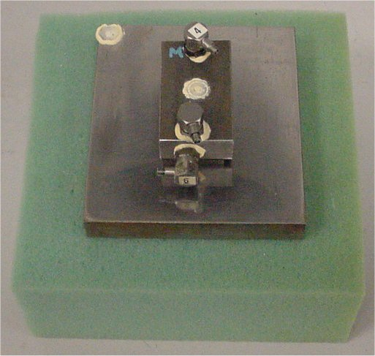
Figure 1. Test setup for modal testing (using a hammer, which is not shown).

The test results (some of which were report in [37]) can be summarised as follows:
- It appears that squeal is not caused by mode coupling since not any two resonant frequencies of the steel plate are close enough for them to coalesce (please note that the steel block is much smaller and thus has much higher resonant frequencies than those of the steel plate, and the foam acts like a soft boundary).
- A squeal frequency can be near one of the resonant frequencies, as shown in the tests.
- In most cases, squeal frequencies (at 5.1 kHz, 5.3 kHz and 5.5 kHz shown in Figure 2-4) are lower than the first resonant frequency of 5.7 kHz of the steel plate. The differences between a squeal frequency and an adjacent resonant frequency can be more than 10% (5.1 kHz versus 5.7 kHz).
- Figure 4 shows that the squeal frequency (5.1 kHz) is not directly related to the first resonant frequency of the steel plate at 5.7 kHz. On the other hand, a lower-intensity instantaneous mode occurs at 5.7 kHz.
- Since squeal frequencies can be far away from and thus does not appear directly related to a resonant frequency, the corresponding squeal mode can be called an instantaneous squeal vibration mode or simply instantaneous squeal mode (ISM) or instantaneous mode as in [37]. In general, an ISM frequency is always aligned with a squeal frequency as shown in Figure 2-4. In Figure 2-4, the ISM frequencies are measured with an accelerometer attached at the test plate, and squeal frequencies are measured with a microphone near the test plate.
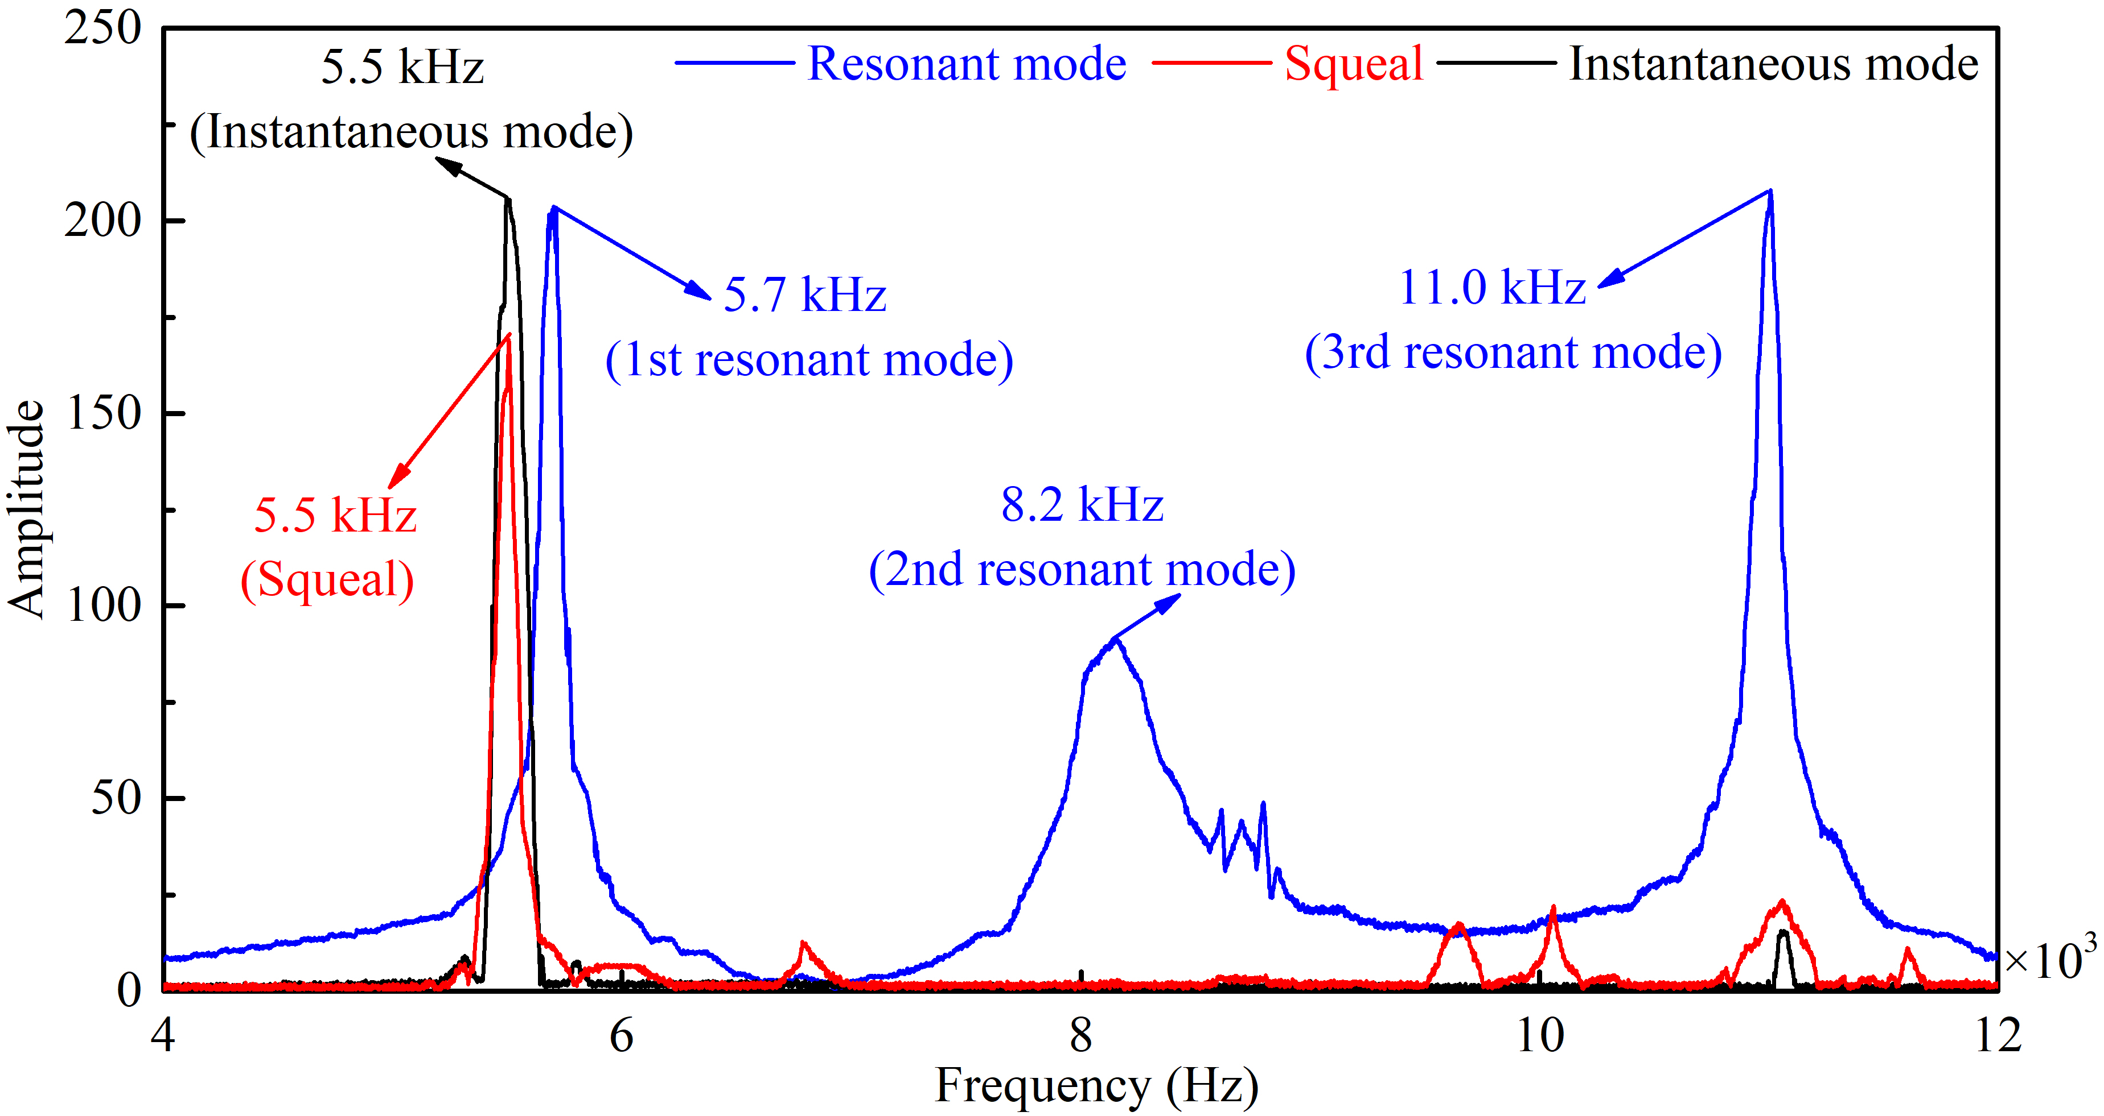
Figure 2. Measured frequency spectra: sound signal (red solid line) and acceleration (dark solid line) during squeal of the whole structure, and free vibration of the steel plate (blue solid line).
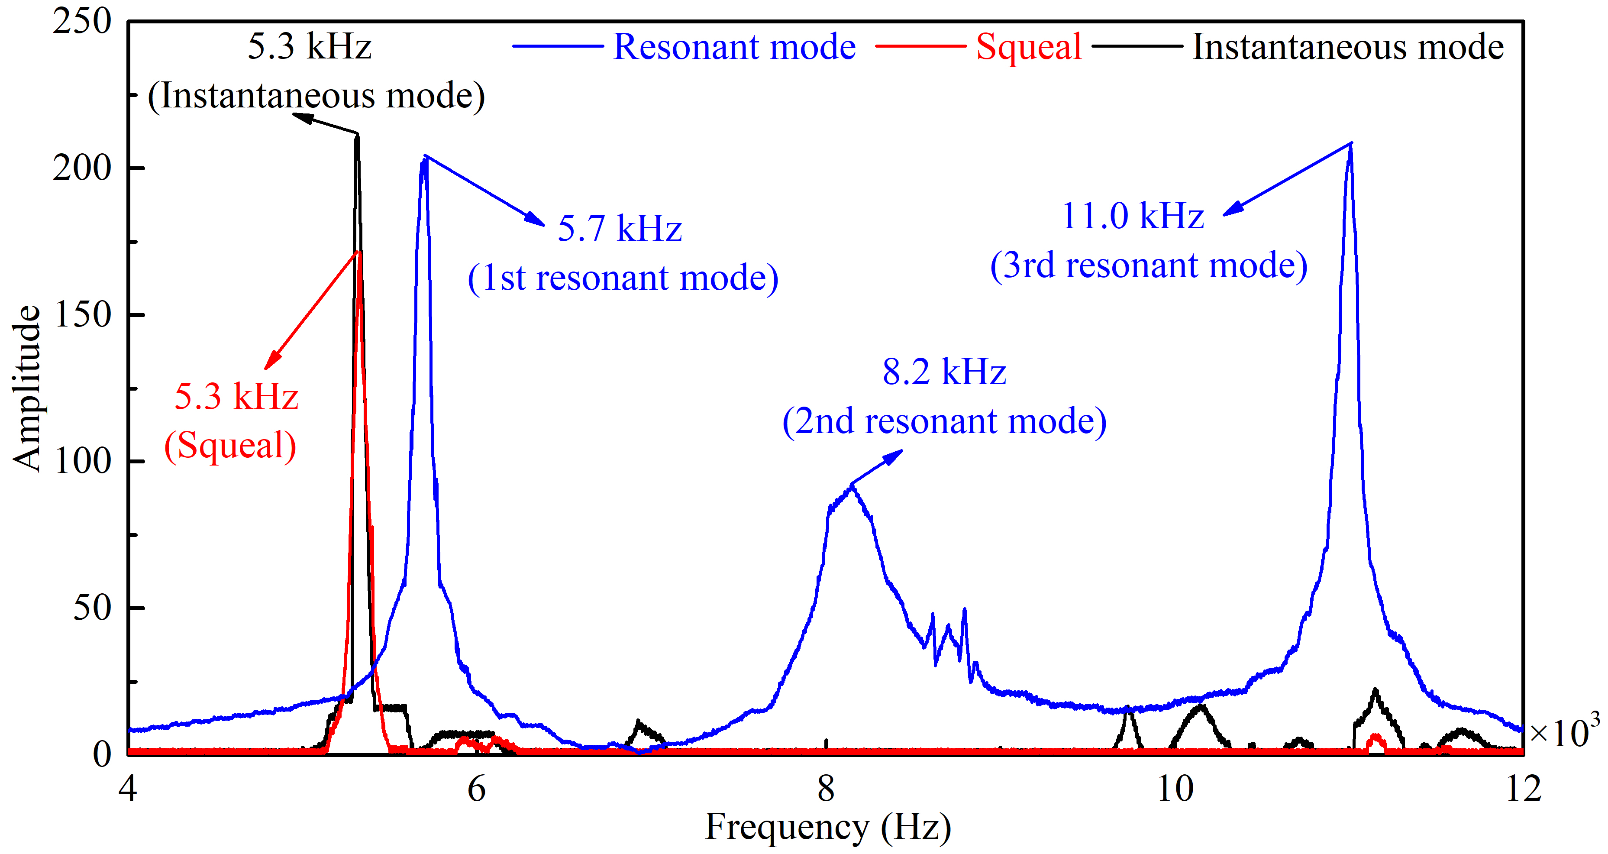
Figure 3. Measured frequency spectra: sound signal (red solid line) and acceleration (dark solid line) during squeal of the whole structure, and free vibration of the steel plate (blue solid line).
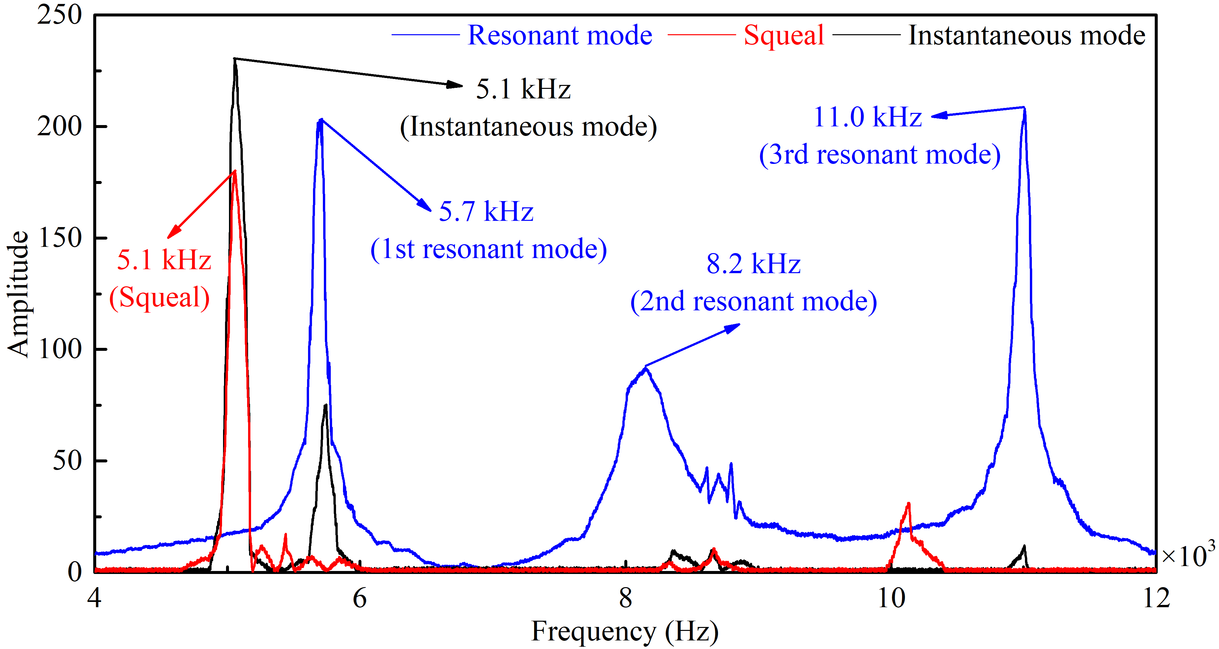
Figure 4. Measured frequency spectra: sound signal (red solid line) and acceleration (dark solid line) during squeal of the whole structure, and free vibration of the steel plate (blue solid line).

According to observation of the test results, the authors hypothesize that there are repeated cycles of detachment between the slider and the base plate and subsequent reattachment at the contact interface; and as the slider moves forward, these cycles of detachment and reattachment act like a periodic impulsive excitation and drives a transient wave around, which can explain the instantaneous nature of the squeal events, which is apparently not strongly related to a resonant frequency (of the base plate). This is believed to be what happens in real brake squeal events that have puzzled researchers for many years. Detachment at a contact interface and subsequent reattachment was found to be theoretically possible in moving-load problems involving frictional sliding [38].

Theoretical Analysis
3.1 Mode -coupling instability
To demonstrate instability of friction-induced vibration in the form of mode coupling, a simple system shown in Figure 5 below is analysed. The system consists of three masses with having a degree-of-freedom in the x (horizontal) direction; having a degree-of-freedom in the y (vertical) direction; and having degrees-of-freedom in both directions. m₁ is preloaded in compression and in sliding contact with a rigid belt moving at a constant speed via a massless rigid slider. The sliding friction at the slider-belt interface is governed by Coulomb friction whose static and kinetic friction coefficients are taken to be the same and the coefficient of friction is denoted by μ. There are 4 degrees-of-freedom (DoFs) in this system: horizontal and vertical displacements of m₂, which are u₂ and v₂; horizontal displacement of m₁, which is u₁; and vertical displacement of m₃, which is v₃.
m₂
m₃
m₁
k_{c}
k₁
k₂
k₃
k₄
k₅
v
u
Figure 5. 4-DoF theoretical model.
The equation of motion can be derived as follows:
$M\ddot{x}+Kx=f$ (1)
where mass matrix M and stiffness matrix K are respectively
,
and displacement and force vectors are respectively
$x^{T}=\left\{\begin{matrix}\begin{matrix}u_{1} & v_{3}\end{matrix} & \begin{matrix}u_{2} & v_{2}\end{matrix}\end{matrix}\right\}$ , $f^{T}=\left\{\begin{matrix}\begin{matrix}0 & 0\end{matrix} & \begin{matrix}0 & -N\end{matrix}\end{matrix}\right\}$
in which N is the contact force due to the preload at the initial state of rest.
The linear stability of the system is characterised by the eigenvalues of the system, λ, in equation (2) below
$\left(λ^{2}M+K\right)φ=0$ (2)
Both λ and eigenvector ϕ are in general complex because of the friction-caused asymmetric term in matrix K. If a system parameter is varied, the system eigenvalues (and their real and imaginary parts) vary with it. When these real and imaginary parts are plotted against μ, bifurcation can be observed. In the following simulation, , , and $k_{c}=k_{1}$. The evolution of the eigenvalues is illustrated in Figure 6.
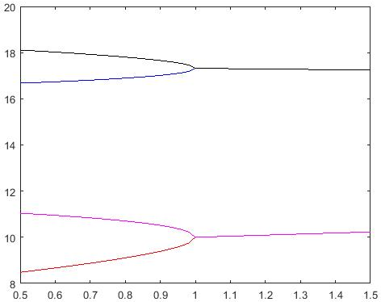
- Imaginary parts (frequencies) versus coefficient of friction
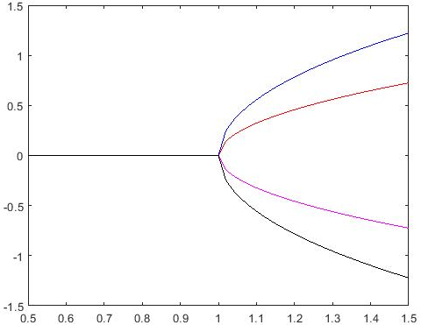
- Real parts (growth rates) versus coefficient of friction
Figure 6. Evolutions of the system eigenvalues with coefficient of friction.
It can be seen from this figure that two pairs of frequencies get closer as μ increases and they coalesce at μ=1, which indicates the two corresponding modes for each pair merge into one mode. At this point, their corresponding real parts of each pair start to bifurcate, beyond which one real part of each pair becomes positive and the system thus becomes unstable. This scenario of instability is called mode coupling. Similar phenomena happen to high-DoF systems, such as detailed finite element models of automotive brakes [39]. One important phenomenon which mode coupling fails to cover is the moving load effects [40].
3.2 Finite Element Analysis
The purpose of this paper is to propose a new mechanism for generation of FIV. For this purpose, a 3-D finite element (FE) model is built in ABAQUS to simulate the tests described in Experimental Investigations section, as shown in Figure 7. The FE model includes the four key components of the real test structure: slider, film, steel plate, foam. In this part, the modal analysis, the complex eigenvalue analysis (CEA) and the transient dynamic analysis (TDA) are reported. Firstly, the modal analysis is performed to validate the accuracy of the built FE model. Then, the complex eigenvalue analysis is made to verify through numerical methods that friction-induced squeal is not caused by mode coupling. Finally, the dynamic transient analysis is applied to study the dynamic behaviour of the model. The dimensions of each component are the same as those of the real test structure. The material properties of the components in the FE model are given in Table 1. It should be noted that the material properties of the slider and the steel plate are based on those of the real components, the material properties of the form and film in Table 1 may be higher than those of their true values, but various other values of them are used in the subsequent CEA to guarantee that the material parameters of foam and film will not alter the main conclusions of this paper. Furthermore, considering that the friction may lead to unstable vibration, the damping of each component is set to zero deliberately to verify whether the friction in this structure causes mode-coupling instability and to support the proposed mechanism in this work.
Based on the real test structure, the boundary conditions (BC for short in Figure 5) in the model are: the top surface of the slider is free in the vertical z direction and fixed in other directions; the bottom surface of the foam is free in the x direction and fixed in the other directions. A normal pressure (see the red arrows in Figure 5) is applied onto the top surface of the slider, and an x-direction velocity (the green arrow in Figure 5) is imposed to the bottom surface of the foam.
In this FE model, all the element type used is C3D8R (eight-node linear brick element with reduced integration) with advancing front meshing algorithm which can efficiently improve the quality of the mesh. Compared with other element types, C3D8R can efficiently reduce computational time and ensure good accuracy. A convergence analysis is performed before the proper numerical analysis to make sure that the built FE model is adequate for the CEA and TDA with good efficiency.
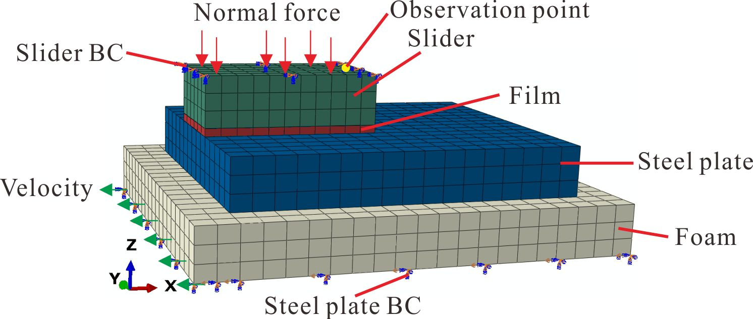
Figure 7. FE model of the test structure.
Table 1. The material parameters of each component in the FE model.
Component | Density ρ (g/cm³) | Young’s modulus E (GPa) | Poisson’s ratio ν
Steel slider | 8.05 | 210 | 0.3
Film | 1 | 10 | 0.25
Steel plate | 7.74 | 230 | 0.28
Foam | 1 | 10 | 0.25
3.2.1 Modal analysis
Firstly, a modal analysis is conducted to verify the built FE model. The calculated natural frequencies of the steel plate are 5.7 kHz, 8.0 kHz and 10.8 kHz in the frequency range from 4 kHz to 12.0 kHz. Compared with the first three measured resonant frequencies of the steel plate (5.7 kHz, 8.2 kHz and 11.0 kHz), the predicted and measured resonant frequencies (without friction) are very close, and therefore, the built FE model is thought to be reliable. Since the first resonant frequency from simulation (5.7 kHz) agrees very well with the first measured resonant frequency (5.7 kHz), the discussion in Section 3.2.3 is mainly focused around this frequency.
3.2.2 Complex eigenvalue analysis
In the CEA, three cases are analysed to verify whether there appears mode-coupling instability when the slider is at different positions relative to the steel plate: the slider is at the starting position (Case 1, as shown in figure 8(1)); the slider is at in middle (Case 2, as shown in figure 8(2)); the slider is at the end position (Case 3, as shown in figure 8(3)). The dynamic behaviour of the friction system is investigated at various values of the coefficient of kinetic friction, in the frequency range of 0-12 kHz, in keeping with the frequency range in the experiments.
(a) (b)
(c)
Figure 8. Slider at various positions for CEA: (1) at the starting position (Case 1); (2) in the middle (Case 2); (3) at the ending position (Case 3).
The CEA results are shown in Tables 2-4, in the form of real parts and the imaginary parts (frequencies) versus the coefficient of friction. It can be seen that no mode coupling happens in any case, even at a very high value of coefficient of friction being 1.
Table 2. CEA result for case 1.
Model |  | μ=0 |  | μ=1
Mode 1 | Real part of eigenvalue |  | 0 | 0
 | Frequency (Hz) |  | 9455 | 9841
Mode 2 | Real part of eigenvalue |  | 0 | 0
 | Frequency (Hz) |  | 9478 | 10012
Mode 3 | Real part of eigenvalue |  | 0 | 0
 | Frequency (Hz) |  | 10601 | 10947
Table 3. CEA result for case 2.
Model |  | μ=0 |  | μ=1
Mode 1 | Real part of eigenvalue |  | 0 | 0
 | Frequency (Hz) |  | 9491 | 9623
Mode 2 | Real part of eigenvalue |  | 0 | 0
 | Frequency (Hz) |  | 9535 | 10073
Mode 3 | Real part of eigenvalue |  | 0 | 0
 | Frequency (Hz) |  | 10697 | 10916
Table 4. CEA result for case 3.
Model |  | μ=0 |  | μ=1
Mode 1 | Real part of eigenvalue |  | 0 | 0
 | Frequency (Hz) |  | 9455 | 8355
Mode 2 | Real part of eigenvalue |  | 0 | 0
 | Frequency (Hz) |  | 9477 | 9739
Mode 3 | Real part of eigenvalue |  | 0 | 0
 | Frequency (Hz) |  | 10601 | 10855
Mode 4 | Real part of eigenvalue |  | / | 0
 | Frequency (Hz) |  | / | 11277
3.2.3 Transient Dynamic Analysis
In this part, the Dynamic Explicit solver is used to perform TDA. The automatic time step is used and the convergence of state variables at the end of a time step is not required. The TDA is about a dynamic contact problem with a moving contact interface, which is complicated to simulate, despite the simple geometric shapes of the components involved. The relative sliding velocity must be low enough to allow contact between the slider and the base plate to be established but must not be too low for a simulation to take an exceedingly long time to finish. A sliding velocity of v = 3-10 mm/s is found to be a good compromise and also largely reproduces the main experimental observations. In ABAQUS, the normal pressure and the relative velocity are implemented gradually in the form of a ramp each to allow convergence of numerical simulations, as shown in Figure 9. At first the normal pressure is applied and gradually increased until time t₁=0.1 s when it reaches the maximum of p=0.1 MPa and then is kept at this constant level. The steel plate starts to slide at t₁ and the speed gradually increases up to time t₂=0.2 s when the velocity reaches the maximum (for example, v=10 mm/s) and then remains constant.
In this investigation, a constant coefficient of (kinetic) friction, μ=0.3 is used, which is obtained from the test. In this model, the film is in direct contact with the steel plate surface, and the surface-to-surface contact regime in ABAQUS is selected. The contact formulation is finite sliding with a penalty method, and the friction formulation is the simple Coulomb’s law, while material damping and structural damping are neglected. The observation point (the yellow dot marked in Figure 7) of the vibration acceleration is located on the surface of the slider, which is also where its acceleration is recorded in the experimental study. Based on the geometric dimensions of the steel plate and the slider, the total travelling time of the slider is set (for example, to be 4.37 s) to allow the slider to move from the left to the right along the steel plate for its left edge to reach the left edge of the steel plate.
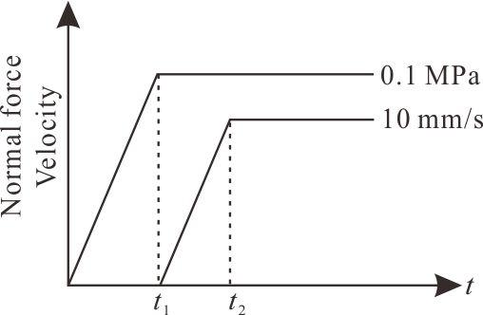
Figure 9. Time history of the normal load and the sliding velocity of the steel plate.
Then a number of dynamic transient analyses are conducted to explore the dynamic behaviour of the FE model. Three examples are used to demonstrate typical vibration scenarios. One set of numerical results (Example 1) are shown in Figures 10–12. Figure 10 provides the time history of the normal acceleration at the observation point during the first 1-s duration of sliding. It can be found that the acceleration shows a complicated oscillation. Its corresponding frequency spectrum is given in Figure 8, which displays several peaks, notably at 5.3 kHz, 5.5 kHz, and 8.7 kHz. Among them, 5.3 kHz and 5.5 kHz agree very well with one set of the measured squeal frequency at 5.5 kHz (as shown in Figure 2) and 5.3 kHz (as shown in Figure 3). In addition, both these simulation and measured results of frequencies show that they are lower than the first measured (5.7 kHz) and theoretically predicted resonant frequency of 5.7 kHz of the steel plate obtained by simulation.
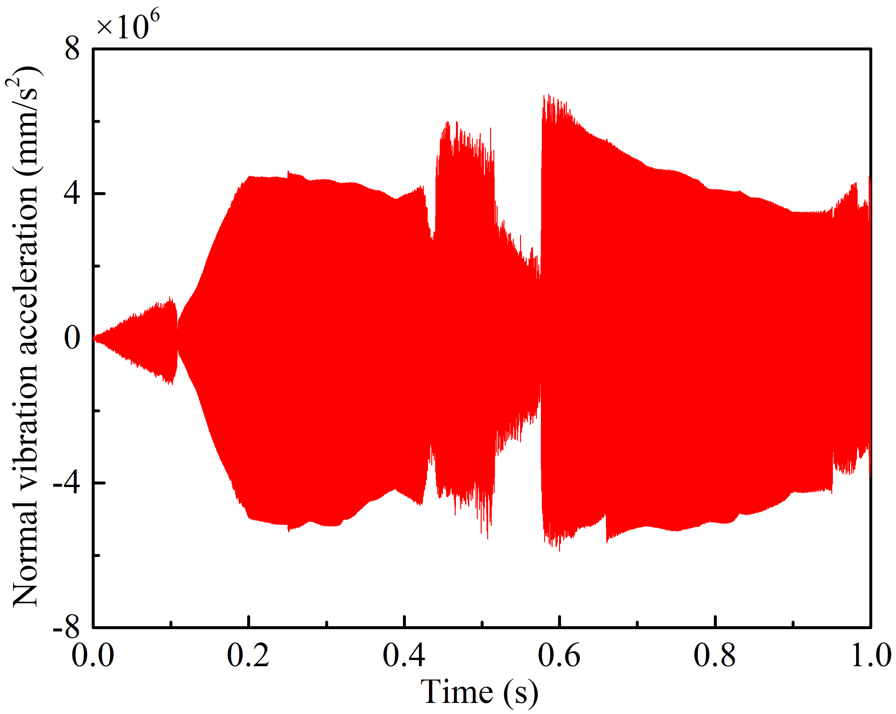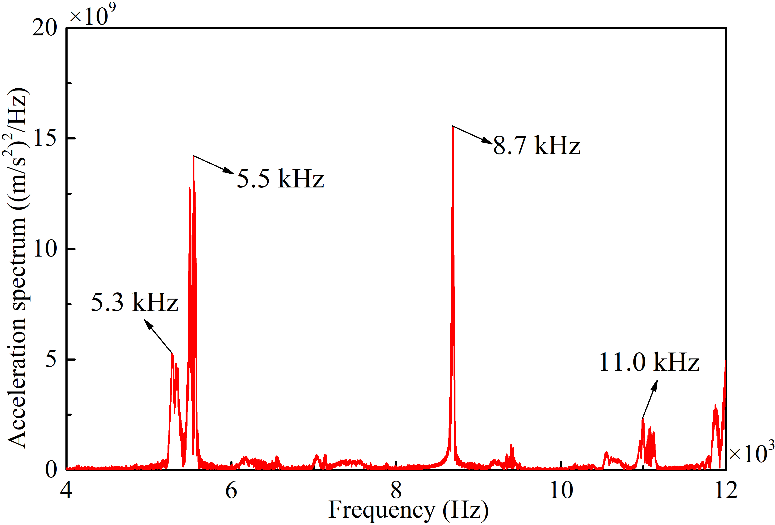
Figure 10. Normal acceleration Figure 11. Frequency spectrum for Figure 10.
(v=10 mm/s, p=0.1MPa).
Figure 12 illustrates the evolution of the contact pressure at the slider-plate interface over time. The contact pressure is overall symmetrical about the longitudinal x axis. In the initial stage of sliding, the highest contact pressure concentrates on the leading edge (on the left), while the contact pressure on the trailing edge is almost zero, as shown in Figure 12 (1) - (3). Although no detachment happens in this stage, energy is being added into the steel plate via friction and thus the vibration of the friction system grows. The contact pressure starts to show a very different distribution at 1.39 s with three pressure centres and the highest pressure shifts towards the trailing edge (on the right), as shown in Figure 12 (4); this shift of pressure is pronounced especially at 1.40 s, as shown in Figure 12 (5), while the contact pressure at the leading edge is almost zero, the distribution of which is opposite to the distribution during the initial stage. Then the highest contact pressure comes back to the leading edge, as shown in Figure 12 (7) - (9).
As time goes on, the highest contact pressure moves to the trailing edge again, as shown in Figure 12 (10) and (12). Then there appears a new phenomenon — high contact pressure appears at/near both the leading and trailing edge, while the contact pressure in the middle is visibly low, as shown in Figure 12 (13). After this, the contact pressure distribution looks like a saddle, which is another unexpected phenomenon and can be seen in Figure 12 (14).
As the sliding continues, the position of the highest contact pressure shifts between the leading edge and trailing edge, as shown in Figure 12 (15) – (20). Considering that the contact pressure distribution shows an approximately periodically shifting over the slider length, more oscillation cycles are not shown here.
(1) (2)
(3) (4)
(5) (6)
(7) (8)
(9) (10)
(11) (12)
(13) (14)
(15) (16)
(17) (18)
(19) (20)
Figure 12. Contact pressure distributions of film at different time instants.
It is important to observe that during sliding, the centre of contact pressure moves from left to right and back repeatedly and there are short periods of partial loss of contact (zero contact pressure). There are similar repeated events of detachment-reattachment, for example, during the period from 1.42 s, which are not shown to save space. They present a kind of periodic impulsive excitation that is believed by the authors to have induced the FIVN. The reattachments that happen in very short time durations act as impact which is known to be capable of exciting high-frequency vibration.
It should be noted that the detachment-reattachment may happen in other friction systems too. Li [38] theoretically investigated the vibration of a 2-DoF slider rotating on the surface of annular disc and found the slider could separate from and then reconnect with the vibrating disc. The disc was modelled as plate which underwent only transverse vibration. Because the contact at the slider-disc interface was at one point, there was only a contact force. In contrast, the friction pair in this investigation is modelled as two three-dimensional deformable bodies and there is now contact area with time- and space-varying contact pressure.
It is also found from both experiments and numerical simulations that the occurrence of squeal and the frequency contents are sensitive to some operating conditions, i.e., the sliding speed and, in particular, the normal pressure. Figure 13 (Example 2) shows the frequency spectrum of a numerical simulation in which the velocity is changed to 3 mm/s instead 10 mm/s as in the first example. Three similar dominant frequencies can be seen. Notably, the first frequency at 5.3 kHz in Figure 11 now disappears and the frequency peak of 11.0 kHz becomes higher in this example, indicating a moderate dependence of instantaneous frequencies on the sliding velocity.
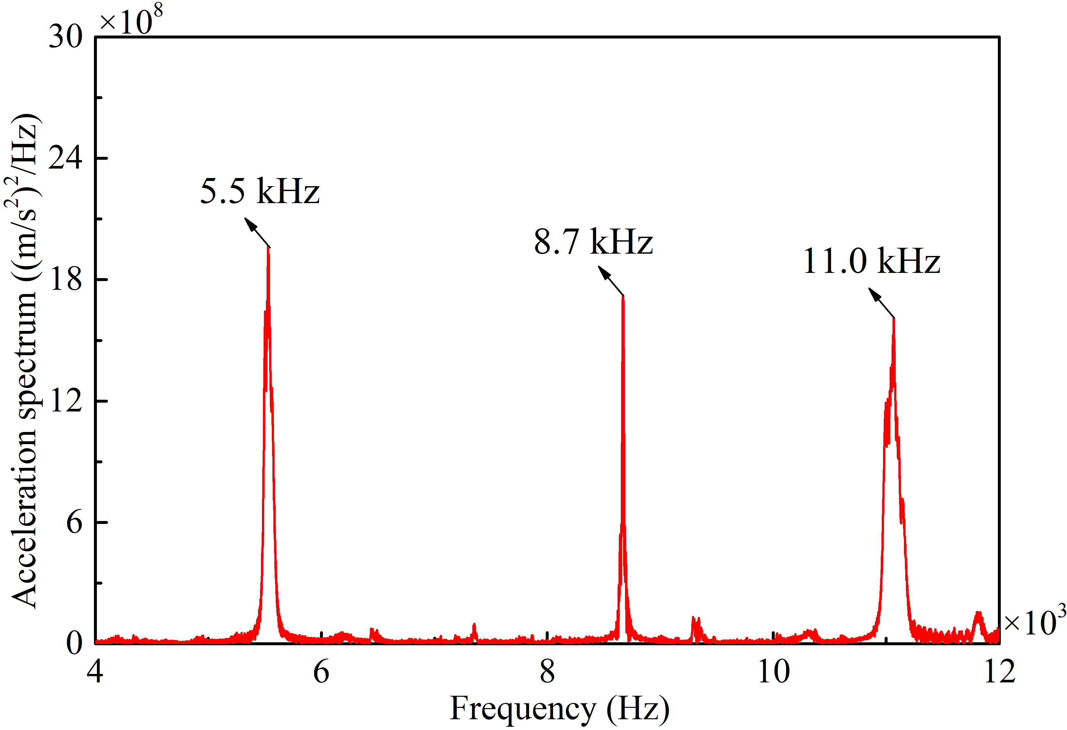
Figure 13. FFT spectrum of tangential acceleration (velocity: 3 mm/s; normal pressure: 0.1 MPa).
The frequency spectrum in Figure 14 (Example 3) is obtained from a numerical simulation in which the velocity is 3 mm/s and the normal pressure is 0.3 MPa. Three different frequencies are seen to dominate the time-domain response. It should be highlighted that (1) the high frequency around 11.0 kHz now disappears, and (2) new frequencies (4.4 kHz, 4.6 kHz, 7.3 kHz, 7.5 kHz, 8.4 kHz and 8.8 kHz) emerge, in which 4.4 kHz and 4.6 kHz are near and lower than the squeal frequency of 5.1 kHz measured in the experiments shown in Figure 4. Due to the change of the normal pressure, a cluster of new frequencies between 7.3 kHz and 7.5 kHz emerge and 7.5 kHz now becomes the dominant one in Figure 14. Thus, it may be speculated that new frequencies in FIVN can emerge and the dominant frequency can vary when the operating conditions (for example, normal pressure and sliding speed) are proper. Actually, the results in Figure 11 indicate that squeals can happen at many frequencies far away from resonant frequencies as long as the combination of sliding speed and contact pressure is proper. These further prove that squeal can happen even without the influences of resonant modes.
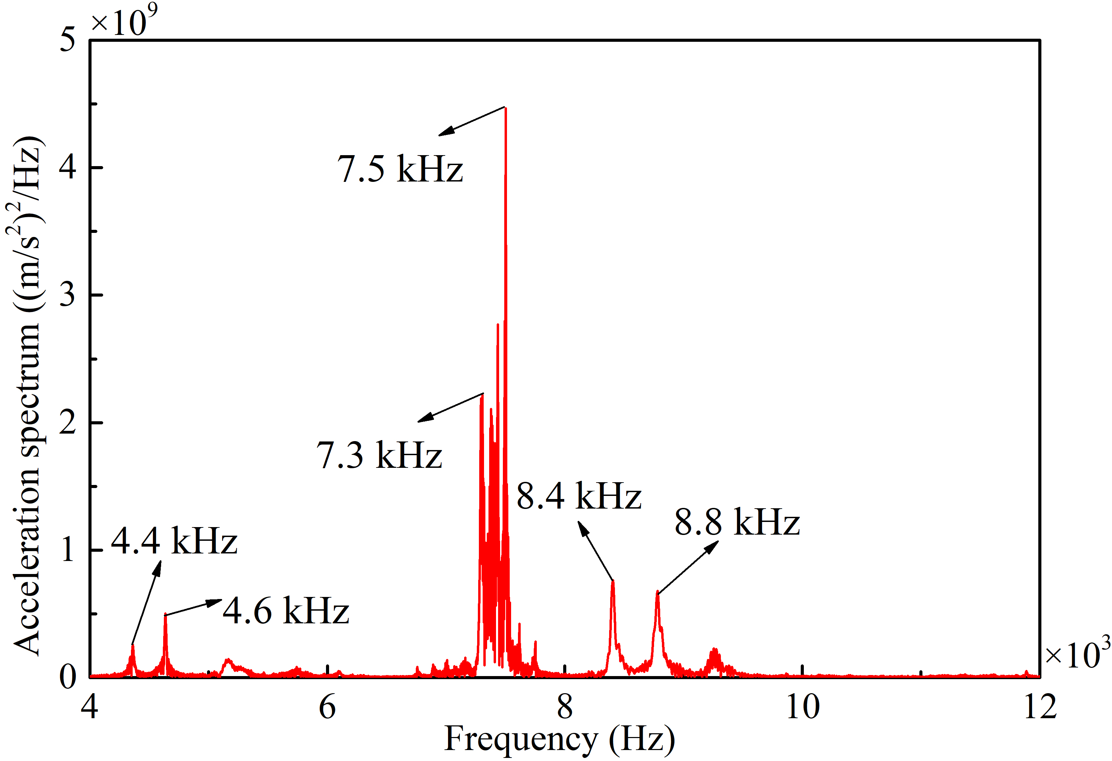
Figure 14. FFT spectrum of tangential acceleration (velocity: 3 mm/s; normal pressure: 0.3 MPa).
The simulation results in Figures 14 and the previous test results show that squeal can occur at frequencies far away from the resonant frequencies of the main component (the steel plate) or the system. Thus, the periodic impulsive excitation caused by the repeated process of detachment-reattachment during friction sliding can be considered the dominant fundamental mechanism for squeal generation in this test structure and it is believed to be the dominant fundamental mechanism in brake squeal.
  - Short Discussion of CEA and TDA results
CEA is based on the perturbed dynamic state around a static equilibrium point and is a linear dynamic stability analysis. In the experiments, the slider moves relatively to the steel plate and presents a moving distributed load, which makes the system time-variant. Therefore, CEA is not very suited to this kind of dynamic systems. Indeed, the frequencies from the CEA runs do not correlate well with the measured frequencies. More importantly, no (mode-coupling) instability is found in these CEA runs, which further indicates its capability of predicting FIV.
On the other hand, TDA tracks the relative movement of the slider and simulate the dynamic contact, and thus is better suited to simulate the experiments and other time-variant systems. Understandably, TDA takes much longer time than CEA for the problem solving under this study but it is worthwhile to do as it reveals phenomena that cannot be captured by CEA.

Conclusions
A combined experimental and theoretical study is conducted in this paper. In the experimental study, friction-induced-vibration under various normal forces and sliding velocities is measured. In the theoretical study, the complex eigenvalue analysis (CEA) is applied to verify whether mode coupling will happen for this friction system, and transient dynamic analysis (TDA) is conducted to simulate the experimental procedure and study the vibration characteristics under different working conditions. The experimental and numerical results lead to the following conclusions:
- From both TDA and experimental results, the values of main squeal frequencies are fairly sensitive to the sliding speeds and very sensitive to the normal contact pressures between the two bodies in sliding contact, even though the resonant/natural frequencies of the main component (the steel plate) and the system remain unchanged.
- For the CEA results, no mode coupling is found in the friction system under study. TDA reveals that the pressure distribution at the contact interface shows (nearly) periodic time-varying patterns and the highest contact pressure changes its magnitude and position during sliding.
- There appears a repeated process of detachment-reattachment of the friction pair at the contact interface during sliding, which provides a periodic impulsive excitation that is believed to be a foremost and fundamental mechanism of friction-induced vibration and brake squeal.
- Squeal can be generated without mode coupling, and at frequencies even far away from the resonant frequencies, which confirms the authors’ belief that squeal can be generated even without the influence of a resonant mode.
This work makes a significant contribution to understanding the FIVN and offers new thinking in reducing or exciting the FIVN in engineering and daily life, like controlling the detachment-reattachment of the brake pad and disc of an automobile brake system in order to impede and suppress unwanted FIVN.

References
[1] Berger E. Friction modeling for dynamic system simulation. Applied Mechanics Reviews 55:25-32(2002).
[2] Kinkaid NM, O"Reilly OM and Papadopoulos P. Automotive disc brake squeal. Journal of Sound & Vibration 267:105-166(2003).
[3] Akay A. Acoustics of friction. Journal of the Acoustical Society of America 111:1525-48(2002).
[4] Rubino V, Rosakis AJ and Lapusta N. Understanding dynamic friction through spontaneously evolving laboratory earthquakes. Nature Communications 8:1-12(2017).
[5] Cong D, Zhu H, Sun G, Zhou Y and Xue Z. Chaotic characteristics and attractor evolution of friction noise during friction process. Friction 6:1-15(2017).
[6] Stelter KP. Stick-Slip Vibrations and Chaos. Philosophical Transactions Physical Sciences & Engineering 332:89-105(1990).
[7] Kendrick JE, Lavallée Y, Hirose T, Di Toro G, Hornby AJ, De Angelis S and Dingwell DB. Volcanic drumbeat seismicity caused by stick-slip motion and magmatic frictional melting. Nature Geoscience 7:438-442(2014).
[8] Papangelo A, Hoffmann N, Grolet A, Stender M and Ciavarella M. Multiple spatially localized dynamical states in friction-excited oscillator chains. Journal of Sound & Vibration 417:56-64(2018).
[9] Nicolas LA and Woodhouse J. Frequency Measurement of Musical Instrument Strings Using Piezoelectric Transducers. Vibration 1:3-19(2018).
[10] Woodhouse J and Lynch-Aird N. Choosing Strings for Plucked Musical Instruments. Acta Acustica united with Acustica 105:516-529(2019).
[11] Kruse S, Tiedemann M, Zeumer B, Reuss P, Hetzler H and Hoffmann N. The influence of joints on friction induced vibration in brake squeal. Journal of Sound & Vibration 340:239-252(2015).
[12] Wang X, Mo J, Ouyang H, Xiang Z, Chen W and Zhou Z. Simultaneous energy harvesting and tribological property improvement. Friction 9:1275-1291(2021).
[13] Merrell RC and Doarn CR. Cicadas: Signal-to-Noise Ratios and Other Thoughts. Telemedicine and E-Health 18:403-403(2012).
[14] Avramov KV. Chaotic frictional vibrations excited by a quasiperiodic load. International Applied Mechanics 42:1071-1076(2006).
[15] Massi F, Berthier Y and Baillet L. Contact surface topography and system dynamics of brake squeal. Wear 265:1784-1792(2008).
[16] Dong X, Dykman MI and Chan HB. Strong negative nonlinear friction from induced two-phonon processes in vibrational systems. Nature Communications 9:1-8(2018).
[17] Eriksson M, Bergman F and Jacobson S. Surface characterisation of brake pads after running under silent and squealing conditions. Wear 232:163-167(1999).
[18] Coudeyras N, Sinou JJ and Nacivet S. A new treatment for predicting the self-excited vibrations of nonlinear systems with frictional interfaces: The Constrained Harmonic Balance Method, with application to disc brake squeal. Journal of Sound & Vibration 319:1175-1199(2009).
[19] Zhao X, Grbner N and Wagner UV. Avoiding creep groan: Investigation on active suppression of stick-slip limit cycle vibrations in an automotive disk brake via piezoceramic actuators. Journal of Sound and Vibration 441:174-186(2018).
[20] Wang XC, Mo JL, Ouyang H, Wang DW, Chen GX, Zhu MH and Zhou ZR. Squeal Noise of Friction Material With Groove-Textured Surface: An Experimental and Numerical Analysis. Journal of Tribology 138:1-11(2016).
[21] Neis PD, Ferreira NF, Poletto JC, Matozo LT and Masotti D. Quantification of brake creep groan in vehicle tests and its relation with stick–slip obtained in laboratory tests. Journal of Sound and Vibration 369:63-76(2016).
[22] Hassan MZ, Brooks PC and Barton DC. The evaluation of disc brake squeal propensity through a fully coupled transient thermomechanical model. Proceedings of the Institution of Mechanical Engineers Part D Journal of Automobile Engineering 227:361-375(2013).
[23] Abu Bakar AR, Ouyang H, James S and Li L. Finite element analysis of wear and its effect on squeal generation. Proceedings of the Institution of Mechanical Engineers Part D Journal of Automobile Engineering 222:1153-1165(2008).
[24] Mottershead JE. Vibration and Friction-induced Instability in Disks. The Shock and Vibration Digest 30:14-31(1998).
[25] Hoffmann N, Fischer M, Allgaier R and Gaul L. A minimal model for studying properties of the mode-coupling type instability in friction induced oscillations. Mechanics Research Communications 29:197-205(2002).
[26] Rhee SK, Tsang PHS and Wang YS. Friction-induced noise and vibration of disc brakes. Wear 133:39-45(1989).
[27] Spurr RT. A Theory of Brake Squeal. Proceedings of the Institution of Mechanical Engineers Automobile Division 1961:33-52(1961).
[28] Ouyang H and Mottershead JE. Dynamic Instability of an Elastic Disk Under the Action of a Rotating Friction Couple. Journal of Applied Mechanics 71:753-758(2004).
[29] Zhang Z, Oberst S and Lai JCS. A non-linear friction work formulation for the analysis of self-excited vibrations. Journal of Sound and Vibration 443:328-340(2018).
[30] Tonazzi D, Massi F, Culla A, Baillet L, Fregolent A and Berthier Y. Instability scenarios between elastic media under frictional contact. Mechanical systems and signal processing 40:754-766(2013).
[31] Paliwal M, Mahajan A, Don J, Chu T and Filip P. Noise and vibration analysis of a disc brake system using a stick slip friction model involving coupling stiffness. Journal of Sound and Vibration 282:1273-1284(2005).
[32] Kang J and Krousgrill CM. The onset of friction-induced vibration and spragging. Journal of Sound and Vibration 329:3537-3549(2010).
[33] Chen GX, Zhou ZR, Ouyang H, Jin XS, Zhu MH and Liu QY. A finite element study on rail corrugation based on saturated creep force-induced self-excited vibration of a wheelset–track system. Journal of Sound and Vibration 329:4643-4655(2010).
[34] Wu B, Qiao Q, Chen G, Lv J, Zhu Q, Zhao X and Ouyang H. Effect of the unstable vibration of the disc brake system of high-speed trains on wheel polygonalization. Proceedings of the Institution of Mechanical Engineers Part F Journal of Rail and Rapid Transit 234:80-95(2019).
[35] Bajer A, Belsky V and Li JZ. Combining a Nonlinear Static Analysis and Complex Eigenvalue Extraction in Brake Squeal Simulation. SAE International:2003-01-3349(2003).
[36] Ouyang H, Nack W, Yuan Y and Chen F. Numerical analysis of automotive disc brake squeal: a review. International Journal of Vehicle Noise & Vibration 1:207-230(2005).
[37] Chen F. Automotive disk brake squeal: An overview. International Journal of Vehicle Design 51:39-72(2009).
[38] Li Z, Ouyang H and Guan Z. Friction-induced vibration of an elastic disc and a moving slider with separation and reattachment. Nonlinear Dynamics 87:1045-1067(2017).
[39] Nobari A, Ouyang H and Bannister P. Uncertainty quantification of squeal instability via surrogate modelling. Mechanical Systems and Signal Processing 60-61:887-908(2015).
[40] Ouyang H and Mottershead JE. Dynamic Instability of an Elastic Disk Under the Action of a Rotating Friction Couple. Journal of Applied Mechanics 71:753-758(2005).

Acknowledgements
The authors would like to thank Mr Bowen Wu at Anhui Polytechnic University for providing the high-speed computer for the numerical study in this work. The support from the National Science Foundation of China (No. 11672052) and Natural Science Foundation of Zhejiang Province (LQ22E050012) are gratefully acknowledged.

