Assessment of Thermal and Urban Micro-Climate of Gelemic, a Traditional Settlement in Turkey
Nurcihan BEKTAS, Haniyeh MOHAMMADPOURKARBAS, Stephen SHARPLES

Abstract
In the built environment, the thermal characteristics of outdoor spaces and the street networks linking them are determinants of people’s comfort, quality of life and the sustainability of that environment. Gelemic, as an earthen architectural heritage site in Turkey, is a historic village located in Bursa city. Low-rise clustered wooden framed earth block structures, narrow streets with old stone pavements, and small backyards shape the authentic urban morphology of Gelemic. The village experiences a Mediterranean climate and in the hot days of summer, Gelemic attracts many visitors due to its thermally comfortable architectural environment. This research investigates the outdoor and indoor thermal environments of Gelemic's architecture to identify and quantify the urban forms that create the best comfort conditions. The study considered the air temperature and relative humidity values of the current urban design and the inhabitants’ comfort levels were assessed by undertaking a questionnaire survey. Air temperature, wind speed and relative humidity were measured and modelled in ENVI-met software to evaluate the existing urban design’s thermal performance.
Keywords: Microclimate, Thermal comfort, Earthen architecture, Urban heat island, Envi-MET

Introduction
Thermal comfort is both a personal and conditional phenomenon. It depends on how people clothe, how hard their physical activity is, the environmental conditions, and how much people’s evolution has made them resistant to heat or cold [1]. Among these parameters, environmental conditions are still not as easy to adapt to as clothing and physical activity, especially against the expected more extreme weather circumstances caused by climate change and global warming. With the motivation to increase adaptability, various built environment studies have examined thermal conditions in different contexts. However, most of these studies were restricted to only indoor thermal comfort and neglect the comfort of pedestrians as they move in the spaces between buildings.
Although climate change is having a growing impact on built and natural environments, there is still limited literature on climate impacts and adaptation measures for buildings [2]. At this point, future weather data projections have a crucial role in maintaining a comfortable built environment. According to a United Nations report [3], an escalation of over 3°C is expected in global temperatures due to excessive greenhouse gases (GHG) density in the atmosphere by 2030. The GHG emission is required to fall by 30 gigatonnes per year to limit this global temperature rise by 1.5°C. GHG emissions for Turkey in 2015 were high, at 510 million tonnes, according to the UN report. The impact of global warming is being experienced in Turkey. Abi [4] examined the average air temperatures within the 32-year observation period between 1975 and 2006 in Bursa, one of Turkey's central industrial cities, and found out that there was an increasing trend in air temperatures. Hence, architectural research in Turkey that contribute to a better understanding of thermal comfort in the context of the built environment and global warming is relevant and important.
Any material configuration of buildings in a defined zone creates a unique climate that differs from the general prevailing weather condition in a larger area. Architectural elements, such as flooring, windows, and walls, affect indoor climate due to their material properties. Each material has a different physical characteristic in response to changes in, for example, temperature and relative humidity. Likewise, urban furniture, building facades, outdoor space layouts, street orientations, and surface materials create different climatic conditions, called microclimates for outdoor spaces. Urban microclimatic conditions matter as they affect how many hours people can spend outside daily. According to studies, mental and physical well-being is closely related to this time period [5]. This research sort to investigate the current urban thermal comfort situation for residents in Gelemic, a traditional heritage village in the Bursa region. The study involved interviewing people, making physical measurements of the thermal environment, and dynamic thermal simulation computer modelling.

Literature Review

Urban Microclimate Studies and Outside Thermal Comfort
Pedestrian thermal comfort is affected by many elements, such as net radiant exchange, air temperature, relative humidity, and the degree of exposure to wind [6]. In urban climatology literature, the factors related to street geometry are less researched than meteorological factors, although they have noticeable influences on urban street microclimates. Shafaghat et al. [7] analysed 27 urban climatology types of research content and found that air temperature and wind speed were the most studied factors, followed by relative humidity, street height-to-width (H/W) ratios, surface temperatures and street orientation.

Urban patterns and microclimate
Urban Heat Island (UHI) is a microclimatic phenomenon that was first recognized by Howard [8] after his study of meteorological conditions in urban and rural parts of London, UK. UHI is partly due to the urban fabric storing solar radiation during the day and releasing it at night [9]. UHI effects can be observed in winter as well as summer, and UHI is directly linked with how much of an area is urbanised and the density of the population [10]. According to United Nations population projections [11], the world’s population is expected to be 9.7 billion in 2050, while in Turkey, the proportion of the population in urban areas is anticipated to be 86% for the same year. Therefore, it becomes more critical to tackle the UHI effect when global population growth and urbanisation are both increasing.
Yahia et al. [12] examined various urban morphologies involving low, medium, and high rise structures by developing microclimate simulations in the software ENVI-met [13]. Different thermal maps were created to illustrate the pros and cons of the current urban design of Dar-es Salam (Tanzania) as part of the study. The study concluded that low rise structures had higher mean radiant temperatures than high-rise ones. Research in Singapore by Jin et al. [14] studied the impact on air temperatures of key urban morphology parameters, like sky view factor (SVF), building plot ratio (BPR), percentage of pavement and distance to water, for daytime periods. The researchers concluded that BPR and SVF were the most important parameters influencing diurnal air temperature. Hamdan and de Oliveira [15] found that creating openings in urban patterns for the prevailing wind direction improved the ventilation of outdoor spaces which, combined with shading effects, brought outdoor temperatures within the comfort range. In conclusion, the impact of urban morphology on urban microclimate is contextual and needs to be investigated locally for each case.

Methodology
ENVI-met is a 3D microclimatic model based on computational fluid dynamics (CFD) and is designed to simulate surface-air interactions in urban environments. It was used in this study to calculate mean radiant temperature, air temperature and relative humidity, and to obtain microclimatic maps of the present urban configurations in the village of Gelemic. The indoor and outdoor thermal performances of the village’s vernacular architecture were examined. A thermal comfort survey with 40 residents of Gelemic was undertaken, and field measurements and dynamic thermal computer modelling were also carried out. Urban airflows, temperatures and relative humidities were measured and modelled to evaluate the existing built environment and user thermal comfort. The real-time weather data recordings from three outdoor and four indoor locations were used to validate the simulation results and investigate the village's actual urban microclimatic conditions. Kestrel 5500 and Rotronic HL-1D/TL-1D data loggers were used for the outdoor and indoor environmental measurement, respectively.

Case Study

Climate type and geographical features in Gelemic
According to the Köppen climate classification, Bursa has a Mediterranean climate, with hot arid summers and temperate winters. However, the Gelemic region of Bursa city can also be classified as Mediterranean mountainous climate, with slightly cooler summers and colder winters. According to Givoni [16], concrete structures are not suitable for a Mediterranean mountainous climate as the structure requires 500 mm wall thickness to adapt itself to cold winter days. Givoni underlined that the thermal resistance of 250-300 mm thick concrete walls is insufficient for comfort standards. In this context, the thermal performances of Gelemic’s local adobe buildings and some new modern concrete structures were investigated.

Life in Gelemic
Gelemic’s population in 2020 was 405 people, according to the Turkish Statistical Institute [17]. The most important economic activities of the people of Gelemic are fruit growing, animal husbandry and agriculture. The fruit growing, which cannot be done in the village due to the rough terrain conditions, is carried out in the Pelitören, which is located on the summit of the mountain behind the settlement. Most of the villagers have other small homes on this plateau, as they spend the harvest season there from June to August. However, those who do not raise sheep and commute between the village and the plateau in summer. Also, some villagers work in different sectors and travel to the city on a daily basis. There is also another group of people who come from the city of Bursa to spend summer days in the village, where they are more thermally comfortable than in Bursa.

The architectural character of Gelemic
Gelemic consists of traditional wooden framed earthen houses, where the sloping topography shapes housing characteristics in the village (Fig. 1). The buildings sit on a slope that falls in a south-north direction; there is almost a one-floor difference between these facades. In other words, a three-storey building is seen as if it is a two-storey from its north façade. The ground floors’ walls are masonry and 700 mm in width.
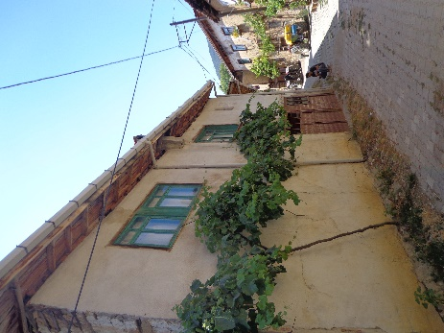
- A typical traditional earthen house (left) and concrete house (right) in Gelemic

Field observations
After two weeks of observations and recording of weather data in the field, a significant temperature difference was found between the outside and inside concrete and earth houses. Four different concrete buildings were visited on-site. The concrete houses had a low air quality, with damp-smelling air inside the buildings and mould problems. On the other hand, the earth houses had very dry but dusty air. The lack of maintenance led to woodworm to infest wooden parts of the buildings and caused mites and dust in the rooms. There were also some fallen pieces in the plaster of the earth walls, resulting in less clean surfaces and a dustier environment. Since most earthen structures are over 70 years old and in need of maintenance, the airtightness of these buildings is very low, which allows dust and air to circulate between the rooms easily. Villagers tend to replace the mud houses with concrete ones due to cleaning and heating problems in addition to the regular maintenance requirements. Furthermore, there is no craftsman in the village to repair these structures. For example, the young villagers have not inherited the skills required to cut earth bricks - they are no longer interested in learning these traditional jobs. In addition, it was observed that the earth wall provided very good soundproofing.

Data Analyses and Results

Survey Data
In August 2021, as part of this research, 40 villagers were asked about their indoor thermal comfort for both winter and summer. Half of these people lived in concrete structures and the other half lived in traditional adobe buildings. Thermal comfort questions in the polls disregarded the weather or environmental circumstances the attendees were exposed to at the time of participation and instead focussed on the inhabitants' more generic feelings and opinions about the buildings they reside in. Participants filled out paper surveys, mostly outside their residences in the settlement. According to these questionnaires, 85% of participants who resided in earth houses felt cool in summer. In terms of winter data, 38% of earth house dwellers felt cold while 24% felt cool and 5% felt slightly cool, which meant that 67% of total contributors think that their traditional earth houses do not fulfil their heating and thermal comfort needs in winter (Fig. 2 and Fig. 3). Nonetheless, immediately after their answer, some participants consciously added that the deterioration in these old buildings due to insufficient maintenance should be taken into account. On the other hand, human activity in these buildings has changed over time. Fireplaces were used for heating in these structures. Occupants later started using stoves instead of fire pits, and the unused chimneys caused heat losses. Therefore, they were either blocked with a plate or entirely removed by the residents. Additionally, the stables on the ground floors were not used in most of these structures, which meant that the animals' contribution to heating these buildings was no longer available.

- How the earthen house dwellers of Gelemic Village thermally feel during the cooling season

- How the earthen house dwellers of Gelemic Village thermally feel during the heating season

As for concrete houses, 30% of those polled said they felt cool inside their homes in summer, while 15% reported they were slightly cool. This indicates that 45% of all attendants considered that these structures provided thermally acceptable living spaces throughout the summer. Out of 20 concrete house users, only one person felt hot, while two others were slightly warm. The number of people feeling neutral was considerable, being 20% of the sample. In winter, a total 60% of people preferred additional heating due to the cold temperature inside. In addition to this, the proportions of those feeling warm and slightly warm in winter were respectively 30% and 10%. (Fig. 4 and Fig. 5) In this context, it is difficult to conclude that the concrete construction in Gelemic adequately contributed to thermal comfort in winter.

- How the concrete house dwellers of Gelemic Village thermally feel during the cooling season

- How the concrete house dwellers of Gelemic Village thermally feel during the heating season

Computer Modelling Data and the Weather Data Obtained from the Field
Fig. 6 displays the data logging points: locations A, B, and C in the village. The architectural material configurations in these zones are also illustrated in this map.

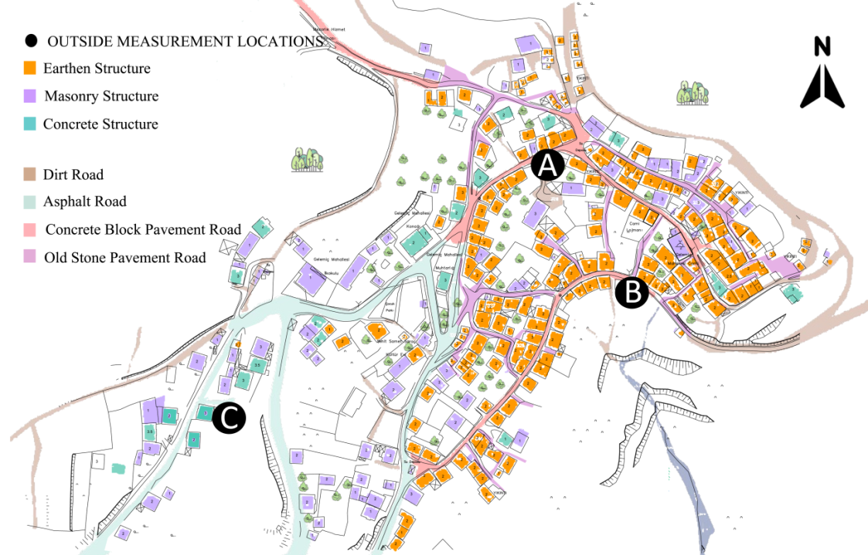
- The data logging and real-time monitoring points: Locations A and B near the adobe houses and Location C near the concrete houses in the village.
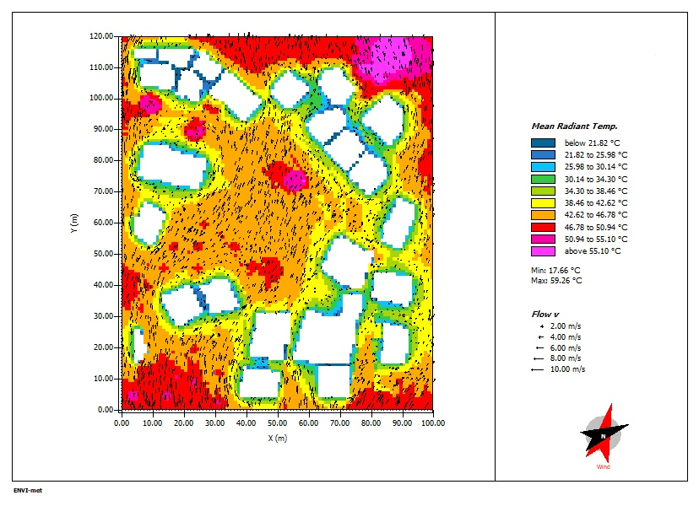
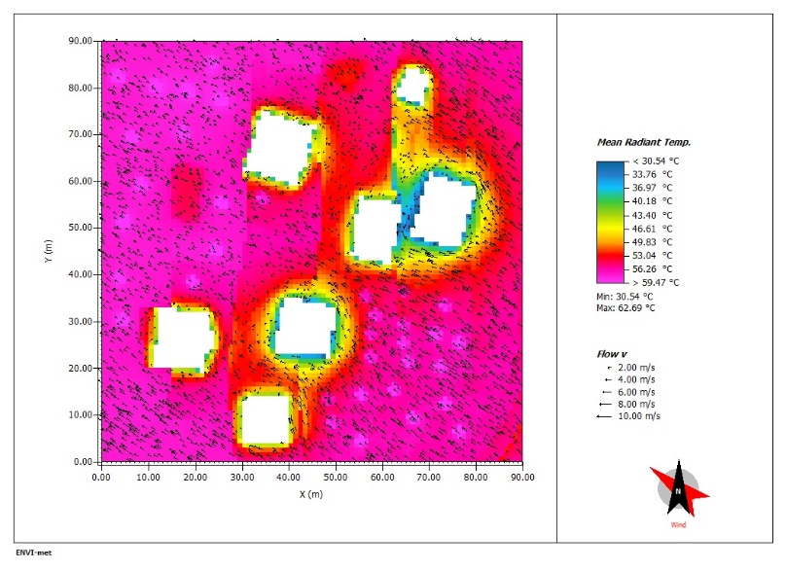
As can be seen in Fig. 6, locations A and B are predominantly close to the earth structures, whilst Location C is consisting of the concrete buildings. The urban density in Location C is less than Location A. The ENVI-met predicted mean radiant temperatures for Locations C and A are presented in Fig. 7, whilst relative humidity and potential air temperature values around these zones are shown in Fig. 8 and Fig.9 respectively. All the Envi-MET simulation maps in this paper depict the values at 1.4 metres above the terrain. The buildings in which the real-time indoor weather data were logged are marked in the graphs. According to the ENVI-met temperature maps, both radiant and air temperatures near the concrete houses at midday on 15th August were notably higher than in the adobe-built environment. It appears from these graphs that the vegetated open areas have extreme radiant temperatures.

- Predicted outdoor mean radiant temperature values on Location C (left) and A(right)
at 12am in 15 August 2021
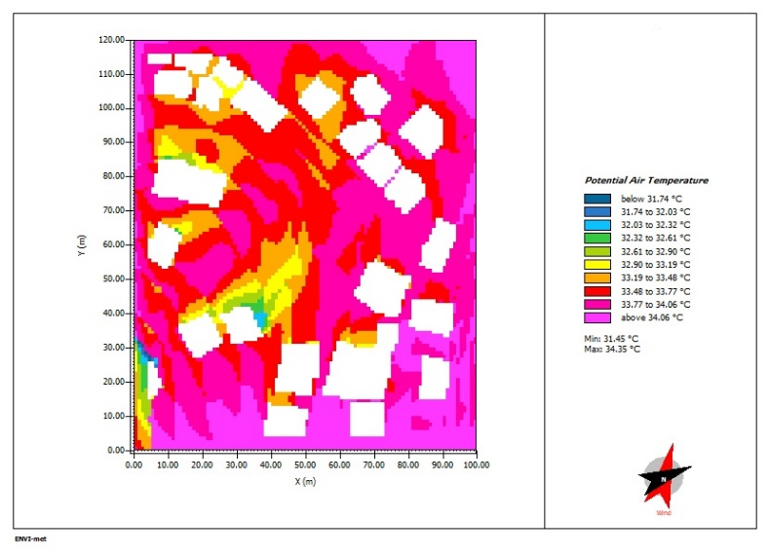
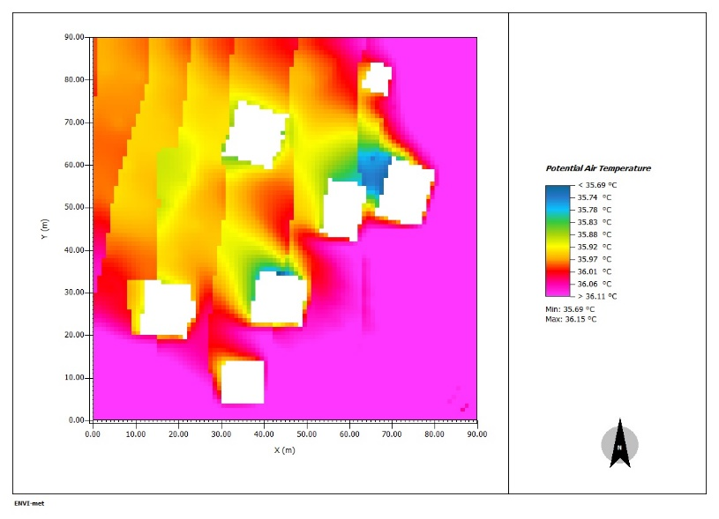

- Predicted outdoor air temperature values on Location C (left) and A(right)
at 12am in 15 August 2021

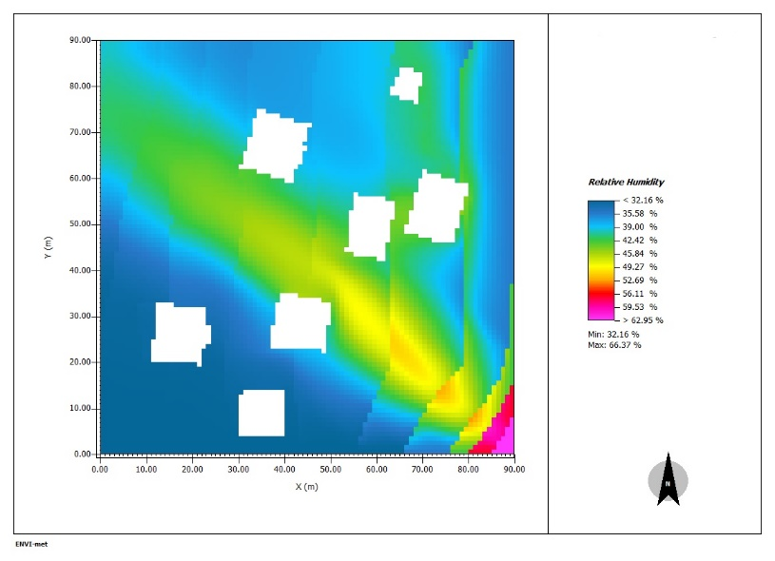
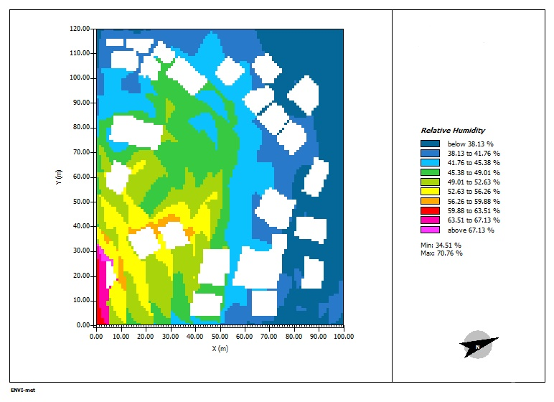
In Fig. 8 it is seen that the temperature variation in the entire zone C is quite minor, with a maximum of 0.42 °C. However, it is obvious that the close perimeters of the buildings were slightly cooler than vegetated south-facing open lands in the area. The right hand map in Fig. 8 above illustrates the air temperature distribution in Location A, where earthen structures had, a more heterogenous profile regarding thermal environment. Especially in the surrounding area to the earthen building in which the indoor weather data were recorded, the air temperature was about 33.5-34.0 °C, which means roughly 2°C cooler compared to Location C. To sum up, both regions did not meet the pedestrians’ comfort needs with the current urban configurations. For this point, further investigation is needed to determine which parameters cause this 2°C gap primarily and which alterations help to reduce the heat.

- Predicted outdoor relative humidity values on Location C (left) and A (right)
at 12 am on 15 August 2021

Based on Fig.9, both built environments include considerable areas where the relative humidity was below the comfort level, although it can be said Location C comparatively performs better since it has a smaller area where the relative humidity doesn’t reach to the minimum required percentage which is 40%.
It can be seen from Figure 11 that Location C was different from Location A, with higher indoor relative humidity values. On the other hand, the indoor hourly temperature in Location C was very similar to Location A during the week. Throughout the week, the average hourly air temperature was between approximately 21.0 to 25.0 °C (Fig.10), which is a quite acceptable range. On the simulation day, the real-time outside weather data seemed more or less coherent with the Envi-MET simulation results with respect to air temperature and humidity.

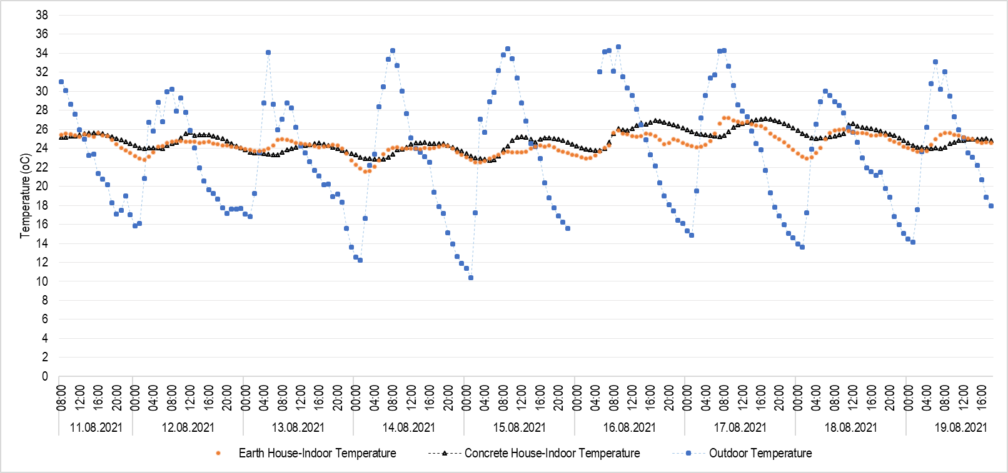

- Real time monitoring data comparing the indoor air temperature in the earth house and the concrete house with outdoor air temperature.
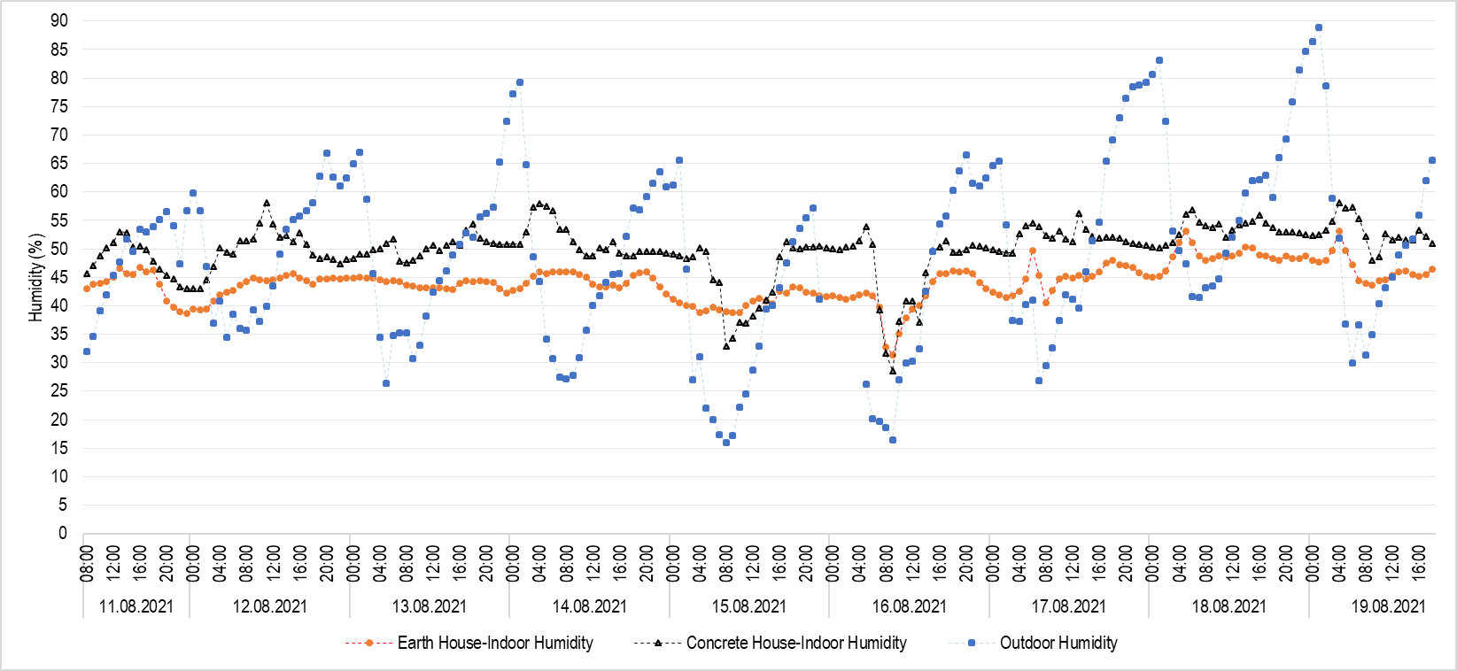
- Real time monitoring data comparing the indoor relative humidity in the earth house and the concrete house with outdoor relative humidity.
According to the one-week on-site weather data, the indoor humidity for the earth house in Location A was lower, with the values ranging from 40 to 50% compared to the indoor humidity in Location C, whilst the outdoor relative humidity was fluctuating in a wide range from 15% to 90% (Fig. 11).

Conclusion
In this paper, the urban microclimate conditions of Gelemic were investigated in the light of on-site observations, resident surveys and weather data recordings in addition to the computer modelling in ENVI-met software. The main findings of this research are:

- Compared to the concrete house residents, traditional earthen house dwellers in Gelemic feel thermally comfortable during summer periods. However, there is a consensus on the low thermal performance of the earthen buildings in winter periods compared to the concrete structures.

- According to the survey data, the ratio of concrete house inhabitants feeling thermally uncomfortable in winters is 60% whereas the figure for summers is restricted with 35%.

- Hourly indoor relative humidity data recorded in concrete and earth buildings demonstrate that the concrete house have a higher humidity than the earth houses, which was also observed in the field by the researcher. Nevertheless, urban microclimatic simulation results don't validate this clearly.

- The indoor hourly temperature recording presented parallel trends with similar figures for the data of concrete and earthen buildings. This indicates that people find the earth houses cool due to the low humidity in these structures.

- ENVI-met simulation maps for air and radiant temperatures show firstly that vegetated open spaces result in high amount of radiative heat and secondly that adobe structures might contribute more in creating cooler microclimates compared to concrete buildings. Notwithstanding, this prediction is not visible apparently in the on-site data recordings.

References
- Erell, E., Pearlmutter, D. and Williamson, T. J. (2015) Urban Microclimate: Designing the Spaces
between Buildings. Abingdon: Earthscan.
- Stagrum, A., Andenæs, E., Kvande, T. and Lohne, J., (2020). Climate Change Adaptation Measures for Buildings—A Scoping Review. Sustainability, 12(5), p.1721.
- UNEP 2021 United Nations Environment Programme (2021). Making Peace with Nature: A scientific blueprint to tackle the climate, biodiversity and pollution emergencies. Nairobi. https://www.unep.org/resources/making-peace-nature
- Abi, K. (2010) Effects of Climate Change on Temperature Features of Bursa Province. Marmara University.
- Meredith, G., Rakow, D., Eldermire, E., Madsen, C., Shelley, S. and Sachs, N., (2020). Minimum Time Dose in Nature to Positively Impact the Mental Health of College-Aged Students, and How to Measure It: A Scoping Review. Frontiers in Psychology, 10.
- Littlefair, P. J. et al. (2000) ‘Environmental site layout planning: solar access, microclimate and passive cooling in urban areas’, Building Research Establishment Ltd, 380, p. 151.
- Shafaghat, A. et al. (2016). Street Geometry Factors Influence Urban Microclimate in Tropical Coastal Cities: A Review, Environment and Climate Technologies, 17(1), pp. 61–75. DOI: https://doi.org/10.1515/rtuect-2016-0006
- Howard, L., (1833). The climate of London: deduced from meteorological observations made in the metropolis and at various places around it. London: Harvey and Darton.
- Mahgoub, M. (2015) ‘Assessment of Thermal and Visual Micro-climate of a Traditional Commercial Street in a Hot Arid Climate, PhD Thesis, University of Newcastle.
- Musco, F., (2016) Counteracting Urban Heat Island Effects in a Global Climate Change Scenario. Springer
- United Nations, Department of Economic and Social Affairs, Population Division (2019). World Population Prospects 2019: Highlights (ST/ESA/SER.A/423).
- Yahia, M., Johansson, E., Thorsson, S., Lindberg, F. and Rasmussen, M., (2017). Effect of urban design on microclimate and thermal comfort outdoors in warm-humid Dar es Salaam, Tanzania. International Journal of Biometeorology, 62(3), pp.373-385.
- ENVI-met (2021) https://www.envi-met.com/
- Jin, H., Cui, P., Wong, N. and Ignatius, M., (2018). Assessing the Effects of Urban Morphology Parameters on Microclimate in Singapore to Control the Urban Heat Island Effect. Sustainability, 10(1), p.206.
- Hamdan, D. and de Oliveira, F., (2019). The impact of urban design elements on microclimate in hot arid climatic conditions: Al Ain City, UAE. Energy and Buildings, 200, pp.86-103.
- Givoni, B., (1976). Man, Climate and Architecture (2nd edition). London: Applied Science Publishers.
- 2020. TUIK. Adrese Dayalı Nüfus Kayıt İstatistikleri. [online] Available at: https://biruni.tuik.gov.tr/medas/?kn=95&locale=tr [Accessed 14 October 2021].

The University of Liverpool, Liverpool, UK, n.bektas@liverpool.ac.uk b The University of Liverpool, Liverpool, UK, Haniyeh.MPK@liverpool.ac.uk c The University of Liverpool, Liverpool, UK, steve.sharples@liverpool.ac.uk

