Renovating the Existing Residential Building Stock in Turkey with Prefabricated Components for Passivhaus-EnerPHit.
Dilek ARSLAN, Steve SHARPLES^{b}, Haniyeh MOHAMMADPOURKARBASI^{c}

Abstract
In order to keep the future global temperature below 2˚C, significant energy reductions must be achieved in the building sector. Since existing buildings consume the biggest share of the sector’s energy budget, then complete, fast, and easy-to-apply energy update methods using prefabrication during the retrofit process are desirable. Although various prefabricated retrofit components have been introduced in different climate contexts, there are very few studies exist on retrofit for buildings in hot climates. In addition, no standard guarantees the operational energy performance of these components. Therefore, this paper aims to adapt one of these prefabricated retrofit solutions, Timber-based Element System (TES), to housing in the hot climate region of Turkey to achieve the Passivhaus-EnerPHit standard in operational energy. Step-by-step interventions were applied to a multi-family building in Istanbul using PHPP software to achieve EnerPHit requirements. While TES successfully decreased the heating demand by 50%, decreasing cooling demand was more difficult and the passive measures were insufficient to lower the cooling energy load. Mechanical ventilation with heat recovery (MVHR) and additional ventilation units were helpful in decreasing the cooling demand to EnerPHit requirement levels and to zero for heating demand. It was concluded that, due to the limiting boundaries in the existing buildings, there may always be a need for a mechanical system for cooling to condition indoor environments in hot climates to comfort levels.
Keywords: Retrofit, Prefabrication, EnerPHit, Hot Climates

Introduction
In 2016, countries began to pledge to tackle climate change by signing Paris Agreement, and targets were established to decrease carbon emissions to the1990s levels by 2030. However, the latest IPCC report [1] showed that the world is crossing the 2˚C threshold, meaning that current measurements are insufficient. As it is responsible for around one-third of global carbon emissions, this climate emergency pushes the building sector to take rapid actions to decrease carbon emissions. Meeting the emission reduction target is particularly essential in countries that fall behind in the climate mitigation race, like Turkey [2]. It is expected that in 2024 the countries that signed the Paris Agreement will start to establish the total amount of emission reductions that they have achieved. Therefore, Turkey needs to speed up its reduction due to the time constraints and obligations to the Paris Agreement. Although, Turkey has introduced a benchmark for new buildings to achieve at least a C Level in energy performance in its Energy Performance Certificate (EPC) system, there are no specific strategies or targets for the existing buildings. Therefore, country-specific solutions should be considered for retrofitting existing buildings in Turkey.
Retrofitting the existing building stock substantially decreases the operational impact from buildings; however, business as usual, models take too much money, time, and source and disturb occupants in the building during the retrofit process [3, 4]. Standardisation in both operational performance and production can avoid these shortcomings. Therefore, prefabrication and an energy standard should be a part of the retrofit process. While prefabrication ensures the quality in component production and reduces the duration [5], energy standards like Passivhaus control the energy demand [6]. Although these retrofit models exist, they are not necessarily considering hot climate conditions nor highlighting the overheating risk in summers. This brings buildings in hot climates to the attention of researchers, to evaluate the boundary conditions to be overcome.
In this study, a case study of a low-rise apartment block in Istanbul, Turkey was evaluated to show whether prefabricated retrofit panels are good at achieving the Passivhaus EnerPHit performance with Timber-based Element System (TES) energy façade systems or not. Also, to explore the challenges during the retrofits in hot climates. This can be a step for a retrofit model to help Turkey to comply with the Paris Agreement requirements. The Passivhaus Planning Package (PHPP) model was used to evaluate step-by-step retrofit strategies. The results showed that the main challenge in achieving EnerPHit performance was decreasing the energy demand for cooling and dehumidification due to a lack of the possibility of changing some building components like window sizes.

Literature

Retrofit considerations
The majority of a building’s energy demand comes from the activities in its operational stage, such as heating, cooling, cooking, and washing. These activities constitute about 50-70% of primary energy demand [6]. While new buildings are more successful in reducing operational energy consumption, existing buildings are still struggling. Although retrofitting buildings is a solution, it often takes more time and money than was expected and disturbs the occupants during the whole process. Also, the boundary conditions of an existing building, such as building orientation and shape or window sizes, affect possible energy reductions. Therefore, people prefer to demolish and reconstruct their house in most cases, which costs less money and effort than a retrofit [3, 4].
Lately, under the European Union Research and Innovation Program, Horizon 2020 projects have integrated prefabrication to retrofit processes to overcome negative aspects of disturbing occupants by decreasing construction times to 10-15 days and lowering construction waste. These modular systems can achieve up to an 80% reduction in operational demand for nearly zero-energy buildings (NZEB) [7]. Although this is a promising step up in modular retrofit, designing modules for NZEB is not providing a clear path in achieving the energy target. On the other hand, energy standards like Passivhaus are not only specifying the minimum energy demand for heating and cooling and identify thermal properties for each building component or air change rate to achieve those targets, which aligns more with a ‘fabric first’ approach in retrofit. Passivhaus also ensures that implications in every step are understood and planned accordingly, with pre-certification options to avoid the performance gap between design and application processes. EnerPHit is a subsection of Passivhaus for retrofit projects. It requires ≤25kWh/m²/pa for space heating, ≤15 kWh/m²/pa for cooling demand, and ≤120kWh/m² for primary energy demand [8].

Situation in Turkey
Turkey is one of the signatories to the Paris Agreement. Therefore, it pledged to play its part in combatting climate change. In Turkey’s climate change strategy, there are five objectives to be achieved by 2023, which are

- Increasing the energy efficiency in buildings by improving the building skin.
- All new buildings should have an EPC with at least a level C.
- Energy consumptions to decrease by at least 20%.
- Meeting of at least 20% of energy demand with renewable sources.
- Decreasing the 2011 greenhouse gas (GHG) figures by 10% [9].

To achieve these objectives, Turkey introduced Building Energy Code and Energy Performance Regulations in 2007 and 2008, respectively [10]. The regulations basically set a baseline for the thermal performance of the building components according to climate zones – for instance, the U-value of a wall should not be more than 0.70 W/m²K in hot climate regions. Despite these steps being taken, Turkey still falls behind other countries in its climate change contributions [11].
The majority of the buildings in Turkey were built in between 1969 and 1996, constituting about 72% of the total stock. An average apartment block’s space heating demand can be up to 200 kWh/m² [12] which covers almost 58% of the total energy demand. These figures are highlighting the poor energy performance conditions in Turkey’s existing housing stock as well as the need for an urgent upgrade. Therefore, a modular retrofit model, aiming for EnerPHit performance, was evaluated using a step by step to establish how a step was making a difference in energy demand.

Methodology

Case Study
Since the majority of the building stock in Turkey is in Istanbul, and the city also experiences a Mediterranean climate (characterised by hot, dry summers and cool, wet winters), a case study apartment in Istanbul was chosen. The selected apartment building was built in 1993 and located in Avcılar/Istanbul, which typically experiences the lowest temperature in winter of 3˚C and 32 ˚C as the highest in summer [13].
The apartment represents an example of standard practice in residential projects in Turkey (Fig.1). The building has one basement with a communal area, four stories with eight flats, and two penthouses. All the flats have almost the same layout and are used for residential purposes (Fig. 2). The total treated floor area (TFA) of the building is 1008m² and each floor is 2.8m height. The building has a reinforced concrete structure and has brick walls with no insulation. Heating, cooking, and domestic hot water energy demands are met by a gas boiler, and other needs like lighting and cooling are supported by electricity and mixed ventilation.
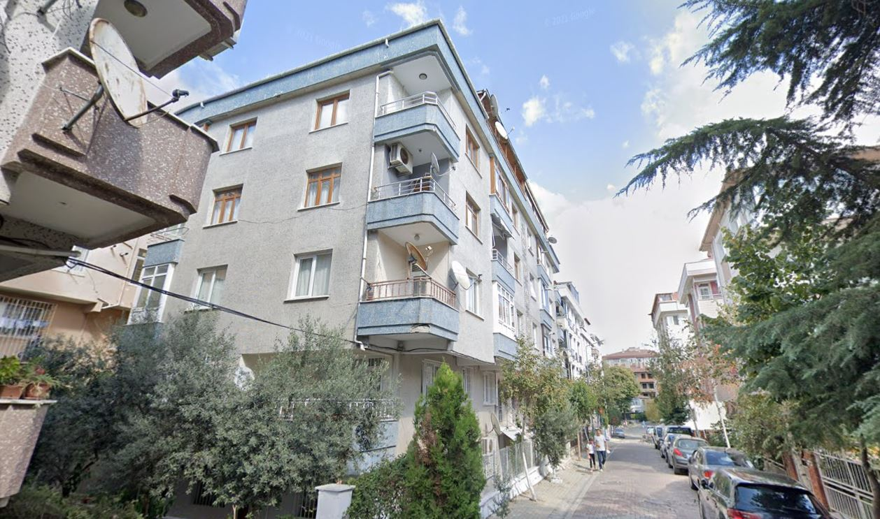
- Case Study Apartment View from Google Maps

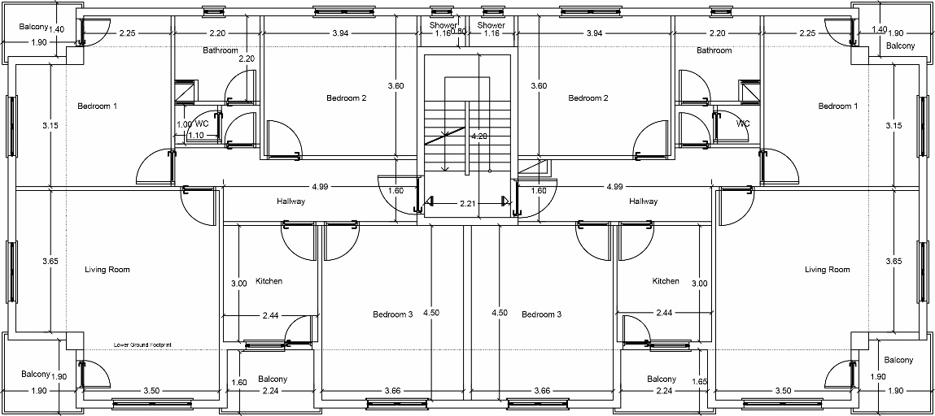
- Floor Plan of the Apartment

Results and Discussion

Step-by-Step Retrofit
The results from PHPP simulations showed that the heating and cooling demand of the existing building were 161 kWh/m²/pa and 108 kWh/m²/pa, respectively, while the primary energy demand was 310 kWh/m²/pa. When the first step of retrofit, a TES façade (Fig.3), was applied to the building, the heating and cooling demands showed a substantial decrease by 50%, due to thermal bridge free components and low thermal transmittance from the building skin.
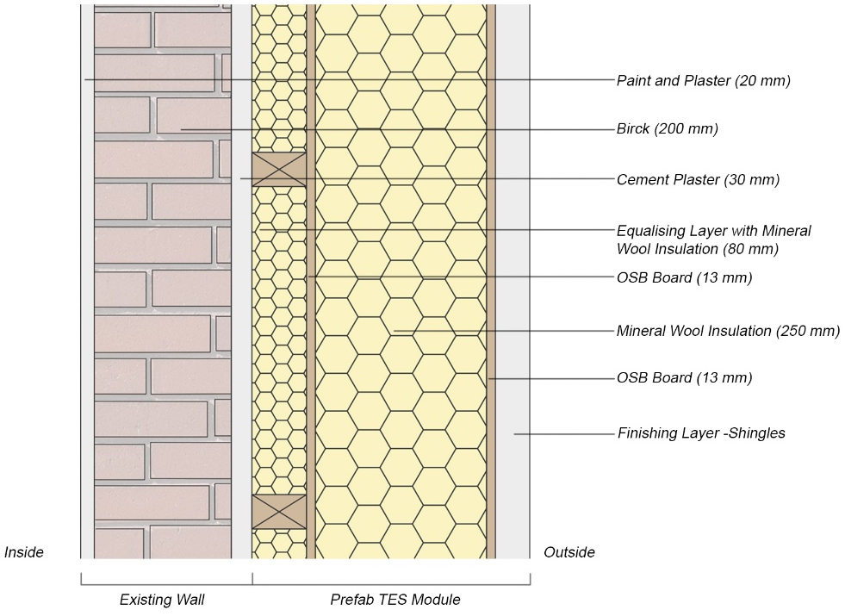
- Retrofitted Wall Detail
Although existing windows were double glazed and in good condition, they were not complying with the Passivhaus-EnerPHit requirements. So, in the second step, windows were replaced with Passivhaus certified timber framed triple glazed windows, and the heating demand decreased by 62% and primary energy demand decreased to 142 kWh/m²/pa, by almost 55%. However, cooling demand increased from 52 to 63 kWh/m²/pa.
In the next step, an MVHR unit was added to the building. It produced a significant reduction in heating energy demand to 9 kWh/m²/pa, a 94% fall, which is a more significant reduction than the other prefabricated retrofit façades [14, 15, 16]. Whilst the heating demand met the EnerPHit criteria, cooling and dehumidification needed more improvements. Although the cooling demand dropped by 66% of the existing performance, it was not enough to comply with the EnerPHit requirement, meaning that the system needed further steps to reduce the cooling load in the building. Therefore, the dehumidification efficiency in the MVHR unit increased from 75% to 95%, which decreased cooling demand from 36 to 30 kWh/m²/pa and heating demand decreased to 6 kWh/m²/pa. Yet, efficiency cannot be guaranteed in these units. Consequently, care should be taken when changing the efficiency, and maintenance should be regularly undertaken in actual designs.
Further, shading elements were added as an overhang to South, East, and West windows since the solar loads were the highest on those façades at 560, 456, 453 kWh/m²_{glazing area} respectively. However, adding shading did not have a tangible impact on cooling energy demand. Therefore, the Additional Ventilation tab was activated in the software to lower the energy load from cooling. Smaller size additional ventilation units were added to floor levels in the buildings, which helped achieving the EnerPHit target. Despite the achievements in each domain of the EnerPHit standard, the primary energy demand was still high, being 136 kWh/m²/pa. Therefore, the final step was to add 29 mono-silicon 1.65x0.99m photovoltaic (PV) panels to the south-facing side of the roof. , The PV panels helped to achieve primary energy from renewables criteria which were 64 kWh/m²/pa. With all the interventions applied, the final figures for heating and cooling demands were 0.1 and 14 kWh/m²/pa, respectively (Fig. 4).
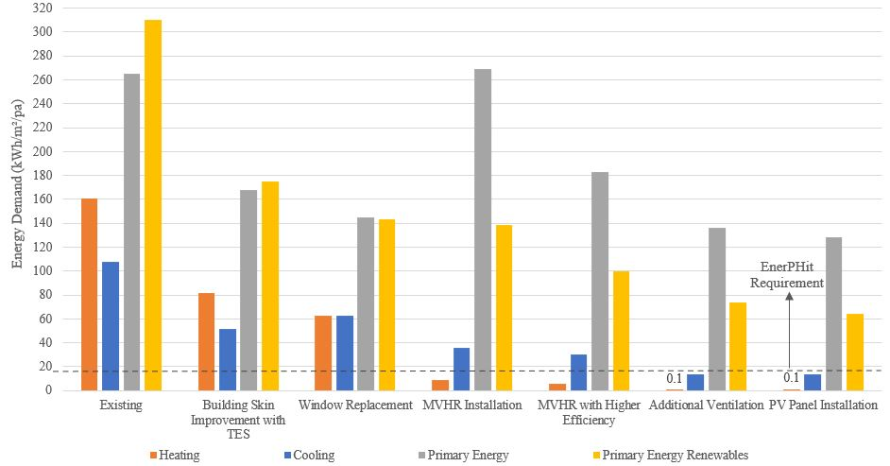
- Step-by-Step Retrofit Results
As the heating demand became almost zero, this allowed a decrease in the insulation thickness in the prefabricated components, while the Passivhaus standard recommends keeping the U-value of the external walls between 0.10 and 0.15 W/m²K. This is much flexible in EnerPHit, which allows external walls U-values to be between 0.30 and 0.50 W/m²K for warm-temperate climates [17]. In the proposed TES the improved exterior walls achieved 0.104 W/m²K with 250 mm mineral fibre wool insulation (Tab.1). If the insulation thickness was decreased to 150 mm, the heating demand increased slightly to 0.6 kWh/m²/pa and the U-value of the walls to 0.143 W/m²K. If the insulation thickness decreased to 100 mm, then the heating demand still stayed low at 1.3 kWh/m²/pa; but the cooling demand approached 15kWh/m²/pa threshold, being 14.4kWh/m² annual energy demand. Further, for an insulation thickness decrease to 50 mm, the heating demand went up to 3.4 kWh/m²/pa, but this was the limit for the cooling demand since it went up to 15 kWh/m²/pa. The U-value of the external walls stayed 0.230 W/m²K, which is still low compared to EnerPHit allows. This shows that substantial energy reductions are possible with little insulation in warm climates and, as with other prefabricated retrofit modules, the TES system for the cold climate requires much more insulation, which is not necessary for the buildings in warmer climates.

- Building Components and Thermal Properties

Building Component | Layers with Improvements | U-Value (W/m²K)
 |  | Existing | Retrofitted | EnerPHit
Exterior Walls | 20mm Plaster and Paint + 200mm Brick + 30mm Cement Plaster and Mosaic Rendering + 80mm Equalising Layer with Insulation + 13mm OSB + 250mm Mineral Wool + 13mm OSB + Finishing Layer | 1.84 | 0.10 | 0.30-0.50
Roof | Ceramic Roof Tiles + 13mm Particle Board + 100mm Wood Battens + 13mm Particle Board + 20mm Plaster and Paint + 13mm OSB + 150 mm Mineral Wool | 0.80 | 0.13 | 0.30-0.50
Windows | Replaced with a PH certified insulated triple glazing with timber frame | 3.70 | 1.00 | 1.05

Retrofit in Hot Climates
Considering the global climate is getting warmer, in the future, the risk of overheating and cooling issues will be a factor of the cold climate regions. Also, some current studies have reported that even the buildings retrofitted to Passivhaus performance in cold climates can have issues about overheating in the summer, thereby increasing the cooling demand [18, 19]. Step-by-step retrofit processes showed that, although the current solutions like TES façade systems are advantageous in decreasing the heating energy demand in residential buildings with passive measurements, cooling and dehumidification still require active solutions, especially when the building boundaries are limited. Even installing an MVHR unit to a single-family unit is quite expensive, and the total cost of installing MVHR units to each floor level and building level will be double. Therefore, the homeowners will probably not be willing to invest too much money in an old building. Both a changing climate and cost issues highlight that retrofit solutions need more passive solutions to achieve Passivhaus-EnerPHit performance in hot climate countries.

Limitations
One of the limitations related to the retrofit process was fixed openings. Because the aim of this retrofit model is to avoid occupant disturbance during the prefabricated retrofit installations, the existing openings were kept the same. This affected the flexibility in taking measures to avoid overheating and cooling at certain levels. Similarly, since the building boundaries and direction cannot be changed in the existing building, the building orientation or shape factor could not be changed. Finally, the PHPP software needs validation in the design process. Normally, the only way to validate the Passivhaus performance is to build the building and test its performance on-site, which is not an easy or cheap way of validating energy performance. Although PHPP is claimed to be reliable on calculation results [20], this is not always the case. The performance gap issue in PHPP has been mentioned in literature [19] and may affect its credibility. Also, PHPP allows users to take building level measurements to tackle the issues in the whole building, like overheating or air leakage, not at the individual room/space level.

Conclusion

Summary
This paper indicated that considerable energy savings are possible with the façades improved by prefabricated components, even for challenging summer conditions. The study revealed that decreasing the cooling demand to 15kWh/m²/pa with passive measurements like shading was not possible. Therefore, MVHR units are needed at both building and floor levels in low-rise apartments in the hot climate regions of Turkey to achieve EnerPHit performance. Also, it has been understood that even though a building component does not comply with the Passivhaus requirements, a building can meet heating and cooling demands as well as primary energy demands. Therefore, even though Passivhaus provides step-by-step retrofit guidelines for climate-specific conditions, it still needs some improvements regarding building components being considered in specific country contexts, especially for hot climates.

Future Work
The main focus of this paper was to assess the challenges faced during the building assessment and achieving EnerPHit performance. Therefore, as a future work, exploring the options and creating a scheme for Turkey’s retrofit path will also include the social and economic aspects of retrofit and government funding. Also, Life Cycle Assessment (LCA) of the building components will be included in the prefabricated retrofit process to evaluate the hidden carbon emissions, and energy consumed during the component production called embodied impact. Operational energy and embodied energy play an important role in reducing the impact related to building construction, especially in retrofit. In retrofit projects, since the building has already spent a period of its time, it is important to understand whether embodying extra carbon for the rest of its time is feasible or not. Finally, given the limited insight of a building’s thermal behaviour from PHPP, the building energy simulation will be carried out with the dynamic simulation software DesignBuilder to validate the existing performance and indicate the problems that may occur at room/space level and explore solutions to them.

Acknowledgement
This PhD study is funded by the Turkish Ministry of Education, including tuition fees and student expenses.

References
- IPCC, 2021: Climate Change 2021: The Physical Science Basis. Contribution of Working Group I to the Sixth Assessment Report of the Intergovernmental Panel on Climate Change [Masson-Delmotte, V., P. Zhai, A. Pirani, S. L. Connors, C. Péan, S. Berger, N. Caud, Y. Chen, L. Goldfarb, M. I. Gomis, M. Huang, K. Leitzell, E. Lonnoy, J. B. R. Matthews, T. K. Maycock, T. Waterfield, O. Yelekçi, R. Yu and B. Zhou (eds.)]. Cambridge University Press. In Press.
- Climateactiontracker.org. n.d. Turkey | Climate Action Tracker. [online] Available at: https://climateactiontracker.org/countries/turkey/ [Accessed 9 April 2021].
- Tahsildoost, M. and Zomorodian, Z., 2020. Energy, carbon, and cost analysis of rural housing retrofit in different climates. Journal of Building Engineering, 30, p.101277.
- D’Oca, S., Ferrante, A., Ferrer, C., Pernetti, R., Gralka, A., Sebastian, R. and op ‘t Veld, P., 2018. Technical, Financial, and Social Barriers and Challenges in Deep Building Renovation: Integration of Lessons Learned from the H2020 Cluster Projects. Buildings, 8(12), p.174.
- Richard, R., 2017. Industrialised building system categorisation. In: Offsite Architecture: Constructing the Future, 1st ed. Oxon: Routledge, pp.3-20.
- Institute, P., n.d. Passivhaus Institut. [online] Passivehouse.com. Available at: https://passivehouse.com/02_informations/01_whatisapassivehouse/01_whatisapassivehouse.htm [Accessed 20 September 2021].
- Ibn-Mohammed, T., Greenough, R., Taylor, S., Ozawa-Meida, L. and Acquaye, A. (2013). Operational vs. embodied emissions in buildings—A review of current trends. Energy and Buildings, 66, pp.232-245.
- MORE-CONNECT. 2019. Results — MORE-CONNECT. [online] Available at: <https://www.more-connect.eu/deliverables/> [Accessed 13 September 2021].
- Passive House Institute, 2016. Criteria for the Passive House, EnerPHit and PHI Low Energy Building Standard. [online] Passive House Institute. Available at: https://passipedia.org/_media/picopen/9f_160815_phi_building_criteria_en.pdf [Accessed 13 September 2021].
- TS 825:2008, 2008. Binalarda Isi Yalitim Kurallari. Ankara, Turkey: TSI. [online] Available at: http://www1.mmo.org.tr/resimler/dosya_ekler/cf3e258fbdf3eb7_ek.pdf [Accessed 11 April 2021].
- Turkish Ministry of Environment and Urbanization, 2012. Turkey’s National Climate Change Adaptation Strategy and Action Plan. Ankara: Turkish Ministry of Environment and Urbanization.
- TS 825:2008, 2008. Binalarda Isi Yalitim Kurallari. Ankara, Turkey: TSI. [online] Available at: http://www1.mmo.org.tr/resimler/dosya_ekler/cf3e258fbdf3eb7_ek.pdf [Accessed 11 April 2021].
- Kazanasmaz, T., Uygun, İ., Akkurt, G., Turhan, C. and Ekmen, K., 2014. On the relation between architectural considerations and heating energy performance of Turkish residential buildings in Izmir. Energy and Buildings, 72, pp.38-50.
- Mgm.gov.tr. 2021. Meteoroloji Genel Müdürlüğü. [online] Available at: https://www.mgm.gov.tr/veridegerlendirme/il-ve-ilceler-istatistik.aspx?m=ISTANBUL [Accessed 13 September 2021].
- ADAPTIWALL, 2018. Multi-functional light-weight WALL panel based on ADAPTive Insulation and nanomaterials for energy efficient buildings. [online] Available at: https://cordis.europa.eu/project/id/608808/reporting [Accessed 14 September 2021].
- BREASER, 2015. BREASER system concept design and methodology for a systemic building. [online] Available at: http://www.bresaer.eu/wp-content/uploads/2017/03/BRESAER-System-concept-design-and-methodology-for-a-systemic-building-refurbishment_D2.2.pdf [Accessed 14 September 2021].
- Passive House Institute, 2016. Criteria for the Passive House, EnerPHit and PHI Low Energy Building Standard. [online] Passive House Institute. Available at: https://passipedia.org/_media/picopen/9f_160815_phi_building_criteria_en.pdf [Accessed 20 September 2021].
- Lattke, F., Larsen, K., Ott, S. and Cronhjort, Y., 2009. TES Energy Facade – prefabricated timber based building system for improving the energy efficiency of the building envelope. [online] Available at: https://www.researchgate.net/publication/294085946_TES_Energy_Facade_-_prefabricated_timber_based_building_system_for_improving_the_energy_efficiency_of_the_building_envelope_funded_by_Woodwisdom_Net_Research_project_from_2008-2009 [Accessed 14 September 2021].
- Fletcher, M., Johnston, D., Glew, D. and Parker, J., 2017. An empirical evaluation of temporal overheating in an assisted living Passivhaus dwelling in the UK. Building and Environment, 121, pp.106-118.
- Kang, Y., Chang, V., Chen, D., Graham, V. and Zhou, J., 2021. Performance gap in a multi-storey student accommodation complex built to Passivhaus standard. Building and Environment, 194, p.107704.
- Passivehouse.com. 2021. Passivhaus Institut. [online] Available at: https://passivehouse.com/04_phpp/04_phpp.htm [Accessed 14 September 2021].

The University of Liverpool, Liverpool, UK, d.arslan@liverpool.ac.uk b The University of Liverpool, Liverpool, UK, steve.sharples@liverpool.ac.uk c The University of Liverpool, Liverpool, UK, Haniyeh.MPK@liverpool.ac.uk

