Broadband Textile Hexagonal Metasurface Antenna for Wearable Applications

Rui Pei, Wenli Lu
Donghua University
Shanghai, China
Yuancheng Wang, Jingchen Wang, Mark Leach, Eng Gee Lim, Zhao Wang
Xi’an Jiaotong-Liverpool University
Suzhou, China
Wenzhang Zhang, Jiafeng Zhou, Yi Huang
The University of Liverpool
Liverpool, UK

Abstract— Wearable antennas working in close proximity to human bodies will suffer from frequency shift due to the effect of the human body tissue and a certain level of bending. A wide operational bandwidth and stable performance under bending conditions are desired for wearable antenna designs. In this paper, a wearable antenna design based on a hexagonal unit cell structure is presented and the effect of bending on antennas is analyzed. The conductive part of the antenna is embroidered with conductive threads onto textile surfaces. Polymer composite is used as the substrate of the antenna. With the wideband hexagonal element design, the antenna can achieve an operation bandwidth from 4.63 GHz to 7.22 GHz and a stable realized gain of 10 dBi when attached to a voxel human body model.
Keywords—wearable antenna, hexagonal elements, metasurface.

Introduction
Technologies like Ultra-wideband positioning, wireless power transfer and wireless energy harvesting could be applied to next-generation flexible wearable devices. Such applications would require antennas with wide/multi-band, high gain and high radiation efficiency. Prior study has proven that RF transmission lines fabricated with conductive threads and embroidery can achieve stable performance over the bandwidth from 1 GHz to 6 GHz [1]. This study laid the foundation of the application of embroidery in RF applications. Patch antennas fabricated with similar techniques can achieve a radiation efficiency of 98.2 % [2]. On the other hand, our previous work has illustrated that metasurface with hexagonal structure unit element reveals wider bandwidth from a characteristic mode analysis point of view [3]. In this study, a hexagonal metasurface wearable antenna is realized with conductive threads embroidery and polymer composite substrate, aiming at a wideband and robust on-body performance.

Geometry of the Antenna
The structure and key parameters of the proposed hexagonal metasurface antenna are shown in Fig. 1.The proposed antenna contains three conductive layers made of embroidered conductive threads, namely a top hexagonal patches layer (as shown in Fig. 1 (a)), a middle ground plane layer, and a bottom feeding microstrip line layer (as shown in Fig. 1 (b)). Between the three conductive layers are two substrate layers made with polydimethylsiloxane (PDMS) material with a dielectric constant of 3.5. Fig. 1 (c) is a cross-section view of the antenna to demonstrate the layers. The dimensions of the structures are summarized in TABLE I. It should be noted that the size of the outer ring of the hexagonal patches is smaller than that of the inner patches. The reason for this design is to create resonances at different frequency centers to broaden the bandwidth of the antenna.
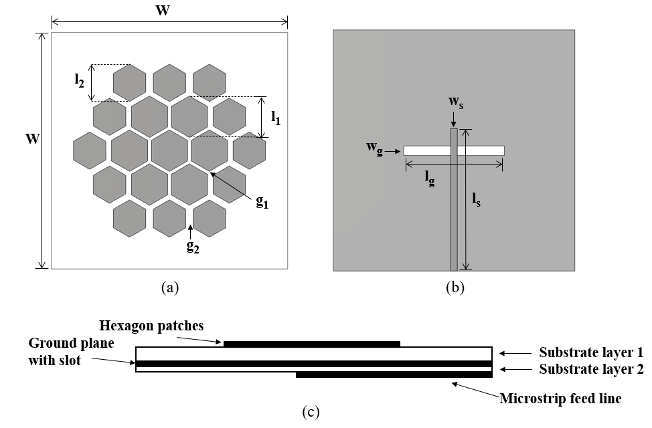
- The geometry and key parameters of the proposed antenna.
- Antenna Geometry Parameters
Symbol | Quantity | Value (mm)
W | width of the antenna | 60
l₁ | width of the inner hexagonal element | 11.34
l₂ | width of the outer hexagonal element | 12.6
g₁ | gap between the inner elements | 1.2
g₂ | gap between the outer elements | 1.6
l_{g} | length of the feeding gap | 25
w_{g} | width of the feeding gap | 2.4
l_{s} | length of the feeding strip line | 35.5
w_{s} | width of the feeding strip line | 1.55

Antenna Performance Analysis
For wearable antennas, a stable performance under bending conditions is essential for the antenna to be reliable and robust. The S₁₁ value for the antenna under flat conditions and bent towards cylinders of radii 100 mm to 250 mm are summarized in Fig. 2. Without any bending, the antenna is able to achieve a bandwidth from 4.63 GHz to 7.22 GHz. When a level of bending is applied to the antenna, a reduction of the bandwidth can be seen. When the antenna is bent towards a cylinder with a radius of 250 mm, the bandwidth is reduced to 4.91 GHz to 7.13 GHz. With a more severe bending towards a cylinder with a radius of 100 mm, the bandwidth is further reduced to 4.96 GHz to 7.07 GHz. The severe bending causes 18% bandwidth loss (from 2.59 GHz to 2.11 GHz).
In terms of the farfield performance, the proposed antenna can achieve a maximal realized gain of 9.47 dBi at 5.6 GHz and 8.10 dBi at 6.6 GHz. The effect of bending on the realized gain is not significant. With the most server 100-
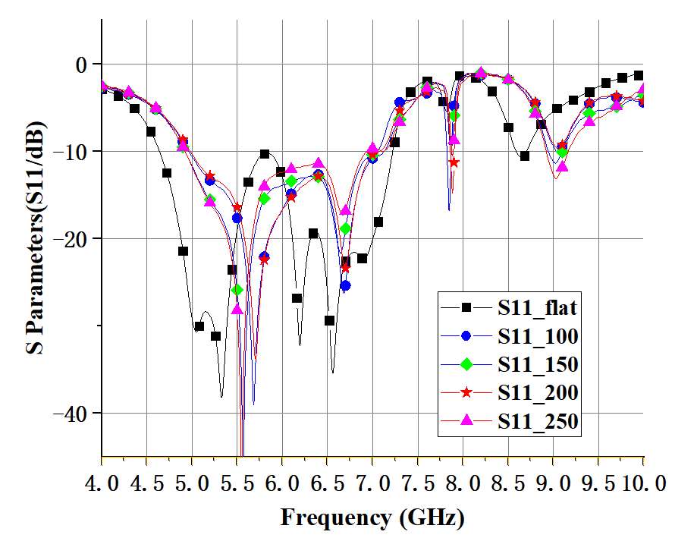
- Simulated reflection coefficient (S₁₁) of the antenna.
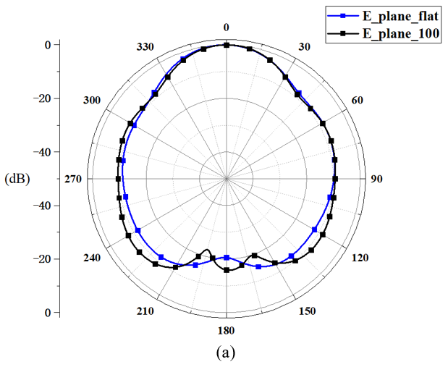
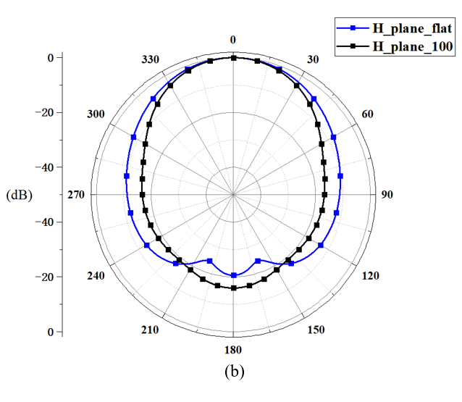
- Simulated radiation pattern under flat and bending conditions (bent towards cylinder with radii of 100 mm): (a): E plane (b): H plane
mm bending, the antenna still achieves a maximal realized gain of 10.16 dBi at 5.6 GHz and 5.56 dBi at 6.6 GHz.
The radiation patterns of the antenna in flat and bending conditions are shown in Fig. 3.
- Simulated maximal SAR value with 0.5 W Input Power (unit:W/kg)
Averaged over | 1g | 10g
Maximal SAR | 0.682 | 0.333
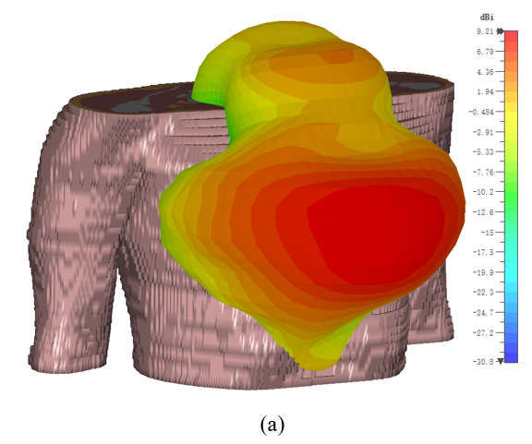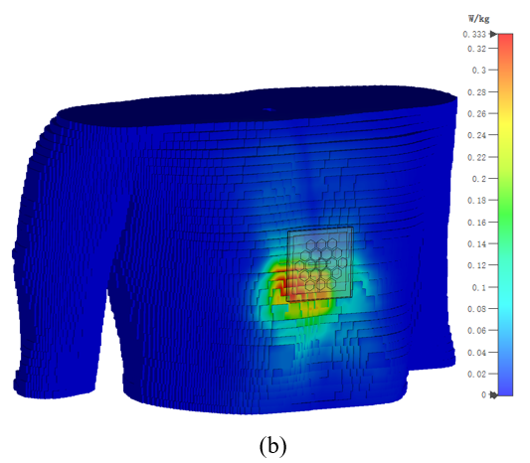
- The simulation results with voxel human body model Gustav. (a) Farfield realized gain result at 5.6 GHz. (b) SAR value distribution averaged over 10 g tissue at 5.6 GHz.
The antenna was simulated with CST Microwave Studio. The CST voxel family human model Gustav ((38-year-old-male, 176 cm and 69 kg)) was used for the on-body simulation. Only the chest area was selected to reduce computational complexity.
The SAR values of the different conditions were also simulated and summarized in the TABLE II. The simulation was performed according to the methods described in standard IEEE/IEC 62704-1 [4]. The input power to the antenna port was set to be 0.5 W. The on-body radiation pattern and the SAR distribution are shown with Fig. 4. The absorption is considerably lower than the widely applied 1.6 W/kg FCC standard.

Conclusion
In this paper, a wideband wearable hexagonal metasurface antenna is introduced. The antenna performance under banding and the human body absorption of the antenna are analyzed. Overall, the antenna can maintain a stable bandwidth. The body tissue absorption is also limited to an acceptable safe level.

Acknowledgment
The authors would like to express their sincere gratitude to CST AG for providing the CST STUDIO SUITE® electromagnetic simulation software package under the China Key University Promotion Program, and their comprehensive support.

References
- Z. Wang, L. Zhang, Y. Bayram, and J. L. Volakis, "Embroidered Conductive Fibers on Polymer Composite for Conformal Antennas," IEEE Transactions on Antennas and Propagation, vol. 60, no. 9, pp. 4141-4147, 2012.
- D. Vital, S. Bhardwaj, and J. L. Volakis, "Textile-Based Large Area RF-Power Harvesting System for Wearable Applications," IEEE Transactions on Antennas and Propagation, vol. 68, no. 3, pp. 2323-2331, 2020.
- W. Zhang, C. Song, R. Pei, Y. Huang, and J. Zhou, "Broadband Metasurface Antenna Using Hexagonal Loop-Shaped Unit Cells," IEEE Access, vol. 8, pp. 223797-223805, 2020..
- I. Guideline, "Guidelines for limiting exposure to time-varying electric, magnetic, and electromagnetic fields (up to 300 GHz)," Health phys, vol. 74, pp. 494-522, 1998..

