Adopting Passivhaus Principles in Residential Buildings in the Extremely Hot and Dry Climate of Saudi Arabia

Ebaa Khan¹, Steve Sharples², Haniyeh Mohammadpourkarbasi²

¹School of Architecture, University of Liverpool, United Kingdom, E.Khan2@liverpool.ac.uk;
²School of Architecture, University of Liverpool, United Kingdom

Abstract: Energy consumption per capita in Saudi Arabia is three times higher than the global average. The residential sector accounts for about 50% of the total national energy consumption. In 2016, Saudi Arabia established a new socio-political plan, Vision 2030, to diversify the economy and mitigate energy usage, particularly in residential buildings. This research assesses energy-efficient measures to help reduce energy consumption in Saudi residential buildings. The city of Makkah, with an extremely hot climate year round, is selected for the analysis. This research considers the feasibility of meeting a rigorous energy efficiency standards, Passivhaus, in Saudi Arabia. The emphasis was on improving the building envelope and using high-performance windows in an existing two-storey residential villa. This house type and occupancy level represent the most typical type in Makkah. The dynamic thermal simulation software DesignBuilder was used to compare the energy performance of the villa built to meet theSaudi Building Code (SBC) and built to meet Passivhaus standard requirements under the current and 2050 climate scenarios. Results indicate that meeting the Passivhaus standard for the building envelope can significantly reduce the cooling demand by 57%, and that the Passivhaus model was more effective than the SBC model in facing the challenges of future climate change.

Keywords: Cooling Energy, Saudi Building Code, Passivhaus retrofit, Climate Change

Introduction
Energy is an essential and indispensable element of human life, and when generated by non-renewable energy sources, such as fossil fuels, it causes global warming and, consequently, climate change. Hence, it is essential to reduce energy consumption. According to the United Nations Development Programme (2020), greenhouse gas emission levels are currently over 50% higher than 1990 levels. Furthermore, according to the US Energy Information Administration’s (EIA) statistics (2015), the overall consumption of energy by the residential sector in the year 2015 was calculated at 7.823 trillion kWh. Therefore, the concept of green buildings for energy efficiency has emerged as a solution to help to reduce energy demands in the building sector, which is considered a key contributor to energy consumption and carbon emissions.
The main aim of this study was to find sustainable solutions that will help reduce energy consumption in residential buildings in the Kingdom of Saudi Arabia (KSA). The Passivhaus concept is considered, which will help to explore the possibility of achieving the objectives for the current climatic situation and future climate change projections. The expected results include reducing the risks associated with high energy consumption and carbon dioxide emissions.

The Trend of Climate Change in Saudi Arabia
The climate of Saudi Arabia has been defined as extremely hot and hyper-arid.The average summer temperature reaches around 45°C, while the average winter temperature ranges from 20-30 °C (Al-Ahmadi and Al-Ahmadi, 2013). Furthermore, the country is considered deficient in yearly rainfall (Meteoblue n.d). According to the 2018 Presidency of Meteorology and Environment (PME), Saudi Arabia's average temperature will rise by 0.72°C every decade, and the expected average warming in Saudi Arabia by 2041 will be higher than the global average. As shown in Figure 1, by 2050, temperatures are expected to rise by 2.0–2.75°C (Almazroui et al., 2012). As a result, the residential construction industry will face significant challenges in mitigating climate change.

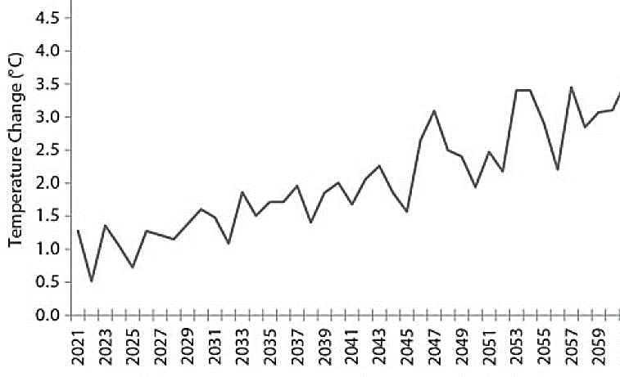
Figure 1. The annual outdoor mean air temperature of KSA changes from 2021 to 2059 (Almazroui et al., 2012).

The Saudi Arabia Energy Challenge and Government Response
Energy consumption per capita in Saudi Arabia is three times higher than the global average (SEEC, 2018). The residential sector is a significant contributor, accounting for about 50% of the total annual national energy consumption (SEEC, 2018). In 2016, Saudi Arabia established a new socio-political plan, entitled Vision 2030, to diversify the economy and mitigate energy usage, particularly in residential buildings. Saudi Arabia's Vision 2030 reforms call for pressure on the economy and the environment to improve energy consumption patterns (Abuhussain et al., 2019).

Saudi Building Code
In response to high energy consumption resulting from the fast-paced growth in the building sector, the government of KSA announced Royal Decree No.6927 in 2012 regarding building thermal insulation levels to improve their energy efficiency (Abuhussain et al., 2019). Furthermore, in 2013, the Saudi Standards, Metrology and Quality Organization distributed a new standard, known as standard No.2856/2014 Thermal Transmittance Values for Residential Buildings, based upon Saudi Building Code (SBC)-Chapter 602 (Energy Conservation Code, 2018). This standard (SBC) aimed to reduce the total electricity consumption by 30%–40% (Abuhussain et al., 2019) by controlling the maximum thermal transmission U-values for residential building envelope elements such as walls, roofs, and window glazing (Energy Conservation, 2018). The fabric U-value requirements are presented in Table 1. They proved to be useful and were made obligatory for all residential buildings in two stages (Code 1 and Code 2). Code 1 was applied to all residential buildings built after 2013, and then Code 2 was compulsory for all residential buildings built after January 2017. The code requires using insulation materials with low thermal conductivity, such as polystyrene and polyurethane, with a thickness of not less than 50 mm and a U-value of less than 0.25 W/m²K for external walls and roofs. Additionally, the U-value of windows should not exceed 2.5 W/m²K, with a solar heat gain coefficient (SHGC) of less than 50%. Moreover, the building should have an airtightness of better than 5.0 ac/h@50pa (Energy Conservation, 2018).

Table 1. U-values for Passivhaus standard and SBC
U-Value  (W/m²K) | Passivhaus standard (Europe) | Passivhaus standard in hot zone | Saudi building code
External Walls | 0.15 | 0.25 | 0.34
Roofs | 0.15 | 0.25 | 0.20
Windows | >0.80  SHGC->50% | 1.0-1.20  SHGC – 0.25 | 2.67  SHGC – 0.25
Air tightness (@ 50 Pa) | < 0.6 | < 0.6 | 5.0

Passivhaus house in Hot Regions
The concept of the Passivhaus standard emerged during the 1990s as a response to the ongoing energy situation that began in the 1970s when the Yom Kippur War and the Iranian Revolution disrupted global oil supplies. The Passivhaus concept was developed by a Swede, Bo Adamson, and a German, Wolfgang Feist. The standard is generally used in Germany, Netherlands, Austria, and North America. The building technique for these houses is based on well-insulated and airtight building envelope (Tyler et al., 2019).
There are several rules upon which a Passivhaus building should be based, with the five most important being: thermal insulation, free from thermal bridges design, airtightness, mechanical ventilation with heat recovery, and efficient windows (Dalbem et al., 2016). Furthermore, the building’s envelope must have a low thermal transmittance value (U-value) with the application of these rules (Dalbem et al., 2016). Overall, opaque building materials must be well insulated, with U-values not exceeding 0.15 W/m²K. An airtight building will provide good ventilation and temperature while preventing humidity loss. The acceptable airtightness cannot exceed 0.6 ac/h@50pa (Passivhaus Institute, n.d). Furthermore, the entire window (including the frame) must have a U-value of 0.80 W/m²K or less. In hot climates, higher U-values may be acceptable, and windows must have a U-value of no more than 0.85 W/m²K. In the cold zone, total solar transmittance (SHGC) must be at least 50% for a net heat gain to be likely in the winter. However, In hot climates, a lower SHGC may be enough (iPHA, n.d.).
Studies have indicated how effective the Passivhaus standard reduces energy consumption - in cold areas by up to 90 percent (Passivhaus trust 2012). However, the same energy reductions may not be achieved in regions with warmer climates (Schnieders et al. 2019). In countries with very hot climates, such as those prevalent in the Middle East, there is still a lack of research about the applicability of the Passivhaus standard. It is also apparent that these principles cannot simply be applied without adapting them to the different meteorological conditions present in these hot climates. However, these regions might use various passive cooling strategies, such as evaporative cooling, which could save between 30 and 40 percent of energy (Lechner and Andrasik, 2021). However, passive cooling with direct natural ventilation cannot be employed in buildings that need to be airtight, such as those that follow the principles of the Passivhaus standard.
Therefore, the development and expansion of Passivhaus principles for use in hot and dry climates to achieve higher performance needs more study. This would involve a direct implementation that might not realise the same level of effectiveness as in cold climates (Passivhaus Institute, n.d). Nevertheless, case studies in arid climates demonstrate that the implementation of Passivhaus principles can significantly reduce energy consumption. Some relevant examples are the Desert Passive House in Hereford, Arizona (PHIUS, 2020) and Qatar's Passivhaus buildings (Khalfan, 2019). In addition, there is a passive office building in Dubai (the Space Centre) located in an extremely hot and humid weather area (Sifferlen, 2017). The results of these case studies in Qatar and the UAE have shown impressive proof of how implementing a well-made building meeting Passivhaus requirements can substantially decrease the cooling energy load, which is the most significant source of energy consumption in houses in hot and dry regions.
The Qatar Passivhaus building shows that, by applying all the Passivhaus standards and strategies, the project had a mission to achieve a 50% decrease in annual energy use, water usage, and CO₂ emissions compared with the standard villa (Khalfan, 2019). However, the project cannot achieve the required energy consumption levels in the Passivhaus standard due to the high cooling loads and the lack of airtightness in the building. (Khalfan, 2019). Qatar and the UAE have very similar climates to parts of Saudi Arabia. Therefore, all of the Passivhaus design approaches utilised in these examples can be applied to a building in Saudi Arabia. Other lessons that can be learned from these cases concern the effectiveness of wall, roof, and floor insulation materials. The Passivhaus standard for hot climate zones states that the U-value for opaque surfaces should be 0.25 W/m²K, and for glazing surfaces it is 1.0-1.20 W/m²K with an SHGC value of <50% and with an airtightness <0.6 ac/h@50pa (Khalfan, 2019). Table 1 compares the thermal U-values required by the Passivhaus standard and SBC.

Methodology

Case Study
Makkah, one of the most significant cities in Saudi Arabia, is also one of the hottest and driest cities in the world. The average temperature in Makkah is excessively high, with peak temperatures exceeding 45°C during summer and winter temperatures reaching 30°C on average (see Figure 2). This location has been selected for the evaluation of the Passivhaus principle. To assess the effectiveness of the envelope for residential buildings, an existing building (villa) was selected as a case study, which is shown in Figure 3. The building was constructed to meet SBC in 2021. Although the local authority approved the SBC for this building, it could not meet the minimum U-values required by the Saudi Energy Conservation Code, as shown in Table 1. The U-values were reviewed according to the construction materials profile, and Table 2 shows the thermal properties of the building.

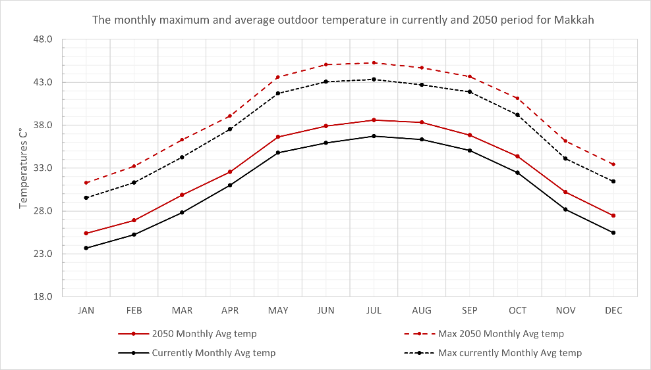
Figure 2. The monthly Max and Avg outdoor temperature over the current and 2050 period for Makkah

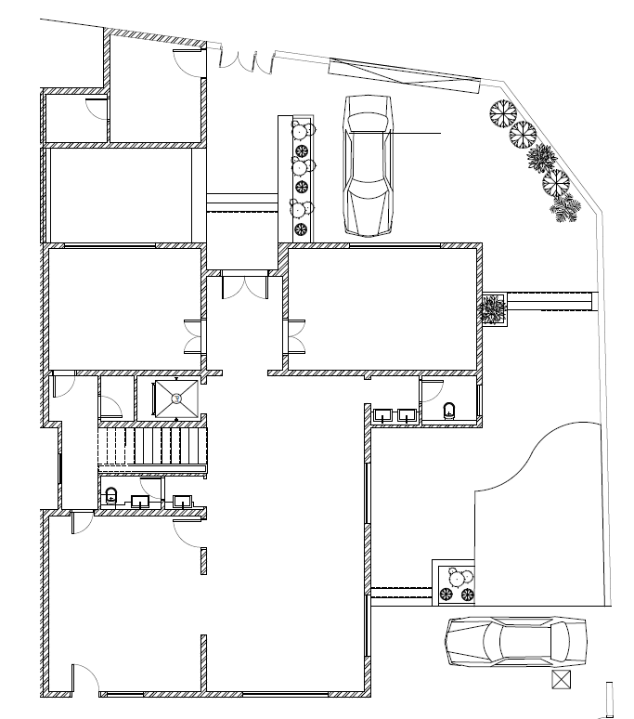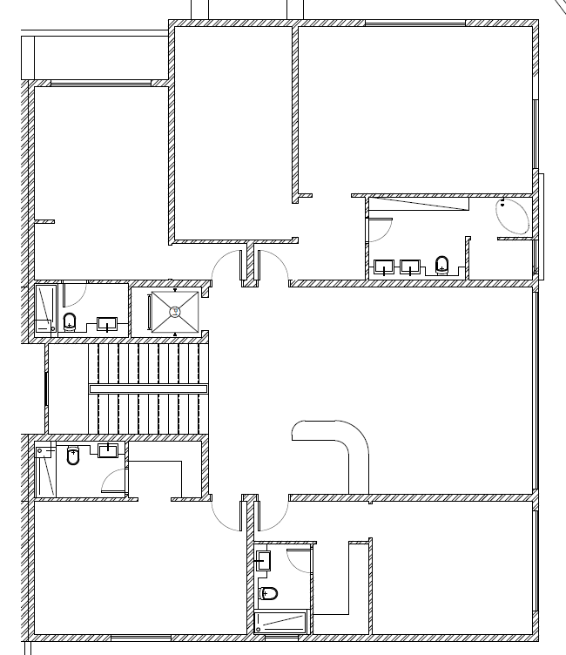
Figure 3. The SBC building under study
Table 2. Thermal properties of the SBC building
Elements | Construction | U-Value (W/m²K)
Total area | 528.55 m²
External walls | 0.02 m mortar + 0. 10 m concrete block + EPS Expanded Polystyrene 0.05 m + 0. 10 m concrete block + plaster 0.02 m | 0.478
Roofs | Terrazzo .025 m + Mortar 0.25 m + Concrete, cast - foam slag 0.5 m+ EPS Expanded Polystyrene (Standard) 0.07 m + Bitumen layers 0.02 m + Reinforced Concrete 0.20 m. | 0.427
Window glazing | 6mm/6mm Air gap double clear glazing | 3.157 / SHGC (0.7)
Occupancy | 0.0183 person/m2
Airtightness | 5.0 ac/h
HVAC system |  | Split no fresh air

Modelling
The DesignBuilder simulation software was used as the primary method of investigation to assess the performance of the residential building envelope for SBC and non-SBC in the context of current and future climate change. Using DesignBuilder simulation software, three-dimensional models of the building were created based on the architectural drawings. Based on actual site visits and surveys, the building's thermal properties, such as construction materials, cooling system types, lighting, and appliances, of the existing villa were applied and modelled in DesignBuilder with appropriate occupancy schedules and activity profiles.

Models’ calibration and simulations
Temperature and relative humidity data loggers (Rotronic HW4) were used to record the indoor temperature in each room in the SBC building, located at positions away from any direct heat sources. The monitoring process was carried out by distributing the devices inside the building to receive data from all orientations; North (Bedroom), East (Kitchen), South (Saloon), and West (Living room). In addition, a Kestrel 5700 data logger was fixed on the building roof to record the outdoor temperature. The device was sheltered from direct sun rays and rainfall. Figure 4 shows the equipment that was used for on-site measurements. The process of field measurements was divided into two periods. The first began in August 2021 and ended in November 2021, and the second started in December 2021 and ended in February 2022.
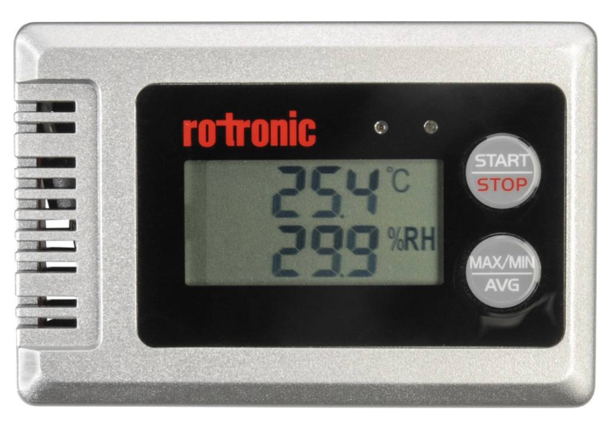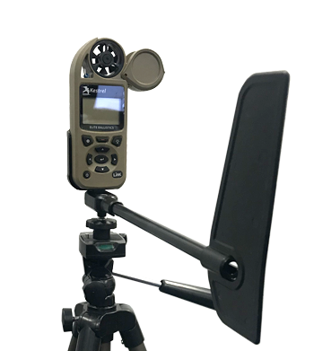
Figure 4. The measurement equipment used on site

Data collected during the monitoring were used for calibrating the DesignBuilder model. The average indoor operative temperature was determined by comparing the monitored indoor and outdoor temperatures at regular intervals of 15 minutes for a period of 7 days while the building was unoccupied, free running and not subjected to any additional electrical loads. In addition, the average indoor and outdoor temperatures were modelled and simulated using weather files obtained from the Meteonorm software and DesignBuilder. The calibration results showed that the difference in temperature between the simulated and measured temperatures was less than 4%. According to Taleb (2014), for a researcher to consider a model valid, the difference between simulated and measured results must be less than 5%. Royapoor and Roskilly (2015) propose that the ASHRAE 14 specification for the Mean Bias Error (MBE) to be +/-10% and Coefficient of Variation of the Root Mean Squared Error (CV_RMSE) be reduced from 30% to +/-5% and 20%, respectively when hourly annual data is available. This would bring the specifications in line with current industry standards. In situations where hourly data is not available, the ASHRAE 14 limits are a reasonable choice.
In addition, in order to guarantee the accuracy of the findings obtained from the annual simulation analysis, the setpoint temperature for the cooling system in the simulation models had been specified to be 25.5 ° C. This is stated in the Saudi Building Code 2017, Chapter 601: Energy Conservation. The Saudi building code stipulates two design temperatures for summer and winter in every climate and type of building, and for Makkah those temperatures are 25.5°C in the summer and 20°C in the winter (SBC, 2017). Moreover, the daily schedule of lighting, air conditioning, equipment, and occupant schedule was observed and obtained from previous monitoring and from the study by Monawar (2001), which depicts the behaviours of most Saudi Arabian residents inside buildings.

Meeting the Passivhaus requirement
This research aimed to find solutions that contribute to reducing the high cooling demand in the hot climate in Saudi Arabia. Consequently, the SBC model was developed and adjusted to meet the requirements of the Passivhaus standard U-values for the building envelope. In this case, U values were determined to be below the Passivhaus average for hot and dry climates and similar to the cold climate requirement to see if this helped decrease the thermal transfer for the building, effectively reducing cooling loads. A high-efficiency glass with a lower thermal U-value of 1.49 and a SHGC of 0.7 was applied. A higher level of airtightness than the SBC model, was modelled. To achieve a U-value of 0.15 or lower for the opaque surfaces, the thermal insulation thickness of the external walls and roofs in this model was increased to approximately three times that of the two models. See Table 3 for more details of the modelled building.

 | Table 3. Thermal properties of Passive model and SBC model U-Value
Elements |  | Construction | U-Value (W/m²K) | SBC U-Value (W/m²K)
External walls |  | 0.02 m mortar + 0. 15 m block concreate + XPS Extruded Polystyrene 0.2 m + 0. 10 m block concreate + plaster 0.02 m | 0.15 | 0.478
Roofs |  | Terrazzo .025 m + Mortar 0.25 m + Concrete, cast - foam slag 0.05 m + XPS Extruded Polystyrene 0.20 m + Bitumen layers 0.02 m + Concrete, Reinforced (with 2% steel) 0.20 m | 0.148 | 0.427
Window glazing |  | Dbl Elec Ref Coloured 6mm/13mm Arg | 1.491  (SHGC 0.144) | 3.157  SHGC (0.7)
Occupancy |  | 0.0183 person/m²
Airtightness |  | 0.3 ac/h (estimated) |  | 5.0 ac/h

Results and discussion
Figure 5 shows the monthly cooling energy consumption for the SBC model under the current and the future climate 2050 scenarios. It can be seen that the monthly cooling loads with the SBC model under the current climate increase from 11.2 kWh/m² in January to a peak cooling load of 38.6 kWh/m² in August. With the 2050 scenario, the cooling load increases from 14.6 kWh/m² in January to 50.2 kWh/m² in August. This means the cooling load will be increased in the future 2050 scenario by around 30% in both winter and summer.

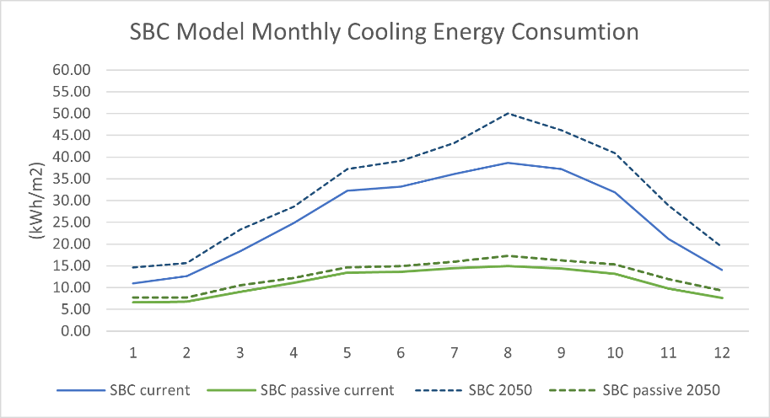
Figure 5. SBC Model Monthly Cooling Energy Consumption with retrofit to Passivhaus standard

Figure 5 also shows that the cooling load will be reduced by retrofitting the model to the Passivhaus standard. It can be clearly seen that the monthly cooling loads with the Passivhaus model under the current climate extend from 6.6 kWh/m² in January to a peak cooling load of 15.1 kWh/m² in August. With the 2050 scenario, the cooling load increases from 7.7 kWh/m² in January to 17.3 kWh/m² in August. The results shown in Figure 6 indicate that the cooling energy consumption reduces by around 56% annually after applying retrofitting measures. The total cooling loads will be 135.0 kWh/m² while the SBC model consume 311.4 kWh/m². Moreover, in 2050 scenario, the Passivhaus model's total consumption rises by 14% compared with the SBC model, which increases by 25%, an increase of approximately 75.9 kWh/m², while the total amount of cooling loads increases by about 19.0 kWh/m² with the Passivhaus model.
In addition, the simulation was rerun with shading activated. According to the findings, there was only a slight drop in Passivhaus model consumption, but that had no significant effect on the overall average. The Passivhaus model uses Double Electrochromic Reflective Coloured 6mm–13mm Arg glass. According to Aldawoud (2017), the energy performance of different types of glass varies. The results show that the Absorbent Double Electrochromic Coloured glass has the best energy performance of all the glazing systems examined, with the potential to save up to 60% when compared to single-glazed energy performance. Furthermore, glass with a gap width of 13 mm is preferable than glass with a gap width of 3 mm or 6 mm. Compared to the energy performance of a single glass, reflective low-E glass reduces energy transmission by 37% (Aldawoud, 2017). Moreover, Argon gas-filled glazing performs better than other types of gases, with a reduction potential of roughly 33%. Low solar heat gain coefficients and low U-value glass, according to Aldawoud (2017), are most effective in reducing the amount of heat entering the building. As a result, the shading has a small effect on the overall performance. On the other hand, the SBC model shows the reduced cooling demand in the annual total by more than 3000 kWh/m².
In general, meeting the Passivhaus standard requirements for the building envelope has significantly contributed to a reduction in the total amount of cooling required, as is clearly apparent compared to the current condition of the SBC building. The simulation results showed that the Passivhaus model was more effective than the SBC building for facing the challenges of climate change in the future. However, the retrofit model cannot meet the energy consumption requirement of the Passivhaus standard, which is 120 kWh/m² for total energy use, including domestic hot water, heating, cooling, auxiliary, and household electricity (International Passive House Association | The Difference, 2022). This suggests that more development of the building envelope needs to be investigated for further solutions to meet energy performance requirements.

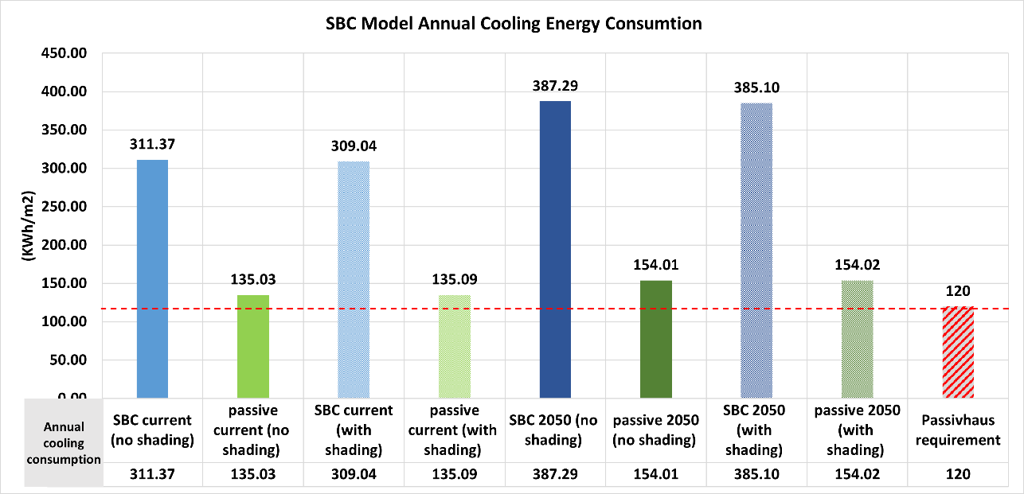
Figure 6. SBC Model’s Annual Cooling Energy Consumption with Passivhaus standard retrofit

Conclusion
This study aimed to find a suitable solution for reducing energy consumption in the arid climates that characterise most Saudi regions. Studies have shown that climate change is an undisputed fact and results from the increase in greenhouse gas levels, which currently stand at 50% over those in 1990. Alongside many other countries, KSA is facing the challenges of climate change due to its high dependence on fossil fuels. KSA is considered the most significant fossil fuel consumer in the Middle East. The building sector is responsible for more than 50% of the total energy consumed in KSA, and cooling loads account for about 70% of this total energy consumption (Alshenaifi, 2015, p. 72). According to the Statistics Authority (2017), the population growth rate will rise by approximately 32% over the next 15 years. This means the country will face a serious problem due to increased energy demands by 2032 unless immediate, sustainable solutions are implemented (Abuhussain et al., 2019). Therefore, the KSA government aims to implement strategies to address increased energy usage and find potential solutions for sustainable and renewable sources of energy under the 2030 Vision. The SBC has been developed as a solution to reduce energy use in residential buildings. Although the SBC had the expectation of reducing energy consumption by up to 40%, it has not achieved the optimum level of reduction. Meanwhile, the Passivhaus standard has successfully reduced total building energy consumption by up to 80% in Europe. This study also aimed to investigate how the SBC performs under current climate conditions and in future climate change scenarios. The DesignBuilder software was used primarily as a simulation and investigation tool to evaluate the efficiency of the SBC for residential buildings. The findings indicate that the existing SBC model requirements will not be able to significantly resolve the impact of global warming in the future, as cooling is a major concern due to the harsh weather conditions in KSA.
The emphasis of this research was on developing a building envelope for the SBC model to meet the requirements of the Passivhaus standard by increasing the thermal insulation proportion for both external walls and roofs to achieve a U-value of <0.15 W/m²K. The type of glass used in building openings was also improved, considering the conditions needed to withstand warm and harsh climatic conditions; the type used has an SGHC of <0.5. By applying the Passivhaus requirements to the SBC model, a 57% reduction in the cooling demand was achieved. The total energy consumption of the Passivhaus model amounted to 135 kWh/m² per year, compared to 311.3 kWh/m² for the SBC model. The Passivhaus principles could, therefore, reduce the effects of potential climate change. However, an increase in demand for cooling energy due to climate change in the future was observed at around 14%. Also, more investigative and passive strategies that are not included in this study, such as shading devices, green roofs, and some architectural solutions, could help to reduce energy consumption further, in order to reduce the effects of future climate challenges and carbon dioxide emissions.
A limitation of this study is that it has focussed just on the envelope insulation and airtightness criteria set by SBC and Passivhaus. Other approaches to reducing enegy demand, such as the impact of increased thermal mass, or the use of natural ventilation instead of air conditioning for cooler periods of the year, have not been considered. Despite the potential of low energy natural ventilation, all recent buildings in Saudi Arabia are basically designed to be artificially cooled on a 24 hours a day, 7 day a week basis, to provide indoor thermal comfort (Alshaikh, 2016), which makes designing the building envelope to be thermally efficient all the more important.

References
Abuhussain, M.A., Chow, D.H.C. and Sharples, S. (2019). Sensitivity energy analysis for the Saudi residential buildings envelope codes under future climate change scenarios: the case for the hot and humid region in Jeddah. IOP Conference Series: Earth and Environmental Science, 329, p.012039
Al-Ahmadi, K. and Al-Ahmadi, S., 2013. Rainfall-Altitude Relationship in Saudi Arabia. Advances in Meteorology, 2013, pp.1-14.
Aldawoud, A. (2017). Assessing the energy performance of modern glass facade systems. MATEC Web of Conferences, 120, p.08001.
Almazroui, M. (2013). Simulation of present and future climate of Saudi Arabia using a regional climate model (PRECIS). International Journal of Climatology, 33(9), pp.2247–2259.
Alshaikh, Abdulrahman. 2016. “Design Principles for Thermally Comfortable and Low Energy Homes in the Extreme Hot-Humid Climatic Gulf Region, with reference to Dammam, Saudi Arabia.” PhD Thesis, Heriot-Watt University. Available at: https://www.researchgate.net/publication/328306951_Designing_Comfortable_Low_Carbon_Homes_in_Dammam_Saudi_Arabia_The_Roles_of_Buildings_and_Behaviours.
Alshenaifi, Mohammad. 2015. “High Performance Homes in Saudi Arabia Revised Passivhaus Principles for Hot and Arid Climates.” MA Thesis, The Faculty of Philadelphia University. 4-9 Available at: https://www.researchgate.net/publication/313887851_High_Performance_Homes_in_Saudi_Arabia_Revised_Passivhaus_Principles_for_Hot_and_Arid_Climates.
Eia.gov,. (2015). Saudi Arabia - U.S. Energy Information Administration (EIA). Retrieved 21 April 2015, from http://www.eia.gov/countries/country-data.cfm?fips=SA#cde
iPHA (n.d.). International Passive House Association | Guidelines. [online] passivehouse-international.org. Available at: https://passivehouse-international.org/index.php?page_id=80.
Khalfan, M. (2019) Lessons Learned from the First Passivhaus Building in Qatar. International Journal of Environ-mental Science & Sustainable Development 4 no.3 (2019): 77-92, https://doi.org/10.21625/essd.v4i3.678.
Lechner, N. and Andrasik, P. (2021) (Heating, Cooling, Lighting: Sustainable Design Strategies Towards Net Zero Architecture, 5th Edition, John Wiley & Sons, Inc.
Meteoblue (2020). Climate Makkah Al Mukarramah. [online] Meteoblue. Available at: [Accessed 31 Aug. 2020]. https://www.meteoblue.com/en/weather/historyclimate/climatemodelled/makkah-al-mukarramah_saudi-arabia_104515.
Monawar, A.H. “A Study of Energy Conservation in the Existing Apartment Buildings in Makkah Region , Saudi Arabia,” PhD Thesis, Sch. Archit. Plan. Landscape, Univ. Newcastle upon Tyne, United Kingdom., 2001 Passive House Institute (n.d). “Passive House requirements.”. Accessed Apr 30,2020, https://passiv.de/en/02_informations/02_passive-house-requirements/02_passive-house-requirements.htm.
Passive House Institute (n.d). “Passive House requirements.”. Accessed Apr 30,2020, https://passiv.de/en/02_informations/02_passive-house-requirements/02_passive-house-requirements.htm.
Passivehouse-international.org. 2022. International Passive House Association | The Difference. [online] Available at: <https://passivehouse-international.org/index.php?page_id=238> [Accessed 29 May 2022].
Passivhaustrust. 2012 “Passivhaus - an Introduction.” Accessed Mar 12,2020. https://passivhaustrust.org.uk/UserFiles/File/PH%20Intro%20Guide%20update%202013.pdf.
PHIUS (2020). Passive House Institute US. ‘’The Desert Passive House’’. Accessed Apr 30,2020, https://www.phius.org/projects/1154.
Royapoor, M. and Roskilly, T. (2015). Building model calibration using energy and environmental data. Energy and Buildings, 94, pp.109-120.
Saudi Energy Conservation Code. 2018, Saudi Building Code National Committee, Riyadh, KSA
Schnieders, Jürgen, Tim Delhey Eian, Marco Filippi, Javier Florez, Berthold Kaufmann, Stefanos Pallantzas, Monte Paulsen, Elena Reyes, Micheel Wassouf, and Shih-Chieh Yeh. “Design and Realisation of the Passive House Concept in Different Climate Zones.” Energy Efficiency, (2019). https://doi.org/10.1007/s12053-019-09819-6.
SEEC. “BUILDINGS | Saudi Energy Efficiency Centre.” Accessed Mar 12,2020, https://seec.gov.sa/en/blog/buildings.
Taleb, H.M “Using passive cooling strategies to improve thermal performance and reduce energy consumption of residential buildings in U. A. E. buildings,” Front. Archit. Res., vol. 3, no. 2, pp. 154–165, 2014.The Presidency of Meteorology and Environment (PME) in Saudi Arabia. 2018a. “Climate Report for Madinah in the Hajj of 2018.” https://www.pme.gov.sa/Ar/DataLists/DocumentLibrary/Climate Reports/Madinah-12-1438.pdf.
The Presidency of Meteorology and Environment (PME) in Saudi Arabia. 2018a. “Climate Report for Madinah in the Hajj of 2018.” https://www.pme.gov.sa/Ar/DataLists//DocumentLibrary/Climate Reports/Madinah-12-1438.pdf.
Tyler, Z., Walker, S., Woundy, M. and Manning, S. (2019). Passive House Literature Review. [online] NMR Group, pp.2,3. [Accessed 20 May 2022]. Available at: https://ma-eeac.org/wp-content/uploads/MA19R05_PassiveHouse_LitReview_Final_2019.07.17.pdf
United Nation Development Programme (2020). Goal 13: Climate Action | UNDP in Saudi Arabia. [online] [Accessed 19 May. 2022]. UNDP. https://www.sa.undp.org/content/saudi_arabia/en/home/sustainable-development-goals/goal-13-climate-action.html

