The Effect of Climatic Background on Users’ Thermal Comfort in University Buildings

Zehra Nur Disci, Steve Sharples and Ranald Lawrence
School of Architecture, University of Liverpool, Liverpool, UK
Abstract
Long-term memory may influence people's thermal experience and expectations of their environment. Educational buildings, such as university libraries, are places where people from different cultural and climatic backgrounds come together. However, it is questionable whether the comfort standards and environmental management of these buildings offer equal comfort conditions to people from different climatic backgrounds. To explore this issue, a longitudinal study investigated the effect of cultural and climatic backgrounds on the thermal perception of users of the Sydney Jones Library at the University of Liverpool. Dataloggers in a study area recorded environmental factors such as temperature and relative humidity. Simultaneously, library users participated in an online survey that sort to understand factors affecting user thermal comfort and their views on the environmental conditions of the space. Statistical analysis of winter-time results from the survey suggested that the thermal perceptions and expectations of users varied depending on their different climatic backgrounds. In addition, the mechanical ventilation and cooling system in the study area negatively impacted upon the thermal comfort of users, while also causing unnecessary heat and energy losses. The average temperature of the study area was measured as 19°C. Although the recommended winter comfort temperature for computer rooms in CIBSE Guide A is 19-21°C, this temperature was found to be slightly cool for the majority of respondents.
Keywords: Thermal comfort, Climatic background, Education buildings, Comfort temperature
1. Introduction
According to a Carbon Trust report (2007), energy consumption in the UK’s Further and Higher Education buildings was 62% for space heating (fossil fuels), 1% for space heating (electricity) and 1% for cooling and ventilation (electricity). If the energy consumed for heating educational buildings is high, but the building users feel uncomfortably cold, then that indicates a problem with the provided services. The important thing is to meet the expectations of the users whilst consuming less energy. Today, educational buildings, such as university libraries, are typically places where people from many different cultural and climatic backgrounds come together. However, it questionable whether the comfort standards and environmental management of these buildings, which are usually based on UK comfort criteria, offer equal comfort conditions to people from different climatic backgrounds. Since thermal environmental conditions affect the productivity and attendance of students, as well as their comfort and health (Mendell and Heath 2005, Wang et al. 2018), the thermal environments of university buildings are expected to provide students with as comfortable conditions as possible.
However, people can be comfortable in different situations (Nicol et al., 2012). ASHRAE Standard 55 and EN ISO 7730:2005 define thermal comfort as “a condition of mind which expresses satisfaction with the thermal environment”. There are various environmental and individual factors that affect this mental state. In previous studies, these factors were discussed in detail under headings such as environmental (Olgyay,1992; De Dear and Brager,2002; Auliciems and Szokolay,2007); personal (De Dear and Brager,2002, Auliciems and Szokolay,2007) and contributing factors (Auliciems and Szokolay,2007). However, Parson (2003) mentioned the effect of cultural and climatic background on thermal comfort, which is also the subject of this study. In later studies, it was mentioned that the experiences of people living in different climatic regions were different (Nicol et al., 2012).
On the other hand, the temperature perception and experience of a person living in an air-conditioned building is different from people living in naturally ventilated buildings (Cândido et al., 2010). In the study conducted by Dear and Auliciems (1988), the fact that people who previously lived in naturally ventilated buildings preferred natural ventilation, while people who lived in air-conditioned environments preferred air conditioning, showed the effect of the climatic background. However, the intensive use of cooling systems in summer months reduces the adaptation of people to environmental conditions and their tolerance to temperature changes (Indraganti 2010). In addition, the fact that people who are accustomed to controlling the ambient temperature are in an environment beyond their control causes them to feel more vulnerable (Dear and Auliciems, 1988).
Knez et al. (2009) mentioned that long-term memory affects people's thermal experiences of and expectations from the environment, and they revealed that long-term thermal comfort memory varies according to the thermal history of people from different regions. In addition, Wang et al. (2017) showed that long-term thermal history has an impact on people's thermal comfort. Jowkar et al. (2020) researched the effect of long-term history and climatic background on thermal comfort in their study of students who had been in the UK for less than 3 years. According to this study, while the ideal acceptable temperature was 24°C for those coming from a hot climate zone, it was 22°C for those coming from a cold climate zone (i.e. a climate zone similar to that of the UK).
In this context, existing or newly designed educational buildings should be designed or renovated in accordance with multinational occupancy. In order to do this, it is necessary to better understand the impact of cultural and climatic background on thermal comfort. Therefore, this research aimed to investigate the effect of cultural and climatic backgrounds of users on thermal perception in buildings with multinational occupancy.
2. Methodology
This case study, which included an online survey and measurement of environmental data, was carried out in a study area of the Sydney Jones library at the University of Liverpool in Liverpool, England (Figure 1). Data were collected between 30th January 2022 and 31st March 2022. According to the University of Liverpool’s on site weather station data, the average air temperature in Liverpool was 7°C during the 2-month period when the study was conducted. All data were collected in the computer room located on the ground floor of the library. One of the most important features of this area is that it consists of two sections with natural ventilation and mechanical ventilation. The plan of the case study area is shown in Figure 2. While underfloor heating and mechanical ventilation are carried out in the area called section 1, radiators on the wall for heating and windows for natural ventilation are used in section 2. Since the heating and cooling of the library is remotely controlled, the current data determined for the computer room were obtained from University Facilities Management staff. According to this information, ventilation, heating and cooling systems operate 24/7, 365 days a year. Especially during the Covid period, the ventilation system worked at full capacity and without bypass, by direct transmission of fresh air by heating or cooling.
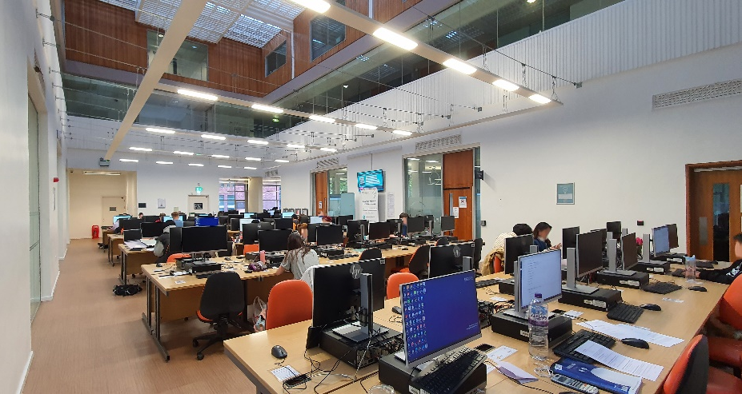
Figure 1. Case study area
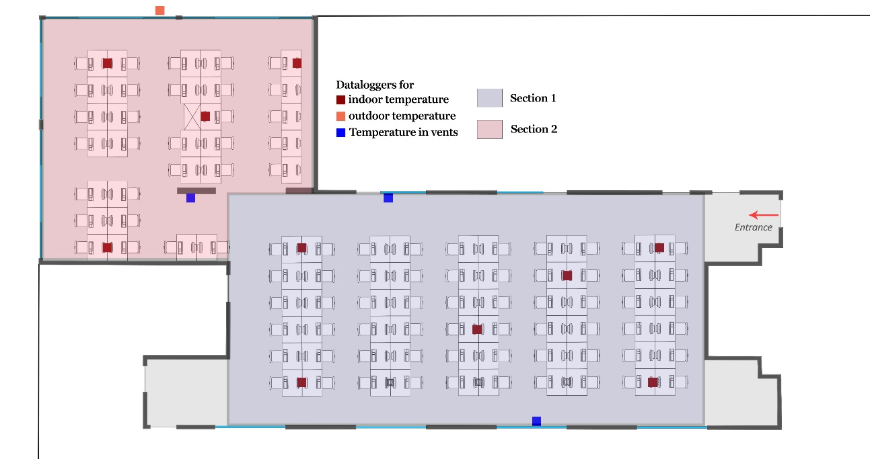
Figure 2. Plan of case study area
EasyLog EL-SIE-2+ dataloggers were set to measure the air temperature and relative humidity of the environment at 15-minute intervals and were placed on some tables in the area. In addition, a Lascar EL-GFX-2 datalogger was placed in a shaded location outside the library to measure the outdoor air temperature. To understand whether the ventilation was working, and to measure the temperature of the air coming from the ventilation, an iButton and a Kestrel DROP D2 datalogger were placed on the ventilation units. In addition, a Testo 405 thermal anemometer was used to manually measure the air velocity in the environment. Apart from these measurements, the weather data measured at 10-minute intervals was also collected monthly from the University’s weather station, which is 300 metres away from the case study area.
Having obtained University ethical approval, an online survey was prepared, containing questions to understand the climatic history of the users and their thoughts on the thermal conditions of their environment. A 7-point scale was used to understand the thermal sensation and thermal preferences of the participants. To reduce contact during the Covid period, posters containing QR codes created a link to the survey and were placed on all desks in the case study area. The participants were asked to record their desk numbers in the area where they participated in the survey and in this way the indoor temperature data at the time they participated in the survey were obtained from the datalogger closest to the area they were in. A total of 135 people participated in the survey. All the data obtained afterwards were analysed using the IBM® SPSS® program (IBM®, 2022).

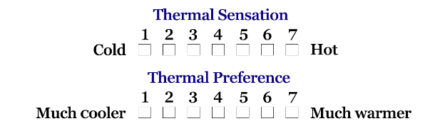
Figure 3. Thermal sensation and thermal preference scale
3. Results
Students from 24 different nationalities participated in the survey. Students were divided into three groups - warmer, similar and cooler backgrounds - and the results were analysed accordingly. As seen in Figure 4, the percentage of people who grew up in the UK and other countries with a similar climate was 63%, while the percentage of those who grew up in countries with climates warmer and cooler than the UK were 31.9% and 5.2%, respectively. In this study, 58% of the participants identified as female, 41% as male and 1% as non-binary. In addition, 60% of the participants were British students, and 40% were international students.
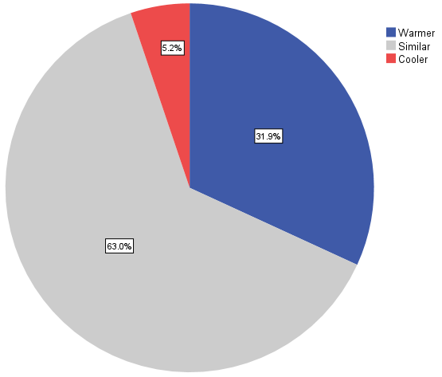
Figure 4. Percentage of climatic backgrounds of respondents
Figure 5 shows the mean indoor and outdoor temperatures when the students participated in the survey between 30th January 2022 and 31st March 2022. The minimum outdoor temperature was 4.5°C, while the maximum value was 16.9°C. The minimum and maximum values of the indoor temperatures were 18. 4°C and 23.0°C respectively. Figure 6 shows the comparison of the indoor temperature with the temperature coming from the ventilation system. In CIBSE Guide A (2015), the comfort temperature specified for computer rooms in winter is 19-21°C, while the comfort temperature specified for library reading rooms is 22-23°C. Although the area where the study was carried out is the library, 19-21°C will be considered for the comfort temperature, since computer use is intense. The indoor temperature was mostly within the specified comfort zone. However, the air temperature from the ventilation supply was below the comfort temperature. In addition, from the comments of the participants at the end of the survey, it was seen that they felt that the air conditioning was on and working in the environment and, therefore, the air was cold.
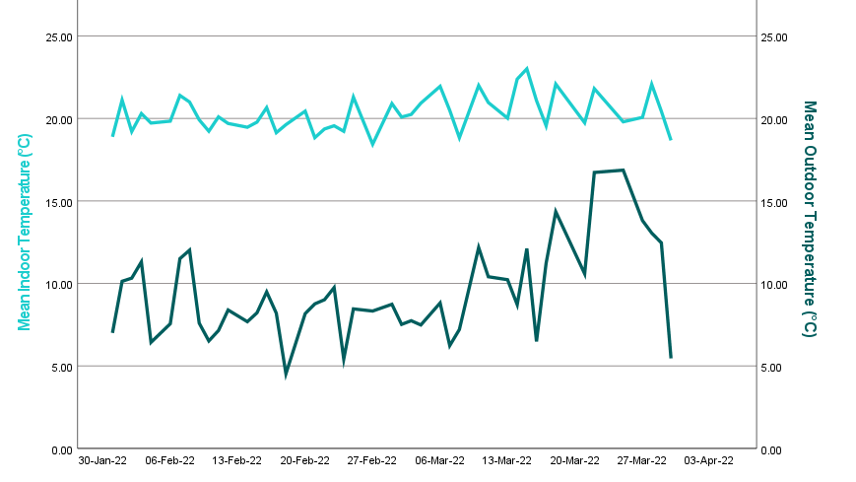
Figure 5. Mean indoor and outdoor temperatures during the survey
The engineering and contract support manager of the University stated that the fresh air is tempered at 20°C within the ductwork and then distributed to the room through the ceiling grills. He also stated that the fan coil unit tries to keep the room temperature at 21°C ± 2°C by performing both cooling and heating.
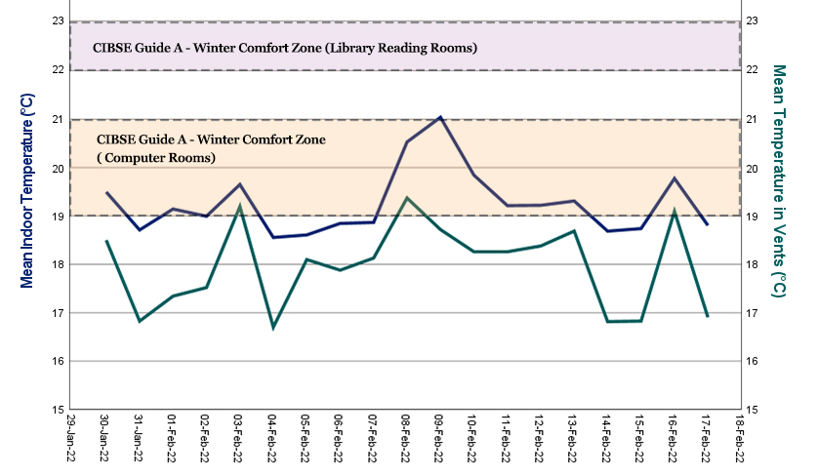
Figure 6. Mean indoor temperature and temperature in vents
Participants were asked to evaluate the air movement in the environment and their responses are compared in Figure 7. Although each group had different percentages within itself, the overall result shows that the majority of students felt 'insufficient' air movement in the environment. Although the mechanical ventilation system worked at full capacity for 24 hours a day at full speed, and constantly provided fresh air to the environment, it is seen that the students found this situation unsatisfactory. The ventilation system may have been found to be insufficient since the windows were closed during the winter months and there was no ventilation in that part of the computer room.
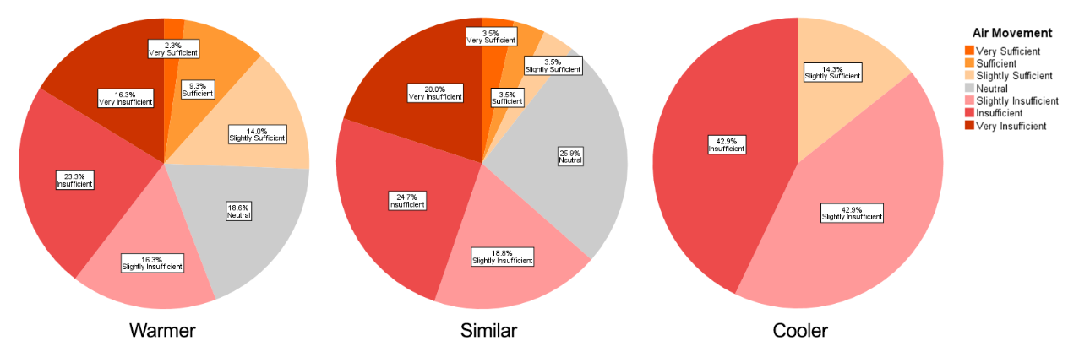
Figure 7. Air movement votes by climatic backgrounds
Figure 8 shows a comparison of the clothing insulation (clo) values of the participants. The mean value for students from a similar background was 1.2clo, while it was 1.4clo for students from a warmer background and 1.7clo for students from a cooler background. While the minimum value is 0.3clo for students from a similar background, it is 0.6clo for the other two groups. The clo value of students from a warmer and cooler background is higher than that of the students from a similar background. The reason for this situation is thought to be cultural differences. International students from 23 different nationalities have different climatic and cultural backgrounds, which may explain why they have different clothing levels.
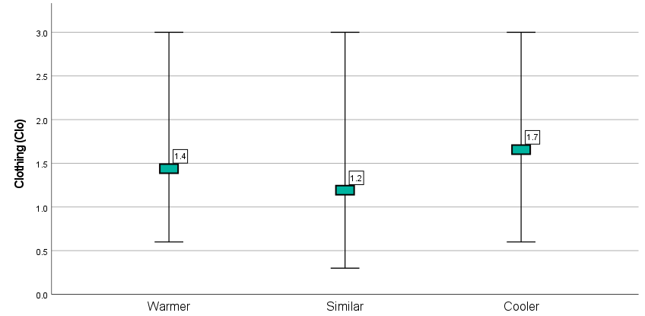
Figure 8. Clothing insulation value by climatic backgrounds
Predicted Mean Vote (PMV) is an index that predicts the mean response from a group of people scoring on a seven-point thermal comfort sensation scale. The CBE Thermal Comfort Tool (Tartarini et al., 2020) was used to calculate PMV for this study. Figure 9 shows the comparison of PMV sensation and thermal sensation by climatic backgrounds. For students from a warmer background, the highest percentage of thermal sensation was ‘neutral’ and ‘slightly cool’ with 23.3 percent, while the percentage of PMV sensation was ‘slightly cool’ at 44.2 percent. Looking at the thermal sensation chart, students from a similar background mostly feel ‘slightly cool’ with 28.2 percent, while it is seen that they should feel ‘neutral’ with 41.2 percent in the PMV sensation chart. For students from a cooler background, the highest percentage of thermal sensation was ‘slightly cool’, at 57.1 percent, while the percentage of PMV sensation was ‘neutral’ at 71.4 percent. It is thought that the difference in PMV values between the three groups was due to the difference in the clo value. As a result, the majority of the students in the three groups felt ‘slightly cool’ in terms of thermal sensation, but when the PMV sensation values are assessed, the students from a warmer background felt ‘slightly cool’, while those in the other two groups felt ‘neutral’. Figure 10 shows the comparison of thermal preference by climatic backgrounds. The students from a warmer background wanted to feel ‘warmer’, while those in the other two groups wanted to feel ‘slightly warmer’. Looking at Figure 9 and Figure 10, the relationship between thermal sensation and preference can be seen. Students who evaluated the environment as ‘slightly cool’ in general wanted it to be a ‘slightly warmer’.
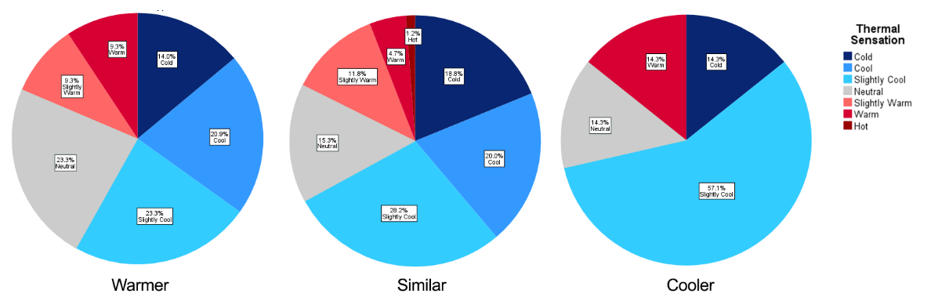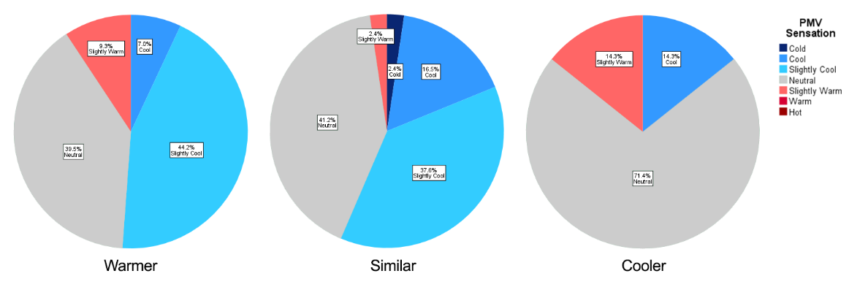
Figure 9. Thermal sensation and PMV sensation by climatic backgrounds
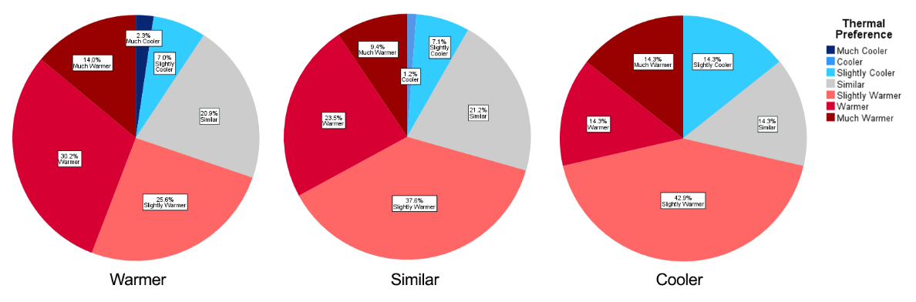
Figure 10. Thermal preference by climatic backgrounds
The overall thermal comfort comparison is given in Figure 11. The majority of students from a warmer background felt ‘comfortable’, while the majority of students from a similar background felt ‘slightly uncomfortable’ and the majority of students from a colder background felt ‘slightly comfortable’ and ‘neutral’.
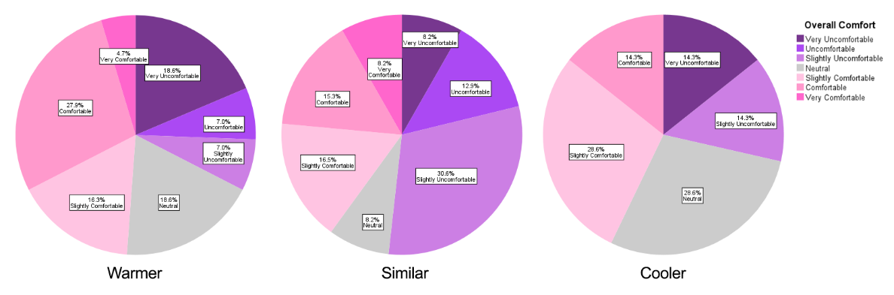
Figure 11. Thermal comfort by climatic backgrounds
4. Discussion and Conclusion
It is known that air temperature, ventilation, thermal sensation and level of clothing affect the overall thermal comfort of building users. In addition, other physical and psychological variables also affect comfort. When looking at the effect of cultural and climatic background on comfort examined in this study, the results of thermal sensation and thermal preference in the same environment were similar, while the thermal comfort results were different for students from three different climatic backgrounds. It is thought that this situation is due to the level of clothing. It has been observed that students from warmer and cooler backgrounds wore more clothes than students from a similar background in order to adapt to cultural influences or environmental conditions. However, this situation did not change the thermal sensation of the students about the environment, and the majority of the students in all three groups stated that the environment was slightly cool. Despite the fact that the mechanical ventilation system was working 24/7 at full capacity due to Covid, it is thought that the users' feeling that the ventilation was insufficient was due to the lack of natural ventilation. In addition, it is predicted that users' past experiences and habits regarding environmental control systems also affect their expectations (Auliciems, 1981).
According to HESA data (HESA, 2020), the University of Liverpool was ranked 10th among 131 universities in total energy consumption for the sector in 2019/20. The cooling of ventilation air during winter months for the library space investigated in this study is not an efficient use of energy and also does not consider the different comfort requirements of students from a range of cultural and climatic backgrounds. It is predicted that if the temperature the incoming air from the ventilation system was increased, the cold air effect felt by the students would decrease, and the heating energy required to balance the ambient temperature would also decrease. Such a situation could contribute to a reduction of energy consumption for the University of Liverpool as well as providing a more comfortable environment for students.
A limitation of this work is that the longitudinal study was only carried out using winter data collected between 30th January 2022 and 31st March 2022. It is planned to consider summer data in future studies.

Acknowledgements
The authors would like to thank the Turkish government and the Republic of Turkey Ministry of National Education for supporting this study.
References
Auliciems, A., 1981. Towards a psycho-physiological model of thermal perception. Int J Biometeorol 25, 109–122 https://doi.org/10.1007/BF02184458
Auliciems, A. and Szokolay, S., 2007. THERMAL COMFORT. 10.1243/PIME_CONF_1967_182_147_02.
ASHRAE Standard 55 2013. Thermal Environmental Conditions for Human Occupancy, American Society of Heating, Refrigerating and Air-Conditioning Engineers, Atlanta.
Cândido, C., de Dear, R.J., Lamberts, R. and Bittencourt, C., 2010. Cooling exposure in hot humid climates: Are occupants ‘addicted’?
Carbon Trust, 2007. Further and Higher Education: Training colleges and universities to be energy efficient.
Chartered Institution of Building Services Engineers (CIBSE), 2015. Guide A – Environmental Design, (with 2021 updates) London: CIBSE.
de Dear, R. and Auliciems, A., 1988. Air conditioning in Australia - II - User attitudes, Architectural Science Review 31, 19–27.
de Dear, R.J. and Brager, G.S., 2002. Thermal comfort in naturally ventilated buildings: Revisions to ASHRAE Standard 55. Energy and Buildings 34(6), 549–61.
HESA, 2020. Energy by HE provider and academic year, available at https://www.hesa.ac.uk/data-and-analysis/estates/table-2 (accessed May 2022)
IBM®, 2022. https://www.ibm.com/uk-en/products/spss-statistics
Indraganti, M., 2010. Behavioural adaptation and the use of environmental controls in summer for thermal comfort in apartments in India. Energy and Buildings 42 1019–25.
ISO 7730, 2005. Ergonomics of the Thermal Environment: Analytical determination and interpretation of thermal comfort using calculation of the PMV and PPD indices and local thermal comfort criteria. Geneva: International Standards Organisation.
Jowkar, M., de Dear, R. and Brusey, J., 2020. Influence of long-term thermal history on thermal comfort and preference. Energy and Buildings, 210, p.109685.
Knez, I., Thorsson, S., Eliasson, I., Lindberg, F., 2009. Psychological mechanisms in outdoor place and weather assessment: towards a conceptual model. Int J Biometeorol 53(1):101–111
Mendell, M. J., and Heath, G. A. 2005. Do indoor pollutants and thermal conditions in schools influence student performance? A critical review of the literature. Indoor air, 15(1), 27–52. https://doi.org/10.1111/j.1600-0668.2004.00320.x
Nicol, F., Humphreys, M. A. and Roaf, S., 2012. Adaptive Thermal Comfort: Principles and Practice. Routledge.
Olgyay, V., 1992. Design with Climate: bioclimatic approach to architectural regionalism. New York.
Parsons, K., 2003. Human thermal environments: The effects of hot, moderate, and cold environments on human health, comfort, and performance. Second edition.
Tartarini, F., Schiavon, S., Cheung, T., Hoyt, T., 2020. CBE Thermal Comfort Tool: online tool for thermal comfort calculations and visualizations. SoftwareX 12, 100563. https://doi.org/10.1016/j.softx.2020.100563
Wang, Y., de Groot, R., Bakker, F., Wörtche, H. J., and Leemans, R., 2017. Thermal comfort in urban green spaces: a survey on a Dutch university campus. International Journal of Biometeorology, 61(1), 87-101. https://doi.org/10.1007/s00484-016-1193-0
Wang, D., Xu, Y., Wang, Y., & Jiang, J., Wang, X., & Liu, J., 2018. Experimental investigation of the effect of indoor air temperature on students' learning performance under the summer conditions in China. Building and Environment. 140. 10.1016/j.buildenv.2018.05.022.

