Embodied Carbon Viability of Prefabricated Retrofit Modules for Passivhaus-EnerPHit Standard – a Case Study in Istanbul, Turkey

Dilek Arslan1, Haniyeh Mohammadpourkarbasi1 and Steve Sharples1

1 University of Liverpool, UK, Dilek.Arslan@liverpool.ac.uk

**Abstract:** The building sector has yet to take drastic steps to lower its carbon emissions to meet net-zero emissions targets by 2050. Although various methods exist to design new buildings with low operational carbon impacts, this is not always true for existing buildings. Improving the operational energy performance of an existing building is difficult, and reducing the overall refurbishment times for existing occupied buildings is challenging. Therefore, prefabrication methods for retrofitting were investigated in this research. The feasibility of using prefabricated retrofit modules that meet the rigorous Passivhaus-EnerPHit standard in Turkey’s warm-temperate climate was explored. An existing residential building in Istanbul was modelled in the thermal simulation software DesignBuilder, and calibrated against on-site measurements. The impact on operational energy performance of applying prefabricated retrofit modules to the digital twin was then tested. Carbon emissions related to the production phase of the modules were assessed using OneClick LCA software. Multiple material replacement scenarios were applied to the prefabricated modules to find the optimum solution with low embodied carbon impact. The results showed that, although the prefabricated retrofit modules were successful in decreasing operational energy and carbon, they were not viable in terms of the cost of the modules in the Turkish context.

**Keywords:** Prefabrication, Retrofit, EnerPHit, Embodied Carbon

# Introduction

Around the world, buildings are responsible for about 30% of the carbon emissions and 40% of energy demand (International Energy Agency, 2019). In Turkey, buildings account for about 40% of energy demand (Republic of Turkey Ministry of Climate and Urbanization, 2018) and one-third of direct and indirect carbon emissions (Climate Transparency, 2021). Hence, buildings offer a significant opportunity for decreasing energy demand and carbon emissions. Acknowledging the Paris Agreement, Turkey established her commitment to climate change in 2021. However, a five-year delay in commitment brings the need for more drastic measures to achieve the carbon reduction targets. Although various regulations have been introduced for new buildings to lower energy demand (Republic of Turkey Ministry of Environment and Urbanization, 2011; TS 825:2008, 2008), there are limited options to improve the existing building stock’s Energy Performance Certificates (EPCs). EPCs are helpful in showing the performance of a building; however, they do not force any steps to achieve a good rate in existing buildings. Further, countries pledged to the Paris Agreement will soon be presenting their carbon reductions. Therefore, to be on track, Turkey needs an approach to the energy renovation of existing buildings (Climate Transparency, 2021; Climateactiontracker.org, 2022).

For existing buildings, the options are either deconstructing and rebuilding or retrofitting. Existing studies have demonstrated that deconstructing and reconstructing a building is not a viable option in terms of energy used and carbon released during the construction and production of the new materials (Langston et al., 2018; Marique and Rossi, 2018; Cheshire and Burton, 2020). Also, during the deconstruction and rebuild time, the occupants of the buildings need to move from the building, which is not convenient for them (Rovers et al., 2018). It can, therefore, be concluded that energy retrofitting the envelope of the building is a more suitable way of tackling the carbon emissions from the existing building stock. Also, it requires less time and materials compared to rebuilding. However, occupant disturbance is still an issue, and retrofit duration might be affected by factors such supply chain problems and weather conditions.

A more recent approach to retrofit, using prefabricated retrofit modules (PRM), can compensate for the negative aspects of the traditional retrofit methods. Prefabrication can significantly decrease the retrofit duration, reduce occupant disturbance during installation and is not as affected by adverse weather conditions. PRMs have gained popularity within the European Union, as evidenced in Horizon 2020-EeB-2015 (EU-H2020) projects. There are extensive examples of PRMs in the European context that present a variety of approaches. For instance, while one of the projects uses construction demolition waste (CDW) materials for non-structural façade elements, Re4 (2016) and VEEP (Veep–project, 2016), others use nanotechnology materials like aerogels, SESBE (n.d.) and GELCLAD (n.d.) or focus on building system management in the buildings retrofitted with prefab modules, such as iNSPiRE (2016). Besides bringing new methods and innovations to retrofit, EU-H2020 projects are also effective at decreasing the operational energy demand (energy needed for heating, cooling, domestic hot water, and equipment) by 85% compared to existing buildings and providing a thermally comfortable environment for the occupants (Rovers et al, 2018).

Unlike the numerous studies on operational energy demand and indoor comfort involving PRMs, there are fewer investigations of the embodied carbon of PRMs (Almeida et al., 2020). The embodied carbon (EC) of a material represents the carbon released during the raw material extraction, its transport to the factory, and production (Almeida et al., 2020). EC is often addressed as a hidden impact in building performance evaluations. Until recently, the focus for buildings was on decreasing the operational energy demand rather than the EC. However, recent literature shows that the EC impact could be higher than the operational impact (Zhu et al., 2020; Rodrigo et al., 2019; Koezjakov, 2017). Therefore, in this study, the aim is to show the EC viability of PRMs over their operational carbon savings and examine the feasibility of using the modules in Turkey’s climate as a methodology to accelerate the country’s climate change mitigation actions.

Another limit of existing PRM approaches is aiming for Net-Zero in operational performance, which may differ from country to country based on their energy mixes and availability of sustainable energy sources. Therefore, PRM needs to ensure the energy performance in existing buildings, specifically in a climate or country context. Energy standards like Passivhaus (PH) can robustly secure how the building will perform after being constructed or renovated. PH is a voluntary energy concept that allows up to 15 kWh/m²/a for heating and cooling demand and 120 kWh/m²/a in total primary energy consumption. Passivhaus has a 'fabric first’ approach to reduce operational energy demand, meaning that the building envelope should be airtight and well insulated with a low level of U-value (0.15 W/m²K or less). PH also provides a standard for retrofit projects, called EnerPHit. For retrofitted buildings to meet the EnerPHit standard, the maximum heating demand is climate-related, ranging from 15 kWh/m²/a (very hot climates), to 20 kWh/m²/a (warm temperate climates) and upto 35 kWh/m²/a (Artic climates). The retrofit cooling energy demand limit is the same for all climates at 15 kWh/m²/a, with the primary energy demand being limited to 120 kWh/m²/a. The EnerPHit concept gives importance to thermal comfort in the retrofitted buildings by keeping the overheating below 10% all year round without active cooling and/or adequately adjusted cooling device (Pomponi et al., 2018; Passive House Institute, 2022). Additionally, EnerPHit buildings give freedom to the occupants to adjust the heating and cooling levels in each room however they feel comfortable (Passive House Institute, 2022). Therefore, this paper will investigate the life cycle carbon payback time of applying the Passivhaus-EnerPHit energy criteria to the PRMs.

# Methodology

## Case Study

In Turkey and Istanbul, due to rapid urbanisation, almost half of the existing buildings were built in the 1990s (Konukcu et al., 2016). Hence, a mid-rise apartment block in Istanbul was selected as a case study building. The building represents the common construction practices in the 1990s (Figure 1). It has five floors above ground with penthouses on the top floor and one basement. The building is used just for residential purposes; 10 families live in the building, with the total occupied area of the building being 1015 m², and each floor is 2.8m in height. The structure is a concrete frame with concrete slabs, and the external skin is a 200mm uninsulated brick wall. Heating, cooling, and domestic hot water (DHW) in the building are provided by gas boilers installed in each flat. Only three families have air conditioners (AC) installed in one of their rooms to meet their cooling needs.

Figure 1: Case study building, Credit: Dilek Arslan, 2021

## Building Energy Simulation and Model Calibration

The apartment block was modelled in a building energy simulation software, DesignBuilder (DB), by using architectural drawings. Then, three months (October, November, and December 2021) of temperature and relative humidity (RH) data were collected from one of the flats at the basement in the building. The data collected from the master bedroom, one bedroom, living room, and kitchen were used to validate the DB model according to the American Society of Heating, Refrigerating, and Air-Conditioning Engineers (ASHRAE) requirements. According to the ASHRAE standard, for the model to be valid, the Mean Bias Error (MBE) should be at 10% or below and the Coefficient of Variation of the Root Mean Squared Error CV(RMSE) at 30% or below (ASHRAE Guideline 14 -2014).

In the initial simulations, the MBEs between measured and simulated room temperatures and RH were 11% and -7% for the Master Bedroom, 8% and -19% for the bedroom, 6% and -9% for the living room, and 10% and -15% for the kitchen, respectively. To further lower the error percentages in temperature and RH, different types of iteration parameters were applied as suggested in the literature, such as changing the infiltration rate on building façades, indoor ventilation rate, occupation factors, and temperature setpoints (Chung et al., 2021; Abrahams et al., 2019; Sun et al., 2016). While indoor ventilation rate and occupation factors were not helpful, the façade infiltration rate in the DB Construction tab and temperature setpoints in the Activity tab significantly impacted the error percentages.

After multiple iterations applied in infiltration and temperature setpoints, the MBEs between measured and simulated room temperatures and RH improved to be 10% and 7% for the Master bedroom, 6% and 2%for the Bedroom, 8% and 9% for the Living room, and 10% and 6% for the Kitchen, respectively, which comply with the ASHRAE MBE threshold.

## Retrofit Applications

PRMs were designed according to the International Energy Agency (IEA) ECBCS-Annex 50 Guideline (2011) from inside to outside. The guideline requires one equalising layer, a sheathing board, a façade structure with insulation (where all of the ducting and wiring are placed), vapour proofing, a sheathing board, and a second layer of insulation and cladding (Figure 2). Materials selected for the modules were decided according to the most common construction materials used in Turkey (Ikbal and Cetiner, 2013; Kurekci, 2016) and layer thicknesses based on the EnerPHit U-value for opaque façade areas (0.30-0.50 W/m²K, for warm-temperate climates). Based on the thermal requirements, the second insulation layer in the IEA guideline became redundant for this project. In the final stage, the PRM build-up layers were one equalising layer, sheathing board (OSB), insulation (XPS), vapour proofing (polythene), sheathing board (OSB), and finishing (cement board) (Figure 3).

Figure 2: IEA prefabricated retrofit module construction principles (IEA, 2011)

After designing the PRM, the modules were applied to the building façade (walls and roof), a ventilation unit with heat recovery was added, which is a requirement for Passivhaus designs, and boilers were left in the building to avoid carbon emissions related to installing a new system into the building. Further, basement walls, ground floor, and cantilever floors were insulated. The infiltration rate of building skin improved to 1 ac/h@50 Pa due to Passivhaus-EnerPHit requirements for airtightness. Double glazed PVC windows in the existing building were replaced with triple glazed PVC windows with UW = 0.75 W/m2 K frame and Ug = 0.70 W/m2 K glazing values.

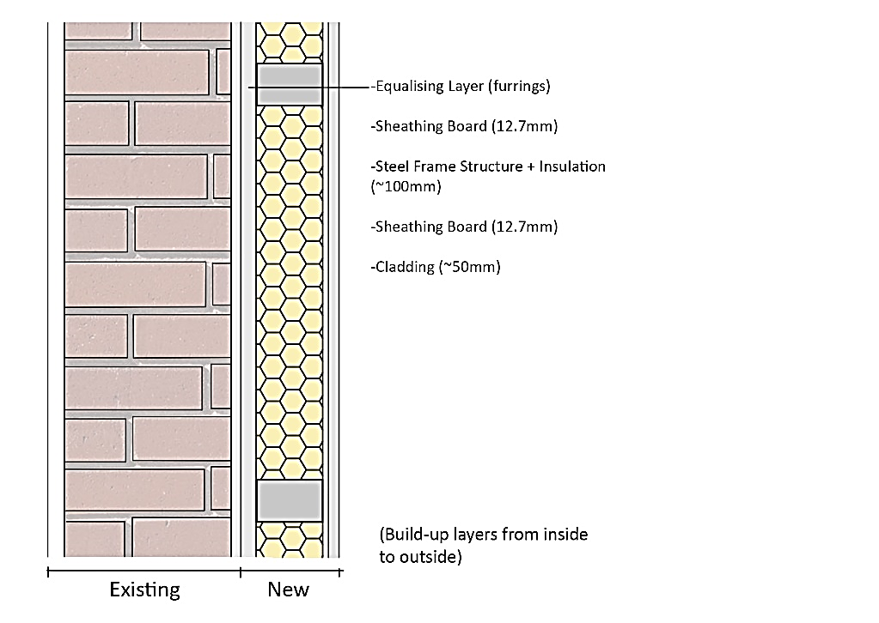

Figure 3: Retrofit layers for 0.30 W/m²K U-value.

## Embodied Carbon Calculations

Embodied carbon calculations were conducted via a web tool, One Click LCA, which brings a wide range of material carbon data from the databases around the world, such as EPD Norge (n.d.), EPD International (n.d.), INIES (n.d.) and IBU (2020). The software categorises the material profiles as manufacturer, local, regional and generic data. The priority is to select the available manufacturer and local data; however, if it is not available, then regional or generic data by using the localisation factor should be selected depending on the country's carbon assessment (OneClick LCA, n.d.).

Material profiles were selected according to the thermal and physical properties' input in the DB model, and the quantities subjected to meeting the EnerPHit standard were also inserted into One Click LCA. After creating the base case, material replacement scenarios were adapted by replacing sheathing board materials with plasterboard, plywood, and MDF and replacing the insulation with EPS, rock wool, and glass wool in PRMs. These scenarios are presented in Table 1.

## Cost Calculations

Material quantities used for carbon assessment were also used for cost calculations. The unit prices of each material were taken from the Construction Unit Prices 2021 report of the Republic of Turkey Ministry of Environment, Urbanisation and Climate Change (Republic of Turkey Ministry of Environment, Urbanisation and Climate Change, 2021). The price of each material also included its assembly and labour costs. When a material or an equipment's prices was not available (e.g. ventilation unit), the manufacturers' prices were used.

# Results and Discussion

## Operational Carbon

Retrofit improvements on the building façade with PRM made significant reductions in the total operational energy demand of the building by 50%. While existing building heating energy demand was 130 kWh/m²/pa, PRMs helped to reduce it to 65 kWh/m²/pa with the best-case scenario for the external façade thermal properties for warm- temperate climate, 0.30 W/m²K U-value. This reduction in energy constitutes about a 35% decrease in operational carbon emissions compared to the existing emissions. Reduction in heating energy demand was the main contributor to the carbon reduction of the building, with 82% of the total energy consumption. This reduction highlights the importance of operational energy reduction in carbon savings, even though the gas currently has a lower carbon intensity than the electricity in countries like Turkey (Gursoy Haksevenler et al., 2020; Turkish Ministry of Energy and Natural Resources, 2021). DHW and equipment demands remain the same since no retrofit strategy were applied. However, even though the consumptions were the same in these categories, the transition to cleaner energy in Turkey shows that DHW and equipment electricity impact can be lowered by about 40% when renewable energies such as sun and wind are applied to the grid in the future (Republic of Turkey Ministry of Energy and Natural Resources, 2021).

The other retrofit scenarios' operational energy and carbon impact had similar results to the base-case retrofit scenario. This was due to selecting similar materials regarding thermal conductivity and density when replacing the material. Thereof they show similar operational performances in DB. Then, the same retrofit scenarios were applied with the components with a 0.50 W/m²K U-value since EnerPHit requirements allow that. The increase in the U-value of the components also slightly increased the operational energy by 6%. This was due to the slight increase in heating demand in the retrofit scenarios regarding reducing the insulating material thicknesses (Table 1).

Table 1: Total Operational Energy Demand Comparison Between Existing and Retrofitted Building.



## Embodied Carbon and Carbon Payback Times

The embodied carbon of the prefab modules with a 0.30 W/m²K U-value in the base-retrofit scenario was 89 kgCO2e/m². The main contribution of the materials' impact was the OSB sheathing, triple glazed PVC windows and XPS insulation with 39%, 16% and 15% of the total emissions, respectively. The *Sheathing Board Replacement – MDF* scenario, with 60 kgCO2e/m², had the lowest impact since the carbon contribution from the sheathing boards decreased from 35 tCO2e/m² to 6 kgCO2e/m². The highest embodied carbon belonged to the *Insulation Replacement - EPS* scenario with 94 kgCO2e/m² because of the rising impact figure in the insulation material section from 14 tCO2e/m² to 19 tCO2e/m² while other embodied impact figures stayed the same in other material layers (Figure 4). In the options with 0.50 W/m²K U-value, the highest and the lowest impact scenarios remained the same but with different emission figures of course.

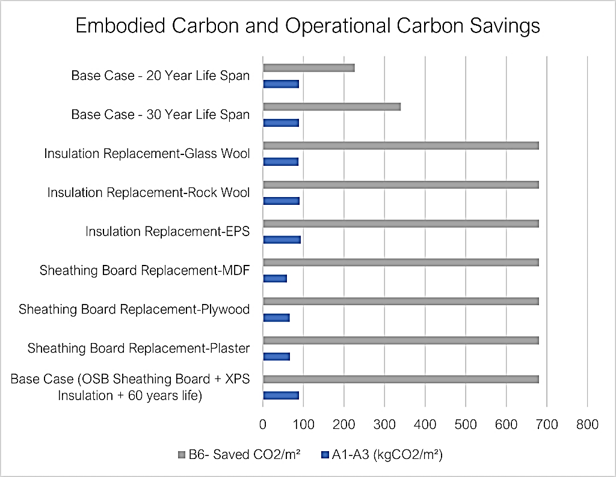

Figure 4: Embodied and operational carbon impacts of the retrofit scenarios

When the carbon saved from the improved operational energy performance was compared to the embodied carbon of the materials used, the results showed that the PRMs could be a viable option for the retrofit projects compared to business-as-usual models. The carbon payback times of the PRMs were not that different among the retrofit scenarios, which ranged between three and five years (Tables 2 and 3).

Table 2: Operational and Embodied Carbon Impact of the PRMs and Carbon Payback Times of Each Scenario for **0.30 W/m²K** U-value.



Table 3: Operational and Embodied Carbon Impact of the PRMs and Carbon Payback Times of Each Scenario for **0.50 W/m²K** U-value.



## Cost Results and Payback Times

The cost calculation results show that while the *Sheathing Board Replacement – Plywood* was the most expensive, the *Sheathing Board Replacement – MDF* was the cheapest option among the other retrofit scenarios. The difference between the cheapest and the most costly option was about 26%. Further, the capital cost of *Insulation Replacement – EPS* was also quite close to *Sheathing Board Replacement – MDF* option. Therefore, a small iteration took place to explore the EPS + MDF as a cost-optimal scenario. It has been seen that 5% embodied carbon reduction can be achieved with the EPS + MDF than the cheapest option in existing scenarios (*Sheathing Board Replacement – MDF).*

Although the new iteration enabled a cost reduction, the payback time of the PRMs was not that attractive for the homeowners. Tables 4 and 5 show the shortest payback time, with the *Cost Optimum* scenario in both components with U-values of 0.30 and 0.50 W/m²K of 47 and 53 years, respectively. These long payback times may be due to the current electricity unit prices, which are more expensive than gas.

Increasing the building’s airtightness was not helpful for summer conditions in the retrofitted building in this project. While high infiltrations were useful for building cooling, the building needed mechanical cooling and ventilation to decrease overheating, increase thermal comfort, and meet the EnerPHit standard. This increases the reliance on the electrical energy demand and, therefore, the operational cost.

Table 4: Existing and Retrofitted Cost of the Building Operation and Materials and Cost Payback Times of Each Scenario for **0.30 W/m²K** U-value.



Table 5: Existing and Retrofitted Cost of the Building Operation and Materials and Cost Payback Times of Each Scenario for **0.50 W/m²K** U-value.



# Conclusion

## Summary

This study showed that significant energy savings with PRMs for an EnerPHit building in a warm-temperate climates are possible. In addition, it has been highlighted that the carbon payback time of this retrofit approach and materials selected for the Turkish context makes the PRMs a viable option in climate change mitigation strategies. Moreover, it is possible to achieve lower embodied impacts and more thermal comfort by retrofitting to the EnerPHit standard. However, the cost side of the modules hinders the PRM approach as a climate change strategy due to the long payback time. High cost brings the need for a funding scheme for retrofit projects supported by the government to lower the payback time. Otherwise, although the PRM approach significantly reduces operational energy demand, such capital investment in improving a 30-year-old concrete building might not be sensible as a retrofit over its operational cost savings.

## Limitations and Recommendations

This study's main limitation is finding an Environmental Product Declaration (EPD) relevant to the Turkish context in the OneClick LCA database. Even though sometimes there was material information for Turkey, it was not suitable for the analysis in terms of not matching the thermal conductivity and density features of the materials in energy simulation. This situation prompts the tool user to select materials from other countries or regions that affect the reliability of the results and increase the contingencies.

Recommendations for a further study would be applying these modules to actual buildings to analyse the limitations and issues faced during the production, transportation, and assembly processes of the PRMs, then monitoring the thermal comfort and energy consumption in the retrofitted building. Additionally, surveys can be conducted with the occupants of the building, asking about their experiences and requirements and conducting interviews with the professionals involved in this process to understand the approaches and willingness to this kind of retrofit as another feasibility study. Lastly, comparing how much the thermal comfort criteria suggested in EnerPHit performance complies with the Turkish occupants’ thermal comfort expectations could be an interesting insight into the Passivhaus standard in warmer climates and different cultural backgrounds.

# Acknowledgements

This PhD project is funded by the Republic of Turkey Ministry of Education Study Abroad Program, including tuition fees and student expenses.

# References

Abrahams, P., André, P., Lang, M. and Falzone, C., 2019. Method For Building Model Calibration Based Upon On-Site Temperature Data To Simulate Overheating Risk In A Passive House In Summer. *Building Simulation Conference proceedings*.

Almeida, M., Barbosa, R. and Malheiro, R., 2020. Effect of Embodied Energy on Cost-Effectiveness of a Prefabricated Modular Solution on Renovation Scenarios in Social Housing in Porto, Portugal. *Sustainability*, 12(4), p.1631.

ASHRAE Guideline 14 - 2014, 2014. *Measurement of Energy, Demand, and Water Savings*. [online] ASHRAE. Available at: <https://www.cibse.org/knowledge/knowledge-items/detail?id=a0q2000000911EDAAY> [Accessed 26 May 2022].

Cheshire, D. and Burton, M., 2020. *The carbon and business case for choosing refurbishment over new build | Without Limits*. [online] Without Limits. Available at: <https://aecom.com/without-limits/article/refurbishment-vs-new-build-the-carbon-and-business-case/> [Accessed 31 May 2022].

Chong, A., Gu, Y. and Jia, H., 2021. Calibrating building energy simulation models: A review of the basics to guide future work. *Energy and Buildings*, 253, p.111533.

Climateactiontracker.org. 2022. *Turkey*. [online] Available at: <https://climateactiontracker.org/countries/turkey/> [Accessed 26 May 2022].

Climate Transparency, 2021. *Turkey|Climate Transparency Report: Comparing G20 Climate Action Towards Net Zero*. [online] Available at: <https://www.climate-transparency.org/wp-content/uploads/2021/10/CT2021Turkey.pdf#page=12> [Accessed 26 May 2022].

Environdec.com. n.d. *EPD International*. [online] Available at: <https://www.environdec.com/home> [Accessed 31 May 2022].

EPD Norge. n.d. *EPD Norge - Forsiden*. [online] Available at: <https://www.epd-norge.no/?lang=no_NO> [Accessed 31 May 2022].

Gelclad.eu. n.d. *Gelclad*. [online] Available at: <https://www.gelclad.eu/> [Accessed 31 May 2022].

Gursoy Haksevenler, B., Celik Onat, G., Akpinar, B. and Bedel, T., 2020. Yerel Yönetimler İçin Karbon Ayak İzinin Belirlenmesi: Ümraniye Belediyesi Örneği. *Doğal Afetler ve Çevre Dergisi*, pp.319-333.

IBU - Institut Bauen und Umwelt e.V. 2020. *Institut Bauen und Umwelt e.V. | Das Detail im Fokus.Das Ganze im Blick.*. [online] Available at: <https://ibu-epd.com/> [Accessed 31 May 2022].

Cetiner, I. and Ceylan, N., 2013. Environmental consequences of rehabilitation of residential buildings in Turkey: A case study of Istanbul. *Building and Environment*, 69, pp.149-159.

Inies. n.d. *Inies, les données environnementales et sanitaires de référence pour le bâtiment et la RE2020*. [online] Available at: <https://www.inies.fr/> [Accessed 31 May 2022].

iNSPiRe. 2016. *Home*. [online] Available at: <https://inspire-fp7.eu/> [Accessed 31 May 2022].

International Energy Agency, 2019. *2019 global status report for buildings and construction: Towards a zero-emission, efficient and resilient buildings and construction sector*. [online] Available at: <https://iea.blob.core.windows.net/assets/3da9daf9-ef75-4a37-b3da-a09224e299dc/2019_Global_Status_Report_for_Buildings_and_Construction.pdf> [Accessed 26 May 2022].

International Energy Agency, 2011. *IEA ECBCS Annex 50 Prefabricated Systems for Low Energy Renovation of Residential Buildings | Retrofit Strategies Design Guied*. [online] Available at: <https://www.iea-ebc.org/Data/publications/EBC_Annex_50_Retrofit_Strategies_Design_Guide.pdf> [Accessed 26 May 2022].

Koezjakov, A., 2017. *The Effect of an Increase in Energy Efficiency on Embodied Energy use: A Scenario Analysis for Dutch Residential Buildings*. Master. Utrecht University.

Konukcu, B., Karaman, H. and Şahin, M., 2016. Determination of building age for Istanbul buildings to be used for the earthquake damage analysis according to structural codes by using aerial and satellite images in GIS. *Natural Hazards*, 85(3), pp.1811-1834.

Kurekci, N., 2016. Determination of optimum insulation thickness for building walls by using heating and cooling degree-day values of all Turkey’s provincial centers. *Energy and Buildings*, 118, pp.197-213.

Langston, C., Chan, E. and Yung, E., 2018. Hybrid Input-Output Analysis of Embodied Carbon and Construction Cost Differences between New-Build and Refurbished Projects. *Sustainability*, 10(9), p.3229.

Marique, A. and Rossi, B., 2018. Cradle-to-grave life-cycle assessment within the built environment: Comparison between the refurbishment and the complete reconstruction of an office building in Belgium. *Journal of Environmental Management*, 224, pp.396-405.

One Click LCA. n.d. *Using EPDs for Building LCA: a guide to Environmental Product Declarations in LCA*. [online] Available at: <https://www.oneclicklca.com/epds-for-building-lca/> [Accessed 26 May 2022].

Passive House Institute, 2022. *Criteria for the Passive House, EnerPHit and PHI Low Energy Building Standards, version 10b*. [online] Darmstadt: Passive House Institute. Available at: [www.passivehouse.com](http://www.passivehouse.com) [Accessed 26 May 2022].

Pomponi, F., De Wolf, C. and Moncaster, A., 2018. *Embodied Carbon in Buildings Measurement, Management, and Mitigation*. [ebook] Available at: <https://link.springer.com/content/pdf/10.1007/978-3-319-72796-7.pdf> [Accessed 26 May 2022].

Re4.eu. 2016. *Home | re4.eu*. [online] Available at: <http://www.re4.eu/home> [Accessed 31 May 2022].

Republic of Turkey Ministry of Energy and Natural Resources, 2021. *Turkey National Electrical Network Emission Factor Information Form*. Ankara: Turkish Ministry of Energy and Natural Resources.

Republic of Turkey Ministry of Environment and Urbanisation, 2018. *Turkish Building Sector Energy Efficiency Technology Atlas Executive Summary and Roadmap*. [online] Ankara. Available at: <https://www.giz.de/de/downloads/giz2019-en-turkish-building-sector.pdf> [Accessed 26 May 2022].

Republic of Turkey Ministry of Environment, Urbanisation and Climate Change, 2021. *Construction Unit Prices and Installations*. [online] Ankara: Ministry of Environment, Urbanisation and Climate Change. Available at: <https://webdosya.csb.gov.tr/db/yfk/icerikler//bf-2021-ingilizce-20210809122118.pdf> [Accessed 22 May 2022].

Republic of Turkey Ministry of Environment and Urbanization (a), 2011. *National Climate Change Action Plan 2011-2023.* Ankara, Turkey. [online] Available at: <https://www.preventionweb.net/files/29675_turkeynationalclimatechangeactionpl.pdf> [Accessed 11 April 2021].

Rodrigo, M., Perera, S., Senaratne, S. and Jin, X., 2019. Embodied Carbon Mitigation Strategies in the Construction Industry. In: *CIB World Building Congress*.

Rover, R., 2018. *A Guide into Renovation Package Concepts for Mass Retrofit of Different Types of Buildings With Prefabricated Elements for nZEB Performance*. [ebook] Available at: <http://file:///C:/Users/ASUS/Downloads/AGUIDEINTORENOVATIONPACKAGECONCEPTSFORMASSRETROFITOFDIFFERENTTYPESOFBUILDINGSWITHPREFABRICATEDELEMENTSFORNZEBPERFORMANCE.pdf> [Accessed 26 May 2022].

TS 825:2008, 2008. *Binalarda Isi Yalitim Kurallari*. Ankara, Turkey: TSI. [online] Available at: < <http://www1.mmo.org.tr/resimler/dosya_ekler/cf3e258fbdf3eb7_ek.pdf> [Accessed 11 April 2021].

Sesbe.eu. n.d. *SESBE – Smart Elements for Sustainable building Envelopes*. [online] Available at: <https://www.sesbe.eu/> [Accessed 31 May 2022].

Sun, K., Hong, T., Taylor-Lange, S. and Piette, M., 2016. A pattern-based automated approach to building energy model calibration. *Applied Energy*, 165, pp.214-224.

Veep-project | Horizon 2020 research | No: 723582. 2016. *Veep-project | Horizon 2020 research | No: 723582*. [online] Available at: <http://www.veep-project.eu/home.aspx> [Accessed 31 May 2022].

Zhu, W., Feng, W., Li, X. and Zhang, Z., 2020. Analysis of the embodied carbon dioxide in the building sector: A case of China. *Journal of Cleaner Production*, 269, p.122438.