Transient absorption spectroscopic studies of linear polymeric photocatalysts for solar fuel generation

Chao Li,ª Alexander J. Cowan^{a,b} and Adrian M. Gardner^{a,b}*
AFFILIATIONS
ªStephenson Institute for Renewable Energy and The Department of Chemistry, University of Liverpool, Liverpool L69 7ZD, United Kingdom
^{b}Early Career Laser Laboratory, University of Liverpool, Liverpool L69 3BX, United Kingdom

Author to whom correspondence should be addressed: Adrian.Gardner@liverpool.ac.uk
ABSTRACT
Organic polymer photocatalysts have garnered much interest in recent years, notably because of their photocatalytic activity towards hydrogen production from water. However, to rationalise the differences in activities between photocatalyst it is crucial that their photodynamics are understood. Here we provide an accessible introduction to the use of transient ultraviolet/visible absorption spectroscopy to study the photodynamics of linear polymeric photocatalysts through a review of literature studies. The principles of transient absorption (TA) spectroscopy, and the apparatus required, is briefly described. A step-by-step method to identify key species and unravel their kinetics is provided through exemplar spectra reported within the literature. This review provides the foundations for researchers new to the field of TA spectroscopy to design, perform and interpret their own TA experiments to probe the photodynamics of organic photocatalysts.

Ⅰ. INTRODUCTION
Currently the world relies on fossil fuels for the supply of energy which has detrimental environmental and economic impacts. Therefore, alternative ways to use renewable energy resources are being urgently sought. Solar is one of the most abundant energy resources available on earth and nearly half of the solar energy incident on the Earth’s surface comes from visible light photons (400–700 nm).¹ Consequently, the efficient capture and conversion of the visible part of the solar spectrum by photocatalysts is being widely sought. Photocatalysts absorb solar energy and use this to form new chemical products, notably high energy density fuels. Inorganic semiconductors were first reported to decompose water under illumination and produce hydrogen around 50 years ago by Fujishima and Honda.² Following these first studies a wide range of inorganic photocatalysts have been reported, however, to date, none have achieved suggested performance requirements (e.g. 10% solar to hydrogen with low cost materials) over prolonged periods (months to years). Compared with inorganic photocatalysts, organic photocatalysts offer several advantages such as readily tunable optical gaps, synthetic control over structure, good processability, and preparation from earth-abundant materials.^{3,4} Poly(p-phenylene) was first identified as being active for photocatalytic proton reduction in 1985,⁵ but there were relatively few subsequent studies on organic photocatalysts immediately following this pivotal study. There has been a renewed interest in organic materials for solar fuel production since the report of the photocatalytic activity of graphitic carbon nitride (g-C₃N₄) type materials in 2009 for hydrogen evolution under visible-light irradiation.⁶ Wide, and expanding, classes of organic materials are now known for photocatalytic hydrogen production and complete water splitting, including covalent triazine-based frameworks (CTFs),^{7–9} covalent organic frameworks (COFs),^{10–12} linear conjugated polymers, conjugated microporous polymers (CMPs)^{13,14} and noncovalent supramolecular assembly of small organic molecules.^{15,16}
To realise the benefits of synthetic tunability it is necessary to understand how structural modifications change the photophysical and catalytic properties of the materials being developed. In 2019, an important review by Tang and colleagues highlighted the challenges facing the polymer photocatalysis community, notably the comparative lack of understanding of the photophysics of polymer photocatalysts.¹⁷ On the basis of studies of related organic photovoltaic materials, and from the emerging mechanistic studies on polymeric materials for solar fuels production, a general mechanistic framework has been proposed, but the understanding of the factors controlling individual steps is still at a relatively early stage.^{18–20} For many polymer photocatalysts, photon absorption typically leads to generation of Frenkel excitons. In contrast to initially photogenerated species in inorganic semiconductors which separate rapidly, in organic polymer materials these are tightly bound owing to the low electric permittivity of the polymer, with binding energies of hundreds of meV up to ~1 eV reported.²¹ In some cases, absorption of high energy photons results in the generation of suitably energetic hot excitonic states,²² enabling rapid exciton separation on the picosecond timescale. More commonly it is proposed that exciton separation involves diffusion to a suitable site, such as an interface between two different polymer materials, a polymer/co-catalyst interface or the interface between the polymer and the surrounding solution, shown schematically in Figure 1. At the interface, exciton quenching occurs via charge transfer, typically involving sacrificial electron donors or acceptors which are frequently employed in photocatalytic studies. Exciton diffusion lengths are typically less than 10 nm,^{23,24} considerably shorter than the photon absorption depth, resulting in high levels of exciton losses through photoluminescence and non-radiative pathways. However, diffusion lengths can be improved through the formation of extended π-conjugated structures and also by structures which facilitate intrachain excitonic and charge diffusion.^{23,25,26} Following exciton quenching, the remaining (desired) charge carrier is retained on the photocatalyst, referred to as a polaron. Charge transport likely proceeds via hopping mechanisms, with charges eventually participating in the desired redox reaction (e.g. H⁺ reduction to generate H₂), which often occurs at a metal co-catalyst.^{1,27}
The individual photophysical and photochemical processes occur over a wide range of timescales, from femtoseconds (fs) to the milliseconds (ms) or even seconds (s),^{28–30} Figure 1, making it hard to generate accurate mechanistic models. The challenge for chemists aiming to develop suitable structures that balance the needs for efficient light harvesting, charge separation and carrier utilisation (catalysis) is often to disentangle the individual roles that a specific chemical modification may have on activity.
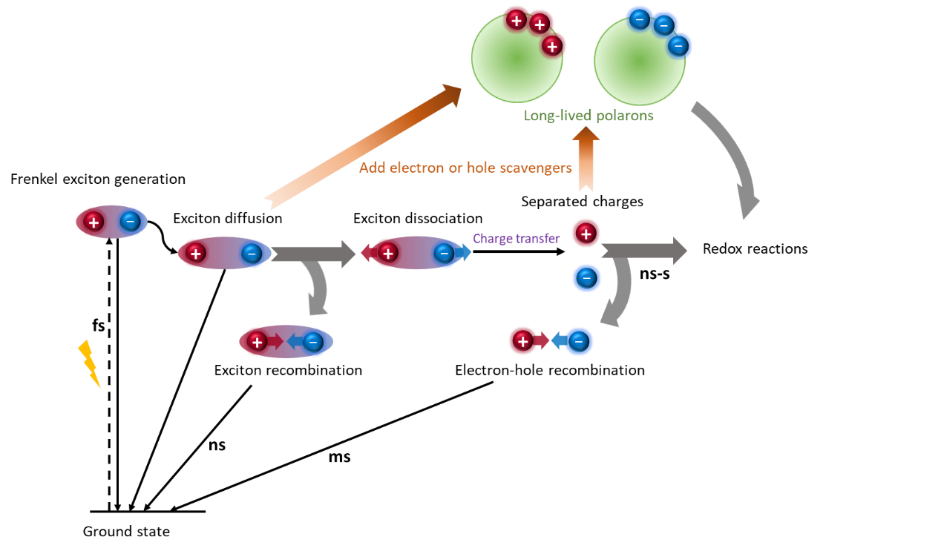
Figure 1. Schematic illustration of the main conversion processes within organic photocatalytic materials following photon absorption. Typical timescales for individual steps are shown.

The most commonly employed probe of the kinetics of photogenerated species in this emerging field is time-correlated single photon counting (TCSPC) measurements.^{31,32} Changes in TCPSC lifetime as a result of a modification to the photocatalyst structure provides a measure of the lifetime of radiative states. However, as recently highlighted in studies of C₃N₄ materials, radiative lifetimes do not always correlate with photocatalytic activity.^{32,33} In contrast, time-resolved electronic absorption, or as it is often called, transient absorption (TA) UV/Vis spectroscopy, probes both the radiative and non-radiative species generated following photon absorption allowing for a greater depth of mechanistic insight to be obtained.^{34,35} Numerous inorganic semiconductor photocatalysts have been studied using TA spectroscopy such as TiO₂,³⁶ α-Fe₂O₃,³⁷ and WO₃.³⁸ Historically, the complexity and cost of the laser systems and spectrometers required for TA spectroscopy limited the use of the technique. However, advances in the design of femtosecond lasers resulting in the development of high stability systems, combined with the availability of commercial TA spectrometers, has led to these measurements becoming increasingly commonplace in photocatalysis studies.^{39,40}
Here we review the application of TA spectroscopy to polymer photocatalysis with the aim of providing an accessible introduction for those who wish to move beyond using the technique as general measure of excited state lifetime in order that a more complete mechanistic understanding can be obtained. Due to the wide variety and very large number of polymer photocatalyst systems that have recently been reported, we focus on a single class of catalysts, conjugated linear polymers (Figure 2) owing to the relatively large number of detailed transient spectroscopic studies on this class of materials, and because of their reported activities for hydrogen and oxygen evolution (water splitting) and also carbon dioxide reduction.^{4,41,42} Following an overview of experimental considerations, we aim to take the reader in a step-by-step path through the literature related to identifying and studying photocatalytic mechanisms using TA spectroscopy for linear polymer photocatalysts.

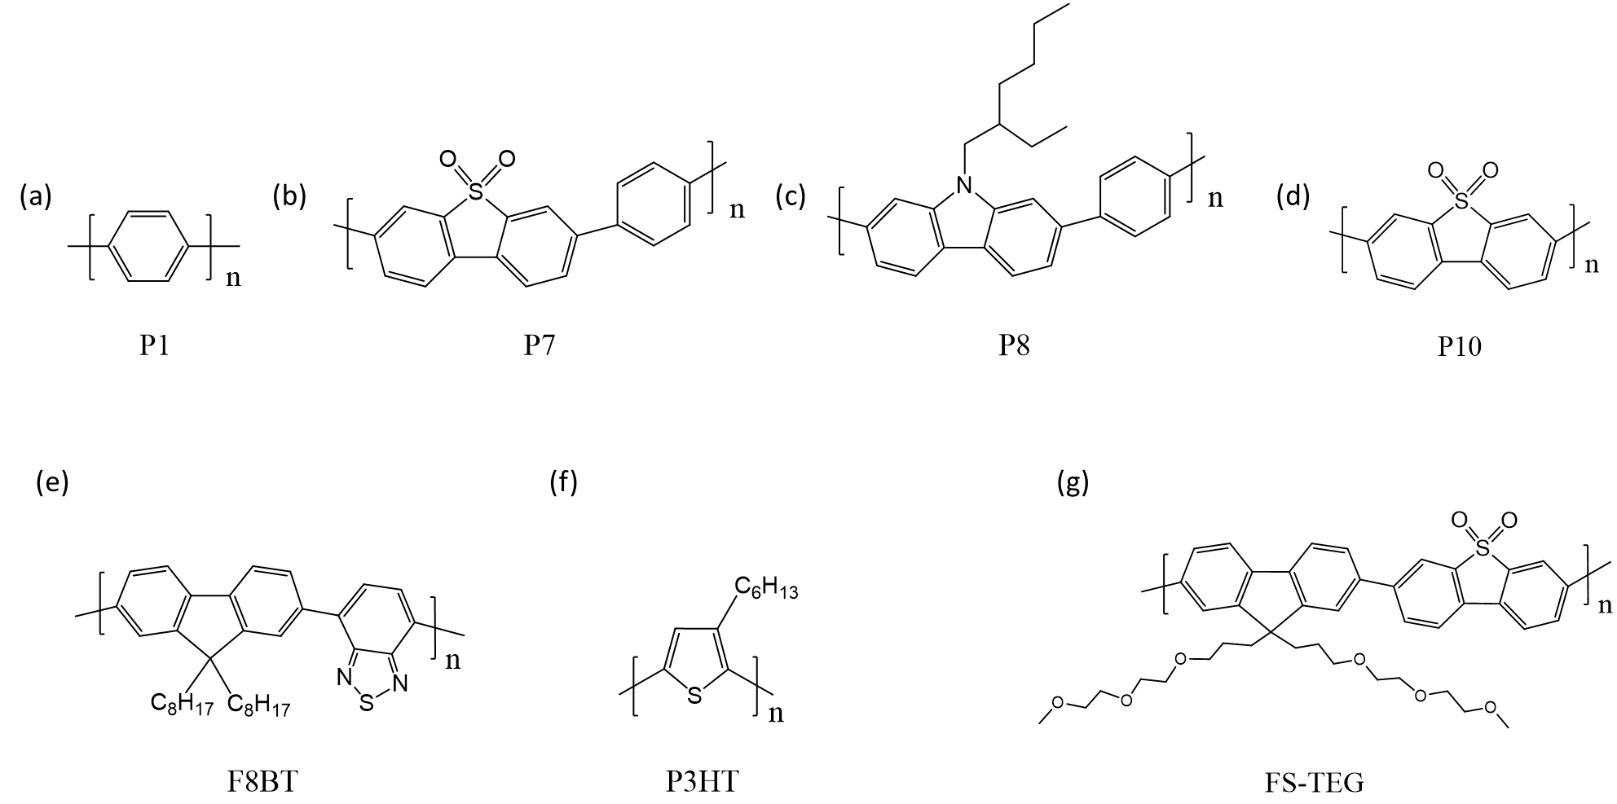
Figure 2. Chemical structures of the linear conjugated polymers discussed herein. (a) Poly(p-phenylene) (P1)^{1,5}and analogous conjugated co-polymers (b) P7,⁴³ (b) P8,⁴⁴ (c) P10,²⁷ (e) F8BT,⁴⁵ (f) P3HT,⁴⁶ and (g) FS-TEG.⁴⁷
Ⅱ. TRANSIENT ABSORPTION SPECTROSCOPY:
- Experimental considerations
TA spectroscopy is a pump-probe technique where a short (typically fs-ps or ns) pump laser pulse is used to excite the photocatalyst, and the resulting change in optical density is measured using a time-delayed optical probe laser pulse or a continuous wave (CW) probe. Figure 3 schematically shows the principles of TA experiments used to probe photodynamics on the ultrafast (fs to ns) and slow (μs to s) timescales.⁴⁸ Generally, the change in optical density as a result of photoexcitation is assumed to equivalent to the change in absorbance in a transmission TA experiment and provides a measurement of the relative change in concentration of photogenerated, or photodepleted species.^{48,49} In ultrafast TA measurements, the probe beam passes through an adjustable delay line and is focused onto a supercontinuum medium (such as CaF₂ or sapphire) resulting in the generation of broadband radiation, which is spatially overlapped with the pump beam at the sample. After transmission through the sample, the broadband probe is dispersed by a spectrograph and detected by an array detector. A 3-dimensional spectrum (ΔO.D. vs. λ vs. t) is then constructed by repeating the measurement at a range of pump-probe time delays. However, due to the limited length of the delay line, most ultrafast TA systems have a limit on the achievable delay of < 10 ns. Slow TA experiments typically employ a low-intensity narrowband CW probe produced by transmission of white light (e.g. from a Xe lamp) through a monochromator. The change in optical density with time is then obtained sequentially at a range of different probe wavelengths. In this way, the data can be recorded out to seconds or even longer if desired with the only limitation being the laser repetition rate. It is highly desirable that any photogenerated intermediates have decayed, and that the system has returned to its ground state, prior to the arrival of the following excitation pump pulse. For slow TA experiments, which typically use low laser repetition rates (< 10 Hz), this is often achievable, however it is not always possible or practical to alter the laser repetition rate. This is particularly true for ultrafast experiments where acquisition of a single time delay may involve collection of data following several thousand excitation events in order to gain a suitable signal to noise ratio. In these circumstances, translating/stirring the sample continuously so the region of excitation is continuously changed, combined with controlling the pulse energy to minimise the yield of long-lived species, reduces the probability of subsequent photoexcitation of these species.
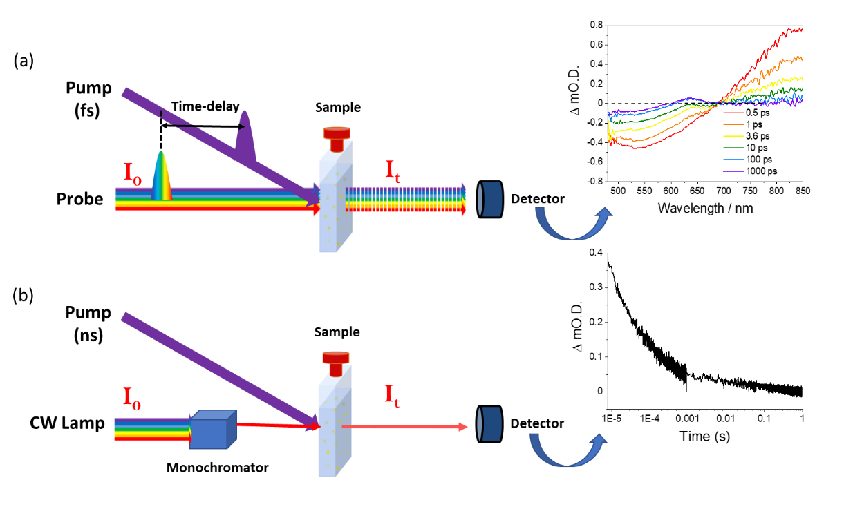
Figure 3. Schematic illustrating principles of TA spectroscopy in a transmission configuration for timescales ranging from femtoseconds to seconds. (a) Ultrafast TA system (fs-ns). A femtosecond laser pump pulse is used to excite the sample, and a broadband probe pulse which arrives at the sample at a temporal delay after the pump pulse allows the difference in optical density of the sample as a result of photoexcitation to be measured. A 3-dimensional spectrum (ΔO.D. vs. λ vs. t) is then constructed by repeating the measurement at a range of pump-probe time delays. (b) Slow TA system (μs-s). A low-power, narrowband probe beam is generated from a continuous wave light source by transmission through a monochromator. By obtaining the change in optical density at various times following the excitation of the sample by nanosecond laser pulse, a single wavelength kinetic trace of ΔO.D. vs. time is obtained.
Polymer photocatalysts present a particular challenge for TA spectroscopy due to the difficulty in generating stable, non-scattering samples. The insolubility of many of the polymer photocatalysts in aqueous solvents means that samples are typically dispersed in an aqueous based solvent with organic sacrificial electron/hole donors, and in some cases a wetting agent,^{25,43} by stirring or sonication prior to study. However, aggregation can still occur, leading to the formation of scattering suspensions. This often leads to increased detection of pump laser scatter giving rise to high levels of noise in the data. Furthermore, aggregation and precipitation lead to both a continuous change in the optical density of the sample and a change in the local environment of the polymer sample (e.g. through decreased accessibility to the solvent for charge carriers and through the changing dielectric environment). The change in local environment is particularly important and often overlooked; for example, by using TA spectroscopy it has been demonstrated that by controlling the water content of a polymeric sample it is possible to turn on/off exciton separation.¹⁶ Supporting this observation, DFT calculations have shown that exciton binding energies can drop from ~1.2 eV within the bulk of a linear polymer photocatalyst to ~0.17 eV at the polymer/water interface.^{16,50} Therefore, to understand the photophysics of the polymer photocatalysts it is important to study them in the form, and in the solvent mixes, used in the photocatalysis activity measurements.
In some cases photocatalysis has been carried out with polymers cast as films,⁴⁴ which can also be beneficial for TA spectroscopy as it circumvents the requirement to form a stable suspension.^{25,43} Diffuse reflectance TA spectroscopy also offers a way to study optically thick scattering polymer suspensions, and this approach has been reported previously in several studies,^{51,52} including g-C₃N₄,^{53,54} but it is important to still consider the stability of the suspension in order to obtain data which is reproducible and free of experimental artefacts.
- Analysis of Transient absorption spectroscopy data
Spectral features commonly observed in a TA spectrum include ground-state bleach (GSB), simulated emission (SE) and excited-state absorptions (ESA)/photochemical product absorptions, shown schematically in Figure 4. GSB results from depopulation of the ground state by the pump pulse and would be expected to have a similar profile to that observed in the steady-state UV–Vis absorbance spectrum. In addition, negative signals can also be attributed to SE which results from excited species radiatively relaxing to their ground electronic state. Positive features are assigned to ESA/photoproduct absorptions. These arise when species formed by the absorption of the pump pulse are subsequently excited to higher level electronic states through the absorption of probe light.⁵⁵ Photogenerated species which give rise to these positive features include the initially formed excitonic state, as shown schematically in Figure 4(b), or photoproducts/intermediates formed from reactions or charge separation of the initially generated excited state, for example, the electron polaron in polymer photocatalysts.^{27,44}
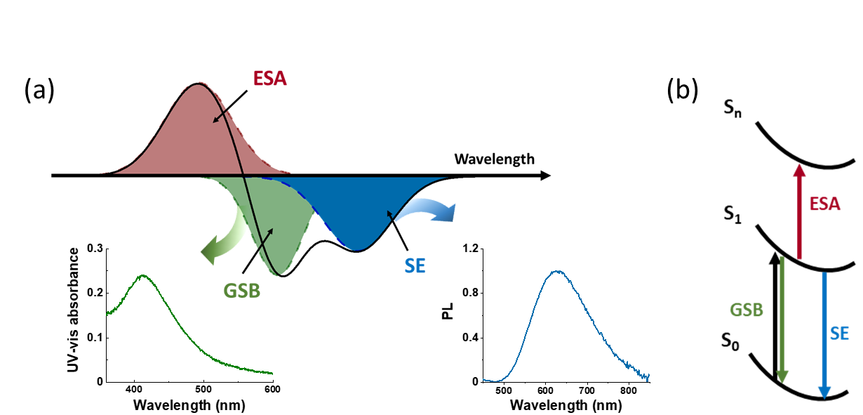
Figure 4. (a) Schematic illustration of contributions to a typical transient absorption spectrum: ground state bleach (GSB) (green dashed line), stimulated emission (SE) (blue dashed line), excited-state absorption (ESA) (red dashed line). The sum of these contributions is shown as a black solid line, which would be the experimentally obtained TA data. A GSB can be inferred from the steady-state UV–Vis absorbance and SE can be identified by the steady-state emission spectra. (b) A simplified schematic of the corresponding processes. The pump pulse promotes the system to the S₁ singlet excited state, depopulating the ground (S₀) electronic state (GSB). Subsequent absorption of probe radiation results in excitation to higher level electronic excited states (ESA). Alternatively, the initially generated S₁ population may radiatively relax to the ground state (SE).
We, and others, have recently reviewed in more detail methodologies for analysing transient absorption data for inorganic photoelectrodes;⁴⁸ as these are the same as those used for organic photocatalysts only the key points will be reiterated here. Typically, TA data sets in the form of the change in optical density as a function of the probe wavelength λ and of the time delay t, (ΔOD (λ, t)) consist of many thousands of individual data points, and it can be challenging to analyse and present the key findings in an accessible form. The most common approach is to simply plot the change in absorbance with time at a set of individual wavelengths, with the change in optical density at each wavelength chosen having been previously identified as being due to a specific spectral component. In this way it is easy to assess lifetimes, either through fitting to combinations of decay functions such as exponential and power-law functions. Disorder within the sample may result in a distribution of lifetimes to be observed as opposed to a single well-defined lifetime expected for an idealised system; in such cases, stretched exponential functions may be employed. In the life-sciences community dispersive TA kinetics have been addressed using lifetime-density analysis where the data is fitted to a continuum of exponential functions, and this approach has recently also been shown to be effective for fitting the kinetics of supramolecular hydrogel photocatalysts.¹⁶ An alternative approach is to report decay half times, the time taken for a TA feature to decay to half of its intensity relative to that at a specified pump-probe delay. However, such approaches become problematic when the different spectral contributions overlap.
Alternatively, global and target analysis can be applied to extract relatively small number of components from the large datasets. Prior to global analysis, it is essential to evaluate the number of components and time constants that can be fitted by means of singular value decomposition (SVD). The aim of global lifetime analysis (GLA) is to provide a way to visualise complex sets of time-resolved spectra by decomposing them into a small number of compartment populations and to examine their time dependence. The lifetime of each compartment is fitted as a single exponential decay function, and conventionally, GLA results in decay-associated spectra (DAS) if the compartments are allowed to decay in parallel, or evolution-associated spectra (EAS) if compartments decay sequentially. The DAS/EAS are wavelength-dependent for each lifetime component enabling simple presentation of the complex experimental data. In many cases, the DAS/EAS are assigned to the spectral signatures of individual species observed or photophysical processes which occur, but it is important to remember that the fitting results are a mathematical model of the data and they do not necessarily represent a meaningful physical model. A further fitting approach is global target analysis (GTA), where in contrast to GLA when fitting is performed without a prior assumed model, GTA fits the data to a pre-identified model. In this way it becomes possible to test the quality of fit to the proposed physical model and to identify lifetimes and spectra of individual species within the complex data sets. More detailed discussions of GLA and GTA of TA data have been discussed in the literature.^{35,56–58}
Ⅲ. TA SPECTROSCPY OF LINEAR POLYMERS
As previously noted, poly(p-phenylene) (P1, Figure 2) was studied as early as 1985,⁵ but more recently there has been a resurgence in the interest in using linear polymers for photocatalytic solar fuel production,^{27,59–61} with an abundance of known effective light absorbers known from the existing organic photovoltaic literature. In 2016, colleagues at the University of Liverpool screened a range of conjugated p-phenylene oligomers and poly(p-phenylene) analogues containing planarized units through the introduction of fluorene, carbazole, dibenzo[b,d]thiophene and dibenzo-[b,d]thiophene functionalities for light driven hydrogen production.⁴³ Only a small increase in hydrogen evolution activity occurred in the planar fluorene oligomers (when compared to p-phenylene oligomers), despite the increased conjugation which would be anticipated to enhance carrier mobility and increase exciton dissociation yields.⁶² However, co-polymers containing planarized sub-units showed large decreases in optical gap and high levels of photocatalytic activity. Amongst these, the dibenzo[b,d]thiophene sulfone co-polymer (P7) showed extremely high levels of activity. As a result of these works there has now been a substantial number of TA spectroscopic studies on these original on materials (P1,P7)²⁷and on related structures, such as the solution processable alkyl modified carbazole co-polymer (P8),⁴⁴ the dibenzo[b,d]thiophene sulfone homo-polymer (P10),^{27,63–65} and common model OPV polymers F8BT and P3HT,⁶⁵ (Figure 2) in an attempt to understand the factors controlling photocatalytic activity of linear polymers. This body of spectroscopic studies, and the very high activities of some of these materials, notably P10, which at the time of its original reporting had the highest external quantum efficiency (EQE, 11.6%) under λ > 420 nm illumination reported for a non-carbon nitride hydrogen-evolving polymer,²⁷ make them ideal exemplar systems for the remainder of this review.
(a) Assignment of initially generated electronic excited states: Early studies on this class of polymers for water splitting assigned the features in the TA spectra obtained in the first few ps after excitation through comparison to the UV/Vis and photoluminescence emission spectra of the aqueous suspensions. For example, spectra of suspensions of P1, P7 and P10 in H₂O are reproduced in Figure 5(b),²⁷ and at 0.5 ps these show a broad negative band between 450 and ~650-700 nm which largely overlaps with the steady state polymer photoluminescence emission spectrum. This correlation, combined with the observed similarity in lifetime of the negative TA signal to that of the broad ESA at wavelengths > 700 nm, enabled the authors to assign these TA features to SE and ESA of singlet exciton states, respectively. Additionally, the ground state UV/Vis spectrum of all three polymers exhibit a tail which partially overlaps with the negative TA band and so contributions from the GSB will also be present. The similarity of the TA spectra at early pump-probe delays of the P1-P10 series as aqueous suspensions is remarkable given the difference in their chemical structures (Figure 5(a)/(b)). Consistent with their assignment to a short-lived singlet exciton, the ESA and SE bands exhibit decay half times of ~10 ps for all three polymers. Additionally, more recent analyses making use of GLA and GTA have identified an evolution of the initially formed ESA and SE bands due to the vibronic cooling of the initially generated excitonic state within 4 ps of excitation.⁶⁴
The assignments of the ESA and SE TA features for the P1-P10 series as aqueous suspensions are also in-line with some earlier photodynamic studies of linear polymer thin films which pre-date these works under photocatalytic conditions where a broad ESA which peaked at ~800-850 nm, along with a negative band at ~500 nm assigned to SE, were observed at a very short (0.1 ps) pump-probe delay for a wide variety of polymers.^{66,67} However, it should be noted that within this wider organic electronics literature, similar spectral features with some of the polymers in Figure 2 have variously been attributed to triplet excitons, polarons, singlet interchain excitons and spatially indirect excitons (polaron pairs), highlighting the challenging nature of assignment of spectral features in TA spectra.^{66,67}

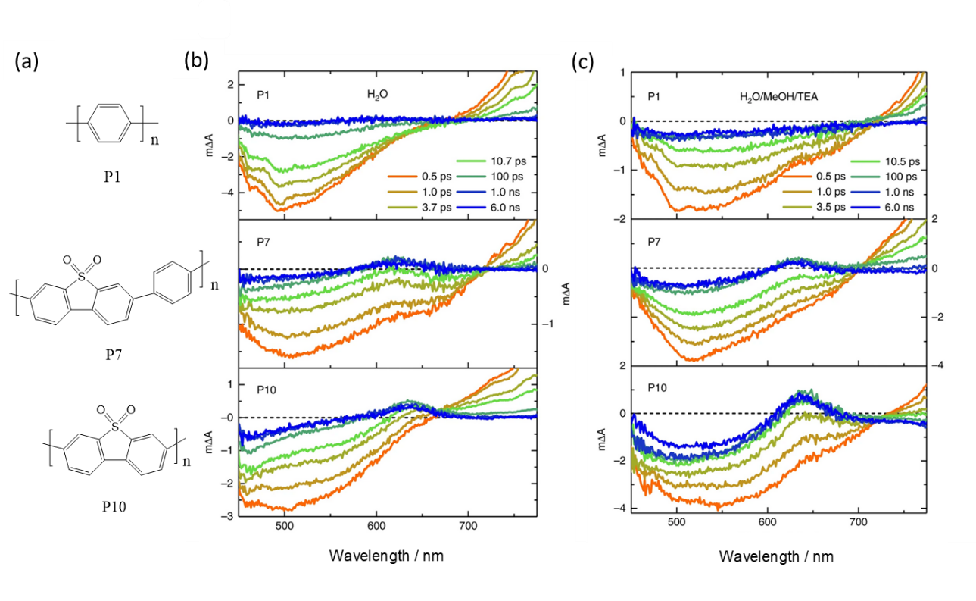/
Figure 5. (a) Chemical structures of P1, P7 and P10, respectively. (b) TA spectra of P1, P7 and P10 in pure H₂O and (c) a 1/1/1 mixture of H₂O/MeOH/TEA following 355 nm excitation.²⁷ Adapted from M. Sachs, R. S. Sprick, D. Pearce, S. A. J. Hillman, A. Monti, A. A. Y. Guilbert, N. J. Brownbill, S. Dimitrov, X. Shi, F. Blanc, M. A. Zwijnenburg, J. Nelson, J. R. Durrant, and A. I. Cooper, Nat. Commun. 9, 4968 (2018); licensed under a Creative Commons Attribution (CC BY) license.
(b) Identification of polaron states: Many photocatalytic experiments employ either a sacrificial electron donor (SED) or sacrificial electron acceptor (SEA) to enhance yields of long-lived polarons required to participate in the desired redox reaction. It follows that a simple route to identifying the polaron states is to carry out the TA experiments in the absence and then presence of the SED/SEA in the anticipation that the SED/SEA will lead to the generation of a population of long-lived electron/hole polarons. The first TA studies of these linear polymers as photocatalysts were reported on P8 films in water where only very short lived (t_{50%} ~2ps) excited states were observed.⁴⁴ In contrast, in a 1/1/1 H₂O/MeOH/triethylamine (TEA) solvent/SED mix, a broad ESA centred at ~700 nm grew within the first few ps and persisted beyond the timescale studied in that work (3 ns). Due its formation in the presence of the SED (TEA), combined with its long lifetime, the ESA at ~700 nm was assigned to the electron polaron,⁴⁴ demonstrating the viability of employing SED to aid spectral assignment.
A similar approach using a SED to identify the electron polaron state was also employed in a TA study of P1, P7 and P10,²⁷ and the TA spectra from this study are reproduced in Figure 5(c). In a H₂O/MeOH/TEA mixture, a prominent, narrow, ESA at ~ 630 nm is clearly observed in the 6 ns spectra of the P7 and P10 suspensions which persists in the data recorded on the µs-s timescale.²⁷ Notably, the ESA at ~630 nm is absent in the spectra of P1 at long (µs) timescales.²⁷ The activity of these polymers towards hydrogen evolution is P10 > P7 > P1, hence, the photocatalytic activity of these materials is proportional to the magnitude of the 630 nm band observed in the TA spectra at long timescales, confirming its assignment to the electron polaron.²⁷ This assignment was also supported by the decrease in magnitude of the 630 nm band in the µs-s range in the presence of O₂, an electron scavenger.²⁷
Careful inspection of TA spectra in Figure 5(b) also shows that the 630 nm ESA is present on the ps timescale, albeit at lower levels, in the spectra of P10 and P7 in pure water. However, on the µs-s timescale no transient band was observed at this wavelength,²⁷ indicating long-lived electron polaron states were only formed when the SED was present. Interestingly an appearance half time of ~1-2 ps for the 630 nm ESA was estimated for both P7 and P10 suspensions in H₂O/MeOH/TEA.²⁷ These two results, the rapid formation of this band, and its short-lived presence in the absence of the SED, led to the conclusion that at very early timescales the ESA at 630 nm may actually be assignable to “an exciton with charge transfer character, such as a polaron pair with electron and hole delocalized over adjacent chains rather than an already fully separated charge”.²⁷ It is challenging to differentiate between polaron pairs and fully separated charges as these both may result in very similar spectral features.^{68,69} However, the high polaron binding energies in organic polymers means that forming a fully separated charge within 1-2 ps is unlikely, hence the assignment of this feature at early timescales was made to a polaron pair,²⁷ the formation of which potentially provides a pathway to form a fully separated electron polaron (Figure 1).
Alongside studies using SEDs, a few reports of TA spectroscopy of linear polymer photocatalysts using electron acceptors are also found in the literature. In a study of P10 modified with a Co co-catalyst for the oxygen evolution reaction Ag⁺ was used as a SEA.⁷⁰ In the presence of Ag⁺, a broad negative band covered the spectral region probed, with the loss of the ESA band at >705 nm.⁷⁰ Furthermore, the long-lived ~630 nm band, assignable either to a partially charge-separated state, or an electron polaron, is also absent,⁷⁰ revealing that Ag⁺ is preventing the formation of long-lived photogenerated electrons. Owing to a significant red-shift observed in the UV/Vis absorption spectrum in the presence of Ag⁺, the broad negative TA band was assigned to GSB.⁷⁰ These observations suggest Ag⁺ is strongly coordinated to the polymer. Owing to the non-observance of the SE and ESA, the mechanism likely involves oxidative quenching of the photogenerated polymer exciton through electron transfer to Ag⁺, however no evidence for either a P10 hole polaron or an oxidised Co state was identified.⁷⁰ P10 has also been successfully coupled to BiVO₄ in a Z-scheme employing iron as a redox mediator for complete water splitting.⁶³ In the presence of Fe²⁺, and equal concentrations of Fe²⁺/Fe³⁺, a long lived (> 3 ns) ~ 630 nm electron polaron band was formed,⁶³ demonstrating that Fe²⁺ could act as an electron donor. Although interestingly, in the presence of Fe³⁺, which may have been expected to act as electron acceptor, the ~630 nm P10 electron polaron band was still formed, but at a reduced intensity.⁶³ It was not possible to conclude whether this was due to the formation of a polaron pair (as formed by P10 suspensions in pure H₂O) which were inefficiently quenched by Fe³⁺, or from a build-up of Fe²⁺ from repeated exposure to pump light.⁶³ Overall it is apparent that electron donors and acceptors are an effective route to identifying the TA spectra of polarons, however caution is required due to the potential accumulation of oxidised and reduced products.
To support the assignment of TA spectra charged (polaronic) species can also be produced by electrochemical methods, however in many cases it can be challenging to carry out a spectroelectrochemical (SEC) measurement of aggregate suspensions. However, SEC has been employed to facilitate assignment of linear polymer photocatalysts by casting as films.⁴⁷ During SEC measurements, a band at ~585 nm grew in as increasingly more negative bias was applied to the FS-TEG polymer photocatalyst film, hence was assigned to the electron polaron.⁴⁷ The position of the SEC band was in excellent agreement with a narrow ESA band observed at ~600 nm in TA measurements of the same polymer in the presence of an SED (TEA), allowing confident assignment of this feature to the electron polaron to be made.⁴⁷
We have also recently explored the use of Raman spectroscopy, both time-resolved resonance Raman (TR³) spectroscopy in parallel with TA spectroscopy to study the dynamics, and conventional Raman spectroscopy to generate high quality spectra, of P10 polarons.⁷¹ Although Raman measurements of polymer photocatalysts are often complicated by the high photoluminescence yields, the vibrational frequencies obtained are characteristic of the chemical and electronic structure of the chromophore. Through correlation of the resonance effect with the ESA bands measured by TA, it was possible to confirm that the 630 nm band seen in TA studies of P10 was indeed due to an electron polaronic state.⁷¹
(c) Mechanism of polaron formation and utilisation: A central aim of many TA studies is to identify the factors controlling the yield of long-lived polarons. For the polymers P1-P10 (Figure 2), quenching of the singlet excitonic state by the SED was proposed to occur and be complete within ~100 ps of excitation during photocatalytic hydrogen evolution.²⁷ In these studies the high activity of P10 was shown through a combination of computational simulations/calculations and TA experiments to be due to the presence of the polar sulfone groups which lead to a shell of water being present which results in a stabilisation of the charged (polaronic) species formed and an increased driving force for hole transfer to the SED. However, the exact mechanism of polaron formation with these polymer catalysts still contains an ambiguity. Although it was clear from the TA experiments that the TEA acted as a SED, the exciton lifetime measured by both TCSPC and from the TA ESA, was not sensitive to the electron donor,²⁷ which would not be expected if quenching of the singlet excitonic state is the dominant polaron formation pathway. This could be due to the low yield of exciton quenching by the SED as proposed but given the high quantum efficiency for H₂ production of >10% for P10 (although this was recorded under CW and not pulsed laser light),²⁷ a disconnect between the photodynamics and photocatalytic activity remained.
More recently a combined TA and TR³ study has led us to propose that during photocatalytic hydrogen evolution using a SED with P10, a significant population of the long-lived electron polaron population is generated via quenching of the polaron-pair like state, which would account for the lack of sensitivity of the emissive excitonic state to the presence of a SED.⁷¹ Analysis of the TR³ lifetimes in the absence of a SED indicated that polaron-pair formation occurs within ~3 ps. In the presence of the SED the polaron like species shows biexponential kinetics with a fast ~1.5 ps and slower component ~ 20 ps, of similar amplitudes,⁷¹ assigned to generation of the polaron-pair like state through hot-exciton dissociation and through the previously proposed mechanism of exciton quenching by the SED.²⁷ Supporting the importance of the role of the hot-excitonic state in the charge separation process of P10 is the results of global lifetime and target analysis of TA spectra of P10 suspensions in pure water.⁶⁴ In this study we arrived at a kinetic model consisting of an initially formed (hot) excitonic state (compartment 0), which could undergo vibrational relaxation to generate a cooled singlet excitonic state (compartment 1), charge-separation to directly form the polaron/polaron pair (compartment 2), or relax to the ground electronic state. A pathway to form the polaronic state from the cooled excitonic state (compartment 1 to 2) was also included in the kinetic model. The model is shown schematically in Figure 6(a) and full details of how the steps taken to derive the model are described elsewhere.⁶⁴ Initially we attempted to fit to a 2-compartment model consisting solely of an initially generated excitonic state and one charge separated state but this gave a poor fit to the experimental data, reinforcing the need to consider the role of the hot excitonic state.⁶⁴ Supporting the model is the observation that the species associated spectra obtained (Figure 6(c)) are consistent with expectations for the proposed states.⁶⁴ From this GTA, we concluded the dominate pathway to form the polaronic state in pure H₂O is directly from the hot excitonic state with a lifetime ~3.5 ps,⁶⁴ in excellent agreement with the TR³ data.⁷¹ Hot exciton dissociation is in direct competition with vibrational and radiative relaxation of the initially formed exciton (Figure 6(a)). As mentioned above, it is challenging to differentiate between polaron pairs and fully separated charges as these both may result in very similar spectral features.^{68,69} In our recent TR³ study, in the absence of SEDs, the intensity of the P10 polaronic vibrational bands were shown to decay with a lifetime of ~100 ps, assigned to charge-recombination. This is consistent with the absence of the polaronic band of both P7 and P10 on the µs-ms timescale in the absence of SEDs. These observations suggest that polaronic species formed for suspensions of P10 in pure H₂O are coulombically-bound polaron pairs rather than fully separated charges. Overcoming the coulombic attraction of electron-hole pairs is an important requirement for the generation of fully charged separated species in the absence of SEDs/SEAs. Hot polaron pairs are known to be key intermediate species required for further charge-separation in a variety of organic donor/acceptor blends.⁷²It is clear that redistribution of excess energy following singlet exciton formation plays a crucial role in charge separation and future detailed studies in which the wavelength dependence on the generation of the polaronic species are desirable to further unravel these effects.
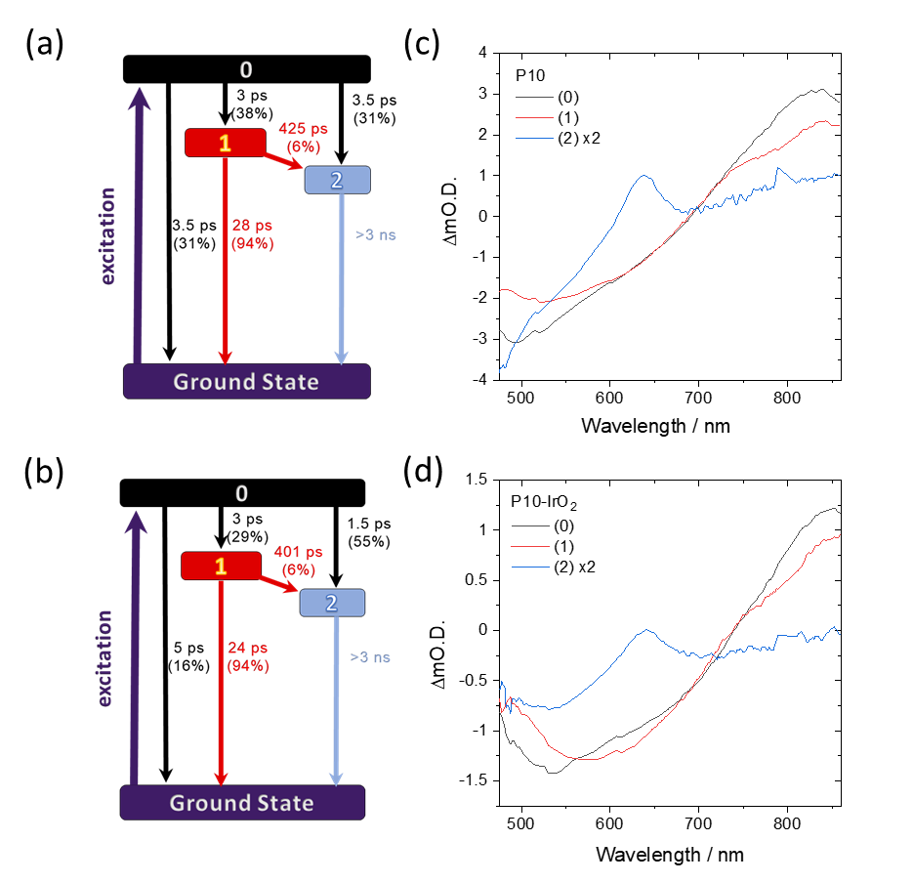
Figure 6. Panel (a) and (b) present the kinetic model from 3-compartment pathway global target analysis (GTA) of the TA data of P10 (a) and P10-IrO₂(b), respectively. Panel (c) and (d) compare the SAS spectra obtained from the GTA of P10 (c) and P10-IrO₂ (d), respectively. Adapted from Y. Bai, C. Li, L. Liu, Y. Yamaguchi, M. Bahri, H. Yang, A. Gardner, M. A. Zwijnenburg, N. D. Browning, A. J. Cowan, A. Kudo, A. I. Cooper, and R. S. Sprick, Angew Chem Int Ed Engl, e202201299 (2022); licensed under a Creative Commons Attribution (CC BY) license.
Further GTA of the TA spectra of a P10-IrO₂ system that is able to carry out complete water splitting (a Pd H₂ evolution catalyst is also present, see below) indicated that the presence of IrO₂ accelerates formation of the polaronic species (compartment 2) directly from the hot excitonic state (compartment 0),⁶⁴ (Figure 6(b)). The lifetime of polaron formation for P10-IrO₂ (~1.5 ps) is reduced compared to P10 (3.5 ps) resulting in higher polaron yields at longer timescales. Analysis of the species associated spectra (Figure 6(d)) led to the proposal that the IrO₂ catalyst enables formation of charge separated P10⁽⁻⁾-IrO₂⁽⁺⁾ by rapid hole transfer directly from the hot excitonic state and this appears to be critical in enabling overall water splitting.⁶⁴
The formation of hot excitonic states through exciton-exciton annihilation (EEA) which subsequently undergo fast exciton dissociation resulting in the formation of charge-separated states has previously been reported for F8BT films.⁶⁷ This conclusion was reached through careful analysis of the how the kinetics and magnitudes of the exciton and polaron features observed in TA spectra changed with pump fluence. Unfortunately, such analysis has not yet been performed on suspensions of these polymer photocatalysts. As an aside, we note that EEA has been used to determine the exciton diffusion lengths in low Pd (< 1 ppm) F8BT suspensions by examining the dependence of the ultrafast decay of the ESA at a single wavelength (950 nm) on pump photon fluence.⁶⁵
Quenching of the initially generated excitonic state by a co-catalyst has also been previously reported in studies on F8BT and P3HT nanoparticles in the presence of a SED.⁶⁵ Pd is often present in linear polymer photocatalysts due to their preparation by Pd-catalyzed cross-coupling polymerization reactions, and despite early suggestions that it may not play an important role in photocatalysis with some systems,⁷³ it has been shown to be vital for hydrogen evolution to occur.⁷⁴ When Pd, which also acts as the hydrogen evolution catalyst, was present in F8BT at high concentrations TCSPC showed that the residual Pd clusters quenched photogenerated excitons via energy and electron transfer on the fs-ps time scale, Figure 7(b), thus outcompeting reductive quenching of the exciton by SEDs which occurred on the ~ns timescale.⁶⁵ The localisation of the polaron with changing Pd content in F8BT can be seen in the µs-s TA spectra of F8BT reproduced from Ref. 65 in Figure 7(a). At low (36 ppm) Pd concentrations, the spectrum shows a narrow ESA centred at 700-750 nm, reminiscent of that discussed for P10. As the Pd concertation is increased to 195 ppm the band broadens to the blue. With further increase in Pd concertation the intensity of the 700-750 nm band decreases, resulting in a broad ESA, with increased absorption into shorter wavelengths. This structure contrasts with expectations of a polymer localised polaron based on the discussion of P7, P8 and P10, above. Sachs et al.⁶⁵ were able to assign the ESA at shorter probe wavelengths in the TA spectra to photogenerated electrons on the Pd clusters in F8BT nanoparticles by carrying out the spectroelectrochemistry of Pd nanoparticles (Figure 7(c)). These studies showed that for hydrogen evolution using F8BT the efficiency of the reaction with the SED was limiting photocatalytic activity, instead of the efficiency of charge transfer to the Pd co-catalyst.⁶⁵
Interestingly, although Pd is present at high concentrations in most studies of P7 and P10, and despite it being essential for photocatalytic hydrogen evolution to occur, it is not thought to not play a role in the initial exciton separation.⁶⁵ Elegant TA experiments on P10 which was prepared using a Ni based coupling reaction, with Pd added in a controlled manner, showed that electron transfer from P10 to the Pd co-catalyst was extremely slow with t_{50%} ~ 50 µs, even when very high (2.7 wt. %) levels of Pd were present.⁶⁵ These experiments showed that for P10 during hydrogen evolution electron transfer to the Pd co-catalyst is the bottleneck. Such behaviour may explain the good selectivity of P7 and P10 for photocatalytic CO₂ reduction to CO in the presence of a Co based co-catalyst.⁴² Although the CO:H₂ yield was sensitive to Pd content, even when > 1% Pd was present a CO:H₂ of ~1:3 could be achieved which is in-line with inefficient electron transfer from the polymer to Pd (which would lead to H₂) enabling competitive charge transfer to the Co CO₂ reduction catalyst.⁴²
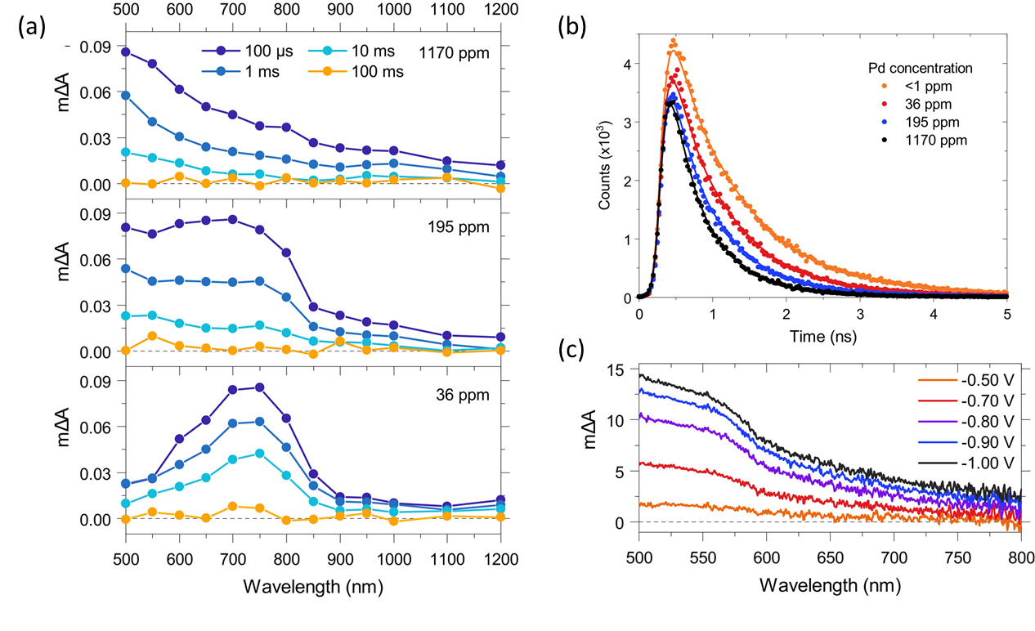
Figure 7. (a) TA spectra of F8BT nanoparticles with different Pd concentrations in an aqueous 30 vol % DEA mixture following 460 nm excitation probed at 100 μs, 1 ms, 10 ms, and 100 ms. (b) TCSPC fluorescence decay curves of F8BT nanoparticle with different Pd concentrations in pure water following 467 nm excitation and probed at 545 nm. (c) SEC spectra of Pd nanoparticles deposited on an FTO-coated glass substrate upon stepwise increase of the potential from -0.5 to -1 V. Adapted from M. Sachs, H. Cha, J. Kosco, C. M. Aitchison, L. Francas, S. Corby, C. L. Chiang, A. A. Wilson, R. Godin, A. Fahey-Williams, A. I. Cooper, R. S. Sprick, I. McCulloch, and J. R. Durrant, J Am Chem Soc 142, 14574 (2020); licensed under a Creative Commons Attribution (CC BY) license.
IV. SUMMARY AND PERSPECTIVE
TA spectroscopy is a powerful technique able to monitor the temporal dynamics of photogenerated transient states and species of conjugated linear polymer photocatalysts. It can provide deep insights into dynamics of the initially formed excitonic state, polaron formation and the mechanism of catalysis. This review presented a brief summary of experimental considerations for performing TA measurements of polymer photocatalysts. Although challenging, the steps required to assign features observed in TA spectra have been outlined. We have highlighted the importance of performing, and reporting, supporting UV/Vis absorption and photoluminescence emission spectra of the polymers under the same conditions as those employed in the TA measurements to aid assignment of GSB and SE TA bands. Several examples have been highlighted which show that by performing TA measurements in the presence and absence of the same chemical scavengers employed in photocatalysis, spectral signatures of the long-lived polaronic species may be identified. We have highlighted how SEC can be used to obtain spectral signatures of charged species, which in turn, can be assigned to features observed within TA spectra.
We have discussed how, once assigned, the kinetics of TA spectral features can be used to rationalise differing photocatalytic activity observed between the polymers shown in Figure 2. Moving beyond this simple form of analysis, we have shown how global analysis can be used to unravel the complex photodynamics of these materials, and we encourage their routine use in future TA studies of these materials. Owing to the wide range of timescales (fs-s) of the key photodynamical processes of these materials, two experimental setups are typically employed to perform TA measurements (Figure 3). Even when both setups are employed, pump laser sources of differing pulse durations are employed, and the crucial ns-µs timescale is not probed. However, by employing time-resolved multiple probe spectroscopy, dynamics across fs-ms timescales could be obtained on a single instrument.⁷⁵ To the best of our knowledge, this technique has not been extended to the transient UV/Vis absorption of linear polymer photocatalysts which would provide a convenient route to unify the study of “ultrafast” and “slow” mechanisms outlined in Figure 1. Vibrational frequencies are characteristic of the chemical and electronic structure of the chromophore and we have briefly described the mechanistic insight which can be provided by employing TR³ spectroscopy to probe P10. TA spectroscopy plays a crucial role in identifying electronic transitions of the transient species which is an essential criterion for spectroscopic selection utilised by resonant Raman enhancement in the TR³ technique and we anticipate many more TA and TR³ studies of these materials to be reported in the future.
In closing, we hope that this review has provided an accessible introduction to the application of TA spectroscopy to the study of polymer photocatalysts and look forward to new mechanistic insights that will be provided by future studies of these important materials.

V. ACKNOWLEDGMENTS
C.L. thanks the China Scholarship Council for a PhD studentship. This work was funded by the University of Liverpool Early Career Laser Laboratory supported by UKRI-EPSRC grant EP/S017623/1 and the University of Liverpool, maintained and operated as a shared research facility by the Faculty of Science and Engineering.

VI. AUTHOR DECLARATIONS
The authors have no conflicts of interest to disclose.

REFERENCES

¹ T. Banerjee, F. Podjaski, J. Kröger, B.P. Biswal, and B. V. Lotsch, Nat. Rev. Mater. 6, 168-190 (2020).
² A. Fujishima and H. Kenichi, Nature. 238, 37-38 (1972).
³ Y. Bai, L. Wilbraham, H. Gao, R. Clowes, H. Yang, M.A. Zwijnenburg, A.I. Cooper, and R.S. Sprick, J. Mater. Chem. A. 9, 19958-19964 (2021).
⁴ C. Zhao, Z. Chen, R. Shi, X. Yang, and T. Zhang, Adv. Mater. 32, e1907296 (2020).
⁵ S. Yanagida, A. Kabumoto, K. Mizumoto, C. Pac, and K. Yoshino, J. Chem. Soc., Chem. Commun. 474-475 (1985).
⁶ X. Wang, K. Maeda, A. Thomas, K. Takanabe, G. Xin, J.M. Carlsson, K. Domen, and M. Antonietti, Adv. Mater. 8, 76-80 (2009).
⁷ D. Kong, X. Han, S.A. Shevlin, C. Windle, J.H. Warner, Z.X. Guo, and J. Tang, ACS Appl. Energy Mater. 3, 8960-8968 (2020).
⁸ Z.A. Lan, Y. Fang, Y. Zhang, and X. Wang, Angew. Chemie. Int. Ed. 57, 470-474 (2018).
⁹ D. Kong, X. Han, J. Xie, Q. Ruan, C.D. Windle, S. Gadipelli, K. Shen, Z. Bai, Z. Guo, and J. Tang, ACS Catal. 9, 7697-7707 (2019).
¹⁰ Z. Fu, X. Wang, A.M. Gardner, X. Wang, S.Y. Chong, G. Neri, A.J. Cowan, L. Liu, X. Li, A. Vogel, R. Clowes, M. Bilton, L. Chen, R.S. Sprick, and A.I. Cooper, Chem. Sci. 11, 543-550 (2020).
¹¹ J. Xu, C. Yang, S. Bi, W. Wang, Y. He, D. Wu, Q. Liang, X. Wang, and F. Zhang, Angew. Chemie. Int. Ed. 59, 23845-23853 (2020).
¹² Y. Zang, R. Wang, P.P. Shao, X. Feng, S. Wang, S.Q. Zang, and T.C.W. Mak J. Mater. Chem. A. 8, 25094-25100 (2020).
¹³ R.S. Sprick, Y. Bai, A.A.Y. Guilbert, M. Zbiri, C.M. Aitchison, L. Wilbraham, Y. Yan, D.J. Woods, M.A. Zwijnenburg, and A.I. Cooper, Chem. Mater. 31, 305-313 (2019).
¹⁴ Z. Wang, X. Yang, T. Yang, Y. Zhao, F. Wang, Y. Chen, J.H. Zeng, C. Yan, F. Huang, and J.X. Jiang, ACS Catal. 8, 8590-8596 (2018).
¹⁵ D. McDowall, B.J. Greeves, R. Clowes, K. McAulay, A.M. Fuentes-Caparrós, L. Thomson, N. Khunti, N. Cowieson, M.C. Nolan, M. Wallace, A.I. Cooper, E.R. Draper, A.J. Cowan, and D.J. Adams, Adv. Energy Mater. 10, 2002469 (2020).
¹⁶ C.L. Smith, L.L.E. Mears, B.J. Greeves, E.R. Draper, J. Doutch, D.J. Adams, and A.J. Cowan, Phys. Chem. Chem. Phys. 21, 26466-26476 (2019).
¹⁷ Y. Wang, A. Vogel, M. Sachs, R.S. Sprick, L. Wilbraham, S.J.A. Moniz, R. Godin, M.A. Zwijnenburg, J.R. Durrant, A.I. Cooper, and J. Tang, Nat. Energy. 4, 746-760 (2019).
¹⁸ N. Kaur, M. Singh, D. Pathak, T. Wagner, and J.M. Nunzi, Synth. Met. 190, 20-26 (2014).
¹⁹ S. Li, H. Zhang, S. Yue, X. Yu, and H. Zhou, Nanotechnology. 33, 072002 (2021).
²⁰ P. Wang, Y. Zhao, and T. Wang, Appl. Phys. Rev.7, 031303 (2020).
²¹ T.M. Clarke and J.R. Durrant, Chem. Rev. 110, 6736-6767 (2010).
²² A.E. Jailaubekov, A.P. Willard, J.R. Tritsch, W.L. Chan, N. Sai, R. Gearba, L.G. Kaake, K.J. Williams, K. Leung, P.J. Rossky, and X.Y. Zhu, Nat. Mater. 12, 66-73 (2013).
²³ O. v. Mikhnenko, P.W.M. Blom, and T.Q. Nguyen, Energy Environ. Sci. 8, 1867-1888 (2015).
²⁴ K.M. Pelzer and S.B. Darling, Mol. Syst. Des. Eng. 1, 10-24 (2016).
²⁵ A. Vogel, M. Forster, L. Wilbraham, C.L. Smith, A.J. Cowan, M.A. Zwijnenburg, R.S. Sprick, and A.I. Cooper, Faraday Discuss. 215, 84-97 (2019).
²⁶ J. Lee, A.J. Kalin, T. Yuan, M. Al-Hashimi, and L. Fang, Chem. Sci. 8, 2503-2521 (2017).
²⁷ M. Sachs, R.S. Sprick, D. Pearce, S.A.J. Hillman, A. Monti, A.A.Y. Guilbert, N.J. Brownbill, S. Dimitrov, X. Shi, F. Blanc, M.A. Zwijnenburg, J. Nelson, J.R. Durrant, and A.I. Cooper, Nat. Commun. 9, 4968 (2018).
²⁸ J. Guo, H. Ohkita, H. Benten, and S. Ito, J. Am. Chem. Soc. 131, 16869-16880 (2009).
²⁹ M. Imran, A.A. Sukhanov, P. Maity, A. Elmali, J. Zhao, A. Karatay, O.F. Mohammed, and V.K. Voronkova, J. Phys. Chem. B. 125, 9244-9259 (2021).
³⁰ U. Balijapalli, Y.T. Lee, B.S.B. Karunathilaka, G. Tumen-Ulzii, M. Auffray, Y. Tsuchiya, H. Nakanotani, and C. Adachi, Angew. Chemie Int. Ed. 60, 19364-19373 (2021).
³¹ S. Nayak, S. Paul, A. Bauri, A. Ray, and S. Bhattacharya, J. Mol. Liq. 272, 137-150 (2018).
³² E. Mitchell, A. Law, and R. Godin, J. Photochem. Photobiol. C Photochem. Rev. 49, 100453 (2021).
³³ M.Z. Rahman and C.B. Mullins, Acc. Chem. Res. 52, 248-257 (2019).
³⁴ J.R. Lakowicz, Principles of Fluorescence Spectroscopy (2006).
³⁵ C. Ruckebusch, M. Sliwa, P. Pernot, A. de Juan, and R. Tauler, J. Photochem. Photobiol. C Photochem. Rev. 13, 1-27 (2012).
³⁶ J. Schneider, M. Matsuoka, M. Takeuchi, J. Zhang, Y. Horiuchi, M. Anpo, and D.W. Bahnemann, Chem. Rev. 114, 9919-9986 (2014).
³⁷ M. Forster, R.J. Potter, Y. Ling, Y. Yang, D.R. Klug, Y. Li, and A.J. Cowan, Chem. Sci. 6, 4009-4016 (2015).
³⁸ V. Cristino, S. Marinello, A. Molinari, S. Caramori, S. Carli, R. Boaretto, R. Argazzi, L. Meda, and C.A. Bignozzi, Journal of Materials Chemistry A 4, 2995-3006 (2016).
³⁹ Y. Zhu and J.X. Cheng, J. Chem. Phys. 152, 020901 (2020).
⁴⁰ B. Lang, Rev. Sci. Instrum. 89, 093112 (2018).
⁴¹ Y. Bai, K. Hippalgaonkar, and R.S. Sprick, J. Mater. Chem. A. 9, 16222 (2021).
⁴² Z. Fu, A. Vogel, M.A. Zwijnenburg, A.I. Cooper, and R.S. Sprick, J. Mater. Chem. A. 9, 4291 (2021).
⁴³ R.S. Sprick, B. Bonillo, R. Clowes, P. Guiglion, N.J. Brownbill, B.J. Slater, F. Blanc, M.A. Zwijnenburg, D.J. Adams, and A.I. Cooper, Angew. Chemie Int. Ed. 55, 1792-1796 (2016).
⁴⁴ D.J. Woods, R.S. Sprick, C.L. Smith, A.J. Cowan, and A.I. Cooper, Adv. Energy Mater. 7, 1700479 (2017).
⁴⁵ L. Wang, R. Fernández-Terán, L. Zhang, D.L.A. Fernandes, L. Tian, H. Chen, and H. Tian, Angew. Chemie Int. Ed. 55, 12306-12310 (2016).
⁴⁶ S. Holliday, R.S. Ashraf, A. Wadsworth, D. Baran, S.A. Yousaf, C.B. Nielsen, C.H. Tan, S.D. Dimitrov, Z. Shang, N. Gasparini, M. Alamoudi, F. Laquai, C.J. Brabec, A. Salleo, J.R. Durrant, and I. McCulloch, Nat. Commun. 7, 11585 (2016).
⁴⁷ D.J. Woods, S.A.J. Hillman, D. Pearce, L. Wilbraham, L.Q. Flagg, W. Duffy, I. McCulloch, J.R. Durrant, A.A.Y. Guilbert, M.A. Zwijnenburg, R.S. Sprick, J. Nelson, and A.I. Cooper, Energy Environ. Sci. 13, 1843-1855 (2020).
⁴⁸ M. Forster, D.W.F. Cheung, A.M. Gardner, and A.J. Cowan, J. Chem. Phys. 153, 150901 (2020).
⁴⁹ S.J.A. Moniz, S.A. Shevlin, D.J. Martin, Z.X. Guo, and J. Tang, Energy Environ. Sci. 8, 731-759 (2015).
⁵⁰ P. Guiglion, C. Butchosa, and M.A. Zwijnenburg, Macromol. Chem. Phys. 217, 344-353 (2016).
⁵¹ M. Alvaro, E. Carbonell, B. Ferrer, F.X. Llabrés I Xamena, and H. Garcia, Chem. Eur. J. 13, 5106-5121 (2007).
⁵² A. Santiago Portillo, H.G. Baldoví, M.T. García Fernandez, S. Navalón, P. Atienzar, B. Ferrer, M. Alvaro, H. Garcia, and Z. Li, J. Phys. Chem. C. 121, 7015-7024 (2017).
⁵³ J.J. Walsh, C. Jiang, J. Tang, and A.J. Cowan, Phys. Chem. Chem. Phys. 18, 24825-24829 (2016).
⁵⁴ M. Zhu, S. Kim, L. Mao, M. Fujitsuka, J. Zhang, X. Wang, and T. Majima, J. Am. Chem. Soc. 139, 13234-13242 (2017).
⁵⁵ J.Y. Xu, X. Tong, P. Yu, G.E. Wenya, T. McGrath, M.J. Fong, J. Wu, and Z.M. Wang, Adv. Sci. 5, 1800221 (2018).
⁵⁶ C. Slavov, H. Hartmann, and J. Wachtveitl, Anal. Chem. 87, 2328-2336 (2015).
⁵⁷ L.J.G.W. van Wilderen, C.N. Lincoln, and J.J. van Thor, PLoS ONE 6, e17373 (2011).
⁵⁸ I.H.M. van Stokkum, D.S. Larsen, and R. van Grondelle, Biochim. Biophys. Acta. 1657, 82-104 (2004).
⁵⁹ R. Diao, H. Ye, Z. Yang, S. Zhang, K. Kong, and J. Hua, Polym. Chem. 10, 6473-6480 (2019).
⁶⁰ J. Kosco, M. Bidwell, H. Cha, T. Martin, C.T. Howells, M. Sachs, D.H. Anjum, S. Gonzalez Lopez, L. Zou, A. Wadsworth, W. Zhang, L. Zhang, J. Tellam, R. Sougrat, F. Laquai, D.M. DeLongchamp, J.R. Durrant, and I. McCulloch, Nat. Mater. 19, 559-565 (2020).
⁶¹ X. Zhang, F. Shen, Z. Hu, Y. Wu, H. Tang, J. Jia, X. Wang, F. Huang, and Y. Cao, ACS Sustain. Chem. Eng. 7, 4128-4135 (2019).
⁶² C. Schwarz, H. Bässler, I. Bauer, J.M. Koenen, E. Preis, U. Scherf, and A. Köhler, Adv. Mater. 24, 922-925 (2012).
⁶³ Y. Bai, K. Nakagawa, A.J. Cowan, C.M. Aitchison, Y. Yamaguchi, M.A. Zwijnenburg, A. Kudo, R.S. Sprick, and A.I. Cooper, J. Mater. Chem. A. 8, 16283-16290 (2020).
⁶⁴ Y. Bai, C. Li, L. Liu, Y. Yamaguchi, M. Bahri, H. Yang, A. Gardner, M.A. Zwijnenburg, N.D. Browning, A.J. Cowan, A. Kudo, A.I. Cooper, and R.S. Sprick, Angew. Chemie Int. Ed. 61, e202201299 (2022).
⁶⁵ M. Sachs, H. Cha, J. Kosco, C.M. Aitchison, L. Francàs, S. Corby, C.L. Chiang, A.A. Wilson, R. Godin, A. Fahey-Williams, A.I. Cooper, R.S. Sprick, I. McCulloch, and J.R. Durrant, J. Am. Chem. Soc. 142, 14574-14587 (2020).
⁶⁶ B. Kraabel, V. Klimov, R. Kohlman, S. Xu, H.L. Wang, and D. McBranch, Phys. Rev. B. 61, 8501-1815 (2000).
⁶⁷ M.A. Stevens, C. Silva, D.M. Russell, and R.H. Friend, Phys. Rev. B. 63, 165213 (2001).
⁶⁸ J.G. Müller, U. Lemmer, J. Feldmann, and U. Scherf, Phys. Rev. Lett. 88, 147401 (2002).
⁶⁹ E. Frankevich, H. Ishii, Y. Hamanaka, T. Yokoyama, A. Fuji, S. Li, K. Yoshino, A. Nakamura, and K. Seki, Phys. Rev. B. 62, 2505-2515 (2000).
⁷⁰ R.S. Sprick, Z. Chen, A.J. Cowan, Y. Bai, C.M. Aitchison, Y. Fang, M.A. Zwijnenburg, A.I. Cooper, and X. Wang, Angew. Chemie Int. Ed. 59, 18695-18700 (2020).
⁷¹ V.L. Piercy, K.H. Saeed, A.W. Prentice, G. Neri, C. Li, A.M. Gardner, Y. Bai, R.S. Sprick, I. v. Sazanovich, A.I. Cooper, M.J. Rosseinsky, M.A. Zwijnenburg, and A.J. Cowan, J. Phys. Chem. Lett. 12, 10899-10905 (2021).
⁷² R.D. Pensack and J.B. Asbury J. Phys. Chem. Lett. 1, 2255-2263 (2010).
⁷³ R.S. Sprick, J.X. Jiang, B. Bonillo, S. Ren, T. Ratvijitvech, P. Guiglion, M.A. Zwijnenburg, D.J. Adams, and A.I. Cooper, J. Am. Chem. Soc. 137, 3265-3270 (2015).
⁷⁴ J. Kosco and I. McCulloch, ACS Energy Lett. 3, 2846-2850 (2018).
⁷⁵ G.M. Greetham, D. Sole, I.P. Clark, A.W. Parker, M.R. Pollard, and M. Towrie, Rev. Sci. Instrum. 83, 103107 (2012).

