EVALUATION OF STUDENTS’ PERFORMANCE IN CDIO PROJECTS THROUGH BLENDED LEARNING

Soumya K Manna¹, Najah Battikh², Anne Nortcliffe³, Joseph Camm⁴

1,2,3School of Engineering Technology and Design, Canterbury Christ Church University, UK 4Department of Mechanical, Materials and Aerospace Engineering, University of Liverpool, UK

ABSTRACT

Current engineering job sectors do not only demand theoretical technical knowledge but also hands-on skills and critical thinking to ensure that engineering graduates are adaptive to the evolving and innovative world. Hence several engineering modules have incorporated CDIO projects at Canterbury Christ Church University to integrate professional skills into the course. Following the UK government COVID lockdown guidelines in 2020, traditional on-campus face- to-face learning was restricted at the UK universities and colleges therefore students faced several challenges from academic and wellbeing perspectives. To overcome the challenges and enhance those professional skills through CDIO projects whilst following COVID19 restrictions, blended learning was implemented via reconfiguring the delivery and implementation of the CDIO projects through an optimal arrangement of the online and on- campus sessions. Online CDIO practical sessions were dedicated to students for transforming their ideas into feasible design and solutions whereas students developed the hardware prototype during the face-to-face sessions. The learning framework was inclusive with additional support for disabled students with accessible learning materials and supportive technical and professional training. The above strategy also helped students to complete their online assessment to achieve the required professional attributes and manage online/blended group-based tasks appropriately. Their outcome of the CDIO project was impressive and the quality of those projects is comparable to final-year projects. The performance of the students was also encouraging as the first-time overall pass rate is relatively high (86%) for a cohort of 75 students where average marks are around 59.6 and Standard deviation is around 18.5. The success rate was achieved in all areas of cohorts such as pass rate in BAME students was 93.75%, in female students was 98.43%, in disabled students was 98.43%. A survey on students’ experience shows that they were highly benefited from the sessions.

KEYWORDS

Blended learning, CDIO project implementation, Inclusive learning, Professional skills

INTRODUCTION

The advancement of technology has changed the required skills of engineering job sectors where applicants should have up to date technical and professional skills and have the ability to adjust with the current trend (Pusca, Bowers, & Northwood, 2017).The present engineering trend supports industry 4.0 (Diez-Olivan, Del Ser, Galar, & Sierra, 2019) which refers to the fourth industrial revolution in the manufacturing and industrial sector. It includes the application of advanced robotics, smart sensor, Internet of Things and advanced automation. Therefore, it is required to include more project-oriented skills in the curriculum as it enhances several

competencies in students so that they would come up with innovative ideas through critical thinking, have the ability to solve problems, improve their competency in hands-on skills, engage in teamwork, and improve project writing skills, strategic competence and future vision. Recent qualitative research suggests (Llorens, Berbegal-Mirabent, & Llinàs-Audet, 2017) that aligning professional skills in active learning methods can establish a satisfactory engineering skillset. Critical thinking (Pee & Leong, 2005) is one of the essential skills that encourage students to choose the best alternative solutions for a specific problem. A few of other important professional skills for engineering students are teamwork and communication skills that would help them to resolve the conflict between individual contribution and provide the best solution (Ercan & Khan, 2017). Along with these skills, writing a project business report (Zainuddin, Pillai, Dumanig, & Phillip, 2019) is required for standard documentation in the industry. In the UK, for engineering students, hands-on skills are identified as one of the important learning outcomes in most of the modules and it must be developed within the higher education curricula by the UK engineering council and accreditation bodies (Engineering Council, 2014). Nevertheless, the lack of an innovative learning framework in engineering education especially in STEM areas leaves several employability skills unaddressed such as critical thinking, statistics, computing ability and so on (Siregar, Rachmadtullah, Pohan, & Zulela, 2019).To overcome those problems, engineering modules are integrated with CDIO projects to embed better professional skills in the curriculum at Canterbury Christ Church University (CCCU) (Manna, Nortcliffe, & Sheikholeslami, 2020). CDIO (Chuchalin, 2020) framework builds an interactive platform for students where they conceive an idea, design and develop a feasible and useful solution to implement that idea, operate the system/solution to evaluate its working function for its improvement. We have been teaching one such CDIO project-oriented module ‘Professional Engineering Project (with Mechatronics) in the last academic year for the level4 (first year) students. The CDIO project was outsourced by a local shipping company ‘Barton Marine’ and the task was focused on resolving an existing real-time problem in the shipping industry, therefore students did not only need technical knowledge to come up with innovative ideas through critical thinking but also can enhance their competency in hand-on skills, engagement in teamwork and project writing skills to document the final project for making it presentable in front of the industry.
Due to the new COVID guidelines in the UK higher education sector, a hybrid learning platform where a combination of online and campus-based learning has been adopted in all higher education institutions (Peimani & Kamalipour, 2021). Along with other universities, courses in CCCU have been shifted to a blended learning platform. In the blended learning approach (Lapitan Jr, Tiangco, Sumalinog, Sabarillo, & Diaz, 2021), both online and face-to-face sessions have been implemented in the teaching and learning framework for lecture and practical sessions respectively. Due to a large cohort of students, lecture sessions were scheduled during online sessions whereas students were divided into a small group of 15-20 students who attended the practical sessions face to face with tutors and technical staff on campus. Based on the following learning and teaching strategies, an optimal arrangement of blended learning approach facilitated the CDIO project effectively: online lectures and practical sessions for 8 weeks until Easter holiday, face-to-face practical sessions on campus for two weeks after Easter (6 hours a day and continued for four days per week). The schedule of the online and face-to-face sessions was organised in a way so that allotted time could be utilised appropriately, learning outcomes will meet whilst maintaining COVID-19 restrictions. Lecture classes had been delivered in two different sessions: in technical lecture session, students were taught about different technical knowledge and skills related to mechatronics for developing the CDIO project whereas in professional lecture session, students were taught about professional attributes such as teamwork, ethics, sustainability, health & safety, project planning and report writing etc. for supporting the CDIO project. Also, separate one-to-one session was provided to individual students for clearing doubts and project guidance. Online

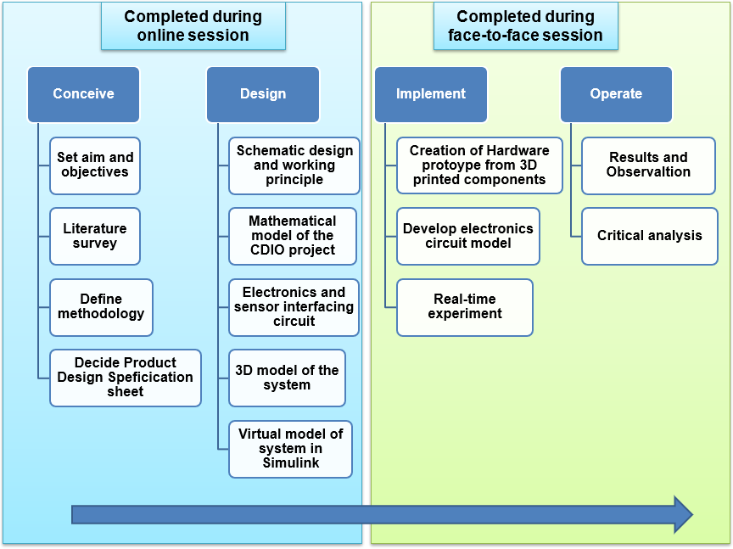
practical sessions were mainly planned for students to find out the possible solution of the CDIO project. During the time, students came up with innovative solutions for the CDIO problem and designed it using different software tools. Face to face practical sessions had been delivered after Easter so that students could manufacture the components and develop the prototype. In order to build the hardware model of the CDIO project, students have used several mechanical pieces of equipment during face-to-face sessions. They had also undergone health and safety training for handling equipment and operating these safely. Hence the arrangement of blended learning (Figure 1) has not only maintained the CDIO projects in flow with COVID19 restrictions but also improved the hands-on skill, critical thinking and teamwork ability of students. In this module, all student groups were encouraged to come up with their individual innovative ideas to design and develop the CDIO project. Following the strategy, conceive and design part of the CDIO project were completed during online sessions whereas the project was implemented and operated during the face-to-face sessions.

Figure 1. Pathway of implementing the CDIO project

During the conceive stage, students defined the aims and objectives of the CDIO project based on their proposed solution. After that, students performed a thorough investigation (literature review) on the existing projects (relevant to the CDIO problem) to know more about their advantages and limitations and drew their conclusion to identity the required properties needed to be incorporated in their proposed solution. In the next stage, the overall methodology of the project was proposed and described by each group with the required product design specification sheet (Stoll, 1999), technical and commercial attributes. As a part of literature research, students accumulated the specifications of the CDIO project with ideal value, target and achieved values where ideal value was determined from the research on existing projects, target values were decided by the cost, time and several other factors whereas achieved values were recorded after developing and testing the prototype. All these processes were

completed during online sessions. During the design stage, students developed the design framework of the CDIO project and its associated outputs from a technical perspective such as schematic design, mathematical model, 3D model, electronics circuit, sensor interfacing circuit, virtual model. A Gantt chart with an appropriate timeline was provided to students. Different types of software were used to develop those models such as Fusion360 for creating 3D models, Tinkercad for designing the electronics circuit and sensor interfacing circuit, Arduino studio for embedding code in Arduino board, MATLAB and Simulink for creating a mathematical and virtual model of the proposed solution. The advantage of using these software tools was that students could furnish those tasks online, evaluate the model virtually before finalizing the hardware. Besides, learning those software made their portfolio strong for a career goal. For implementing the CDIO project, face-to-face sessions were arranged so that students could manufacture the hardware parts of the CDIO project. During operate stage, a comparative analysis was drawn by students between the real-time results, simulation results and theoretical results. Finally, all students submitted their CDIO project report (mentioning individual contribution in the project work) and presented as a group.

GROUP PROJECT SESSIONS

The CDIO project was based on a group-based task where 3 to 4 students were involved per group in providing an innovative solution to a real-time engineering problem. Although it is a group project, students found it difficult to manage teamwork during online sessions due to several reasons such as technical, physiological and mental wellbeing issues (Savage et al., 2020). Several students suffered from COVID19, therefore they could not attend several sessions and missed important discussions of the project work. Staying at home, disengagement with peers and friends in person has made the majority of students mentally not well. Students with prolonged medical illness (legionnaires disease and mental health issues) and learning disability ( dyslexia, AHDD, and autism) sometimes unable to convey their opinion properly during online sessions and a miscommunication gap occurred. Should be noted that 20% of the cohort have learning support plans typically learning disability (dyslexia, AHDD or autistic), equally the cohort has number of students not officially diagnosed due to costly, protracted process, waiting times for appointments in the UK. Students not in University accommodation in Canterbury, surrounding area or countryside locations faced challenges with internet connectivity (as Kent is poorly broadband served). Therefore the communication was often interrupted during the group sessions. In addition students’ hardware mic and cameras would function with MS Teams, but not Blackboard Collaborate, however chat functions were operable. Another important issue was the lack of IT equipment among the students from low economic backgrounds hence it did not allow them to continue the scheduled online sessions with other students.
In order to incorporate the seed of teamwork among the students during online sessions, breakout groups were created in the blackboard collaborate platform for facilitating teamwork, nurturing constructive discussion and generating critical thinking. Even disabled students had been treated in the same way (with extra support from tutors) as they joined a usual group and participated in the group task. Constructive criticism of ideas was always helpful for a group project. A discussion room was created in blackboard for sharing weekly progress, and doubts and tutors reviewed those reports by providing constructive comments to improve them further. The whole task was divided into several sub-tasks and distributed among the group members so that each team member in the group had the responsibility to complete a specific part of the project and shared the outcome with others. For example, the person who did the 3D modelling of the project during online sessions, will manufacture the components using 3D printer and assemble them to develop the prototype during face-to-face sessions. Although the subtasks were assigned to each person in a group, they could seek

assistance from team members while doing their part of the job hence enhancing their ability to pursue teamwork and partnership in the project. To support the students with physical and mental health issues, the student-wellbeing team functioned efficiently and provided the required help. Students also got benefited from the CCCU hardship fund to buy IT equipment for learning.

ONLINE ASSESSMENT STRATEGY

The assessments associated with the CDIO project were designed to judge their technical skills as well as several professional attributes such as critical thinking, hands-on skill etc.
- At the end of the CDIO project, students submitted a group poster where they described the aims, methodology, design, manufacturing and testing results of the CDIO project. All team members in a group contributed to designing the poster and present it in front of a panel. Due to COVID restrictions, the poster presentation was organised online.
- Finally, students also submitted individual CDIO project on producing their novel idea to overcome the issues raised by the industry. The project report included the design model, test and results in detail. Through this CDIO project, students did reflect on designing a project from scratch with the help of other team members, finding an appropriate solution and develop the prototype and finally writing a scientific report.

CDIO PROJECT OUTCOME AND PERFORMANCE OF STUDENTS

The project was based on designing and developing a digital, portable and affordable solution for measuring tensile strength. The project ideas (Figure 2) pursued by the students were brilliant, innovative and diverse consisting of spring based linear displacement to transform tensile strength into digital scale, ultrasonic sensor displacement in terms of measuring continuous tensile force, encoder based angular displacement due to tensile force, strain gauge-based solution for measuring tensile strength, force sensor-based solution for measuring tensile strength etc along with different types of mechanism. Their outcome of those CDIO project was satisfactory as per the quality and standard.
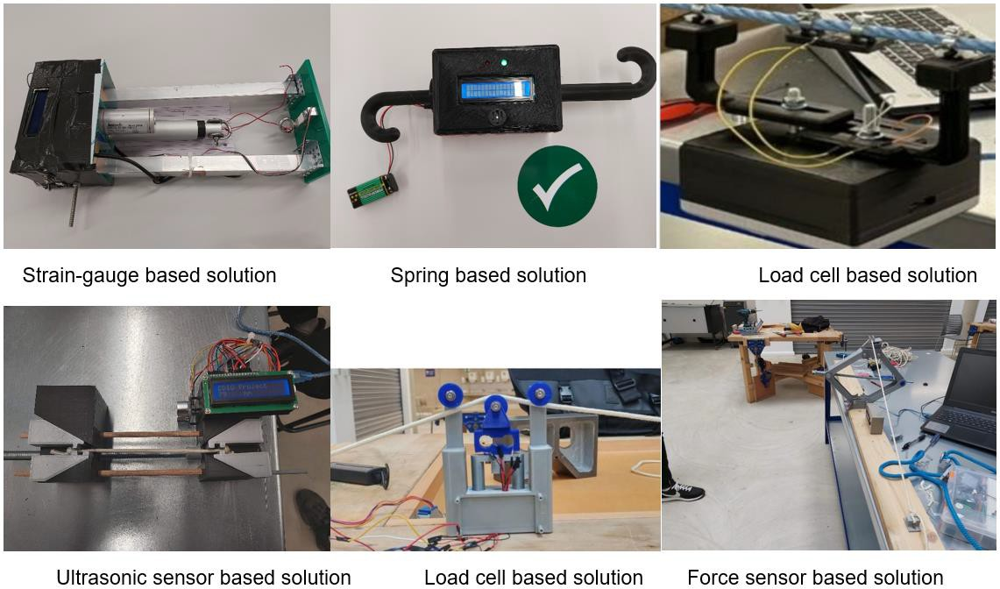
Figure 2. Innovative solutions proposed by students

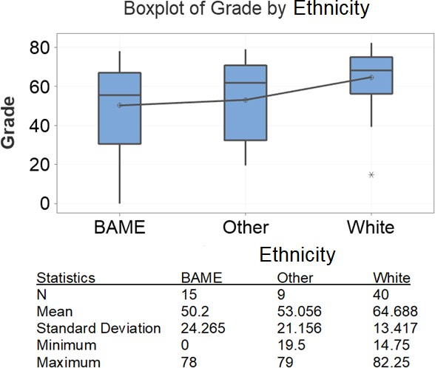
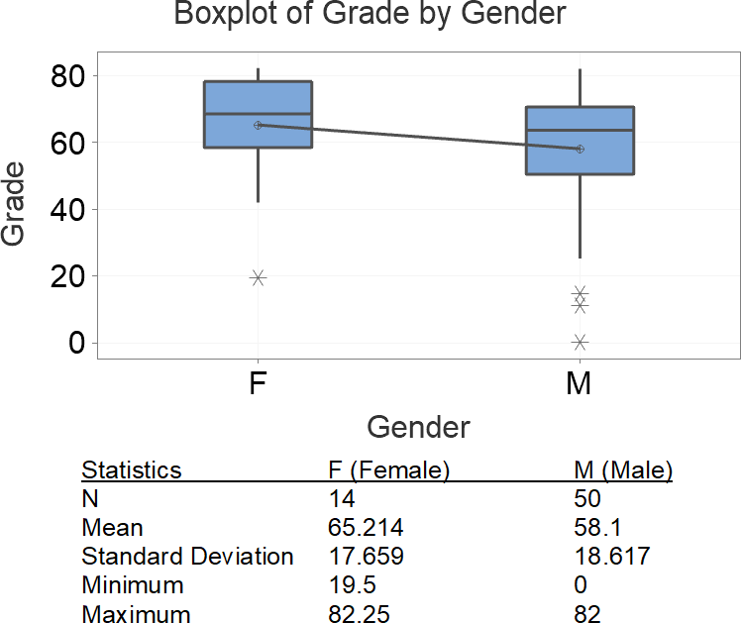
Along with the outcome of the prototype, both group poster and individual CDIO project report of the students were assessed for evaluating their performance and grades. The student grades have been analysed through Minitab® (statistical software). There were 72 students enrolled in the module, however, 8 students did not engage in the module and their marks are excludes. Hence, we have only considered the marks of 64 students for the analysis. The first- time overall pass rate is relatively high (86%). The average grade of the module is 59.66 (excluding missing marks) and the Standard deviation is around 18.51 which proves that students have achieved high grades. The grades of the students have been investigated further based on ethnicity (Figure 3a), Gender (Figure 3b) and disability (Figure 3c) using box plots. From Figure 4a, it shows that the average grade of the white students is 64.69 which is comparatively higher than that of BAME (black, Asian and minority ethnic, 50.2) and other ethnic students (53.06), also the grades of white students have been distributed close to the mean value whereas the spread of grades for BAME and other ethnic students is varied across a longer range. The grades achieved by female students (mean value: 65.21) is also appeared to be higher than male students (mean value: 58.1), as shown in Figure 3b. Due to the inclusive learning framework, disabled students have performed well in the CDIO project, the average grade of disabled students is 66.59. Although the number of disabled students is only 13, it shows a significant improvement.

a. Overall grades of students based on ethnicity b. Overall grades of students based on gender
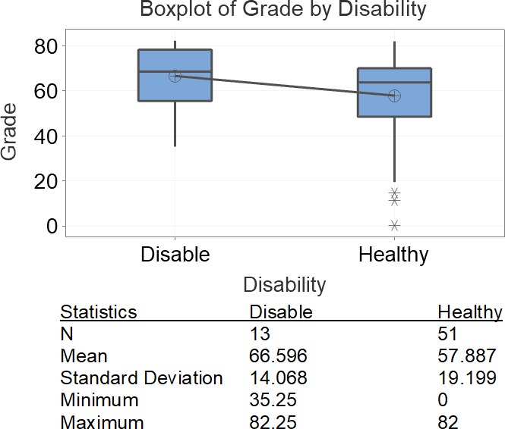

c. Overall grades of students based on health status
Figure 3. Performance analysis of students based on several factors

The pass rate of students has been reflected in all types of student cohorts, for example, the pass rate of female students is 98.43%, for BAME students is 93.75% and for other ethnic students is 95.31%. The overall pass rate of disabled students is also 98.43%. The performance of students has been further investigated using box plot of groups where student cohorts have been divided into disabled and healthy around gender, ethnicity around gender. Figure 4a shows that disabled students of both male and female gender have achieved higher grades compared to health students. Similarly, male and female white students have achieved higher grades compared to other ethnic and BAME students (Figure 4b). It also shows that female BAME students actually performed well and achieved good grades, however, male BAME students faced difficulties and need more support (Figure 4b).
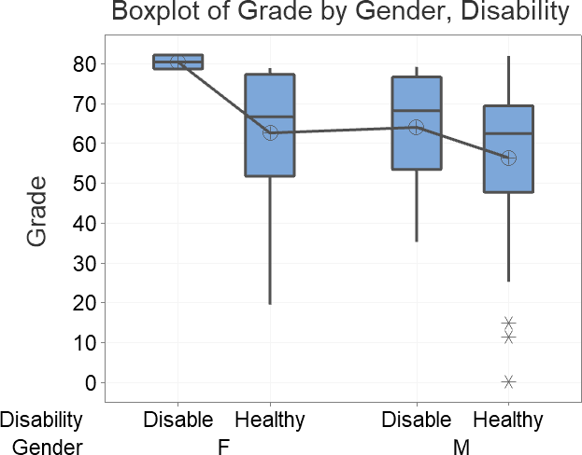
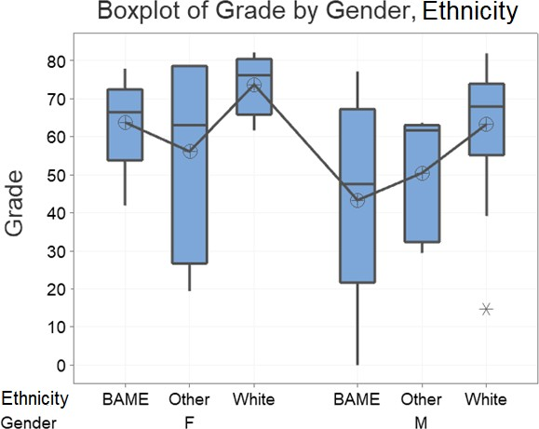
Figure 4a. Performance of disabled students Figure 4b. Performance of different ethnicity based on gender students based on gender

The grades of the students have been distributed around the age level of students and shown in the main effect plot (Figure 5). It shows that students within the age group (> 23 years and
< 19 years) have achieved higher grades. On the other hand, the average grade of the students in the age group between 21 and 23 is lower and the amount of variation in the grades is significantly higher compared to other age groups.
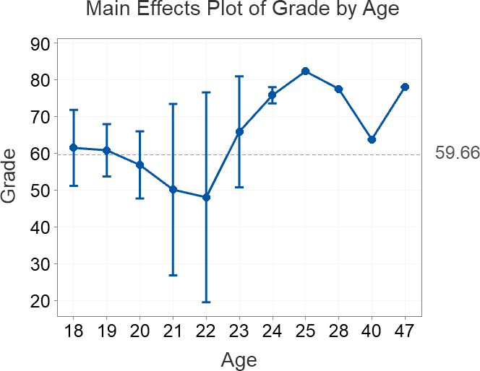
Figure 5. Distribution of grade over the age group of students

A survey with a qualitative questionnaire was conducted among the students to know their experience in the module. The questionnaire was focused to judge their experience while

completing and supporting CDIO projects and how it helped to grow the professional and technical skills of students. It also included the experience and future recommendations from students related to the engagement of employability skills using CDIO projects. Ethical consideration was approved before starting the project to maintain the data protection act and GDPR. The overall experience was above the satisfactory level from students’ perspectives. Feedback from students was really positive, helpful and informative. The arrangement of CDIO project sessions was really efficient in terms of fulfilling students’ expectations and it was also reflected in their final assessment. There are few improvements required in several areas such as in time allocation for completing the project, industrial engagement, engagement of disabled students in group work, blended learning approach, conflict of interest in a group project, enhancing outreach and networking in the real-time world etc. We have also received positive feedback from ‘Barton Marine’ regarding the outcome and standard of the project.

CONCLUSION

The main aim of introducing the CDIO project in this module was to enhance the critical thinking, hands-on skills, teamwork and report writing skill of students. Most of the aims have been already achieved through optimal use of blended learning, arrangement of supporting workshops, problem-based learning and so on while keeping several areas for improvement. The survey consisting of students’ involvement and experience (innovative ideas development, way of completion, level of outcome, project planning) in finishing the CDIO project was satisfactory. In this CDIO project, students also implemented previously gained knowledge that had been taught in previous modules. For example, students learned Fusion360 and Tinkercad in the last semester. However, they used Fusion360 for designing the 3D model of the CDIO project and Tinkercad for designing its electronics model. Due to the involvement of industry, it did not merely appear as an academic project as students are engaged to the industrial platform, talked to industry people and have created an understanding of the outside engineering world. Working in a multidisciplinary CDIO project, students became familiar with the overall structure of a system, its associated components and functions. Therefore, it also helped to incorporate the problem-solving skill so that students could resolve real-life engineering problems using their mechatronics knowledge. Several future action plans have been considered in the reflecting stage in order to overcome the current limitations. For example, the CDIO project can be divided into two segments between two levels (Foundation year and level4) where basic parts will be designed and developed by foundation year students and level 4 students will work at the advanced level of the project. The students from both levels will be working together to present the project, in a way level4 students can supervise the foundation year students enhancing teamwork and leadership capability. Due to COVID19 restrictions, it was not possible to keep face-to-face interaction with the industry. When the situation will become normal, an industrial visit will be planned for students to enhance their engagement. It is always difficult to integrate disabled students in a group project due to their communication issues with other group members. The best practice will be to provide extra support for them so that would not fall apart and lag behind other team members. Students will be encouraged to unite irrespective of their abilities and disabilities in order to manage the group work. In the last academic year, we had to keep block practical during the face-to-face sessions for maintaining a certain number of students in a lab. To improve the student learning experience, weekly practical sessions will be arranged for students as students can follow weekly lectures with relevant practical sessions rather than doing it after five to six weeks. Apart from all these academic supports, more individual support should be provided to students suffering from mental and physical wellbeing. Although several learning support arrangements are already in place for disabled students, still the university should provide extra student-

that students will be more confidents during their studies.

REFERENCES

Chuchalin, A. (2020). Evolution of the CDIO approach: BEng, MSc, and PhD level. European Journal of Engineering Education, 45(1), 103-112.
Diez-Olivan, A., Del Ser, J., Galar, D., & Sierra, B. (2019). Data fusion and machine learning for industrial prognosis: Trends and perspectives towards industry 4.0. Information Fusion, 50, 92-111.
Engineering Council. (2014). The accreditation of higher education programmes: UK standard for professional engineering competence.
Ercan, M. F., & Khan, R. (2017). Teamwork as a fundamental skill for engineering graduates.
Paper presented at the 2017 IEEE 6th International Conference on Teaching, Assessment, and Learning for Engineering (TALE), 24-28.
Lapitan Jr, L. D., Tiangco, C. E., Sumalinog, D. A. G., Sabarillo, N. S., & Diaz, J. M. (2021).
An effective blended online teaching and learning strategy during the COVID-19 pandemic. Education for Chemical Engineers, 35, 116-131.
Llorens, A., Berbegal-Mirabent, J., & Llinàs-Audet, X. (2017). Aligning professional skills and active learning methods: An application for information and communications technology engineering. European Journal of Engineering Education, 42(4), 382-395.
Manna, S., Nortcliffe, A., & Sheikholeslami, G. (2020). Developing engineering growth mindset through CDIO outreach activites.
Pee, S. H., & Leong, H. (2005). Implementing project based learning using CDIO concepts.
Paper presented at the 1st Annual CDIO Conference,
Peimani, N., & Kamalipour, H. (2021). Online education and the covid-19 outbreak: A case study of online teaching during lockdown. Education Sciences, 11(2), 72.
Pusca, D., Bowers, R. J., & Northwood, D. O. (2017). Hands-on experiences in engineering classes: The need, the implementation and the results. World Trans.on Engng.and Technol.Educ, 15(1), 12-18.
Savage, M. J., James, R., Magistro, D., Donaldson, J., Healy, L. C., Nevill, M., & Hennis, P.
J. (2020). Mental health and movement behaviour during the COVID-19 pandemic in UK university students: Prospective cohort study. Mental Health and Physical Activity, 19, 100357.
Siregar, Y. E. Y., Rachmadtullah, R., Pohan, N., & Zulela, M. S. (2019). The impacts of science, technology, engineering, and mathematics (STEM) on critical thinking in elementary school. Paper presented at the Journal of Physics: Conference Series, , 1175(1) 012156.
Stoll, H. W. (1999). Product design methods and practices CRC Press.
Zainuddin, S. Z. B., Pillai, S., Dumanig, F. P., & Phillip, A. (2019). English language and graduate employability. Education Training,

BIOGRAPHICAL INFORMATION

Dr Soumya Kanti Manna is currently a Lecturer and Course Director (Biomedical Engineering) at the School of Engineering Technology and Design, Canterbury Christ Church University, UK. Soumya completed his master in Mechatronics and PhD in Medical Robotics. Soumya’s research interest primarily lies in the areas of designing assistive devices and healthcare products, sensor deployment for gait analysis and and IoT based biomedical applications. He is also interested in engineering education-based research using CDIO based project curriculum to explore new pedagogy approaches.

Dr Najah Battikh is currently a Lecturer and Course Director for Chemical Engineering at the School of Engineering Technology and Design, Canterbury Christ Church University, UK. Najah has a degree in Chemical Engineering, MSc in Embedded Systems Engineering and PhD in Chemical Engineering. Najah’s main research interests include the use of optical techniques in characterising the crystallisation process as also how this can be utilised in combination with rapid heating and cooling to control the crystallisation process in chemical and pharmaceutical industries as well as water treatment, Desalination, and the removal of microplastics from water. She is also interested in Engineering Education Research and CDIO based project activities.

Dr Anne Nortcliffe is Head of the School of Engineering, Design and Technology. Anne has a degree in Chemistry, MSc in Control Engineering, PhD in Process Control Engineering, industrial experience in artificial intelligence and software engineering for the Chemical Engineering Industry. Anne has been an academic in several institutions teaching, leading in areas of automation, manufacturing, computer networks, aerospace/aeronautical, software engineering, software entrepreneurship, mechanical and materials engineering. Anne is an active engineering education researcher with an international reputation in engineering employability development, learning technology to support computing and engineering education, and engineering education pedagogical approaches.

Dr Joseph Camm is currently a Lecturer at Department of Mechanical, Materials and Aerospace Engineering, University of Liverpool, UK. He was a former Lecturer at the School of Engineering Technology and Design, Canterbury Christ Church University, UK. His doctorate research focused on reducing harmful exhaust emissions in the car industry, and has now been adapted to study greener alternatives for asthma inhalers. He also contributed towards developing the CDIO project and its implementation at CCCU.

Corresponding author

Dr Soumya Kanti Manna  School of Engineering, Technology and Design  Canterbury Christ Church University Canterbury, Kent  CT11QU, UK  soumyakanti.manna@canterbury.ac.uk | This work is licensed under a Creative Commons Attribution-NonCommercial- NoDerivatives 4.0 International License.

