‘Honour’-Based Abuse: A descriptive study of survivor, perpetrator, and abuse characteristics

Keziah Ridley
Department of Psychology, University of Liverpool. Keziah.ridley@outlook.com

Professor Louise Almond
Department of Psychology, University of Liverpool. lalmond@liverpool.ac.uk

Nefeli Bafouni
Savera UK. info@saverauk.co.uk

Afrah Qassim
Savera UK. info@saverauk.co.uk

Acknowledgements
The present study would not have been made possible without the significant contribution of Savera UK staff. The authors would like to recognise the assistance of the Support Team in the methodological phases and the Communications Team in the publication stages of this research project. Specifically, we would like to acknowledge Beatriz Roberts and Tania Vera-Rigby for their help in the design of the coding directory. We would also like to thank Merfat Musleh, Beatriz Roberts, Leah Kratschmann and Laura Toohey for their support in the data collection, coding and anonymization phases. Special thanks to Nikki Croft-Girvan for her input around terminology and branding.

Abstract
Current literature on ‘honour’-based abuse (HBA) has largely focused on exploring the lived experience of individuals, with limited analysis of the prevalence and associations of abuse characteristics. The aim of this study was to identify base rates of survivor, perpetrator and abuse characteristics. To identify these characteristics and their prevalence, 160 cases from Savera UK, a charity specialising in ‘honour’-based abuse and harmful practices, were coded for 66 variables and descriptive statistics produced. Fifteen of the coded abuse characteristics were present in more than 50% of cases, with “Emotional / psychological abuse and coercive control”, “Specific family cultural traditions”, “Gender-based socialisation” and “Physical violence” being the only characteristics seen in more than 75% of cases. These represent the core characteristics of HBA but there are indications of qualitative and quantitate differences in this sample. Understanding the prevalence of characteristics is key to effectively identifying abuse, supporting survivors and improving effective prevention strategies.

Keywords: ‘honour’-based abuse/violence, survivors, characteristics, base rates.
Introduction
It is estimated that around 15 murders are committed in the UK each year in response to a perceived breach of ‘honour’ (Khan et al., 2021). Home Office (2020) statistics including all UK police forces, except Greater Manchester, recorded 2,024 ‘honour’ -based abuse offences in 2019. These figures are still likely to represent a lower number of incidents than those that have actually taken place, as they capture only incidents recorded by police. As perpetrators and involved communities often make efforts to ensure these crimes are kept hidden, many incidents may never be reported (Gill et al., 2012; Home Office, 2020; Payton, 2014). Despite the scale of offences highlighted in these statistics, this type of abuse is not officially recognised as a specific recorded crime category (CPS, 2017; Gill et al., 2018).
It is important to highlight distinctions between the term ‘honour’-based violence (HBV) and ‘honour’-based abuse (HBA). The former refers specifically to behaviours involving physical force intended to hurt, damage or kill to defend the ‘honour’ of an individual, family and/or community, while the latter refers to (but is not limited to) acts or threats of physical violence and other non-physical forms of abuse. However, these terms are frequently used interchangeably and this is also the case in this study. The following is the definition of ‘honour’-based abuse used by the UK Crime Prosecution Service (CPS):
“An incident or crime involving violence, threats of violence, intimidation coercion or abuse (including psychological, physical, sexual, financial or emotional abuse) which has or may have been committed to protect or defend the honour of an individual, family and/ or community for alleged or perceived breaches of the family and/or community’s code of behaviour.” (CPS, 2019).
‘Honour’-based abuse is therefore addressed in law as a collection of offences which are covered under other existing legislation (CPS, 2017). This means that incidents may be recorded under other headings, further complicating the determination of how prevalent ‘honour’-based abuse is (Gill et al., 2018; Mulvihill et al., 2019). The recognition and identification of this abuse is also complicated by the absence of statistics on the characteristics present in ‘honour’-based abuse (Aplin, 2017).
In 2008, an inquiry into domestic violence and ‘honour’-based abuse by the U.K. Parliament’s Home Affairs Select Committee highlighted that the lack of data on ‘honour’-based abuse makes it difficult for agencies to understand and appropriately respond to this type of abuse/violence (Parliament, House of Commons, 2008). However, despite this, in the years since that report there has been limited improvement in the availability of statistics on ‘honour’-based abuse. Bates (2021) highlights that there is a dearth of evidence on specific behaviours involved in ‘honour’-based abuse that are not murder, as well as the associations between those behaviours, along with the characteristics of those who perpetrate ‘honour’-based abuse.
Literature on ‘honour’-based abuse has typically explored the lived experienced of survivors. This often involves the use of interviews, focus groups and case studies. These methodologies allow an in-depth insight into the experiences of survivors, highlighting the unique vulnerabilities of specific individuals and the barriers they face in accessing support. By exploring the experiences of individuals, characteristics which occur across different cases are more easily identifiable. Across these studies, common characteristics seen in survivors are gender (e.g. Gill et al., 2012; Hague et al., 2012), having premarital sex (e.g. Gill et al., 2012; Payton, 2014) and survivors’ romantic partner not being approved of by their family (e.g. Campbell et al., 2020; Dyer, 2015). Similarities are also seen in the abuse characteristics, such as forced marriage (e.g. Bates, 2021; Gill et al., 2018) and threats to harm or kill the survivor or their children (e.g. Dyer, 2015; Gill, 2008), as well as in vulnerability characteristics, for example, having an insecure immigration status (e.g. Bates, 2021; Begum et al., 2020; Payton, 2014). However, despite recognition of recurring characteristics, limited research exists on the prevalence of each of these characteristics within a larger sample (Bates, 2021).
Currently in the UK, ‘honour’-based abuse is often addressed as a form of domestic abuse and generic domestic abuse risk assessment tools are used to identify it. Domestic abuse is defined as “any incident or pattern of incidents of controlling, coercive or threatening behaviour, violence or abuse between those aged 16 or over who are or have been intimate partners or family members regardless of gender or sexuality” (Home Office, 2012). In comparing this definition to that of ‘honour’-based abuse, the similarities between the two are easily identified, with the key difference being that the primary motive in ‘honour’-based abuse is the protection or defence of a family’s or community’s ‘honour’. In fact, Bates (2021) argues that honour is a “culturally specific” tool for control of a victim, which could be replaced with other cultural tools in cases of white British domestic abuse.
However, literature on ‘honour’-based abuse has suggested that distinguishing it from domestic abuse creates a separation of abuse against black and ethnic minority women from domestic abuse against white women (Bates, 2021; Gill & Brah, 2013). It is argued that by othering of victims of ‘honour’-based abuse from “mainstream” abuse, we perpetuate stereotypical beliefs of people from other backgrounds and different practices (Gill & Brah, 2013; Payton, 2014). This in turn encourages the attribution of this form of abuse to ethnic minority cultures and communities, but the assumption that ‘honour’-based abuse is only a cultural or religious issue can cause dismissal and disregard of victims, preventing their needs from being met (Gill et al., 2012; Walker, 2020).
It is important to recognise the range of other characteristics which make ‘honour’-based abuse distinct from domestic abuse. Gill et al. (2018) discuss how ‘honour’-based abuse holds, to at least some extent, family or community complicity, whether that be in approving or contributing to the abuse. HBA is mostly committed in response to shameful or inappropriate behaviours judged to be against a family’s or community’s accepted code of behaviour, again pointing to a wider group involvement in ‘honour’-based abuse than is seen in domestic abuse. Acts committed with the intention of restoring ‘honour’ are often premeditated and rooted in patriarchal beliefs of male control over women’s lives (Dyer, 2015; Gill, 2008). This element of restoring ‘honour’ is therefore a key feature of ‘honour’-based abuse and treating HBA within domestic abuse frameworks may be limiting the specificity and appropriateness of recommendations for supporting those at risk. Therefore, in order to better support survivors, an improved understanding of ‘honour’-based abuse is needed.
Not being able to evidence the pervasiveness of specific characteristics limits the level to which we can understand ‘honour’-based abuse. This gap in knowledge increases the difficulty of identification efforts, limits the ability of policies and legislation to accurately address the abuse that individuals are suffering and can hamper agencies’ ability to provide specific recommendations or tailored interventions to best safeguard survivors. In addition to this, an understanding of which characteristics are present in cases of ‘honour’-based abuse can also provide the basis for identifying relationships between abuse behaviours and largely assist in developing frameworks to risk assess cases based on the characteristics of the survivor, the perpetrator/s and the abuse itself. This study therefore aims to provide base rate information on key characteristics of survivors, perpetrators and abuse in incidents of ‘honour’-based abuse.

METHOD

Savera UK provided 160 anonymised cases of ‘honour’-based abuse, coded for 66 different survivor, perpetrator and abuse characteristics. Savera UK is a leading national charity tackling culturally-specific abuse in the UK, including ‘honour’-based abuse/violence, forced marriage and female genital mutilation (FGM). It works with survivors and those at risk of ‘honour’-based abuse and harmful practices, providing individuals with holistic support to leave abusive environments and find their ‘savera’ - meaning ‘new beginning’ in Hindi - regardless of age, culture, sexuality or gender. The charity also campaigns to eradicate harmful practices, educating and empowering organisations and individuals to identify and challenge harmful attitudes, behaviours, prejudices and practices that violate individual human rights (Savera UK, n.d). Whilst advice and guidance is available to anyone in the UK, long term support work is currently undertaken with survivors residing in specific regions of the North West.
The coded information was extracted from cases of ‘honour’-based abuse survivors who had received intervention and support from Savera UK. A literature review highlighted key characteristics that were considered prevalent in ‘honour’-based abuse cases and in how this phenomenon is understood in the UK. Alongside this, the Savera UK Support Team employed their professional experience and judgement to collate further characteristics and abuse patterns observed in ‘honour’-based abuse cases they had worked on. The experience of the Savera UK Support Team enabled the consideration of characteristics that the literature may not have highlighted, helping expand the present understanding of ‘honour’-based abuse. The characteristics identified from both existing literature and professional experience were combined to create a coding list of HBA factors (see Appendix for coding dictionary). The Savera UK Support Team then reviewed case files to identify the presence of these characteristics, which ensured survivor anonymity and confidentiality. The data used was collected during initial interview and ongoing support work with survivors and staff were able to use their professional judgement to recognise the presence of characteristics based on survivor disclosures, specialist assessments and multi-agency intelligence. Variables were coded as Present/Absent or Unknown. The anonymised data was provided to the researchers who then conducted analyses of the frequencies and percentages of the different survivor, perpetrator and abuse characteristics to identify their specific base rates within this sample.

RESULTS
Survivor characteristics
From the total 160 cases, 155 were female and 5 were male survivors, aged between 13 and 68 years (Median=33 years; see Figure 1). Geographical origin was known in 149 cases. The 29 different origins listed were grouped into 6 large geographical regions (see Table 1). Around a third of known cases were from South Asia (36.9%), followed by Middle East (31.5%). It is important to note there was also a small prevalence of survivors from Europe (8.1%). Religion was also recorded for 127 survivors, with three in four identifying as Muslim (74.8%; see Table 2).

Figure 1 - Survivor age (n=160)
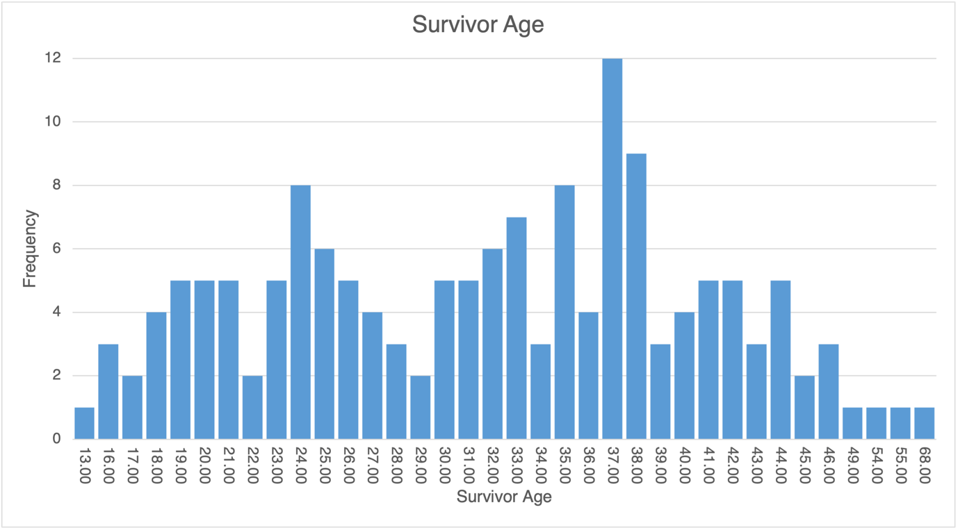

Table 1: Survivor and Perpetrator Geographical Origin

 | Survivor N=149 |  | Perpetrator N=59
Geographical origin | N | % | N | %
South Asian | 55 | 36.9 | 21 | 35.6
Middle Eastern | 47 | 31.5 | 23 | 39.0
African | 33 | 22.1 | 12 | 20.3
European | 12 | 8.1 | 2 | 3.4
Other | 2 | 1.3 | 1 | 1.7
Note. When survivors had dual nationality the second origin was coded, i.e. British-Nigerian was coded as African

Table 2: Survivor and Perpetrator Religion
 | Survivor N=127 |  | Perpetrator N=84
Religion | N | % | N | %
Muslim | 95 | 74.8 | 69 | 82.1
Christian | 18 | 14.2 | 9 | 10.7
Hindu | 7 | 5.5 | 6 | 7.1
Atheist | 6 | 4.7 | 0 | 0.0
Bahai | 1 | 0.8 | 0 | 0.0

The relationship status of survivors was known in 147 cases. The most frequently recorded was married (31.3%), single (26.5%) or separated (22.4%). In cases where the immigration status of survivors was known (133), 41.4% held citizenship, 27.8% were asylum seekers, 11.3% had Limited Leave to Remain and 6.8% had Indefinite Leave to Remain. Other known immigration statuses (12.7%) included student, family and spouse visas, refugees, European citizenship or expired visas.

Perpetrator characteristics
Nearly two thirds of the 160 cases involved multiple perpetrators (n=101; 63.1%). Age was known for only 57 perpetrators and ranged from 24 – 70 years (Median=41 years; see Figure 2). The perpetrator gender was known in 110 cases. All of these cases involved male perpetrators, although in 36.4% (40 cases) there were additional female perpetrators. No cases involved a sole female perpetrator.
Perpetrator geographical origin was known in only 59 cases (see Table 1), 39% of which were from the Middle East and 35.6% from South Asia. Cases with multiple perpetrators were from the same geographical origin. Similarly, religion was known in 84 cases (see Table 2), with 82.1% recorded as Muslim. The same religion was listed in cases when multiple perpetrators were present. Perpetrator relationship to survivor was known in 117 cases, with intimate partner (38.5%), family member (28.2%) or intimate partner and family member (24.8%) being the most common relationships.

Figure 2: Perpetrator age (n=57)
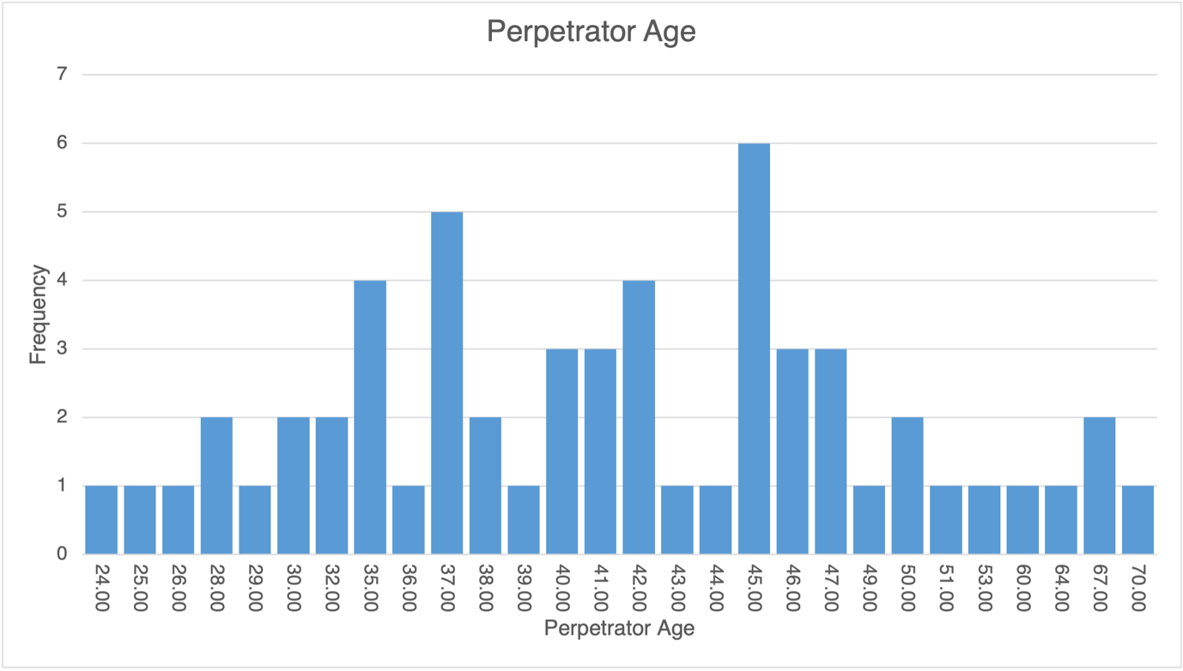

Abuse characteristics
Abuse characteristics were identified by reviewing the case files of survivors, and so primarily focus on the experience of the survivor, not perpetrators. As a result, the characteristics are discussed in their prevalence per case, rather than split into their prevalence for survivors or perpetrators. To ease understanding, characteristics have been split here into behaviours and attributes associated either with the perpetrator (see Table 3) or the survivor (see Table 4). Across the sample, the number of abuse characteristics for each case ranged from 0-31, with median number being 12.5 (see Figure 3). The most common characteristic was “Emotional / psychological abuse and coercive control”, identified in 91.7% of cases where presence or absence was known. “Specific family cultural traditions” (90.5%) and “Gender-based socialisation” (88.4%) were similarly high, with “Physical violence” (79.2%) being the only other characteristic present in over 70% of cases where presence or absence was known. Of the ten most prevalent characteristics, only one was associated with the actions and attributes of the survivor, “Attempts to flee / separate” (64.3%), whilst all other characteristics were associated with the perpetrators.

Figure 3: Number of abuse characteristics present
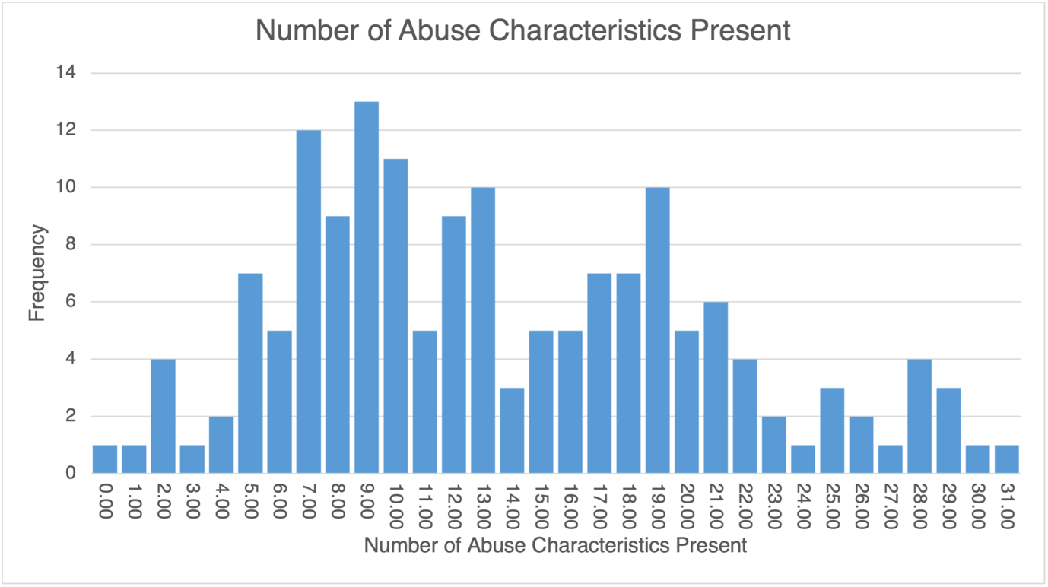

Table 3. Prevalence of Abuse Characteristics Associated with Perpetrators
Characteristic (where presence/absence is known) | n | %
Emotional / psychological abuse and coercive control (N=132) | 121 | 91.7
Specific family cultural traditions (N=148) | 134 | 90.5
Gender-based socialisation (N=138) | 122 | 88.4
Physical violence (N=125) | 99 | 79.2
Threats to harm / kill the survivor or their children (N=114) | 78 | 68.4
Multiple perpetrators (N=148) | 101 | 68.2
Behaviours / communications are policed (N=98) | 62 | 63.0
Community is influencing perpetrator (N=90) | 56 | 62.2
Intimate partner violence (N=137) | 85 | 62.0
Perpetrator has parental responsibility (N=93) | 48 | 51.6
Financial abuse (N=102) | 50 | 49.0
Threats towards survivor’s family (in UK) (N=76) | 30 | 39.5
Perpetrator has history of violence (N=93) | 36 | 38.7
Forced marriage (N=133) | 51 | 38.3
Sexual violence (N=105) | 38 | 36.2
Dependants have contact with perpetrator (N=102) | 36 | 35.3
Threats to remove / kidnap children (N=94) | 27 | 28.7
No access to phone / internet (N=98) | 27 | 27.6
False imprisonment (N=83) | 21 | 25.3
Perpetrator is a professional (N=124) | 17 | 13.7
Female genital mutilation (N=123) | 13 | 10.6
“Special ceremony” planned (N=85) | 4 | 4.7
Sudden announcements of engagement (N=86) | 3 | 3.5
Extended school holiday requests (N=81) | 1 | 1.2

Table 4. Prevalence of Abuse Characteristics Associated with Survivors (n=160)
Characteristic (cases where presence/absence is known) | n | %
Attempts to flee / separate (N=126) | 81 | 64.3
Social isolation (N=113) | 69 | 61.1
Domestic violence within family home (N=114) | 67 | 58.8
Westernisation (N=101) | 52 | 51.5
Location risk (N=154) | 78 | 50.6
Community links (N=107) | 42 | 39.3
Court proceedings (N=109) | 42 | 38.5
Agencies’ lack of understanding around HBA (N=93) | 32 | 34.4
Career / education (N=71) | 24 | 33.8
Language barrier (N=153) | 51 | 33.3
Missing school / work (N=88) | 26 | 29.5
Mental health illness (N=150) | 43 | 28.7
Shared housing (N=146) | 40 | 27.4
Previous attempts to access support (N=92) | 24 | 26.1
Police perception (N=91) | 21 | 23.1
Premarital sex (N=91) | 21 | 23.1
Public “flirting” / male friendships (N=101) | 23 | 22.8
Cohabiting with perpetrator (N=157) | 33 | 21.0
Religion conversion (N=76) | 12 | 15.8
Self-harm (N=84) | 12 | 14.3
Premarital / unwanted pregnancy (N=95) | 10 | 10.5
Learning / physical disability (N=154) | 15 | 9.7
Identifiable vehicle (N=93) | 8 | 8.6
Adultery (N=97) | 8 | 8.2
Substance mis/use (N=108) | 4 | 3.7

DISCUSSION
Current research on ‘honour’-based abuse has provided limited information on the base rates of survivor, perpetrator or abuse characteristics. This study aimed to fill this gap, by using a larger sample to produce base rate information on key characteristics of survivors, perpetrators and abuse in cases of ‘honour’-based abuse within the UK. The generated statistics suggest that, on average, a case of ‘honour’-based abuse will include around 14 of the investigated abuse characteristics. The most common of these characteristics were “Emotional / psychological abuse and coercive control”, “Specific family cultural traditions”, “Gender-based socialisation” and “Physical violence”, present in over 75% of cases (where presence or absence was known). The high prevalence of these characteristics suggests that they are core elements of ‘honour’-based abuse in the UK and so are key to how we recognise and respond to this form of violence.
In the definition used for ‘honour’-based abuse, the presence of intimidation and coercion, physical violence and defence of a family or community ‘honour’ code is core, so the high prevalence of these characteristics associated with ‘honour’-based abuse was an expected finding. Similarly, characteristics such as gender and threats against the survivor and their children are frequently mentioned in ‘honour’-based abuse literature (e.g. Dyer, 2015; Gill, 2008; Gill et al., 2012; Hague et al., 2012), so while direct comparisons to their prevalence cannot be made here, it was expected that they would have a high presence. More surprising was the lower frequencies of some characteristics which have been highly linked to ‘honour’-based abuse within existing literature. “Premarital sex”, for example, was present in this study in less than 25% of the cases where presence was known, but female sexuality is frequently mentioned in ‘honour’-based abuse literature as a key motivation for acts of abuse (e.g. Aplin 2019; Gill, 2008; Payton, 2014). Given that much of the previous research on the topic has been based on self-reported data, be that through qualitative interviews or survivor questionnaires, it is possible that the abuse characteristics explored were more “obvious” breaches of the ‘honour code’. Examples of infidelity or exploration of identity and sexual orientation transcending heteronormative paradigms are certainly risk factors more readily recognisable by survivors, professionals and the general public in the discourse of ‘honour’-based abuse.
This study, however, was able to explore broader and subtler forms of abuse, as the data reflected not only survivor experiences, but also the professional judgement of Savera UK support staff specialising in this field. Savera UK support staff develop rapport and trusting relationships with survivors over time as part of their support intervention, which helps survivors feel safe and secure to make further disclosures and process their experiences. Through ongoing support survivors are encouraged to recognise abusive signs and behaviours which they may have initially considered as “normal” practice within the context of the abuse and common practice in their respective communities. This informed appreciation of survivors’ background enable them to overcome barriers and apprehension – common when speaking to professionals with a limited understanding of their cultural context, which greatly limits the scope and depth of disclosures made –, allowing them to go into greater detail and supporting a broader understanding of ‘honour’-based abuse. Therefore the informed interventions and professional judgement of Savera UK staff supported this study in capturing more behaviours than those identified in current literature.
The above highlight that potentially some of the characteristics which have been highly associated with ‘honour’-based abuse thus far might in reality reflect more westernised perceptions of the phenomenon rather than actual prevalence figures. This may be related to the big range of characteristics and behaviours which are constitute ‘honour’-based abuse, yet it raises important questions about what is considered fundamental to HBA. The identified prevalence of ‘honour’-based abuse characteristics does highlight similarities to domestic abuse. For example, the high prevalence of “Emotional / psychological abuse and coercive control” is also seen in intimate-partner violence, where a pattern of control and power emerges over time, with progressively increased financial and emotional abuse, the inclusion of children in the abuse, isolation of the victim and the use of intimidation, coercion and threats (Elkin, 2018, Johnson, 2010; Pence & Paymer, 1993). Much like this, ‘honour’-based abuse is also a form of control used to reinforce certain behaviours and expectations via threats or physical harm, as evidenced in the current study (Aplin, 2017; Gill, 2008; Idriss, 2017).
However, the presence of characteristics such as “Specific family cultural traditions”, “Gender-based socialisation”, “Multiple perpetrators” and “Community is influencing the perpetrator” in over 60% of cases highlights unique elements distinct in ‘honour’-based abuse. Indeed, the descriptive statistics in this study identified a core set of HBA characteristics prevalent in most cases, but the majority of abuse characteristics resulted in low/medium prevalence. This demonstrates the heterogeneity of the sample, indicating that there may be distinct HBA subgroups or themes of risk factors worth exploring further. It is possible, for example, that characteristics seen across both domestic and ‘honour’-based abuse may only reflect a subgroup or theme of HBA that aligns with generic domestic abuse, which is distinct from many other forms of HBA perpetration. Further exploration is thus essential in understanding the different manifestations of ‘honour’-based harm.

Implications
Understanding the prevalence of different ‘honour’-based abuse characteristics is key to an improved insight into this type of abuse (Bates, 2021). In providing a preliminary dataset on the prevalence of survivor, perpetrator and abuse characteristics, this study can assist frontline workers, such as police officers and social workers, in better recognising identifiable characteristics which are present in ‘honour’-based abuse cases in the UK. This can also support the development of risk assessment tools, much like the Domestic Abuse, Stalking, and ‘Honour’-based abuse (DASH; Richards, 2009) tool or Merseyside Risk Identification Toolkit (MeRIT), to risk assess specific cases of ‘honour’-based abuse more effectively and separately to generic domestic abuse. The identification of the unique characteristics of ‘honour’-based abuse and their prevalence forms the foundation for the exploration of their intricate relationships, which in turn can feed into the development of specialist risk assessment tools for survivors of ‘honour’-based abuse. This will allow support organisations to better identify individuals who are most at risk of further abuse and also tailor their programs of support to most appropriately and effectively meet individual identified needs. Above and beyond that, however, studies of this kind will enable agencies to better evidence their professional judgments based on scientific research results and not just empirical or anecdotal knowledge.

Limitations
The 160 cases of ‘honour’-based abuse examined in this study provided a good source of information. However, the data was not collected for the purpose of research and thus might have been captured slightly differently by support staff. Therefore, some characteristics may have been recorded as unknown even when present and thus variables may have occurred at higher frequencies than evidenced. Similarly, the sample collection was undertaken by multiple members of the Savera UK Support Team, so potential issues of inter-coder reliability need to be taken into consideration. An additional limitation was that the sample consisted of both historic and recent cases, so gathered information reflected a variety of life stages and survivor journeys. For example, active cases had more limited information, partly because in practice a good level of rapport and trust needs to be established before survivors can make full disclosures of the range of abusive behaviours they have endured. Furthermore, it is key to highlight that all included cases were UK-based and so represent only ‘honour’-based abuse characteristics and survivor experiences within the UK context. Naturally, the same characteristics may occur in different frequencies elsewhere and it is possible that other factors not identified in this UK sample are prevalent in other countries.
Lastly, information on the perpetrators was more limited than that of the survivors and many cases of abuse involved multiple perpetrators who might not have been discussed in length with support workers. The nature of ‘honour’-based abuse does mean that secondary perpetrators may never be identified. Information about the characteristics of these individuals and their behaviours is not known, which increases the difficulty of examining perpetrator characteristics. Although the instances where information was known allowed perpetrator characteristics to be analysed, there was a lower number of cases where this was possible. This also highlights the importance of accurate and thorough data gathering, as support agencies usually focus on survivors and often under-appreciate how perpetrator characteristics can provide useful insights into the nature of abuse and inform safeguarding efforts.

Future Research
This study has identified the base rates of key characteristics across survivors, perpetrators and abuse behaviours in ‘honour’-based abuse within the UK, but further exploration is still necessary. The replication of this study with a sample collected for the purposes of research and from a broader geographical region will provide a further understanding of ‘honour’-based abuse characteristics and consolidate current findings. Additionally, the base rates produced by this study can be used to inform the development of a risk assessment tool for ‘honour’-based abuse. The next step for this would be examining the relationship between the different characteristics and various outcomes in order to establish how they interact to increase the severity of abuse.
Future research could also investigate the relationships between different abuse characteristics, as well as their link to different types of perpetrators and survivors. For example, further exploration of intimate partner perpetration of ‘honour’-based abuse compared to family members’ perpetration would improve how this abuse is understood and recognised as separate to domestic abuse. Additionally, by exploring associations between characteristics, a thematic model of ‘honour’-based abuse could be developed, identifying distinct themes/risk profiles. A better understanding of these elements of ‘honour’-based abuse will assist the efforts of identification, support and policy agencies, allowing professionals to not only address this phenomenon more effectively, but also prevent it.

References
Aplin, R. L. (2017) Exploring the role of mothers in ‘honour’ based abuse perpetration and the impact on the policing response. Women’s Studies International Forum, 60, 1-10. 10.1016/j.wsif.2016.10.007
Aplin, R. L. (2019). Policing UK Honour-Based Abuse Crime. Springer International Publishing. 10.1007/978-3-030-18430-8
Bates, L. (2021). Honor-based abuse in England and Wales: Who does what to whom? Violence Against Women, 107780122095216-1077801220952168. 10.1177/1077801220952168
Begum, R., Khan, R., Brewer, G., & Hall, B. (2020). “They will keep seeing young women murdered by men. Enough is enough-we have seen too many women lose their lives”. Lessons for professionals working with survivors of ‘Honour’ abuse and violence. Genealogy (Basel), 4(3), 69. 10.3390/genealogy4030069
Campbell, G., Roberts, K. A., & Sarkaria, N. (2020). Harmful Traditional Practices. Palgrave Macmillan UK.
Crown Prosecution Service (CPS). (2017). Honour Based Violence and Forced Marriage. https://www.cps.gov.uk/publication/honour-based-violence-and-forced-marriage
Dyer, E. (2015). ‘Honour’ killings in the UK. The Henry Jackson Society.
Elkin, M. (2018). Domestic abuse: findings from the Crime Survey for England and Wales: year ending March 2018. Office for National Statistics.
Gill, A. (2008). ‘Crimes of honour’ and violence against women in the UK. International Journal of Comparative and Applied Criminal Justice, 32(2), 243-263. 10.1080/01924036.2008.9678788
Gill, A. K., & Brah, A. (2014). Interrogating cultural narratives about ‘honour’- based violence. European Journal of Women’s Studies, 21(1), 72–86. 10.1177/1350506813510424
Gill, A. K., Begikhani, N. & Hague, G. (2012). ‘Honour’-based violence in Kurdish communities. Women’s Studies International Forum, 35(2), 75-85. 10.1016/j.wsif.2012.02.001
Gill, A. K., Cox, P., & Weir, R. (2018). Shaping priority services for UK survivors of Honour‐Based violence/abuse, forced marriage, and female genital mutilation. Howard Journal of Crime and Justice, 57(4), 576-595. 10.1111/hojo.12287
Hague, G., Gill, A. K., & Begikhani, N. (2012). ‘Honour’-based violence and Kurdish communities: Moving towards action and change in Iraqi Kurdistan and the UK. Journal of Gender Studies, 22(4), 383-396. 10.1080/09589236.2012.708825
Home Office. (2012). New definition of domestic violence. https://www.gov.uk/government/news/new-definition-of-domestic-violence
Home Office. (2020). Statistics on so called ‘honour-based’ abuse offences recorded by the police. https://www.gov.uk/government/statistics/statistics-on-so-called-honour-based-abuse-offences-england-and-wales-2019-to-2020/statistics-on-so-called-honour-based-abuse-offences-recorded-by-the-police#:~:text=In%202019%202020%2C%20there%20were,and%20140%20forced%20marriage%20offences.
Idriss, M. M. (2017). Not domestic violence or cultural tradition: is honour-based violence distinct from domestic violence? Journal of Social Welfare and Family Law, 39(1), 3-21. 10.1080/09649069.2016.1272755
Johnson, M. P. (2010). A Typology of Domestic Violence: Intimate Terrorism, Violent Resistance, and Situational Couple Violence. Northeastern University Press.
Khan, Y., Khan, R., Adisa, O., Kumari, M., & Allen, K. (2021). ’honour’ abuse, violence, and forced marriage in the UK. Police cases (incidents and charges) and specialised training: 2018-2019. University of Central Lancashire.
Mulvihill, N., Gangoli, G., Gill, A. K. & Hester, M. (2019) The experience of interactional justice for survivors of ‘honour’-based violence and abuse reporting to the police in England and Wales. Policing and Society, 29(6), 640-656. 10.1080/10439463.2018.1427745
Payton, J. (2014). “Honor,” Collectivity, and Agnation. Journal of Interpersonal Violence, 29(16), 2863-2883. 10.1177/0886260514527171
Pence, E. & Paymar, M. (1993). Education Groups For Men Who Batter: The Duluth Model. Springer Publishing Company. 10.1891/9780826179913
Richards, L. (2009). Domestic Abuse, Stalking and Harassment and Honour Based Violence (DASH) Risk Identification and Assessment and Management Model. Association of Police Officers (ACPO).
Savera UK. (n.d). About Savera UK. https://www.saverauk.co.uk/information-support/about-savera-uk/
Walker, S. (2020). The culturalization of ‘honour’-based violence and its impact on service provision in rural communities. Journal of Gender-Based Violence 4:3, pages 377-391.

APPENDIX
Coding Dictionary

Characteristic | Description
Adultery | Survivor has had an extramarital affair
Agencies’ lack of understanding around HBA | Professionals (especially statutory agencies, i.e. Police, Social Services) are not appropriately recognising or managing risks, relevant protocols are disregarded etc.
Attempts to flee / separate | Survivor attempts to flee abusive environment or separate from spouse, i.e. accessing refuge
Behaviours / communications are policed | Survivor’s movements and contacts are closely monitored
Career / education | Survivor’s wishes to study or work go against their family’s/ community’s expectations
Cohabiting with perpetrator | Survivor resides in the same address as perpetrator
Community is influencing perpetrator | Community members advise or pressure perpetrator, influencing abusive behaviour
Community links | Survivor mixes or engages with community members who perpetuate honour beliefs or has mutual friends with perpetrator
Court proceedings | Ongoing criminal prosecution or civil applications, i.e. for injunctions, divorce, child arrangements etc.
Dependants have contact with perpetrator | Survivor’s children are in direct (in-person) or indirect (online) contact with perpetrator, both court-mandated or informally agreed
Domestic violence within family home | Survivor has experienced violence from parents or relatives growing up
Emotional / psychological abuse and coercive control | Survivor has experienced threats, humiliation, intimidation, manipulation, “gaslighting” etc.
Extended school holiday requests | Guardians request long absence periods from school during term
False imprisonment | Survivor is locked away or restricted outings (especially after puberty)
Female genital mutilation | “Cutting” of the genitalia or risk thereof
Financial abuse | Survivor is denied access to their individual or familial financial assets
Forced marriage | Non-consensual marriage (including child marriage) or risk thereof
Gender-based socialisation | Survivor has to follow culturally assigned gender roles and expectations based on patriarchal models
History of violence | Perpetrator is known to agencies due to previous delinquency, including domestic abuse, drug or firearms offences etc.
Identifiable vehicle | Survivor’s vehicle is known to perpetrator/community or has unique features, i.e. personalised registration plates
Intimate partner violence | Survivor is subjected to abuse by spouse or partner
Language barrier | Survivor has limited knowledge of English
Learning / physical disability | Any type of identified disability (excluding mental health)
Location risk | Survivor lives within danger/risk area or perpetrator is aware of survivor’s location
Mental health illness | Survivor struggles with mental health issues, severely affecting their personal and professional life
Missing school / work | Survivor is missing from education or is absent from work as a result of abuse
Multiple perpetrators | More than one persons of risk
No access to phone / internet | Survivor does not have a personal mobile or internet connection, i.e. due to perpetrator restrictions or living conditions
Parental responsibility | Perpetrator can exercise parental responsibility towards dependants
Partner is not approved of by family | Survivor is in a relationship family disapproves of, i.e. interracial
Perpetrator is a professional | Perpetrator has a notifiable occupation, i.e. is a civil servant, medical or legal professional etc.
Physical violence | Survivor has experienced physical assaults, i.e. strangulation, beating, kicking, burns etc.
Police perception | Survivor believes that Police will not assist them or that it is culturally unacceptable/shameful to report private matters to Police
Premarital / unwanted pregnancy | Survivor has become pregnant before marriage or unwillingly
Premarital sex | Survivor has had intercourse before marriage
Previous attempts to access support | Survivor is already known to agencies due to historic involvement
Public “flirting” / male friendships | Survivor has male friends and family/community perceive the relationship as romantic
Religion conversion | Survivor has chosen or has been forced to change faith
Self-harm | Survivor self-harms (i.e. cutting themselves) as a coping mechanism
Sexual violence | Survivor has been subjected to sexual harassment, assault, rape etc.
Shared housing | Survivor lives with other individuals in address, i.e. in asylum seeker accommodation
Social isolation | Survivor has limited or no support network, i.e. due to coercive control or location move
“Special ceremony” planned | Family/community make preparations for “special ceremony”, including buying special clothes/jewellery or travelling to meet on certain date
Specific cultural traditions | Family/community follows distinct norms, customs, rituals or expectations
Substance mis/use | Survivor has a drug or alcohol issue
Sudden announcements of engagement | Survivor discloses plans of marriage unexpectedly
Threats of abduction or fear of survivor being taken abroad | Perpetrators threaten to remove survivor from the UK and often return them to their country of origin or survivor fears this
Threats to harm / kill the survivor or their children | Perpetrators threaten to physically harm or murder a survivor or their kids
Threats to remove / kidnap children | Perpetrators threaten to remove children from survivor’s care and often return them to their country of origin
Threats towards survivor’s family (abroad) | Perpetrator and their family/community are harassing survivor’s family to follow cultural expectations, norms and commitments and to uphold the ‘honour’ code (family is outside the UK)
Threats towards survivor’s family (in UK) | Perpetrator and their family/community are harassing survivor’s family to follow cultural expectations, norms and commitments and to uphold the ‘honour’ code (family is in the UK)
Westernisation | Survivor is considered to be “westernised”, in terms of their appearance, behaviour, beliefs etc.

