Materialities of Critique: A comparison of the Projects’ Media in face-to-face, emergency-distance and distance learning environments of a Critical Design Course in Turkey

Fazıl Akın

Hessen State University of Art and Design, Ph.D. Student
University of Liverpool, Lecturer

Orcid: 0000-0003-3921-0980

critical design, medium of design, design education, distance-learning, learning tools

Fazıl Akın has a BA and MSc in Industrial Design from Middle East Technical University, an MA in Product Design and Management from Lucerne University of Applied Sciences and Arts, and a CAS in Interaction Design from the University of Applied Sciences and Arts of Southern Switzerland. Currently, he is a Ph.D. student at Hessen State University of Art and Design near Frankfurt am Main. He teaches in the University of Liverpool, School of Engineering.

Abstract

Critical Design uses design activities to ask questions and produces objects and experiences not to fulfill a function but ask questions and make people talk about a certain issue. As the philosopher Bruno Latour (2003) asks ‘Why Has Critique Run out of Steam?’ he suggests investing more time to the ‘matters of concern’. Design researcher Stephan (2015) answers Latour and proposes that designers to create a transformation in society should take the challenge and visualize the 'matters of concerns'. The critical design course aims to let architecture and city planning students get familiar with the concept of critical design and produce such visualization of 'matters of concern'. Throughout the four semesters this course was given. Due to the Covid-19 Pandemic face-to-face, emergency-distance and distance learning environments were experienced. The paper is concentrated on the issue of how the learning environment affects the participants' choice of project media and whether digitalization of the outcomes of the projects affects the quality of the works. The examined 68 projects were produced in four semesters by 212 students. The projects are listed according to their media, subject and description. The projects were evaluated by the author and three expert designers. The evaluation of the projects revealed that during the distance-learning experiences the medium of the projects is extended with digital tools, but the physical media were abandoned which resulted that the variety and the quality of the projects have changed.

Latour, B. (2003). Why Has Critique Run out of Steam? From Matters of Fact to Matters of Concern. Retrieved from http://www.bruno-latour.fr/sites/default/files/89-CRITICAL-INQUIRY-GB.pdf on 7th of April, 2021.

Stephan, P. F. (2015) Designing ‘Matters of Concern’ (Latour) – A Future Design Challenge?. Jonas, W.; Zerwas, S.; von Anshelm, K. (Eds.) Transformative Design. Basel: Birkhäuser.

Materialities of Critique: A comparison of the Projects’ Media in face-to-face, emergency-distance and distance learning environments of a Critical Design Course in Turkey

1. Introduction

Design can be seen as always in turbulence as it is rather an activity than a profession. This can be seen as a major advantage of the disciplines that design. Industrial Design is such a discipline that from its name you cannot limit its activity into one medium. Industrial Design rather defines itself by the context its works are located, in an industrial society, more and more in a post-industrial society.

An important design theorist Klaus Krippendorf suggests that design should not limit itself to being a servant for the commercial system, rather it should shape the system and try to turn it into a better one (Ylirisku, 2013). Critical Design is an important area of design practice that produces things, ideas, and materials with aim of communicating critical stances of designers to a wider audience. Critical Design is located in the alternative practices of design such as design fiction, design for debate, speculative design, discursive design and sometimes it is used as an umbrella term for such alternative practices of design (Malpass, 2012).

Another design theorist John Thackara (1988) also underlines such kind of stance by saying: “Because product design is thoroughly integrated into capitalist production, it is bereft of an independent critical tradition on which to base an alternative.” One of the important critical design practitioners Dunne and Raby (cited in Puolakka & Sutela, 2010) even go further and say: “I think that art shouldn’t need to exist. In an ideal, utopian world, everyday life would be so rich, meaningful and challenging that we wouldn't need this separate category called art. I kind of feel that art exists because the design has failed."

As a response to the above cited statements, the author trained as an industrial and interaction designer conducts the elective course 'Critical Design' for the last three years. From the tradition of Industrial Design practice, the outcomes of the projects that are developed during the course are freely selected by the students. During these three years, the courses had to be translated first into an emergency-distance learning environment, and then, later into a more planned distance-learning environment. In this paper, this transformation with such kind of liberty of choice regarding the medium of projects is going to be explored in two ways, whether the instruction mode affected students’ choice of medium and whether this choice affected the quality of the projects.

The research aims to examine projects that are produced during the three different education environments (face-to-face, emergency-distance and distance-learning) throughout the years concerning their medium and about how successfully they convey messages appropriate to critical design. The outcomes of the research would be beneficial to add learnings from the distance-learning environments into the face-to-face or hybrid learning environment which will continue after the Covid-19 Pandemic.

2. Literature Review

Subjects about media philosophy, critical design and design education using virtual tools would be beneficial to talk about how a course on Critical Design acts as a face-to-face, emergency-distance and distance-learning version.

2.1 Materialities in Critical Design
Design mostly is defined by its subject, the one who designs (Mareis, 2006). The objects of design are also such kind and you can find art and design objects exhibited together in museums or galleries (Steinbrenner, 2010). Objects have also some rhetorical features (Buchanan, 2007) just like several media. Lash and Lury (2008) consider products as 'a medium' with 'structure and surface'. Products like other media can be seen as containers of meanings (Mareis, 2006). For critical design practice, objects like other outcomes of design, are containing meanings, emotions, and statements, and therefore there is a need to be interpreted or read. For such kind of a challenge, it is important not to limit projects into categories, some of the subjects are easier to be formed as certain media, and the others are more suitable for other kinds of media.
The definition of medium is important while evaluating the materialities of the projects. One of the earliest definitions of medium is as "middle" or "being in the middle" or from the year 1911, as defined in the Brockhaus Dictionary "someone who communicates the messages from spirits" (Münker & Rösler, 2008). Every medium can widen humans' perception (Engell, 2003) which has immense importance in the aspect of critical design. As Critical Design is concerned with messages and discourses that are conveyed through material creations, the term medium could be seen as an appropriate word to define projects that are developed during the Critical Design course.
2.2 Critical design and its role in the design field

Critical design sets itself apart from the ‘mainstream’ (Malpass, 2012) design or ‘affirmative design’ (Dunne & Raby, 2013). It is a critical action that works outside the commercial production. Dadaism could be seen as the earliest critical object creating practice, other important historical forerunners of critical design could be listed as Radical Design groups such as Archizoom, Archigram or Superstudio, and the movements such as Arte Povera or Situationist, the design groups such as Droog Design and the design duo Dunne & Raby (Malpass, 2012).

When Latour in 2003 asks ‘Why Has Critique Run out of Steam?’ one of his suggestions is to write about ‘matters of concern’ instead of 'matters of facts'. Another philosopher Graham Harman (2005) similarly suggests that philosophers need to be like 'carpenters' and modify the ideas, making them fit into others. Design researcher Stephan (2015) answers Latour (2003) and proposes that designers need to take the challenge and visualize the 'matters of concerns', similarly to Otto Neurath’s Isotype or Buckminster Fuller’s World Game. At several design schools in Europe and North America subjects related to critical design, speculative design and design fiction are being handled. Some of them are RCA's Products of Interactions program, MIT's Media Lab, or Cranbrooke Academy’s Industrial Design course (Malpass, 2012).

Critical Design is going to have a more important role in the design world as humanity is experiencing the results of their production and consumption habits. As also Viktor Papanek (1973) suggests: "There are professions more harmful than industrial design, but only a very few of them." (p.14). The responsibility of producing new things can be a difficult one to take and the designers/architects and planners of the future should be more careful doing their profession in the commercial world. The course of critical design would like to show alternative ways of using activities of such professions.

We all experienced how a virus has spread over the world and turned the whole life upside down, which can be seen as one of the outcomes of the globalization humanity has built. As our critique at least since the formation of The Club of Rome in 1968 was probably not effective and not resulted in the intended changes, we may as Latour (2003) suggests had to find new ways of arguing. One of those new ways would be as designers to create 'things' that act as 'matters of concern'.

2.3 Teaching Design in an online environment

Before Covid-19 Pandemic, the tools for distance education have been researched to collaborate with students of different universities (McMahon & Bhamra, 2012; Chen & You, 2010; Karpova et. al., 2009). From the 1990s on different schools and institutes have been working on collaboration in architectural and design education using virtual tools (Broadfoot & Bennett, 2003). At that time digital tools were used to enhance studio courses, for example, to make students from different parts of the world work together on the same subject (Chiu, 2002) or make tutors from different countries collaborate on the same topic (Kolarevic et al., 2000). Collaborating through virtual systems has advantages such as that people remotely can work together (Kolarevic et al., 2000). Ham and Schnabel (2011) describe their experience with those tools positively and underline that implementation of those tools enabled students and instructors to build an alternative formation to the traditional design studio practice. Interaction between peers and tutors is another important aspect of such education practices (Turner & Dipinto, 1997). Virtual tools enhance interaction as peers can comment, share, or collaborate without the limits of space and time. On the other hand, during the pandemic such tools are not just used to enhance the interaction between the participants of the course, they were the essential medium that enabled the course to happen. Students and tutors were dependent on the ability of digital tools to conduct their courses.

3. The Research Field: Critical Design Course

Critical Design course is an elective course at the Faculty of Architecture and Design, the University of Pamukkale where students of architecture and city & region planning can take. The course aims to convey alternative practices of design that would work outside of the commercial system. To make the participant familiar with such practices and show an alternative way of working as a designer/architect or planner is an essential asset of the course’s goals. The research will explore the four different semesters on which this course was offered. During the time this paper was written the course was offered the fifth time in two sections one face to face, the other online.

During the four different semesters, 68 projects were developed. As the projects were developed in groups of 2 to 4 students, more than 200 students submitted the projects for the courses. The first version of the course was conducted with 56 students, who produced 24 projects. The second version was conducted with 128 students resulting 49 projects, the third version was conducted with 22 students and resulting 9 projects. The fourth version was with 23 students who submitted 10 projects. At all four semesters of the teaching, a similar schedule was followed. The first six weeks were about weekly works followed by short lectures or the other way around. The seventh and the eighth weeks were about developing ideas for the final project. After having submitted the project ideas as mid-term work, the latter six weeks were used for selecting, developing and producing one idea. At the full face-to-face version of the course, the materials for the course were communicated on a digital medium like a website, a google group and project materials. At the emergency-distance learning version, the first seven weeks were conducted as the former version, for the latter seven weeks besides the website, Discord for communication and Google Meet for live courses, a Tumblr-Blog as exhibition area were used. For the distance-learning version of the course, the website acted as a Syllabus, Discord was used for communication, Google Meet was used for synchronous-courses, Miro was used for weekly material share and work submission, a Tumblr-Blog was used for an exhibition means (Figure 01).

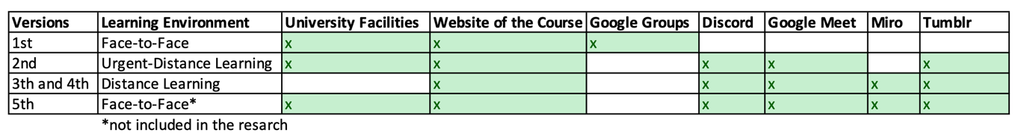
Figure 01. Different facilities and tools to be used at the several versions of the course

3.1 Weekly Schedule and Methodology of the Course

The participants of the courses are architecture students who finished at least their third year, city and regional planning students who finished at least their first year. The lectures at the first half of the course cover subjects such as critical thinking and the Frankfurt School, alternative design practices such as critical design, speculative design and design fiction. The materials are parts of Dunne and Raby's (2013) Speculative Everything book, Matt Mallpass' Ph.D. Thesis (2012) ‘Contextualising Critical Design’ and Transformation Design (2015) of Board of International Research on Design. Another core reading of the course is Bruno Latour's (2003) ‘Why Has Critique Run out of Steam? From Matters of Fact to Matters of Concern Outcomes' paper, from which the concepts of 'matters of concern' and 'matters of fact' are adapted for the final projects.

Peter Friedrich Stephan's (2015) methodology for designing 'concerns' is partly applied to the weekly plan:

“1. Observe chains of operations as closely as possible (Latour: ANT’s view).
2. Accept that objects have agency too (ANT).
3. Build an appropriate repertoire to record operations (data
visualization, visual rhetoric).
4. Understand actors’ concerns through empathy and cognitive
analysis (Latour: actor scripts).
5. Find translations and breaks between values, concerns, needs,
and issues.
6. Follow the deduction and dynamic changes of frames of mind.
7. Invent alternative scripts and translations (social innovation).
8. Design services, products, and environments that demand
new scripts and translations.
9. Implement new services, products, and environments (triple
-loop learning).
10. Observe working of new scripts and translations, evaluate,
and start the next iteration.”

Another asssignment was the observation task which is a re-transformed version of Fulton Suri's photographs from her book 'Thoughtless Act?' (Suri & IDEO, 2005). The task is to take photos of a field and interpret people's behavior, conveying the interpretations to the class in form of sketches applied to the photographs. This small task which was used as a starting point for some of the student’s final projects was the most difficult task to be translated into the distance learning environment. At the emergency-distance learning version, this task had been done but some of the groups did not have the chance to re-visit their observation field. At the first distance-learning version of the course due to the many lockdowns at that time, the observation task was transferred into the social media where participants observed Instagram pages or Facebook groups and instead of taking photos they took screenshots. At the second distance-learning version each participant conducted the task at the city where they were located at the time.

Other than the observation task, other weekly assignments were not changed, their medium of submission changed from a printed or sketched handout to uploaded digital files (Figure 02). Such a process eased the archiving of the submissions.

Weekly tasks with the lectures at the first six weeks of the course act as a starting point for developing subjects for the final projects. Most of the time students used their most successful weekly tasks for developing ideas for the final projects.

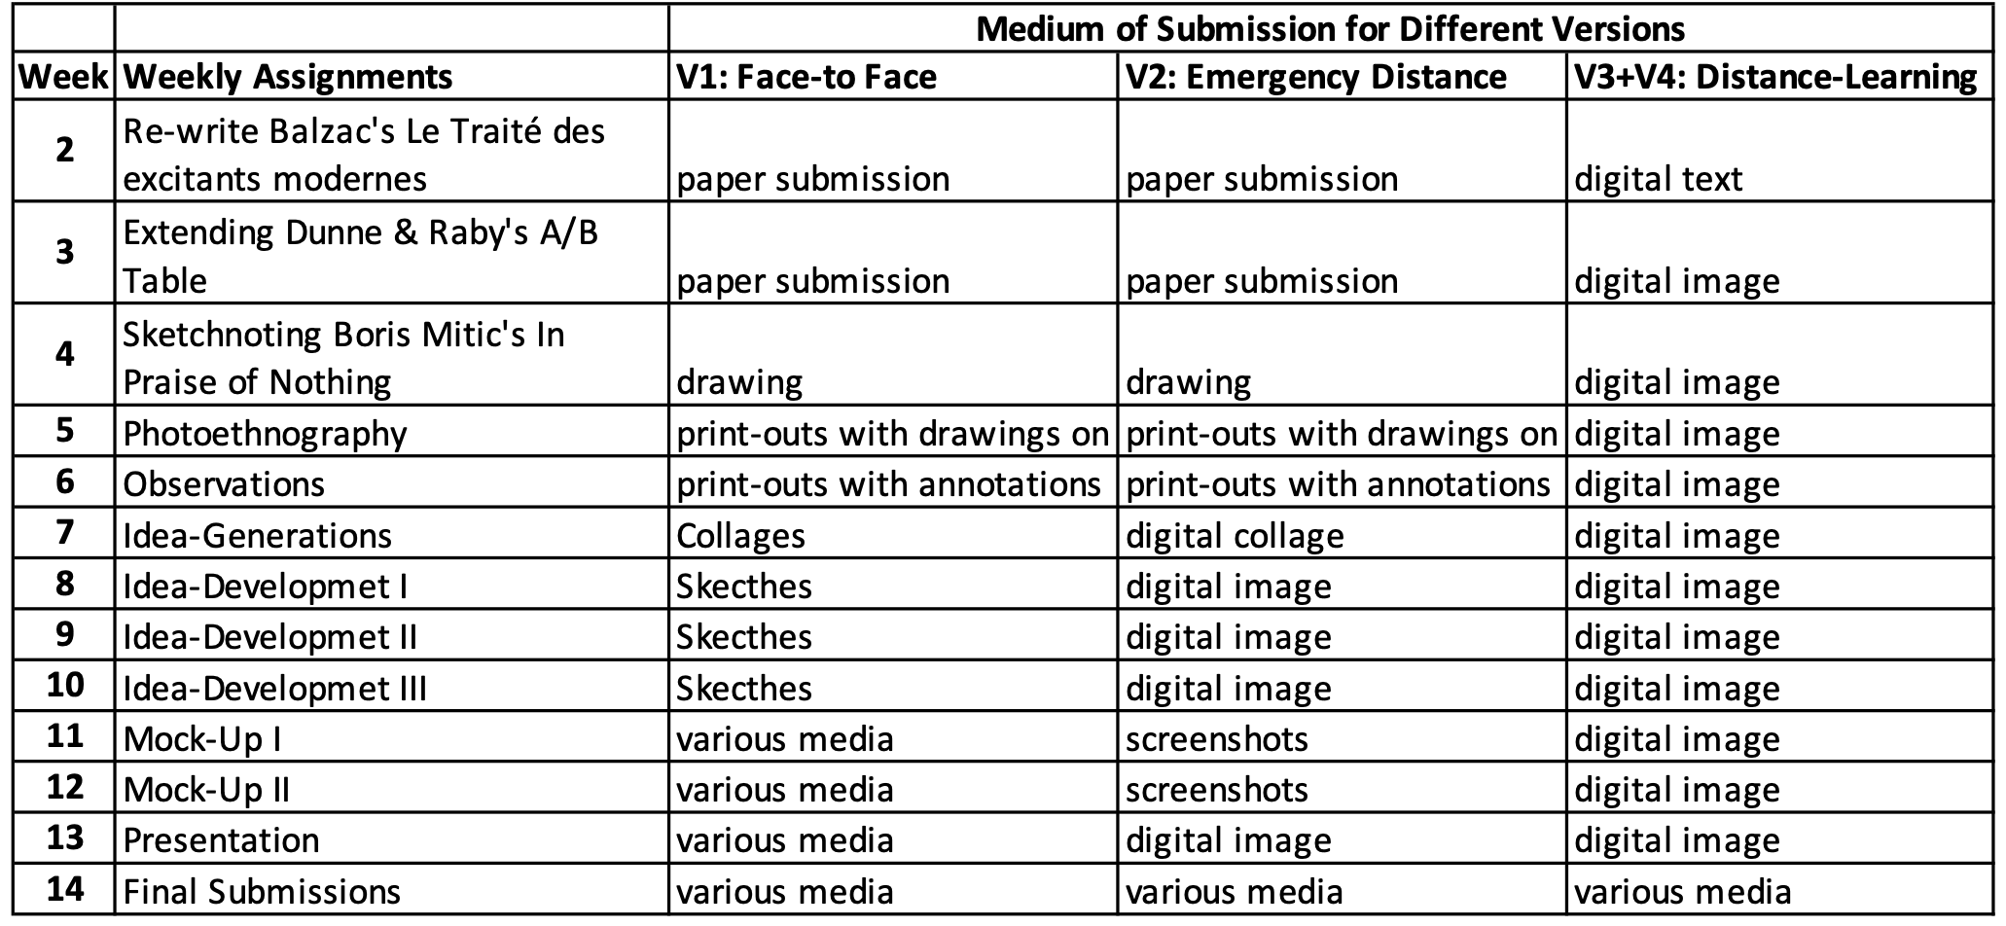
Figure 02. Weekly Assignments and their media of submissions for the four versions of the course

3.2 Final Projects and their Media

After having examined different concepts of alternative design practices and having done weekly tasks related to several methods that could be useful for creating 'matters of concern' groups of students develop several ideas for the mid-term examination. Those ideas then are evaluated with the class using matrices of evaluation, where ease of implementation and range of the impact are important axes.

Throughout the six weeks, the ideas are reduced to one idea and each week critiques were given to develop them and during the class how the idea would be implemented is discussed. While at the face-to-face critiques, the discussions were mostly limited to the student group, presenting their ideas and the tutor, during the digital meetings the discussion would be more easily transferred to the whole class. The extensiveness of the discussions is decreased in the digital versions of the meetings which could be because some participants were not listening to the critiques as not all the participants were visible through their web cameras or it was more exhausting to follow discussions remotely.

3.2.1 Evaluation of the Media

The medium of the final projects was evaluated separately for the face-to-face, emergency-distance learning, and distance learning environments to compare how the learning environment affected the medium choices of the students for their projects.

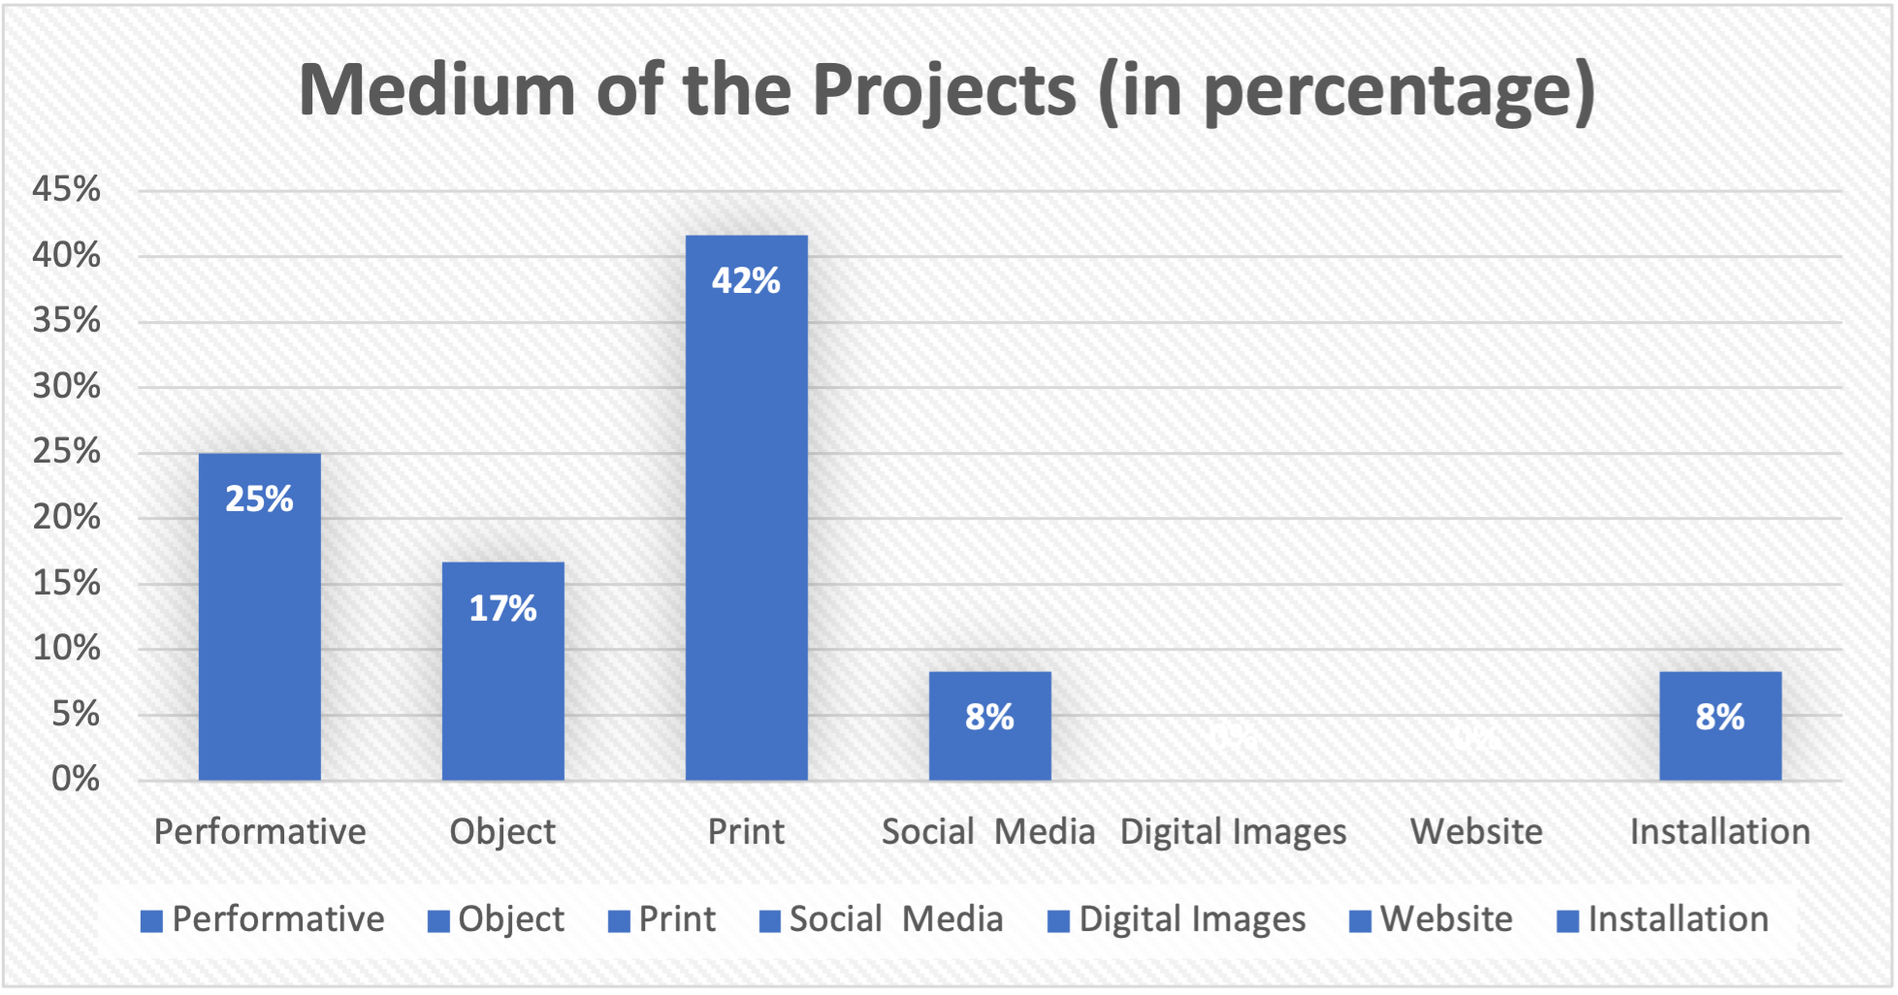
Figure 03. Comparing different media, which were used at the face-to-face version of the course.

For the first version of the course, 56 students submitted 24 projects. We see that, at the first version of the course where instructions were given face-to-face %42 of the projects were print materials and %25 of the projects had a performative nature such as planning and conducting events, flash mobs and similar performances. %17 of the projects created an object to convey the critique they designed (Figure 03).

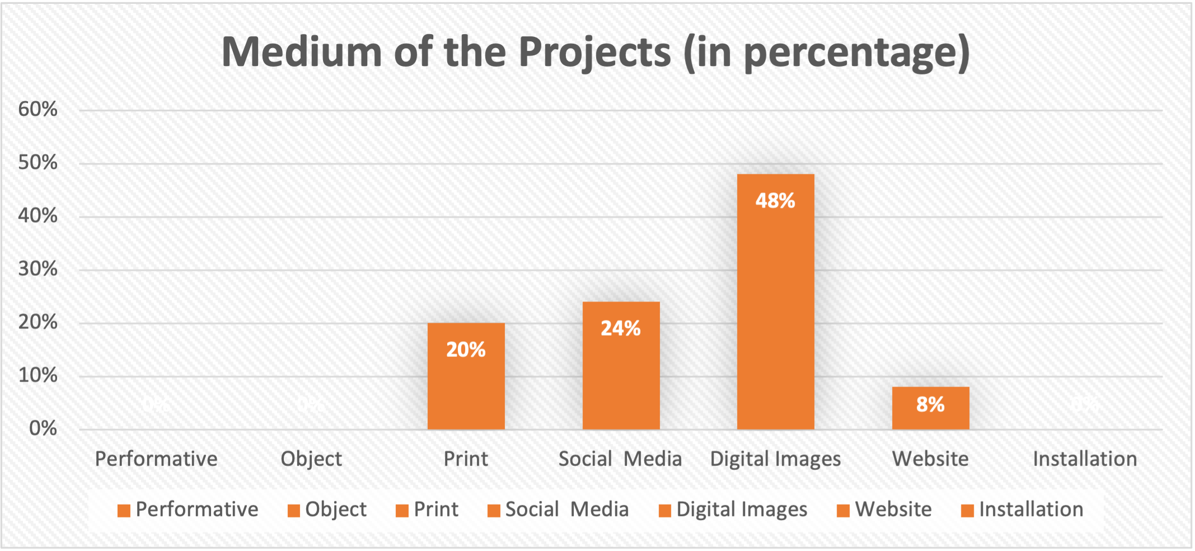
Figure 04. Comparing different media, which were used at the emergency-distance learning version of the course.

The second version was where half of the semester was instructed face-to-face and the other half had to be turned into an emergency-distance learning environment in which 128 students submitted 49 projects. %48 of the projects were digital images and are intended to be distributed digitally, while %24 of the projects were submitted as outcomes of Social Media Accounts, and %20 of the projects were print material (Figure 04).

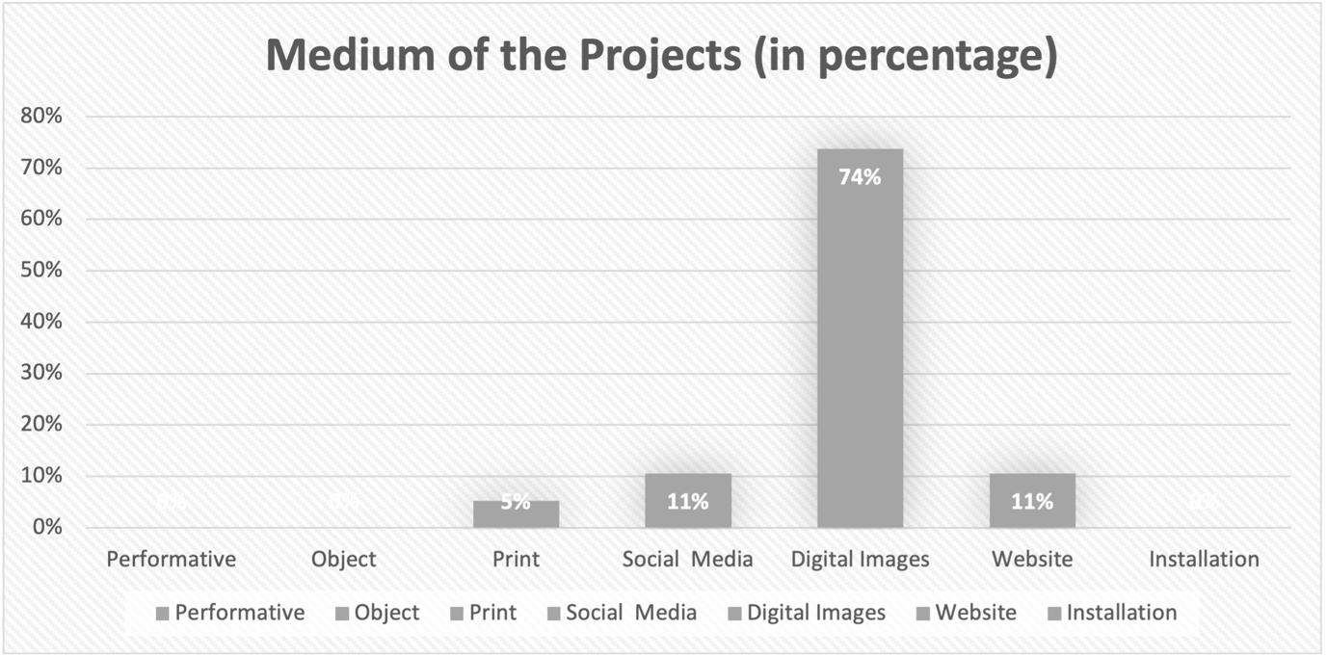
Figure 05. Comparing different media, which were used at the distance learning versions of the course.

At the third and the fourth version, the course was transferred fully into the online learning environment and the participants were more familiar with the digital tools used at this time. 45 students submitted 19 projects. %75 of the projects intended to be distributed as digital images, %11 of the projects were in form of a website and %10 of the projects were social media accounts (Figure 05).

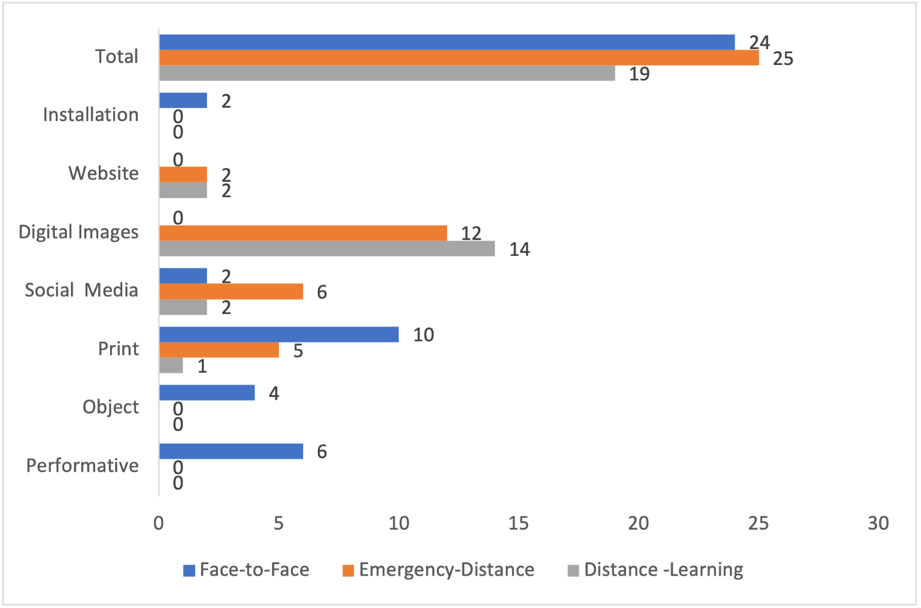
Figure 06. Comparing the number of projects for each medium for the three different learning environments: face-to-face, emergency-distance learning and distance learning environments.

In clusters of three: face-to-face, emergency-distance learning and distance learning, all 68 final project submissions were evaluated first by their medium of production. In the face-to-face learning environment 6 projects used the medium of performance, 4 projects were objects and 2 installations were produced. Whereas at the emergency-distance and distance-learning environments websites and digital images were produced as a new medium for the projects (Figure 06).

3.2.2 Evaluation of the Projects

The outcomes of the projects were listed on a table with information about the project (up to two sentences) and a picture explaining the outcome. The projects on this table were evaluated according to their quality of design, understandability and appropriateness to critical design. The evaluation was done by the author and three external experts who work as design professionals and produce projects in various media.

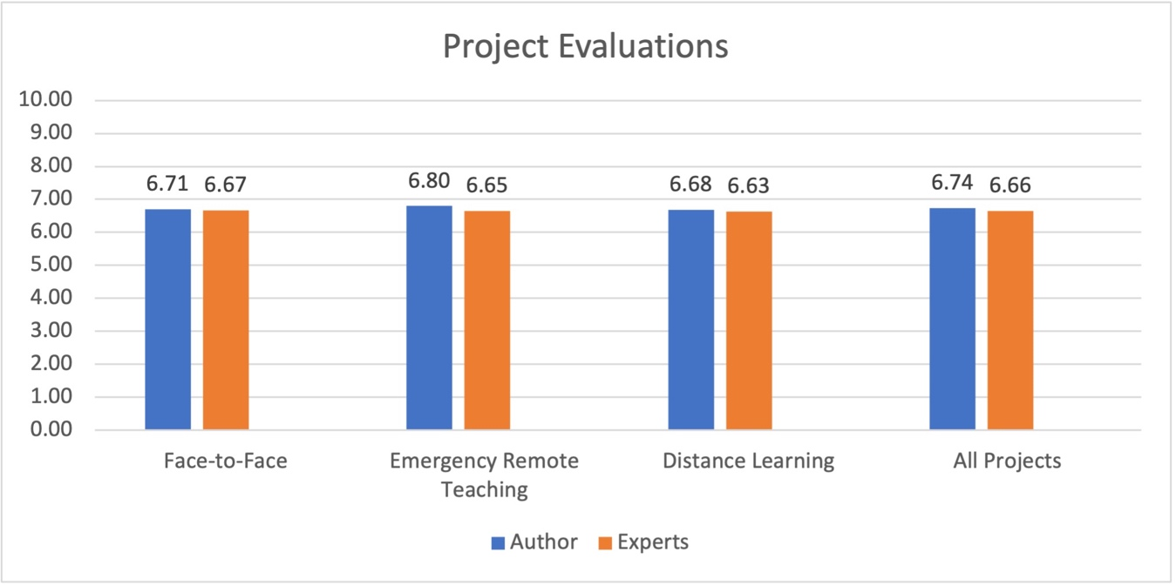
Figure 07. Comparison of the points given to the project by the author and the external experts.

On the chart (Figure 07) we can see that the difference between experts’ evaluation and the author's evaluation highest during the emergency-distance education when the outcomes lose their physical materiality. On the other hand, the author who is aware of the process grades higher the projects which are completed at that learning environment. This may be a bias on the evaluation of the author’s points given to the projects compared to the experts’ points. The evaluation criteria were the same as the author communicated them: quality of design, understandability, and appropriateness to critical design. The experts had a list of the projects, a picture showing the project and explanations about the project. The list did not include the information in which learning environment projects were developed. The projects were given a grade between 0 (lowest grade) to 10 (highest grade).

We may conclude that for critical design projects to fulfill their aim of creation: making people talk about things, may need to use a variety of media. Because of the worldwide Covid-19 Pandemic, new media of production were used by the students but physical ones such as performances diminished in this process. During the distance learning environments, as students and tutors are more used to using digital media, it should be seen as an opportunity to add new ways of expression into the course, but it should be never forgotten that those digital ways of expression are not replacing the physical media.

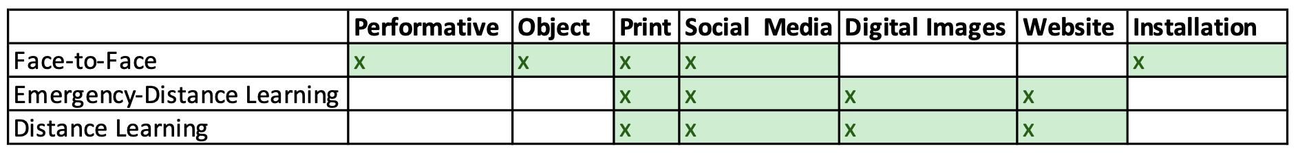
Figure 08. Table showing which media were used at which versions of the course.

As we can see on the table (Figure 08) digital images and websites were introduced after the course was transferred into the digital environment. But performances, objects and installations were given up on the other hand. This would be apologized due to the pandemic conditions but as we can also see by the experts’ evaluation such kind of transfer can also affect the quality of the critical expression.

4. Discussion

The digitalization of the course enabled the participant to explore new digital media and create ‘matters of concerns' on several new platforms. Also, the digital tools that were used during the course enabled the whole class to archive what they did for each week and still made it possible to access them later. For example, the size of the classroom could be a limit compared to a digital meeting. Problems such as being at the end of the classroom and not able to see the drawings which the tutor and the group is discussing were eliminated thanks to the digital tools. The whole class was turned into a more organized structured system thanks to sharing platforms like Discord or Miro. The interaction between the peers and between the tutor and the participants were enhanced where participants were more used to communicate through different channels. Beforehand even signing up to the Google Groups’ e-mail list would take several weeks to accomplish. The presentation of the final projects to a wider audience was also easier with a web blog replacing a physical exhibition in the campus.

On the other hand, as the experts’ evaluation shows the limit of the media that participants use can also affect the quality of their production or the creativity they would otherwise show with physical media. Another problematic issue with the distance-learning environments is that the participants were not able to observe their environment, people, and activities due to the restrictions related to the Covid-19 Pandemic. While translating this essential task into online forums or social media platforms, the authenticity of the work decreased, the task did not work better than a data collection algorithm. At the second distance-learning semester when the restrictions were a bit looser and students were at different locations, the common ground for discussions was missing.

To exemplify several advantages and disadvantages of the three different learning environments three projects are going to be explored more deeply as three cases. The 'Inflatable Whale at the Park' was developed in the face-to-face learning environment, the 'Smoke Globes' were developed when the course needed to be transferred into the emergency-distance learning environment, the third case 'Fruits and Vegetables from the Tech-Box' was developed during the distance learning environment.

4.1 The Case: Inflatable Whale at the Park

Participants observed their environments, and their concern was about the park which is the meeting point for many university students as it is just opposite of the campus. The park was not maintained by the local municipality well. They wanted to underline this situation and put an inflatable whale inside the pond of the park which was always empty. They observed the situation and after an hour they took the whale back. As the park was an important meeting spot for university students, some of the students shared the picture of the inflatable whale and on an Instagram gossip page (Figure 09) the picture was shared and nearly 2500 people liked it and around 40 comments were added. The picture worked very well in the Latorian sense as a ‘matter of concern’.

As this project is a performative event it would be impossible to do with digital tools and the important aspect here is the digital effect of this physical installation which can be seen as a very good working together of digital and physical space.

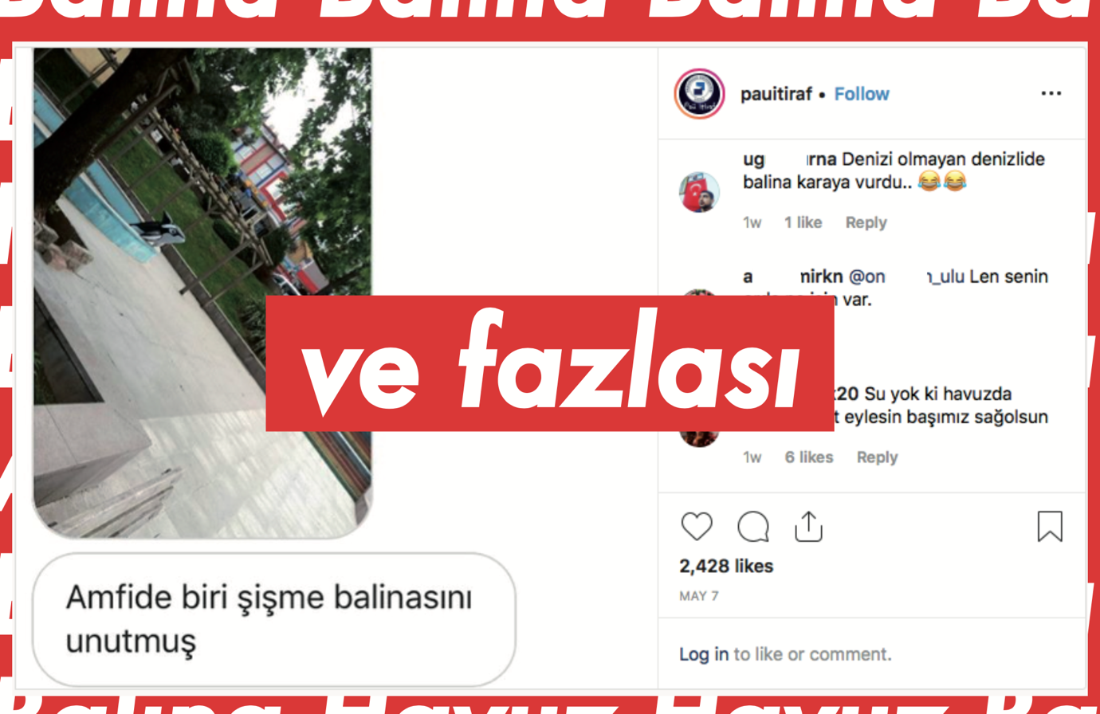
Figure 09. The Inflatable Whale by Nzife Coşkun, Mustafa Enes Karabulut, Mehmet Emin Diler and Ali Atakan Kundakçı

4.2 The Case: Smoke Globes

Participants observed that at many places where students spend their time, it was very difficult to get fresh air. Outside the buildings of the university, people were smoking. At many cafés, students went, it was allowed to smoke hookah and this also affected other restaurants and cafés nearby. The park next to the campus could be used partly for making barbecue so it was also difficult to get fresh air there, too. Students designed several globes (Figure 10) where such situations were put under a glass dome and instead of buying as snow-globe for the new year they would buy smoke-globes as this was more commonly seen at the city where they go to the university.

The project could have been easily turned into a series of objects. But as this project was developed during the emergency-distance learning version of the course, until the 7th-week students thought to submit a physical object at the end of the class which would fit best their idea. At that time lockdowns limited students' ability to obtain materials for making prototypes, students decided to produce several collages of the smoke globes idea. Maybe if they were going to produce an object, they would just prototype a smoke globe. By using a digital medium, they developed several proposals for the same idea.
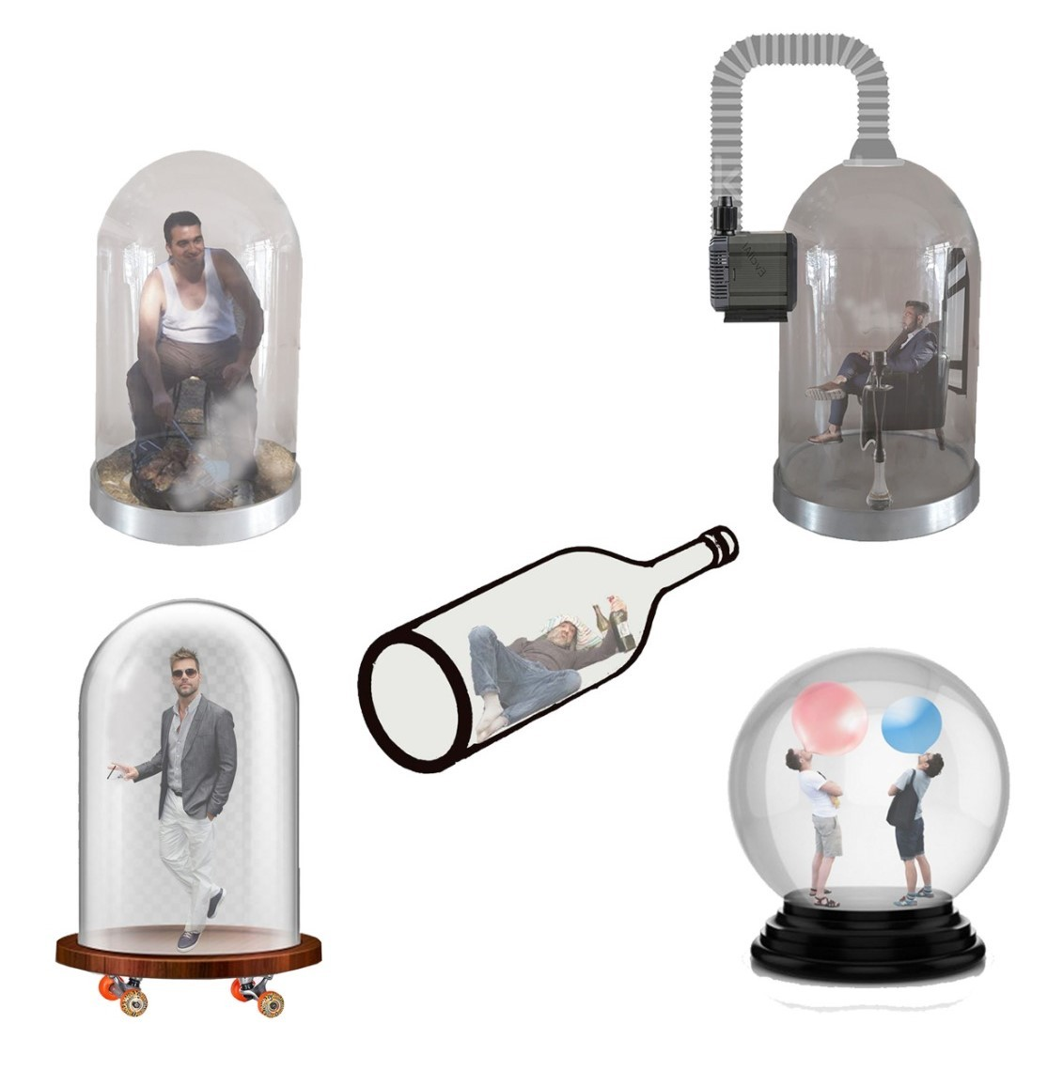
Figure 10. Smoke Globes by Beyzanur Akıncı, Bengisu Baş, Gözde Başkan and Selay Nur Yılan

4.3 The Case: Fruits and Vegetables from the Tech-Box

Participants researched on the internet about new technological devices and during their research, they came across news articles about people being frauded by buying new smartphones or tablets. The online sellers would just send the boxes of the smartphones with some vegetables or fruits as weights inside, not to be uncovered by the shipping company. Students built a mock-shopping website (Figure 11) selling vegetables and fruits in boxes of technological devices. It was a tragicomic way of making people aware not to trust any shopping website that just sells a product for bargain.

Students developed this project in a distance learning environment. The process of the course was translated fully into a digital learning environment where for example observation assignments were conducted by observing social media users or by gathering data from forums and groups. Students used the news articles on the web about people being frauded by others to develop the project. They also selected a medium that would fit into a digital exhibition. The idea would not have been developed by making observations on physical places as it would be a rare occasion to meet someone who was just got frauded. This case also shows that digital translations of current methods for physical places would reveal subjects that otherwise would be missed.

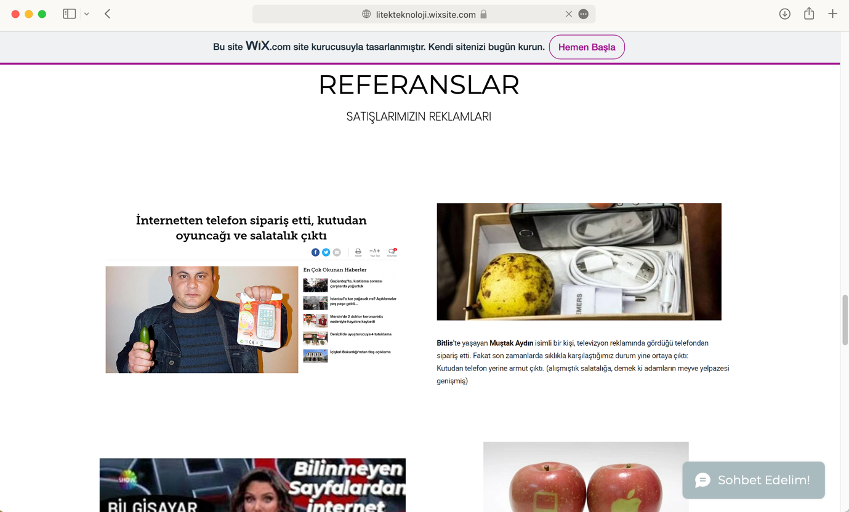
Figure 11. Fruit and Vegetables from the Tech-Box by Eda Beltekin and Esra Düzen

5. Conclusion and Further Suggestions

Critical Design course can be very useful for people who are designing our daily life such as industrial designers, architects, graphic designers, or city planners. To make students of such professions aware of their practices out of the commercial system such kinds of courses could be seen as essential. The more we encounter the results of our current economic system, the more we understand that we need more and maybe better critiques about this system to result in changes in people's behavior.

Digital tools can enhance the way we teach but we also need to be aware of their limitations and we may see those tools as enhancements but not as replacements for our university buildings and environments. The very famous sentence of Marshall McLuhan (1994) would maybe guide us, as he says ‘the medium is the message’.

The Covid-19 Pandemic has resulted that the digital tools being developed further and widely adopted by society. This should be seen as an advantage to implement such tools in our design activities as well as in the design education activities.

It can be concluded that the Covid-19 Pandemic and the following changes to the education environments affected the tools used at the course which resulted in that new media for the projects being added.

Another conclusion would be that the limitations during the Covid-19 Pandemic also affected the uses of physical media such as conducting performances or producing objects which then affected some qualities of the projects as not all the project ideas could be best conveyed through digital media.

The third conclusion would be that the changes in learning environments could have a positive impact on the creativity of the students as they explored new possibilities for finding data or translating their ideas through digital media.

The limitations of the research would be that there exists very little research on the process of critical design and each course concerning alternative uses of design has a different approach to the subject. Another limitation is that more evaluations of the projects are needed to discuss whether learning environments affected the quality of the projects for this critical design course. It would be also useful to compare similar research that may be published in the following years that research design courses’ media of projects before, during and after the Covid-19 Pandemic.

Suggestions for the subject would be to further research projects’ media for design courses as they can reveal new insights on the topic of design education. To research the choices of students for their projects, maybe the choice of the medium shouldn't be defined by the tutor of the class and students need to be free on selecting their project' medium.

References

Broadfoot, O., & Bennett, R. (2003). Design studios: online. In Apple University Consortium Academic and Developers Conference Proceedings 2003 (pp. 9- 21).

Buchanan, R. (2007) Strategies of Design Research: Productive Science and Rhetorical Inquiry. In R. Michel (ed.) Design Research Now. Basel, Birkhäuser.

Chen, W., & You, M. (2010). Student response to an Internet-mediated industrial design studio course. International Journal of Technology and Design Education, 20(2), 151-174.

Chiu, M. L. (2002). An organizational view of design communication in design collaboration. Design studies, 23(2), 187-210.

Dunne, A. & Raby, F. (2013) Speculative Everything. Massachusetts: MIT Press.

Engell, L. (2003). Taste, Wählen, Denken. In Münker, S; Roesler, A; Sandbothe, M. (Eds.) Medienphilosophie. Frankfurt a. M.: S. Fischer Verlag.

Ham, J. J., & Schnabel, M. A. (2011). Web 2.0 virtual design studio: social networking as facilitator of design education. Architectural Science Review, 54(2), 108-116.

Harman, G. (2005). Guerrilla Metaphysics: Phenomenology and the Carpentry of Things. Illinois: Open Court.

Karpova, E., Correia, A. P., & Baran, E. (2009). Learn to use and use to learn: Technology in virtual collaboration experience. The Internet and Higher Education, 12(1), 45-52.

Kolarevic, B., Schmitt, G., Hirschberg, U., Kurmann, D., & Johnson, B. (2000). An experiment in design collaboration. Automation in Construction, 9(1), 73-81.

Lash, S. & Lury, C. (2007) Global Culture Industry. Cambridge, Polity Press.

Latour, B. (2003). Why Has Critique Run out of Steam? From Matters of Fact to Matters of Concern. Retrieved from http://www.bruno-latour.fr/sites/default/files/89-CRITICAL-INQUIRY-GB.pdf on 7th of April, 2021.

Malpass, Matt (2012) Contextualising Critical Design: Towards a Taxonomy of Critical Practice in Product Design. Ph.D. thesis, Nottingham Trent University.

Mareis, C. (2006) Design Wissen: Zum Verhältnis von Design und Wissen im Diskurs der Designforschung in der Schweiz. [MA Thesis]. Zürich, ZhdK.

McLuhan, M. (1994). Understanding Media: The Extensions of Man. Massachusetts: MIT Press.

McMahon, M., & Bhamra, T. (2012). ‘Design Beyond Borders’: international collaborative projects as a mechanism to integrate social sustainability into student design practice. Journal of Cleaner Production, 23(1), 86-95.

Münker, S. & Rösler A. (2008). Einleitung. In Münker, S. & Roesler, A. (Hg.) Was ist ein Medium. Frankfurt am Main: Suhrkamp.

Papanek, V. (1973). Design for the Real World. New York: Bantam Books.

Puolakka, A., & Sutela, J. (2010). Science Poems. Helsinki & Paris: OK Do.

Steinbrenner, J. (2010) Wann ist Design? Design zwischen Funktion und Kunst. Hamburg, Hatje Cantz.

Stephan, P. F. (2015). Designing ‘Matters of Concern’ (Latour) – A Future Design Challenge?. Jonas, W.; Zerwas, S.; von Anshelm, K. (Eds.) Transformative Design. Basel: Birkhäuser.

Suri, J. F. & IDEO (2005). Thoughtless Acts?: Observations on Intuitive Design. San Francisco: Chronicle Books.

Thackara, J. (1998). Beyond the Object in Design. In Design after Modernism, ed.
John Thackara,11-34. New York: Thames and Hudson.

Turner, S. V., & Dipinto, V. M. (1997). Peer collaboration in a hypermedia learning environment. Journal of Research on Computing in Education, 29(4), 392-402.

Ylirisku, S. (2013) Frame it Simple! Towards a theory of conceptual designing. [Doctoral Dissertation]. Aalto University, Helsinki, Finland.

