Continuous in-line decontamination of food-processing surfaces using cold atmospheric pressure air plasma
Andreas S. Katsigiannisª, Nataša Hojnik^{b}, Martina Modic^{b}, Danny L. Bayliss^{c}, Janez Kovač^{d}, James L. Walsh^{a,*}

ªCentre for Plasma Microbiology, Department of Electrical Engineering and Electronics, University of Liverpool, 9 Brownlow Hill, Liverpool L69 3GJ, United Kingdom.
^{b}Laboratory for Gaseous Electronics F6, Jožef Stefan Institute, Jamova cesta 39, 1000 Ljubljana, Slovenia.
^{c}Processing & Production Research Department, Campden BRI, Station Road, Chipping Campden, Gloucestershire GL55 6LD, United Kingdom.
^{d}Department of Surface Engineering F4, Jožef Stefan Institute, Jamova cesta 39, 1000 Ljubljana, Slovenia.

Abstract

This study assessed a continuous in-line decontamination system for food contact surfaces and processing equipment that utilized cold atmospheric pressure plasma (CAP) generated from ambient air. The plasma system was evaluated against two common foodborne pathogens (Salmonella Typhimurium, Listeria monocytogenes) on stainless steel surfaces and against S. Typhimurium on commercial poly[ether]-thermoplastic poly[urethane] (PE-TPU) conveyor belts, under simulated conditions of a food-processing facility. A significant level of microbial inactivation was achieved, up to 3.03±0.18 and 2.77±0.71 logCFU/mL reductions of L. monocytogenes and S. Typhimurium respectively within 10 sec total treatment on stainless steel surfaces, and a 2.56±0.37 logCFU/mL reduction of S. Typhimurium within 4 sec total treatment on the PE-TPU material, according to a procedure based on the well-established EN 13697:2015 industrial protocol. CAP exposure was shown to have a minor impact on the morphology and composition of the treated surfaces. The results indicated that CAP can be applied for effective and continuous disinfection against common foodborne pathogens in food-processing facilities.

Industrial relevance: Low temperature plasmas have shown great promise for microbial decontamination, yet industrial uptake of the technology has been limited due to scaling limitations. In this study, a prototype conveyor-based CAP decontamination system was developed and tested under realistic conditions expected within a food-processing facility. The results showed a high level of antimicrobial action against two common foodborne pathogens within a few seconds of CAP exposure, a timescale in line with industrial line processing speeds. Our findings demonstrated that CAP shows great promise for the continuous in-situ decontamination of food contact surfaces, with the potential to mitigate against the costly downtimes incurred in current production line practices implementing chemical disinfectants.

Keywords: Cold atmospheric plasma, Dielectric barrier discharge, Stainless steel, Conveyor belt, Listeria monocytogenes, Salmonella Typhimurium.

Introduction

Microbial contamination poses a major challenge for the food industry. Several biological contaminants, including bacteria, fungi, and viruses cause serious illnesses to over 2 billion people annually, through the consumption of contaminated food (FAO, 2021). These contaminants hinder global food production, generating food waste during processing (e.g., 16% of the food waste in the UK is produced during processing) (WRAP, 2021). With estimates suggesting that the global food production needs to increase by 50% until 2050 (Holban & Grumezescu, 2017), control of microbial contamination during production is of paramount importance for the sustainability of the food supply chain (Elkhishin, Gooneratne, & Hussain, 2017).
Inside food-processing facilities, microorganisms that are naturally present on foods or carried by personnel can contaminate processing surfaces and equipment. As such, sanitation of these is of vital importance, yet some equipment is difficult to sanitize. Many studies indicate that traditional sanitation methods cannot completely eradicate microorganisms from food-processing surfaces (Fagerlund, Møretr, Heir, Briandet, & Langsrud, 2017); (Corcoran et al., 2014). To minimize the risk to consumers, food manufacturers comply with legal guidelines to provide safe food, whereby specific rules must be applied through the whole production line (e.g., Good Manufacturing Practices - GMPs) (Holban & Grumezescu, 2017); (Lelieveld, Holah, & Gabric, 2016). The choice of materials is a key design constraint, with only selected materials being permitted, including metallic alloys (e.g., austenitic stainless steel types 304 & 316), plastics (e.g., poly[propylene] (PP), poly[carbonate] (PC), high-density poly[ethylene] (HDPE), poly[tetra-fluoro-ethylene] (PTFE) & poly[vinyl-chloride] (PVC) and elastomers (e.g., natural rubber, silicon rubber and nitrile rubber). All food-processing surfaces must be smooth, finished, and free from pores, pits and crevices. Additionally, they must be easy-to-clean and have a mean roughness value of ~0.8 μm or proof that they can be adequately cleaned (Lelieveld et al., 2016).
Apart from manufacturing demands, the food industry has to implement and frequently apply costly sanitation schemes to ensure microbial levels are below critical points. Studies estimated that the installation and annual operation costs for these in the US can be up to $860 and $650 million respectively, depending on the size of the company (Hessing et al., 2018). It is estimated that sanitation schemes can require up to 500 hours downtime per year, resulting in up to $10 million losses (Lowe, 2019).
Despite all the above efforts, outbreaks of foodborne illnesses continue to occur. For example, in the US more than 60 outbreaks have been reported since 2018 (“List of Selected Multistate Foodborne Outbreak Investigations | Foodborne Outbreaks | Food Safety | CDC,” 2021) and many have led to costly product recalls, with estimated losses of $10 and $100 million per recall for direct and indirect costs, respectively (Wood, 2017). In many outbreaks of foodborne illness, the source can be traced back to contaminated food-processing surfaces, especially on ready-to-eat products. For example, contaminated fresh produce with L. monocytogenes from slicers (Buchanan, Gorris, Hayman, Jackson, & Whiting, 2017) or contaminated diced celery with L. monocytogenes from machine cut that resulted in five deaths in the US in 2010 (Gaul et al., 2013).
In order to better control cross-contamination from processing surfaces and reduce the financial burden associated with sanitation, manufacturers constantly seek novel systems that offer effective decontamination of food-processing surfaces and equipment, preferably in a continuous in-line process, negating the need to halt production for sanitation. Several systems have been developed to meet these requirements; for example, the use of mechanical brushing for conveyor belts (e.g., Patents US3583555A, US8240460B1 & US5497872A), Cleaning-In-Place systems which employ chemicals (Leadley, 2016) and specialized systems to apply chemicals for the cleaning of conveyor belts (Patent US6971503B2). For disinfection, examples of continuous in-line systems include solutions that utilize steam (Lelieveld et al., 2016), UV-C (Koutchma, 2014) and ultrasound in combination with steam (Musavian, Butt, Larsen, & Krebs, 2015).
A promising emerging decontamination technology is cold atmospheric plasma (CAP). Plasma, also known as the “4th state of matter”, has a gaseous form and contains ions, electrons, free radicals, excited species, atoms, molecules and photons. In low temperature (or cold) plasmas, only the electrons have a high temperature, while heavier particles have a temperature close to ambient. A consequence of this non-equilibrium characteristic is that target materials subjected to CAP treatment experience very little temperature increase and thus the approach is ideal for the treatment of thermo-sensitive materials (Ekezie, Sun, & Cheng, 2017); (Misra, Schlüter, & Cullen, 2016). In CAPs generated from ambient air, a vast array of reactive species are produced based on Oxygen (ROS – e.g., O●, O*, ¹O₂, O₃, OH●, H₂O₂) and Nitrogen (RNS – e.g., N, N*, NO●, NO_{x}, ONOO⁻, HNO₃). Production of these (RONS) depends on the physical properties of CAP, including the energy and density of electrons, as well as the air temperature and humidity (Hasan & Walsh, 2016); (Misra et al., 2016). Typical CAP sources that can be used to create stable air plasma include Dielectric Barrier Discharges (DBDs), Atmospheric Plasma Jets (APJs) and gliding arcs. Among them, DBDs are widely used for surface treatment, as they offer uniform treatment of large areas, are low-cost, easy to build, flexible, scalable and can operate using low input powers (Ekezie et al., 2017); (Misra et al., 2016).
A number of previous studies have shown that CAP generated in atmospheric air possesses antimicrobial properties, linked to the synergistic action of RONS, UV photons and charged particles. Amongst them, RONS are typically considered to play a key role in inactivation, due to their high oxidation potential (e.g., OH●, O●, O₃, ONOO⁻, H₂O₂ etc.) (Bourke, Ziuzina, Han, Cullen, & Gilmore, 2017); (Ekezie et al., 2017); (Misra et al., 2016); (Scholtz, Pazlarova, Souskova, Khun, & Julak, 2015). RONS react initially with the outer cell membrane/wall, causing peroxidation of phospholipids and lipopolysaccharides, denaturation of glycoproteins, break of peptidoglycan bonds and creation of openings and legions through etching (Šimončicová et al., 2018); (Han et al., 2016); (Yusupov et al., 2013). At later stages they are transferred inside the cell and react with internal components, causing peroxidation of fatty acids, denaturation of proteins, change in activity of enzymes, peroxidation of lipids, DNA damage and disruption of respiration (Šimončicová et al., 2018).
Studies at the laboratory scale have shown air CAP can be used for inactivation of foodborne pathogens on various food-processing surfaces, including stainless steel and polymers (Kordova et al., 2018); (Dasan et al., 2017); (Gabriel et al., 2016). Other CAP systems have been developed for specific applications within a food-processing facility, for example the inactivation of Listeria innocua on stainless steel rotating knives (4 logCFU reduction within 68 sec) (Leipold, Kusano, Hansen, & Jacobsen, 2010), the inactivation of L. monocytogenes on plastic trays (>7 logCFU reduction within 90 sec) and aluminium foils (3.0 logCFU reduction within 90 sec) (Yun et al., 2010), and the use of a microwave plasma system for decontamination of glass bottles (3.0, 4.0 and >5.5 logCFU reduction of Bacillus atrophaeus spores, Escherichia coli K12 and Staphylococcus aureus respectively within 7 sec) (Schnabel, Andrasch, Weltmann, & Ehlbeck, 2014). Despite these promising studies, there are several challenges to be overcome in order to fully realize industry implementation of CAP sanitation technology. Most notably, the required treatment time to achieve the desired antimicrobial effect is usually high. In addition, the final outcome depends on critical parameters that are difficult to control in real-world processing conditions, such as the microbial population density, the nature of the microorganisms and the air environmental conditions within the facility.
This study explores a CAP system integrated within a moving conveyor for the decontamination of food-processing surfaces, it was evaluated against two common foodborne pathogens under conditions typically found within a food-processing facility. The influence of treatment time, continuous in-line operation, localized microbial density, the facility’s cleanliness state, the target microorganism and target surface were considered. Finally, the effects of CAP treatment on the exposed surface materials were examined using X-ray Photoelectron Spectroscopy (XPS), Atomic Force Microscopy (AFM) and water contact angle measurements to assess the potential CAP-induced changes to the material surface.

Materials and methods

Conveyor plasma system, power settings & environmental measurements

The CAP system consisted of a main conveyor unit and a custom-made DBD unit. The conveyor unit was a belted conveyor from Dorner (model 22EDU06), featuring a 2 mm thick poly[urethane] (PU) belt and a two-way motor with adjustable speed. The direct DBD featured a High Voltage (HV) electrode on top of the moving belt and a ground electrode underneath it. The HV electrode was comprised of a copper plate (50x50 mm) and a quartz dielectric (1 mm thick) inside a frame made from poly[ether-ether-ketone] (PEEK). A supporting aluminium frame was used to fix the HV electrode above the moving belt and the gap between them was adjusted to 2 mm (see Fig. 1(a)). For the electrical ground electrode, a copper sheet was placed underneath the belt.
The direct DBD was driven by a homemade power source, supplying a sinusoidal waveform up to 15 kV peek-to-peek at 33 kHz. The current and voltage were monitored by an oscilloscope from Tenma (model 72-7640) using a HV probe from Tektronix (model P6015A) and a current monitor from Pearson Electronics (model 2877). The dissipated power was held constant at ~15W for all investigated cases, which produced a uniform plasma across the entire electrode area, while ensuring the temperature of plasma treated samples moving through the plasma did not exceed 40 ºC. To accurately control the speed of the belt, two IR light barriers from Velleman (model MK120) were used with a microcontroller to measure the time of travel between two fixed points. To facilitate rapid assessment of different surface materials, a circular hole of 30 mm diameter was cut into the conveyor belt, enabling coupons of different materials to be pulled through the onboard DBD by the conveyor. This approach overcame the need to repeatedly change the entire conveyor belt. The system was tested to produce uniform plasma while the belt was in motion, as shown in Fig. 1(a).
Ambient air was used as the working gas, with the temperature and relative humidity (RH) being monitored close to the point of plasma generation using a temperature & humidity sensor (model AM2302).
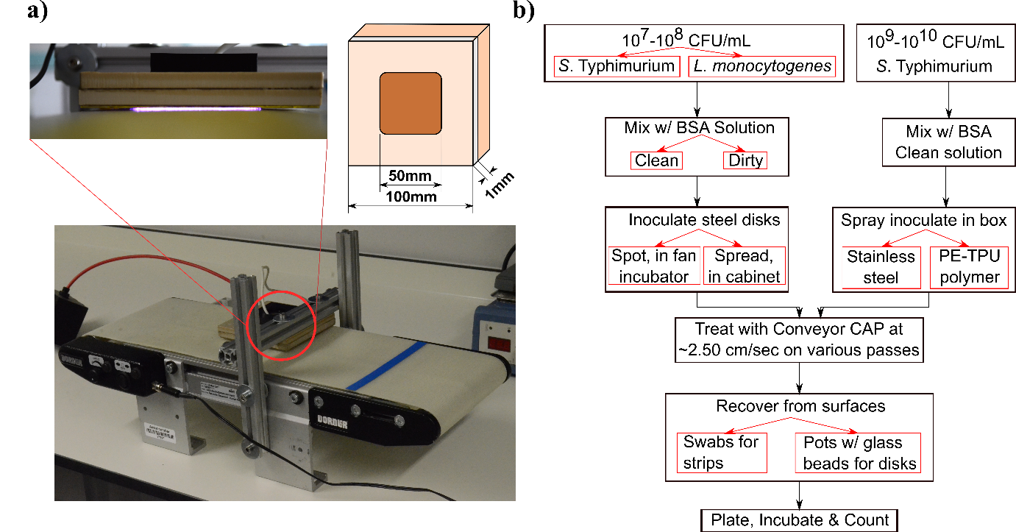Fig. 1. (a) Photograph of the conveyor CAP system and schematic showing the dimensions of the plasma-generating electrode, and (b) outline of the microbiological experimental procedure; black arrows denote steps, red arrows denote parameters.

Bacterial strains, culture media & target surfaces

Stock cultures of Listeria monocytogenes (NCTC 11994) and Salmonella enterica serovar Typhimurium (NCTC 12023) were obtained from the Public Health England pathogen library. These were streaked on Tryptic Soy Agar (TSA) plates and incubated at 37ºC overnight. From those, a second subculture was obtained using the same procedure on fresh TSA plates, and subsequently from that, the working microbial suspension with either L. monocytogenes or S. Typhimurium was prepared using a sterile diluent solution, comprising of 8.5 g/L NaCl and 1.0 g/L tryptone. This suspension was adjusted to 10⁷-10⁸ CFU/mL using a spectrophotometer from BMG LabTech (model SPECTROstar Nano). To verify its concentration, 10-fold serial dilutions were constructed and plated on TSA plates. The plates were subsequently incubated at 37ºC overnight and counted for CFUs.
The microbial testing procedure was based on the EN 13697:2015 protocol for evaluating chemical disinfectants for use in food-processing environments (BS EN 13697:2015). As described in the EN 13697:2015 protocol, two solutions of Bovine Serum Albumin (BSA) were used as an interfering substance, namely “Clean” (0.6 g/L) and “Dirty” (6.0 g/L), in order to simulate best and worst case conditions respectively inside a food-processing facility (facility’s cleanliness state). These were made from stock BSA with sterile deionized water and sterilized by membrane filtration (0.45 μm pore size).
For target surfaces, two different surface materials were tested, namely stainless steel 304 (2b finish) and a food-grade conveyor belt made from PE-TPU polymer. These were small disks of 20 mm diameter and 2.0 and 1.0 mm height respectively. All surfaces were prepared according to the EN 13697:2015 protocol, namely submerged in 5%^{V}/_{V} Decon® 90 for 1 hour, rinsed twice with deionized water and sterilized using 70%^{V}/_{V} isopropanol for 15 min. Finally, they were left to dry inside a class-II microbiological cabinet from ESCO (model NC2-4L8) under laminar flow air. The TSA, BSA, tryptone and NaCl were bought from Merck, isopropanol from VWR and Decon® 90 from Decon Laboratories Ltd.

Preparation & surface inoculation

The microbial testing procedure was based on the EN 13697:2015 protocol and described in a previous study (Katsigiannis, Bayliss, & Walsh, 2021). Briefly, 1.0 mL of BSA solution (either “Clean” or “Dirty”) were mixed with 1.0 mL of the working microbial suspension (with either L. monocytogenes or S. Typhimurium) in a test tube, vortexed and left standing for 2 min. After the 2 min, the solution was vortexed again and 50 μL of it was placed on the test surface using a pipette, as a single spot or spread to completely cover the entire surface area, using the edge of the pipette’s tip. These inoculation modes were chosen to examine the effect of microbial density on inactivation; the spot inoculation represented a higher density and used in the EN 13697:2015 protocol, whereas the spread inoculation represented a lower density and used in the EN 17272:2020 air automated disinfection standard (BS EN 17272:2020).
Additionally, a third inoculation method was investigated that involved a spray of the solution to the surfaces using a nebulizer from AnD Medical (model UN-014) in an airtight box (~4 L). Spraying was done in 5 cycles, using 5 min spraying time and 10 min settle time. On these, the working microbial suspension was higher (10⁸-10⁹ CFU/mL) to account for the increased desiccation stress from spraying. Following inoculation, the surfaces were left to dry, either inside an incubator at 37ºC with an internal fan (spot) or inside the class-II cabinet under laminar flow air (spread & spray).

CAP treatment & recovery

Dried inoculated surfaces were placed in the hole of the conveyor belt and dragged through the CAP to simulate a continuous in-line treatment. The speed of the belt was adjusted to provide a 2 sec treatment (~25 mm/sec) and a scheme of repeated treatments was adopted (up to five passes for a 10 sec total treatment) to mimic a typical industry scenario where a contaminated belt would experience multiple passes beneath the plasma generating electrode.
The recovery of microorganisms from treated disks was performed according to the EN 1369:2015 protocol. The treated disk was placed inside a sterile pot that contained a layer of glass beads (~5 mm diameter) and 10 mL of the same diluent solution that was used for the microbial suspensions (section 2.2), with the treated side facing the glass beads. The pots were then sealed and shaken vigorously for ~15 min inside an orbital incubator from Stuart (model SI500). Finally, the solution of the pots was analysed for surviving microorganisms, by constructing 10-fold serial dilutions, plating them on TSA plates, incubating the plates at 37ºC overnight and counting the CFUs.
Treatments were conducted in two groups with the belt moving in both cases. The first group of tests was performed on stainless steel disks only and investigated the effect of the different protocol parameters on inactivation of both target microorganisms (L. monocytogenes, S. Typhimurium). More specifically, the different facility’s cleanliness states (“Clean”, “Dirty”) were examined using spread inoculations to investigate the effect of the organic contamination simulating a food processing environment; and subsequently the different inoculation modes (spot, spread) were examined under “Clean” conditions to investigate the effect of the microbial density. It is known that both of these parameters can affect inactivation (Bourke et al., 2017); (Ekezie et al., 2017).
The second group of tests investigated the effect of different surface materials on inactivation and involved spray inoculations under “Clean” conditions against S. Typhimurium on different target surfaces (stainless steel, PE-TPU polymer). The use of spray inoculations was driven by the fact that the PE-TPU polymer was found too hydrophobic to allow for spread inoculations. A generic outline of the inactivation experiments is also shown in Fig. 1(b). Statistical analysis was performed using the Minitab software. All tests were performed in triplicates and all agar plates were tested in duplicate.

X-ray Photoelectron Spectroscopy

The chemical composition of both target surfaces was examined with XPS analysis. The surfaces were prepared by triple washing with distilled water for 15 min inside an ultrasonic bath from Ultrawave (model QS25). The surfaces were then CAP-treated for three different times: a 10 sec exposure, representative of five passes under the plasma generating electrode; a 15 min exposure of PE-TPU, equivalent to 450 passes under the plasma generating electrode; and a 30 min exposure of stainless steel, equivalent to 900 passes under the plasma generating electrode.
After CAP treatment, the surfaces were wrapped in aluminium foil and transferred to the XPS (Stevie, Garcia, Shallenberger, Newman, & Donley, 2020). The analysis was performed using an XPS instrument from Physical Electronics Inc. (model TFA XPS, USA) employing a monochromatic Al K_{α} radiation source at 1486.6 eV and an analysis area of 400 μm in diameter. MultiPak version 9.9 software was used for the spectral analysis. To process the data, each spectra was aligned by fixing the C1s spectrum at 284.8 eV. Chemical compositions were calculated from peak intensities by considering the relative sensitivity factors provided by the manufacturer. Following the acquisition of the spectra at the surface, sputter depth profiles of elemental distribution were obtained for stainless steel samples. An Ar⁺ ion beam with an energy of 3 keV was rastered over a 3 x 3 mm² area to etch the surface at a sputtering rate of 2.0 nm/min.

Water contact angle tests

The water contact angle of both surfaces pre- and post-plasma treatment were examined for changes in their hydrophobicity. Samples were prepared according to the EN 13697:2015 protocol (see section 2.2), treated for 10 sec and analysed through water contact angle tests. For these, a 50 μL water drop was placed in the middle of the surface and a picture was taken from a close distance (10 cm), using a DSLR camera from Nikon (model D7000). The contact angles were calculated from the photographs using the ImageJ software with the Low-Bond Axisymmetric Drop Shape Analysis (LB-ADSA) plugin that applied a drop fitting based on the Young-Laplace equation (Stalder et al., 2010).

Atomic Force Microscopy

The surface microstructure and roughness of both surfaces were examined through AFM. Surfaces were prepared and treated similarly with the samples for XPS analysis (see section 2.5) and analysed with an AFM from NT-MDT (model Solver PRO). Images were acquired using silicon cantilevers with 240 kHz resonant frequency and 11.8 N/m spring constant in semi-contact mode at 1.5 Hz scanning rate under ambient conditions. Analysis was performed using the Gwyddion software on randomly selected points on the sample measuring 3 x 3 μm².

Results and discussion

CAP antimicrobial effects on stainless steel

Preliminary tests on stainless steel without applying CAP treatment shown in Fig. 2(a), revealed that the microbial recoveries from control surfaces significantly varied from the theoretically expected values of a complete deposition. For example, in case of L. monocytogenes on “Clean” spot conditions, a 5.90 logCFU/mL was theoretically expected, but only 4.40±0.42 logCFU/mL were recovered. Additionally, the differences in recoveries further varied among the different conditions and microorganisms examined; with “Dirty” conditions and spot inoculations generally resulting in values closer to the theoretical ones (see supplementary Table S.1). This implied that in some cases the microorganisms did not survive the drying stages of the experimental procedure very well. Nevertheless, these results are in agreement with previous studies that used the same bacterial strains and showed that it is possibly due to the stress from the desiccation procedure (Katsigiannis et al., 2021); (Laguerre et al., 2017); (Margas, Meneses, Conde-Petit, Dodd, & Holah, 2014).
Initial tests with the conveyor CAP were made to compare the chosen moving treatment mode and a stationary mode of operation, in order to confirm belt movement had no impact on the antimicrobial potential of CAP. These were conducted on stainless steel disks under “Clean” spread conditions against S. Typhimurium. The comparison between the two modes was based on the total treatment time. Between the two modes, a <0.21 logCFU difference was observed across a number of time points (Fig. 2(b)), confirming that the moving belt did not statistically influence inactivation.
Tests conducted on moving stainless steel examined the effect of key parameters affecting inactivation, including the impact of facility’s cleanliness state and the microbial population density. As noted in section 2.4, both of these parameters can influence the inactivation efficacy of the system and indeed both of them were found to affect it significantly. Fig. 2(c-f) shows the resulting inactivation curves obtained for both microorganisms in all conditions examined. Both microorganisms were tested under both facility’s cleanliness states (“Clean” & “Dirty”) on spread inoculation and subsequently on both inoculation modes (spot & spread) under “Clean” conditions (see supplementary Table S.2). Generally, the system produced considerable reductions against the examined foodborne pathogens, given the short-duration treatments. For “Clean” spread conditions, the system achieved 3.03±0.18 and 2.77±0.71 logCFU/mL reductions of L. monocytogenes and S. Typhimurium respectively after 5 passes through the plasma (10 sec total treatment). It is also worth noting that the system yielded around 1.0 logCFU/mL reduction on both microorganisms under these conditions on a single pass (2 sec treatment).
These results obtained exceed many previous CAP studies exploring the inactivation of common foodborne pathogens on food contact materials. For example, in a study using an air APJ against E. coli on various surfaces, 3.40 logCFU were achieved within 60 sec on stainless steel, however 2.70 logCFU within 90 sec on mild steel, indicating differences between steel types (Cahill et al., 2014). Higher levels of reduction have been observed on stainless steel (e.g., air indirect DBDs achieved 5.6 logCFU against E. coli K12, or 6.5 logCFU against Salmonella Heidelberg), however they required considerably more treatment time (5 and 3 min respectively) (Aboubakr et al., 2020); (Pavlovich, Chen, Sakiyama, Clark, & Graves, 2012).

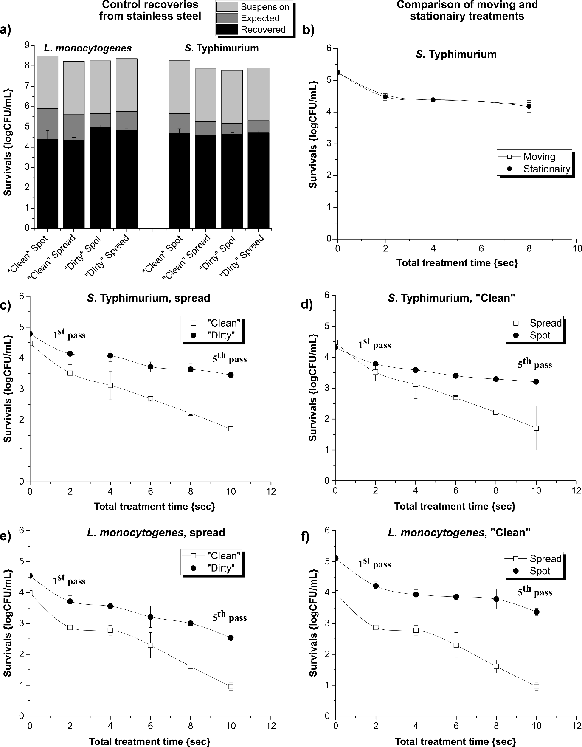
Fig. 2. Conveyor CAP tests on stainless steel: (a) control recoveries from surfaces among all conditions studied, (b) comparison of moving and stationairy treatment modes, (c) against S. Typhimurium under spread inoculations, (d) against S. Typhimurium under “Clean” conditions, (e) against L. monocytogenes under spread inoculations and (f) against L. monocytogenes under “Clean” conditions.

Concerning the “Dirty” spread conditions, the system achieved lower microbial reductions on these, compared with the “Clean” spread conditions. For the “Dirty” spread conditions, the system yielded only 2.01±0.09 and 1.33±0.03 logCFU/mL reductions of L. monocytogenes and S. Typhimurium, respectively after five passes, whereas for “Clean” spread conditions the same treatment resulted in 3.03±0.18 and 2.77±0.71 logCFU/mL reductions, respectively. Additionally, for “Dirty" spread conditions, a 1.0 logCFU/mL reduction required two passes for L. monocytogenes and three passes for S. Typhimurium (i.e., 4 and 6 sec treatments, respectively), while for “Clean” spread conditions a single pass was sufficient on both. The results are in agreement with previous studies that have shown that presence of organic substances, like BSA, are able to scavenge RONS and thus offer a level of protection to the microorganisms (Katsigiannis et al., 2021).
The two different inoculation modes were also found to affect inactivation performance. After five passes, the system yielded only 1.73±0.13 and 1.11±0.15 logCFU/mL reductions of L. monocytogenes and S. Typhimurium respectively under “Clean” spot conditions, which is considerably lower than the reductions achieved under “Clean” spread conditions shown above (3.03±0.18 and 2.77±0.71 logCFU/mL reductions of the same bacteria for the same treatment, respectively). This result is in agreement with previous studies that have shown higher population densities (e.g., spot inoculations) cause microorganisms to form multi-layers, with the outer layers significantly reducing the transport of CAP species to the internal layers (Kramer, Hasse, Guist, Schmitt-John, & Muranyi, 2019).
With regard to the two microorganisms examined, S. Typhimurium was found to be slightly more resistant to CAP treatment compared to L. monocytogenes. This is contrary to previous studies that suggest that generally Gram+ bacteria, such as L. monocytogenes, can be slightly more resistant to CAP, compared with the Gram– bacteria, such as S. Typhimurium (Han et al., 2016); (Misra et al., 2016). Nevertheless, these differences were not statistically significant, while the drying stress sensitivity of L. monocytogenes in combination with CAP exposure may explain its increased inactivation, compared with S. Typhimurium.
A final parameter investigated was the impact of air temperature and humidity on inactivation. None of these parameters were found to significantly affect inactivation. It is known that the formation and exact composition of RONS produced depend on the ambient temperature and humidity. Increased temperature favours a transition from ROS generation towards less reactive RNS (e.g., from O₃ to NOx) which has the potential to reduce inactivation, while humidity contributes to the formation of highly reactive species such as OH● and HO₂• that can enhance inactivation (Shimada et al., 2019); (Hasan & Walsh, 2016); (Misra et al., 2016).
For example, a study using an air indirect DBD against Bacillus spores on poly[ethylene-terephthalate] (PET) films showed that >3 logCFU reduction could be achieved within 2 min in humid air (>90% RH), yet the treatment had negligible effect when dry air was used right up to 10 min of exposure (Kramer et al., 2019). A similar effect is produced on moist surfaces, compared to dry ones. For that reason researchers recommend the application of CAP after a pre-cleaning stage to benefit from residual water molecules (Aboubakr et al., 2020).

Comparison of inactivation between stainless steel and PE-TPU materials

While stainless steel is frequently used for food-processing equipment, the vast majority of conveyor systems employ belts made from polymeric materials, such as PVC, HDPE and PU (Lelieveld et al., 2016). To assess the performance of the prototype CAP system on polymeric belt materials, samples of commercial food-grade PE-TPU material were acquired. Critically though, this material is favoured for its excellent resistance properties to water (Røn, Javakhishvili, Jeong, Jankova, & Lee, 2021) and indeed was found to be too hydrophobic to allow for spread inoculations; therefore, the spray inoculation mode was adopted to enable complete surface coverage. In order to provide a means of comparison between polymeric and metallic surfaces, the previous stainless steel surfaces were also tested using spray inoculation. Only S. Typhimurium was examined on these, as previous results showed that they are more resistant to the experimental procedure and CAP treatment.
Fig. 3(a) shows the results for both polymeric and metallic belt materials. For stainless steel, the level of inactivation achieved using spray inoculation was similar to those obtained using the spread inoculation method. The system yielded a 2.19±0.25 logCFU/mL reduction of S. Typhimurium under “Clean” spray conditions after 5 passes (10 sec total treatment) and a 1.22±0.08 logCFU/mL on a single pass. Generally, inactivation seemed to initially follow the spread inoculation and then the spot one, falling in-between the two (2.77±0.71 and 1.11±0.15 logCFU/mL reductions respectively). A possible explanation for this is that, as shown in Fig. 3(b), the spraying did not result in the same even spread of the inoculum on the surface, rather created many small spots that resulted in higher localized population densities, although not as high as those created by a single large spot as observed on the spot-inoculated surface.

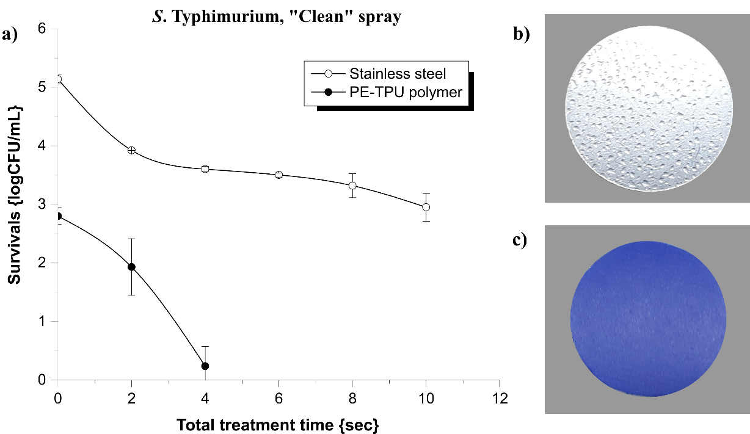
Fig. 3. (a) Reduction of S. Typhimurium under “Clean” spray conditions on various target surfaces, (b) stainless steel after spray inoculation and (c) PE-TPU polymer after spray inoculation.

For PE-TPU polymer, the spray inoculation was more uniform (Fig. 3(c)); however, the microbial recovery was considerably lower than those observed on stainless steel samples. Despite this shortcoming, the conveyor CAP performed equally well, resulting in a 0.87±0.50 and 2.56±0.37 logCFU/mL reduction after 1 and 2 passes, respectively (2 and 4 sec total treatments).
In an attempt to improve control recoveries, larger strip surfaces were additionally examined (40x100 mm), which provided ~10x more available area, compared with the previous disks. These allowed more microorganisms to settle after spraying, and ultimately improved the control recoveries (~5.50 logCFU/mL). Tests on these surfaces resulted in 1.12±0.36 and 3.53±0.62 logCFU/mL reductions after 1 and 2 passes, respectively (see supplementary Fig. S.1). Nevertheless, this increase of the efficiency was expected due to the lower initial population density per unit area, similar with the previously observed differences between spread and spot inoculations.

Impact of CAP exposure on target surfaces

In order for CAP to be used within an industrial context, it must have minimal impact on the surface properties of the food contact surface. Previous studies have shown that CAP treatment can have an impact on both metallic and polymeric surfaces. Nevertheless, it has also been shown that these effects are not permanent and materials tend to recover to their initial state in time (Scholtz et al., 2015); (Kostov, Nishime, Hein, & Toth, 2013).
XPS analysis shown in Fig. 4 was employed to assess the impact of CAP exposure on the surface chemistry of both polymeric and metallic samples. For stainless steel, the depth profile of control samples revealed a thin carbon-based layer of contamination about 1 nm thick. Beneath this layer was the Cr/Fe-oxide passivation layer followed by the steel matrix, consisting of iron, chromium and nickel. The curve for oxygen indicated the thickness of the oxide layer was about 2.0±0.5 nm. The same analysis for the 10 sec treated samples revealed an increase in thickness of the Cr/Fe-oxide layer to 3.0±0.5 nm, a higher concentration of oxygen in the top layer of the surface, with concurrent lower concentration of carbon and a small increase in the concentration of iron, which relates to additional Fe-oxide formation. Following a further CAP exposure up to 30 min, the XPS analysis revealed that there were negligible further changes to the surfaces. This was a key finding, indicating that the surface composition of CAP treated stainless steel does not substantially change following multiple successive CAP exposures.
For PE-TPU polymer, high-resolution spectra of carbon shown in Fig. 4 revealed that the area percentage of the C₁ peak corresponding to C-C/C-H bonds was decreased significantly following a 10 sec CAP exposure, but further CAP treatment up to 15 min, showed little change. The area percentages of the C₂ and C₃ peaks corresponding to C-O/C-OH and O-C=O/C=O bonds, respectively, were increased significantly following a 10 sec treatment, but showed minimal difference following 15 min of exposure (from 5.78% to 11.51% and 12.89% for C₂ and from 1.61% to 2.23% and 2.42% for C₃ respectively). The observed changes in the chemical composition of the top layers of the surfaces agree with previous studies that examined the effects of CAP on both metallic and polymeric materials. For example, an indirect Ar & O₂ CAP on stainless steel 304L resulted in decreased C-C bonds and increased C-O, C=O bonds and Fe oxides on the treated samples (Tang, Kwon, Lu, & Choi, 2005). Similarly for polymeric surfaces, a direct air-based DBD operating at 36 kV peek-to-peek and 17 kHz resulted in introduction of oxygen-related bonds on PP within some seconds and introduction of a thin top layer of oxidized material (Kostov et al., 2013).
Changes to the surface composition of a material can affect its hydrophilicity. To investigate this, water contact angle tests were performed on both materials following a 10 sec CAP exposure, shown in Fig. 4. It was found that the stainless steel became significantly more hydrophilic immediately after exposure (from ~65º to ~11º). Nevertheless, subsequent periodic tests indicated that the surfaces had mostly recovered after approximately 90 min (see supplementary Fig. S.2). On the other hand, the PE-TPU was unaffected by a 10 sec treatment, remaining hydrophobic at ~98º. Extended treatments for up to 2 min caused only a slight reduction to ~91º. This increase in hydrophilicity of the material correlates with the observed changes due to chemical oxidation and agrees with previous studies (Kostov et al., 2013); (Tang et al., 2005). However, it is interesting to note that the change in the water contact angle of the PE-TPU material was considerably less than what has been previously reported for other polymers. For example, a direct air-based DBD operating at 36 kV peek-to-peek and 17 kHz caused a decrease of the water contact angle to PP from ~105º to ~65º within some seconds (Kostov et al., 2013). It is anticipated that these differences arise due to the chemical nature of the commercial PE-TPU material that provides resistance to water.

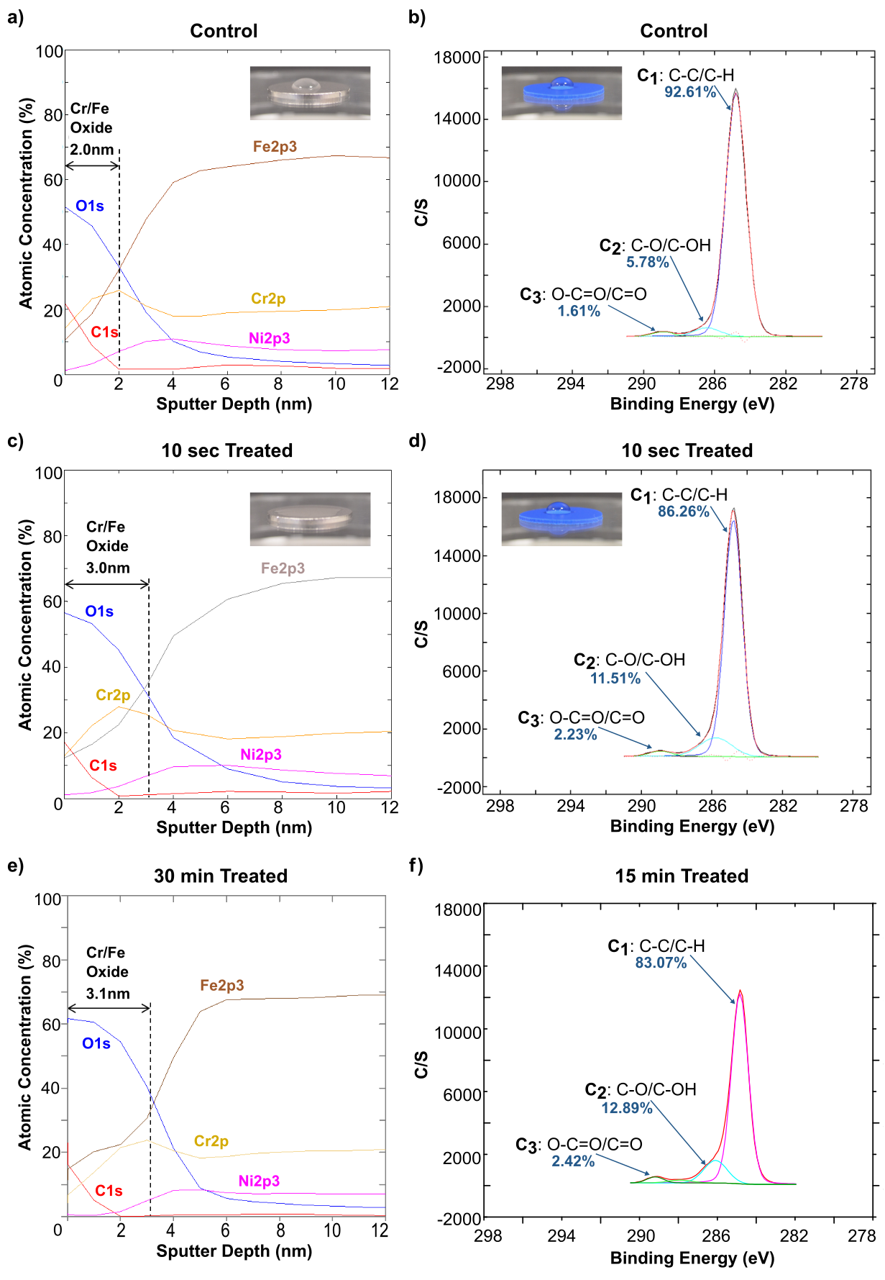
Fig. 4. XPS spectra showing depth profiles for stainless steel and high-resolution carbon spectra for PE-TPU polymer; inserts show water contact angle photographs: (a) Untreated stainless steel, (b) untreated PE-TPU, (c) 10 sec treated stainless steel, (d) 10 sec treated PE-TPU, (e) 30 min treated stainless steel, and (f) 15 min treated PE-TPU.

Beyond the composition of the surface, plasma exposure has the potential to alter the morphology of the surface. AFM analysis indicated that a 10 sec CAP treatment had negligible effect to the average roughness of stainless steel surfaces (~13.50 nm); however, it caused a modest increase in the average roughness of PE-TPU surfaces, from 4.00±0.61 nm to 6.12±0.87 nm. Extended treatment up to 15 min further increased average roughness to 12.35±3.69 nm. While average roughness is a useful metric to compare surfaces, it does not fully reflect the impact of the treatment on the nanoscale topography of a sample. Fig. 5 shows AFM topography data over a 3 x 3 µm² area. Stainless steel samples showed little change following CAP exposure, whereas PE-TPU samples showed formation of mountain-like globular structures that are possibly due to polymeric low molecular weight oxidized materials (Kostov et al., 2013). Extended treatments did not show significant changes in comparison with the 10 sec treatments for both materials. The obtained AFM results are in agreement with previous studies that noted no significant morphological changes to the microstructure of stainless steel following CAP treatment (Tang et al., 2005). For polymeric materials exposed to CAP, such as PP, it has been reported that roughness increases (from ~5 to ~25 nm) and small features appear on the nanoscale (Kostov et al., 2013).

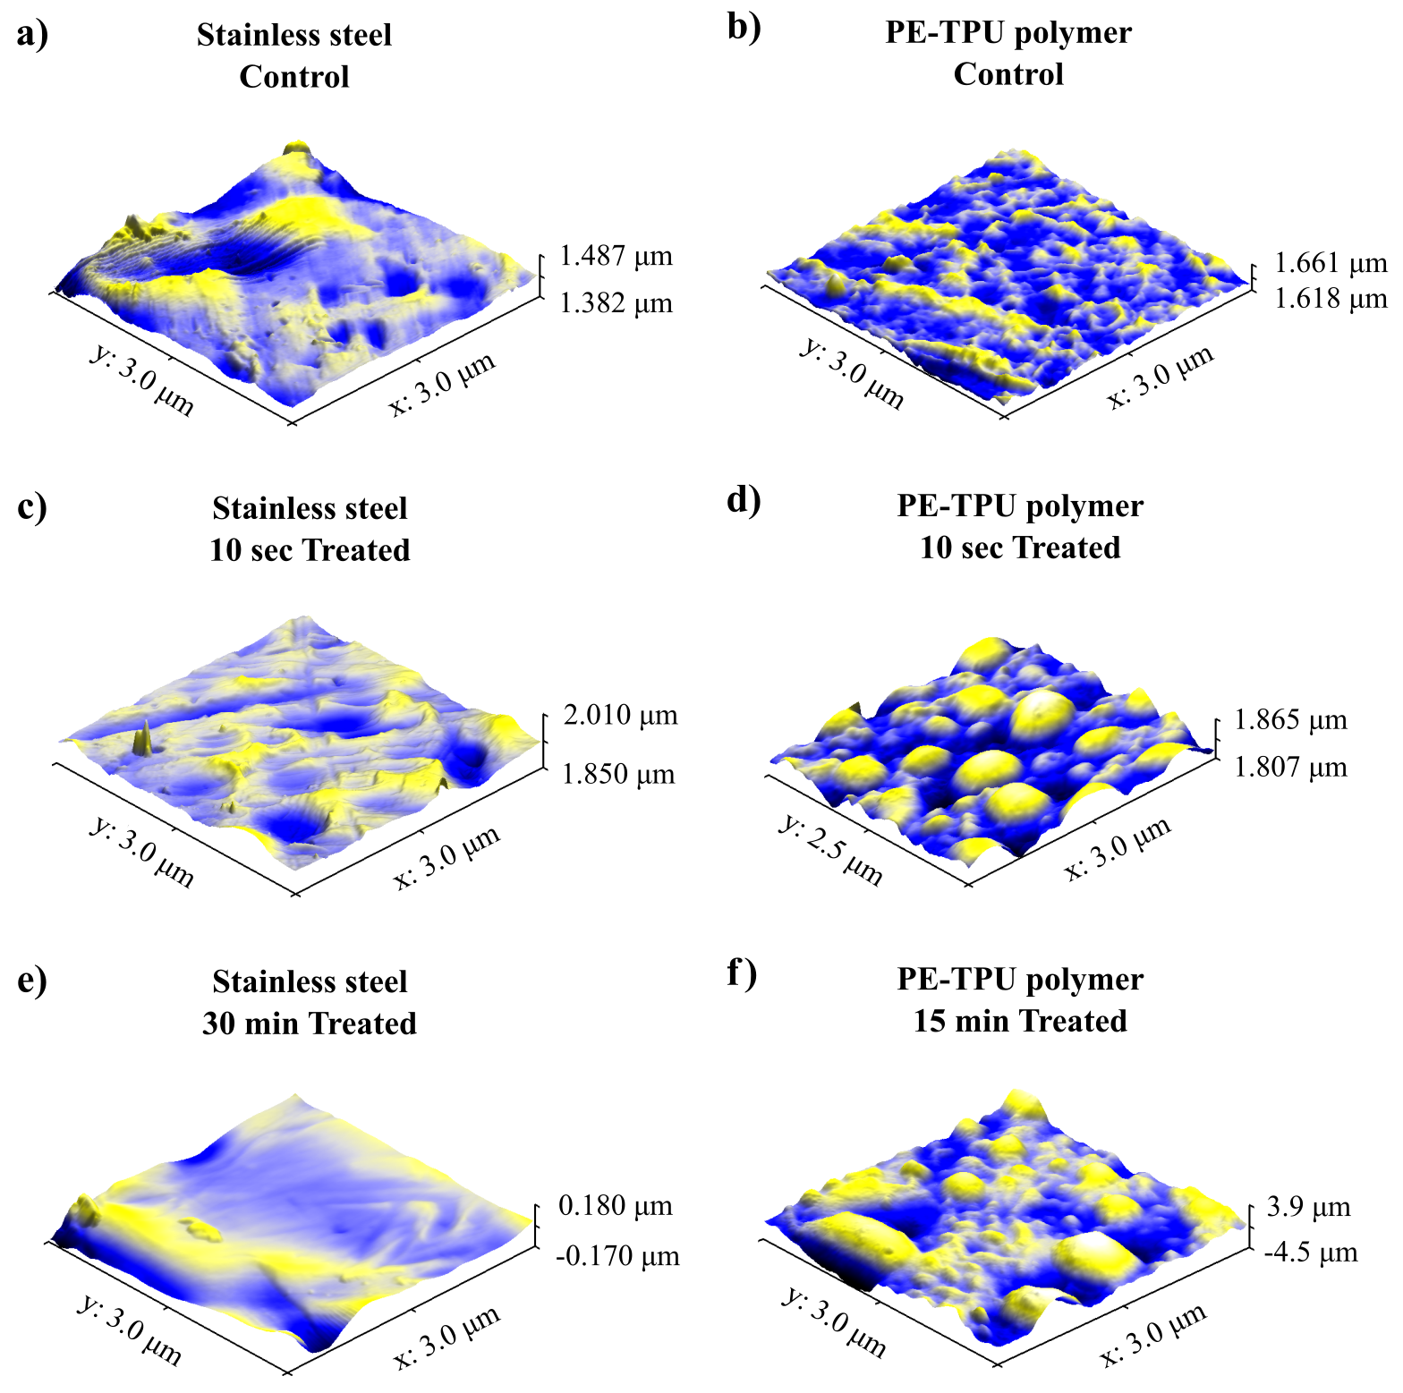
Fig. 5. AFM analysis of surface microstructure: (a) Untreated stainless steel, (b) untreated PE-TPU, (c) 10 sec treated stainless steel, (d) 10 sec treated PE-TPU, (e) 30 min treated stainless steel and (f) 15 min treated PE-TPU.

Analysis of the microstructure of the surface is vital, as surfaces that contain microscale cracks and crevices provide opportunities for microorganisms to hide and gain protection against CAP treatment. For that reason, CAP is more effective on smooth surfaces, compared with rough ones (Dasan et al., 2017); (Cahill et al., 2014). Additionally, the aforementioned changes on the surfaces may have a direct impact on the ability of the microorganisms to settle on them. For example, an increase in the hydrophilicity of the surface from CAP treatment might enhance the attachment of microorganisms on it (Scally, Gulan, Weigang, Cullen, & Milosavljevic, 2018). On the other hand, some plasma treatments might induce changes in the microstructure of the surface that lead to reduced attachment of microorganisms on it (e.g., up to 99.74% for Enterobacter sakazakii on stainless steel and 70% for Pseudomonas aeruginosa on PVC) (Masák, Čejková, Schreiberová, & Řezanka, 2014); (Şen, Bağcı, Güleç, & Mutlu, 2012), or even cell death due to rupture of cell membranes (Vassallo et al., 2017).
From the surface analysis shown in Fig. 4 and 5, it is clear that direct CAP exposure caused a change to both the composition and morphology of the treated surface. Both surfaces showed an increase in hydrophilicity following CAP exposure, indicating an increase of oxygen-related bonds and/or a change in the microstructure of the surface. However, extended treatments showed only minor changes compared with the initial 10 sec treatments. While further work is required to assess how these changes affect the mechanical properties of the surfaces or the ability of bacteria to colonise them, it is encouraging to note that extended treatments, representing hundreds of passes through the plasma, did not cause an increasing level of damage to both surfaces examined.

Conclusions

This study presented an effective and efficient CAP prototype decontamination system for food-processing surfaces and equipment against two common foodborne pathogens, which was designed to run in parallel with the production line and negate the need for costly production downtimes for decontamination procedures. This system produced up to 3.03±0.18 logCFU/mL within a short timescale, depending on the various factors examined. However, it was shown that CAP exposure caused some effects on the morphology and composition of the surfaces. Although further research is vital to understand the long-term effects of CAP exposure on the surfaces, it is clear that CAP is highly effective at eliminating microorganisms on food contact surfaces, while is clearly capable of meeting industry requirements, both in terms of decontamination level and treatment duration.

Acknowledgments

Authors would like to thank Campden BRI for their scientific and technical support.

Funding

This work was supported by the UK Engineering & Physical Sciences Research Council (EPSRC) [grant numbers EP/N021347/1, EP/R041849/1] and Campden BRI.

References

Aboubakr, H. A., Nisar, M., Nayak, G., Nagaraja, K. V, Collins, J., Bruggeman, P. J., & Goyal, S. M. (2020). Bactericidal Efficacy of a Two-Dimensional Array of Integrated, Coaxial, Microhollow, Dielectric Barrier Discharge Plasma Against Salmonella enterica Serovar Heidelberg. Foodborne Pathogens and Disease, 17(3). https://doi.org/10.1089/fpd.2019.2698
Bourke, P., Ziuzina, D., Han, L., Cullen, P. J., & Gilmore, B. F. (2017). Microbiological interactions with cold plasma. Journal of Applied Microbiology, 123(2), 308–324. https://doi.org/10.1111/jam.13429
BS EN 13697:2015: Chemical disinfectants and antiseptics. Quantitative non-porous surface test for the evaluation of bactericidal and/or fungicidal activity of chemical disinfectants used in food, industrial, domestic and institutional areas. Test method . (2015, April). Retrieved from https://bsol.bsigroup.com/en/Bsol-Item-Detail-Page/?pid=000000000030262906
BS EN 17272:2020 Chemical disinfectants and antiseptics. Methods of airborne room disinfection by automated process. Determination of bactericidal, mycobactericidal, sporicidal, fungicidal, yeasticidal, virucidal and phagocidal activities. (2020). Retrieved from https://standardsdevelopment.bsigroup.com/projects/2018-00666#/section
Buchanan, R. L., Gorris, L. G. M., Hayman, M. M., Jackson, T. C., & Whiting, R. C. (2017). A review of Listeria monocytogenes: An update on outbreaks, virulence, dose-response, ecology, and risk assessments. Food Control, 75, 1–13. https://doi.org/10.1016/j.foodcont.2016.12.016
Cahill, O. J., Claro, T., O’Connor, N., Cafolla, A. A., Stevens, N. T., Daniels, S., & Humphreys, H. (2014). Cold Air Plasma To Decontaminate Inanimate Surfaces of the Hospital Environment. Applied and Environmental Microbiology, 80(6), 2004–2010. https://doi.org/10.1128/AEM.03480-13
Corcoran, M., Morris, D., Lappe, N. De, O’Connor, J., Lalor, P., Dockery, P., & Cormican, M. (2014). Commonly Used Disinfectants Fail To Eradicate Salmonella enterica Biofilms from Food Contact Surface Materials. Applied and Environmental Microbiology, 80(4), 1507. https://doi.org/10.1128/AEM.03109-13
Dasan, B., Onal-Ulusoy, B., Pawlat, J., Diatczyk, J., Sen, Y., & Mutlu, M. (2017). A New and Simple Approach for Decontamination of Food Contact Surfaces with Gliding Arc Discharge Atmospheric Non-Thermal Plasma. Food and Bioprocess Technology, 10(4), 650–661. https://doi.org/10.1007/s11947-016-1847-2
Ekezie, F.-G. C., Sun, D.-W., & Cheng, J.-H. (2017). A review on recent advances in cold plasma technology for the food industry: Current applications and future trends. Trends in Food Science & Technology, 9, 46–58. https://doi.org/10.1016/j.tifs.2017.08.007
Elkhishin, M. T., Gooneratne, R., & Hussain, M. A. (2017). Microbial Safety of Foods in the Supply Chain and Food Security. Advances in Food Technology and Nutritional Sciences - Open Journal, 3(1), 22–32. https://doi.org/10.17140/aftnsoj-3-141
Fagerlund, A., Møretr, T., Heir, E., Briandet, R., & Langsrud, S. (2017). Cleaning and Disinfection of Biofilms Composed of Listeria monocytogenes and Background Microbiota from Meat Processing Surfaces. Applied and Environmental Microbiology, 83(17). Retrieved from https://search.proquest.com/docview/1957166728
FAO. (2021). The State of Food Security and Nutrition in the World 2021. https://doi.org/10.4060/CB4474EN
Gabriel, A. A., Ugay, M. C. C. F., Siringan, M. A. T., Rosario, L. M. D., Tumlos, R. B., & Ramos, H. J. (2016). Atmospheric pressure plasma jet inactivation of Pseudomonas aeruginosa biofilms on stainless steel surfaces. Innovative Food Science and Emerging Technologies, 36, 311–319. https://doi.org/10.1016/j.ifset.2016.07.015
Gaul, L. K., Farag, N. H., Shim, T., Kingsley, M. A., Silk, B. J., & Hyytia-Trees, E. (2013). Hospital-Acquired Listeriosis Outbreak Caused by Contaminated Diced Celery—Texas, 2010. Clinical Infectious Diseases, 56(1), 20–26. https://doi.org/10.1093/cid/cis817
Han, L., Patil, S., Boehm, D., Milosavljevic, V., Cullen, P. J., & Bourke, P. (2016). Mechanisms of Inactivation by High-Voltage Atmospheric Cold Plasma Differ for Escherichia coli and Staphylococcus aureus. Applied and Environmental Microbiology, 82(2), 450–458. https://doi.org/10.1128/AEM.02660-15
Hasan, M. I., & Walsh, J. L. (2016). Numerical investigation of the spatiotemporal distribution of chemical species in an atmospheric surface barrier-discharge. Journal of Applied Physics, 119(20), 203302. https://doi.org/10.1063/1.4952574
Hessing, A., Schneider, R. G., Gutierrez, A., Silverberg, R., Gutter, M. S., & Schneider, K. R. (2018). The Cost of Food Safety. Latin Trade. Retrieved from https://edis.ifas.ufl.edu/pdffiles/FS/FS27000.pdf
Holban, A. M., & Grumezescu, A. M. (2017). Microbial contamination and food degradation (Vol. 10). Retrieved from http://www.vlebooks.com/vleweb/product/openreader?id=none&isbn=9780128112632&uid=none
Katsigiannis, A. S., Bayliss, D. L., & Walsh, J. L. (2021). Cold plasma decontamination of stainless steel food processing surfaces assessed using an industrial disinfection protocol. Food Control, 121, 107543. https://doi.org/10.1016/j.foodcont.2020.107543
Kordova, T., Scholtz, V., Khun, J., Souskova, H., Hozak, P., & Cerovsky, M. (2018). Inactivation of Microbial Food Contamination of Plastic Cups Using Nonthermal Plasma and Hydrogen Peroxide. Journal of Food Quality, 2018(5616437), 7. https://doi.org/10.1155/2018/5616437
Kostov, K. G., Nishime, T. M. C., Hein, L. R. O., & Toth, A. (2013). Study of polypropylene surface modification by air dielectric barrier discharge operated at two different frequencies. Surface & Coatings Technology, 234, 60–66. https://doi.org/10.1016/j.surfcoat.2012.09.041
Koutchma, T. (2014). Food Plant Safety. Retrieved from https://ebookcentral.proquest.com/lib/[SITE_ID]/detail.action?docID=1655614
Kramer, B., Hasse, D., Guist, S., Schmitt-John, T., & Muranyi, P. (2019). Inactivation of bacterial endospores on surfaces by plasma processed air. https://doi.org/10.1111/jam.14528
Laguerre, O., Lecoq, L., Zoz, F., Guyot, S., Beney, L., & Flick, D. (2017). Influence of the air humidity on the drying of a liquid droplet on a solid plate and on bacterial destruction. Journal of Food Engineering, 212, 76–86. https://doi.org/10.1016/j.jfoodeng.2017.05.014
Leadley, C. E. (2016). Innovation and future trends in food manufacturing and supply chain technologies. Amsterdam: Woodhead Publishing.
Leipold, F., Kusano, Y., Hansen, F., & Jacobsen, T. (2010). Decontamination of a rotating cutting tool during operation by means of atmospheric pressure plasmas. Food Control, 21(8), 1194–1198. https://doi.org/10.1016/j.foodcont.2010.02.006
Lelieveld, H. L. M., Holah, J., & Gabric, D. (2016). Handbook of Hygiene Control in the Food Industry (Second edi). Retrieved from http://lib.myilibrary.com?ID=36179
List of Selected Multistate Foodborne Outbreak Investigations | Foodborne Outbreaks | Food Safety | CDC. (2021). Retrieved from https://www.cdc.gov/foodsafety/outbreaks/multistate-outbreaks/outbreaks-list.html
Lowe, A. (2019). Uncovering The 7 Hidden Costs of Plant Sanitation What food processors should consider when evaluating and comparing plant sanitation options. Retrieved from https://www.foodprocessing.com/assets/wp_downloads/pdf/2019/10-sanitation/1910-PSSI.pdf
Margas, E., Meneses, N., Conde-Petit, B., Dodd, C. E. R., & Holah, J. (2014). Survival and death kinetics of Salmonella strains at low relative humidity, attached to stainless steel surfaces. International Journal of Food Microbiology, 187, 33–40. https://doi.org/10.1016/j.ijfoodmicro.2014.06.027
Masák, J., Čejková, A., Schreiberová, O., & Řezanka, T. (2014). Pseudomonas biofilms: possibilities of their control. FEMS Microbiology Ecology, 89(1), 1–14. https://doi.org/10.1111/1574-6941.12344
Misra, N. N., Schlüter, O., & Cullen, P. J. (2016). Cold Plasma in Food and Agriculture. Retrieved from http://www.vlebooks.com/vleweb/product/openreader?id=none&isbn=9780128014899&uid=none
Musavian, H. S., Butt, T. M., Larsen, A. B., & Krebs, N. (2015). Combined steam-ultrasound treatment of 2 seconds achieves significant high aerobic count and Enterobacteriaceae reduction on naturally contaminated food boxes, crates, conveyor belts, and meat knives. Journal of Food Protection, 78(2), 430–435. https://doi.org/10.4315/0362-028X.JFP-14-155
Pavlovich, M. J., Chen, Z., Sakiyama, Y., Clark, D. S., & Graves, D. B. (2012). Effect of Discharge Parameters and Surface Characteristics on Ambient-Gas Plasma Disinfection. https://doi.org/10.1002/ppap.201200073
Røn, T., Javakhishvili, I., Jeong, S., Jankova, K., & Lee, S. (2021). Low friction thermoplastic polyurethane coatings imparted by surface segregation of amphiphilic block copolymers. Colloids and Interface Science Communications, 44(August), 0–4. https://doi.org/10.1016/j.colcom.2021.100477
Scally, L., Gulan, M., Weigang, L., Cullen, P. J., & Milosavljevic, V. (2018). Significance of a Non-Thermal Plasma Treatment on LDPE Biodegradation with Pseudomonas Aeruginosa. Materials, 11(10), 1925. https://doi.org/10.3390/ma11101925
Schnabel, U., Andrasch, M., Weltmann, K., & Ehlbeck, J. (2014). Inactivation of Vegetative Microorganisms and Bacillus atrophaeus Endospores by Reactive Nitrogen Species (RNS). Plasma Processes and Polymers, 11(2), 110–116. https://doi.org/10.1002/ppap.201300072
Scholtz, V., Pazlarova, J., Souskova, H., Khun, J., & Julak, J. (2015). Nonthermal plasma--A tool for decontamination and disinfection. Biotechnology Advances, 33(6 Pt 2), 1108–1119. https://doi.org/10.1016/j.biotechadv.2015.01.002
Şen, Y., Bağcı, U., Güleç, H., & Mutlu, M. (2012). Modification of Food-Contacting Surfaces by Plasma Polymerization Technique: Reducing the Biofouling of Microorganisms on Stainless Steel Surface. Food and Bioprocess Technology, 5(1), 166–175. https://doi.org/10.1007/s11947-009-0248-1
Shimada, K., Takashima, K., Kimura, Y., Nihei, K., Konishi, H., & Kaneko, T. (2019). Humidification effect of air plasma effluent gas on suppressing conidium germination of a plant pathogenic fungus in the liquid phase. Plasma Processes and Polymers, (e1900004), 15. https://doi.org/10.1002/ppap.201900004
Šimončicová, J., Kaliňáková, B., Kováčik, D., Medvecká, V., Lakatoš, B., Kryštofová, S., … Zahoranová, A. (2018). Cold plasma treatment triggers antioxidative defense system and induces changes in hyphal surface and subcellular structures of Aspergillus flavus. Applied Microbiology and Biotechnology, 1–12. https://doi.org/10.1007/s00253-018-9118-y
Stalder, A. F., Melchior, T., Müller, M., Sage, D., Blu, T., & Unser, M. (2010). Low-bond axisymmetric drop shape analysis for surface tension and contact angle measurements of sessile drops. Colloids and Surfaces. A, Physicochemical and Engineering Aspects, 364(1), 72–81. https://doi.org/10.1016/j.colsurfa.2010.04.040
Stevie, F. A., Garcia, R., Shallenberger, J., Newman, J. G., & Donley, C. L. (2020). Sample handling, preparation and mounting for XPS and other surface analytical techniques. Journal of Vacuum Science & Technology. A, Vacuum, Surfaces, and Films, 38(6), 63202. https://doi.org/10.1116/6.0000421
Tang, S., Kwon, O.-J., Lu, N., & Choi, H.-S. (2005). Surface characteristics of AISI 304L stainless steel after an atmospheric pressure plasma treatment. Surface & Coatings Technology, 195(2), 298–306. https://doi.org/10.1016/j.surfcoat.2004.07.071
Vassallo, E., Pedroni, M., Silvetti, T., Morandi, S., Toffolatti, S., Angella, G., & Brasca, M. (2017). Bactericidal performance of nanostructured surfaces by fluorocarbon plasma. Materials Science & Engineering C, 80, 117–121. https://doi.org/10.1016/j.msec.2017.05.111
Wood, H. (2017). The cost of product recalls to food businesses | Rentokil. https://www.rentokil.com/blog/cost-of-product-recalls/
WRAP. (2021). Food surplus and waste in the UK - key facts. Retrieved from https://wrap.org.uk/sites/default/files/2021-06/Food Surplus and Waste in the UK Key Facts June 2021.pdf
Yun, H., Kim, B., Kim, D. B., Jung, S., Kruk, Z. A., Choe, W., & Jo, C. (2010). Inactivation of Listeria monocytogenes inoculated on disposable plastic tray, aluminum foil, and paper cup by atmospheric pressure plasma. Food Control, 21(8), 1182–1186. https://doi.org/10.1016/j.foodcont.2010.02.002
Yusupov, M., Bogaerts, A., Huygh, S., Snoeckx, R., van Duin, A. C. T., & Neyts, E. C. (2013). Plasma-Induced Destruction of Bacterial Cell Wall Components: A Reactive Molecular Dynamics Simulation. The Journal of Physical Chemistry C, 117(11), 5993–5998. https://doi.org/10.1021/jp3128516

