<AT>Title: “In Line with the Modern Conception of Much Mental Illness”: Psychiatric Reforms and Architectural Design Contributions in Post-War England

<AA>Author: Christina Malathouni

ArchitectureMPS. vol. 16, no. 4.
December 2019

<AFL>Affiliation: School of Architecture, University of Liverpool, United Kingdom, Senior Lecturer

Volume Editor: Glyn Everett, University of the West of England, UK

Keywords: mental health, Admission Unit, post-war England, Nuffield Provincial Hospitals Trust, World Health Organisation, Richard Llewelyn Davies, Paul Sivadon

ORCID (if assigned): 0000-0001-6233-6034
Funding acknowledgement: UoL; Wellcome ISSF (re images)

Abstract

This article examines the history of, and specialist design principles behind, two Admission Units that were added to two existing mental health hospitals in post-World War II England. Their commission and realisation fell within a period of critical psychiatric reforms, some of which first emerged in the first half of the twentieth century with further developments peaking after World War II. Although the two buildings preceded subsequent interdisciplinary advancements that specifically fed into the correlation between buildings and healthcare, namely, environmental psychology and evidence-based design, they emerged at a time when prominent hospital architecture studies were embracing a research culture and aimed at merging an interdisciplinary approach with modernist architectural principles. Yet, these and numerous other such units have been virtually absent from existing scholarship, both general architectural historiography and studies of specialist healthcare architecture.
The discussion opens with a brief overview of the general policy and psychiatric context within which the two units were commissioned and erected. This is then followed by a closer inspection of the two buildings as realised which brings to light both similarities and differences. Discussed in parallel to principles outlined in healthcare architecture guidance published at the time, this comparison highlights the complex and nuanced associations between architectural design and mental healthcare, as well as the way these evolved in this particular time period. The paper also makes the case for further research in the area that studies the post-war history in this field as well as comparisons both to the inter-war and to the contemporary periods.

Introduction

Despite the fervently championed double aims of deinstitutionalisation and the merging of mental and physical health in the post-war period and late twentieth century, in recent years, an intensive building programme has been advancing within the English National Health Service (NHS) that aims to provide specialist, usually standalone, buildings that specifically cater for inpatient mental healthcare services. Similar trends are known internationally and the discourse on specialist mental healthcare design continues to draw from the areas of environmental psychology, evidence-based design, and new technological developments that are employed to enhance sensory design or safety and security measures. This emphatic assertion of the need for specialist mental health inpatient facilities invites a closer examination of the actual reality during the transitional period in the second half of the twentieth century. Of special interest in this connection is the post-war period, when such a transition was taking critical steps and which has been widely recognised as a period of psychiatric reform.
Indeed, despite the strong emphasis on deinstitutionalisation that led away from mental hospitals and towards the incorporation of mental healthcare either within general hospitals, or in the community, building activity in the 1950s and 1960s within existing mental hospital grounds resulted in a number of purpose-designed buildings. What is more, architects engaging in such commissions repeatedly expressed their aspiration to make their designs match the positive developments in the field of mental health. The quote used in the title of this paper comes from an article on the newly-completed Admission Unit at Fair Mile Hospital, in Cholsey, near Wallingford, Berkshire (now Oxfordshire; the first case study for this paper), published in the Architects’ Journal on 19 April 1956. The article reveals the aspirations of architectural professionals to make their own contribution to the field of mental health:
“The general atmosphere of this admission unit is reassuring and optimistic, to be in line with the modern conception of much mental illness as a curable condition.” [1956]
Similar language was used for the “Admission Villa” at Fulbourn Hospital, near Cambridge (the second case study for this paper), in 1964. In addition to another confident assertion that the architecture can indeed match the principal aims of its specified use, here we also have mention of the increasing openness of, and psychosocial approach to, mental healthcare:
“Modern treatment, with its emphasis on essential interaction, realistic activities and close links with the outside community, is well within the capabilities of this interesting new building.” [1964]
In the period between these two quotes, however, the professional press also voiced the increasing realisation that further support was needed so that architects were provided with the specialist knowledge required to design appropriate mental health facilities. In 1959, an article in the Architects’ Journal discussing the new Admission Unit at St John’s Hospital, in Stone, Buckinghamshire, stated:
“So little building has been done in this field since new ideas of treatment for mentally sick developed that it will clearly be the job of the health authorities to establish research teams in mental hospital building similar to the Ministry of Education’s.” [1959]
What actually followed, to what extent such calls were answered, in what ways, and by whom has not been comprehensively addressed in existing scholarship. What is more, given the revived interest in specialist mental healthcare facilities at present, an in-depth understanding of these early attempts to address the specificities of this particular area of healthcare design gains additional momentum.

Historical background and policy context

By its chronological framing, the investigation presented here is directly linked to the British welfare state. The launch of the National Health Service in July 1948 was one of the strongest manifestations of the British welfare state in the post-war period and also heavily focused on hospitals, both as buildings and as organisational entities. Not only did the National Health Service introduce healthcare provision to all that was to be free at the point of delivery but it also brought all hospitals under one administrative system. Legal restrictions that separated mental from physical health were still in place and it would take more than another full decade before the Mental Health Act of 1959 eventually removed all legal separation between physical and mental health provision. Nonetheless, mental hospitals had been included in the new administrative organisation under the NHS as early as 1948, placed under the newly formed Regional Hospital Boards but forming their own Hospital Management Committees.
The National Health Service inherited hospitals that were in dire need of upgrade, whilst bed shortages also dictated the commission of new hospitals. Although these needs were clearly pressing, there were also budgetary constraints. These meant that a substantial hospital building programme could not be put in place before 1962 when The Hospital Plan for England and Wales was published by the Ministry of Health and set out a framework for the development of hospital services. Limited activity was, however, initiated in the 1950s and, as regards new buildings, mental hospitals featured amongst the top priorities: tuberculosis had come first as a priority, but was soon obsolete, and mental hospitals were second. Competing priorities outside the field of healthcare, however, further limited hospital rebuilding: the 1954 capital expenditure prioritized housing and schools, with just £10m budgeted for hospitals. Most important for the discussion here was the “mental million” (the name referring to the amount of funding approved), the “meagre” funding allocated by Minister of Health Iain Macleod for additional psychiatric facilities in 1954-55, which directly relates to the cases discussed here. As additional budgetary constraints delayed all major building projects, though, further policy changes were also introduced and mental hospitals effectively disappeared from new building programmes. What followed was indeed a gradual implementation of deinstitutionalisation which resulted in the closure of mental hospitals, integration of mental and physical inpatient care through the introduction of psychiatric wings within general hospitals, and the even slower implementation of community care. Notably, this was a process that took several decades to complete and therefore more studies are still required to uncover the rich granularity and significance of this period.

Existing Scholarship

The investigation presented here first started in response to the virtual absence of post-war mental health facilities from architectural historiography. Although all evidence identified below demonstrates how post-war Admission Units were seen as specialist hospitals in their own right and often attracted higher investment in actual funds and in architectural expertise (in comparison to other post-war buildings added to existing asylum grounds), they are virtually absent from existing scholarship. The policy changes outlined above meant that the second half of the twentieth century in England (and in most of the Western world) has long been associated with deinstitutionalisation. As a result, until recently, this period has been largely considered as of no particular interest as regards related architectural design developments within England, despite the fact that the actual closure of mental hospitals took several decades to be realised.
Indeed, although numerous studies have firmly established the significance of spatial arrangements in the development of psychiatry and the social history of madness, as well as the wide-ranging architectural scholarship on nineteenth-century asylums, scholarship on mental healthcare facilities in the twentieth century remains largely fragmentary even if it is slowly growing. In particular, architectural historiography has virtually obliterated any purpose-built mental health facilities realised for the newly founded National Health Service. To date, there is no comprehensive survey of this period, nor has it been established how many commissions there were under the “mental million” scheme, or how many were actually realised or survive. Recent studies have started highlighting the persistence of large institutions and inviting a closer inspection of reforms that were taking place within them, both in terms of care practices and as regards the adaptation of existing building fabric and furnishings. This study maintains that this should also apply to new environments that were purpose-designed within the grounds of existing mental hospitals, especially since the fundamental changes in policy have clearly impacted on the scarcity of architectural historiography in this area.
Building activity directly linked to the mid-1950s funding can be identified in a small number of articles in the architectural press. A few Admission Units can be traced in the architectural press originating both during World War II and in the early post-war period, the latter including the two chosen case studies here. Yet, systematic studies of post-war English architecture hardly mention design interventions relating to mental healthcare during the post-war period. Elain Harwood’s 2015 Space, Hope and Brutalism: English Architecture, 1945-1975 touches upon the topic of post-war mental health facilities by identifying the Oxford Regional Hospital Board as “the most architecturally ambitious” in commissioning and building “several lightweight acute admissions units in the grounds of its Victorian institutions”. She specifically lists two units for the mentally ill that opened in 1956 – one at Fair Mile Hospital and one at St John’s Hospital, that is, the two units already briefly mentioned above in connection to the first two quotes from the architectural press. These were designed by Powell and Moya and by Gollins, Melvin, Ward and Partners respectively. A third unit mentioned by Harwood was for the mentally handicapped at Borocourt Hospital, Oxfordshire, also by Powell and Moya, and opened in 1964. All three buildings also featured in the architectural press of the time. This limited recognition remains attached to “named” modernist architects and draws the conclusion that there are no significant developments from earlier asylum typologies, or other architectural or mental health developments, in the transition from a comprehensive asylum to the particular focus to admissions and, in most cases, physical treatments too.
Other significant studies that have examined realised healthcare buildings in England have either specifically focused on the period up to the introduction of the National Health Service, or simply omitted the post-war period. For example, an early 1990s survey of realised English Hospitals, conducted on behalf of the Royal Commission on the Historical Monuments of England (RCHME), focused on the period 1660–1948. Similarly, a brief “Listing Selection Guide” by English Heritage (now Historic England), on “Health and Welfare Buildings” hardly mentions twentieth-century mental healthcare buildings, with a single reference to a particular influence on design in the 1920s in just two sentences. This is despite two substantial new hospitals for the mentally ill being built in the 1930s, and large new hospitals for the “mentally handicapped” added considerably later; for example, the Ida Darwin Hospital, near Cambridge (adjacent to the second case study examined here, Fulbourn Hospital), and Fieldhead Hospital, in Wakefield, Yorkshire (designed by Yorke, Rosenberg and Mardall), that opened in 1970 and 1972 respectively.
Existing studies of twentieth-century mental hospitals in other geographical settings have highlighted that closer analysis can reveal critical gradations in design devices used by architects which, in turn, can have far-reaching implications in the context of mental healthcare. A few studies on the post-war period – again in other geographical settings – have focused on the collaboration between mental health professionals and architects, either in terms of direct collaboration for individual projects or in terms of broader research in the field.
As regards the British context, in two earlier papers I have already used the first building discussed here, the Admission and Treatment Unit at Fair Mile Hospital. The first paper outlined an introduction to connections between English post-war Admission Units and the broader shift of the earlier areas of madness, incarceration, and asylums towards a medical model of mental illness and treatment. In the second paper I have also highlighted critical questions regarding any real or aspired associations between the built environment and mental healthcare. My re-visiting here Fair Mile, but this time in parallel to the post-war Admission Unit at Fulbourn Hospital, aims to bring to the foreground the complexity of such issues by underlining the multiple nuances both within mental healthcare and in its real and aspired associations to (mental) healthcare architecture. A number of particularities as regards Fulbourn Hospital, as explained below, promise to make this an especially fruitful addition to my earlier analysis of Fair Mile.

Scope and Case Studies

Despite the lack of research in this area and the exclusion of post-war buildings from the 1998 summary publication of the RCHME project, several more similar projects can be identified across the country through the original survey material that is deposited at the Historic England Archive in Swindon, Wiltshire. A scoping exercise at this archive, undertaken by the author, was interrupted by the outset of the Covid-19 pandemic in early March 2020 but resumed two years later, in January and May 2022. The files on mental hospitals in this archive include numerous mentions, photographic recordings, as well as some architectural drawings of structures realised in the post-war period and surviving until the time of the survey in the early 1990s. These include a number of Admission and Treatment Units commissioned in the mid-1950s but also reveal that a similar building programme had started in the inter-war period. As is in fact also suggested by a handful of admission wards published in the architectural press in the early 1940s, the RCHME files confirm that numerous Admission Units were planned and several actually built in the 1920s and 1930s. It is safe to presume that this building programme was boosted by those practice and policy developments that had stressed the importance of early treatment since the 1920s and also led to the Mental Treatment Act of 1930 that legally formalised voluntary admissions. Although in-depth analysis is still lacking, the fragmentary yet substantial evidence examined so far firmly suggests that critical medical advances further speared the commission of those new additions, namely, the introduction of “physical treatments” in the course of the 1930s (most notably, insulin coma therapy in 1935 and electro-convulsive treatment in 1937). What is more, the distribution established so far strongly suggests that this building activity was widespread throughout England.
Although Admission Units were not the only additions, or conversions, within existing mental hospital sites in the post-war period, their representation in the architectural press as noted above demonstrates that they received higher funds and architectural attention, including being commissioned to leading modern architectural practices. Indeed they were also considered to play a particularly unique role in the new direction that mental health was taking: away from custodial care and towards treatment.
Out of this expanding list of Admission Units, the one at Fair Mile has been chosen as a Unit that was completed exceptionally early and also designed by a very prominent post-war architectural firm. In addition, it is one of those few examples that have already featured in the limited existing scholarship in this area. The second case study is missing from Harwood’s account, yet it did receive considerable coverage in the architectural press, presumably to a degree because of the contribution to its constructional design by leading post-war engineer Felix J. Samuely. Interestingly, Fulbourn hospital also had a substantial inter-war Admission Unit, which apparently survives to date, currently being used for the Forensic Psychiatry Service. What is more, during the post-war period it became quite famous for the exceptional contributions to social psychiatry by Dr David H. Clark, “first as Medical Superintendent and then as Senior Consultant of the hospital for 30 years, from 1953 to 1983”.

Admission and Treatment Unit, Fair Mile Hospital, Berkshire (now Oxfordshire) (1956)

Described as an “Admission and Treatment Unit”, and subsequently named the “George Schuster Hospital”, the new building for Fair Mile comprised four wings on a single level, in a cruciform plan. There were two separate male and female wings with 30 beds for women and 23 beds for men, each one including its own single-sex dining and day rooms, and as well as a mixed-sex common room in its third wing.. The second component of the building, the “Treatment Hospital” housed insulin and electro-convulsive therapy (ECT) and was to be open to inpatients as well as “the ever-increasing number of out-patients requiring treatment”.
As a particularly early post-war project, the design featured use of modest building materials and simple building techniques. Rather than constructional innovation, therefore, noteworthy here are the obvious distancing – physical and stylistic – from the main hospital, as well as the influence on issues such as ward sizes and layouts, and interior lighting elements of the landmark study on hospitals, titled Studies in the Functions and Design of Hospitals: report of an investigation and published in 1955 by the Division for Architectural Studies of the Nuffield Provincial Hospitals Trust.

Admission Villa, Fulbourn Hospital, Cambridgeshire (1964)

Named “Kent House”, the “admission villa” at Fulbourn Hospital, opened in 1964. That is, it was completed almost a decade later than the Unit at Fair Mile, following the launch of the 1959 Mental Health Act and the publication of the 1962 Hospital Plan for England and Wales. Similar to the Unit at Fair Mile, it was designed to provide short-term psychiatric treatment, as well as residential accommodation. It could house 95 patients in four wards comprising single rooms, and four- and 10-bed wards in a two-storey block (42 beds for male patients, 51 beds for female patients, and 2 beds for either sex). This block intersected the “leg” of a “T”-shaped single-storey block that accommodated recreation and occupational therapy sections, whereas the “head” of the “T” accommodated administrative and treatment areas, with the dining hall and entrance areas occupying the link between those two parts.
Chronologically more distanced from the building material shortages that had followed World War II, this unit demonstrates more advanced constructional techniques as well as a consideration for future-proofing. For example, the designers anticipated further evolution of treatments:
“While the treatment areas is at present subdivided into a special sequence of rooms it will be possible to re-arrange this in the future should the treatment system change”.
Such functional flexibility was strongly supported by constructional solutions like “the roof span[ning] clear over the whole area and rooflights, constructed on a modules system, provid[ing] daylight to the central areas”. There were also special arrangements for the external appearance of the building that complemented the in situ reinforced concrete frame with ribbed precast concrete panels: “The outer wall cladding units and windows can be rearranged to suit the requirements of modifications to the rooms.”

Similarities and differences

Although different in size and times of completion, the two units bear significant similarities: both buildings embrace a largely cruciform layout, which allowed the separation of male and female wards and their further separation from shared social and treatment facilities. They also allowed relatively short distances to reach those shared facilities as well as the provision of single-sex external spaces accessible directly from the wards, and the creation of well-lit and well-ventilated wings rather than deep floor plans. At Fair Mile, the cruciform plans includes the treatment wing, which was for outpatients too, whereas in the larger Kent House, the treatment wing is effectively an added element transforming the fourth wing of the cruciform plan (the one that housed a mixed-sex dining room) into a T-shaped wing.
The list of spaces included in each unit also presents close similarities: wards are of a similar size, both buildings include specialist treatment rooms that could also receive outpatients, as well as mixed-sex spaces that were used for social activities and occupational therapy. As regards catering, both buildings relied on the main kitchen of the hospital, although the floor plan of Kent House also includes a small room designated for “patients’ cooking”.
The respective siting of the two units is one of the most noticeable differences between the two cases: as already discussed elsewhere, the Admission Unit at Fair Mile was distinctly located away from the main hospital and the two buildings were visually separated too. Conversely, at Fulbourn the new building was adjacent to the earlier inter-war Admission Unit, which in turn was also in close proximity to the original building of the hospital. Another notable difference is the addition of a second floor at Fulbourn, an approach that was subsequently criticised by some of the nursing staff. As mentioned above, the two buildings were also quite dissimilar in terms of construction. Although the shift to more adventurous constructional methods was to be expected to a degree, as post-war material shortages were being overcome, a considerably greater investment in the actual construction of the building is evident at Fulbourn. Their consultant engineers Felix J. Samuely, one of the most influential engineers as regards English architectural modernism, and the connection of standardisation and pre-fabrication to functional flexibility and adaptability suggests a transition to a later phase of post-war hospital design that engaged with fast construction and future-proofing by enabling expansion or modifications as required.

Studies in the Functions and Design of Hospitals (1955)

Evidently the discussion here leaves aside crucial philosophical questions about whether there is such a thing as “mental illness”, or whether there should be “treatments” of any sort. Instead, this study is embedded within the current official framework of mental healthcare, which includes spaces for inpatient treatment, and seeks to explore how developments in the two professional areas have been informing, and potentially also affecting, each other. Most of the considerations discussed above can be easily linked to practices in mental healthcare, such as the separation of early admissions from long-term patients or the increasing number of outpatients. Even when some points appear to be internal, possibly even insular, professional considerations of built environment professionals – for example, construction – there too one can trace connections to the fast evolving field of mental healthcare as reflected in the aim to enable flexibility in the new building at Fulbourn. Similarly, although one might initially consider the adoption of a modernist approach as regards the appearance of the two buildings to be a purely architectural consideration with no connection to healthcare practices, visually matching modern approaches to mental health served as a further step towards the symbolic elevation of mental healthcare as an area worthy of attention and investment.
Beyond such general points, however, it is important to explore how specific guidance for specialist psychiatric spaces evolved in the post-war period, as was requested by the 1959 article in the Architects’ Journal. As discussed elsewhere, there is evidence that the design of the Admission Unit at Fair Mile was influenced by the 1955 Nuffield report Studies in the Functions and Design of Hospitals. The report was the principal outcome of research launched in 1949 by the Nuffield Provincial Hospitals Trust, with the co-operation of the University of Bristol. The Nuffield Trust had been founded in 1939 by Lord Nuffield to promote the coordination of hospital and ancillary services in the provinces, as a provincial equivalent of the King Edward’s Hospital Fund for London. This particular research project was conducted by the Trust’s Division for Architectural Studies, under the direction of Richard Llewelyn Davies and a multi-disciplinary team.
Amongst other points, the influence of the Nuffield study at Fair Mile includes the design of 4- and 6-bed wards (as well as 10-bed dormitories and single rooms). This influence is particularly interesting as the report had been based on research conducted specifically on general hospitals and explicitly excluding mental hospitals. Some blurring between the two areas of mental and physical health, and related hospital guidance, could be seen as understandable in a period when the aim to achieve parity was at the forefront. What is more, though, this same aim may have actually served as intentional motivation for embracing general hospital guidelines, rather than an oversight or a compromise, despite the parallel awareness that more specific guidance was also required.
Considering the above, it is particularly noteworthy that the wards at Fulbourn also largely adopted the same layouts as those at Fair Mile. Remarkably, 6-bed wards are missing here, but the single rooms, and 4- and 10-bed wards match the pattern followed at Fair Mile. Although completed in 1964, the “admission villa” at Fulbourn Hospital was actually planned in 1957-58, that is, not much later than the unit for Fair Mile. With this fact in mind, all the similarities listed above suggest the very likely influence from the Nuffield study of 1955, despite the completion of the building being after the publication of a report by the World Health Organisation (WHO) that was published in 1959 and focused specifically on Psychiatric Services and Architecture. A closer look to similarities and differences between the two documents and how these correspond to the realised designs of the two buildings is particularly rewarding. This comparison helps reveal critical elements distinguishing the medical emphasis of physical health, but also of physical treatments adopted within mental healthcare, vs. the increasing emphasis on the psychosocial approach to mental health.

Psychiatric Services and Architecture (1959)

Published in 1959 to provide international guidance on the topic, the report on Psychiatric Services and Architecture appeared the same year that in England the 1959 Mental Health Act received royal assent, on 29 July. One can presume that it was in response to at least one, if not both, of these events that, two and a half months later, the Architects’ Journal raised the pressing issue of specialist guidance for architects designing mental healthcare. What is more, the WHO report did not introduce completely new guidance as far as English architectural designers were concerned. The three leading persons behind the report involved one architect and two psychiatrists, the former being Richard Llewelyn Davies, the Director of the Division for Architectural Studies of the Nuffield Trust and therefore the same person that had led the 1955 Nuffield report Studies in the Functions and Design of Hospitals too. The two named psychiatrists were the French Paul Sivadon and the British Alex Baker, but a larger team is acknowledged as having contributed: “Twenty-nine psychiatrists from thirteen countries and four architects from three countries further commented on the first draft.”
Various points can be seen as problematic from our contemporary perspective, for example, the fact that leading team was restricted to three men from two European countries. Indeed, although the main content of the report mentions as positive precedents examples from non-Western countries, for example, a mental hospital in Nigeria or Soviet psychiatry, the section about “tropical countries” reveals a strongly imbalanced outlook that presents temperate climate countries as the norm in comparison to which tropical conditions are presented as “the Other”. What is more, the language of the report is also strongly gendered: male pronouns are used as the standard for patients, with limited exceptions when there is a specific reference to female patients. Similarly about professionals, a “hostess” that is recommended as good practice upon the arrival of a patient at an out-patient clinic is suddenly specified as female.
Despite the above issues that are largely representative of its time, the WHO report does document specific attempts to address architectural questions relating to psychiatry. It therefore further supports the position held here of the need to study further the relationship between designed environments and mental healthcare in the post-war period. Dating the establishment by the WHO Expert Committee on Mental Health of the principles that “should govern the structure and function of psychiatric hospitals” as early as 1952, the report sums up the principal requirements set out by the Committee as “a strong therapeutic atmosphere” and a “close liaison with the surrounding community”. Taking into consideration further developments since 1952, as the report was prepared in the autumn of 1957, it expanded beyond the psychiatric hospital to related services, such as “out-patient departments, psychiatric wards in general hospitals, rehabilitation facilities, and other mental health services”. In actual fact, no admission units are discussed in the WHO report and, interestingly, there is a strong recommendation against their use. The closest to admission units and treatment centres as documented in the two cases studies here are the “out-patient clinic and early treatment centre” presented first - and “taken together as their functions overlap”.
The opening paragraph of the main body of the report is particularly enlightening as, not only does it specify the “social” turn within psychiatry, but it also gives architecture a role precisely within this psychosocial context:
“Architecture is an important part of man’s environment and he creates it for himself. Buildings not only provide an immediate solution for his needs, but also reflect his culture and aspirations. In most cultures, buildings last more than one generation and therefore the architecture of one generation will affect the next. During recent decades, psychiatry has become more concerned with the influence of social factors on psychiatric patients, and among social factors architecture must be included. In this report we are concerned with the buildings and facilities that psychiatry needs if it is to treat patients successfully...”
It is in this context that the most notable difference between the Nuffield study and the WHO report can be discerned: this is not related to the optimum number of beds recommended, but to the rationale behind those sizes and to the actual layout and furnishings recommended. That is, the WHO report also recommended the range of 4 to 8 beds as the best range, and specifically outlined examples of 6-bed wards. However, the rationale behind the number of beds does not originate here on nursing requirements and efficiency, nor on natural lighting and the avoidance of glare as can be seen in the Nuffield report. Instead, the rationale for the WHO report is very strongly based on the social element seen in the role of architecture: the specific examples provided in the WHO report promote a 6-bed ward as a recommended size (in addition to single rooms), primarily based on the social dynamics for various group sizes considered in relation to psychotic patients. Before it was reiterated in the discussion of patient spaces, the significance of social dynamics was first introduced in terms of staff groups:
“… Each [therapeutic group, comprising doctors, social aides, nurses, etc] should form a social field in the sense of Lewin’s definition, that any individual in the group can influence the whole, and the whole will influence all the individuals. ...”
The report also specifically presents alternatively arranged wards, encourages the possibility of flexibility in furniture arrangements (which also include a small desk for each patient, or as shared by two patients), and recommends windows in more than one wall. What is more, the floor plans presented in the 1959 report are not very clear as regards the nature of the beds recommended, whereas photographs of the wards at Fair Mile and Fulbourn clearly depict strongly recognisable metal hospital beds. [FIGURES: wards] What is more, the WHO report stresses the distinction between mental and physical healthcare requirements and specifically stipulates the need for some private space for each patient that extends beyond the limited scope of a bed. In this same context, recommended ward furniture per patient include a wardrobe and a desk. These are also used to sub-divide wards into individual cubicles, i.e. they also served as dividers for additional privacy, as clearly stressed both in the text and the illustrations of the WHO report and markedly distinct from the small bedside cupboard and curtain only in the two buildings studied here.

Hospital Building Notes (1961-1966)

From 1961 onwards, the Ministry of Health would publish a number of different specialist guidance notes on psychiatric facilities, as part of its series of Hospital Building Notes (HBN). These comprised five separate issues: Volume 5, on Short Stay Psychiatric Unit (1961); Volume 30, on Accommodation for Psychiatric Patients (1963); Volume 31, on Psychiatric Ward Type 1 (1964); Volume 32, on Psychiatric Ward Type 2 and Pre-Discharge (Hostel Type) Ward (1964); and Volume 33 on Rehabilitation Centre for Psychiatric Patients (1966).
These guides broadly embraced the recommendations of the 1959 WHO report in terms of the general classification of psychiatric facilities and their siting closer to population centres, as well as broad recommendations as regards the organization of psychiatric services, e.g. the need to have teams responsible for a complete cross-section of patients for a number of reasons, including training, appropriate care of long-term patients and continuity of care (§7). However, two differences are worth noting in relation to the discussion here: firstly, focusing on hospital accommodation, the closest to what WHO had classified as “outpatient clinics and early treatment centres” becomes in the HBN series “short-stay psychiatric wards” that are incorporated in general hospitals (HBN No. 30, 1963; HBN No. 31, 1964). By the publication of HBN No. 30 (1963), the need to have Note No. 5 revised is also noted, so as to address “out-patient and day patient facilities for the mentally ill, and also for suitably sited short-stay beds” (§§35, 41). “Separate (self-contained) psychiatric hospitals” were to continue existing for “mentally subnormal” patients adopting “a general layout comparable to that of a compact village or urban neighbourhood” (§42).
What is more, although the recommendation for ideal groupings of 4 or 6 patients in wards (as well as single bed rooms) and in dining tables is adopted in the BHN No. 5, there is a more flexible approach as regards the actual furnishings of the wards. A clear distinction can be seen in comparison to general hospital wards as outlined in HBN No. 4 (c1961, rev. 1968), where there is simply a recommendation for a small sitting area within the bed space for appropriate groups of patients that would be able to use these, with separate day spaces for other activities (HBN No. 4, 1968, §§38(a)(a)(ii), 38(b)). By contrast, there is substantially more emphasis in providing personal storage furniture (wardrobes), which is also seen as having the potential to provide more privacy by creating individual cubicles (or alternatively by using screens), as well as a bedside locker and a chair by each bed. Yet, the guidance holds back from recommending a desk per 1-2 patients as essential, although it does mention the possibility of a small table (HBN No. 5, 1961, Section IV. §A(e)(ii)). Interestingly, separate day rooms for each sex and a general sitting room for mixed-sex use are also recommended (HBN No. 5, 1961, Section IV. §§A(d)(i), A(d)(iii)), as already applied in the Admission Unit at Fair Mile by 1956 and at Fulbourn by 1964, and in the latter we can also see a mixed-sex dining room too.
HBN No. 30 (1963) that “gives general advice on the planning of hospital accommodation for psychiatric patients”, referring to “patients suffering from all forms of mental disorder”, i.e. both “mentally ill” and “mentally subnormal”. The practical need to consider siting accommodation for psychiatric patients in or adjacent to existing sites of district general or psychiatric hospitals, as well as the adaptation of existing buildings. The subsequent three volumes of the series also focused on spaces linked to psychiatry but diverted from the discussion here: HBN No. 31 (1964) and HBN No. 32 (1964) focused on two types of wards for the mentally subnormal, whereas HBN No. 33 (1966) discussed a Rehabilitation Centre for Psychiatric Patients.

Conclusions

The analysis above touches upon just a handful only of the issues around mental healthcare in the post-war period and its association to inpatient spaces. Out of the continuously expanding range of available treatments, whether following biological or psychosocial models, there is open reference to two types of physical treatments only, whereas there is vague mention only of the broader significance of social connections but no specific remarks on non-biological treatments such as psychotherapy, or rehabilitation therapies. Even with such a narrow sample of this multifaceted field, the potential, but also additional complexities, emerging from the field of architecture becomes apparent. Yet, although the particular requirements for insulin coma and electro-convulsive therapy can become immediately visible to the non-expert eye, other specialist uses can be less fixed, or missed or misinterpreted without additional evidence.
Indeed, such lack of evidence allows very limited scope for accurate interpretation of influences that fed into the design of the two buildings discussed here, or their subsequent use. Answers to the latter issues come from administrative papers by the hospitals, their management committees, and regulating bodies, as well as publications by mental health professionals. Limited information from administrative papers for Fair Mile, for example, reveal a range of uses accommodated in the Admission Unit during the course of its lifetime, beyond its original programme: it was temporarily used as a geriatric unit and even housed a therapeutic community from 1967 until 1975. Architectural scholarship also reveals some partial clues only as regards influences during its design. Similarly, the extensive writings by Clark and scholars studying the history of Fulbourn reveal the enthusiastic embrace of the new building as the new base for progressive mental healthcare practices, yet they also reveal the expansion of such practices to the “back wards” for rehabilitation and geriatric patients that had not been specially designed. Conversely, specific information on the decision process for the design of the new Admission Unit is even more limited that in the case of Fair Mile.
The new cases analysed here, their new readings through partial exploration of available sources, the numerous similar post-war buildings identified to date and, finally, the current landscape as regards mental health inpatient units, all support the position that this is a very fertile and topical field for further research. Developments in the field of mental healthcare architecture during the course of the twentieth century reveal the unfolding of a thread that continues to date. Despite gradual changes during the last century, but also some noticeable shifts in contemporary practices, such as the definitive move closer to the communities served by mental health acute units, the addition of social areas for a broader circle of users, e.g. family and friends too, and the marked shift to predominantly single ensuite bedrooms, other earlier trends continue, such as the emphasis on single-level buildings and outdoors recreation spaces continue to be valued. In sum, one cannot but notice that the fundamental principles towards a “strong therapeutic atmosphere” and an emphasis on social aspects persist throughout this long period. Seen therefore from our contemporary perspective, when the necessity of specialist mental health inpatient units has been widely adopted, the crucial gap in architectural historiography as well as the potential value of such research for contemporary practices become evident. What is more, both the WHO report and the later Hospital Building Notes series made special references to the need and potential of building re-use, a particularly topical issue at present as linked both with financial constraints and with sustainability.

Figures (tentative list)

Figure 1. Admission and Treatment Unit, Fair Mile Hospital, common room exterior [RIBA56471. Admissions Unit, Fairmile Hospital, Wallingford, Oxfordshire: corner detail of the common room showing the roof supported on a timber frame]

Figure 2. Admission and Treatment Unit, Fair Mile Hospital, floor plan (drawn by Alex Wood)

???
Figure 3. Admission and Treatment Unit, Fair Mile Hospital, ward

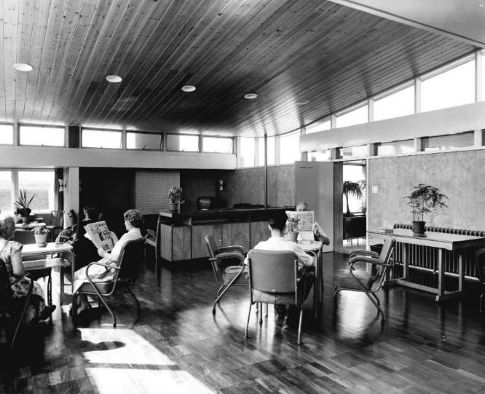
Figure 4. Admission and Treatment Unit, Fair Mile Hospital, common room (BRO, P/HA2/5/1, Fair Mile Hospital, ‘Into the Light’, staff recruitment booklet, 1959)

Figure 5. Admission and Treatment Unit, Fair Mile Hospital, outdoor space (RIBA56473. Admissions Unit, Fairmile Hospital, Wallingford, Oxfordshire: the south side of the female ward wing)

Figure 6. Post-war Admission Villa, Fulbourn Hospital, Cambridge, front elevation (CCRO, Fulbourn Hospital, KHF/6/1/15, “Photographs taken at the opening of Kent House by Princess Marina, Duchess of Kent, 1964”)

CCRO, Fulbourn Hospital, KHF/6/2/9, “Programme for the opening of Kent House new admission unit, 1964”, site plan, p. 19
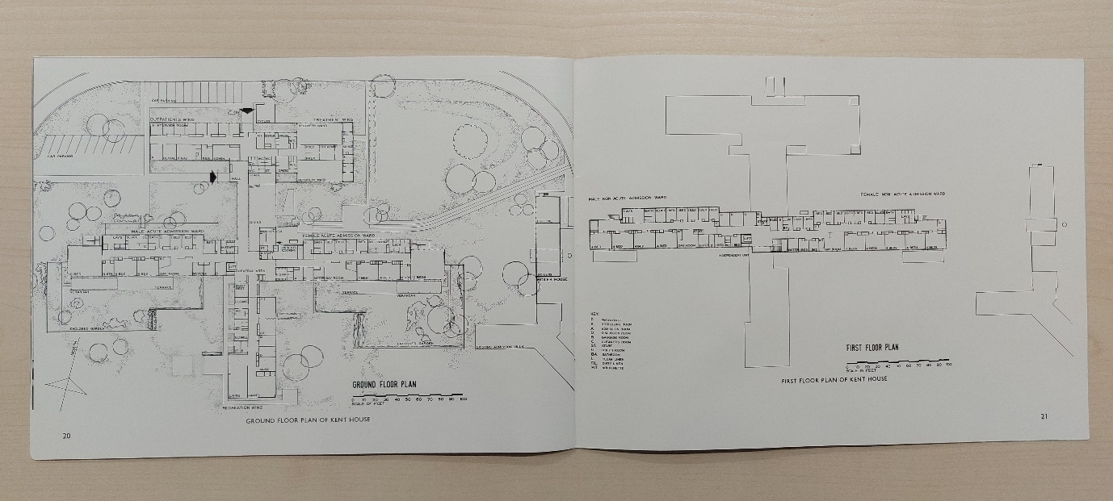
CCRO, Fulbourn Hospital, KHF/6/2/9, “Programme for the opening of Kent House new admission unit, 1964”, floor plans, pp. 20-21
Figure 7. Post-war Admission Villa, Fulbourn Hospital, Cambridge, site plan or floor plans

(CCRO, Fulbourn Hospital, KHF/6/2/9, “Programme for the opening of Kent House new admission unit, 1964”, “A 4-bedded dormitory”, p. 12)

(CCRO, Fulbourn Hospital, KHF/6/1/15, “Photographs taken at the opening of Kent House by Princess Marina, Duchess of Kent, 1964”)
Figure 8. Post-war Admission Villa, Fulbourn Hospital, Cambridge, wards

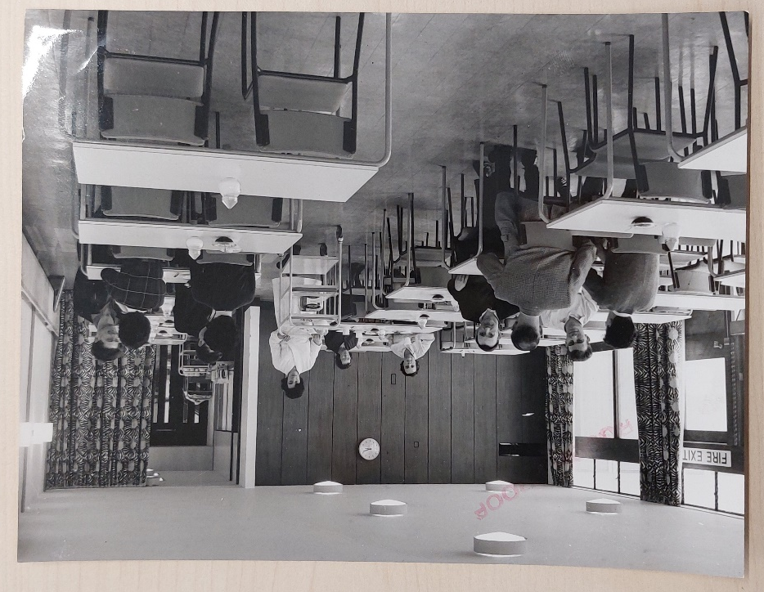
Figure 9. Post-war Admission Villa, Fulbourn Hospital, Cambridge, dining room (CCRO, Fulbourn Hospital, KHF/6/1/15, “Photographs taken at the opening of Kent House by Princess Marina, Duchess of Kent, 1964”)
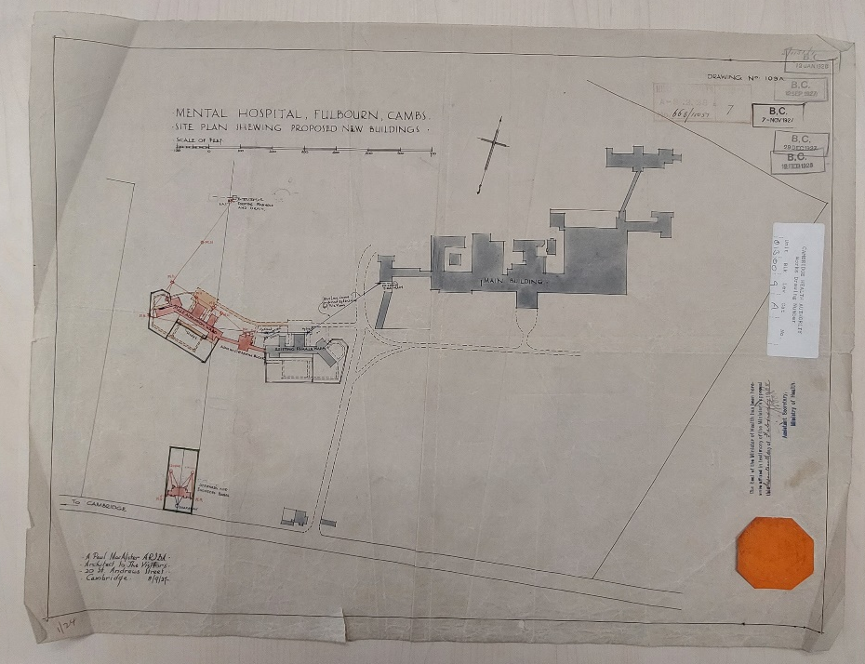
CCRO, Fulbourn Hospital, KHF/5/1/11, “Plans of new admission wards”, “Site Plan Shewing [sic] Proposed New Buildings” [incl. Administration Block and new Male Admission Ward, as added to Existing Female Ward], 1927
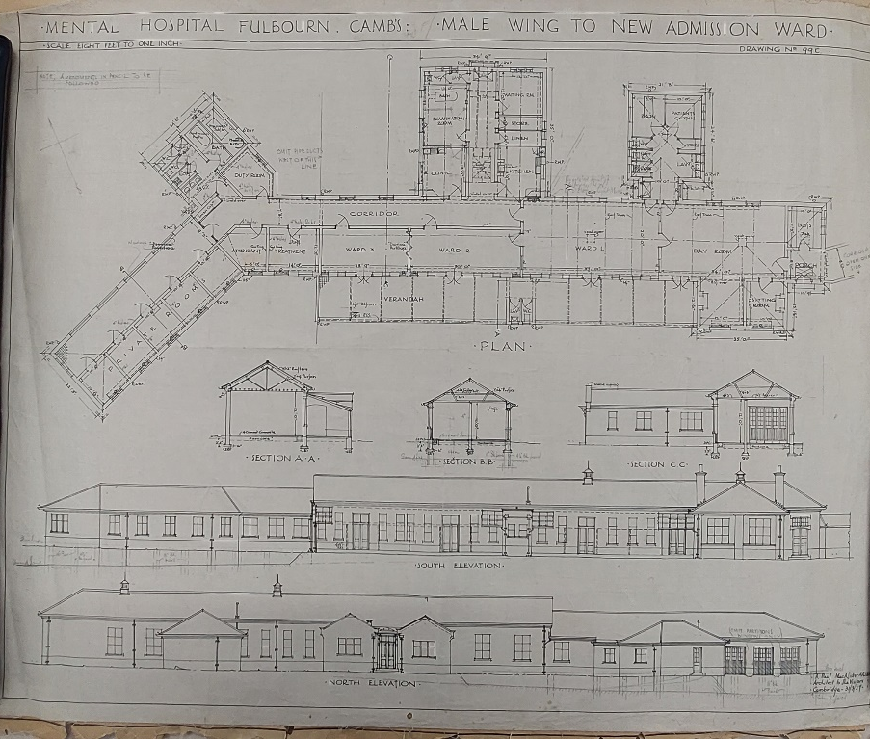
CCRO, Fulbourn Hospital, KHF/5/1/11, “Plans of new admission wards”, “Male Wing to New Admission Ward”, 1927
Figure 10. Inter-war Admission Villa, Fulbourn Hospital, Cambridge, floor plan

Notes

For example: Anonymous, “Courtyard cultivates a sense of calm; Architects: Devereux Architects,” Architects’ Journal 206:13 (October 9, 1997): 12; Anonymous, “Environmental healing: Devereux Architects in Bristol,” Architecture Today 163 (November 2005): 70-74; Christina Malathouni and Haziq Khairi, “Repurposing heritage buildings for recovery,” The Network: Journal of the Design in Mental Health Network (April 2021): 16-20; Anonymous, “Construction starts on £8m therapeutic eating disorders unit in Sandbanks”, The Network: Journal of the Design in Mental Health Network (January 2022): 8.
For example: Mardelle McCuskey Shepley and Samira Pasha, Design for Mental and Behavioral Health (London and New York: Routledge, 2017); Stephen Verderber, Innovations in Behavioural Health Architecture (Abingdon, Oxon: Routledge, 2018).
Volker Hess and Benoît Majerus, “Writing the history of psychiatry in the 20th century,” History of Psychiatry 22:2 (2011): 139-145.
Kathleen Jones, Asylums and After: a revised history of the mental health services from the early 18th century to the 1990s (London: Athlone Press, 1993); Evangelia Chrysikou, Architecture for Psychiatric Environments and Therapeutic Spaces (Amsterdam, Netherlands: IOS Press, 2014).
Anonymous, “Admission Unit at the Fairmile Hospital,” Architects’ Journal: 385.
Anonymous, “Hospital, Cambridge”: 967.
Anonymous, “Hospital Extension”: 362. This increasing realisation that there could be a correlation between distinctive characteristics of mental illness and associated care facilities was also strongly reflected in a 1961 memorandum of the Scottish Home and Health Department (Long, “‘Heading up a Blind Alley’?”: 118).
Geoffrey Rivett, From Cradle to Grave The history of the NHS 1948-1987 (Blurb, 2014). Online version: www.nuffieldtrust.org.uk/health-and-social-care-explained/the-history-of-the-nhs/.
Rivett, From Cradle to Grave; RHB(47)1, National Health Service, Regional Hospital Boards, General scope of their work and relationship to the Minister and others (1947), §1; RHB(48)1, National Health Service, The development of specialist services (1948), VIII. Mental Health Service (1948), §62.
Elain Harwood, Space, Hope and Brutalism: English Architecture, 1945–1975 (New Haven, CT, and London: Yale University Press, 2015), 283; Jones, Asylums and After, 143-144.
Jonathan Frederick Allan Hughes, “The brutal hospital: efficiency, identity & form in the National Health Service” (PhD thesis, Courtauld Institute of Art, University of London, UK, 1996), 39.
Hughes, “The brutal hospital,” 41.
Despo Kritsotaki, Vicky Long, and Matthew Smith, eds., Deinstitutionalisation and After: Post-War Psychiatry in the Western World (Basingstoke: Palgrave, 2016).
For example: Andrew Scull, Museums of Madness: The Social Organization of Insanity in Nineteenth Century England (London: Allen Lane, 1979); Leslie Topp, “The modern mental hospital in late nineteenth-century Germany and Austria: psychiatric space and images of freedom and control,” in Madness, Architecture and the Built Environment: Psychiatric Spaces in Historical Context, ed. Leslie Topp et al. (New York: Routledge, 2007), 241–261.
For example, Harriet Richardson, ed., English Hospitals 1660–1948: A Survey of their Architecture and Design (Swindon: Royal Commission on the Historical Monuments of England, Swindon, 1998); Jeremy Taylor, Hospital and Asylum Architecture in England 1840–1914: Building for Health Care (London: Mansell, 1991).
For example, Stephen Soanes, Rest and Restitution: Convalescence and the Mental Hospital in England, 1919–1939 (Unpublished PhD thesis, University of Warwick, UK, 2011); Leslie Topp, Freedom and the Cage: Modern Architecture and Psychiatry in Central Europe, 1890–1914 (University Park, PA: Pennsylvania State University Press, 2017).
Vicky Long, “‘Heading up a Blind Alley’? Scottish Psychiatric Hospitals in the Era of Deinstitutionalization,” History of Psychiatry 28:1 (March 2017): 115–128, doi: 10.1177/0957154X16673025. See also Megan ?’s study of interiors in existing mental hospitals in post-war Ireland (…).
For example: Anonymous, “New Admission Unit. Fair Mile Hospital, near Wallingford, Berkshire,” RIBA Journal (May 1957): 268.
For example: Anonymous, "Asylum Hospital [by Walter Alison],” The Builder (September 20, 1940): 285-287.
Harwood, Space, Hope and Brutalism, 283.
Harwood, Space, Hope and Brutalism, 283-284. The two buildings by Powell and Moya also feature in Kenneth Powell, Powell and Moya (London: RIBA Publishing, 2009), 87-98).
See: Anonymous, “Fair Mile Hospital, Wallingford: New Admission Unit,” The Hospital (January 1956): 9-16; Anonymous, “Admission Unit Fair Mile Hospital. Wallingford, Berks for the Oxford Regional Hospital Board,” The Architect and Building News (5 January 1956): 11-18; Anonymous, “Admission Unit at the Fairmile Hospital, Wallingford, Berkshire,” Architects’ Journal (19 April 1956): 385–398; Anonymous, “Admission Unit at Fair Mile Hospital,” The Builder (27 April 1956): 386-390; Anonymous, “New Admission Unit,” RIBA Journal; Anonymous, “St John’s Hospital, Stone. Admission & Treatment Unit,” The Architect & Building News, 212:23 (December 4, 1957): 760–762; Anonymous, “Hospital Extension [Admission and treatment unit, St. John's Hospital, Stone, Aylesbury; Architects: Gollins, Melvin & Ward],” Architects’ Journal (October 15, 1959): 359-370; Anonymous, “Sick and admission unit for Borocourt Hospital for Mental Defectives, Peppard, Oxon; Architects: Powell & Moya,” Architectural Review (March 1964): 202-205.
Richardson, English Hospitals 1660-1948.
English Heritage, Health and Welfare Buildings. Designation Listing Selection Guide (London: English Heritage, 2011).
Jones, 1993: 138.
CCRO, Fulbourn Hospital, KHF/6/2/13.
South West Yorkshire Partnership NHS Foundation Trust, “Fieldhead at 50”, 11 July 2022; online: https://www.southwestyorkshire.nhs.uk/2022/07/11/fieldhead-at-50/ (accessed on 31 July 2022).
Topp, 2017.
Published scholarship to date includes studies in relation to 1950s and 1960s work in Saskatchewan, Canada (Dyck, 2010), in 1960s France, in relation to Nicole Sonolet’s work as well as the research collective CERFI (Centre d’Etudes, de Recherches et de Formations Institutionelles, or Centre for Institutional Studies, Research and Training) (TenHoor, 2019), and in 1960s US, in relation to Community Mental Health Centers (Knoblauch, 2020: Ch. 2).
Christina Malathouni, “Beyond the asylum and before the ‘care in the community’ model: exploring an overlooked early NHS mental health facility,” History of Psychiatry 31:4 (December 2020): 455-469, doi: 10.1177/0957154X20945974.
Christina Malathouni, “‘The general atmosphere of this admission unit is reassuring and optimistic’: modernism, architectural research and evolving psychiatric reforms in post-war England,” in Doing Psychiatry. Practices in European Psychiatric Institutions and Beyond, 1945-1990, ed. Gundula Gahlen and Henriette Voelker (Manchester: Manchester University Press, 2022) (forthcoming).
Historic England Archive, Swindon, Wiltshire, UK, “Hospitals Project”, Reference: RCH01/008.
For example: Anonymous, "Asylum Hospital [by Walter Alison],” The Builder (September 20, 1940): 285-287.
Richardson, 1998: 180.
Elizabeth Twinem, “A Place of Refuge”, Newmarket Journal, 13 February 1975, p. 19.
REFERENCE: Clark?
Harwood; Powell; articles; Malathouni; Malathouni.
Reference.
CCRO, Fulbourn Hospital, “Plans of nurses' and superintendent's and other staff accommodation”, KHF/5/1/10 and “Plans of new admission wards”, KHF/5/1/11; Swindon archive.
See Cambridgeshire & Peterborough NHS Foundation Trust, Elizabeth House, Fulbourn Hospital, Cambridge, CB21 5EF, in Google Maps: https://goo.gl/maps/E6SE3VnQhkdvWewr7 (accessed on 31 July 2022).
David H. Clark, Story of a Mental Hospital: Fulbourn 1858-1983 (Process Press, 1996), p. xii.
Anonymous, “Admission Unit at the Fairmile Hospital,” Architects’ Journal: 388.
Anonymous, “Admission Unit at the Fairmile Hospital,” Architects’ Journal: 394. The introduction of these treatments to Fair Mile pre-dated the new unit. Electro-convulsive therapy was introduced by 1951 (The National Archives, Kew, Richmond, UK, General Nursing Council for England and Wales: Education, Hospital Inspectors’ Reports and Papers, DT 33 [hereafter TNA, DT 33], 1243, 8 March 1951: 4) and Insulin Coma Therapy by 1954 (TNA, DT 33/1243, 8 July 1954: 5).
For a more extensive discussion of this connection, see: Christina Malathouni, “‘The general atmosphere of this admission unit is reassuring and optimistic’: modernism, architectural research and evolving psychiatric reforms in post-war England,” in Doing Psychiatry. Practices in European Psychiatric Institutions and Beyond, 1945-1990, ed. Gundula Gahlen and Henriette Voelker (Manchester: Manchester University Press, 2022) (forthcoming).
Nuffield Provincial Hospitals Trust and the University of Bristol, Studies in the Functions and Design of Hospitals: report of an investigation. London: Oxford University Press, 1955.
Anonymous, “Precast Framework at Cambridge Hospital Building,” Industrialised Building Systems & Components (September 1964): 32; Anonymous, “Hospital, Cambridge,” The Architect & Building News (November 18, 1964): 967, 970.
See Harwood, Space, Hope and Brutalism.
Anonymous, “Hospital, Cambridge”: 970.
Anonymous, “Hospital, Cambridge”: 970.
Anonymous, “Precast Framework at Cambridge Hospital Building”: 32; Anonymous, “Hospital, Cambridge”: 971.
Anonymous, “Hospital, Cambridge”: 970.
Charite.
Reference: Adams?
Hughes, “The brutal hospital.” Although such a trend is not evident in the Admission Unit at Fair Mile, it is particularly noteworthy that the Oxford Regional Hospital Board went on to develop its own standardisation?/prefabrication? construction system that became known as “the Oxford method”.[reference?]
Charite.
McLachlan, 1992: 9.
Charite,
For example: Anonymous, “Future organization of the psychiatric services,” British Medical Journal 1:4406 (1945): 111–116; accessed June 22, 2020, http://www.jstor.org/stable/20348908.
See fuller discussion in Charite.
The Nuffield report especially promoted 4- and 6-bed wards, as tested at Musgrave Park Hospital, in Belfast, Northern Ireland, but placed particular emphasis on the potential of 6-bed wards as a more compact planning solution that was common in continental Europe but so far received with scepticism in Britain (NPHT, 1955: xix, 30).
CCRO, Fulbourn Hospital, KHF/6/2/9, “Programme for the opening of Kent House new admission unit”, p. 3.
Baker, Alex, Richard Llewelyn Davies and Paul Sivadon, Psychiatric Services and Architecture (Geneva: World Health Organization, 1959).
Baker, et al, Psychiatric Services, p. 8. Note also the “disclaimer” in the concluding paragraph of the Preface: “It must be stressed that the opinions expressed do not necessarily represent the policy of the World Health Organization in this matter. …” (p. 8)
Baker, et al, Psychiatric Services, p. 12.
Baker, et al, Psychiatric Services, p. 17.
See, for example: “In tropical countries, ‘gardens’ replace the day rooms described for more temperate climates, and many of the social centre’s facilities will be in the open air.” (Baker, et al, Psychiatric Services, p. 58).
Baker, et al, Psychiatric Services, pp. 19, 50.
Baker, et al, Psychiatric Services, p. 7.
Baker, et al, Psychiatric Services, p. 7.
Baker, et al, Psychiatric Services, pp. 7-8.
“Special admission units should be avoided. The building should be arranged so that the patient can be admitted and looked after by one person, preferably the nurse, who, acting as hostess, arranges his admission to the ward, escorts him to his bed, and explains the function of the ward.” (Baker, et al, Psychiatric Services, p. 50)
Baker, et al, Psychiatric Services, p. 19. In fact, “early treatment units” are not addressed separately. These are considered to be simply out-patient clinics that also include some beds when these are deemed necessary due to their location far from a mental hospital (p. 19).
Baker, et al, Psychiatric Services, p. 9.
Nuffield report, pp. ???
Baker, et al, Psychiatric Services, p. 25 and Figures 1-2, 4-6.
Baker, et al, Psychiatric Services, p. 24.
Baker, et al, Psychiatric Services, p. 16.
Baker, et al, Psychiatric Services, Figures 4 and 5.
BHN No.4 (1968) also specified the size of multi-bed wards for general hospitals as being recommended between 4 and 8 beds, and ideally 6 beds, on the basis of the social potential of such group sizes for variety of company and companionship (§4(a)(a)(ii)(4)).
HBN No. 30, 1963, §1.
HBN No. 30, 1963, §2.
HBN No. 30, 1963, §§10, 37.ii.
The National Archives, Kew, Richmond, UK, National Health Service Health Advisory Service: Reports and Papers, BN 37 [hereafter TNA, BN 37], 34, October 1971: 4; Ian Wheeler, Fair Mile: A Victorian Asylum (Stroud, UK: The History Press, 2015), 69. For a more comprehensive discussion of the building’s history and further analysis of its design, see: Christina Malathouni, “Beyond the asylum and before the ‘care in the community’ model: exploring an overlooked early NHS mental health facility,” History of Psychiatry 31:4 (December 2020): 455-469, doi: 10.1177/0957154X20945974; and Malathouni, “‘The general atmosphere of this admission unit’.”
Adams, “‘Challenge and Change in a Cinderella Service’,” 236-237.
Baker, et al, Psychiatric Services, p. 7. Bibliography Archival sources CCRO … CCRO … Historic England Archive, Swindon, Wiltshire, UK. “Hospitals Project”, Reference: RCH01/008. The National Archives, Kew, Richmond, UK. National Health Service Health Advisory Service: Reports and Papers, BN 37. The National Archives, Kew, Richmond, UK. General Nursing Council for England and Wales: Education, Hospital Inspectors’ Reports and Papers, DT 33. Publications Adams, John Stephen. “‘Challenge and Change in a Cinderella Service’: A History of Fulbourn Hospital, Cambridgeshire, 1953–1995.” Unpublished PhD thesis. The Open University, UK, 2009. Anonymous. "Asylum Hospital [by Walter Alison].” The Builder (September 20, 1940): 285-287. Anonymous. “Future organization of the psychiatric services.” British Medical Journal 1:4406 (1945): 111–116. Accessed June 22, 2020. http://www.jstor.org/stable/20348908. Anonymous. ‘Fair Mile Hospital, Wallingford: New Admission Unit.” The Hospital (January 1956): 9-16. Anonymous. “Admission Unit Fair Mile Hospital. Wallingford, Berks for the Oxford Regional Hospital Board.” The Architect and Building News (5 January 1956): 11-18. Anonymous. “Admission Unit at the Fairmile Hospital, Wallingford, Berkshire.” Architects’ Journal (19 April 1956): 385–398. Anonymous. “Admission Unit at Fair Mile Hospital.” The Builder (27 April 1956): 386-390. Anonymous. “New Admission Unit. Fair Mile Hospital, near Wallingford, Berkshire.” RIBA Journal (May 1957): 268–271. Anonymous. “St John’s Hospital, Stone. Admission & Treatment Unit.” The Architect & Building News, 212:23 (December 4, 1957): 760–762. Anonymous. “Hospital Extension [Admission and treatment unit, St. John's Hospital, Stone, Aylesbury; Architects: Gollins, Melvin & Ward].” Architects’ Journal (October 15, 1959): 359-370. Anonymous. “Sick and admission unit for Borocourt Hospital for Mental Defectives, Peppard, Oxon; Architects: Powell & Moya.” Architectural Review (March 1964): 202-205. Anonymous. “Precast Framework at Cambridge Hospital Building.” Industrialised Building Systems & Components (September 1964): 32-36. Anonymous. “Hospital, Cambridge.” The Architect & Building News (November 18, 1964): 967-972. Anonymous. “Courtyard cultivates a sense of calm; Architects: Devereux Architects.” Architects’ Journal 206:13 (October 9, 1997): 12. Anonymous. “Environmental healing: Devereux Architects in Bristol.” Architecture Today 163 (November 2005): 70-74. Anonymous. “Construction starts on £8m therapeutic eating disorders unit in Sandbanks.” The Network: Journal of the Design in Mental Health Network (January 2022): 8. Baker, Alex, Richard Llewelyn Davies and Paul Sivadon. Psychiatric Services and Architecture. Geneva: World Health Organization, 1959. Chrysikou, Evangelia. Architecture for Psychiatric Environments and Therapeutic Spaces. Amsterdam, Netherlands: IOS Press, 2014. English Heritage. Health and Welfare Buildings. Designation Listing Selection Guide. London: English Heritage, 2011. Fair, Alistair. “‘Modernization of Our Hospital System’: The National Health Service, the Hospital Plan, and the ‘Harness’ Programme, 1962–77.” Twentieth Century British History 29:4 (December 2018): 547–575. Harwood, Elain. Space, Hope and Brutalism: English Architecture, 1945–1975. New Haven, CT, and London: Yale University Press, 2015. Hess, Volker, and Benoît Majerus. “Writing the history of psychiatry in the 20th century.” History of Psychiatry 22:2 (2011): 139-145. Hughes, Jonathan Frederick Allan. “The brutal hospital: efficiency, identity & form in the National Health Service.” PhD thesis. Courtauld Institute of Art, University of London, UK, 1996. Jones, Kathleen. Asylums and After: a revised history of the mental health services from the early 18th century to the 1990s. London: Athlone Press, 1993. Kritsotaki, Despo, Vicky Long, and Matthew Smith, eds. Deinstitutionalisation and After: Post-War Psychiatry in the Western World. Basingstoke: Palgrave, 2016. Long, Vicky. “‘Heading up a Blind Alley’? Scottish Psychiatric Hospitals in the Era of Deinstitutionalization.” History of Psychiatry 28:1 (March 2017): 115–128. doi: 10.1177/0957154X16673025. Malathouni, Christina. “Beyond the asylum and before the ‘care in the community’ model: exploring an overlooked early NHS mental health facility.” History of Psychiatry 31:4 (December 2020): 455-469. doi: 10.1177/0957154X20945974. Malathouni, Christina. “‘The general atmosphere of this admission unit is reassuring and optimistic’: modernism, architectural research and evolving psychiatric reforms in post-war England.” In Doing Psychiatry. Practices in European Psychiatric Institutions and Beyond, 1945-1990, edited by Gundula Gahlen and Henriette Voelker (forthcoming). Manchester: Manchester University Press, 2022. Malathouni, Christina, and Haziq Khairi. “Repurposing heritage buildings for recovery.” The Network: Journal of the Design in Mental Health Network (April 2021): 16-20. Nuffield Provincial Hospitals Trust and the University of Bristol. Studies in the Functions and Design of Hospitals: report of an investigation. London: Oxford University Press, 1955. Powell, Kenneth. Powell and Moya. London: RIBA Publishing, 2009. RHB(47)1. National Health Service, Regional Hospital Boards, General scope of their work and relationship to the Minister and others (1947). RHB(48)1. National Health Service, The development of specialist services (1948), VIII. Mental Health Service (1948). Richardson, Harriet, ed. English Hospitals 1660–1948: A Survey of their Architecture and Design. Swindon: Royal Commission on the Historical Monuments of England, Swindon, 1998. Rivett, Geoffrey. From Cradle to Grave The history of the NHS 1948-1987. Blurb, 2014. Online version: www.nuffieldtrust.org.uk/health-and-social-care-explained/the-history-of-the-nhs/. Scull, Andrew. Museums of Madness: The Social Organization of Insanity in Nineteenth Century England. London: Allen Lane, 1979. Shepley, Mardelle McCuskey, and Samira Pasha. Design for Mental and Behavioral Health. London and New York: Routledge, 2017. Soanes, Stephen. Rest and Restitution: Convalescence and the Mental Hospital in England, 1919–1939. Unpublished PhD thesis. University of Warwick, UK, 2011. Taylor, Jeremy. Hospital and Asylum Architecture in England 1840–1914: Building for Health Care. London: Mansell, 1991. TenHoor, Meredith. “State funded militant infrastructure? CERFI’s équipements collectifs in the intellectual history of architecture.” The Journal of Architecture 24:7 (2019): 999-1019. doi: 10.1080/13602365.2019.1698638. Topp, Leslie. “The modern mental hospital in late nineteenth-century Germany and Austria: psychiatric space and images of freedom and control.” In Madness, Architecture and the Built Environment: Psychiatric Spaces in Historical Context, edited by Leslie Topp, James E. Moran and Jonathan Andrews, 241–261. New York: Routledge, 2007. Topp, Leslie. Freedom and the Cage: Modern Architecture and Psychiatry in Central Europe, 1890–1914. University Park, PA: Pennsylvania State University Press, 2017. Verderber, Stephen. Innovations in Behavioural Health Architecture. Abingdon, Oxon: Routledge, 2018. Wheeler, Ian. Fair Mile: A Victorian Asylum. Stroud, UK: The History Press, 2015.

