Dynamic Contrast Enhanced -MRI and Doppler Sonography in Patients with Squamous Cell Carcinoma of Head and Neck Treated with Induction Chemotherapy
Abstract
R1.1
Objective: In view of the inherent limitations associated with performing dynamic contrast enhanced-magnetic resonance imaging (DCE-MRI) in clinical settings, the current study was designed to investigate as to whether Doppler sonography and DCE-MRI derived perfusion parameters could provide similar hemodynamic information from metastatic lymph nodes in squamous cell carcinomas of head and neck (HNSCC).
Methods: Five patients were scanned with DCE-MRI and Doppler sonography before and after induction chemotherapy. Pearson correlation analyses were performed between DCE-MRI [volume transfer constant (K^{trans}), volume fraction of extracellular-extravascular space in tissues (Ve) and volume fraction of plasma space in tissues (Vp)] and Doppler sonography [blood flow (BF), blood volume (BV) and % area perfused] derived perfusion parameters.
Results: Strong positive correlations between Vp and BV (r=0.72, p=0.02) and between Vp and % area perfused (r=0.65, p=0.04) were observed when all parameters at both time points were analyzed together (N=10). Additionally, a moderate positive correlation trending towards significance was obtained between K^{trans} and % area perfused (r=0.49, p=0.09).
Conclusions: Doppler sonography and DCE-MRI may provide similar information about tumor vasculature in HNSCCs.

Key Words: Head and neck squamous cell carcinoma; Induction Chemotherapy; Dynamic contrast enhanced-MRI; Doppler sonography; Perfusion parameters

Introduction
Head and neck squamous cell carcinomas (HNSCCs) represent one of the most common cancers worldwide and are associated with poor clinical outcomes.¹ The neck metastatic lymph nodes, which are characterized by increased angiogenic activity and presence of rich network of blood vessels,² are the major determinant of poor prognosis in these patients.³ Therefore, it is crucial to assess the physiological aspect of neck lymphadenopathy in HNSCC patients for prognostication, making informed decisions for future therapeutic interventions and assessment of treatment response.
High-resolution sonography is considered as a first-line imaging modality for providing valuable information about the morphological and vascular characteristics of lymphadenopathies in HNSCC.⁴ Color Doppler sonography allows quantitative estimation of the direction of blood flow, velocities, and flow patterns of intranodal blood vessels using Doppler shift of acoustic frequencies.^{5, 6} While color Doppler sonography is a useful imaging modality, it does not always display all the blood vessels due to some physiological and technical issues.⁶ In contrast to color Doppler, power Doppler sonography is more sensitive in visualizing smaller blood vessels. It is because power Doppler possesses greater dynamic range that permits detection of weak signals and low Doppler shift frequencies.⁷ Metastatic lymph nodes usually show intense peripheral flow and/or scattered parenchymal flow signals on Doppler sonograms. Multiple studies^{5, 7-10} have demonstrated the potential utility of color/power Doppler sonographic imaging in characterizing superficial metastatic lymph nodes in HNSCC. However, limited soft-tissue penetration depth and overlying bone or air artefacts constraint the utility of these sonographic modalities for reliable assessment of deep-seated neck lymph nodes which are difficult to reach by ultrasound waves.^{11, 12}
Dynamic contrast enhanced magnetic resonance imaging (DCE-MRI) is another promising imaging technique that provides quantitative and biologically relevant information related to perfusion characteristics of metastatic lymph nodes in the entire neck region.^{13, 14} Numerous studies have shown the clinical potential of DCE-MRI derived parameters in predicting and evaluating treatment response to induction chemotherapy¹⁵ and concurrent chemo-radiation therapy¹⁶⁻²² in HNSCC. Collectively, these studies have suggested that patients harboring high pretreatment tumor perfusion respond more favorably to therapies and demonstrate improved disease-free and overall survival. However, one must be aware of challenges associated with DCE-MRI in HNSCCs.
For instance, the acquisition and quantitative analysis of DCE-MRI data is not trivial and is difficult to implement in routine clinical workflow. Secondly, DCE-MRI is associated with systemic errors and biases caused by a variety of physiological, experimental and pharmacokinetic modeling factors, which can potentially confound the overall estimates of perfusion parameters.^{23, 24} In contrast, Doppler sonography is a widely available, fast, easy to use, and economically affordable imaging modality that has been shown to provide reliable estimation of blood flow in HNSCC especially from superficially located lymph nodes.^{25, 26} In view of the inherent limitations of DCE-MRI, it is highly desirable to ascertain as to whether similar or complementary information from color/power Doppler sonography can be obtained that may obviate the need to perform DCE-MRI in assessing cervical metastatic lymph nodes in certain conditions.
With this objective in mind, we sought to investigate the relationships between DCE-MRI and color and power Doppler sonography derived perfusion parameters in evaluating treatment response to induction chemotherapy in patients with HNSCC in the present study.
Methods
Patient Population
The inclusion criteria for patient enrollment in the present study were if the patient (a) had the availability of previously acquired computed tomography (CT)/magnetic resonance imaging (MRI) report and/or biopsy confirming the presence of HNSCC, (b) had superficial neck metastatic lymph nodes ≥ 1cm³ (c) had not been treated with induction chemotherapy. Patients were excluded from the study if they (a) had received any previous chemotherapy or radiation therapy, (b) had any prior history of cancer other than HNSCC. All patients received one cycle of platinum-based induction chemotherapy. Patients were classified into two groups; responders and non-responders based on degree of reduction in nodal volume as observed on anatomical images. Patients harboring ≥ 50% reduction in volume of metastatic lymph node following induction chemotherapy were categorized as responders and patients harboring <50% reduction in volume of metastatic lymph node were categorized as non-responders.
Acquisition of Data
All patients were scanned on a 3T Magnetom-Trio MRI system (Siemens, Erlangen, Germany) prior to surgery, or chemoradiation therapy. Anatomical imaging protocol included axial T₂-weighted and T₁-weighted images with and without gadolinium-based contrast agent using standard parameters. Prior to acquisition of DCE-MRI data, inversion-recovery based T₁-weighted images were acquired using five inversion times (TIs) of 60, 200, 400, 800, and 1600ms for quantification of pre-contrast T₁ values. As described previously, ^{17, 20} DCE-MRI data were acquired using a rapid three-dimensional (3D)-spoiled gradient-echo sequence, modified to acquire 8 angle-interleaved sub-aperture images from the full-echo radial data. The acquisition parameters were: repetition time (TR)/echo time (TE)=5.0/4.2ms, 256 readout points/view, 256 views (32 views/sub-aperture, 8 sub-apertures), field of view (FOV)=260×260mm²; number of slice sections=8; section thickness=5mm. Fat saturation was applied once every 8 excitations. Spatial saturation was applied once every 32 excitations to minimize the flow effect while minimizing acquisition time. The total acquisition time for the DCE-MRI studies was xxx mins
Color and power Doppler sonography were performed using an ultrasound scanner (GE LOGIC E9) and a frequency probe of 7.5MHz using a protocol described earlier²⁷ within 24-48 hours of the MRI at both time points. Imaging was performed by a sonographer with 25 years of clinical experience. Standardized clinical procedures and scanner presets were used to maximize color Doppler gain until appearance of noise. The pulse repetition frequency was increased to just below aliasing. The total time for US study was xxx min
R2.2
Processing of DCE-MRI and Sonography Data
An in-house developed algorithm was applied on the raw DCE-MRI data to correct for any artifacts caused by physiological motion.^{17, 20} All images (axial T2-weighted, T1-weighted, post-contrast T1-weighted, and DCE-MRI) were co-registered using a 2-step non-rigid image registration technique. Regions of interest (ROIs) were drawn on solid tissue components of the largest nodal mass on all slices of post-contrast T1-weighted images encompassing the metastatic node. While drawing these ROIs, necrotic/cystic or hemorrhagic regions as well as surrounding blood vessels were avoided. Pharmacokinetic analysis of DCE-MRI data was performed for each voxel in the selected ROIs using the extended generalized kinetic model (GKM) as proposed by Tofts and Kermode.^{28, 29} Pharmacokinetic parametric maps such as volume transfer constant (K^{trans}), volume fraction of extracellular-extravascular space in tissues (Ve) and volume fraction of plasma space in tissues (Vp) were obtained in all the cases. Mean values of parameters (K^{trans}, Ve, Vp) were computed from the largest node as mentioned above.
Color and power Doppler sonographic images from the same metastatic lymph nodes were digitally analyzed to obtain blood flow (BF), blood volume (BV) and % area perfused values using an approach described earlier.³⁰
Statistical Analyses
Pearson correlation analyses were performed between DCE-MRI (K^{trans}, Ve, Vp) and Doppler sonography derived perfusion parameters (BF, BV, % area perfused) using all the parameters at both the time points together (N=10). A probability (p)-value of less than 0.05 was considered significant. In addition, % changes in each parameter between baseline and post-treatment period were calculated as (N - baseline)/baseline × 100 for all the patients to evaluate the treatment response to induction chemotherapy. A statistical package, SPSS for Windows (version 18.0; SPSS Inc., Chicago, Illinois) was used to perform all statistical analyses.
Results
Based on the inclusion criteria, five newly diagnosed HNSCC patients (mean age, 58.4 ± 8.9 years, all males) were recruited in this study. The clinical characteristics from the patients are summarized in Table 1. Post-contrast T1 weighted image, DCE-MRI derived maps and color/power sonography derived maps from a representative patient with HNSCC before induction chemotherapy are shown in Figure 1. A strong positive correlation (r=0.72, p=0.02) between Vp and BV was observed (Figure 2). Similarly, a strong positive correlation was also found between Vp and % area perfused (r=0.65, p=0.04) (Figure 2). Additionally, a moderate positive correlation with a trend towards significance was obtained (r=0.49, p=0.09) between K^{trans} and % area perfused values. However, no significant correlation was noted between K^{trans} and BF (r=0.32, p>0.05) or between K^{trans} and BV (r=0.42, p>0.05).
R1.2
Three patients were categorized as responders as ≥ 50% reduction in nodal volume was noted in these cases after induction chemotherapy. The remaining two patients were classified as non-responders as the nodal volume decrease was less than 50%. The DCE-MRI and Doppler sonography derived parameters before and after induction chemotherapy are shown in Figure 3. All the three responders demonstrated decreases in Vp (mean ± standard deviation = -61.5 ± 28.8%), BV (-43.6 ± 32.9%) and in % area perfused parameter (-25.4 ± 32.0%) after treatment. Whereas both non-responders demonstrated increase in Vp (55.8 ± 41.1%) and BV (16.3 ± 12.1%) after induction chemotherapy. However, the % area perfused parameter increased in one (80.1%) and slightly decreased (-6.6%) in another non-responder.
Discussion
Induction chemotherapy is considered as an attractive treatment option for nonresectable tumors in HNSCC patients.^{31, 32} However, not all patients with HNSCC demonstrate a significant positive response to induction chemotherapy.^{33, 34} Given that induction chemotherapy is associated with economic burden and toxic side effects,³⁴ development of reliable and quantifiable imaging biomarkers is warranted to evaluate the treatment response, especially early on during the course of treatment. In this exploratory study, we examined the relationships between DCE-MRI and Doppler sonography derived perfusion parameters in evaluating treatment response to induction chemotherapy in HNSCC patients. Our findings show that Doppler sonography provided similar information to those obtained by DCE-MRI in characterizing tumor vasculature in HNSCCs. These results suggest that Doppler sonography may be considered as an alternative imaging modality for assessing tumor perfusion, especially for larger superficial metastatic nodes and hence, for evaluating treatment response to induction chemotherapy in HNSCCs.
DCE-MRI is a useful diagnostic tool in predicting and monitoring of treatment response in HNSCC as it allows characterization of microvascular environment of tumors.^{13, 14} However, DCE-MRI presents unique challenges as it requires intravenous injection of a gadolinium-based contrast agent, which are contraindicated in patients with severe renal impairments and hypersensitivity.³⁵ Moreover, quantitative analysis of DCE-MRI data requires measurement of T1 values from tissues before the administration of a contrast agent (prebolus T1 mapping), reliable estimation of arterial input function from a feeding artery as well as data analysis using sophisticated pharmacokinetic models.^{36, 37} These analytical methods include certain assumptions, such as blood and tissue relaxivity as well as hematocrit values, that may introduce systematic errors in the estimation and interpretation of DCE-MRI derived perfusion parameters. On the other hand, Doppler sonography is generally easy to perform, does not require any contrast agent injection, is widely accessible, portable, less expensive, and the perfusion parameters are typically obtained instantly without the need for complicated and time consuming data analytical methods.^{4, 38} Therefore, it is more appealing to utilize tumor vasculature from Doppler sonography for evaluating treatment response in HNSCCs.
Some preclinical³⁹ and clinical^{40, 41} studies have in fact reported strong associations between contrast enhanced sonography and DCE-MRI derived perfusion parameters in characterizing cancers, and healing tendons. Similarly, some studies have reported strong positive correlations between Doppler sonography and DCE-MRI derived perfusion parameters.^{42,43} In a preclinical study of chronic allograft nephropathy,⁴² strong positive correlations were observed between power Doppler sonography derived graded scores of blood flow pattern and DCE-MRI derived semi-quantitative perfusion parameter (ratio of post-injection image signal intensity divided by signal intensity prior to gadolinium based contrast agent administration). Likewise, in a clinical study,⁴³ power doppler sonography derived signal scores were significantly correlated with peak enhancement shape patterns as obtained from DCE-MRI derived contrast time intensity curves in characterizing peripheral zones and inner glands in prostate cancers. Taken together, these studies indicate that DCE-MRI and sonography derived perfusion parameters provide similar or complementary information about vascular properties of cancers and other soft-tissues. To our knowledge, our study is the first to evaluate and correlate perfusion parameters obtained from DCE-MRI and Doppler sonography techniques in HNSCCs. Moreover, quantitative and objective perfusion parameters were extracted from DCE-MRI and Doppler sonography imaging modalities in the current study. We observed strong positive relationships between DCE-MRI derived Vp and Doppler sonography derived BV and % area perfused parameters indicating that these perfusion parameters reflect similar physiological process i.e., angiogenic activity in tumors, which is critical for proliferation and spread of tumor cells.⁴⁴⁻⁴⁶ In contrast, no correlations were observed between K^{trans} and BV as well as between K^{trans} and BF as these parameters do not necessarily measure the same physiological processes. Although, BV and BF are proportional to true tissue perfusion, K^{trans} reflects combination of tissue perfusion and vascular permeability.²⁹ In fact, the degree to which each component contributes to K^{trans} depends on the local tissue characteristics. In high permeability regions, K^{trans} is directly proportional to BF, whereas in low permeability regions, K^{trans} generally measures vessel permeability.^{13, 14}
R2.1
Interestingly, we also observed a decrease in both DCE-MRI and Doppler sonography derived parameters (K^{trans}, Vp, BV and % area perfused) in responders. These results are congruent with a previous study reported by Gandhi et al.⁴⁷ in which the investigators observed reduction in BV, and blood flow in the post-induction period relative to pretreatment in responders using a CT based perfusion imaging technique. Additionally, we observed similar trends in K^{trans}, Vp, and BV at post-treatment period relative to baseline in non-responders. Collectively, these findings support the notion that DCE-MRI and Doppler sonography derived perfusion parameters provide similar hemodynamic information in HNSCC patients treated with induction chemotherapy.
Doppler sonography is an operator-dependent technique requiring careful interpretation of the imaging findings. In the present study, an investigator (CMS) with expertise in ultrasound imaging and long-standing experience in this field evaluated the Doppler sonograms. Though promising, the results of our initial experience should be treated with caution, as these findings are from a relatively small number of patients. Another shortcoming of the current study was that images from two modalities were not spatially co-registered. Despite these limitations, the results show that Doppler sonography is a reliable imaging modality, which yields similar results as DCE-MRI in HNSCC. This is potentially important as Doppler sonography could be used as an alternative imaging modality for assessing treatment response of superficial neck lymph nodes in HNSCC patients. While, DCE-MRI may be reserved for evaluating metastatic lymph nodes located in the deep-seated neck regions such as infrahydoidal, retropharyngeal, parapharyngeal and paratracheal spaces. Future studies with larger patient populations are warranted to confirm these findings.

Table 1. Clinical characteristics of HNSCC patients
R1.3 & R2.3

ID | Age (Yrs) | Gender | Primary Tumor Site | TNM Staging | *Time Interval between Two Scans (Days) | One Cycle of Induction Chemotherapy Protocol | Response to Induction Chemotherapy
1. | 54.1 | Male | Base of tongue | T2N2bM0 | 62 | Cetuximab, Paclitaxel, Carboplatin | Non-responder
2. | 68.7 | Male | Base of tongue | T2N2bM0 | 64 | Cetuximab, Paclitaxel, Carboplatin | Responder
3. | 51.8 | Male | Base of tongue | T3N2bM0 | 60 | Cetuximab, Paclitaxel, Carboplatin | Responder
4. | 67.4 | Male | Vallecular mucosa | T2N2bM0 | 68 | Cetuximab, Paclitaxel, Carboplatin | Responder
5. | 50.2 | Male | Base of tongue | T2N2cM0 | 66 | Cetuximab, Paclitaxel, Carboplatin | Non-responder

* Time interval between two scans indicate a period of time between baseline (before initiation of induction chemotherapy) and follow-up (after completion of induction chemotherapy) DCE-MRI and Doppler Sonography scans

Figure Legends

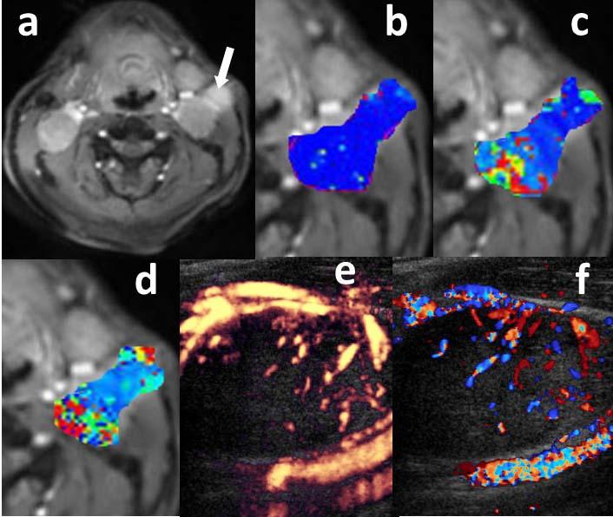
Figure 1.
Representative images from a patient with HNSCC (primary site=base of tongue) before induction chemotherapy. Post contrast T1 weighted image (a) demonstrating a heterogeneously enhancing left metastatic neck level IIa lymph node (arrow). DCE-MRI derived parametric maps K^{trans} (b), Vp (c) and Ve (d) are shown as overlaid color images on the metastatic node indicated by the arrow in image (a). Blood flow (BF) map (e) obtained from color Doppler sonography and blood volume (BV) map (f) obtained from power Doppler sonography are also shown.

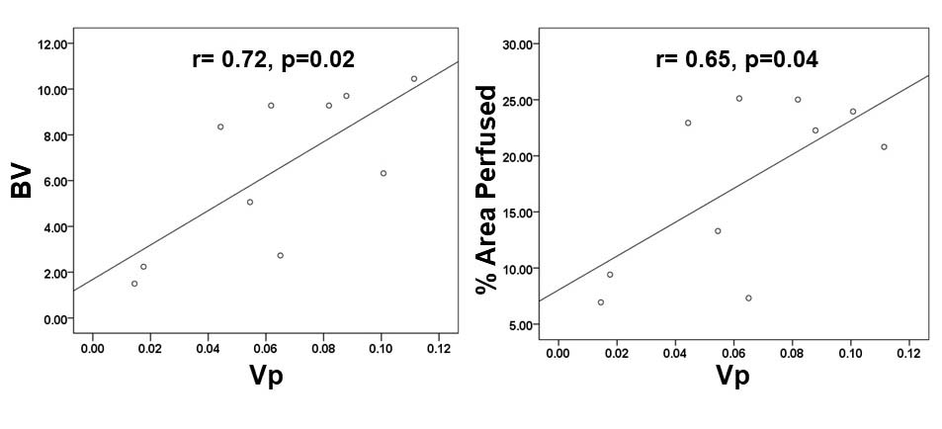
Figure 2.
Correlation plots showing DCE-MRI derived Vp and power Doppler derived BV and % area perfused demonstrating strong positive correlations. The best fit solid lines as obtained from standard linear regression analyses are shown.

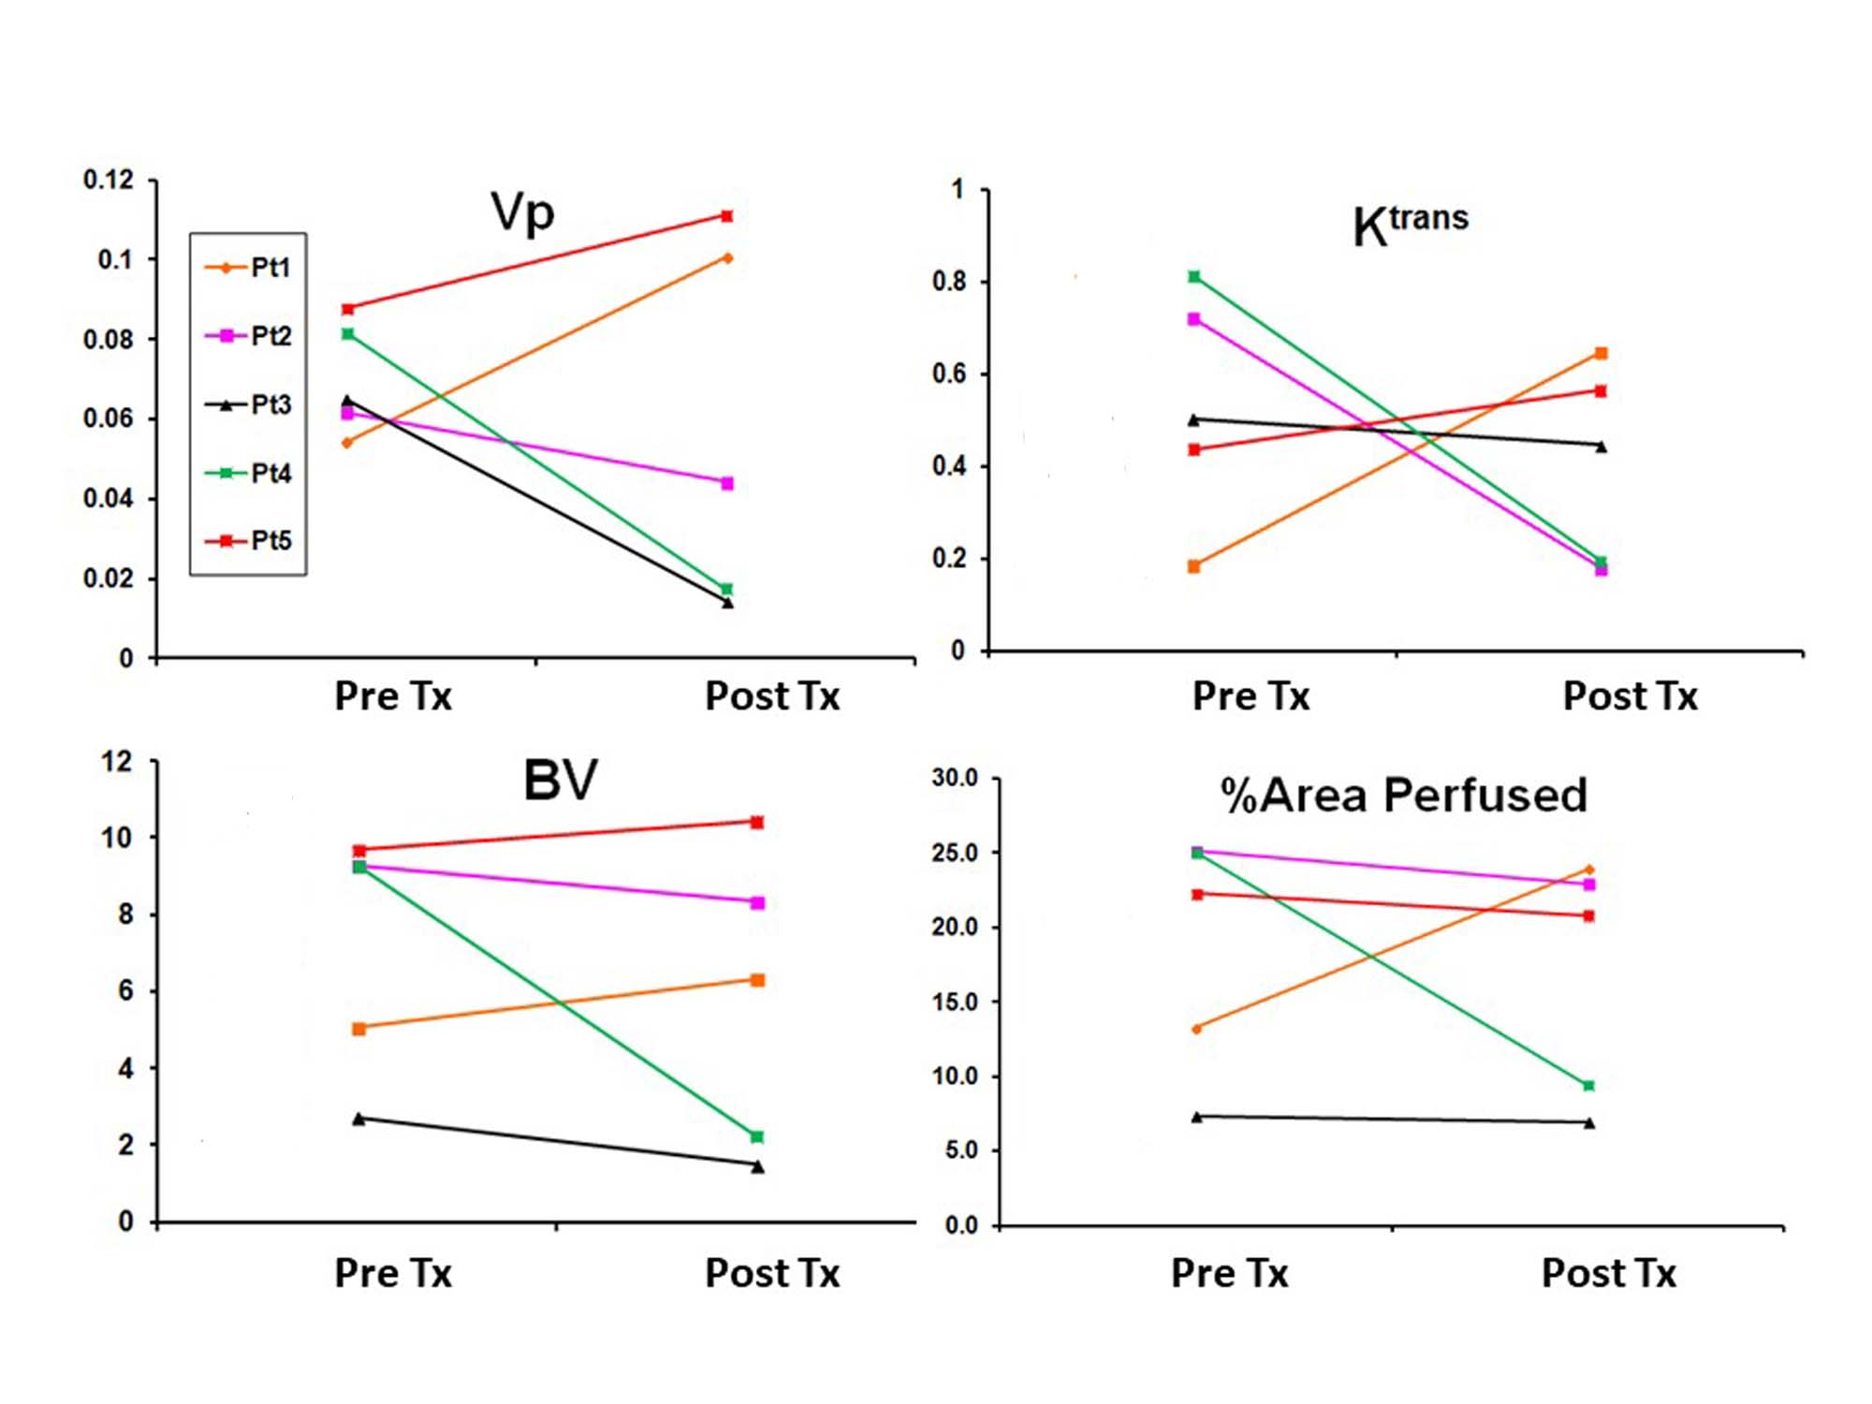
Figure 3.
The plots showing changes in DCE-MRI derived parameters [K^{trans} (min⁻¹) and Vp] and Doppler sonography derived parameters [BV (ml) and % area perfused] before and after induction chemotherapy. Three patients (Pt # 2-4) were responders, and two patients (Pt # 1 and 5) were non-responders.

References
1. McDermott JD, Bowles DW. Epidemiology of Head and Neck Squamous Cell Carcinomas: Impact on Staging and Prevention Strategies. Curr Treat Options Oncol.
2019;20:43.
2. Herman PG, Kim CS, de Sousa MA, et al. Microcirculation of the lymph node with metastases. Am J Pathol. 1976;85:333-348.
3. Shen Y, Liu J, Zhang L, et al. Identification of Potential Biomarkers and Survival Analysis for Head and Neck Squamous Cell Carcinoma Using Bioinformatics Strategy: A Study Based on TCGA and GEO Datasets. Biomed Res Int. 2019;2019:7376034.
4. Chan JM, Shin LK, Jeffrey RB. Ultrasonography of abnormal neck lymph nodes. Ultrasound Q. 2007;23:47-54.
5. Tschammler A, Ott G, Schang T, et al. Lymphadenopathy: differentiation of benign from malignant disease--color Doppler US assessment of intranodal angioarchitecture. Radiology. 1998;208:117-123.
6. Shirakawa T, Miyamoto Y, Yamagishi J, et al. Color/power Doppler sonographic differential diagnosis of superficial lymphadenopathy: metastasis, malignant lymphoma, and benign process. J Ultrasound Med. 2001;20:525-532.
7. Ariji Y, Kimura Y, Hayashi N, et al. Power Doppler sonography of cervical lymph nodes in patients with head and neck cancer. Am J Neuroradiol. 1998;19:303-307.
8. Chikui T, Yonetsu K, Nakamura T. Multivariate feature analysis of sonographic findings of metastatic cervical lymph nodes: contribution of blood flow features revealed by power Doppler sonography for predicting metastasis. Am J Neuroradiol. 2000;21:561-567.
9. Ahuja A, Ying M, King A, et al. Lymph node hilus: gray scale and power Doppler sonography of cervical nodes. J Ultrasound Med. 2001;20:987-992.
10. Yonetsu K, Sumi M, Izumi M, et al. Contribution of doppler sonography blood flow information to the diagnosis of metastatic cervical nodes in patients with head and neck cancer: assessment in relation to anatomic levels of the neck. Am J Neuroradiol. 2001;22:163-169.
11. Vishwanath V, Jafarieh S, Rembielak A. The role of imaging in head and neck cancer: An overview of different imaging modalities in primary diagnosis and staging of the disease. J Contemp Brachytherapy. 2020;12:512-518.
12. King AD, Ahuja AT, To EW, et al. Staging papillary carcinoma of the thyroid: magnetic resonance imaging vs ultrasound of the neck. Clin Radiol. 2000;55:222-226.
13. Cuenod CA, Balvay D. Perfusion and vascular permeability: basic concepts and measurement in DCE-CT and DCE-MRI. Diagn Interv Imaging. 2013;94:1187-1204.
14. Heye AK, Culling RD, Valdes Hernandez Mdel C, et al. Assessment of blood-brain barrier disruption using dynamic contrast-enhanced MRI. A systematic review.
Neuroimage Clin. 2014;6:262-274.
15. Bernstein JM, Kershaw LE, Withey SB, et al. Tumor plasma flow determined by dynamic contrast-enhanced MRI predicts response to induction chemotherapy in head and neck cancer. Oral Oncol. 2015;51:508-513.
16. Chawla S, Kim S, Loevner LA, et al. Prediction of disease-free survival in patients with squamous cell carcinomas of the head and neck using dynamic contrast-enhanced MR imaging. Am J Neuroradiol. 2011;32:778-784.
17. Chawla S, Kim S, Dougherty L, et al. Pretreatment diffusion-weighted and dynamic contrast-enhanced MRI for prediction of local treatment response in squamous cell carcinomas of the head and neck. Am J Roentgenol. 2013;200:35-43.
18. Chawla S, Kim SG, Loevner LA, et al. Prediction of distant metastases in patients with squamous cell carcinoma of head and neck using DWI and DCE-MRI. Head Neck. 2020;42:3295-3306.
19. Chawla S, Loevner LA, Kim SG, et al. Dynamic Contrast-Enhanced MRI-Derived Intracellular Water Lifetime (tau i ): A Prognostic Marker for Patients with Head and Neck Squamous Cell Carcinomas. Am J Neuroradiol. 2018;39:138-144.
20. Kim S, Loevner LA, Quon H, et al. Prediction of response to chemoradiation therapy in squamous cell carcinomas of the head and neck using dynamic contrast-enhanced MR imaging. Am J Neuroradiol. 2010;31:262-268.
21. Shukla-Dave A, Lee NY, Jansen JF, et al. Dynamic contrast-enhanced magnetic resonance imaging as a predictor of outcome in head-and-neck squamous cell carcinoma patients with nodal metastases. Int J Radiat Oncol Biol Phys. 2012;82:1837-1844.
22. King AD, Chow SK, Yu KH, et al. DCE-MRI for Pre-Treatment Prediction and Post-Treatment Assessment of Treatment Response in Sites of Squamous Cell Carcinoma in the Head and Neck. PLoS One. 2015;10:e0144770.
23. Manning C, Stringer M, Dickie B, et al. Sources of systematic error in DCE-MRI estimation of low-level blood-brain barrier leakage. Magn Reson Med. 2021;86:1888-1903.
24. Ng CS, Wei W, Bankson JA, et al. Dependence of DCE-MRI biomarker values on analysis algorithm. PLoS One. 2015;10:e0130168.
25. Pellini R, Manciocco V, Turri-Zanoni M, et al. Planned neck dissection after chemoradiotherapy in advanced oropharyngeal squamous cell cancer: the role of US, MRI and FDG-PET/TC scans to assess residual neck disease. J Craniomaxillofac Surg. 2014;42:1834-1839.
26. Yusa H, Yoshida H, Iwasa S, et al. Ultrasonographic assessment for response to radiochemotherapy of metastatic cervical lymph nodes in head and neck cancer: usefulness of grey-scale and color doppler sonography. Ultrasound Med Biol. 2000;26:1081-1087.
27. Sultan LR, Xiong H, Zafar HM, et al. Vascularity assessment of thyroid nodules by quantitative color Doppler ultrasound. Ultrasound Med Biol. 2015;41:1287-1293.
28. Tofts PS, Kermode AG. Measurement of the blood-brain barrier permeability and leakage space using dynamic MR imaging. 1. Fundamental concepts. Magn Reson Med.
1991;17:357-367.
29. Tofts PS, Brix G, Buckley DL, et al. Estimating kinetic parameters from dynamic contrast-enhanced T(1)-weighted MRI of a diffusable tracer: standardized quantities and symbols. J Magn Reson Imaging.1999;10:223-232.
30. Sehgal CM, Arger PH, Rowling SE, et al. Quantitative vascularity of breast masses by Doppler imaging: regional variations and diagnostic implications. J Ultrasound Med. 2000;19:427-440.
31. Muzaffar J, Bari S, Kirtane K, et al. Recent Advances and Future Directions in Clinical Management of Head and Neck Squamous Cell Carcinoma. Cancers (Basel). 2021;13.
32. Okano S, Homma A, Kiyota N, et al. Induction chemotherapy in locally advanced squamous cell carcinoma of the head and neck. Jpn J Clin Oncol. 2021;51:173-179.

33. Geoffrois L, Martin L, De Raucourt D, et al. Induction Chemotherapy Followed by Cetuximab Radiotherapy Is Not Superior to Concurrent Chemoradiotherapy for Head and Neck Carcinomas: Results of the GORTEC 2007-02 Phase III Randomized Trial. J Clin Oncol. 2018;36:3077-3083.
34. Haddad R, O'Neill A, Rabinowits G, et al. Induction chemotherapy followed by concurrent chemoradiotherapy (sequential chemoradiotherapy) versus concurrent chemoradiotherapy alone in locally advanced head and neck cancer (PARADIGM): a randomised phase 3 trial. Lancet Oncol. 2013;14:257-264.
35. Weinreb JC, Rodby RA, Yee J, et al. Use of Intravenous Gadolinium-Based Contrast Media in Patients With Kidney Disease: Consensus Statements from the American College of Radiology and the National Kidney Foundation. Kidney Med. 2021;3:142-150.
36. Ewing JR, Bagher-Ebadian H. Model selection in measures of vascular parameters using dynamic contrast-enhanced MRI: experimental and clinical applications. NMR Biomed. 2013;26:1028-1041.
37. Sourbron SP, Buckley DL. Classic models for dynamic contrast-enhanced MRI. NMR Biomed. 2013;26:1004-1027.
38. Gupta A, Rahman K, Shahid M, et al. Sonographic assessment of cervical lymphadenopathy: role of high-resolution and color Doppler imaging. Head Neck. 2011;33:297-302.
39. Yankeelov TE, Niermann KJ, Huamani J, et al. Correlation between estimates of tumor perfusion from microbubble contrast-enhanced sonography and dynamic contrast-enhanced magnetic resonance imaging. J Ultrasound Med. 2006;25:487-497.

40. Fischer C, Miska M, Jung A, et al. Posttraumatic Perfusion Analysis of Quadriceps, Patellar, and Achilles Tendon Regeneration With Dynamic Contrast-Enhanced Ultrasound and Dynamic Contrast-Enhanced Magnetic Resonance Imaging: Preliminary Results. J Ultrasound Med. 2021;40:491-501.
41. Kim MJ, Su MY, Yu HJ, et al. US-localized diffuse optical tomography in breast cancer: comparison with pharmacokinetic parameters of DCE-MRI and with pathologic biomarkers. BMC Cancer. 2016;16:50.
42. Gaschen L, Schuurman HJ, Bruttel K, et al. MRI and ultrasonographic detection of morphologic and hemodynamic changes in chronic renal allograft rejection in the rat. J Magn Reson Imaging. 2001;13:232-241.
R2.1
43. Ito H, Kamoi K, Yokoyama K, et al. Visualization of prostate cancer using dynamic contrast-enhanced MRI: comparison with transrectal power Doppler ultrasound. Br J Radiol. 2003;76:617-624.
44. Cosgrove D. Angiogenesis imaging--ultrasound. Br J Radiol. 2003;76 Spec No 1:S43-49.
45. Hata K, Miyazaki K. Color Doppler imaging and angiogenesis in ovarian tumors.
Med Electron Microsc.2003;36:127-130.
46. Jansen JF, Carlson DL, Lu Y, et al. Correlation of a priori DCE-MRI and (1)H-MRS data with molecular markers in neck nodal metastases: Initial analysis. Oral Oncol. 2012;48:717-722.
47. Gandhi D, Chepeha DB, Miller T, et al. Correlation between initial and early follow-up CT perfusion parameters with endoscopic tumor response in patients with advanced squamous cell carcinomas of the oropharynx treated with organ-preservation therapy. Am J Neuroradiol. 2006;27:101-106.

