Number of words (including highlights) 8498

The circular economy and longer product lifetime: Framing the effects on working time and waste

Luzzati Tommaso^{1*}, Distefano Tiziano¹, Ialenti Samuele², Andreoni Valeria³

¹Dipartimento di Economia e Management, Università di Pisa, Via Cosimo Ridolfi 10, 56124, Pisa, Italy. Corresponding author: tommaso.luzzati@unipi.it
² Dipartimento di Economia e Scienze Sociali, Università di Torino, Corso Unione Sovietica, 218 bis, 10134 Torino, Italy
³ Management School, University of Liverpool, Chatham Street, Liverpool L69 7ZH, UK

Abstract
An important goal of circular economy strategies is the extension of product lifetimes, under the assumption that this will deliver reductions in materials, energy use and waste. More broadly, longer lifetimes might counter the “broken windows fallacy” on which much of economic growth is based. The aim of this paper is to elaborate on this assumption rather than take it for granted. What are the systemic effects of policies aimed at saving materials? Who will benefit from them? To answer these research questions, we start connecting two issues that are often handled separately, despite being closely interlinked, namely (i) working time reduction and (ii) (over)production and waste generation. Trends in work indicators and material consumption in the EU15 countries confirm that higher material efficiency has not delivered the hoped-for benefits, thereby supporting the rest of our analysis. The conceptual framework that we propose shows that efforts towards material savings might allow reductions in working time per inhabitant while keeping labour compensation unchanged. However, such a possibility is hindered by competition over material efficiency gains.

Keywords
Working time; Material consumption; Waste reduction; Circular economy; Product lifetime.

Highlights
● The efficiency gains from Longer Product Lifetimes (LPL) do not benefit labour
● A shorter working time without cuts in labour compensation becomes feasible with LPL
● The integration of policies for LPL and for shorter working times increases wellbeing
● Longer product lifetimes (LPL) does not necessarily reduce material use and waste

1. Introduction
The need for sustainable development has been officially acknowledged more than 30 years ago (Brundtland et al., 1987) and periodically reaffirmed by science, engaged civil society, business organisations, and public institutions. At the global governance level, sustainable transitions have received increasing attention, as witnessed by various United Nations initiatives, such as the Agenda 21, the Millennium Development Goals (MDGs) and the Agenda 2030 with the related Sustainable Development Goals (SDGs). Nonetheless, governance and policies largely failed to regulate markets towards development paths, as is evident when looking at the material and energy use that, despite huge improvements in efficiency, have been impressively rising. Progress has been made, at last, in widely acknowledging the urgent need to take action to combat climate change (see e.g., the G7 meeting in Cornwall in June 2021). Still the question remains: why are our societies locked into unsustainable paths despite the increasing and overwhelming evidence of uneconomic growth, as Herman Daly defined it?
Among the many factors, as we will see in the next section, a key role is played by the societal difficulty to understand the urgency of downsizing the material scale of the economy. Only in recent years, the EU started several initiatives which include to fight planned obsolescence and increase product durability, particularly within the circular economy action plans. Product lifetimes has also attracted widespread interest from research, for instance the recent special issue “Understanding and Managing Product Lifetimes in support of a Circular Economy” in the Journal of Cleaner Production (Bakker et al. 2021). Prolonging lifetimes is exactly thought of as a tool for downsizing the material scale of the economy. The aim of this paper is to discuss this idea, rather than taking it as granted. For which aspects can policies for durability be effective? In what respect and under which conditions? Who will benefit from them?
To answer those research questions, as a first step we connect two debates that remain often separate, despite being the two sides of the same coin: (i) the debate about working time reduction (section 3) and that about (ii) (over)production, societal metabolism and waste generation (section 4). For this reason, there is not a specific section dedicated to the literature review, rather we introduce for each of the two research strands the main concept and results from the relevant literature and then the temporal patterns of the EU15 countries, obtained by figures available from public databases.
The reasons for the focus on the EU is given by its commitment to sustainable development and its effort to implement strategies for the transition to a circular economy, such as product-life-time which is at the core of the current study, while we restrict our empirical analysis on EU15 because they are a set of rather homogeneous mature economies for which better fit Keynes’ hypothesis on working time reduction.
Thereafter (section 5), we move to discuss how to conceptualise and model the effects of longer lifetime policies, namely as an exogenous positive shock on resource productivity in some sectors. This allows understanding that the competition over the generated gains is a major barrier to use higher resource efficiency for getting more leisure time and less waste.
To sum up, the paper is structured as follows. Sections 2 discusses the background, 3 and 4, tackles the issue respectively of working time and material indicators, also presenting the empirical evidence for the EU15. Section 5, by adopting a systemic perspective, outlines the potential effects of the policies aiming at reducing material input and waste. Section 6 concludes.

2. Background: the broken windows economy
As Georgescu-Roegen emphasised, humans have evolved exosomatically, by creating tools and using energy sources different from food. The industrial revolution and the related exploitation of fossil fuels allowed unprecedented levels of production and related consumption increase, the dependence on which Georgescu-Roegen did not hesitate to indicate as addiction (Georgescu-Roegen 1975, p. 379). Asking for a wiser and sober use of energy and matter, in his concern for future generations and for the needs of poor countries, he proposed a “minimal bioeconomic program” centred on avoiding waste of energy and matter, which included an increase in the durability of goods.
Already in 1850, the French economist Frederic Bastiat (1964) [1850] wrote about the “parable of the broken windows” which was popularised after one century by Hazlitt (2008). This parable was meant to point out that we often fail to see opportunity costs, in this case that a glazier repairing a broken window involves that another good (for example a pair of shoes) is not being produced. “The Kid” by Chaplin gives a visual example of the jobs “created” by breaking windows, when the Kid is sent by Charlie to break windows so he could repair them. In this type of economy, the number of actual glaziers would be higher than efficiency would recommend. Also in the XIX century, William Morris argued that to get and maintain profits, capitalists must sell a “mountain of rubbish…things which everybody knows are of no use” (Morris, 1886). If some authors point out the profit motive as pushing much production being socially useless (Kinna, 2000), inefficiency can be better thought of as arising from systemic failures. K.W. Kapp, and many institutional economists, saw the emergence of social costs and the negative effects of economic activity as arising from an unregulated competitive system (Luzzati, 2009). The problem of misallocation of resources is further aggravated in an era of climate change and decline in the energy return on investment (EROI) values (Rye and Jackson, 2018; Brockway et al., 2019). The fact that such contradictions are often overlooked by mainstream economics is odd, because efficient allocation is at the core of microeconomics, as undergraduate microeconomics handbooks explain, while macroeconomics blindly insists on GDP growth overlooking the inefficient resource allocation generated by negative externalities.
While initial environmental concerns focused on hazardous and toxic pollution, since the 1990s we started to become aware that also the overall material size of economies was a serious problem (e.g., von Weizsäcker et al., 1998), because of the exponential growth in consumption of materials started after WWII, which now goes under the name of “Great acceleration” (McNeill and Engelke. 2014). Consistently, many started invoking urgent efforts for downsizing the material scale of the economy, which is also at the basis of the degrowth movement (D’Alisa et al., 2015). Different initiatives have then been proposed, among which also the introduction of the Material Flow Accounting indicators among the official EUROSTAT statistics (Eurostat, 2013). In addition, the preventing waste strategy, reuse, and recycling have been included as core elements of the five-step waste hierarchy approach established with the EU Waste Framework Directive (2008/98/EC); and the European Parliament has adopted a resolution (T9-0318/2020) to encourage a culture of reuse and repair, and to devise a strategy against planned obsolescence.
At the same time, in the collective perception the need for reducing the material throughput is not considered at the core of sustainability principles. Since the very beginning, sustainability was reduced to two main ideas, namely, 1) a balance between economy, society, and environment, and 2) a concern for future generations. This is surprising since the Brundtland Commission report, published as Our common Future, specifically stated that:
“[Sustainable development] contains within it two key concepts: the concept of 'needs', in particular the essential needs of the world's poor, to which overriding priority should be given; and the idea of limitations imposed by the state of technology and social organisation on the environment's ability to meet present and future needs.” (Brundtland et al. 1987)
In Our common future, needs are at the centre of sustainability (Håland, 1999) together with the concept of limits that are the existing constraints of satisfaction of needs. On limits, Brundtland herself wrote, in a commentary to the report, that “We must tackle the myth that energy consumption must be allowed to grow unchecked” (Brundtland 1989, p. 41). Unfortunately, the need for “material degrowth” is not fully appreciated even within those institutions that include decoupling among their goals, in particular the European Union. For instance, several measures for the EU circular economy (CE) seem to overlook that recycling often requires extensive energy use. While CE proposes to mimic nature, it does not stress enough that natural cycles are closed thanks to solar energy (de Man and Friege, 2016).
To summarise, a substantial reduction of material throughput is urgently needed, and sustainable transitions need to stop the current throwaway economy. Unrepairable and short-lived products quickly become garbage, which involves a huge waste of materials, working hours and resources in general. This makes clear that, as was also stressed by the “Beyond GDP Debate” (EC, 2013), it should become widely acknowledged that GDP only measures the size of the market plus the cost of the public administration, rather than wellbeing, and that its exponential growth is not a precondition for efficiency and material consumption changes (Andreoni and Galmarini, 2014).

3. Working time reduction: a Keynesian dream?
Just before the great depression, J.M. Keynes gave a lecture about the “Economic possibilities for our grandchildren'' that was then published some years later. In this famous essay he affirmed that technological progress would have provided a great increase in material wellbeing and liberated humans from the need of labour. In particular, he predicted that in one century the working week of his country would have been not longer than 15 hours (Keynes, 2010 [1931], p. 329). Keynes’s intuition did not come true. On why he was wrong much has been said and the most frequent answer points out the role of socially generated needs (consumerism) and insatiability of wants (Pecchi and Riga, 2010).
The aim of this section is to assess the trends that we observed from WWII in the EU15 countries. To this purpose, we propose to avoid using the indicator that is commonly used, hours per workers, and focus rather on hours per inhabitant. The reason is that the amount of worked hours per inhabitant allows to account for that part of the population that has been liberated from labour, such as the younger people that can study for longer, the elderly that can enjoy an extended retirement, and for longer paid holidays, increase of part-time and temporary contracts, higher women participation in the labour force.
A first outcome from using hours per inhabitant is a correct assessment of Keynes’ prediction error. Weekly hours per worker in the UK averaged at about 49 (Hart 2019, p. 8) when Keynes wrote his essay, while at about 41 in the 1950s, which corresponded to 19.4 hours per week per person (all population included). Since, despite some fluctuations, the ratio between engaged workers and population remained similar with that of the 50s Keynes’ guess of a threefold increase in labour productivity in 100 years would roughly correspond to 7 hours per week per person in 2030, while the average for the period 2015-2019 was more than double, at about 15.5 per person (and 32 weakly hours per worker).
Looking at the evolution in time provides a more useful picture. Here we will focus on the EU15 countries because they have reached a mature phase of development, for which Keynes’ claim of working time reduction is more plausible. Data Penn World Table 10.0 (Feenstra et al. 2015) allows long period comparisons for the EU15, from 1950 until nowadays. In Figure 1 we plotted the time series of the average working hours per 7 days. The left-hand panel shows the average per person for the EU15 countries (continuous line), while the shaded red area includes the data for all countries, where the upper (lower) bound is associated with the maximum (minimum) value reported in a specific year and country. The right-hand panel focuses on a selection of countries (UK, France, and Italy) for the period 1951-2019.
The average EU15 working time per person decreased until the 1980s and became stable thereafter. This is temporally associated with the wave of neoliberalism that progressively became mainstream since Margaret Thatcher’s UK governments (1979-1990) and Ronald Reagan’s US presidency (1981-1989) (on neoliberalism see, e.g., King et al. 1999). Hence, working time has stopped decreasing long before the intense globalisation that has occurred since the 2000s (when China entered the WTO). The same dynamic characterised each of the EU15 countries with two exceptions. The weekly working hours per person fell in Sweden from about 18 in 1950 to 14 in the early ‘70s going back to 18 in 2019, while in Greece the descending trend was almost linear from 20 to 12 hours during the considered time-period, probably due to a fall in the overall production and employment.
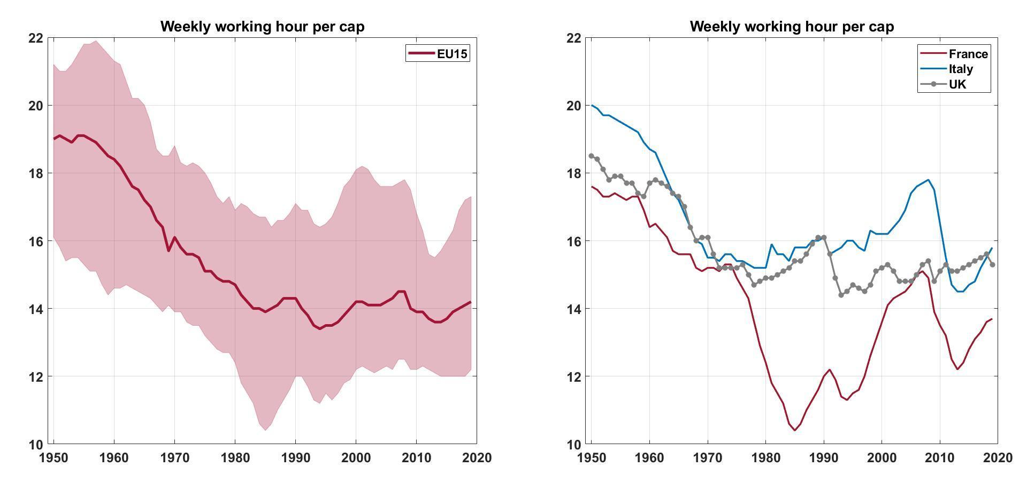
Figure 1. Weekly working hours per person in the EU15 (Luxembourg excluded), from 1951 to 2019.
The left-hand panel plots the time series of the average working hours per 7 days in EU15 (continuous line). The shaded red area includes the data for all countries, where the upper (lower) bound is associated with the maximum (minimum) value reported in a specific year and country. Source: PENN World Table, own elaboration.
In figure 2 we consider the period between 1995 and 2019. We took data from the EU KLEMS database, http://www.euklems.net/. The red line represents the weekly (7 days) working hours per inhabitant, while the blue line represents the weekly working hours per person engaged (defined as employees plus self employed; see OECD, 2001, pp. 39-43). To highlight regional heterogeneity, we also drew the trends of the countries that, for most of the time, showed the minimum and maximum values in each series.
On average, worked hours per inhabitant fluctuated around a value of 14 hours per week (bottom lines of Figure 2) while the number of worked hours per person engaged showed a moderate, but constant decline - from about 32 to 30.5 per week. Upper and lower bounds are different, depending on which indicator is looked at. . Regarding hours per inhabitant, France is the lower bound, with an average of about 13 hours per week, while Luxembourg is the upper bound, with an increasing trend from about 16 to more than 20 hours per week in 2019. For hours per engaged workers, Denmark and Greece are the lower and upper bound, respectively. In both cases, they show slightly declining trends with an average of about 27 and 40 hours per week, respectively..
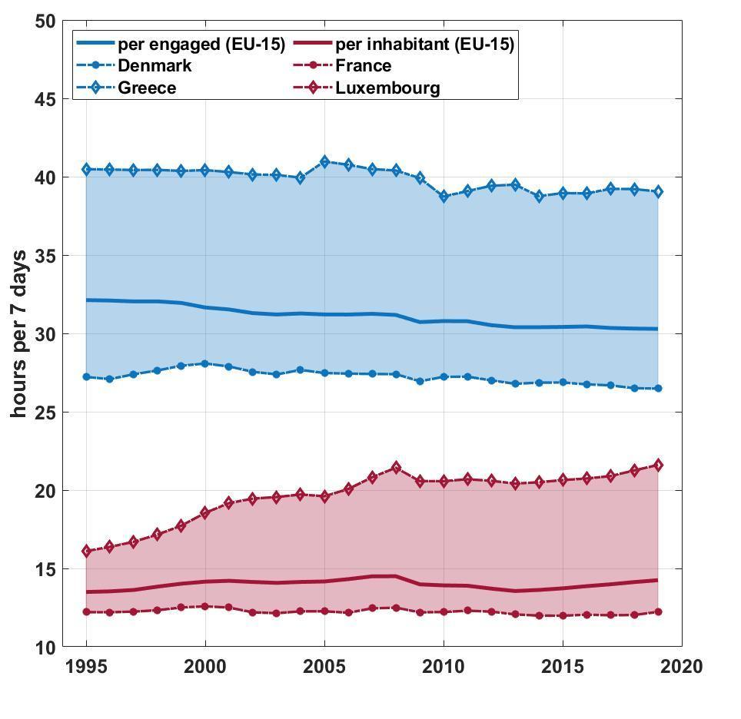
Figure 2. Weekly working hours in EU15, from 1995 to 2019.
Blue (red) line indicates the average number of hours per 7 days in EU15 by engaged workers (total population). Top (bottom) dotted line indicates the country that reported maximum (minimum) values most of the time. Source: PENN World Table, own elaboration.
Figure 3, then, suggests that the potential for reducing the working time per inhabitant has not been exploited. We plotted the cumulative growth, normalised with respect to 1995, of real GDP, real labour compensation, number of inhabitants and engaged workers. All the variables are expressed in terms of working hours, telling respectively how much GDP is produced in an hour of work, hourly labour compensation, the reciprocal of average working time, and how many inhabitants a society can sustain with an hour of work. The trend of real employee compensation per one employee working hour (grey line) has increased by almost 25%, indicating that one hour of work has been receiving growing compensation. At the same time, also the real GDP per hour (green line) increased at a faster rate (more than 50% in 23 years), which is in line with the productivity compensation gap that has been observed in the OECD countries (Criscuolo 2018, Pasimeni 2018, Schwellnus et al., 2017). This involves that distribution of the value added produced in one hour has been going in favour of profits and rents. Hence, the fact that the benefits of increased productivity has gone in major part to the companies might explain why the technological progress, which is currently higher than Keynes’ expectations, did not translate in a dramatic working time reduction. At the same time, the trend of the variable “population over the number of worked hours” (red line) has fluctuated around a rather constant value (corresponding to the value of 14 hours shown in Figure 2), which tells that one hour of work per day has supported half a person. These facts suggest that the increase in compensation and GDP has not translated into a reduction in the working hours, since the annual hours worked by engaged persons in EU15 increased by more than 11% over the considered period. Hence, data shows that, even in rather recent times and in a set of mature economies like the EU15 countries, the opportunities for reducing working time at the whole society level have not been exploited.
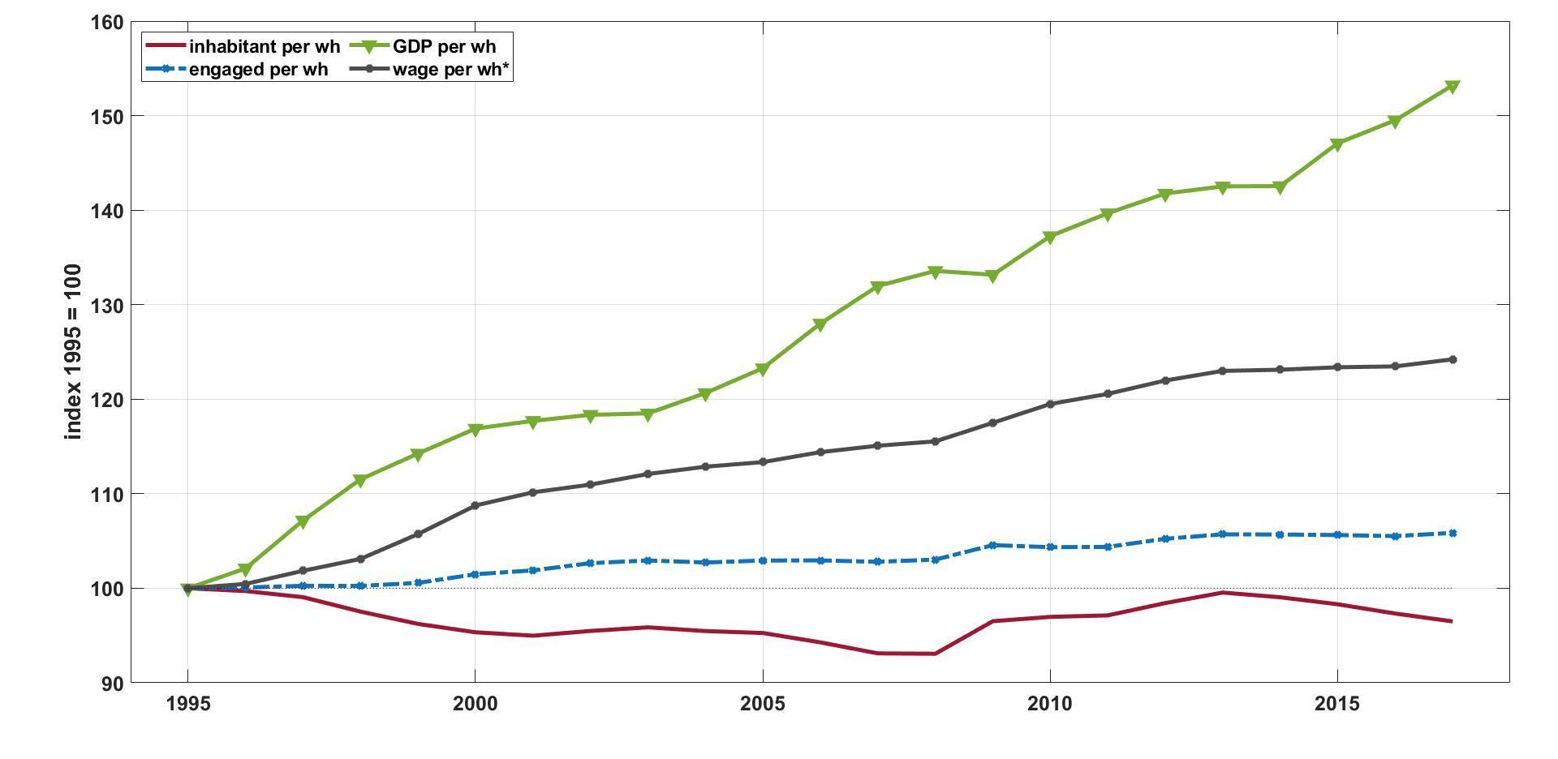
Figure 3. Socio-economic statistics per hour worked in EU15.
Cumulative change from 1995 of real GDP per worked hours, employees labour compensation per hours worked by employees (wh*), engaged workers per worked hours by engaged (wh), and population per worked hours. Source: PENN Table and KLEMS, own elaboration.

We can now give a glimpse to the huge literature on working time reduction, which, however, mainly focuses on the hours per workers, overlooking the question concerning to what extension increase in productivity has gone to decrease the amount of paid work in the whole economy (e.g., number of students, days off, retired workers). Working hours per worker have decreased substantially in the last 150 years (e.g., Messenger et al. 2007). Part of the success in reducing working hours (per worker) stands in increasing labour productivity, because of technological progress and structural changes such as the transition from the industrial to the service sector activities with higher value-added generation. The net result of labour productivity growth is that fewer people have been needed to produce the same amount of goods. However, labour productivity growth is an endogenous dynamic of capitalism, and it is emerging from the concentration of wealth and in the pursuit of overproduction (Mair et al., 2020).
At a better look, recent decades have shown a bifurcation of working hours, with substantial portions of the global workforce working either very long hours (more than 48 hours per week), particularly men, or short hours/part-time work (less than 35 hours per week), predominantly women (De Spiegelaere and Piasna, 2017; Messenger, 2018). Even in richest countries working hours tend to be longer in case of greater income inequality (Bowles and Park, 2005). Moreover, although in the richest OECD countries the standard working week is still around 40 hours, there is remarkable cross-country heterogeneity: from a minimum of about 1400 yearly hours per worker in Denmark to more than 2100 in Mexico.
All in all, the evidence on working time is mixed due to gender and skill gaps. Ramey and Francis (2009) showed that hours of work are essentially unchanged, with the rise in women's hours fully compensating for the decline in men's hours and that average annual lifetime leisure increased by only four or five hours per week during the last 100 years in the US. Costa (2000) found that the most highly paid worked fewer hours than the lowest paid in the 1890s but that by 1973 differences in hours worked were small and by 1991 the highest paid worked the longest day. Huberman and Minns (2007) provided evidence that since 1870 the decline in weekly and annual hours was consistently greater in the Old World; the New World has had fewer days off for the last 130 years. Finally, as the data on the EU15 we presented tell, reductions in working hours per employee are found higher than those per person (Kallis et al., 2013).

4. Social metabolism in the EU15 countries
This section will present some data about the social metabolism of the EU15 countries. Before, however, it might prove useful to briefly recall what this concept is about and why it is relevant. A consolidated research strand studies the material exchange between the economy and the natural environment; in analogy to living systems, needing material intake from the environment, and returning waste to it, the research object is termed societal metabolism. Martinez-Alier (1987) traces back this way of considering the interrelations between human and environment to Podolinsky and Geddes, in the late 19th century, who inspired authors such as Pfaundler and Popper-Lynkeus a few decades later. The contemporary studies got inspiration from the seminal paper by Ayres and Kneese (1969). Nicholas Georgescu-Roegen (1971) contributed to the foundations of the metaphor by emphasising that, by transforming concentrated materials and easily available resources into products and wastes, the economic process increases the material degradation and entropy. The concept of social metabolism has then received growing attention from a wide range of studies in the fields of Ecological Economics and Industrial Ecology and Ecological Economics (some seminal ones are Adriaanse et al., 1997, Fischer-Kowalski, 1998, Weisz, et al., 2002, Giljum and Eisenmenger, 2004), that empirically analysed the materials and the energy flows going through the socio-economic systems.
Many key concepts concerning economic growth and sustainability have been pointed out thanks to the notion of social metabolism, in particular the need of a material down-scaling. Since low entropy is a necessary condition for usability, the entropy production associated with material dissipation will become a limiting factor for economic growth (Kaberger & Mansson, 2001). Moreover, every transformation process, by increasing entropy, can damage environmental sustainability both generating pollution and reducing resources availability (Bianciardi et al., 1993). The larger the scale of the economy, the greater becomes the risk of destroying the conditions for human life on earth. Since biophysical limits exist, economic systems should have an optimal scale relative to the total ecosystem and a reduction in the scale of social metabolism is by many scholars acknowledged as a prerequisite of sustainable development (Hinterberger et al., 1997).
The field has developed to such an extent that material flows accounting has entered the official statistics, not only in the EU, but also being included in the UN System of Environmental-Economic Accounting (SEEA). For this analysis, the most relevant indicator is the raw material consumption (RMC), better known as Material Footprint (MF). This indicator has not yet entered the official statistics because it comes from highly uncertain estimates. MF is based on domestic material consumption (DMC), an official indicator that records the annual quantity of raw materials domestically extracted plus the physical commercial balance (in terms of weights) without including the materials extracted to produce traded goods. Hence, the DMC of a net importer country tends to underestimate its actual material footprint, because many goods are produced with raw materials extracted abroad. MF is estimated by adjusting the weight of processed goods traded internationally by estimating the corresponding raw material extractions they need.
The most reliable and comprehensive database is the Global Material Flows Database, available at the UNEP International Resource Panel, which we used for showing the trends of per capita RMC, DMC, and the ratio between the two for EU15 in the period 1995-2015 (Figure 4). The continuous lines indicate the values for EU15, while each country has trends included in the shadowed areas. To analyse the content of Figure 4, let us start from the right picture, showing that the MF has increased compared to the DMC, summarising the increasing EU15 dependency from material extracted abroad. The central and the left side pictures show the time series of the DMC and MF. Both summarise a growing trend for the period that preceded the 2008 crisis. After, DMC has been decreasing, while MF first decreased then remained stable.
Figure 4. Material Footprint, Domestic Material consumption and MF/DMC ratio in the EU15, from 1995 to 2015, per capita values.
Continuous lines indicate the average for the EU15. Top (bottom) dotted line indicates the country that reported maximum (minimum) values most of the time. Source: PENN World Table, own elaboration.
Figure 5, for which we used data from EUROSTAT, shows the output side, summarised by wastes. The time span goes from 2004, the first year for which homogeneous time series have been available from Eurostat only since 2004. The chart on the left shows that waste generation (WG) per capita has slightly increased, while the one on the right shows a significant increase in terms of WG/DMC ratio that between 2004 and 2016 moved from 28% to almost 40%. The increase in waste generation per capita seems to contradict the idea that the service sector, which is highly developed in higher income countries, brings overall lower material intensity. In fact, services require more matter than one can intuitively expect, also because we tend to overlook the energy requirements (for the computer or commuting, for instance). It is interesting to note that the Eurostat website makes it possible to build personalised Sankey diagrams connecting INPUTS to OUTPUTS for different European countries. In Figure 6, the diagram for the year 2015 is reported for the aggregate EU15 countries and the largest part of inputs is returned to the environment not as solid wastes but as emissions.
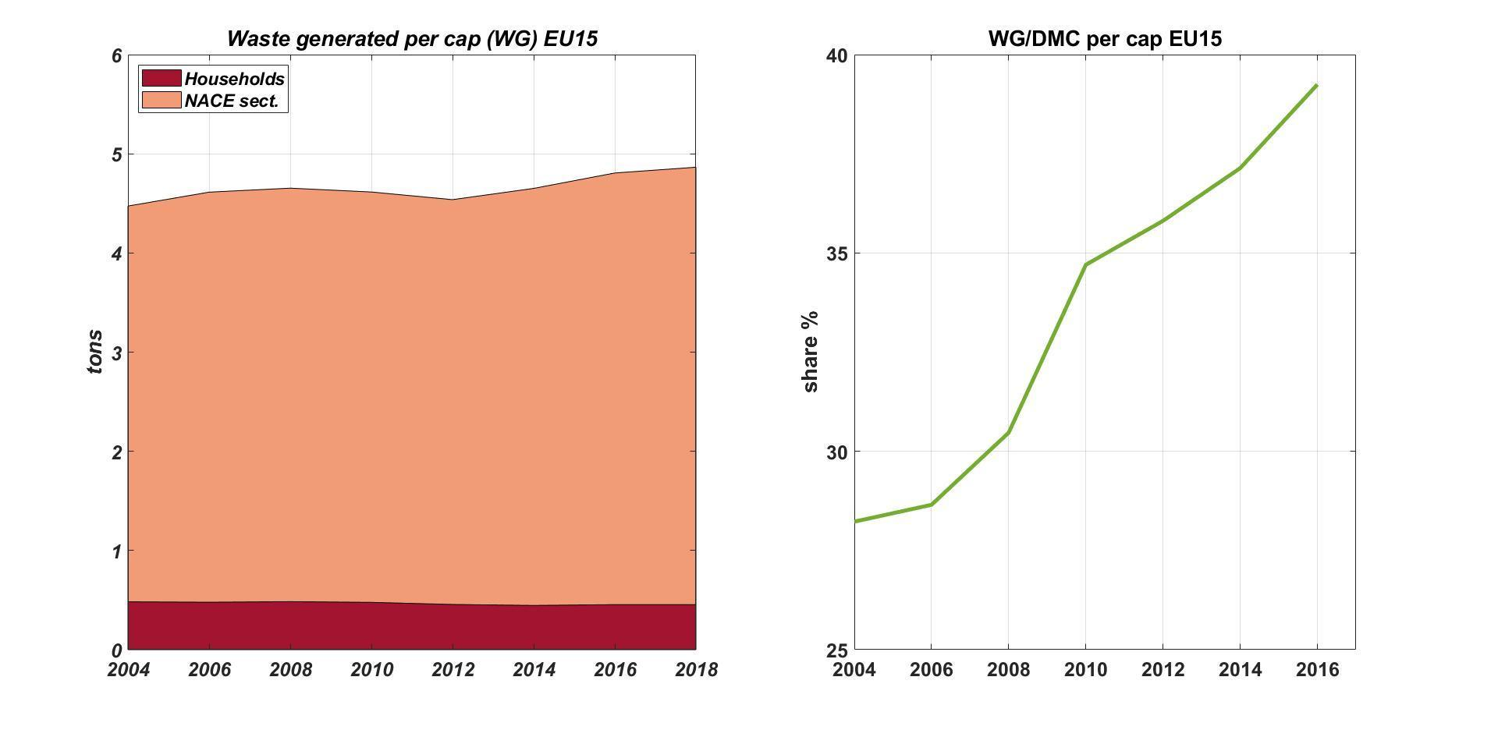
Figure 5. Waste generation (WG) per capita and WG/DNC ratio in the EU15, from 2004 to 2015, per capita values.
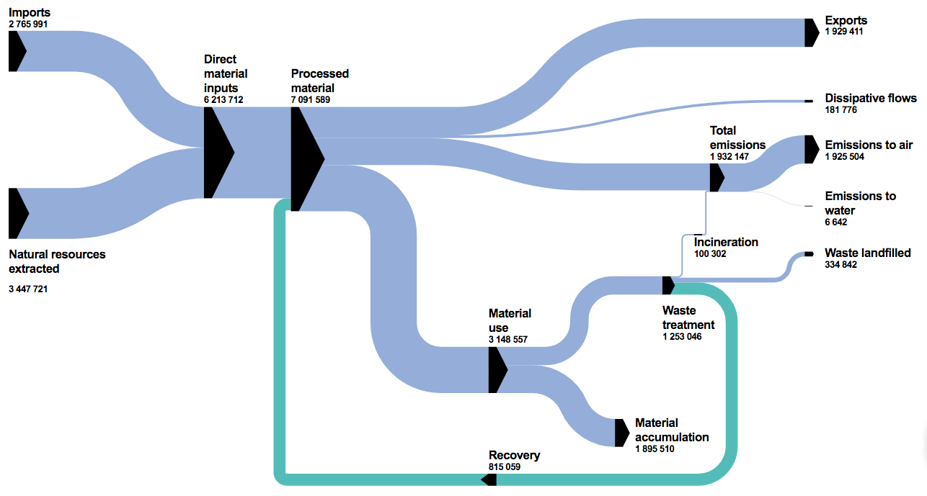
Continuous lines indicate the average for the EU15. Top (bottom) dotted line indicates the country that reported maximum (minimum) values most of the time. Source: EUROSTAT, https://appsso.eurostat.ec.europa.eu/nui/show.do?dataset=env_wasgen. Our own elaboration.

Figure 6. Sankey diagram of Input-Output material flows for the EU15 minus UK, for the year 2015. Source: EUROSTAT.

5. Increasing material efficiency for reducing both working time and material throughput

5.1 The general argument
The data for the EU15 shown in the previous sections (but also those for many other countries) are consistent with the idea that contemporary rich economies are based not only on producing useful stuff, but also on “breaking windows”. This has become a rather affirmed idea, to the point that institutions like the European Parliament and Commissions approved several circular economy measures for fighting planned obsolescence and improving resource productivity, including preventive actions for saving materials. In the following, we will first briefly recall the main pillars of those measures and then discuss the conditions under which those measures can be effective, and the implications for working time and leisure.
In the last 10 years, the European Parliament has acknowledged that planned obsolescence is a very serious problem. Usually, planned obsolescence affects the durable consumption goods, such as smartphones, TVs, dishwashers, and clothes. In this direction, the report of the EU Parliament, “On a longer lifetime for products: benefits for consumers and companies” (2016/2272 (INI)), indicates that the Commission must act encouraging the design of robust, durable, and high-quality products and the promotion of reparability and longevity of durable goods and fight planned obsolescence. Such an approach has entered the more recent and more complete “Circular Economy Action Plan” (EU Parliament 2020). The EU will intervene in “improving product durability, reusability, upgradability and reparability, addressing the presence of hazardous chemicals in products, and increasing their energy and resource efficiency”, all of this considered in a more detailed plan of circular economy, that will try to connect both final consumers and producing firms. The real problematic issue is that, in general, planned obsolescence is a market strategy for firms which operate in a market that exhibits a strong degree of monopolistic behaviour, such as oligopolies (e.g., ITC market). Probably, not only a legislative action on the characteristics of final goods is required - and we know the EU is moving in this direction - but also a deeper consideration on the degree of competition to assure in the market: a more competitive environment may reduce the incentive for these practices (if firms compete on the duration of their final durable consumption good). According to the EU 2016 survey, “80% of EU consumers desire more durable and reparable consumption goods”, so the problem regards mainly the production side of the economy, and economic actors usually act moved by incentives.
At a first glance, this kind of policy approach might be highly beneficial in lowering waste and pollution. Is such an idea correct and to what extent? And, moreover, who will benefit from this policy action?
We would like to stress that in many instances no new research or costly innovation is needed for increasing the lifetime of the products; rather it would suffice to redesign them. Actually, planned obsolescence went in the opposite direction. Although the strategies for longer product lifetime might be different - e.g., reparability, circular design, reuse, refurbishment, among others - we decided to keep the level of analysis more general without going into details. Indeed, our main aim is to focus on the possible impact of longer product lifetime given the linkage between material use and working time, independently from a specific intervention. For this reason we start from an example which involves material resource saving, although not via a durability, and requiring almost any industrial adaptation. Suppose that a new law imposes doubling the concentration of liquid laundry detergents. Which socio-economic and environmental consequences will be generated? For the sake of simplicity, imagine that firms choose to keep the price of a detergent bottle unchanged by using 50% smaller bottles. This involves an almost corresponding reduction both in packaging requirements (but for the cap and some effect of the square-cube law on the bottle) and in transportation to the retailers. Hence, on the environmental side, the quantity of energy and material requirement, emissions, and plastic waste will be strongly reduced, almost to half.
In the negatively affected industries, turnover will decrease, existing capital will become underutilised and labour unemployed, generating lower prices of plastic bottles and transport, and, if the sector is not very small, some downwards pressure in the hourly wages at the economy level. In any case, the implication is that businesses operating in the detergents industry will become lower because their inputs per unit of production will be lower both in volumes and in prices. Operating profits will increase, which will make the industry attractive to entrants. This competitive pressure will generate a downward pressure in detergents price that, however, will generate only a moderate increase in detergents demand (and sales) since it is reasonable to assume that the price demand elasticity at the for detergents is reasonably low. Hence, households will be able to buy other goods and/or work less. At the same time, the income of households working in the negatively affected industries will become lower because of the already mentioned increases in unemployment. Also, wages might decrease, particularly in the countries where collective bargaining is weak.
What would lower prices, wages and disposable income follow is a standard debated question in macroeconomics. In any case, the extent to which the depressive effects will propagate from the plastic bottle and transport industry to the rest of the economy depends on the inter-industrial links, labour structure and type of policies.
The synthesis is that higher resource efficiency in one sector increases real productivity of all factors (labour, capital, and raw materials) so that the demand for factors decreases. The reductions of the costs will increase operating profits and foster industry competition. This will lower product prices, provided the demand elasticity is not too low as compared to the supply elasticity. The degree of competition, the size of the affected sector, and the nature of the good (its demand elasticity value), are relevant to determine both the price decline and the final effects of the process and its beneficiaries. For instance, the policies would not imply high material savings if high elasticity generates higher demand for the goods.

5.2. A possible formalisation and strategies for research
Previous arguments can be visualised in a formal framework. We propose here a very simple two-sector model of the economy, where two goods are produced, C and D. The first is a standard bundle of consumption goods, while D indicates goods that can be affected by resource efficiency policies, such as those aimed at fighting planned obsolescence and increasing the life of products. Production uses labour (L), capital (K) and natural resources (R). The production functions (Equation 1 and Equation 2) keep separate the roles of R from L and K, whose contribution is expressed by f( ) and g( ) for C( ) and D( ) respectively. This distinction is needed to recall that substitution between what Georgescu-Roegen named “fund elements” (K and L) is easier than that between funds and flows, elements that are more easily thought of as complements rather than substitutes. Resource efficiency is indicated by 𝞽. Policies as those discussed above would increase its value. Efficiency might be different for fund elements and resource use, indicated respectively by two different parameters $τ$_{f} and $τ$_{R}. in Equation 2. In the liquid detergent example, one can assume that an increased concentration affects (almost) in the same way all production factors, hence it can be modelled as Hicks neutral technical progress with a unique 𝞽 which would double if concentration doubles. What is important to stress is that D can be thought of as the liquid detergent used in above arguments, or as services from “durable” goods. In all cases, the effect of the policies is to change the sectoral resource efficiency.
Equations 3 and 4 indicate the total amount of capital and labour force used in the two sectors. The inequality ($≥$) means that input factors do not need to be fully employed (K^{max} and L^{max}), depending on which theoretical framework one adopts, while Equation 5 is for assuming that all extracted resources are used (to add an extractive sector would not be useful to the argument).
Equation 6 tells that each household (indicated by j) has some preferences over consumption goods, durables, and leisure. L indicates working time, the maximum of which is set to 1 so that leisure time is 1-L. Negative externalities(E), which are not under the control of the single household, arise because of the pollution generated by resource use (R). , Equation 7 is the usual budget constraint: the left hand side is the expenditure for buying C and D at respective prices of $p_{C}$ and $p_{D}$ while the right hand side tells that income comes from selling the services of the production factors each household owns, where r the price of the capital services, w is the wage rate, $p_{R}$ is the price of the resources, $π_{C}$ and $π_{D}$the profits from the shares held in the two sectors. The mainstream framework models consumer choice as maximising Eq. 6 subject to Eq. 7, the budget constraint. The actual modelisation, however, is relevant in empirical studies (see next-subsection), while here is enough to recall that individuals face a trade-off between consumption and leisure and that using resources reduces their wellbeing via negative externalities.
Finally equations 8 and 9 indicate the aggregate profits in the two sectors.
Aggregate production
$$C=C (f\left(K_{C} , L_{C}\right) , R_{C} )$$ | [eq. 1]
$D=D (τ_{f}g\left(K_{D} , L_{D}\right) , τ_{R}R_{D} )$ | [eq. 2]
$$K^{max}≥ K=K_{C}+K_{D}$$ | [eq. 3]
$$L^{max}≥ L=L_{C}+L_{D}$$ | [eq. 4]
$$R=R_{C}+R_{D}$$ | [eq. 5]
Individual household (j)
$U^{j}=U(C^{j}, D^{j}, 1-L^{j})$*E(R) | [eq. 6]
$$p_{C}C^{j}+p_{D}D^{j}=rK_{i}+w_{i}{L^{j}}_{i}+p_{R}R_{i}+{ π}_{C}+{ π}_{D}$$  where$i= C, D$ | [eq. 7]
Representative firms
$$π_{C}=p_{C}C-{r_{C}K}_{C}-{w_{C}L}_{C}-p_{R}R_{C}$$ | [eq. 8]
$$π_{D}=p_{D}D-{r_{D}K}_{D}-{w_{D}L}_{D}-p_{R}R_{D}$$ | [eq. 9]

The consequences of an increase in resource efficiency in one sector would end up in a new composition in the bundle that households consume. Even if D remained about the same, the change in relative prices and income might favour either C or L. Also, the price of raw materials will decrease, allowing to increase goods consumptions but also longer leisure times.

5.3. Strategies for empirical research
The above formalisation is useful to conceptualise the issue, in particular for showing that the policies under discussion can be conceived as a positive shock to one sector of the economy. What will actually be their effects is intrinsically an empirical problem that can be tackled with very different methodologies. We briefly review them hereinafter.
Firstly, the Computational General Equilibrium (CGE) models have been used to assess how the economic system may react to specific policies (Grepperud and Rasmussen, 2004), i.e., by mean of comparative static exercises (how the economy changes when some exogenous parameter changes). This approach seeks for a computational analytical solution to find the general equilibrium that emerges assuming specific functions representing the behaviour of the economic agents that are supposed to be rational. These functions include different characteristics of substitutability between inputs (production function), or various configurations of preferences of the consumer (utility function). Once solved the equilibrium, comparative static exercises may be performed: imagine for example that a policy against planned obsolescence is able to rise economic efficiency of capital (it can be viewed as an innovation from a pure economic viewpoint); an exogenous increase in capital efficiency has an effect on the whole economy, which can be seen computationally simply by changing the magnitude of the parameters of interest. The dynamic version of CGE is represented by the Dynamic Stochastic General Equilibrium (DSGE) models that include adjustments due to an exogenous change in structural parameters, counting also for the presence of stochasticity (Freire-González and Ho, 2018).
Although CGE and DSGE are widely used, they present several shortcomings - e.g., optimising behaviour, exclusion of out-of-equilibrium dynamics, perfect competition, among others - that might undermine their reliability to indicate appropriate policy response (Stiglitz, 2018). These shortcomings call for different approaches that attempt to consider complexity, nonlinear dynamics, uncertainty, agents’ heterogeneity and the institutional context (Hafner et al., 2020). Those models are mostly based either on Input-Output tables, or system dynamics (Chaudhary and Vrat, 2020; Franco, 2019), or both (Towa et al., 2020).
Studies on circular economy and waste management are usually based on the so-called Environmentally Extended Input-Output (EEIO) analysis that deals with the quantification of environmental pressures that take place along the supply chain of goods and services, by assuming that production structure remains fixed (Donati et al., 2020). Nakamura and Kondo (2002) firstly introduced the waste extended IO model to connect monetary flows of products and services between sectors with physical waste flows generated and treated. The main advantage of using hybrid IO models (Towa et al., 2021) is the possibility to trace and quantify the physical volumes (e.g., TJ of energy, ktoe of air emissions, kton of waste, etc), the monetary values of intersectoral and final trade, and the social side consequences of a given economic structure (e.g., income inequality, distribution of the value added between wage and profits, wage gender gap, sustainability of the pension systems, etc) in space and time. The EEIO models have been further extended to include the dynamic of the economic system (Nakamura and Kondo, 2018). Implementing dynamic recursive in IO models permits to assess the use of materials over time and the implications of extending the lifetime of products. For instance, it has contributed to trace the fate of materials (mostly metals) over time and across products (such as automobiles) in recycling (Pauliuk et al., 2017). Finally, the combination of the system dynamic approach - i.e., inclusion of feedback effects, multidimensional analysis, emergence of new properties due to interactions, etc - allow to implement scenario analysis on the short- and long-term aftermaths of both socio-economic and energy-environmental policies (D’Alessandro et. al., 2020).
However, regardless of which methodology is used to explore in depth the subject, the main message of this section is that competition over the gains generated by the higher material efficiency promoted by circular economy policies is a major obstacle for converting potential material savings into lower material throughput and longer leisure time. In our example about the detergents, since the amount of money paid by the households for buying the detergents would remain more or less unchanged, an increase in the price of the goods such to leave unchanged the price per unit of service allow to keep unchanged the income of all factors involved in the whole production chain, despite a reduction in their use. How to redistribute such efficiency gains to the other industries is the central issue for the policies aimed at saving materials to succeed and avoiding higher unemployment and lower labour compensation.

6. Conclusion
This study attempted to connect the debate on working time and that on material throughput, with a special focus on data from the EU15. An integration of the two issues is needed because, on the one hand, the time devoted to work per capita remains high despite the technological achievements and efficiency increase, on the other hand, the “great acceleration” (McNeill and Engelke 2014) has been provoking unprecedented impairments on the human environment.
The literature on working time reduction and our analysis of the evolution of the EU15 countries (Section 3) do not only confirm that Keynes’ guess about a threefold reduction of working time in one century is far from becoming real, but also that the reduction of working time in the EU15 stopped in the 1980s. We argued in favour of using the working time per inhabitant as the appropriate indicator rather than the working time per worker, which is the most used indicator despite being deeply affected by changes in the labour force structure, such as longer retirement periods, delayed working entrance, higher female participation and changes in employment types (part-time, temporary jobs). Indeed, the two indicators show different trends. Since 1995, in the EU15, while working time (per worker) has moderately declined, working time per inhabitant has remained rather unchanged. Those figures contrast with the increase in labour compensation per hour and the higher increase in the GDP per hour, thereby showing that the opportunities for reducing working time at the society level have not been exploited. This cannot be attributed (solely) to a stronger preference for working and consuming over leisure time driven by consumerism, as claimed for instance by the debate on Keynes’ prediction mentioned in section 3. A major factor is rather the increase of the productivity-compensation gap (at least) in the OECD countries, involving a distribution of the value added in favour of profits and rents, which is also true for the EU15 countries analysed in this paper.
On the material side (Section 4), in the EU15 from the 1990s to the great recession in 2008, Domestic Material Consumption (DMC) remained rather stable, while Material Footprint (MF) increased, showing a growing material dependence on international trade. After 2008, MF has become rather stable while the DMC has started to decline. Finally, solid waste generation has increased, except for a temporary slowdown after the great recession. After all, EU15 countries are experiencing a mild shift towards less material intensive consumption, which parallels the stability in the number of hours worked per inhabitant.
Thus, both the literature review and data suggest that there is room and viability for policies centred on reducing material waste and increasing leisure, as suggested 50 years ago by Georgescu-Roegen in his minimal bioeconomic program. Section 5 has shown that such policies can be conceptually framed as positive technological shocks hitting some specific sectors. While the economy could benefit from such a surplus, this might not occur depending on how these resource savings are redistributed to the other sectors. The literature on degrowth and post-growth has emphasised the possible existence of rebound and Jevons’ effect fostered by consumerism. As it is well-known, the argument is that higher efficiency, by freeing resources, will give impulse to systemic changes that will end up reducing (or even more than offsetting) the material savings (Polimeni et al. 2015).
This might not be a crucial issue here because the reduction of the demand for factors in some sectors, and the implied unemployment, might offset the consumers’ gains coming from lower prices of the products that benefited from the positive technological shock.
In general terms, we highlighted that one barrier to the success of policy measures aimed at prolonging the product life is that the competition over the generated surplus worsens the labour conditions. Of course, in some cases a lower amount of paid work might drive the individual towards non-market activities, which are time-consuming but might require lower energy and material intensity than work (Pullinger, 2014), and might increase personal wellbeing and happiness (for details on the argument see, e.g. Curtis, 2003, or Andreoni and Galmarini 2014). Ecological economists advocated to attain both a working time reduction (Jackson and Victor, 2011) and a slowdown of labour productivity (Nørgård, 2013; Ferguson, 2016; Jackson, 2017), which is consistent with the core message of the degrowth movement that promotes “an equitable downscaling of production and consumption that increases human wellbeing and enhances ecological conditions at the local and global level, in the short and long term” (Schneider et al., 2010). However, a voluntary change in lifestyles of some people cannot be thought of as a lever strong enough to win the resistance to change of a society based on consumerism, in which fulfilment of given wants generates new and higher order wants (Hirsch, 1977) and consumption is so high (Huppes and Ishikawa, 2009).
Hence, measures to increase product durability need to be accompanied by policies that redistribute the material efficiency gains to the rest of the economy both by reallocating labour and reducing working times without reducing labour compensation. In other terms, policies that only limit the competitive pressure to produce short-lived goods would provide firms gains that in the end would destabilise the system if not appropriately regulated.
Finally, even from a very mainstream point of view, the wrong allocation of factors should be acknowledged, rather than insisting on the need for GDP growth, and corrected for. Indeed temporary unemployment arising from circular economy policies can be addressed by using the increase in efficiency for promoting the reallocation of productive factors from some sectors to others. This paper suggested that there is space not only for factors reallocation, but also for reducing working time while keeping unchanged the purchasing power of the labour force.

References
Adriaanse A., Bringezu S., Hammond A., Moriguchi Y., Rodenburg E., et al. (1997). Resource Flows: The Material Basis of Industrial Economies. World Res. Inst., Washington, DC.
Andreoni, V., Galmarini, S. (2014). How to increase wellbeing in a context of Degrowth. Future 55, 78-89
Ayres, R.U. and Kneese, A.V. (1969). Production, consumption, and externalities. The American economic review, 59(3), 282-297.
Bakker, C. A., Mugge, R., Boks, C., & Oguchi, M. (2021). Understanding and managing product lifetimes in support of a circular economy. Journal of cleaner production, 279, 123764.
Bastiat F. (1964). Selected Essays on Political Economy. Trans. Seymour Cain. Ed. George B. de Huszar. Princeton, N.J.: D. Van Nostrand.
Bianciardi, C., Tiezzi, E. & Ulgiati, S., (1993). Complete recycling of matter in the framework of physics, biology and ecological economics. Ecological Economics 8, 1-5.
Bowles, S., & Park, Y. (2005). Emulation, inequality, and work hours: Was Thorsten Veblen right? The Economic Journal, 115(507), F397-F412.
Brockway, P. E., Owen, A., Brand-Correa, L. I., & Hardt, L. (2019). Estimation of global final-stage energy-return-on-investment for fossil fuels with comparison to renewable energy sources. Nature Energy, 4(7), 612-621.
Brundtland, G. H. (1989). Global change and our common future. Environment: Science and Policy for Sustainable Development, 31(5), 16-43.
Brundtland, G. H., Khalid, M., Agnelli, S., Al-Athel, S., Chidzero, B. J. (1987). Our Common Future. Report of the World Commission on Environment and Development. Oxford University Press. Available at: http://www.un-documents.net/wced-ocf.htm (Accessed: 12 August 2021)
Chaudhary, K., Vrat, P. (2020). Circular economy model of gold recovery from cell phones using system dynamics approach: a case study of India. Environment, Development and Sustainability, 22(1), 173-200.
Corbett, P. (2014). Purex laundry detergent to cut its water content by 25 percent. Available at: thttps://eu.azcentral.com/story/money/business/2014/05/13/purex-laundry-detergent-cut-water-content-percent/9049081/ (Accessed: 12 August 2021)
Costa, D. L. (2000). The wage and the length of the work day: From the 1890s to 1991. Journal of Labor Economics, 18 (1), 156–181.
Criscuolo, C., Schwellnus, C. (2018). Decoupling of wages from productivity. OECD Economic Outlook.
Curtis, F. (2003). Eco-localism and sustainability. Ecological Economics 46, 83-102.
D’Alessandro, S., Cieplinski, A., Distefano, T., Dittmer, K. (2020). Feasible alternatives to green growth. Nature Sustainability, 3(4), 329-335.
D’Alisa G. Demaria F., Kallis G., (Eds.) Degrowth: A Vocabulary for a New Era. Routledge, Earthscan, 2015
Daly, H. (1999). Uneconomic growth and the built environment: in theory and in fact. In C.J. Kibert (ed.). Reshaping the Built Environment: Ecology, Ethics, and Economics. Washington DC: Island Press.
de Man, R., Friege, H. (2016). Circular economy: European policy on shaky ground. Waste Management & Research 34(2), 93–95.
De Spiegelaere, S., Piasna, A. (2017). The why and how of working time reduction. European Trade Union Institute.
Donati, F., Aguilar-Hernandez, G. A., Sigüenza-Sánchez, C. P., de Koning, A., Rodrigues, J. F., Tukker, A. (2020). Modelling the circular economy in environmentally extended input-output tables: Methods, software and case study. Resources, Conservation and Recycling, 152, 104508.
EC (2013). Progress on “GDP and beyond” actions. Commission Staff Working Document. SWD (2013) 303 final. Available at: SWD_2013_303.pdf (europa.eu) (Accessed: 12 August 2021)
EU parliament (2020). Resolution T9-0318/2020: Towards a more sustainable single market for business and consumers. Available at https://www.europarl.europa.eu/doceo/document/TA-9-2020-0318_EN.html (Accessed: 12 August 2021)
Eurostat (2013). Economy-Wide Material Flow Accounting (EW-MFA) - Compilation guide 2013. Available at: 2013 EW-MFA Guide (10Sep2013) (europa.eu) (Accessed: 12 August 2021).
Feenstra, R. C., Inklaar, R., & Timmer, M. P. (2015). The next generation of the Penn World Table. American economic review, 105(10), 3150-82.
Ferguson, P. (2016). Productivity growth as a barrier to a sustainability transition. Environmental Innovation and Societal Transitions, 20, 86-88.
Fischer-Kowalski, M. (1998). Society’s Metabolism. The intellectual History of Materials Flow Analysis, Part I, 1860-1970. Journal of Industrial Ecology, 2: 61-78.
Franco, M. A. (2019). A system dynamics approach to product design and business model strategies for the circular economy. Journal of Cleaner Production, 241, 118327.
Freire-González, J., Ho, M. S. (2018). Environmental fiscal reform and the double dividend: evidence from a dynamic general equilibrium model. Sustainability 10(2), 501
Georgescu-Roegen N. (1971). The entropy law and the economic process, Harvard University Press, Cambridge (Massachusetts).
Georgescu-Roegen, N. (1975). “Energy and economic myths”, Southern Economic Journal, 347-381.
Giljum, S. & Eisenmenger N., (2004). North-South Trade and the Distribution of Environmental Goods and Burdens: a Biophysical Perspective. The Journal of Environment and Development 13: 73.
Grepperud, S., Rasmussen, I. (2004). A general equilibrium assessment of rebound effects. Energy Economics 26(2), 261–282.
Hafner, S., Anger-Kraavi, A., Monasterolo, I., Jones, A., 2020. Emergence of new economics energy transition models: A review. Ecological Economics, 177, 106779.
Håland, W. (1999). On needs—a central concept in the Brundtland report. In: Towards Sustainable Development (pp. 48-69). Palgrave Macmillan, London.
Hart, R.A. (2019). Labor Productivity during the Great Depression in UK Manufacturing, IZA Discussion Papers, No. 12379, Institute of Labor Economics (IZA), Bonn
Hazlitt H. (2008). Economics in One Lesson. Auburn, Ala.: Ludwig von Mises Institute.
Hinterberger, F., Luks, F., & Schmidt-Bleek, F. (1997). Material flows vs. natural capital': What makes an economy sustainable? Ecological economics, 23(1), 1-14.
Hirsch, F., (1977). Social Limits to Growth. Routledge, London
Huberman, M., Minns C. (2007). The times they are not changing’: Days and hours of work in old and new worlds, 1870–2000. Explorations in Economic History 44 (4), 538–567.
Huppes, G., Ishikawa, M. (2009). Eco-efficiency guiding micro-level actions towards sustainability: Ten basic steps for analysis. Ecological Economics 68, 1687-1700.
Jackson, T. (2016). Prosperity without growth: Foundations for the economy of tomorrow. Routledge.
Jackson, T., & Victor, P. (2011). Productivity and work in the ‘green economy’: Some theoretical reflections and empirical tests. Environmental Innovation and Societal Transitions, 1(1), 101-108.
Kaberger, T. & Mansson, B., (2001). Entropy and economic processes – physics perspectives. Ecological Economics 36, 165-179.
Kallis, G., Kalush, M., O’Flynn, H., Rossiter, J., Ashford, N. (2013). Friday off’: Reducing Working hours in Europe. Sustainability 4(5), 1545-1567.
Keynes, J.M. (2010) [1931]. Economic possibilities for our grandchildren. In Essays in persuasion (pp. 321-332). Palgrave Macmillan, London.
King, D. and Wood, S., 1999. The political economy of neoliberalism: Britain and the United States in the 1980s. Continuity and change in contemporary capitalism, 13, pp.371-397.
Kinna, R. (2000). William Morris: art, work, and leisure. Journal of the History of Ideas, 61(3), 493-512.
Knight, K.W., Rosa, E.A., Schor, J.B. (2013). Could working less reduce pressures on the environment? a cross-national panel analysis of OECD countries, 1970–2007. Global Environmental Change, 23 (4), 691–700.
Luzzati, T. (2009). Human needs, sustainable development, and public policy: learning from KW Kapp (1910–1976). In Salvadori N. and Opocher A. (eds.) Long-run Growth, Social Institutions and Living Standards. Edward Elgar, 306-322.
Mair, S., Druckman, A. Jackson. T. (2020). A tale of two utopias: Work in a post-growth world. Ecological Economics, 173, 106653.
Martinez-Alier, J. (1987). Ecological economics: energy, environment and society. Blackwell, Oxford..
McNeill, J.R., Engelke P. (2014). The Great Acceleration: An Environmental History of the Anthropocene since 1945. Cambridge: Belknap P, 2014.
Messenger, J. C. (2018). Working time and the future of work. Future of Work Research Series. Geneva: ILO.
Messenger, J. C., Lee, S., & McCann, D. (2007). Working time around the world: Trends in working hours, laws, and policies in a global comparative perspective. Routledge.
Morris, W. (1886). Useful work versus useless toil. Socialist League Office, No. 48.
Nakamura, S., Kondo, Y., (2002). Input-output analysis of waste management. Journal of Industrial Ecology, 6, 39-63.
Nakamura, S., Kondo, Y. (2018). Toward an integrated model of the circular economy: Dynamic waste input–output. Resources, Conservation and Recycling, 139, 326-332.
Nørgård, J. S. (2013). Happy degrowth through more amateur economy. Journal of cleaner production, 38, 61-70.
OECD (2001), Measuring Productivity - OECD Manual: Measurement of Aggregate and Industry-level Productivity Growth, OECD Publishing, Paris. Available at: https://doi.org/10.1787/9789264194519-en (Accessed: 12 August 2021)
Pasimeni, P. (2018). The relation between productivity and compensation in Europe (No. 079). Directorate General Economic and Financial Affairs (DG ECFIN), European Commission.
Pauliuk, S., Kondo, Y., Nakamura, S., Nakajima, K., (2017). Regional distribution and losses of end-of-life steel throughout multiple product life cycles insights from the global multiregional MaTrace model. Resour. Conserv. Recycl., 116, 84-93.
Pecchi L., Piga G. (Eds.) (2010). Revisiting Keynes: economic possibilities for our grandchildren. Mit Press.
Polimeni, J. M., Mayumi, K., Giampietro, M., & Alcott, B. (2015). The myth of resource efficiency: the jevons paradox. Routledge.
Pullinger, M. (2014). Working time reduction policy in a sustainable economy: Criteria and options for its design. Ecological Economics, 103, 11–19.
Ramey, V.A., Francis, N. (2009). A century of work and leisure. American Economic Journal: Macroeconomics, 1(2), 189–224.
Rezai, A., Taylor, L., Mechler, R. (2013). Ecological macroeconomics: An application to climate change. Ecological Economics, 85, 69–76.
Rye, C. D., & Jackson, T. (2018). A review of EROEI-dynamics energy-transition models. Energy policy, 122, 260-272.
Schneider, F., Kallis, G., & Martinez-Alier, J. (2010). Crisis or opportunity? Economic degrowth for social equity and ecological sustainability. Introduction to this special issue. Journal of cleaner production, 18(6), 511-518.
Schwellnus, C., Kappeler, A. Pionnier, P. (2017). Decoupling of wages from productivity: Macro-level facts. OECD Economics Department Working Papers, No. 1373, OECD Publishing, Paris. Available at: https://doi.org/10.1787/d4764493-en (Accessed: 12 August 2021)
Stiglitz, J.E. (2018). Where modern macroeconomics went wrong. Oxford Review of Economic Policy, 34(1-2), 70-106.
Towa, E., Zeller, V., Achten, W. M. (2020). Input-output models and waste management analysis: A critical review. Journal of Cleaner Production, 249, 119359.
Towa, E., Zeller, V., Achten, W.M. (2021). Circular economy scenario modelling using a multiregional hybrid input-output model: The case of Belgium and its regions. Sustainable Production and Consumption, 27, 889-904.
von Weizsäcker, E.U., Lovins, A.B., Lovins, L. H. (1998). Factor four: doubling wealth-halving resource use: the new report to the Club of Rome. Earthscan.
Weisz, H., et al., (2002). Economy-wide Material Flow Accounts and Indicators of Resource Use for the EU. Eurostat Tender 2001/S125 – 084782/ EN. Final Report, Luxemburg, 2002.

Acknowledgements
This paper received helpful insights from colleagues at the Responsible Management Research Center (REMARC) of the University of Pisa, within which this piece of research was elaborated. Errors remain our own. The Centre for Logistics Systems (Livorno) of the University of Pisa partially supported the participation of Distefano, who also acknowledges the contribution from the “EMERITUS' MIT-UNIPI project -IX call (2021-22)”.
The paper is the outcome of intense discussion among the authors. Nonetheless, the first draft of each section can be attributed as follows: section 1 Luzzati, section 2 Distefano and Luzzati, section 3 Andreoni and Luzzati, section 4 Ialenti and Luzzati.

In several of his writings H. Daly popularised the idea that growth can become uneconomic, namely when the additional benefits from production are outweighed by its additional negative environmental and social consequences (e.g., Daly 1999). In other terms, it is against its technical definition to interpret GDP as a measure of wellbeing.
Own calculations from the PENN World Table 10.0. https://febpwt.webhosting.rug.nl/Dmn/AggregateXs/VariableCodeSelect
For Luxembourg, which is usually to be considered an outlier for its peculiarity, data are available from 1971 onwards. Hence, we excluded it from this table.
Due to the lack of data, we use the labour compensation referred to employees, as provided in KLEMS.
Already in 1950, KW Kapp warned against the incompatibility between an unregulated competitive economic system and human survival (see, e.g. Luzzati, 2009).
See https://seea.un.org/content/material-flow
See https://www.resourcepanel.org/global-material-flows-database
The highest per capita values refer to Luxembourg, which however is an outlier for several reasons, among which the most important is the high rate of commuters from the bordering countries. Hence, its values are considered for drawing the shadowed areas.
https://ec.europa.eu/eurostat/cache/sankey/circular_economy/sankey.html
The sankey diagram shows only data but not the size of the flows when UK is included. For this reason, Figure 6 does not include the UK.
Water is very abundant in liquid detergents, usually ranging between 60% and 90% (Corbett, 2014).
The reason why liquid detergents are very diluted seems to be due to marketing reasons (see. e.g. Corbett 2014).
In our detergent example, the increase of concentration affects almost in the same way all production factors, hence we would have a Hicks neutral technical progress with a unique 𝞽.
Any activity requires matter. Overall, very few activities have a low material intensity, particularly non-working ones like reading books (in hardcopies).

