10322 words

Determinants of workers' pro-environmental behaviour towards enhancing construction waste management: Contributing to China’s circular economy
Jian Li Hao^{1*}, Shiwang Yu¹, Xiaonan Tang¹, Weiwei Wu²
¹Department of Civil Engineering, Xi’an Jiaotong-Liverpool University, Suzhou 215123, China.
²Department of Construction and Real Estate, Southeast University, Nanjing, Jiangsu 210096, China.
*Corresponding author: Jian Li Hao
Email address: jianli.hao@xjtlu.edu.cn
Postal address: Department of Civil Engineering, Xi’an Jiaotong-Liverpool University
111 Ren’ai Road, Suzhou, Jiangsu Province 215123, China

Abstract
Construction waste presents many challenges for sustainable development and ultimately for China’s goal of a circular economy. Effective construction waste management (CWM) is necessary to tackle these challenges, the success of which depends in large part on the behaviour of workers. Most previous behavioural research relating to CWM focused on reduction or recycling behaviour, with few studies having examined pro-environmental behaviour (PEB) within organisations. This study therefore conducted research into the key determinants of two types of PEB relating to CWM. A questionnaire survey was conducted on five construction sites in China to identify the critical organisational and personal determinants predicting PEB relating to CWM, including self-enacted PEB and co-worker PEB. One hundred and fifty-two valid questionnaires were collected for data analysis, representing an overall response rate of 30.4%. Results of the analysis reveal that physical stress, environmental awareness, and tedious construction processes are significant predictors of PEB. Based on these results, practical suggestions for enhancing CWM are proposed. The findings of this research could help improve PEB among construction workers and thereby contribute to China’s circular economy.
Keywords
Construction waste management; circular economy; pro-environmental behaviour; personal and organisational determinants

- Introduction

With China's urbanisation and city renewal projects, a large amount of construction waste is generated every year. It is estimated that the amount of construction waste per 10,000 m² is about 600 t during the construction process (Lu et al., 2017). Given that the area of completed construction projects in China can reach 2 billion (10⁹) m²/year, which is half of the world's total annual construction (Hong et al., 2019), without effective response measures over 1 billion tons of construction waste will be generated each year. Large amounts of construction waste have brought tremendous pressure on China's environment and society and have become a problem that requires urgent attention (Hao et al., 2021); the Covid-19 pandemic has exacerbated the problem and increased the urgency (Fan et al., 2021). Given that construction waste is a significant contributor to carbon emissions and the Chinese government has promised to take concrete steps toward the goal of achieving peak carbon emissions by 2030 and carbon neutrality by 2060 (Zhao et al., 2022), it is necessary to take measures to lower carbon emissions in the construction sector, by reducing the generation of construction waste at source through effective construction waste management (CWM) (Ma et al., 2022a). Sustainable development has become a priority in China, which can be achieved with the help of a circular economy.
Although the government has released several policies in recent years related to CWM in China, many of them have only short-term benefits without a long-lasting impact on the quantity of construction waste (Yu et al., 2022a). Due to construction workers' direct involvement with the materials, the way they perform on-site significantly impacts the generation of construction waste (Aslam et al., 2020). It is estimated that 50% of construction waste can be prevented if waste source reduction measures are implemented on-site (Liu et al. 2020). Most previous studies of behaviour towards construction waste minimisation and recycling focused on reduction behaviour (Hao et al., 2019), or sorting behaviour (Yang et al., 2020) with only a few investigating pro-environmental behaviours (PEB) towards construction waste within organisations, which is more in line with the circular economy strategies of recovery, recycling, re-use, and refuse (Morseletto, 2020). In fact, PEB is widely adopted in studying different problems including solid waste management (Pierini et al., 2021). By adopting two types of PEB to measure the behaviour of construction workers regarding construction waste, this study can provide a more comprehensive understanding by examining construction workers' behaviour when construction waste is generated and enrich the behavioural research of construction waste management. The study also provides an important reference for contractors to take countermeasures to improve the PEB of construction workers.
In addition, prior studies identified determinants of construction waste-related behaviour only in terms of attitude, intention, and subjective norms (Su, 2020), while omitting personal and organisational factors like stress and tedious construction processes, which have been shown to impact workers' behaviour (Stackhouse and Turner, 2019). The aim of this study is to identify the key personal and organisational influencing determinants of two types of workers' PEB, namely self-enacted PEB and co-worker PEB. The novel contributions of this study are:
(i) Adopting pro-environmental behaviour on the construction site to promote sustainable construction within a circular economy strategy;
(ii) Examining the effect of physical and psychological stress on workers’ pro-environmental behaviour towards construction waste;
(iii) Confirming the significant impact of physical stress and tedious construction processes on both types of PEB; and
(iv) Providing advice to guide construction workers’ performance in relation to minimizing the environmental footprint of construction projects.
This paper is organised as follows. An explanation of the importance of PEB to sustainable development is first provided followed by a comprehensive and systematic analysis of previous studies relating to PEB factors. In the third section, the research methodology is described in terms of research design, research instrument sampling, and data collection. The results of descriptive statistical analysis, factor analysis, Pearson's correlation analysis, and multiple linear regression analysis are then presented. The paper concludes with several suggestions for construction company stakeholders concerning actions they can initiate in their organisations to support successful PEB.

- Literature Review

The concept of a circular economy has become increasingly important in recent years, and is seen as instrumental in solving the construction waste problem (López Ruiz et al., 2020). The circular economy aims to improve the utilization rate of resources and obtain the maximum economic output with as little environmental cost as possible, including minimum resource consumption and minimum waste generation (Palafox-Alcantar et al., 2020). In a circular economy, more attention is paid to maximizing the usefulness and utility of resources. However, circular strategies seeking to boost the efficiency of construction materials will not succeed without the participation of construction workers who are directly involved in two important phases: construction materials use, and waste disposal (Bakshan et al., 2017). Construction workers' behaviour and decision making in the two phases not only directly affect the circular economy in the preferred option of success in reduction, reuse, and waste separation at source, but also have a direct impact on the subsequent construction waste recovery and recycling.
An increasing number of scholars are focusing on behavioural research in effective CWM towards a circular economy, including contractor's CWM behaviour and construction contractor employees' waste reduction behaviour (Li et al., 2018), attitudes towards construction waste recycling (Yuan et al., 2022), and separation behaviour (Mak et al., 2019). However, these studies focused on one specific aspect of construction waste behaviour only while omitting the workers' behaviour toward minimisation and recycling of construction waste. Furthermore, previous studies focused on workers' individual personal behaviour toward construction waste in terms of waste management behaviour (Wu et al., 2017) and waste reduction behaviour (Yang et al., 2020), with little attention paid to co-workers' behaviour. The PEB of employees refers to the individual's behaviour to improve the structure of the ecosystem by reducing or eliminating the negative impact of their own activities on the environment (Coelho et al., 2017). Its essence is to achieve environmental improvement by effectively alleviating environmental problems (Ansari et al., 2021). The main purpose of CWM is to reduce the negative impact of construction activity on the environment (Wang et al., 2019). The adoption of PEB in this study helps to combine CWM and environmental protection together and make the behavioural study of construction waste more comprehensive; PEB focuses on actions that help reduce the environmental impact of construction waste, rather than a single reduction of construction waste. Therefore, PEB towards CWM can be a solution to the dilemma of studying unilateral behaviour toward construction waste.
PEB was proposed to measure workplace individual pro-environmental behaviour (Robertson and Barling, 2017), which has attracted much interest in recent years. Researchers adopted PEB to study workplace pro-environmental issues in the manufacturing industry (Rasheed et al., 2020), tourism (Yoon et al., 2021), and education sector (Ojedokun, 2018). Boiral and Paillé (2012) proposed three types of PEB, eco-initiatives, eco-civic engagement, and eco-helping, but they did not provide an assessment of the content and validity of the three types of PEB. Robertson and Barling (2017) developed and validated a new measure of PEB, which comprised three levels: the self-enacted level, the co-worker level, and the organisational level. Organizational PEB mainly refers to the individual behaviour of helping organizations to carry out more effective environmental management without compensation, including promoting enterprises to improve existing environmental protection initiatives and making environmental protection related suggestions to leaders of the organization (Mi et al., 2019). In China, labour subcontracting is quite common in most construction projects: the general contractor subcontracts the labour part of the contracted project to the labour subcontractors with the corresponding qualifications (Xie et al., 2022). Construction workers do not have a high sense of organizational belonging to construction contractors (Wang et al., 2020). Moreover, the tense construction schedule and high-intensity work also make construction workers have few opportunities to communicate with the project management team (Xing et al., 2021). This means that the construction worker has no direct or long-term contractual relationship with the construction contractor, and as the project ends, the construction worker joins another contractor's construction project. Construction workers' self-enacted PEB and co-worker PEB relating to CWM are adopted in this study.
The major personal determinants of PEB are revealed in previous literature, including environmental awareness, sense of responsibility, personal value, physical stress, and psychological stress (Gkargkavouzi et al., 2019). The association between environmental awareness and PEB has been reported in various sections (Fu et al., 2020). Moreover, environmental awareness has been identified as one of the significant determinants affecting the recycling of waste in China (Jiang et al., 2020). A sense of responsibility helps pro-environmental behaviour by activating a sense of moral obligation toward the environment (Afsar et al., 2016). Moreover, it is argued that employees' PEB can be encouraged by strengthening their sense of responsibility (Neessen et al., 2021). Personal value plays a significant role in shaping one's behaviour and is regarded as a key predictor and determinant of PEB (Bhattacharyya et al., 2020). All these findings tend to support the need for research into the association between personal determinants and workers' PEB. In recent years, greater attention has been paid to the individual determinants related to reducing construction waste (Bakshan et al., 2017). Physical stress refers to all kinds of physical symptoms caused by excessive physical consumption (Leung et al., 2016). The intensity and long hours involved in construction work induce physical stress amongst workers (Zhao et al., 2018), which is also associated with anti-social behaviour, insomnia, and injuries (Jebelli et al., 2019). Psychological stress is the physiological change and mood fluctuation caused by a change of the external environment and the internal state of the body (Anwer et al., 2021). The psychological stress of workers, usually manifested as exhaustion and breakdown, is also widely reported in the construction industry. It is associated with low job satisfaction, poor work performance, and a high level of intention to leave the construction industry (Lim et al., 2017). These findings indicate the significant impact of physical and psychological stress on construction workers. The connection between stress and pro-environmental behaviour has been identified in the literature (Clercq and Belausteguigoitia, 2020). However, evidence of an association between stress and pro-environmental behaviour toward construction waste is few and far between.
The organisational factors of individual PEB are also reported in the literature, including site management (Ajayi et al., 2017), tedious construction process (Bølviken and Koskela, 2016), and training (Li et al., 2018). Although construction waste adversely impacts the natural environment, many construction contractors seem to be oblivious to it (Wu et al., 2022). Poor site management was a significant factor in the generation of construction waste (Magalhães et al., 2017). The performance of the construction workers is dependent on the quality of site management, such that workers would take PEB seriously and exhibit construction) waste minimisation behaviour when the site management is strict and efficient (Ma et al., 2022b). Another contributor to construction waste generation is tedious construction processes. Despite the fact that much effort goes into disposing of construction waste by applying technical measures (Davis et al., 2021), little attention is given to avoiding the generation of construction waste by improving construction processes. Furthermore, lack of training is regarded as one of the major causes of construction waste (Li et al., 2018), and it is claimed that effective training is a good way to overcome difficulties of PEB relating to CWM and decrease the generation of construction waste (Park and Tucker, 2017). To encourage PEB of workers on-site, it is necessary to first identify the organisational determinants that affect it.
The foregoing studies show that personal and organisational factors greatly impact workers' behaviour and construction waste minimisation. However, empirical evidence of the association between personal and organisational factors and workers' PEB relating to CWM is lacking. CWM scholars have paid little attention to these factors, and thus we have limited knowledge concerning their effects on employees' PEB. This study addresses a significant knowledge gap by examining the association between PEB and personal and organisational factors. The conceptual model of this study is depicted in Figure 1.
Figure 1. Conceptual model of the PEBs and their personal and organisational variables

- Methodology

- Research design
To identify the determinants influencing workers' PEB relating to CWM, a literature review and a questionnaire survey were employed. Based on the literature review, eight potential factors were identified. A structured questionnaire was then developed for data collection. Questionnaire respondents were all full-time workers on five selected construction sites. Statistical analyses were then carried out on the collected data.
- Research instrument
A questionnaire was designed to investigate the impact of personal and organisational factors on PEB for workers. To ensure the content validity of the questionnaire, the variables were adapted from previous studies, as depicted in Table 1. The detailed information about the questionnaire measurement items and their references can be found in Appendix 1. These items were modified to make them consistent within the context of effective CWM and the circular economy.
Table 1. Variables adopted in the questionnaire and their sources
Variables | No. of questions | Key references
Personal values | 3 | Chan et al., 2014; Li et al., 2022; Lu et al., 2015; Valle et al., 2005
Environmental awareness | 4 | Chang et al., 2016; Esa et al., 2017; Guo et al., 2022; Poon et al., 2013; Rahman et al., 2014; Severo et al., 2021; Valle et al., 2005
Sense of responsibility | 3 | Bao et al., 2020; Corvellec, 2019; Li et al., 2022; Valle et al., 2005
Site management | 3 | Bakshan et al., 2017; Hao et al., 2020a; Hwang and Yang, 2014; Liu et al., 2022; Yang et al., 2020; Yap et al., 2021
Tedious construction process | 3 | Ajayi et al., 2017; Allwood, 2014; Newaz et al., 2020; Salgin et al., 2017
Training | 2 | Li et al., 2018; Liu et al., 2019; Tam and Hao, 2019
Physical stress | 3 | Jebelli et al., 2019; Leung et al., 2017, 2012
Psychological stress | 3 | Anwer et al., 2021; Lazarus, 2020; Leung et al., 2017; Olanrewaju et al., 2017
Pro-environmental behaviours | 5 | Hao et al., 2020b; Paillé and Boiral, 2013; Robertson and Barling, 2017

The questionnaire was divided into two parts. The first part was designed to collect demographic information, including gender, age, education level, working years, and type of work, and the second part focused on the organisational factors and personal factors of PEB. Respondents were asked to answer 29 questions using a 5-point Likert scale ranging from "extremely disagree" (1) to "extremely agree" (5). The mode for each element was further strengthened by examining the maximum, the minimum, the mean, and standard deviation as the value for the most substantial probable Likert score value for the element.
- Sampling and data collection
Five hundred questionnaires were distributed via WeChat, QQ and in-person to construction workers on five construction sites in Yunfu City, Guangdong Province, China, with potential respondents given the assurance that the survey was anonymous. Guangdong is the most economically powerful and populous province in China, with a GDP of 1243.70 billion yuan and a population of 126.84 million (Statistics Bureau of Guangdong Province, 2022). The construction industry of Guangdong province is highly developed, and the construction management level ranks among the highest in China. Since Guangdong province started CWM very early on, it has accumulated rich practical experience and achieved remarkable results. Therefore, the questionnaire survey conducted at construction sites in Guangdong province not only has a high reference value for developed provinces to realize efficient CWM, but also accumulates practical experience for exploring the application of PEB in CWM. The details of the five construction sites are described in Table 2. Respondents were invited to choose the response that best described their level of agreement with the statements in the questionnaire. To ensure the validity and reliability of the questionnaire survey, the following screening criteria were adopted: (1) If a returned questionnaire had more than five unanswered questions, it was marked as invalid; (2) If there were apparent regularities in a returned questionnaire it was marked as invalid; and (3) If there was more than one answer to a question, the questionnaire was marked as invalid. The well-trained questionnaire investigator firstly explained the questionnaire information to the construction workers before the team meeting and sent the questionnaire weblink to the construction workers through WeChat and QQ with the help of the team leader. Among the 250 sent questionnaires, 46 were returned, and 20 valid questionnaires were finally collected after eliminating the invalid ones. Hard copies of the questionnaire were distributed to project office workers during their lunch break and after the regular evening meeting, and construction workers were randomly approached at the construction site and asked to complete a questionnaire. All these measures largely guarantee the validity and authenticity of the collected data. Of the 500 surveys distributed, 152 completed valid questionnaires were finally collected, representing a response rate of 30.4%. Of the collected questionnaires, 86.8% are traditional pen-and-paper questionnaires (n=132) completed in person, and 13.2% are online questionnaires (n=20) via WeChat and QQ.
Table 2. Construction sites surveyed in this study
No. of construction cite | No. of employees | Project type
1 | 138 | Residential building
2 | 53 | Industrial plant
3 | 45 | Municipal project
4 | 168 | Commercial building
5 | 96 | Residential building
SPSS25.0 was employed to analyse the collected data. The Cronbach's Alpha coefficient of the questionnaire was 0.8, indicating a good internal consistency of the whole questionnaire (Abu-Bader, 2021). The questionnaire data were then analysed through descriptive statistical analysis, factor analysis, reliability analysis, Pearson's correlation analysis, and stepwise multiple linear regression analysis.

- Results

- Descriptive statistical analysis
Descriptive statistical analysis was conducted to analyse the detailed demographic factors. The result, including the frequency and percentage of each item, is presented in Table 3. Among the respondents, there were 146 male and 6 female workers, accounting for 96.1% and 3.9% respectively.
Table 3. Detailed information of questionnaire respondents
Items | Category | Frequency | Percentage (%)
Gender | Male | 146 | 96.1
 | Female | 6 | 3.9
Age (Years old) | ≤20 | 2 | 1.3
 | 21–30 | 55 | 36.2
 | 31– 40 | 59 | 38.8
 | 41– 50 | 30 | 19.7
 | 51– 60 | 6 | 3.9
Education | Elementary school | 3 | 2.0
 | Junior middle school | 19 | 12.5
 | Senior middle school | 46 | 30.3
 | Technical secondary school | 76 | 50.0
 | Bachelor and above | 8 | 5.3
Job type | Steelworker | 41 | 27.0
 | Concrete worker | 20 | 13.2
 | Masonry worker | 30 | 19.7
 | Carpentry | 4 | 2.6
 | Water-electric worker | 13 | 3.9
 | Plasterer | 4 | 2.6
 | Electric welder | 6 | 3.9
 | Painter | 4 | 2.6
 | General worker | 30 | 19.7
Working period (Years) | 1–5 | 58 | 38.2
 | 6 – 10 | 57 | 37.5
 | 11 – 15 | 24 | 15.8
 | ≥16 | 13 | 8.6
The majority (94.7%) of the participants were in the 21-50 years age group, and 94.8% of the respondents did not have a university education. Respondents were distributed into 9 job types, with 58 respondents having worked on construction sites for 1 to 5 years, representing 38.2%, and 57 respondents having worked on-site for 6-10 years, accounting for 37.5%. Respondents with experience on site of 11-15 years and over 15 years represent 15.8% and 8.6% respectively

- Factor analysis
Factor analysis was conducted to reduce the items into distinct factors using statistical analysis. The principal component method was adopted to extract the factors, and the eigenvalue should be over 1 (Kline, 2014). Varimax rotation was used to obtain a clear association between the variables and the factors (Hinton et al., 2014). The sampling sufficiency test predicts whether the data are likely to have good factors based on correlation and partial correlation, and KMO measures greater than 0.6 are considered acceptable (Hair et al., 2018). The value of factor loading should be equal to or larger than 0.6 (Pallant, 2020). By conducting factor analysis, twenty-six variables were finally grouped into nine factors.
- Validity analysis
Validity analysis showed that values of the KMO measure of sampling adequacy test (0.760) and Bartlett’s test of sphericity (0.000) were acceptable and the data appropriate for factor analysis. Three factors were identified from eight items of organisational factors in the factor analysis, accounting for 75.296% of the total variance. The three identified factors were Site Management (O1), Tedious Construction Process (O2), and Training (O3), as shown in Table 4. All the factor loadings are larger than 0.6, which is acceptable. The Cronbach's Alpha for variables O1, O2, and O3 are 0.810, 0.746, and 0.728, which at more than 0.7 indicates good internal consistency.
Table 4. Factor analysis of organisational factors for workers
Factors | Items | Statement | Factor Loading | Cronbach's Alpha
O1 - Site Management | 1 | The company has relevant supervision and management systems to reduce CW. | 0.920 | 0.810
 | 2 | Intentionally generation of construction waste will be punished. | 0.848
 | 3 | The management team provided adequate supervision at work. | 0.780
O2 -Tedious Construction Process | 1 | The habit of traditional construction methods and practices makes me waste materials unconsciously. | 0.887 | 0.746
 | 2 | Repeating the same process operation during work (such as tying steel bars) makes it easier for me to overuse materials. | 0.851
 | 3 | The complicated construction process makes me very tired. | 0.679
O3 - Training | 1 | I lack training in knowledge and skills related to waste reduction. | 0.885 | 0.728
 | 2 | I didn't receive any training before I started. | 0.871
The KMO measure of sampling adequacy test (0.739) and Bartlett’s test of sphericity (0.000) indicate that the data are appropriate for factor analysis. Three factors were identified from ten personal items in the factor analysis, accounting for 69.974% of the total variance. The two identified factors were Environmental Awareness (P1) and Sense of Responsibility (P2), as shown in Table 5. Personal Values (P3) were excluded due to the low level of factor loadings. The Cronbach's Alpha for variables P1 and P2 are 0.829 and 0.792, which at more than 0.7 indicates good internal consistency.
Table 5. Factor analysis of personal factors for workers
Factors | Items | Statement | Factor Loading | Cronbach's Alpha
P1 - Environmental Awareness | 1 | Reducing construction waste can reduce pollution. | 0.890 | 0.829
 | 2 | I think the generation of construction waste is related to environmental awareness. | 0.782
 | 3 | I often pay attention to environmental issues. | 0.737
 | 4 | Reducing construction waste will contribute to the environment. | 0.704
P2 - Sense of Responsibility | 1 | If I produce CW, I will feel very guilty. | 0.915 | 0.792
 | 2 | I feel guilty when wasting construction materials. | 0.743
 | 3 | It is my duty to reduce CW. | 0.702
P3* - Personal Values | 1 | I am happy to help others. | 0.891 | 0.669
 | 2 | I'm happy with the behaviour that helps change the environment | 0.535
 | 3 | I'll be happy to reduce waste | 0.518
Note: * – Personal Values (P3) were deleted due to low factor loadings

The KMO measure of sampling adequacy test (0.819) and Bartlett’s test of sphericity (0.000) indicate that the data are appropriate for factor analysis. Three factors were identified from six stress items during the data analysis, accounting for 73.050% of the total variance. The two identified factors were Psychological Stress (S1) and Physical Stress (S2), as shown in Table 6. The Cronbach's Alpha for variables S1 and S2 are 0.842 and 0.758, which at more than 0.7 indicates good internal consistency.
Table 6. Factor analysis of construction worker stress
Factors | Items | Statement | Factor Loading | Cronbach's Alpha
S1 -Psychological Stress | 1 | I feel like I am about to break down at work. | 0.861 | 0.842
 | 2 | I am tired of my current job. | 0.835
 | 3 | Work makes me feel tired physically and mentally. | 0.831
S2 - Physical Stress | 1 | I am suffering from body aches and other diseases due to long hours of work. | 0.900 | 0.758
 | 2 | Work makes me have a bad appetite and decreased appetite. | 0.758
 | 3 | I think that the intensity of my work greatly affects my health. | 0.676
The KMO measure of sampling adequacy test (0.771) and Bartlett’s test of sphericity (0.000) indicate that the data are appropriate for factor analysis. Two factors were identified from five items of PEB factors during the data analysis, accounting for 74.271% of the total variance. The two identified factors were Co-worker PEB (B1) and Self-enacted PEB (B2), as shown in Table 7. The Cronbach's Alpha for variables B1 and B2 are 0.784 and 0.756, which at more than 0.7 indicates good internal consistency.
Table 7. Factor analysis of PEB for workers
Factors | Items | Statement | Factor Loading | Cronbach's Alpha
B1 - Co-worker PEB | 1 | I encourage co-workers to take more environmentally friendly measures toward construction waste. | 0.830 | 0.784
 | 2 | I encourage co-workers to express their opinions on issues related to waste minimisation and recycling. | 0.824
 | 3 | I will actively take the time to help workers take waste minimisation and recycling activities into consideration at work. | 0.750
B2 - Self-enacted PEB | 1 | I voluntarily participate in the organisation's activities of construction waste minimisation and recycling. | 0.874 | 0.756
 | 2 | I usually sort construction waste on-site. | 0.848

Based on the factor analysis and reliability analysis, all the composite variables were obtained by calculating the unweighted average of the items under each latent variable (Torlak and Kuzey, 2019). The descriptive statistics of PEB personal and organisational constructs are shown in Table 8. The results show that the highest mean value is Environmental Awareness, which is 3.83±0.50, while the second-highest mean value is Training at 3.54±0.71. Psychological Stress and Tedious Construction Process got the lowest mean value at 2.67±0.65 and 2.79±0.64. The results indicate a relatively high level of environmental awareness and a low level of psychological stress.
- Reliability analysis
Reliability analysis was conducted to check whether the subject has absolute stability and consistency or not. Reliability can be divided into intrinsic reliability and external reliability (Knight et al., 2010): inherent reliability is the test of whether a set of projects can continuously measure the same concept. Inherent reliability was adopted in this study to estimate the internal consistency of the factors, and the Cronbach coefficient (Cronbach's Alpha) was used as the criterion. The threshold of Cronbach's Alpha is 0.6, which means the variable is reliable to represent a set of items (Comrey and Lee, 2013). The reliability analysis showed that all the factors were reliable in this study.
Table 8. Comparison between reliability and Cronbach's Alpha coefficient (Fayers and Machin, 2015)
Cronbach's Alpha | Reliability
α＜0.5 | Not ideal, very inappropriate
0.5≤α＜0.6 | Acceptable
0.6≤α＜0.7 | Good
0.7≤α＜0.8 | Quite good
0.8≤α＜0.9 | Ideal
0.9≤α | Perfect
The Cronbach’s alpha values of the 29-item questions was 0.807 and of each domain ranged from 0.669 to 0.842 which is acceptable.

- Pearson's correlation analysis
Pearson's correlation analysis was conducted to evaluate the association's strength between two continuous variables, and the Pearson correlation coefficient was adopted as the threshold (Cohen et al., 2013). The results of the correlation analysis, as shown in Table 9, indicate that a significant relationship can be established between PEB and its antecedents, including stress and personal and organisational factors. Co-worker PEB (B1) is positively and significantly correlated with Self-enacted PEB (B2: 0.537), Environmental Awareness (P1: 0.323), Sense of Responsibility (P2: 0.298), and Site Management (O1: 0.435); while negatively and significantly correlated with Physical Stress (S2: -0.246) and Tedious Construction Process (O2: -0.207). Self-enacted PEB (B2) is found to have a positive correlation with Environmental Awareness (P1: 0.369), Sense of Responsibility (P2: 0.272), and Site Management (O1: 0.214); while negatively and significantly correlated with Physical Stress (S2: -0.383) and Tedious Construction Process (O2: -0.258).
Table 9. Results of descriptive statistical analysis and correlation analysis among variables
Variables | Mean | Std. Deviation | B1 | B2 | S1 | S2
B1 - Co-worker PEB | 3.20 | 0.57 | 1.000** | - | - | -
B2 - Self-enacted PEB | 3.09 | 0.64 | 0.537** | 1.000** | - | -
S1 - Psychological Stress | 2.67 | 0.65 | 0.099 | -0.022 | 1.000** | -
S2 - Physical Stress | 3.16 | 0.67 | -0.246** | -0.383** | 0.517** | 1.000**
P1 - Environmental Awareness | 3.83 | 0.5 | 0.323** | 0.369** | -0.293** | -0.274**
P2 - Sense of Responsibility | 3.51 | 0.53 | 0.298** | 0.272** | -0.229** | -0.271**
O1 - Site Management | 3.36 | 0.61 | 0.435** | 0.214** | -0.271** | -0.190**
O2 - Tedious Construction Process | 2.79 | 0.64 | -0.207** | -0.258** | 0.314** | 0.435**
O3 - Training | 3.54 | 0.71 | 0.138* | 0.061 | 0.038 | -0.086
Note: N=152; *- p＜0.10; **- p＜0.05.

Likewise, Psychological Stress (S1) has correlations with Physical Stress (S2: 0.517), Environmental Awareness (P1: -0.293), Sense of Responsibility (P2: -0.229), Site Management (O1: -0.271) and Tedious Construction Process (O2: 0.314). Finally, Physical Stress (S2) correlates to Environmental Awareness (P1: -0.274), Sense of Responsibility (P2: -0.271), Site Management (O1: -0.190), and Tedious Construction Process (O2: 0.435).

- Multiple linear regression analysis
Multiple linear regression analysis was conducted to explore the causal factors of PEB (Denis, 2021). The stepwise method was used in the regression analysis, and several essential parameters were adopted to ensure the reliability of the regression model, including p-value, variance inflation factor (VIF) (Montgomery et al., 2021), and R² (Seber and Lee, 2012). The criteria for entry and removal of variables in this study were based on the likelihood ratio test and the entry and removal limits were set at p < 0.05 and p > 0.10. P-values less than 0.05 threshold were considered as statistically significant. The VIF value of each model was acceptable when it was less than 10. In Model I, co-worker PEB was selected as the dependent variable and eight individual and organisational factors were put into the model as the independent variables. Model II examined the impact of eight individual and organisational factors on self-enacted PEB by setting eight factors as independent variables and self-enacted PEB as dependent variable. Two models were finally identified, Model I and Model II as summarised in Table 10 and Table 11 respectively. All the factors p-value (<0.05) and VIF (less than 10) value were acceptable (Keith, 2019), indicating the positive qualification of the two models.
Meanwhile, in line with the recommendation of Pallant (2011, 2020), the normal probability plot (P-P) of the regression standardised residual and scatter plot were examined. The normal P-P Plot in Figure 2 and Figure 4 show points that reasonably lie on a straight diagonal line from bottom left to top right, indicating an absence of major deviations from normality. The scatterplots in Figure 3 and Figure 5, on the other hand, depict that the residuals are rectangularly distributed with most of the scores concentrated at the centre (along with the 0 point), which indicates that the assumptions are not violated.
In Model I, Co-worker PEB (B1) is positively associated with Site Management (O1), Psychological Stress (S1), Environmental Awareness (P1), and Training (O3), while negatively related to Physical Stress (S2) and Tedious Construction Process (O2), accounting for 42.2% of the variance. The result of the multiple linear regression equation for Model I is expressed as Eq. (1):
$B1=0.340+0.390*O1-0.141*O2+0.142*O3+0.402*S1-0.216*S2+0.276*P1$ Eq. (1)
Table 10. Regression analysis of Co-worker PEB and its antecedents
Model I | B | Std. Error | t | Sig. | VIF | R | R² | Sig (ANOVA)
(Constant) | 0.340 | 0.382 | 0.890 | 0.374 |  | 0.649 | 0.422 | 0.000
O1-Site Management | 0.390 | 0.047 | 8.326 | 0.000 | 1.266
S1 -Psychological Stress | 0.402 | 0.047 | 8.495 | 0.000 | 1.472
S2 - Physical Stress | -0.216 | 0.048 | -4.538 | 0.000 | 1.590
O2-Tedious Construction Process | -0.141 | 0.045 | -3.125 | 0.002 | 1.294
P1-Environmental Awareness | 0.276 | 0.061 | 4.538 | 0.000 | 1.468
O3 - Training | 0.142 | 0.039 | 3.671 | 0.000 | 1.178

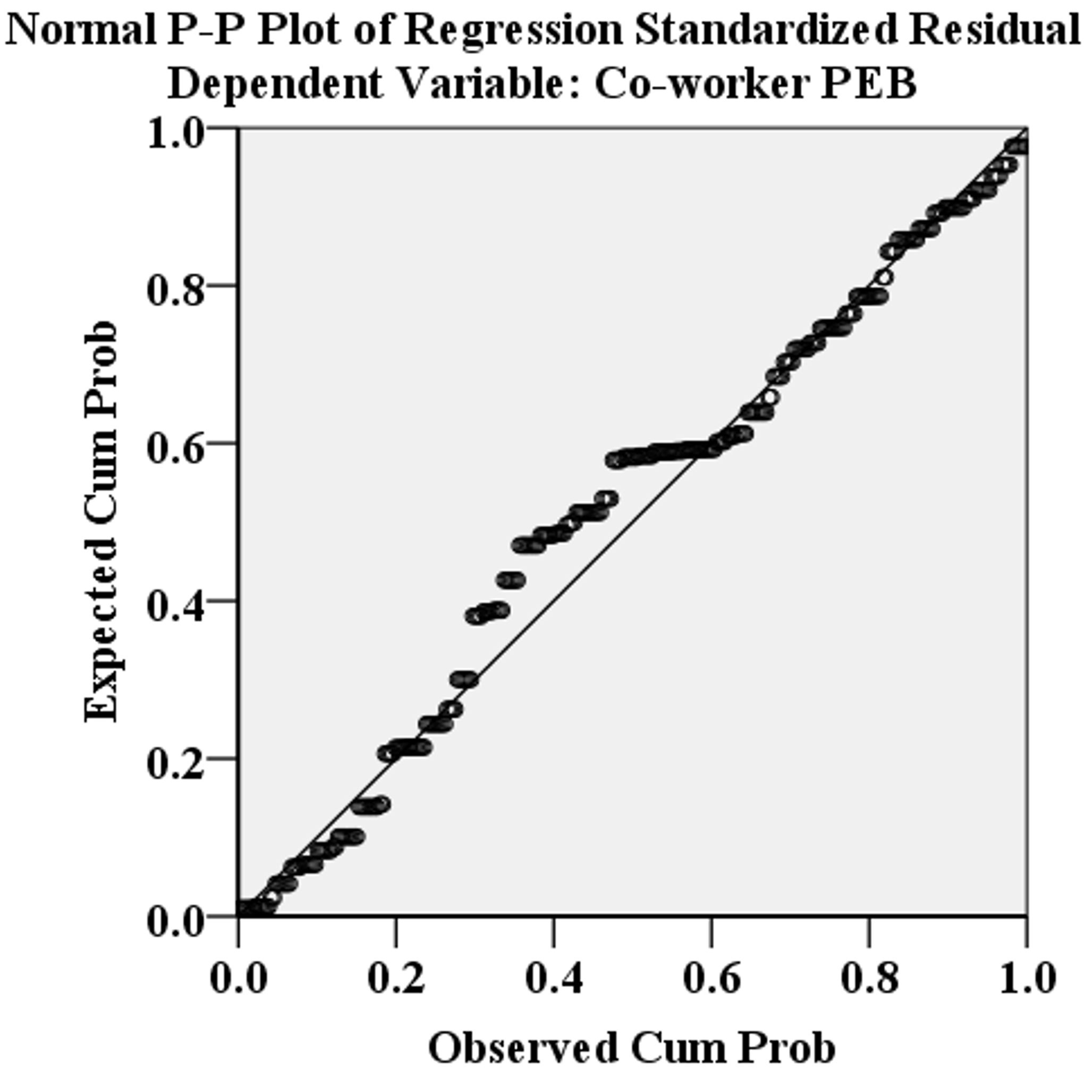 | 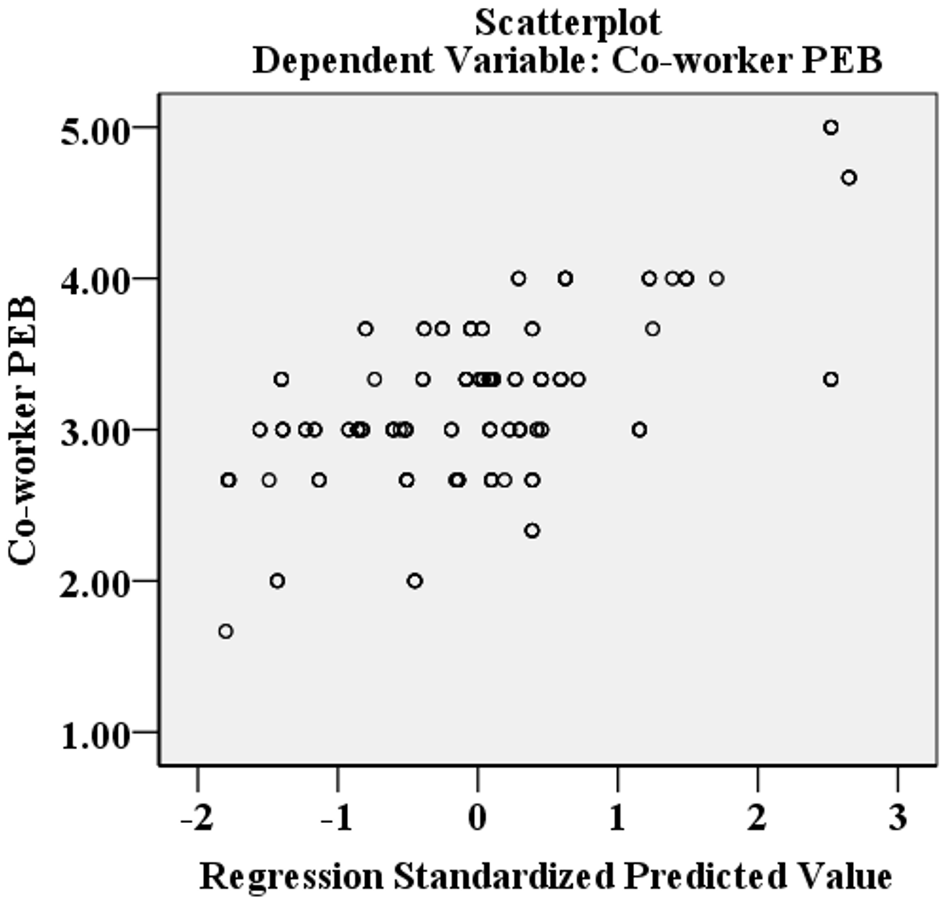
Figure 2. Normal P-P plot regression standardized residual of Co-worker PEB | Figure 3. Scatter plot of Co-worker PEB

In Model II, Self-enacted PEB (B2) is positively predicted by Environmental Awareness (P1), Psychological Stress (S1), Training (O3) and Sense of Responsibility (P2), while negatively associated with Physical Stress (S2) and Tedious Construction Process (O2), explaining 32.6% of the variance. The multiple linear regression equation for Model II is expressed as Eq. (2):
$B2=1.293-0.148*O2+0.109*O3+0.333*S1-0.347*S2+0.417*P1+0.132*P2$ Eq. (2)

Table 11. Regression analysis of Self-enacted PEB and its antecedents
Model II | B | Std. Error | t | Sig. | VIF | R | R² | Sig (ANOVA)
(Constant) | 1.293 | 0.470 | 2.752 | 0.006 |  | 0.571 | 0.326 | 0.000
S2 - Physical Stress | -0.347 | 0.059 | -5.880 | 0.000 | 1.653
P1-Environmental Awareness | 0.417 | 0.073 | 5.711 | 0.000 | 1.443
S1 -Psychological Stress | 0.333 | 0.057 | 5.828 | 0.000 | 1.461
O3 - Training | 0.109 | 0.047 | 2.322 | 0.021 | 1.173
O2-Tedious Construction  Process | -0.148 | 0.057 | -2.610 | 0.010 | 1.390
P2-Sense of Responsibility | 0.132 | 0.058 | 2.266 | 0.024 | 1.387

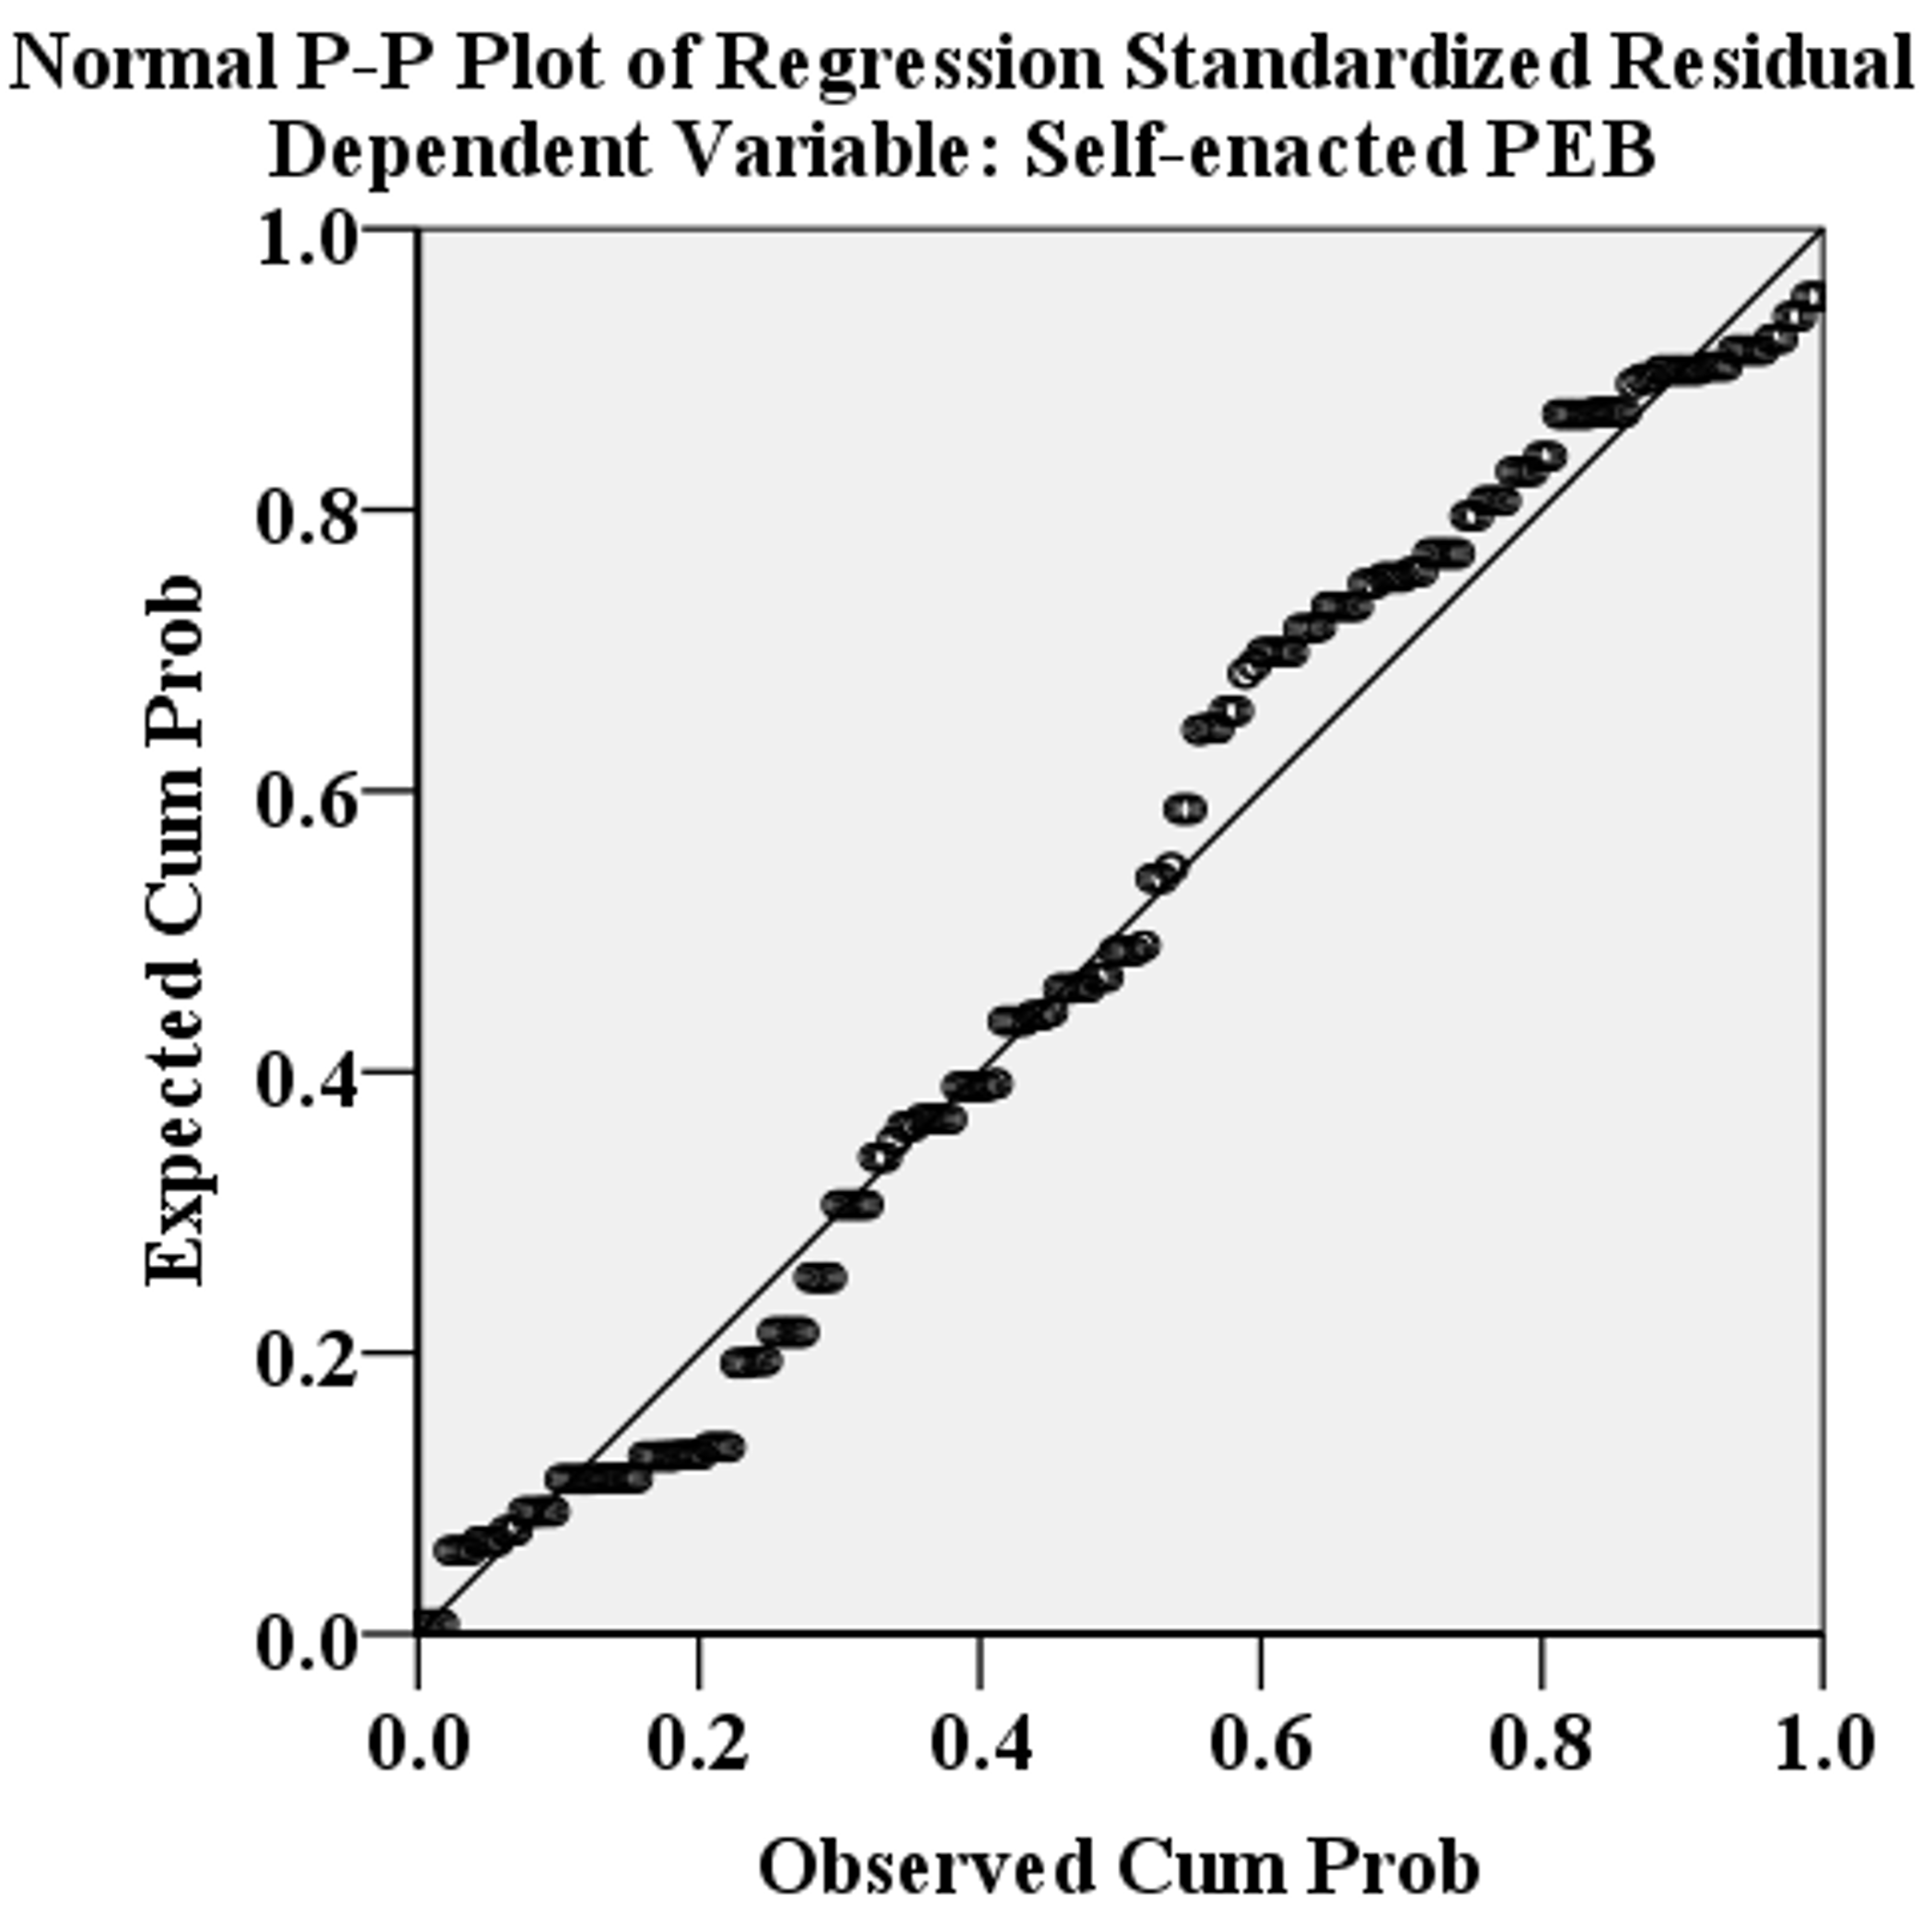 | 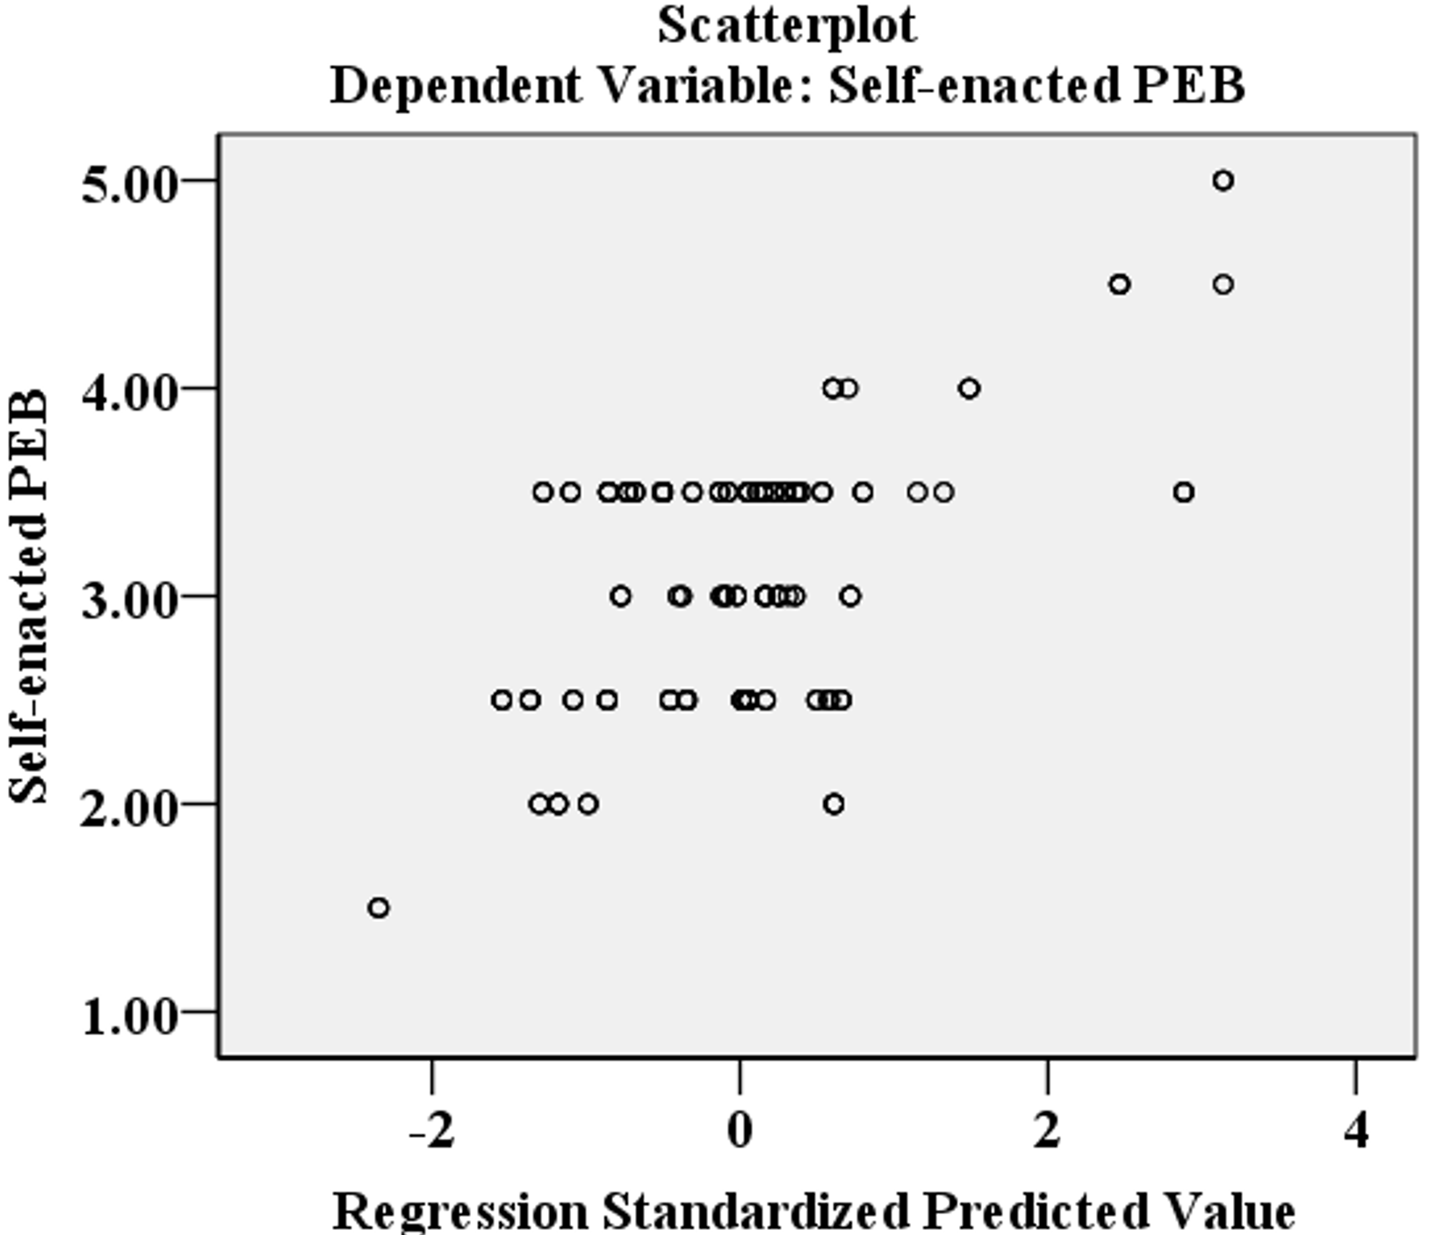
Figure 4. Normal P-P plot regression standardized residual of Self-enacted PEB | Figure 5. Scatter plot of Self-enacted PEB

The results of correlation and regression analysis relating to PEB are summarised in Table 12. The result shows the impact of organisational and personal factors on PEB for workers. Two personal factors and one organisational factor, namely, physical stress (S2), Environmental Awareness (P1), and Tedious Construction Process (O2), were revealed in correlation and regression analysis to be associated with two PEB factors. A significant relationship between Site Management (O1) and Co-worker PEB (B1) was also shown in correlation and regression analysis. Similarly, Sense of Responsibility (P2) was significantly associated with Self-enacted PEB (B2) revealed in both correlation and regression analysis. In addition, although Psychological Stress (S1) and Training (O3) were not correlated with the two types of PEB, they were all significantly associated with both PEB types in regression analysis.
Table 12. Summary of the results of correlation and regression analysis relating to PEB
Factors | Co-worker PEB (B1) |  |  | Self-enacted PEB (B2)
 | Correlation | Regression |  | Correlation | Regression
S1 - Psychological Stress | × | √ |  | × | √
S2 - Physical Stress | √ | √ |  | √ | √
P1 - Environmental Awareness | √ | √ |  | √ | √
P2 - Sense of Responsibility | √ | × |  | √ | √
O1 - Site Management | √ | √ |  | √ | ×
O2 - Tedious Construction Process | √ | √ |  | √ | √
O3 - Training | × | √ |  | × | √
Note: √-significant relationship was found; ×- no significant relationship was found.

- Discussion
The results of this study show that the proportion of male construction workers is 96.1%. The main reason for this result is that construction work requires a lot of physical energy, while also enduring a poor working environment and long working hours, none of which are conducive to women's physiological characteristics. Previous studies relating to construction workers, which were conducted in Ethiopia (Lette et al., 2018) and Hong Kong (Wong et al., 2020), have also drawn the same conclusions as this study. Moreover, according to a report from the People's Data Research Institute (PDRI, 2022), workers in the construction industry in China are predominantly male, accounting for 89%.
Previous research has shown that behavioural dimension is one of the main obstacles to the adoption of circular economy in construction waste management (Mahpour, 2018). In this study, the two types of PEB cover the main strategies of circular economy, namely waste reduction, reuse, recycling, as well as construction waste sorting. Encouraging PEBs on workplace with in construction project helps to implement the concept of circular economy and effectively reduce the generation and discharge of construction waste during construction. It is suggested that encouraging behaviour change can help realize the circular economy (Patwa et al., 2021), and encouraging the adoption of PEBs on construction site can help achieve this goal.
This study has found that there is a significant impact of physical stress on PEB. Due to the heavy workload and tight schedule of construction projects, workers usually must focus all their energy on the work at hand, and therefore often feel exhausted and suffer physical stress (Liang et al., 2018). Since physical stress is caused by high energy expenditure, workers are less likely to fully concentrate on PEB activities (Umer et al., 2022). Moreover, PEB activities are not compulsory on construction sites, and the criterion for performance is based entirely on the degree to which they fulfil the work allocated to them. Construction workers must prioritise completing their specific construction task, be it tying steel rods or pouring concrete. This is consistent with former findings regarding stress and PEB (Clercq and Belausteguigoitia, 2020). After all, completing the construction project according to the contract is the most crucial issue for the construction team.
Construction workers’ environmental awareness score is the highest, indicating that in their opinion, construction waste tends to increase the environmental burden and should be avoided. Evidence shows that people with high environmental awareness easily behave in an environmentally friendly manner (Sekhokoane et al., 2017). This suggests that workers will actively take self-enacted PEB to reduce the negative impact of their own work on the environment and society. This is consistent with previous studies regarding the significant impact of environmental awareness on individual behaviour, including green consumption behaviour and environmental behaviour (Rustam et al., 2020). Also, environmental awareness can trigger voluntary actions and promote pro-environmental behaviour among friends and colleagues (Syed-Abdullah, 2020). Construction workers with better environmental awareness will tend to conduct co-worker PEB, such as encouraging their co-workers to save construction materials and recycle construction waste.
A construction project consists of many complicated, tedious, and strenuous construction processes, which workers need to put a lot of effort into conducting. Their performance on site has a significant impact on what is characteristically a tight schedule under tough conditions (Al Nahyan et al., 2019). Construction workers are generally too busy to spare time on PEB, which does not contribute to schedule and quality requirements. Since any construction schedule delays will lead to penalties according to the contract (Ahmadisheykhsarmast and Sonmez, 2020), workers are unlikely to focus on self-enacted PEB and co-worker PEB, not because they are not willing to do so but because they have no time.
Interestingly, between the two types of PEB, only co-worker PEB was found to have a significant relationship with site management. Considering these observations, it is reasonable to speculate that co-worker PEB will be more obvious in terms of attitude and action in connection with construction waste environmental issues, such as reduction and recycling. Perhaps, under strict site management, performing co-worker PEB is a more effective way to show they are capable and have the right attitude toward the construction tasks they are assigned to.
Normally, workers need to focus on their work, and are not obliged to engage in environmental activities (Yuriev et al., 2018). However, since the large amount of construction waste generated by construction activities can place a heavy burden on society and the environment, the actual behaviours of construction workers on construction site is particularly important. The sense of responsibility of construction workers is considered as one of the important factors contributing to the construction waste management (Vilventhan et al., 2019). When workers lack a sense of responsibility for environmental protection, they will have little incentive to implement environmental behaviour because they believe that any attempt to affect environmental results is futile (Kalamas et al., 2014). In fact, workers' sense of responsibility for the environmental protection inspires their ethical obligations and personal enthusiasm for the environment and motivates them to actively participate in PEB which is self-enacted PEB (Afsar et al., 2020), while doing so also brings them pride (Venhoeven et al., 2016), and positive self-affirmation (Thiermann and Sheate, 2020). In this case, the greater the sense of responsibility of construction workers, the more they will take the initiative to take self-enacted PEB on the construction site to avoid damaging environment.
Although significant correlations between psychological stress and two types of PEB were not found in this study, it is surprising that a significant association between them was revealed in regression analysis. The correlation analysis in this study is to analyse the correlated relationship between two variables, without considering the influence of other variables (Fan et al., 2020). While regression analysis is to test the effect of a group of independent variables on the dependent variable (Stockemer, 2019). The relationship between dependent variable and independent variable is impacted by other variables which could be mediators or moderators (Darlington and Hayes, 2016). In this study, the associations between psychological stress and two types of PEB may be impacted by other independent variables. The workers suffering psychological stress can hardly get involved in their jobs (Lin et al., 2020). However, they will be financially punished due to the strict site management when they do nothing in the workplace. Therefore, they usually make an effort to look busy by taking ‘slack off’ strategies (Rhee and Kim, 2016). Perhaps, compared with the heavy-duty construction work, it would be relatively cushy for these psychologically stressed construction workers to engage in PEB like construction waste sorting or encouraging co-workers to reduce and recycle construction waste.

Different from previous behavioural research on construction waste, this study adopts two types of PEB relating to CWM. This approach enriches the research on construction waste management by providing a more comprehensive understanding of the PEB and associated determinants relating to CWM. This study also reveals the negative impact of physical stress on PEB, which is a strong indication that the industry and academia need to pay more attention to the stress experienced by construction workers. The results show that the determinants of the two types of PEB are not the same, which can help the industry to formulate more targeted measures to encourage positive PEB towards CWM.

- Conclusions and Implications
This study investigated the impact of key organisational and personal determinants of workers' PEB through a questionnaire survey. Based on the analysed results, conclusions can be drawn that: (i) physical stress, environmental awareness, and tedious construction processes are the three determinants significantly associated with co-worker and self-enacted PEB; (ii) site management positively predicts co-worker PEB; and (iii) among all the determinants, environmental awareness received the highest score, while psychological stress received the lowest score.
The study also provides sustainable construction and circular economy implications for construction contractors and the government. To realize the circular economy and sustainable development, construction contractors need to take a series of measures to ensure that construction waste reduction, reuse, and recycling. Encouraging PEBs on construction site will help to achieve this goal. An effective way is to improve organizational and personal factors which have important impact on PEBs. Since the study shows that workers' physical stress plays a negative role in their PEB performance, it is suggested that they be given regular rest periods throughout their workday so that they are not so physically stressed and have more energy with which to fulfil their tasks. The findings indicate that PEB could be encouraged by promoting environmental awareness among workers and improving tedious construction processes. The descriptive statistical analysis results showed that the mean score of 3.83 for environmental awareness in this study was higher than the mean score of 3.2 for co-worker PEB and 3.09 for self-enacted PEB. This may reflect the dilemma between construction project goals (schedule, cost, quality) and pro-environmental practices. In the interest of reducing carbon emissions, the performance of pro-environmental procedures on construction sites will be greatly improved if pro-environmental actions are mandated by the government for all construction projects. This will encourage construction contractors to take measures to encourage PEB among their workers, which could be done by introducing a bonus for pro-environmental activities. It is also suggested that advanced construction techniques and machines should be used for tedious construction processes wherever possible to optimise workers' tasks, which will reduce their physical stress and allow them to devote more energy to PEB activities.
Given the remarkable effect of system dynamics on CWM, further related research could adopt a systematic dynamics approach to assessing the output of construction waste and the impact on the economic and social benefits of construction contractors in several scenarios, including PEB and common behaviour. It is also suggested to simulate the effectiveness of different management measures and workers' responses through an agent-based model. Salary was not considered in this study, which may have an impact on construction workers' PEB relating to CWM. It is suggested that future studies examine the relationship between different levels of income and the two types of PEB examined in this study.

Acknowledgments
The authors gratefully acknowledge the support of the PGRS project (PGRS1906021) from Xi'an Jiaotong-Liverpool University, and the Key Special Fund Exploring Program (KSF-E-29) from Xi'an Jiaotong-Liverpool University and Suzhou Industrial Park, China.

Authors' contributions
Jian Li Hao conceptualisation, supervision, review, and editing, funding acquisition; Shiwang Yu conceptualisation, data collection, results analysis, and original draft; Xiaonan Tang supervision and review; Weiwei Wu data collection and original draft. All the authors contributed to the paper and approved the final version.

Declarations
The authors declare that they have no known competing financial interests or personal relationships that could have appeared to influence the work reported in this paper.

Availability of data and materials
The data and materials used during the current study are available from the corresponding author upon reasonable request.

References
Abu-Bader, S.H., 2021. Using statistical methods in social science research: With a complete SPSS guide. Oxford University Press, USA.
Afsar, B., Badir, Y., Kiani, U.S., 2016. Linking spiritual leadership and employee pro-environmental behavior: The influence of workplace spirituality, intrinsic motivation, and environmental passion. Journal of Environmental Psychology 45, 79–88. https://doi.org/10.1016/j.jenvp.2015.11.011
Ahmadisheykhsarmast, S., Sonmez, R., 2020. A smart contract system for security of payment of construction contracts. Automation in Construction 120, 103401. https://doi.org/10.1016/j.autcon.2020.103401
Afsar, B., Maqsoom, A., Shahjehan, A., Afridi, S.A., Nawaz, A., Fazliani, H., 2020. Responsible leadership and employee’s proenvironmental behavior: The role of organizational commitment, green shared vision, and internal environmental locus of control. Corporate Social Responsibility and Environmental Management 27, 297–312. https://doi.org/10.1002/csr.1806
Ajayi, S.O., Oyedele, L.O., Bilal, M., Akinade, O.O., Alaka, H.A., Owolabi, H.A., 2017. Critical management practices influencing on-site waste minimization in construction projects. Waste Management 59, 330–339. https://doi.org/10.1016/j.wasman.2016.10.040
Al Nahyan, M.T., Sohal, A., Hawas, Y., Fildes, B., 2019. Communication, coordination, decision-making and knowledge-sharing: a case study in construction management. Journal of Knowledge Management 23, 1764–1781. https://doi.org/10.1108/JKM-08-2018-0503
Allwood, J.M., 2014. Chapter 30 - Squaring the Circular Economy: The Role of Recycling within a Hierarchy of Material Management Strategies, in: Worrell, E., Reuter, M.A. (Eds.), Handbook of Recycling. Elsevier, Boston, pp. 445–477. https://doi.org/10.1016/B978-0-12-396459-5.00030-1
Ansari, N.Y., Farrukh, M., Raza, A., 2021. Green human resource management and employees pro-environmental behaviours: Examining the underlying mechanism. Corporate Social Responsibility and Environmental Management 28, 229–238. https://doi.org/10.1002/csr.2044
Anwer, S., Li, H., Antwi-Afari, M.F., Wong, A.Y.L., 2021. Associations between physical or psychosocial risk factors and work-related musculoskeletal disorders in construction workers based on literature in the last 20 years: A systematic review. International Journal of Industrial Ergonomics 83, 103113. https://doi.org/10.1016/j.ergon.2021.103113
Aslam, M.S., Huang, B., Cui, L., 2020. Review of construction and demolition waste management in China and USA. Journal of Environmental Management 264, 110445. https://doi.org/10.1016/j.jenvman.2020.110445
Bakshan, A., Srour, I., Chehab, G., El-Fadel, M., Karaziwan, J., 2017. Behavioral determinants towards enhancing construction waste management: A Bayesian Network analysis. Resources, Conservation and Recycling 117, 274–284. https://doi.org/10.1016/j.resconrec.2016.10.006
Bao, Z., Lu, W., Chi, B., Hao, J.L., 2020. Construction waste management performance in green building: contextualising LEED in China. Detritus 125–134. https://doi.org/10.31025/2611-4135/2020.13992
Bhattacharyya, A., Biswas, K., Moyeen, A., 2020. Determinants of Pro-environmental Behaviours–A Cross Country Study of Would-be Managers. Australasian Accounting, Business and Finance Journal 14, 51–71. https://doi.org/10.14453/aabfj.v14i2.5
Boiral, O., Paillé, P., 2012. Organizational Citizenship Behaviour for the Environment: Measurement and Validation. J Bus Ethics 109, 431–445. https://doi.org/10.1007/s10551-011-1138-9
Bølviken, T., Koskela, L., 2016. Why Hasn’t Waste Reduction Conquered Construction? Presented at the 24th Annual Conference of the International Group for Lean Construction, Boston, USA, pp. 3–12.
Chan, Y.S., Leung, M., Yuan, T., 2014. Structural relationships between cultural values and coping behaviors of professionals in the stressful construction industry. Engineering, Construction and Architectural Management 21, 133–151. https://doi.org/10.1108/ECAM-07-2012-0069
Chang, R., Zuo, J., Soebarto, V., Zhao, Z., Zillante, G., Gan, X., 2016. Sustainability Transition of the Chinese Construction Industry: Practices and Behaviors of the Leading Construction Firms. Journal of Management in Engineering 32, 05016009. https://doi.org/10.1061/(ASCE)ME.1943-5479.0000439
Coelho, F., Pereira, M.C., Cruz, L., Simões, P., Barata, E., 2017. Affect and the adoption of pro-environmental behaviour: A structural model. Journal of Environmental Psychology 54, 127–138. https://doi.org/10.1016/j.jenvp.2017.10.008
Cohen, P., Cohen, P., West, S.G., Aiken, L.S., 2014. Applied Multiple Regression/Correlation Analysis for the Behavioral Sciences, 2nd ed. Psychology Press, New York. https://doi.org/10.4324/9781410606266
Comrey, A.L., Lee, H.B., 2013. A First Course in Factor Analysis, 2nd ed. Psychology Press, New York. https://doi.org/10.4324/9781315827506
Corvellec, H., 2019. Waste as scats: For an organizational engagement with waste. Organization 26, 217–235. https://doi.org/10.1177/1350508418808235
Darlington, R.B., Hayes, A.F., 2016. Regression analysis and linear models: Concepts, applications, and implementation. Guilford Publications, New York, USA.

Davis, P., Aziz, F., Newaz, M.T., Sher, W., Simon, L., 2021. The classification of construction waste material using a deep convolutional neural network. Automation in Construction 122, 103481. https://doi.org/10.1016/j.autcon.2020.103481
De Clercq, D., Belausteguigoitia, I., 2020. When does job stress limit organizational citizenship behavior, or not? Personal and contextual resources as buffers. Journal of Management & Organization 1–25. https://doi.org/10.1017/jmo.2020.7
De Magalhães, R.F., Danilevicz, Â.M.F., Saurin, T.A., 2017. Reducing construction waste: A study of urban infrastructure projects. Waste Management 67, 265–277. https://doi.org/10.1016/j.wasman.2017.05.025
Denis, D.J., 2021. Applied Univariate, Bivariate, and Multivariate Statistics: Understanding Statistics for Social and Natural Scientists, With Applications in SPSS and R. John Wiley & Sons, Hoboken, N.J, USA.
Esa, M.R., Halog, A., Rigamonti, L., 2017. Strategies for minimizing construction and demolition wastes in Malaysia. Resources, Conservation and Recycling 120, 219–229. https://doi.org/10.1016/j.resconrec.2016.12.014

Fan, J., Li, R., Zhang, C.H., Zou, H., 2020. Statistical foundations of data science. Chapman and Hall/CRC, Boca Raton. https://doi.org/10.1201/9780429096280
Fan, Y.V., Jiang, P., Hemzal, M., Klemeš, J.J., 2021. An update of COVID-19 influence on waste management. Science of The Total Environment 754, 142014. https://doi.org/10.1016/j.scitotenv.2020.142014
Fayers, P.M., Machin, D., 2015. Quality of Life: The Assessment, Analysis and Reporting of Patient-reported Outcomes. John Wiley & Sons, Oxford, UK.
Fu, L., Sun, Z., Zha, L., Liu, F., He, L., Sun, X., Jing, X., 2020. Environmental awareness and pro-environmental behavior within China’s road freight transportation industry: Moderating role of perceived policy effectiveness. Journal of Cleaner Production 252, 119796. https://doi.org/10.1016/j.jclepro.2019.119796
Gkargkavouzi, A., Halkos, G., Matsiori, S., 2019. Environmental behavior in a private-sphere context: Integrating theories of planned behavior and value belief norm, self-identity and habit. Resources, Conservation and Recycling 148, 145–156. https://doi.org/10.1016/j.resconrec.2019.01.039
Guo, N.
Hair, J.F., Black, W.C., Babin, B., Anderson, R.E., Tatham, R., 2018. Multivariate data analysis: Cengage, Chicago, USA.
Hao, J.L., Chen, Z., Zhang, Z., Loehlein, G., 2021. Quantifying construction waste reduction through the application of prefabrication: a case study in Anhui, China. Environmental Science and Pollution Research 28, 24499–24510. https://doi.org/10.1007/s11356-020-09026-2
Hao, J.L., Cheng, B., Lu, W., Xu, J., Wang, J., Bu, W., Guo, Z., 2020a. Carbon emission reduction in prefabrication construction during materialization stage: A BIM-based life-cycle assessment approach. Science of the Total Environment 723, 137870. https://doi.org/10.1016/j.scitotenv.2020.137870
Hao, J.L., Maria, F.D., Chen, Z., Yu, S., Ma, W., Sarno, L.D., 2020b. Comparative Study of Construction and Demolition Waste Management in China and the European Union. Detritus 114. https://doi.org/10.31025/2611-4135/2020.14029
Hao, J.L., Yuan, H., Liu, J., Chin, C.S., Lu, W., 2019. A model for assessing the economic performance of construction waste reduction. Journal of Cleaner Production 232, 427–440. https://doi.org/10.1016/j.jclepro.2019.05.348
He, Q., Wang, Z., Wang, G., Zuo, J., Wu, G., Liu, B., 2020. To be green or not to be: How environmental regulations shape contractor greenwashing behaviors in construction projects. Sustainable Cities and Society 63, 102462. https://doi.org/10.1016/j.scs.2020.102462
Hinton, P.R., McMurray, I., Brownlow, C., 2014. SPSS explained, 2nd ed. Taylor & Francis (Routledge), London, UK.
Hong, J., Zhong, X., Guo, S., Liu, G., Shen, G.Q., Yu, T., 2019. Water-energy nexus and its efficiency in China’s construction industry: Evidence from province-level data. Sustainable Cities and Society 48, 101557. https://doi.org/10.1016/j.scs.2019.101557
Hwang, B.G., Yang, S., 2014. Rework and schedule performance: A profile of incidence, impact, causes and solutions. Engineering, Construction and Architectural Management 21, 190–205. https://doi.org/10.1108/ECAM-10-2012-0101
Jebelli, H., Choi, B., Lee, S., 2019. Application of Wearable Biosensors to Construction Sites. I: Assessing Workers’ Stress. Journal of Construction Engineering and Management 145, 04019079. https://doi.org/10.1061/(ASCE)CO.1943-7862.0001729
Jiang, P., Fan, Y.V., Zhou, J., Zheng, M., Liu, X., Klemeš, J.J., 2020. Data-driven analytical framework for waste-dumping behaviour analysis to facilitate policy regulations. Waste Management 103, 285–295. https://doi.org/10.1016/j.wasman.2019.12.041
Kalamas, M., Cleveland, M., Laroche, M., 2014. Pro-environmental behaviors for thee but not for me: Green giants, green Gods, and external environmental locus of control. Journal of Business Research 67, 12–22. https://doi.org/10.1016/j.jbusres.2013.03.007
Keith, T.Z., 2014. Multiple Regression and Beyond: An Introduction to Multiple Regression and Structural Equation Modeling. Routledge, New York, NY, USA.
Kline, P., 2014. An Easy Guide to Factor Analysis. Routledge, London, UK.
Knight, N.L., Wang, J., Rizos, C., 2010. Generalised measures of reliability for multiple outliers. Journal of geodesy 84, 625–635.
Lazarus, R.S., 2020. Psychological stress in the workplace, in: Occupational Stress. CRC Press, pp. 3–14, Boca Raton USA.
Lette, A., Ambelu, A., Getahun, T., Mekonen, S., 2018. A survey of work-related injuries among building construction workers in southwestern Ethiopia. International Journal of Industrial Ergonomics 68, 57–64. https://doi.org/10.1016/j.ergon.2018.06.010
Leung, M., Chan, I.Y.S., Yu, J., 2012. Preventing construction worker injury incidents through the management of personal stress and organizational stressors. Accident Analysis & Prevention 48, 156–166. https://doi.org/10.1016/j.aap.2011.03.017
Leung, M., Liang, Q., Chan, I.Y., 2017. Development of a stressors–stress–performance–outcome model for expatriate construction professionals. Journal of Construction Engineering and Management 143, 04016121.
Leung, M., Liang, Q., Yu, J., 2016. Development of a mindfulness–stress–performance model for construction workers. Construction Management and Economics 34, 110–128. https://doi.org/10.1080/01446193.2016.1147652
Li, J., Wu, Q., Wang, C.C., Du, H., Sun, J., 2022. Triggering factors of construction waste reduction behavior: Evidence from contractors in Wuhan, China. Journal of Cleaner Production 337, 130396. https://doi.org/10.1016/j.jclepro.2022.130396
Li, J., Zuo, J., Cai, H., Zillante, G., 2018. Construction waste reduction behavior of contractor employees: An extended theory of planned behavior model approach. Journal of Cleaner Production 172, 1399–1408. https://doi.org/10.1016/j.jclepro.2017.10.138
Liang, Q., Leung, M., Cooper, C., 2018. Focus Group Study to Explore Critical Factors for Managing Stress of Construction Workers. Journal of Construction Engineering and Management 144, 04018023. https://doi.org/10.1061/(ASCE)CO.1943-7862.0001477
Lim, S., Chi, S., Lee, J.D., Lee, H.-J., Choi, H., 2017. Analyzing psychological conditions of field-workers in the construction industry. International Journal of Occupational and Environmental Health 23, 261–281. https://doi.org/10.1080/10773525.2018.1474419
Lin, W., Koopmann, J., Wang, M., 2020. How Does Workplace Helping Behavior Step Up or Slack Off? Integrating Enrichment-Based and Depletion-Based Perspectives. Journal of Management 46, 385–413. https://doi.org/10.1177/0149206318795275
Liu, J., Chen, Y., Wang, X., 2022. Factors driving waste sorting in construction projects in China. Journal of Cleaner Production 336, 130397. https://doi.org/10.1016/j.jclepro.2022.130397
Liu, J., Gong, E., Wang, D., Lai, X., Zhu, J., 2019. Attitudes and behaviour towards construction waste minimisation: a comparative analysis between China and the USA. Environmental Science and Pollution Research 26, 13681–13690. https://doi.org/10.1007/s11356-018-2247-0
Liu, J., Teng, Y., Wang, D., Gong, E., 2020. System dynamic analysis of construction waste recycling industry chain in China. Environmental Science and Pollution Research 27, 37260–37277. https://doi.org/10.1007/s11356-019-06739-x

Lu, W., Peng, Y., Webster, C., Zuo, J., 2015. Stakeholders’ willingness to pay for enhanced construction waste management: A Hong Kong study. Renewable and Sustainable Energy Reviews 47, 233–240. https://doi.org/10.1016/j.rser.2015.03.008
Lu, W., Webster, C., Peng, Y., Chen, X., Zhang, X., 2017. Estimating and calibrating the amount of building-related construction and demolition waste in urban China. International Journal of Construction Management 17, 13–24. https://doi.org/10.1080/15623599.2016.1166548
Ma, W., Hao, J.L., Zhang, C., Di Sarno, L., Mannis, A., 2022a. Evaluating carbon emissions of China’s waste management strategies for building refurbishment projects: contributing to a circular economy. Environmental Science and Pollution Research. https://doi.org/10.1007/s11356-021-18188-6
Ma, W., xxx
Mahpour, A., 2018. Prioritizing barriers to adopt circular economy in construction and demolition waste management. Resources, Conservation and Recycling 134, 216–227. https://doi.org/10.1016/j.resconrec.2018.01.026
Mi, L., Gan, X., Xu, T., Long, R., Qiao, L., Zhu, H., 2019. A new perspective to promote organizational citizenship behaviour for the environment: The role of transformational leadership. Journal of Cleaner Production 239, 118002. https://doi.org/10.1016/j.jclepro.2019.118002
Montgomery, D.C., Peck, E.A., Vining, G.G., 2021. Introduction to Linear Regression Analysis. John Wiley & Sons, Hoboken, USA.
Morseletto, P., 2020. Targets for a circular economy. Resources, Conservation and Recycling 153, 104553. https://doi.org/10.1016/j.resconrec.2019.104553
Neessen, P.C.M., de Jong, J.P., Caniëls, M.C.J., Vos, B., 2021. Circular purchasing in Dutch and Belgian organizations: The role of intrapreneurship and organizational citizenship behavior towards the environment. Journal of Cleaner Production 280, 124978. https://doi.org/10.1016/j.jclepro.2020.124978
Newaz, M.T., Davis, P., Sher, W., Simon, L., 2020. Factors affecting construction waste management streams in Australia. International Journal of Construction Management 1–9. https://doi.org/10.1080/15623599.2020.1815122
Ojedokun, O., 2018. Associations of the five-factor personality traits with environmental citizenship behavior of youth in a Nigerian university community. Management of Environmental Quality: An International Journal 29, 1135–1155. https://doi.org/10.1108/MEQ-02-2018-0040
Olanrewaju, A., Tan, S.Y., Kwan, L.F., 2017. Roles of Communication on Performance of the Construction Sector. Procedia Engineering, Creative Construction Conference 2017, CCC 2017, 19-22 June 2017, Primosten, Croatia 196, 763–770. https://doi.org/10.1016/j.proeng.2017.08.005
Paillé, P., Boiral, O., 2013. Pro-environmental behavior at work: Construct validity and determinants. Journal of Environmental Psychology 36, 118–128. https://doi.org/10.1016/j.jenvp.2013.07.014
Palafox-Alcantar, P.G., Hunt, D.V.L., Rogers, C.D.F., 2020. The complementary use of game theory for the circular economy: A review of waste management decision-making methods in civil engineering. Waste Management 102, 598–612. https://doi.org/10.1016/j.wasman.2019.11.014
Pallant, J., 2020. SPSS Survival Manual: A Step by Step Guide to Data Analysis using IBM SPSS. McGraw-Hill Education, New York, NY, USA.
Park, J., Tucker, R., 2017. Overcoming barriers to the reuse of construction waste material in Australia: a review of the literature. International Journal of Construction Management 17, 228–237. https://doi.org/10.1080/15623599.2016.1192248
Patwa, N., Sivarajah, U., Seetharaman, A., Sarkar, S., Maiti, K., Hingorani, K., 2021. Towards a circular economy: An emerging economies context. Journal of Business Research 122, 725–735. https://doi.org/10.1016/j.jbusres.2020.05.015
People’s Data Research Institute, 2022. Big Data Analysis Report on the Status Quo of Labor Employment in the Construction Industry (2021). People’s Data Research Institute, Beijing.
Pierini, V.I., Mazzeo, N., Cazenave, M., Semmartin, M., 2021. Waste generation and pro-environmental behaviors at household level: A citizen science study in Buenos Aires (Argentina). Resources, Conservation and Recycling 170, 105560. https://doi.org/10.1016/j.resconrec.2021.105560
Poon, C.S., Yu, A.T.W., Wong, A., Yip, R., 2013. Quantifying the Impact of Construction Waste Charging Scheme on Construction Waste Management in Hong Kong. Journal of Construction Engineering and Management 139, 466–479. https://doi.org/10.1061/(ASCE)CO.1943-7862.0000631
Rahman, I.A., Nagapan, S., Asmi, A., 2014. Initial PLS Model of Construction Waste Factors. Procedia - Social and Behavioral Sciences, 2nd International Conference on Innovation, Management and Technology Research 129, 469–474. https://doi.org/10.1016/j.sbspro.2014.03.702
Rasheed, A., Aslam, H., Rashid, K., 2020. Antecedents of pro-environmental behavior of supply chain managers: an empirical study. Management of Environmental Quality: An International Journal 32, 420–435. https://doi.org/10.1108/MEQ-04-2020-0066
Rhee, H., Kim, S., 2016. Effects of breaks on regaining vitality at work: An empirical comparison of ‘conventional’ and ‘smart phone’ breaks. Computers in Human Behavior 57, 160–167. https://doi.org/10.1016/j.chb.2015.11.056
Robertson, J.L., Barling, J., 2017. Toward a new measure of organizational environmental citizenship behavior. Journal of Business Research 75, 57–66. https://doi.org/10.1016/j.jbusres.2017.02.007
Ruiz, L.A.L., Ramón, X.R., Domingo, S.G., 2020. The circular economy in the construction and demolition waste sector – A review and an integrative model approach. Journal of Cleaner Production 248, 119238. https://doi.org/10.1016/j.jclepro.2019.119238
Rustam, A., Wang, Y., Zameer, H., 2020. Environmental awareness, firm sustainability exposure and green consumption behaviors. Journal of Cleaner Production 268, 122016. https://doi.org/10.1016/j.jclepro.2020.122016
Salgin, B., Akgün, A., Coşgun, N., Agyekum, K., 2017. Construction Waste Reduction Through BIM-Based Site Management Approach. International Journal of Engineering Technologies IJET 3, 135–142. https://doi.org/10.19072/ijet.315180
Seber, G.A.F., Lee, A.J., 2012. Linear Regression Analysis. John Wiley & Sons, Hoboken, N.J, USA.
Sekhokoane, L., Qie, N., Rau, P.L.P., 2017. Do Consumption Values and Environmental Awareness Impact on Green Consumption in China?, in: Rau, P.L.P. (Ed.), Cross-Cultural Design, Lecture Notes in Computer Science. Springer International Publishing, Cham, pp. 713–723. https://doi.org/10.1007/978-3-319-57931-3_58
Severo, E.A., De Guimarães, J.C.F., Dellarmelin, M.L., 2021. Impact of the COVID-19 pandemic on environmental awareness, sustainable consumption and social responsibility: Evidence from generations in Brazil and Portugal. Journal of Cleaner Production 286, 124947. https://doi.org/10.1016/j.jclepro.2020.124947
Stackhouse, M., Turner, N., 2019. How do organizational practices relate to perceived system safety effectiveness? Perceptions of safety climate and co-worker commitment to safety as workplace safety signals. Journal of Safety Research 70, 59–69. https://doi.org/10.1016/j.jsr.2019.04.002
Statistics Bureau of Guangdong Province, 2022. Statistical Communiqué of National Economic and Social Development of Guangdong Province in 2021 (No. 00693981X/2022–00082). Statistics Bureau of Guangdong Province.
Stockemer, D., 2019. Multivariate regression analysis, in: Stockemer, D. (Ed.), Quantitative methods for the social sciences: A practical introduction with examples in SPSS and Stata. Springer International Publishing, Cham, pp. 163–174. https://doi.org/10.1007/978-3-319-99118-4_9
Su, Y., 2020. Multi-agent evolutionary game in the recycling utilization of construction waste. Science of The Total Environment 738, 139826. https://doi.org/10.1016/j.scitotenv.2020.139826
Syed-Abdullah, S.I.S., 2020. Extending the concept of pro-environmental action and behaviour: a binary perspective. Environmental Education Research 26, 1764–1786. https://doi.org/10.1080/13504622.2020.1850645
Tam, V.W.Y., Hao, J.L., 2019. Adaptive reuse in sustainable development. International Journal of Construction Management 19, 509–521. https://doi.org/10.1080/15623599.2018.1459154
Thiermann, U.B., Sheate, W.R., 2020. Motivating individuals for social transition: The 2-pathway model and experiential strategies for pro-environmental behaviour. Ecological Economics 174, 106668. https://doi.org/10.1016/j.ecolecon.2020.106668
Torlak, N.G., Kuzey, C., 2019. Leadership, job satisfaction and performance links in private education institutes of Pakistan. International Journal of Productivity and Performance Management 68, 276–295. https://doi.org/10.1108/IJPPM-05-2018-0182
Umer, W., Yu, Y., Antwi-Afari, M.F., 2022. Quantifying the Effect of Mental Stress on Physical Stress for Construction Tasks. Journal of Construction Engineering and Management 148, 04021204. https://doi.org/10.1061/(ASCE)CO.1943-7862.0002243
Valle, P.O.D., Rebelo, E., Reis, E., Menezes, J., 2005. Combining Behavioral Theories to Predict Recycling Involvement. Environment and Behavior 37, 364–396. https://doi.org/10.1177/0013916504272563
Venhoeven, L.A., Bolderdijk, J.W., Steg, L., 2016. Why acting environmentally-friendly feels good: exploring the role of self-image. Frontiers in Psychology 7, 1-8. https://doi.org/10.3389/fpsyg.2016.01846
Vilventhan, A., Ram, V., Sugumaran, S., 2019. Value stream mapping for identification and assessment of material waste in construction: A case study. Waste Management & Research 37, 815–825. https://doi.org/10.1177/0734242X19855429
Wang, J., Wu, H., Tam, V.W.Y., Zuo, J., 2019. Considering life-cycle environmental impacts and society’s willingness for optimizing construction and demolition waste management fee: An empirical study of China. Journal of Cleaner Production 206, 1004–1014. https://doi.org/10.1016/j.jclepro.2018.09.170
Wang, Y., Hu, N., Zuo, J., Rameezdeen, R., 2020. Project Management Personnel Turnover in Public Sector Construction Organizations in China. Journal of Management in Engineering 36, 05019009. https://doi.org/10.1061/(ASCE)ME.1943-5479.0000735
Wong, T.K.M., Man, S.S., Chan, A.H.S., 2020. Critical factors for the use or non-use of personal protective equipment amongst construction workers. Safety Science 126, 104663. https://doi.org/10.1016/j.ssci.2020.104663
Wu, Z., Ann, T.W., Shen, L., 2017. Investigating the determinants of contractor’s construction and demolition waste management behavior in Mainland China. Waste management 60, 290–300. https://doi.org/10.1016/j.wasman.2016.09.001
Wu, Z., Yu, A.T.W., Wang, H., Wei, Y., Huo, X., 2019. Driving Factors For Construction Waste Minimization: Empirical Studies in Hong Kong and Shenzhen. Journal of Green Building 14, 155–167. https://doi.org/10.3992/1943-4618.14.4.155
Xie, L., Luo, Z., Zhao, X., 2022. Critical factors of construction workers’ career promotion: evidence from Guangzhou city. Engineering, Construction and Architectural Management ahead-of-print. https://doi.org/10.1108/ECAM-08-2021-0691
Xing, W., Hao, J.L., Qian, L., Tam, V.W., Sikora, K.S., 2021. Implementing lean construction techniques and management methods in Chinese projects: A case study in Suzhou, China. Journal of Cleaner Production 286, 124944.
Yang, B., Song, X., Yuan, H., Zuo, J., 2020. A model for investigating construction workers’ waste reduction behaviors. Journal of Cleaner Production 265, 121841. https://doi.org/10.1016/j.jclepro.2020.121841
Yap, J.B.H., Goay, P.L., Woon, Y.B., Skitmore, M., 2021. Revisiting critical delay factors for construction: Analysing projects in Malaysia. Alexandria Engineering Journal 60, 1717–1729. https://doi.org/10.1016/j.aej.2020.11.021
Yoon, A., Jeong, D., Chon, J., 2021. The impact of the risk perception of ocean microplastics on tourists’ pro-environmental behavior intention. Science of The Total Environment 774, 144782. https://doi.org/10.1016/j.scitotenv.2020.144782
Yu, S., Awasthi, A.K., Ma, W., Wen, M., Di Sarno, L., Wen, C., Hao, J.L., 2022. In support of circular economy to evaluate the effects of policies of construction and demolition waste management in three key cities in Yangtze River Delta. Sustainable Chemistry and Pharmacy 26, 100625. https://doi.org/10.1016/j.scp.2022.100625
Yuan, H., Wang, Z., Shi, Y., Hao, J.L., 2022. A dissipative structure theory-based investigation of a construction and demolition waste minimization system in China. Journal of Environmental Planning and Management 65, 514–535. https://doi.org/10.1080/09640568.2021.1889484
Yuriev, A., Boiral, O., Francoeur, V., Paillé, P., 2018. Overcoming the barriers to pro-environmental behaviors in the workplace: A systematic review. Journal of Cleaner Production 182, 379–394. https://doi.org/10.1016/j.jclepro.2018.02.041

Zhao, X., Ma, X., Chen, B., Shang, Y., Song, M., 2022. Challenges toward carbon neutrality in China: Strategies and countermeasures. Resources, Conservation and Recycling 176, 105959. https://doi.org/10.1016/j.resconrec.2021.105959
Zhao, Y., Yi, W., Chan, A.P.C., Wong, D.P., 2018. Impacts of cooling intervention on the heat strain attenuation of construction workers. International Journal of Biometeorology 62, 1625–1634. https://doi.org/10.1007/s00484-018-1562-y

