Factors affecting ventriculoperitoneal shunt revision: a post hoc analysis of the British Antibiotic and Silver Impregnated Catheter Shunt multicenter randomized controlled trial
*Geraint J. Sunderland, MBChB, MRCS,^{1–3} Elizabeth J. Conroy, PhD,⁴ Alexandra Nelson, MBChB, MRes,^{1,5} Carrol Gamble, PhD,⁴ Michael D. Jenkinson, FRCSEd (NeuroSurg), PhD,^{2,6} Michael J. Griffiths, BM, BS, MRCP (Paeds), DPhil,^{3,7} and Conor L. Mallucci, MB, BS, FRCS¹
¹Department of Paediatric Neurosurgery, Alder Hey Children’s NHS Foundation Trust, Liverpool; ²Department of Neurosurgery, The Walton Centre NHS Foundation Trust, Liverpool; ³Institute of Infection, Veterinary and Ecological Sciences, University of Liverpool; ⁴Liverpool Clinical Trials Centre, University of Liverpool; ⁵University Hospitals Bristol and Weston NHS Trust, Bristol; ⁶Institute of Systems, Molecular and Integrative Biology, University of Liverpool; and ⁷Department of Paediatric Neurology, Alder Hey Children’s NHS Foundation Trust, Liverpool, United Kingdom
Objective The British Antibiotic and Silver Impregnated Catheter Shunt (BASICS) trial established level I evidence of the superiority of antibiotic-impregnated catheters in the prevention of infection of newly implanted ventriculoperitoneal shunts (VPS). A wealth of patient, shunt, and surgery-specific data were collected from trial participants beyond that of the prespecified trial objectives.
Methods This post hoc analysis of the BASICS shunt survival data explores the impact of patient age, hydrocephalus etiology, catheter type, valve type, and previous external ventricular drain on the risk of infection or mechanical failure. Time to failure was analyzed using Fine and Gray survival regression models for competing risk.
Results Among 1594 participants, 75 underwent revision for infection and 323 for mechanical failure. Multivariable analysis demonstrated an increased risk of shunt infection associated with patient ages < 1 month (subdistribution HR [sHR] 4.48, 95% CI 2.06–9.72; p < 0.001) and 1 month to < 1 year (sHR 2.67, 95% CI 1.27–5.59; p = 0.009), as well as for adults with posthemorrhagic hydrocephalus (sHR 2.75, 95% CI 1.21–6.26; p = 0.016). Age ≥ 65 years was found to be independently associated with reduced infection risk (sHR 0.26, 95% CI 0.10–0.69; p = 0.007). Antibiotic-impregnated catheter use was also associated with reduced infection risk (sHR 0.43, 95% CI 0.22–0.84; p = 0.014). Independent risk factors predisposing to mechanical failure were age < 1 month (sHR 1.51, 95% CI 1.03–2.21; p = 0.032) and 1 month to < 1 year (sHR 1.31, 95% CI 0.95–1.81; p = 0.046). Age ≥ 65 years was demonstrated to be the only independent protective factor against mechanical failure risk (sHR 0.64, 95% CI 0.40–0.94; p = 0.024).
Conclusions Age is the predominant risk for VPS revision for infection or/and mechanical failure, with neonates and infants being the most vulnerable.
Clinical trial registration no.: ISRCTN 49474281 (https://www.journalslibrary.nihr.ac.uk/programmes/hta/1010430/#/)
Abbreviations BASICS = British Antibiotic and Silver Impregnated Catheter Shunt Randomised Controlled Trial; csHR = cause-specific HR; EVD = external ventricular drain; IIH = idiopathic intracranial hypertension; iNPH = idiopathic normal pressure hydrocephalus; PHH = posthemorrhagic hydrocephalus; sHR = subdistribution HR; VPS = ventriculoperitoneal shunt.
Keywords BASICS trial; infection; mechanical failure; ventriculoperitoneal shunt; VPS; hydrocephalus
SUBMITTED March 15, 2022. ACCEPTED April 20, 2022.
* M.D.J., M.J.G., and C.L.M. share senior authorship of this work.
Ventriculoperitoneal shunt (VPS) insertion is one of the most common neurosurgical procedures performed worldwide in both adults and children, with 3500 insertions performed per year in the United Kingdom and 33,000 per year in the United States.^{1,2} VPS insertion can lead to infection or mechanical failure, resulting in all-cause revision rates of 19%–25% by 6 months, 22%–40% by 1 year, and 80% by 10 years.^{3,4}
The British Antibiotic and Silver Impregnated Catheter Shunt (BASICS) randomized controlled trial (ISRCTN 49474281, https://www.journalslibrary.nihr.ac.uk/programmes/hta/1010430/#/), funded by the National Institute for Health Research Health Technology Assessment, demonstrated a reduced infection rate of 2.2% in patients receiving antibiotic-impregnated VPS tubing (clindamycin + rifampicin: Bactiseal, Integra LifeSciences; and Ares, Medtronic) compared with 6.0% in standard silicone catheters and 5.9% in silver-impregnated catheters.⁴ Also noted at the time of publication was that VPS infection rates were higher in young children compared with adults and, despite the reduced infection rate associated with antibiotic catheters, that all-cause revision rates were equivocal for all catheter types.
In clinical practice, it has been observed that VPS infection and mechanical failure rates vary between patients. There is, however, a lack of high-quality evidence to support these anecdotal observations, with inconsistent reporting of factors that influence VPS longevity.^{5–11} Their identification is based on several smaller trials and some larger-scale case series. There has been a small number of systematic reviews reporting on failure rates in specific etiologies, although no systematic review exists evaluating all-cause failure in hydrocephalus.^{12–15} Most revisions occur within 1 year after insertion, and the revision risk decreases over time. Commensurate with this, patients who have undergone VPS revision are at higher risk of needing future VPS revision.¹⁶
The aim of this study was to perform a post hoc analysis to investigate the risk of VPS infection and mechanical failure stratified by patient, technical, and surgical factors.
Methods

Study Design
This was a post hoc analysis of derived data sets from the BASICS trial; full trial details have been previously published.^{4,17} All data sets used anonymized unique patient identification numbers.
Study Participants and Data Collection
Patients of any age with various hydrocephalus etiologies who underwent de novo VPS insertion were eligible for inclusion in the BASICS trial. Patients were randomized to receive standard silicone, silver-impregnated, or antibiotic-impregnated ( Bactiseal, Integra LifeSciences; and Ares, Medtronic) VPS catheters. In addition to the primary outcome data on VPS survival, patients also gave their consent for collection of demographic and clinical data relevant to their condition and treatment-to-inform analysis.
Patient Groupings
For the primary trial analysis, patients were grouped into 3 age cohorts; pediatric (upper age defined according to individual unit practice), adult (≤ 65 years), and adult (> 65 years). For the purpose of post hoc analysis, a novel age categorization scheme was devised to separate patients into more clinically relevant groups as follows: < 1 month, 1 month to < 1 year, 1 year to < 5 years, 5 years to < 16 years, 16 years to < 65 years, and ≥ 65 years. Prematurity was defined as birth prior to 37 weeks’ gestation and was considered as a potential clinically important factor for both infection and mechanical failure up to the age of 2 years, beyond which it was discounted from analysis.
Clinical data recorded at recruitment included information on hydrocephalus etiology. For this post hoc analysis, clinically relevant etiologies recorded in at least 30 patients were analyzed. Patients with nonspecific (other congenital, other acquired, other idiopathic, and cyst) or rare etiologies (n < 30) were excluded due to concerns that the number of events would be insufficient for any meaningful analysis. Each etiology is explored as separate variables to allow for multiple etiologies to be present (e.g., spina bifida and Chiari malformation).
VPS valves were categorized as nongravitational or gravitational on the basis of whether they comprised either an integrated or add-on device designed to prevent posture related over drainage (e.g., antisiphon device or gravitational valve). In addition, valves were categorized as programmable or nonprogrammable based on whether they had programmable opening pressure settings to permit postimplantation regulation of CSF drainage.
Outcomes
Participants were followed up for a maximum of 24 months. The primary endpoint for the trial was time to first VPS revision for infection. Revision for infection includes all VPS failures determined by central trial panel review to represent definite, probable, or possible bacterial VPS infection or deep wound infection, managed by VPS removal and antibiotic treatment. Secondary outcomes included revision for any reason other than infection, herein collectively termed mechanical failure. Mechanical failure encompasses all noninfective VPS failures including but not limited to mechanical obstruction, disconnection, and functional failure (both under- and overdrainage) requiring surgical VPS revision.
Statistical Analysis
Data management and statistical analysis were performed in RStudio with R version 4.02. Participant characteristics including age and etiology are presented with counts and percentages and associations presented descriptively and graphically. Association between valve type and age/etiology is presented descriptively. Reason for VPS revision is presented descriptively, and analysis, where the event of interest was due to infection or mechanical failure alternately, used Fine and Gray survival regression models with subdistribution hazard ratios (sHRs) and cause-specific HRs (csHRs) presented per established convention.¹⁸ Multiple regression models for infection and mechanical failure risk were developed based on factors significant on univariable analysis (p < 0.05), approaching significance level, or of specific clinical interest. A backward selection method was employed, comparing Akaike and Bayesian information criteria to determine final factor inclusion and produce the most parsimonious model. Schoenfeld residuals from these models were plotted to test the assumption of proportional hazards. VPS survival over time is illustrated using cumulative incidence plots. Statistical significance threshold was set at p < 0.05. Data were assumed to be missing at random, and therefore no imputation was carried out during analysis. No adjustment for multiplicity was performed; rather, inferences are drawn from the statistical significance of the results reported.
Results
A total of 1605 patients receiving de novo VPS insertion from 21 neurosurgery centers in the United Kingdom were recruited and randomized to the trial between June 2013 and October 2017. These included 1011 adult (63%) and 594 pediatric (37%) patients. Following dropout (0.7%), outcome data from 1594 patients were recorded. The median follow-up was 22 months.
A total of 398 VPS revisions were undertaken during the trial period, giving an all-cause VPS revision rate of 21.77% at 1 year and 24.97% at 2 years. Seventy-five VPS revisions (4.67%) were performed for infection within 24 months of insertion. The median time to revision in the setting of infection was 1 month (IQR 0–1 months). A total of 323 VPS revisions (20.26%) were performed for other reasons, defined as mechanical failure herein, within 24 months. The median time to revision for this group was 3 months (IQR 1–8 months).
Univariable Analysis

Catheter Type
Patients were randomized to receive standard silicone, antibiotic-impregnated, or silver-impregnated catheters (Table 1). Primary outcome analysis published previously revealed a statistically significant reduction in infection rates for the antibiotic catheter group (2.24%) versus standard silicone (6.00%) and silver-impregnated (5.89%) catheters.⁴ In addition, a relative increase (nonsignificant) in mechanical failure rate in the antibiotic catheter arm (22.43%) was noted compared with the standard silicone (18.39%) and silver-impregnated (19.96%) catheter arms (Fig. 1). This resulted in equivocal all-cause VPS revision rates for antibiotic, standard silicone, and silver impregnated-catheter cohorts (24.67%, 24.39%, and 25.85%, respectively).

Patient Age
Participants ranged from 1 day to 91 years old (median age 42.72 years [IQR 0.82–69.67 years]). A roughly bimodal distribution of patient ages was seen with 409 patients < 1 year of age, of whom 135 patients were neonates (< 1 month). There was a second peak of patients ≥ 65 years (n = 503). The age distribution of participants is summarized in Table 1. Risk for both VPS infection and mechanical failure was increased in younger patients (Table 1 and Fig. 2). When compared with patients in the 16- to 65-year age group, children < 1 month old had the greatest risk for infection (14.07%; sHR 3.23, 95% CI 1.77–5.87; p < 0.001) followed by those 1 month to < 1 year of age (8.03%; sHR 1.79, 95% CI 1.00–3.19; p = 0.050). Patients ≥ 65 years of age demonstrated the lowest risk of VPS infection (0.99%; sHR 0.21, 95% CI 0.08–0.56; p = 0.002).
Compared with patients aged 16–65 years, children < 1 month of age had the highest risk for mechanical failure (32.59%; sHR 1.84, 95% CI 1.29–2.61; p < 0.001), again followed by those 1 month to < 1 year of age (29.56%; sHR 1.60, 95% CI 1.19–2.13; p = 0.002). Age ≥ 65 years was associated with reduced risk of mechanical failure (9.94%; sHR 0.49, 95% CI 0.35–0.69; < 0.001).

Prematurity
A total of 177 patients born at < 37 weeks’ gestation were classified as preterm; the median gestation was 29 weeks (IQR 26–34 weeks), and the median age at VPS insertion was 0.24 years, giving a median corrected gestational age at insertion of 0.03 years (1.56 weeks). Of the patients younger than 2 years at recruitment, 265 were born at term (median gestation 38 weeks [IQR 37–38 weeks], with a median age at VPS insertion of 0.07 years [3.64 weeks]). No significant difference in the rates of infection or mechanical failure were seen when comparing preterm and term births (Table 1).

Hydrocephalus Etiology
A total of 17 separate etiologies were recorded in the trial. Excluding nonspecific and rare etiologies (n < 30), 11 separate etiology groups remained, n=1353 (Table 1). A clear association between age and hydrocephalus etiology is evident (Fig. 3). Pediatric posthemorrhagic hydrocephalus (PHH) and spina bifida dominated the neonatal and infant cohorts; the median ages at time of recruitment were 0.06 years (IQR 0.03–0.12 years) and 0.26 years (IQR 0.16–0.42 years), respectively. Idiopathic normal pressure hydrocephalus (iNPH) and adult PHH dominated the adult cohorts; the median ages at time of recruitment were 74.77 years (IQR 69.79–79.08 years) and 61.70 years (IQR 49.84–69.44 years), respectively.
Hydrocephalus associated with spina bifida demonstrated the highest risk of VPS infection (12.61%; sHR 3.16, 95% CI 1.79–5.59; p < 0.001). This was followed by aqueductal stenosis (11.76%; 2.76, 1.34–5.68; p = 0.006) and pediatric PHH (7.59%; sHR 1.92, 95% CI 1.05–3.54; p = 0.035). Patients with VPSs inserted for iNPH demonstrated a significantly reduced infection risk compared with other etiologies (0.55%; sHR 0.14, 95% CI 0.04–0.44; p < 0.001).
Mechanical failure risk was highest also in patients with spina bifida (30.63%; sHR 1.64, 95% CI 1.16–2.31, p = 0.005), pediatric PHH (26.21%; sHR 1.51, 95% CI 1.10–2.09; p = 0.012), and aqueductal stenosis (26.47%; sHR 1.39, 95% CI 0.87–2.23; p = 0.17) compared with all other etiologies. Patients with IIH also demonstrated a higher mechanical failure rate of 25.29%, although this was not statistically significant. Patients with iNPH demonstrated the lowest risk of mechanical failure (9.14%; sHR 0.36, 95% CI 0.25–0.51; p < 0.001).

Shunt Valve
Data on the VPS valve implanted were available for 1555 (97.5%) of trial participants. As illustrated in Table 2, there was a variability seen between valve choice (both gravitational and programmable) in the various etiology and age groups.
No difference in mechanical failure rate was demonstrated between gravitational and nongravitational valves (Table 1). There was, however, a statistically significant reduction in mechanical failure rate associated with the use of programmable valves compared with nonprogrammable valves (13.23% vs 24.28%; sHR 0.53, 95% CI 0.41–0.68; p < 0.001) (Fig. 4).
Due to the lack of meaningful mechanistic link between valve type and infection, no statistical analysis of their association is reported.

Prior External Ventricular Drain
A total of 283 patients had indwelling external ventricular drain (EVD) prior to VPS insertion. An increase in infection rate was seen in comparison with patients without prior EVD (7.77% vs 4.04%; sHR 1.95, 95% CI 1.19–3.18; p = 0.008) (Table 1 and Fig. 5).
Multivariable Analysis
Multivariable models were designed with infection and mechanical failure as the outcomes of interest (Table 3).

Infection
Age factors predominated the infection risk with a marked increase associated with ages of < 1 month (sHR 4.48, 95% CI 2.06–9.72; p < 0.001) and 1 month to < 1 year (sHR 2.67, 95% CI 1.27–5.59; 0.009). As previously published, the use of antibiotic-impregnated VPS catheters was significantly protective against infection (sHR 0.43, 95% CI 0.22–0.84; p = 0.014) in the current model.^{4,19,20} Adult PHH etiology was also noted to be an independently significant risk factor for infection (sHR 2.75, 95% CI 1.21–6.26; p = 0.016), although this was not the case for pediatric PHH.

Mechanical Failure
Multivariable modeling revealed ages of < 1 month (sHR 1.51, 95% CI 1.03–2.21; p = 0.032) and 1 month to < 1 year (sHR 1.31, 95% CI 0.95–1.81 p = 0.046) to be the only factors independently associated with increased risk of VPS mechanical failure when adjusting for covariates. Age ≥ 65 years was seen to be protective (sHR 0.64, 95% CI 0.4–0.94; p = 0.024).
Discussion
In this post hoc analysis, multivariable regression analysis of survival data demonstrated young patient age, nonantibiotic catheter type, and PHH in adults to be the main factors contributing to infection risk, while patient age was the predominant influence on the risk of mechanical failure. The BASICS multicenter randomized controlled trial provided level I evidence of the efficacy of antimicrobial (rifampicin and clindamycin)–impregnated catheters in reducing the rate of infection related to VPS revision compared with silver-impregnated and plain silicone catheters.⁴ The robust protocol of the trial ensured data quality and consistency of follow-up in addition to minimal loss to follow-up (< 1%) gives weight to our findings.
Patient Age
Our novel age categorization scheme employed herein was devised to mirror hydrocephalus patient populations seen in clinical practice. This was done to facilitate a pragmatic and clinically applicable analysis. Younger age is associated with increased risk of VPS infection and mechanical failure; evidence of this association has been known for more than 30 years.²¹ All-cause failure (infection and mechanical failure) is most commonly reported in the literature, predominantly from retrospective cohort studies.^{5,6} Pediatric populations have demonstrated the highest risk of VPS revision, up to 4 times that of their adult counterparts, with the risk being most pronounced in infants and neonates with preterm birth also previously identified as a risk factor.²²
Further studies analyzing infection risk alone in VPS patients have demonstrated significantly elevated risk of infection for infants < 6 months of age (between 2 and 3 times higher) than for adult patient).^{9,23} Infection risk has been noted to decrease with older age in childhood, with equivalent risk attained by adolescence.^{10,24}
We did not find any statistically significant risk difference for either infection or mechanical failure associated with preterm birth. We deliberately chose to limit comparison of VPS survival in preterm children with children born at term who underwent surgery before 2 years of age. The main rationale for excluding older patient cohorts from this comparison is that in addition to younger children being physically smaller with more delicate tissues and impaired wound healing, they are known to have less mature immune and biological responses to infection than older children and adults.^{23,25}
Existing studies have reported preterm birth (< 40 weeks’ gestation) as a significant risk factor, with approximately double the risk; however, those studies compared preterm infants with older children and adults, which may explain this discrepancy.^{10,26}
Another compelling explanation for the lack of additional risk seen in our preterm cohort, when compared with the existing literature, is that the age at surgery for these two groups in the trial was comparable when correcting for prematurity. The median gestationally corrected age in weeks at time of implantation was 1.56 weeks for children born preterm compared with 3.64 weeks for children born at term. Any additional risk for infection and mechanical failure that is conferred by preterm status was therefore likely mitigated by the now-widely employed practice of delaying surgery until preterm infants reach a threshold minimum body weight (typically 2 kg).
Our analysis has demonstrated a markedly increased risk of VPS complication associated with younger age in pediatric cohorts, in particular in neonates and infants when compared with older children and adults. This risk was most notably exaggerated for infection. The underlying pathophysiological reason for this is unclear, although a combination of factors, including patient size, immature immune system, deficiencies in wound healing and poor skin integrity and intercurrent illnesses, are implicated.^{9,10,23,27} This risk is reduced by early childhood and entirely by adolescence.^{10,24} We propose that studies of pediatric hydrocephalus patients should not be grouped together as a single cohort, since this ignores the clear variation in risk profile between younger and older children and would therefore confound analysis. Similarly, comparison of adult and pediatric cohorts is also potentially misleading for the same reason. Future studies of VPS infection and mechanical failure should analyze outcomes with finer granularity.
Etiology and EVD Use
Posthemorrhagic hydrocephalus in adults was associated with an almost threefold increase in the risk of VPS infection when correcting for covariates. Paradoxically, this group shows reduced risk of mechanical failure in comparison with other etiologies. The high proportion of patients within this cohort who had an EVD in situ prior to VPS placement (61.4% compared with 11.8% for non-PHH etiology) was likely a factor in the increased infection risk. The infection rate for adult patients with PHH with prior EVD was 8.5% compared with 5.3% for those without prior EVD. Published studies have reported EVD infection rates between 3.5% and 23%.^{28–30} In clinical practice, CSF microbiology analysis from an indwelling EVD is undertaken prior to VPS insertion to confirm clean status. A negative CSF microscopy and culture result at 48 hours would constitute confirmation of a noninfected EVD for most clinicians, and this is the most widely employed test.³¹ Evidence of prior or active CSF infection constituted an exclusion to enrollment in the BASICS trial; however, even in patients in whom clean EVD system is confirmed, the presence of the EVD during VPS implantation remains a potential source of bacterial contamination and VPS inoculation. We observed an increased risk of infection for patients with EVDs on univariable analysis. This association did not reach statistical significance, however, when correcting for covariates on multivariable regression. This suggests that there may be other factors related to posthemorrhagic etiology, beyond EVD use, that are contributing to an increased infection risk.
The underlying reason for reduced mechanical failure risk in adults with posthemorrhagic hydrocephalus is less clear. One hypothesis is that a proportion of these patients manifest only impaired CSF resorption in the immediate and intermediate terms, resulting in the temporary requirement of EVD and/or subsequent VPS. CSF resorption pathways obstructed by acute blood and resulting inflammatory processes and adhesion formation may reopen over time as blood products clear or alternative routes for resorption are developed, thus obviating the need for CSF diversion in the long term.³² This hypothesis is supported somewhat by the fact that between 52% and 83% of adult patients treated with EVD for acute PHH do not go on to develop VPS-dependent hydrocephalus in the long term.^{33,34} Further to this, a small proportion of patients with subarachnoid hemorrhage have undergone delayed VPS insertion for PHH presenting as secondary NPH.³⁵ This is regarded as a communicating hydrocephalus subtype that presents most typically with cognitive decline in the absence of raised CSF pressure.³⁶ The hydrocephalus phenotype is akin to iNPH, and so it follows that these patients would demonstrate reduced VPS revision rate as seen in iNPH.
The association between VPS complications and hydrocephalus etiology has been widely evaluated, although the evidence to date is more mixed. Moreover, there is no uniform reporting of either single etiologies or etiology groups, which makes comparison across studies difficult. An association between congenital hydrocephalus, including spina bifida, and risk of VPS complications (infection and mechanical failure) has been commonly reported with risk up to 3 times that of other etiology groups.^{6,7,11,21,22,37} PHH has also been identified as increasing risk in some reports, although none of these have separated adult and pediatric posthemorrhagic cohorts as we have done in this study.^{5,21,22}
Idiopathic NPH has almost universally been associated with reduced risk of all-cause VPS revision; the risk of failure is up to 3 times less than other etiologies.^{5,24,38} A 7-fold reduction in risk of infection has also previously been reported which is consistent with our findings on univariable analysis.³⁹
Valve Type
VPS valves regulate the flow of CSF from the ventricles to the distal catheter. The ideal valve would replicate normal physiological CSF pressure/flow dynamic, but, despite technological advances, this does not exist. In theory, such a valve should translate to improved VPS survival and a relative reduction in revision for mechanical failure. To date, there has only been one randomized study that compared the performance of gravitational and nongravitational valves. That study demonstrated superiority of gravitational valves in reducing overdrainage complications in NPH patients.⁴⁰ There is no convincing published evidence, including our own data presented here, to indicate superiority of either nongravitational or gravitational valves across broader hydrocephalus practice.^{22,24,41} Further data from well-designed and adequately powered studies would be of value.
There has been one randomized trial comparing nonprogrammable and programmable valves, this did not demonstrate any significant difference between the groups in terms of VPS survival.⁴² In addition, a number of nonrandomized single- and multicenter cohort studies have been published that broadly support the use of programmable valves in terms of lower VPS complication and revision rates in selected populations.^{42–45} Evidence regarding an advantage in pediatric populations is mixed.^{7,8,43} We have shown that the frequency of use of specific valve types varies between groups based on hydrocephalus etiology and patient characteristics. Adjusting for these differences in our multivariable model does not reveal a significant survival benefit associated with the use of programmable valves. Thus, while their use in appropriate patients may be advantageous (e.g., those with iNPH), there is insufficient evidence to recommend their selection across the breadth of hydrocephalus management.
Limitations
The main limitation of this post hoc analysis is that the data were not collected for the specific purpose of identifying risk factors for VPS failure; rather, they were collected to identify any survival advantage associated with antibiotic-impregnated catheter use. As no power calculation was performed for this purpose, there is the risk of underestimating true risk associated with specific factors. A potential confounding factor identified is the close association of age and etiology factors (i.e., spina bifida and PHH dominating the neonate and infant cohort and iNPH being present almost exclusively in patients > 65 years of age). The influence on VPS failure risk is therefore difficult to parse, and resulting collinearity on regression analysis potentially leads to underestimation of risk. Furthermore, comparison of our findings on etiological factors with prior studies is limited by inconsistent nomenclature use in existing literature. The definitions of hydrocephalus etiology used for future studies need to be more uniform and logical to capture real and meaningful associations. Collective and nonspecific terms such as congenital hydrocephalus and more mechanistic descriptors such as obstructive or communicating are commonly used but can lead to grouping of unrelated pathologies. Likewise, clustering otherwise disparate patient groups on a single apparently unifying etiology is potentially flawed. For illustration, both pediatric and adult patients can develop hydrocephalus secondary to intracranial hemorrhage. These two groups are obviously very different in terms of risk profile when considering VPS complication risk; thus, analyzing them together is inappropriate.
Conclusions
Rather than being a discrete pathological entity, hydrocephalus exists as a component of multiple related and unrelated neurological disorders that share the common pathology of CSF accumulation under pressure. Hydrocephalus management is complex and often complicated. CSF diversion via VPS constitutes the standard of treatment in the majority of cases. There is a multiplicity of interrelated factors that impact VPS survival. From our analysis of this large data set collected within a robust trial setting, we have established that the predominant factor predicting VPS failure (infection or mechanical) is patient age. Young age, especially neonatal and infant ages, is associated with the most exaggerated risk. VPS catheter type is also demonstrated as an independent predictor, with antibiotic-impregnated catheters significantly reducing infection risk.
Our data demonstrate that in the modern VPS era, both mechanical failure and infection rates are decreasing compared with historical cohort studies. VPS remains a low risk and very effective treatment for the vast majority of hydrocephalus patient groups. These new, high-quality prospective data will contribute to the ongoing debate over the choice between VPS and endoscopic third ventriculostomy and will allow neurosurgeons and patients to weigh treatment options more effectively.
Acknowledgments
The BASICS trial was funded via the UK National Institute for Health and Care Research.
References [ok]
<jrn>1. Richards HK, Seeley HM, Pickard JD. Efficacy of antibiotic-impregnated shunt catheters in reducing shunt infection: data from the United Kingdom Shunt Registry. J Neurosurg Pediatr. 2009;4(4):389-393. PubMed</jrn>
<jrn>2. Bondurant CP, Jimenez DF. Epidemiology of cerebrospinal fluid shunting. Pediatr Neurosurg. 1995;23(5):254-259. PubMed</jrn>
<jrn>3. Kestle J, Drake J, Milner R, et al. Long-term follow-up data from the Shunt Design Trial. Pediatr Neurosurg. 2000;33(5):230-236. PubMed</jrn>
<jrn>4. Mallucci CL, Jenkinson MD, Conroy EJ, et al. Antibiotic or silver versus standard ventriculoperitoneal shunts (BASICS): a multicentre, single-blinded, randomised trial and economic evaluation. Lancet. 2019;394(10208):1530-1539. PubMed</jrn>
<jrn>5. Reddy GK, Bollam P, Caldito G. Long-term outcomes of ventriculoperitoneal shunt surgery in patients with hydrocephalus. World Neurosurg. 2014;81(2):404-410. PubMed</jrn>
<jrn>6. Wu Y, Green NL, Wrensch MR, Zhao S, Gupta N. Ventriculoperitoneal shunt complications in California: 1990 to 2000. Neurosurgery. 2007;61(3):557-563. PubMed</jrn>
<jrn>7. Notarianni C, Vannemreddy P, Caldito G, et al. Congenital hydrocephalus and ventriculoperitoneal shunts: influence of etiology and programmable shunts on revisions. J Neurosurg Pediatr. 2009;4(6):547-552. PubMed</jrn>
<unknown>8. Riva-Cambrin J, Kestle JRW, Holubkov R, et al. Risk factors for shunt malfunction in pediatric hydrocephalus: a multicenter prospective cohort study. J Neurosurg Pediatr. 2016;17(4):382-390. </unknown>
<jrn>9. Renier D, Lacombe J, Pierre-Kahn A, Sainte-Rose C, Hirsch JF. Factors causing acute shunt infection. Computer analysis of 1174 operations. J Neurosurg. 1984;61(6):1072-1078. PubMed</jrn>
<jrn>10. Kulkarni AV, Drake JM, Lamberti-Pasculli M. Cerebrospinal fluid shunt infection: a prospective study of risk factors. J Neurosurg. 2001;94(2):195-201. PubMed</jrn>
<jrn>11. Khan F, Shamim MS, Rehman A, Bari ME. Analysis of factors affecting ventriculoperitoneal shunt survival in pediatric patients. Childs Nerv Syst. 2013;29(5):791-802. PubMed</jrn>
<jrn>12. Xu H, Wang ZX, Liu F, Tan GW, Zhu HW, Chen DH. Programmable shunt valves for the treatment of hydrocephalus: a systematic review. Eur J Paediatr Neurol. 2013;17(5):454-461. PubMed</jrn>
<jrn>13. Mazzola CA, Choudhri AF, Auguste KI, et al. Pediatric hydrocephalus: systematic literature review and evidence-based guidelines. Part 2: Management of posthemorrhagic hydrocephalus in premature infants. J Neurosurg Pediatr. 2014;14(suppl 1):8-23. PubMed</jrn>
<jrn>14. Baird LC, Mazzola CA, Auguste KI, Klimo P Jr, Flannery AM. Pediatric hydrocephalus: systematic literature review and evidence-based guidelines. Part 5: Effect of valve type on cerebrospinal fluid shunt efficacy. J Neurosurg Pediatr. 2014;14(suppl 1):35-43. PubMed</jrn>
<unknown>15. Kemp J, Flannery AM, Tamber MS, Duhaime AC. Pediatric hydrocephalus: systematic literature review and evidence-based guidelines. Part 9: Effect of ventricular catheter entry point and position. J Neurosurg Pediatr. 2014;14(Suppl 1):72-76. </unknown>
<jrn>16. Merkler AE, Ch’ang J, Parker WE, Murthy SB, Kamel H. The rate of complications after ventriculoperitoneal shunt surgery. World Neurosurg. 2017;98:654-658. PubMed</jrn>
<unknown>17. Jenkinson MD, Gamble C, Hartley JC, et al. The British antibiotic and silver-impregnated catheters for ventriculoperitoneal shunts multi-centre randomised controlled trial (the BASICS trial): study protocol. Trials. 2014;15:4. </unknown>
<jrn>18. Austin PC, Fine JP. Practical recommendations for reporting Fine-Gray model analyses for competing risk data. Stat Med. 2017;36(27):4391-4400. PubMed</jrn>
<unknown>19. Gutiérrez-González R, Boto GR, González N, Viudez I, Pérez-Zamarrón A, Rivero-Garvía M. Effect of antibiotic-impregnated catheters on the incidence of infection after cerebrospinal fluid shunting. Article in Spanish. Med Clin (Barc). 2008;131(4):121-124. </unknown>
<unknown>20. James G, Hartley JC, Morgan RD, Ternier J. Effect of introduction of antibiotic-impregnated shunt catheters on cerebrospinal fluid shunt infection in children: a large single-center retrospective study. J Neurosurg Pediatr. 2014;13(1):101-106. </unknown>
<jrn>21. Di Rocco C, Marchese E, Velardi F. A survey of the first complication of newly implanted CSF shunt devices for the treatment of nontumoral hydrocephalus. Cooperative survey of the 1991-1992 Education Committee of the ISPN. Childs Nerv Syst. 1994;10(5):321-327. PubMed</jrn>
<jrn>22. Tuli S, Drake J, Lawless J, Wigg M, Lamberti-Pasculli M. Risk factors for repeated cerebrospinal shunt failures in pediatric patients with hydrocephalus. J Neurosurg. 2000;92(1):31-38. PubMed</jrn>
<jrn>23. Pople IK, Bayston R, Hayward RD. Infection of cerebrospinal fluid shunts in infants: a study of etiological factors. J Neurosurg. 1992;77(1):29-36. PubMed</jrn>
<jrn>24. Anderson IA, Saukila LF, Robins JMW, et al. Factors associated with 30-day ventriculoperitoneal shunt failure in pediatric and adult patients. J Neurosurg. 2018;130(1):145-153. PubMed</jrn>
<jrn>25. Gutierrez-Murgas Y, Snowden JN. Ventricular shunt infections: immunopathogenesis and clinical management. J Neuroimmunol. 2014;276(1-2):1-8. PubMed</jrn>
<jrn>26. McGirt MJ, Leveque JC, Wellons JC III, et al. Cerebrospinal fluid shunt survival and etiology of failures: a seven-year institutional experience. Pediatr Neurosurg. 2002;36(5):248-255. PubMed</jrn>
<jrn>27. McGirt MJ, Zaas A, Fuchs HE, George TM, Kaye K, Sexton DJ. Risk factors for pediatric ventriculoperitoneal shunt infection and predictors of infectious pathogens. Clin Infect Dis. 2003;36(7):858-862. PubMed</jrn>
<jrn>28. Kitchen WJ, Singh N, Hulme S, Galea J, Patel HC, King AT. External ventricular drain infection: improved technique can reduce infection rates. Br J Neurosurg. 2011;25(5):632-635. PubMed</jrn>
<jrn>29. Lozier AP, Sciacca RR, Romagnoli MF, Connolly ES Jr. Ventriculostomy-related infections: a critical review of the literature. Neurosurgery. 2002;51(1):170-182. PubMed</jrn>
<jrn>30. Hoefnagel D, Dammers R, Ter Laak-Poort MP, Avezaat CJ. Risk factors for infections related to external ventricular drainage. Acta Neurochir (Wien). 2008;150(3):209-214. PubMed</jrn>
<jrn>31. Lewis A, Wahlster S, Karinja S, Czeisler BM, Kimberly WT, Lord AS. Ventriculostomy-related infections: the performance of different definitions for diagnosing infection. Br J Neurosurg. 2016;30(1):49-56. PubMed</jrn>
<jrn>32. Bu Y, Chen M, Gao T, Wang X, Li X, Gao F. Mechanisms of hydrocephalus after intraventricular haemorrhage in adults. Stroke Vasc Neurol. 2016;1(1):23-27. PubMed</jrn>
<jrn>33. Jabbarli R, Bohrer AM, Pierscianek D, et al. The CHESS score: a simple tool for early prediction of shunt dependency after aneurysmal subarachnoid hemorrhage. Eur J Neurol. 2016;23(5):912-918. PubMed</jrn>
<jrn>34. Esposito DP, Goldenberg FD, Frank JI, Ardelt AA, Roitberg BZ. Permanent cerebrospinal fluid diversion in subarachnoid hemorrhage: influence of physician practice style. Surg Neurol Int. 2011;2:117. PubMed</jrn>
<jrn>35. Walcott BP, Iorgulescu JB, Stapleton CJ, Kamel H. Incidence, timing, and predictors of delayed shunting for hydrocephalus after aneurysmal subarachnoid hemorrhage. Neurocrit Care. 2015;23(1):54-58. PubMed</jrn>
<unknown>36. Daou B, Klinge P, Tjoumakaris S, Rosenwasser RH, Jabbour P. Revisiting secondary normal pressure hydrocephalus: does it exist? A review. Neurosurg Focus 2016;41(3):E6. </unknown>
<jrn>37. Enger PØ, Svendsen F, Wester K. CSF shunt infections in children: experiences from a population-based study. Acta Neurochir (Wien). 2003;145(4):243-248. PubMed</jrn>
<jrn>38. Dickerman RD, McConathy WJ, Morgan J, et al. Failure rate of frontal versus parietal approaches for proximal catheter placement in ventriculoperitoneal shunts: revisited. J Clin Neurosci. 2005;12(7):781-783. PubMed</jrn>
<jrn>39. Reddy GK, Bollam P, Caldito G. Ventriculoperitoneal shunt surgery and the risk of shunt infection in patients with hydrocephalus: long-term single institution experience. World Neurosurg. 2012;78(1-2):155-163. PubMed</jrn>
<jrn>40. Lemcke J, Meier U, Müller C, et al. Safety and efficacy of gravitational shunt valves in patients with idiopathic normal pressure hydrocephalus: a pragmatic, randomised, open label, multicentre trial (SVASONA). J Neurol Neurosurg Psychiatry. 2013;84(8):850-857. PubMed</jrn>
<jrn>41. Davis SE, Levy ML, McComb JG, Sposto R. The delta valve: how does its clinical performance compare with two other pressure differential valves without antisiphon control? Pediatr Neurosurg. 2000;33(2):58-63. PubMed</jrn>
<jrn>42. Pollack IF, Albright AL, Adelson PDA. A randomized, controlled study of a programmable shunt valve versus a conventional valve for patients with hydrocephalus. Neurosurgery. 1999;45(6):1399-1411. PubMed</jrn>
<jrn>43. McGirt MJ, Buck DW II, Sciubba D, et al. Adjustable vs set-pressure valves decrease the risk of proximal shunt obstruction in the treatment of pediatric hydrocephalus. Childs Nerv Syst. 2007;23(3):289-295. PubMed</jrn>
<jrn>44. Hatlen TJ, Shurtleff DB, Loeser JD, Ojemann JG, Avellino AM, Ellenbogen RG. Nonprogrammable and programmable cerebrospinal fluid shunt valves: a 5-year study. J Neurosurg Pediatr. 2012;9(5):462-467. PubMed</jrn>
<jrn>45. Mpakopoulou M, Brotis AG, Gatos H, Paterakis K, Fountas KN. Ten years of clinical experience in the use of fixed-pressure versus programmable valves: a retrospective study of 159 patients. Acta Neurochir Suppl (Wien). 2012;113:25-28. PubMed</jrn>

Disclosures
The authors report no conflict of interest concerning the materials or methods used in this study or the findings specified in this paper.
Author Contributions
Conception and design: Conroy, Gamble, Jenkinson, Griffiths, Mallucci. Acquisition of data: Conroy, Gamble, Jenkinson, Mallucci. Analysis and interpretation of data: all authors. Drafting the article: Sunderland, Jenkinson, Griffiths, Mallucci. Critically revising the article: Sunderland, Jenkinson, Griffiths, Mallucci. Reviewed submitted version of manuscript: Sunderland, Nelson, Gamble, Jenkinson, Griffiths, Mallucci. Approved the final version of the manuscript on behalf of all authors: Sunderland. Statistical analysis: Sunderland, Gamble. Administrative/technical/material support: Sunderland. Study supervision: Griffiths, Mallucci.
Supplemental Information

Previous Presentations
Portions of this analysis were presented as an oral presentation at the autumn meeting of the Society of British Neurological Surgeons, Dundee, Scotland, September 22–24, 2021; and at the International Society of Paediatric Neurosurgery Virtual Meeting, November 5–7, 2021.
Correspondence
Geraint J. Sunderland: Department of Paediatric Neurosurgery, Alder Hey Children’s NHS Foundation Trust, Liverpool, UK. geraintsunderland@doctors.org.uk.
Fig. 1. Cumulative incidence of infection and mechanical failure by catheter type (standard, silver, and antibiotic).
Fig. 2. Cumulative incidence of infection and mechanical failure by catheter type (standard, silver, and antibiotic) comparing patients < 1year old at time of VPS insertion with patients ≥ 1year.
Fig. 3. Percentage stacked bar chart demonstrating associations between patient age and hydrocephalus etiology.
Fig. 4. Cumulative incidence plot illustrating VPS revision by valve type (nonprogrammable vs programmable) with mechanical failure as the event of interest and infection as competing risk.
Fig. 5. Cumulative incidence plot illustrating VPS revision rates comparing patients with and without prior EVD.
Sunderland et al.

A wealth of high-quality patient and clinical data from 1594 pediatric and adult patients of all hydrocephalus etiologies were analyzed in this multivariable post hoc analysis of the British Antibiotic and Silver Impregnated Catheter Shunt trial data set. Young patient age, in particular neonates and infant, is demonstrated as the predominant factor predisposing to risk of both infection and mechanical ventriculoperitoneal shunt failure. This will help surgeons and patients to evaluate individual risk related to ventriculoperitoneal shunt surgery.

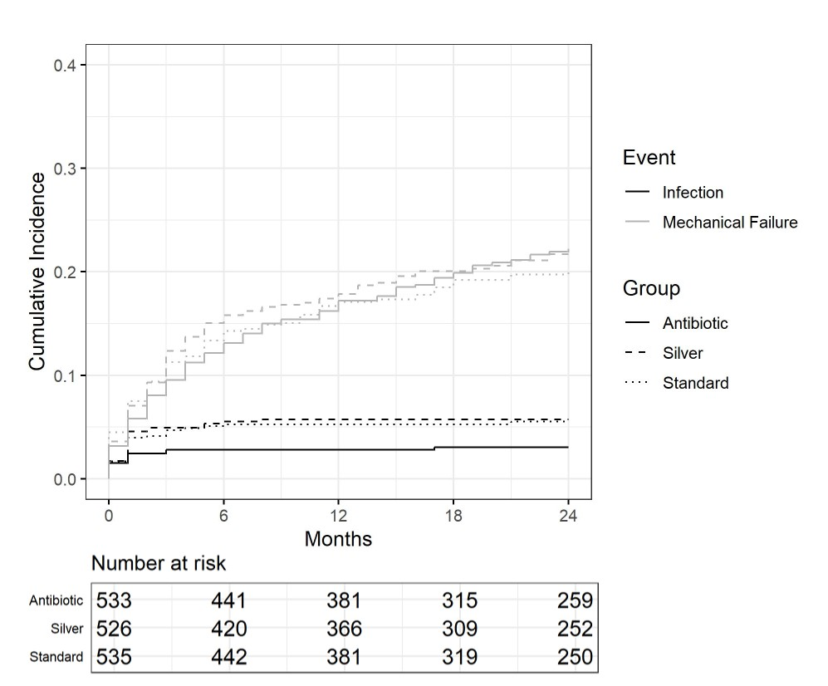
Fig.1

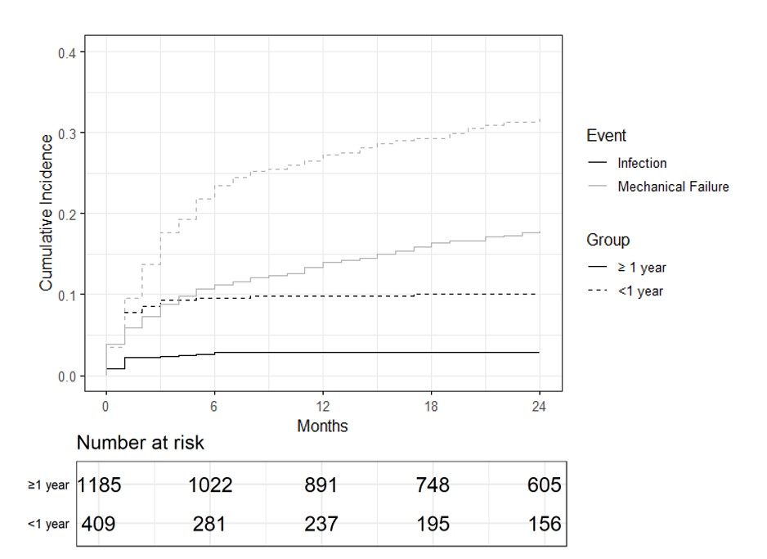
Fig2

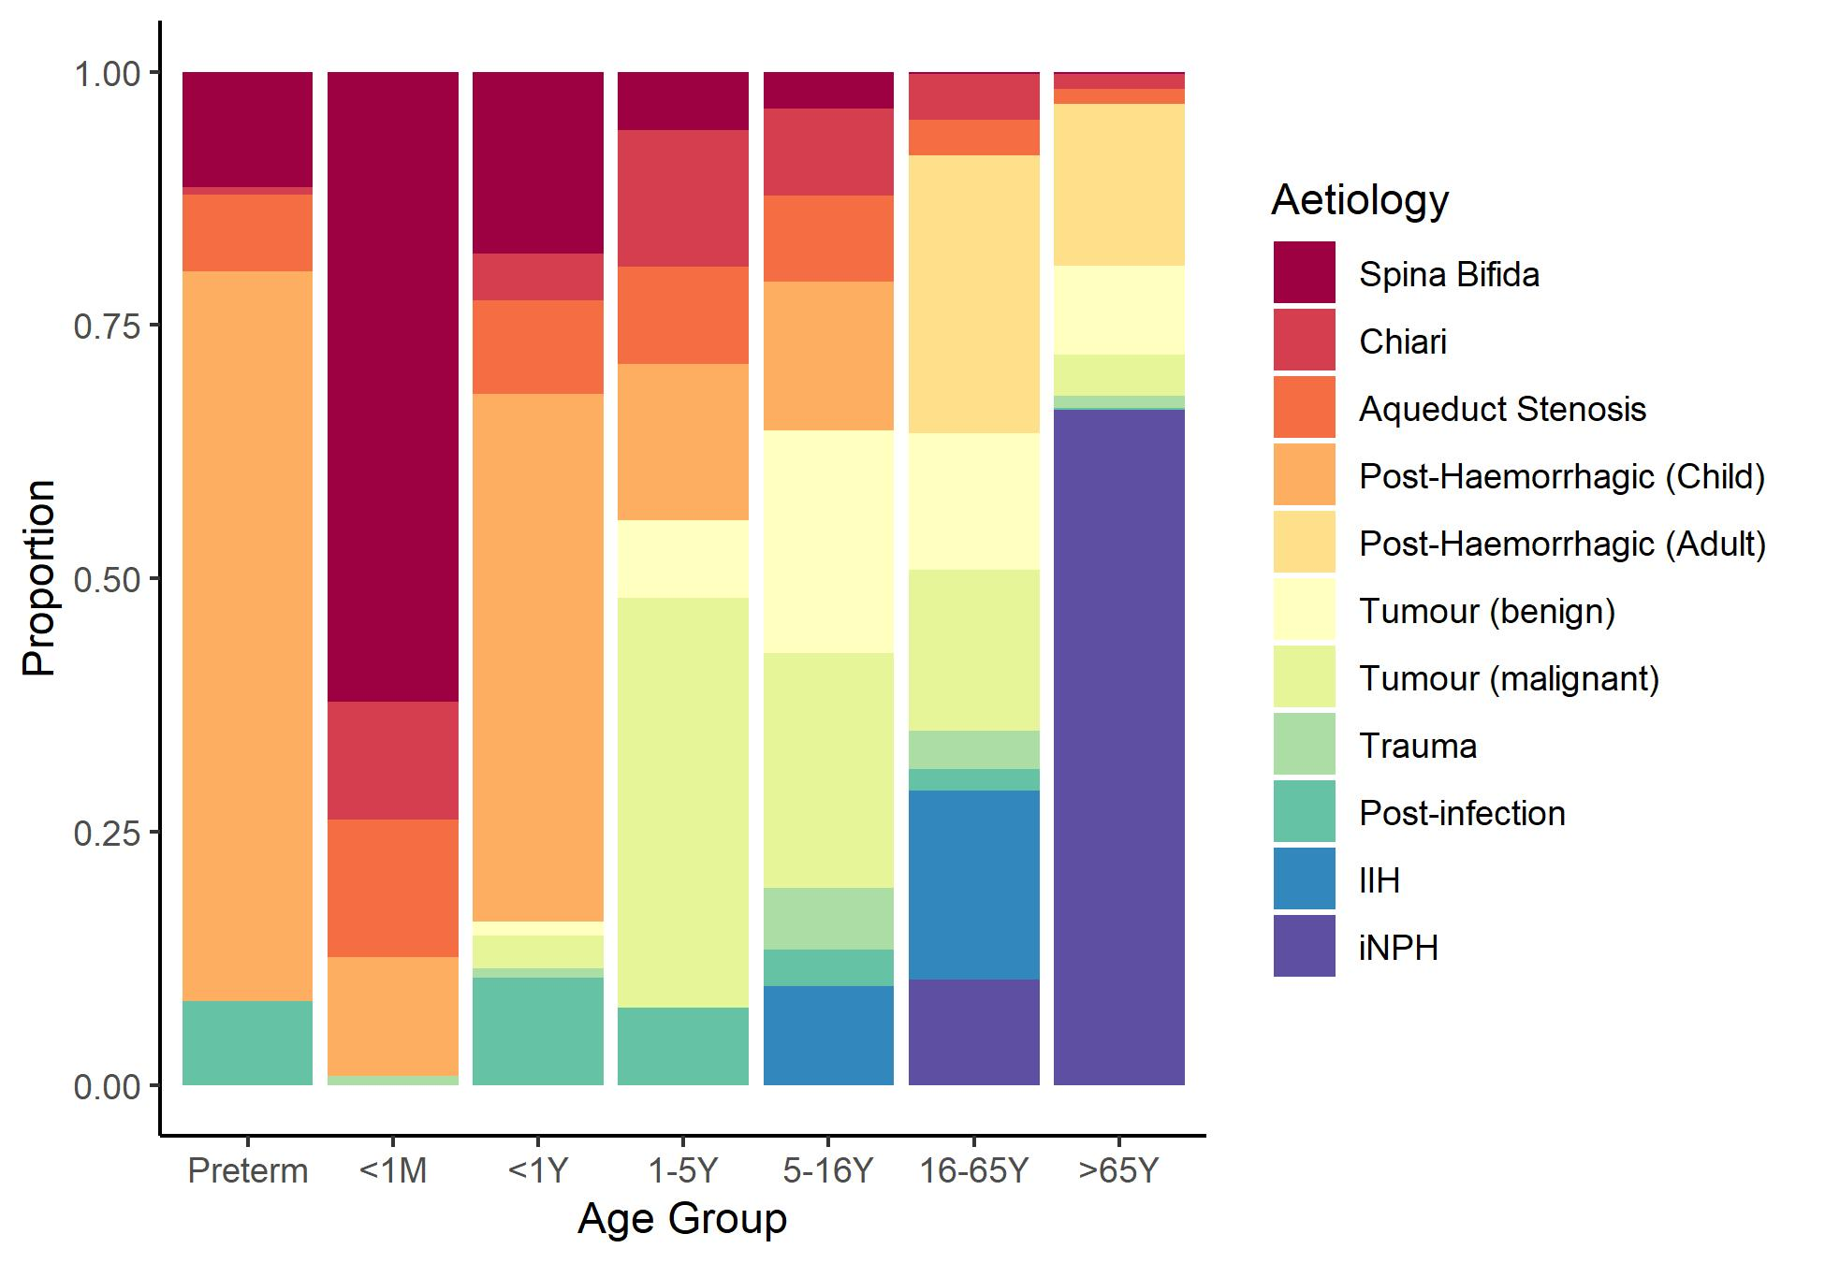
Fig3

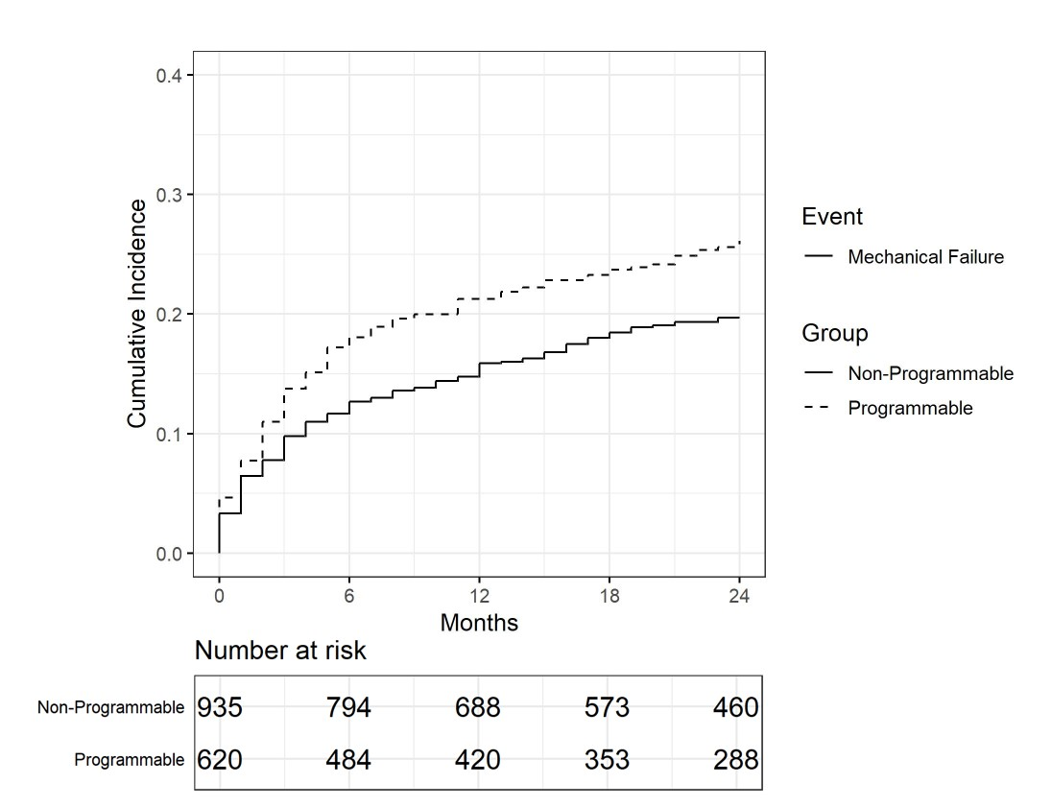
Fig4

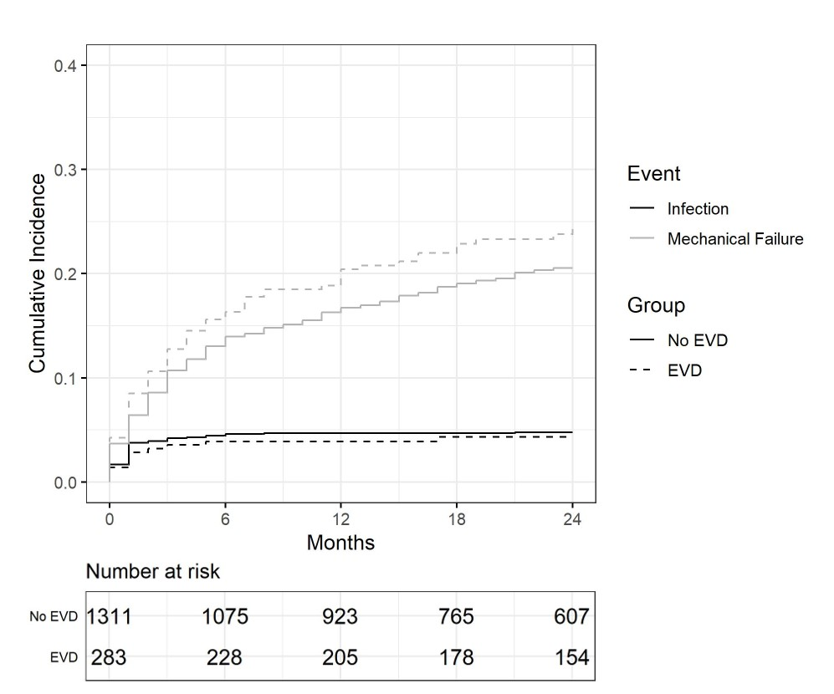

Fig5

TABLE 1. Summary of univariable analysis of infection and mechanical failure risk
Variable | No. of Pts | Infection, n (%) | sHR (95% CI; p value) | csHR (95% CI; p value) | Mechanical Failure,  n (%) | sHR (95% CI; p value) | csHR (95% CI; p value)
Catheter type
Standard | 533 | 32 (6.00) | Referent |  | 98 (18.39) | Referent
Antibiotic | 535 | 12 (2.24) | 0.37 (0.19–0.71; 0.003) | 0.38 (0.19–0.75; 0.005) | 120 (22.43) | 1.25 (0.96–1.63; 0.099) | 1.20 (0.92–1.57; 0.182)
Silver | 526 | 31 (5.89) | 0.98 (0.60–1.60; 0.94) | 1.00 (0.61–1.64; 0.988) | 105 (19.96) | 1.09 (0.83–1.44; 0.51) | 1.09 (0.83–1.44; 0.515)
Patient age
<1 mo | 135 | 19 (14.07) | 3.23 (1.77–5.87; <0.001) | 4.06 (2.21–7.47; <0.001) | 44 (32.59) | 1.84 (1.29–2.61; <0.001) | 2.13 (1.49–3.04; <0.001)
1 mo to <1 yr | 274 | 22 (8.03) | 1.79 (1.00–3.19; 0.050) | 2.08 (1.16–3.74; 0.014) | 81 (29.56) | 1.60 (1.19–2.13; 0.002) | 1.68 (1.25–2.26; <0.001)
1 yr to <5 yrs | 87 | 4 (4.60) | 1.01 (0.35–2.89; 0.990) | 1.11 (0.38–3.21; 0.845) | 23 (26.44) | 1.38 (0.89–2.15; 0.150) | 1.38 (0.88–2.18; 0.159)
5 yrs to <16 yrs | 91 | 2 (2.20) | 0.47 (0.11–1.99; 0.310) | 0.54 (0.13–2.29; 0.402) | 27 (29.67) | 1.56 (1.04–2.41; 0.032) | 1.55 (1.01–2.38; 0.042)
16 yrs to <65 yrs | 504 | 23 (4.56) | Referent |  | 98 (19.44) | Referent
≥65 yrs | 503 | 5 (0.99) | 0.21 (0.08–0.56; 0.002) | 0.19 (0.07–0.50; <0.001) | 50 (9.94) | 0.49 (0.35–0.69; <0.001) | 0.47 (0.33–0.66; <0.001)
Preterm birth status
Term birth | 265 | 26 (9.81) | Referent |  | 73 (27.55) | Referent
Preterm | 177 | 16 (9.04) | 0.92 (0.50–1.70; 0.8) | 0.80 (0.55–1.91; 0.93) | 61 (34.46) | 1.36 (0.97–1.89; 0.075) | 1.37 (0.97–1.91; 0.072)
Hydrocephalus etiology
Spina bifida | 111 | 14 (12.61) | 3.16 (1.79–5.59; <0.001) | 3.81 (2.13–6.80; <0.001) | 34 (30.63) | 1.64 (1.16–2.31; 0.005) | 1.84 (1.29–2.63; <0.001)
Chiari | 62 | 4 (6.45) | 1.4 (0.52–3.81; 0.51) | 1.33 (0.49–3.65; 0.574) | 7 (11.29) | 0.77 (0.41–1.44; 0.42) | 0.79 (0.42–1.42; 0.454)
Aqueductal stenosis | 68 | 8 (11.76) | 2.76 (1.34–5.68; 0.006) | 3.11 (1.49–6.47; 0.002) | 18 (26.47) | 1.39 (0.87–2.23; 0.17) | 1.55 (0.96–2.49; 0.072)
PHH
Pediatric | 145 | 11 (7.59) | 1.92 (1.05–3.54; 0.035) | 2.20 (1.18–4.10; 0.012) | 38 (26.21) | 1.51 (1.10–2.09; 0.012) | 1.6 (1.15–2.22; 0.005)
Adult | 192 | 13 (6.77) | 1.69 (0.95–3.01; 0.073) | 1.55 (0.87–2.77; 0.139) | 26 (13.54) | 0.61 (0.41–0.91; 0.015) | 0.62 (0.42–0.93; 0.021)
Tumor
Benign | 124 | 2 (1.61) | 0.49 (0.15–1.56; 0.23) | 0.49 (0.15–1.54; 0.222) | 25 (20.16) | 1 (0.66–1.51; >0.99) | 0.97 (0.65–1.47; 0.901)
Malignant | 133 | 7 (5.26) | 1.13 (0.52–2.46; 0.75) | 1.07 (0.49–2.33; 0.863) | 19 (14.29) | 0.75 (0.48–1.17; 0.21) | 0.75 (0.48–1.17; 0.21)
Trauma | 30 | 0 (0) | NA | NA | 4 (13.33) | 0.81 (0.33–2.00; 0.65) | 0.77 (0.32–1.86; 0.559)
Postinfectious | 40 | 1 (2.5) | 1.07 (0.26–4.34; 0.93) | 1.07 (0.26–4.36; 0.925) | 8 (20.00) | 0.97 (0.49–1.93; 0.93) | 0.97 (0.48–1.96; 0.933)
IIH | 87 | 5 (5.75) | 1.24 (0.51–3.03; 0.64) | 1.38 (0.56–3.41; 0.489) | 22 (25.29) | 1.46 (0.98–2.18; 0.064) | 1.49 (0.98–2.26; 0.061)
iNPH | 361 | 2 (0.55) | 0.14 (0.04–0.44; <0.001) | 0.12 (0.04–0.37; <0.001) | 33 (9.14) | 0.36 (0.25–0.51; <0.001) | 0.34 (0.23–0.48; <0.001)
Valve type
Nongravitational | 1149 |  |  | 1149 | 219 (19.06) | Referent
Gravitational | 406 |  |  | 406 | 90 (22.17) | 1.17 (0.92–1.49; 0.200) | 1.23 (0.96–1.57; 0.097)
Unknown | 39 |  |  | 39 | 14 (35.90) | NA | NA
Nonprogrammable | 935 |  |  | 935 | 227 (24.28) | Referent
Programmable | 620 |  |  | 620 | 82 (13.23) | 0.53 (0.41–0.68; <0.001) | 0.5 (0.39–0.64; <0.001)
Unknown | 39 |  |  | 39 | 14 (35.90) | NA | NA
Previous EVD
No | 1311 | 53 (4.04) | Referent |  | 275 (20.98) | Referent
Yes | 283 | 22 (7.77) | 1.95 (1.19–3.18; 0.008) | 1.87 (1.14–3.08; 0.0135) | 48 (16.96) | 0.79 (0.58–1.07; 0.12) | 0.82 (0.23–0.48; 0.204)
Pt = patient.
Boldface type indicates statistical significance.

TABLE 2. Proportion of gravitational and programmable valves implanted in patients in the BASICS trial by age group and etiology
Variable | No. of Pts | Gravitational, n (%) | Programmable, n (%)
Patient age group
<1 mo | 133 | 41 (30.83) | 19 (14.29)
1 mo to <1 yr | 268 | 123 (45.90) | 33 (12.31)
1 yr to <5 yrs | 85 | 30 (35.29) | 15 (17.65)
5 yrs to <16 yrs | 87 | 41 (47.13) | 25 (28.74)
16 yrs to <65 yrs | 492 | 85 (17.28) | 187 (38.01)
≥65 yrs | 490 | 86 (17.55) | 341 (69.59)
All | 1555 | 406 (26.11) | 620 (39.87)
Hydrocephalus etiology
Spina Bifida | 110 | 32 (29.09) | 18 (16.36)
Chiari | 61 | 20 (32.79) | 19 (31.15)
Aqueductal stenosis | 68 | 20 (29.41) | 24 (35.29)
PHH
Pediatric | 139 | 68 (48.92) | 19 (13.67)
Adult | 185 | 19 (10.27) | 65 (35.13)
Tumor
Benign | 121 | 22 (18.18) | 27 (22.31)
Malignant | 129 | 32 (24.81) | 26 (20.15)
Trauma | 30 | 9 (30.0) | 14 (46.67)
Postinfection | 40 | 19 (47.5) | 10 (25.0)
IIH | 83 | 20 (24.1) | 39 (46.99)
iNPH | 353 | 76 (21.53) | 299 (84.7)
All | 1319 | 337 (25.6) | 560 (42.5)

TABLE 3. Summary of multivariable modeling of factors contributing to VPS infection and mechanical failure risk
Infection Risk
Variable | No. of Pts | Infected, n (%) | sHR (95% CI; p value) | csHR (95% CI; p value)
Patient age group
<1 mo | 135 | 19 (14.07) | 4.48 (2.06–9.72; <0.001) | 5.61 (2.68–11.72; <0.001)
1 mo to <1 yr | 274 | 22 (8.03) | 2.67 (1.27–5.59; 0.009) | 3.08 (1.51–6.26; 0.002)
1 yr to <5 yrs | 87 | 4 (4.6) | 1.51 (0.48–4.72; 0.48) | 1.61 (0.52–5.04; 0.41)
5 yrs to <16 yrs | 91 | 2 (2.20) | 0.65 (0.14–0.3.08; 0.59) | 0.71 (0.16–3.23; 0.66)
16 yrs to <65 yrs | 504 | 23 (4.56) | Referent
≥65 yrs | 503 | 5 (0.99) | 0.26 (0.10–0.69; 0.007) | 0.23 (0.09–0.61; 0.003)
Catheter type
Standard | 533 | 32 (6.0) | Referent
Antibiotic | 535 | 12 (2.24) | 0.43 (0.22–0.84; 0.014) | 0.42 (0.22–0.83; 0.012)
Silver | 526 | 31 (5.89) | 1.05 (0.64–1.74; 0.82) | 1.04 (0.63–1.73; 0.87)
Hydrocephalus etiology
Aqueductal stenosis | 68 | 8 (11.76) | 1.88 (0.89–3.96; 0.10) | 1.99 (0.93–4.26; 0.080)
PHH, adult | 192 | 13 (6.77) | 2.75 (1.21–6.26; 0.016) | 2.60 (1.16–5.81; 0.019)
Other | 1093 | 46 (4.21) | Referent
Previous EVD
No EVD | 1311 | 53 (4.04) | Referent
EVD | 283 | 22 (7.77) | 1.71 (0.96–3.03; 0.07) | 1.77 (1.00–3.13; 0.06)
Mechanical Failure Risk
Variable | No. | Mechanical Failure n (%) | sHR (95% CI; p value) | csHR (95% CI; p value)
Patient age group
<1 mo | 135 | 44 (32.59) | 1.51 (1.03–2.21; 0.032) | 1.76 (1.21–2.58; 0.034)
1 mo to <1 yr | 274 | 81 (29.56) | 1.31 (0.95–1.81; 0.046) | 1.39 (1.01–1.92; 0.042)
1 yr to <5 yrs | 87 | 23 (26.44) | 1.22 (0.78–1.92; 0.38) | 1.24 (0.78–1.98; 0.363)
5 yrs to <16 yrs | 91 | 27 (29.67) | 1.42 (0.91–2.20; 0.12) | 1.40 (0.90–2.19; 0.138)
16 yrs to <65 yrs | 504 | 98 (19.44) | Referent
≥65 yrs | 503 | 50 (9.94) | 0.64 (0.40–0.94; 0.024) | 0.58 (0.38–0.89; 0.013)
Hydrocephalus etiology
PHH, adult | 192 | 26 (13.54) | 0.64 (0.40–1.01; 0.053) | 0.66 (0.41–1.05; 0.077)
NPH | 361 | 33 (9.14) | 0.68 (0.41–1.12; 0.13) | 0.68 (0.41–1.13; 0.137)
Other | 800 | 175 (21.88) | Referent
Valve type
Nonprogrammable | 935 | 227 (24.28) | Referent
Programmable | 620 | 82 (13.23) | 0.80 (0.59–1.07; 0.14) | 0.79 (0.59–1.05; 0.10)
Unknown | 39 | 14 (35.90) | NA | NA

