Short-title: Bracken control in the Atlantic forest
Title: Combining mechanical control and tree planting to restore montane Atlantic forests dominated by the Neotropical bracken (Pteridium arachnoideum)

Rafael O. Xavier^{1,2*}, Ualas Marques Melo^{1,3}, Vânia Regina Pivello¹, Robert H. Marrs⁴, Pedro Abilleira¹, Jorge Luis do Nascimento⁵, Dalva Maria da Silva Matos⁶
- Departamento de Ecologia, Instituto de Biociências, Universidade de São Paulo, São Paulo, 05508-090, SP, Brazil
- Departamento de Biologia Vegetal, Instituto de Biologia, Universidade de Campinas, Campinas, 13083-862 , SP, Brazil.
- Programa de Pós-graduação em Agroecologia e Desenvolvimento rural, Universidade Federal de São Carlos, Araras, 13565-905, SP, Brazil.
- Centro de Referência em Biodiversidade da Serra dos Órgãos, PARNASO, NGI ICMBio Teresópolis, 25960-602, RJ, Brazil
- School of Environmental Sciences, University of Liverpool, Liverpool, L69 3GP, UK
- Departamento de Hidrobiologia, Universidade Federal de São Carlos, São Carlos, 13565-905, SP, Brazil.

*author for correspodence: filosxavier@gmail.com

Abstract
Climate and land-use changes have driven the dominance of native herbaceous plants in degraded tropical forests leading to losses in biodiversity and ecosystem services. However, controlling these super-dominant species to promote forest regeneration is often ineffective and may favour undesirable species. Native clonal ferns from the Pteridium genus often dominate degraded tropical forests subjected to repeated fires. Although many ways of controlling these species have been proposed, the efficiency of different combinations of strategies and their effect on forest recovery remain unknown. Here, we assessed to what extent removing the above-ground biomass of the shade-intolerant Pteridium arachnoideum and planting trees contributed to the control of this fern and the recovery of montane Atlantic forests in south-east Brazil. In four sites dominated by P. arachnoideum we applied five treatments in adjacent plots: (1) control without interference, (2) cutting twice per year, (3) cutting twice per year plus tree planting, (4) cutting three times per year, and (5) cutting three times per year plus tree planting. Over two consecutive years we repeated the treatments and monitored P. arachnoideum height, rhizome and above-ground biomass, as well as the composition of the established vegetation and soil seed bank. We also assessed the survival and growth of the planted trees. Tree planting accounted for over half of the treatment costs, whereas increasing the cutting frequency only increased costs by 15%. After two years, the three times per year cutting treatment caused the largest decrease in above-ground biomass (1 to 0.1 kg/m²) and abundance (80 to 15%) of P. arachnoideum. Planted trees exhibited low survival (47%) rates and growth (30 cm/year), and hence had no effect on the dominance of P. arachnoideum. Treatments did not affect rhizome biomass, suggesting that P. arachnoideum could regain its dominance if cutting treatments were discontinued. Although two annual cuts slightly favoured tree regeneration, trees were rare in both the established vegetation (<10%) and seed bank (<0.3 seeds/dm³). Conversely, under three annual cuts the African grass M. minutiflora became more abundant in both the established vegetation (5 to 25%) and seed bank (1 to 4 seeds/dm³). Our findings show that intensive mechanical removal decreases the dominance of P. arachnoideum in Atlantic forests. However, its benefits to forest recovery seem to be limited by lack of tree regeneration, impoverished seed banks and invasive grasses. Therefore, planting fast-growing and drought-tolerant tree species may be essential to the recovery of these degraded Neotropical forests.
Keywords – superdominant species, native invader, seed bank, forest recovery, invasive grasses, tree regeneration.

1. Introduction
Land-use and climate changes have promoted the dominance and spread of many native species, particularly in forest ecosystems (e.g. Ferreira et al., 2019; Figueiredo et al., 2022; Wijewickrama et al., 2022). Some of these species, hereafter referred to as super-dominant species (Marrs et al., 2011; Marrs et al. 2013; Pivello et al., 2018) threaten the biodiversity and functioning of native communities (Gaira et al., 2022; Nackley et al., 2017; Zhao et al., 2021). A range of strategies have been proposed to manage these super-dominant species, which aim to restore the local diversity and ecosystem services (Britez et al., 2020; Tiberio et al., 2022; Xu et al., 2020). Nevertheless, controlling super-dominant species may have low cost-efficiency and lead to unexpected results (Kettenring and Adams, 2011; Rinella et al., 2009), such as favouring the establishment and spread of other undesirable native and non-native species that may hamper forest regeneration (Marrs et al., 1998a; Zavaleta et al., 2001; Zipkin et al., 2009).
The genus Pteridium is native to all continents except Antarctica, and Pteridium species often form large mono-specific stands in temperate and tropical forests subjected to repeated human impacts (Amouzgar et al., 2020; Dumas et al., 2022; Hartig and Beck, 2003; Marrs and Watt, 2006). Pteridium arachnoideum (Kaulf.) Maxon is the most common species found in southern South America, where it often shows a high productivity and dominance (Portela et al., 2009; Silva Matos et al., 2014). As a result, this species often limits the abundance and richness of native trees (Hartig and Beck, 2003; Miatto et al., 2011; Schneider, 2006; Xavier et al., 2016). Although woody species may become established in some Pteridium-dominated sites (Marrs and Hicks, 1986; Guerin e Durigan 2015), conditions at most sites tend to be unfavorable for tree regeneration. Accordingly, these mononpecific patches may persist over long periods (Pivello et al., 2018) especially under repeated fires (Alonso-Amelot and Rodulfo-Baechler, 1996; Carvalho et al., 2022; Portela et al., 2009; Silva and Silva Matos, 2006). Currently, P. arachnoideum is often dominant in fragments of Atlantic Forest in south-east Brazil, a biodiversity hotspot that has been reduced to less than 30 % of its original area and is threatened by land-use change and fire (Rezende et al., 2018; Scarano and Ceotto, 2015).
The dominance of Pteridium species in disturbed sites has been attributed to the large carbohydrate and nutrient reserves and abundant frond buds in their extensive rhizome system, which support rapid emergence and growth of new fronds (Marrs and Watt, 2006). As reducing this below-ground rhizome mass can only realistically be done in most situations through the manipulation of the above-ground fronds, controlling Pteridium is challenging (Stewart et al., 2008). In temperate climates, Pteridium aquilinum L. (Kuhn) has been controlled effectively by a combination of repeated annual cutting of the above-ground biomass - aiming to deplete rhizome reserves - and periodic herbicide application, targeting the rhizome buds (Marrs et al., 1998b; Marrs and Watt, 2006). Continuous mechanical removal of fronds has been proposed as a means of controlling Pteridium species in tropical forests, where climatic conditions tend to support frond regrowth throughout the year (Roos et al., 2011). Alternatively, given the high financial costs of repeated selective cutting, it has been suggested that introducing fast-growing native trees may accelerate the recovery of tropical forest cover and Pteridium growth would be reduced by shading/competition (Aguilar-Dorantes et al., 2014; Douterlungne et al., 2013; Toledo-Aceves et al., 2022a). Nevertheless, it is still unclear to what extent combining (1) repeated selective frond cutting and (2) tree planting would be an effective strategy to control Pteridium in tropical forests.
In this paper, therefore, we tested the efficacy of mechanical control of P. arachnoideum during the most favourable part of its growing season in south-east Brazil (November to April) along with the planting of fast-growing trees as a combined strategy to promote the recovery of montane Atlantic Forest sites in south-east Brazil. We specifically aimed to answer the following questions:
- Is increasing the frequency of frond cutting from twice to three times per year a cost-effective strategy to control P. arachnoideum? Cutting the fronds more intensively tends to improve control efficacy (Milligan et al., 2016). In our study, cutting will be concentrated into the wettest and warmest period of the year (December-April), when frond productivity is greatest, and hence most frond regrowth after cutting will occur in less-favourable growing conditions.
- Does the planting of native trees in sites subjected to frond cutting lead to a further decrease in the dominance and productivity of P. arachnoideum? Pteridium arachnoideum is shade intolerant (Xavier et al., 2019), and fast-growing trees may cause a rapid decrease in the dominance of Pteridium species in tropical forests (Douterlungne et al., 2013). Therefore, tree planting may contribute to P. arachnoideum control, particularly under three annual cuts.
- Do P. arachnoideum control treatments lead to more tree regeneration and increased numbers of seeds in the soil? Considering the well-known negative effects of Pteridium species on tree establishment in tropical forests (Senyanzobe et al., 2020; Ssali et al., 2018; Ssali et al., 2019), intensive frond cutting may favour tree regeneration. Nevertheless, undesirable native and exotic species commonly present in degraded forest sites may also benefit from repeated mechanical removal.

2. Material and methods
2.1. Study site
We performed the study in the Parque Nacional da Serra dos Órgãos (PARNASO), a 20,024 ha protected area in the montane region of Rio de Janeiro state, south-east Brazil (Figure 1a). The Park includes some large, well-preserved areas of montane and sub-montane Atlantic Forest with many endemic and threatened species. For this study we selected a specific region (22º.41’20” S; 43º.03’94” W, Figure 1a). It has an average annual temperature of 17.3° C and an average annual precipitation is 1740 mm (WorldClim); however, less than 20% of the precipitation occurs during a winter dry-season (May-September) and most rainfall occurs in the summer wet-season (October-March) (INMET, 2022; Figure 1c). This region of the Park has a long history of human interference (de Oliveira et al., 2007) , including repeated fires over the last decade, mainly as a result of its proximity to a local highway. Consequently, it currently includes many sites covered by dense, mono-specific P. arachnoideum. We selected four accessible sites with at least 20m × 100 m of nearly-continuous cover of P. arachnoideum and a similar fire history, slope, and elevation (1200 to 1500 m) (Figure 1a).
2.2.. Experimental treatments
In each P. arachnoideum-dominated site we installed five 15 m × 15 m adjacent plots, which were assigned randomly to one of the following treatments: (1) experimental control without interference, (2) frond cutting twice per year, (3) frond cutting twice per year plus planting of native pioneer trees, (4) frond cutting three times per year, and (5) frond cutting three times per year plus planting of native pioneer trees (Figure 1b). We did not include once per year cutting because of the well-known lack of efficiency of this treatment for controlling Pteridium (Marrs and Watt, 2006). Likewise, we did not include a treatment with tree planting but no frond cutting, as planting within control plots would cause extensive disturbance given the dense cover of P. arachnoideum present. Frond cutting occurred from late-spring (early December) to early-autumn (early April) with a 2.5 month interval between cuts; this timing was based on the frond growth period and average time required for full frond expansion shown by P. arachnoideum in a previous study in south-east Brazil (Xavier et al., 2019). The third annual cut in the second cutting cycle was scheduled for April but was only performed in September 2020 due to Covid-19 pandemic restrictions. Due to the very high density of both living and dead P arachnoideum fronds in all study sites, a metal strimmer was used for the first cutting in each plot at the beginning of the study (December 2018); all further cuttings were performed manually. In order to favour natural tree regeneration and the establishment of planted tree saplings, we removed all P. arachnoideum fronds from the plots after each cutting treatment, included all fragments of dead fronds that had not been incorporated into the litter layer at the time of the first cut.
After the first annual cutting of P. arachnoideum (December 2018), we planted 49 saplings of six native evergreen tree species on 2 m centres. The tree species were Anadenanthera peregrina (L.) Speg., Inga marginata Willd., Inga affinis DC., Schinus terebinthifolia Raddi, Trema micrantha (L.) Blume and Moquiniastrum polymorphum (Less.) G. Sancho). These species were selected on the basis of their (a) success in Atlantic Forest restoration projects (Meli et al., 2018), (b) natural occurrence in the study region, and (c) sapling availability at the time of planting. Individual trees were assigned randomly to position and all species were present in a similar abundance (eight or nine individuals) in each plot.
We also estimated the economic costs associated with both frond cutting and tree planting. These costs included equipment, transportation and personnel associated in each year . The costs are presented in $US and were adjusted for the average rate of inflation in Brazil accumulated since the end of the study (December 2020 to September 2022, IBGE, 2022) and expressed on a 1 ha basis.
2.2.2. Vegetation monitoring
Before each first annual cutting and at the end of the experiment (early December in 2019, 2020 and 2021) we assessed frond density and the cover (%) of P. arachnoideum within two 1m × 1 m sub-plots placed randomly in each 15 m × 15 m plot. In each sub-plot we also removed at least 25% of the fronds to measure their length, and collected all rhizomes of P. arachnoideum from a pit of 25 cm × 25 cm area to a depth of 50 cm (Le Duc et al., 2003). Afterwards, rhizomes were classified as either short-shoots, which tend to occur close to soil surface and are mostly associated with frond emergence, or long-shoots, generally found in deeper soil layers and associated with reserve storage and colonization from the patch margins (Marrs and Watt, 2006). Both rhizomes and frond samples were oven-dried at 50°C for 72 h and weighed to obtain dry biomass.
The cover (%) of P. arachnoideum and all other species was estimated visually in four randomly assigned 1 m x 1 m subplots within each 15 m x 15 m plot. Due to the expected disturbance in our experimental plots after the first frond cutting, we did not survey the whole herbaceous community before treatment application; instead, these surveys were conducted before the third frond cutting of each cutting cycle (Figure 1c).
At the same time, and in the same subplots used for frond and rhizome sampling, we also collected two 20 cm × 20 cm soil samples to a depth of 4 cm (two soil samples per plot × 20 plots = 40 samples per sampling period). The abundance of viable seeds in each soil sample was estimated by the seedling emergence method (Roberts, 1981). Two days after sampling, these soil samples were sieved through a 3 mm mesh to remove debris and plant fragments and transferred to plastic trays over a 1 cm deep layer of washed sand. Trays were transferred to a greenhouse with natural light, where they remained covered with transparent plastic sheets to reduce evapotranspiration and were watered at least twice per week. All emergent individuals in each tray were counted and identified once every two weeks over four months. Morphotypes were classified to the lowest taxonomic level, and thereafter, divided into three groups (herb, shrub, tree) based on literature information. When morphotypes could not be identified to the species-level during the experiment, specimens of each of them were transferred to individual pots and allowed to grow on until identification was possible.,

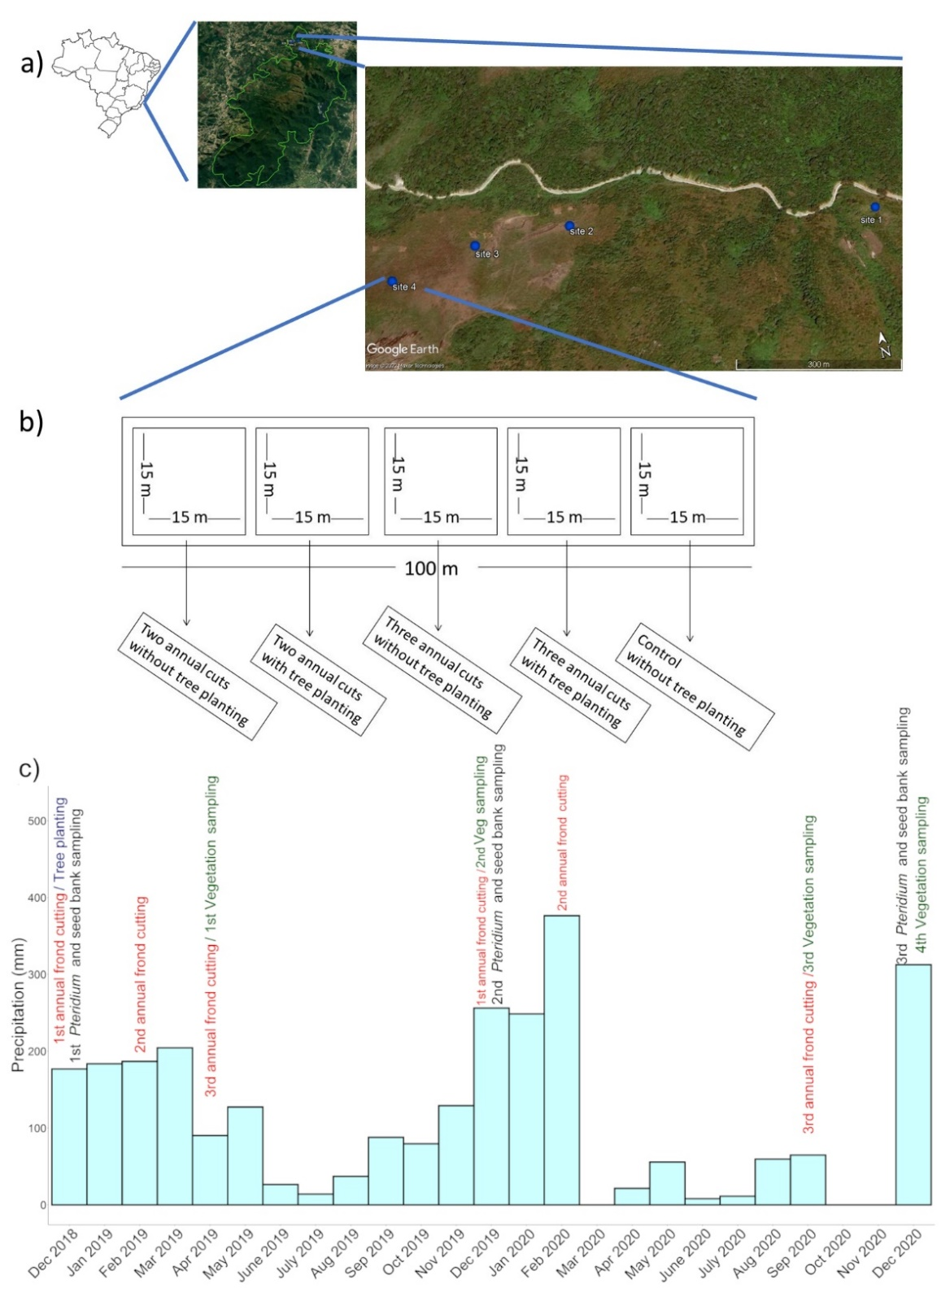
Figure 1 –Details of the four study sites and experimental design: (a) location in the Parque Nacional da Serra dos Órgãos in south-east Brazil, (b) the experimental design in each site, and (c) the monthly precipitation during the study period and the timing of tree planting, frond cutting and sampling events.
2.3. Data analysis
We assessed the effect of frond cutting treatments on the abundance, size and productivity of P. arachnoideum, as well as on the richness and abundance of other native species both in the vegetation and soil seed bank, using generalized linear mixed models (GLMMs, Zuur et al., 2009). To assess treatment effects on P. arachnoideum in each sampling (December 2018, 2019 and 2020), we considered as response variables the percent cover, frond density, average frond size, frond biomass (calculated as average frond biomass multiplied by frond density) and rhizome biomass of P. arachnoideum in each 1 × 1 m subplot. To assess treatment effects on the local plant community, we considered as response variables species richness and the cover of each species group (tree, shrub, herb or non-native) at each 1 × 1m subplot (vegetation) and in each soil sample (soil seed bank). We assumed a Poisson distribution for modelling frond density and species richness, a negative binomial distribution of the cover of each group of native and non-native species, and a Gaussian distribution for other variables (Bolker et al., 2009). In each analysis we considered the five applied treatments as fixed effects, and site and plot nested within site as random effects. Each model was validated through analyses of simulated residuals in the “DHARMa” package (Hartig 2022). Models with and without interactions were compared using likelihood-ratio tests, and the Minimum Adequate Model (MAM) selected (Crawley, 2012). The significance of the main effects and interactions was obtained from the MAMs in an analysis of variance based on the Kenward-Roger degrees of freedom approximation, which was performed in the “lmerTest” package (Kuznetsova et al., 2017). Where significant fixed effects and interactions, post-hoc comparisons between all factor levels were implemented in the "emmeans" R package (Lenth, 2020). We also used GLMMs to assess the effect of cutting frequency (either twice or three times per year) on the survival, and height and growth rate of the planted trees, two years after they were planted. In this case we considered species, plot and study sites as random effects, and assumed either a binomial (survival data) or gamma (growth rate) distribution. All models were implemented in the package "glmmTMB” (Brooks et al., 2017) in the R statistical environment (R Core Team, 2022). Data manipulation and visual presentation of results were performed in the “tidyverse” (Wickham et al., 2019) and “ggplot2” (Wickham, 2010, p. 2) packages respectively.
3. Results
3.1. Economic cost of control treatments
The overall cost of two years of P. arachnoideum control across all study sites and treatments (0.36 ha) was US$2,856 (i.e. US$7,933/ha, Table S1). Combined tree planting and frond cutting accounted for 58% of the overall cost (Table S1). Conversely, increasing frond cutting frequency from two to three cuts per year only led to a 16% increase in costs(Table S1).
3.2. Effects of frond cutting on the dominance, biomass, and morphology of P. arachnoideum
All the minimum adequate models for the effect of frond cutting treatments on the biomass, cover, density, and frond length of P. arachnoideum included an interaction between frond-cutting frequency and sampling period (Table S2, Figure 2). In plots where fronds were removed three times per year, there was a three-fold decrease in the above-ground biomass after the first cutting cycle, and a ten-fold decrease after the second cutting cycle (Figure 2a). Conversely, the above-ground biomass did not decrease after one cycle of twice-a-year frond cutting, although after the second cycle there was a two-fold decrease (Figure 2a). In both cutting treatments the average cover of P. arachnoideum decreased by 50% after the first cutting cycle (Figure 2b). However, after the second cutting cycle it was two and four times lower than initial values under two and three annual cuttings, respectively (Figure 2b).
There were no significant changes in frond density among treatments after the first cutting cycle, but after the second cycle the average frond density under three annual cuts decreased from over five to less than two fronds per m², whereas under two annual cuts it only decreased by 30% (Table S2; Figure 2c). Under three annual cuts there was an almost two-fold decrease in frond length after the first cutting cycle and a further 70% decrease after the second cycle (Figure 2c). Although there was an over 30% decrease in frond length under the first cycle of the twice-a-year cutting treatment, frond length did not decrease further in the second cycle (Figure 2d). After two cutting cycles we found no significant effect of frond cutting nor sampling period on the rhizome biomass of P. arachnoideum (Table S2, Figure S1).

3.3. Effects of tree planting on P. arachnoideum performance
Only 47% of the planted trees survived after two years, although the survival rate in plots where P. arachnoideum was cut three times per year was almost 40% greater than under two annual cuttings (Figure 3a). The average growth rate among the surviving individuals was lower than 30 cm per year and did not differ between cutting treatments (Figure 3b). Therefore, after two years the average height of the planted individuals was less than 75 cm, so tree planting could have had no shading significant effect on the dominance, frond length, and biomass of P. arachnoideum (Table S2).

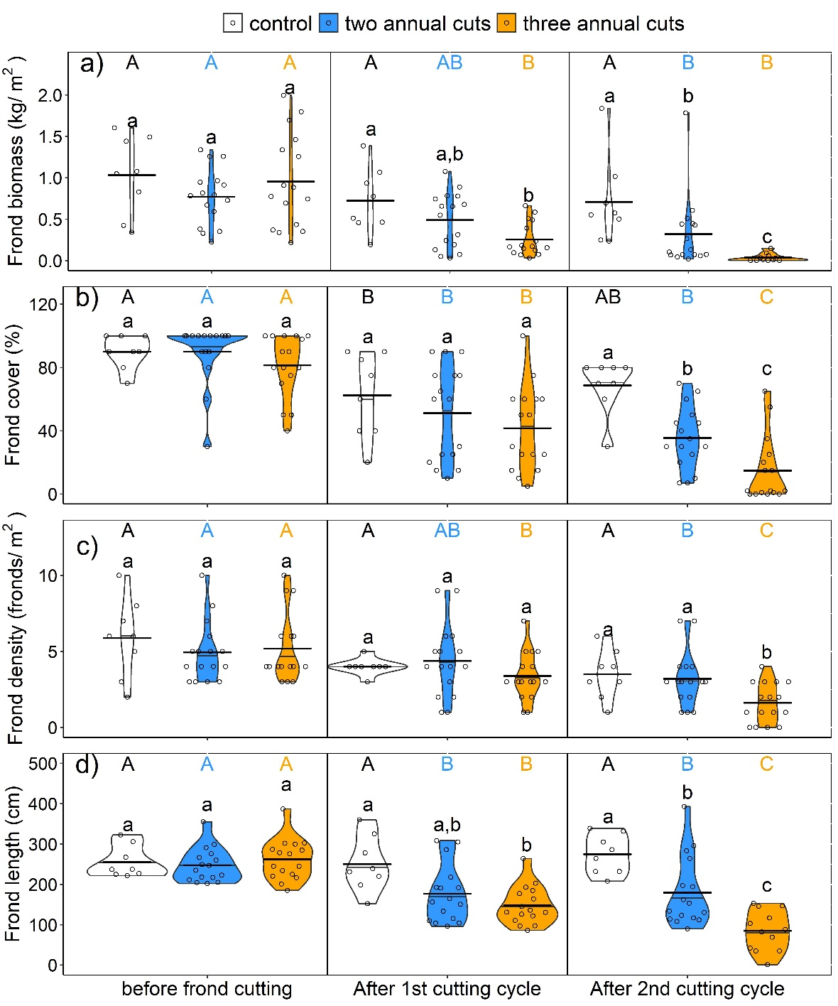
Figure 2–Above-ground biomass, abundance, morphology and biomass of Pteridium arachnoideum before and after one and two treatment cycles of cutting the of above-ground biomass twice-a-year and three-times-a-year, compared to the unmanipulated control treatment in montane Atlantic Forest sites in south-east Brazil. Different letters indicate significant differences between: (a) experimental treatments at each sampling period (lower-case), and (b) sampling periods for each experimental treatment (upper-case).
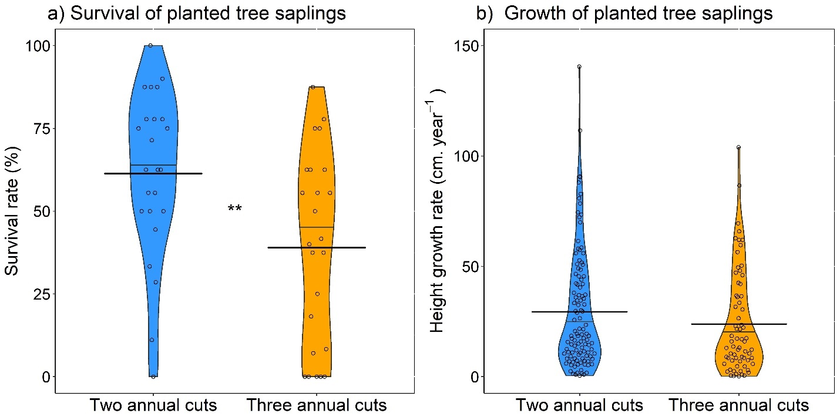
Figure 3 – Performance of tree saplings two years after planting in plots subjected to either two or three annual cuts of the super-dominant fern Pteridium arachnoideum in montane tropical forests in south-eastern Brazil. Values are (a) mean percentage survival rates per species per plot and (b) mean height growth rate of individual saplings. Asterisks indicate significant differences between cutting treatments (**p<0.01).

3.2. Effects on the established vegetation and soil seed bank
We found a significant interaction between sampling period and frond cutting treatment on the cover of both trees and the invasive African grass Melinis minutiflora P. Beauv, which was the only non-native species detected (Table S3, Figure 4). The cover of tree species under two annual cuts increased from close to 0% in the middle of the first frond cutting cycle to 10% after the second frond cutting cycle (Figure 4a), whereas the cover of M. minutiflora under three annual cuts increased from less than 10% at the middle of the first cutting cycle to over 25% at the end of the second cycle (Figure 4b). Although the cover of native shrubs decreased after the first cutting cycle under all treatments, it returned to the initial levels after the second cutting cycle (Figure S2). Sampling period and frond cutting treatments had no significant effect on the cover of native herbs and native species richness (Table S3, Figure S2).
Tree species were generally very rare in the seed bank (Figure 5a), and neither their abundance (Figure 5b) nor the abundance of native herbs and shrubs in the seed bank (Figure S3) were affected by cutting treatments (Table S4). Conversely, there was an over 50% increase in the average abundance of the invasive grass M. minutiflora in the seed bank after the first cutting cycle, although differences were no longer significant after the second cutting cycle (Figure 5b).

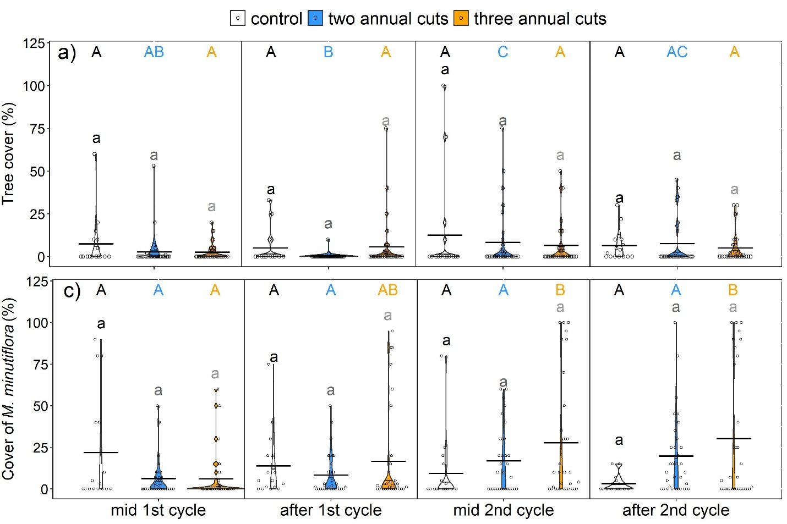
Figure 4 – Cover (%) of (a) native trees, (b) shrubs, and (c) the invasive African grass Melinis minutiflora in the middle and after the first and second cycles of above-ground biomass cutting either twice-a-year or three-times-a-year, compared to an unmanipulated control treatment in montane Atlantic Forest sites in south-east Brazil. Different letters indicate significant differences between: (a) experimental treatments at each sampling period (lower-case), and (b) sampling periods for each experimental treatment (upper-case).
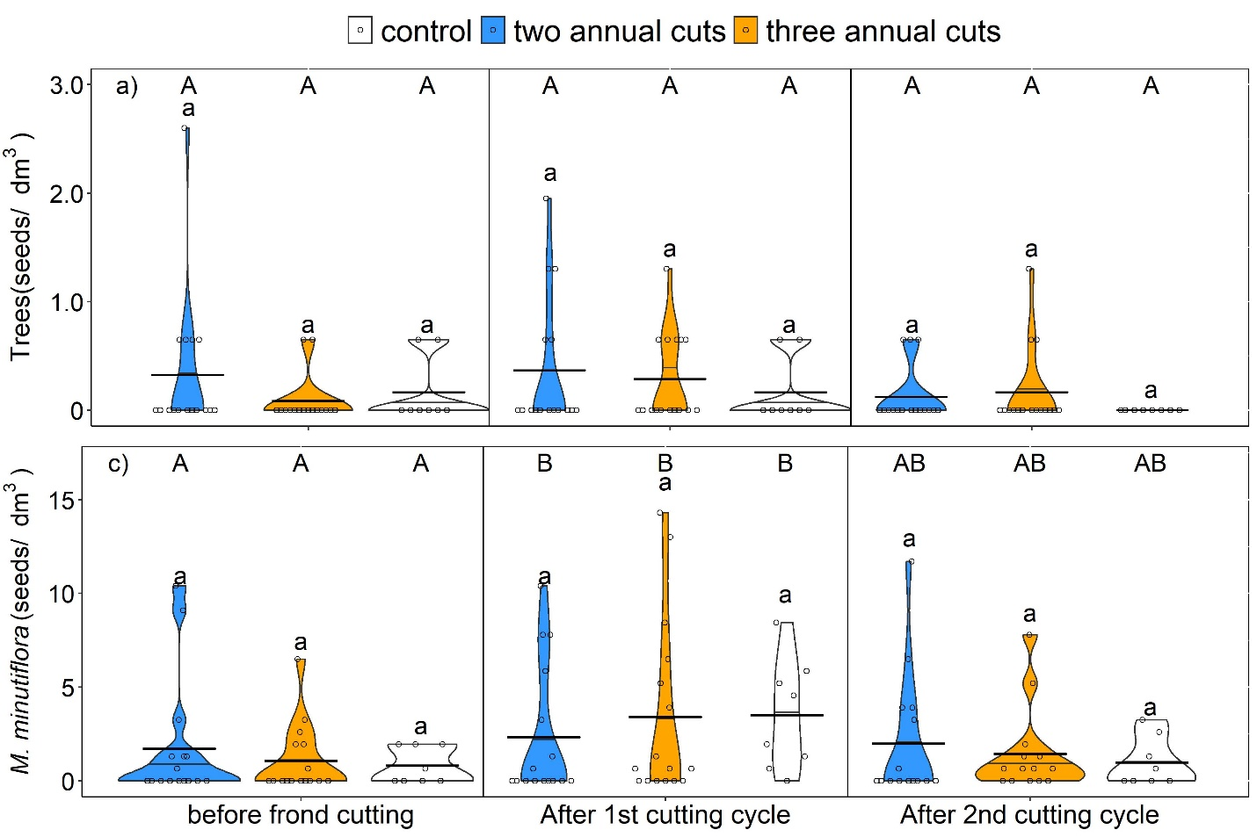
Figure 5 – Abundance of (a) native trees, (b) shrubs, and (c) the invasive African grass Melinis minutiflora the soil seed bank before cutting treatments and after the first and second cycles of above-ground biomass cutting either twice-a-year or three-times-a-year, compared to an unmanipulated control treatment in montane Atlantic Forest sites in south-east Brazil. Different letters indicate significant differences between: (a) experimental treatments at each sampling period (lower-case), and (b) sampling periods for each experimental treatment (upper-case).

4. Discussion
We investigated the effects of cutting the above-ground biomass of the super-dominant fern P. arachnoideum at different frequencies, with or without tree planting, on the recovery of degraded montane Atlantic forests. Frond cutting three times a year during the wet season caused a large decline in the dominance, height and above-ground biomass of P. arachnoideum. By contrast, after two years tree planting had no effect on the fern dominance. Our study shows that repeated frond cutting may lead to a rapid decline of the dominance of Pteridium in tropical forests, although benefits of this mechanical control to forest recovery may be limited by slow natural tree regeneration and the presence of exotic invasive species.
4.1. Effects of frond cutting on Pteridium arachnoideum performance.
We found that two years of the most intensive frond cutting treatment led to a rapid decrease in P. arachnoideum dominance . This result is consistent with those obtained from longer-term experiments testing the efficacy of repeated frond cutting during the warm season on the control of P. aquilinum in temperate ecosystems (Marrs & Watt, 2006; Milligan et al., 2016). Likewise, previous studies found that frond cutting throughout the year may control Pteridium in Neotropical forests (Aguilar-Dorantes et al., 2014; Roos et al., 2011). Our results show that a large negative effect on the dominance and frond biomass of P. arachnoideum may be achieved at relatively low cost by increasing frond cutting frequency from two to only three annual cuts (Figure 1).
In both study years the amount of precipitation in the seven-month interval between the third annual cut of the first cycle (late April) and the first annual cut of the second cycle (early December) was only 30% of the average annual precipitation (Figure 1c), a pattern typically found in this region (INMET, 2022). In addition, minimum absolute monthly temperatures during the winter were below 8°C (Figure 1c). Accordingly, cutting the fronds of P. arachnoideum at the end of the wet season (April) limited frond regrowth to the dry winter, a period of lower water availability and lower temperatures, including some frosts. Pteridium species are usually sensitive to dry conditions (Gordon et al., 1999a, 1999b) and to frost, which can be lethal to fronds (Amouzgar et al., 2022; Marrs and Watt, 2006; Lowday, 1983). Pteridium species may respond to variations in nutrient, water and light availability by changing resource use efficiency and leaf morphology (Amouzgar et al., 2020; Baer et al., 2020; Gray et al., 2022; Xavier et al., 2019). Therefore, we hypothesize that the timing of frond cutting played a major role in the treatment efficiency. We acknowledge that the delay in the third annual cut of the second treatment year may also have contributed to reduce P. arachnoideum size and biomass at the beginning of the following rainy season. Nevertheless, the advantages of three annual cuts were consistent even after a single year of treatment and their economic costs were less than 20% greater than those of two annual cuts per year. Therefore, it seems that three annual cuts are overall the most cost-effective strategy to a rapid control of Pteridium arachnoideum in the Atlantic forest, and this strategy should be tested for the control of super-dominant Pteridium species elsewhere in tropical forests.
Despite its consistent effect on the above-ground biomass, two years of periodic frond cutting did not decrease the rhizome biomass of P. arachnoideum. In unmanaged P. arachnoideum, new fronds are produced using carbohydrates reserves stored in the rhizomes. As the fronds develop the rhizome reserves are replaced through translocation of frond photosynthates (Williams and Foley, 1976; Marrs & Watt, 2006). Cutting the fronds disrupts this process as the fronds are cut before the re-translocation can begin (Marrs and Watt, 2006). Indeed, in temperate ecosystems two annual cuts led to a decrease in the biomass of P. aquilinum rhizomes over an 18-year period (Marrs et al., 1998b), and in other Neotropical sites repeated frond cutting throughout the year has been shown to decrease the rhizome biomass of P. arachnoideum (Aguilar-Dorantes et al., 2014).
The lack of effect on the rhizomes after cutting treatments may be related to the relatively short period covered by our study, as changes in the rhizome system often take place over longer time periods (Douterlungne et al., 2013). Therefore, discontinuity of the frond cutting treatment after only two years would lead to high production of new fronds, thus possibly reversing the control benefits obtained after two cycles of treatment. Considering the relatively low costs of cutting P. arachnoideum three times per year, we recommend that this treatment should be maintained for at least three consecutive years, as this could cause a further decline in the dominance of the species while decreasing the probability of a large post-control clonal regrowth supported by the rhizome system.
4.2. Effect of tree planting on the control of P. arachnoideum
Pteridium arachnoideum is shade-intolerant (Xavier et al., 2019), and combinations of shading plus frond cutting have been shown to decrease both its dominance and rhizome biomass (Aguilar-Dorantes et al., 2014). Here the introduction of fast-growing native trees did not decrease either the productivity or dominance of P. arachnoideum, suggesting that this is not a cost-effective short-term strategy to control this species in Atlantic Forest sites. Although we introduced fast-growing tree species commonly used for restoring Atlantic Forest sites (Meli et al., 2018), drought conditions associated with a seasonal precipitation pattern and exposure to severe insolation and strong winds possibly contributed to the large mortality and the slow growth we detected for these species in our study (Mangueira et al., 2019). However, in another Neotropical forest site in Mexico, the introduction of a fast-growing, broad-leaved, native tree species led to a rapid and large decrease in the abundance and productivity of Pteridium caudatum (Douterlungne et al., 2013).
Contrasting with the possible negative effects of frond cutting on the survival of planted trees, we found higher tree mortality in plots subjected to two than three annual cuts. We believe that this pattern was associated with the fact that many of the planted species are light-demanding pioneer trees, whose growth and survival was possibly limited by the presence of fronds of P. arachnoideum that emerged late in the wet season, and hence could not be removed under the two annual cut treatments. This variety of possible tree species responses to the control is consistent with a previous study in African forests dominated by P. aquilinum, which found that frond-cutting had a positive effect on the survival of seedlings of pioneer trees, whereas secondary trees survived more without frond removal (Ssali et al., 2019). Therefore, combining frond cutting with the planting of fast-growing, native tree species that form a close canopy, and are moderately tolerant to both drought and shading, could accelerate tree growth and provide a dense canopy cover that could limit the dominant P. arachnoideum (Douterlungne et al., 2013). This highlights that the restoration of tropical forests dominated either by super-dominant or other undesirable species may benefit from a more rigorous process of tree species selection. This process should consider interactions between species attributes and local biotic and abiotic factors (Zirbel & Brudvig, 2020), which have rarely been investigated in restoration studies in the Atlantic Forest and other tropical forests (Toledo-Aceves et al., 2022b; Zupo et al., 2022).
4.2. Effects of control treatments on forest regeneration
Cutting the P. arachnoideum fronds did not lead to a consistent increase in the abundance of native species. Indeed, the abundance of native shrubs and vines decreased during the first cutting cycle, although twice-a-year cutting treatments led to a small increase in species richness and tree cover in the middle of the second treatment cycle. This was unexpected considering that removing Pteridium tends to favour tree germination and establishment (Ssali et al., 2019), as Pteridium monospecific stands generally form a very close canopy that limits the regeneration of light-demanding species (Marrs and Watt, 2006). Nevertheless, the establishment of other species may also be limited by the deep litter layer and low pH and nutrient availability typically found in sites dominated by this fern (Marrs and Watt, 2006; Milligan et al., 2018). Therefore, rapid benefits of intensive mechanical control of P. arachnoideum for tree regeneration were probably also limited because in sites dominated by this fern the local conditions only become suitable for the establishment of woody species after many years (Guerin and Durigan, 2015; Miatto et al., 2011; Milligan et al., 2018).
In addition to a legacy of unsuitable conditions associated with the long-term presence of Pteridium, in the short-term the removal of P. arachnoideum fronds three times per year likely led to greater sunlight exposure and lower soil moisture conditions, which are unsuitable for the natural seed regeneration of many shade-tolerant and drought intolerant tree species (Kupers et al., 2019). Indeed, frond removal in Pteridium-dominated Neotropical sites may reduce the survival and recruitment of shade-tolerant tree species, and studies have suggested that the presence of Pteridium may facilitate their establishment (Gallegos et al., 2015; Palomeque et al., 2017; Ssali et al., 2019). This is consistent with the greater species richness and abundance of trees under two annual cuts in our study, as the intermediate density of fronds under this treatment possibly led to better water availability and hence favoured the early establishment of other species. On the other hand, maintaining a moderate density of P. arachnoideum facilitates the occurrence of fires, and the greater the biomass the greater the fuel load, and hence fire intensity (Keeley, 2009). Perhaps the addition of seeds of other native herbs that are tolerant to the more extreme climatic conditions (drought, strong winds, high insolation), would be an appropriate strategy to contribute with further establishment of tree species. These species could be sown just after the first frond cutting treatment, thus allowing establishment before subsequent frond cutting periods.
Tree species were rarely detected in the seed bank either before, or after, control treatments. Soil seed banks play an important role in the establishment of pioneer tree species in tropical forests (Dalling and Brown, 2009), so that fast tree regeneration was possibly also limited in our study sites by the absence of seed in the soil seed bank (Figure 4). Likewise, tree regeneration in the Atlantic Forest often relies on seed dispersal arrival, either from adjacent sites or long-distance animal vectors (Baider et al., 2001) and both of these may be limited in our experimental sites as a result of severe forest fragmentation and degradation. Therefore, a lack of propagule availability due to low abundance both in the seed bank and seed rain likely contributed to the low natural tree establishment following the removal of P. arachnoideum fronds. Accordingly, planting tree species that are able to tolerate the harsh abiotic conditions typical of degraded tropical forests dominated by P. arachnoideum could be crucial to a fast recovery of these sites.
Contrasting with the lack of positive effects of cutting the fronds of P. arachnoideum on the regeneration and soil seed bank abundance of native herbs and shrubs, we found a rapid increase in the abundance of the African grass M. minutiflora both in the vegetation and in the seed bank in plots subjected to three annual cuts. We hypothesise that the removal of P. arachnoideum fronds provided more space and light at the ground level, thus favouring the spread, seed dispersal and seed bank formation of this light-demanding and prolific seed producer species (Xavier et al., 2017; Xavier et al., 2021), which is widespread in degraded Atlantic Forest sites (Sansevero et al., 2020). Such undesirable effect of controlling invasive and super-dominant species have been found in other ecosystems (Marrs et al., 1998a; Cox and Allen, 2008; Prior et al., 2018). Nevertheless, rather than suggesting the control of super-dominant species tends to be ineffective, our findings highlight the need to be aware of invasive exotic species in the management planning. Accordingly, cutting P. arachnoideum fronds twice a year seems to be the most appropriated treatment where there is consistent natural tree regeneration and occurrence of non-native invasive grasses.
Conclusions
Our study shows that cutting P. arachnoideum fronds three times yearly during the growing season leads to a large decrease in its cover, biomass, and frond size. Nevertheless, repeating this most intensive mechanical removal treatment for two consecutive years does not favour tree establishment, and may even facilitate the spread of exotic invasive grasses. The short timeframe of our study likely contributed to the treatments not being effective in controlling the rhizome system, as well as to the absence of a negative effect of tree planting on the dominance of P. arachnoideum. We believe the rapid decline of P. arachnoideum due to intensive frond cutting may favour both the natural forest regeneration and the success of tree planting, although the most appropriate cutting frequency may depend on the local seed rain and seed bank composition, as well as the tree species introduced.
Tropical forests dominated by Pteridium species exhibit a high fire risk, thus generating a positive fire feedback for this species, which may be intensified in the following decades under climate change. Therefore, the benefits of using intensive mechanical control and tree planting to manage Pteridium in disturbed tropical forests tend to be much higher than the associated economic costs, thus highlighting the importance of evidence-based active restoration to the success of forest management.
Acknowledgments
We thank the managers, researchers, fire brigade and technicians of the Parque Nacional das Serra dos Órgãos (PARNASO) for the extensive discussions and essential logistic and fieldwork support. César Sampaio Pardo produced the tree saplings and contributed to species selection, and volunteers of the PARNASO and Ecotreino citizen-science project provided essential assistance during tree planting. The research was funded by the Conselho Nacional de Desenvolvimento Científico e Tecnológico (CNPq, Grant 421309/2017-2), that also provided grants to VRP (CNPq, Grant 304559/2021-0) and DMSM (CNPq, Grant 312381/2020-4). The Fundação de Amparo à Pesquisa do Estado de São Paulo provided a scholarship to ROX (FAPESP, Grant 2019/23208-2) . The Leverhulme Trust (EM-2018-073/2) granted an Emeritus Fellowship to RHM.

References
Aguilar-Dorantes, K., Mehltreter, K., Vibrans, H., Mata-Rosas, M., Esqueda-Esquivel, V.A., 2014. Repeated selective cutting controls Neotropical bracken (Pteridium arachnoideum) and restores abandoned pastures. Invasive Plant Science and Management 7, 580–589. https://doi.org/10.1614/IPSM-D-13-00062.1
Alonso-Amelot, M.E., Rodulfo-Baechler, S., 1996. Comparative spatial distribution, size, biomass and growth rate of two varieties of bracken fern (Pteridium aquilinum L. Kuhn) in a neotropical montane habitat. Plant Ecology 125, 137–147. https://doi.org/10.1007/bf00044647
Amouzgar, L., Ghorbani, J., Shokri, M., Marrs, R.H., Alday, J.G., 2020. Pteridium aquilinum performance is driven by climate, soil and land-use in Southwest Asia. Folia Geobot 55, 301–314. https://doi.org/10.1007/s12224-020-09383-3
Amouzgar, L., Ghorbani, J., Shokri, M., Marrs, R.H., Alday, J.G., 2022. A regional assessment of the Pteridium aquilinum growth and phenology: a case study in Southwestern Asia. Landscape Ecol Eng. https://doi.org/10.1007/s11355-022-00528-4
Baer, A., Wheeler, J.K., Pittermann, J., 2020. Limited hydraulic adjustments drive the acclimation response of Pteridium aquilinum to variable light. Ann Bot 125, 691–700. https://doi.org/10.1093/aob/mcaa006
Baider, C., Tabarelli, M., Mantovani, W., 2001. The soil seed bank during Atlantic Forest regeneration in south-east Brazil. Brazilian Journal of Biology 61, 35–44. https://doi.org/10.1590/S0034-71082001000100006
Bolker, B.M., Brooks, M.E., Clark, C.J., Geange, S.W., Poulsen, J.R., Stevens, M.H.H., White, J.-S.S., 2009. Generalized linear mixed models: a practical guide for ecology and evolution. Trends in Ecology & Evolution 24, 127–135. https://doi.org/10.1016/j.tree.2008.10.008
Britez, D.D., Romero, C., Putz, F.E., 2020. Coppicing of two native but invasive oak species in Florida. Forest Ecology and Management 477, 118487. https://doi.org/10.1016/j.foreco.2020.118487
Brooks, M.E., Kristensen, K., van Benthem, K.J., Magnusson, A., Berg, C.W., Nielsen, A., Skaug, H.J., Machler, M., Bolker, B.M., 2017. glmmTMB balances speed and flexibility among packages for zero-inflated generalized linear mixed modeling. The R journal 9, 378–400.
Carvalho, T.F., Carvalho, A.C., Zanuncio, J.C., de Oliveira, M.L.R., Machado, E.L.M., José, A.C., Santos, J.B., Pereira, I.M., 2022. Does invasion by Pteridium aquilinum (Dennstaedtiaceae) affect the ecological succession in Atlantic Forest areas after a fire? Environ Sci Pollut Res 29, 14195–14205. https://doi.org/10.1007/s11356-021-16761-7
Crawley, M.J., 2012. The R Book. John Wiley & Sons.
Cox, R.D., Allen, E.B., 2008. Stability of exotic annual grasses following restoration efforts in southern California coastal sage scrub. Journal of Applied Ecology 45, 495–504.
Dalling, J.W., Brown, T.A., 2009. Long‐Term Persistence of Pioneer Species in Tropical Rain Forest Soil Seed Banks. The American Naturalist 173, 531–535. https://doi.org/10.1086/597221
de Oliveira, S.N., de Carvalho Júnior, O.A., de Souza Martins, É., da Silva, T.M., Gomes, R.A.T., Guimarães, R.F., 2007. Identificação de Unidades de Paisagem e sua Implicação para o Ecoturismo no Parque Nacional da Serra dos Órgãos, Rio De Janeiro. Revista Brasileira de Geomorfologia 8. https://doi.org/10.20502/rbg.v8i1.88
Douterlungne, D., Thomas, E., Levy-Tacher, S.I., 2013. Fast-growing pioneer tree stands as a rapid and effective strategy for bracken elimination in the Neotropics. Journal of Applied Ecology 50, 1257–1265. https://doi.org/10.1111/1365-2664.12077
Dumas, N., Dupouey, J.-L., Gégout, J.-C., Boulanger, V., Bontemps, J.-D., Morneau, F., Dalmasso, M., Collet, C., 2022. Identification and spatial extent of understory plant species requiring vegetation control to ensure tree regeneration in French forests. Annals of Forest Science 79, 41. https://doi.org/10.1186/s13595-022-01160-w
Ferreira, E., Kalliola, R., Ruokolainen, K., 2019. Bamboo, climate change and forest use: A critical combination for southwestern Amazonian forests? Ambio. https://doi.org/10.1007/s13280-019-01299-3
Figueiredo, P.H.A., Sánchez-Tapia, A., de Siqueira, M.F., Sansevero, J.B.B., 2022. Linking regeneration niche to monodominance in biodiverse tropical forest landscapes. Journal of Vegetation Science 33, e13128. https://doi.org/10.1111/jvs.13128
Gaira, K.S., Pandey, A., Sinha, S., Badola, H.K., Lepcha, J., Dhyani, P.P., Chettri, N., 2022. Maling bamboo (Yushania maling) overdominance alters forest structure and composition in Khangchendzonga landscape, Eastern Himalaya. Sci Rep 12, 4468. https://doi.org/10.1038/s41598-022-08483-8
Gallegos, S.C., Hensen, I., Saavedra, F., Schleuning, M., 2015. Bracken fern facilitates tree seedling recruitment in tropical fire-degraded habitats. Forest Ecology and Management 337, 135–143. https://doi.org/10.1016/j.foreco.2014.11.003
Gordon, C., Woodin, S.J., Alexander, I.J., Mullins, C.E., 1999a. Effects of increased temperature, drought and nitrogen supply on two upland perennials of contrasting functional type: Calluna vulgaris and Pteridium aquilinum. The New Phytologist 142, 243–258. https://doi.org/10.1046/j.1469-8137.1999.00399.x
Gordon, C., Woodin, S.J., Mullins, C.E., Alexander, I.J., 1999b. Effects of environmental change, including drought, on water use by competing Calluna vulgaris (heather) and Pteridium aquilinum (bracken). Functional Ecology 13, 96–106. https://doi.org/10.1046/j.1365-2435.1999.00012.x
Gray, B.A., Toucher, M.L., Savage, M.J., Clulow, A.D., 2022. Seasonal evapotranspiration over an invader vegetation (Pteridium aquilinum) in a degraded montane grassland using surface renewal. Journal of Hydrology: Regional Studies 40, 101012. https://doi.org/10.1016/j.ejrh.2022.101012
Guerin, N., Durigan, G., 2015. Invasion impact by Pteridium arachnoideum (Kaulf.) Maxon (Dennstaedtiaceae) on a neotropical savanna. Acta Botanica Brasilica 29, 213–222.
Hartig, K., Beck, E., 2003. The bracken fern (Pteridium arachnoideum (Kaulf.) Maxon) dilemma in the Andes of Southern Ecuador. Ecotropica 3, 11.
Hartig, M., 2022. DHARMa: Residual Diagnostics for Hierarchical (Multi-Level / Mixed) Regression Models_. R package version 0.4.5, <https://CRAN.R-project.org/package=DHARMa>.
IBGE, 2022. Inflacao - Instituto Brasileiro de Geografia e Estatística, https://www.ibge.gov.br.
INMET, 2022. National Institute of Meteorology:Weather Stations Data.
Keeley, J. E. 2009. Fire intensity, fire severity and burn severity: A brief review and suggested usage. International Journal of Wildland Fire 18, 116-126. https://doi.org/10.1071/WF07049
Kettenring, K.M., Adams, C.R., 2011. Lessons learned from invasive plant control experiments: a systematic review and meta-analysis. Journal of Applied Ecology 48, 970–979. https://doi.org/10.1111/j.1365-2664.2011.01979.x
Kupers, S.J., Wirth, C., Engelbrecht, B.M.J., Hernández, A., Condit, R., Wright, S.J., Rüger, N., 2019. Performance of tropical forest seedlings under shade and drought: an interspecific trade-off in demographic responses. Sci Rep 9, 18784. https://doi.org/10.1038/s41598-019-55256-x
Le Duc, M.G., Pakeman, R.J., Marrs, R.H., 2003. Changes in the rhizome system of bracken when subjected to long-term experimental treatment. Journal of Applied Ecology 40, 508-522. https://besjournals.onlinelibrary.wiley.com/doi/10.1046/j.1365-2664.2003.00818.x.
Lenth, R., 2020. emmeans: Estimated marginal means, aka least-squares means. R package version 1.4.5. https://CRAN.R-project.org/package=emmeans.
Lowday, J.E, 1983. Frost damage to emerging fronds during bracken cutting experiments. Transactions of the Botanical Society of Edinburgh 44, 151-1551. https://doi.org/10.1080/03746608308685381
Mangueira, J.R.S.A., D. Holl, K., Rodrigues, R.R., 2019. Enrichment planting to restore degraded tropical forest fragments in Brazil. Ecosystems and People 15, 3–10. https://doi.org/10.1080/21513732.2018.1529707
Marrs, R.H., Hicks, M.J., 1986. Study of vegetation change at Lakenheath Warren: a re-examination of A.S. Watt's theories of bracken dynamics in relation to succession and vegetation management. Journal of Applied Ecology, 1029-1046. https://doi.org/10.2307/2403953.
Marrs, R.H., Watt, A.S., 2006. Biological Flora of the British Isles: Pteridium aquilinum (L.) Kuhn. Journal of Ecology 94, 1272–1321. https://doi.org/10.1111/j.1365-2745.2006.01177.x
Marrs, R.H., Johnson. S.W., Le Duc, M.G., 1998a. Control of bracken and restoration of heathland. VIII. The regeneration of the heathland community after 18 years of continued bracken control or six years of control followed by recovery. Journal of Applied Ecology 35, 857-870. https://doi.org/10.1111/j.1365-2664.1998.tb00004.x
Marrs, R.H., Johnson, S.W., Le Duc, M.G., 1998b. Control of bracken and restoration of heathland. VII. The response of bracken rhizomes to 18 years of continued bracken control or 6 years of control followed by recovery. Journal of Applied Ecology 35, 748–757. https://doi.org/10.1046/j.1365-2664.1998.355346.x
Marrs, R.H. Le Duc, M.G., Smart, S.M., Kirby, K.J, Bunce, R.G.H., Corney, P.M., 2011. Aliens or Natives: who are the ‘Thugs’ in British woods? Kew Bulletin 65, 583-594. https://doi.org/10.1007/s12225-010-9237-9.
Marrs, R.H., Kirby, K.J., Le Duc, M.G., McAllister, H., Smart, S.M., Oksanen, J., Bunce, R.G.H. & Corney. P.M., 2013. Native dominants in British woodland– a potential cause of reduced species-richness? New Journal of Botany, 3, 156-168. https://doi.org/10.1179/2042349713Y.0000000028.
Meli, P., Isernhagen, I., Brancalion, P.H.S., Isernhagen, E.C.C., Behling, M., Rodrigues, R.R., 2018. Optimizing seeding density of fast-growing native trees for restoring the Brazilian Atlantic Forest. Restoration Ecology 26, 212–219. https://doi.org/10.1111/rec.12567
Miatto, R.C., Silva, I.A., Silva-Matos, D.M., Marrs, R.H., 2011. Woody vegetation structure of Brazilian Cerrado invaded by Pteridium arachnoideum (Kaulf.) Maxon (Dennstaedtiaceae). Flora - Morphology, Distribution, Functional Ecology of Plants 206, 757–762. https://doi.org/10.1016/j.flora.2010.12.001.
Milligan, G., Cox, E.S., Alday, J.G., Santana, V.M., McAllister, H.A., Pakeman, R.J., Le Duc, M.G., Marrs, R.H., 2016. The effectiveness of old and new strategies for the long-term control of Pteridium aquilinum, an 8-year test. Weed Research 56, 247–257. https://doi.org/10.1111/wre.12203
Milligan, G., Booth, K.E., Cox, E.S., Pakeman, R.J., Le Duc, M.G., Connor, L., Blackbird, S., Marrs, R.H., 2018. Change to ecosystem properties through changing the dominant species: Impact of Pteridium aquilinum-control and heathland restoration treatments on selected soil properties. Journal of Environmental Management 207, 1–9. https://doi.org/10.1016/j.jenvman.2017.11.013
Nackley, L.L., West, A.G., Skowno, A.L., Bond, W.J., 2017. The Nebulous Ecology of Native Invasions. Trends in Ecology & Evolution 32, 814–824. https://doi.org/10.1016/j.tree.2017.08.003
Palomeque, X., Günter, S., Siddons, D., Hildebrandt, P., Stimm, B., Aguirre, N., Arias, R., Weber, M., 2017. Natural or assisted succession as approach of forest recovery on abandoned lands with different land use history in the Andes of Southern Ecuador. New forests 48, 643–662. https://doi.org/10.1007/s11056-017-9590-8
Pivello, V.R., Vieira, M.V., Grombone-Guaratini, M.T., Matos, D.M.S., 2018. Thinking about super-dominant populations of native species – Examples from Brazil. Perspectives in Ecology and Conservation 16, 74–82. https://doi.org/10.1016/j.pecon.2018.04.001
Portela, R.C.Q., Matos, D.M.S., Siqueira, L.P. de, Braz, M.I.G., Silva-Lima, L., Marrs, R.H., 2009. Variation in aboveground biomass and necromass of two invasive species in the Atlantic rainforest, south-east Brazil. Acta Bot. Bras. 23, 571–577. https://doi.org/10.1590/S0102-33062009000200029
Prior, K.M., Adams, D.C., Klepzig, K.D., Hulcr, J., 2018. When does invasive species removal lead to ecological recovery? Implications for management success. Biological Invasions 20, 267–283. https://doi.org/10.1007/s10530-017-1542-x
R Core Team, 2022. R: A language and environment for statistical computing.
Rezende, C.L., Scarano, F.R., Assad, E.D., Joly, C.A., Metzger, J.P., Strassburg, B.B.N., Tabarelli, M., Fonseca, G.A., Mittermeier, R.A., 2018. From hotspot to hopespot: An opportunity for the Brazilian Atlantic Forest. Perspectives in Ecology and Conservation 16, 208–214. https://doi.org/10.1016/j.pecon.2018.10.002
Rinella, M.J., Maxwell, B.D., Fay, P.K., Weaver, T., Sheley, R.L., 2009. Control effort exacerbates invasive‐species problem. Ecological Applications 19, 155–162. https://doi.org/10.1890/07-1482.1.
Roberts, H.A., 1981. Seed banks in soils. Advances in Applied Biology 6, 1–55.
Roos, K., Rödel, H.G., Beck, E., 2011. Short‐and long‐term effects of weed control on pastures infested with Pteridium arachnoideum and an attempt to regenerate abandoned pastures in South Ecuador. Weed Research 51, 165–176. https://doi.org/10.1111/j.1365-3180.2010.00833.x
Sansevero, J.B.B., Garbin, M.L., Sánchez-Tapia, A., Valladares, F., Scarano, F.R., 2020. Fire drives abandoned pastures to a savanna-like state in the Brazilian Atlantic Forest. Perspectives in Ecology and Conservation 18, 31–36. https://doi.org/10.1016/j.pecon.2019.12.004
Scarano, F.R., Ceotto, P., 2015. Brazilian Atlantic Forest: impact, vulnerability, and adaptation to climate change. Biodivers Conserv 24, 2319–2331. https://doi.org/10.1007/s10531-015-0972-y
Schneider, L.C., 2006. Invasive species and land-use: the effect of land management practices on bracken fern invasion in the region of Calakmul, Mexico. Journal of Latin American Geography 5, 92–107. http://dx.doi.org/10.1353/lag.2006.0028
Senyanzobe, J.M.V., Mulei, J.M., Bizuru, E., Nsengimuremyi, C., 2020. Impact of Pteridium aquilinum on vegetation in Nyungwe Forest, Rwanda. Heliyon 6, e04806. https://doi.org/10.1016/j.heliyon.2020.e04806
Silva Matos, D.M., Xavier, R.O., Tiberio, F.C.S., Marrs, R.H., 2014. A comparative study of resource allocation in Pteridium in different Brazilian ecosystems and its relationship with European studies. Brazilian Journal of Biology 74, 156–165. https://doi.org/10.1590/1519-6984.22012
Silva, Ú., Silva Matos, D., 2006. The invasion of Pteridium aquilinum and the impoverishment of the seed bank in fire prone areas of Brazilian Atlantic Forest. Biodiversity and Conservation 15, 3035–3043. https://doi.org/10.1007/s10531-005-4877-z
Ssali, F., Moe, S.R., Sheil, D., 2018. Tree seed rain and seed removal, but not the seed bank, impede forest recovery in bracken (Pteridium aquilinum (L.) Kuhn)-dominated clearings in the African highlands. Ecology and Evolution 8, 4224–4236. https://doi.org/10.1002/ece3.3944
Ssali, F., Moe, S.R., Sheil, D., 2019. The differential effects of bracken (Pteridium aquilinum (L.) Kuhn) on germination and seedling performance of tree species in the African tropics. Plant Ecol 220, 41–55. https://doi.org/10.1007/s11258-018-0901-8
Stewart, G., Cox, E., Le Duc, M., Pakeman, R., Pullin, A., Marrs, R., 2008. Control of Pteridium aquilinum: Meta-analysis of a Multi-site Study in the UK. Annals of Botany 101, 957–970. https://doi.org/10.1093/aob/mcn020
Tiberio, F.C.S., Xavier, R.O., Dodonov, P., Silva-Matos, D.M., 2022. Fire has short-term negative effects on a super-dominant native fern, Pteridium arachnoideum (Dennstaedtiaceae) in a Brazilian savanna. Nature Conservation Research 7, 15–25. https://dx.doi.org/10.24189/ncr.2022.027
Toledo-Aceves, T., López-Barrera, F., Vásquez-Reyes, V., Günter, S., 2022b. Restoration of tropical montane cloud forest in bracken dominated pastures: The role of nurse shrubs. Forest Ecology and Management 508, 120055. https://doi.org/10.1016/j.foreco.2022.120055
Toledo-Aceves, T., Bonilla-Moheno, M., Sosa, V.J., López-Barrera, F., Williams-Linera, G., 2022b. Leaf functional traits predict shade tolerant tree performance in cloud forest restoration plantings. Journal of Applied Ecology 59, 2274–2286. https://doi.org/10.1111/1365-2664.14128
Wickham, H., 2010. ggplot2: elegant graphics for data analysis. J Stat Softw 35, 65–88.
Wickham, H., Averick, M., Bryan, J., Chang, W., McGowan, L.D., François, R., Grolemund, G., Hayes, A., Henry, L., Hester, J., 2019. Welcome to the Tidyverse. Journal of open source software 4, 1686.
Wijewickrama, T., Karunaratne, I., Wijesundara, S., Madawala, S., 2022. Impacts of Bambusa bambos spread on seedling recruitment, mortality and regeneration potential of native species in tropical moist evergreen forest in Sri Lanka. Journal of Tropical Forest Science 34, 48–62. https://doi.org/10.26525/jtfs2022.34.1.48
Williams, G.H., Foley, A., 1976. Seasonal variations in the carbohydrate content of bracken. Botanical Journal of the Linnean Society 73, 87-93. https://doi.org/10.1111/j.1095-8339.1976.tb02014.x.
Xavier, R. de O., Leite, M.B., da Silva‐Matos, D.M., 2017. Stress responses of native and exotic grasses in a Neotropical savanna predict impacts of global change on invasion spread. Austral Ecology 42, 562–576. https://doi.org/10.1111/aec.12475
Xavier, R.O., Alday, J.G., Marrs, R.H., Matos, D.M.S., 2016. The role of Pteridium arachnoideum (Kaulf) on the seed bank of the endangered Brazilian Cerrado. Brazilian Journal of Biology 76, 256–267. https://doi.org/10.1590/1519-6984.21814
Xavier, R.O., Dodonov, P., Silva Matos, D.M., 2019. Growth and mortality patterns of the Neotropical bracken (Pteridium arachnoideum) and their response to shading in a savanna–riparian forest transition. Flora 452, 36-43. https://doi.org/10.1016/j.flora.2019.02.005
Xavier, R.O., Christianini, A.V., Pegler, G., Leite, M.B., Silva-Matos, D.M., 2021. Distinctive seed dispersal and seed bank patterns of invasive African grasses favour their invasion in a neotropical savanna. Oecologia 1–15. https://doi.org/10.1007/s00442-021-04904-z
Xu, Q.-F., Liang, C.-F., Chen, J.-H., Li, Y.-C., Qin, H., Fuhrmann, J.J., 2020. Rapid bamboo invasion (expansion) and its effects on biodiversity and soil processes. Global Ecology and Conservation 21, e00787. https://doi.org/10.1016/j.gecco.2019.e00787
Zavaleta, E.S., Hobbs, R.J., Mooney, H.A., 2001. Viewing invasive species removal in a whole-ecosystem context. Trends in Ecology & Evolution 16, 454–459. https://doi.org/10.1016/S0169-5347(01)02194-2
Zhao, Y.-H., Memmott, J., Vaughan, I.P., Li, H.-D., Ren, Z.-X., Lázaro, A., Zhou, W., Xu, X., Wang, W.-J., Liang, H., Li, D.-Z., Wang, H., 2021. The impact of a native dominant plant, Euphorbia jolkinii, on plant–flower visitor networks and pollen deposition on stigmas of co-flowering species in subalpine meadows of Shangri-La, SW China. Journal of Ecology 109, 2107–2120. https://doi.org/10.1111/1365-2745.13624
Zipkin, E.F., Kraft, C.E., Cooch, E.G., Sullivan, P.J., 2009. When can efforts to control nuisance and invasive species backfire? Ecological Applications 19, 1585–1595. https://doi.org/10.1890/08-1467.1
Zirbel, C.R., Brudvig, L.A., 2020. Trait–environment interactions affect plant establishment success during restoration. Ecology 101, e02971. https://doi.org/10.1002/ecy.2971
Zupo, T., Lazzarotto Freitas, J., Almeida dos Reis, D., Ferreira de Siqueira, M., 2022. Trends and knowledge gaps on ecological restoration research in the Brazilian Atlantic Forest. Restoration Ecology, e13645. https://doi.org/10.1111/rec.13645
Zuur, A., Ieno, E.N., Walker, N., Saveliev, A.A., Smith, G.M., 2009. Mixed effects models and extensions in ecology with R. Springer, Berlin.

