3D smoothed particle finite element method for large deformation analysis
Yujia Zhang^{a*}, Hoang Chanh Nguyenª, Xue Zhangª,
ª Department of Civil Engineering and Industrial Design, University of Liverpool, UK
*Email: Y.Zhang369@liverpool.ac.uk

Abstract
The traditional finite element method (FEM) cannot handle geotechnical problems with very large deformations due to mesh distortion and severe free-surface evolution. In this study, a three-dimensional Smoothed Particle Finite Element Method (SPFEM), which is an improved version of the Particle Finite Element Method (PFEM), is developed for tackling large deformation geotechnical problems. Integrals of terms related to stress and strain in the SPFEM are carried out over smoothed cells rather than finite elements. Low-order elements can be used in the SPFEM without issues of volumetric locking for modelling incompressible materials. To validate the proposed method, the Cook’s membrane test has been reproduced with comparisons between the simulation result and the analytical result. Moreover, the developed SPFEM is applied to the collapse of a 3D soil column for demonstrating its robustness.

Keywords: Large deformation, Smoothed particle finite element method

Introduction
There are many large deformation problems in geotechnical engineering, such as landslides, cone penetration tests, foundation installation, etc., and it is important for predicting the potential risks by using numerical analysis. The traditional finite element method (FEM) is one of the most power numerical methods, but it cannot handle these large deformation problems due to mesh distortions and severe free-surface evolution. The Particle Finite Element Method (PFEM) was proposed to overcome the mesh distortions, and it is a combination of a Lagration FEM with an efficient and fast remeshing process, meaning that the PFEM is a mixture of both a FEM-based and a particle method [3]. In the PFEM, while the standard FEM using lower-order tetrahedral elements is applied in the dynamic analysis, a fast and efficient remeshing procedure with combination of the smoothing techniques over the domain surrounding the nodes is also used. That means all governing equations are solved based on the standard FEM and the mesh distortion issues can be overcome by the remeshing procedure.

In this study, a three-dimensional version of the Smoothed Particle Finite Element Method (SPFEM) is developed for tackling large deformation geotechnical problems. The 3D SPFEM is an improved version of the Particle Finite Element Method (PFEM). The key feature of the modelling procedure of the SPFEM is like that of the PFEM. In both two methods, nodes are viewed as free particles, and they can move freely without the limit of their original domain. However, unlike the integrals of terms related to stress and strain are carried out over finite elements in the traditional PFEM [3], they are over smoothed cells in the SPFEM. By doing so, volumetric locking issue is prevented even when the low order elements are used. Furthermore, the requirement of variable mapping between integration points is removed, because the information of all field variables is stored on mesh nodes and the nodal integration is performed [4]. To show the correctness and robustness of the SPFEM, there are two simulations performed in this paper: one is called the Cook’s membrane, which is a benchmark for testing for quasi-static problems; the other is a soil column collapse simulation, which is a common geotechnical problem with large deformation, for testing dynamic processes.

SPFEM procedure
The computational cycle of the 3D SPFEM for a typical time interval is briefly described as follows:

- Use a cloud of particles to represent the computational domain at time t_{n}.
- Use the alpha-shape method to identify the boundary of the computational domain and perform tetrahedron meshes based on the particles and identified boundary.
- Construct smoothing domains according to the tetrahedron meshes (Figure 1).
- Solve the optimization problem and obtain the state of field variables at t_{n+1}.
- Update the position of particles, ease the old mesh, and represent a new cloud of particles.
- Loop the above process over all time steps.

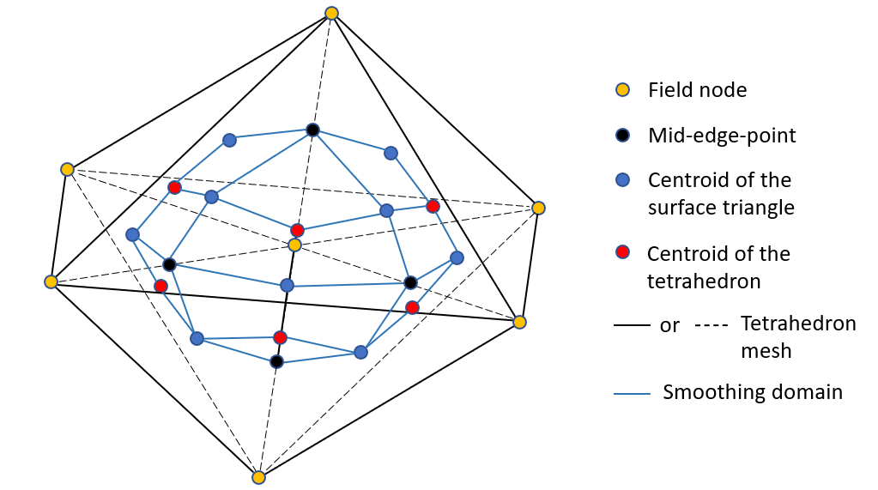
Figure 1. 3D smoothing domain based on given tetrahedron mesh

Numerical examples

Cook’s membrane
The first example is the Cook’s membrane problem, which is a well-known testing example in finite element analysis [2]. The model consists of a tapered plate clamped on one side with a transversal distributed load applied to the opposite side (Figure 2). For the quasi-incompressible material, the Poisson’s ratio $v$ is 0.49999, the Young’s modulus $E$ is 250 Pa. The thickness of the plate is 0.1 m, and the transversal distributed force $F$ is 100 N. The test is considered as an elastic problem and all nonlinear contributions in balance equations are omitted.

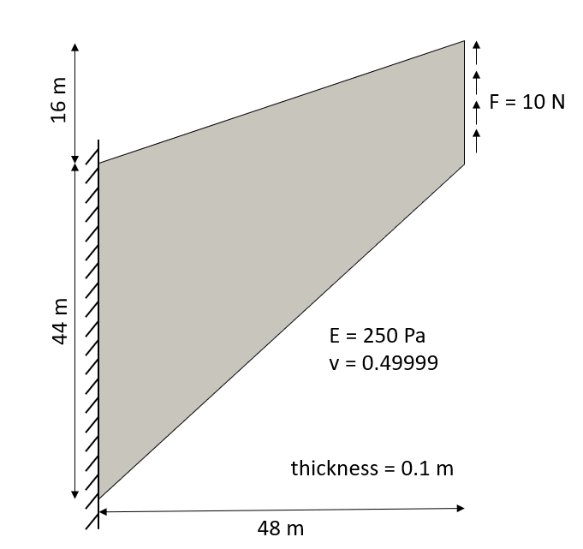
Figure 2. Cook’s membrane: geometry and material properties

The results from the SPFEM and the standard FE displacement formulation (FEM-U) [1] are compared with the reference solution [2] in Figure 3. The two results have an increased accuracy with the increased number of elements. However, the FEM-U result tends to show volumetric locking, and this locking phenomenon causes a large error between the FEM-U result and the reference solution. Additionally, the SPFEM can use a much smaller number of elements when the result tends to convergence, and its accuracy is much greater than the FEM-U. The result at the convergence from the SPFEM is only 1% larger than the reference solution.

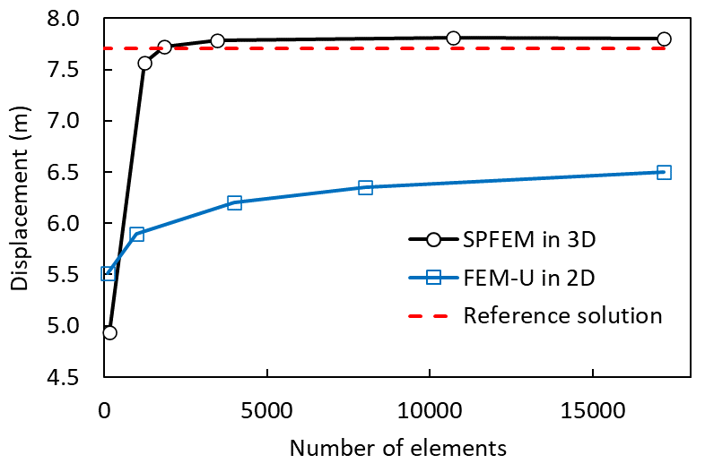
Figure 3. Cook’s membrane: top right corner vertical displacement

Landslide modelling
The second example is the collapse of a soil column. The original geometry of the column is 2 m high, 4 m long and 0.6 m thick (Figure 4a). The wall on the right side is removed instantly to lead the collapse of soils under the gravity. The material is allowed to collapse under the gravity by quickly removing the right wall. The soil materials are of density 1850 kg/m³, Young’s modulus 1.8 MPa, Passion’s ratio 0.3 and cohesion 5000 Pa. The mesh size is 0.2 m, the time step is 0.01s, and the total time is 10s. Figure 4b shows the deformed shape of the collapse at t = 10s. According to the simulation results, when t = 1.5s, the collapse process stopped, and deformed model has a stable state.

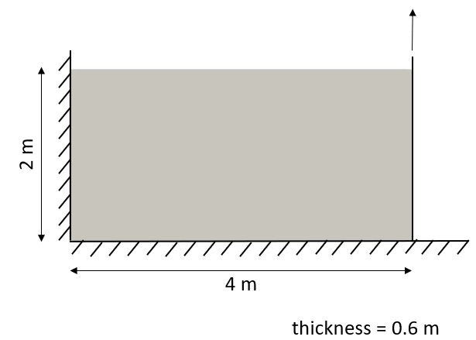 | 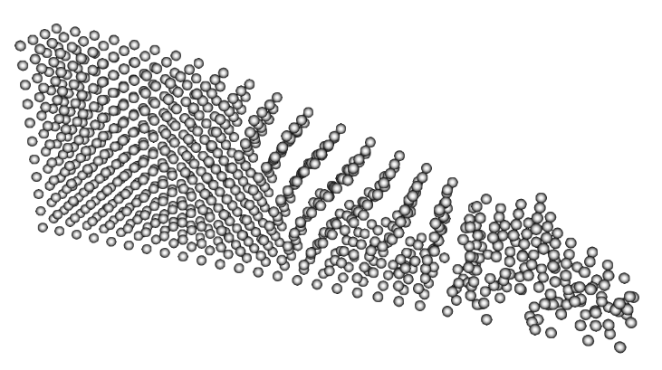
(a) | (b)
Figure 4. (a) Geometry of the landslide model; (b) Deformed 3D landslide model at t = 10s

Conclusion
A 3D SPFEM is developed to simulate large deformation soil mechanics problem. The SPFEM is an improved version of the traditional PFEM. Nodal integrations are carried out over cells rather than elements so that no volumetric locking issue is encountered even though linear elements are used. The nodal integration also removes away the variable mapping which is necessitated in the traditional PFEM when modelling history-dependent materials. Two numerical examples are shown to illustrate the robustness of the proposed method.

References
[1] Reinold, J. and Meschke, G., A mixed u–p edge-based smoothed particle finite element formulation for viscous flow simulations. Computational Mechanics, 2021: p. 1-20.
[2] Romero, I. and Bischoff, M., Incompatible Bubbles: A non-conforming finite element formulation for linear elasticity. Computer methods in applied mechanics and engineering, 2007. 196(9-12): p. 1662-1672.
[3] Zhang, X., et al., Particle finite element analysis of large deformation and granular flow problems. Computers and Geotechnics, 2013. 54: p. 133-142.
[4] Zhang, X., Meng, J., and Yuan, S., An implicit nodal integration based PFEM for soil flow problems. Computers and Geotechnics, 2022. 142: p. 104571.

