The Conversion of Buildings to Housing Use: England’s Permitted Development Rights in Comparative Perspective
Faced with acute housing crises, some governments are inclined to strip away the ‘bureaucracy’ of planning, relaxing rules on the scrutiny of planning applications and seeking to accelerate the building of new homes. The planning that remains becomes a ‘client service’ for the development industry – a system of housing licensing that follows on from a basic consideration of legal compliance. Such a system has been introduced in England, rooted in the extension of permitted development rights (PDR) for office-to-residential conversions. This article examines the determinants of housing quality through the conversion process, comparing the deregulated approach to conversion in England with Italy’s regulated approach, set within its zonal planning system. The conclusion drawn, after the examination of case studies, is that good quality housing cannot be delivered from the conversion of buildings without either the retention of strong case-by-case planning control or a much more detailed prescriptive approach to housing standards, which would have halted the majority of recent office-to-residential conversions in England.
Keywords: Building Conversions; England; Italy; Permitted Development; Regulation; Planning

Part 1: Introduction
Countries around the world have, in recent years, been confronted by a global crisis of housing affordability. That crisis has many causes, some shared between nations (cross-border flows of private capital, historically low interest rates and the financialisation of residential property – leading to the securitisation of home-loans and increased credit flowing into housing) and others more local (including planning restrictions on new supply and local economic challenges affecting housing production). Numerous authors have pointed to the common roots of reduced housing affordability and access (Fields and Hodkinson, 2018; Gallent, 2019; Rolnik, 2013; Ryan-Collins, et al., 2017; Ryan-Collins, 2021; Wetstein, 2017), to the complexity of local situations (Potts, 2020) and to the myriad responses being developed by governments of various political colouring (Anacker et al, 2019).
Some nations have accelerated public housing programmes as compensation for the critical cost barriers affecting private supply (Chong and Li, 2020). Some have sought to control housing costs, especially private rents in core cities (Weber and Lee, 2020). But others have taken the path of deregulation, presenting reform of land-use policy and planning practices as the desired route to increasing the supply of homes. Planning reforms are regularly underpinned by neoliberal and right-leaning critiques of how systems have been operating, and of the balance achieved between planning as a ‘public service’ (advancing democracy and participation in the processes of plan-making and development management) and planning as a ‘client service’ that lubricates the path of property development. Such critiques are prominent in countries operating more ‘discretionary’ planning systems – including England (Ferm et al, 2021) and Australia (Gurran et al, 2016) – but are also seen in countries with compliance-based ‘by right’ planning systems as well (for example in the USA; Glaeser et al, 2005). Further, such critiques always get louder under right-wing governments that lean towards reduced tax and financial deregulation. Such governments judge their own success in terms of house price inflation and the advancement of personal wealth through asset accumulation. But at the same time, the electoral necessity of broader appeal means that they must explain why private housing is increasingly inaccessible to households with no family history of ownership: the practices of land-use regulation therefore come under the spotlight.
The proponents of deregulation often argue that a stripping away of planning strictures, on the use of land and buildings, will allow the ‘market’ (in the form of private enterprise) to respond more quickly and efficiently, without the drag of bureaucratic cost, to the housing crises that are said to arise from the disequilibrium between expressed demand and the rate of housing production. In England, right-wing think tanks have been particularly influential in framing and shaping the debate over at least the last decade (Haughton and Allmendinger, 2016). That debate has moved on from one where a complete removal of the planning regulation is advocated, to instead focusing on the particular forms of planning practice in operation. The discretionary nature of the planning system in England has been a recent focus of critique (Airey and Doughty, 2020) with claims that it is a major source of uncertainty and risk for the development sector, inspiring the Planning for the Future White Paper’s (MHCLG, 2020a) push towards a zonal approach to land-use control (Gallent et al, 2021), which appears to have been neutered, for now, by local political backlash.
Deregulation of those land-use regulation practices – loosening the rules and removing democratic scrutiny of planning processes – is applied not only to new development but also the conversion of buildings to residential use (Morton, 2012; Ferm et al, 2021). The practice of building conversion diverges greatly between countries operating discretionary and compliance-based (‘by right’ or ‘regulatory’) planning systems. The former traditionally judge the appropriateness of conversion on a case-by-case basis, taking a holistic view of the merits of a scheme against various policies. Conversion opportunities in the latter are assessed against zonal ordinances and codified rules. And whilst the former engages in political scrutiny of those opportunities by local lawmakers, against local principles that are consistent with national policy, the latter follows a strict rule-book. In both systems, there are a range of checks and balances designed to ensure that conversions are locationally and typologically appropriate and will perform their future function, e.g. as homes, as well as might be expected. However, deregulation can remove these safeguards and impact the design quality of the housing being created as a result.
The purpose of this paper is to analyse and compare the conversion of buildings to residential use in the contexts of different planning systems, to link processes with an assessment of product quality. The systems chosen are those of England and Italy: England because of the breadth and depth of deregulation witnessed in recent years; and Italy because of its conformity to the zonal model and the consistency of approach to building conversion. It is also the case that our research and practice has been based in these countries for a number of years. Insights are drawn from past projects (e.g. Madeddu et al, 2015; Clifford et al, 2018) and, in the case of the lead-author, periods in architectural practice in Italy. We aim, through this analysis, to contribute greater understanding to planning’s role in the regulation and procurement of quality in residential development, whether through the close scrutiny of applications or regulatory compliance.
1.1 Achieving housing quality in England and Italy
England and Italy operate very different planning systems. Planning in England is traditionally discretionary: the power to grant permission for residential development lies with local authorities, which judge applications on a case-by-case basis (Booth, 2007). Proposals to develop land – or make material changes to buildings – must comply with local plan policy, but it is still for local planners and politicians to weigh the proposal (and its compliance) against other considerations, including the input of local communities, which may object to some aspect of the proposal. Although local discretion has always been circumscribed by national policy, which has become more prescriptive in recent years (within the National Planning Policy Framework and associated Planning Practice Guidance) to ensure that local requirements do not undermine the viability of development, considerable scope remains to vary and attach conditions to planning permissions where there is a need for a full application and where locally-evidenced policies have been included in a Local Plan.
Discretion generates risk for development actors and has resulted in perennial attacks on the foundations of English planning. It is derided as bureaucratic, slow and excessively political by some actors, although many developers – who are adept at navigating the idiosyncrasies of the system – appreciate the flexibility that local discretion and negotiation provides (Gallent et al, 2021). They are able, for example, to negotiate on planning gain requirements (agreeing contributions that add value to their development – for example, a new school in proximity to the new homes that they will need to sell) rather than being tied to a formulaic fixed tariff that may not lead to investments that directly benefit their scheme. Nevertheless, calls for root and branch reform have become louder over the last couple of years (see Airey and Doughty, 2020; Breach, 2019; 2020), with opponents of the current system perhaps sensing an opportunity for very radical change arising from the Covid-19 pandemic, and government’s desire to ‘build, build, build’ (Scott, 2020). There has been significant advocacy of a ‘zonal’ approach, that green-lights compliant development without the need for further professional or political scrutiny (MHCLG, 2020a). Proposals to take the planning system in this direction, set out in the aforementioned 2020 White Paper, were abandoned following a by-election defeat for the ruling Conservative Party in the constituency of Chesham and Amersham in 2021. Planning reform, and especially zoning proposals, proved a decisive factor in that defeat as local voters took issue with what they perceived as an erosion of local control over planning decisions. But the reform agenda did not disappear, with the aspiration to deregulate remaining firmly in government’s sights. During the short premiership of Liz Truss, the achievement of economic growth was presented as being wholly dependent on deregulation of various forms, including the extension of permitted development rights (see detailed discussion below) – which can be achieved relatively quietly, through tweaks to secondary legislation (instruments that are subordinate to existing laws), rather than needing potentially high-profile changes that risk upsetting voters. But these quieter reforms have the effect of waiving through certain kinds of development, substituting discretionary processes with ‘by right’ permissioning, which looks very much like zoning.
Zoning instruments of this type bring a degree of convergence between English planning and the system that operates in Italy, where municipal plans fix development zones, allowing compliant projects – that adhere to the zoning ordinance – to proceed after technical consent. That technical consent depends on detailed compliance with a relatively complex building code first established in 1898 and then revised in 1976 (Gallent et al, 2010). Housing and other forms of development can go ahead so long as they comply with a raft of technical standards that, amongst other things, will prescribe minimum floor space for rooms and housing units, the arrangement of bathrooms in relation to living rooms, and the dimension of windows relative to the size of rooms. Those standards are rooted in public health legislation and intended to deliver good quality housing, whether new build or arising from the conversion of previously non-residential buildings.
Approaches to delivering ‘housing quality’ in England and Italy differ fundamentally. In England, the current approach of case-by-case scrutiny of development proposals provides local authorities with the opportunity to work with developers on the type and quality of housing built. There has been longstanding interest in the adoption of floor-space standards of the type used in Italy. However, it was decided in 2015 that such standards should be described rather than prescribed, and thereafter available to be adopted in local plans, providing authorities with a common basis on which to negotiate, with developers, for good standards in housing development. The introduction of these Nationally Described Space Standards (NDSS – DCLG, 2015) via this route takes an approach that is clearly in-step with the discretionary nature of planning in England. Local authorities, through the exercise of their planning function, are traditionally seen as the guardians of housing quality. This approach may continue to evolve in the future, as it looks likely that England will adopt standardised ‘national development management’ policies for all local authorities (DLUHC, 2022). These will seek to increase the uniformity of plans and the certainty of development management, further circumscribing the discretion available to local authorities, although the core tenets of decision-making, by a local authority that reaches a decision after weighing up different material considerations, will remain. This will mean that where the traditional route to planning permission is retained, authorities will continue to work with their development partners on quality assurance. The different planning system in Italy requires a different approach to governing quality. Its compliance-based system, without discretionary scrutiny, means that a fixed set of standards is essential. In other words, a prescribed rather than described building standard – governing floor space, layout, air circulation etc. – becomes essential if case-by-case scrutiny of planning applications is either absent or is removed.
1.2 Deregulation and housing quality
That removal of case-by-case scrutiny has already been happening in England over the last 10 years, as government – influenced by various think-tanks – has introduced reforms that dismantle local discretion in planning control in favour of more ‘as-of-right’ zoning instruments. Those instruments include the extension of permitted development rights (PDR – introduced in 2013 and accelerated after 2015) (Clifford et al., 2019) and the use of permission in principle for selected brownfield sites (Gallent et al., 2019). Permitted development rights in England have allowed the conversion of a range of commercial buildings (most notably offices, but also light industrial and retail) to residential use with no case-by-case planning scrutiny as to whether the principle of development (i.e. meeting key locational attributes) or design is adequate. The conversion of buildings to residential use through PDR in England is part of the wider political economy of the response to the ‘housing crisis’ already noted. Under the Coalition and Conservative governments in power since 2010, this housing crisis has been presented primarily as a ‘building problem’: too few homes are being built relative to demand because of a slow and cumbersome planning system that inhibits the market’s capacity to self-correct (Gallent, 2019). In that context, PDRs are presented by the UK Government as a means of ‘cutting the red tape’ that stands in the way of the rapid acceleration of housing unit delivery that the country needs (Ferm et al, 2021). Building conversion in England is now strongly associated with this push to increase housing unit numbers and with the deregulation that has been promoted over recent years.
However, the UK government’s recent push on deregulated building conversions – turning office and other commercial buildings to housing use – needs to be set against the broader rationale for conversions, which is rooted in a careful consideration of their adaptive potential. Changes in the use of buildings are normally part of their ‘adaptation’ process, as ‘buildings are not static’ but rather subject to a variety of transformations that affect their use, including technological innovations (Douglas, 2006: 9). In this context, the ‘adaptive reuse’ of buildings - which includes both the conversion to alternative uses and adaptations to the same use – aims to intervene in buildings that are not able to fulfil their original function anymore but that cannot be demolished, due to their real estate, cultural or symbolic value (Camocini, 2016) and has become a key part of many governments’ responses to sustainability and climate change, as well as their strategies for the preservation and valorisation of cultural heritage (Olivadese, 2016; Yung and Chan, 2012). This is the case in Italy, where adaptive reuse is a large part of the construction sector (SSDA, 2020); this, combined with the country’s history of reliance on conversion to create new uses, its mature architectural sector focused on conversion, and the presence of a strong regulatory framework, makes practices of building conversions in Italy a good comparator, from which lessons can be learnt.
The intention in this article, then, is to compare the conversion of non-residential buildings to residential use in England and Italy, illustrating how such conversions progress (the process), and what quality is achieved (the product), in these two systems with their respectively different approaches to planning control and building regulation. The paper is structured in the following way. We begin, in Part 2, by providing additional detail on the two countries’ respective approaches to the conversion of non-residential buildings. Part 3 then looks briefly at conversion and change of use from locational and typological perspectives. Different conversions – for example, industrial to residential or office to residential – pose different architectural design and reuse challenges, by virtue of the building type (basic structure and shell parameters) and the likely location of buildings earmarked for conversion. Part 4 of the paper then turns to the history of conversion in the two countries – what sorts of buildings have been converted in the past and the size and scope of conversion activity. It is important to understand the maturity of these industries and therefore the familiarity of actors with good practice in residential conversion. Part 5 of the paper then returns to an issue introduced above: the interplay between regulation and design (i.e. the design process) in residential conversion. The focus here is particularly on Italy and the involvement of specialist architects in working with and interpreting Italian building code when involved in the conversion of buildings for residential use. Illustrative examples of office to residential conversions (which form the majority of PDR conversions), focusing on processes and outcomes, are then presented in Part 6. Then, in our conclusions (Part 7) we return to, and more fully discuss, the critical problem highlighted above: the challenge of delivering good quality housing – good in terms of function, liveability and location - from the conversion of buildings without either the retention of strong planning control or a prescriptive approach to housing standards.
Part 2: The Extension of PDR in England and Italy’s Building Code
2.1 PDR in England
The change of use of buildings has been considered ‘development’ requiring planning permission in the UK since the Town and Country Planning Act 1947. To help determine whether particular changes of use are materially significant or not, buildings are categorised into use groups by the Town and Country Planning (Use Classes) Order 1987 (as amended). Prior to 2013 (for offices) and 2015 (for light industrial and retail buildings), a change of use from commercial to residential use was considered a material change of use requiring planning permission on a case-by-case basis by the local planning authority, who would take the decision against the backdrop of policies in the local plan and other relevant considerations. Following a deregulatory policy decision by central government, these changes of use are now considered ‘permitted development’ in England. Under the procedures set out in the Town and Country Planning (General Permitted Development) Order 2015, these changes of use are granted planning permission on a national basis, i.e. assumed to be acceptable in principle, and local authorities can only check them in relation to a narrow set of technical planning issues such as flood risk and highways impacts under a process known as ‘prior approval’. This has not included anything related to the design or location of the proposal.
These conversion schemes are still subject to building regulations. This technical building code is now set out in 16 ‘approved documents’, all updated between 2010 and 2022. They prescribe standards that must be achieved in the areas of building structure, fire safety, site preparation, toxic materials, sound, ventilation, sanitation, drainage, heating, falling objects, power and fuel efficiency, access, overheating, electrical safety, security, ICT, infrastructure for electrical vehicles and workmanship. Approved Document M ‘Access’ has some prescriptions on building access for the mobility-impaired but does not apply universally (and does not apply to these PDR conversions since it links back to local plan policies). There are no floor-space prescriptions written into England’s building code, nor requirements for the penetration of natural light into a dwelling. Rather, the code is focused on materials, various aspects of building safety and efficiency, basic services and production quality.
Residential development in England has been plagued by accusations of poor workmanship: new homes handed over to occupants with dozens of ‘snaggings’; ill-fitting doors and windows, poorly rendered walls and so forth. Hence the addition of Regulation 7 in 2013 (updated 2018 to restrict the use of combustible materials in external walls of buildings higher than 18m following the Grenfell Disaster), addressing this issue (HM Government, 2013). But wider quality issues – including the appropriateness of location, the internal layout of homes (to suit the needs identified by local planners) and broader ‘design features’ – are agreed between development management officers and housebuilders during the permissioning process. Some of these issues are covered in design guides or codes referenced in local plans. Whether or not developers comply with the wishes of planning teams will depend on the ‘soundness’ and viability of planning policy, but generally there is an opportunity for planning to shape the quality of residential development, which is foregone in the case of permitted development. Plan policies do not apply, there is no discretionary scrutiny, and technical consent means meeting the limited prescriptions of England’s building code and the very limited set of considerations in the prescribed prior approval process only.
Government statistics are available for 2015-2021 and show that during this period, 83,611 new dwelling units were created across England under PDR, including 73,575 from the conversion of office buildings (MHCLG, 2021a). The original expansion of PDR to cover office-to-residential conversion in 2013 was on a temporary basis but was subsequently lauded as successfully delivering thousands ‘more homes’ and made permanent in 2015. The government’s impact assessment when introducing the deregulation in 2015 did not consider impacts on housing quality from the policy changes, but did say that developers would be unlikely to deliver conversions in unsuitable locations, such as industrial estates, because they would ‘struggle to sell’ such housing (DCLG, 2013): an ideological belief in the self-regulating capacity of the market (and a measure of quality boiled down to ‘what sells’) which, as we will show, was misplaced.
2.2 Conversion to residential use in Italy
All sorts of buildings are converted to residential use in Italy, but this conversion happens in the context of both a general building code and technical floor space standards. The general code – or Testo Unico dell’Edilizia – dates from 2001 but is subject to periodic revision. It provides a broad framework for technical building consent, covering core legal responsibilities and the different consents and sign-offs needed at various build stages in Part 1 and all of Italy’s ‘technical regulations for building’ in Part 2. The Testo Unico covers many of the same issues as England’s Approved Documents, including building access. Indeed, Article 82 of the Testo Unico has the same focus as Part M of the building regulations, being concerned with ‘eliminating or overcoming access barriers in private and public buildings’. But this general building code sits beside Istruzioni Ministeriali (Ministerial Instructions) originally issued in 1896 but then revised and reissued in 1975, that stipulated room volumes, ceiling heights and window dimensions. The 1975 ‘modification’ to the Istruzioni provides a baseline for the design of homes in Italy: ceiling heights must be at least 2.7m (with the concession that corridors and garages can drop to 2.4m); floor space minimums must be achieved for particular rooms so they are inhabitable (superficie abitabile) and overall dwelling space (superficie dell’alloggio) minimums are also set; to ensure light capture, window dimensions must not be less than 1/8 of a room’s superficie abitabile; and toilets must have direct natural light.
Both the Testo Unico and Istruzioni Ministeriali provide national standards for new build and conversion but are generally incorporated into local codes that reflect contextual conditions. Authorities in the mountains, for example, will have reduced ceiling height stipulations; and those with concentrations of historic or industrial buildings will set requirements – on local architects and builders – that reflect their particular contexts. For example, ceiling minimums or window dimension rules may be eased or stipulations on natural or mechanical ventilation altered. The national standards will be made relevant to local context in a comprehensive building and design code (Regolamento Edilizio) aimed at ensuring regulatory compliance, build quality, and that all residential buildings and spaces achieve a benchmark of inhabitability, measured in terms of floor-space, ventilation, natural light and good sanitation. In Italy, there is no getting around the rule that at least one bathroom in each separate dwelling house must have, amongst other bathroom basics, a bidet (Article 7, Modificazioni, 1975). For new build, benchmarks can be achieved through standard pattern-book designs. But the conversion of non-residential shells into residential use is often challenging, requiring architects to have intimate knowledge of local codes and considerable dexterity in interpreting those codes and carving out compliant residential spaces from former industrial or commercial buildings (see Part 5).
Part 3: Typological and Locational Issues in Building Conversion
As well as knowledge of the regulatory framework, understanding the building’s context and characteristics is indispensable when contemplating the adaptive reuse of buildings: in this respect, typology and location are significant determinants of what is possible in terms of residential conversion (Douglas, 2006).
In common parlance, the word typology has become synonymous with type and ‘understood as buildings grouped by their use’; however, more precisely, the former indicates ‘the discourse, theory, treatise (method) or science of type. Its reduction to category of use is limiting as buildings are independent from their function and evolve over time’ (Lee and Jacoby, 2011: 17). It is this ‘essential quality of change and transformation […which] endows type with the possibility to transgress its functional and formal limitations’ (ibid: 17) that we are considering here.
It is not uncommon for buildings that have outlived their original use to be converted into housing. However, different building types - such as offices, retail and industrial buildings - have various degrees of conversion potential that is intrinsically linked to the building type itself. This conversion potential is influenced, first of all, by their overall quality. Fianchini and Ferrucci (2018: 1) point out that industrial buildings are often turned into (prevalently) luxury flats, as well as public facilities, because of their ‘architectural character and / or their identity value for local communities’. In England, for example, the character of Victorian warehouses, has made their conversion very ‘desirable for buyers’ (CGL et al, 2011: 17) but, more broadly, across Europe and North America a variety of former industrial buildings of distinctive architecture have become attractive to people aspiring to a ‘loft living’ style (Camocini, 2016; Zukin, 1982). On the contrary, the conversion of offices has generally proved ‘less attractive […] for designers, and of little interest to developers’ (Fianchini and Ferrucci, 2018: 1), unless incentives are provided by governments, such as in the case of PDRs in England.
The adaptability to other uses of different building types is also influenced by specific physical features, such as their structure, façade, floor span and layout, including the number and locations of stairwells and elevators (Remøy and De Jonge, 2007). These features can either facilitate or complicate conversions. In converting offices to housing, building structure and floor span are considered key elements. Precast concrete floors, for example, are not easily pierced with holes and this ‘makes it difficult to add vertical shafts’ (ibid: 166), that in housing blocks are needed in higher numbers (for water circulation or electricity), whilst ‘steel framed buildings are the easiest to convert because […] units can be partitioned along beam lines and services can be placed close to partition walls’ (Gann and Barlow, 1996: 61). Deep floorplates are problematic for day-light access and natural ventilation. Nonetheless, careful design consideration, such as the location of kitchens, bathrooms and storage areas at the most internal points so that living areas can access natural lighting, can make the conversion of deep floorplate office buildings feasible; this was the case, for example, in the conversion into luxury flats of Trade Towers at Plantation Wharf in Battersea, London, where a deep floorplate was accompanied by high ceilings and large windows (ibid.). The same sort of conversion is ongoing at Liverpool’s Tobacco Warehouse, where the deep floorplate / light penetration problem is being resolved with double-height living areas onto which the original windows of two floors face. Such solutions, however, can be expensive with that expense reflected in sale price.
The physical characteristics mentioned above vary from country to country and have evolved though time, so that the conversion potential of buildings is also affected by the time at which they were built. Recurring design solutions can be found in specific periods. The specificities of the office buildings, for example, started developing after the industrial revolution. Until then, offices had much in common with houses – but the advent of Taylorism, the development of steel structures and, later on, of artificial lighting and mechanical ventilation, led to the introduction of open floor plans and larger floorplates (Remøy and De Jonge, 2007). Research on UK office-to-residential conversions has revealed how buildings of different ages (i.e. pre-1945, 1945 to 1979, and 1980 onwards) tend to have different levels of reuse potential: indeed, ‘the shift in format and design between these vintages has an impact on the practical viability of conversion potential’ (CGL et al, 2011: 14). That research claimed that post-war buildings (1945 to the late 1970s) are better suited to conversion not only because of the absence of conservation policy constraint but also because of shallower floor plates (ibid.) and the typical distribution of cellular rooms either side of central corridors (Gann and Barlow, 1996). Such buildings are, however, ‘likely to require significant upgrade to the façade’ (CGL et al, 2011: 18). A similar picture has emerged from research in Italy, focused on the city of Milan. It has been shown that offices built during this post-war period can more easily meet contemporary dwelling requirements because of their ‘low spatial and functional internal definition, modularity, divisibility, modular coordination, standardization, flexibility, accessibility, maintainability and usability of the technological systems’ (Ginelli, 2016: 4).
Support for the repurposing of office buildings to residential use is rooted in a reality of office redundancy and acute housing need. Typologically, offices have the advantage of a generic layout that ‘can easily be adapted to any use and occupation’ as the floor plan is ‘typically organized as unobstructed space with a minimum number of vertical supports and vertical circulation and clustered services’ (Aureli and Tattara, 2015, para.8). This ‘abstraction of the office plan’ allows the ‘invention of alternative housing configurations’ when office space is converted into dwelling space; indeed, the load-bearing structure of office buildings is ‘independent from partitions’ rather than being ‘combined with the walls that separate rooms’ as in apartment blocks and this makes it ‘easier to organize a more flexible collective and shared mode of living both in social and economic terms’ (ibid., para.9). It is often the case, therefore, that office buildings lend themselves to co-housing configurations, where minimal individual spaces are coupled with expanded communal spaces. Conversion into self-contained units, however, is often more challenging and ‘the right type of building needs to be found to meet a particular housing need’ (Gann and Barlow, 1996: 64).
Although some specific building features can make conversion from other use types to housing difficult, there are few ‘that make conversion impossible’. Location, however, is often a deal breaker when it comes to successful conversion: ‘a building is more easily manipulated than its location’ (Remøy and De Jonge, 2007: 169). Douglas (2006: 146) confirms that, albeit within the limits of the constraints explored above, ‘potentially, most types of buildings can be adapted to another use’ but the range of possibilities for conversion is greatly limited by locational attributes. Those attributes include the presence and quality of services and amenities (such as green spaces, retail and leisure), the general accessibility of the site, especially via public transport (which should ideally be located within a five-minute walking distance), and critical locational barriers such as proximity to dangerous and noxious neighbouring uses (Kincaid, 2002; Olivadese, 2016). Historic buildings, whilst presenting a greater range of technical challenges and regulatory constraints (Douglas, 2006), often have the advantage of a central location. In the Italian planning system, locational considerations are addressed through zoning regulations included within local plans (Piani Regolatori Comunali). These prescriptions forbid change of use in specified areas (see Part 5).
Whilst the consideration of typology and location is paramount for developers when converting buildings to residential use, as these attributes will affect the saleability or rentability of housing units, research (Clifford et al, 2018 and 2020) has shown that conversions in England under PDR rules, frequently proceed where typological and locational characteristics are sub-optimal. This is because the attractiveness of units, to either buyers or renters able to exercise a degree of market choice, is not a consideration. The units built are targeted at either low-income renters, who could not otherwise afford local market rents, or used to provide temporary accommodation for the homeless, with costs met by local authorities through the housing benefit system. Those at the sharpest end of the housing crisis have little choice but to live in poor quality, and poorly located, housing units where they exist. PDR opens up such ‘opportunities’ for the most vulnerable households, breaking from the typological and locational standards of more conventional conversions and assigning these attributes less importance for households unable to exercise choice.
Part 4: The Conversion ‘Industries’ in England and Italy
4.1 Reuse in England
Whilst the expansion of PDR triggered an increase in the number of buildings being converted from commercial to residential use, this type of development activity was not unknown before the recent rounds of deregulation: in 2006-07, 20,150 new dwellings in England were created through such change of use (MHCLG, 2021). Indeed, there have long been conversions of wharf style industrial buildings to residential use, particularly in waterside locations across England, but also other commercial use buildings to residential. There have also been buildings which were originally residential in use, such as early nineteenth century town houses in inner city locations which were converted to office use in the 1960s and 70s and are now returning to housing use as neighbourhoods change functional focus and the spatial economics of urban areas shift. These conversions have often been undertaken by specialist developers, with many ‘big players’ in a development industry dominated by a small number of large national volume housebuilders displaying a clear preference for new-build schemes, especially on greenfield sites (Clifford et al, 2019).
The profitability of PDR conversions, given the lack of design control coupled with an absence of requirements to provide affordable housing or make affordable housing contributions to local authorities for such schemes, has attracted new development actors into this space (Clifford et al, 2018). On the whole, it has not been traditional large housing developers who have been doing these conversions, but rather small and medium sized local developers (SMEs). For example, Inspired Homes in London was a small company which converted existing large residential buildings into smaller flats before expanding into large office-to-residential conversions under PDR, whilst YPP in Leeds is a business which has grown entirely on the basis of the opportunity provided by PDR, and Caridon, in London, is a property management company which has been involved in a number of large office conversions, but did not have a history of housing development prior to PDR.
Whilst not all PDR conversions are poor quality (and targeted at households with least choice - see above), there have been significant concerns about the quality of design of a majority of them (see Clifford et al, 2018; Clifford, 2019; Clifford et al, 2020). The poorest quality schemes appear to have been delivered by SMEs that lack any significant experience of housing development prior to the introduction of PDR regime. New entrants to the construction and conversion industries have seldom achieved accredited quality standards. As noted in the last section, the poorest quality conversions have been used for private rental or temporary housing rather than market sale, and indeed many of them would appear to be un-mortgageable for private sale purposes (see Moore, 2020, on conversions used for temporary housing). Some small-scale office and retail to residential conversions have been undertaken without the involvement of an architect, although many of the more significant office-to-residential conversions appear to have drawn on architectural expertise, but not always to enhance design quality. Rather, architects have been engaged to formulate clever space arrangements that maximise the number of housing units created – or crammed onto an otherwise limiting floorplate.
4.2 The Italian experience
The conversion of office buildings to residential use in Italy has become more commonplace in recent years (Camocini, 2016; Russillo, 2016) but does not have a long history. This is in part because of a recent surplus of offices in large cities such as Milan, where 31% of office space was vacant in 2018 (Fianchini and Ferrucci, 2018), and also because of increasing demands on the available housing stock from growing urban populations (Micelli and Mangialardo, 2017). Within that context, there has been some advocacy of office to residential conversion (Olivadese et al., 2017) and some interest from international companies looking to invest in adaptive reuse, especially of historic buildings in prime locations (Benna, 2021).
However, adaptive reuse of various types is not a new phenomenon in Italy. There are many historic precedents: the Bath of Diocletian in Rome, for example, was transformed into a church during the Renaissance, and religious buildings were frequently being converted into a variety of uses, including housing, by the middle of the nineteenth century (Di Biase, 2017). More recently, the rediscovery of the country’s industrial heritage has led to a proliferation of conversions of old factories into public (mainly cultural) and commercial uses, as well as (mostly luxury) flats, especially since the 1990s. Italy’s building stock is old, with almost 30% of residential buildings dating from before 1945 and 60% from before 1970 (SSDA, 2020). It is perhaps unsurprising, therefore, that more than 70% of the value of the Italian construction industry currently comes from retrofitting and reusing existing buildings (ibid.). Whilst interventions are primarily concerned with building maintenance and energy efficiency (ibid.), adaptive reuse is increasingly considered by the Government as a means of reducing land consumption (Olivadese et al., 2017). The high proportion of empty buildings in Italy – 5.2% of total building stock at the last Census (and 27% of these publicly owned: Tacconi, 2018) – gives further incentive to the conversion industry, with adaptive reuse seen as a key strategy for the preservation and enhancement of buildings of historic and cultural value (Bottero et al, 2019).
Buildings ‘are considered for change in use because of their historical, morphological and architectural interest. These buildings are usually located in historical city centres or existing urban areas or […] in a strategic location’ (Olivadese et al., 2017: 171). The new uses of the buildings are influenced by financing and management models: whilst ‘public-driven’ projects normally host public functions, such as museums or universities, those led by private actors target housing, commercial and tourism use; and those projects involving non-profit organisations seek ‘socially-oriented’ uses - community hubs or enterprises that are temporary and often involve a partnership with a public landlord (Lupacchini and Gravagnuolo, 2019).
Companies big and small are involved in conversions. The profile of the Italian construction sector is weighted towards smaller enterprises: almost two-thirds (61%) of company registrations have a single employee (the owner); a third (34%) employ between 2 and 9 people; and a very small proportion (4%) are considered mid-sized (10 to 49 employees) or large (more than 50 employees). Most companies (75%) are specialist, so tradesmen and potential sub-contractors. The remainder are companies that actually engage in construction and conversion. Ninety percent of companies file turnover of less than 500,000 euros per year. Only 0.1% file more that 20 million euros (ANCE, 2019). It is difficult to discern the profile of the sector (the balance of volume, regional and small producers) from official data as unit output figures are not provided. However, the scope of reporting suggests a more mixed eco-system of housing delivery in Italy than in England, where 80% of private housing is supplied by a small number of volume builders.
The majority of large conversions are entrusted to bigger companies – those with significant turnovers. Turin’s Zumaglini & Gallina Spa, for example, transformed a former train repair depot (Officine Grandi Riparazioni) into a cultural centre. Also in Turin, another large company (DeGa) converted a nineteenth century hostel (which had been the erstwhile home of Antonio Gramsci) into a hotel. That conversion involved numerous smaller companies and such projects often involve large networks of local subcontractors (Minello, 2019). Architects, engineers and geometri (building surveyors) who are familiar with coding strictures and consents for conversion are also heavily involved in adaptive reuse. For many, it is their main business – with design and regulatory considerations finely balanced.
Part 5: The Interplay of Regulation and Design in Residential Conversion
Regulation is not a guarantor of housing quality (see, for example, Carmona et al (2020) who demonstrate that poor quality housing development is not unusual, even where it has been consented under the normal permissioning process). Nor is it the only determinant of quality: Clifford et al (2020) found an apparent correlation between the quality of the homes being delivered through the deregulated PDR route and local socio-economic deprivation levels, with stronger real estate markets appearing to support higher standards, because of the presence of extractable value and the possibility of targeting higher-income clients. However, in all cases examined (ibid.), the deregulated PDR conversions were of lower design quality than the homes delivered under the more regulated traditional planning permission route. Regulation contributes significantly to the overall quality of housing by acting as a brake on poor design and providing a framework for good design. We have argued elsewhere that whilst overly prescriptive standards might stifle innovation and result in banal built environments, flexible regulation, which flexes with different circumstances, can help deliver well-designed homes (Madeddu and Clifford, 2021).
Building conversions in Italy are strongly regulated: firstly, local plans (Piani Regolatori Generali - PRG) determine which uses are permitted in each development zone, so changing the use of a building is not always possible. This zoning system – introduced just after the unification of the Kingdom of Italy in 1861 - aims to avoid the co-location of incompatible uses and to ensure that minimum services are guaranteed, as specific infrastructure and service provision (e.g. green spaces) are associated with different development zones (standard urbanistici). In Turin, for example, residential uses are not permitted within ‘productive zones’ (areas for industrial or artisanal activities) and main high streets have to retain commercial uses at street level. And even where new functions are compliant with the zoning ordinance, the PRG may still prohibit changing the use of specific buildings (e.g. Turin’s PRG affords special protection to some cinemas). Secondly, conversions must adhere to the same regulations that are applied to new buildings, including respecting minimum space standards and ceiling heights. Adaptive reuse always requires that permission be obtained from the Local Planning Authority in the form of a building permit (Permesso di costruire). Furthermore, applications to convert part of an office building to residential use requires that the applicant considers the incremental impact of the conversion and how it fits with changes made during the previous three years.
Whilst Italian regulations have been criticised for their rigidity, and some authors have pointed to the difficulty of adapting standards to older buildings (Agostiano, 2016; Olivadese et al., 2017), those standards have also been lauded as ‘one of the foundations of modern public health’ (Werna et al, 2020: 11). Past research in Italy has highlighted their role in the promotion of healthy homes (Gallent et al., 2010; Madeddu et al., 2015) that contribute to the physical and psychological wellbeing of occupants. Moreover, since the 1980s an increasing number of ‘exceptions’ to national rules have contributed to the flexibility of Italian regulation. These often pertain to the conversion of historic buildings (Agostiano, 2016) and increase the scope for local deviation from fixed standards where it can be shown that the ‘performance’ of the building will not be unduly compromised. The shift away from a ‘prescriptive’ to a ‘performance-based’ regulatory approach, based on case-by-case analysis, seeks ways in which ‘original and innovative solutions’ may be able to compensate for ‘space and functional reduction’ (ibid, 94). In short, the interplay between design and regulation has come to the fore and there is a new emphasis on negotiation with local authorities (Olivadese et al., 2017), with designers demonstrating different ways of interpreting rules and seeking derogations (Olivadese, 2016) that can be shown to not impede function or performance.
This often happens in historic centres, where authorities prioritise the preservation of building frontages over strict prescription of ceiling heights or window dimensions. Similarly, buildings located at higher elevations (i.e. in mountainous areas) are able to have lower ceiling heights, which aids performance in terms of air circulation owing to different climatic conditions. It is also the case that where designers can show that new technologies will aid building function and performance, compromises are possible against dimension and configuration prescriptions (Agostiano, 2016). Local Regolamenti Edilizi (building regulations) will grant their own concessions depending on circumstances and, again, local professionals will have to argue for derogations from the norms if they require further flexibilities. Despite the lack of a separate building code for conversions, many Local Authorities include in their general building and design codes specific sections addressing interventions in existing buildings (Olivadese et al., 2017). In Turin, for example, sections of the Regolamento Edilizio aim specifically at incentivising adaptive reuse, permitting flexibility when converting attics and agricultural buildings, as well as in relation to cultural heritage, whilst Milan’s building code draws attention to the need for conversions to residential use to provide ‘accessory’ spaces such as balconies, loggias and roof gardens. The local regulations can grant greater flexibility but also seek attributes, including private external space, which exceeds the national standard.
Italian architects have long been confronted with the conundrum of regulation versus the need for flexibility in design - but the presence of strong regulations has not been an impediment to delivering quality. Farris (2016) has argued that Italy’s large stock of ‘heritage’ buildings has incubated a particular ‘Italian way’ of balancing regulation with design innovation. Although an antipathy towards the burden of regulation has been noted in some countries (see, for example, Imrie and Street, 2009), that burden – or constraint – can also be seen as a call to innovate, to test the boundaries of regulation, and even as a ‘resource that leads to alternative, but similarly valid, solutions’ when confronting the challenges of conversion (Agostiano, 2016: 96). Previous research on this topic concluded that fixed standards force architects to more closely explore different space possibilities and configurations (Madeddu et al, 2015: 91) and that the great majority continue to see regulation as an essential means of protecting residents from bad housing (Olivadese, 2016). This is not only because basic quality thresholds are set, but because regulations demand that architects are engaged in the process of design innovation.
These debates, concerning the role and centrality of regulation in design quality, are mainly drawn from the Italian case, where it is generally agreed that the fixing of basic standards is necessary to achieve a baseline quality for new housing, with deviations only permitted where good design can offer innovations that overcome critical constraints, often arising from the typological characteristics of the building earmarked for conversion. In a context of constraint, the challenge of meeting regulatory standards can be viewed as a potential driver of innovation. Baseline standards, design innovation and often substantial cash investment (that render some buildings unconvertible, except for high-end clients) are important determinants of the eventual quality of outcome from conversions.
Part 6: Converting buildings to residential use – cases from England and Italy
The discussion above has sought to draw attention to the contexts for, and drivers of, building conversion in our case study countries. In England, conversion is considered part of the problem-resolution to the housing crisis, aligned with a neoliberal logic of market deregulation. We would contend that there have been few mechanisms in place to ensure that the conversion of offices to residential use delivers good quality housing under the PDR regime, particularly between 2013 and 2020/21 when conversions under this regime were not subject to the described space standards. In Italy, conversion is part of a long history of dealing with the adaptive reuse of existing buildings and is underpinned by a strong regulatory framework which can flex according to local conditions and in response to design innovations that maintain the functionality and performance of converted space. In both cases, the success of any conversion will depend on building typology and location.
The aim now is to present illustrative cases that link the rules and processes of conversion to achieved outcomes in England and Italy. In terms of the former, our focus is on situated processes (having outlined rules above): how the conversion of office buildings to residential use was undertaken in the context of local regulation. To this end, we explore the histories of case study buildings, explain the drivers behind their adaptive reuse, which stakeholders were involved in the process, and how the design and build processes interacted with the regulatory context. Through the cases, we offer answers to the following regulatory questions:
- In the English cases, what impact did the local authorities’ inability to take the scheme through ‘normal planning’ have on attained quality (relative to what may have been achieved through discretionary permissioning?)
- In the Italian cases, how did prescribed standards support quality, and / or how did flexible or inflexible interpretation of those standards affect eventual outcomes?
The broader question of what we might conclude about the role of the regulatory regime in helping deliver quality is considered in the discussion presented after the cases. In terms of outcomes, the second major concern, our focus is, first, on dwelling quality - measured in the space provided, access to natural light and good ventilation, and provision of external private space (i.e. functional and amenity quality, see van der Voordt and van Wegen, 2007) and, second, on immediate locational attributes including proximity to services and amenities, and accessibility (Douglas, 2006; Kincaid, 2002)
The English cases have been constructed from research undertaken for RICS in England (Clifford et al, 2018 and 2020; Clifford, 2019). That research involved detailed analysis of office to residential conversion cases, drawing on site visits, desk research and interviews with development actors. The Italian cases presented here draw on previous research on housing space standards in Italy and England (Gallent et al, 2010), a mix of secondary sources and a small number of conversations with key informants. Interviews with residents were not included in the research design and this is a recognised limitation of this study and something that would enrich future comparisons. A table detailing the different phases of the research in the two countries is provided below (Table 1).
England |  | Italy
Timescale | Phase 1: 2017-18  Phase 2: 2019  Phase 3: 2019-20 | Timescale | Phase 1: 2009  Phase 2: 2020-2021  Phase 3: 2021
Phase 1 | Study looking at office-to-residential conversion in five English case study local authorities: Camden, Croydon, Leeds, Leicester and Reading and comparisons in Glasgow and Rotterdam. A total of 568 buildings converted or proposed for conversion between 2013 and 2017 were visited to consider implementation, quality and location. A further 45 typical implemented conversions were then subject to detailed desk-based research including scrutiny of floorplans and evaluation of data on sales and renting. 30 detailed interviews with stakeholders including planners, politicians, business and community groups and developers were also conducted. | Phase 1 | Detailed interviews (14) with key stakeholders in Turin, focused on regulations of housing standards for both new build developments and building conversions. Stakeholders included academics, architects, Public Health Regulators, a Local Authority representative, Co-operative and private house builders, a social housing provider, a real estate expert, a politician and estate agents. Interviews addressed the role that standards play in achieving social and market mix, and in safeguarding the wellbeing of people; they drew attentions to norms and expectations in Italy.
Phase 2 | Study looking at 30 examples of office-to-residential conversion across England. Examples were collated by the Town and Country Planning Association (TCPA) and these implemented conversions were each subject to a site visit and detailed document analysis (e.g. floorplans, mapping of location) to consider site and design quality. | Phase 2 | Analysis of selected case studies based on secondary data: media reporting (local newspapers and websites), promotional materials for the schemes (which provide floor plans) and academic literature referencing the cases.
Phase 3 | Study looking at all commercial to residential conversion (office, retail and light industrial to residential) in 11 local authorities across England (Bristol, Crawley, Derby, Enfield, Huntingdonshire, Manchester, Richmond, Sandwell, Sunderland, Wakefield and Waverley) considering proposed and implemented conversions schemes from 2015-18. Site visits to 639 buildings and detailed desk based analysis of 240 of these considering location, site, design and overall housing quality. Supplemented by detailed interviews with 11 local authority planners, one from each case study authority. | Phase 3 | Follow up conversations with key stakeholders (5). These included academics working in the polytechnic universities in Turin and Milan, local architects and a single real estate professional working at IPI S.p.A. (a real estate company involved in building conversion and based in Turin). Conversations focused on regulations for building conversions and on the specificities of the case studies considered in this paper.
Table 1: Phases of research in England and Italy
6.1 PDR Conversions in England
Although PDR conversions have been seen across England, ten of the twenty authorities which saw the most new dwellings delivered through such conversions from 2015-2018 were in London (Clifford et al, 2020). London has been at the epicentre of England’s PDR debate and also a focus of the country’s housing crisis. The ‘crisis’ label has been applied across England but takes different geographical forms. There is a crisis associated with rural areas, rooted in planning constraint and counter-urbanization. There is another crisis in left-behind and coastal towns, which is more strongly associated with economic decline and a commensurate decline in good quality rented accommodation. Key cities face their own crises, rooted in supply shortfalls (it is argued that too much development is concentrated in London and the south east of England) and in a pattern of recent employment growth which has amplified competition for too few homes.
London faces a broader array of pressures. A combination of international migration, an overheating economy, an aged infrastructure which is unable to disperse growth pressures, the constraint on housebuilding imposed by the green belt, a rentier economy that results in intense domestic investment demand, and the global movement of investment capital give London a unique ‘World City’ crisis. Government has shied away from the regulation of international real estate speculation or refused to apply meaningful ‘tax brakes’ (as opposed to tax breaks) on investment demand, prioritising instead a market-led increase in new housing supply. It acts on the supply side rather than the demand side, arguing that housing is a wealth machine that has the potential to deliver distributed benefits through housebuilding. Some of these pressures spill out across the broader south east of England. The latest London Plan identifies a need for 66,000 additional homes each year (Mayor of London, 2021), and government views PDR as a means of delivering a significant portion of those homes. Given high private land costs and a shortage of public land on which to implement council-led development, there has been more interest in PDR in London and surrounding towns in the south east of England than in other parts of England. London Boroughs have all seen high rates of PDR conversions, which are a reflection of the city’s housing costs and its affordability crisis.
Affordable housing is very broadly defined by the UK government: it is said to range from ‘social rented housing’, through ‘affordable rent’ housing, to ‘shared ownership’ (MHCLG, 2021b). Social rented housing managed by Registered Providers (RPs) of social housing has rent levels set at between 40% and 60% of local market rents. Affordable rents (again attached to units usually managed by RPs) are typically 80% of market rents (Bureau of Investigative Journalism, 2015). Shared ownership housing is a market entry produced, targeted at household who need a ‘leg up’ into home-ownership, because they are unable to secure a big enough deposit, or meet the mortgage costs, for mainstream homeownership. These affordable housing products are funded from a mix of RP borrowing, government grant, local council support, and developer contributions secured via planning agreements on market development. Planning agreements (attached to planning permissions) have provided a major source of affordable housing across the UK for the last 30 years, but they do not apply to PDR schemes, which sit outside the normal permissioning process. This means that none of the approximately 100,000 new homes delivered since 2013 across England through PDR have comprised affordable housing products.
Given high housing demand and prices, the pressure to resort to PDR is greater in London and surrounding towns (including new towns near London with a significant stock of 1960s and 1970s office buildings) than in other parts of the country. The London Borough of Croydon, for example, produced more housing units through PDR (2,521) than any other English local authority between 2015 and 2018. For this reason, we draw here on four examples of office-to-residential conversion selected from the case studies examined in the three research phases noted in Table 1. These are illustrative of the types of scheme which can be implemented under PDR. Figure 1 pinpoints the locations of these schemes.
Figure 1: Locations of case studies in London
6.1.1 New Horizons Court, Brentford
The first case study is the conversion of 1 New Horizons Court, Brentford (in the London Borough of Hounslow) (Figure 2). This 1980s office building, located on a business park next to a dual carriageway in west London (see Figure 3), was previously the headquarters for Sky TV. The company moved premises in 2016, leaving this multi office-block site vacant. The building was converted into 99 flats under a 2017 prior approval. No units have access to any private amenity space (for example, a balcony) and the flats, which are primarily studio and one bed units, are sometimes oddly shaped, as a large and previously open-plan building has been sub-divided into individual flats. Many of the units have a floor area of between 30 and 34sqm and 60 of the 99 would not meet the Nationally Described Space Standards (NDSS), which the planning authority was anyway unable to apply to this PDR scheme. The vast majority of the flats are single aspect, many facing north. Twenty-five of the flats only have windows looking onto a small central atrium, which afford minimum access to daylight and a high degree of overlooking. Whilst building standards in other countries prescribe the dimensions of windows relative to room sizes, building regulations in England are silent on window requirements and nothing is said on the dimension or aspect of windows, including whether they should face outwards. Whilst all the units at New Horizons Court appear to have at least a window, the combination of minimum windows, some facing into the atrium, and irregular layouts, mean that flats are often dark and poorly ventilated. Such outcomes have not been uncommon following the conversion of large floorplate office buildings under the PDR regime.
These functional shortcomings are compounded by poor location. Public greenspace can compensate, to some degree, for a lack of private external space in high density housing schemes (although this has been questioned during the Covid-19 pandemic: see Place Alliance, 2020). However, in the case of New Horizons Court, there is no green space or dedicated play space for children provided as part of this large development, and the nearest public open space is a 10 minute walk from the building. Little has been done to alter the exterior of the building from its appearance as an office, even though it is now in residential use. The flats in this development are for private sale and rental. An internet search reveals that some flats in the development are available to rent, at the time of writing, for £349 per week (for a studio flat) and £554 per week (for a one bed flat). These rents are above the Borough average (BBC, 2020). Planning portal documents, accessible from the London Borough of Hounslow, reveal the developer to be a private limited company, which was registered only a month before the prior approval application was submitted to the local planning authority. The developer’s agent, making the application, was an architectural firm whose website contains examples of several building conversions they have worked on, including retail, storage and hospital to residential schemes.
Had local borough planners in Hounslow considered this proposed conversion through full planning permission rather than the deregulated PDR route, they would have been able to take a case specific view on the principle of the conversion and its merits including locational and design factors. In such decision making, the adopted development plan would have had primacy and this includes the Hounslow Local Plan (London Borough of Hounslow, 2015). The Mayor of London’s housing supplementary planning guidance (Mayor of London, 2016) would also have been an important material consideration. The development is situated in a zone designated in Hounslow’s Local Plan as being a ‘key existing office location’. This means that had an application been submitted through the standard process, within the framework of the Local Plan principles, the Local Authority would in all probability have not approved the principle of the conversion at all, seeking instead to protect the site for employment uses and viewing this location as unsuited to residential use.
But even if they had been minded to approve a conversion project, the local planning team would undoubtedly have insisted on compliance with the nationally described space standards. They would also have sought to achieve the Local Plan requirement that all residential units have a private outdoor space (a balcony, roof terrace or private garden) of at least 5sqm for each ‘1 to 2 person dwelling’, together with communal amenity space within the development. The Local Plan’s policy on the inclusion of affordable housing and on size and tenure mix, stipulating a portion of larger flats for families, would also have been a material consideration, alongside the goal of achieving ‘high-quality design’ and providing ‘a good standard of living conditions and amenity for future occupiers in terms of privacy, daylight and outlook’ (London Borough of Hounslow, 2015: 114). The lack of on-site or nearby play space, which the London Plan says should be provided for developments were there may be ten or more children living (Mayor of London, 2016), would have been another consideration. At the same time, the proposal would have raised critical locational concerns, not least related to air quality given the very close proximity of the building to the A4 Great West Road. Air quality can be mitigated by good design and by ensuring that units are dual aspect, with major windows facing away from the road. Building constraints would have made this impossible. The combination of all these considerations means that the conversion of this building from office to residential use looks unlikely to have been permitted at all through the normal planning process.
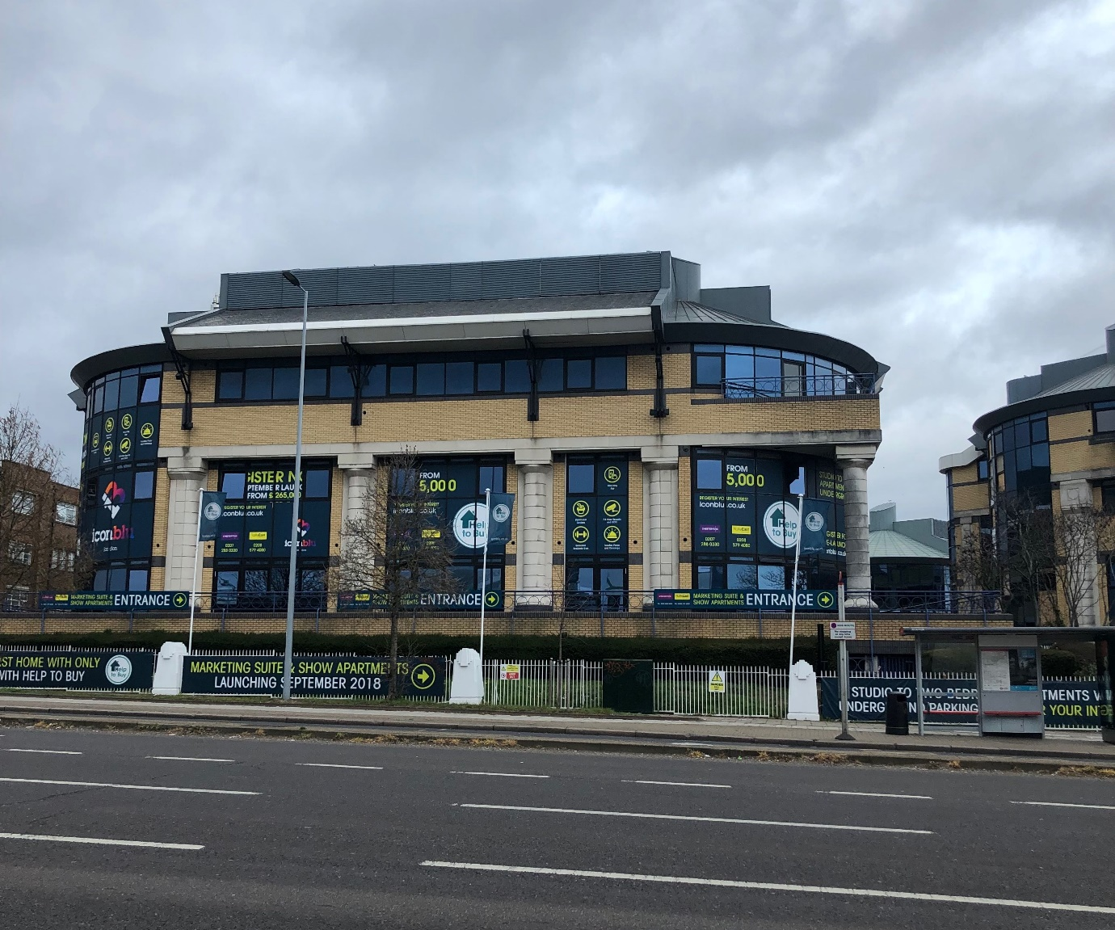
Figure 2 – New Horizons Court, Hounslow (now in residential use) (photo: Ben Clifford)
Figure 3: New Horizons Court in its local context
6.1.2 Central Business Centre, Neasden
The second case study is the Central Business Centre, Neasden (in the London Borough of Brent) (Figure 4). This is an early 1990s business park which has been used for office and light industrial purposes and is located between the busy North Circular Road, tube and railway lines and various warehouse and heavy industrial uses in North West London (see Figure 5). The building concerned received planning permission in 1989. It is not clear if the first floor of the building, which has been converted into 20 studio flats, was occupied or vacant prior to its conversion to residential use. At the time of conversion, however, the ground floor and similar neighbouring buildings were occupied by a range of businesses. No units have access to any private amenity space, and the building opens directly onto a car park used by the neighbouring commercial buildings. The studio flats are each between 30 and 34sqm in size, and they are all single aspect. Half of the units face north-west, directly onto a steep grass embankment, which – along with a wire fence - separates the building from the A406.
It is difficult to imagine a noisier or more polluted location. The A406 is the North Circular Road – a busy six-lane orbital highway that serves as London’s inner ring-road. Other neighbouring uses include an industrial estate with a cement works. The location appears unsuited to residential use, offering no on-site amenities to residents. However, the North Circular can be crossed via a nearby walkway, which provides access to a large supermarket (usually reached by car) and an Ikea store. There is also a cluster of shops a few hundred metres’ walk along the road, including a fast-food takeaway. There are no nearby green spaces, apart from the steep grass embankment previously noted.
The conversion of buildings on unsuitable, and sometimes isolated, industrial and business parks into residential use has been a common problem with numerous PDR projects, as locational attributes cannot be considered as part of the prior approval process – since the principle of development permission has already been established in the national PD regulations. The Neasden scheme was delivered by an SME developer, utilising the services of a large planning consultancy but with no obvious involvement from any architects. The flats are available for private rent – although it was not possible to obtain data on rent levels or particular rental arrangements. Interestingly, the London Borough of Brent was able to prevent the conversion of two neighbouring office buildings to residential use, by introducing an ‘Article 4 Direction’. This is a mechanism by which permitted development rights can be suspended, but government has strongly resisted their use in relation to PDR, strictly limiting the circumstances where they can be used. Brent’s Article 4 Direction success on the adjoining buildings was likely to have related to the protection of employment use for occupied building and the lack of substitute spaces.
The London Borough of Brent’s Local Plan, in force when this scheme gained prior approval, references the design and quality standards contained within the London Plan. It also includes a Supplementary Planning Guidance (SPG) relating to housing, which emphasizes adherence to the nationally described space standards and the requirement for amenity space when permissioning new housing schemes (London Borough of Brent, 2016). Like the New Horizons Court scheme, Central Business Centre was afforded protection for employment use, in this case being designated as ‘strategic industrial land’. As such, the Local Plan precluded residential use given the lack of nearby amenities and the likely impact of traffic noise and also noise from adjoining industrial and warehousing units on residents. Whilst the project might, in theory at least, have been redesigned to improve dwelling space standards and provide communal amenity space as part of a full planning application, the locational problems would always have weighed against conversion. It would not have been permitted without the facility, provided by PDR, to bypass the normal planning process. The reasons for refusal would have related almost exclusively to the wellbeing of prospective residents, alongside the desire to preserve the opportunity for employment use.
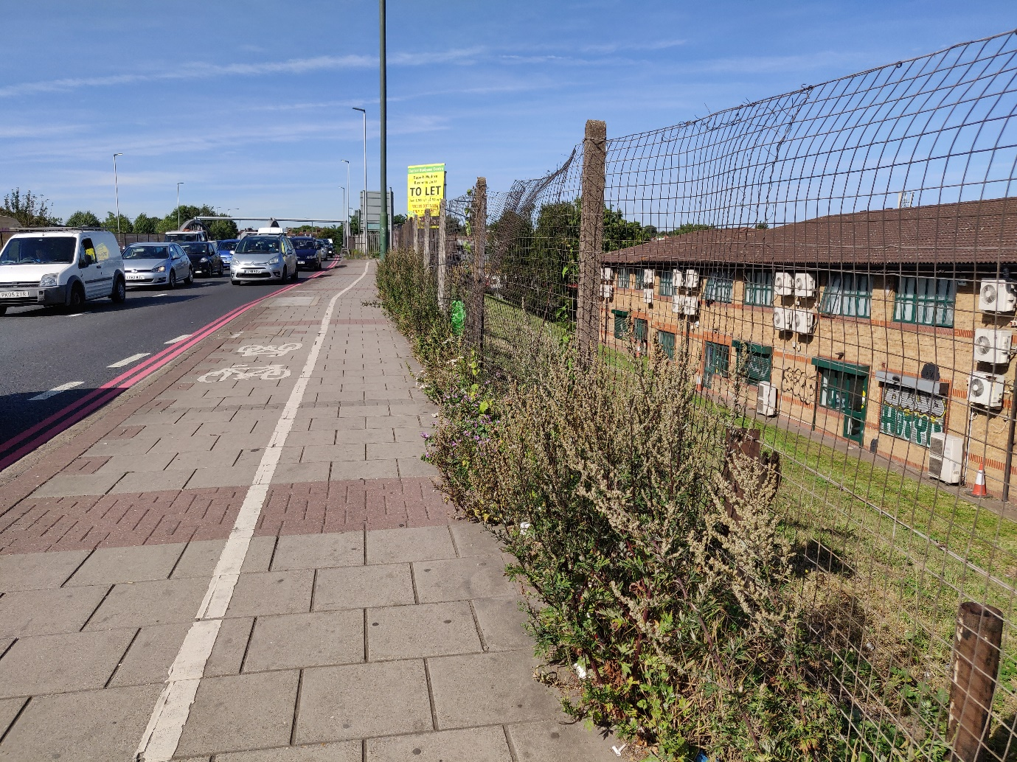
Figure 4 – Central Business Centre, Neasden (the building on the right is now in residential use) (photo: Ben Clifford)
Figure 5: Central Business Centre in its local context
6.1.3 St Anne’s House, Croydon
The third case study is St Anne’s House, Croydon (Figure 6), which is a large, twelve-storey office building constructed in 1963. It is located in Croydon’s town centre, in an area which saw a large number of office buildings developed in the 1960s and 1970s. St Anne’s House had previously contained offices for a large civil engineering company, but was vacant before conversion. A planning application to convert the building into a hotel and a relatively small number of residential units was approved shortly before the introduction of PDR deregulation in 2013. Once the rules changed, the developer withdrew the previous application and elected to convert the building entirely to residential use, utilising the prior approval given by PDR. Rather than seeking the mixed re-use of the building, the replacement scheme comprised 197 flats, with many studios of between 18 and 27 sqm – well below the government’s recommended minimum of 37 sqm. The great majority of flats (151) have the appearance and layout of hotel rooms and, like hotel rooms, they are all single aspect boxes. Twenty-two of the 197 flats have access to ‘private balconies’, which were previously external fire escapes (required when the building was in commercial use, as Building Regulations stipulate that higher-occupancy office buildings need more fire escapes than residential buildings). The scheme was delivered by an SME developer, in partnership with a chartered planning consultant and an architectural technician, but not a professionally registered architect. Flats are offered on short term and regular letting arrangements. At the time of writing, studio flats in the development were being advertised online for a rent of between £260 and £300 per week, well above the current local ‘affordable rent’ rate of £168.34 per week for a one-bed unit (Croydon Choice, 2022).
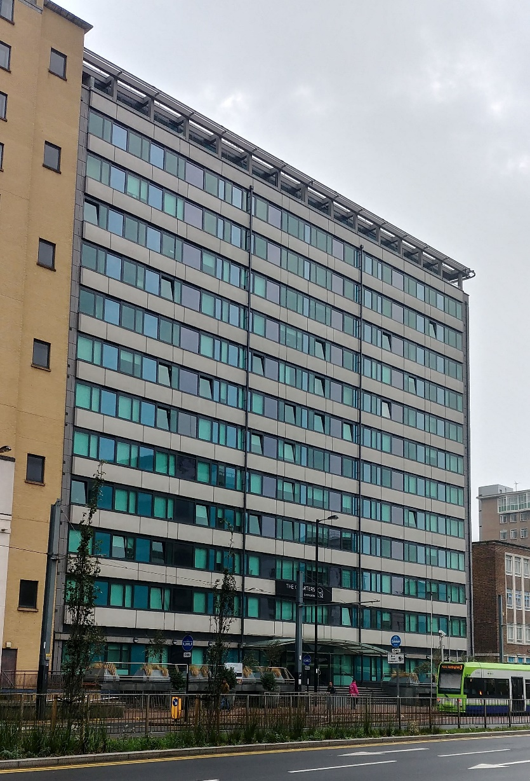
Figure 6 – St Anne’s House, Croydon (now in residential use) (photo: Ben Clifford)
It is notable in this case that planning permission had been granted, prior to the introduction of permitted development rights, for a mixed-use conversion that included an element of residential use. The location and principle of the change of use had been deemed acceptable in relation to Local Plan policies (see London Borough of Croydon, 2018) and following its consideration by the London Borough of Croydon’s planning team. This was essentially because the town centre of Croydon had been designated an ‘Opportunity Area’ within the London Plan – a location where there are opportunities to recycle previously developed land and convert vacant office space to housing (Mayor of London, 2022). However the scheme originally envisaged had fewer residential units, all meeting planning requirements in terms of space standards, mix and amenity.
The PDR scheme that replaced it, sought to radically change the economics of the development, squeezing in a far higher number of flats. The chances of it gaining planning permission through the normal process would have been slim. Apart from lacking any element of affordable housing, critical issues relating to private outdoor and amenity space, the absence of play space, poor space standards of units, and the mix of flat types – particularly a lack of larger units suitable for families – would have all resulted in refusal. Although the flats are all single aspect, which is not recommended in the Borough’s own housing SPG, this alone may not have prevented the conversion had other aspects of the project been acceptable. There is a demonstrable need for new housing in this part of London and planning already leaned towards green-lighting residential conversions. Aspects of the project point to some potential for housing use, including the presence of fire escapes-cum-balconies, and the possibility of creating larger units, albeit single aspect. The original proposal was for a smaller number of bigger flats, mixed with hotel use. This was acceptable to local planning because it accorded with design and planning policies. The developer had done enough to assuage any concerns and arrived at a proposal that met its own requirements and those of the planning authority. It changed tack when the opportunity to develop at higher density and lower quality presented itself, via the PDR route.
6.1.4 Church Road, Croydon
The fourth example is that of 3 Church Road, Croydon (Figure 7). This 1990s four-storey office building is located at the edge of the town centre, between a shopping street and a school. It was partially occupied by small businesses prior to conversion. The building was subject to repeated ‘prior approval’ applications - each proposing a higher number of smaller units - until the implementation of the current scheme, which comprises 32 studio flats of between 16 and 22 sqm. The smallest flats are tiny, offering very little utility to occupants. Six are located in the building’s basement and have very little natural light and no view whatsoever of the outside world. They featured in a newspaper article (Wall, 2019), which likened the flats to prison cells. Having to live in them was considered harsh punishment. There is no communal amenity space (to compensate for the lack of internal space) and no private or communal outdoor space. The scheme was progressed by an SME developer, which engaged a private planning consultancy for the prior approval. It is not apparent that any professional architects were involved in the conversation from office use. The flats in this development have been used as temporary housing by the local council (Wall, 2019), available to those who are homeless or at risk of being homeless. Current guidance on such emergency accommodation from the local authority is that it typically costs about £180 per week for a single person (Croydon Council, 2022).
Like St Anne’s House, the Church House example is also in the Croydon town centre opportunity area (London Borough of Croydon, 2018). The neighbourhood provides a reasonable location for new housing, benefiting from nearby amenities and no ‘bad use’ neighbours. The constraints of the building and site make it hard to provide any on-site private amenity space such as roof terraces, gardens or balconies. However, it would have been possible to have provided larger flats, some of which could have been dual aspect, meeting the nationally described space standards. The building is typologically and structurally suited to a better scheme, which could have been achieved through the normal planning process. What is the rationale for bypassing planning in these types of scheme? Local planning teams will insist on the achievement of minimum standards, which adds cost to a development. PDR provides an opportunity to duck below those standards and cram more units into a converted building. The economic case for doing so is not always clear. The Church Road flats are likely to be ‘achieving’ the emergence rent noted above, and higher gross rental value may have been possible from fewer units aimed at a ‘higher end’ market. But that is also not clear. A better scheme, taken through normal planning, would have incurred greater risk: the risk of having to spend money on modifying a proposal and the risk of not appealing to the target market, and therefore not achieving target returns. A quick and dirty conversion, with the developer spending as little money as possible, offers the guarantee of regular income from occupants for whom Church House is ‘last resort’ or emergency housing. One of the major criticisms of PDR, which is levelled at schemes up and down the country, is that it expresses an uncaring economic model that seeks to cover its minimal costs from occupants that have little choice but to put up with this minimum-utility, lowest-quality offer. PDR has brought a race to the bottom, facilitating schemes that barely deserve the label ‘housing’.
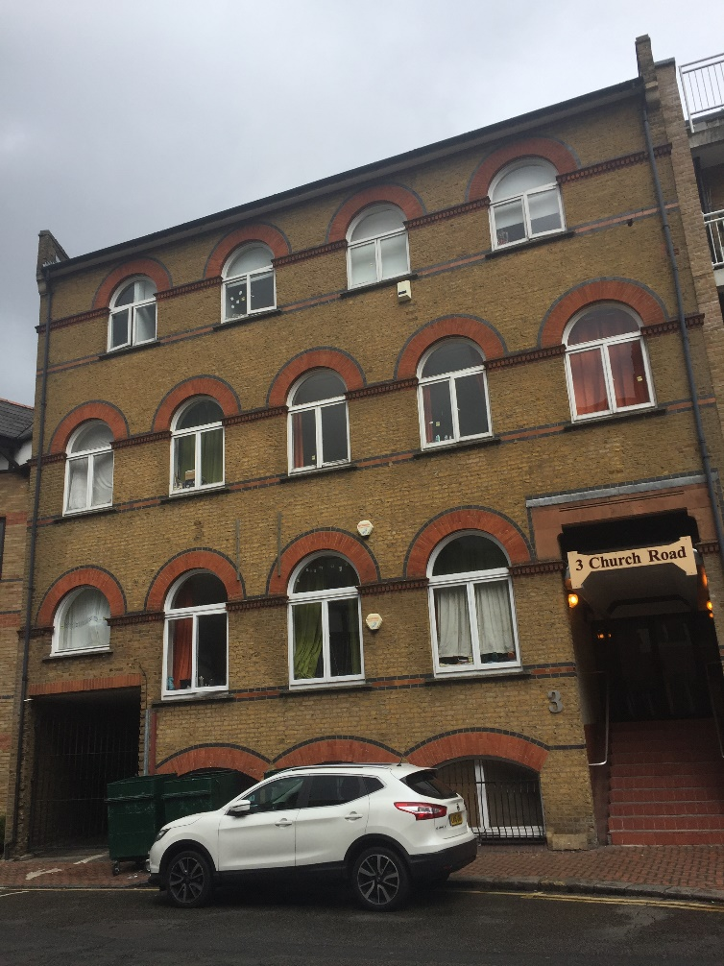
Figure 7 – 3 Church Road, Croydon (now in residential use, including the basement) (photo: Ben Clifford)
6.2 Italian Conversion Cases
Our four Italian case studies represent conversions of a range of building types, initiated by different actors. They are located in two cities in the north-west of Italy, where there is a concentration of offices (OMI, 2021) and where conversions are running at pace: Milan and Turin. These two cities have been linked by a relationship of ‘competitive cooperation’ since the beginning of the nineteenth century (De Magistris and Rolando, 2011); they share an industrial past and are united by a common history of economic restructuring. Together with Genoa, they formed the first Italian ‘industrial triangle’, which was the main destination for economic migrants from the rest of the country after the Second World War, and drove the country’s ‘economic miracle’. This led ‘the cities and their hinterland[s]’ to become ‘a large-scale service infrastructure for industrial production’ (Petsimeris, 1998: 450). Both cities then experienced a period of deindustrialization and urban decline, followed by a ‘tertiarisation’ of their economies (ibid.). Milan’s industrial restructuring since the late 1980s led it to become the financial capital of Italy and to gain national primacy in the economic, innovation and creative sectors (Mugnano et al, 2010), as well as becoming recognised as a global capital for fashion and design (Coppola et al, 2018). During the same period, Turin changed from being Europe’s main example of a ‘one company town’ (Giaccaria, 1999) – whose economy largely depended on the automobile company FIAT – to a centre with a more diversified economy, where the finance and insurance sectors are key, and the innovation-oriented, cultural and tourist sectors are growing (Prat and Mangili, 2016 ). Today the two cities - the most populous in northern Italy - are connected by a fast rail service (a little over 30 minutes from centre to centre), and form a mega-city region that, despite not corresponding to the organisation of any local authority, is identified through spatial and socio-economic dynamics (De Magistris and Rolando, 2011).
In Milan, ‘the presence of empty buildings […] has reached such a prominent level as to be a periodic focus of attention from the media’ (Fianchini and Ferrucci, 2018: 2). The municipality started mapping them in 2014, with the aim of developing regeneration projects: 20% of these buildings are offices (ANCE, 2017) and both of our Milan cases were part of that mapping project. The first comprises a single building but the second is a larger project comprising a cluster of buildings. Figure 8 below shows their respective locations.
Figure 8: Locations of case studies in Milan
6.2.1 Torre GalFa, Milan
The first case study, Torre GalFa (Figure 9), is a 31-storey glass office tower, designed by architect Melchiorre Bega in the 1930s’ ‘international style’ and built between 1956 and 1959. It originally housed the headquarters of the SAROM oil company and was used by a bank (Banca Popolare di Milano) for its offices from the 1970s until it was abandoned in 2001. The building remained empty for more than a decade, despite having been bought in 2006 by a financial service company based in Turin. It was only when the company was merged with the Unipol Group, the second largest insurance company in the Italian market, that a project for the reuse of the tower, as well as for the regeneration of its immediate context, was initiated in collaboration with Milan Local Authority (Olivadese, 2016).
Works undertaken between 2016 and 2020 resulted in the conversion of the former office block into residential use (occupying the 13th to 30th floors) and a hotel (from the 1st to 12th floor). There is also a rooftop restaurant and a basement gymnasium, both open to the public. An initial plan to refurbish the building for new office use was not possible due to regulatory requirements (‘class A’ offices need to have a minimum 3.00 m ceiling height – and the building’s ceilings were very slightly too low). Designed by architect Maurice Kanah of the Milan-based BG&K Studio (which has turned its attention to building conversions in recent years), the residential component comprises 73 one, two and three bedroom flats. The intention was that these should be for sale but they have now been offered as short-term lets.
All flats exceed minimum space standard requirements: the one-bedroom flats range in size from 65 to 80 sqm; the two-bedroom from 112 to 143 sqm; and the three bedroom (including two penthouses) from 141 to 160 sqm. The majority of the flats are dual aspect and a few are triple aspect; there are only 18 single aspect flats, for which, however, air quality is ensured through mechanical ventilation, as prescribed by Milan’s Regolamento Edilizio. This also affected the distribution of service spaces: some of the smaller flats (under 70 sqm) have a windowless bathroom, but all larger flats have direct natural light into their bathrooms, as this was a requirement of the Regolamento Edilizio until 2013; whilst on the one hand this can be seen as a quality-insurance mechanism, on the other hand the architect pointed out that it imposed unnecessary constraints to the overall spatial distribution, given the possibility of using controlled mechanical ventilation in bathrooms and the need to use existing windows in rooms that are lived in (see Olivadese, 2016). All two- and three-bedroom flats have two bathrooms, which is the Italian norm.
Building regulations also required that the flats had a separate entrance from the hotel, so a vertical shaft was added at the back of the building – leaving the entrance to the hotel at the front and ensuring residents’ privacy. A new glass façade replaced the old one to ensure that the building kept its original appearance – attention was given to the façade's design, which retained the modularity, rhythm and language of the original one - but also became more energy efficient, in line with current regulations and for the comfort of residents. This, however, meant that no balconies were provided; whilst, as seen earlier, Milan’s building code highlights the need to include private outdoor spaces in residential conversions, in this instance the preservation of the façade’s architectural integrity was given priority, given the historical importance of the building. Improvements were also made to the public space surrounding the tower, which had previously been used exclusively for parking (Olivadese, 2016), including the redesign of the space at the rear of the building as a sunken square – which now provides residents with an outdoor space at their doorstep - and of the space at the front, which became part of an important pedestrian route, connecting the main railway station to the Pirelli skyscraper (one of Milan’s most iconic buildings).
The Torre GalFa is located at the heart of Milan’s CBD, at the intersection between Galvani Street and Fara Street (hence ‘Gal-Fa’), a strategic position easily accessible from both the main motorways and the city centre. This primary location give its residents access to a wide range of services and amenities: the building is within 5 minutes’ walking distance from the main railway station (Stazione Centrale), three underground stations and a large park and botanical garden (Parco Biblioteca degli Alberi). The area is also well-served by a variety of shops, restaurants, cafes and many essential services including a post office.
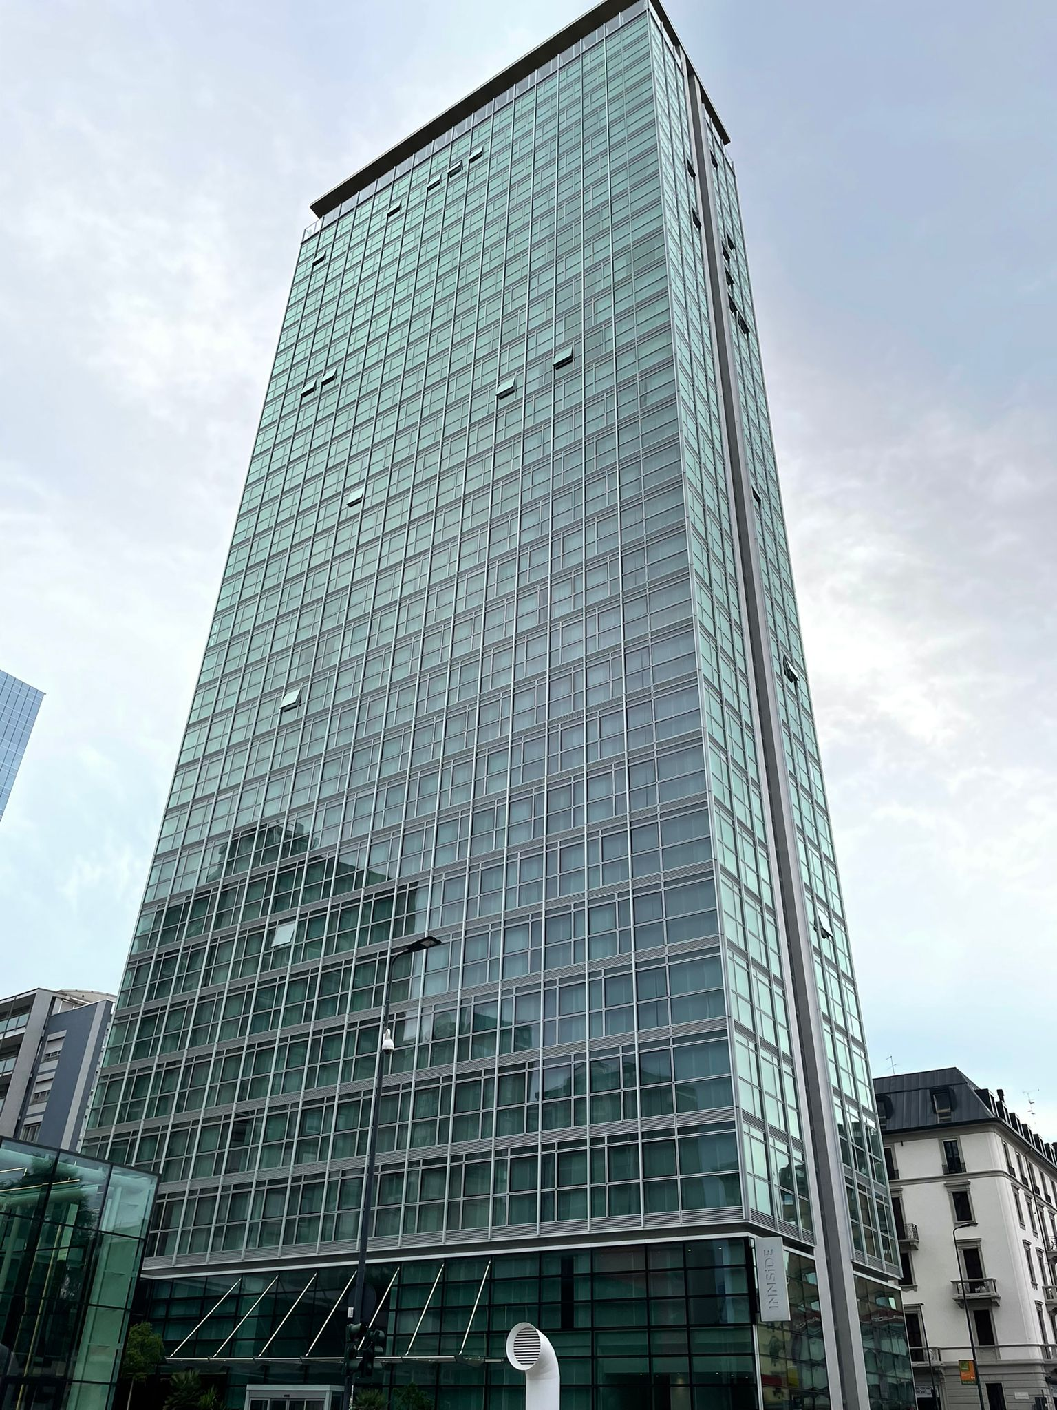
Figure 9: Torre GalFa (photo: Barbara Grigoletto)
6.2.2 5Square Via Antegnati, Milan
Our second case study is 5Square Via Antegnati (Figure 10). Five buildings are being converted as part of a regeneration project in the southern periphery of Milan, with completion due late in 2022. These buildings were designed as three-to-four storeys perimeter blocks in the 1980s to host both industrial facilities and associated offices and were owned by investor Salvatore Ligresti. After his bankruptcy, the buildings changed ownership several times. Although they were never fully completed and used, they were nevertheless in a serviceable state until 2011, when they were abandoned and subsequently occupied illegally, becoming a ‘ghost neighbourhood’ where drug dealing and prostitution were concentrated (Valtolina, 2021). In 2017 the buildings were bought by an asset management company, and they are now being converted by a public-private partnership, under the auspices of Fondo Immobiliare Lombardia (an investment vehicle which brings together the regional authority and private banks). The buildings are being converted into social housing for both sale (164 flats) and rent (304 flats) with the design and build process being led by Barrecca & La Varra, a Milan-based urban and architectural design firm that deals with both new build and adaptive reuse.
The conversion is comprehensive. The heights of the buildings straddling the main street is being raised to five storeys whilst buildings further back retain their existing three or four storeys. The aim is to create a new neighbourhood through redesign and through the installation of community spaces on the ground floors, comprising a community centre, a nursery, a gym, a café, a clinic and a supermarket. Five internal courtyards are also being created – with interconnected play areas for children, and green spaces. Trees are being planted to establish a barrier to the main road.
The flats comprise studios (for single person occupancy, of 40 sqm), one-bedroom units (for childless couples, 58 to 90 sqm), two-bedroom units (for families with a single child, 100 to 110 sqm) and three-bedroom units for families with two children (120 sqm); all flats have generous space standards that exceed minimum requirements (e.g. minimum space standards for a studio for single person occupancy are 28 sqm, for two people are 38 sqm). The studios and some of the one bedroom flats have single aspects, this being permissible in the Regolamento Edilizio only for flats smaller than 60 sqm. But none of the single aspect flats face the north, as this is prohibited by the regulations, which aim to counterbalance the lack of double aspect with a better exposure to natural light. The larger two- and three-bedroom units all have two bathrooms. As recommended in the local regulations, all flats have access to an outside private space: on upper floors they either have balconies or loggia, whilst all ground floor units, irrespective of size, have private gardens. Every building in the redevelopment has an underground floor where a cellar and parking space is provided for each flat.
5Square is located in a mixed-use area, including residential, commercial and productive uses, near the Parco Agricolo Sud, a 47,000 hectare protected rural area, so residents will have access to other nearby shops and services besides the ones provided on-site. These include cafes and restaurants, three tram stops within 5 minutes’ walking distance, and an underground station 10 minutes’ walk away, allowing residents to reach the centre of Milan in around 40 minutes. The Local Authority is also undertaking a regeneration project in the area adjacent to 5Square, where an 8 ha site is being redeveloped to include housing for private sale, a new school, and a building for either cultural or sport use as well as the improvement of the green spaces and the development of a cycle path. This wider transformation will greatly benefit the residents of 5Square.
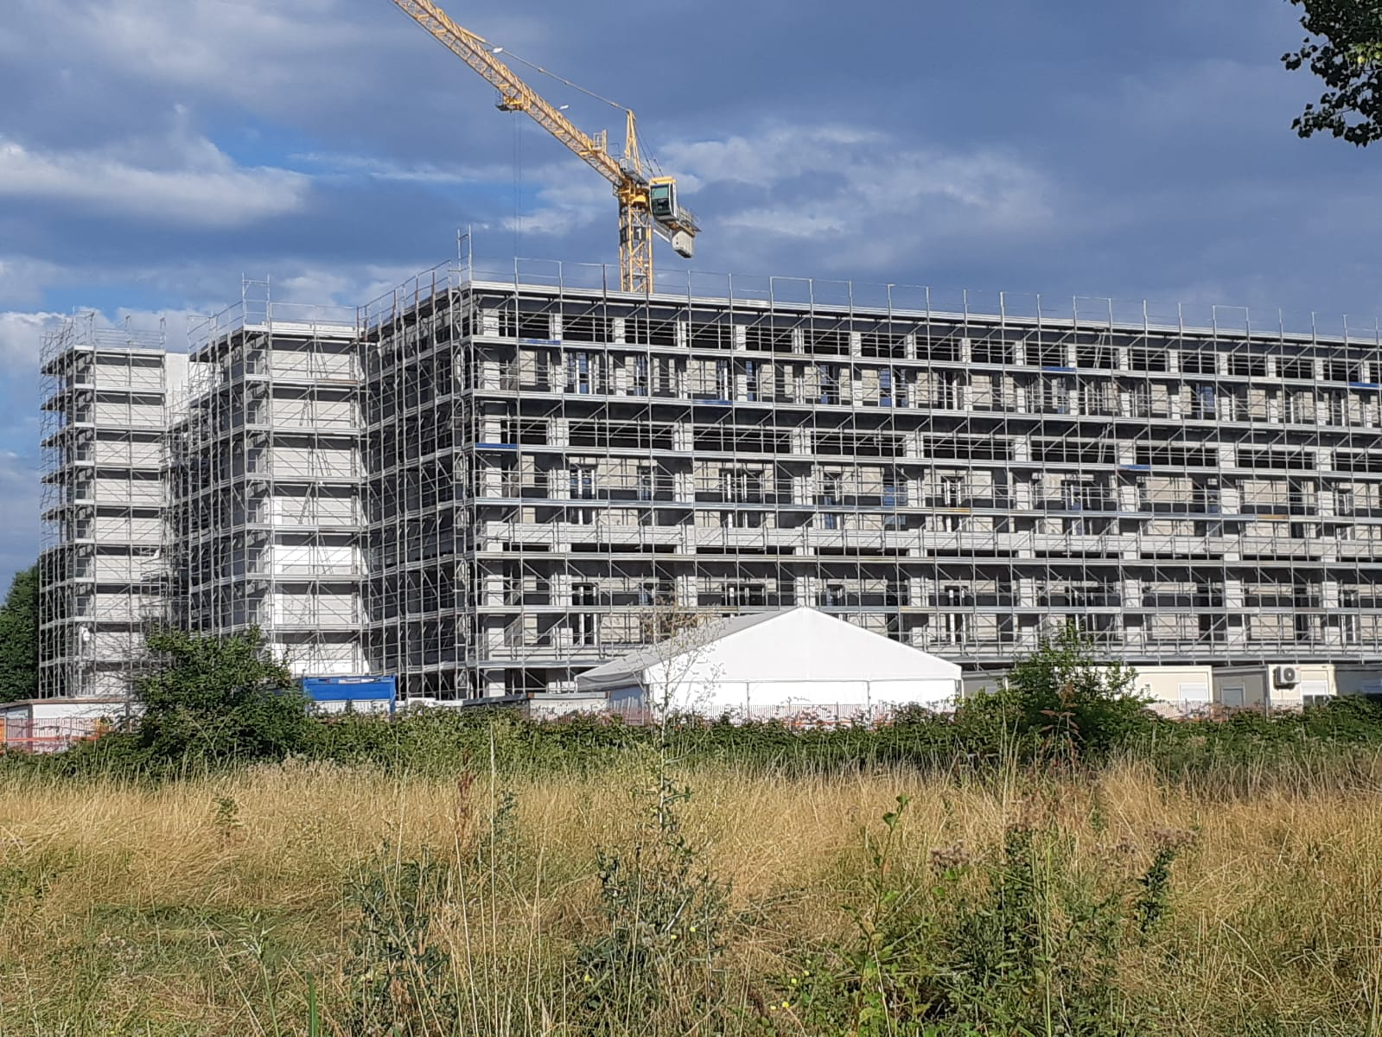
Figure 10: 5Square Via Antegnati (under conversion) (photo: Marco Manfredi)
In Turin, a trend in office to residential conversions began in 2016 and is continuing today, mainly focused on buildings located in the historic centre (IPI, 2020). That trend is underpinned by a growing preference for inner-city living (which has been interrupted by the Covid-19 pandemic) coupled by rising housing demand (Dezza, 2020) and the relative abundance of historic buildings that are no longer needed as offices (as those offices close or decentralise). Investor interest is transforming Turin’s historic core – from a business district into a new residential enclave (Benna, 2021). Both our Turin case studies are located in the city’s historic area (see Figure 11).
Figure 11: Locations of case studies in Turin
6.2.3 Palazzo Novecento, Turin
Palazzo Novecento was one of the first office buildings to be converted to residential use (Figure 12). It was formerly known as Palazzo Gualino, named after the financier for whom it was originally built (between 1928 and 1930) as the headquarter of his chemical company. Designed by Turin-based architects Levi Montalcini and Pagano, it is one of the first ‘rationalist’ buildings in Italy (De Magistris, 2020). In 1932, following the bankruptcy of Gualino, it was acquired by FIAT (Fabbrica Italiana Automobili Torino) and in the 1970s it was purchased by Turin Local Authority and used as its tax office until 2005 (Baietto, 2020). These changes in ownership resulted in numerous alterations to the original building, including floor plan and façade changes.
In 2007, the local authority established Fondo Città di Torino (City of Turin Fund) with private finance partners. Its goal was to valorise its unused heritage assets by refurbishing and converting 19 buildings owned by the authority. Palazzo Novecento was one of those buildings and plans were drawn up for its conversion by the Turin-based architecture studio Baietto Battiato Bianco, a well-known practice dealing with both new-build projects and conversions. The studio wanted to retain the office function on the building’s lower floors but install an alternate public function on the top floor of the building. The global financial crisis of the following year put pay to these ambitions and the project was halted. The authority subsequently sold the building to a private investor who then sold it to a Turin-based real estate company in 2014.
Engaging the same architectural studio as before, a plan was concocted to convert the entire building to residential use (Baietto, 2020). This was the result of a complex negotiation process between the architects and the regulatory bodies, which, as well as the LA, included the ASL (the body responsible for ensuring the conformity with health and hygiene regulations / minimum standards of local projects), the Soprintendenza ai Beni Architettonici del Piemonte (the body aimed at regulating the conversion of important listed buildings) and the Fire Brigades. The negotiations aimed at understanding how a conversion could be undertaken without changing the main character of the building (its façade and vertical distribution) given its architecture value.
Works started in 2017 and were completed in 2019, resulting in 47 residential units. These comprise two studio flats (both 51 sqm, exceeding the required minimum of 38 sqm), nine one-bedroom duplex flats occupying the basement and ground floor levels (59 to 77 sqm – residential units that solely occupy basement spaces are not permitted), another 12 one-bedroom single-floor flats (54 to 86 sqm) on the next four floors, 15 two-bedroom flats (78 to 127 sqm), and nine three-bedroom flats (117 to 320 sqm) of which five are ‘high-end’ and occupy the top two floors of the building. The flats have different but regular shapes and the majority (all but 16) are dual aspect; Turin’s building regulations do not have specific rules on orientation, however none of the single aspect flats face north. Many of the flats have two bathrooms, and the larger three-bedroom units have up to four bathrooms, the majority of which have no natural light – which is permissible under Turin’s Regolamento Edilizio (adapted to the large number of historic buildings in the city).
Because the building is listed, no modification to the façade was possible. This meant that every room in the flats had to have windows of the same dimensions (despite their different dimensions and hence light needs) and very few flats – only 11 in total – were able to have balconies or terraces (two of which are very large, for the high-end flats); however, all residents can access and use the internal courtyards, which have been redesigned and provide them with shared communal outdoor spaces.
Considerable attention was expended on access to overcome the limitations of the original office floorplan: the flats are reached by three staircases, one of which was added to the inner courtyard for circulation and spatial distribution reasons and is constructed of glass. The original building had a small basement. This was extended to run under the entirety of the building, while two further basement levels were excavated to provide the flats with cellars (one for each flat) and 40 parking spaces (required by the PRG). The main courtyard now has spaces for bikes; this is also a requirement of the building regulations.
Palazzo Novecento is located in one of four neighbourhoods that form Turin’s historic centre, next to the River Po. Residents have easy access to shops, cafes and restaurants. Recent research has identified more than 20 services within 10 minutes walking distance and five bus stops within 5 minutes’ walk (Alagna, 2018). The building’s central location means that rail and underground links are nearby (both are 10 minutes’ walk), as is the Parco del Valentino – one of the city’s large parks running alongside the River Po – which is in front of the building.
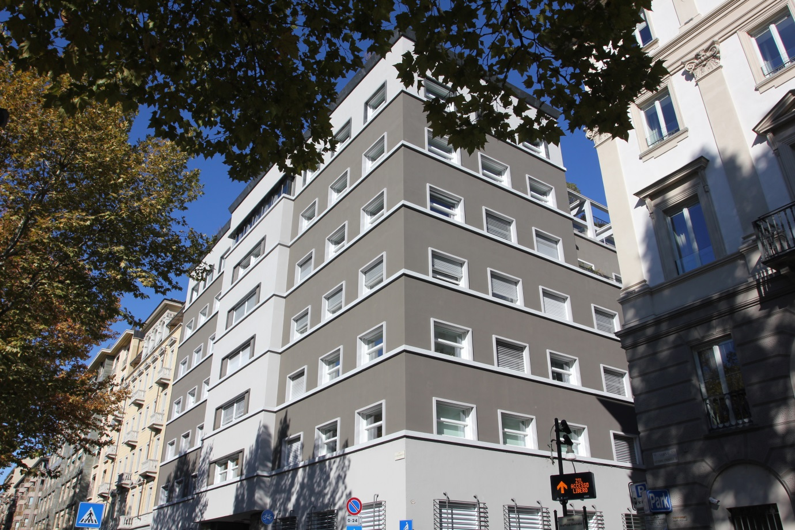
Figure 12: Palazzo Novecento (photo: Michela Barosio)
6.2.4 Corte Alfieri, Turin
Works at Corte Alfieri (Figure 13) were completed in 2021 and transformed a finance company’s (Allianz) former headquarters into residential use. The building had been the headquarters of an insurance company from 1928. It has a typical 19th century courtyard typology and was built as part of the expansion of Turin’s central area, following the demolition of the city’s walls. There are many similar courtyard buildings, laid out on regular grids, just beyond the old boundaries of the city. The building was purchased by BNP Paribas REIM, a real estate investment management company, along with 37 other buildings owned by Allianz in Italy, in 2015. BNP established Fondo Alloro as an investment vehicle for the conversion and redevelopment of its newly-acquired property portfolio in principal Italian cities. Corte Alfieri is one of the more prestigious buildings acquired by the company (Tonero, 2015).
The building’s conversion was taken forward by the same architects, Baietto Battiato Bianco, who led the adaptive reuse of Palazzo Novecento, with the main works being carried out by Zumaglini & Gallina. The adaptive reuse of Corte Alfieri led to the creation of 71 residential units distributed over six floors. Offices and commercial uses were retained on a portion of the ground floor in order to comply with the PRG. The residential space comprises seven studios (of circa 50 sqm), 16 one-bedroom flats (of circa 60 sqm), 30 two-bedroom flats (70 to 120 sqm), 16 three-bedroom flats (100 to 150 sqm) and two four-bedroom (circa 180 sqm) flats; all flats exceed minimum space standards requirements. The provision of small and medium sized units, both in Corte Alfieri (where 37 of the flats have been classified as such by the vendor) and in the Palazzo Novecento, is in line with the current demand for housing in Turin (Dezza, 2020). As the second floor – the piano nobile - has higher ceilings than the others, flats built on this floor include mezzanines over the living room (regulations require that the minimum ceiling height in these instances is 4.2 m) whilst in the wing at the rear of the building, which is adjacent to another building and therefore has a smaller number of windows, some duplex flats have been developed. The top floor comprises an attic conversion, and as this is an historic building, lower ceiling heights were exceptionally permitted. Most of the flats are dual aspect; 23 are single aspect but, as in the Palazzo Novecento conversion, none of these are north facing, although nine face north-east.
Because of the building’s typology, the majority of flats have either internal courtyard-facing or external street-facing (or both) balconies. Twenty-eight flats, however, have neither balconies nor terraces, including those occupying the ground floor. Again for façade listing reasons, it was not possible to add additional street-facing balconies – although the old internal balconies (ballatoi) have been replaced with new larger ones. Four out of the nine top floor flats have small roof terraces. Regulations prevented modifications to the skyline: therefore the original project, comprising a ‘continuous crown’ of terraces, could not be implemented – the rigidity of regulations, in this instance, not only compromised the architectural quality of the intervention, but also impacted on residents’ liveability; nonetheless, an ‘interpretation of the norm’ (using part of the possible buildable surface previously used for technical volumes on the roof) allowed four terraces to be built.
The wider reuse project included the redesign of both internal and external communal areas: bike parking spaces and lockers were added to the ground floor whilst in the courtyard a green area was provided as well as trees and seating areas, making it an enjoyable outdoor space that, whilst accessible by all residents, is particularly valuable for those without access to a private balcony (Figure 14). Underground car parking was also added, as required by the PRG. Street parking is extremely limited and heavily regulated in Turin.
Located in the city centre, Corte Alfieri is 5 minutes from one of Turin’s main historic squares - Piazza San Carlo - in an area offering a variety of shops, restaurants, cafes, amenities (such as museums) and services. It is also 5 minutes walking distance from six bus/tram stops and 10 minutes from an underground station. One of the city’s principal train stations (Porta Susa) and another underground station are 15 minutes away. Corte Alfieri is close to a small public garden and 20 minutes from Giardini Reali – Turin’s ‘Royal Gardens’. This conversion is typical of many office conversions now underway in the city, whose courtyard typologies lend themselves to residential reuse.
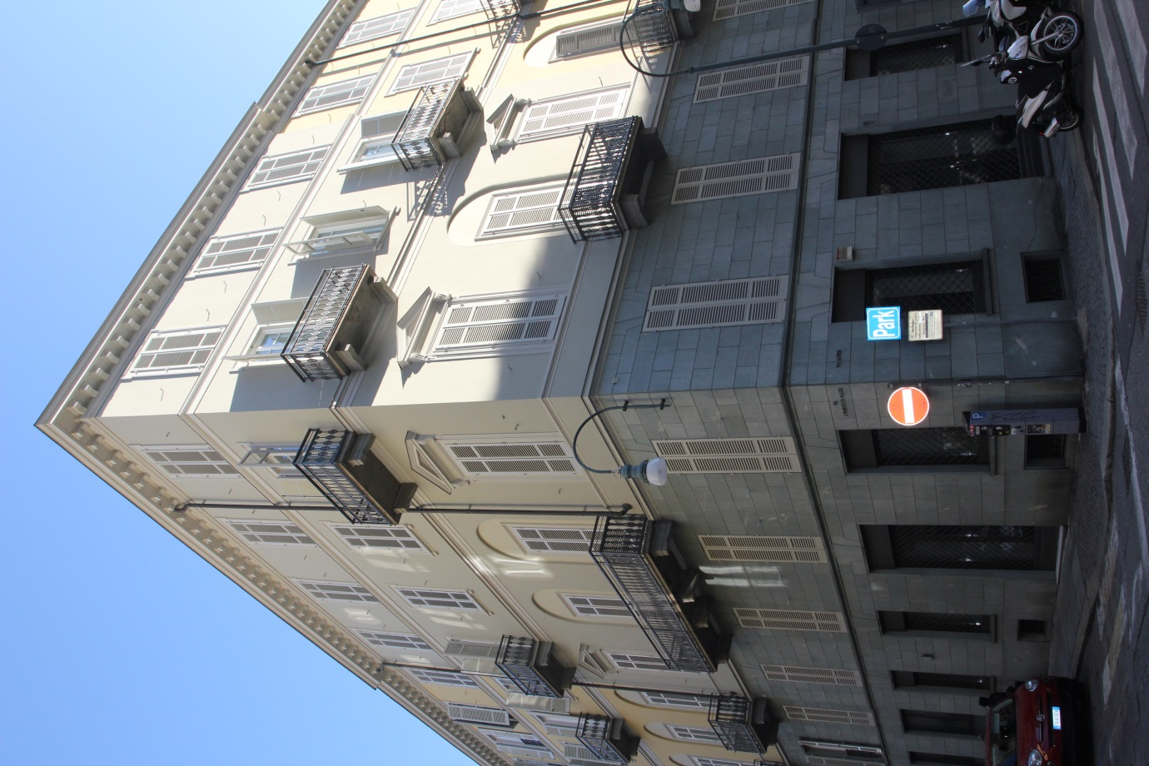
Figure 13: Corte Alfieri (photo: Michela Barosio)
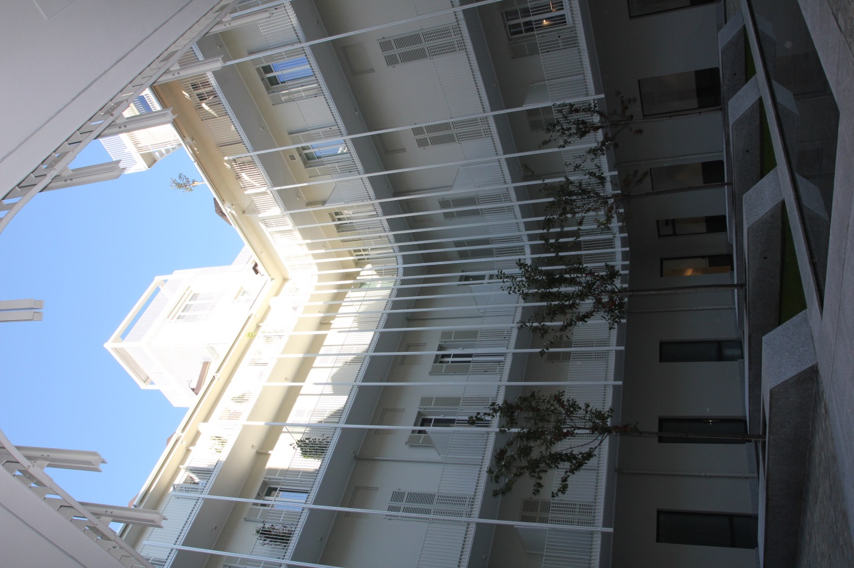
Figure 14: Corte Alfieri’s internal courtyard (photo: Michela Barosio)
The tables below provide a summary of key information for both the English (Table 2) and Italian (Table 3) case studies.

Case study | 1 New Horizons Court, Brentford | 1-5 Central Business Centre, Neasden | St Anne’s House, Croydon | 3 Church Road, Croydon
Year of construction | 1980s | 1990s | 1963 | 1990s
Year of conversion | 2018-2019 | 2015 | 2014-15 | 2015-16
Total floorspace converted | 5,883 sqm | 625 sqm | 9405 sqm | 836 sqm
Tenure | Private sale and private rental | Private rental | Private rental and short term lets | Temporary accommodation
Number of flats | 99 | 20 | 197 | 32
Type of flats | Studio, 1 Bed, 2 Bed | Studio | Studio, 1 Bed, 2 Bed | Studio
Floorspace of studio flats | 30-56sqm | 30-34sqm | 18-27 sqm | 16-22 sqm
Floorspace of 1 Bed flats | 31-68sqm | - | 57 sqm | -
Floorspace of 2 Bed flats | 62-90sqm | - | 63-79 sqm | -
Floorspace of 3 Bed flats | - | - | - | -
Floor space of 4 Bed flats | - | - | - | -
Private outdoor space | None | None | 22 flats have balconies in previous fire escapes | None
Parking space | Car park | Car park | Car and bike space | None
Amenities nearby | Public park 10 minutes’ walk | - | Public gardens within 10 minutes’ walk | Public park 5 minutes’ walk
Services nearby | Bus stop 5 minutes’ walk (one single bus route). A single restaurant 10 minutes’ walk | Bus stop 10 minutes and underground station 20 minutes’ walk (along North Circular Road). Large supermarket within 10 minutes’ walk beyond North Circular Road | Bus stops within 5 minutes, tram stop and rail stations within 10 minutes’ walk. Cafes, restaurants, shops. | Tram/bus stops within 5 minutes and rail station within 10 minutes’ walk. Cafes, restaurants, shops, essential services
Table 2: Summary of key information for English case studies
Case study | Torre GalFa (Milan) | 5Square Via Antegnati (Milan) | Palazzo Novecento (Turin) | Corte Alfieri (Turin)
Year of construction | 1956-59 | 1980s | 1928-39 | 19th c.
Year of conversion | 2016-20 | 2019-22 | 2017-19 | 2019-21
Total floorspace converted | 15,600 sqm | 35,000 sqm | 7,000 sqm | 7,000 sqm
Tenure | Short term lets | Social housing for rent and sale | Private sale | Private sale
Number of flats | 73 | 478 | 47 | 71
Type of flats | 1 Bed, 2 Bed, 3 Bed | Studio, 1 Bed, 2 Bed, 3 Bed | Studio, 1 Bed, 2 Bed, 3 Bed | Studio, 1 Bed, 2 Bed, 3 Bed, 4 Bed
Floorspace of studio flats | - | 40 sqm | 51 sqm | 50 sqm
Floorspace of 1 Bed flats | 65-80 sqm | 58-90 sqm | 54-86 sqm | 60 sqm
Floorspace of 2 Bed flats | 112-143 sqm | 100-110 sqm | 78-127 sqm | 70-120 sqm
Floorspace of 3 Bed flats | 141-160 sqm | 120 sqm | 117-320 sqm | 100-150 sqm
Floorspace of 4 Bed flats | - | - | - | 180 sqm
Private outdoor space | None | All flats have either a balcony, loggia or garden | Some flats have balconies or terraces; two internal courtyards | The majority of flats have balconies; some have roof terraces; internal courtyard
Parking space | None | Parking for each flat and for bikes | Parking and bike space | Parking and bike space
Amenities nearby | New square at the rear of building; public park and botanical garden within 5 minutes’ walk | Green spaces and play areas are part of the conversion project | Public park in front of building | Main city square and small public garden 5 minutes’ walk
Services nearby | Restaurant and gymnasium within the building. Main railway and 3 underground stations within 5 minutes’ walk. Shops, restaurants, cafes, essential services | Essential services at ground floor of buildings (e.g. outpatient clinic, gym, shops). Tram stops 5 minutes and underground station 10 minutes’ walk | Tram/bus stops 5 minutes, rail and underground 10 minutes’ walk. Shops, cafes and restaurants | Tram/bus stops 5 minutes and underground 10 minutes’ walk. Shops, cafes and restaurants
Table 3: Summary of key information for Italian case studies

Part 7: Discussion and Conclusions
The case studies presented above illustrate how different planning processes support different building conversion outcomes. The contexts are of course very different, with greater latent value waiting to be extracted through conversion in the Milan and Turin cases, owing to the inner-city locations and architectural quality of the building being converted (in 3 out of the 4 cases). This made quite complex and costly conversions possible. But our focus in this paper has been on the typological suitability of buildings to conversion, whether their locational attributes support residential reuse, and the role played by regulation in delivering good quality conversions. The English cases, all from London, are varied in type. Two have serious locational suitability issues (see Figures 3 and 5). Most presented critical typological challenges that would either need expensive reconfigurations to overcome or limit their potential for reuse. We would suggest that little effort was expended on overcoming those challenges. Rather, and in the absence of guiding regulations – on living space, ventilation and light – developers, many of whom were new to the sector, simply proceeded to build substandard homes, often without the involvement of an architect. In this respect, the 3 Church Road example is particularly interesting, as rather than typology per se, the lack of design thinking, as well as the decision to squeeze in many tiny flats (for economic reasons discussed at the end of the case), were the major problems. Some of the Italian cases also presented typological challenges; whilst in some instances these could be resolved – in Palazzo Novecento, for example, an extra staircase was added to allow a distribution of spaces that was adequate for residential units – in others, compromises had to be reached – in both Palazzo Novecento and Torre GalFa balconies could not be added as the preservation of the facades’ architectural integrity took priority. However, the explicit desire to achieve high quality conversions is evident in all Italian cases, as demonstrated, amongst other things, by the involvement of architects in their redesign. As noted above, most of the Italian cases had clear locational advantages. Where this was not the case, at Milan’s peripheral 5Square, a more comprehensive planning intervention was needed to ensure that the scheme benefitted from its own services. In terms of both situated process – the formulation of design solutions to overcome typological constraint and work with regulatory prescriptions – and eventual outcomes the Italian cases demonstrate significant care for the wellbeing of future housing occupants.
This care has market, regulatory and design drivers. In some instances regulations can detract from the quality and usability of the conversion, as well as from the overall quality of the intervention, as in the example of the Corte Alfieri, where some of the residential units occupying the top floor could not be provided with terraces due to façade constraints, despite the limited disruption that would result from the installation of such terraces; or in the case of Torre GalFa, where the impossibility of having windowless bathrooms constrained the arrangement of internal space. In this respect, the Italian set of regulations does not always allow for experimentation and innovation, and architects point to the fact that it too often prevents alternate spatial configurations that, in their view, would contribute to enhanced residential quality. They often say that compared to 20 to 30 years ago, fixed regulation has become too fixed, and does not bend to architectural innovation. That said, the same architects generally agree that a solid regulatory baseline ensures that future housing occupants are protected in terms of their right to (adequate and functional) space and general wellbeing; and the case studies demonstrate this: the provision of minimum space standards is always ensured (and these are often exceeded), there is attention to the orientation of residential units, to the adequate provision of natural light, and to the wider needs of residents, including the need to park a bike. Italian regulations bring together concerns over health and hygiene with broader urban quality objectives. And their fixity does not stop them being re-interpreted and negotiated (for different settings and building typologies) within certain parameters, as seen in the case studies. Despite the gripes from architects (who were centrally involved in all of the presented cases), and their inevitable defence of creative freedoms, they value the opportunity to propose design solutions that can be accommodated by relatively flexible regulation rather than simply having to be compliant with regulatory strictures. The Italian cases presented above illustrate how good housing can be carved out of former office buildings through a meaningful dialogue between regulations and design.
The argument here is not that typologically-challenging and poorly-sited office buildings in London can reach the standards of conversion achieved in Milan and Turin, but rather that a great many buildings should never be brought forward for development unless the value and investment exists to create liveable and well-connected places. The assessment of whether that is possible cannot be left entirely to the market but should rather be the task of a planning process that targets the achievement of public benefit. Planning processes differ considerably in our two case study countries. Whilst Italy has evolved a system of codified regulations applied to fixed zones, planning in England is underpinned by principle-based non-regulatory plans. In essence, England’s PDR is not dissimilar to Italy’s technical approach to granting development permission. However, in the absence of zonal code-books – the hugely detailed Regolamenti Edilizi – PDR has been a green-light for poor development, and because it is housing development – homes for actual people - it has had a profoundly negative impact on human wellbeing. The research community has been quick to flag and evidence the shortcomings of PDR – both in terms of the low quality of homes created and the loss of employment space caused by conversions (Clifford et al, 2019) - whilst government has been slow to acknowledge any problems with this regime.
Ideology is difficult to unseat, especially in a UK government so committed to advancing ‘market freedoms’ and so ready to lay the blame for the housing crisis at the door of public servants. Planning reform is used as a political pressure valve for that crisis, with government never conceding the obvious truth that house price inflation is viewed by it, by its supporters, and by many homeowners as good inflation. This means, on the one hand, that it is quick to support the market with demand-side stimulants (mortgage supports for first time buyers and transaction tax reductions) whilst, on the other, it is happy to use PDR as a means of procuring housing that will often only be occupied by household with no other choice. Forcing households into last-resort office-conversions has no effect on the trajectory of house prices. The poorest quality conversions have often been used for emergency, temporary accommodation purposes. Others are assigned to the private rental (and occasionally sale) markets - but despite amenity, design and locational shortcomings, rents are seldom lower that area averages. The number of additional dwellings being brought through the PDR route is not impacting on affordability, as it is the wrong type of housing in the wrong places. PDR offers no solution to the affordability crisis and is not intended to.
Ideology means that right-leaning governments present planning as a cause of the housing crisis (while other drivers, from investment and consumption behaviours, tax treatment, interest rates - linked to general inflation targets but ignoring house price inflation - and bank lending preferences carry on in the background) and present deregulation as the necessary reaction, in this case in the form of PDR. Ministers are certainly politically committed to this presentation and action (Ferm et al, 2021) and to the further extension of PDR. Since the office-to-residential PDR was introduced in 2013, other categories of commercial building have been added so that they too can be converted to residential use without the requirement of planning permission. In summer 2020, the government expanded PDR in England yet further, to allow additional storeys to be added to existing buildings so as to expand upwards to provide extra residential units and to allow commercial buildings to be demolished and replaced with new residential buildings without needing planning permission (Whitney, 2020). The government’s radical planning reform White Paper, Planning for the Future, published in August 2020 also proposed further expansions to PDR to allow more housing to be built through this route, subject to complying with ‘pattern books’. Little detail was provided on the form these might take, and these particular reforms now appear to have stalled due to political tensions within the Conservative party, with some more limited reforms now proposed via a ‘Levelling up and Regeneration Bill’ being considered by Parliament at the time of writing. However, these newer reforms include a standardisation of local plan policies, and design codes, that in terms of detail and intent, will not match the regulatory codes that have evolved in Italy during the past century.
At the same time as these recent reforms and reform proposals, there have been growing concerns in the media and amongst Members of Parliament over the quality of housing being delivered under the existing PDR routes in England. In parallel with the extension of PDR, the government also published independent research it had commissioned which compared conversion schemes under PDR with similar schemes through a traditional, full planning permission route across England and concluded that ‘permitted development conversions do seem to create worse quality residential environments than planning permission conversions in relation to a number of factors widely linked to the health, wellbeing and quality of life of future occupiers’ (Clifford et al, 2020: 10). Based on existing research on the relationship between housing and health, it appears extremely likely that the conversions being advanced under PDR will continue to have negative health impacts and contribute towards widening health inequalities (Marsh et al, 2020), although further research involving residents of PDR housing would help provide a clearer picture of this challenge.
In response to these concerns, the government amended the General Permitted Development Order in June 2020 so that all new PDR conversions will need to afford adequate natural light to all habitable rooms (Planning Portal, 2020) and again in November 2020 so that future conversions will need to comply with the nationally described space standards (MHCLG, 2020b and 2020c). These higher standards will only apply to future developments, not retrospectively, and do not themselves guarantee liveable and healthy dwellings. For example, a reasonably sized dwelling with skylights but no windows you could look out (views of the outside world being commonly linked to mental health), with no private outdoor space and located in an industrial estate far from public open space, and lacking play space for children, or access to public transport, shops or community services, would still be permissible under even these amended PDR standards.
This goes back to a fundamental issue of discretionary versus prescriptive approaches to planning. Under the traditional, case-by-case planning permission approach in England, there is the possibility to take a holistic view of whether a scheme works in the round, whether it will really deliver wellbeing and liveable outcomes. Under the very detailed prescribed standards in Italy, there are rigorous tests that seek to uphold acceptable design standards and outcomes in all cases (plus the flexibility to bend rules where it can be shown that design innovation, and the enhanced liveability of homes, will ensue). At the moment, under PDR in England, there is an unacceptable mismatch which does not work: removal of holistic case-by-case decision making but without adequate prescribed standards to prevent substandard housing being developed, which may impact negatively on those living in it and society more generally for years to come.
The 2020 White Paper’s much-publicised zoning proposals (see Gallent et al, 2021) have now been abandoned. However, expansions of PDR now mean that about 80% of non-residential buildings can, in theory - and subject to certain size limits and technical considerations - be converted to residential use without planning permission (Clifford et al, 2021). Government has also touted the idea of ‘street votes’: very local communities given the chance, through referenda, to greenlight development outcomes including building conversions. This might open the door for further PDR projects, if these win community support (Eardley and Scott, 2022), although the extent to which design considerations would constrain community appetite for conversions is not yet clear.
The UK government remains ideologically committed to delivering a deregulated planning process in England: one that is dual-track, with the PDR route available for projects that give buildings a new lease of life and promote new uses, and the standard planning permission route used to (try to) preserve amenity, protect private interest, and promote public benefit in places where new development is being taken forward. The conversion and reuse of buildings that no longer serve their original purpose can bring many benefits. It is a greener option than demolition and new build, releasing less carbon and promoting the recycling of vacant spaces. It can support regeneration of neighbourhoods. The Italian case studies illustrate that very good outcomes are possible from building conversion, from a heritage and sustainability perspective, and from the perspective of residents. But these good outcomes are rooted in a comprehensive building code, prescribed and fixed in regulation. Regulation is needed to guide the transformation of a building from one use to another, and also to ensure that buildings which cannot be transformed, because of typological or locational factors, are not considered for conversion. PDR in England has precipitated a race to the bottom. It facilitates the conversion of unsuitable buildings or allows market actors to extract the meagre value existing in poorly-located or unsuitable buildings with minimal upfront investment. Ideology dictates that regulation imposes a cost on development, which is unnecessary and acts as a brake on the projects needed to address the housing crisis. However, the reality revealed by the English PDR projects reviewed in this paper, and by the Italian comparisons, is that deregulation is worsening the housing crisis for many people in England, and good quality residential outcomes – that support the health and wellbeing of residents – depend on planning and regulating in the public interest.
A system of prior approval (establishing the principle of planning permission) should not apply universally and without caveat. Viewed from overseas, the direction of travel in the English planning system, both in terms of its deregulatory ethic and the row-back on strategy, appears deeply puzzling. The logic of planning for public benefit has been jettisoned in favour of unleashing the power of the market, which is too frequently a power to do harm. The argument in this paper is not that building conversions in England should replicate Italian norms. The opportunities, buildings and contexts are very different. But there is clearly an argument that good planning (in Italy) creates and sustains value, and that bad planning (under the PDR regime in England) is a desperate act of support for extant processes that fail to deliver ‘decent homes’ for all. The lesson from Italy is that planning and regulation need to pursue a public interest, which is in large part concerned with the health and wellbeing of citizens, irrespective of their ability to meet market costs. In England, the choice faced – if the delivery of healthy housing is the goal – is to either rein back recent PDR reforms or square those reforms with a far more comprehensive regulatory regime, much closer to the Italian framework (at national and local level) than England’s building regulations. As in Italy, this regime ought not to be rigid; rather, it should allow for some design flexibility, which supports design innovation and acknowledges that the use of buildings may change again in the future as needs change. What happens in this respect, and whether there is a new focus on residential development quality, will depend on future election outcomes. Moving from described to prescribed standards is clearly a price that will need to be paid for more ‘by right’ as opposed to discretionary planning, but that will reduce the ‘quantity’ gains being targeted by PDR advocates. There is no way round the case for intervention, through planning or building code, in defence of housing quality. Private enterprise, motivated by private profit, cannot be sole guardian of the public good.

Aknowledgements
The two research projects on which this paper draws were funded by the Royal Institutio of Chartered Surveyors (RICS).
The mapas inlcuded in this paper were drawn by Sandra Mather, University of Liverpool.
References
Alagna, L. (2018) ‘La valutazione della sostenibilità ambientale in edilizia. LEED, LCA e Levels: tre esempi a confronto’ [The evaluation of buildings’ environmental sustainability. Three LEED, LCA and Levels: three comparative examples]. Master’s Degree Thesis, Politecnico di Torino, Turin.
ANCE - Associazione Nazionale Costruttori Edili (2017) Comune di Milano: monitoraggio edifici e aree in stato di degrado [Milan Local Authority: monitoring of abandoned buildings and areas], https://portale.assimpredilance.it/articoli/comune-di-milano-monitoraggio-edifici-e-aree-in-stato-di-degrado (accessed 22.06.21)
ANCE (2019) Le imprese nel settore delle costruzioni [Companies in the construction sector], https://www.ance.it/docs/docDownload.aspx?id=48770 (accessed 15.06.21)
Anacker, K. B., Nguyen, M. T. and Varady, D. P. (Eds.). (2019) The Routledge Handbook of Housing Policy and Planning. London: Routledge.
Agostiano, M. (2016) ‘L’adeguamento funzionale delle strutture esistenti’ [Functional adaptation of existing buildings], in P. Posocco and M. Raitano, M. (eds) La seconda vita degli edifici: riflessioni e progetti [The second life of buildings: thoughts and projects]. Macerata: Quodlibet, pp. 90-96.
Airey, J. and Doughty, C. (2020) Rethinking the Planning System for the 21st Century, London: Policy Exchange.
Aureli, P.V. and Tattara, M. (2015) ‘Production/Reproduction: Housing beyond the Family’, Harvard Design Magazine, 41 (Family Planning) http://www.harvarddesignmagazine.org/issues/41/production-reproduction-housing-beyond-the-family (accessed 16.10.20)
Baietto, A. (2020) ‘Recovery and Transformation of Palazzo Gualino: The Project’, in A. Baietto (ed.) Palazzo Gualino. A Masterpiece of Italian Rationalism by Giuseppe Pagano Pogatschnig and Gino Levi-Montalcini, Macerata: Quodlibet, pp. 46-50.
BBC (2020). House price calculator: Where can I afford to rent or buy? at https://www.bbc.co.uk/news/business-23234033 (accessed 19.10.22)
Benna, C. (2021) ‘Attici e loft negli ex uffici; nel centro di Torino sta spuntando un nuovo quartiere residenziale’ [Attics and lofts in former offices; a new residential neighbourhood is developing in the centre of Turin], Corriere della Sera, 21 February https://torino.corriere.it/economia/21_febbraio_21/attici-loft-ex-uffici-torino-torna-centro-8cb4f804-746a-11eb-88fd-12da203c2b8b.shtml (accessed 21.06.21)
Booth, P. (2007). ‘The Control of Discretion: Planning and the Common-Law Tradition’, Planning Theory, 6(2), pp. 127-145
Bottero, M., D’Alpaos, C. and Oppio, A. (2019) ‘Ranking of Adaptive Reuse Strategies for Abandoned Industrial Heritage in Vulnerable Contexts: A Multiple Criteria Decision Aiding Approach’, Sustainability, 11 (3), pp.1-18.
Breach, A. (2019) Capital Cites: How the Planning System creates Housing Shortages and drives Wealth Inequality, London: Centre for Cities.
Breach, A. (2020) Planning for the Future: How Flexible Zoning will end the Housing Crisis, London: Centre for Cities.
Bureau of Investigative Journalism (2015). What is affordable housing? A bureau guide. At https://www.thebureauinvestigates.com/explainers/what-is-affordable-housing-a-bureau-guide (accessed 19.10.22)
Camocini, B. (2016). Adapting Reuse. Strategie di conversione d’uso degli interni e di rinnovamento urbano [Adapting Reuse. Strategies for the conversion of internal spaces and urban renewal]. Milano: Franco Angeli.
Carmona, M., Alwarea, A., Giordano, V., Gusseinova, A. and Olaleye, F. (2020) A housing design audit for England, https://indd.adobe.com/view/23366ae1-8f97-455d-896a-1a9934689cd8 (accessed 11.05.20)
CGL - Child Graddon Lewis, NLP - Nathaniel Lichfield & Partners, RLF – Robinson Lowe Francis & Gifford (2011) Departments to Apartments: converting office buildings to residential, https://lichfields.uk/media/2493/departments-to-apartments.pdf (accessed 13.07.21)
Chong, T. T. L. and Li, X. (2020) ‘The development of Hong Kong housing market: past, present and future’, Economic and Political Studies, 8(1), pp.21-40.
Clifford, B. (2019). ‘Healthy Homes? Thirty Examples of Permitted Development Conversions’, https://www.ucl.ac.uk/bartlett/planning/sites/bartlett/files/tcpa_room_the_breathe_examples_-_clifford_et_al.pdf (accessed 04.05.20)
Clifford, B., Ferm, J., Livingstone, N. and Canelas, P. (2018). Assessing the impacts of extending permitted development rights to office-to-residential change of use in England. London: RICS.
Clifford, B., Ferm, J., Livingstone, N. and Canelas, P. (2019) Understanding the Impacts of Deregulation in Planning: Turning Offices into Homes? London: Palgrave Pivot.
Clifford, B., Canelas, P., Ferm, J., Livingstone, N., Lord, A. and Dunning, R. (2020). Research into the quality standard of homes delivered through change of use permitted development rights. London: Ministry of Housing, Communities and Local Government.
Clifford, B., Dennett, A. and Chi, B. (2021). ‘Mapping Class E: Understanding the expansion of permitted development’, https://tcpa.org.uk/wp-content/uploads/2021/11/mappingclassereport-uclv3_ss.pdf (accessed 12.05.22)
Coppola, F., Daveri, F., Negri, V. and Saini, S. (2018) Revamping growth in an advanced country: the case of Milano, https://www.assolombarda.it/centro-studi/the-case-of-milano-report-completo (accessed 06.06.22)
Croydon Choice (2022). Croydon choice based lettings at https://www.croydonchoice.org.uk/ (accessed 19.10.22)
Croydon Council (2022). Emergency accommodation: what to expect at https://www.croydon.gov.uk/sites/default/files/articles/downloads/Emergency-Accomodation-What-to-expect_revised.pdf (accessed 19.10.22)
DCLG (2013) Relaxation of planning rules for change of use from offices to residential: Impact assessment, https://www.gov.uk/government/uploads/system/uploads/attachment_data/file/207922/Relaxation_of_planning_rules_for_change_of_use_from_offices_to_residential_-_impact_ assessment.pdf (accessed 01.11.17)
DCLG (2015) Technical housing standards – nationally described space standard, https://assets.publishing.service.gov.uk/government/uploads/system/uploads/attachment_data/file/524531/160519_Nationally_Described_Space_Standard____Final_Web_version.pdf (accessed 13.11.20)
Dezza, P. (2020) ‘Torino, immobiliare in rilancio. Investimenti per 185 milioni’ [Turin, real estate in recovery. 185 millions of investment], Il Sole 24 Ore, 6 March, https://www.ilsole24ore.com/art/torino-immobiliare-rilancio-investimenti-185-milioni-ACGYSBMB (accessed 13.07.21)
De Magistris, A. (2020) ‘Palazzo Gualino in the History of Italian Architecture in the Twenties and Thirties’, in A. Baietto (ed.) Palazzo Gualino. A Masterpiece of Italian Rationalism by Giuseppe Pagano Pogatschnig and Gino Levi-Montalcini, Macerata: Quodlibet, pp. 22–24.
De Magistris, A.and Rolando, A. (Eds) (2011). Turin-Milan: territorial perspectives for a competitive cooperation. Atti e Rassegna Tecnica, 144 (3-4).
Di Biase, (2017) ‘Suitable use rather than adaptive reuse: religious heritage in contemporary societies’, in: D. Fiorani, L. Kealy and S.F. Musso (eds) Conservation-Adaptation. Keeping alive the spirit of the place, adaptive reuse of heritage with symbolic value. Hasselt, Belgium: EAAE, pp. 55-64.
DLUHC (2022). Levelling Up and Regeneration: further information at https://www.gov.uk/government/publications/levelling-up-and-regeneration-further-information/levelling-up-and-regeneration-further-information (accessed 18.10.22)
Douglas, J. (2006) Building Adaptation (Second Edition). London: Butterworth-Heinemann Publishing.
Eardley, N. and Scott, J. (2022) ‘Gove pledges votes on neighbours' extensions but leaves question mark over housing target’, https://www.bbc.co.uk/news/uk-politics-61400935 (accessed 12.05.22)
Farris, A. (2016) ‘Tra un muro antico e un muro nuovo. Note sul progetto della residenza negli edifici storici’ [Between an old and a new wall. Notes on residential projects within historic buidlings], in Posocco P. and Raitano, M. (Eds) La seconda vita degli edifici: riflessioni e progetti [The second life of buildings: thoughts and projects]. Macerata: Quodlibet, pp. 107-114.
Ferm, J., Clifford, B., Canelas, P. and Livingstone, N. (2021) ‘Emerging problematics of deregulating the urban: The case of permitted development in England’, Urban Studies, 58 (10), pp. 2040-2058.
Fianchini M. and Ferrucci, F. (2018) ‘Turning empty office buildings into sustainable social housing’. 42nd IAHS World Congress, 10-13 April, Naples.
Fields, D. J. and Hodkinson, S. N. (2018) ‘Housing policy in crisis: An international perspective’, Housing Policy Debate, 28 (1), pp. 1-5.
Gallent, N. (2019) Whose housing crisis? Assets and homes in a changing economy. Bristol: Policy Press.
Gallent, N., Madeddu, M. and Mace, A. (2010) ‘Internal housing space standards in Italy and England’, Progress in Planning, 74 (1), pp. 1-52.
Gallent, N., De Magalhaes, C., Freire Trigo, S., Scanlon, K. and Whitehead, C. (2019) ‘Can ‘permission in principle’ for new housing in England increase certainty, reduce ‘planning risk’, and accelerate housing supply?’, Planning Theory & Practice, 20 (5), pp. 673-688.
Gallent, N., De Magalhaes, C. and Freire Trigo, S. (2021) ‘Is Zoning the Solution to the UK Housing Crisis?’, Planning Practice & Research, 36 (1), pp. 1-19.
Gann, D. M. and Barlow, J.G. (1996) ‘Flexibility in building use: The technical feasibility of converting redundant offices into Flats’, Construction Management and Economics, 14, pp. 55–66.
Giaccaria, P. (1999) ‘Learning and local competitiveness: The case of Turin’. GeoJournal, 49, pp. 401–410.
Ginelli, E. (2016) ‘Adaptive reuse of vacant office buildings in Milan’. 41st IAHS World Congress Sustainability and Innovation for the Future, 13-16 September, Albufeira, Algarve, Portugal.
Glaeser E, Gyourko J and Saks R (2005) ‘Why is Manhattan so expensive? Regulation and the rise in housing prices’, Journal of Law and Economics, 48, pp. 331–369.
Gurran, N., Gallent, N. and Chiu, R. (2016). Politics, planning and housing supply in Australia, England and Hong Kong. London: Routledge.
Haughton, G. and Allmendinger, P. (2016), ‘Think tanks and the pressures for planning reform in England’, Environment and Planning C, 34 (8), pp. 1676–1692.
HM Government (2013) The Building Regulations 2010: Materials and Workmanship, NBS: London
Imrie, R. and Street, E. (2009) ‘Regulating design: the practices of architecture, governance and control’, Urban Studies, 46, pp.2507-2518.
IPI (2020) Report Torino Uffici H2 2020 [Report Turin Offices H2 2020], https://www.immobiliareipi.com/report-uffici-torino-h2-2020-2 (accessed 13.07.21)
Kincaid, D. (2002) Adapting buildings for changing uses. Guidelines for change of use refurbishment. London: Spoon Press.
Lee, C. C.M. and Jacoby S. (2011) ‘Typological Urbanism and the idea of the city’, Architectural Design - Typological Urbanism. Projective Cities, 81 (1), pp. 14-23.
London Borough of Brent (2016) Local Plan: Development Management Policies, https://legacy.brent.gov.uk/media/16405868/development-management-policies-final_small-nov-2016.pdf
London Borough of Croydon (2018) Croydon Local Plan. https://www.croydon.gov.uk/sites/default/files/Planning/Regeneration/Croydon_Local_Plan_2018.pdf
London Borough of Hounslow (2015) Local Plan 2015-2030, https://www.hounslow.gov.uk/info/20167/local_plan/1108/local_plan
Lupacchini, R. and Gravagnuolo, A. (2019) ‘Cultural heritage adaptive reuse: learning from success and failure stories in the city of Salerno, Italy’, BDC – Bollettino del Centro Calza Bini, 19 (2), pp. 353-377.
Madeddu, M., Gallent, N. and Mace, A. (2015) ‘Space in new homes: delivering functionality and liveability through regulation or design innovation?’, Town Planning Review, 86 (1), pp.73-95.
Madeddu, M. and Clifford, B. (2021) ‘Housing quality, Permitted Development and the role of regulation after COVID-19’, Town Planning Review, 92 (1), pp.41-48.
Marsh, R., Chang, M. and Wood, J. (2020) ‘The relationship between housing created through Permitted Development Rights and health: a systematic review’, forthcoming in Cities & Health.
Mayor of London (2016) Housing Supplementary Planning Guidance, https://www.london.gov.uk/sites/default/files/housing_spg_revised.pdf (accessed 12.05.22)
Mayor of London (2021) The London Plan, https://www.london.gov.uk/sites/default/files/the_london_plan_2021.pdf (accessed 12.05.22)
Mayor of London (2022) Croydon Opportunity Area, https://www.london.gov.uk/what-we-do/planning/implementing-london-plan/opportunity-areas/oa-monitoring/croydon-opportunity (accessed 12.05.22)
MHCLG (2020a) White paper: Planning for the Future, https://www.gov.uk/government/consultations/planning-for-the-future (accessed 12.11.20)
MHCLG (2020b) "Permitted development" homes to meet space standards, https://www.gov.uk/government/news/permitted-development-homes-to-meet-space-standards (accessed 12.11.20)
MHCLG (2020c) Boost for restaurants, pubs and cafes as Jenrick extends takeaway services , https://www.gov.uk/government/news/boost-for-restaurants-pubs-and-cafes-as-jenrick-extends-takeaway-services (accessed 12.11.20)
MHCLG (2021a) Live tables on housing supply: net additional dwellings, https://www.gov.uk/government/statistical-data-sets/live-tables-on-net-supply-of-housing (accessed 16.06.22)
MHCLG (2021b). Affordable housing supply at https://www.gov.uk/government/collections/affordable-housing-supply (accessed 19.10.22)
Micelli E., Mangialardo A. (2017) ‘Recycling the City New Perspective on the Real-Estate Market and Construction Industry’, in: Bisello A., Vettorato D., Stephens R., Elisei P. (Eds) Smart and Sustainable Planning for Cities and Regions. Switzerland: Springer International Publishing, pp. 115-126.
Minello, B. (2019) ‘Apre il Piazza Carlina’ [The Piazza Carlina has opened], La Stampa, 01 December, https://www.lastampa.it/torino/2014/12/01/news/apre-il-piazza-carlina-1.35596327 (accessed 03.06.21)
Moore, R. (2020) ‘‘It's like an open prison’: the catastrophe of converting office blocks to homes’, https://www.theguardian.com/society/2020/sep/27/housing-crisis-planning-converting-office-blocks-homes-catastrophe-jenrick (accessed 12.11.20)
Morton, A. (2012) ‘Don’t blame developers: Britain’s planning system pushes up prices’, https://policyexchange.org.uk/dont-blame-developers-britains-planning-system-pushes-up-prices/ (accessed 12.05.22)
Mugnano, S., Murphy, E. and Martin-Brelot, H. (2010) ‘Strategic economic policy: Milan, Dublin and Toulouse’, in Musteard, S. and Murie, A. (Eds.). Making competitive cities: real estate issues. Oxford: Wiley-Blackwell, pp. 244-62.
Olivadese, R. (2016) ‘Il riuso degli edifici esistenti a scopo residenziale in Italia: nuovi standard per l’innovazione dei modelli abitativi’ [The resue of existing buildings into residential use in Italy: new standards for the innovation of housing models]. PhD Thesis, Università di Pavia, Pavia.
Olivadese, R., Remøy, H., Berizzi, C. and Hobma, F. (2017) ‘Reuse into housing: Italian and Dutch regulatory effects’, Property Management, 35 (2), pp. 165-180.
OMI – Osservatorio del Mercato Immobiliare (2021) Rapporto Immobiliare 2021. Immobili a destinazione terziaria, commerciale e produttiva [Real estate report 2021. Tertiary, commercial and productive buildings], https://www.agenziaentrate.gov.it/portale/web/guest/schede/fabbricatiterreni/omi/pubblicazioni/rapporti-immobiliari-non-residenziali (accessed 21.06.21)
Petsimeris, P. (1998) ‘Urban Decline and the New Social and Ethnic Divisions in the Core Cities of the Italian Industrial Triangle’, Urban Studies, 35 (3), pp. 449-465.
Place Alliance (2020) Home Comforts during the Covid-19 Lockdown. London: Place Alliance.
Potts, D. (2020) Broken Cities: Inside the Global Housing Crisis. London: Bloomsbury Publishing.
Prat, A. and Mangili, S. (2016) ‘Turin Case Study’, in Carter D., K. (Ed) Remaking Post-Industrial Cities: Lessons from North American and Europe. Oxon: Routledge, pp.210-231.
Remøy, H. and de Jonge, H. (2007) ‘Transformation and typology. Vacancy, characteristics and conversion-capacity’, Building Stock Activation 2007 Conference Proceedings, Tokyo, Tokyo Metropolitan University, pp. 163-170.
Rolnik, R. (2013) ‘Late neoliberalism: The financialization of homeownership and housing rights’, International Journal of Urban and Regional Research, 37 (3), pp. 1058-1066.
Russillo, F. (2016) ‘La conversione del patrimonio immobiliare terziario in housing sociale’ [The conversion of tertiary building stock to social housing]. PhD Thesis, Università degli Studi di Napoli “Federico II”, Naples.
Ryan-Collins, J. (2021) ‘Breaking the housing–finance cycle: Macroeconomic policy reforms for more affordable homes’, Environment and Planning A: Economy and Space, 53 (3), pp. 480-502.
Ryan-Collins, J., Lloyd, T. and Macfarlane, L. (2017) Rethinking the economics of land and housing. Bloomsbury Publishing.
Scott, A. (2020) ‘Is ‘build build build’ really the best way forward for England’s planning system?’, https://theconversation.com/is-build-build-build-really-the-best-way-forward-for-englands-planning-system-141857 (accessed 12.11.20)
SSDA - Servizio Studi Dipartimento Ambiente (2020) Il recupero e la riqualificazione energetica del patrimonio edilizio: una stima dell’impatto delle misure di incentivazione [Reuse and energy requalification of the building stock: an estimate of the impact of incentives]. Documentazione e Ricerche, 32/2, http://documenti.camera.it/leg18/dossier/testi/am0036b.htm?_1626106810796 (accessed 05.07.21)
Tacconi, G. (2018) ‘Il riuso degli spazi pubblici abbandonati, una guida per orientarsi’ [Reusing abandoned public spaces, an orientation guide], https://www.teknoring.com/guide/guide-edilizia-e-urbanistica/il-riuso-degli-spazi-pubblici-abbandonati-una-guida-per-orientarsi/ (accessed 15.06.2021)
Tonero, L. (2015) ‘Parte la vendita degli immobili ex Allianz’ [The former Allianz buildings are starting to be sold], Il Piccolo, 16 October, https://ricerca.gelocal.it/ilpiccolo/archivio/ilpiccolo/2015/10/16/nazionale-parte-la-vendita-degli-immobili-ex-allianz-19.html (accessed 13.07.21)
Valtolina, G. (2021) ‘Milano, novità al Vigentino: nasce il progetto «Cinque piazze» di housing collaborativo’ [Milan, news in the Vigentino neighbourhood: the collaborative housing project «Five Squares» comes to life], Corriere della Sera, 11 February, https://milano.corriere.it/notizie/cronaca/21_febbraio_11/milano-novita-vigentino-nasce-progetto-cinque-piazze-housing-collaborativo-e793a89c-6c3b-11eb-bd17-59a445633f5e.shtml (accessed 12.07.21)
van der Voordt, D. J. M. and van Wegen, H. B. (2007) Architecture in Use. London: Routledge.
Wall, T. (2019). 'It feels almost like prison': the developers building homes with no natural light, https://www.theguardian.com/cities/2019/dec/19/it-feels-almost-like-prison-the-developers-building-homes-with-no-natural-light (accessed 12.11.20)
Weber, J. P. and Lee, G. (2020) ‘A new measure of private rental market regulation index and its effects on housing rents. Cross-country evidence’, International Journal of Housing Markets and Analysis, 13 (4), pp. 635-659.
Werna, E. J., Siri, G., Tan, D.T. and Howden-Chapman, P. (2020) ‘As safe as houses? Why standards for urban development matter’, forthcoming in Cities & Health.
Wetzstein, S. (2017) ‘The global urban housing affordability crisis’, Urban Studies, 54 (14), pp. 3159–317.
Whitney, H. (2020). ‘New homes: extending into the sky!’, https://lichfields.uk/blog/2020/august/18/new-homes-extending-into-the-sky/ (accessed 12.11.20)
Yung E. H. K. and Chan E. H. W., (2012) ‘Implementation challenges to the adaptive reuse of heritage buildings: Towards the goals of sustainable, low carbon cities’, Habitat International, 36, pp. 352-361.
Zukin, S. (1982) ‘Loft living as `historic compromise' in the urban core: the New York experience’, International Journal of Urban and Regional Research, 6, pp.256-267.

Because planning across the UK is a devolved responsibility, the governments of Northern Ireland, Scotland and Wales have not replicated many of England’s recent planning reforms. The deregulation of rules governing ‘change of use’ apply only in England, hence the exclusive focus on England in this paper.
Unico because there is one for the whole of Italy. The best, but not literal, translation is National Building Regulations.
The superficie abitabile is the net space; the superficie dell’alloggio is the gross space.
This was confirmed in conversations with academic commentators and representatives of architecture firms and real estate companies.
As noted above, PDR revisions apply only in England and have been avoided in the other UK nations, being generally regarded as problematic.

