Working title: On the Role of Glutaminases in the Head and Neck Cancers

Haneen A. Basheer,¹ * Lina Elsalem,² Anwar Salem,³ Artysha Tailor,⁴ Keith Hunter,⁴and Kamyar Afarinkia³

Correspondence to: hbasheer@zu.edu.jo

¹ Faculty of Pharmacy, Zarqa University, PO Box 132222, Zarqa 13132, Jordan
²Department of Pharmacology, Jordan University of Science and Technology, PO Box 3030, Irbid 22110, Jordan.
³ Institute of Cancer Therapeutics, University of Bradford, Richmond Road, BD7 1DP, United Kingdom.
⁴School of Clinical Dentistry, University of Sheffield, Sheffield S10 2TN, United Kingdom.
.

Abstract:
Background: The increased glutamine metabolism is a characteristic feature of cancer cells. The interconversion between glutamine and glutamate is catalyzed by two glutaminase isoforms, GLS1 and GLS2, which appear to have different roles in different types of cancer. We investigated their role in head and neck cancers.
Method: Consecutive slides from a tissue microarray comprised of 80 samples ranging from normal to metastatic, were stained immunohistochemically for GLS1, GLS2, HIF-1α or CD147. Following analysis by two expert pathologists we carried out statistical analysis of the scores.
Results: GLS1 and GLS2 are upregulated at protein level in head and neck tumours compared to normal tissues and this increased expression correlated positively (GLS1) and negatively (GLS2) with tumor grade, indicating a metabolic switch of GLS enzyme isoforms based on tumor differentiation. Increased expression of GLS1 was associated with high CD147 expression; and elevated GLS2 expression was associated with high CD147 and HIF-1α expressions. The correlation of the GLS1 and GLS2 with HIF-1α or CD147 was strongly associated with more advanced clinicopathologicalparameters.

Introduction
Incidence of head and neck cancers are on the rise and they currently account for the sixth most prevalent type of the disease [1]. Surgery, radiotherapy, chemotherapy and immunotherapy are used for the treatment of head and neck cancer patients [2]. However, the long-term survival rate for this cancer is poor, and the rate of recurrence is considerably high [3]. Therefore, developing newer, targeted anti-cancer drugs to achieve better outcomes and long-term disease-free survival merits investigation.
Cancer metabolism has gained a lot of interest to develop novel therapeutics to target cancer progression [4]. Tumor cells are highly dependent on anaerobic glycolysis (The Warburg effect) and the consumption of glutamine to maintain proliferation and growth [4, 5]. The conversion of glutamine to glutamate is catalyzed by the glutaminase (GLS) enzymes [6]. In human, GLS enzymes are expressed by two different genes; One gene, GLS, encodes for kidney-type isozyme (KGA) and the other gene, GLS2, encodes for liver-type glutaminase (LGA) [7]. Interestingly, the two glutaminase isozymes appear to have different roles in cancer. Overexpression of GLS1 is strongly implicated with tumor proliferation, invasion, and metastasis in colorectal and pancreatic cancers[8,9]. On the other hand, GLS2 is significantly less studied and evidence supporting its role in cancer appears to be equivocal [10]. Furthermore, GLS inhibitors have been shown to have antitumor effects in breast [11] , ovarian [12], lung [13] and osteosarcoma [14] cancers. Moreover, Koch, K., et al., have demonstrated that Telaglenastat (CB839), a selective GLS1 inhibitor, could eradicate the stem-like cell populations that are responsible for drug resistance and tumor recurrence in glioblastoma [15].
Hypoxia inducible factor 1 alpha (HIF-1α) was shown to have a significant role in cancer progression [16]. HIF-1α is promptly degraded under normoxic conditions, however under hypoxic conditions it is stabilized, hence its use as a hypoxia biomarker in cancer [17, 18]. Furthermore, HIF-1α expression has been involved in cancer metabolism by enhancing glutaminloysis, glycolysis and through increasing the expression of different metabolic molecules such as GLS1, hexokinase, glucose transporters (GLUTs), and Lactate dehydrogenase A (LDHA) [8, 19, 20]. Also, the expression of CD147, a glycosylated protein of the immunoglobulin family, has been shown to increase tumor proliferation, invasion, and metastasis in different types of cancer in a non-metabolic pathway, such as the induction of extracellular matrix metalloproteinase (MMP). In addition, CD147 expression has been correlated with worse clinical outcomes and therefore it is suggested to act as a prognosis biomarker in different cancers including head and neck cancer [21-23]. More recently, the role of CD147 in the glycolytic metabolic cycle of cancer is gaining a lot of interest [24]. For instance, CD147 expression is linked to the expression of GLUT1 in hepatocellular carcinoma [25].
Recently, combination treatment targeting the metabolic cycle of cancer including glutaminase inhibition has provided an attractive strategy to enhance tumor response and overcome drug resistance [26]. Studies on the expression of GLS1 or GLS2 in head and neck cancer are limited, further, to our knowledge the role of HIF-1α and CD147 in glutaminloysis has yet to be determined in head and neck cancer. In the present study, we evaluated the expression of GLS1 and GLS2 in head and neck cancer, as well as the correlation of GLS enzyme expression with HIF-1α and CD147, to investigate the opportunity of using GLS inhibitors alone or with other metabolic inhibitors as a potential treatment in head and neck cancer.

Materials and methods
Tissue microarray Head and neck tissue microarrays slides (consecutive slides from block HN803f were purchased from Insight Biotechnology Limited (Wembley, UK). The microarrays were prepared by the US Biomax Inc. (https://www.biomax.us/) and information on tumor extent (T), regional lymph nodes (N) and distant metastasis (M) was provided, along with patient clinical characteristics is available at (https://www.biomax.us/tissue-arrays/Head_Neck/HN803f). Biomax human tissue microarrays are prepared under HIPPA approved protocols with the donors providing informed consent.
Immunohistochemistry The microarray slides were de-paraffinized by immersing them into xylene and rehydrated in graded alcohol. Endogenous peroxidase was blocked with 3% aqueous H₂O₂ for 30 min. Antigen retrieval was completed by using citrate buffer (pH 6.0) for 20 min in a microwave oven. After blocking with goat or horse serum, as appropriate, for 30 min at room temperature, slides were incubated with primary antibodies at 4 °C overnight. Primary antibodies used were as follows: rabbit polyclonal anti-GLS1 (Abcam; ab93434; dilution 1:200); rabbit polyclonal GLS2 (Abcam; ab113509; dilution 1:200); rabbit polyclonal anti- HIF-1α (Abcam; ab51608, dilution 1:100); mouse monoclonal anti- CD147 (Abcam; ab666; dilution 1:100).
The primary antibody was washed off with distilled water and PBS. The slides were then covered with biotinylated secondary antibody (anti rabbit or anti mouse as appropriate, vectastain® ABC kit; dilution 1:200 Consequently, after secondary antibody incubation, ABC reagent (vectastain® ABC kit) for another 30 min. Finally, color was developed using DAB detection kit (Vector laboratories) and counterstained in Harris’ haematoxylin. The stained TMA slides were scanned in an Aperio Slide CS2 Scanner (Leica Biosystems Aperio) at x40 magnification.

Scoring of GLS1, GLS2, CD147 and HIF-1α staining in microarrays. The H-score system [38] was used for the evaluation of the staining level of GLS1, GLS2, HIF-1α and CD147. Briefly, tumor cells were scored according to a pre agreed staining level intensity and the H- score was subsequently generated by adding the percentage of strongly stained cell (×3), the percentage of moderately stained cell (×2), and the percentage of weakly stained cell (×1), over a possible range of 0–300 (Figure 1).
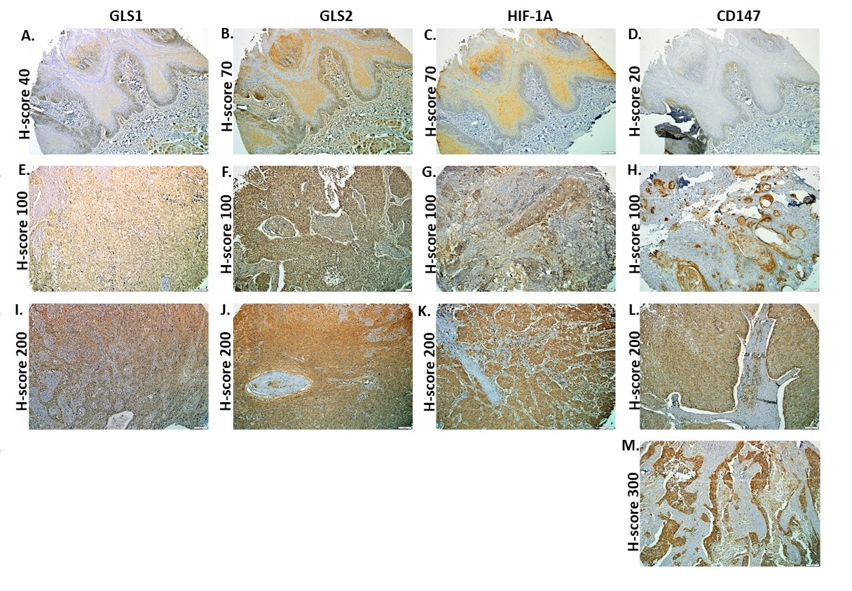
Figure 1: Representative Immunohistochemical staining patterns of GLS1, GLS2, HIF-1α and CD147 in normal and head and neck cancer tissues, (A-D) normal tissues with low/negative expression (E-H) cancer tissues with low/negative expression, (I-M) cancer tissues with high expression. Scale bar = 50µm Photomicrographs were taken at 20x magnification from the scanned TMA slides using Imagescope (Leica Biosystems Aperio).
The scores were independently obtained by two expert pathologists (KDH and AT) and the correlation between the two independent scores was above 0.9. High expression levels were assigned for H-score ≥ median for each protein; GLS1 ≥ 100, GLS2 ≥ 150, HIF-1α ≥ 95, and CD147 ≥ 150.
Statistical analysis. Analyses were performed using IBM Statistical Package for Social Sciences (SPSS©) Statistics for Windows, Version 22, (IBM Corp., Armonk, N.Y., USA). The difference in expression between normal and cancer tissue or difference within different clinicopathologic characteristics were tested via Mann-Whitney U-test or Kruskal–Wallis H-test as appropriate. Pearson correlation test χ² and Fisher exact tests were used to test associations for categorial variables. Correlations between variables were evaluated by Spearman’s rank correlation test. P-values ≤.05 were deemed statistically significant.
Results
Differential expression of GLS1 and GLS2 between normal and cancer tissues
To investigate whether the expression of GLS1, GLS2 or both have clinical significance in head and neck cancer microarrays, we compared the expression level of the two proteins between normal and cancer tissues (Figure 2. We found that the expression level of GLS1 (p≤.05) and GLS2 (p≤.01) was higher in cancer tissue compared to normal tissues. We also invistigated the expression of two other markers of malignancy in head and neck cancer HIF-1α [27] and CD147 (also known as basigin and extracellular matrix metalloproteinase inducer, EMMPRIN) [28] in the microarrays to assess the correlation of these proteins with GLS1 and GLS2 expression (Figure 2). We found that CD147 expression is sigificantly higher in cancer tissues than normal tissues (p≤.01). In contrast, although the expression of HIF-1α had shown to be increased in some cancer tissues over the normal, this increase was not statistically significant over the whole cohort (p=.74) as a number of tumor tissues had lower expression than the normal tissues.
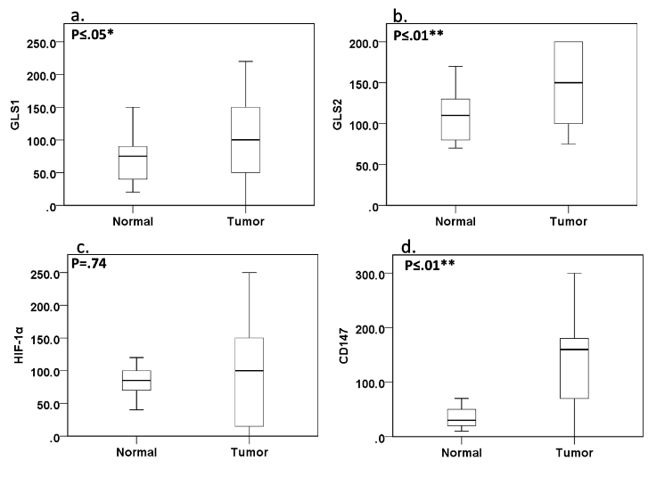
Figure 2: Expression of GLS1 (a), GLS2 (b), HIF-1α (c), and CD147 (d) protein level in normal and cancer tissues microarrays. *P values ≤.05 and **P values ≤.01 were considered statistically significant.
Glutamine metabolism is switched from GLS2 to GLS1 in more aggressive tumors
Furthermore, we aimed to evaluate the differences of GLS1 and GLS2 expression with different clinicopathological parameters (grade, stage and LN metastasis status). It appears that there is no further significant increase in expression levels with stage progression and tumors with LN node metastases but clearly these levels are consistently higher for all tumor tissues compared to the normal (data not shown). On the other hand, the level of expression was correlated with the tumor grade, showing a positive and a negative correlation with GLS1 (Rho=.312, P≤.01) and GLS2 (Rho=.281, P≤.05) respectively (Figure 2).
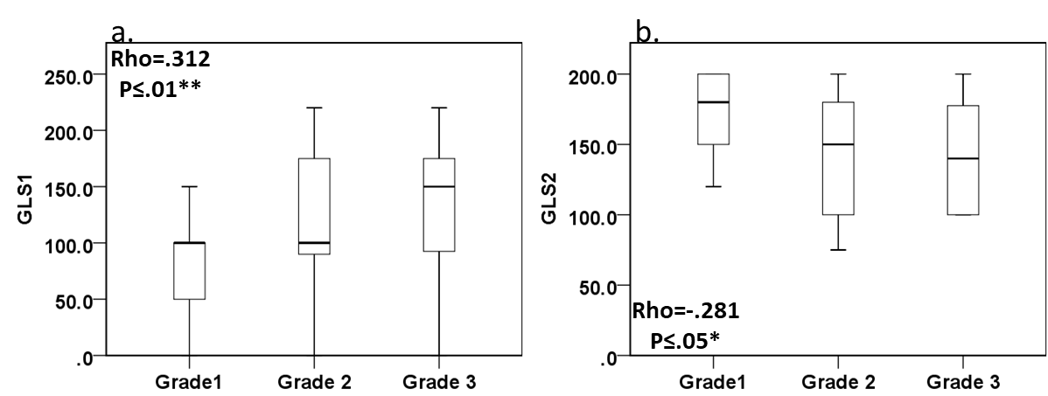
Figure 3: Expression of GLS1 and GLS2 among different clinicopathological grades. (a.). The expression of GLS1 is increased with the increased grade level, on the contrary GLS2 expression is decreased with increased grade level (b.). The correlation between the expression and grade level was tested by Spearman’s rank correlation test. *P ≤ 0.01, **P ≤0.05 were considered statistically significant.
Association of high expression of GLS1 and GLS2 with different clinicopathological parameters, hypoxia and prognosis biomarkers
The high expression of GLS1 was associated with tumor tissue rather than normal tissue (P≤.01) but not with any other clinicopathological characteristics. On the other hand, high GLS2 expression was associated with presence of tumor and tumor origin (primary vs metastatic) but not with any other clinicopathological parameters (Table 1). Furthermore, we examined the association between GLS1 or GLS2 and HIF-1α (hypoxia biomarker) and CD147 (a potential prognosis biomarker) in head and neck. We found that high GLS1 expression was associated with high CD147 expression only, while high GLS2 expression was associated with high HIF-1α and CD147 (Table 2). Of note, these associations were only seen in tumor tissues.

Table 1: Association of GLS1 and GLS2 high expression and different clinicopathological parameters
 | GLS1 |  | p | GLS2 |  | p
 | low | high |  | low | high
 | N (%) | N (%) |  | N (%) | N (%)
Age |  |  | .46 |  |  | .47
≤ 56 | 17 (39.5) | 24 (60.5) |  | 22 (51.2) | 21 (48.8)
≥ 56 | 11 (31.4) | 24 (68.6) |  | 15 (42.9) | 20 (57.1)
Gender |  |  | .33 |  |  | .95
M | 21 (33.3) | 42 (66.7) |  | 30 (47.6) | 33 (52.4)
F | 7 (46.7) | 8 (66.7) |  | 7 (46.7) | 8 (66.7)
Normal vs Tumor |  |  | ≤.01** |  |  | ≤.01**
Normal | 8 (80.0) | 2 (20.0) |  | 9 (90) | 1 (10)
Tumor | 21 (30.4) | 48 (69.6) |  | 29 (42.0) | 40 (58.0)
Histological grade |  |  | .82 |  |  | .24
1 | 6 (35.3) | 11 (64.7) |  | 4 (23.5) | 13 (76.5)
2 | 8 (26.7) | 22 (73.3) |  | 13 (42.3) | 17 (56.7)
3 | 4 (26.7) | 11 (73.3) |  | 8 (53.3) | 7 (46.7)
Clinical stage |  |  | .40 |  |  | .91
1 | 3 (60.0) | 2 (40.0) |  | 2 (40.0) | 3 (60.0)
2 | 4 (20.0) | 16 (80.0) |  | 7 (35.0) | 13 (65.0)
3 | 6 (28.6) | 15 (71.4) |  | 6 (28.6) | 15 (71.4)
4 | 4 (33.3) | 8 (66.7) |  | 5 (41.7) | 7 (58.3)
Primary tumor vs metastatic tumor |  |  | .26 |  |  | ≤.05*
Primary | 1 (12.5) | 7 (87.5) |  | 6 (75.0) | 2 (25.0)
Metastatic | 19 (31.7) | 41 (68.3) |  | 22 (36.7) | 38 (63.3)
LN metastasis |  |  | .60 |  |  | .60
Yes | 5 (25.0) | 15 (75.0) |  | 6 (30.0) | 14 (70.0)
No | 12 (31.6) | 26 (68.4) |  | 14 (36.8) | 24 (63.2)
LN represents lymph node. *P ≤.01, **P ≤.05 were considered statistically significant.

Table 2: Correlation of GLS1 and GLS2 with HIF-1α and CD147

 |  |  | GLS1 |  |  | GLS2
 |  |  | Low | High | P | Low | High | P
HIF-1α | N | Low | 6 (85.7) | 1 (14.3) | 1.00 | 6 (85.7) | 1 (14.3) | 1.00
HIF-1α | N | High | 2 (66.7) | 1 (33.3) | 1.00 | 3 (100.0) | 0 (0.0) | 1.00
HIF-1α | T | Low | 10 (32.3) | 21 (67.7) | .56 | 14 (48.3) | 15 (51.7) | ≤.05*
HIF-1α | T | High | 9 (25.7) | 26 (74.3) | .56 | 7 (17.5) | 33 (82.5) | ≤.05*
CD147 | N | low | 8 (80.0) | 2 (20.0) |  | 9 (90.0) | 1 (0.0)
CD147 | N | high | 0 (0.0) | 0 (0.0) |  | 0 (0.0) | 0 (0.0)
CD147 | T | low | 14 (48.3) | 15 (51.7) | ≤.01** | 18 (62.1) | 11 (37.9) | ≤.01**
CD147 | T | high | 7 (17.5) | 33 (82.5) | ≤.01** | 11 (27.5) | 29 (72.5) | ≤.01**
N represents normal tissues and T represents tumor tissues. *P ≤.01, **P ≤.05 were considered statistically significant.

Correlation between GLS1, GLS2, HIF-1α, and CD147 in head and neck cancer tissues.
Next, we investigated the correlation between GLS1 with GLS2, GLS1 with CD147 and GLS1 with HIF-1α in tumor tissues. Also, we examined the correlation between GLS2 with GLS1, GLS2 with CD147 and GLS2 with HIF-1α. If any significant correlation was observed between any of the aforementioned proteins, further correlation studies between these proteins were also performed within stages, grades, and primary tissues with and without LN metastasis. There was no correlation between GLS1 and GLS2 or HIF-1α, but a weak positive correlation between GLS1 and CD147 was significantly observed (Rho=.273, p≤.05) (Figure 4, Table 3). Moreover, once we separated tissues into grades, stages, and primary tumors with or without LN metastases, this correlation was only associated with tumors in grade 3 at a moderate level (Rho=.512, p≤.05) (Figure 5).
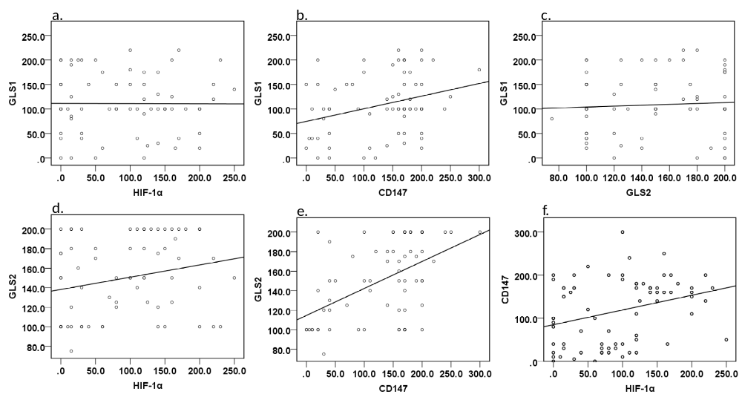
Figure 4: Correlation between GLS1, GLS2, HIF-1α and CD147. Correlation between GLS1 and HIF-1α (a.), GLS1 and CD147 (b.), GLS1 and GLS2 (c.), GLS2 and HIF-1α (d.), GLS2 and CD147 (e.), and CD147 and HIF-1α (f.). The significance of correlation was measured by Spearman’s rank correlation test (see Table 3).
Table3: Correlation of GLS1, GLS2, HIF-1α and CD147

Correlation between | Rho | P
GLS1 and HIF-1α | -.007 | .96
GLS1 and CD147 | .273 | ≤.05*
GLS2 and HIF-1α | .240 | ≤.05*
GLS2 and CD147 | .492 | ≤.01**
GLS1 and GLS2 | .061 | .62
CD147 and HIF-1α | .328 | <.01**
Correlation was tested by Spearman’s rank correlation test. *P≤ 0.05, **P≤0.01 were considered statistically significant.
Regarding GLS2, its expression was positively correlated with HIF-1α at a weak level (Rho=.240, p≤.05) and CD147 at a moderate level (Rho=.492, p≤.01) (Figure4, Table3). Next, we tested the previous significant correlations within grades, stages, and primary tumors with or without LN metastasis. We found a strong positive correlation between GLS2 and HIF-1α in stage 4 (Rho=.861, P≤.01) (Figure 6).
The correlation between CD147 and GLS2 was moderate in tumors in grade 1(Rho=0.527, P<0.05), grade 3 (Rho=0.527, P<0.05) and stage 3 (Rho=0.526, P≤.01), however this correlation was significantly strong in stage 4 (Rho=0.833, p≤.01), and tumors with LN metastasis (Rho=0.746, p<.01) (Figure 7-9).

Figure 5: Correlation between GLS1 and CD147 within grade 1(a.), grade 2 (b.), and grade 3(c.). A moderate correlation was observed in grade 3 (P≤.05*).
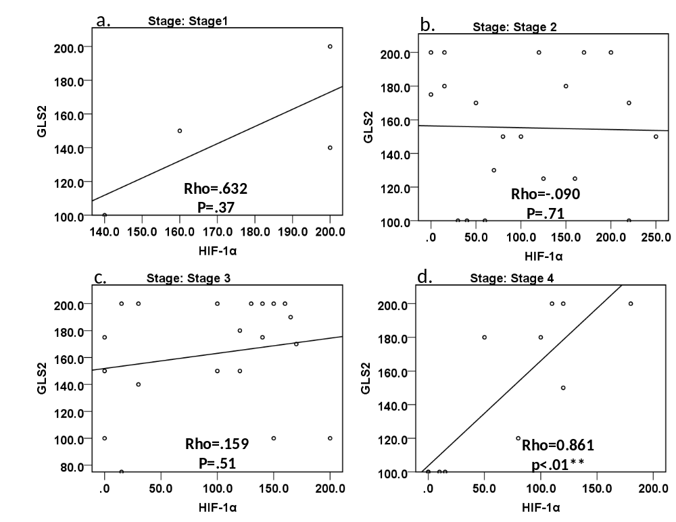
Figure 6: Correlation between GLS2 and HIF-1α within stages. Stage 1 (a.), stage 2 (b.), stage 3 (c.), and stage 4 (d.). The correlation was positively strong and only observed in stage 4 tumors (P≤.01**).

Figure 7: Correlation between GLS2 and CD147 within grades. Grade 1 (a.), grade 2 (b.), and grade 3 (c.) A moderate correlation was observed in grade 1, grade 3. (P≤.05*).
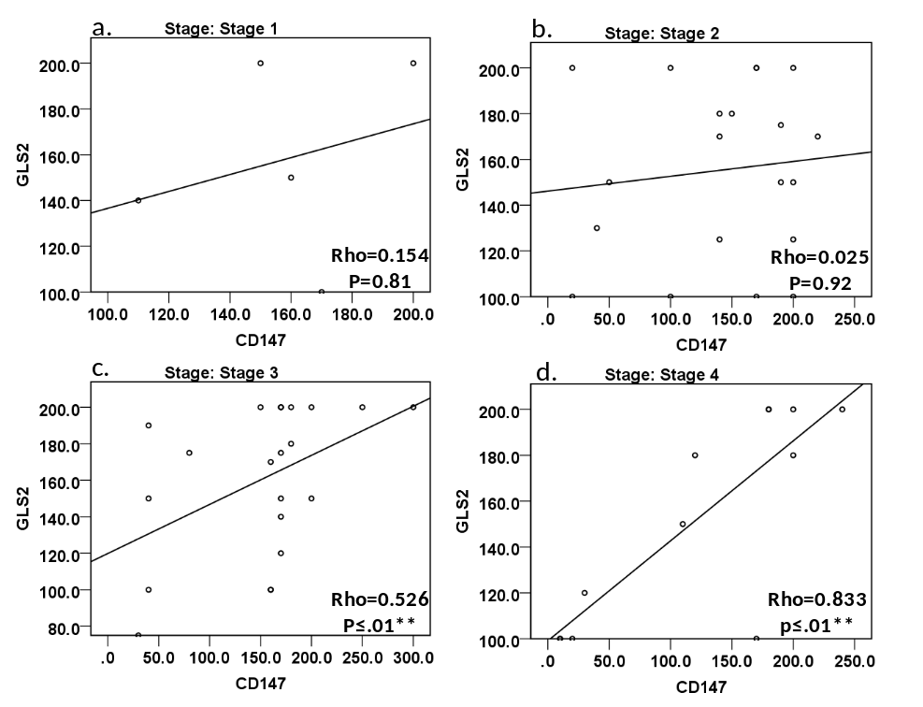
Figure 8: Correlation between GLS2 and CD147 within stages Stage 1 (a.), stage 2, (b.), stage 3 (c.), and stage 4 (d.). A moderate correlation was observed in stage 3 (c.) (P≤.05*). Furthermore, this correlation was significantly strong in stage 4 (d.) (P≤.01**).
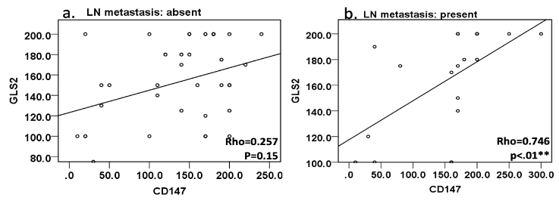
Figure 9: Correlation between GLS2 and CD147 in tumors without (a.) and with (b.) LN metastasis. This correlation was significantly strong in primary tumors with LN metastasis (P≤.01**).
Discussion
The increased glutamine metabolism is a hallmark characteristic of cancer cells [29]. The upregulation of GLS1 expression and its role in cancer progression is well documented in different cancer types including, liver[30], breast[31], colorectal[32] and leukemia[33]. However, studies on GLS2 expression are limited and its overexpression in cancer tissue has been shown to suppress[34] or increase[35] tumor progression in a tissue dependent manner.
Previous comparison between GLS1 and GLS2 expression in head and neck cancer in the same study is limited to a multiomics gene analysis, in which GLS1 and GLS2 expression was increased in tumor tissues compared to the normal ones[36]. In the previous study, the expression of GLS1 and GLS2 were increased at the mRNA level in cancer cells compared to normal cells. Furthermore, the expression of GLS1 in head and neck cancer tissues was associated with poor patient survival, however, survival data on GLS2 was not available. Indeed, the expression of GLS1 and GLS2 at the gene level in normal and tumor tissues could give some insight about the expression prolife of glutaminases and their role in cancer. Nonetheless, there is precedence that gene-level expression of glutaminases may not correlate to their protein level expression. For instance, the expression of GLS2 in colon cancer was shown to be upregulated at the gene level[36], and downregulated[8] at the protein level compared to normal tissues. In view of the relevance of protein expression studies in target validation and therapeutics studies, it is important that expression of glutaminases should be evaluated in clinical tissues at the protein level.
To the best of our knowledge, this is the first study to compare the expression of GLS1 and GLS2 in head and neck cancer tissues at the protein level. Our results showed a significant increase of expression in head and neck cancer cells compared to normal cells which confirms earlier gene expression results from Saha et al., [36]. Interestingly, this up-regulation of expression was positively correlated with the histological grade for GLS1 and negatively correlated with GLS2. This is concordant with previous research suggesting that GLS1 expression is increased in highly proliferating cells, whereas GLS2 expression is increased in resting differentiated cells[37].
It is particularly noteworthy that we observed a metabolic switch from GLS2 expression to GLS1 associated with higher grade tumours. This metabolic switch was found also to be observed during progression of human liver tumors towards higher grade lesions [38]. How this switch may be promoted in head and neck cancers is unknown, however the induced expression of MYC oncogene in mouse liver tumor cells has similarly resulted in the switch from GLS2 expression to GLS1[39]. More importantly, whilst the wider role of this switch is still unknown, it is a significant factor to be considered when developing inhibitors towards one of the GLS enzymes.
The upregulation of CD147 expression in different types of tumors including head and neck was found to regulate not only the proliferation of cancer cells but also its invasion through the increased expression of matrix metalloproteinases[28]. In addition, CD147 expression was shown to be correlated with increased chemoresistance and poorer clinical outcome in many cancers, hence it has role as a potential prognosis biomarker[22]. Our study is the first to evaluate the association between CD147 and glutamine metabolizing enzymes in cancer. We have found a strong association between the high expression of GLS1 or GLS2 with high CD147 expression in head and neck tissues. The correlation between GLS1 and CD147 was only seen in grade 3 tumors. On the other hand, the correlation between GLS2 and CD147 was observed in grade 1, and more aggressive clinico-pathological characteristics; grade 3, stage 3, stage 4 and primary tumors with LN metastasis. Although the role of CD147 in cancer metabolism is still elusive, a number of studies have correlated the increased expression of CD147 with lactate metabolism, through induction of lactate transporters [40, 41]. The increased expression of lactate transporters has shown to be associated with cancer progression and metastasis [42]. Moreover, it has been demonstrated that treating cancer cell lines with lactate stimulates glutaminolysis [43]. The results shown here could suggest that CD147 is a key player in GLS enzyme expression by stimulating the synthesis of lactate transporters in more aggressive cancer tissues. This suggests that the increased expression of either GLS1 or GLS2, combined with CD147, could be a better prognostic predictor of the clinical outcome in head and neck cancer patients than the use of CD147 on its own.
The presence of hypoxia in tumor tissues is a well-known feature of solid cancers [44] supporting drug resistance, tumor survival, invasion, and metastasis[45]. Many hypoxia inducible genes are under the regulation by HIF-1α which is shown to be play a role in regulating many solid tumors including head and neck cancers [46-48]. HIF-1α has been shown to increase the expression of many proteins involved in the metabolic process that enhance tumor progression including GLUT and LDH [49, 50]. It has been shown that the expression of GLS1 was stimulated by HIF-1α expression in colorectal cancer [9]. In the present study, we demonstrated for the first time that in head and neck cancer tissues, there was a strong positive correlation between HIF-1α and GLS2 expressions in advanced clinical stage. Taken together, the correlation of GLS2, HIF-1α and CD147 could indicate the presence of a crosstalk between the signalling pathways of these cancer oncoproteins, which might act together to enhance cancer progression. Additionally, our results indicate that further knockdown and pharmacological studies to determine the differing roles of GLS1 and GLS2 in head neck cancer is warranted. Also, future signalling studies should be directed to confirm the association between HIF-1α, CD147 and GLS enzymes and investigate the effect of combination treatments targeted against the previous proteins on tumor progression and improving clinical outcomes in head and neck cancer patients

Conclusion
The glutaminase enzymes GLS1 and GLS2 are upregulated at protein level in head and neck cancer compared to normal tissues and this expression was positively correlated (GLS1) and negatively correlated (GLS2) with tumor grade, indicating a metabolic switch of GLS enzymes based on tumor differentiation. Increased expression of GLS1 was associated with high CD147 expression; and elevated GLS2 expression was associated with high HIF-1α and CD147 expressions. The correlation of the GLS1 and GLS2 with HIF-1α or CD147 was strongly associated with more advanced clinicopathological.
Ethics approval and consent to participate.
Biomax human tissue microarrays are prepared under HIPPA approved protocols with the donors providing informed consent.
Consent for publication
Not applicable.
Competing interests
The authors declare no competing interests.
Data Availability
The data generated during and/or analysed during the current study are available from the corresponding author on reasonable request.
Author Contribution
Study concept and design was provided by HAB and KA. Experimental work was carried out by HAB and AS. The histological examination, tissues scoring and imaging was conducted by KH and AT. LA and HAB performed the statistical analysis and drafted the manuscript. All authors read and approved the final manuscript.
Funding
We wish to thank Zarqa University for supporting this research (grant number: 2018/489).
References
1. Thompson-Harvey, A., et al., Rising incidence of late-stage head and neck cancer in the United States. 2020. 126(5): p. 1090-1101.
2. Guidi, A., C. Codecà, and D. Ferrari, Chemotherapy and immunotherapy for recurrent and metastatic head and neck cancer: a systematic review. Med Oncol, 2018. 35(3): p. 37.
3. Brands, M.T., et al., Time patterns of recurrence and second primary tumors in a large cohort of patients treated for oral cavity cancer. Cancer medicine, 2019. 8(12): p. 5810-5819.
4. Teicher, B.A., W.M. Linehan, and L.J. Helman, Targeting cancer metabolism. Clinical cancer research : an official journal of the American Association for Cancer Research, 2012. 18(20): p. 5537-5545.
5. Liberti, M.V. and J.W. Locasale, The Warburg Effect: How Does it Benefit Cancer Cells? Trends in biochemical sciences, 2016. 41(3): p. 211-218.
6. Curthoys, N.P. and M. Watford, Regulation of glutaminase activity and glutamine metabolism. Annu Rev Nutr, 1995. 15: p. 133-59.
7. Aledo, J.C., et al., Identification of two human glutaminase loci and tissue-specific expression of the two related genes. Mammalian Genome, 2000. 11(12): p. 1107-1110.
8. Xiang, L., et al., Glutaminase 1 expression in colorectal cancer cells is induced by hypoxia and required for tumor growth, invasion, and metastatic colonization. Cell Death & Disease, 2019. 10(2): p. 40.
9. Son, J., et al., Glutamine supports pancreatic cancer growth through a KRAS-regulated metabolic pathway. Nature, 2013. 496(7443): p. 101-5.
10. Wang, Z., et al., Targeting Glutaminolysis: New Perspectives to Understand Cancer Development and Novel Strategies for Potential Target Therapies. Frontiers in Oncology, 2020. 10(2321).
11. Gross, M.I., et al., Antitumor activity of the glutaminase inhibitor CB-839 in triple-negative breast cancer. Mol Cancer Ther, 2014. 13(4): p. 890-901.
12. Shen, Y.A., et al., Inhibition of the MYC-Regulated Glutaminase Metabolic Axis Is an Effective Synthetic Lethal Approach for Treating Chemoresistant Ovarian Cancers. Cancer Res, 2020. 80(20): p. 4514-4526.
13. Lee, Y.Z., et al., Discovery of selective inhibitors of Glutaminase-2, which inhibit mTORC1, activate autophagy and inhibit proliferation in cancer cells. Oncotarget, 2014. 5(15): p. 6087-101.
14. Ren, L., et al., Glutaminase-1 (GLS1) inhibition limits metastatic progression in osteosarcoma. Cancer & Metabolism, 2020. 8(1): p. 4.
15. Koch, K., et al., A comparative pharmaco-metabolomic study of glutaminase inhibitors in glioma stem-like cells confirms biological effectiveness but reveals differences in target-specificity. Cell Death Discovery, 2020. 6(1): p. 20.
16. Masoud, G.N. and W. Li, HIF-1α pathway: role, regulation and intervention for cancer therapy. Acta Pharmaceutica Sinica B, 2015. 5(5): p. 378-389.
17. Jun, J.C., et al., Hypoxia-Inducible Factors and Cancer. Current sleep medicine reports, 2017. 3(1): p. 1-10.
18. Le, Q.-T. and D. Courter, Clinical biomarkers for hypoxia targeting. Cancer metastasis reviews, 2008. 27(3): p. 351-362.
19. Semenza, G.L., HIF-1: upstream and downstream of cancer metabolism. Current Opinion in Genetics & Development, 2010. 20(1): p. 51-56.
20. Cui, X.G., et al., HIF1/2α mediates hypoxia-induced LDHA expression in human pancreatic cancer cells. Oncotarget, 2017. 8(15): p. 24840-24852.
21. Lian, C., et al., Targeting CD147 is a Novel Strategy for Antitumor Therapy. Curr Pharm Des, 2017. 23(29): p. 4410-4421.
22. Landras, A., et al., CD147 Is a Promising Target of Tumor Progression and a Prognostic Biomarker. Cancers (Basel), 2019. 11(11).
23. Yu, B., et al., CD147 promotes progression of head and neck squamous cell carcinoma via NF-kappa B signaling. J Cell Mol Med, 2019. 23(2): p. 954-966.
24. Li, X. and W. Xu, CD147-mediated reprogrammed glycolytic metabolism potentially induces immune escape in the tumor microenvironment (Review). Oncol Rep, 2019. 41(5): p. 2945-2956.
25. Li, X., et al., Enhanced glucose metabolism mediated by CD147 contributes to immunosuppression in hepatocellular carcinoma. Cancer Immunology, Immunotherapy, 2020. 69(4): p. 535-548.
26. Matés, J.M., et al., Therapeutic targeting of glutaminolysis as an essential strategy to combat cancer. Seminars in Cell & Developmental Biology, 2020. 98: p. 34-43.
27. Swartz, J.E., et al., Clinical implications of hypoxia biomarker expression in head and neck squamous cell carcinoma: a systematic review. Cancer medicine, 2015. 4(7): p. 1101-1116.
28. Xin, X., et al., CD147/EMMPRIN overexpression and prognosis in cancer: A systematic review and meta-analysis. Sci Rep, 2016. 6: p. 32804.
29. Cluntun, A.A., et al., Glutamine Metabolism in Cancer: Understanding the Heterogeneity. Trends Cancer, 2017. 3(3): p. 169-180.
30. Li, B., et al., Targeting glutaminase 1 attenuates stemness properties in hepatocellular carcinoma by increasing reactive oxygen species and suppressing Wnt/beta-catenin pathway. EBioMedicine, 2019. 39: p. 239-254.
31. Kim, J.Y., et al., Glutaminase expression is a poor prognostic factor in node-positive triple-negative breast cancer patients with a high level of tumor-infiltrating lymphocytes. Virchows Archiv, 2017. 470(4): p. 381-389.
32. Huang, F., et al., Expression of glutaminase is upregulated in colorectal cancer and of clinical significance. International journal of clinical and experimental pathology, 2014. 7(3): p. 1093-1100.
33. Matre, P., et al., Inhibiting glutaminase in acute myeloid leukemia: metabolic dependency of selected AML subtypes. Oncotarget, 2016. 7(48): p. 79722-79735.
34. Szeliga, M., et al., Silencing of GLS and overexpression of GLS2 genes cooperate in decreasing the proliferation and viability of glioblastoma cells. Tumor Biology, 2014. 35(3): p. 1855-1862.
35. Dias, M.M., et al., GLS2 is protumorigenic in breast cancers. Oncogene, 2020. 39(3): p. 690-702.
36. Saha, S.K., et al., Multiomics Analysis Reveals that GLS and GLS2 Differentially Modulate the Clinical Outcomes of Cancer. Journal of clinical medicine, 2019. 8(3): p. 355.
37. Pérez-Gómez, C., et al., Co-expression of glutaminase K and L isoenzymes in human tumour cells. The Biochemical journal, 2005. 386(Pt 3): p. 535-542.
38. Yu, D., et al., Kidney-type glutaminase (GLS1) is a biomarker for pathologic diagnosis and prognosis of hepatocellular carcinoma. Oncotarget, 2015. 6(10): p. 7619-31.
39. Yuneva, M.O., et al., The metabolic profile of tumors depends on both the responsible genetic lesion and tissue type. Cell Metab, 2012. 15(2): p. 157-70.
40. Kirk, P., et al., CD147 is tightly associated with lactate transporters MCT1 and MCT4 and facilitates their cell surface expression. The EMBO journal, 2000. 19(15): p. 3896-3904.
41. Schneiderhan, W., et al., CD147 silencing inhibits lactate transport and reduces malignant potential of pancreatic cancer cells in in vivo and in vitro models. Gut, 2009. 58(10): p. 1391.
42. de la Cruz-López, K.G., et al., Lactate in the Regulation of Tumor Microenvironment and Therapeutic Approaches. Frontiers in Oncology, 2019. 9(1143).
43. Pérez-Escuredo, J., et al., Lactate promotes glutamine uptake and metabolism in oxidative cancer cells. Cell Cycle, 2016. 15(1): p. 72-83.
44. Jing, X., et al., Role of hypoxia in cancer therapy by regulating the tumor microenvironment. Molecular Cancer, 2019. 18(1): p. 157.
45. Brown, J.M., Tumor Hypoxia in Cancer Therapy, in Methods in Enzymology. 2007, Academic Press. p. 295-321.
46. Al Tameemi, W., et al., Hypoxia-Modified Cancer Cell Metabolism. Frontiers in cell and developmental biology, 2019. 7: p. 4-4.
47. Lai, S.Y. and J. Rubin-Grandis, HIF-1 modulates head and neck cancer progression and invasion. Otolaryngology - Head and Neck Surgery, 2004. 131(2): p. P112.
48. Basheer, H.A., et al., Hypoxia modulates CCR7 expression in head and neck cancers. Oral Oncol, 2018. 80: p. 64-73.
49. Ban, H.S., et al., The novel hypoxia-inducible factor-1α inhibitor IDF-11774 regulates cancer metabolism, thereby suppressing tumor growth. Cell Death & Disease, 2017. 8(6): p. e2843-e2843.
50. Semenza, G.L., Targeting HIF-1 for cancer therapy. Nature Reviews Cancer, 2003. 3(10): p. 721-732.

